Portal user guide – Portal user roles

All portal users need to be assigned a role within the portal which allows the user to access certain portal functions. There is no one-size-fits-all approach, and the roles you assign to your staff will depend on a range of factors including the size of your organisation, number of sites and users and your business processes.

The portal has four user roles for service providers

* SP Admin
* SP Manager
* SP Site
* SP Claims

And one user role for device suppliers

* DM Admin

The functions available to each of these roles are

|  | SP Admin | SP Manager | SP Site | SP Claims | DM Admin |
| --- | --- | --- | --- | --- | --- |
| Add site | Yes | Yes |  |  |  |
| Search and view site details | Yes | Yes |  |  |  |
| Export site details | Yes | Yes |  |  |  |
| Edit site details | Yes | Yes |  |  |  |
| Close site | Yes | Yes |  |  |  |
| Apply for client | Yes |  | Yes | Yes |  |
| Update draft application | Yes |  | Yes | Yes |  |
| Search and view client details | Yes |  | Yes | Yes |  |
| Export client details | Yes | Yes | Yes | Yes |  |
| Edit client details | Yes |  | Yes | Yes |  |
| Transfer client | Yes |  | Yes | Yes |  |
| Confirm return voucher | Yes |  | Yes |  |  |
| Retrieve all clients | Yes | Yes |  |  |  |
| Submit manual claims and recoveries | Yes |  | Yes | Yes |  |
| View manual claims | Yes |  | Yes | Yes |  |
| Search and export claims | Yes |  | Yes | Yes |  |
| Batch download of claims | Yes |  | Yes | Yes |  |
| Reconciliation Report | Yes |  | Yes |  |  |
| Add new practitioner | Yes | Yes |  |  |  |
| Edit provider- practitioner links | Yes | Yes |  |  |  |
| Create user accounts | Yes | Yes |  |  | Yes |
| View user accounts | Yes | Yes |  |  | Yes |
| Export user accounts | Yes | Yes |  |  | Yes |
| Edit user accounts | Yes | Yes |  |  | Yes |
| Edit business details | Yes |  |  |  | Yes |
| Add new device |  |  |  |  | Yes |
| Edit device details |  |  |  |  | Yes |
| Cancel device |  |  |  |  | Yes |
| Search and view devices |  |  |  |  | Yes |

Depending on the functions you would like your staff to complete, you may assign a user multiple user roles.

# Creating users

The first portal user (SP Admin or DM Admin) for a business is created by the department. The SP Admin/DM Admin user can then create new users for their business, including other admin users, as required.

## Access

### What access do I need?

SP Admin, SP Manager, DM Admin

## To add a new user

#### Step 1

Ensure the new user has a myID account; the myID app on their smart phone; Relationship Authorisation Manager (RAM) authorisation; and Google Chrome installed as their default web browser.

#### Step 2

Login to the portal and click on the User Accounts section to expand the view.

Click on the Add New User button.

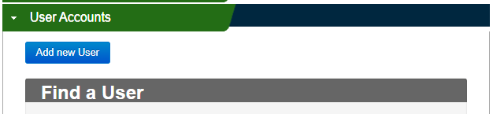

#### Step 3

When expanded, complete the relevant fields such as user type, given name, family name and email address (this is the email address that the invitation email will be sent to, and should be the same email address as that they use for their myID account).

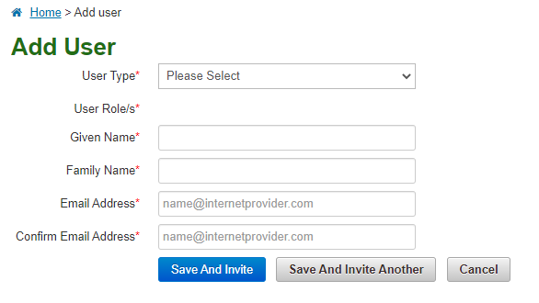

#### Step 4

Once the fields are complete, click the Save and Invite button. The user will then be sent an invitation to join the portal via email.

## User accepting the invitation

Clicking the unique URL in the invitation email will take the user to the portal, where they will login using their myID to confirm and activate their portal registration.

Note - Invitations to join the portal remain valid for ten days. After this time a new invitation will need to be issued.

Depending on the role assigned, an existing SP Admin/Manager or DM Admin within your organisation can re-invite expired users through the portal.

## Revoking user access

A User needs to have SP Admin, SP Manager or DM Admin access in order to revoke someone’s account on the portal.

To revoke a user account

#### Step 1

Click on the User Accounts section to expand the view.

Enter the details of the user you wish to revoke access to.

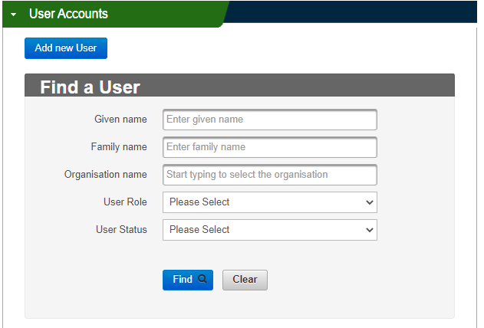

#### Step 2

When the user’s details come up, click the blue Edit section under the users email address.

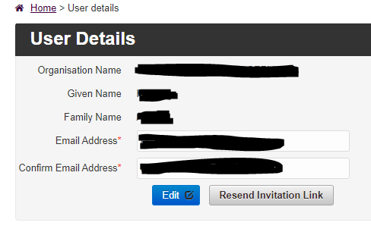

#### Step 3

On the right hand side next to User Status, click the down arrow and select Revoke.

The Reason field will appear underneath.

Select the appropriate reason for revoking access.

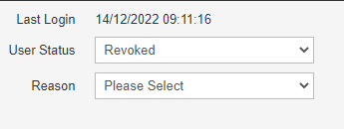

#### Step 4

Click Save to finalise.