Portal user guide – Accessing the training environment

The HSO training environment allows providers to practice existing portal processes, test new features, and train staff to use the HSO portal. Data in the Training portal are test data.  All records can be accessed and edited without affecting sensitive business or client information, as test data is not connected to information in the live portal environment. The Training Environment is visually identifiable by the yellow/black colour schematic and the banner Training Environment at the top of each portal webpage.

# Access

## What access do I need?

A specific training environment account and a current myID account and Relationship Authorisation Manager (RAM) authorisation.

# Creating an Admin User Account

To access the HSO training environment, an SP Admin User must create a user account specifically for the Training Environment.

If the SP Admin User for your business does not have a current Training Environment account, please request one to be set up for you by emailing [hearing@health.gov.au](mailto:hearing@health.gov.au)

Once an account has been set up for the training portal the SP Admin User will be sent an invitation which they need to accept. This process is the same as accepting an invitation to the Live Portal.

# How to invite users to the training environment

Only users with SP Admin portal access can add new users to the training environment. The user you are trying to invite should already have a portal user account. See the ‘[Portal user roles](https://www.health.gov.au/resources/publications/hearing-services-program-portal-user-guide-portal-user-roles)’ guide if they do not have access already.

## Step 1

Visit the [training environment](http://acc.hearingservices.gov.au/wps/portal/hso/site/HSOHome/) webpage.

Select the Portal Login button on the top right corner of the webpage. This will enable you to log in using myID.

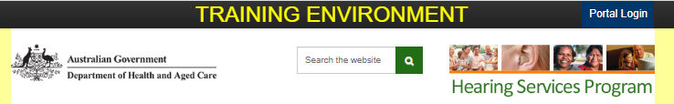

## Step 2

Select a site, tick the certification box and select Agree.

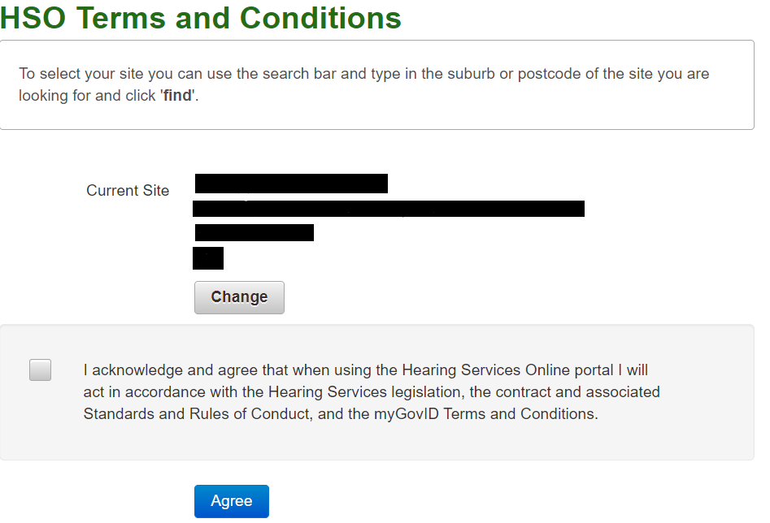

## Step 3

Select the User Accounts accordion and click Add New User

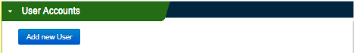

Assign them one or more user roles and enter the user’s details.

Note – if you are a device manufacturer, you only have one user role ‘DM Admin’.

Select Save and Invite.

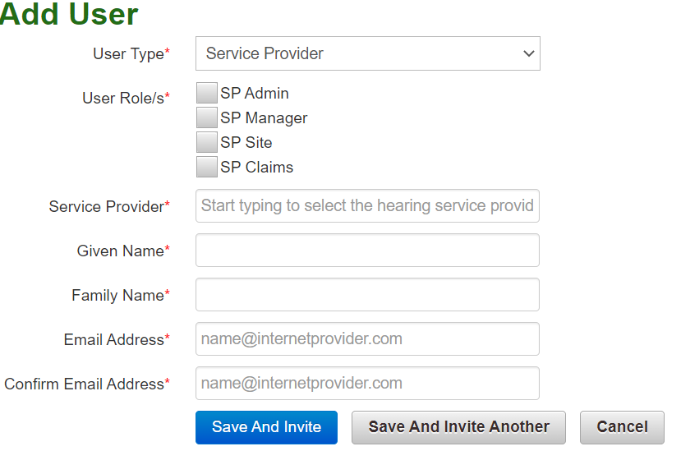

## Step 4

Re-open the User Accounts accordion and search for the user you have just added.

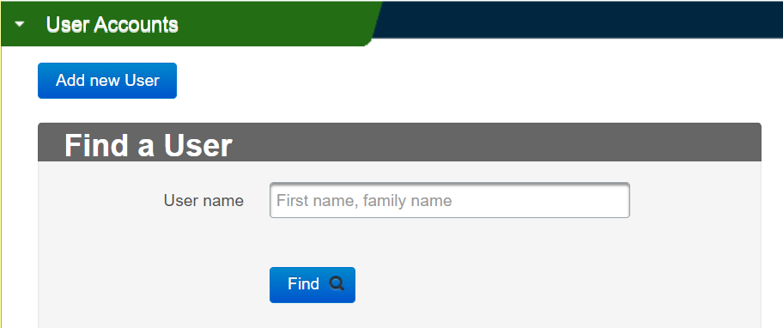

Because the training environment is not a live environment, the invitation email will not be sent. You will need to copy the email text in the Invite User email and forward it to the new user yourself.

Under the Correspondence Issued accordion, click the InviteUserlink to open the invitation email.

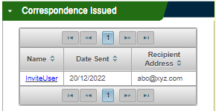

Copy and send the link to the new user from your business email account. They can then follow the steps below to accept the user invitation.

# Receiving and accepting an invitation

An SP Admin from your company will add you as a new user in the portal and send you an invitation link. The invitation will be active for 10 days. If you have not accepted your invitation within this time, your SP Admin user will need to send you a new invitation.

## Step 1

Ensure you have set up your myID and finalised your RAM authorisation. Then, select the link in the email.

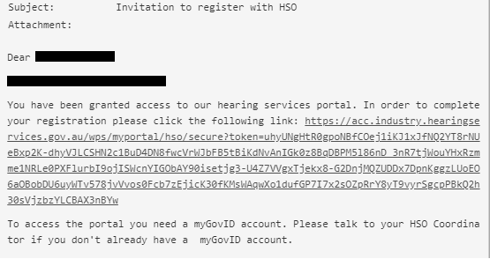

## Step 2

Do not go directly to the provider login link on the top right of the screen at this stage.

Click the Continuebutton.

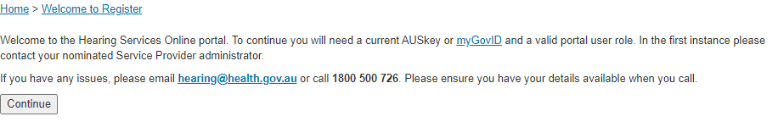

You will be taken to the myID login screen and can proceed through the authentication steps.

You will then be taken to the Training Portal landing page.