Portal User Guide – Accepting a portal invitation

If you require access to the Hearing Services Online Portal, you must be added by someone within your organisation and have a myID and Digital Identity. You will receive an email link providing you with access.

# Access

## What access do I need?

Your user role will depend on your organisation’s requirements: SP Admin, SP Manager, SP Site, SP Claims or DM Admin. [The Portal user roles guide](https://www.health.gov.au/resources/publications/hearing-services-program-portal-user-guide-portal-user-roles?language=en) provides information on the functions available to each of these roles.

## What else do I need?

Before attempting to access the portal, you must have:

* a [myID account](https://www.mygovid.gov.au/set-up),
* the myID app on a smart phone or other device,
* Relationship Authorisation Manager ([RAM](https://info.authorisationmanager.gov.au/get-started)) authorisation.
* Google Chrome installed as your web browser.

# Getting an email invitation

When an SP Admin/Manager from your company creates your user account the portal will send you a portal invitation email. The email invitation contains a link which will be active for 10 days. If you do not click the link within this period, you will need to have a new invitation issued.

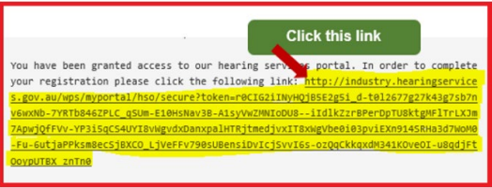

# Accepting the invitation

When you have your myID account setup, and are authorised in RAM, accept the portal invitation by clicking the link in the invite email. Please ensure that Google Chrome is set as your default web browser for opening links.

Click the Continue button.

**Do not click the Portal Login button at this step – this will result in an error**.

Enter the email address associated with your myID account.

Step through Digital Identity and myID screens and complete your 2- step verification via the myID application on your smartphone. You will then see the portal landing page.

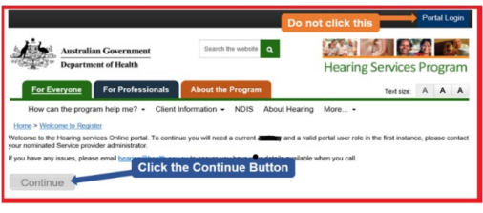

## Still having trouble?

If you are unable to activate your account, or having difficulty at any of the steps described above, please take a screenshot of any system/error messages on screen, and email this to [hearing@health.gov.au](mailto:hearing@health.gov.au) - we will contact you to troubleshoot your connection.

For assistance in setting up your myID account or RAM authorisation, please contact the Australian Tax Office on 1300 287 539.