Healthdirect Pregnancy, Birth and Baby service review

Final Report – December 2024

Acknowledgement of Country

We, the Department of Health and Aged Care, and the Cube Group, proudly acknowledge the Traditional Owners and Custodians of Country throughout Australia and pay respect to those who have preserved and continue to care for the lands and waters on which we live and, work, and from which we benefit each day. We recognise the strengths and knowledge Aboriginal and Torres Strait Islander peoples provide to the health and aged care system and thank them for their ongoing contributions to those systems and the wider community. We extend this gratitude to all health and aged care workers who contribute to improving health and wellbeing outcomes with, and for, First Nations peoples and communities.

# Executive summary

## About Pregnancy, Birth and Baby

Pregnancy, Birth and Baby (PBB) is a national service providing support and information for expecting parents and parents, families, and carers of children from birth to five years of age. Maternal and child health (MACH) nurses provide phone and video support to callers seven days a week. The PBB website and social media channels provide resources and information.

Healthdirect Australia delivers PBB through an agreement with the Australian Government Department of Health and Aged Care (the department). The Australian Government is the sole funder of PBB.

## About this review

The current term for PBB commenced on 1 July 2023. The department recommended a review of the service during the first two years of the current agreement to examine and determine:

* the extent to which the service meets the needs of women, parents/carers of babies to five-year-olds, particularly among priority populations, and the broader health sector in Australia
* PBB’s relationship with and/or duplication of existing services at a national and jurisdictional level including identification of any service gaps
* the extent to which PBB supports current and emerging Commonwealth health policy directions
* the cost-efficiency of PBB.

The department and Cube Group co-delivered the review (March to August 2024) and co-authored this report; working together and leveraging each other’s strengths to bring to life Australian Public Service (APS) Reform through active knowledge sharing, capability building and targeted use of consultant expenditure.

## Our approach

The review commenced with a series of desktop reviews and analysis of PBB administrative data.

Our desktop analysis focused on:

* sources of information available to women and how likely they are to be used; women’s perceptions and preferences; issues, or limitations, with the available sources of information; experience of priority populations obtaining information from these sources
* identifying key Commonwealth policy documents and testing the congruence of these with PBB objectives.

Our data analysis explored usage by region and population subgroups and compared PBB data with Australian Bureau of Statistics (ABS) and Australian Institute of Health and Welfare (AIHW) data to determine whether use is proportionate across population groups. We also considered the extent to which PBB, and other similar services, contribute to improved outcomes.

This analysis was enriched with:

* insights obtained through two roundtables with key stakeholders – the first with consumer and priority population representative groups and the second with health professional organisations and Commonwealth officials
* further research and analysis across the five review domains.

Stakeholder engagement provided us with input on the role PBB plays, or could play, in the context of the breadth of services provided in Australia. This input included perspectives on:

* promotion and marketing
* usage of the services by priority populations not identified in quantitative data
* outcomes of service usage for priority populations
* reasons priority populations use (or do not use) PBB
* usage of the services among health professionals
* reasons health professionals use or recommend (or do not use or recommend) PBB.

Analysis of PBB outputs supported our exploration of its effectiveness across different subgroups.

We also conducted economic analysis to estimate the monetary value of the PBB helpline to government and consumers.

## Key insights

As currently implemented PBB does not support government policy directions

Our analysis shows that while PBB is intended to align with current and emerging Commonwealth health policy directions, its ability to fully achieve this intent falls short. This is due to service design that is not individualised, culturally safe, responsive, or human-centred. Key principles of the Women’s health strategy, Woman-centred care strategy and Early-years strategy are not reflected in the service. This is also due to funding constraints that:

* do not provide scope to increase workforce capacity or composition to accommodate growth in call volumes
* provide no capacity for promotion to some target groups including Aboriginal and Torres Strait Islander peoples and culturally and linguistically diverse (CALD) people (or provide for the translation of material and resources)
* do not provide scope to include person-centred features in the service, including but not limited to user-friendly products, consumer participation and empowerment and support for continuity of care
* provide for only limited promotional activity (social media and limited promotion of video call services) to create service awareness and increase uptake.

With a narrower scope, service refinements and enhanced funding, PBB has the potential to deliver policy objectives and bridge current service gaps

This review has established the need for services to support women, their partners, and families through the preconception to postnatal period up to one year of age (a current service gap).

PBB is well placed to meet this more defined scope.

PBB has the potential to deliver greater value and support government policy directions by:

* addressing gaps in the promotion and provision of continuity of care
* enhancing consumer participation and empowerment to meet the needs of priority populations.

Our findings detail which parts of PBB currently work well, as well as how the service could be improved in future.

These findings have enabled us to propose informed options for considerationfor a (redesigned or enhanced) PBB service that would equip PBB to deliver outcomes more appropriately, effectively, equitably, economically, and efficiently.

We have also provided a range of suggested features to operationalise the proposed options into service enhancements. Additional resourcing will be needed for implementation of these options and associated features, which will improve the alignment of PBB with government policy directions (table 4 in chapter 3 provides a matrix of Commonwealth policy themes and PBB’s alignment). Resources required will depend on preferred features and their implementation approach, following consultation between the department and Healthdirect.

### Key findings and proposed options for consideration

| Key Evaluation Question (KEQ) | What we found | Options for consideration |
| --- | --- | --- |
| Appropriateness and justification  KEQ 1: What is the evidence to support the continued need for PBB and what is the role of government in delivering the program?  KEQ 2: To what extent was PBB appropriately designed to meet its intended objectives? | * High-quality, accessible, and culturally safe information from trusted sources leads to more positive experiences during the pregnancy, birth and postnatal period (section 3.2.1) * PBB has the potential to address gaps in the promotion and provision of continuity of care (section 3.2.2) * The role and purpose of PBB in the existing information landscape is not clear but the service addresses some important gaps (section 3.2.3) | 1. The scope of PBB should be narrowed to focus on preconception, pregnancy, and the postnatal period. 2. The capability and composition of call handlers should reflect a trauma-informed and midwifery-led approach, while representing the populations they serve. |
| Effectiveness  KEQ 3: To what extent does PBB align with Commonwealth policy direction?  KEQ 4: To what extent are the outputs of PBB achieving intended objectives and outcomes of the service? | * The government’s Women’s health strategy, Woman-centred care strategy and Early-years strategy emphasise consumer choice and empowerment, access to maternity care, midwifery-led approaches and continuity of care models. While the framing and intent of PBB supports government policy directions, as currently implemented PBB falls short of its potential impact (section 3.2.1) * The helpline and website differ in their level of effectiveness, but both could deliver greater value with enhancements in design and promotion (section 3.2.2) | 1. PBB should emphasise individual decision-making and empowerment to reflect principles of the government’s Woman-centred care strategy. 2. PBB should be enhanced to inform and support women (and parents/carers) in using local services, to align with government policy directions. 3. PBB should support continuity of care, to align with principles of Woman-centred care strategy. 4. A monitoring and evaluation framework should be developed for PBB, to enable active monitoring of PBB and assess whether the updated service model is achieving its intended objectives. |
| Equity  KEQ 5: How equitably are the benefits of PBB distributed? | * PBB is not achieving its goal of supporting priority populations (section 3.3.1) * Promotion of PBB does not effectively target priority populations (section 3.3.2) * Meeting the needs of priority populations requires content designed with them in mind based on consumer participation and empowerment (3.3.4) | 1. All existing content should be reviewed, and new content developed through a co-design process to ensure it is intersectional, culturally safe, inclusive, accessible, trauma-informed, in plain English and uses imagery or videos where possible. 2. Promotional activities should be targeted to priority populations (including Aboriginal and Torres Strait Islander peoples, CALD, women with disability, teenage mothers, and people living in rural and remote locations). |
| Economy  KEQ 6: Are the program inputs (cost and quantity) appropriate and efficient? | * In 2023, the helpline saved governments more than $3.3 million and consumers more than $700,000 (3.4.1) * Women and parents in regional and remote Australia are among the groups with the most to gain from PBB (3.4.2) | 1. Improved service awareness and quality should be appropriately resourced to ensure greater helpline utilisation across jurisdictions and populations, delivering benefits for those who need it the most. |
| Efficiency  KEQ 7: Are the delivery of program outputs efficient? | * Comparable services provide examples of more efficient models of operation (3.5.1) * There is duplication of content between the PBB website and other government funded websites. * Healthdirect’s operating model for the healthdirect information and advice (HIAS) helpline provides more value for money and efficient service delivery than PBB. | 1. The Healthdirect brand, assets, operating model and capabilities should be leveraged to improve PBB’s value for money and service delivery efficiency. 2. Healthdirect should improve the content and design of PBB, to ensure it is fit-for-purpose, user-centric, and effectively leverages information partners and other government funded information services to remove duplication and improve integration. |

# Table of Contents

Executive summary iii

About Pregnancy, Birth and Baby iii

About this review iii

Our approach iii

Key insights iv

Table of Contents viii

Glossary x

1. Background and context 14

1.1 About Pregnancy, Birth and Baby 14

1.2 Service objectives 15

1.3 The context in which PBB operates 16

2. About the review and this report 20

2.1 About the PBB review 20

2.2 Review limitations 21

3. Observations 23

3.1 Review purpose and domains 23

3.2 Appropriateness and justification 24

3.3 Effectiveness 30

3.4 Equity 40

3.5 Economy 49

3.6 Efficiency 52

4. Options for consideration 55

5. Features 59

5.1 Workforce 60

5.2 Products 61

5.3 Promotion and service expansion 63

5.4 Content and information 65

5.5 Continuity of care 67

References 69

Appendices 71

Appendix 1 — Brief literature scan 72

Appendix 2 — Summary of key Commonwealth policy documents 78

Appendix 3 — Ready reckoner of PBB and comparable services 79

Appendix 4 — PBB stakeholder insight summary 83

Appendix 5 — Roundtable focus questions for discussion 87

Appendix 6 — Roundtable attendee organisations 88

# Glossary

|  |
| --- |
| **Aboriginal and Torres Strait Islander Health Practitioners and Workers:** Registered healthcare practitioners and/or primary care providers who provide clinical services and patient care with a focus on culturally safe practice for Aboriginal and Torres Strait Islander people. They work collaboratively within multidisciplinary healthcare teams to achieve better health outcomes for Aboriginal and Torres Strait Islander people and communities and play a key role in facilitating relationships between Aboriginal and Torres Strait Islander patients and other health practitioners. |
| **Antenatal:** Having to do with the time a woman is pregnant before birth occurs. Often referred to as prenatal. |
| **Clinical governance:** The combination of relationships, responsibilities, structures, systems, policies and processes a health organisation establishes to ensure that everyone is accountable for the safety and quality of the services it provides to service users and the community. Healthdirect’s clinical governance framework defines measures of safety and quality and is applied to all its services. |
| **Co-design**: A participatory process whereby the government works collaboratively with people and key stakeholders on the design of policies and services. |
| **Commonwealth health policy**: A course or principle of action adopted or proposed by the Commonwealth government pertaining to the health sector. |
| **Continuity of care**: A philosophy that involves shared understanding of care pathways by all health professionals involved in a women’s care, with the aim of reducing fragmented care and conflicting advice. It involves are from a known health professional or a small number of health professionals who are known to the woman and provide continuity of care throughout pregnancy, during labour and birth, and for a period of postpartum. |
| **Cultural safety:** Describes a state, where people are enabled and feel they can access health care that suits their needs, are able to challenge personal or institutional racism (when they experience it), establish trust in services, and expect effective, quality care. |
| **Family violence**: ‘Family violence’ may involve partners, siblings, parents, children, and people who are related in other ways. It includes violence in many family contexts, including violence by a same sex partner, violence by young people against parents or siblings, elder abuse, and violence by carers in a domestic setting against those for whom they are responsible. It is also referred to as domestic violence. |
| **First antenatal visit**: The first visit specifically for antenatal care following confirmation of the pregnancy. |
| **General practitioner (GP)**: Doctors who have completed training in general practice. They have broad knowledge and the skills to work out how to manage all the health issues a consumer might have through life. GPs are available at their practice, in some hospitals, in residential care facilities, during a home visit or even on the internet or telephone. |
| **Government policy**: Government policy is the basic agreed principles by which government is guided. The Australian Public Service provides policy advice to government decision makers, to equip them with the information they need to make the best possible decision. |
| **Health Information and Advice Service (HIAS) or Healthdirect nurse-triage service**: The healthdirect helpline, or HIAS, known as NURSE-ON-CALL in Victoria, is available 24 hours a day, 7 days a week in all Australian states and territories except Queensland. Callers to the helpline are triaged by registered nurses who ask a series of clinical questions. Based on the urgency of their situation, callers are advised how to manage their health issue. This advice may range from information to assist them in looking after themselves at home to advice on the type of medical help they need and may include connecting them to the appropriate health service, such as GP, a virtual care pathway or urgent care. |
| **Health professional**: In this document, refers to any health professional involved in maternity care including, but not limited to, general practitioners, midwives, obstetricians (both specialist and general practitioner), Aboriginal and Torres Strait Islander Health Practitioners and Workers, anaesthetists, neonatal paediatricians, physicians, mental health professionals and allied health professionals. |
| **Healthdirect Australia:** Healthdirect Australia is a national virtual public health information service. The company works towards the health priorities of Commonwealth and state and territory funders to improve the health of Australians. |
| **Jurisdictions**: In this document, refers to Australian, state and territory governments, and professional bodies, and maternity services within those states and territories. |
| **Key evaluation question (KEQ)**: Refer to high-level questions that are used to guide an evaluation or a review. They form the basis of what a review or evaluation wants to discover about the program, policy or service being evaluated or reviewed. |
| **Maternal and child health (MACH)**: Refers to health service provided to mothers (women in their childbearing age) and children. The targets for MACH are all women in their reproductive age groups, i.e., 15 - 49 years of age, children, school age population and adolescents. In some jurisdictions, this is referred to as MCH (maternal child health). |
| **Maternal health:** Refers to the health of women during pregnancy, childbirth, and the postnatal period. |
| **Maternity care**: Care provided during pregnancy and in the 12 months after giving birth. Good maternity services aim for a safe and healthy pregnancy and birthing experience for mothers and babies. They also consider the woman’s needs and preferences.  **Maternity services:** Health services that provide maternity care and/or support for maternal health. |
| **Midwife (or midwives)**: Refers to a health professional trained to provide women with support and care during pregnancy, labour, and birth. If no medical complications arise, midwives are the main professionals who support women during a birth with little intervention. Midwives can also care for women and their baby for the first six weeks following the birth. Midwives work in many settings including public hospitals, birth centres and private clinics. Practising midwives are health professionals who must register with the Nursing and Midwifery Board of Australia. Some have extra qualifications and can prescribe certain medicines, or practise privately. Private midwives must also register with the Australian Health Practitioner Regulation Agency (AHPRA). |
| **Obstetrician:** A doctor with specialist qualifications. Obstetricians are trained to provide medical care during pregnancy, labour and birth, and after the birth. Obstetricians have the skills to manage complex or high-risk pregnancies and births, and can perform medical interventions, including caesareans. Most obstetricians are also trained in female reproductive health (gynaecology). |
| **Peak bodies:** Apeak organisation or peak body refers to an advocacy group or trade association, an association of industries or groups with allied interests. They are generally established for the purposes of developing standards and processes, or to act on behalf of all members when lobbying government or promoting the interests of the members. This document refers to consumer peaks to identify peak bodies representing health consumers, and professional peaks that represent health professionals and health practices. |
| **Peripartum**: The period shortly before, during, and immediately after giving birth. |
| **Postnatal**: Often used interchangeably with **postpartum**. While postnatal generally refers to the newborn and postpartum refers to the mother, for the purpose of this report, postnatal is used to capture the period from birth up to 12 months. As PBB provides support and advice for both mothers and babies during the postnatal period, this term is used to capture both. |
| **Preconception:** Refers to the period before pregnancy. Preconception health is a woman's health before she becomes pregnant. It means knowing how health conditions and risk factors could affect a woman or her unborn baby if she becomes pregnant. |
| **Pregnancy Birth and Baby (PBB)**: Throughout this report, PBB refers to the service delivered by Healthdirect Australia. |
| **Priority populations:** Groups within Australia that disproportionately experience disadvantage and poorer healthoutcomes. In the context of PBB, this term refers to Aboriginal and Torres Strait Islander peoples, culturally and linguistically diverse people, those living in rural and remote areas, teenage mothers, LGBTQIA+ people and those living with a disability. |
| **Raising Children Network:** TheRaising Children Network website is funded by the Australian Government Department of Social Services to produce and maintain educational tools and resources for families raising children in Australia. |
| **Safety**: In this document, safety refers to the cultural, emotional, and physical safety of women and health professionals. |
| **Service Definition Management Order (SDMO)**: In this report, SDMO refers to the agreement between the Department of Health and Aged Care (on behalf of the Commonwealth government) and Healthdirect Australia to deliver the PBB service. |
| **Telehealth:** Refers to consultation with a healthcare provider by phone or video call. The term is a subset of virtual care. Though often used interchangeably with virtual care, telehealth primarily refers to real-time virtual interactions between healthcare providers and patient. |
| **Virtual care:** Broad term that encompasses various healthcare services provided remotely through digital communication tools. It refers to the delivery of healthcare services, including consultations, assessments, monitoring, and even treatments, using technology such as video calls, messaging platforms, and mobile applications. Virtual care can also be non-clinical in nature, referring to provision of connection to care or health advice |
| **Woman or women**: For the purposes of this report, we have adopted the definition of woman, or women included in the Woman-centred Care Strategy. It refers to a person who accesses pregnancy and parenting support, experiences pregnancy or gives birth. In this report, the term may extend to carer of a baby. This term is also inclusive of gender diverse communities, including trans and non-binary people who give birth. While the term ‘woman’ is used throughout this report in the context of the PBB service, this includes gender diverse communities, including non-binary and trans people who access pregnancy and parenting support. |
| **Woman-centred care**: Woman-centred care considers the woman’s individual circumstances, and aims to meet the woman’s physical, emotional, psychosocial, spiritual, and cultural needs. This care is built on a reciprocal partnership through effective communication. It enables individual decision-making and self-determination for the woman to care for herself and her family. Woman-centred care respects the woman’s ownership of her health information, rights and preferences while protecting her dignity and empowering her choices. It recognises the woman’s baby or babies, part, family, and community, and respects cultural diversity as defined by the woman herself. |
| **Woman-centred care: Strategic directions for Australian maternity services:** This document, published in 2019 and updated in 2022, outlines a national strategy to support the delivery of maternity services to women, from conception until 12 months after the pregnancy or birth. |

# 1. Background and context

## 1.1 About Pregnancy, Birth and Baby

Pregnancy, Birth and Baby (PBB) is a national service providing support and information for expecting parents and parents, families and carers of children, from birth to five years of age.

PBB has operated since 2010 but evolved significantly since inception (Figure 1).

Figure 1: The evolution of PBB

A vertical timeline showing the evolution of PBB from its inception in 2007 to the current review in 2024. 

The PBB service started as a helpline only. In 2013, the website was introduced. In 2015, maternal and child health nurses were introduced to the workforce.Currently, consumers access the information provided by the service via:

* phone: speaking with a MACH nurse (registered nurses usually with midwifery and maternal and child health qualifications), 7am – midnight (AET), 7 days a week. Calls from landlines are free, however, mobile charges may apply.
* video call: a secure, high quality video call option with a MACH nurse, 7am – midnight (AET), 7 days a week.
* website: provides information for parents on a range of topics.
* social media: Facebook, Instagram and X (previously Twitter).

PBB provides guidance, advice and referral to local services for a range of issues including:

* preconception: fertility; unexpected outcomes; and planning for pregnancy
* healthy pregnancy: decision making in pregnancy; relationship changes; having a healthy pregnancy; check-ups; and common pregnancy discomforts
* newborn essentials: preparing for birth; feeding and settling a baby; when birth doesn’t go to plan; and the mother and baby after the birth
* becoming a parent: adjusting to parenthood; fatherhood; parenting styles; anxiety and postnatal depression
* parenting (up to 5 years): baby’s health and safety; all stages of a child’s development: eating, sleeping, walking and talking; toddler tips for tantrums and toilet training; and preschool preparation
* psychosocial support: support and advice for parent’s emotional needs before and after having a baby; pregnancy options or after having suffered a [pregnancy loss](https://www.pregnancybirthbaby.org.au/experiencing-a-pregnancy-loss).

## 1.2 Service objectives

Figure 2: PBB service objectives

Figure 2 lists the 6 objectives outlined in the service definition management order.

The objectives emphasise the importance of information provision to support decision making, workforce capability, using technology to improve equity and accessibility, and providing a coordinated entry point of support for women, parents and families. The Service Definition Management Order (SDMO) sets out the objectives (Figure 2), requirements and funding levels agreed between the Commonwealth (represented by the department) and Healthdirect. The current service agreement, agreed on 16 June 2023, covers the financial year 2023-24 to 2024-25 with the option to extend for another year.

Healthdirect creates annual service plans which detail how the company plans to deliver service objectives within the funding envelope available.

Of note, the current service plan draws attention to the risk that current funding levels may result in service degradation and limited promotional activity. Current funding levels do not provide scope to increase staff hours to accommodate growth in call volumes. Promotional efforts have been limited to less effective social media and promotion of the video call service, with no promotion to some target groups including Aboriginal and Torres Strait Islander peoples.

## 1.3 The context in which PBB operates

PBB represents a small part of government health programs, with Commonwealth, state and territory governments spending a combined $183 billion on health in 2022/23 (Australian Bureau of Statistics, 2024).

Even within the context of births in Australia, the 24,000 unique callers to PBB in 2023 represent only a small proportion of parents and prospective parents interacting with the broader health system during that time.[1]

The broader service system available to parents and prospective parents includes 251 maternity services operating across Australia, child and maternal health services in each state and territory as well as a range of other government-funded and not-for-profit support and advice helplines and websites (see Figure 3).

PBB operates within the broader Healthdirect umbrella of services. Its operations and effectiveness are heavily dependent on these other services, outlined in Figure 4.

Figure 3: Summary of helpline and websites providing comparable services to PBB

Figure 3 is a map of Australia with a list of similar services active in each jurisdiction. PBB, raising children network, PANDA and parent hub are national. 

The map shows that some jurisdictions have more services available than others. Queensland and New South Wales have numerous additional services for their populations, and others such as Western Australia, Tasmania and South Australia have less support available. 

Figure 4: Relationships between PBB and other Healthdirect services.

Source: Healthdirect

Figure 5 presents a summary of quantity, quality and value for money of PBB services delivered in 2023 based on analysis undertaken for this review.

Figure 5: Summary of the support and advice provided by PBB in 2023

More than 40,000 calls.
70 million page views.
45% of calls were about pregnancy.
5% of page views and 0.5% of calls were about birth.
40% of page views were about the term, 'baby'.
65% of calls to the PBB helpline are resolved by the MACH nurse handling the call. 
The remainder of calls were referred to another service. For example, a registered nurse triage line, specialist helpline like ABA or PANDA, or a local General Practitioner or emergency department. 

PBB saved an estimated over 3.3 million dollars for Government, and more than 700,000 dollars for consumers. 

This information was sourced from Healthdirect for Cube Group analysis.


# 2. About the review and this report

## 2.1 About the PBB review

The current term for PBB commenced on 1 July 2023. The department recommended a review of the service during the first two years of the current agreement. The department engaged Cube Group to support this department-led review of PBB.

The department and Cube Group co-delivered the review; working together and leveraging each other’s strengths. The project aimed to bring to life APS Reform through active knowledge sharing, capability building and targeted use of consultant expenditure. Features of this co-delivery approach are summarised in Figure 6.

Figure 6: Features of our co-delivery approach

 a combined and integrated review framework (developed collaboratively)

 shared primary data collection (stakeholder engagement) and report writing

 regular sensemaking meetings (with the project team) and workshops (with broader departmental stakeholders)

 ongoing reflection and sharing and opportunities for two-way transfer of knowledge

 the provision of quantitative analysis in relation to options for future directions

 a summative project closure workshop to capture and document reflections on the experience of collaboration to inform future partnerships.

### 2.1.1 Structure of this report

This report summarises our observations for each review domain (see chapter 3) and distils these observations down to a set of options that could be considered for a redesigned PBB (chapter 4).

We then set out features that could be implemented for PBB to operationalise these options into service enhancements (chapter 5).

The features set out in this report aim to inform future PBB service design.

Figure 7: Overview of the PBB review

Figure 7 is a flowchart depicting the review process. 

The teams undertook desktop research to develop an initial progress report and run a sense making workshop. 
After consultation and analysis, the teams created a second progress report and ran another sense making workshop.
After refining and assessing findings, the final report was written. 

### 2.1.2 Use of language

While the term ‘women’ is used throughout this report, this includes gender diverse communities, including non-binary and trans people who access pregnancy and parenting support.

The PBB service and the scope of this review is aimed at women and families who intend to become pregnant or otherwise become a parent or carer and are seeking resources and advice about fertility or intention to become parents, wanted pregnancies, and parenting.

## 2.2 Review limitations

Table 1: Summary of review limitations

| Limitation | Impact on the review |
| --- | --- |
| Stakeholder engagement was limited to peak bodies with limited familiarity with PBB. | Stakeholder engagement provided important insights on PBB’s role in the broader service landscape, national women’s, maternal and child health policy setting and models of care.  However, stakeholders indicated they had limited familiarity with PBB. |
| We have not directly engaged with users of PBB or similar services. | Timing and resource constraints did not allow us to seek input directly from users of the service or potential users to understand their needs and preference.  This limitation was partially mitigated through our analysis of user satisfaction data compiled over several years, provided by Healthdirect through Fiftyfive5. We also relied on consultation with consumer peak bodies to capture consumer concerns and needs. |
| Available financial data is limited and highly aggregated. | PBB contractual arrangements mean the limited financial data available is highly aggregated (i.e., financial year data at the service level). |

# 3. Observations

## 3.1 Review purpose and domains

The purpose of this review was to examine and determine:

* the extent to which the service meets the needs of women, parents/carers of babies to five-year-olds, particularly priority populations, and the broader health sector in Australia.
* PBB’s relationship with and/or duplication of existing services at a national and jurisdictional level including identification of any service gaps
* the extent to which PBB supports current and emerging Commonwealth health policy directions
* the cost-efficiency of PBB.

The review answered seven questions across five review domains (Figure 8).

This section summarises observations against these domains.

Figure 8: Review domains and key evaluation questions

Figure 8 depicts the 7 key evaluation questions under 5 review domains. 
The domains are appropriateness and justification, effectiveness, equity, economy and efficiency. 

## 3.2 Appropriateness and justification

The appropriateness and justification review domain explored the continued need for PBB, the role of government in responding to this need, and the extent to which PBB is appropriately designed.

Relevant key EVALUATION question(s)

KEQ 1: What is the evidence to support the continued need for PBB and what is the role of government in delivering the program?

KEQ 2: To what extent was PBB appropriately designed to meet its intended objectives?

The project team undertook a targeted scan of Australian and international literature focused on information available to women, to answer the relevant KEQs. This review considered:

* how information is likely utilised
* women’s perceptions and preferences about various sources
* any issues, or limitations, with the available information
* the experience of priority populations obtaining information.

Appendix 3 provides a summary of this targeted scan.

The project team further explored PBB’s appropriateness and justification in the context of other available services by:

* mapping various services against a matrix of information requirements
* engaging with stakeholders to gather input on the role PBB plays, or could play, in the context of the service landscape in Australia.

Observations

High-quality, accessible, and culturally safe information from trusted sources leads to more positive experiences during the pregnancy, birth and postnatal period (3.2.1)

PBB has the potential to address gaps in the promotion and provision of continuity of care (3.2.2)

The role and purpose of PBB in the existing information landscape is not clear but the service addresses some important gaps (3.2.3)

### 3.2.1 High-quality, accessible, and culturally safe information from trusted sources leads to more positive experiences during the pregnancy, birth and postnatal period

For many, pregnancy is a time of unprecedented physical, emotional, and hormonal changes. During this time, it is common to worry about what is ‘normal’, particularly for first-time expecting parents. Similarly, the postnatal period can be physically and emotionally overwhelming for new parents, with many women and parents experiencing trouble with feeding, sleep, birth trauma and/or postnatal anxiety and depression.

High-quality, accessible, and culturally safe information helps women, their partners and families to prepare themselves, to feel more confident in their communication with healthcare providers, and to make more informed decisions during and after pregnancy.

The need for quality trusted information remains relevant over time. Each new mother, their partner and family will have the same information requirements as those who preceded them. Parents of second and subsequent children continue to have questions — whether about new issues or about information forgotten over time.

Women’s preferences for accessing information differ based on where they are in their pregnancy or where their child is in their development (McCarthy, Houghton, & Matvienko-Sikar, 2021).

Stakeholder feedback supported our assessment about the information needs of women but highlighted that PBB’s role in the information landscape is not clear. Duplication with existing services — particularly Raising Children Network — combined with a lack of clarity in relation to PBB’s purpose may reduce consumers’ ability to determine which sites are trustworthy and reduce practitioners’ willingness to refer their clients to PBB.

### 3.2.2 PBB has the potential to address gaps in the promotion and provision of continuity of care

Most women, their partners and families will receive information from health professionals — such as GPs, midwives and obstetricians — who play a key role in looking after women and babies during and after pregnancy. Typically, women have between 8 to 10 antenatal appointments during their pregnancy which allow these health professionals to check their and their baby’s health (Royal Australian College of General Practitioners, 2022). These appointments provide opportunities to ask questions and talk about any concerns expecting parents may have (Lang, Harrison, & Boyle, 2023).

Encouragingly over the last decade, the proportion of women attending their first antenatal visit before 14 weeks’ gestation has increased substantially (Figure 9).

Figure 9: Duration of pregnancy at first antenatal visit

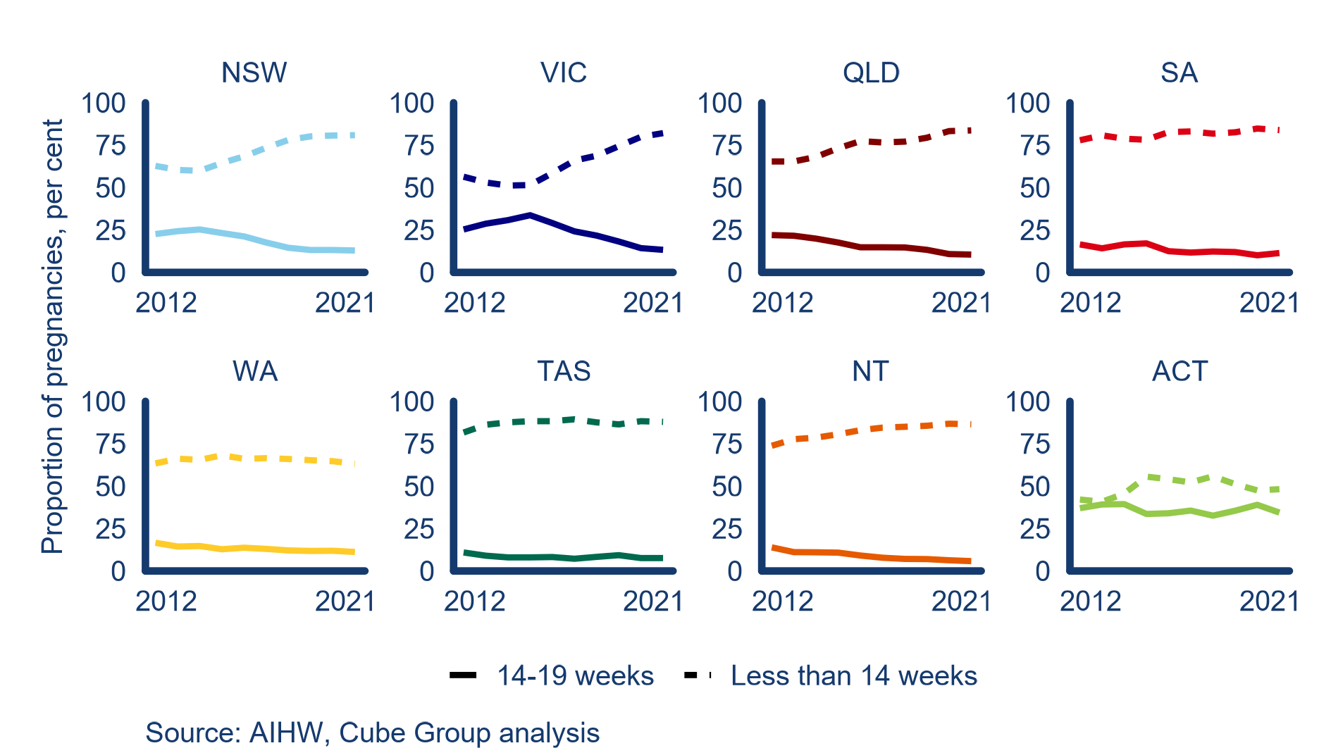

Continuity of care refers to women, their partners and families receiving care from the same health professional, or a small group of health professionals from early pregnancy until after the birth of their baby. Information provided through continuity of care models is more trusted and responsive to the needs of women, their partners, and families, and delivered in a timely manner.

Women who experience continuity of care report more positive experiences during the pregnancy, birth and postnatal period. These include having a more positive experience during labour and birth; having reduced need for medical interventions; being more likely to have a vaginal birth; and being more likely to successfully breastfeed their baby. Families also experienced cost savings in this period (Sandall J, 2024).

Additionally, access to continuity of care with a known and trusted midwife is a key principle of the Australian government’s *Woman-centred care: Strategic directions for Australian maternity services.*

While women, their partners and families receiving high-quality, accessible, and culturally safe information from trusted sources through continuity of care is the gold standard, the current state of maternity care in Australia means not all consumers experience this model. This was evident from stakeholder engagement and data (Figure 10) which identified large gaps in the community’s knowledge of and access to continuity of care. The ACT is the only jurisdiction where more than 75 per cent of services provide continuity of care for at least some part of the pregnancy, birth and postnatal period.

Figure 10: Proportion of models of care, by continuity of carer and state/territory, 2023

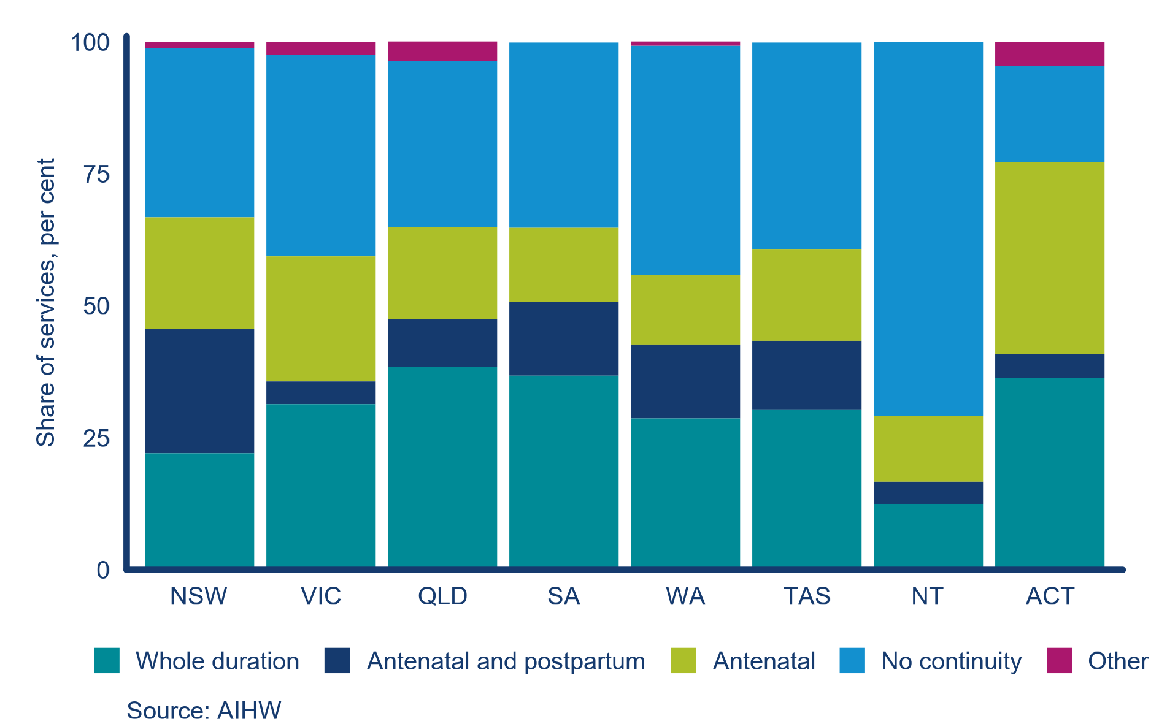

Stakeholder responses highlighted a role for PBB and other similar services to address these gaps. An assessment of the large range of services that seek to address gaps in care and advice available to Australian women is summarised in 3.2.3.

It is also important to note clinical evidence shows, where used appropriately, telehealth achieves broadly similar clinical outcomes to in-person services. However, there are many situations in which patients need to be physically examined.

### 3.2.3 The role and purpose of PBB in the existing information landscape is not clear but the service addresses important gaps

Australian parents have access to a large range of services. In addition to maternal and child health services, there are government-funded and private not-for-profit parenting helplines, video call and website services available in each jurisdiction and nationally for expecting parents, parents, families, and carers. In some jurisdictions, parents and carers have access to multiple parenting helplines, video call and websites in the age range of 0-5 years.

Stakeholder consultation confirmed duplication exists and suggested a lack of precision in relation to PBB’s purpose (information provision, education, and advice) may reduce consumers’ ability to determine trustworthy sources. Many stakeholders noted the duplicated content on website resources between Raising Children Network and PBB, stating a preference for the former due to perceptions of greater quality, inclusivity, accessibility, credibility, familiarity and user-friendliness.

While duplication exists, Table 2 shows PBB has a unique value proposition in offering women across Australia access to a telehealth service with qualified call handlers. While this is available in some states and territories, PBB is the only nationally available service.

Table 2: Summary ready reckoner of national telehealth and website information and advice service offerings

|  | PBB | Provided nationally (Inclusive of PBB) | Gap in national service offering |
| --- | --- | --- | --- |
| Key: Harvey Balls 100% with solid fill comprehensive service offered.Harvey Balls 50% with solid fill Patial service offered Harvey Balls 0% with solid fill service not offered Badge New with solid fill Service only offered by PBB nationally | | | |
| Coverage | | | |
| Tage aged range | 0-5 years | Harvey Balls 100% with solid fill |  |
| National coverage | Harvey Balls 100% with solid fill | Harvey Balls 100% with solid fill |  |
| Telehealth | | | |
| 24/7 nurse advice/referral pathway | Harvey Balls 0% with solid fill  (7am-12am) |  | Harvey Balls 100% with solid fill |
| Qualified called handlers | Harvey Balls 100% with solid fill | Badge New with solid fill |  |
| Video chat | Harvey Balls 100% with solid fill | Badge New with solid fill |  |
| Interpreter services | Harvey Balls 50% with solid fill | Harvey Balls 50% with solid fill |  |
| Text based helpline | Harvey Balls 0% with solid fill |  | Harvey Balls 100% with solid fill |
| Website/digital | | | |
| Service finder | Harvey Balls 100% with solid fill | Harvey Balls 100% with solid fill |  |
| AI symptom checker | Harvey Balls 100% with solid fill | Harvey Balls 100% with solid fill |  |
| Health information library | Harvey Balls 100% with solid fill | Harvey Balls 100% with solid fill |  |
| Health information translation | Harvey Balls 50% with solid fill | Harvey Balls 100% with solid fill |  |
| AI web chat | Harvey Balls 0% with solid fill | Harvey Balls 50% with solid fill | Harvey Balls 100% with solid fill |
| Nurse assisted webchat | Harvey Balls 0% with solid fill | Harvey Balls 50% with solid fill | Harvey Balls 100% with solid fill |
| Mobile app | Harvey Balls 0% with solid fill | Harvey Balls 50% with solid fill | Harvey Balls 100% with solid fill |
| Multi-format content (eg: video, simplified) | Harvey Balls 50% with solid fill | Harvey Balls 50% with solid fill | Harvey Balls 100% with solid fill |
| Promotion | Harvey Balls 0% with solid fill |  | Harvey Balls 100% with solid fill |

The complete ready reckoner showing all services assessed is presented in Appendix 3.

## 3.3 Effectiveness

The effectiveness review domain primarily focused on the extent of alignment of PBB with Commonwealth policy direction and the delivery of its intended objectives and outcomes.

Relevant key EVALUATION questions

KEQ 3: To what extent does PBB align with Commonwealth policy direction?

KEQ 4: To what extent are the outputs of PBB achieving intended objectives and outcomes of the service?

We sought to answer the relevant key evaluation questions through a desktop review of Commonwealth policy documents. This review led to our initial observation that PBB and Commonwealth policy directions are broadly aligned in seeking to promote women’s access to quality health information including for priority populations.

We formalised our analysis by developing a matrix setting out key themes in Commonwealth policy relevant to PBB to comprehensively answer KEQ 3. This matrix supported the observation that while PBB’s intent is broadly aligned with Commonwealth policy directions, its design limits its effectiveness in contributing to relevant policy objectives. A full summary of key Commonwealth policy documents is available in Appendix 2.

Observations from analysis of helpline and website data collection show consumers use the helpline for information and advice as well as a point of referral for other pregnancy and parenting services. We undertook further analysis of PBB outputs exploring the effectiveness across different population subgroups.

Our analysis was supplemented with insights from a range of health professionals and stakeholders informed about the experiences of parents.

Observations

While the framing and intent of PBB supports government policy directions, as currently implemented PBB falls short of its potential impact (3.3.1)

While the helpline and website differ in their level of effectiveness, both could deliver greater value with enhancements to design and promotion (3.3.2)

### 3.3.1 While the framing and intent of PBB supports government policy directions, as currently implemented PBB falls short of its potential impact

Following our desktop review, we noted evidence of congruence between PBB and Commonwealth policy. Our mapping of PBB objectives against relevant policies revealed a clear intent for PBB to strongly align with the government’s policy directions (Table 4).

At its core, PBB looks to improve the quality of information available to women and families before, during and after pregnancy. In doing so, it specifically aims to address service gaps in rural and remote areas and to meet the requirements of priority population subgroups. However, the strategic documents found in our desktop review establish broader ambitions particularly for woman-centred care that are not reflected in the PBB service. Stakeholder feedback noted:

* continuity of care and carer of choice was highlighted as the centrepiece of government policy and midwifery, but is largely absent from PBB material
* PBB — particularly the website — was not appropriately designed to meet a broad range of its audience’s needs.

The effectiveness review was assessed based on both alignment with Commonwealth policy direction and how well PBB achieves its objectives and contributes to outcomes.

A structured policy assessment matrix of the policy effectiveness of PBB (Table 3) demonstrates PBB, as currently implemented, falls short of its potential impact. The design of PBB limits its effectiveness in contributing to the objectives of relevant policies.

The matrix is structured around the four values of the *Woman-centred care strategy: Strategic directions for Australian maternity services*. These values were determined appropriate for the matrix after careful assessment of their alignment with the other relevant strategies (the National Women's Health Strategy 2020–2030 and Early Years Strategy 2024-2034). The key themes of these policies are presented in Appendix 3.

Section 3.4 describes evidence that PBB delivers value for money to the Commonwealth by supporting women, their partners, and families through its helpline. However, PBB is not effectively meeting needs in some critical areas and as currently implemented may not be clinically, culturally, or otherwise appropriate for consumers, particularly for priority populations.

Table 3: Matrix of Commonwealth policy themes

| Key | | |  | | | | | |
| --- | --- | --- | --- | --- | --- | --- | --- | --- |
| PB fully aligns with or implements the policy theme  Harvey Balls 75% with solid fillPBB largely aligns with or implements the policy theme  Harvey Balls 50% with solid fill PBB somewhat aligns with or implements the policy theme | | | Harvey Balls 25% with solid fill PBB partially aligns with or implements the policy theme  Harvey Balls 0% with solid fill PBB does not align with or implement the policy theme | | | | | |
| Theme | Reference | Intent | | | Effect | | Observation | | |
| Respect  Women are treated with dignity and respect throughout maternity care. | Chronic conditions and preventive health (Women’s health strategy).  Empower parents, caregivers and families (Early-years strategy). | Harvey Balls 50% with solid fill | | Harvey Balls 25% with solid fill | | PBB has not been designed around current strategic priorities including woman-centred design and continuity of care. | |
| Access  Women have access to appropriate maternity care where they choose. | Maternal, sexual and reproductive health (Women’s health strategy).  Support and work with communities (Early-years strategy). | Harvey Balls 75% with solid fill | | Harvey Balls 25% with solid fill | | PBB aims to provide a level of care in underserviced regions of Australia as well as direct women to suitable local services.  However, women in regional and rural Australia access PBB less than those in some major cities.  PBB’s online referral ability is limited by the NHSD. | |
| Safety  Women have access to individualised, culturally safe and responsive maternity care, in their preferred language. | Health impacts of violence against women and girls (Women’s health strategy). | Harvey Balls 75% with solid fill | | Harvey Balls 25% with solid fill | | PBB aims to support a range of priority populations.  However, service data and stakeholder feedback indicate PBB, as currently implemented, could potentially be unsafe for priority populations. | |
| Choice  Women are supported to make informed decisions and choices about their care. | Maternal, sexual and reproductive health (Women’s health strategy).  Choice (Woman-centred care strategy).  Empower parents, caregivers and families (Early-years strategy). | Harvey Balls 100% with solid fill | | Harvey Balls 25% with solid fill | | Providing information to women to support their decision making is the principal aim of PBB.  However, stakeholder feedback indicates information may not be clinically, culturally or otherwise appropriate. | |

### 3.3.2 The helpline and website differ in their level of effectiveness, but both could deliver greater value with enhancements to design and promotion

#### Analysis of the helpline

Around 220,000 calls were made to PBB between October 2018 and January 2024 from around 93,000 unique callers — an average of around 40,000 calls per annum (Figure 11). The rate of calls per one thousand births has been increasing since 2015. 98 percent of callers made fewer than 10 calls to the helpline (95 percent making fewer than 5 calls and 3 percent making between 5 and 10 calls).

Figure 11: Monthly calls and calls per birth to PBB helpline, 2011 to 2023

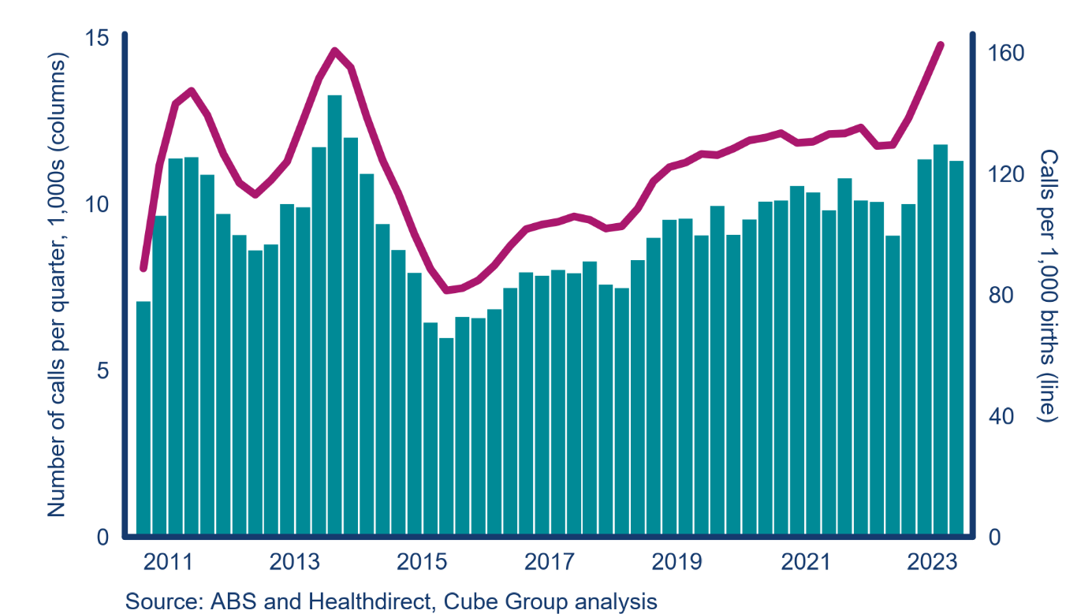

Most calls relate to the antenatal and postnatal period (Figure 12) which has been increasing over time. The share of calls not related to a specific stage of pregnancy (i.e. Other) increased during COVID-19, notably in the June quarter 2020 and early 2021. The number of calls in this category has declined post-pandemic.

Figure 12: Call category (stage of pregnancy or other) of calls to PBB, 2019 to 2023

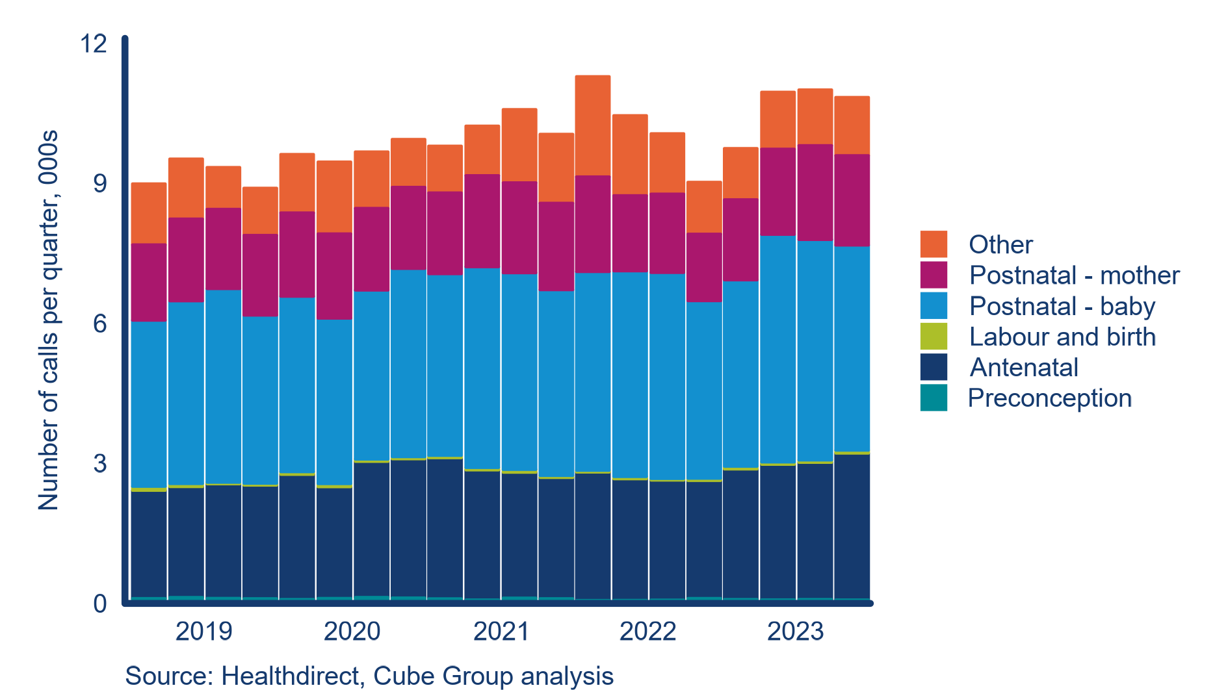

During the postnatal period, most calls relate to either the mother in the first six weeks, or to the baby in the first six weeks up to 12 months (Figure 13), with the share of calls related to the baby increasing over time. The share of calls related to toddlers (13 months to 3 years) reflect seasonality with more calls during the winter months. Fewer than 1 per cent of calls in any quarter relate to children over 3 (preschooler).

Figure 13: Age of child for postnatal calls, 2019 to 2023

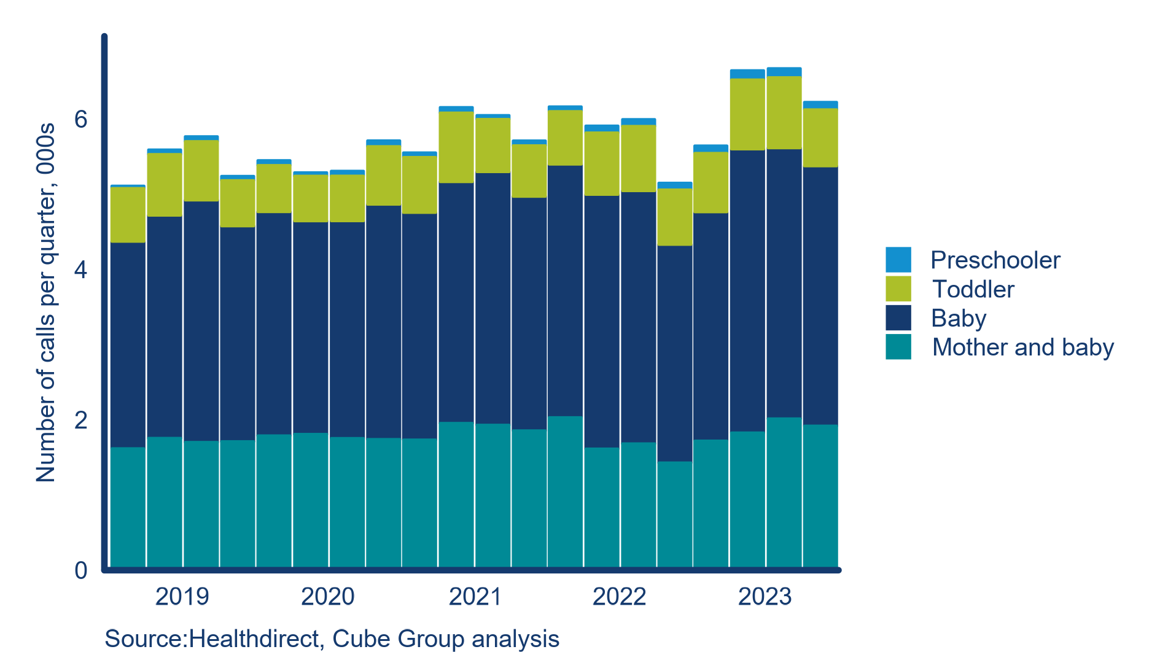

PBB call handlers either resolve caller queries themselves or refer them to other parenting and related services (Figure 14). In 2023, call handlers resolved around 65 per cent of calls.[2]

Figure 14: Outcomes of calls (including referral destination) to PBB helpline, 2018 to 2023

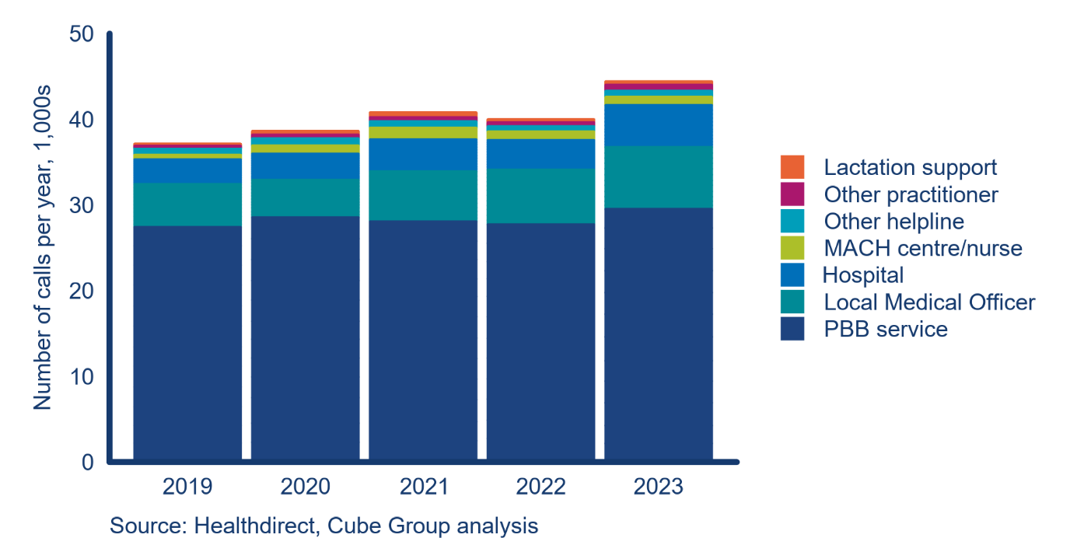

Resolved calls generally relate to minor illnesses and injuries. For calls PBB cannot appropriately manage, callers are referred to a follow-up service (around 30 different services in 2018-2023). These services include local GPs or maternal and child health centres or nurses, other medical practitioners (e.g. obstetricians, paediatricians, pharmacists) or other helplines (e.g. specialist services for pregnancy loss, mental health). The service landscape reflects the complex health and non-health needs of women during the antenatal and postnatal periods. However, calls being referred to multiple and different services for similar issues suggests there may be an opportunity to streamline referral pathways.

Evidence found disparities in the effectiveness of the helpline across different populations, despite many users of the helpline service indicating it met their needs. Stakeholders corroborated these differences, with roundtable participants noting significant concerns about some of the advice and information provided on the website as well as through the helpline.

Consumers and health professional stakeholders highlighted there was low awareness about PBB. Though mostly focused on website content, stakeholder feedback indicated PBB material was not sufficiently inclusive of midwifery perspectives. This may contribute to health professionals being less likely to refer users to PBB due to concern about the appropriateness of its content.

Stakeholders identified a range of opportunities to improve PBB’s effectiveness through promotion and redesigning content with the audience’s needs and preferences in mind, including:

* introduction of options to enable consumers to receive a more personalised service, through registering their preferences, potentially via an app
* establishment of a lived experience reference group of relevant consumers and health professionals to co-design and review information to ensure it meets the needs of a diverse range of consumers
* ensuring the currency, safety and consistency of information to support PBB being a trusted source of Commonwealth-funded information during pregnancy, birth and parenting.

Our analysis of user experience data, compiled by Fiftyfive5 on a biannual basis, demonstrates strong levels of user satisfaction with the helpline. Figure 15 shows that since April 2020, 97 per cent of surveyed helpline users indicated positive experiences with the service. 77 per cent of users were very satisfied with the helpline.

However, in the most recent reporting period (July – December 2023), overall satisfaction levels dropped below the minimum service standard of 95 per cent. In October 2023, 60 per cent of users reported being very satisfied and 30 per cent satisfied. In particular:

* calls about older infants and first-time callers were less likely to be rated “very satisfied”
* caller confidence in management of the health issue in October 2023 was at its lowest level since 2021 (70 per cent).

Figure 15: PBB user satisfaction with service, users survey from 2020 to now

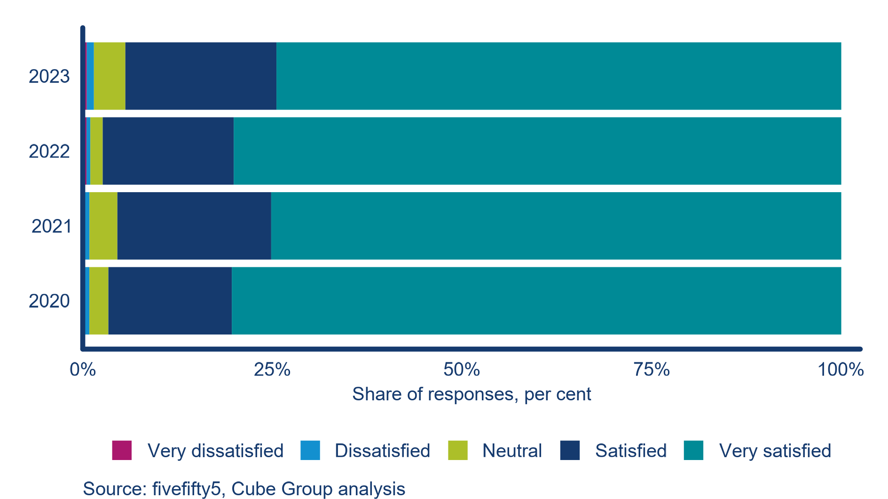

Fiftyfive5 identified key drivers for reduced satisfaction levels that all relate to the MACH nurse call handlers, including the call handlers’ ability to understand the caller’s question, their ability to answer that question, and trustworthiness of the information provided.

This analysis suggests that while the helpline is a highly effective service, quality drivers related to the MACH nurse call handlers are falling. All six helpline complaints recorded between January and July 2023 were related to the call handler’s tone of voice or advice. This accords with feedback from peak body stakeholders which emphasised the importance of appropriately qualified, trained and skilled call handlers to ensure a safe and valuable experience for users. Stakeholders further emphasised the importance of midwife call handlers, who are better placed than MACH nurses to provide support to callers in the antenatal to postnatal periods.

#### Website analytics

Website data from 2014 to 2024 were analysed to understand the value of the website (Figure 16 and Figure 17). Initially the PBB website generated low volumes of traffic, with around 100,000 views per month in 2014. The quality of these views, measured by the bounce rate (the percentage of visitors that leave a webpage without taking an action), was at a level considered positive by industry standards (lower than 40 per cent).

Figure 16: Website page views and bounce rate over time

Figure 16 is a graph depicting the page views per month, including total views and top 30 page views. The top 30 pages are the 30 pages with the most views that month. 
The graph also has a pink line indicating bounce rate.
The page views and bounce rate has been increasing since 2018.


The volume of website views increased in 2015 and 2016, coinciding with the introduction of a range of online tools, including a due date calculator and child height and weight comparators. These tools generated more than 1.5 million views in 2016 alone (more than the total views in 2014) and were associated with increased traffic to other pages.

Page views continued to grow through to 2019, with the share dedicated to online tools declining over this time. Over this period, the quality of engagement appears to have declined, with the bounce rate increasing to around 70 per cent, indicating potential problems with website design by industry standards, and content that is potentially failing to meet the needs of the user.

Total website views and bounce rates have largely remained stable from 2019 to 2024. However, the share of views the top 30 pages has generated has fallen and the composition of these views has changed over this period.

Combined, these patterns suggest Australian parents and practitioners are getting less information from the website now than at any point since 2016 when promotion ceased.

Website views can be grouped pages into five categories:

1. PBB **homepage**
2. **information** about pregnancy, birth and babies
3. interactive **webtool**
4. **navigation** such as the search and A to Z index
5. about PBB.

Figure 17 shows data for the first three categories, with the final two omitted to aid legibility. From 2019, the number of views of information and online tool pages has decreased year on year and are now at around half of their peaks. At the same time, the number of visits to the homepage has increased. This could potentially indicate that for consumers accessing the PBB website, their engagement is relatively limited. This could be due to inadequate website design, poor user experience and content that is not culturally or clinically safe, or otherwise meeting user needs.

Figure 17: Composition of pages viewed over time (based on monthly top 30 counts)

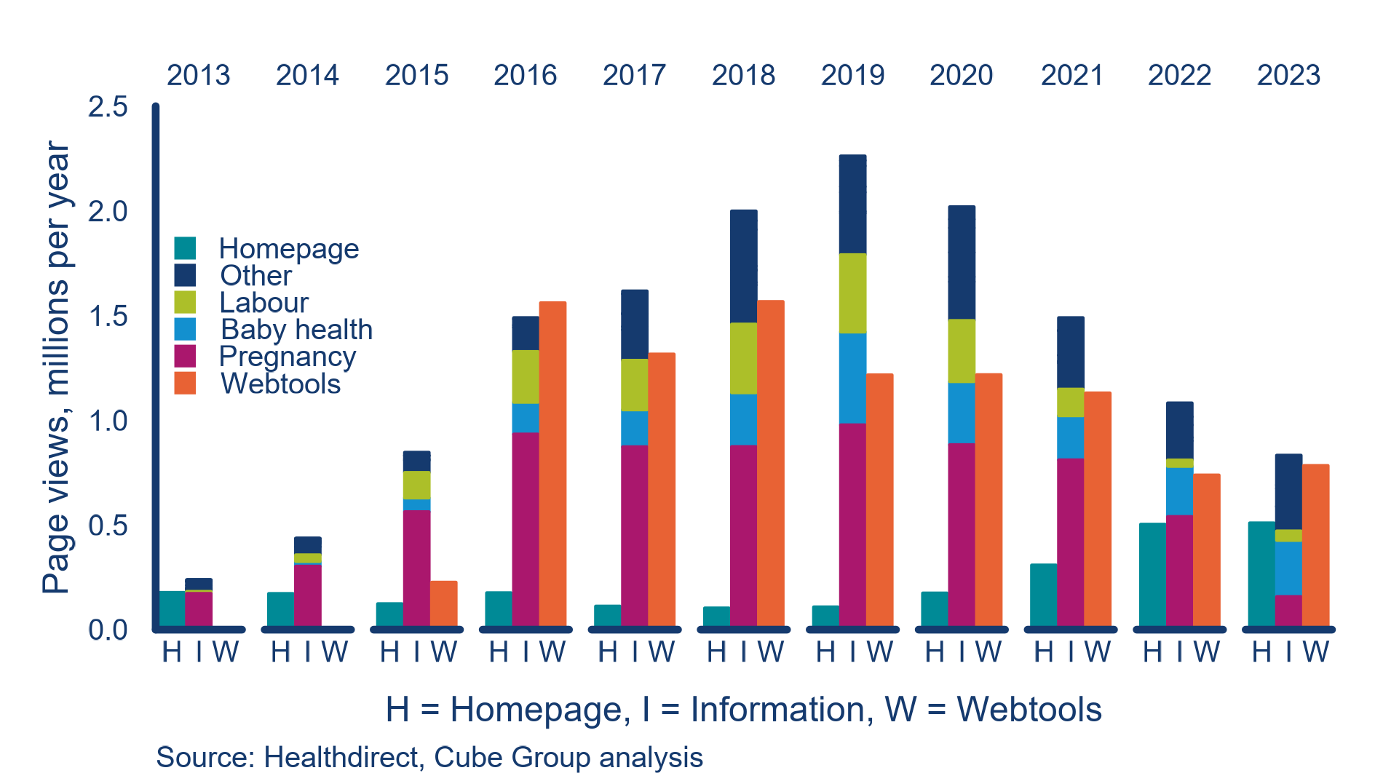

Furthermore, while it is difficult to measure how well informed prospective and new parents are, some indicators from the National Perinatal Data Collection demonstrate how certain knowledge and behaviours change over time.

Looking at two indicators (duration of pregnancy at the first antenatal visit and smoking status) there is generally a positive trend. More women are attending antenatal services prior to 14 weeks (Figure 9) and fewer smoke during pregnancy (Figure 18). We are not suggesting these improvements are due to PBB. Establishing a meaningful level of causality between the service and any measures of outcomes is not likely to be possible. However, these trends indicate that efforts to improve antenatal health are working and there is scope for further improvements including more information provision. For example, there is evidence that knowledge and behaviour vary across jurisdictions, and women in some jurisdictions appear more likely to be receiving information that is changing behaviour.

Figure 18: Smoking status of women over term of pregnancy

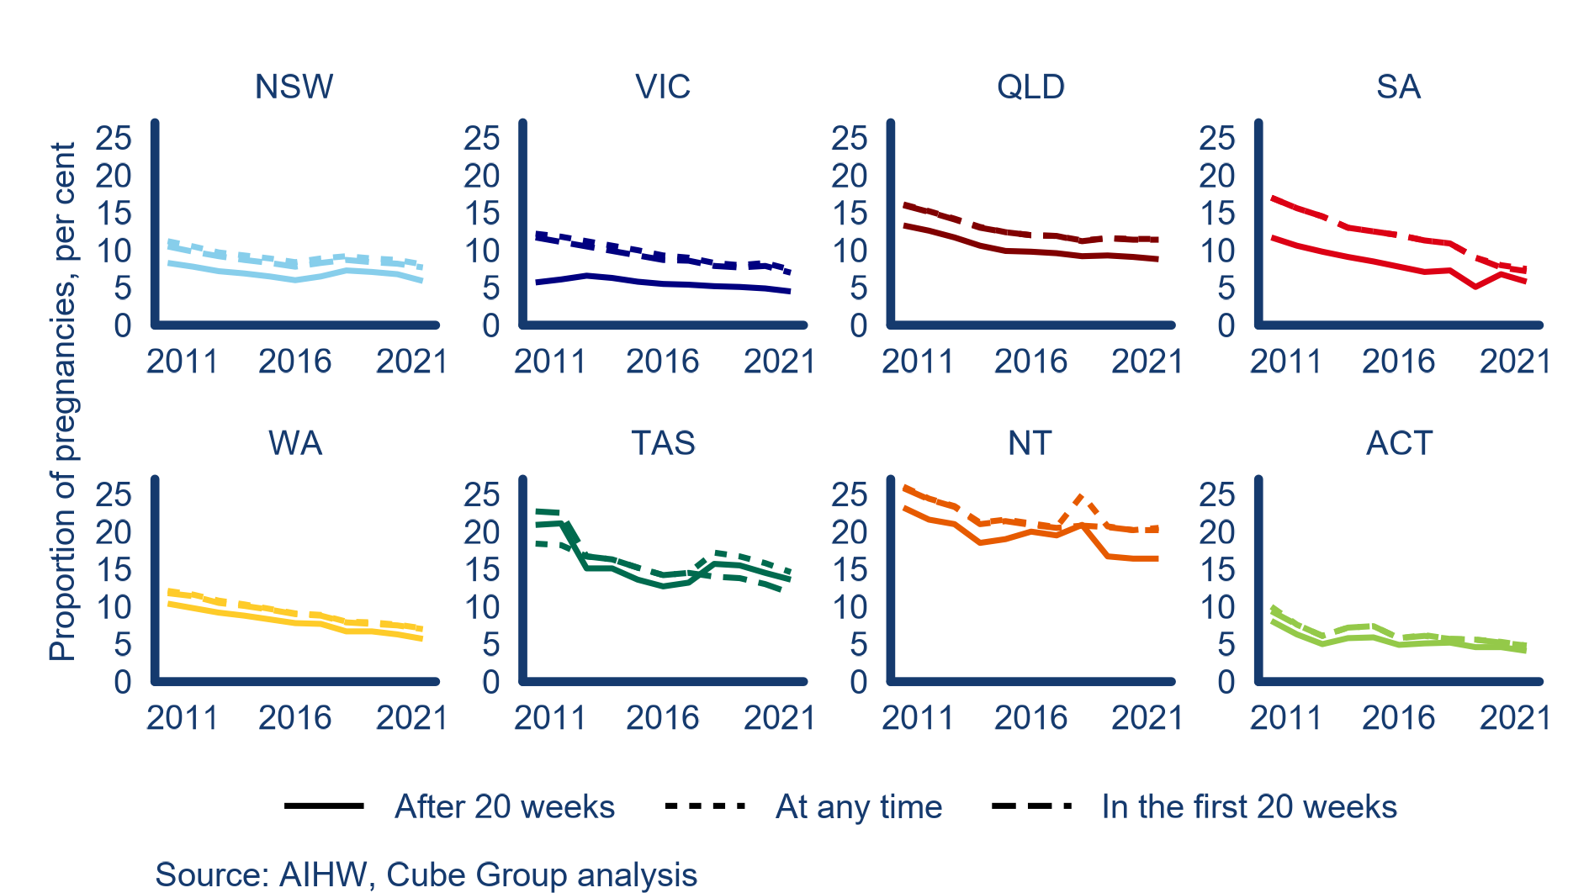

## 3.4 Equity

The equity domain sought to understand how equitably the benefits of PBB have been distributed.

Relevant key EVALUATION question

KEQ 5: How equitably are the benefits of PBB distributed?

A key objective of PBB is to improve equity of access to information and advice regardless of geographic location; and for population subgroups such as CALD communities, women with a disability, women and parents in rural and remote areas, Aboriginal and Torres Strait Islander peoples, and teenage mothers.

Our analysis explored data on Aboriginal and Torres Strait Islander peoples, CALD communities, teenage mothers and Australians living in regional and remote areas. We concluded culturally and linguistically diverse and Aboriginal and Torres Strait Islander populations, as well as teenage mothers, are underrepresented in their use of the PBB helpline.

Stakeholder consultation enabled us to gather qualitative evidence in relation to:

* promotion and marketing
* usage of the services by priority populations not identified in quantitative data
* outcomes of service usage for priority populations
* reasons priority populations use (or do not use) PBB.

Observations

PBB is not achieving its goal of supporting priority populations (3.4.1)

Promotion of PBB does not effectively target priority populations (3.4.2)

Meeting the needs of priority populations requires content to be designed with them in mind, reflecting consumer participation and empowerment (3.4.3)

### 3.4.1 PBB is not achieving its goal of supporting priority populations

Meeting the needs of Aboriginal and Torres Strait Islander peoples and CALD populations has been a focus of PBB since its inception. Since 2018, the service objectives of PBB seek to better serve these populations. Despite this, Aboriginal and Torres Strait Islander peoples and CALD people make up 3.8 and 23 per cent of the population but around 2 and 12 per cent (respectively) of calls to PBB in 2023 (Figure 19).

Figure 19: Comparison of call and population shares for select priority populations, 2023

Figure 19 includes 2 icon arrays showing proportion of calls to PBB from people in priority populations compared with their general population share. In both arrays, dark blue symbols represent culturally and linguistically diverse callers, green symbols represent First Nations callers and grey symbols represent other.
The first icon array is 100 telephone symbols showing calls to PBB, and the second array is 100 traditional 'female person' symbols to represent the Australian population. They are coloured based on respective priority population statistics as described in the report.

Usage of the service among these priority populations has consistently been below their Australian population representation and for CALD communities, has been declining since 2020 (Figure 20).

Figure 20: Share of callers identifying as Aboriginal and/or Torres Strait Islander peoples or people from a CALD background

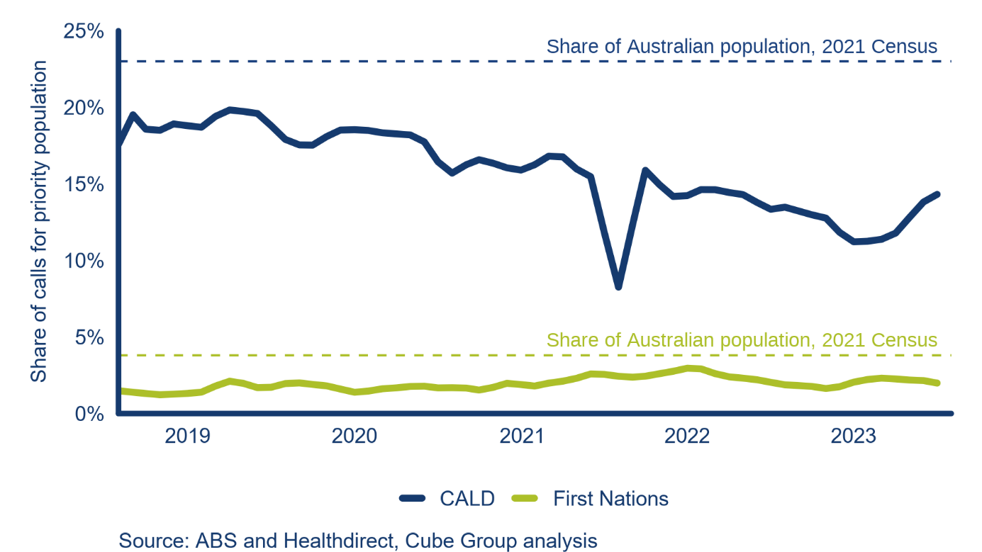

Callers who identify as Aboriginal and/or Torres Strait Islander or as CALD are less likely to make repeat use of the service (Figure 21). Our analysis (Fig 21) of the share of callers identifying as Aboriginal and/or Torres Strait Islander indicates a reluctance of this group to self‑identify.

Figure 21: Repeat call patterns by population subgroup

Figure 21 shows three column charts that indicate how often people repeatedly use the PBB service. From top to bottom, each graph represents culturally and linguistically diverse people, First Nations peoples, and all other callers. 
Very few culturally and linguistically diverse people call more than 19 times.
Very few First Nations peoples call more than 9 times. 
People in the 'other' graph consistently call more often. Some people use the service up to 60 times, and consistent groups of people use the service up to 33 times. 

Additionally, PBB appears to be less effective at reaching teenage mothers. Calls from this subgroup make up less than 2 per cent of calls to PBB (Figure 22), around a percentage point lower than their share of births.

Figure 22: Age distribution of women for calls and births

Figure 22 is a stacked bar graph showing age distribution of people giving birth, compared with age distribution of PBB callers for 2018 to 2021. 
The graph shows that callers under the age of 20 and between 35 and 39 are underrepresented compared to the actual population. 
Callers aged 25 to 29 are overrepresented, and callers aged 30 to 34 and over 40 are about representative.

Our analysis indicates that when callers from CALD, Aboriginal and Torres Strait Islander peoples and other priority populations do access the helpline, they generally receive less effective support. Figure 23 shows the proportion of calls to the helpline the MACH nurse resolved versus those referred to another service. For the general user population, PBB resolved around two-thirds of calls. For Aboriginal and Torres Strait Islander peoples, the percentage of resolved calls drops below 60 per cent, and lower still for teenage mothers. While people from CALD communities and regional and remote Australia had a higher percentage of calls resolved, they were still below the level for the ‘all other users’ group.

Figure 23: Outcomes of calls to the helpline by population group, 2023 (lowest proportion of calls resolved to the highest)

Figure 23 shows 5 pie charts showing proportion of resolved calls versus referred calls. 
They are displayed in order of least resolved calls on the left to most resolved on the right. 
From left to right, the categories are teenage mothers, First Nations, regional and remote, culturally and linguistically diverse and finally all other users. 

These outcomes are reflected in repeat call patterns, with Aboriginal and Torres Strait Islander peoples, teenage mothers, people from CALD communities and regional and remote Australians less likely to make repeat use of the helpline (Figure 24).

Figure 24: Repeat caller patterns by population group (lowest proportion of repeat calls to highest)

Figure 24 is a stacked column graph showing proportion of repeat callers from 5 priority groups. 

As described, the groups are listed from lowest rates of repeat calls to highest. These are teenage mothers, culturally and linguistically diverse, regional and remote, First Nations and all others. 

### 3.4.2 Promotion of PBB does not effectively target priority populations

Priority population peak bodies argued promotional activities and materials should be tailored to resonate with and reach these groups. Effective promotion to priority populations requires direct engagement, often through partnerships with local or specialised health professionals and services.

Due to budget constraints, Healthdirect’s ability to increase awareness of PBB through partnerships and adaptive content has been limited. Instead, Healthdirect has focused on organic and broad-brush promotion activities including social media and Infant Health Records listings in some jurisdictions.

Targeted promotion to health professionals also ceased in 2016, along with other stakeholder activity and communications.

PBB operates standalone Instagram and Facebook accounts which deliver health information to a wider audience while promoting the service. PBB has approximately 48,000 followers on Instagram and 86,000 followers on Facebook (as of July 2024). Of all similar helpline and information services in Australia, PBB has the largest audience on Instagram and second largest on Facebook (Raising Children Network has 307,000 followers). PBB is prioritising efforts on Instagram due to shifts in audience reach, with this account experiencing a growth of 750 per cent since 2021.

While PBB’s social media channels reach a wide audience, its promotion effect is limited. With a small budget allocation, paid social media drives 3 per cent of traffic to the website. Organic, or non-paid, social media engagement represents a much smaller referral pathway, focusing on information provision rather than service promotion. Healthdirect notes social media and other forms of digital promotion for PBB, including podcasts, provide an avenue to target specific audiences and demographics. Paid social media campaigns appear to have been aimed at the broad group of women and parents across Australia and not priority populations.

In Australia, every newborn child is provided with an ‘Infant Health Record’ that provides information on, and a means to monitor, that child’s growth and development. These are commonly referred to by their colour (e.g., ‘blue book’ in the ACT).

Evidence suggests Infant Health Records are an effective and cost-efficient method of service promotion. However, as each jurisdiction determines their design and content, and the listing of a service in the book is up to jurisdictional discretion, PBB is unable to leverage them to target priority populations or the broader parent demographic.

Figure 25: Calls to the PBB helpline per 10 births, by state and territory.

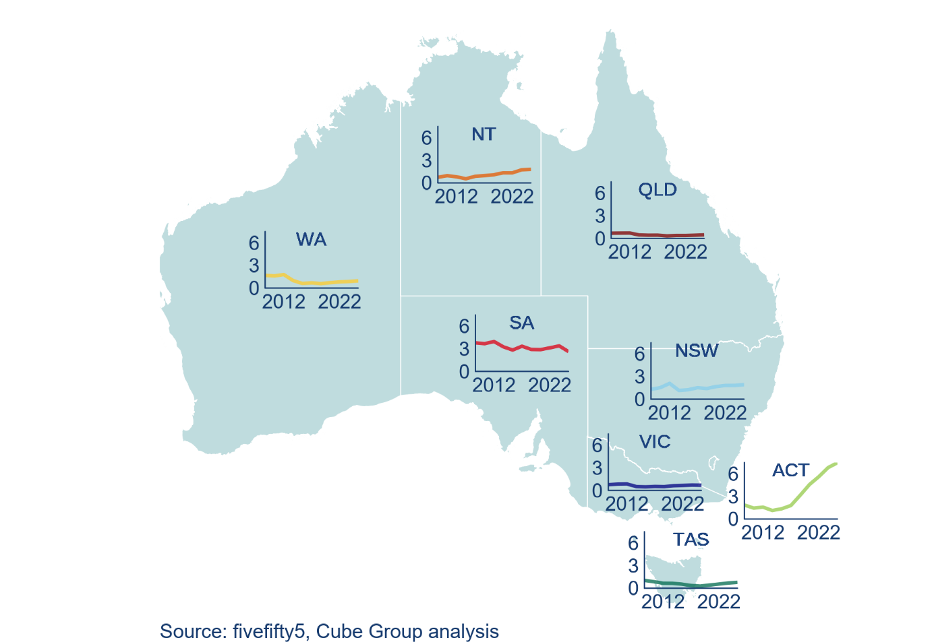

PBB is listed as a relevant service and information source in two of the eight books — ACT and South Australia (SA). Healthdirect identifies this as a significant promotion mechanism informing women and parents of the service. Data supports this, with consumers from these two jurisdictions accessing the PBB helpline more than any other state or territory on a per birth basis (Figure 25). Infant Health Records provided in other states and territories list other parent and maternal health helplines, such as those included in Appendix 3, rather than PBB.

Service usage by region (SA4) is broadly consistent across much of Australia with most populations making fewer than one call per ten births over the 2019 to 2022 period (Figure 26). Service usage in rural and remote areas is generally at this level, though populations in rural and regional areas of South Australia recorded usage of between two to three calls per ten births. However, use of the service by these South Australian populations has declined over time (Figure 27).

Two SA4 regions, the Australian Capital Territory and Sydney – Outer South-West make more than five calls per ten births and the former has seen the largest increase in use over 2019 to 2022. The proportion of the Sydney – Outer South-West population that identifies as Aboriginal and/or Torres Strait Islander or speaks a language other than English at home is marginally higher than the national average. For the ACT, the higher-than-average call rate may be linked to the promotion of PBB on the back of the ACT ‘Blue Book’ as noted above.

Figure 26: Calls to PBB helpline per 10 births by SA4, 2019 to 2022

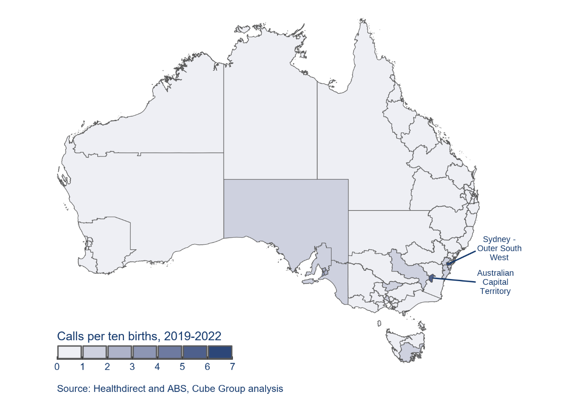

Figure 27: Change in calls to PBB helpline per 10 births by SA4, 2019 to 2022

Figure 27 is a map of Australia divided by level 4 statistical area. This map shows a change in PBB usage over time. 
Usage has increased the most in the Australian Capital Territory, Sydney Ryde and Sydney Inner West.
Usage has decreased the most in South Australia, particularly in Adelaide and the Barossa region. Another area with more significant decrease is Far West and Orana in North West New South Wales. 

### 3.4.3 Meeting the needs of priority populations requires content to be designed with them in mind, reflecting consumer participation and empowerment

Understanding the needs of priority populations and their reasons for using (or not using) PBB was a focus of our stakeholder consultations. Our questions focused on seeking additional insights in relation to this important domain, particularly for populations not captured in the data (e.g., LGBTQIA+, people with a disability).

Stakeholder feedback indicated PBB material reflected cultural assumptions about what is appropriate advice during pregnancy, largely from a mainstream western, heteronormative perspective (e.g., in relation to healthy eating, weight gain, skin colour, gender and family structures etc.). These issues likely contribute to priority populations being less likely to use PBB, generally being less well-served when they do, and less satisfied (Figure 28).

Stakeholders identified a range of opportunities to improve PBB’s ability to meet the needs of priority populations, including:

* ensuring information and advice adopts inclusive language and imagery to support representation and cultural safety
* recognising the intersectionality of priority populations
* adopting plain English with enhanced emphasis on multimedia content such as infographics and videos to support broader interpretations of health information and advice (for web content and social media posts)
* establishing a lived experience reference group of consumers and health professionals to co-design and review information to ensure it meets the needs of consumers
* providing translation (including for helpline callers) and personalisation of online materials to support accessibility
* building and maintaining on-the-ground partnerships with local community and health organisations to increase reach among priority populations.

Figure 28: PBB user satisfaction by population subgroup

Figure 28 is a stacked bar graph showing satisfaction levels for First Nations and culturally and linguistically diverse people compared to other users. 
Culturally and linguistically diverse people are the most likely to be 'satisfied', and First Nations peoples are most likely to be 'neutral' or 'dissatisfied'.
People in the other category are the most likely to be very satisfied. 

The PBB website is designed for the user to navigate to content based on their stage in pregnancy through to parenting, rather than based on the demographic or consumer type. There are other websites that offer customised resources, imagery and language tailored to the user type that could inform the future design of the PBB website. For example, the Grow & Go Toolbox (a website with resources on food and nutrition for children under 5 years) has a link on its homepage to customised resources for health professionals, parents and families, early childhood educators, Aboriginal and Torres Strait Islander peoples and multicultural resources.

## 3.5 Economy

The economy domain sought to understand how appropriate and efficient PBB inputs are, to produce a value for money assessment of PBB.

Relevant key EVALUATION question

KEQ 6: Are the program inputs (cost and quantity) appropriate and efficient?

Our analysis of this domain included reviewing previous examinations of the value for money of the service, as well as the value of avoided costs resulting from PBB resolving parents’ queries.

We then adapted the Productivity Commission’s methodology to estimate the monetary value of the PBB helpline to government and consumers.

Observations

In 2023, the PBB helpline saved governments more than $3.3 million and consumers more than $700,000 (3.4.1)

Women and parents in regional and remote Australia are among the groups with the most to gain from PBB (3.4.2)

### 3.5.1 In 2023, the helpline saved governments more than $3.3 million and consumers more than $700,000

Previous value for money assessments of PBB noted some evidence the services may effectively handle calls that would otherwise result in more expensive presentations.

The Productivity Commission recently estimated telehealth in Australia saves consumers around $895 million annually. This value is based on the Commission’s estimate of the time saved by not attending an in-person appointment (around 65 minutes including travel and waiting time), the number of telehealth consultations provided, and the proportion of those consultations that would have otherwise resulted in an in-person presentation.

We adapted this methodology to estimate the value for money PBB generates.

PBB user surveys indicate around 31 per cent of callers in 2023 would have used a GP and 30 per cent would have gone to an emergency department if PBB had not been available. Applying these shares to the number of calls PBB call handlers resolved (as opposed to referred to other services), we estimate PBB saved consumers around $370,000 in avoided GP presentations and $360,000 in avoided emergency department presentations in 2023.

The savings to consumers may have been higher than these estimates for a range of reasons:

* the Commission assumed between 70 and 90 per cent of telehealth calls resulted in an avoided in-person presentation. If we used the Commission’s 90 per cent, PBB would have saved consumers more than $1 million in 2023.
* the Productivity Commission’s estimate of 35 minutes travel time and 30 minutes waiting time were based on a GP presentation in a major city. Adding 30 minutes to the time saved to reflect a national population and ED waiting times while maintaining the higher share of calls benefiting at 90 per cent would increase the savings to more than $1.5 million.

The Commission did not estimate the saving to governments of telehealth consultations. This is because subsidies paid to the telehealth provider generally offset the savings of avoided in-person presentations. However, there are no per call subsidies paid to PBB. Hence, we can estimate these savings to be around $380,000 for avoided GP visits and $2.9 million in avoided ED presentations.

Our estimates of savings to governments are based on data from Medicare and the Independent Health and Aged Care Pricing Authority (IHACPA) report on public sector hospital costing. For GP visits, we used the value of the Medicare Rebate Scheme amount for a standard consultation, $41.40. For ED attendances, we have used IHACPA to estimate the cost of non-admitted emergency department presentation, $324 (Independent Health and Aged Care Pricing Authority, 2024). Savings would be higher for calls that were more complex or in regional or remote Australia, depending on the extent to which a call to the PBB helpline avoided a GP or ED attendance. Therefore, our estimates should be regarded as a lower bound estimate.

### 3.5.2 Women and parents in regional and remote Australia are among the groups with the most to gain from PBB

Consultation with peak bodies, including from the National Rural Health Alliance and CRANAplus, highlighted how rural and remote women may especially benefit from PBB acting as a safety net due to the lack of reliable and accessible healthcare and resources in these settings (Hennegan, Kruske, & Redshaw, 2014).

There is currently a marked shortage of antenatal and postnatal care in regional Australia, which has worsened following the gradual closures of rural and remote birthing services (Bradow, Smith, & Davis, 2021). This results in women having to travel much further to access maternal health care, which brings significant logistical, financial and sociocultural challenges (Hoang, Le, & Terry, 2014).

There may be additional adverse health risks associated with a lack of local access to midwives (or similar maternity care providers). One stakeholder noted not all maternity care is provided by qualified and experienced maternity care providers in rural and remote settings. Other health professionals (Aboriginal Health Workers and Practitioners, registered nurses, remote area nurses, general practitioners) with limited or no maternal health experience generally provide care in the peripartum period. Furthermore, stakeholders described gaps in continuity of care being particularly wide in rural and remote settings.

There is a significant body of literature which emphasises the important role telehealth services play in addressing health care gaps in rural and remote Australia (Bradford, Caffery, & Smith, 2016; Moffatt & Eley, 2010). Stakeholder consultation suggested PBB, if designed appropriately to cater to the unique needs of these consumers, can offer great value in providing reliable and accessible information for women.

While PBB service satisfaction data for rural and remote users is unavailable, inner regional users tend to report lower levels of satisfaction than users in major cities (fiftyfive5, 2023). Understanding how to improve the experience of rural and remote users and enhance the appropriateness of the service for this cohort hence presents an important opportunity for PBB.

## 3.6 Efficiency

The efficiency domain considered the efficiency of PBB program-level outputs. This considers alternative delivery models to determine if the current service provides value for money for Commonwealth funding.

Relevant key EVALUATION question

KEQ 7: Are the delivery of program outputs efficient?

Our exploration of this domain benchmarked the output of PBB calls to other Healthdirect-delivered call centres, including HIAS.

PBB has delivered between 40,000 and 50,000 calls per year since 2019 at roughly a cost of $85 per call[3]. This is within the range of per call costs at similar services with:

* a call to the healthdirect helpline costing $45
* a call to the healthdirect After Hours GP service costing $130.

The relative costs of these services largely reflect the costs of staff employed to deliver them combined with the operating hours.

To comprehensively address this review domain, we intended to undertake a more complete assessment of all suitable cost items against their benchmark. However, the data required for this task was not available. Instead, we identified a range of options for delivering PBB’s outputs based on comparisons with other service providers and stakeholder engagement.

Observations

Comparable services provide examples of more efficient models of operation (3.5.1)

### 3.6.1 Comparable services provide examples of more efficient models of operation

We used the ready reckoner – developed to identify duplication and gaps in the service offerings Australia (see section 3.2.1) – to help identify options to improve either the effectiveness or efficiency of PBB operations. The complete ready reckoner with our assessment of the range of services compared is included in Appendix 3. A summary of some of our observations based on the tool and further analysis is presented below.

#### Hours of operation

We had intended to analyse data on staffing at various times to identify whether there were other options to improve rostering of staff to serve more users. While these data weren’t available, our ready reckoner provides some evidence that reducing operating hours might be appropriate.

PBB is unique among pregnancy, birth and baby related helplines in operating before 8am and after 8pm, with some alternative services operating for fewer than eight hours a day. PBB operates from 7am to midnight. Other comparable services operate from 9 to 4:30 pm (ForWhen) and up to 24 hours (HIAS). An analysis of calls per hour (Figure 29) suggest increasing the hours of operation would likely increase costs without a commensurate increase in benefits. Conversely, there may be merit in reducing the hours of operation noting the volume of calls before 8am and after 10pm is considerably lower than for other hours.

Figure 29:Average calls to PBB helpline by hour and weekday/weekend, 2019 to 2023

Figure 29 is a bar graph showing calls per hour on weekdays and weekends.
The graph shows that the most popular times to call on both weekdays and weekends are the early evening from 5 to 7pm.

However, despite fewer operating hours, many state-based services handle more calls per person than PBB does for the same population. Ngala in Western Australia (operating 9 am to 5 pm) handles nearly ten times as many calls per person as PBB.

#### Text-based services

The ready-reckoner includes a text-based helpline as a best-practice feature. This service would make the helpline more inclusive, and available to a broader range of users, such as those with hearing loss, those who experience psychological or intellectual barriers to talking on the phone, or those who simply prefer text-based communication.

Text-based services in the pregnancy, birth and baby space are limited in Australia, with ABA being the only identified service to offer this. However, it was referenced several times throughout our stakeholder consultations as a consumer-centric feature and there are international examples which could be drawn on to inform design.

#### Regional free call back service

Women in regional and remote Australia are those most likely to benefit from a service like PBB. Not only are they less likely to have access to quality local services, the amount of time they would save in avoiding in-person services (where available) is likely to be greater. Currently, calls from landlines to the PBB helpline are free, however, mobile charges may apply.

While increased promotion is likely to be a key enabler in encouraging more women in regional and remote Australia to use PBB, the introduction of a dedicated free mobile call back service for regional and remote areas might help. A dedicated free call number for regional consumers is a feature of the Ngala helpline in Western Australia. This feature helps to both emphasise that the service caters for rural and remote consumers and increase accessibility.

#### Enhanced integration with local services

In its 2024 research report on telehealth, the Productivity Commission identified innovative Aboriginal Community Controlled Health Organisations (ACCHO) telehealth-based models, which help them deliver culturally appropriate healthcare. Stakeholders suggested this model of care could be an effective way for consumers to receive culturally appropriate care from PBB’s MACH nurses.

This model involves an Aboriginal Health Worker and Practitioner supporting the person at their local ACCHO clinic, while consulting with another clinician via telehealth.

With the support of an Aboriginal Health Worker and Practitioner, this model of care can lead to better communication and information sharing between consumers and telehealth clinicians. Local workers bring knowledge of the consumer’s context and personal circumstances and can help ensure consumers fully understand any advice and its implications. Another benefit of this model of care is that it allows Aboriginal and Torres Strait Islander peoples to stay in their local community (Productivity Commission, 2024). There is opportunity to also apply this model to CALD and regional communities, whereby a dedicated worker can help provide linkages between local services and PBB.

# 4. Options for consideration

This review has established the ongoing need for services to support women, their partners, and families through the preconception to postnatal period. The findings contained in this report detail which parts of PBB currently work well, as well as how the service could be improved in future. These findings have informed the below options for consideration, which, if implemented, would enhance PBB to deliver outcomes more appropriately, effectively, equitably, economically, and efficiently. Additional resourcing will likely be required to improve the alignment of PBB with government health policy directions, and to enable PBB to deliver the service enhancements. The additional resources required will depend on the chosen features and their implementation approach.

The options assume Healthdirect would remain the service provider for PBB.

| Options for consideration | | |
| --- | --- | --- |
| 1. | | The scope of PBB should be narrowed to focus on preconception, pregnancy, and the postnatal period. |
| Evidence: | | * There is a need for high quality information during preconception, pregnancy and the postnatal period, and there is currently is a gap in comprehensive services for this period (3.2.1) * There is significant duplication in the parenting supports (especially post the age of 1) provided by the Commonwealth and states and territories. (3.2.3) * Stakeholder consultation suggested a lack of precision in relation to PBB’s purpose and scope may reduce consumers’ ability to determine trusted sources. (3.2.3) * PBB has a unique value proposition in offering pregnant women and parents and carers across Australia access to a telehealth service with qualified health professionals. (3.2.3) * Helpline utilisation is greatest for queries relating to preconception, pregnancy, and babies under 1 year old. Utilisation is limited between 1-5 years. (3.3.2) |
| 2. | | The capability and composition of call handlers should reflect a trauma-informed and midwifery-led approach, while representing the populations they serve. |
| Evidence | | * The Woman-centred care strategy emphasises a midwifery-led continuity model compared to other models of care (3.3.1) * Service-level data shows recent helpline satisfaction has decreased due to falling quality drivers related to the MACH nurse call handlers. All six complaints regarding the helpline recorded between January and July 2023 were related to the call handler’s tone or advice. (3.3.2) * Feedback from stakeholders emphasised the importance of appropriately qualified, trained and skilled call handlers to ensure a safe and valuable service experience for users. (3.3.2) * The scope of practice for a MACH nurse is not appropriate to meet the needs of the 45 per cent of callers who call during pregnancy. (3.3.2) |
| 3. | | PBB should emphasise individual decision-making and empowerment to reflect principles of the government’s Woman-centred care strategy. |
| Evidence: | | * Providing information to women to support their decision-making is the principal aim of PBB. However, stakeholder feedback indicates information may not be clinically, culturally or otherwise appropriate. (3.3.1) * Stakeholders suggested PBB’s service delivery could enable consumers to receive a more personalised service, that would result in content being adapted to their needs. (3.3.2) * There is a gap in the current service landscape for text-based service delivery and other technologies which enable consumer-centric and personalised care. (3.2.3) |
| 4. | | PBB should be enhanced to inform and support women (and parents/carers) in using local services, to align with government policy directions. |
| Evidence: | | * Women’s health strategy, Woman-centred care strategy and Early-years strategy emphasise women should have access to appropriate maternity care where they choose. * Approximately 2 per cent of PBB’s budget goes towards integrating the NHSD into its website to support users to find suitable local services. However, stakeholders report there are limitations with the NHSD which means consumers experience barriers searching for local services that offer preconception, pregnancy, birth, and postnatal care. (3.3.1) * There are adverse effects for women who have limited access to maternity care in rural and remote areas (3.5.2). Building and maintaining on-the-ground partnerships with local community and health organisations can support PBB to reach this cohort. (3.6.1) |
| 5. | | PBB should support continuity of care, to align with the principles of Woman-centred care strategy. |
| Evidence: | | * Women who experience continuity of care report more positive experiences during the pregnancy, birth and postnatal period. (3.2.2) * Continuity of care from a provider of choice was highlighted as the centrepiece of government policy for maternity care, but was not promoted in PBB material (3.3.1) |
| 6. | | A monitoring and evaluation framework should be developed for PBB, to enable active monitoring of PBB and assess whether the updated service model is achieving its intended objectives. |
| Evidence: | | * While PBB’s intent is broadly aligned with Commonwealth policy directions, its design, implementation and resourcing has limited its effectiveness in contributing to service and policy objectives. (3.3.1) * Ongoing monitoring and periodic evaluation of PBB will provide evidence and insights for the impact of PBB’s service enhancements, as well as support continued optimisation of the service to meet consumer needs. |
| 7. | | All existing content should be reviewed, and new content developed through a co-design process to ensure it is intersectional, culturally safe, inclusive, accessible, trauma-informed, in plain English and uses imagery or videos where possible. |
| Evidence: | | * Stakeholder feedback indicated PBB material was overly clinical (though not necessarily accurate or applicable to diverse settings) and not inclusive of midwifery perspectives. This likely contributes to health professionals being less likely to refer users to PBB due to concern about the appropriateness of its content. (3.3.2) * Stakeholder feedback indicated PBB material was embedded in western, heteronormative and middle-class assumptions about what is appropriate advice during pregnancy. These issues likely contribute to priority populations being less likely to use PBB, generally being less well-served when they do, and less satisfied (3.4.3) * Stakeholders noted co-design with consumers was a key area where PBB could improve its accessibility and trauma-informed approach. (3.3.2). Peak bodies and the literature highlight co-design as best practice (Appendix 1) * Stakeholders observed that consumer empowerment and participation exists on a continuum, ranging from consultation and review of content to true co-design where consumers are involved in the early stages of service design (3.3.2) |
| 8. | | Promotional activities should be targeted to priority populations (including Aboriginal and Torres Strait Islander peoples, CALD, women with disability, teenage mothers and people living in rural and remote locations). |
| Evidence: | | * Due to budget constraints, Healthdirect has been limited in its ability to increase awareness and uptake of PBB through partnerships and adaptive content, especially among priority populations (3.4.2) * Consultation with peak bodies representing priority populations as well as health professionals identified that promotional activities and materials must be tailored to resonate with and reach these groups. (3.4.2) |
| 9. | | Improved service awareness and quality should be appropriately resourced to ensure greater helpline utilisation across jurisdictions and populations, delivering benefits for those who need it the most. |
| Evidence: | | * Analysis indicates many users of the helpline service found it met their needs — with call handlers resolving around 65 per cent of calls and a 97 per cent satisfaction rate since 2020. (3.3.2) * Estimates indicate PBB, in its current form, delivers annual savings to governments of more than $3.3 million and consumers more than $700,000 (3.5.1). Increased utilisation should deliver increased efficiencies. * Despite indicators of effectiveness, consumers and health professional stakeholders highlighted there was low awareness of PBB generally. (3.3.2) * Women and parents in regional and remote areas are among the groups with the most to gain from using PBB, but this is not reflected in helpline utilisation. There is underrepresentation of particular populations and jurisdictions, especially among Aboriginal and Torres Strait Islander peoples and CALD communities. (3.4.1) * Consultation with peak bodies highlighted how PBB could provide a safety net for women living in rural and remote locations, given the lack of consistently reliable and accessible healthcare and resources in these settings. (3.5.2) |
| 10. | | The Healthdirect brand, assets, operating model and capabilities should be leveraged to improve PBB’s value for money and service delivery efficiency. |
| Evidence | | * PBB operates as a standalone service and is not immediately perceived as part of the Healthdirect ecosystem from a consumer perspective. With its own website, branding, and phone number, it does not leverage the brand or credibility of Healthdirect. The PBB website has no direct or clear linkages with Healthdirect’s website or social media channels. (3.4.2) |
| 11. | | Healthdirect should improve the content and design of PBB, to ensure it is fit-for-purpose, user-centric, and effectively leverages information partners and other government funded information services to remove duplication and improve integration. |
| Evidence: | | * Many stakeholders noted the duplicated content on website resources between the Raising Children Network and PBB, stating a preference for the former due to perceptions of greater quality, inclusivity, accessibility, credibility, familiarity and user-friendliness. (3.3.3) * Stakeholders noted potential for integration between the Raising Children Network and PBB websites, with the scope of both websites being clearer and complementary, and consistent links between the two websites. (3.3.3) |
|  | * The PBB website has been designed to be navigated and tailored based on the consumer’s stage in pregnancy through to parenting, rather than demographic or consumer type. There are other websites that offer customised resources, imagery and language tailored to the user type that could inform the future design of the PBB website. For example, the Grow & Go Toolbox (a website with resources on food and nutrition for children under 5 years) has a link on its homepage to customised resources for health professionals, parents and families, early childhood educators, Aboriginal and Torres Strait Islander peoples and multicultural resources. (3.4.3) |

# 5. Features

To operationalise any of the options for consideration to enhance PBB, a range of additional features would be required. These features (listed below) have been:

* differentiated and specified according to an estimated scale of cost and feasibility (low, medium and high)
* informed through a combination of review findings, stakeholder and departmental input
* grouped by category, with any dependencies highlighted.

Framing the specifications around features will enable the department to request a proposal and costings from Healthdirect to support potential implementation of service enhancements in future.

Where possible, Healthdirect should cost features individually, rather than as a packaged group. This will enable comparison between different compositions of an enhanced PBB service, before undertaking potential redesign of the service according to the preferred composition.

An indicative level of cost and feasibility are provided for each feature. A continuous bar across multiple levels indicates that cost and feasibility is dependent on scale of activity.

## 5.1 Workforce

| Feature [related option] | Cost and feasibility | | |
| --- | --- | --- | --- |
| Low | Medium | High |
| Workforce capacity [5/9] | | | |
| Increase the call handler workforce by 7 FTE to enable ~90,000 calls annually. This would support a minimum of 3 calls per 10 births in each jurisdiction and bring the number of call handlers to a total of 14 FTE. |  |  |  |
| Increase the call handler workforce by 19 FTE to enable ~150,000 calls annually. This would support a minimum of 5 calls per 10 births in each jurisdiction and bring the number of call handlers to a total of 26 FTE. |  | P |  |
| Increase the call handler workforce by 28 FTE to enable ~200,000 calls annually. This would support a minimum of 7 calls per 10 births in each jurisdiction and bring the number of call handlers to a total of 35 FTE. |  |  |  |
| Workforce composition [9] | | | |
| With re-orientation of PBB to be focused on preconception, pregnancy, birth and babies up to 1 year of age it is expected the need for dedicated midwives will need to increase. This would likely result in a workforce composition with majority midwives. To accommodate this re-orientation two compositions should be modelled, noting costs will vary for each: 60 per cent midwives and 40 per cent MACH nurses; and 70 per cent midwives and 30 per cent MACH nurses. |  |  |  |
| Wherever possible, the call handler workforce should reflect the diversity of the Australian community and include call handlers who are culturally and linguistically diverse and Aboriginal and Torres Strait Islander peoples. A high-cost component of this feature may include a decentralised or geographically dispersed workforce (see Continuity of Care features for further detail). |  |  |  |
| Workforce capability [9] | | | |
| Healthdirect should consider engaging the PBB workforce through a ‘panel of providers’ arrangement rather a single provider model, similar to HIAS. This would enable PBB to draw on different skills and meet the specific needs of different regions. |  |  |  |
| While MACH nurses and registered midwives are required to fulfil annual continuing professional development (CPD) as part of their registration requirements and Bolton Clarke conducts monthly call coaching feedback discussions, satisfaction data and stakeholders identified a need for a trauma-informed care approach. In addition to their core competencies and qualification, ongoing training should be provided to call handlers in relation to trauma-informed virtual care, and cultural awareness and safety. | 0 |  |  |
| Call handlers should be actively practicing or have recent practical experience as midwives or qualified nurses. This is important to ensure up to date knowledge and understanding of the service environment. |  | 0 |  |

## 5.2 Products

| Feature [related option] | Cost and feasibility | | |
| --- | --- | --- | --- |
| Low | Medium | High |
| App [2,5,10] | | | |
| Integrate PBB into the existing Healthdirect app and provide communications about the app’s new scope. This app should include synchronised content from the PBB website (in a mobile-friendly format) and links to the PBB helpline. A user’s Healthdirect mobile account should include an option to subscribe to relevant PBB topics depending on their needs and journey. |  |  |  |
| Develop a standalone PBB app, utilising the existing Healthdirect technology stack. The app should include PBB-specific Service Finder capabilities. The app should allow customisation for the consumer’s needs and journey, including milestone updates and reminders for vaccinations and development checks. |  |  |  |
| Text-based service delivery [2,5,10] | | | |
| Develop a chat-based service delivery tool, operated by idle call handlers. This tool should be accessible through the website and a standalone mobile application (if developed). |  |  |  |
| Develop chat-based service delivery, operated by dedicated MACH nurses and midwives (2 FTE). This tool should be accessible through the website and a standalone app (if developed). This tool should allow users to select preferences on setup, to ensure they only receive relevant resources. |  |  |  |
| Peer support groups [4] | | | |
| Include links to existing peer support groups. |  |  |  |
| Establish a peer support group on social media, for example a visible but private Facebook group. The Healthdirect communications team should moderate the group periodically to ensure it meets community guidelines. | Blue oblong shape indicating |  |  |
| Establish peer support groups or a forum-based approach through the PBB app and/or website. Users can join these by creating accounts. The Healthdirect communications team should regularly moderate the group to ensure it meets community guidelines. |  |  |  |

## 5.3 Promotion and service expansion

| Feature [related option] | Cost and feasibility | | |
| --- | --- | --- | --- |
| Low | Medium | High |
| Broad service expansion [5] | | | |
| Design and implement a communication and promotion strategy to increase broad service awareness to a target call volume for each jurisdiction of 3 calls per 10 births by region and population (~90 000 calls nationally on an annual basis). Demand-driven funding should continue to enable this. Please note: this expansion would be enabled by an increase in the call handler workforce of 7 FTE. |  |  |  |
| Design and implement a communication and promotion strategy to increase broad service awareness to a target call volume for each jurisdiction of 5 calls per 10 births by region and population (~150 000 calls nationally on an annual basis). Demand-driven funding should continue to enable this. Please note: this expansion would be enabled by an increase in the call handler workforce of 19 FTE. |  |  |  |
| Design and implement a communication and promotion strategy to increase broad service awareness to a target call volume for each jurisdiction of 7 calls per 10 births by region and population (~200 000 calls nationally on an annual basis). Demand-driven funding should continue to enable this. Please note: this expansion would be enabled by an increase in the call handler workforce of 28 FTE. |  |  |  |
| Improve referral channels with states and territories to list PBB on each jurisdiction's Infant Health Record and other advice provided to women related to pregnancy. Improved awareness and relationships with states and territories as a result of other content and information enhancements and improving the ability for PBB to refer consumers to local providers will provide further support (see Content and Information, and Continuity of Care features). |  |  |  |
| Introduce a dedicated free regional call back service. |  |  |  |
| Targeted promotion to consumers [7] | | | |
| Increase awareness and uptake of the service through targeted advertising and marketing activities through digital and traditional channels, including behavioural and demographic data-driven marketing through social media and search engines. This should include creating awareness of the service in areas with higher rates of teenage mothers, as well as targeting other broader primary consumer groups (e.g., pregnant women, women interested in fertility/pregnancy etc). Marketing activities should include customised user journeys and creating a pipeline of potential consumers through a lead generation form encouraging email subscriptions. |  |  |  |
| Establish partnerships with local health professionals and services, and community organisations to promote PBB to priority populations. |  |  |  |
| Increase promotion through health professionals and at health facilities. This may include providing collateral and assets to these health practitioners to be displayed in waiting rooms or to consumers. |  |  |  |
| Add customised web sections for different population groups (e.g., Aboriginal and Torres Strait Islander peoples and CALD groups) that provide tailored and customised content, language and imagery. |  |  |  |
| Targeted promotion to health professionals [6] | | | |
| Increase promotion of PBB to health professionals through digital and traditional assets. This may include pamphlets and online resources, including a dedicated landing page on the PBB website for health professionals. |  |  |  |
| Develop partnerships with higher education institutions to promote PBB through nursing and midwifery training syllabus, and through course coordinators. |  |  |  |
| Seek endorsements from major organisations such as the Australian College of Midwives (ACM) and the Royal Australian and New Zealand College of Obstetricians and Gynaecologists (RANZCOG) following a review and redesign of content and information. |  |  |  |

## 5.4 Content and information

| Feature [related option] | Cost and feasibility | | |
| --- | --- | --- | --- |
| Low | Medium | High |
| Consumer participation and empowerment [2,5,6] | | | |
| Establish a reference group of consumers (including consumers representing priority population groups), midwives and health professionals to review online content to ensure it meets the needs of consumers and adopts a midwifery perspective. |  |  |  |
| Partner with academics, clinical experts, and consumer groups to co-design new content and help shape service design. |  |  |  |
| Translation [6,8] | | | |
| Translate key online materials into the 20 most spoken languages other than English in Australia (including Auslan). This should include the 10 most accessed online pages, as well as important culturally specific information for respective CALD groups. PBB should reference in-language content from other services, including the Raising Children Network, where PBB translation is not available. |  |  |  |
| Translate all online content into 20 most spoken languages other than English in Australia (including Auslan) and develop a dedicated ‘Languages other than English’ landing page. Content should be personalised and adapted for priority CALD groups where relevant, including culturally specific information and multimedia content. |  |  |  |
| Employ qualified call handlers with translation skills (or multilingual call handlers) for priority CALD groups. Key languages that should be targeted include Mandarin, Arabic and Vietnamese as the most commonly spoken languages in Australia other than English. |  |  |  |
| General content accessibility [6] | | | |
| Establish a mirrored content feed from the Raising Children Network and other information partners onto the PBB website for selected topics where there is overlap in scope between the two services, including for example content relating to the postnatal period and parenting children under the age of one year. At the higher cost level, this should include the sharing of best practice principles for web design and user experience. |  |  |  |
| Enhance emphasis on multimedia content such as infographics and videos to support broader interpretations of health information and advice. Initially, this should include developing infographics and videos for key web-based and mobile application content. |  |  |  |
| Redesign content, retaining an evidence-based approach but aligned with the principles of the Woman-centred care strategy (including a greater emphasis on midwifery-led care). People with lived experience should inform content, with a broader range of clinical and non-clinical perspectives drawn upon to validate. It should adopt an intersectional lens and be culturally safe, inclusive, accessible and trauma-informed and presented in plain English. |  |  |  |
| Cultural safety [6] | | | |
| Adopt inclusive language and imagery across content and advice, for Aboriginal and Torres Strait Islander peoples, CALD and LGBTQIA+ families and for people with disability. This should include greater cultural awareness training for call handlers, a considered approach to how different groups are represented on the website and personalised user experiences for different groups (noting the Grow & Go Toolbox provides a good example of this). |  |  |  |
| Have a lead call taker for diverse groups (e.g. a Aboriginal and Torres Strait Islander peoples and LGBTQIA+ families lead) whose role is to take calls from diverse groups and train and share knowledge with other call handlers on best practice. |  |  |  |

## 5.5 Continuity of care

| Feature [related option] | Cost and feasibility | | |
| --- | --- | --- | --- |
| Low | Medium | High |
| Enhanced service directory [3] | | | |
| Partnerships with local helplines (i.e., state-based parenting helplines) and existing information partners should be strengthened to allow warm referral when the caller requires local information. These relationships will likely be enabled through investment in on-the-ground partnerships. Partnerships should include community service organisations in rural and remote areas where there are no dedicated health providers. Preferred partners should be identified to ensure callers are being referred to trusted sources. |  |  |  |
| Establish a decentralised workforce model, with call handlers located across each jurisdiction rather than just in Melbourne. These call handlers should have knowledge of local services to have informed conversations with callers about options. Calls would be routed to the relevant locally based call handler depending on call location and need. This should complement a workforce composition that reflects the Australia’s diversity (refer to Workforce features). |  |  |  |
| Enable locally-based call handlers to provide updated information about local health services to the NHSD through migrating PBB to the Healthdirect operating platform. This will support enhancing the NHSD to provide greater navigation of local preconception, pregnancy, birth and postnatal services. |  |  |  |
| Service integration and case management [4] | | | |
| Implement a call back service option through an online form (whereby callers can avoid outbound mobile call costs) and in-call option if there is a wait time. |  |  |  |
| Introduce functionality that allows repeat callers to be linked to the same call handler, where possible. This should be part of a case management approach to working with callers to provide ongoing support throughout pregnancy, birth and the postnatal period where required, particularly for women and families in remote and regional locations where there is limited access to maternity care options and continuity of care. |  |  |  |
| Leverage Healthdirect’s capability to send a call summary/case summary to the consumer’s primary care provider, where relevant and where the consumer has provided consent, noting this functionality depends on the health provider having a receiver API. |  |  |  |
| Integrate My Health Record into case management practices to improve continuity of care and communication with local care provider of choice. |  |  |  |
| Introduce function (e.g., an online form) that allows users to request a copy of their Health Record as required of all private sector organisations in Victoria by the Health Records Act 2001 (Victoria). |  |  |  |

# References

Artieta-Pinedo, I., Paz-Pascual, C., Grandes, G., & Villanueva, G. (2018). An evaluation of Spanish and English on-line information sources regarding pregnancy, birth and the postnatal period. *Midwifery*, 19-26.

Australian Bureau of Statistics. (2024, 6 5). *Births, Australia*. Retrieved from ABS Website: https://www.abs.gov.au/statistics/people/population/births-australia/latest-release

Australian Bureau of Statistics. (2024). *Insights Into Government Finance Statistics, Annual, 2022-23.*

Australian Commmunication and Media Authority. (2021). Communications and media in Australia – The digital lives of younger Australians. Retrieved from https://www.acma.gov.au/sites/default/files/2021-05/The%20digital%20lives%20of%20younger%20Australians.pdf

Bradford, N. K., Caffery, L. J., & Smith, A. C. (2016). Telehealth services in rural and remote Australia: a systematic review of models of care and factors influencing success and sustainability. *Rural Remote Health, 16*(4).

Bradow, J., Smith, S. D., & Davis, D. A. (2021). A systematic integrative review examining the impact of Australian rural and remote maternity unit closures. *Midwifery, 103*.

Conrad, M. (2022). Health information-seeking internet behaviours among pregnant women: a narrative literature review. *Journal of Reproductive and Infant Psychology*. doi: https://doi.org/10.1080/02646383.2022.2088711

Dona, S., Angeles, M., Nguyen, D., Cooper, P., Sweet, L., & Peeters, A. (2024). An assessment of ten popular pregnancy applications (Apps) available for women in pregnancy. *International Journal of Medical Informatics*(184). doi:https://doi.org/10.1016/j.ijm

fiftyfive5. (2023). *Deep Dive - Pregnancy, Birth and Baby - Dec 2023.*

Hennegan, J., Kruske, S., & Redshaw, M. (2014). Remote access and care: A comparison of Queensland women's maternity care experience according to area of residence. *Women and Birth, 27*(4), 281-291.

Hoang, H., Le, Q., & Terry, D. (2014). Women's access needs in maternity care in rural Tasmania, Australia: A mixed methods study. *Women and Birth, 27*(1), 9-14.

Hussain, I., Hartney, N., & Sweet, L. (2023). A survey of Australian women’s digital media usage in pregnancy and labour and birth. *BMC Pregnancy Childbirth*. doi:https://doi.org/10.1186/s12884-023-06003-8

Independent Health and Aged Care Pricing Authority. (2024). *NHCDC Public Sector Report 2021-22.*

Lang, A. Y., Harrison, C. L., & Boyle, J. A. (2023). Australian women's information-seeking preferences and needs in preparation for pregnancy. *Health promotion journal of Australia*.

Lang, A. Y., Harrison, C. L., & Boyle, J. A. (2023). Australian women's information-seeking preferences and needs in preparation for pregnancy. . *Health promotion journal of Australia* .

Lupton, D., & Pedersen, S. (2016). An Australian survey of women’s use of pregnancy and parenting apps. *Women and Birth*, 368-375.

Mathew, S., Fitts, M. S., Liddle, Z., Bourke, L., Campbell, N., Murakami-Gold, L., . . . Wake, J. (2024). Telehealth in remote Australia: a supplementary tool or an alternative model of care replacing face-to-face consultations? *BMC Health Services Research volume*.

McCarthy, M., Houghton, C., & Matvienko-Sikar, K. (2021). Women’s experiences and perceptions of anxiety and stress during the perinatal period: a systematic review and qualitative evidence synthesis. *BMC Pregnancy Childbirth*. doi: https://doi.org/10.11

Moffatt, J. J., & Eley, D. S. (2010). The reported benefits of telehealth for rural Australians. *Aust Health Rev, 34*(3), 276-81.

Productivity Commission. (2024). *Leveraging digital technology in healthcare.*

Royal Australian College of General Practitioners. (2022). *Antenatal care during pregnancy*. Retrieved from https://ranzcog.edu.au/wp-content/uploads/2022/05/Antenatal-Care-during-Pregnancy.pdf

Sandall J, F. T.-J. (2024). Are midwife continuity of care models versus other models of care for childbearing women better for women and their babies? *Cochrane Database of Systematic Reviews*.

Vogels-Broeke, M., Daemers, D., & Budé, L. (2022). Sources of information used by women during pregnancy and the perceived quality. *BMC Pregnancy Childbirth, 22*(10). doi:https://doi.org/10.1186/s12884-022-04422-7

# Appendices

## Appendix 1 — Brief literature scan

### Accessing preconception and pregnancy information

Pregnant women seek information to prepare themselves, to feel more confident in their communication with healthcare providers, and to make more informed decisions during the peripartum period.

A 2022 study of Dutch women found the most used pregnancy information sources were midwives (91.5 per cent), family or friends (79.3 per cent), websites (77.9 per cent), and apps (61 per cent). More than 80 per cent of women found professional information sources trustworthy and useful, while digital sources were perceived as less trustworthy and useful(Vogels-Broeke, Daemers, & Budé, 2022).

Across various studies, consumers endorsed online resources as their preferred source of information due to ease of use. As there are fewer antenatal care appointments early in pregnancy, which is when there are often the most questions, consumers expressed a need for more information to gain knowledge prior to antenatal appointments, clarify things mentioned by their healthcare provider, or turning to the internet rather than ‘bothering’ their provider with extra questions (Conrad, 2022).

There are differences in how specific digital platforms fulfill the needs for information. A US study found that while women often used search engines to undertake simple searches about pregnancy-related symptoms, they were more likely to use smartphone apps for information about foetal and child development, and to use social media to learn about the experiences of others or request emotional support (Artieta-Pinedo, Paz-Pascual, Grandes, & Villanueva, 2018). In addition to information, community forums and social media often fulfill needs for social and emotional support, particularly for consumers in rural and remote communities who lack traditional family and/or peer support (Conrad, 2022)

Despite providing the most accurate information, academic or government websites are less commonly used as a source of pregnancy information than commercial information websites. An Australian study found that while half of women interviewed used *BabyCenter* only 28 per cent had used a government website for pregnancy-related information. This may be due to the reluctance of government agencies to provide specific advice, which may mean their information is perceived as less useful (Conrad, 2022)

Although health professionals are often trusted sources, consumers from culturally and linguistically diverse backgrounds have reported preferring to self‐identify information discreetly through broad‐reaching avenues such as the internet, particularly given sensitivity among some cultures (Lang, Harrison, & Boyle, 2023).

In a 2014 survey of 410 respondents aged between 25 and 40 and from all jurisdictions in Australia, 73 per cent of the respondents said they had used a pregnancy app. Of these participants, 37 per cent had used only one app, 57 per cent had used between 2 and 4, and 6 per cent had used 5 or more apps. All were asked what online media other than apps they used for pregnancy or parenting information or support and only 9 per cent said they used no other online media. The answers from the other respondents demonstrated websites remain very popular — 57 per cent used them for pregnancy and 66 per cent for parenting (Lupton & Pedersen, 2016).

Most consumers described using digital media in pregnancy to connect with others, primarily as a form of peer support and for social support and reassurance from family and friends and identified how using digital media in pregnancy provided them ‘ease of access’ and ‘accessibility, [that was] not invasive, informative and flexible’ (Lupton & Pedersen, 2016).

A small sample of 20 women surveyed in 2021 (fiftyfive5, 2023) revealed consumers are:

* using Australian websites but American apps
* looking for ‘bite-sized,’ easy to scan content with visuals and quotes from trustworthy sources
* looking for Australian and person / situation specific information that adheres to visual and person-centred design.

### Accessing postnatal information

The PBB helpline commenced on 1 July 2010. On 1 November 2010, the PBB website was launched as an information support tool intended to complement the helpline service. The web portal provided consumers with access to a range of factsheets on issues related to pregnancy, birthing and the first 12 months of a baby’s life. It was a subset of the Healthdirect Australia website. The department appointed Healthcare Management Advisors (HMA) to undertake an evaluation of the PBB helpline and web portal from July 2010 to June 2011, with the report being released in 2012.

As part of the overall evaluation methodology, 7 consumer focus groups were undertaken with women from metropolitan and regional areas, and priority population subgroups, including: women from CALD communities, women with a disability, Aboriginal and Torres Strait Islander women and young women. These were held in Victoria and South Australia and included a total of 35 participants. Sources of participants included playgroups, parenting and mother groups, community MACH services and programs, education programs, hospital based maternity service and Victorian Aboriginal Community Controlled Health Service.

Knowledge of the PBB helpline was low among all focus group participants. The ability of participants to differentiate between the PBB helpline and the ‘healthdirect’ or ‘nurse-on-call’ helplines was found to be low.

Of the participants who had heard of the PBB helpline, it was found they were made aware of the service through their midwife, a fridge magnet contained with a Bounty bag or similar, and on the back of their Blue Book (South Australian Baby and Child Health Record).

Another key finding was that internet was an important resource for participants in obtaining information during pregnancy and the postnatal period, particularly for the Aboriginal women, the young women and those residing in regional Victoria. None of the women participating in the focus groups had knowledge of, nor had accessed the PBB web portal. A website frequently cited by the focus group members was *BabyCenter.* The feature of *BabyCenter* participants was particularly drawn to, was the personalised week-by-week information available during pregnancy and after birth. The animated videos were considered very useful.

Although knowledge of the PBB helpline or web portal was very low, there was general support for both services and the majority stated they would likely have used these services had they been aware of them. This is because they would have greater trust in the accuracy and currency of information a government-funded helpline provides.

For women from a non-English speaking background, the importance of translated materials such as brochures, magnets and posters to disseminate information regarding the PBB helpline was discussed. There was an identified need for reinforcement such as a verbal endorsement from their health professional or community centre group coordinator to support greater awareness of the PBB helpline.

Participants from CALD backgrounds, younger participants, and participants with intellectual disabilities strongly supported a helpline due to isolation, relocation, or dislocation from family support networks. A telephone-based service was viewed as important as it could provide consumers with ‘peace of mind’ and where participants lacked easy access to transportation, they would find value in knowing when a trip to ED was necessary.

Some of the participants further expressed interest in being able to access information that was not commonly found on other websites (perceived value of the PBB website). This included honest commentary on sex after giving birth, changes in your body during and directly following pregnancy, and straightforward advice about nutrition during pregnancy and while breastfeeding. In addition, some women felt a PBB website needed to host a balanced range of information on birthing options or suggest an alternative source to which the women may access this information.

It is important to note that although the women from a non-English speaking background showed strong support for the use of a helpline, this group was not likely to access a webpage due to limited use of, and access to, computers and language barriers.

Many of the focus group participants stated they would be less likely to access a webpage at times when they were experiencing anxiety or sense of urgency regarding a health matter. However, they commented they would be happy to access the PBB website for more general information regarding pregnancy, birth and parenting as needed. Some of the women suggested they would appreciate an online real-time chat facility through which they would be able to engage in online dialogue with a trained professional in an ‘instant’ and anonymous mode.

Through the focus groups, it was found that overall, there was a strong support for the PBB helpline and to a lesser degree the PBB web portal (in its 2010-11 form). The low level of awareness of both services was the key barrier to its use. In addition, the implications of accessing the PBB helpline for women who rely on mobile phones was noted as warranting further attention. While these focus groups were held shortly after PBB launched in 2010, insights related to consumer preferences, the needs of priority populations and the importance of promotion and consumer awareness of the service remain relevant.

### How PBB compares to existing services at national and state/territory levels

In addition to child and family health services, there are several government funded as well as private/not-for-profit parenting helplines, video call and website services available in each jurisdiction and nationally for expecting parents, parents, families, and carers. These are summarised in Figure 3.

Research indicates digital media has become an integral source of information and support throughout pregnancy and early parenthood. Information-seeking tends to be the main reason for pregnant women and mothers of young children using digital media, while seeking connections with others for social support and reassurance, and assistance in decision making and reassurance are also common reasons (Hussain, Hartney, & Sweet, 2023).

It is therefore unsurprising that a range of national and state-based services exist that offer a similar remit to PBB. This provides an opportunity for the Commonwealth to play a leadership role in providing a cohesive, holistic, and effective service for the target demographic across their pregnancy and parenting journey.

While this literature review has primarily focused on website and helplines, it is important to note pregnant women, parents and families use a range of mobile apps, both Australia-based and international. PBB does not offer an app, though there is a Healthdirect app. With mobile phones the most common device used by 18–34-year-old Australians, and a large majority of these preferring to use mobile apps over phone calls, this highlights a potential missed opportunity (Australian Commmunication and Media Authority, 2021).

Research suggests ‘apps are becoming important as a source of information and self-monitoring and for providing reassurance for Australian pregnant women and women with young children’ (Lupton & Pedersen, 2016). Pregnancy apps were the most popular choice of digital media, followed by websites and social media for Australian women during the pregnancy, labour and birth period (Hussain, Hartney, & Sweet, 2023).

A recent study evaluated the top 10 pregnancy and parenting related apps in Australia, all of which were found to rank well in ‘evidence base’ and ‘usability’, but could be improved in terms of privacy, integration, and accessibility. While all apps were commercially available in Australia, only two apps in the study were locally hosted and operated (Dona, et al., 2024).

The top apps used in Australia like the scope of PBB are identified in Table 4.

Table 4: Additional services that show alignment with PBB, used in Australia

| Service | Website | App | Helpline | PBB Partner | Scope |
| --- | --- | --- | --- | --- | --- |
| Pregnancy + | Tracker (International) |  | ● |  |  | Pregnancy support |
| Baby Center (International) | ● | ● |  |  | Pregnancy and parenting journey support |
| What to Expect’s Pregnancy & Baby Tracker (International) | ● | ● |  |  | Pregnancy and parenting journey support |
| Raising Children Network & Raising Healthy Minds App | ● | ● |  | ● | Parenting — children’s social/emotional wellbeing |
| MumSpace & MindMum App | ● | ● |  | ● | Pregnancy and parenting — psychosocial support |
| COPE | ● | ● |  | ● | Pregnancy and parenting — psychosocial support |
| Feed Safe App (Australian Breastfeeding Association) | ● | ● | ● | ● | Alcohol and breastfeeding — women |
| Gidget Foundation | ● |  | ● | ● | Pregnancy and parenting — psychosocial support |
| Tresillian | ● |  | ● | ● | Early parenting support |
| Saferbaby | ● |  |  |  | Pregnancy (specialised: stillbirth) |
| Pink Elephants Network | ● |  |  | ● | Pregnancy (specialised: miscarriage) |
| Stillbirth CRE | ● |  |  | ● | Pregnancy (specialised: stillbirth) |
| ForWhen | ● |  | ● | ● | Pregnancy and new parenthood — psychosocial support |
| Australasian Birth Trauma Association (ABTA) | ● |  |  | ● | Pregnancy, birth and postnatal care (specialised: trauma) |
| Red Nose | ● |  | ● | ● | Pregnancy (specialised: stillbirth) |
| 1800 My Options | ● |  | ● | ● | Pregnancy options |

Healthdirect engage a range of Australian information partners to deliver the content on its website, some of which are PBB information partners. Healthdirect describes this relationship with its information partners as a contractual and reciprocal agreement between the company and Australia’s leading health subject matter expert organisations, allowing contextual links to information partner resources on Healthdirect’s website and app. Table 5 outlines these PBB information partners, as well as other notable specialist services in the maternal and child health landscape with a similar scope to PBB.

Some of PBB’s information partners have a general health focus, rather than specifically maternal and child health. These are excluded from Table 5 as their scope differs from PBB but are primarily culturally and linguistically diverse and Aboriginal and Torres Strait Islander organisations or services. They include the Australian Indigenous HealthInfoNet website, WellMob (online hub), 13YARN (a helpline and website), Rahma Health website, and the Multicultural Health Communication Service NSW.

## Appendix 2 — Summary of key Commonwealth policy documents

Figure 30: Summary of themes from key Commonwealth policy document

Figure 30 provides a summary of key themes from the policy documents that informed this report. These documents include the women's health strategy 2020-2030, woman-centred care strategy: strategic directions for Australian maternity services, and the early years strategy 2024-2034.
The figure also includes the PBB service objectives referenced earlier in the report.

## Appendix 3 — Ready reckoner of PBB and comparable services

Table 5: Ready reckoner of PBB and other advice and information services

|  | Gap | Provided nationally | PBB | Healthdirect | Raising Children's Network | Ngala | PANDA | FACES Family Support Line | Parent Helpline SA (CaFHS | Maternal and Child Health Line | 13 Health | Parent line Tas | Parentline Vic | Parentline ACT | Parent Line NSW | |
| --- | --- | --- | --- | --- | --- | --- | --- | --- | --- | --- | --- | --- | --- | --- | --- | --- |
| General | | | | | | | | | | | | | | | |
| Target age range | Harvey Balls 0% with solid fill | Harvey Balls 100% with solid fill | First 2000 days | Any age | First 7000 days | C-18 | Perinatal | Any age | 0-5 | First 2000 days | Any age | Any age | 0-18 | Any age |  | |
| National coverage | Harvey Balls 0% with solid fill | Harvey Balls 100% with solid fill | Harvey Balls 100% with solid fill | Harvey Balls 100% with solid fill | Harvey Balls 100% with solid fill | Harvey Balls 0% with solid fill  WA only | Harvey Balls 100% with solid fill | Harvey Balls 0% with solid fill  NT only | Harvey Balls 0% with solid fill  SA only | Harvey Balls 0% with solid fill  Vic only | Harvey Balls 0% with solid fill  QLD only | Harvey Balls 0% with solid fill  Tas only | Harvey Balls 0% with solid fill  Vic only | Harvey Balls 0% with solid fill  ACT only | Harvey Balls 0% with solid fill  NSW only | |
| Assisted service — helpline | | | | | | | | | | | | | | | |
| 24/7 nurse advice and referral pathway | Harvey Balls 100% with solid fill | Harvey Balls 0% with solid fill | ⭘  7am-12am | ⬤ | Harvey Balls 0% with solid fill | Harvey Balls 0% with solid fill  8am-8pm | Harvey Balls 0% with solid fill  9am -7:30pm M-F 9am-4pm Sat. | Harvey Balls 0% with solid fill  8am-4.21pm M-F | Harvey Balls 50% with solid fill  7.15 am - 9.15 pm  Otherwise redirected to Health  direct | Harvey Balls 100% with solid fill  24/7 | Harvey Balls 100% with solid fill  24/7 | Harvey Balls 100% with solid fill  24/7 | Harvey Balls 0% with solid fill  8am -12am | Harvey Balls 0% with solid fill  9-5, M-F | Harvey Balls 0% with solid fill  9-9, M-F and 4-9 w/end | |
| ualified called handlers | Harvey Balls 0% with solid fill | Harvey Balls 100% with solid fill | Harvey Balls 100% with solid fill | Harvey Balls 50% with solid fill | Harvey Balls 0% with solid fill | Harvey Balls 50% with solid fill | Harvey Balls 0% with solid fill | Harvey Balls 50% with solid fill |  | Harvey Balls 100% with solid fill  MACH nurse | Harvey Balls 100% with solid fill  MACH nurse | Harvey Balls 50% with solid fill  HealthDirect | Harvey Balls 50% with solid fill  Counsellor | Harvey Balls 50% with solid fill  Counsellor | Harvey Balls 50% with solid fill  Counsellor | |
| Video chat | Harvey Balls 0% with solid fill | Harvey Balls 100% with solid fill | Harvey Balls 100% with solid fill | Harvey Balls 100% with solid fill | Harvey Balls 0% with solid fill | ◐ | Harvey Balls 0% with solid fill | Harvey Balls 0% with solid fill | ◐ | Harvey Balls 0% with solid fill | Harvey Balls 0% with solid fill | Harvey Balls 0% with solid fill | Harvey Balls 0% with solid fill | Harvey Balls 0% with solid fill | Harvey Balls 0% with solid fill | |
| Interpreter services | Harvey Balls 0% with solid fill | Harvey Balls 100% with solid fill | Harvey Balls 100% with solid fill | Harvey Balls 100% with solid fill | Harvey Balls 0% with solid fill | Harvey Balls 100% with solid fill | Harvey Balls 100% with solid fill | ? | ? | Harvey Balls 100% with solid fill | ? | ? | Harvey Balls 100% with solid fill | ? | ? | |
| Text based helpline | Harvey Balls 100% with solid fill | Harvey Balls 0% with solid fill | Harvey Balls 0% with solid fill | Harvey Balls 0% with solid fill | ⭘ | Harvey Balls 100% with solid fill | Harvey Balls 0% with solid fill | Harvey Balls 0% with solid fill | Harvey Balls 0% with solid fill | Harvey Balls 0% with solid fill | Harvey Balls 0% with solid fill | Harvey Balls 0% with solid fill | Harvey Balls 0% with solid fill | Harvey Balls 0% with solid fill | Harvey Balls 50% with solid fill | |
| Self-Service — Digital | | | | | | | | | | | | | | | | |
| Service finder | Harvey Balls 0% with solid fill | Harvey Balls 100% with solid fill | Harvey Balls 100% with solid fill | Harvey Balls 100% with solid fill | Harvey Balls 0% with solid fill | Harvey Balls 0% with solid fill | Harvey Balls 0% with solid fill | Harvey Balls 50% with solid fill | Harvey Balls 50% with solid fill | Harvey Balls 0% with solid fill | Harvey Balls 0% with solid fill | Harvey Balls 0% with solid fill | Harvey Balls 50% with solid fill | Harvey Balls 100% with solid fill | Harvey Balls 50% with solid fill | |
| AI Symptom Checker | Harvey Balls 0% with solid fill | Harvey Balls 100% with solid fill | ⬤ | ⬤ | Harvey Balls 0% with solid fill | Harvey Balls 0% with solid fill | Harvey Balls 0% with solid fill | Harvey Balls 0% with solid fill | Harvey Balls 0% with solid fill | Harvey Balls 0% with solid fill | Harvey Balls 0% with solid fill | Harvey Balls 0% with solid fill | Harvey Balls 0% with solid fill | Harvey Balls 0% with solid fill | Harvey Balls 0% with solid fill | |
| Health information library | Harvey Balls 0% with solid fill | Harvey Balls 100% with solid fill | Harvey Balls 100% with solid fill | Harvey Balls 100% with solid fill | Harvey Balls 100% with solid fill | Harvey Balls 100% with solid fill | Harvey Balls 100% with solid fill | Harvey Balls 0% with solid fill | Harvey Balls 50% with solid fill | Harvey Balls 0% with solid fill | Harvey Balls 0% with solid fill | Harvey Balls 0% with solid fill | Harvey Balls 0% with solid fill | Harvey Balls 0% with solid fill | Harvey Balls 50% with solid fill | |
| Health information translation | Harvey Balls 0% with solid fill | Harvey Balls 50% with solid fill | Harvey Balls 50% with solid fill | Harvey Balls 50% with solid fill | Harvey Balls 100% with solid fill | ⭘ | Harvey Balls 100% with solid fill | Harvey Balls 0% with solid fill | Harvey Balls 0% with solid fill | Harvey Balls 50% with solid fill | ⭘ | ⭘ | Harvey Balls 50% with solid fill | Harvey Balls 0% with solid fill | Harvey Balls 0% with solid fill | |
| AI web chat | Harvey Balls 50% with solid fill | Harvey Balls 50% with solid fill | Harvey Balls 0% with solid fill | Harvey Balls 0% with solid fill | Harvey Balls 0% with solid fill | Harvey Balls 0% with solid fill | Harvey Balls 0% with solid fill | Harvey Balls 0% with solid fill | Harvey Balls 0% with solid fill | Harvey Balls 100% with solid fill | Harvey Balls 0% with solid fill | Harvey Balls 0% with solid fill | Harvey Balls 0% with solid fill | Harvey Balls 0% with solid fill | Harvey Balls 0% with solid fill | |
| Nurse assisted webchat | Harvey Balls 50% with solid fill | Harvey Balls 50% with solid fill | Harvey Balls 0% with solid fill | Harvey Balls 0% with solid fill | Harvey Balls 0% with solid fill | Harvey Balls 50% with solid fill | Harvey Balls 0% with solid fill | Harvey Balls 0% with solid fill | Harvey Balls 0% with solid fill | Harvey Balls 0% with solid fill | Harvey Balls 0% with solid fill | Harvey Balls 0% with solid fill | Harvey Balls 0% with solid fill | Harvey Balls 0% with solid fill | Harvey Balls 0% with solid fill | |
| Mobile app | Harvey Balls 50% with solid fill | Harvey Balls 50% with solid fill | Harvey Balls 0% with solid fill | Harvey Balls 50% with solid fill | Harvey Balls 100% with solid fill  10k+ | Harvey Balls 0% with solid fill | Harvey Balls 0% with solid fill | Harvey Balls 0% with solid fill | Harvey Balls 0% with solid fill | Harvey Balls 100% with solid fill  50k+ | Harvey Balls 0% with solid fill | Harvey Balls 0% with solid fill | Harvey Balls 0% with solid fill | Harvey Balls 0% with solid fill | Harvey Balls 0% with solid fill | |
| Multi-format contentveg; video, simplified | Harvey Balls 50% with solid fill | Harvey Balls 50% with solid fill | Harvey Balls 50% with solid fill | Harvey Balls 50% with solid fill | Harvey Balls 100% with solid fill | Harvey Balls 0% with solid fill | Harvey Balls 100% with solid fill | Harvey Balls 0% with solid fill | Harvey Balls 0% with solid fill | Harvey Balls 0% with solid fill | Harvey Balls 0% with solid fill | Harvey Balls 0% with solid fill | Harvey Balls 0% with solid fill | Harvey Balls 0% with solid fill | Harvey Balls 0% with solid fill | |
| Promotion | | | | | | | | | | | | | | | | |
| Digital/social |  | Harvey Balls 50% with solid fill | Harvey Balls 50% with solid fill | Harvey Balls 50% with solid fill | Harvey Balls 100% with solid fill | Harvey Balls 50% with solid fill | Harvey Balls 50% with solid fill | Harvey Balls 0% with solid fill | ◐ | Harvey Balls 0% with solid fill | Harvey Balls 0% with solid fill | Harvey Balls 0% with solid fill | Harvey Balls 0% with solid fill | Harvey Balls 0% with solid fill | Harvey Balls 50% with solid fill | |
| Social media followers facebook |  |  | 85k | 43k | 307k | 11k | 27k | N/A | 21k | N/A | N/A | N/A | N/A | N/A | 4.9k | |
| Social media followers instagram |  |  | 46.2k | 11.7k | 20k | 1.7k | 22.1k | N/A | 2.5k | N/A | N/A | N/A | N/A | N/A | 1000 | |
| Health professionals as intended audience | Harvey Balls 0% with solid fill | Harvey Balls 100% with solid fill | Harvey Balls 100% with solid fill |  | Harvey Balls 100% with solid fill | Harvey Balls 50% with solid fill | Harvey Balls 100% with solid fill | Harvey Balls 100% with solid fill | Harvey Balls 0% with solid fill | Harvey Balls 0% with solid fill | Harvey Balls 0% with solid fill | Harvey Balls 0% with solid fill | Harvey Balls 100% with solid fill | Harvey Balls 50% with solid fill | Harvey Balls 100% with solid fill | |

## Appendix 4 — PBB stakeholder insight summary

The following summary captures insights from two stakeholder discussions — a virtual roundtable with consumer and peak body representatives on 29 May 2024 and a virtual meeting with health professional representative organisations on 30 May 2024. The focus questions posed at each discussion are outlined in Appendix 5.1. A full list of consumer, peak body and health professional organisations consulted is included in Appendix 5.2.

Comprehensive notes were taken by multiple observers at each session. These notes were entered into MaxQDA — a qualitative software package — and subsequently analysed for common themes relating to the key domains and review questions in the review framework guiding PBB service review. Thematic analysis also covered stakeholder insights regarding implementation of future iterations of PBB. Cube Group has undertaken an integrated analysis of feedback from both sessions, and unless otherwise stated, themes below are common to both stakeholder groups.

| Domain | Stakeholder observations | Implementation considerations |
| --- | --- | --- |
| Appropriateness/ justification Effectiveness | The role and purpose of PBB in the existing information landscape is not clear  Most participants were not aware of PBB prior to their invitation. Having reviewed the website, participants (consumers and health professionals) observed the role PBB plays among other resources and helplines aimed to support pregnancy and parenting is not clear.  Duplication with existing resources — in particular Raising Children Network — combined with a lack of precision in relation to PBB’s purpose (information provision, education, and advice) may reduce consumers’ ability to determine which is the trusted site.  The breadth of information available on PBB website (particularly information targeted at both professionals and for consumers) make it difficult to easily identify its strategic intent (information, referral or both) and target audiences.  Depending on strategic intent and alignment, the scope of PBB could be either narrowed or expanded. A narrower PBB might focus on the pregnancy to baby phase, with greater emphasis on midwifery and maternal care. Potential expanded roles could include: information on preconception; parenting advice beyond 5 years; a stronger focus on vulnerabilities and risk factors such as family violence; and broader service supports and information such as financial distress and housing. | There is a need for PBB to define its role and position as a Commonwealth funded provider of advice (in the context of other Commonwealth funded programs and state and territory programs).  There is scope for the audience and intent of PBB to be better defined should PBB be retained as a standalone service (with individual website/social media presence and helpline).  There is the opportunity to enhance linkages with information partners to reduce duplication of services and improve the currency of information.  In addition to refining its intent and audience, there is the opportunity to consider the scope of information presented to ensure it meets the needs of its identified audience. A more targeted approach to information provision (along with enhancement around appropriateness of content — see below) may help improve its services offering. This includes links/referral pathways to wrap-around support e.g. including financial and family violence supports. |
| Equity | Access to continuity of care is a key priority but a significant gap in regional and remote areas  Stakeholders relayed that continuity of care is difficult to access particularly in regional and remote areas of Australia.  Continuity of care and care from a known and trusted health professional, most commonly a midwife, was highlighted as the gold standard maternity model of care as part of a person-centered approach to provision of services, but as being absent from PBB material. PBB material was identified as being pro-doctor with a need to be more inclusive of midwifery perspectives.  Health professionals highlighted that increased awareness of the benefits of continuity of care is driving increased demand.  Consumers and health professionals stated there was a role for PBB to play in the promotion and provision of continuity of care — providing advice on models of care/midwifery-led practice, alternatives where service provision is low, or in filling the gaps while consumers determined what services were available. | There is scope for PBB to play a role in supporting continuity of care  Potential adaptations that could be made to PBB to improve its capacity to support continuity of care include:   * additional services to assist women, their partners and families know what to expect or help inform their experiences of pregnancy, birth and postnatal care * call back services * linkages to the same call handler on the helpline * SMS subscription/reminder services * improve awareness and targeting of content of existing email subscription services * online peer support groups or connecting consumers to existing support groups * connecting with and working with local services (e.g. community centres and ACCHOs) to enable women in regions without midwifery services to benefit from PBB via local staff who support their engagement with the service |
| Appropriateness/ justification | The website is not perceived to be appropriate to a wide range of audiences’ needs  Stakeholders from both roundtables indicated PBB – particularly the website — was not currently designed to meet a broad range of audiences’ needs, particularly priority populations.  Observations regarding the accessibility of the website included:   * **lack of general accessibility** — including overly text-based content in clinical language; lack of plain English or visual content. This may create access barriers for those who are less digitally literate or for whom English is a second language. * **low level of inclusivity of the website** with stakeholders noting its tendency to use language and imagery that did not represent a diverse range of parents and families e.g. families of diverse ethnic backgrounds, LGBTQIA+ families, and Aboriginal and Torres Strait Islander families, diagnostic advice that was dependent on a fair skinned child or a child of European descent. Advice and information provided was observed in some instances to be embedded with cultural assumptions about what is appropriate advice during pregnancy — e.g. western notions of healthy eating and weight gain. * **lack of co-design with consumers** was noted as a key area where PBB could improve its accessibility. * **Lack of multimedia content** to engage audiences was highlighted as a gap — with suggestions for videos, social media, a mobile app and interactive personalisation tools. * **need to deliver trauma-informed care** both via the helpline and website to ensure it feels like a safe space where anyone could belong. Inclusion of compassionate information about miscarriage and stillbirth was identified as a gap. * **consistency and currency of information** was raised as a concern by both consumers and health professionals.   Health professionals noted there is an opportunity for PBB to cover additional postnatal issues consistent with the Woman‑centered care: Strategic directions for Australian maternity services. | Information and advice provided by PBB would benefit from co-design with consumers and adopt a stronger focus on inclusion and access — particularly for priority groups — potentially through improved triaging and personalisation  To promote inclusion, cultural safety and to support information seeking from priority populations, potential adaptations or refinements include:   * ensure PBB information and advice adopts inclusive language to support feeling of cultural safety * adopt plain English with enhanced emphasis on infographics to support broader interpretations of health information and advice (for web content and social media posts) * ensure information reflects the diversity of different parenting styles and cultural approaches; design features including depictions of diverse families for a range of backgrounds. * introduce options to enable consumers to receive a more personalised service, via triaging or a registration process that would result in content being adapted to their needs. This could be delivered via an app. * include videos, case studies and alternative forms of communication including WhatsApp messaging options, a mobile phone app, or AI chatbots may increase accessibility of the service. * establish a lived experience reference group of consumers to audit information to ensure it meets the needs of consumers may support future iterations of PBB. * ensure currency and consistency of information will support PBB as a trusted source of Commonwealth-led information during pregnancy, birth and parenting. * provide translation and personalisation of materials to support accessibility. |
| Effectiveness | Partnerships with PBB information partners and other organisations are not being fully leveraged  Consumer representative organisations identified they have broad networks they could leverage to help co-design service offering, as well as support promotion. This could include cross promotion and links from PBB website to information partners’ resources and direct referral (provided additional funding).  Health professionals noted their links to preservice training courses which could support embedding the knowledge of the service with future cohorts of nurses and midwives.  Consumers and health professional highlighted there was low awareness of PBB — with some highlighting how they would have appreciated having access to the information earlier to support themselves or their patients during pregnancy.  Health professional representatives in the roundtable noted midwives in their networks were reluctant to refer to the service in its current state. | Leveraging partnerships to strengthen PBB’s service offering and support its promotion  Development of a lived experience reference group can strengthen the person-centered focus of the service and shift its current medicalised emphasis (see above).  Opportunities exist to promote the awareness and uptake of PBB by leveraging these partnerships.  A range of channels to support awareness and uptake of the service to both consumers and health care professionals were noted, including promotion via:   * social media promotion to meet young consumers’ needs * nursing and midwifery training syllabus and through course coordinators * endorsement by major organisations such as RANZOG * promotion through GPs, pharmacies and allied health services, such as dentists and physiotherapists * co-design of community resources including on the ground collateral such as posters to display in clinics, developed in multiple languages. |
| Appropriateness/ justification | PBB’s unique point of difference is its focus on women, pregnancy and birth  While stakeholders noted duplication — particularly in relation to the Raising Children Network, they observed PBB offered some key points of difference. These included PBB’s unique focus on women, pregnancy and birth.  There was acknowledgement some areas of content were user-friendly, and the service finder tool was useful (although noting there are some challenges with currency of information contained in the National Health Services Directory).  Stakeholders observed it was important for PBB to not seek to ‘do too much’ and be all things to all people. Rather it should refine what it does best — linked to its unique value proposition. | Redesign and refining the purpose of PBB — including a focus on person-centred care — has the potential to contribute to increasing service’s value proposition  Opportunities include:   * articulating a clearer strategic purpose linked to establishing PBB’s unique value proposition in the context of other offerings could be – including the spectrum of support and advice it includes (e.g., including preconception). * leveraging PBB’s role as a referral pathway to maximise access to more localised service provision, and linkages to information partners can reduce duplication. |

## Appendix 5 — Roundtable focus questions for discussion

The following focus questions were posed at each roundtable discussion.

|  |  |
| --- | --- |
| Roundtable 29 May — Consumer and priority population representatives | Roundtable 30 May — Health professional and government representatives |
| 1. What do women, parents and caregivers need in terms of information and advice to support them throughout pregnancy and parenting journey of children up to five years of age? 2. As a Commonwealth-funded service, what role should PBB play in the maternal and child health (and family planning) landscape? 3. What features (if any) set PBB apart from other support and advice service available to parents and carers? parents and carers? 4. What do you think women, parents and caregivers from priority groups listed above need in terms of information and advice to support them throughout pregnancy, and their parenting journey of children up to five years of age? 5. What features should Pregnancy, Birth and Baby as a service have, to provide support to these priority groups? 6. What role could PBB play for women, parents and caregivers in areas with gaps in continuity of care during pregnancy, birth and the postnatal period? 7. To what extent is there scope for PBB’s role to be maximised in areas with limited access to quality, continuous maternity care? 8. What would an ideal PBB look like that supports women, parents and caregivers; and priority populations from pregnancy through to parenting children up to five years of age? 9. Are there specific issues, population groups or geographic locations that should be the focus of future enhancements of the service? 10. How could PBB improve awareness and uptake of the service, especially among priority groups? | 1. What types and forms of information do health professionals most commonly rely upon to support mothers, their partners and caregivers from pregnancy to up to five years of age? 2. What aspects of PBB are most useful to health professionals? What features (if any) set PBB apart from other support and advice services? 3. What would motivate health professionals to refer consumers to PBB for advice and access to conception, antenatal, postnatal and parenting support? 4. How could PBB improve awareness and uptake of the service, especially among priority groups, and among health practitioners (both as users and as referral partners)? 5. What would an ideal PBB look like that supports all Australian women, parents and caregivers from pregnancy through to parenting children up to five years of age? 6. In the existing maternal and child health landscape, what currently works well and what doesn’t? What are the gaps PBB can fill? As a national Commonwealth-funded service, what role should PBB play in the landscape? 7. What role could PBB play for women, parents and caregivers in areas with gaps in continuity of care during pregnancy, birth and the postnatal period? 8. To what extent is there scope for PBB’s role to be maximised in areas with limited access to quality, continuous maternity care? |

## Appendix 6 — Roundtable attendee organisations

Attendees representing the following organisations at each roundtable are outlined in the table below.

|  |  |
| --- | --- |
| Roundtable 29 May — Consumer and priority population representatives | Roundtable 30 May — Health professional and government representatives |
| * Australian Breastfeeding Association (ABA) * Australian College of Midwives * Australian Pediatric Society * Birthing on Country (Molly Wardaguga Research Institute) * Gidget Foundation * Harmony Alliance * LGBTIQ+ Health Australia / Rainbow Families * Maternity Choices Australia * Maternity Consumer Network (MCN) * Multicultural Centre for Women’s Health * National Aboriginal Community Controlled Health Organisation (NACCHO) * National Rural Health Alliance (NRHA) * Perinatal Anxiety and Depression Association (PANDA) * Red Nose * The Pink Elephant Support Network | * Australian College of Midwives * Congress for Aboriginal and Torres Strait Islander Nurses and Midwives (CATSINaM) * CRANAplus — The Peak Professional Body for Remote Health * ForWhen * Maternal, Child and Family Health Nurses Australia (MCaFHNA) * Raising Children Network — Department of Social Services * Services Australia (Early Years Strategy Taskforce) — Department of Social Services * The Royal Australian and New Zealand College of Obstetricians and Gynaecologists (RANZCOG) * The Royal Australian College of General Practitioners (RACGP) |

Health.gov.au

All information in this publication is correct as at September 2024

1. Data for 2023 weren’t available, but there were more than 300,000 births in each of the three previous years (Australian Bureau of Statistics, 2024)
2. We note Healthdirect’s internal performance measures record a higher proportion of calls being resolved by call handlers. Differences reflect the categorisation of calls that are not referred to a medical professional, e.g. those referred to another helpline or online resource.
3. Calculated as total costs attributed to the call centre divided by the number of calls in the relevant financial year.