# Guidance on Priority for Home Care Packages

## Key principles

Clients assessed by a needs assessor and approved as eligible for a Home Care Package must be approved for a:

* Home Care Package level – either 1, 2, 3, or 4 with the package level indicating the current care needs of the client; and
* Home care services priority – either medium or high priority with the priority indicating how quickly the client requires the package. The default priority will be medium priority with only a small percentage of clients who are at immediate risk being approved as high priority.

Care level and priority for home care service are not necessarily linked – a level 4 client will not always have a ‘high’ priority for home care service – they may need a high level of care, but not be at immediate risk for a range of reasons.

The priority for home care service is an Assessment Delegate decision, similar to the package level decision, and can be appealed by a client if they disagree with the decision.

Clients will be told what their priority for home care service is in their approval letter that will inform them which level of package they have been approved for.

## Key elements of the National Prioritisation System

The National Prioritisation System allows a consistent national approach to prioritising access to Home Care Packages through My Aged Care. The queue provides a more equitable and flexible way of distributing Home Care Packages based on consumers’ individual circumstances, regardless of where they live.

Clients will be prioritised based on the following two variables:

* Time waited for package (commencing from the date of Delegate approval); and
* Priority for home care service.

## Priority for home care service

When making a decision about which package level to recommend a client for at the end of assessment, needs assessors will also need to make a decision about the client's priority for home care service. The priority will default to ‘medium’, as this should apply to the majority of clients. However, a needs assessor can amend the My Aged Care system ‘priority for service’ to select ‘high’. If a needs assessor changes the priority to high, they will be required to provide a reason. This will then be sent to the Assessment Delegate for approval along with the level recommendation.

A needs assessor’s recommendation regarding a client’s priority for home care service should be based on their clinical judgement, information they have gathered during the comprehensive assessment and knowledge of the relative urgency of the client’s need for a Home Care Package. The priority recommendation must be consistent with the care needs of the person.

The table below describes the difference between medium versus high priority and how this will influence a client’s position on the national queue.

Table 1: Comparison between medium and high priority, including factors to consider

|  | MEDIUM priority | HIGH priority |
| --- | --- | --- |
| **Description** | This priority should apply to the majority of clients approved for home care.  A ‘medium’ priority for home care services should indicate that while a client is in need of a Home Care Package, their need is not as urgent, relative to some other clients.  The client should not be at immediate risk in terms of health, physical injury, safety or significant decline that may result in the client needing to enter a residential care home. | This priority should only apply to a small number of clients approved for home care.  A ‘high’ priority for home care services is defined as: Client is considered at urgent and immediate risk in terms of their personal safety or at immediate risk of entry to residential care. The client may have a carer and the carer arrangements are unsustainable or at crisis point.  Clients with special needs should not automatically be considered to have a ‘high’ priority, as they may not have an urgent need to access a package quickly. |
| **Application in the queue** | Clients will be placed in the ‘medium’ priority stream of the national queue according to when they received their approval for home care. | Clients will be placed on the ‘high’ priority stream of the national queue according to when they received their approval for home care.  The intention of the ‘high’ priority queue is that it will move more quickly than the ‘medium’ priority queue.  However, there is no guarantee a client will receive a package in a certain time period. There are a limited number of packages available for high priority clients each package release.  How quickly a package will be assigned will depend on how many other clients have also been assigned a ‘high’ priority. |

NB Consistency in assessing priority enables clients with the most urgent need to receive care promptly and supports the flow of packages to others.

## Guidance for home care package high priority

Guidance for home care package high priority has been developed to inform and support assessors when determining a client’s priority for home care service. This assists needs assessors to check whether a client falls into one of the ‘high’ priority categories and highlights other support arrangements that need to be considered prior to assigning a high priority for home care services. The guide is provided on the following page for reference.

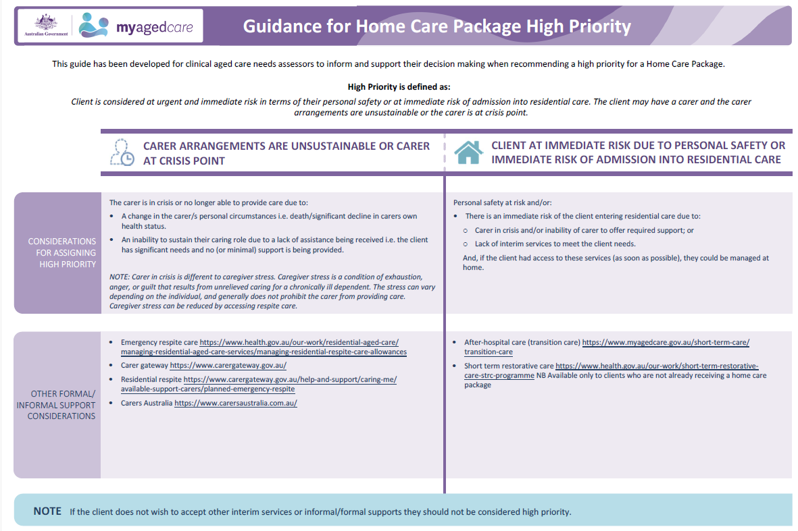

## Re‑assessment

Following a comprehensive assessment, allocating a person’s priority requires an Assessment Delegate decision and is a reviewable decision under the *Aged Care Legislation Amendment (Increasing Consumer Choice) Act 2016*. Any change to the priority for home care will need a re‑assessment by a needs assessor to inform the Assessment Delegate of the evidence that constitutes the need for a new decision around priority. This re‑assessment record is also required in the event that the decision is subject to a reconsideration process under the *Aged Care Act 1997*. However, the format of the re‑assessment (e.g. face-to-face interview, phone call etc.) would depend on the level of evidence required to satisfy the Delegate in order to make their decision.

## Review

The Department will be reviewing the allocation of priority recommendations when approving Home Care Packages to ensure that there are no unintended consequences and that people are receiving timely access to services.



* For further information on determining Home Care Package levels, please visit <https://agedcare.health.gov.au/programs-services/my-aged-care/information-for-assessors> to review the guidance materials.

Note: The information provided is intended as general information and not as prescriptive advice. Assessors will use their professional training and clinical judgement to determine the most appropriate priority for home care services.