# User Guide: Guidance Framework for Home Care Package Level

This user guide provides a general indication on how to use the Guidance Framework for Home Care Package Level (Guidance Framework). The Guidance Framework has been developed for and with clinical aged care needs assessors to provide further clarity in determining package levels. The Guidance Framework does not replace clinical judgement, rather assists in achieving consistent assessments that will support equitable distribution of packages via the National Priority System to support older people, regardless of their location.

The Guidance Framework is not intended to be an additional assessment tool. It is a reference or resource that a clinical assessor can use when populating the support plan and providing a recommendation to the Delegate. Alternatively, some clinical assessors may choose to use it as a reference to confirm their recommendation for a particular Home Care Package level.

The Guidance Framework is published on the Department of Health and Aged Care website and can be accessed through the following link: [Guidance Framework for Home Care Package Level](https://www.health.gov.au/resources/publications/acat-guidance-framework-for-home-care-package-level).

# About the Guidance Framework

The Guidance Framework reflects information about a client’s needs, as indicated by the frequency, intensity and complexity of services required, and the extent to which these needs are being met. This information is collected as part of the comprehensive assessment.

The Guidance Framework is split into two stages:

* Stage 1 – Identification of the client’s needs
* Stage 2 – Understanding the extent to which the client’s current needs are being met.

The Guidance Framework may be more helpful for less experienced clinicians. However, it could be a valuable review mechanism for all clinicians in reviewing or considering an assessment using their clinical expertise.

## Stage 1: Identification of Client Needs

### Structure of Stage 1

Stage 1 of the Guidance Framework is a matrix style document including levels, domains, categories and descriptors. Stage 1 is aligned to the Integrated Assessment Tool (IAT) and is used by clinical assessors when conducting a comprehensive assessment, to assist in identifying the client’s current needs.

The matrix includes three Commonwealth subsidised aged care programs: Commonwealth Home Support Programme (CHSP); Home Care Package (HCP) Level 1, 2, 3, 4; and Residential Care.

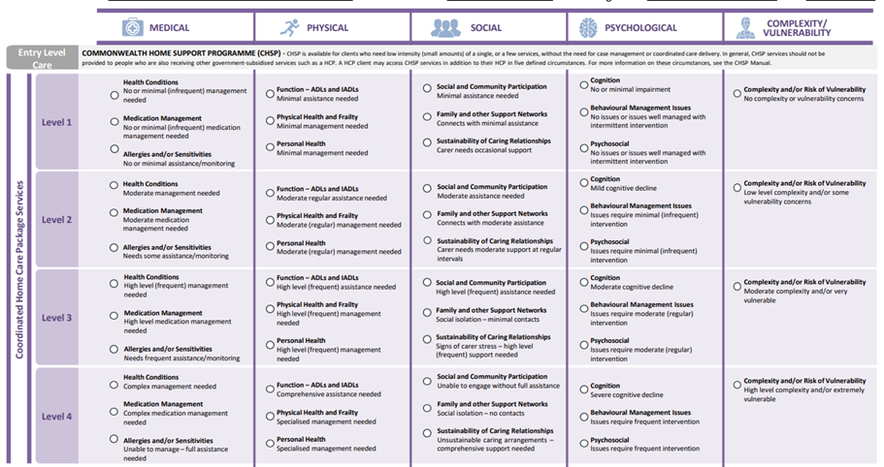

**CATEGORIES**

**DESCRIPTORS**

**LEVELS**

#### Levels

The HCP section of the matrix is divided into the four HCP levels: 1, 2, 3 and 4. These represent packages of aged care services for people with:

**Level 1**: basic care needs

**Level 2**: low-level care needs

**Level 3**: intermediate care needs

**Level 4**: high-level care needs

#### Domains

The matrix is divided into five domains, aligning with the IAT:

* Medical
* Social
* Physical
* Psychological, and
* Complexity / Vulnerability.

#### Categories

Within each of these domains are several categories. These categories do not include all those addressed in the IAT, as it is not intended to be a repeat assessment. Instead, it includes those categories that the clinical assessor stakeholder group felt were the most important factors to consider when determining the appropriate level for a Home Care Package.

For example, the key categories under the physical domain are:

* Function – Activities of daily living (ADLs) and instrumental activities of daily living (IADLs) - includes activities such as eating, taking a bath or shower, toileting, going shopping, preparing meals and undertaking housework.
* Physical health and frailty, and
* Personal health.

These categories align to questions from the IAT. For example, the ‘physical health’ category under the ‘Physical’ domain aligns to several questions, including:

* Sensory concerns
* Swallowing difficulties
* Slips, trips and falls

Other categories may align predominantly to one question in the IAT, for example the ‘family and other support networks’ category, under the “Social” domain aligns to the questions in the Duke Social Support Index (DSSI).

#### Descriptors

Under each domain is a list of associated categories and corresponding descriptors for each package level: 1, 2, 3 and 4.

Broadly, across each of the levels, the frequency or level of ability described in the Guidance Framework is consistent:

* Level 1: no or minimal (infrequent) assistance or management, intermittent intervention, no complexity or risk of vulnerability.
* Level 2: moderate (regular – it happens at predictable intervals such as once a week) assistance or management, minimal (infrequent) intervention, low level complexity and/or some vulnerability concerns.
* Level 3: high level (frequent – it happens often) assistance or management, moderate (regular) intervention, moderate complexity and/or very vulnerable.
* Level 4: comprehensive (full) assistance or management is required, frequent intervention, high level complexity and/or very vulnerable.

A client’s level of ability is likely to vary across the different domains and activities.

### Completing Stage 1 of the Guidance Framework

You may wish to complete Stage 1 by ticking each of the categories with the appropriate descriptor within each level, which best describes the client’s individual needs and circumstances.

For example, if when completing the medical domain, the client needs high level (frequent) management to manage their health condition/s, high level (frequent) medication management, and some assistance/monitoring of their allergies, then each of the corresponding descriptors would be ticked as below:

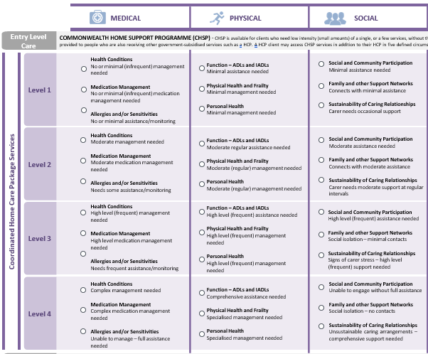



| **MEDICAL DOMAIN**   * The medical domain explores the client’s healthcare connections and health conditions (including mental health and disabilities), and whether these impact on the client’s need for assistance with activities of daily living and social participation. * The ‘Health Conditions’ category relates to the health conditions the client experiences, which have an impact on their activities of daily living and social participation. It seeks information on the health condition(s); their diagnosis status; the impact of health conditions and the support the client is receiving to manage them. This can be found in the ‘Medical and Medication’ and ‘Frailty’ sections of the IAT. * The ‘Medication Management’ category relates to the ‘Medical and Medication’ and ‘Function’ sections in the IAT and relates to whether the client is taking any medications to manage their health conditions. * The ‘Allergies and/or Sensitivities’ category relates to whether the client has and/or had allergies and/or sensitivities such as to food, medication and environmental allergens. This can be found in the ‘Advanced Medical Assessment’ section of the IAT. * Recommended considerations are the: * Client’s health conditions, the cause and length of time the client has had the health condition, the specific impact it has on the client, and any treatment or medical specialist oversight of the condition. * Client’s pre-existing conditions such as arthritis, hypertension (high blood pressure), recent diagnosis of dementia or another physical, neurological or mental health condition/disability. * Types and amount of medication the client takes including creams/lotions, eye drops, natural therapies and injections. * Client’s allergies and/or sensitivities such as food, medication and environmental allergies and/or sensitivities. * Reactions the client may have if they come in contact with the allergens and/or sensitivities and whether they have a severe reaction or one that they manage themselves. | |
| --- | --- |
| **Stage 1 Guidance Framework categories and descriptors** | **Explanation** |
| **Health Conditions**  **1** No or minimal (infrequent) management needed  **2** Moderate (regular) management needed  **3** High level (frequent) management needed  **4** Complex management needed | * This category refers to whether the client has any health conditions that impact on their daily activities, identifying the client’s primary health condition, and recording the diagnosis status of the health condition. * As people age, they are more likely to experience multiple, and more complex health conditions that impact on how they complete day-to-day activities. * The descriptors relate to the amount of management the client requires for their health conditions. Consideration should be given to the type and frequency of assistance the client needs to manage the condition, and the extent to which the client’s health conditions impact on their need for assistance with activities of daily living and social participation. |
| **Medication Management**  **1** No or minimal (infrequent) medication management needed  **2** Moderate (regular) medication management needed  **3** High level (frequent) medication management needed  **4** Complex medication management needed | * This category refers to whether the client is taking any prescribed medication to manage their health conditions and whether they can take their own medication or need assistance. * Medications may have been recommended by the client’s doctor, specialist or pharmacist. In some instances, they can also be self-prescribed. * Factors to consider are whether the client:   + needs to measure the medication prior to taking it,   + is able to take the right doses of medication at the right time,   + needs some assistance, for example if someone prepares their medication or prompts with a reminder, or   + is completely unable to organise, dispense or take their own medication and/or has compliance issues with their medication regime. * The descriptors relate to the amount of management the client needs to manage their medications. |
| **Allergies and/or Sensitivities**  **1** No or minimal assistance/monitoring  **2** Needs some assistance/monitoring  **3** Needs frequent assistance/monitoring  **4** Unable to manage – full assistance needed | * This category refers to whether the client has any allergies or sensitivities. * The descriptors relate to the amount of assistance the client requires to manage their allergies and/or sensitivities. |

| **PHYSICAL DOMAIN**   * The physical domain explores aspects of the client’s function, physical health, personal health and frailty. * The ‘Function’ category relates to the client’s ability to complete activities of daily living and seeks information on how the client undertakes these activities and whether the client needs assistance with these activities. * The ‘Physical Health and Frailty’ category relates to aspects of the client’s physical health. It seeks information on sensory concerns; communication difficulties; slips, trips and falls; any illnesses and ability to walk unaided. * The ‘Personal Health’ category relates to aspects of the client’s personal health. It seeks information on oral health; swallowing; skin conditions; pain; sleep; physical activity; alcohol use; and tobacco use. * Recommended considerations are: * Clients’ ability to complete activities of daily living without help, with some help or completely unable. * Client reporting low vision or blindness, hearing concerns or speech concerns, and whether they use aids. * Number and cause of any falls the client has had in the past 4 weeks and in the past 12 months. * Client concerns or problems with oral health, swallowing (dysphagia), appetite, weight loss and/or fluid intake, skin conditions, pain, sleep, physical activity, alcohol consumption or tobacco use. | |
| --- | --- |
| **Stage 1 Guidance Framework categories and descriptors** | **Explanation** |
| **Function – ADLs and IADLs**  **1** Minimal assistance needed  **2** Moderate (regular) assistance needed  **3** High level (frequent) assistance needed  **4** Comprehensive assistance needed | * This category relates to if/how the client:   + gets to places out of walking distance, including whether they drive a motor vehicle,   + undertakes housework and the intensity of this housework (eg. light, moderate or heavy),   + goes shopping   + prepares meals   + takes medicine   + handles money   + uses the telephone   + uses other communication devices   + uses online services   + operates their wheelchair (if applicable)   + climbs stairs   + bathes or showers   + dresses themselves   + grooms themselves   + eats   + transfers, and   + toilet use, including incontinence considerations (if applicable). * The descriptors relate to the amount of assistance the client requires when performing these activities. |
| **Physical Health and Frailty**  **1** Minimal management needed  **2** Moderate (regular) management needed  **3** High level (frequent) management  needed  **4** Specialised management needed | * This category refers to whether the client:   + has any sensory concerns or difficulties with their vision, hearing or speech,   + unintentional weight loss,   + has the ability to walk unaided,   + Has had any slips, trips or falls in the past 12 months, and/or   + has a one of the following illnesses: hypertension, chronic lung disease, angina, kidney disease, diabetes, heart attack, asthma, cancer, congestive heart failure, arthritis. * The descriptors relate to the amount of assistance the client needs to manage any of these aspects of their physical health. |
| **Personal Health**  **1** Minimal management needed  **2** Moderate (regular) management needed  **3** High level (frequent) management  needed  **4** Specialised management needed | * This category refers to whether a client:   + Has oral health concerns such as problems with teeth, mouth or dentures   + Has problems swallowing (dysphagia)   + Has any foot problems that affect their ability to walk or move around   + Has any major skin conditions   + Experienced any pain or discomfort during the past four weeks, whether this pain has impacted their day-to-day activities and the strategies the client uses to manage the pain (if applicable).   + Experiences any difficulties sleeping   + Drinks alcohol, and   + Currently smokes daily or frequently. * The descriptors relate to the degree of management assistance needed by the client, to manage particular aspects of their personal health. |

| **SOCIAL DOMAIN**   * The social domain explores aspects of the client’s family, community engagement and support and current care arrangements (if any). * The ‘Social and Community Participation’ and ‘Family and other Support Networks’ categories are from the questions in the Duke Social Support Index or Good Spirit Good Life Tool of the IAT and relate to the relationships and activities that are important to the client, and how they are maintained. * The ‘Sustainability of Caring Relationships’ category is from the ‘Carer Profile’ and ‘Respite and Emergency Care’ sections of the IAT, and relates to the sustainability of the caring relationship (the informal support being provided to the client, and the informal support being provided by the client); whether the client has accessed respite and whether the client has an emergency care plan in place. * Recommended considerations are: * Client involvement in community-based activities, special interest groups and/or interests or hobbies * Assistance or supervision client is receiving in order to participate in community-based or recreational, cultural or religious activities; attending day centres, managing finances and writing letters. * Family situation and relationship with close family (partners, children) and extended family * Engagement with social/community groups, clubs etc. * Recent changes in the client’s family, cultural and social situation * Client experiencing loneliness and/or social isolation * Sustainability of carer arrangements without additional services or supports (this refers to the sustainability of both the carer in their caring role and the client in their caring role) * Client currently in or has been in receipt of respite in the past 12 months. | |
| --- | --- |
| **Stage 1 Guidance Framework categories and descriptors** | **Explanation** |
| **Social and Community Participation**  **1** Minimal assistance needed  **2** Moderate (regular) assistance needed  **3** High level (frequent) assistance needed  **4** Unable to engage without full assistance | * This category relates to the types of activities the client undertakes, and the assistance they receive in order to complete these activities. Examples of activities include shopping, banking, participating in recreational, cultural or religious activities, attending day centres, managing finances and writing letters. |
| **Family and other Support Networks**  **1** Connects with minimal assistance  **2** Connects with moderate (regular) assistance  **3** Social isolation – minimal contacts  **4** Social isolation – no contacts | * This category refers to whether the client has existing personal and family support networks. * Having meaningful relationships and social connections is important for clients to achieve and maintain quality of life and prevent social isolation. It is important to understand relationships that are important to a client and how they are maintained. |
| **Sustainability of Caring Relationships**  **1** Carer needs occasional support  **2** Carer needs moderate support at regular intervals  **3** Signs of carer stress – high level (frequent) support needed  **4** Unsustainable caring arrangements – comprehensive support needed | * This category relates to both the Carer and Client as a Carer sections of the IAT. It seeks information on the sustainability of the caring relationship (the informal support being provided to the client, and the informal support being provided by the client); whether the client has accessed respite and whether the client has an emergency care plan in place. * Carers can be a physical and social enabler that is integral to ensuring the quality of life and independence of the older person. In recognition of the vital role that carers play in supporting older people to remain living at home and in the community, a number of carer specific programmes are funded by federal and state and territory governments (such as planned respite services delivered through the Commonwealth Home Support Program). These programmes provide carers with assistance and support to maintain their caring role. |

| **PSYCHOLOGICAL DOMAIN**   * The psychological domain explores the client’s cognition, changes in behaviour and psychosocial wellbeing. * The ‘Cognition’ category relates to changes the client has experienced in relation to their cognition. It seeks information on changes in memory and thinking; changes in personality; changes in behaviour; and assistance with decision making. This can be found in the ‘Cognition’ section of the IAT and includes assessment tools such as the GPCog, and KICA-Cog for Aboriginal and/or Torres Strait Islander clients. * The ‘Behavioural Management Issues’ category relates to management of behavioural issues such as aggression, wandering, agitation, resistive behaviour hallucinations/delusions and sleep disturbances. This can be found in the ‘Behaviour’ and ‘Personal Health’ sections of the IAT. * The ‘Psychosocial’ category relates to the client’s mental health and social wellbeing. It seeks information on feelings of nervousness or depression; and feelings of loneliness or social isolation. This can be found in the ‘Psychological’ and ‘Social’ sections of the IAT. * Recommended considerations are: * Changes in memory and thinking the client may have experienced or any concerns reported by a carer or family. * Client presenting as agitated, aggressive, suspicious, repetitive or inappropriate. * Indications that a client’s behaviour has changed. Changes can include aggression, wandering, inappropriate exposure, hoarding, agitation, hallucinations and delusions. * The feelings experienced by the client and the frequency of the feelings (a little of the time, some of the time, all of the time). | |
| --- | --- |
| **Stage 1 Guidance Framework categories and descriptors** | **Explanation** |
| **Cognition**  **1** No or minimal impairment evident  **2** Mild cognitive decline  **3** Moderate cognitive decline  **4** Severe cognitive decline | * This category refers to whether the client has had any changes in their memory, judgement and thinking. * Cognitive decline can have a major impact on a client’s functional abilities and can lead to a loss of autonomy and capacity to function independently. * The descriptors used reflect the degree of cognitive decline (if any) as it relates to the outcome of the GPCOG and KICA-Cog tools, as well as how cognitive impairment impacts the client’s ADLs and IADLs, how they sequence tasks, communication and memory. For example, a client with mild cognitive decline may have problems with driving, finances or shopping, loses track or goes off topic when talking. A client with moderate decline may need assistance sequencing dressing and grooming, use vague terms or fragmented sentences. A client with severe decline may have problems with eating and walking, speech disturbances and memory deficits. **These are general guidelines** and there will be individual variability. * The scores of the GPCog Step 1 are as follows:   Score = 9 no cognitive impairment, interview not necessary  Score = 5–8 proceed to informant interview (GPCog Step 2)  Score = 0–4 cognitive impairment, interview not necessary.   * The score of the GPCog Step 2 are as follows:   Score = 4–6 no cognitive impairment  Score = 0–3 cognitive impairment detected   * The KICA-Cog Regional Urban Cognitive Assessment will yield a score out of 39. A score of 33/39 and below indicates possible dementia. * The KICA- Carer yields a score our of 16. A score equal to or greater than 3/16 requires further investigation. |
| **Behavioural Management Issues**  **1** No issues or issues well managed with intermittent intervention  **2** Issues require minimal (infrequent) intervention  **3** Issues require moderate (regular) intervention  **4** Issues require frequent intervention | * This category refers to the management of behavioural issues. * Problem behaviours include those that are difficult to manage and may have a significant impact on the carer as well as the client’s ability to live in the community. * For example, being demanding, uncooperative, agitated, prone to wandering, aggressive behaviours. Also included are harmful behaviours directed at self (self-neglect and/or self-harm), or others (verbal and physical abuse), sleep disturbance and mood swings. * The descriptors relate to the amount of intervention required for any behavioural issues. |
| **Psychosocial**  **1** No issues or issues well managed with intermittent intervention  **2** Issues require minimal (infrequent) intervention  **3** Issues require moderate (regular) intervention  **4** Issues require frequent intervention | * This category refers to whether the client experiences feelings of nervousness or depression, and whether intervention is required to assist the client in managing these issues. * Feelings of nervousness can be expressed as feeling anxious, worried, edgy, jumpy, panicky or uneasy. * Feelings of being depressed can be expressed as feeling unhappy, ‘blue’, down, miserable, dejected, low, disheartened or sad. * The descriptors relate to the amount of intervention required for any psychosocial issues. * The scoring of the Geriatric Depression Scale is as follows: * 0-4 normal; 5-8 mild depression; 9-11 moderate depression; 12-15 severe depression. |

| **COMPLEXITY/VULNERABILTY DOMAIN**  Complexity and vulnerability forms part of the ‘Support Considerations’, ‘Financial or Legal’ and ‘Home and Personal Safety’ sections of the IAT. The questions in this section assist to identify the complexity of a client, and their risk of vulnerability, indicating a potential need for linking support. Clinical assessor judgement also plays a significant role, as the presence of the same risk in different people may signify varying degrees of vulnerability. | |
| --- | --- |
| **Stage 1 Guidance Framework categories and descriptors** | **Explanation** |
| **Complexity and/or Risk of Vulnerability**  **1** No complexity or vulnerability concerns  **2** Low level complexity and/or some vulnerability concerns  **3** Moderate complexity and/or very vulnerable  **4** High level complexity and/or extremely vulnerable | * This category refers to the complexity of a client and their risk of vulnerability. * The Financial and Legal section has been added with the introduction of the IAT. It includes questions about any financial or legal issues the client has (if applicable) including decision making capacity, whether they have a Power of Attorney, who assists them to make health and financial decisions, whether they have an Advanced Care Plan or are subject to a Mental Health Act order. * The complexity indicators include: * Client living in inadequate housing or with insecure tenure or is already homeless which compromises their health, wellbeing and ability to remain living in the community * Risk of suspected abuse or there is confirmed abuse * Client has emotional or mental health issues that significantly limits self-care capacity, requires intensive supervision and/or frequent changes to support * Client is experiencing financial disadvantage or other barriers that threaten their access to services essential to their support * Client has experienced adverse effects of institutionalisation and/or systems abuse (e.g. spending time in institutions, prisons, foster care, residential care or out of home care) and is refusing assistance or services when they are clearly needed to maintain safety and wellbeing * Client is exposed to risks due to drug and/or alcohol related issues and likely to cause harm to themselves or others * Client is exposed to risks or is self-neglecting of personal care and/or safety and likely to cause harm to themselves and others * Client has a memory problem or confusion that significantly limits self-care capacity, requires intensive supervision and/or frequent changes to support * Risk of vulnerability includes: * Client belongs to a population cohort who is at risk of vulnerability:   + Aboriginal or Torres Strait Islander   + Veteran   + Change in family/carer support arrangements   + Refugees, asylum seekers or recent migrants without support   + Lesbian, Gay, Bisexual, Transgender, Intersex or other gender diverse individuals   + Culturally and linguistically or ethnically diverse individual   + Socially isolated individual * Client has one or more areas of complexity that impact on their ability to live independently in the community * Risk or issues need to be immediately addressed in order to prevent further deterioration * Client’s level of complexity is impacting on their ability to access aged care services. * The descriptors relate to the level of complexity and/or vulnerability of the client. |

# Stage 2: Identifying package levels

Stage 2 of the Guidance Framework is a diagram defining each level of care, demonstrating that as complexity, vulnerability, risk and frequency increases, so does the package level and corresponding package value. Stage 2 is used to assist in understanding the extent to which the client’s needs (as identified in Stage 1) are being met, and as a result, inform recommendations for the most appropriate package level to meet the client’s current need.

### Structure of Stage 2

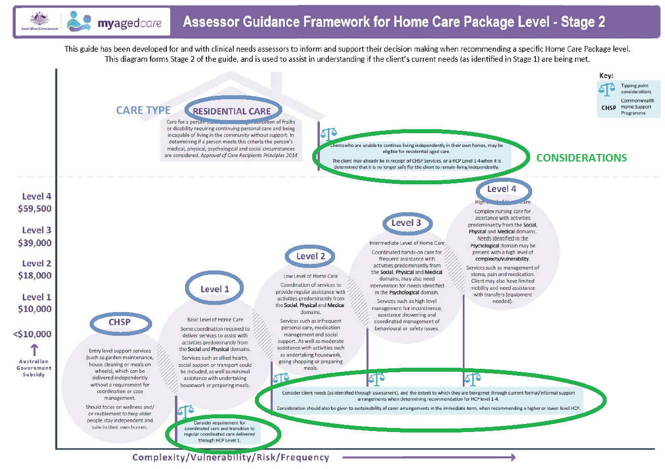

### *Care type*

The diagram includes three Commonwealth subsidised aged care programs; Commonwealth Home Support Programme (CHSP), Home Care Packages (Level 1, Level 2, Level 3, Level 4) and Residential Care.

Descriptions are provided for each care program, and for each HCP level. Within each of the HCP levels, the domains are ‘bold’ to demonstrate the predominant areas of need that may be met, and examples of the services that may be included, through each package of aged care services. For example:

* + **Level 1** provides assistance with activities predominantly from the **Social** and **Physical** domains.
  + **Level 2** provides assistance with activities predominantly from the **Social**, **Physical** and **Medical** domains.
  + **Level 3** provides assistance with activities predominantly from the **Social**, **Physical** and **Medical** domains and may also need intervention for needs identified in the **Psychological** domain.
  + **Level 4** providesassistancewith activities from the **Social**, **Physical** and **Medical** domains, and needs are identified in the **Psychological** domain with a high level of **complexity/vulnerability**.

### *Considerations*

Considerations have been included to assist clinical assessors in determining the ‘tipping point’ between one level of care and another.

# Interpreting the Guidance Framework

Together, Stage 1 and 2 of the Guidance Framework should provide a sense of the client’s range of care needs and the extent to which they are currently being met. This will assist in determining the most appropriate package level recommendation, based on the client’s current needs.

The point of reference for completing the framework is not derived from responses to specific questions but rather an overall clinical judgement, taking into account all information collected at the time of assessment.

For example, if on balance the client’s results are mostly level 2s and the client’s needs are not being met through current formal/informal support arrangements – this will likely indicate that the appropriate Home Care Package is also a level 2. However, there may be some factors, such as function (ADLs and IADLs) or continence that could substantially impact on the package level required. So, for example, if a client scores mostly 2s but scores as a 4 in one or both of these categories, and the client’s needs are not being met through current formal/informal support arrangements, the Home Care Package level required could be higher due to requiring more frequent services or needs not currently being met.

In the previous example (in the ‘Completing Stage 1 of the Guidance Framework’ section), the client had mostly 3s in the medical domain with one 2. If, looking holistically at the remainder of the Guidance Framework the client also had mostly 3s, and the client’s needs were being partially met through current formal/informal support arrangements, then depending on your clinical judgement and assessment, it may be that the client is recommended for a Home Care Package level 2.

As another example, a client who is generally managing well (i.e. mostly level 1s) but has a few level 2s, may be recommended for a level 1 overall, depending on the types of areas where the client requires assistance, and the current formal/informal support arrangements.

If you would like to provide feedback and suggestions about the Guidance Framework, you can email [MyAgedCare.Assessment@health.gov.au](mailto:MyAgedCare.Assessment@health.gov.au)



