Government Provider Management System

User Guide: Reporting Assessments

February 2024

Version 1.2

This Government Provider Management System (GPMS) User Guide aims to provide Residential Aged Care Providers with an overview of how to access the Reporting Assessment application, upload information and documents for Care Minutes and 24/7 Registered Nurse Reporting Assessments, and view on-site bookings.

Contents

1. Introduction 3

1.1 Purpose 3

1.2 Before proceeding 3

1.3 Login to the GPMS portal 3

2. Further information and support 4

3. Reporting Assessments 4

3.1 Accessing Reporting Assessments Application 4

3.2 Uploading documents 7

3.3 Archiving Documents 10

3.4 Submitting the request 11

3.5 Viewing On-site Bookings 14

3.6 Notifications 15

3.7 Communications 16

# Introduction

With the introduction of mandatory [Care Minutes](https://www.health.gov.au/our-work/care-minutes-registered-nurses-aged-care/care-minutes) and [24/7 Registered Nurse (RN)](https://www.health.gov.au/our-work/care-minutes-registered-nurses-aged-care/24-7-rns) staffing responsibilities, Residential Aged Care Providers will be required to report the hours worked by their RNs and care staff to meet mandatory targets. As part of ensuring compliance, the Department will undertake Reporting Assessments of Care Minutes and 24/7 RN reports submitted by providers to support accurate reporting.

## Purpose

This User Guide has been designed to support Residential Aged Care Providers with the following actions:

* Accessing the Reporting Assessments application
* Uploading information and documents
* Viewing on-site bookings
* Viewing notifications

## Before proceeding

Please be advised of the following:

The Department of Health and Aged Care will retain records of your access to GPMS. When prompted, you must accept the [*GPMS Terms of Use*](https://www.health.gov.au/resources/publications/government-provider-management-system-terms-of-use?language=en) to be able to access the system.

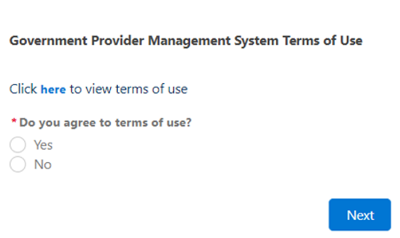

## Login to the GPMS portal

To login to the GPMS portal please visit [Log In Using | Service Provider Portal](https://provider.health.gov.au/serviceproviderportal/login?ec=302&startURL=%2Fserviceproviderportal%2Fs%2F).

If you require assistance logging into the GPMS portal, please refer to the GPMS [Logging in to the Aged Care Systems](https://www.health.gov.au/resources/publications/logging-in-to-the-aged-care-systems).

# Further information and support

Visit the [Care time reporting assessments](https://www.health.gov.au/our-work/care-minutes-registered-nurses-aged-care/care-minutes/care-time-reporting-assessments) website for more information.

If you require further assistance to login to GPMS please contact the My Aged Care service provider and assessor helpline on **1800 836 799**, Monday to Friday (8am to 8pm) and Saturday (10am to 2pm) local time across Australia.

For translating and interpreting services, call **131 450** and ask for My Aged Care service provider and assessor helpline on **1800 836 799**.

To use the National Relay Service, visit [About the National Relay Service (NRS) | Access Hub](https://www.accesshub.gov.au/about-the-nrs) or call **1800 555 660**.

To access sign language interpreting and captioning services through Deaf Connect, call [**1300 773 803**](tel:1300%20773%20803) or email [interpreting@deafconnect.org.au](mailto:interpreting@deafconnect.org.au).

# Reporting Assessments

## Accessing Reporting Assessments Application

Reporting Assessments are completed through the GPMS portal.

The primary purpose of the Reporting Assessment application is to allow residential aged care provider services to provide requested documentation and information, and to check the correct date and time have been recorded for their on-site booking.

To access the Reporting Assessment application, you will need to have the 24/7 RN Reporter role. If you do not have this role you will need to discuss your need with your Organisation Administrator.

If you are an Organisation Administrator, you can assign yourself and other staff members 24/7 RN Reporter access. To do this, please refer to the [[Government Provider Management System – User Guide](https://www.health.gov.au/resources/publications/government-provider-management-system-user-guide?language=en)](https://www.health.gov.au/resources/publications/government-provider-management-system-user-guide?language=en) for more information.

If you are not an Organisation Administrator, at the time of being given reporter access, you will receive a welcome email with the details of the GPMS portal’s internet address (URL) and next steps. To do this, please refer to the [Government Provider Management System – User Guide](https://www.health.gov.au/resources/publications/government-provider-management-system-user-guide?language=en) for more information.

Once you are in the GPMS portal, you can access the Reporting Assessment application, by completing the following actions:

1. In the GPMS portal landing page select the Reporting Assessments tile.

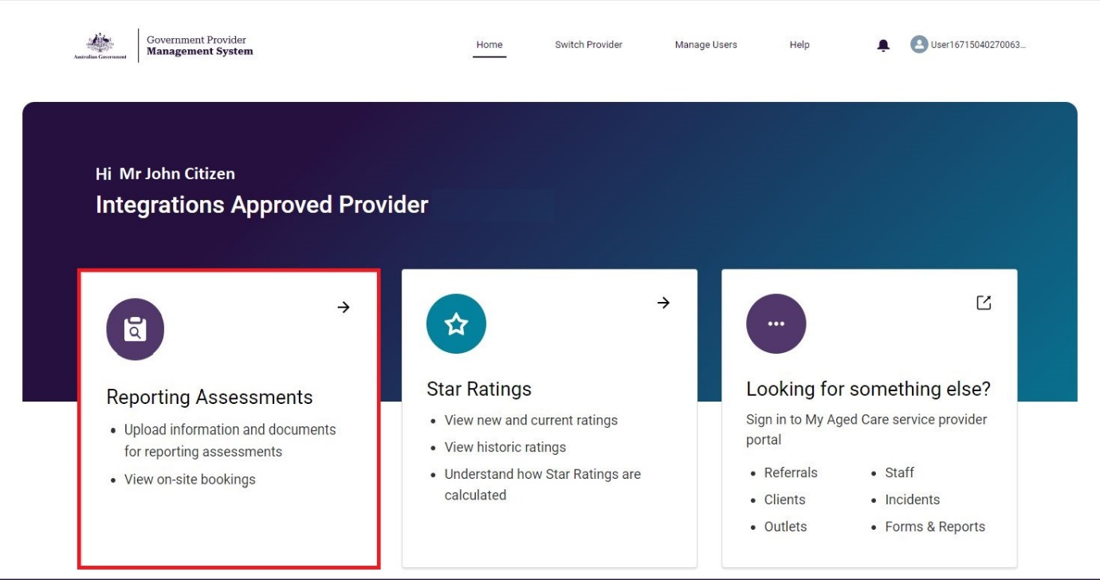

1. The Reporting Assessments page will display the list of services currently associated with your provider that have active tasks and/or inactive tasks.

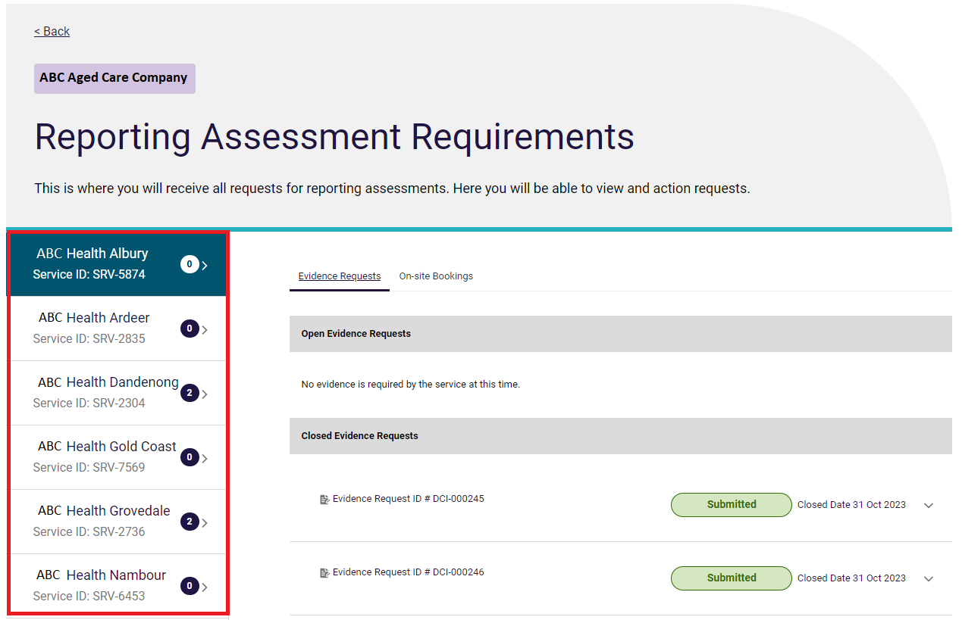

1. You can select any service that you are authorised to view and report on.

By selecting the service, you will be able to view the requests for evidence for the service and on-site bookings. You will be able to view all of the open and closed requests for evidence under the ‘Evidence Requests’ tab, and all of the on-site bookings under the ‘On-site Bookings’ tab.

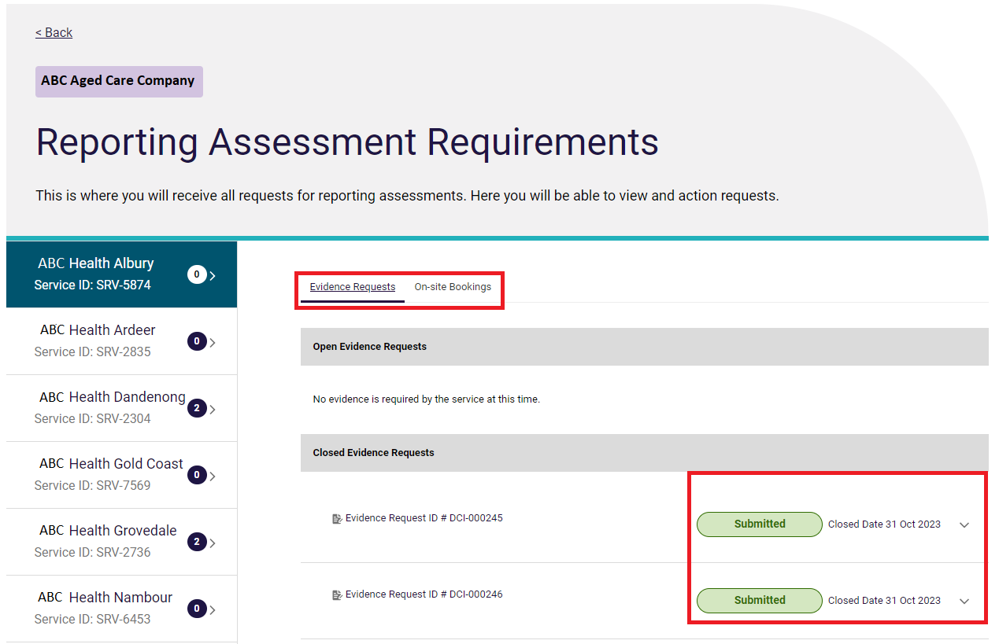

Evidence requests can have the following statuses

* **Pending upload:** The evidence request hasn’t been actioned yet.
* **Upload in progress:** Documents have been uploaded but not submitted yet.
* **Overdue:** The due date for the request has passed.
* **Submitted:** The request has been submitted.
* **Submitted Late:** The request has been submitted after the due date.

## Uploading documents

1. To identify which services have a request for evidence, the indicator against the service will include a number. Select the service to view the requests that need to be actioned.

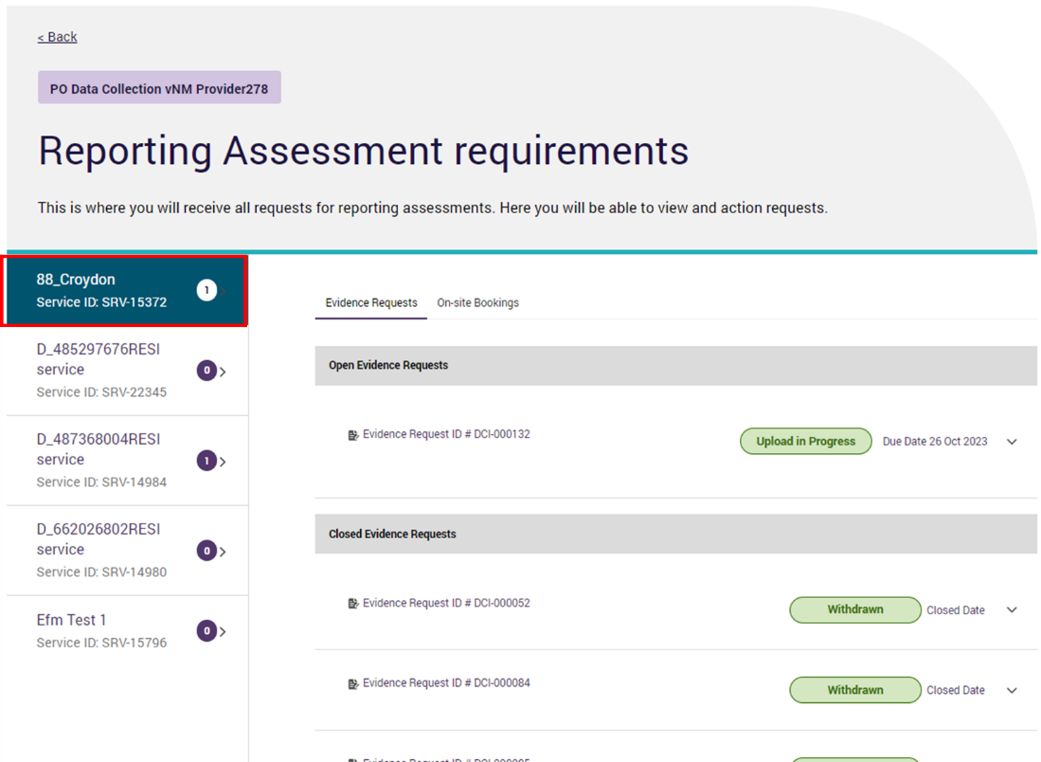

1. To begin uploading a document for a service’s evidence request, select the dropdown on the right-hand side of the evidence request that you want to action.

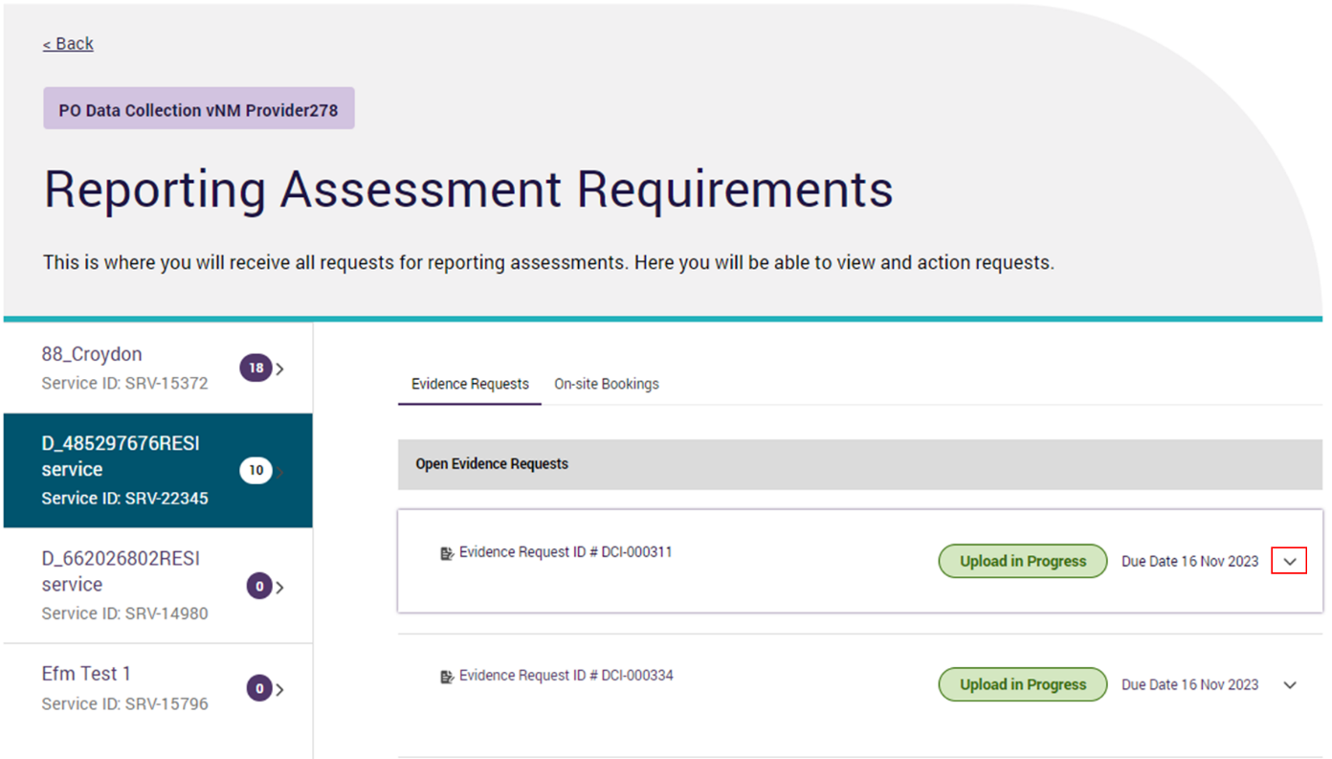

1. The request will expand and show the file management table.This table displays all the documents that have been uploaded.

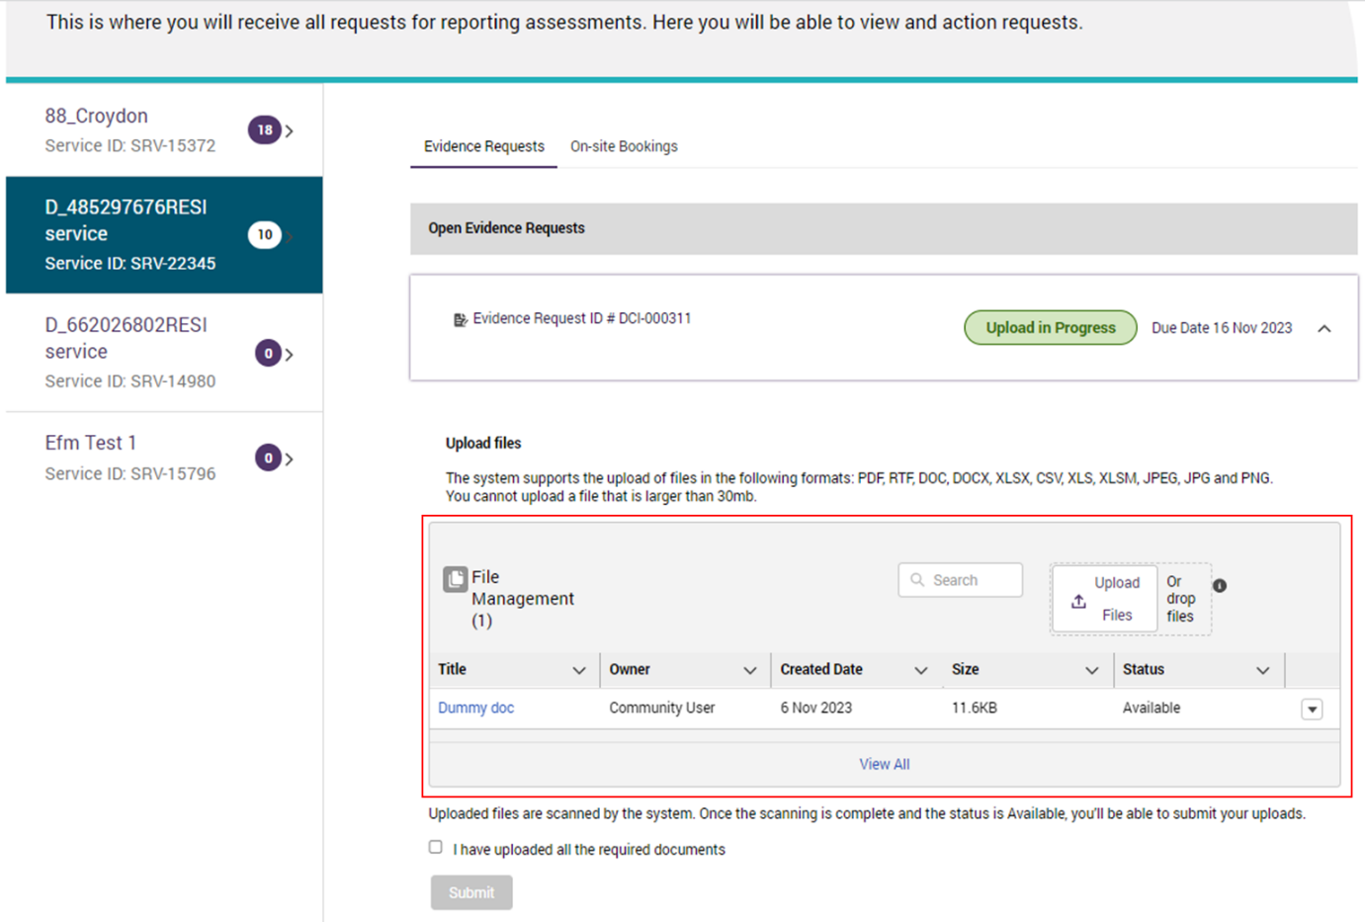

1. To upload files you can either:
   1. Click the “Upload Files” button, which will open your file manager. Select the documents and press open; or
   2. Drag and drop files into the file management table.

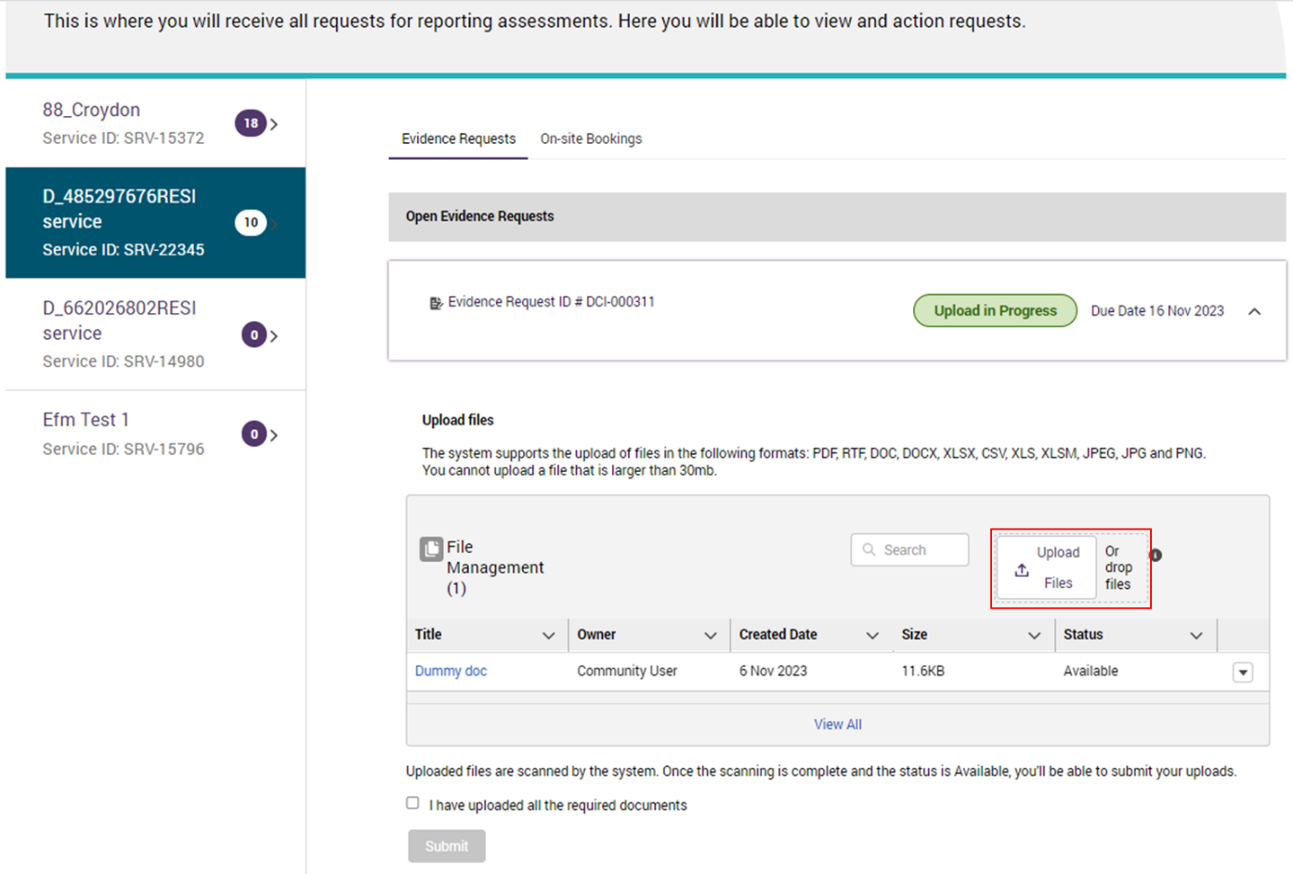

**Please note:**

* Please ensure that personal sensitive information is not included or is appropriately redacted in any documents before you upload them.
* Once a document has been uploaded it can only be archived.
* Only 3 documents can be uploaded at a time. If you want to upload more than 3 documents, upload the first 3 and then select the ‘upload files’ button again to upload any other documents.

1. A pop-up will appear showing the upload progress of the file. Once the upload is successful, select the “Done” button.

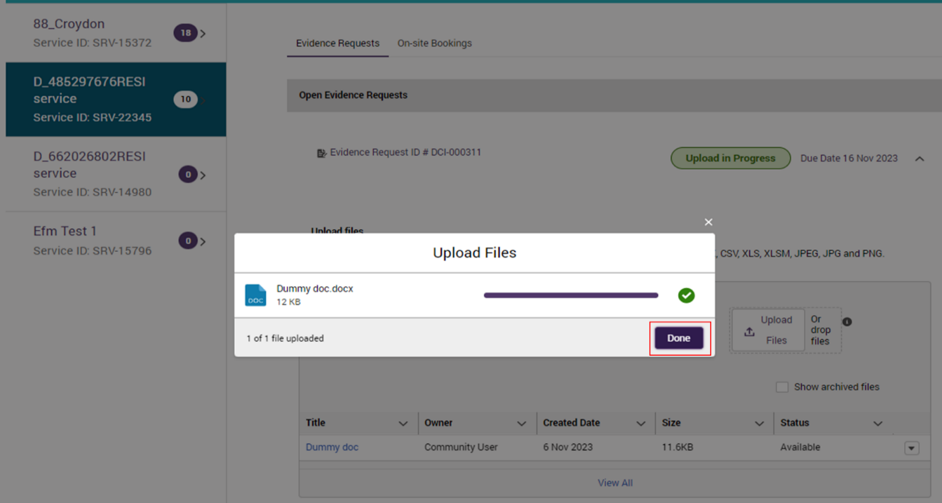

1. The system will begin to scan the file for viruses. The status of the scan can be seen in the status column of the File Management table. If the status changes to ‘Available’, this means no viruses were found and the document can be viewed.

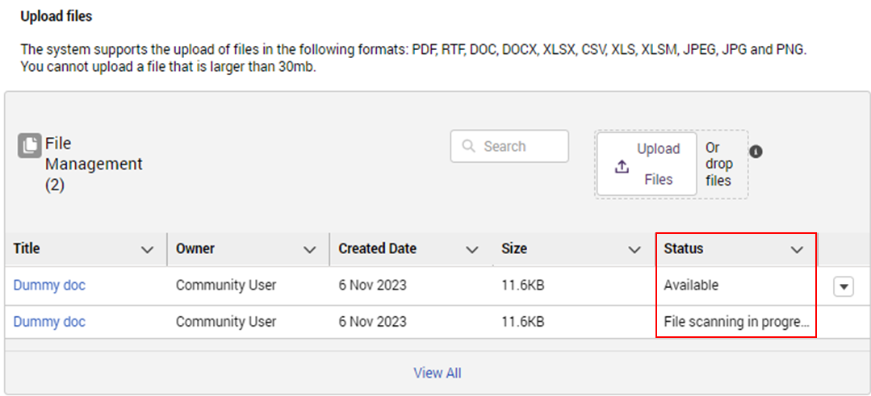

In the case a virus is detected, you will receive a notification in the bell icon and the document will become unviewable. You will then need to upload a new file to be scanned.

## Archiving Documents

1. If a document is uploaded by accident, select the small triangle on the right-hand side of the document that you need to archive.

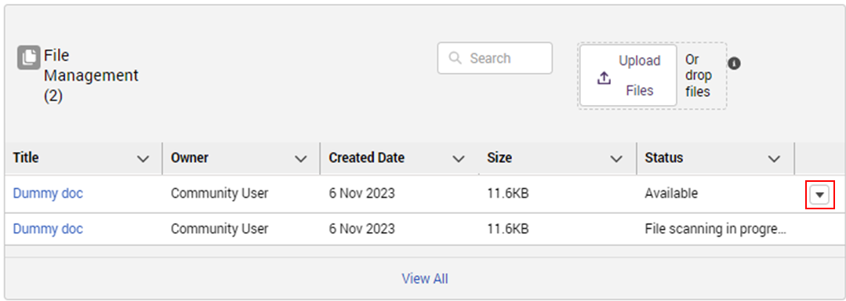

1. Select the Archive button.

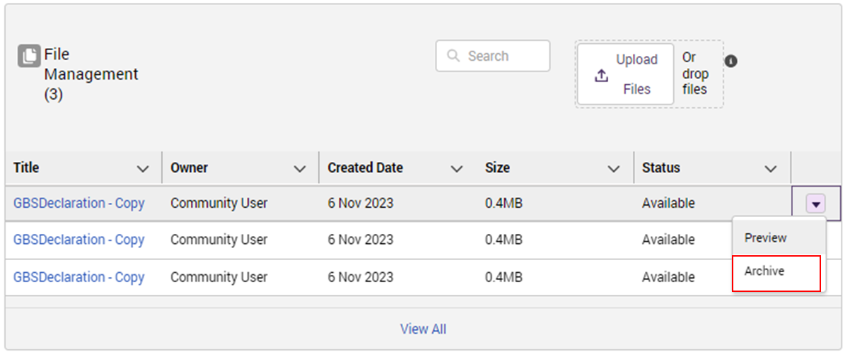

1. A pop-up will appear to confirm archiving of the document. Select “OK” to confirm intention to archive. Once confirmed, the document will no longer be displayed in the File Management table.

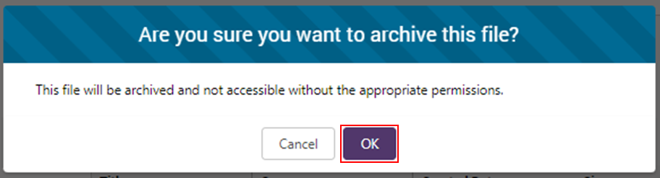

## Submitting the request

1. Before the evidence request can be submitted, the scanning status of the documents must be “available”. Once that is confirmed, you then need to confirm that the correct documents have been uploaded.

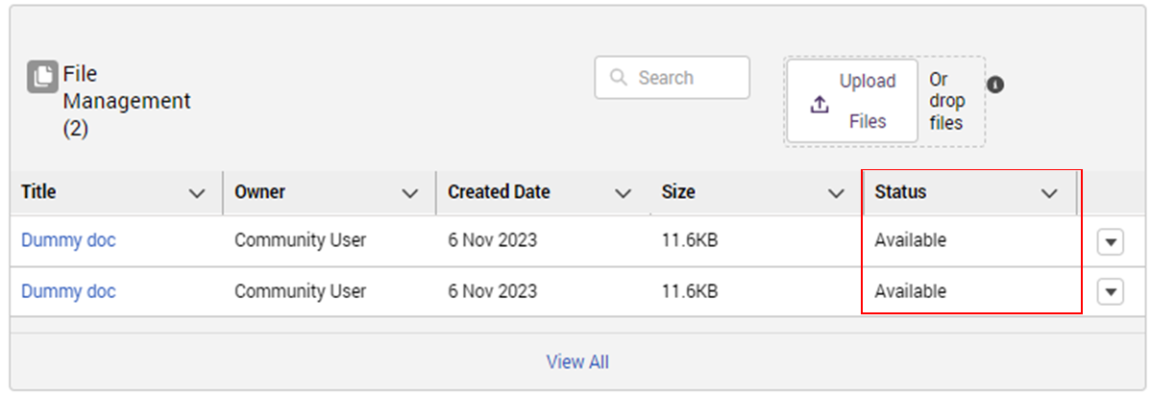

1. To preview each document, select the little triangle on the right hand side of the document.

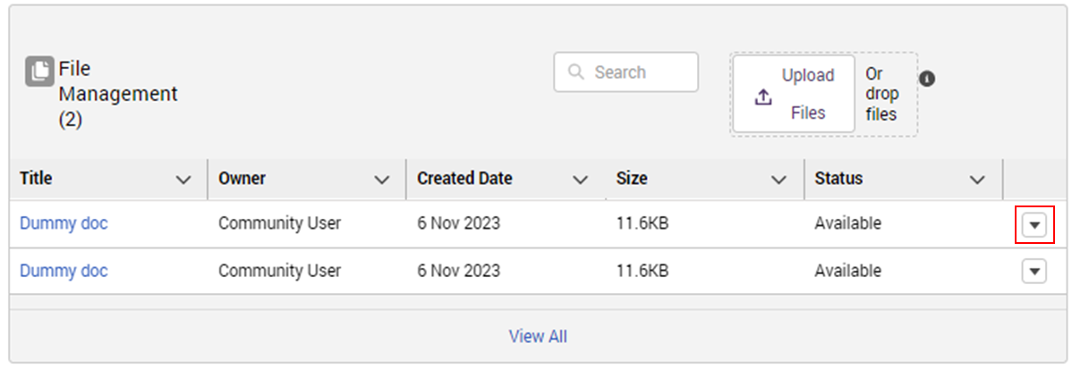

1. Next, select the preview button. This will open the document in another tab where you can preview it.

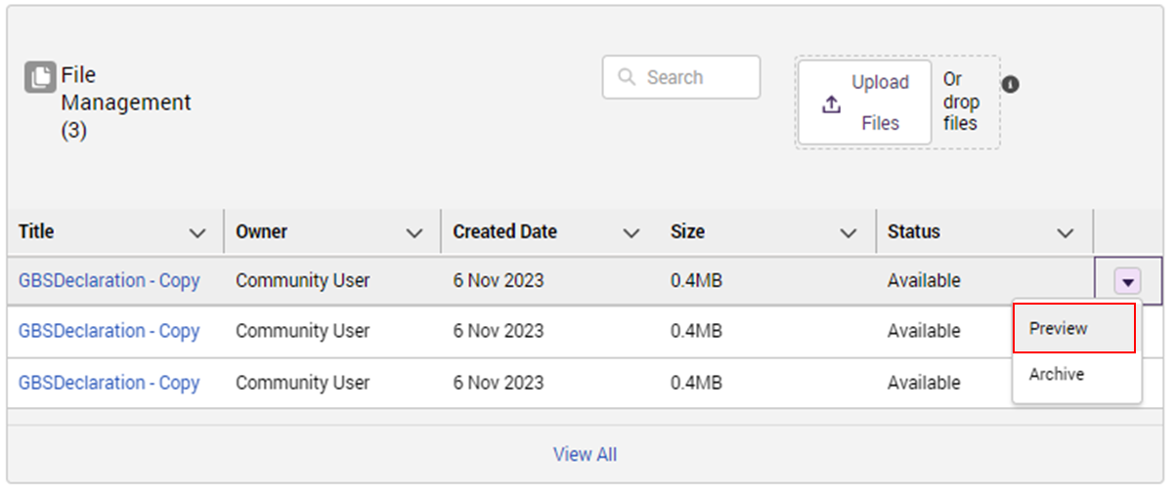

1. Once you have confirmed that all the correct documents have been uploaded and their scanning status is “Available”, you can tick the “I have uploaded all the required documents” box.

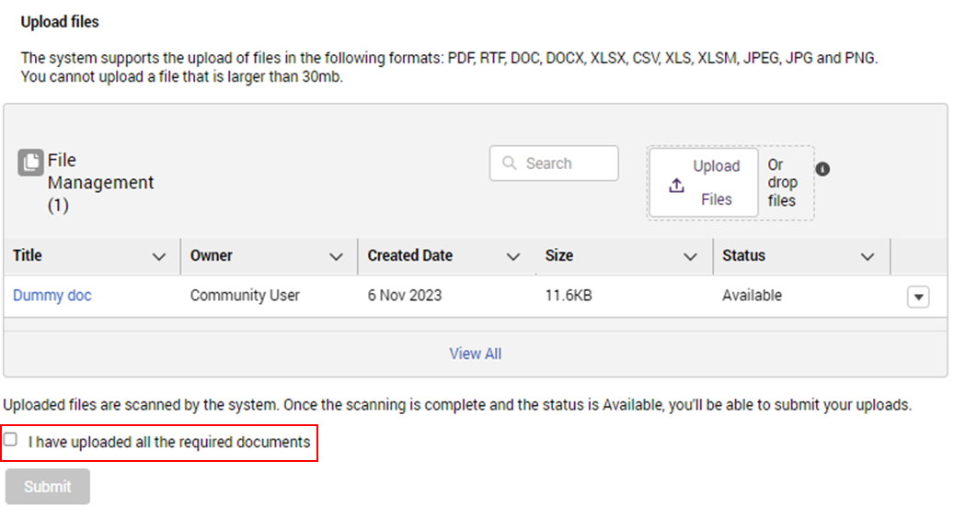

1. Then, you can select the “Submit” button.

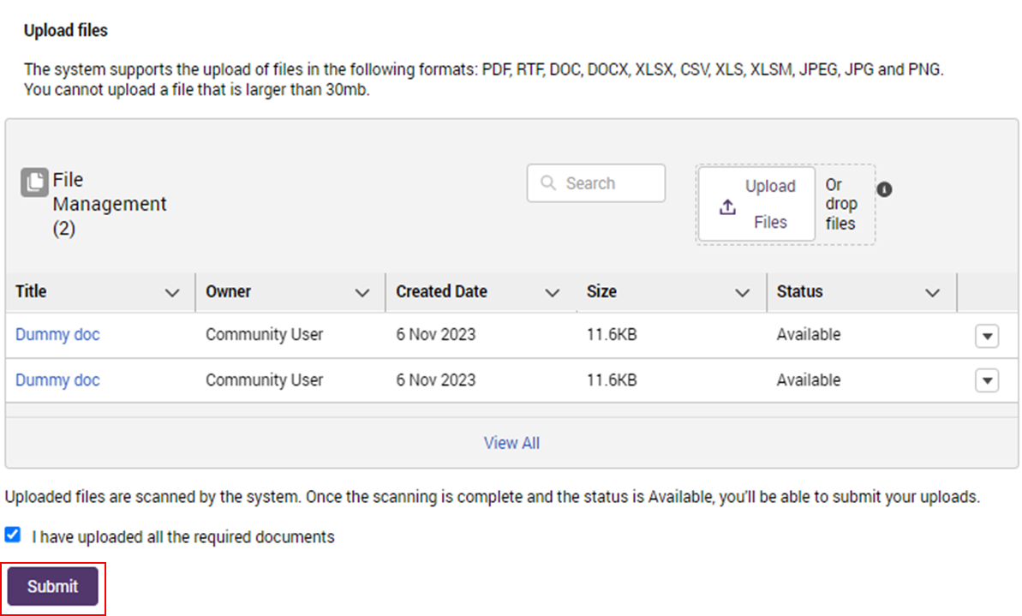

**Please note:**

* **You can only select ‘Submit’ once you have ticked the ‘I have uploaded all the required documents’ box.**
* **Once a request has been submitted, no more changes can be made to it. If you have missed a document or uploaded the wrong document, please contact your assigned auditor.**

1. The Submitted Evidence Request will move from ‘Open Evidence Requests’ to ‘Closed Evidence Requests’.

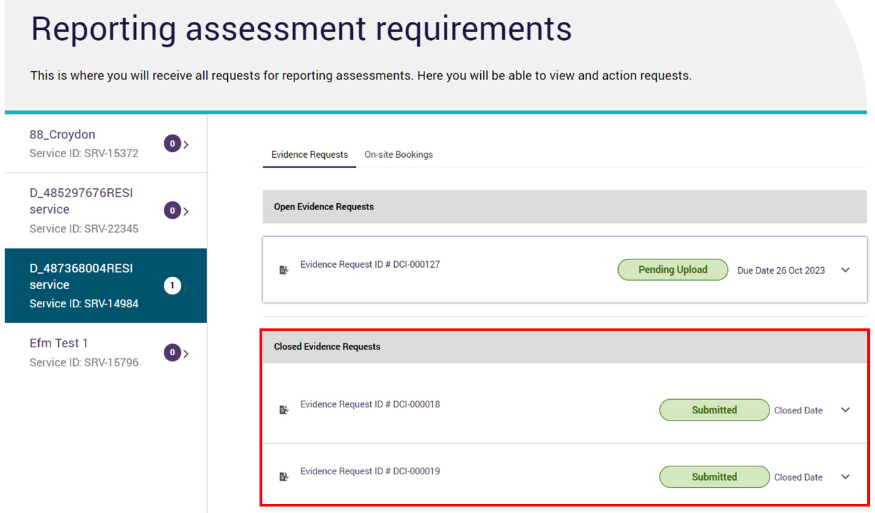

1. Select the small triangle on the right hand side of the request to view the names of the documents that were submitted.

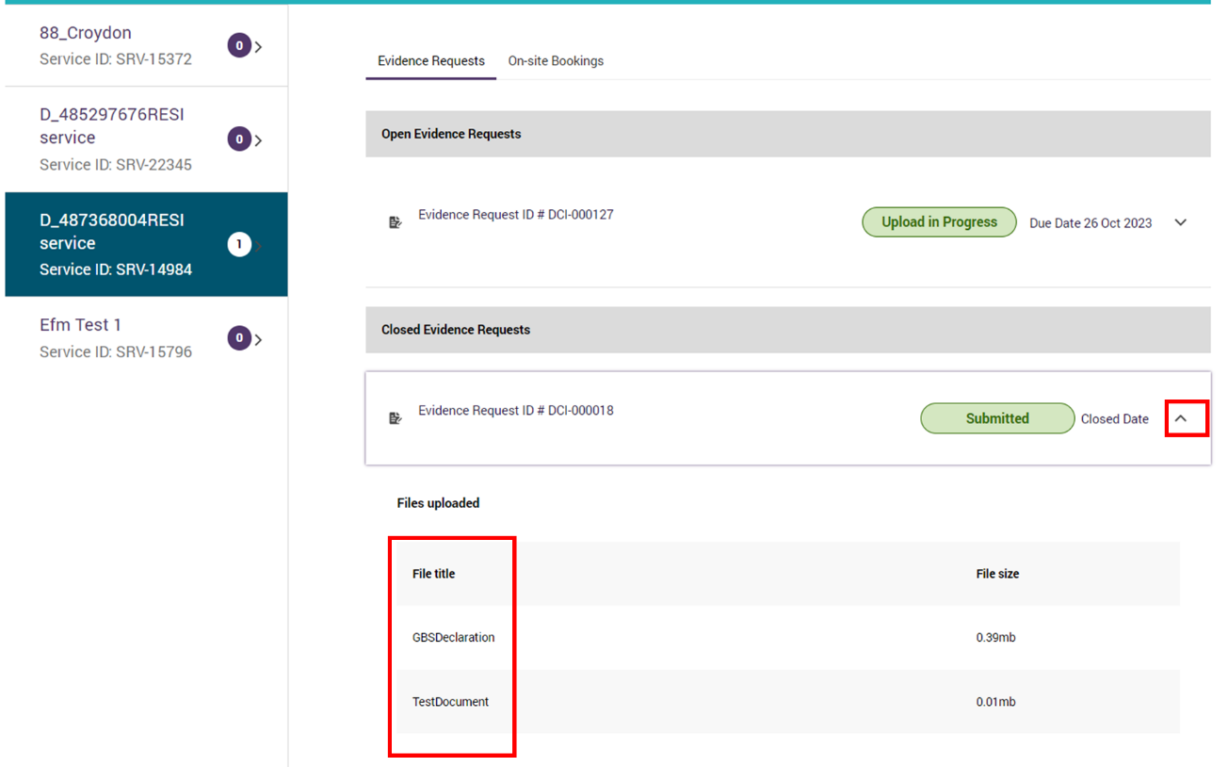

## Viewing On-site Bookings

**Please note:**

On-site bookings will only be visible once the new Aged Care Act has passed.

1. To view a service’s on-site bookings, select the relevant service and then select the “On-site Bookings” tab.

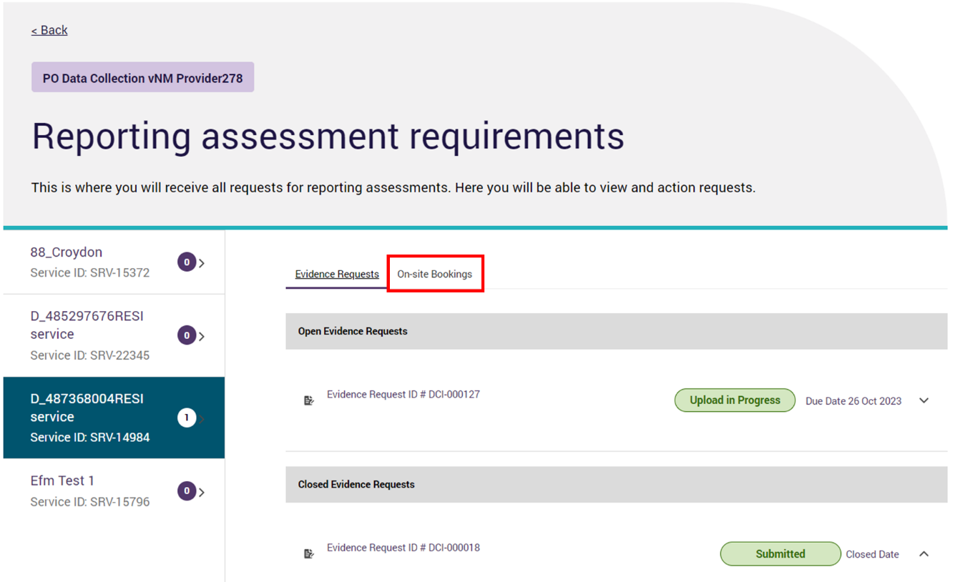

1. The current and past on-site bookings for the service will be displayed.

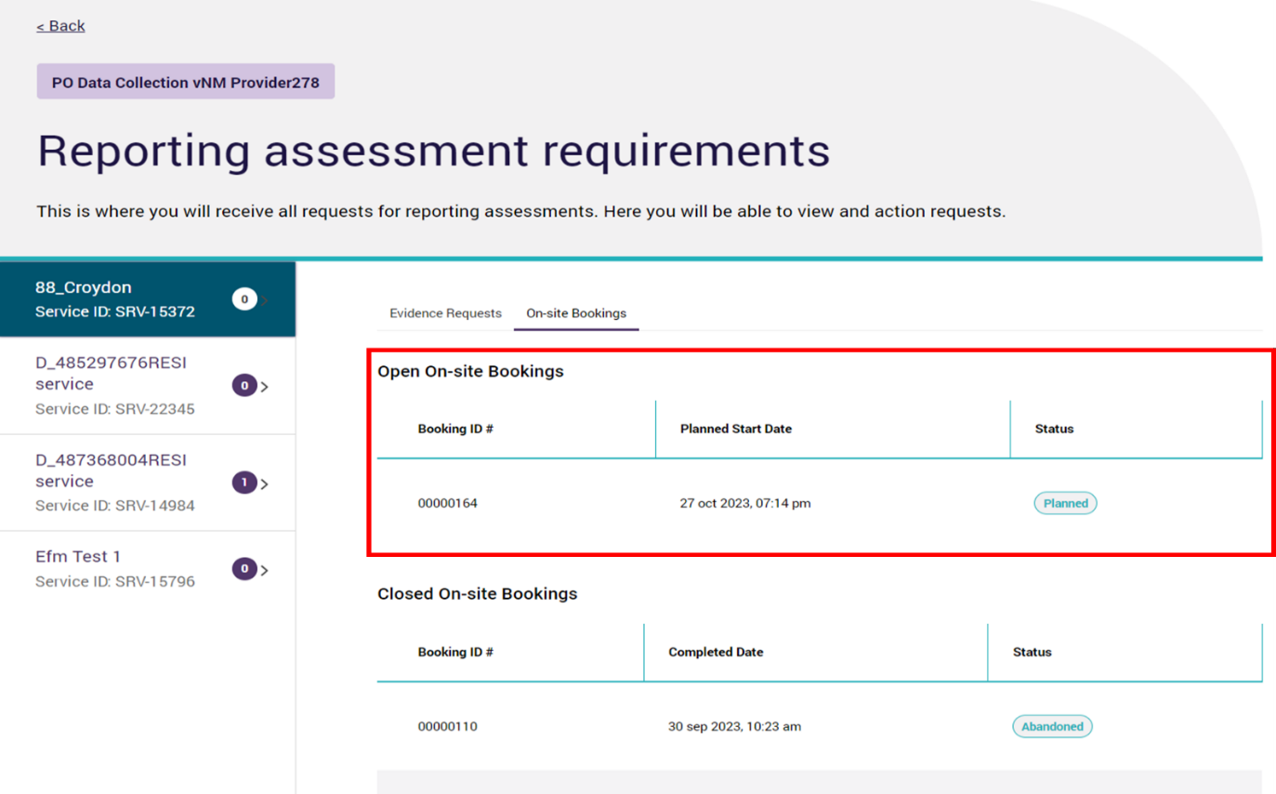

On-site Bookings can have the following statuses:

* **Planned:** The on-site visit has been booked but not actioned.
* **Abandoned:** The on-site visit has been cancelled.
* **Completed:** The auditor has visited the service in person.

**Please note:**

**Contact your assigned auditor if you have any enquiries on the on-site bookings.**

## Notifications

Key statuses about your reporting assessment are shown in notifications. Select the bell P130#yIS1 icon at the top right of the portal and any notifications will be displayed here.

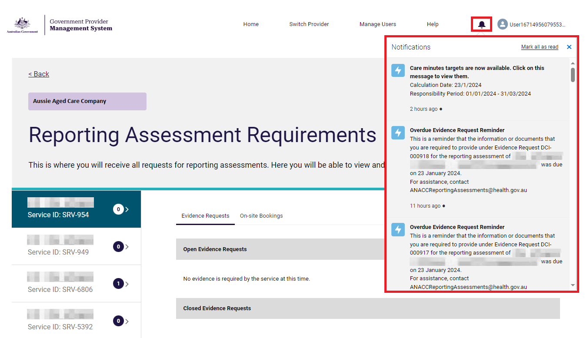

The types of notifications related to Reporting Assessments are:

1. **Reporting Assessment Cancellation:** Informs the provider of when an assessment has been cancelled. It will be sent directly after the cancellation has been confirmed within GPMS.
2. **Request for Documents:** Sent when an evidence request has been created, and is sent directly after the evidence request is made.
3. **Evidence Request Reminder:** Sent to remind providers that the evidence request is due soon It is sent 3 days, and 1 day, before the due date of the evidence request.
4. **Evidence Request Withdrawn:** Informs the provider of when an evidence request has been cancelled. It will be sent directly after the request cancellation has been confirmed within GPMS.
5. **Overdue Evidence Request Reminder:** Sent the day after the due date of the evidence request. Reminds the provider to complete the evidence request.
6. **On-Site Visit Booked:** Informs the provider that an on-site booking has been created for their service.
7. **On-Site Visit Abandoned:** Informs the provider of when an on-site booking has been cancelled. It will be sent directly after the cancellation has been confirmed within GPMS.
8. **On-Site Visit Updated:** Sent when there has been an update to an on-site booking. It will be sent directly after the update has been confirmed within GPMS, when either the date or time of the booking has been updated/changed.
9. **Reporting Assessment Completed:** Informs the provider of when an assessment has been completed. It will be sent directly after the assessment has been finalised within GPMS.

## Communications

Throughout the Reporting Assessment process, a member of the department will be in contact with you.

Initial contact will be made by a member of the department before anything appears in the portal for the Reporting Assessment. This member of the department will be your primary contact.

They will inform you about any evidence requests, and in the case an on-site visit is required, they will contact you to organise a date and time to conduct the on-site visit.

If you have any issues or enquiries with the Reporting Assessment, please use this member of the department as your first point of contact.

In the case that you cannot contact your assigned auditor, please email the Reporting Assessments Team ([ANACCReportingAssessments@health.gov.au](mailto:ANACCReportingAssessments@health.gov.au))