Government Provider Management System User Guide: Care Minutes Targets

February 2024

Version 1.0

This Government Provider Management System (GPMS) User Guide provides Residential Aged Care Providers with an overview of how to access the Care Minutes application, view current and upcoming Care Minutes Targets, and view historical Care Minutes Targets.

Contents

1. Introduction 3

1.1 Purpose 3

1.2 Before proceeding 4

1.3 Login to the GPMS portal 4

2. Further information and support 4

3. Care Minutes Targets 5

3.1 Accessing Care Minutes Targets 5

3.2 Care Minutes Target Summary 6

3.3 Care Minutes Detail 9

3.4 Care Minutes History 10

3.5 Notifications 11

# Introduction

Care minutes refer to the amount of direct care, measured in minutes, that care recipients in Australia living in residential care services receive from:

* registered nurses (RNs)
* enrolled nurses (ENs)
* personal care workers (PCWs), and
* assistants in nursing (AINs), also known as nursing assistants.

Approved providers of residential care services are required by law to ensure that a certain amount of direct care minutes is provided to care recipients at each residential care service each quarter.

## Purpose

This User Guide has been designed to support residential care service providers to:

* view their current care minutes targets for their residential care service/s.
* view their upcoming care minutes targets for their residential care service/s when available, until the start of the new care minutes responsibility period.
* access notifications when their care minutes targets become available.
* view historical care minutes targets.

**Please note:**

The Responsibility Period is the time period where the care minutes target must apply.

## Before proceeding

Please be advised of the following:

The Department of Health and Aged Care will retain records of your access to GPMS. When prompted, you must accept the [*GPMS Terms of Use*](https://www.health.gov.au/resources/publications/government-provider-management-system-terms-of-use?language=en) to be able to access the system.

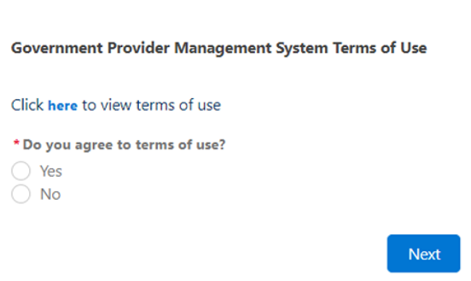

## Login to the GPMS portal

To login to the GPMS portal please visit [Log In Using | Service Provider Portal](https://provider.health.gov.au/serviceproviderportal/login?ec=302&startURL=%2Fserviceproviderportal%2Fs%2F).

If you require assistance logging into the GPMS portal, please refer to the GPMS [Logging in to the Aged Care Systems](https://www.health.gov.au/resources/publications/logging-in-to-the-aged-care-systems).

# Further information and support

For information on the care minutes responsibility, please visit the [Care Minutes](https://www.health.gov.au/our-work/care-minutes-registered-nurses-aged-care/care-minutes) website.

Please refer to the [Government Provider Management System](https://www.health.gov.au/our-work/government-provider-management-system) webpage for more information on GPMS.

If you require further assistance to login to GPMS please contact the My Aged Care service provider and assessor helpline on **1800 836 799**, Monday to Friday (8am to 8pm) and Saturday (10am to 2pm) local time across Australia.

For translating and interpreting services, call **131 450** and ask for My Aged Care service provider and assessor helpline on **1800 836 799.**

To use the National Relay Service, visit [About the National Relay Service (NRS) | Access Hub](https://www.accesshub.gov.au/about-the-nrs) or call **1800 555 660**.

To access sign language interpreting and captioning services through Deaf Connect, call [**1300 773 803**](tel:1300%20773%20803) or email [interpreting@deafconnect.org.au](mailto:interpreting@deafconnect.org.au).

# Care Minutes Targets

## Accessing Care Minutes Targets

Care Minutes Targets are accessed through the GPMS portal.

Users with the role ‘SR Reviewer’ (organisation level) or ‘SR Reviewer’ (service level) will be able to access Care Minutes Targets.

If you do not have this role you will need to discuss your need with your Organisation Administrator.

If you are an Organisation Administrator, you can assign yourself and other staff members access. To do this, please refer to the [[Government Provider Management System – User Guide](https://www.health.gov.au/resources/publications/government-provider-management-system-user-guide?language=en)](https://www.health.gov.au/resources/publications/government-provider-management-system-user-guide?language=en) for more information.

New GPMS users will receive a welcome email that provides a link to the GPMS portal and next steps. Refer to the [GPMS User Guide](https://www.health.gov.au/resources/publications/government-provider-management-system-user-guide?language=en) for more information.

Once access is granted, on the GPMS Provider Portal home page, select the ‘Care Minutes Targets’ tile.

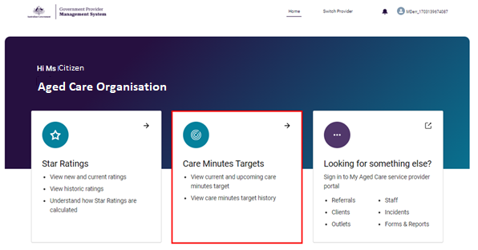

It will then take you to the ‘All Services’ page, otherwise known as the ‘Display Summary’ page.

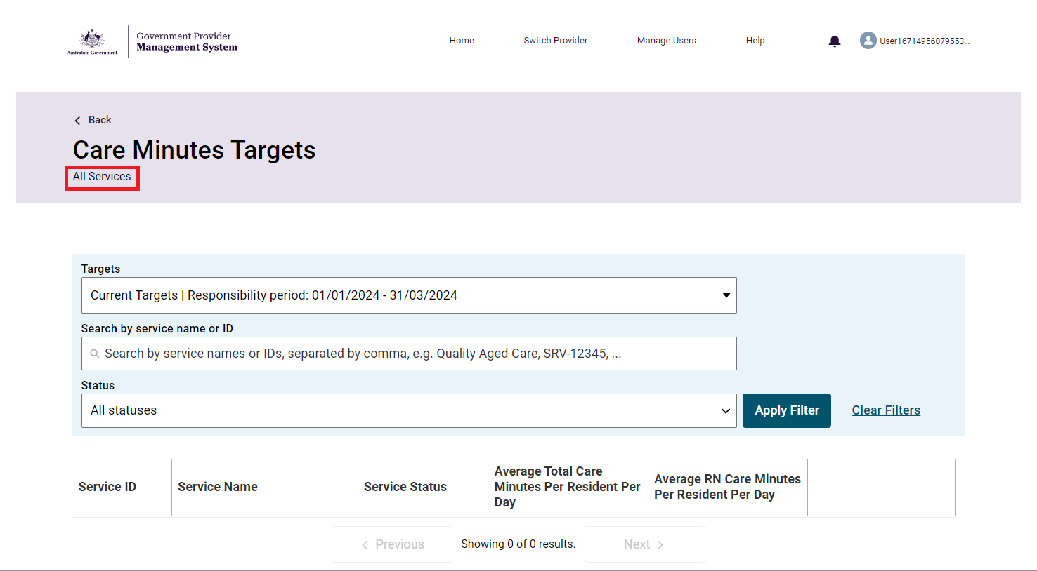

**Please note:**

You will need either the SR Reviewer (organisation) or SR Reviewer (service) role to access Care Minutes Targets.

If you cannot see the Care Minutes Target tile on the GPMS portal landing page, notify your Organisation Administrator.

## Care Minutes Target Summary

On this page, you can view the list of service/s attached to the provider with their details and their care minutes target. This includes:

* service ID
* service name
* service status
* average total care number of care minutes per resident per day, and
* average RN (registered nurse) care minutes per resident per day.

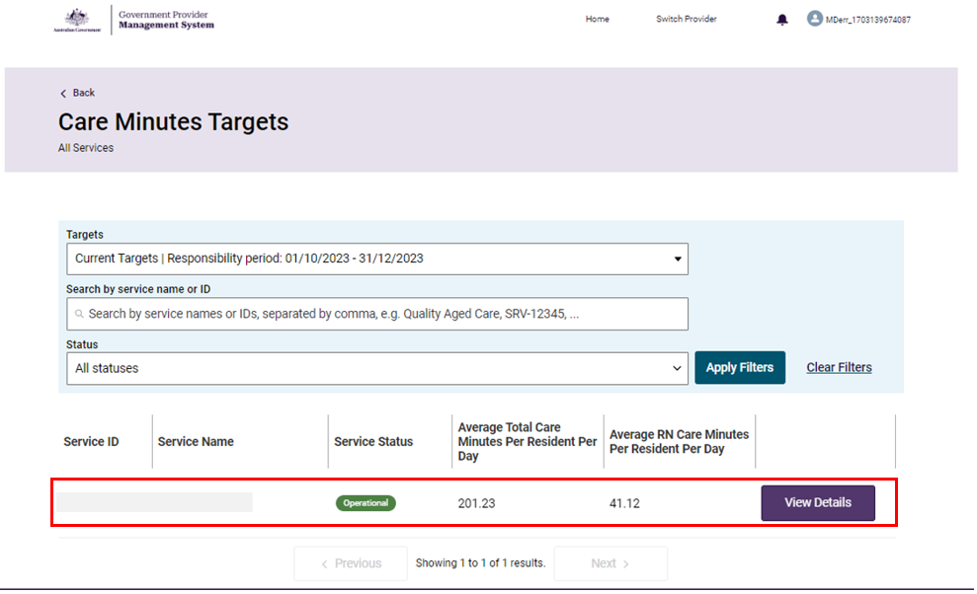

There are two filters available: Targets, and Status.

For example, to view care minutes for the current responsibility period, select “*Current Targets | Responsibility period: <Responsibility Period Start Date – End Date>”* from the Targets dropdown. To view upcoming care minutes targets, select “*Upcoming Targets | Responsibility period: <Responsibility Period Start Date – End Date>”* from the Targets dropdown.

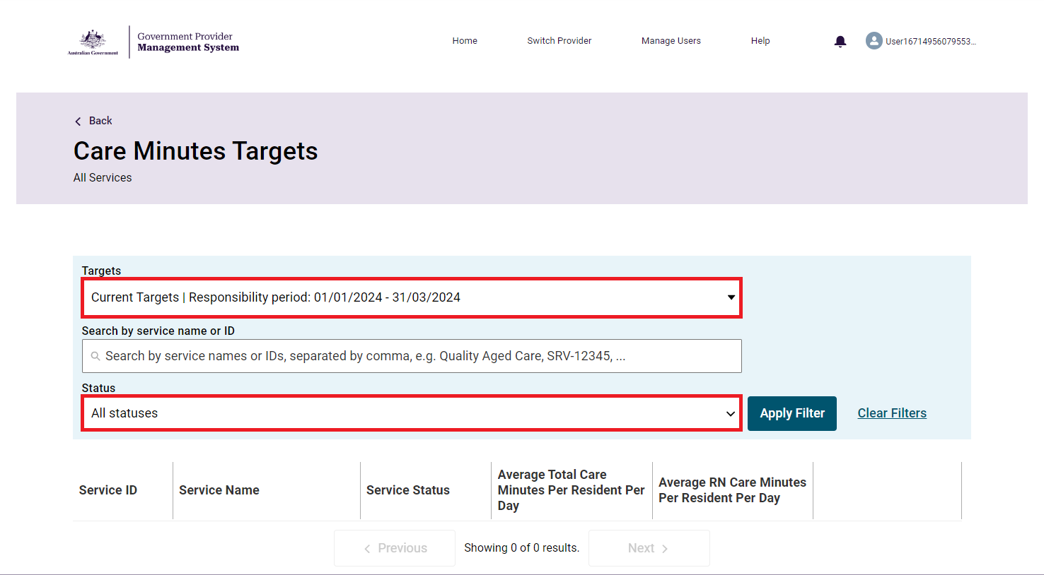

**Please note**:

When selecting ‘Upcoming Targets’ from the ‘Targets’ filter, the page will display the list of services, only when upcoming targets for the services are available (that is from the 15th day of the month prior to the commencement of the responsibility period).

Use the **search bar** to search for service name/s or service ID/s. You can then sort the list of services based on service name, service ID, and service status.

Select the **View Details** button next to a service, to open the Care minutes detail page for that service.

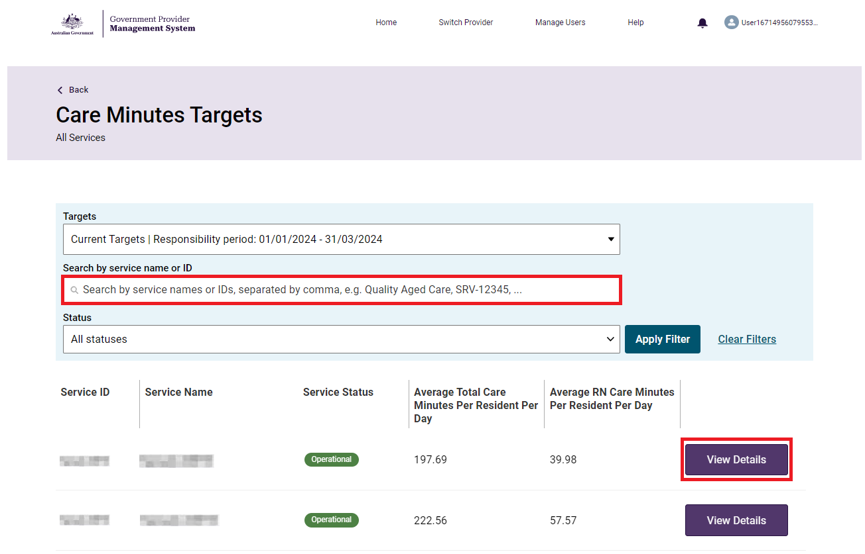

## Care Minutes Detail

The ‘Care Minutes Detail’ page, titled by Service ID and Status, shows the care minutes detail of a service. You can view the care minutes target for the current responsibility period, for the duration of the current responsibility period.

You can view the following in each detailed record:

* Service name, service ID and service status
* Current Targets heading
* Upcoming Targets heading (when available)
* Period type (such as Quarterly)
* Calculation date
* Calculation period (start and end date)
* Average care minutes per resident per day, including total care minutes, and Registered Nurse care minutes.
* Responsibility period (start and end date).

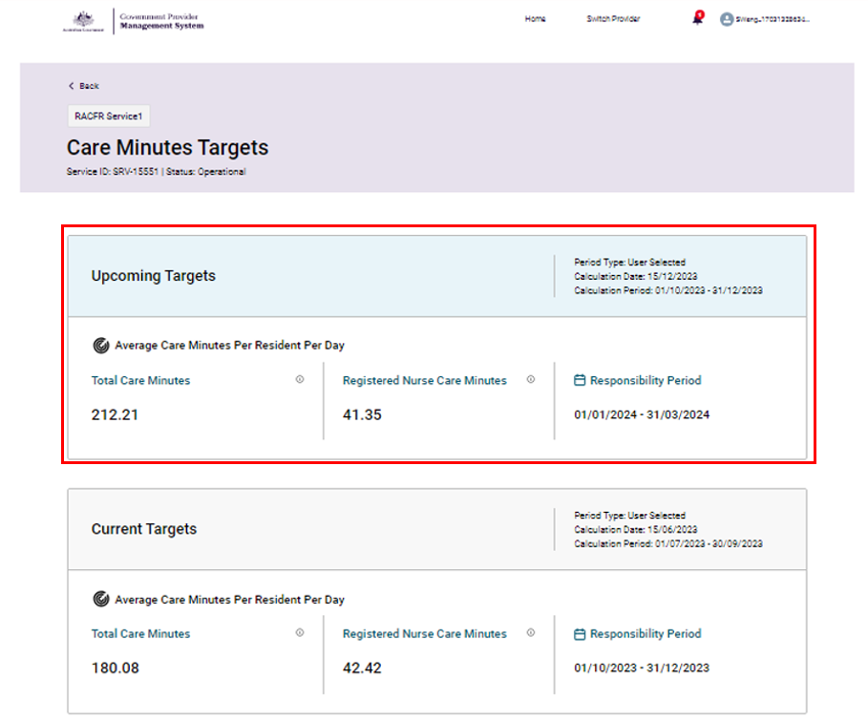

**Please note:**

‘Total Care Minutes’ is the average total care minutes required to be delivered by a combination of registered nurses, enrolled nurses, and personal care workers/assistants in nursing, per resident per day.

‘Registered Nurse Care Minutes’ indicates the average care minutes required to be delivered by a registered nurse per resident per day and are included as part of Total Care Minutes.

Select the ToolTip Tooltip symbol - circle with a letter i inside to read the description.

To go back to the Care Minutes Summary page, select ‘Back’.

**Please note:**

The ‘Upcoming Targets’ section will appear only when upcoming targets are calculated and available for the service, that is from the 15th day of the month prior to the commencement of the responsibility period. The ‘Upcoming Targets’ section will not be shown once the upcoming responsibility period begins.

## Care Minutes History

In this section, located at the bottom of the ‘Care Minutes Detail’ page, you can view previous (historical) care minutes information.

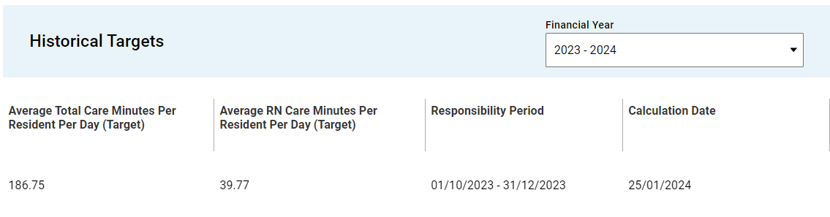

In the Financial Year drop down menu, you can choose to view up to the last five financial years’ worth of targets.

You can view the following in each historical record:

* Calculation date
* Average total care minutes per resident per day (target)
* Average RN care minutes per resident per day (target)

Responsibility period (start and end date)

## Notifications

You will receive notification in the GPMS portal whenever care minutes have been calculated for your service.

To view a notification, at the GPMS portal home page, select the notification tray (bell symbol) to expand the Notifications drop down. Then, select a notification to view.

When you select the ‘Care minutes targets are now available’ notification, it will take you to the Care Minutes Target application, to view the targets for your applicable service/s.

