Australian Respiratory Surveillance Report
Report 16, 2024

Key messages
This report presents a national epidemiological update for coronavirus disease 2019 (COVID-19), influenza and respiratory syncytial virus (RSV) with a focus on the current reporting period (21 October to 17 November 2024) and earlier severity reporting periods (up to 3 November 2024).
Activity: In recent weeks, respiratory illness activity (self-reported new fever and cough symptoms) in the community has increased and are currently similar to the levels of activity observed in the same period in previous years. General practice consultation rates for respiratory illnesses (new fever and cough symptoms) monitored through sentinel surveillance sites have decreased in the last month but remain similar to consultation rates observed in the same period in previous years. Nationally, COVID-19 activity has been increasing in the past month, signaling that a new wave of transmission may have begun. Influenza activity has decreased considerably since July 2024, and activity has now returned to interseasonal levels. RSV activity has been decreasing since late May 2024.
Severity: The number of patients hospitalised with COVID-19 monitored through sentinel hospital-based surveillance has remained relatively stable across September and October 2024, though some week-on-week increases have been observed recently. The number of patients hospitalised with influenza and RSV monitored through sentinel hospital-based surveillance have been decreasing overall, since reaching a peak in April 2024 and July 2024, respectively. The proportion of those patients with a severe acute respiratory infection who were admitted directly to an intensive care, monitored through sentinel hospital-based surveillance, has remained low and stable in 2024. Nationally, the number of patients admitted to sentinel intensive care surveillance sites with a severe acute respiratory infection has remained relatively low and stable across October 2024. Patients with COVID-19 accounted for most severe acute respiratory infection admissions at sentinel intensive care surveillance sites this year.
At-risk populations: In the year to date, most deaths in patients admitted to sentinel intensive care sites with a severe acute respiratory infection occurred in those aged 60 years or over. In the year to date, age-specific mortality rates for cases have been highest among those aged 70 years or over.
Impact: Fewer people reported taking time off work due to respiratory illness (self-reported new fever and cough symptoms) last month, compared with the previous month. Nationally, the number of COVID-19 cases in intensive care increased this month. Similarly, the average number of intensive care staff unavailable due to COVID-19 illness or exposure has increased this month.
Genomic surveillance and virology: The Omicron BA.2.86 sublineage, JN.1, remains the dominant circulating sub-lineage (which includes the KP, JN.1.17, and JN.1.8 sub-sub-lineages). The KP.3 sub-sub-lineage is the most common JN.1 sub-lineage in AusTrakka. There has been an increasing proportion of the recombinant lineage XEC sequenced recently. This lineage has attracted recent attention due to its estimated growth rate. This year, influenza A has accounted for most influenza notifications nationally.
Vaccine coverage, effectiveness and match: Australian studies suggest that in 2024, vaccinated individuals are roughly 60% less likely to attend general practice or be hospitalised with influenza than unvaccinated people. COVID-19 and RSV vaccination data will be included in future iterations of the Australian Respiratory Surveillance Report.

Introduction
This Australian Respiratory Surveillance Report was prepared by Jenna Hassall, Suzie Whitehead, Nga Nguyen and Aaliya Ibrahim on behalf of the interim Australian Centre for Disease Control. We thank the staff and participants from the surveillance systems who contribute data for acute respiratory illness surveillance across Australia.
The Australian Respiratory Surveillance Reports present a national overview of acute respiratory infections in Australia, drawing information from several different surveillance systems. Our surveillance systems help us to understand the distribution of acute respiratory illness activity in the community, the severity of disease, which populations might be at risk of severe disease, and the impact of acute respiratory illness on the community and health system in Australia. Surveillance indicators presented in this report are based on the Australian National Surveillance Plan for COVID-19, Influenza, and RSV.
A summary of data considerations for this Australian Respiratory Surveillance Report are provided below. Please refer to the Technical Supplement – Australian Respiratory Surveillance Report for further detail on our surveillance sources and data considerations, including the considerable impact of the COVID-19 pandemic on acute respiratory infection surveillance in Australia.

Data considerations
- Due to the dynamic nature of the surveillance systems used in this report, surveillance data are considered preliminary and subject to change as updates are received, with the most recent weeks considered particularly incomplete. Data in this report may vary from data reported in other national reports and reports by states and territories. Data in this report are presented by International Organization for Standardization (ISO) 8601 weeks, where the week ends on a Sunday.
- In Australia, states and territories report notified cases to the National Notifiable Diseases Surveillance System (NNDSS) based on the Australian national surveillance case definitions. From 1 July 2024, only laboratory-confirmed COVID-19 cases are notified to the NNDSS and included in this report (except where specified otherwise). NNDSS data are analysed and reported based on diagnosis date, which is the true onset date of a case if known, otherwise it is the earliest of the specimen date, the notification date, or the notification received date. NNDSS data for this report were extracted on 20 November 2024.
- To account for the lag in collection and provision of severity data from some surveillance systems, and for the time delay between illness onset and the development of severe disease outcomes, cases with an admission date or a diagnosis date in the last two weeks are excluded from severity analyses, which includes analyses of hospitalisations, intensive care admissions and deaths. As such, the severity reporting periods are two weeks behind the end of the current reporting period. For this report, severity reporting includes data up to 3 November 2024.
- While every care has been taken in preparing this report, the Australian Government Department of Health and Aged Care does not accept liability for any injury or loss or damage arising from the use of, or reliance upon, the content of the report or Technical Supplement. For further information about this report please refer to the Technical Supplement – Australian Respiratory Surveillance Report or contact respiratory.surveillance@health.gov.au.

1. Activity
Activity measures the capacity of the circulating respiratory viruses to spread from person to person and may be measured indirectly through systems that monitor acute respiratory illnesses and more directly through systems that monitor cases.

1.1 Community-based surveillance

FluTracking
- Community surveys suggest respiratory illness symptoms and test positivity have increased this month, indicating respiratory viruses are continuing to circulate in the community past winter. This is likely due to increased SARS-CoV-2 circulation in recent weeks.
- This month (21 October to 17 November 2024), more FluTracking participants reported new fever and cough symptoms (1.4%), than in the previous month (1.2%) (Figure 1).
- This month, a larger proportion of FluTracking participants with new fever and cough symptoms used a rapid antigen test (RAT) (63.0%; 998/1,584) compared with a polymerase chain reaction (PCR) (14.5%; 230/1,584) to test for severe acute respiratory syndrome coronavirus 2 (SARS-CoV-2).
  - Self-reported SARS-CoV-2 RAT positivity was higher this month (37.6%; 375/998) than in the previous month (24.2%; 277/1,146). Likewise, self-reported SARS-CoV-2 PCR positivity was higher this month (16.1%; 37/230) than in the previous month (8.2%; 26/316).
- This month, 19.8% (313/1,584) of FluTracking participants with new fever and cough symptoms used a PCR test to test for influenza.
  - Self-reported influenza PCR positivity was lower this month (10.9%; 34/313), than in the previous month (16.5%; 67/405).
- In the year to date, new fever and cough symptoms in FluTracking participants has fluctuated, peaking at 2.6% in late June 2024 (Figure 1).

Figure 1: Age standardised percentage of FluTracking participants reporting new fever and cough symptoms compared with the five-year mean by year and week of report*, Australia, 2017 to 17 November 2024
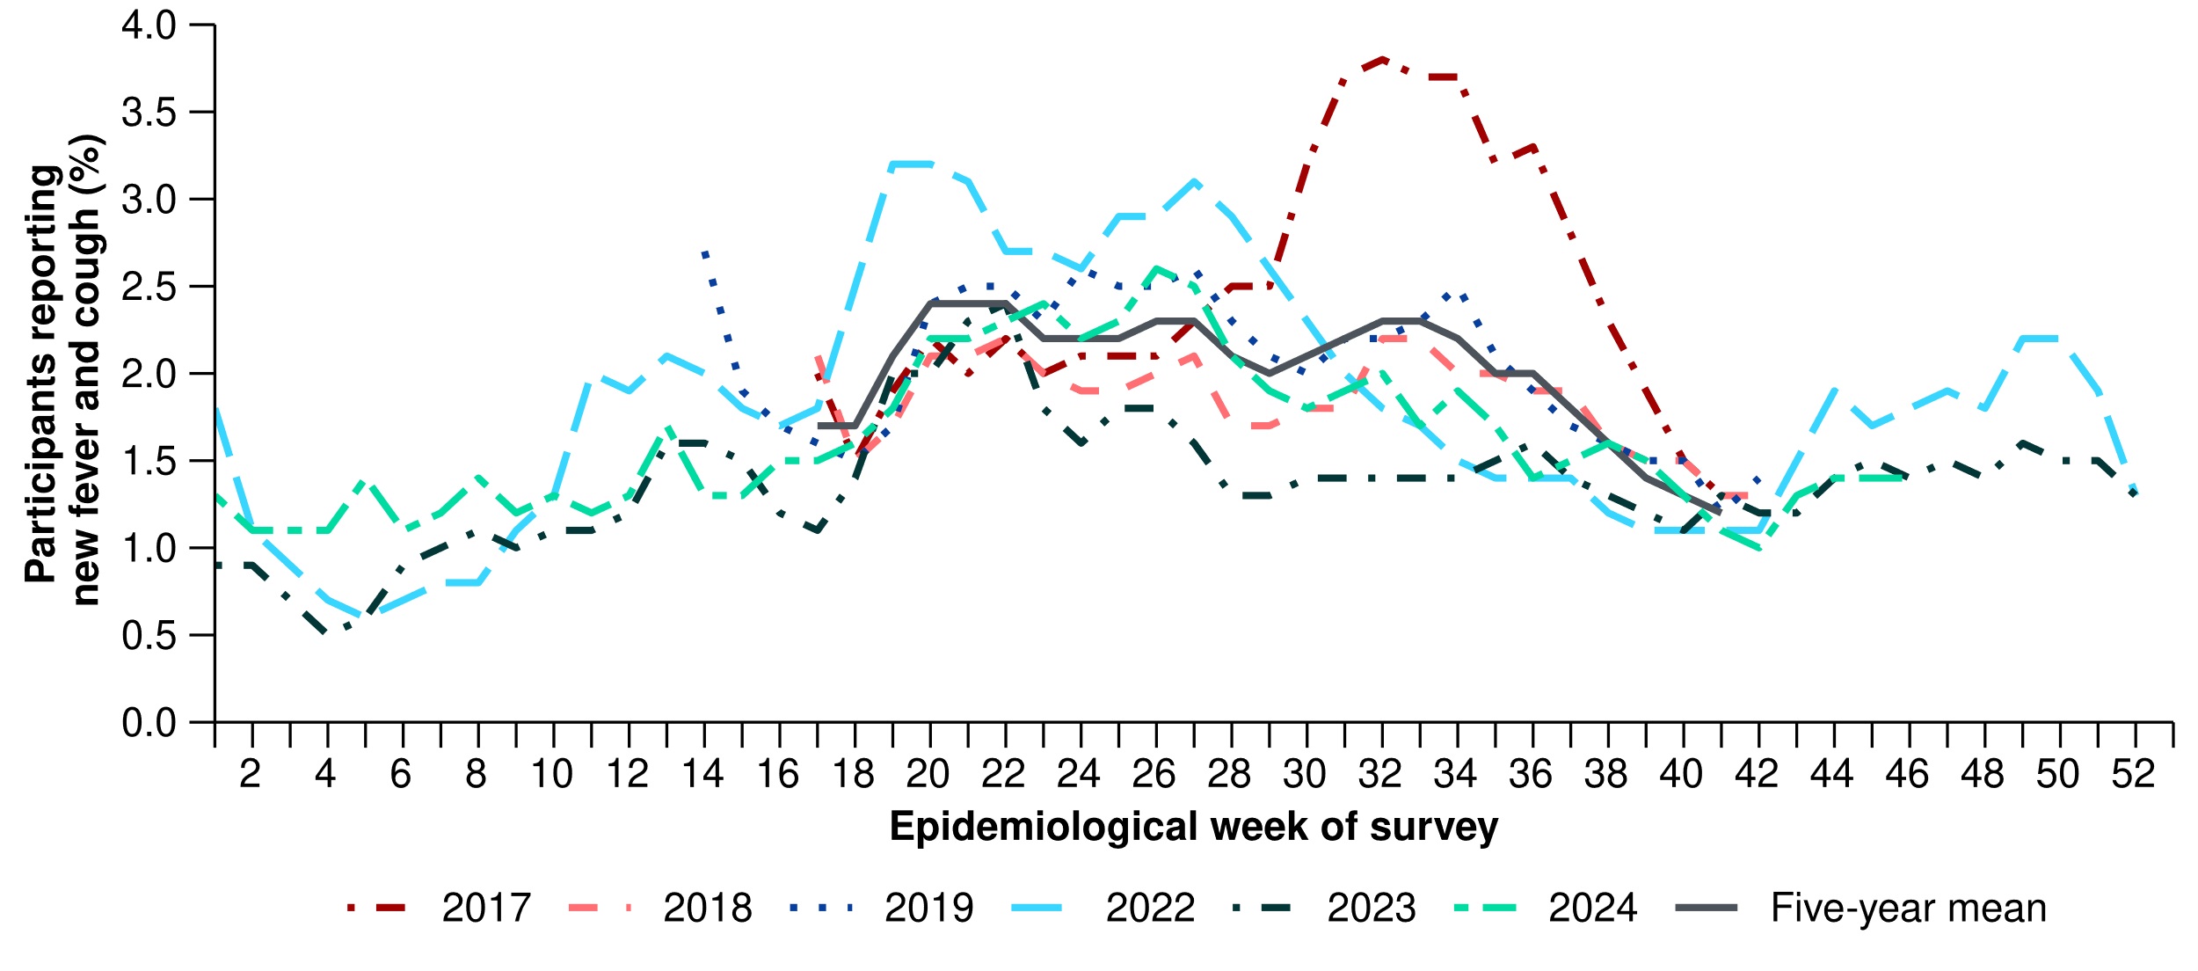
* FluTracking has expanded the reporting period from 2020 onwards due to COVID-19. As such, five-year historical comparisons are not available for data reported before May and after October for any year before 2020. The years 2020 and 2021 are excluded when comparing the current season to historical periods when influenza virus has circulated without public health restrictions. As such, the five-year mean includes the years 2017 to 2019 and 2022 to 2023. Please refer to the Technical Supplement for interpretation of the five-year mean and for notes on impact of COVID-19 on FluTracking data.

Australian Sentinel Practice Research Network (ASPREN)
- Sentinel general practice surveillance suggests medical attendance for respiratory illness is decreasing this month, though a variety of respiratory pathogens continue to circulate in the community, with rhinovirus and human metapneumovirus being the most common.
- This month (21 October to 17 November 2024), there were fewer general practice consultations for new fever and cough symptoms (4.5 per 1,000 consultations per month) than in the previous month (4.8 per 1,000 consultations per month) (Figure 2).
  - Of those who presented with new fever and cough symptoms, 68.9% (82/119) tested positive for a respiratory pathogen. Rhinovirus (39.0%; 32/82) was the most commonly detected, followed by human metapneumovirus (17.1%; 14/82), SARS-CoV-2 (13.4%; 11/82), and parainfluenza type-3 (9.8%; 8/82).
- In the year to date, general practice consultations for new fever and cough symptoms have fluctuated, peaking at 13.4 per 1,000 consultations in early August 2024 (Figure 2).
- In the year to date, 67.5% (1,745/2,585) of people attending general practice for new fever and cough symptoms have then tested positive for a respiratory pathogen. Rhinovirus (30.4%; 531/1,745) was the most commonly detected, followed by influenza (22.7%; 396/1,745), SARS-CoV-2 (11.5%; 200/1,745), RSV (8.4%; 146/1,745), and human metapneumovirus (7.6%; 132/1,745).

Figure 2: Rate of new fever and cough symptoms per 1,000 consultations per week with ASPREN sentinel general practitioners and nurse practitioners compared with the five-year mean by year and week of consultation*†, Australia, 2017 to 17 November 2024
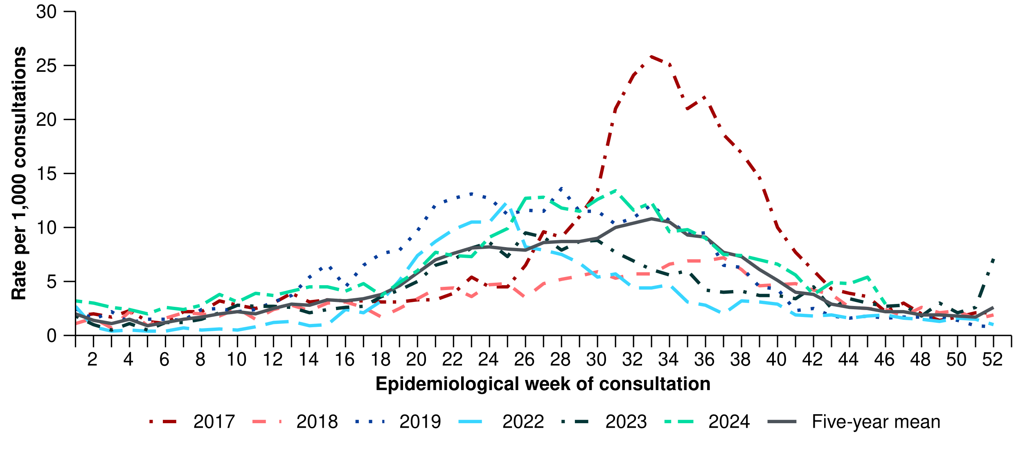
* The years 2020 and 2021 are excluded when comparing the current season to historical periods when influenza virus has circulated without public health restrictions. As such, the five-year mean includes the years 2017 to 2019 and 2022 to 2023. Please refer to the Technical Supplement for interpretation of the five-year mean.
† Please refer to the Technical Supplement for notes on impact of COVID-19 on ASPREN data.

1.2 Case-based surveillance

NNDSS
- Nationally, COVID-19 activity has been consistently increasing in the past month, signalling that a new wave of transmission may have begun. This is similar to trends observed over the 2023-24 summer period. This recent increase follows a decreasing trend since early June 2024 when activity last peaked. All jurisdictions experienced relatively consistent timing of peaks in COVID-19 activity across late May and June 2024.
- Nationally, influenza activity has decreased considerably since July 2024, and influenza activity has now returned to interseasonal levels. The peak of influenza activity in each jurisdiction varied across Australia, generally occurring between May and early August 2024.
- Nationally, RSV activity has remained low and stable across November, following a decreasing trend since late May 2024. As with influenza, the peak in RSV activity has not been consistent across all jurisdictions. Some jurisdictions reached a peak in April 2024, while other jurisdictions did not reach a peak until either July or August 2024.
Table 1: Notifications to the NNDSS and notification rate per 100,000 population by disease, five-year age group, and jurisdiction*†, Australia, 1 January to 17 November 2024
 | COVID-19 |  |  | Influenza |  |  | RSV
 | Reporting  period  (n) | Year to  date  (n) | Year to  date  (rate) | Reporting  period  (n) | Year to  date  (n) | Year to  date  (rate) | Reporting  period  (n) | Year to  date  (n) | Year to  date  (rate)
Age group (years)
0–4 | 1,446 | 21,223 | 1,399.9 | 463 | 47,985 | 3,165.2 | 1,711 | 82,593 | 5,448.1
5–9 | 589 | 6,354 | 394.6 | 660 | 51,438 | 3,194.1 | 384 | 14,132 | 877.5
10–14 | 732 | 6,653 | 401.4 | 469 | 33,233 | 2,005.2 | 242 | 7,219 | 435.6
15–19 | 921 | 8,066 | 501.4 | 410 | 22,268 | 1,384.1 | 135 | 3,840 | 238.7
20–24 | 698 | 8,810 | 508.7 | 266 | 17,149 | 990.2 | 61 | 2,745 | 158.5
25–29 | 770 | 11,149 | 580.2 | 255 | 19,279 | 1,003.3 | 72 | 3,112 | 161.9
30–34 | 943 | 13,340 | 672.9 | 313 | 21,392 | 1,079.0 | 115 | 4,055 | 204.5
35–39 | 1,043 | 14,569 | 751.8 | 334 | 23,266 | 1,200.6 | 87 | 4,099 | 211.5
40–44 | 1,078 | 14,015 | 787.3 | 315 | 20,908 | 1,174.5 | 95 | 3,513 | 197.3
45–49 | 1,035 | 12,844 | 795.7 | 268 | 16,099 | 997.3 | 88 | 3,408 | 211.1
50–54 | 1,013 | 13,624 | 810.8 | 267 | 15,133 | 900.6 | 112 | 4,254 | 253.2
55–59 | 886 | 13,220 | 867.7 | 277 | 13,112 | 860.6 | 126 | 4,152 | 272.5
60–64 | 1,008 | 14,170 | 934.3 | 243 | 12,740 | 840.0 | 167 | 4,831 | 318.5
65–69 | 1,051 | 14,913 | 1,123.9 | 215 | 10,324 | 778.0 | 157 | 4,722 | 355.9
70+ | 5,873 | 90,258 | 2,794.4 | 682 | 31,241 | 967.2 | 692 | 20,523 | 635.4
Jurisdiction
ACT | 314 | 4,290 | 919.0 | 80 | 4,744 | 1,016.3 | 40 | 2,679 | 573.9
NSW | 7,166 | 115,306 | 1,382.7 | 1,687 | 158,476 | 1,900.3 | 1,484 | 70,615 | 846.8
NT | 133 | 2,472 | 979.1 | 25 | 3,250 | 1,287.3 | 100 | 1,509 | 597.7
Qld | 3,685 | 59,561 | 1,091.0 | 905 | 77,918 | 1,427.2 | 1,424 | 38,935 | 713.2
SA | 1,205 | 16,813 | 908.0 | 663 | 21,946 | 1,185.2 | 285 | 11,863 | 640.7
Tas. | 416 | 4,291 | 749.2 | 133 | 3,919 | 684.2 | 124 | 2,719 | 474.7
Vic. | 5,246 | 46,754 | 686.3 | 1,472 | 69,024 | 1,013.2 | 465 | 29,950 | 439.6
WA | 973 | 14,058 | 488.4 | 472 | 16,320 | 566.9 | 322 | 8,946 | 310.8
Total | 19,138 | 263,545 | 989.3 | 5,437 | 355,597 | 1,334.9 | 4,244 | 167,216 | 627.7
* Rate per 100,000 population for the given time period. Population data are based on the Australian Bureau of Statistics (ABS) Estimated Resident Population (ERP) as at June 2023.
† Total includes cases with missing age.

- This year to date, COVID-19 notifications showed an increasing trend starting in late March, reaching a peak in early June 2024. From June to August, COVID-19 notifications declined, but there has been an increasing trend again since mid-October 2024 (Figure 3).
- In the year to date, there have been fewer laboratory-confirmed COVID-19 notifications than in the same period in 2023; however, this trend should be interpreted with caution due to a reduction in case ascertainment and reporting in all jurisdictions (Figure 3).
- In the year to date, COVID-19 notification rates have been highest in people aged 70 years or over years, followed by children aged 0–4 years (Table 1).
  - The trend for older age groups is likely to be a reflection of higher case ascertainment due to targeted testing strategies in place for populations at-risk of severe disease and who live in a high-risk setting, such as a residential aged care facility.
- This month, increases in COVID-19 notification rates have been observed across all jurisdictions compared with the previous month (Figure 4).

Figure 3: COVID-19 cases notified to the NNDSS showing (A) laboratory-confirmed and probable cases in all pandemic years 2020–2024 and (B) laboratory-confirmed cases in recent pandemic years 2023 and 2024 by year and week of diagnosis, Australia, 1 January 2020 to 17 November 2024
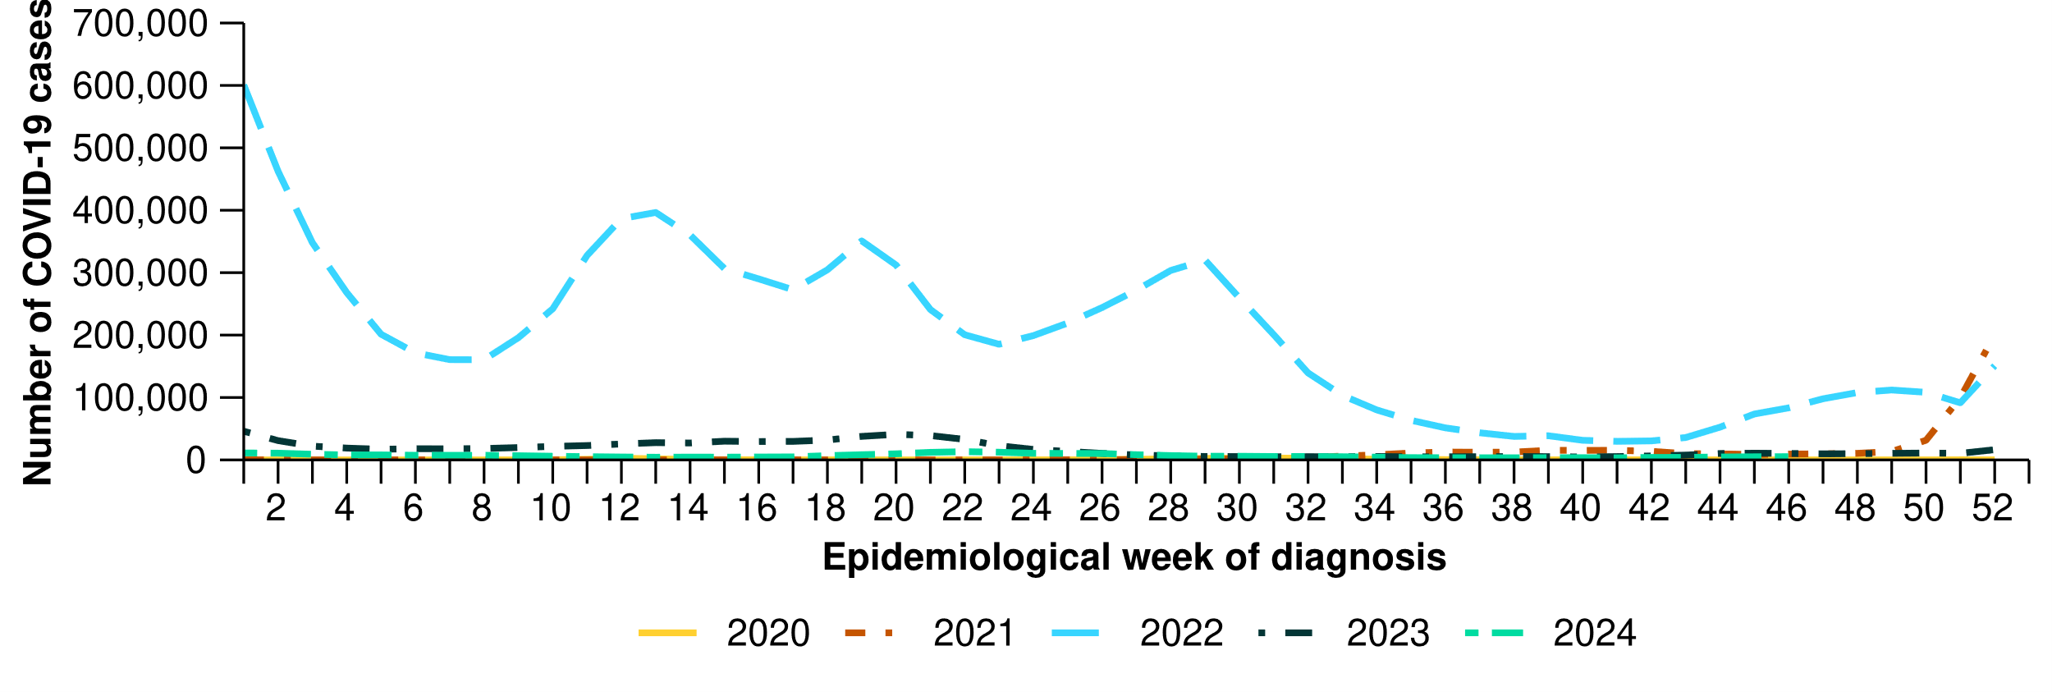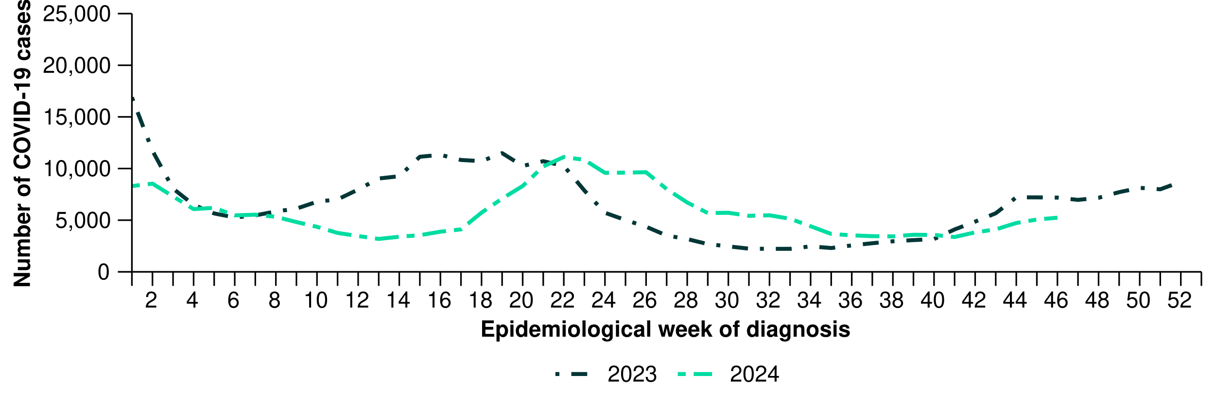

Figure 4: Notification rates per 100,000 population for COVID-19 cases notified to the NNDSS* by state or territory and week of diagnosis, Australia, 1 January to 17 November 2024
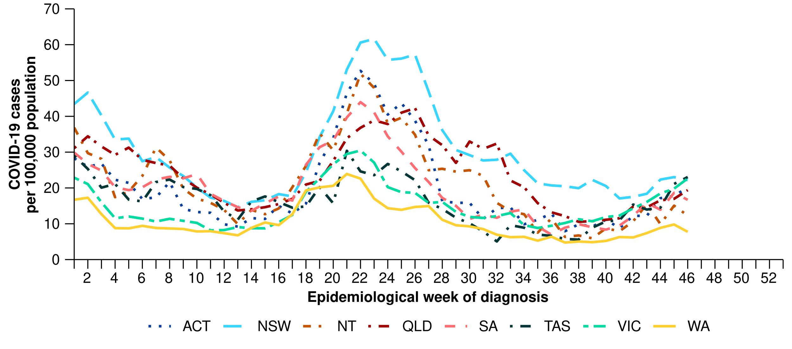
* Rate per 100,000 population for the given time period. Population data are based on the ABS ERP as at June 2023.
- This year to date, there was an increase in influenza notifications from late April to a peak in early July 2024. Influenza notifications have now returned to interseasonal levels (Figure 5). The timing of peaks in influenza notifications has varied across jurisdictions, occurring between May and early August 2024; however, the Northern Territory experienced peaks in April and May 2024, followed by a smaller peak in early September 2024 (Figure 6).
- In the year to date, there have been more influenza notifications than in the same period in 2023 and the five-year mean (Figure 5).
- In the year to date, influenza notification rates have been highest in children aged 5–9 years, followed closely by children aged 0–4 years (Table 1).
- This month, influenza notification rates have continued to decrease or have plateaued across most jurisdictions, compared with the previous month (Figure 6).

Figure 5: Influenza cases notified to the NNDSS and five-year mean* by year and week of diagnosis, Australia, 2017 to 17 November 2024
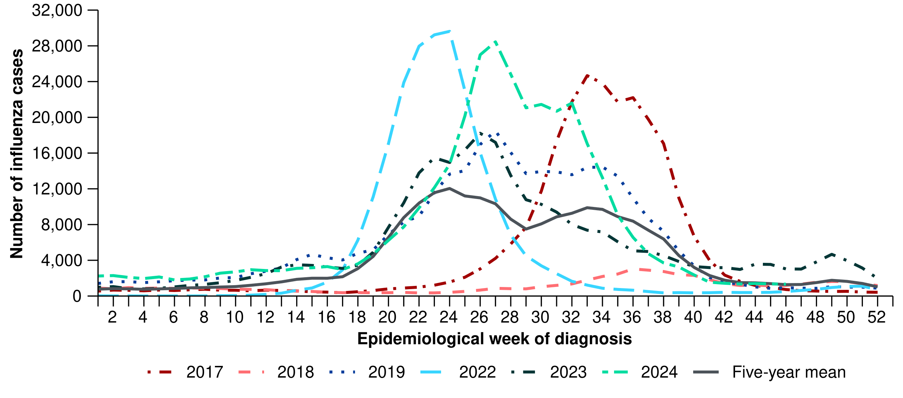
* The years 2020 and 2021 are excluded when comparing the current season to historical periods when influenza virus has circulated without public health restrictions. As such, the five-year mean includes the years 2017 to 2019 and 2022 to 2023. Please refer to the Technical Supplement for interpretation of the five-year mean.
Figure 6: Notification rates per 100,000 population for influenza cases notified to the NNDSS* by state or territory and week of diagnosis, Australia, 1 January to 17 November 2024
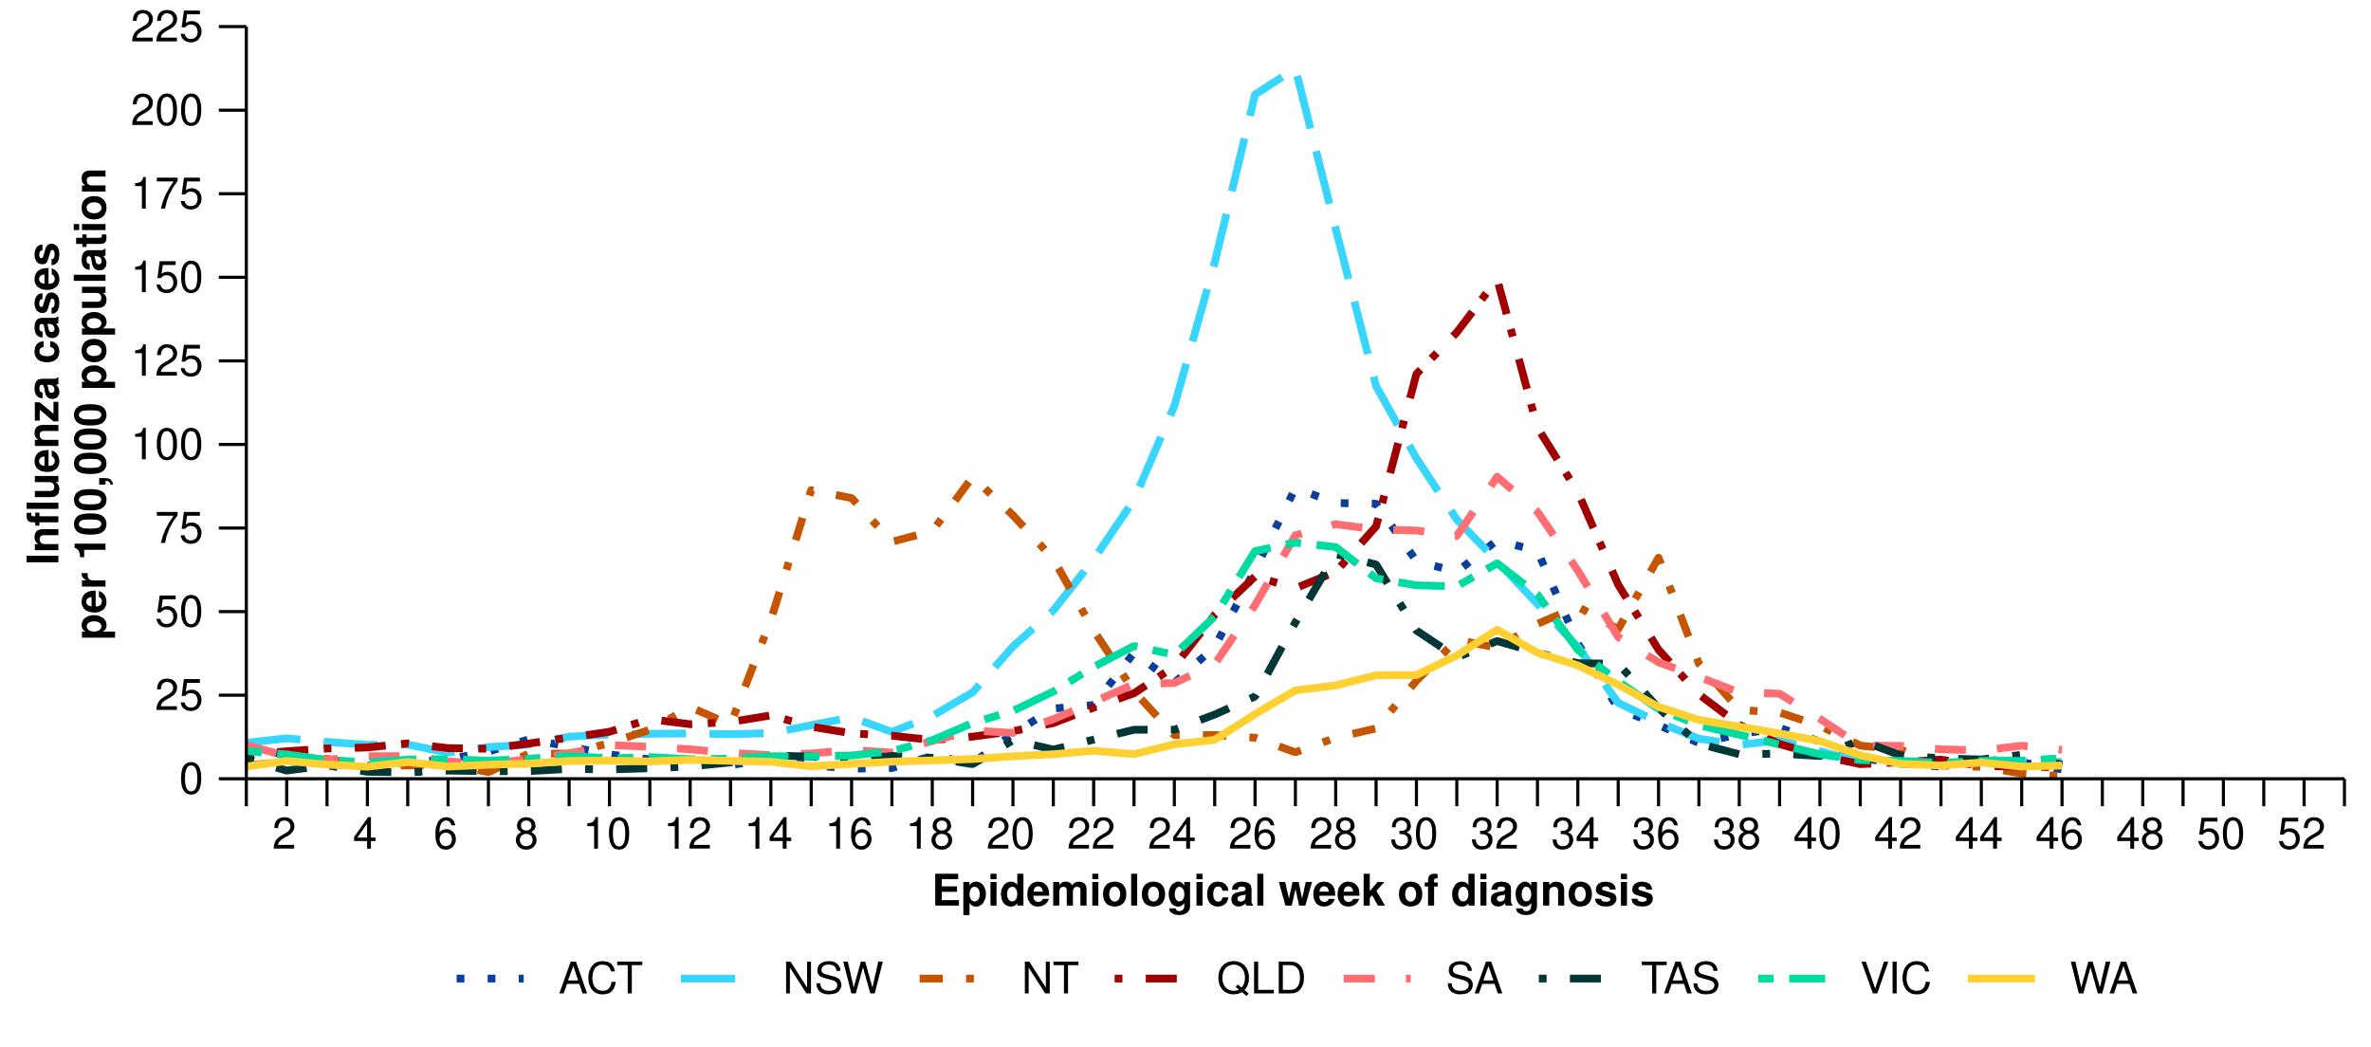
* Rate per 100,000 population for the given time period. Population data are based on the ABS ERP as at June 2023.
- This year to date, RSV notifications increased from January through to a peak in late May 2024, after which notifications have followed a decreasing trend (Figure 7). However, this trend in RSV notifications has not been consistent across all jurisdictions. Some jurisdictions (the Northern Territory) reached a peak in April 2024, while other jurisdictions (South Australia, Tasmania and Western Australia) did not reach a peak until either July or August 2024 (Figure 8). Most jurisdictions have observed a consistent decrease in RSV notifications since mid-July 2024, except Western Australia where RSV activity began decreasing after mid-August 2024.
- In the year to date, the number of RSV notifications is almost 1.4 times higher than the number of notifications in the same period in 2023 (Figure 7).
- In the year to date, RSV notification rates have been highest in children aged 0–4 years, followed by children aged 5–9 years (Table 1).
- This month, RSV notification rates have remained low and stable across most jurisdictions compared to the previous month, except in the Northern Territory where an increase in RSV notifications was observed (Figure 8).

Figure 7: RSV cases notified to the NNDSS by year and week of diagnosis*, Australia, 2023 to 17 November 2024
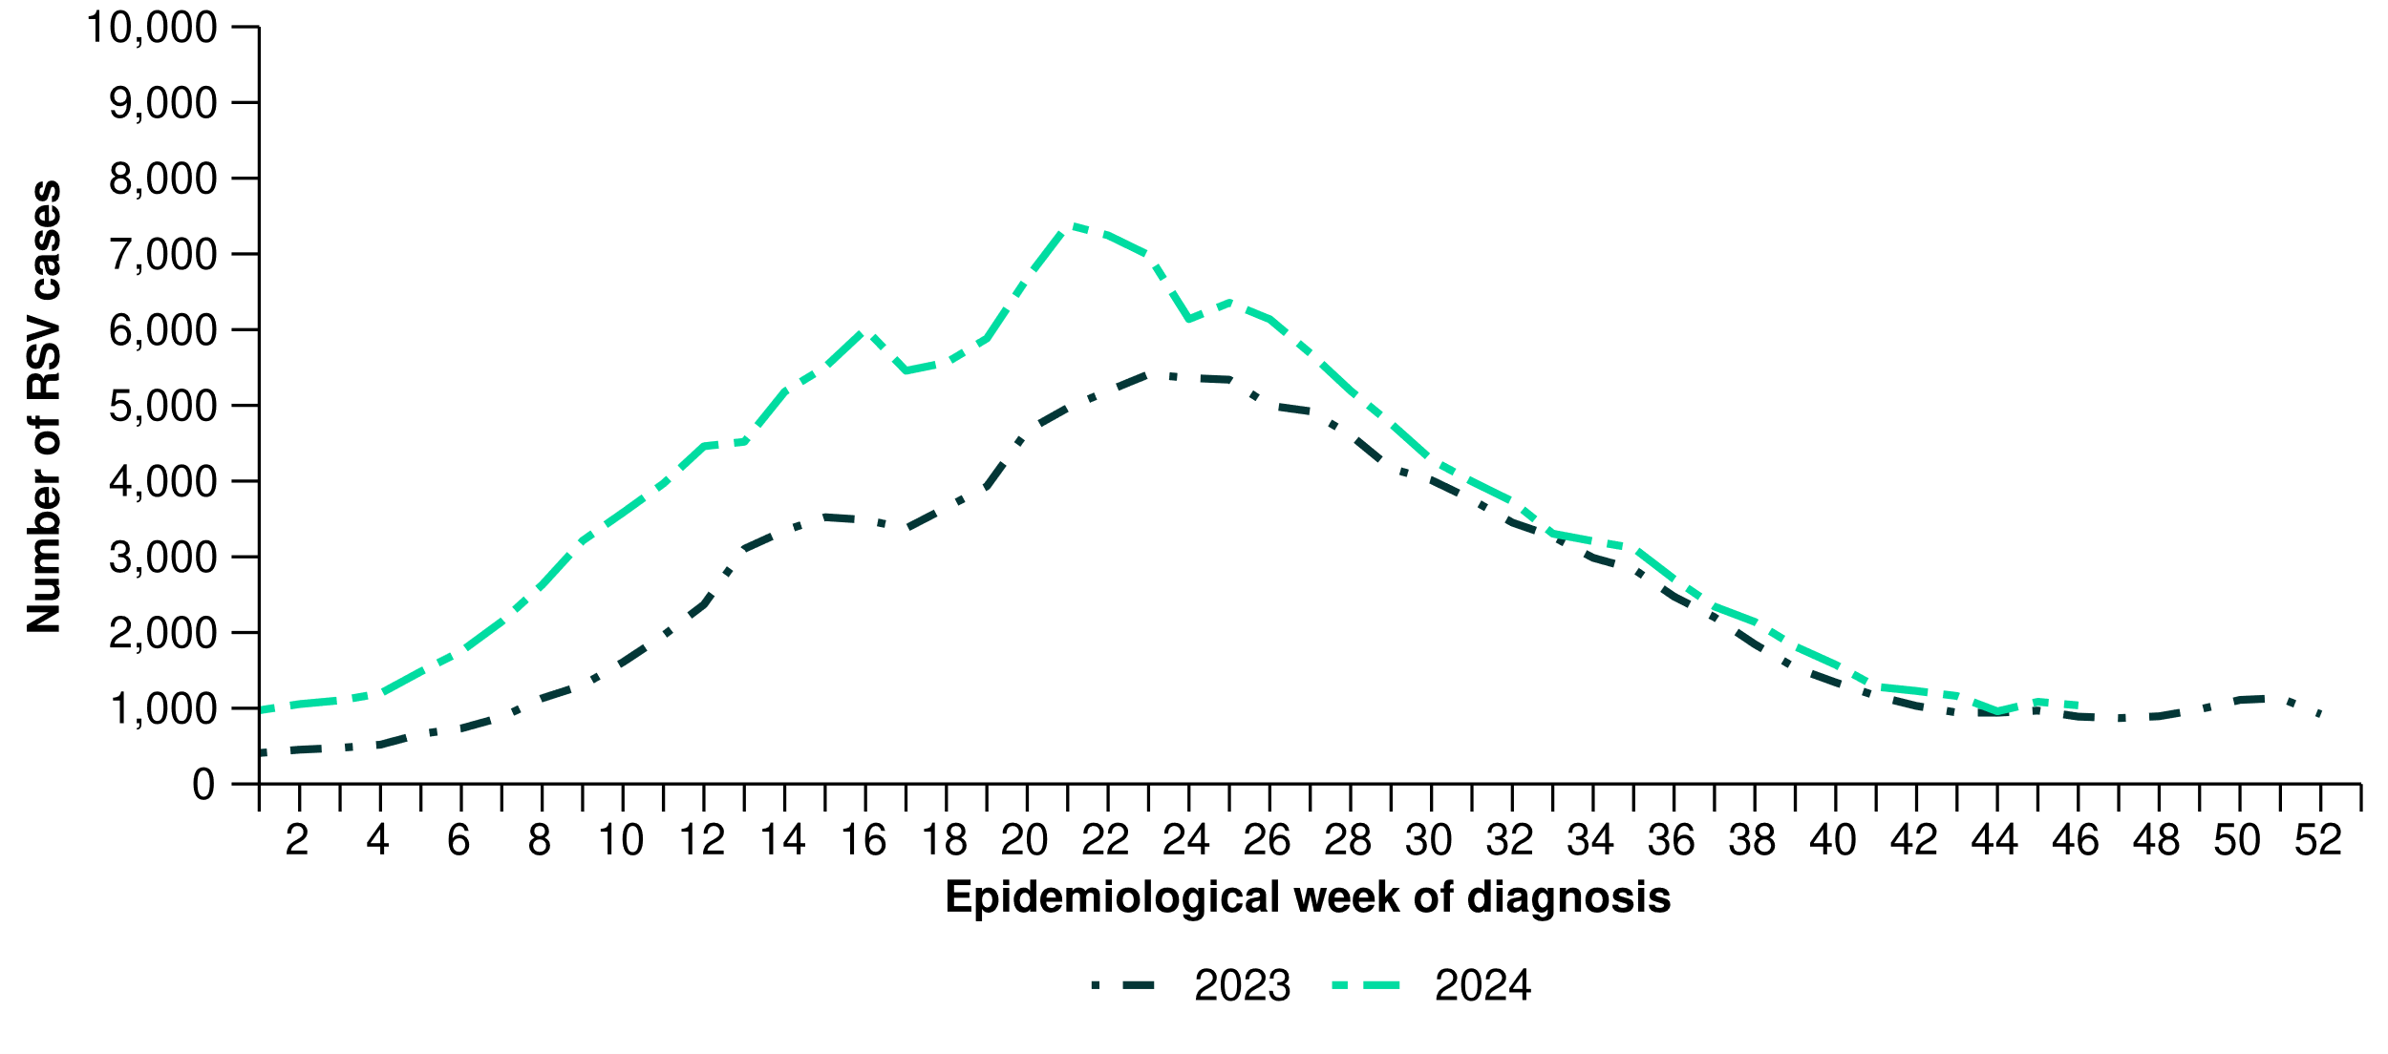

Figure 8: Notification rates per 100,000 population for RSV cases notified to the NNDSS* by state or territory and week of diagnosis, Australia, 1 January to 17 November 2024
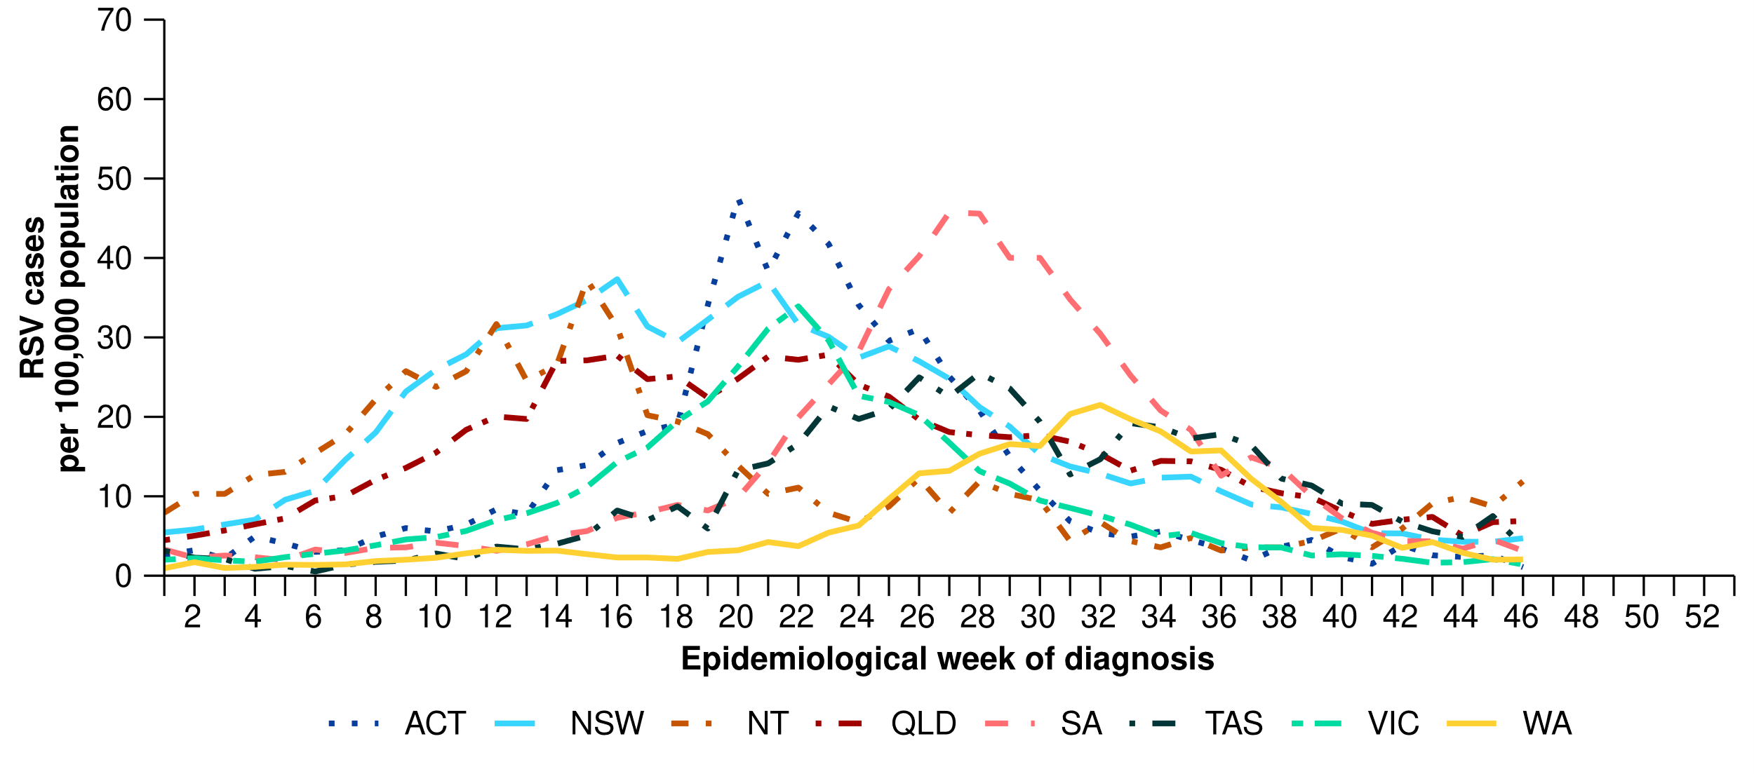
* Rate per 100,000 population for the given time period. Population data are based on the ABS ERP as at June 2023.

2. Severity
The severity of acute respiratory infections is measured as those who are hospitalised, admitted to intensive care, or have died. Measuring and understanding severity quantifies the most significant health impacts of circulating respiratory viruses.

2.1 Hospital-based surveillance

Influenza Complications Alert Network (FluCAN)
- Sentinel hospital surveillance shows the proportion of patients with severe acute respiratory infections has remained low and stable this month. The duration of hospital stay varies only slightly between illnesses.
- In this month for severity reporting (7 October to 3 November 2024), fewer patients were admitted to a sentinel hospital with a severe acute respiratory infection (n = 387), than in the previous month (n = 577). This month, 4.9% (19/387) of patients were admitted directly to an intensive care in a sentinel hospital with a severe acute respiratory infection (Figure 9).
- In the year to date for severity reporting (1 January to 3 November 2024), 6.1% (656/10,830) of patients have been admitted directly to an intensive care in a sentinel hospital with a severe acute respiratory infection (Figure 9).
  - Among patients with COVID-19, 6.2% (285/4,601) have been admitted directly to an intensive care in a sentinel hospital (Figure 9) and their median length of stay in hospital was 3 days (interquartile range [IQR]: 2–7 days). This excludes one patient with COVID-19 with a missing admission location.
  - Among patients with influenza, 6.4% (265/4,110) have been admitted directly to an intensive care in a sentinel hospital (Figure 9) and their median length of stay in hospital was 2 days (IQR: 1–4 days).
  - Among patients with RSV, 5.0% (106/2,119) have been admitted directly to an intensive care in a sentinel hospital (Figure 9) and their median length of stay in hospital was 2 days (IQR: 1–4 days).
- Since influenza surveillance commenced on 1 April 2024 to date for severity reporting, 97.2% (3,994/4,110) of patients admitted to sentinel hospitals with influenza have been admitted with influenza A and 2.8% (115/4,110) with influenza B.
  - Most hospital admissions have been with influenza A(Unsubtyped) (84.4%; 3,372/3,994), followed by influenza A(H3N2) (9.0%; 361/3,994) and influenza A(H1N1) (6.5%; 261/3,994).

Figure 9: Number of patients admitted with a severe acute respiratory infection to FluCAN sentinel hospitals by disease, admission location and week of admission*†‡, Australia, 1 January to 3 November 2024
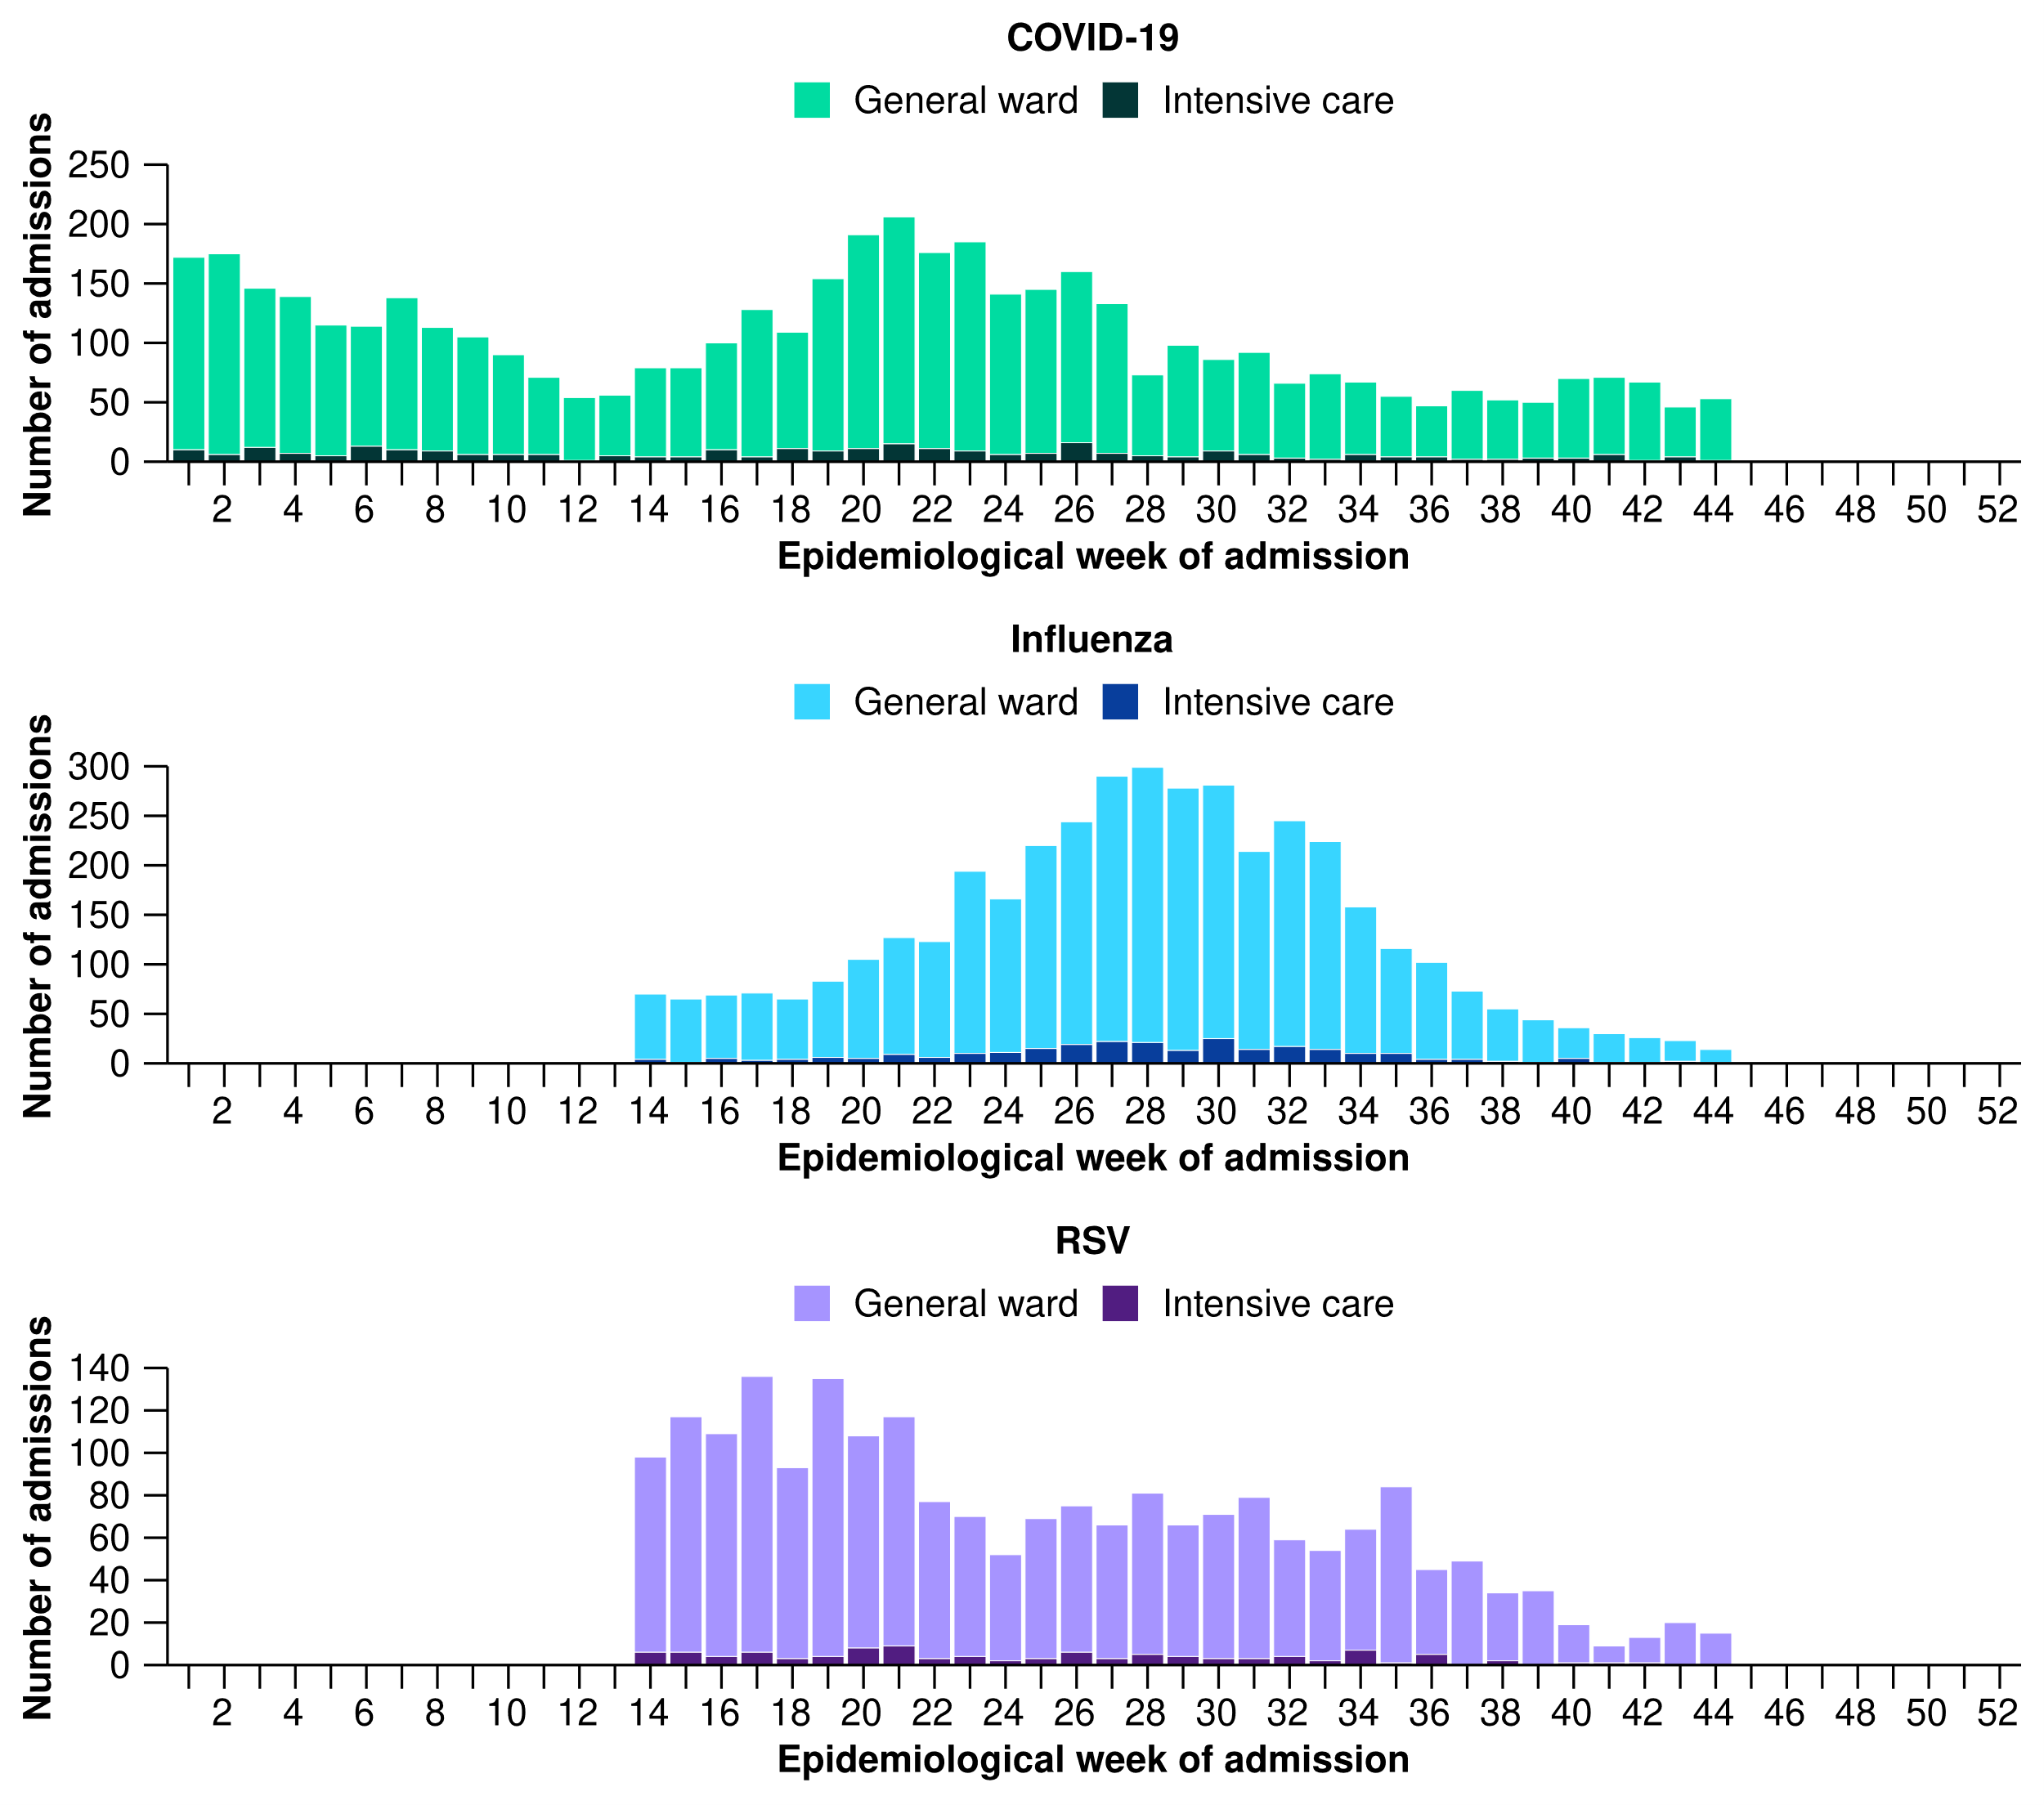
Note: Surveillance for influenza and RSV commenced in sentinel hospitals on 1 April 2024.
* Axis varies between disease groups.
† Excludes one patient with a severe acute respiratory infection admitted to sentinel hospitals with a missing admission location.
‡ Admission location reflects the initial admission ward; some patients may be initially admitted to general ward then later admitted to an intensive care and this is not reflected here.

Short Period Incidence Study of Severe Acute Respiratory Infection (SPRINT-SARI) Australia
- Sentinel intensive care surveillance shows the number of patients with severe acute respiratory infections has remained low and stable this month. The duration of intensive care and hospital stay varies slightly between illnesses.
- In this month for severity reporting (7 October to 3 November 2024), fewer patients have been admitted to a sentinel intensive care with a severe acute respiratory infection (n=100), than in the previous month (n=138) (Figure 10).
- Among patients admitted to a sentinel intensive care with a severe acute respiratory infection in the year to date for severity reporting (1 January to 3 November 2024):
  - 38.6% (1,035/2,682) had SARS-CoV-2
  - 24.8% (664/2,682) had influenza
  - 12.1% (324/2,682) had RSV
  - 26.6% (714/2,682) had other respiratory pathogens including parainfluenza and rhinovirus.
- Some patients (2.7%; 73/2,682) had co-infections of multiple respiratory pathogens; therefore, the sum of pathogen-specific totals above may not equal the total number of patients.
- In the year to date for severity reporting, patients with a severe acute respiratory infection had a median length of mechanical ventilation of 4 days (IQR: 1–8 days) days, a median length of stay in intensive care of 3 days (IQR: 2–6 days) days, and a median length of stay in hospital of 7 days (IQR: 4–14 days) days.
- In the year to date for severity reporting, most patients admitted to a sentinel intensive care with a severe acute respiratory infection have been discharged home (71.0%; 1,904/2,682). Unfortunately, 11.6% (311/2,682) of patients admitted to a sentinel intensive care with a severe acute respiratory infection have died in hospital.
  - Note, deaths in patients admitted to a sentinel intensive care with a severe acute respiratory infection may not necessarily represent a death due to the severe acute respiratory infection.
Figure 10: Number of patients admitted with severe acute respiratory infections to a SPRINT-SARI sentinel intensive care by disease*† and week of admission, Australia, 1 January to 3 November 2024
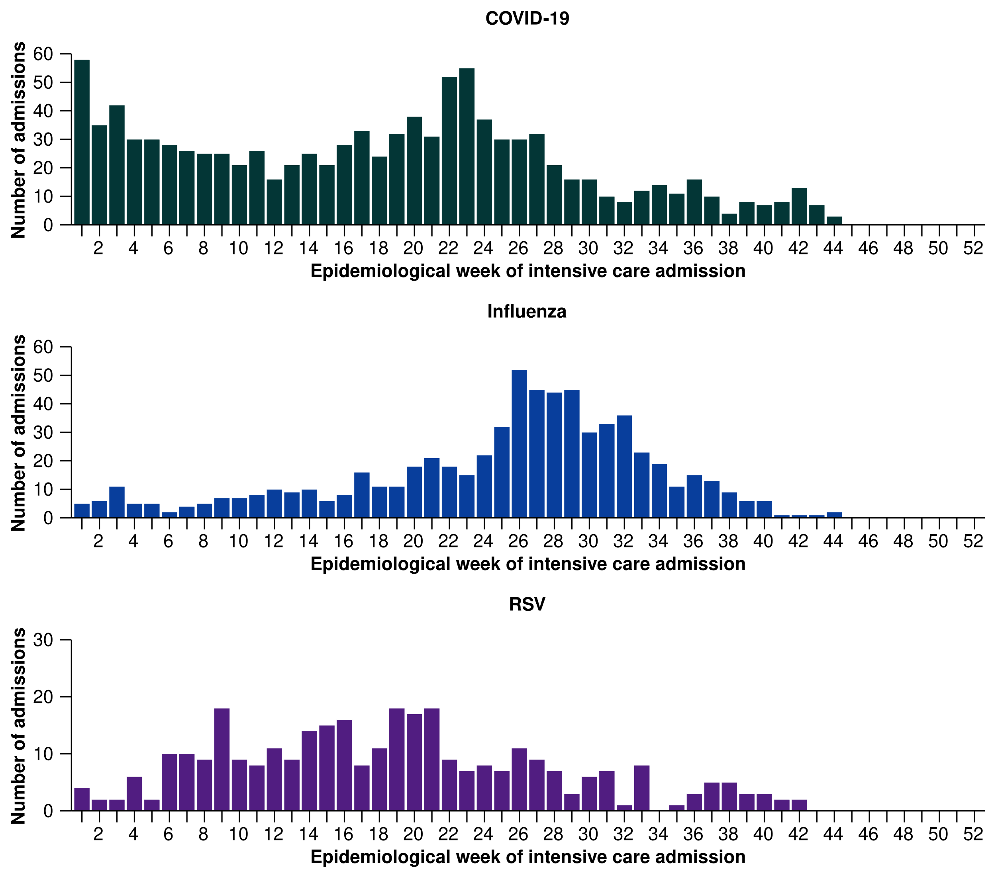* Axis varies between disease groups.
† Includes 23 patients with viral co-infection of SARS-CoV-2/influenza/RSV in the year to date for severity reporting.
Table 2: Outcomes for patients admitted with a severe acute respiratory infection(s) to a SPRINT-SARI sentinel intensive care by disease*†‡, Australia, 1 January to 3 November 2024
 | COVID-19 |  | Influenza |  | RSV |  | Other
 | Severity reporting period  (n=31) | Year to date  for severity reporting  (n=1,035) | Severity reporting period  (n=5) | Year to date  for severity reporting  (n=664) | Severity reporting period  (n=4) | Year to date  for severity reporting  (n=324) | Severity reporting period  (n=60) | Year to date  for severity reporting  (n=714)
Received invasive mechanical ventilation
Number (%) | 12  (44.4%) | 346  (34.0%) | 2  (67.0%) | 255  (38.7%) | 1  (33.3%) | 80  (24.8%) | 9  (17.6%) | 204  (29.2%)
Duration of invasive mechanical ventilation (days)
Median [IQR] | 2.5  [1.4–8.4] | 2.8  [1.0–7.9] | 0.6  [0.0–1.1] | 5.1  [1.6–10.5] | – | 3.8  [1.7–7.1] | 3.8  [0.4–5.8] | 3.5  [1.1–6.3]
Length of intensive care stay (days)
Median [IQR] | 3.6  [2.0–5.9] | 3.0  [1.7–5.7] | 1.0  [0.8–1.3] | 3.7  [2.0–7.4] | 1.2  [0.5–2.0] | 2.7  [1.6–4.8] | 2.3  [1.0–4.1] | 2.6  [1.3–5.6]
Length of hospital stay (days)
Median [IQR] | 7.1  [4.7–8.8] | 8.4  [4.5–16.5] | 8.8  [1.3–16] | 8.2  [4.7–14.9] | 1.8  [0.5–3.0] | 6.0  [3.6–11.7] | 4.0  [2.6–9.0] | 5.8  [3.0–11.8]
Patient outcome
Ongoing care in intensive care | 8  (25.8%) | 22  (2.1%) | 3  (60.0%) | 16  (2.4%) | 2  (50.0%) | 5  (1.5%) | 14 (23.3%) | 23  (3.2%)
Ongoing care in hospital ward* | 9  (29.0%) | 23  (2.2%) | – | 8  (1.2%) | – | 4  (1.2%) | 4  (6.7%) | 11  (1.5%)
Transfer to other hospital or facility | 1  (3.2%) | 89  (8.6%) | – | 53  (8.0%) | 1  (25.0%) | 27  (8.3%) | 2  (3.3%) | 43  (6.0%)
Transfer to rehabilitation | 2  (6.5%) | 74  (7.1%) | – | 33  (5.0%) | – | 7  (2.2%) | 1  (1.7%) | 22  (3.1%)
Discharge home | 10 (32.3%) | 646 (62.4%) | – | 479 (72.1%) | 1  (25.0%) | 259 (79.9%) | 34 (56.7%) | 560 (78.4%)
Died† – intensive care† | 1 (3.2%) | 110 (10.6%) | 1  (20.0%) | 58  (8.7%) | – | 16  (4.9%) | 4  (6.7%) | 37  (5.2%)
Died† – hospital ward† | – | 62  (6.0%) | 1  (20.0%) | 15  (2.3%) | – | 5  (1.5%) | 1  (1.7%) | 17  (2.4%)
Missing‡ | – | 9  (0.9%) | – | 2  (0.3%) | – | 1  (0.3%) | – | 1  (0.1%)
Note: Includes two patients with viral co-infection of multiple pathogens in the 28-day severity reporting period and multiple patients with co-infection of respiratory pathogens in the year to date for severity reporting. For patients whom are still receiving treatment in intensive care data may not be complete; therefore, data are not included in the duration of ventilation or length of intensive care stay.
* Patients who have been admitted in intensive care/hospital wards with no discharge information for less than 90 days have been assumed to have ongoing care in the hospital.
† Death may not necessarily represent a death due to the disease.
‡ Patients who have no outcome entered or have been admitted to intensive care/hospital wards for more than 90 days with no discharge information have been treated as missing.

2.2 Case-based surveillance

NNDSS
- In the year to date for severity reporting (1 January to 3 November 2024), mortality rates for COVID-19, influenza and RSV associated deaths in cases notified to the NNDSS have been highest in those aged 70 years or over (Table 3).

Table 3: Notifications of deaths to the NNDSS and mortality rates per 100,000 population by disease and ten-year age groups*†‡, Australia, 1 January to 3 November 2024
 | COVID-19 |  | Influenza |  | RSV
 | Year to  date  (n) | Year to  date  (rate) | Year to  date  (n) | Year to  date  (rate) | Year to  date  (n) | Year to  date  (rate)
Age group (years)
0–9 | – | – | 7 | 0.2 | – | –
10–19 | – | – | – | – | – | –
20–29 | – | – | – | – | – | –
30–39 | 8 | 0.2 | – | – | – | –
40–49 | 19 | 0.6 | 12 | 0.4 | – | –
50–59 | 54 | 1.7 | 24 | 0.7 | 8 | 0.2
60–69 | 146 | 5.1 | 50 | 1.8 | 12 | 0.4
70+ | 1,874 | 58.0 | 371 | 11.5 | 131 | 4.1
Total | 2,105 | 7.9 | 473 | 1.8 | 159 | 0.6
Note: To reduce the risk of re-identification, primary cell suppression has been applied to cells with a count of < 5.
* Rate per 100,000 population for the given time period. Population data are based on the ABS ERP as at June 2023.
† Notified deaths are reported based on diagnosis date not date of death, as date of death data are not collected for influenza or RSV in the NNDSS. Death may not necessarily represent a death due to the disease and notified deaths are likely to be an underrepresentation of the true mortality associated with COVID-19, influenza and RSV. In addition, notified deaths may not be representative of deaths in each jurisdiction as data is sourced in different ways by state and territories based on their local surveillance system capabilities, definitions, priorities, and needs. For more detail, please refer to reports and data considerations published by individual jurisdictions, or the Technical Supplement – Australian Respiratory Surveillance Report.
‡ Total may include cases with missing age.

3. At-risk populations
At-risk populations are people who may be more susceptible to infection with circulating respiratory viruses and/or who may be more likely to experience severe disease associated with their infection.

3.1 Hospital-based surveillance

FluCAN
Children (16 years or younger) are over-represented in FluCAN to provide enhanced surveillance of this at-risk population. Consequently, the age distribution in FluCAN may not reflect the age distribution of hospital admissions nationally. Therefore, children (≤16 years) and adults (>16 years) admitted to a sentinel hospital are reported separately, though all age groups are shown together in figures.
- In the year to date for severity reporting (1 January to 3 November 2024), 1,332 children have been admitted to sentinel hospitals with COVID-19 (Figure 11). The median age at admission was 1 years (IQR: 0–4 years) and 6.7% (89/1,332) of admissions were among Aboriginal and Torres Strait Islander people.
- In the year to date for severity reporting, 3,269 adults have been admitted to sentinel hospitals with COVID-19 (Figure 11). The median age at admission was 75 years (IQR: 64–84 years) and 3.9% (127/3,269) of admissions were among Aboriginal and Torres Strait Islander people.
Figure 11: Number of patients admitted with confirmed COVID-19 to FluCAN sentinel hospitals by age group, year and week of admission*, Australia, 2020 to 3 November 2024
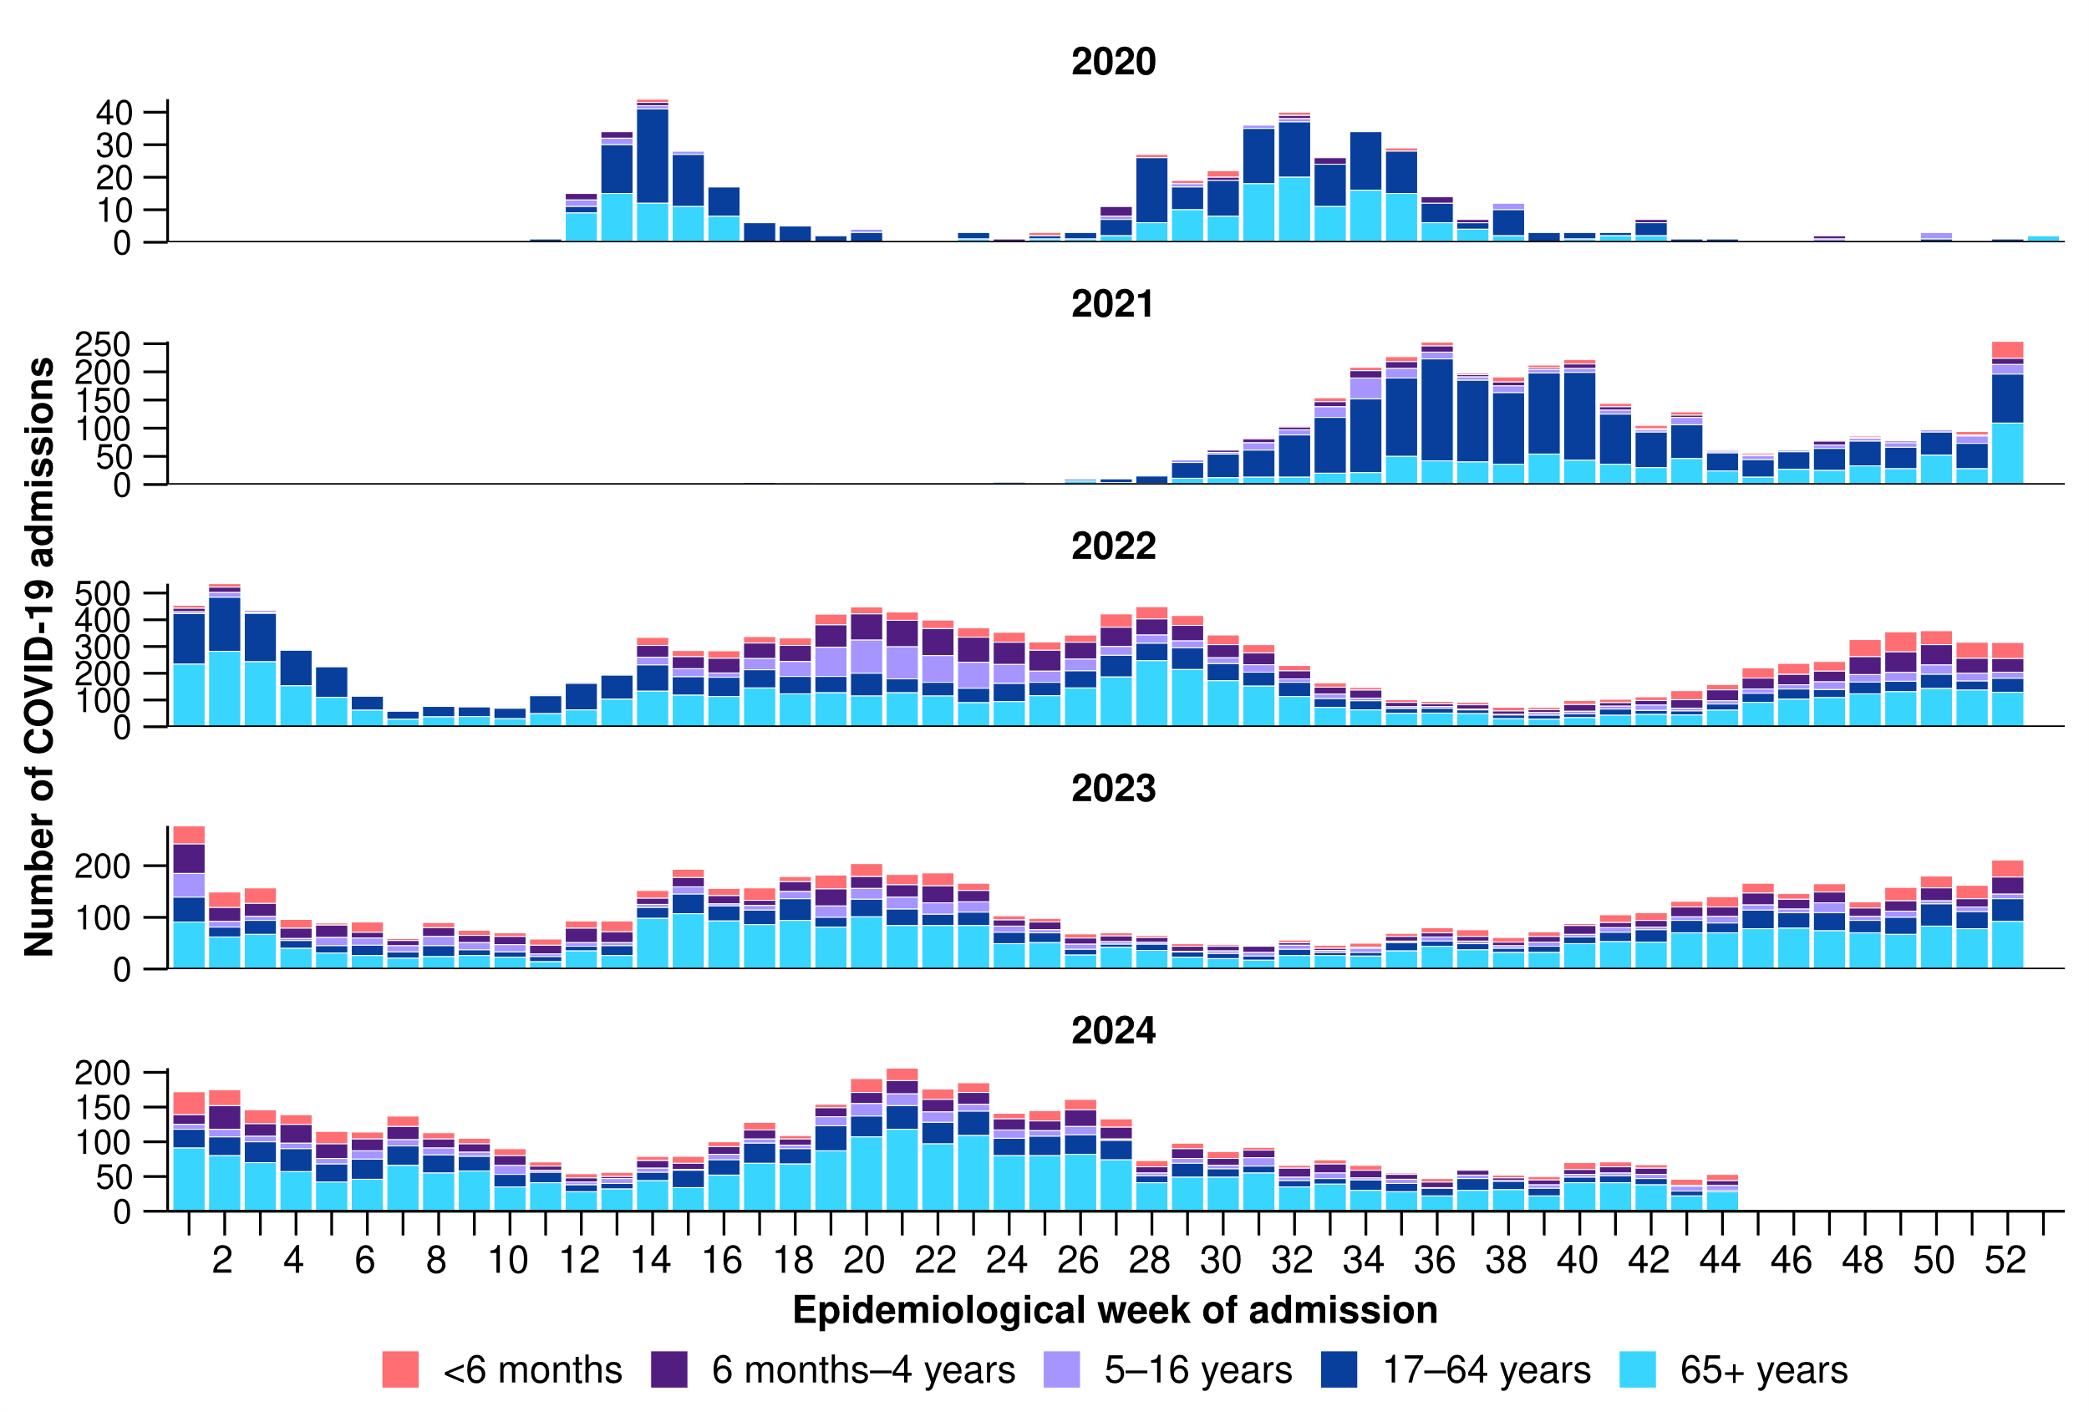
* Axis varies between years.

- Since influenza surveillance commenced on 1 April 2024 to date for severity reporting (3 November 2024), 2,151 children have been admitted to sentinel hospitals with influenza (Figure 12). The median age at admission was 4 years (IQR: 1–7 years) and 7.7% (166/2,151) of admissions were among Aboriginal and Torres Strait Islander people.
- Since influenza surveillance commenced on 1 April 2024 to date for severity reporting, 1,959 adults have been admitted to sentinel hospitals with influenza (Figure 12). The median age at admission was 64 years (IQR: 47–77 years) and 11.7% (230/1,959) of admissions were among Aboriginal and Torres Strait Islander people.
Figure 12: Number of patients admitted with confirmed influenza to FluCAN sentinel hospitals by age group, year and week of admission*†, from April to October, 2017 to 3 November 2024
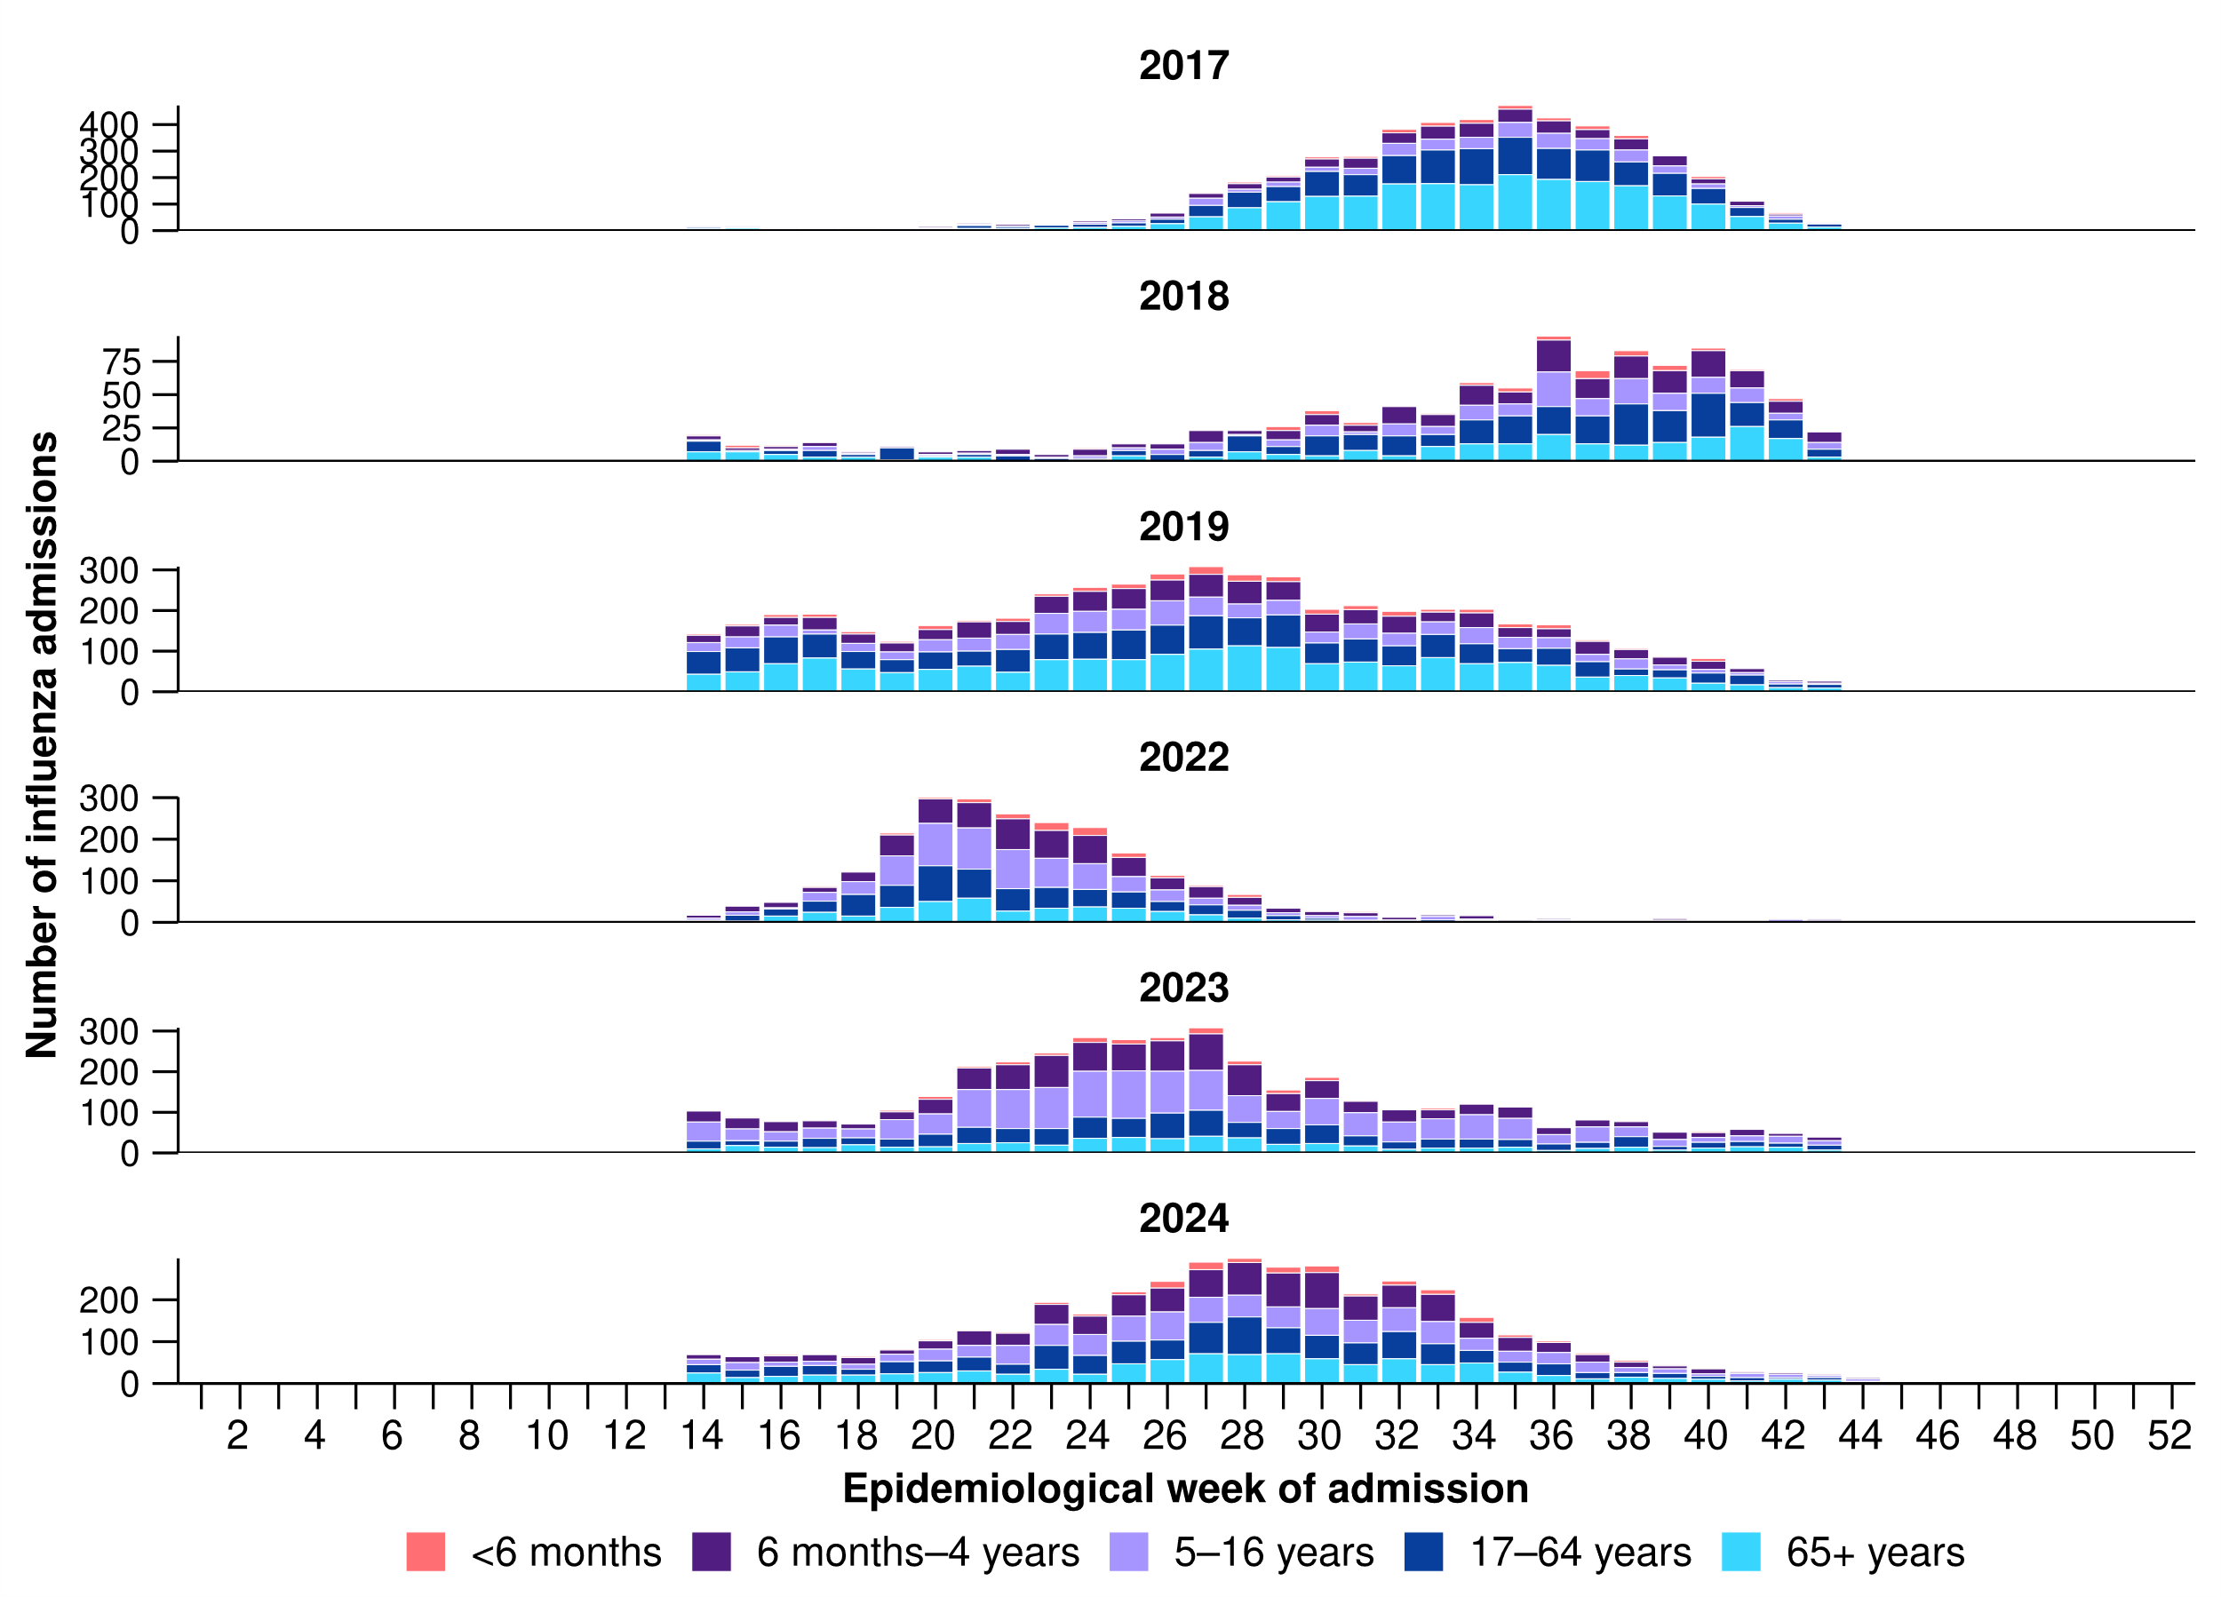
* Axis varies between years.
† The years 2020 and 2021 are excluded when comparing the current season to historical periods when influenza virus has circulated without public health restrictions. Please refer to the Technical Supplement for further detail.
- Since RSV surveillance commenced on 1 April 2024 to date for severity reporting (3 November 2024), 1,760 children have been admitted to sentinel hospitals with RSV (Figure 13). The median age at admission was 1 years (IQR: 0–2 years) and 6.0% (105/1,760) of admissions were among Aboriginal and Torres Strait Islander people.
- Since RSV surveillance commenced on 1 April 2024 to date for severity reporting, 359 adults have been admitted to sentinel hospitals with RSV (Figure 13). The median age at admission was 71 years (IQR: 56–82 years) and 13.9% (50/359) of admissions were among Aboriginal and Torres Strait Islander people.
Figure 13: Number of patients admitted with confirmed RSV to FluCAN sentinel hospitals by age group, year and week of admission, Australia, 1 April to 3 November 2024
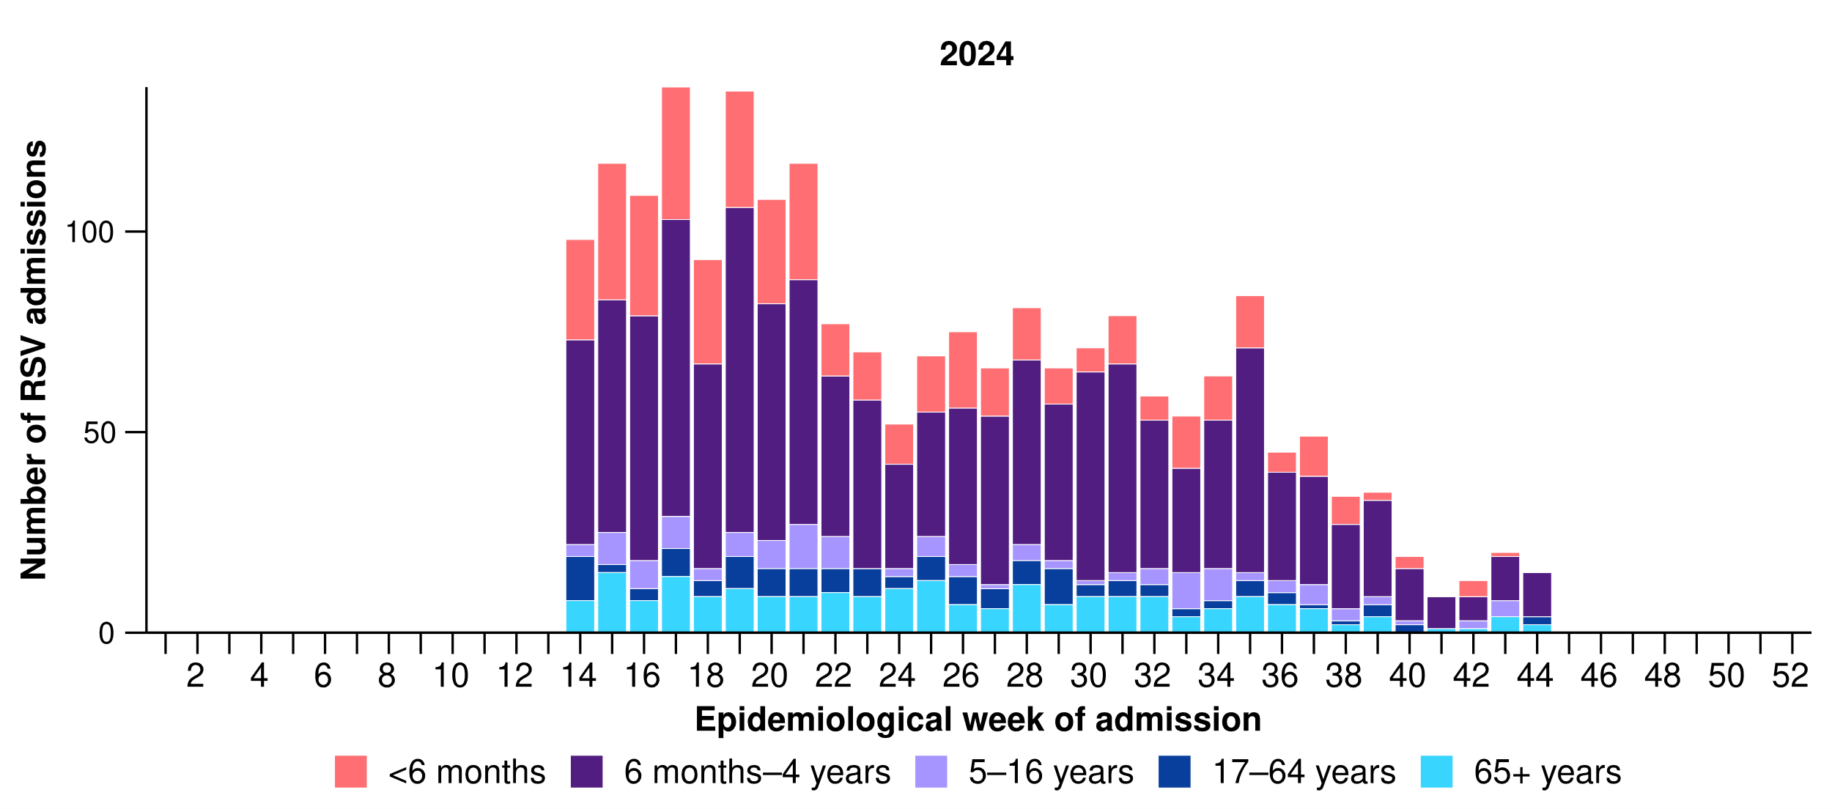

Paediatric Active Enhanced Disease Surveillance (PAEDS)
- Since 1 January 2020 to date for severity reporting (3 November 2024), there have been 203 cases of possible, probable, or confirmed paediatric inflammatory multisystem syndrome – temporally associated with SARS-CoV-2 (PIMS-TS) admitted to sentinel hospitals.
  - There have been no PIMS-TS associated deaths to date for severity reporting.
  - The highest proportion of PIMS-TS cases occurred in 2022 (65.0%; 132/203), followed by 2021 (14.8%; 30/203).
- In the year to date for severity reporting, there have been 13 PIMS-TS cases reported, with the last PIMS-TS case reported in August 2024.
- Most PIMS-TS cases have been aged 5 to < 12 years (52.7%; 107/203) or 6 months to < 5 years (27.6%; 56/203). Approximately 5.4% (11/203) of PIMS-TS cases occurred among Aboriginal and Torres Strait Islander people.

SPRINT-SARI Australia
- In this month for severity reporting (7 October to 3 November 2024), the median age of patients admitted to a sentinel intensive care with a severe acute respiratory infection was 55 years (IQR: 31–71 years) and 8.0% (8/100) of patients were among Aboriginal and Torres Strait Islander people.
- In the year to date for severity reporting (1 January to 3 November 2024), the median age of patients admitted to a sentinel intensive care with a severe acute respiratory infection was 57 years (IQR: 24–71 years) and 6.9% (185/2,682) have been among Aboriginal and Torres Strait Islander people.
- In the year to date for severity reporting, 11.6% (311/2,682) of patients admitted to a sentinel intensive care with a severe acute respiratory infection died in hospital. Most deaths were in patients aged 60 years or over (75.2%; 234/311) (Figure 14).

Figure 14: Number of patients admitted with severe acute respiratory infections to a SPRINT-SARI sentinel intensive care by age group, sex and outcome*†‡, Australia, 1 January to 3 November 2024
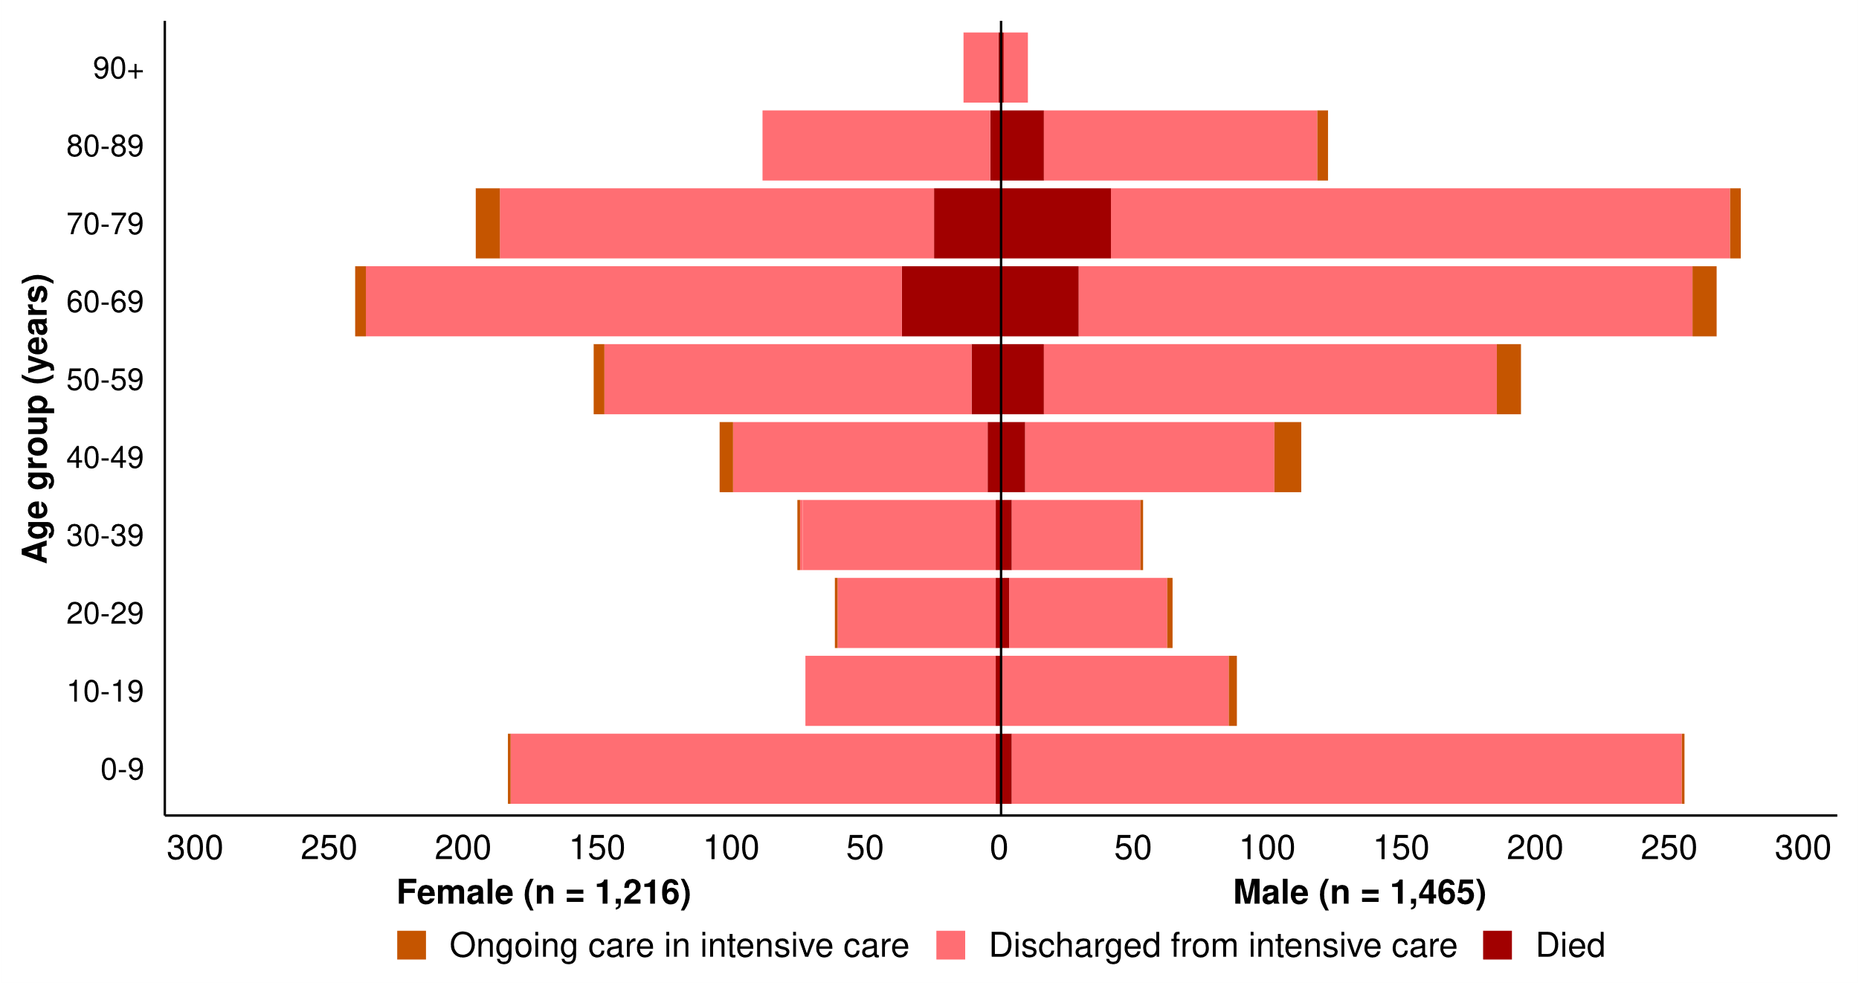
* The age and sex distribution of severe acute respiratory infection intensive care admissions in the SPRINT-SARI Australia sentinel surveillance system may not reflect the age or sex distribution of all patients admitted with a severe acute respiratory infection intensive nationally. In addition, if data are missing or a patient does not identify as either female or male, the sum of gender-specific totals above may not equal the total number of patients.
† Ongoing care reflects the need for ongoing care in intensive care. Where a patient has been discharged from intensive care, the patient may still be receiving ongoing care in a hospital ward.
‡ Death may not necessarily represent a death due to the disease.

3.2 Case-based surveillance

NNDSS
The ascertainment of Indigenous status in the NNDSS for influenza and RSV, and more recently for COVID-19, is insufficient for accurate epidemiological assessments or meaningful interpretation. This is due to a number of factors, including: most laboratory notifications do not include Indigenous status, case follow-ups are not routinely conducted and are not a requirement of notification, and data linkage systems that have been used to help capture Indigenous status for COVID-19 cases have not been extended for COVID-19 in the post emergency climate, and have not been comprehensively extended to influenza or RSV cases. Therefore, data are not currently analysed by Indigenous status.

4. Impact
Impact measures how circulating respiratory viruses adversely affect the community and the healthcare system.

4.1 Community-based surveillance

FluTracking
- This month (21 October to 17 November 2024), fewer FluTracking participants reported taking three or more days off work or normal duties due to fever and cough symptoms (46.7%; 740/1,584), than in the previous month (47.3%; 852/1,803).

4.2 Hospital-based surveillance

Critical Health Resource Information System (CHRIS)
- This month (21 October to 17 November 2024), there have been more COVID-19 cases in intensive care across Australia than in the previous month (Figure 15).
- This month, there have been more intensive care staff unavailable to work due to COVID-19 exposure or illness across Australia than in the previous month (Figure 15).
Figure 15: Mean number of COVID-19 cases in intensive care and the mean number of intensive care staff unavailable to work due to COVID-19 exposure or illness reported to CHRIS by week of report*†, Australia, 1 January to 17 November 2024 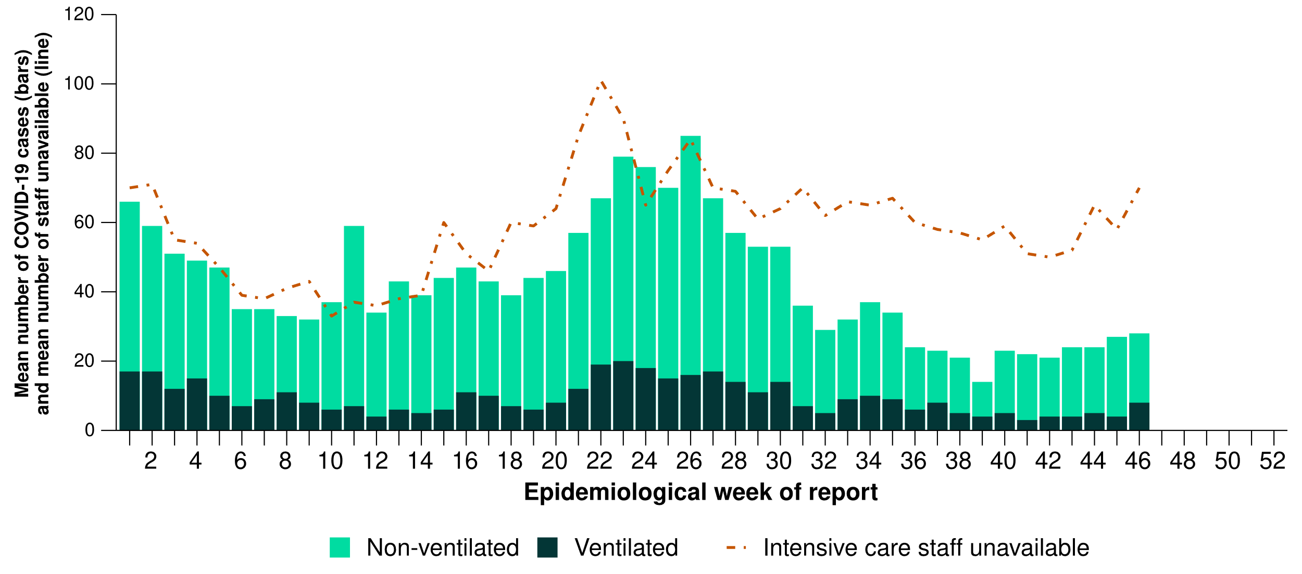
* Mean number of ventilated and non-ventilated COVID-19 cases in intensive care includes only active COVID-19 cases (those in isolation) and does not include cleared COVID-19 cases.
† Intensive care staff include both medical and nursing staff.
- This month, COVID-19 cases in intensive care have increased or remained relatively stable in most jurisdictions, except in New South Wales and South Australia where a slight decrease was observed compared with the previous month (Figure 16).
- This month, the number of unavailable intensive care staff has increased or remained relatively stable in most jurisdictions, except in Tasmania where a small decrease was observed compared with the previous month (Figure 16).
Figure 16: Mean number of COVID-19 cases in intensive care and the mean number of intensive care staff unavailable to work due to COVID-19 exposure or illness reported to CHRIS by jurisdiction and week of report*†‡, Australia, 1 January to 17 November 2024
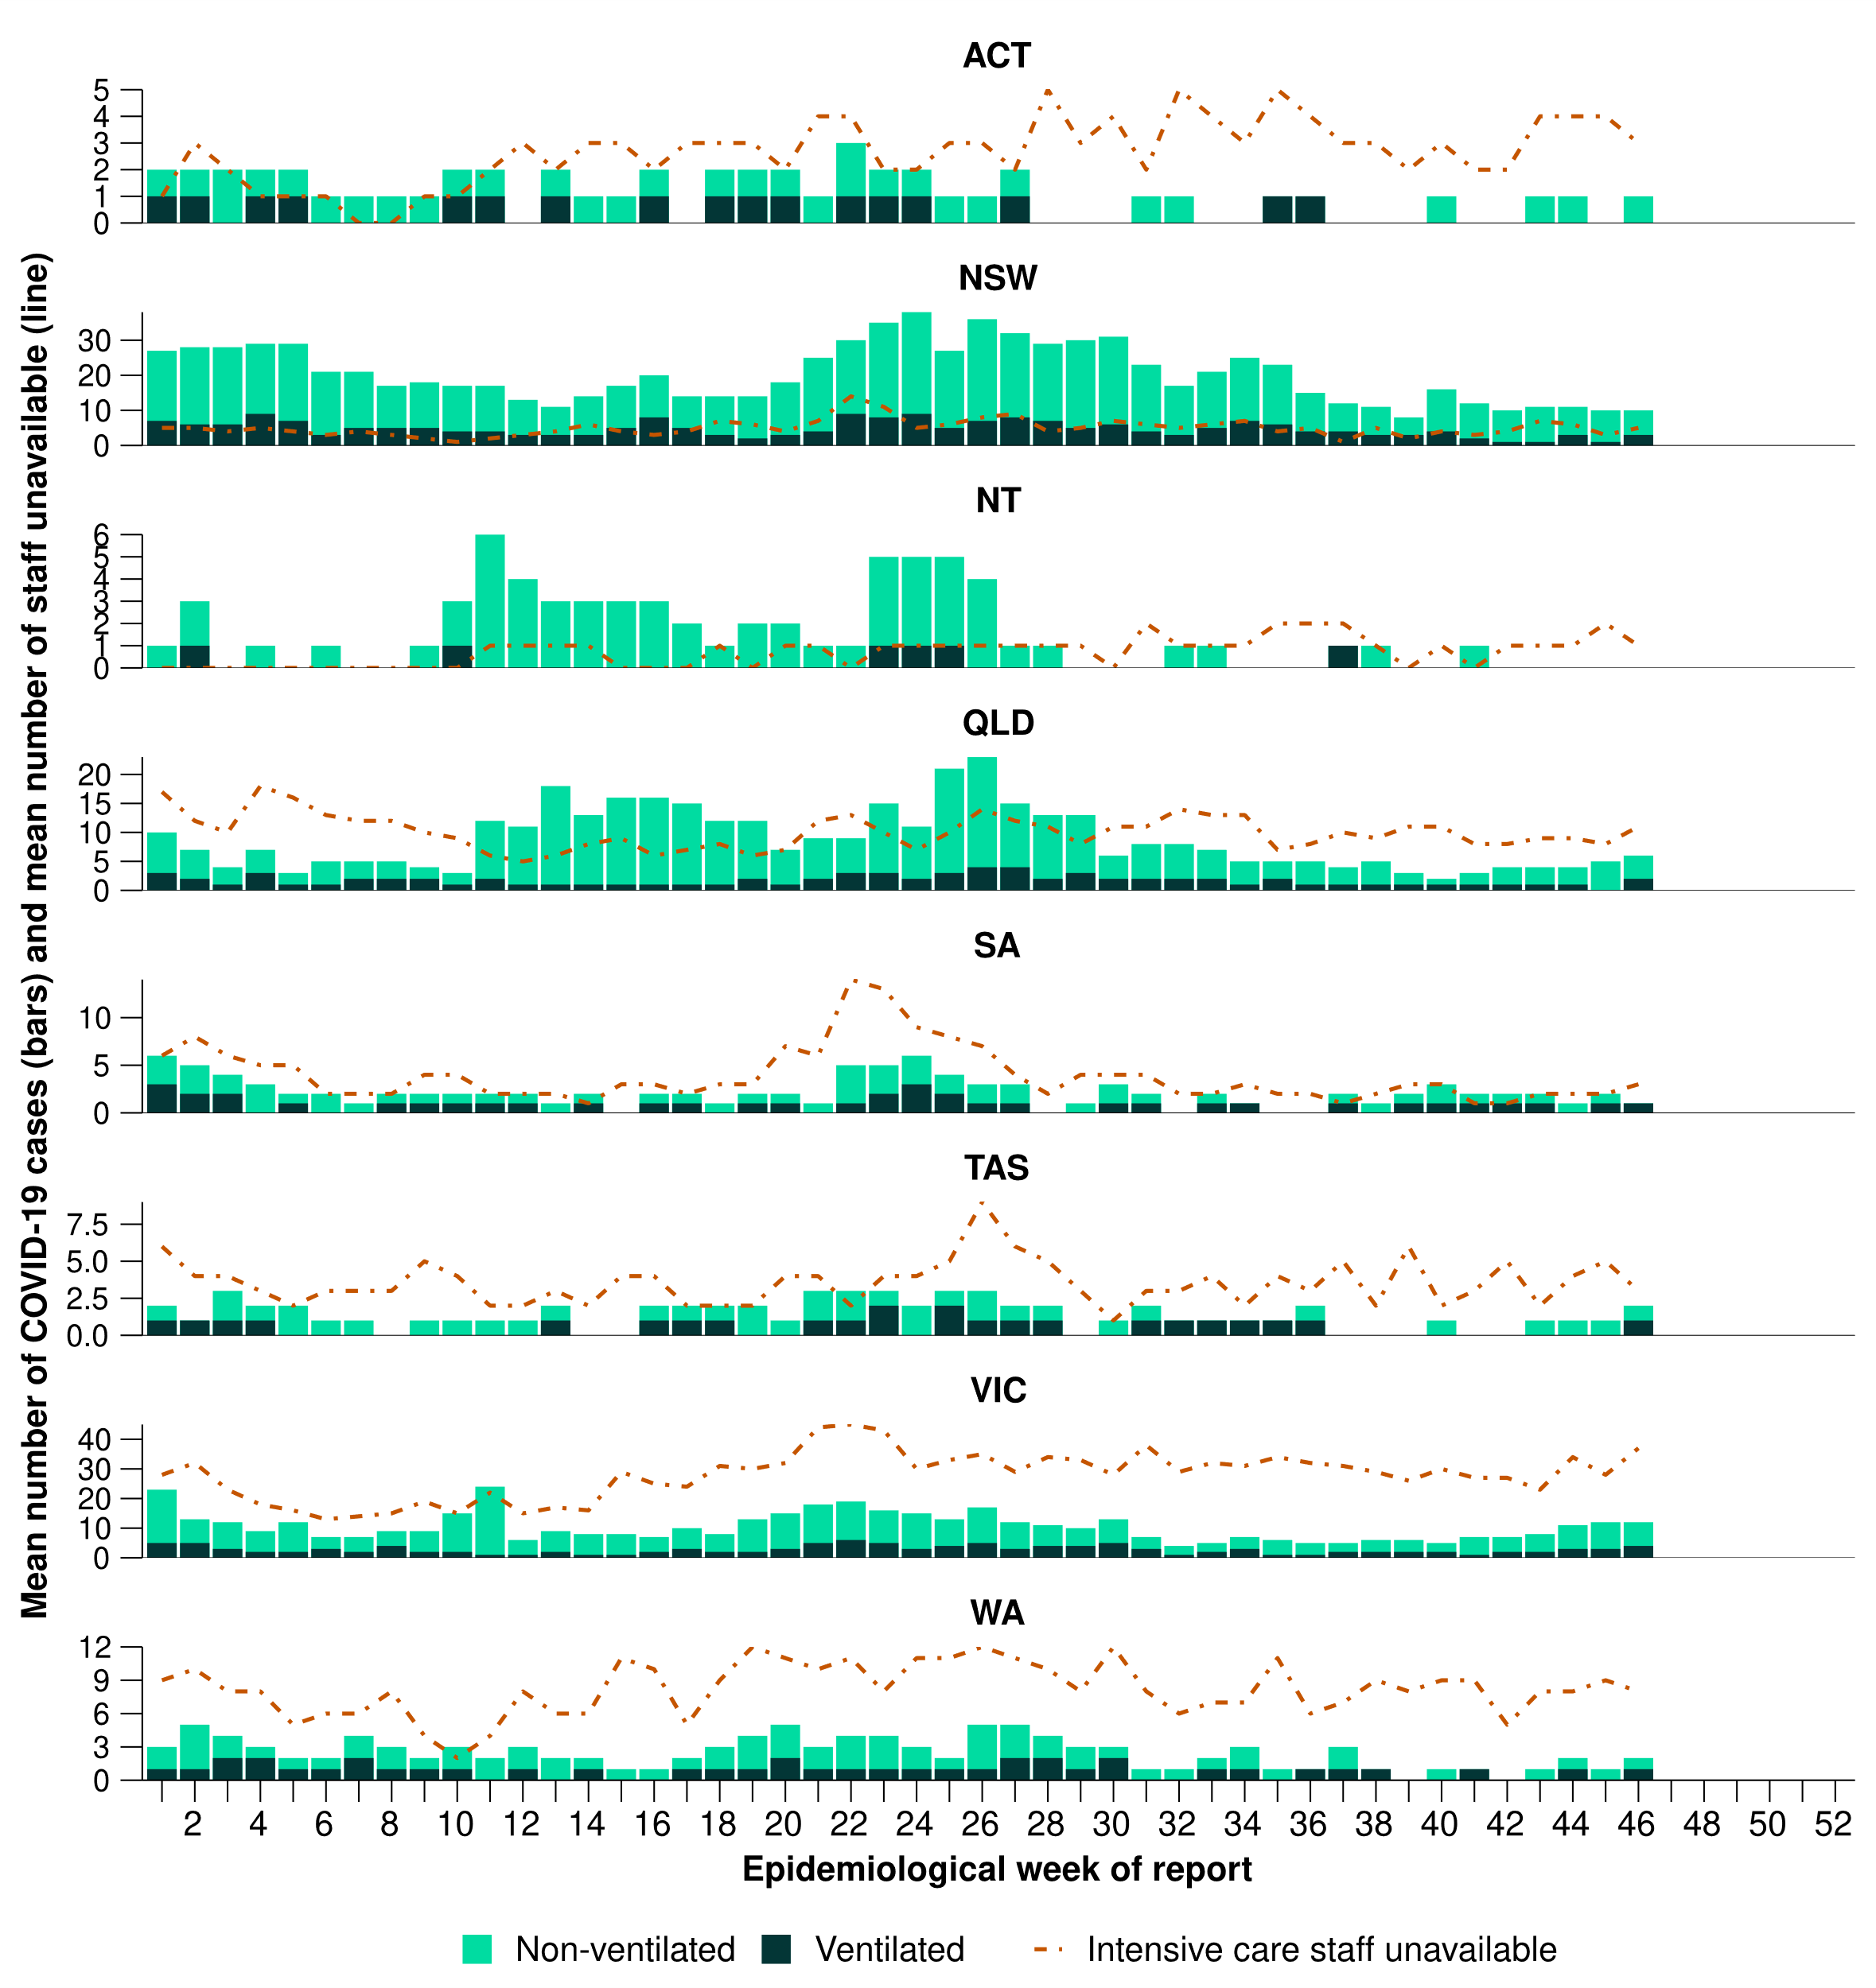
* Axis varies between jurisdictions.
† Mean number of ventilated and non-ventilated COVID-19 cases in intensive care includes only active COVID-19 cases (those in isolation) and does not include cleared COVID-19 cases.
‡ Intensive care staff include both medical and nursing staff.

5. Genomic surveillance and virology

5.1 Laboratory-based surveillance

Sentinel laboratories, including National Influenza Centres
- This month (21 October to 17 November 2024), SARS-CoV-2 positivity increased across sentinel laboratories (3.8%; 1,053/27,666), compared with the previous month (3.2%; 886/27,729) (Figure 17).
- This month, influenza positivity decreased across sentinel laboratories (1.7%; 584/33,829), compared with the previous month (2.0%; 690/33,971) (Figure 17).
- This month, RSV positivity decreased across sentinel laboratories (0.9%; 261/27,666), compared with the previous month (1.0%; 273/27,729) (Figure 17).
- This month, the most commonly detected respiratory viruses were rhinovirus (New South Wales, South Australia, and Tasmania), picornavirus (Victoria), and SARS-CoV-2 (Western Australia).
- In the year to date, positivity across sentinel laboratories has been:
  - 4.3% (14,664/341,105) for SARS-CoV-2
  - 6.8% (27,603/404,952) for influenza
  - 2.8% (9,584/341,105) for RSV.

Figure 17: Total number of specimens tested by sentinel laboratories and proportion of positive sentinel laboratory tests by pathogen and week of report*†, 1 January to 17 November 2024
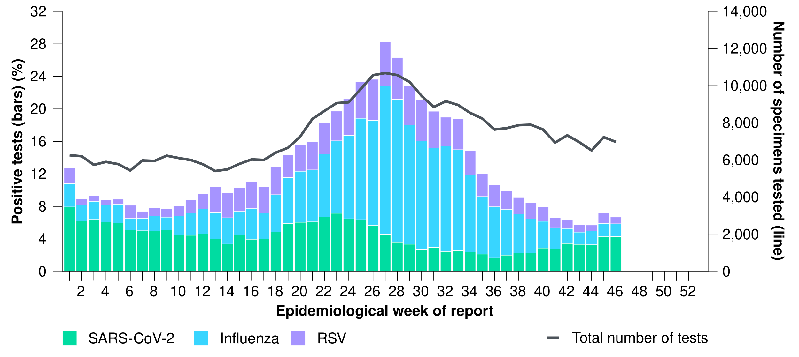
* Number of specimens tested excludes data from Western Australia as testing denominator data are different for the three pathogens in Western Australia.
† A small minority of total samples from Victoria are tested only by respiratory panel (influenza, parainfluenza, adenovirus, human metapneumovirus, seasonal coronaviruses, RSV, and some picornaviruses) but not for SARS-CoV-2. These minority samples include only forensic materials; all other samples are tested by respiratory panel and SARS-CoV-2 assay.

AusTrakka
Data on SARS-CoV-2 genomics should be interpreted with caution as SARS-CoV-2 sequencing strategies have changed significantly, and the representativeness of sequences uploaded to AusTrakka may be limited by the different sample referral pathways for each jurisdiction and a significant reduction in sequencing across the country. Sequences are reported based on date of sample collection, not date of sequencing.
- There were 304 sequences uploaded to AusTrakka with dates of collection in the past 28 days (21 October to 17 November 2024). These sequences were from New South Wales, Queensland, South Australia, Tasmania, Victoria, and Western Australia, with the most recent collection date 4 November 2024.
- All 304 sequences were assigned to the BA.2.86 sub-lineage within B.1.1.529 (Omicron) or recombinants consisting of one or more Omicron sub-lineages (Figure 18). In the past 28 days:
  - 70.1% (213/304) of sequences were from the sub-sub-lineages JN.1 (BA.2.86.1.1), including from KP.2 (4/213) and KP.3 (170/213)
  - 29.9% (91/304) of sequences were recombinant or recombinant sub-lineages, including XEC, a recombinant between KS.1.1 (JN.1.13.1.1.1) and KP.3.3
  - There were no BA.1, BA.3, BA.4, BA.5 or other BA.2 sub-sub-lineage sequences.
- JN.1 and associated sub-lineages continue to dominate the variants identified in AusTrakka with a growing proportion of recombinant sequences seen each month (Figure 18).
- The World Health Organization (WHO) have identified certain sub-sub-lineages and recombinants as variants under monitoring (VUM) or variants of interest (VOI) because of their epidemiological, pathological, or immunological features of concern. A select number of designated VUM or VOI are highlighted below due to their relevance in the Australian context:
  - Recombinant lineage XEC has been designated as a VUM as of 24 September 2024. This lineage has attracted recent attention due to its estimated growth rate. A total of 310 XEC lineages have been identified in AusTrakka, including 82 collected in past 28 days.
  - A total of 226 sequences of LB.1 are identified in AusTrakka, with 13 sequences identified in the past 28 days.
  - A total of 1,248 sequences of KP.3.1.1 have been identified in AusTrakka, with 142 sequences identified in the past 28 days.
  - The proportion of JN.1 sequences has decreased (70.1%; 213/304) in the past 28 days, compared with the previous 28-day period, with an increase in the proportion of recombinant lineages.

Figure 18: Omicron sub-lineage*^ sequences in AusTrakka by sample collection date, showing (A) proportions and (B) count per week^†, Australia, 1 January to 17 November 2024
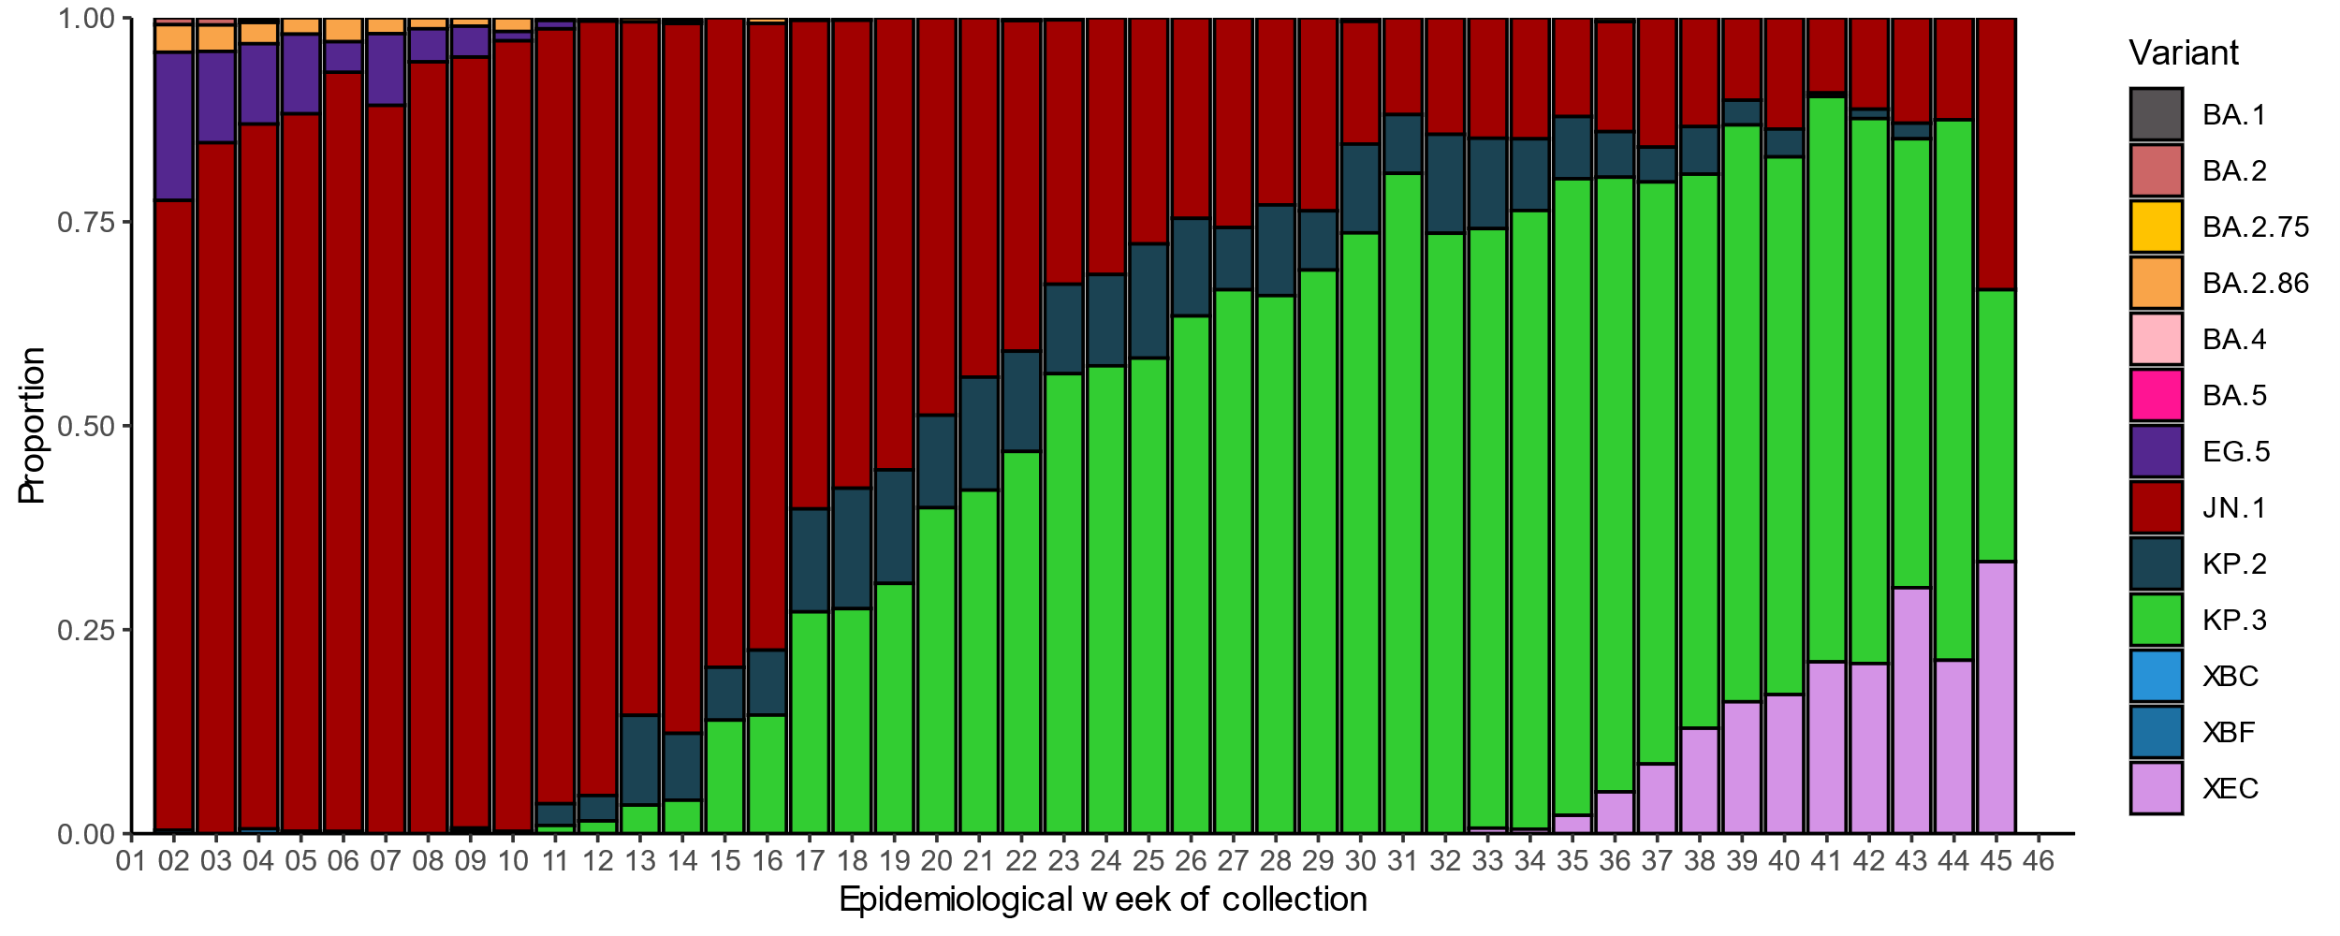
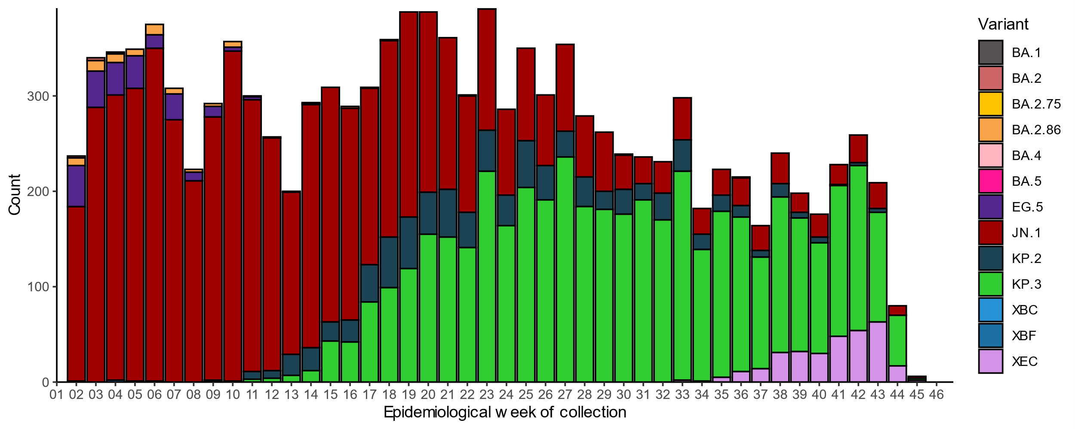* Some sub-sublineages are shown alongside their parent lineage, but not included in the parent lineage totals. For instance, KP.2 and KP.3 are sub-sub lineages of JN.1, so the total of JN.1 sequences will be higher than shown in the corresponding colour alone, and should include the KP.2 and KP.3 totals.
^ Sequences in AusTrakka aggregated by epidemiological week. Sequences are reported based on date of sample collection, not date of sequencing.
† Proportions in Figure 18A may not be representative when sequence numbers are small; refer to Figure 18B. Data for earlier epidemiological weeks may change between reporting periods as sequences with older collection dates are uploaded. These numbers are not equivalent to number of cases, as there are many cases which may not be sequenced. Non-VOI and non-VUM Omicron sub-lineages have been collapsed into parent lineages BA.1, BA.2, BA.3, BA.4 and BA.5.

NNDSS
- This month (21 October to 17 November 2024), most influenza notifications were influenza A(Unsubtyped) (68.2%; 3,709/5,437), followed by influenza B (28.2%; 1,531/5,437) and influenza A(H3N2) (2.1%; 113/5,437) and influenza 1.4% (78/5,437) were influenza A(H1N1). Two notifications were an influenza A&B co-detection (Figure 19).
- In the year to date, influenza A has accounted for the majority of influenza notifications across all jurisdictions (Figure 20).

Figure 19: Influenza notifications to the NNDSS by subtype and week of diagnosis, Australia, 1 January to 17 November 2024
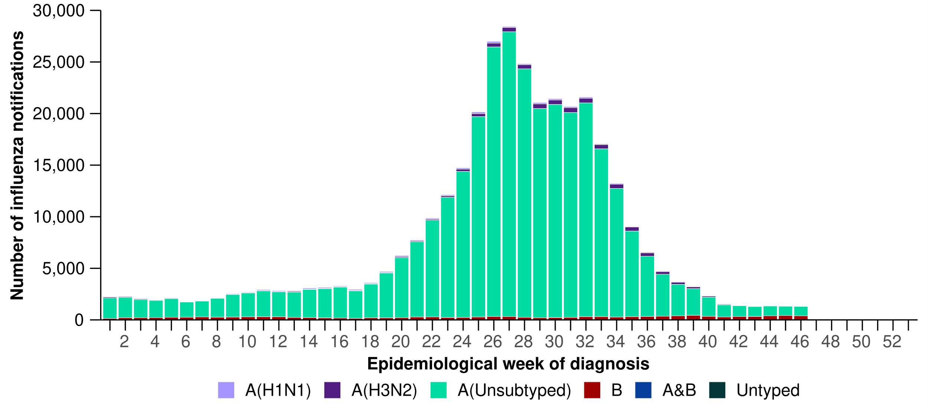

Figure 20: Proportion of influenza notifications to the NNDSS by subtype and jurisdiction*, Australia, 1 January to 17 November 2024
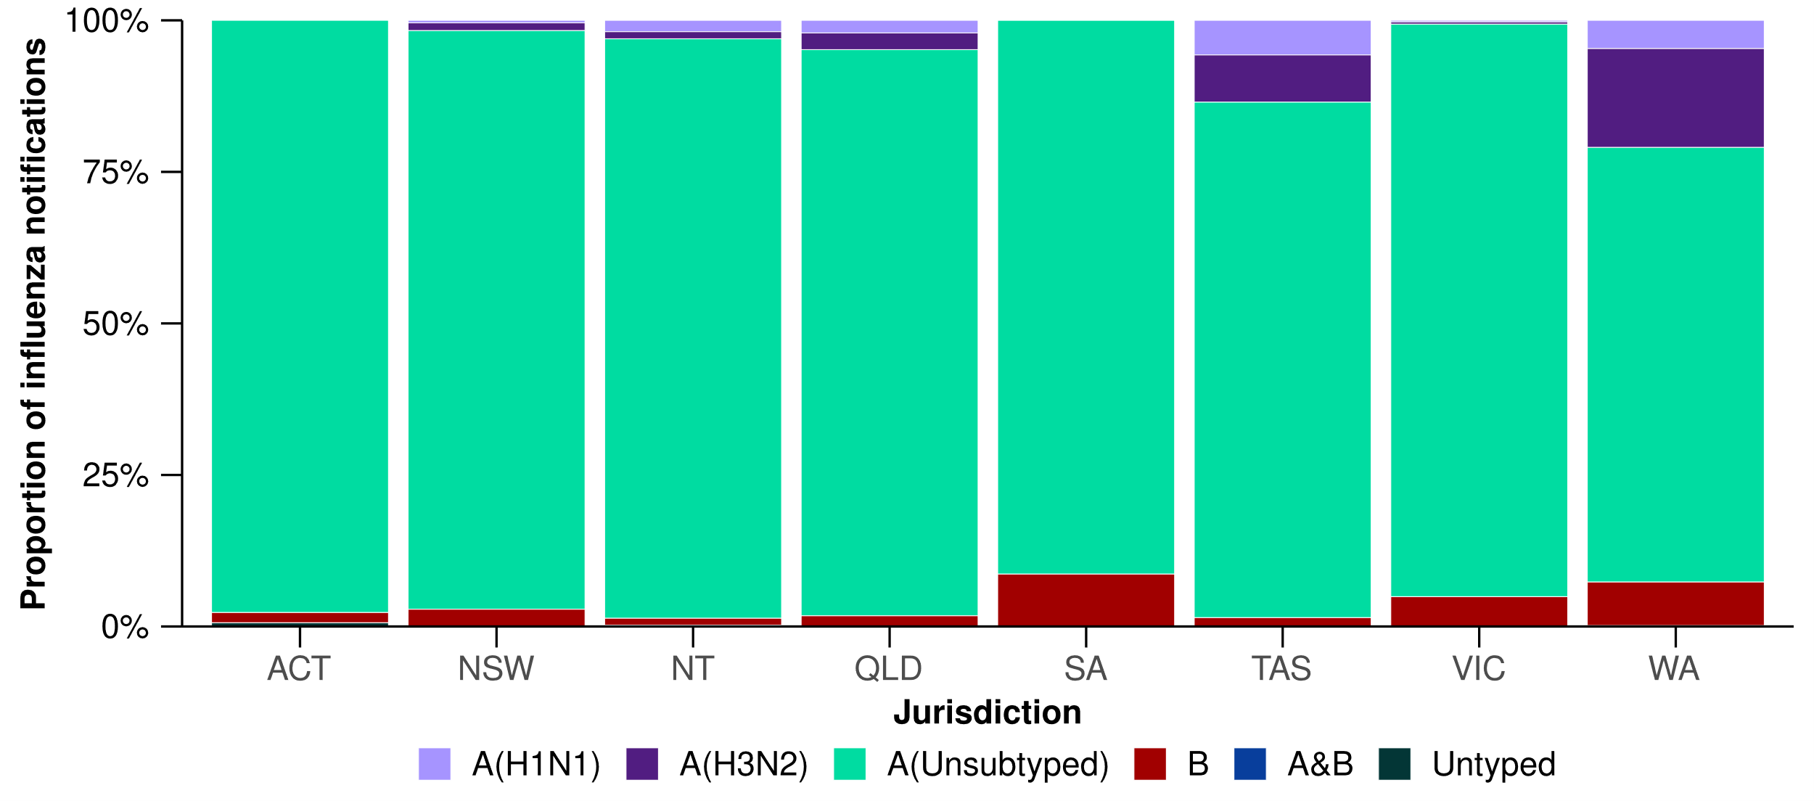

World Health Organization Collaborating Centre (WHOCC) for Reference and Research on Influenza
- In the year to date, the WHOCC has characterised 2,943 influenza viruses (Table 4), of which:
  - 47.9% (1,410/2,943) have been influenza A(H1N1)
  - 47.7% (1,404/2,943) have been influenza A(H3N2)
  - 4.4% (129/2,943) have been influenza B/Victoria.
- In the year to date, there have been no influenza B/Yamagata viruses characterised by the WHOCC (Table 4).
- Of the influenza A(H1N1) samples tested for neuraminidase inhibitor resistance, 0.9% (9/1,000) demonstrated reduced inhibition to Oseltamivir. Of the influenza A(H3N2) samples tested for neuraminidase inhibitor resistance, 0.1% (1/1,045) demonstrated reduced inhibition to Oseltamivir.
- None of the samples tested demonstrated reduced inhibition to Zanamivir.
Table 4: Australian influenza viruses typed by the WHOCC for Reference and Research on Influenza by haemagglutination inhibition assay and jurisdiction*†, 1 January to 17 November 2024
Strain | ACT | NSW | NT | Qld | SA | Tas. | Vic. | WA | Total
A(H1N1) | 83 | 230 | 335 | 55 | 42 | 103 | 470 | 92 | 1,410
A(H3N2) | 77 | 256 | 390 | 58 | 47 | 48 | 427 | 101 | 1,404
B/Victoria lineage | 13 | 4 | 9 | 5 | 10 | 3 | 53 | 32 | 129
B/Yamagata lineage | 0 | 0 | 0 | 0 | 0 | 0 | 0 | 0 | 0
Total | 173 | 490 | 734 | 118 | 99 | 154 | 950 | 225 | 2,943
*Viruses tested by the WHOCC for Reference and Research on Influenza are not necessarily a random sample of all those in the community and early-year data may be based on limited samples received. There may be up to a month delay on reporting of samples.
† Jurisdiction indicates the residential location for the individual tested, not the submitting laboratory.

6. Vaccine coverage, effectiveness and match
In this report, data reported on vaccine coverage, effectiveness and match relate to influenza vaccinations. COVID-19 and RSV vaccination data will be included in future iterations. Refer to the Technical Supplement – Australian Respiratory Surveillance Report for further detail on relevant vaccine terminology and methodology.

6.1 Vaccine coverage
- Data on vaccine coverage is currently unavailable.

6.2 Vaccine effectiveness

ASPREN and FluCAN for the Global Influenza Vaccine Effectiveness (GIVE) Collaboration
- Vaccine effectiveness is the reduction in risk of influenza and its complications in those vaccinated, compared to those not vaccinated. Australian studies suggest that in 2024, vaccinated individuals are roughly 60% less likely to attend general practice or be hospitalised with influenza than unvaccinated people.
  - Estimated vaccine effectiveness against general practice attendance was 62% (95% Confidence Interval [CI]: 45%, 74%).
  - Estimated vaccine effectiveness against hospitalisation was 56% (95% CI: 48%, 63%).
  - Estimated vaccine effectiveness against both general practice attendance and hospitalisation with influenza was similar against influenza A(H1N1) and influenza A(H3N2).
  - Vaccine effectiveness was not able to be estimated against influenza B due to low circulation of influenza B during the 2024 season.
  - These figures are based on incomplete data and the final estimates for 2024 may differ.
- These estimates are on the higher end when compared to historical estimates. The higher vaccine effectiveness in 2024 is likely due to a good match between circulating and vaccine strains and an earlier season with less opportunity for immunological waning after vaccination.

6.3 Vaccine match

WHOCC for Reference and Research on Influenza
- In the year to date, 98.7% (1,391/1,410) of influenza A(H1N1) isolates, 91.1% (1,279/1,404) of influenza A(H3N2) isolates and 100% (129/129) of influenza B/Victoria isolates characterised by the WHOCC have been antigenically similar to the corresponding vaccine components.

