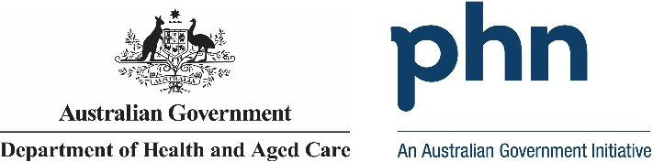

Western Sydney

# PHN Fact sheet 2024

## Snapshot:

Selected PHN Western Sydney has a total population of 1070789 people. Of this total 20595 are First Nations people. The total population growth for 2016 to 2022 was 0.13%. The population aged 65 years and over equate to 290360 people. Population growth for this age group in 2016 to 2022 was 0.25%. The PHN covers 765.72 square kilometres. Snapshot information is based on data published by the Public Health Information Development Unit at Torrens University from the Social Health Altas of Australia by Primary Health Network Decemeber 2023.

## Key Information:

Selected PHN Western Sydney have 4.92% of its population who require assistance for core activities due to a disability. The unemployment rate for the labour force is 3.5%. People who use another language and who do not speak English well account for 2.13% of people, while 5.88% do not speak English at all

## Demographics:

Selected PHN Western Sydney has a male population of 541283 people, which equates to 51% of the total population. Females account for 529506 people. That is 49% of the total population. Demographics information is based on Estimated Resident Population for 2022 calculated by the Australian Bureau of Statistics.

## Age:

Selected PHN Western Sydney has the following age distribution: Zero to fourteen year olds account for 222129 people. 15- to 24-year-olds account for 136246 people. 25- to 44-year-olds account for 349311 people. 45- to 64-year-olds acount for 232383 people. 65- to 84-year-olds acount for 275603 people. And lastly those aged 85 years and above account for 14757 people. This data is sourced from the Australian Bureau of Statistics.

**Source**: a – Australian Bureau of Statistics – Census of Population and Housing 2021 l b – PHIDU Social Health Atlas of Australia Data by Primary Health Network Dec 2023

**ERP**: Estimated Resident Population l Need for Assistance: Core Activity need for Assistance Core activity need for assistance (ASSNP) l English Proficiency: Proficiency in spoken English (ENGLP) | Australian Bureau of Statistics (abs.gov.au) Data has been obtained from a range of publicly available sources, and DoHAC does not take responsibility for data quality. Last Updated: May 2024