Quarterly Financial Snapshot

Aged Care Sector

Quarter 4 2023-24

April to June 2024

Contents

Introduction 3

Aged care reform priorities 4

Summary of findings 6

Residential care 7

Home care 10

Residential aged care 11

Financial performance 11

Average care minutes 17

Staff cost and time 19

Hourly rates 22

Food and nutrition 24

Home care 25

Financial performance 25

Staff cost and time 29

Hourly rates 30

Care and package management 32

Unspent funds 33

Glossary 34

Appendix 37

How to read the QFS 37

Data sources and method 38

Previous snapshots and feedback 38

# Introduction

The Australian Government is committed to transparency in aged care. Publishing of financial information gives valuable insights to the sector and community.

The Department of Health and Aged Care (the department) publishes a Quarterly Financial Snapshot (QFS) on the Australian aged care sector. The QFS:

* provides transparency about providers’ finances and operations and helps older people, and their families, make informed decisions about their care
* provides timely information for aged care service providers to compare and benchmark their performance with sector-level results
* supports the monitoring of critical financial metrics across the aged care system
* complements other publications such as:
  + the annual Financial Report on the Australian Aged Care Sector (FRAACS)
  + the Food and Nutrition Report
  + registered nurse coverage in aged care dashboard
  + care minutes in residential aged care dashboard
  + the quarterly reporting of service-level financial and operations information on My Aged Care through the ‘Find a Provider’ tool.

This QFS covers the period 1 April to 30 June 2024 (quarter 4 of 2023-24). It has three sections:

The infographic in the introduction chapter, page 2 shows icons and the names of each section in the QFS. The QFS is split into summary, residential care and home care. 



Appendix 1 contains tips on how to read the QFS, including provider type definitions, information about the data sources, and methodologies used throughout this QFS.

An Excel data extract, containing all headline figures from QFS reports published to date is available on the [department’s website](https://www.health.gov.au/resources/publications/data-extract-from-the-quarterly-financial-snapshot-reports-of-the-aged-care-sector-inclusive-of-quarter-3-2023-24). It includes a breakdown of results by provider types. This data extract will be updated quarterly.

**The department would like to thank all aged care providers who completed the Quarterly Financial Report (QFR) and helped develop the QFS.**

## Aged care reform priorities

The Australian Government is continuing to develop programs and initiatives that underpin high quality and safe aged care for older people in Australia. These reforms will strengthen choice and transparency for older people, their family members and carers. They also improve the sustainability of the aged care sector.

### Reform impacts on quarter 4 (Apr – Jun 2024) results

The June 2024 year-to-date (YTD) results show an improvement in the financial performance of the residential care sector on the June 2023 YTD position. Net profit before tax (NPBT) improved, and more providers reported positive earnings before interest, tax, depreciation, and amortisation (EBITDA). Profitable providers serviced 64.1% of residential care recipients in quarter 4 2023-24.

An improved financial position was also reflected in home care, where providers reported an improvement in NPBT and EBITDA results. Profitable home care providers serviced 81.9% of home care recipients in quarter 4 2023-24.

The quarter 4 2023-24 results published in this report show the impact on aged care providers from the following reforms and initiatives:

* a 16.6% increase from 1 July 2023, and a further 4.4% increase from 1 December 2023 to average Australian National Aged Care Classification (AN-ACC) funding. For quarter 4 2023-24, AN-ACC funding for the sector was $5.1 billion.
* investment from 1 July 2023 has supported residential aged care and Home Care Package providers to implement the ‘Fair Work Commission (FWC) decisions’:
  + Stage 2 of the FWC Aged Care Work Value Case which increased award wages by 15.0%
  + the Annual Wage Review decision, which increased award wages by 5.75%.
* introduction of a mandatory average of 200 care minutes per resident per day from 1 October 2023 in residential aged care. This includes 40 minutes of direct registered nurse care.
* commencement of the Aged Care Outbreak Management Support Supplement in February 2024. This replaced the previous COVID-19 grants application process. It supports providers to plan for and manage outbreaks of COVID-19 and other infectious diseases.
* investment of $91 million from 2022-23 in the Home Care Workforce Support Program. This provides funding for home care providers to attract, recruit, and train new personal care workers, and upskill the existing workforce.
* release of an additional 9,500 Home Care Packages (HCP) in 2023-24 to meet the growing preference for older people to remain at home.

### Future reform impacts

In the 2024-25 financial year QFS reports, the department expects to see further operational and financial impacts on the sector. These impacts follow the introduction of the following initiatives:

* investment of an additional $3.8 billion over four years to fund the FWC’s decision in Stage 3 of the Aged Care Work Value Case from 1 January 2025, which will increase award wages for approximately 340,000 aged care workers.
* measures announced in the [Government response to the Aged Care Taskforce](https://www.health.gov.au/resources/publications/australian-government-response-to-the-aged-care-taskforce?language=en). These structural reforms, pending passage of legislation, will allow the sector to sustainably provide quality care for older people into the future.
* increase in the AN-ACC price from $253.82 to $280.01 from 1 October 2024. This will support residential aged care providers to meet increased costs, including to increase their care minutes.
* increase in the hotelling supplement from $11.24 to $12.55 from 20 September 2024.
* increased care minutes responsibilities for residential aged care providers. From  
  1 October 2024 providers must deliver a sector-wide average of 215 care minutes per resident per day. This must include 44 minutes of registered nurse care.
* continued investment of $88.4 million in programs and initiatives from 2024-25 to attract and retain the aged care workforce. These programs focus on:
  + growing the home care workforce in regional, rural, and remote areas where shortages are the most acute
  + supporting better pathways for nurses in aged care.
* release of 24,100 extra HCPs in 2024-25 to reduce wait times and support more people to access in-home aged care.
* provider preparations for the commencement of the new Aged Care Act and regulatory model (from 1 July 2025). These will mark changes to provider registration and renewal processes, the Aged Care Quality Standards, and worker screening and regulation approach for aged care.

While the department expects to see the impacts of these initiatives in the short term, the Government’s reform is ongoing. More information on aged care reform is available on the [Department of Health and Aged Care’s website](https://www.health.gov.au/our-work/aged-care-reforms). A [summary resource](https://www.health.gov.au/sites/default/files/2024-05/budget-2024-25-quality-aged-care.pdf) about the Government’s commitment to strengthening the quality of aged care services in the 2024-25 Budget is also available.

# Summary of findings

The infographic in the introduction chapter shows a summary of year-to-date financial data for quarter 4 for residential care and home care. The YTD NPBT result for residential care in quarter 3 was $8.22 per resident per day, an increase of $22.03 per resident per day from the YTD result in quarter 3 from the previous year. The YTD EBITDA result for residential care in quarter 3 was $44.92 per resident per day, an increase of $23.57 per resident per day on the YTD result for quarter 4 prior year. The YTD NPBT result for home care in quarter 4 was $5.69 per care recipient per day, an increase on the YTD result in quarter 4 the year prior by $1.62 per care recipient per day. The YTD EBITDA result in home care in quarter 4 was $6.04 per care recipient per day, an increase of $1.45 per care recipient per day from the YTD result recorded at the end of quarter 4 in 2022-23 financial year. There was 65.9% of residential care providers that were profitable YTD in quarter 4, an increase of 17.0 percentage points compared to the YTD percentage in quarter 4 2022-23. There was 76.7% profitable home care providers YTD in quarter 4, an increase of 2.0 percentage points compared to the YTD result recorded in quarter 4 2022-23. The percentage of residential care providers with a positive EBITDA YTD was 82.7%, an increase of 12.6 percentage points compared with the YTD result recorded in quarter 4 2022-23. For home care, it was 79.4% of providers had a YTD positive EBITDA result, an increase of 3.9 percentage points on the YTD quarter 4 2022-23 financial year. There was a total of 736 residential care providers recorded in quarter 3 and 909 home care providers. The residential care sector average care minutes for quarter 3 was a total of 207.98 minutes per resident per day, an increase of 3.50 minutes compared with the previous quarter. The total sector average care minutes for registered nurses was 41.44 care minutes per resident per day, enrolled nurses was 13.04 minutes and personal care workers/assistants in nursing was 153.22 minutes.  For-profit providers reported total average care minutes of 202.34, an increase of 4.50 minutes on quarter 3 2023-24 result. Not-for-profit providers reported total average care minutes of 209.50 which is an increase of 3.16 minutes on quarter 3 2023-24.


## Residential care

**The quarter 4 2023-24 YTD financial position of the residential aged care sector improved significantly from quarter 4 2022-23 YTD.**

### Results:

* YTD EBITDA improved by $23.57 per resident per day, totalling $44.92.
  + The proportion of providers reporting a positive YTD EBITDA position improved to 82.7%, up 12.6 percentage points.
  + The median EBITDA margin increased to 9.0%, up 3.7 percentage points. This means an EBITDA return of $9.00 for every $100 of revenue earned.
* YTD NPBT performance improved by $22.03 per resident per day, totalling $8.22.
  + The total YTD NPBT for the sector was a profit of $571.3 million.
  + The proportion of providers reporting a positive YTD NPBT position increased to 65.9%, up 17.0 percentage points.
  + Year-end adjustments impacted the final NPBT position of the sector. Providers wrote off $683.5 million YTD in bed licenses amortisation.
* Average occupancy rate increased to 88.5%, up 1.8 percentage points.

### Insights:

The data reported in quarter 4 2023-24 emphasises emerging trends. These trends, as outlined below, give insights into expected future financial performance.

1. An increase in AN-ACC funding and the introduction of the hotelling and 24/7 registered nurse supplements in the 2023-24 financial year increased profitability in the residential sector.

In quarter 4 2023-24, the total YTD NPBT for the sector was a profit of $571.3 million. This was an increase of $1,495.3 million from quarter 4 2022-23. The increase in NPBT was driven by a revenue increase of $76.37 per resident per day. This outweighed the increase in expenses of $54.34 per resident per day.

Revenue increases between quarter 4 2022-23 and quarter 4 2023-24 are primarily attributed to a $1.2 billion increase in AN-ACC funding. The payment of the $11.24 hotelling supplement per resident per day, and $46.5 million for the 24/7 registered nurse supplement to eligible services also contributed. The hotelling supplement includes the value of the Basic Daily Fee supplement of $10.00 which was included in the AN-ACC price before 1 July 2023.

As outlined below, 59.5% of services are not meeting both their service-specific total care minutes and registered nurse targets. It is expected that labour costs will continue to increase as these providers start to meet these targets. This may reduce the scale of reported NPBT in the 2024-25 financial year.

1. Total care minutes and registered nurse minutes delivered to residents in aged care services were above the sector targets for the first time. However, improvements are required to improve compliance in individual services.

In quarter 4 2023-24, providers delivered an average of 207.71 care minutes per resident per day. This included 41.44 minutes delivered by a registered nurse. This is the first quarter since the care minutes responsibilities came into effect on 1 October 2023 that both targets have been met at the sector level.

However, the results show that only 40.5% of services met both their service-level total care minutes and registered nurse care minute targets (up 5.0 percentage points on quarter 3 2023-24). Compliance with the care minutes responsibility also continues to vary by provider type. Since the care minutes obligation was introduced, not-for-profit providers have exceeded the mandatory target. Comparatively, for-profit providers have delivered under the mandatory target. Under delivery against care minute targets appears to be contributing to profits, with for-profit providers more likely to have a positive NPBT (73.9% with a positive YTD NPBT) than not-for-profit providers (61.2% with a positive YTD NPBT).

As outlined in a recent [Letter to aged care providers from the Minister for Aged Care](https://www.health.gov.au/resources/publications/letter-to-aged-care-providers-from-the-minister-for-aged-care-about-care-minutes-1-october-2024?language=en), the department is developing options, including funding policy options, to boost care minutes compliance for Government consideration.

1. Provider performance on accommodation will need to improve to enable capital investment and ensure care funding is spent on care delivery.

Reporting in FRAACS 2022-23 showed the accommodation result was negative $1.20 per resident per day. Along with the variance in YTD NPBT results from care minutes compliance, this indicates that providers may be using care funding to cover accommodation losses. To maintain profitability while meeting care minutes targets, performance on accommodation will need to improve.

The Government delivered its response to the recommendations of the Aged Care Taskforce on 12 September 2024. These reforms will improve accommodation funding by:

* requiring providers to retain 2.0% per year of refundable accommodation deposits (RAD) and refundable accommodation contributions (RAC) for up to five years from 1 July 2025
* requiring providers to index daily accommodation payments (DAP) twice per year by the consumer price index for residents that enter care on or after   
  1 July 2025
* increasing the maximum room price a provider can charge without approval from the Independent Heath and Aged Care Pricing Authority from $550,000 to $750,000 from 1 January 2025, and indexing on 1 July every year after that.

## Home care

**The quarter 4 2023-24 YTD results highlight continued improvements to the home care sector’s financial position from quarter 4 2022-23 YTD.**

### Results:

* YTD EBITDA improved by $1.45 per care recipient per day, totalling $6.04.
  + The proportion of providers reporting a positive YTD EBITDA position also increased to 79.4%, up 3.9 percentage points.
  + Median EBITDA margin increased to 7.5%, up 0.7 percentage points.   
    This means an EBITDA return of $7.50 for every $100 of revenue earned.
* YTD NPBT performance improved by $1.62 per care recipient per day, totalling $5.69.
  + The total YTD NPBT for the sector was a profit of $528.8 million.
  + The proportion of providers reporting a positive YTD NPBT position also increased to 76.7%, up 2.0 percentage points.

### Insights:

1. A marked increase in claim days drove a strong increase in profitability in the home care sector.

In quarter 4 2023-24, the total YTD NPBT for the sector was a profit of   
$528.8 million. This was an increase of $208.4 million (65.1%) from the quarter 4 2022-23 result of $320.4 million. The increase in NPBT was driven by an increase in revenue of $4.05 per care recipient per day. This outweighed the increase in expenses of $2.43 per care recipient per day.

Revenue increases are primarily attributed to an 18.1% increase in claim days. This change follows the increase uptake in Home Care Packages (average of 69.7% in quarter 4 2023-24, compared to 68.4% in quarter 4 2022-23). Also contributing to the increase in revenue was an 11.9% increase in the Home Care Subsidy and Supplements. This uplift was to support funding of wage increases following the FWC decisions.

# Residential aged care

## Financial performance

### Financial summary

The YTD financial performance of the residential aged care sector improved in quarter 4 2023-24, when compared to quarter 4 2022-23.[1]

* YTD EBITDA improved by $23.57 per resident per day, totalling $44.92.
* YTD NPBT for the sector was $571.3 million, an increase of $1,495.3 million from quarter 4, 2022-23. This equates to improvement of $22.03 per resident per day, totalling $8.22.
* Revenue grew by $76.37 per resident per day (up 22.1%).
* Expenses have grown by $54.34 per resident per day (up 15.1%).

The **change in revenue** from YTD quarter 4 2022-23 is driven by:

* a $1.2 billion increase in AN-ACC funding, from $3.9 billion in quarter 4 2022-23 to $5.1 billion in quarter 4 2023-24
* payment of the $11.24 hotelling supplement per resident per day
* payment of $46.5 million for the 24/7 registered nurse supplement to eligible services
* a 3.8% increase in claim days
* the payment in quarter 4 2023-24 of $51.7 million via the Aged Care Outbreak Management Support Supplement, which was introduced on 1 February 2024.[2]

Average care funding allocated to providers per occupied bed day (OBD) was $271.72 for quarter 4 2023-24. This was an increase on the average of $270.81 per OBD[3] for quarter 3 2023-24, and $227.03 per OBD for quarter 4 2022-23.

The **change in expenses** for YTD quarter 4 2022-23 is driven by:

* increased wage costs and employee benefits following the FWC decisions
* providers writing off $683.5 million YTD in bed license amortisation in 2023-24 ($535.6 million YTD by for-profit providers, and $147.9 million by not-for-profit providers). For-profit providers still have approximately $254.5 million left in bed licenses to amortise by 30 June 2025, and not-for-profit providers have approximately $58.9 million left to amortise.

Table 1 provides a financial YTD summary to 30 June 2024.

**Table 1: 30 June 2024 YTD and comparison with 30 June 2023 YTD, summary of financial performance of residential for-profit and not-for-profit aged care providers**

|  |  |  |  |
| --- | --- | --- | --- |
|  | Total | Per resident per day | Change from 30 June 2023 YTD per resident per day |
| Revenue | $29,364.1m | $422.58 | ▲ $76.37 |
| Expenses | $28,792.8m | $414.36 | ▲ $54.34 |
| Net profit before tax (NPBT) | $571.3m | $8.22 | ▲ $22.03 |
| Net profit before tax margin | 2.0% | 2.0% | ▲ 5.9 percentage points |
| Earnings before interest, tax, depreciation, and amortisation (EBITDA) | $3,121.4m | $44.92 | ▲ $23.57 |

**Insights: Impact of bed license write-off expenses on NPBT**

The higher value of bed license write-off expenses resulted in for-profit providers recording a lower YTD NPBT of $6.61 per resident per day, compared with   
not-for-profit providers recording a YTD NPBT of $9.37 per resident per day.

The EBITDA results highlight financial performance by provider type when excluding the impacts of bed license amortisation. For-profit providers reported a higher YTD EBITDA of $57.24 per resident per day, compared to not-for-profit providers who reported a YTD EBITDA per resident per day of $36.09.

As providers have until 30 June 2025 to write-off the remaining $313.3 million in bed licenses, the department expects these expenses will continue to impact financial results in the 2024-25 financial year. It is important to note that the impacts are to provider balance sheets (decreasing net assets) and non-recurrent expenses. There will be no impact to recurrent income and expenses.

### Profitable providers

At 30 June 2024 YTD, the percentage of profitable providers (defined by NPBT) was 65.9% (up 17.0 percentage points from 30 June 2023 YTD). The percentage of providers making a profit increased for both for-profit providers and not-for-profit providers. Profitable providers at 30 June 2024 YTD serviced 64.1% of residential care recipients (up 27.6 percentage points from 30 June 2023 YTD).

Figure 1 shows the percentage of profitable providers and percentage of residents serviced by profitable providers.

Figure 1: At 30 June 2024 YTD percentage of profitable providers and percentage of residents serviced by profitable providers and sector level comparison at 30 June 2023 YTD

Figure 1 is a circular pie graph titled At June 30 2024 YTD percentage of profitable providers and percentage of residents serviced by profitable providers and sector level comparison at 30 June 2023 YTD. The percentage of providers that were profitable increased from 48.9% in Q3 to 65.9% in Q4. The percentage of For-profit and Not-for-profit providers both increased at 73.9% and 61.2% respectively.
64.1% of residents were serviced by profitable providers up from 36.5% (increase of 27.6 percentage points from 30 June 2023 YTD). 66.4% of residents in For-profit settings were serviced by profitable providers, 62.% of residents were serviced by profitable providers in Not-for profit settings. 

### EBITDA margin

At 30 June 2024 YTD, the median EBITDA margin for the sector was 9.0%, which means an EBITDA return of $9.00 for every $100 of revenue earned. This was an increase of 3.7 percentage points on the 30 June 2023 YTD result. These improvements are primarily driven by increased AN-ACC revenue and the additional $11.24 per resident per day hotelling supplement. Expenses also increased in comparison to quarter 4 2022-23, but on a smaller scale than revenue.

Chart 1 shows the median and quartile EBITDA margin over the most recent five quarters.

Chart 1: YTD median and quartile EBITDA margin (quarter 4 2022-2023 to quarter 4 2023-2024)

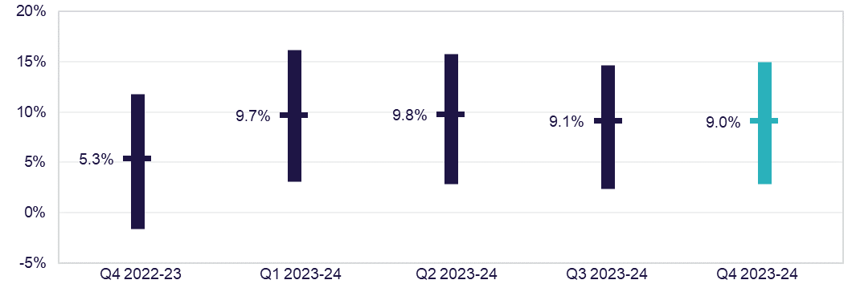

### Occupancy

In quarter 4 2023-24, the average occupancy rate was 88.5% (up 1.8 percentage points on the quarter 4 2022-23).

Chart 2 shows the average occupancy rate over the most recent five quarters.

Chart 2: Average occupancy rate (quarter 4 2022-2023 to quarter 4 2023-2024)[4]

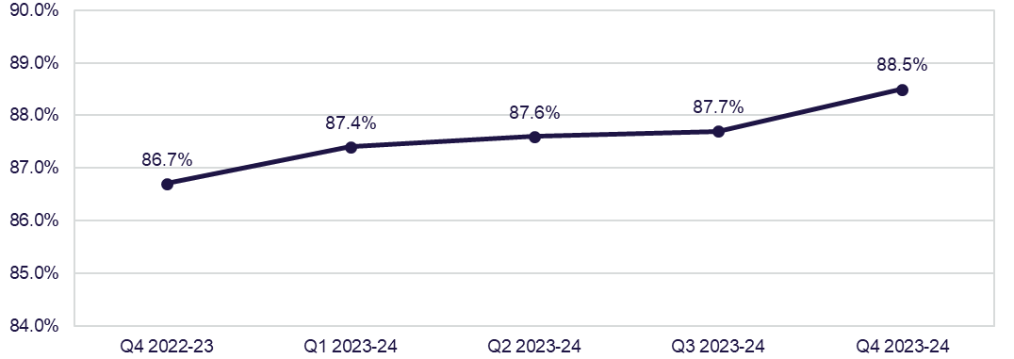

Average occupancy rate = Total number of days an operational place is occupied by a resident / Total number of days an operational place was available to be occupied

### Liquidity

At 30 June 2024, the median liquidity ratio for the sector was 0.38 (up 0.04 from   
30 June 2023), meaning providers had just over a third of cash and financial assets available when compared to their debt obligations.

Chart 3 shows the median and quartile liquidity ratio over the most recent five quarters.

Chart 3: Median and quartile liquidity ratio (quarter 4 2022-2023 to quarter 4 2023-2024)

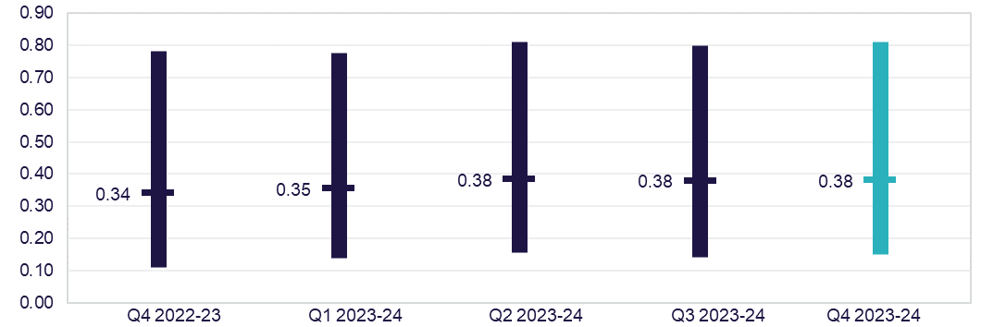

Liquidity ratio = (cash and cash equivalents + financial assets) ÷ (total liabilities - lease liabilities).

Calculations do not include undrawn credit facilities as liquid assets. Total liabilities do not include RADs that residents have agreed to pay, but the amount has not yet been received by the provider.

### Capital adequacy

At 30 June 2024, the median capital adequacy ratio for the sector was 0.29, meaning for every $100 of assets owned, $29 was funded through equity and $71 was funded through debt or other liabilities. This is unchanged from the 30 June 2023 position.

Chart 4 shows the median and quartile capital adequacy ratio over the most recent five quarters.

Chart 4: Median and quartile capital adequacy ratio (quarter 4 2022-2023 to quarter 4 2023-2024)

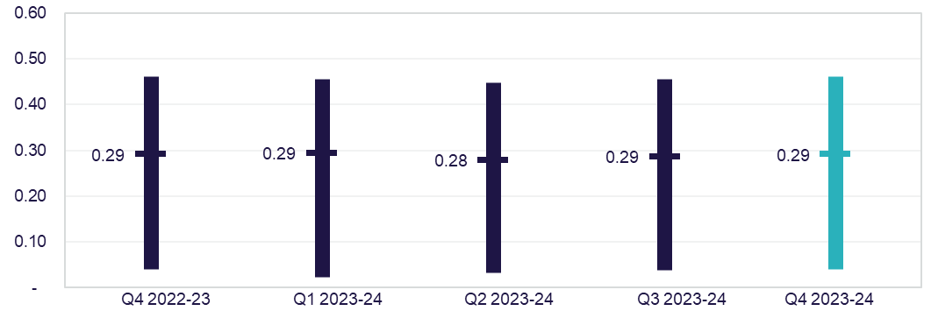

Capital adequacy ratio = (net assets - intangible assets) ÷ (total assets - intangible assets).

Intangible assets are removed as they are not considered to have value in the event of insolvency. This provides a more realistic reflection of the available capital to absorb unforeseen circumstances.

### Wages to revenue

At 30 June 2024 YTD, wages as a proportion of revenue for the sector was a median of 70.4% (down 0.5 percentage points from 30 June 2023). Wages are inclusive of all residential aged care employees.

Chart 5 shows the YTD median and quartile wages as a proportion of revenue over the most recent five quarters.

Chart 5: YTD median and quartile wages to revenue percentage (quarter 4 2022-2023 to quarter 4 2023-2024)

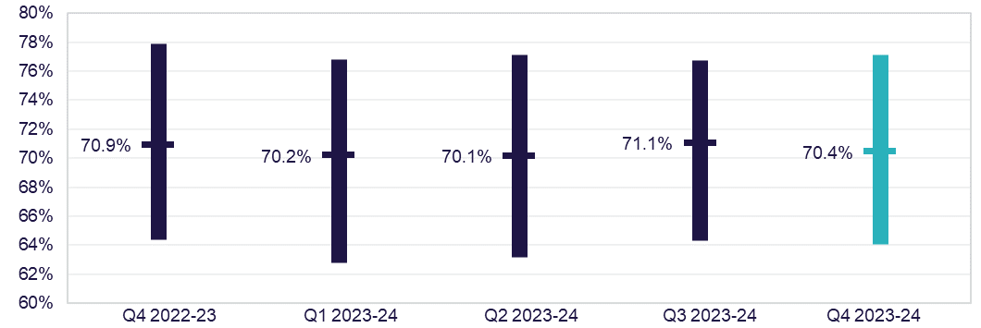

## Average care minutes

In quarter 4 2023-24, the sector targets were 204.98 minutes per resident per day for total care minutes, and 40.51 per resident per day for registered nurse care minutes.

Overall, across the **sector**:

* residents received an average of 207.71 total care minutes per day (up   
  3.50 minutes from quarter 3 2023-24). This included 41.44 minutes delivered by a registered nurse (up 1.23 minutes)
* 57.6% of services met their service-level total care minutes targets (up   
  4.9 percentage points)
* 58.8% met their service-level registered nurse targets (up 6.6 percentage points)
* 40.5% of services met both their service-level total care and registered nurse care minute targets (up 5.0 percentage points).

Average care minutes per resident per day for quarter 4 2023-24 is shown in Table 2.

**Table 2: Average care minutes per resident per day (sector and by provider type)**

|  |  |  |  |  |  |
| --- | --- | --- | --- | --- | --- |
|  | Sector | Change in average sector care minutes from Q3 2023-24 | For-profit | Not-for-profit | LST government |
| Registered nurse | 41.44 | ▲ 1.23 | 39.90 | 40.94 | 68.93 |
| Enrolled nurses | 13.04 | ▼ 0.29 | 9.96 | 10.88 | 87.46 |
| Personal care workers / assistants in nursing | 153.22 | ▲ 2.56 | 152.49 | 157.67 | 87.50 |
| Total * | 207.71 | ▲ 3.50 | 202.34 | 209.50 | 243.88 |

* Total sector care minutes does not equal the sum of care minutes by role due to rounding.

Average care minutes per resident per day are calculated using occupied bed days rather than claim days. Average care minutes = Total care minutes / Occupied bed days.

When breaking down results by **provider type** (compared to quarter 3 2023-24):

* for-profit providers delivered below the sector care minute target (202.34 average care minutes per resident per day, up 4.50 minutes)
* not-for-profit providers delivered above the sector care minute target (209.50 average care minutes per resident per day, up 3.16 minutes)
* local, state or territory government providers delivered above the sector care minute target (243.88 average care minutes per resident per day, up 0.93 minutes).

**Insights: Care minutes by provider type**

Care minutes delivery continues to vary by provider type, evident when comparing the results of for-profit and not-for-profit providers since the care minutes obligation was introduced in October 2023 (quarter 2 2023-24) (see Chart 6). Not-for-profit providers have steadily increased their total average care minutes and exceeded the mandatory target since its introduction. Comparatively, while for-profit providers have increased their total average care minutes, they have consistently delivered under the sector mandatory care minutes target.

**Chart 6: Total care minutes by provider type (quarter 4 2022-23 to quarter 4 2023-24)**

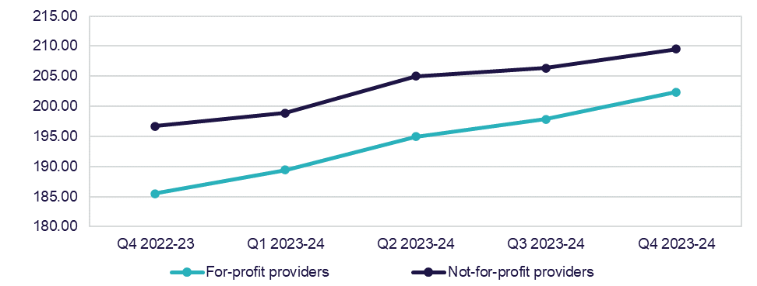

Under delivery against care minute targets appears to be contributing to profits, with for-profit providers more likely to have a positive NPBT (73.9% with a positive YTD NPBT) than not-for-profit providers (61.2% with a positive YTD NPBT).

## Staff cost and time

### Total median staff cost and time

The total median staff costs and time have increased from quarter 4 2022-23 to   
quarter 4 2023-24. Costs increased to $224.42 per resident per day (up $39.44 from quarter 4 2022-23) and total time increased to 225.41 minutes per resident per day (up 7.32 minutes from quarter 4 2022-23). This change was primarily driven by providers increasing their care minutes and wage increases following the FWC decisions.

Table 3 shows the quarter 4 median total staff cost and time per resident per day.

Table 3: Quarter 4 2023-24 and comparison with quarter 4 2022-23, median staff cost and time per resident per day

|  | Cost per resident per day | Change in cost from Q4 2022-23 | Minutes per resident per day | Change in minutes from Q4 2022-23 |
| --- | --- | --- | --- | --- |
| Registered nurses | $57.32 | ▲ $12.27 | 41.20 | ▲ 3.93 |
| Enrolled nurses | $11.27 | ▼ $0.29 | 10.92 | ▼ 1.93 |
| Personal care workers / assistants in nursing | $130.38 | ▲ $25.49 | 152.54 | ▲ 8.01 |
| Allied health | $5.41 | ▲ $0.05 | 4.16 | ▼ 0.10 |
| Diversional / lifestyle / recreation / activities officer | $5.58 | ▲ $0.29 | 7.54 | ▼ 0.66 |
| Care management staff | $6.03 | ▼ $0.06 | 3.65 | ▼ 0.47 |
| Total median* | $224.42 | ▲ $39.44 | 225.41 | ▲ 7.32 |

* Total median staff cost and time is derived from the QFR data set. It is not the sum of sub-categories listed above the totals. Local, state or territory government providers are included in this data.

### Agency median staff cost and time

Agency staff costs represented 9.3% of the total direct care labour cost in quarter 4 2023-24, a decrease from quarter 4 2022-23 of 2.0 percentage points. Agency staff hours represented 6.4% of the total direct care labour hours to the sector in quarter 4 2023-24, a decrease from quarter 4 2022-23 of 1.2 percentage points. Agency staff hours increased only for registered nurses, likely driven by increased demand as providers aim to meet the 24/7 registered nurse care and care minute responsibilities.

Table 4 shows the agency staff costs and hours as a percentage of the total direct care labour costs and hours.

Table 4: Quarter 4 2023-24 and comparison with quarter 4 2022-23, agency staff costs and hours as a percentage of direct care costs and hours

|  | Agency staff costs as % of total | Change in cost from Q4 2022-23 | Agency staff hours as % of total | Change in hours from Q4 2022-23 |
| --- | --- | --- | --- | --- |
| Total direct care | 9.3% | ▼2.0  percentage points | 6.4% | ▼1.2  percentage points |
| Registered nurses | 13.1% | – 0.0  percentage points | 9.0% | ▲0.2  percentage points |
| Enrolled nurses | 7.7% | ▼0.5  percentage points | 5.4% | ▼0.2  percentage points |
| Personal care workers / assistants in nursing | 5.8% | ▼3.1  percentage points | 4.5% | ▼1.6  percentage points |

### Allied health median staff cost and time

In quarter 4 2023-24, the proportion of providers that delivered allied health care was 98.9% (up from 97.8% in quarter 4 2022-23). As shown in Table 3, the median total cost and time for allied health services per resident per day was $5.41 and   
4.16 minutes, respectively, in quarter 4 2023-24. The highest median allied health cost and time per resident per day was for physiotherapists. The median cost was $3.41 per resident per day (down $0.13 on quarter 4 2022-23). This equates to a median spend on physiotherapy of $310.07 per resident per quarter (down $12.37 on quarter 4 2022-23). The median allied health minutes delivered by physiotherapists was 2.66 minutes per resident per day (down 0.07 minutes on quarter 4 2022-23). This equates to 242.38 minutes per resident per quarter (down 6.01 minutes on quarter 4 2022-23).

Table 5 shows the median cost and time for allied health per resident per day.

Table 5: Quarter 4 2023-24 and comparison with quarter 4 2022-23, median allied health cost and time per resident per day

|  | Cost per resident per day | Change in cost from Q4 2022-23 | Allied health minutes of care per resident per day | Change in minutes from Q4 2022-23 |
| --- | --- | --- | --- | --- |
| Physiotherapist | $3.41 | ▼ $0.13 | 2.66 | ▼ 0.07 |
| Podiatrist | $0.32 | ▲ $0.04 | 0.22 | ▼ 0.01 |
| Dietetic Care | $0.26 | ▲ $0.04 | 0.15 | ▲ 0.03 |
| Speech Pathologist | $0.15 | ▲ $0.03 | 0.07 | ▲ 0.01 |

Note: Local, state or territory government providers are included in this data. Median results for occupational therapists, allied health assistants and other allied health categories have not been included, as more than half of QFR respondents did not report any expenditure for these categories.

## Hourly rates

In quarter 4 2023-24, median sector hourly rates increased for all direct care staff compared to quarter 4 2022-23. The sector median of the average hourly rate was:

* $49.04 for registered nurses (up $5.04 on quarter 4 2022-23)
* $36.00 for enrolled nurses (up $4.00 on quarter 4 2022-23)
* $31.08 for personal care workers and assistants in nursing (up $4.08 on quarter 4 2022-23).

Charts 7, 8 and 9 show the median of the sector’s lowest, average, and highest hourly rates paid to registered nurses, enrolled nurses, and personal care workers and assistants in nursing, respectively. These average hourly rates are for staff employed per the employee award, enterprise agreement or contract. It does not include on-costs, penalty rates or casual rates. Nil-value responses are excluded.

Chart 7: Lowest, average, and highest hourly rates (medians) paid to registered nurses (quarter 4 2022-2023 to quarter 4 2023-2024)

Chart 7 titled Lowest, average, and highest hourly rates (medians) paid to registered nurses (quarter 4 2022-2023 to quarter 4 2023-2024 show the median of the sector's lowest, average and highest hourly rated paint to registered nurses. Comparing wages in quarter 4 2022-23 and quarter 4 2023-24 provides a view of the passing on of Government funding.  
Over this 12-month period, the average (median) wages increased by 11.5%. An increase lower than the expected 15.0% can be due to several factors, including: the reporting of median rates in the QFS, providers already paying above the new award wages in quarter 4 2022-23, providers not passing on the increase until after quarter 1 2023-24. 



Chart 8: Lowest, average, and highest hourly rates (medians) paid to enrolled nurses (quarter 4 2022-2023 to quarter 4 2023-2024)

Chart 7 titled Lowest, average, and highest hourly rates (medians) paid to enrolled nurses (quarter 4 2022-2023 to quarter 4 2023-2024 show the median of the sector's lowest, average and highest hourly rated paid to enrolled nurses. Comparing wages in quarter 4 2022-23 and quarter 4 2023-24 provides a view of the passing on of Government funding.  
Over this 12-month period, the average (median) wages increased by 12.5%. An increase lower than the expected 15.0% can be due to several factors, including: the reporting of median rates in the QFS, providers already paying above the new award wages in quarter 4 2022-23, providers not passing on the increase until after quarter 1 2023-24. 


Chart 9: Lowest, average, and highest hourly rates (medians) paid to personal care workers and assistants in nursing (quarter 4 2022-2023 to quarter 4 2023-2024)

Chart 7 titled Lowest, average, and highest hourly rates (medians) paid to personal care workers and assistants in nursing (quarter 4 2022-2023 to quarter 4 2023-2024 show the median of the sector's lowest, average and highest hourly rated paint to personal care workers and assistants in nursing. Comparing wages in quarter 4 2022-23 and quarter 4 2023-24 provides a view of the passing on of Government funding.  
Over this 12-month period, the average (median) wages increased by 15.1%. 


**Note in relation to Charts 7, 8, and 9**: Reporting to two decimal places (cents) commenced in quarter 2 2023-24.

Insights: Hourly wages following the FWC decisions



Government funding to support Stage 2 FWC decision in the Aged Care Work Value Case of a 15.0% increase to award wages for registered nurses, enrolled nurses, and personal care workers and assistants in nursing in residential aged care came into effect on 1 July 2023. Comparing wages in quarter 4 2022-23 and quarter 4 2023-24 provides a view of the passing on of Government funding.

Over this 12-month period, the average (median) wages increased by:

● 11.5% for registered nurses

● 12.5% for enrolled nurses, and

● 15.1% for personal care workers and assistants in nursing.

These median increases reflect workers paid above award on Enterprise Bargaining Agreements as well as those workers that are award-reliant.

## Food and nutrition

In quarter 4 2023-24, at a **sector level**:

* the median total cost of food and ingredients was $14.47 per resident per day (up $0.84 on quarter 4 2022-23)
* the median proportion of the total cost of food and ingredients spent on fresh food and ingredients (foods free of GST as per itemised purchase receipts) was 83.6% (up 0.5 percentage points on quarter 4 2022-23).

The amount spent on food and ingredients per resident per day is only one indicator of food quality. It should not be taken in isolation, as it does not consider factors such as residents’ satisfaction, cooking preparation method and overall nutritional status.

Charts 10 and 11 show the sector median total cost of food and ingredients over the most recent five quarters, and median proportion spent on fresh food and ingredients.

Chart 10: Median food and ingredients cost per resident per day (quarter 4 2022-2023 to quarter 4 2023-2024)[5]

Chart 10 : Median food and ingredients cost per resident per day (quarter 4 2022-2023 to quarter 4 2023-2024 outlines the median cost per resident per day for food and ingredients spent. 
The median total cost of food and ingredients was $14.47 per resident per day, up $0.84 on quarter 4 2022-23

Chart 11: Median proportion of the total cost of food and ingredients spent on fresh food and ingredients (quarter 4 2022-2023 to quarter 4 2023-2024)

Chart 11 states the median proportion of the total cost of food and ingredients spent on fresh food and ingredients.
The median proportion of the total cost of food and ingredients spent on fresh food and ingredients (foods free of GST as per itemised purchase receipts) of was 83.6%, up 0.5 percentage points on quarter 4 2022-23

# Home care

## Financial performance

### Financial summary

The YTD financial performance of the home care sector improved in quarter 4   
2023-24, when compared to quarter 4 2022-23.

* YTD EBITDA improved by $1.45 per care recipient per day, totalling $6.04.
* YTD NPBT for the sector was $528.8 million, an increase of $208.4 million from quarter 4, 2022-23. This equates to improvement of $1.62 per care recipient per day, totalling $5.69.
* Revenue grew by $4.05 per care recipient per day (up 5.8%).
* Expenses have grown by $2.43 per care recipient per day (up 3.7%).

**Revenue increases** were driven by an 11.9% increase in the Home Care Subsidy and Supplements due to the FWC decisions, and an 18.1% increase in claim days.

**Expense increases** were driven by higher wage costs to deliver services. This related to the changes to award wages following the FWC decisions and correlating expenses related to the increase in home care claim days.

Table 6 provides a financial YTD summary to 30 June 2024.

Table 6: 30 June 2024 YTD and comparison with 30 June 2023 YTD, summary of financial performance of home care for-profit and not-for-profit providers

|  | Total | Per care recipient per day | Change from 30 June 2023 YTD per care recipient per day |
| --- | --- | --- | --- |
| Revenue | $6,883.0m | $74.03 | ▲ $4.05 |
| Expenses | $6,354.2m | $68.34 | ▲ $2.43 |
| Net profit before tax | $528.8m | $5.69 | ▲ $1.62 |
| Net profit before tax margin | 7.7% | 7.7% | ▲ 1.86 percentage points |
| Earnings before interest, tax, depreciation and amortisation (EBITDA) | $561.6m | $6.04 | ▲ $1.45 |

### Profitable providers

At 30 June 2024 YTD, the percentage of profitable providers (defined by NPBT) was 76.7%. This was an increase of 2.0 percentage points from 30 June 2023 YTD. Profitable providers at 30 June 2024 YTD serviced 81.9% of home care recipients. This was an increase of 3.5 percentage points from 30 June 2023 YTD.

Figure 2 shows the percentage of profitable providers and percentage of home care recipients serviced by profitable providers.

Figure 2: 30 June 2024 YTD percentage of profitable providers and percentage of home care recipients serviced by profitable providers and comparison with 30 June 2023 YTD

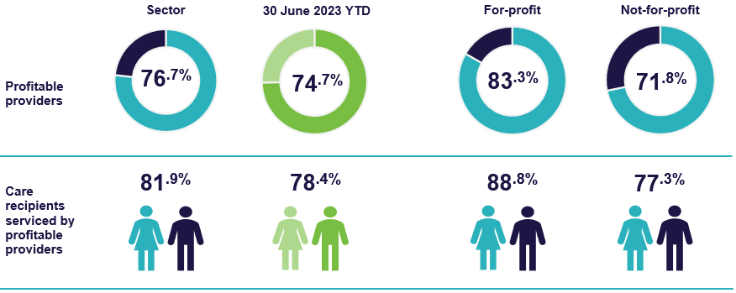

### EBITDA margin

At 30 June 2024 YTD, the median EBITDA margin for the sector was 7.5%. This means an EBITDA return of $7.50 for every $100 of revenue earned. This was an increase of 0.7 percentage points on the 30 June 2023 YTD result.

Chart 12 shows the median and quartile EBITDA margin over the most recent five quarters.

Chart 12: YTD median and quartile EBITDA margin (quarter 4 2022-2023 to quarter 4 2023-2024)

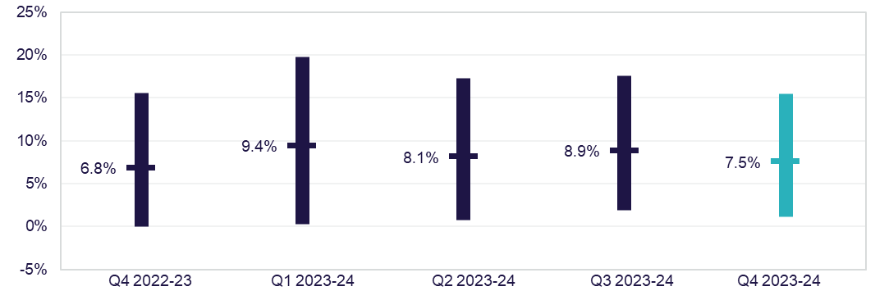

### Liquidity

At 30 June 2024, the median sector liquidity ratio was 0.82. This was an increase of 0.05 from 30 June 2023. This means for every $100 of debt obligations, providers had $82 in liquid assets.

Chart 13 shows the median and quartile liquidity ratio over the most recent five quarters.

Chart 13: Median and quartile liquidity ratio (quarter 4 2022-2023 to quarter 4 2023-2024)

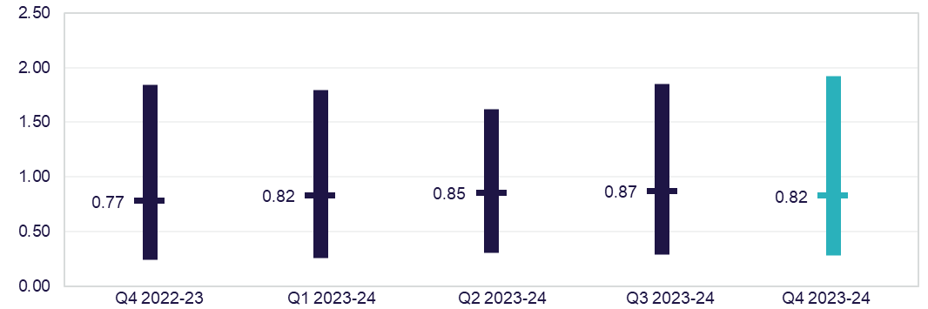

Liquidity ratio = (cash and cash equivalents + financial assets) ÷ (total liabilities – lease liabilities). Calculations do not include undrawn credit facilities as liquid assets.

### Capital adequacy

At 30 June 2024, the sector median capital adequacy ratio was 0.53. This means for every $100 of assets owned, $53 was funded through equity and $47 was funded through debt or other liabilities. This is an increase of 0.03 from 30 June 2023.

Chart 14 shows the median and quartile capital adequacy ratio over the most recent five quarters.

Chart 14: Median and quartile capital adequacy ratio (quarter 4 2022-2023 to quarter 4 2023-2024)

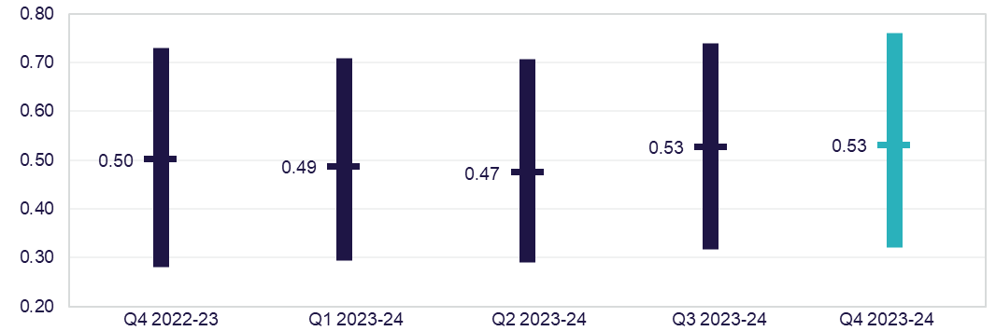

Capital adequacy ratio = (net assets - intangible assets) ÷ (total assets - intangible assets)

### Wages to revenue

At 30 June 2024 YTD, wages as a proportion of revenue for the sector was a median of 61.4%. This is an increase of 0.4 percentage points from 30 June 2023.

Chart 15 shows the YTD median and quartile wages as a proportion of revenue over the most recent five quarters. Wages include salaries and employment benefits, agency and subcontractor costs, and management fees. They do not include staff training and development.

Chart 15: YTD median and quartile wages to revenue percentage (quarter 4 2022-2023 to quarter 4 2023-2024)

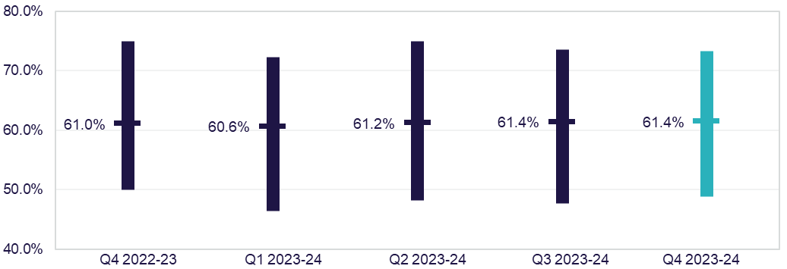

## Staff cost and time

Total median staff costs have increased to $53.13 per care recipient per day (up $7.65 or 16.8% from quarter 4 2022-23). Total median time increased to 56.60 minutes per care recipient per day (up 2.65 minutes or 4.9% from quarter 4 2022-23).

The increases in median staff costs and time are driven by providers increasing their care minutes. Though, unlike in residential care, there is no mandated care minutes target in home care. Median staff costs increased at a proportionally higher rate compared to the median staff time due to increased wages after the FWC decisions.

Table 7 shows the median total staff cost and time per care recipient per day.

Table 7: Quarter 4 2023-24 and comparison with quarter 4 2022-23, median staff cost and time per care recipient per day

|  |  |  |  |  |
| --- | --- | --- | --- | --- |
|  | Cost per care recipient per day | Change in cost from Q4 2022-23 | Minutes per care per recipient per day | Change in minutes from Q4 2022-23 |
| Registered nurse | $1.12 | ▲ $0.34 | 0.78 | ▲0.25 |
| Personal care staff | $25.88 | ▲ $4.99 | 30.01 | ▲1.22 |
| Allied health | $3.62 | ▲ $1.24 | 1.74 | ▲0.55 |
| Other direct care | $0.68 | ▼ $0.87 | 0.38 | ▼0.81 |
| Care management | $7.20 | ▲ $0.57 | 7.93 | ▲0.06 |
| Administration and non-care staff | $6.88 | ▲ $0.98 | 7.70 | ▲0.64 |
| Total median* | $53.13 | ▲ $7.65 | 56.60 | ▲2.65 |

* Total median staff cost and time was derived from the QFR data set, and is not the sum of the medians listed above the total medians. Local, state or territory government providers are included in this data.

Note: Any staff travel, or work done on administration tasks during care staff paid hours, is included in the results of Chart 15, which shows the median wages to revenue percentage.

Data for enrolled nurses has not been included as 70% of home care providers did not report any expenditure in this category.

## Hourly rates

In quarter 4 2023-24, the sector median of the average hourly rates increased for all direct care staff in comparison to quarter 4 2022-23, at:

* $50.00 for registered nurses (up $3.00 on quarter 4 2022-23)
* $37.50 for enrolled nurses (up $1.50 on quarter 4 2022-23)
* $33.53 for personal care staff (up $2.53 on quarter 4 2022-23).

Charts 16, 17, and 18 show the median of the sector’s highest, average, and lowest hourly rates for quarter 4 2023-24 and a comparison with quarter 4 2023-24. These average hourly rates are for staff employed per the employee award, enterprise agreement or contract. It does not include on-costs, penalty rates, casual rates, agency fees and subcontracting arrangements. Nil-value responses are excluded.

Chart 16: Lowest, average, and highest hourly rates (medians) paid to registered nurses (quarter 4 2022-2023 to quarter 4 2023-2024)

Chart 16 titled Lowest, average, and highest hourly rates (medians) paid to registered nurses (quarter 4 2022-2023 to quarter 4 2023-2024) show the median of the sector’s highest, average, and lowest hourly rates for quarter 4 2023-24 and a comparison with quarter 4 2023-24.In quarter 4 2023-24, the sector median of the average hourly rates increased for all direct care staff in comparison to quarter 4 2022-23, at: $50.00 for registered nurses (up $3.00 on quarter 4 2022-23)


Chart 17: Lowest, average, and highest hourly rates (medians) paid to enrolled nurses (quarter 4 2022-2023 to quarter 4 2023-2024)

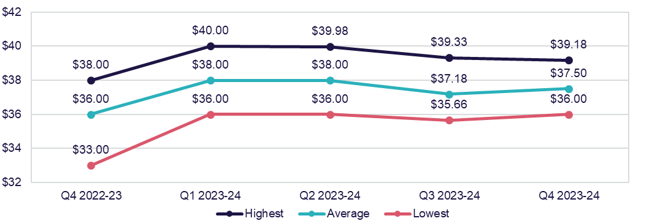

Chart 18: Lowest, average, and highest hourly rates (medians) paid to personal care staff (quarter 4 2022-2023 to quarter 4 2023-2024)

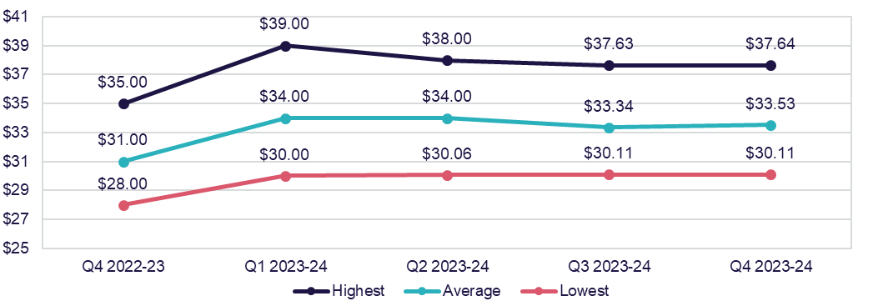

**Note in relation to Charts 16, 17, and 18**: Reporting to two decimal places (cents) commenced in quarter 2 2023-24.

** Insights: Hourly wages following the FWC decisions**

Government funding to support of the Stage 2 FWC decision in the Aged Care Work Value Case of a 15.0% increase to award wages for registered nurses, enrolled nurses, and personal care staff in home care came into effect on   
1 July 2023. A comparison of the wages in quarter 4 2022-23 and   
quarter 4 2023-24 provides a view of the passing on of funding to direct care workers.

Over this 12-month period, the average (median) wages increased by:

● 6.4% for registered nurses

● 4.2% for enrolled nurses, and

● 8.2% for personal care staff.

The department undertook targeted quality assurance in quarter 2 2023-24, supporting providers in improving wage reporting. This has impacted (decreased) wage results in quarter 2 2023-24 and in later quarters.

These median increases reflect workers paid above award on Enterprise Bargaining Agreements as well as those workers that are award-reliant.

## Care and package management

In quarter 4 2023-24, all HCP levels had a median care management percentage of 17% per HCP, under the cap of 20%. The care management percentage per HCP remained the same for HCP levels 1, 3 and 4 when compared to quarter 4 2022-23. For HCP level 2, it decreased by 1.0 percentage point.

In quarter 4 2023-24, the package management charges increased for all HCP levels to 12% (up from 11% in quarter 4 2022-23). All HCP package management charges remain under the 15% cap.

Chart 19 shows the quarter 4 2023-24 median care management and package management fee per HCP level, as reported on My Aged Care.

Chart 19: 30 June 2024 and 30 June 2023, median care and package management percentage per HCP level

Chart 19 titled 30 June 2024 and 30 June 2023, median care and package management percentage per HCP level Chart 19: 30 June 2024 and 30 June 2023, median care and package management percentage per HCP level.
In quarter 4 2023-24, all HCP levels had a median care management percentage of 17% per HCP, under the cap of 20%. The care management percentage per HCP remained the same for HCP levels 1, 3 and 4 when compared to quarter 4 2022-23. For HCP level 2, it decreased by 1.0 percentage point.
In quarter 4 2023-24, the package management charges increased for all HCP levels to 12% (up from 11% in quarter 4 2022-23). All HCP package management charges remain under the 15% cap


Care management percentage = care management expenses ÷ total Government subsidy

Package management percentage = package management expenses ÷ total Government subsidy

## Unspent funds

At 30 June 2024, there was $3.6 billion in unspent HCP funds (up $0.8 billion from   
30 June 2023). This includes:

* $3.2 billion of unspent funds in the Home Care Account (up $1.0 billion)
* $0.4 billion in the Provider Held Portion of unspent funds (down $0.2 billion).

Chart 20 shows the change in unspent HCP funds over the most recent five quarters.

Chart 20: Unspent funds ($) at 30 June 2024 and comparison with 30 June 2023

**Chart 20 titled Unspent funds ($) at 30 June 2024 and comparison with 30 June 2023 shows the change in unspent HCP funds over the most recent five quarters.
At 30 June 2024, there was $3.6 billion in unspent HCP funds (up $0.8 billion from 
30 June 2023). This includes:
$3.2 billion of unspent funds in the Home Care Account (up $1.0 billion)  
$0.4 billion in the Provider Held Portion of unspent funds (down $0.2 billion).
**

# Glossary

| Term | Description |
| --- | --- |
| [Aged Care Outbreak Management Support Supplement](https://www.health.gov.au/topics/aged-care/managing-covid-19/government-support) | The Aged Care Outbreak Management Support Supplement was introduced on 1 February 2024. It provides funding of:   * $2.81 per day per occupied bed for residential aged care providers * $2.81 per day per operational place for Multi-Purpose Services and National Aboriginal and Torres Strait Islander Flexible Aged Care providers. |
| [Australian National Aged Care Classification  (AN-ACC) funding model](https://www.health.gov.au/our-work/AN-ACC) | The AN-ACC funding model is a casemix funding model that represents the care component of residential aged care funding. AN-ACC is designed to provide equitable care funding to approved residential aged care services, by linking subsidy to characteristics of services and residents. The Independent Heath and Aged Care Pricing Authority (IHACPA) provides annual pricing advice to the Minister of Health and Aged Care on the AN-ACC model. This ensures funding is based on advice on the actual cost of care. |
| [Care management](https://www.health.gov.au/our-work/home-care-packages-program/managing/care-management) | [Care management](https://www.health.gov.au/our-work/home-care-packages-program/managing/care-management#:~:text=Care%20management%20is%20a%20service,services%20align%20with%20other%20supports) ensures recipients receive the appropriate level of support in a way that meets their care needs. It is a service that home care providers must deliver to all care recipients. It may include ensuring a care recipient receives safe and effective personal and/or clinical care, organising the delivery of services, and ensuring the supports they receive are safe. Providers must not charge more than 20% of the Australian Government Subsidy for care management. |
| [Care minutes](https://www.health.gov.au/our-work/AN-ACC/providers/care-minutes) | Care minutes refers to the amount of care time older people who live in Government-funded residential aged care services receive from registered nurses, enrolled nurses, and personal care workers / assistants in nursing. From 1 October 2023, the sector-wide care minutes benchmark was an average of 200 total care minutes per resident per day, including 40 minutes of care per resident per day by a registered nurse. This sector-wide care minutes benchmark increased to 215 total care minutes on 1 October 2024, including 44 minutes of registered nurse time. From this time, approved providers are able to meet up to 10% of their registered nurse targets with care time provided by enrolled nurses. Approved providers of a residential care services have a responsibility to meet service-level care minutes targets for each service.  Allied health, diversional / lifestyle / recreation / activities officer and care management staff minutes do not contribute to the care minute targets. Providers must, however, continue to deliver allied health and lifestyle services to their residents in line with requirements under Schedule 1 of the [Quality of Care Principles 2014](https://www.legislation.gov.au/F2014L00830/latest/text). Care minutes data in this QFS report is consistent with the [care minutes in residential aged care dashboard](https://www.health.gov.au/resources/publications/care-minutes-in-residential-aged-care-dashboard?language=en). |
| Capital adequacy ratio | The capital adequacy ratio measures a provider's net asset position divided by total asset position (not including intangibles). This ratio can be used as an indicator of a provider's ability to absorb any unexpected losses through their net asset position (also known as an asset buffer). If a provider has a stronger (higher) capital adequacy ratio, they will be able to fund and absorb the impacts of unforeseen circumstances by using business equity. Intangible assets are removed as they are not considered to have value in the event of insolvency. |
| EBITDA margin | EBITDA margin is used as an indicator of a provider’s financial performance and underlying profitability before accounting for depreciation assumptions, tax obligations or financing choices. EBITDA margins focus on a provider’s operating profitability and cash flow. The higher the EBITDA margin is, the lower operating expenses are in comparison to total revenue. |
| Fair Work Commission decisions | The Australian Government is funding the Fair Work Commission’s decision on the [Aged Care Work Value Case](https://www.fwc.gov.au/documents/decisionssigned/pdf/2023fwcfb40.pdf) of a 15% increase to award wages for registered nurses, enrolled nurses, assistants in nursing, personal care workers and home care workers, head chefs and cooks, and recreational activities officers (lifestyle workers). The wage increase came into effect on 30 June 2023. The Government also continues to fund FWC decisions relating to [Annual Wage Reviews](https://www.fwc.gov.au/hearings-decisions/major-cases/annual-wage-reviews) (AWRs). These wage increases take effect on 1 July each year. These decisions are collectively referred to as the ‘FWC decisions’ in this report. |
| [Home Care Package subsidy](https://www.health.gov.au/our-work/home-care-packages-program/funding/subsidy) | The Australian Government pays a monthly subsidy amount into each care recipient’s home care account which Services Australia creates and holds.. The subsidy includes a basic subsidy amount and any supplements. Approved providers are paid in arrears for care management, package management and services delivered based on a month claim to Services Australia made against the care recipients home care account. |
| [Hotelling supplement](https://www.health.gov.au/our-work/residential-aged-care/funding/supplements/hotelling) | Approved providers of residential aged care have received a supplement to help meet hotelling costs from 1 July 2023. This supplement supports providers for the cost of services such as catering, cleaning, and gardening. The hotelling supplement will be indexed on 20 March and 20 September each year |
| Total labour (staff) costs | Labour (staff) costs include salaries for all care and non-care staff, superannuation, bonuses and incentives, allowances, termination payments, value of fringe benefits, salary sacrifice and leave entitlements. Training costs for all employment categories are included under ‘Administration and non-care staff’ costs. Total worked staff hours excludes leave and training hours and only includes the time spent delivering care. |
| Liquidity ratio | The liquidity ratio measures the availability of cash and financial assets to cover providers' debt obligations (without raising external capital) if they were to become immediately due and payable. If the ratio result is greater than 1.0, the provider has more cash and financial assets than their debt obligations. If the ratio result is less than 1.0, the provider’s debt obligations are more than their cash and financial assets. |
| [Package management](https://www.health.gov.au/our-work/home-care-packages-program/managing/package-management) | Package management is the ongoing administration and organisational activities associated with ensuring the smooth delivery of a home care package. Providers must not charge more than 15% of the Australian Government subsidy for package management. |
| Refundable Accommodation Deposit (RAD) and Daily Accommodation Payment (DAP) | A refundable accommodation deposit (RAD) is the lump-sum payment for a room (or part of a room) in an aged care service. Providers earn a return on RADs by investing the funds, either by making capital improvements on their facilities or by investing in approved financial products.  A daily accommodation payment (DAP) is an ongoing, non-refundable rental-style payment, paid instead of a RAD. The DAP is calculated by multiplying the RAD of a room by the Maximum Permissible Interest Rate (which is set by the government) and divided by the number of days in a year. |
| [Support at Home Program](https://www.health.gov.au/our-work/support-at-home) | The new Support at Home (SaH) program is scheduled to commence from 1 July 2025, and will replace the HCP Program and the Short-Term Restorative Care (STRC) Programme. The Commonwealth Home Support Programme (CHSP) will transition to the new SaH program no earlier than 1 July 2027.  The SaH program will ensure in-home aged care supports people to remain independent at home longer through faster access to safe and high quality services. More information on SaH can be found in the [Support at Home program handbook](https://www.health.gov.au/resources/publications/support-at-home-program-handbook?language=en). |
| [Unspent funds](https://www.health.gov.au/our-work/home-care-packages-program/managing/unspent-funds) | From 1 September 2021, unspent Government subsidy for Home Care Packages is accrued in a Home Care Account set up for care recipients by Services Australia. These funds are available for providers to use for care and services provided to the care recipient. Some providers also have access to the Provider Held Portion of unspent funds accrued prior to 1 September 2021. These funds can be used towards a care recipient’s care and services. |

# Appendix

## How to read the QFS

### Comparison data

Comparison with the prior four quarters is presented in most **charts** to understand changes or trends in performance over time. The exception is *Chart 19: 30 June 2024 and 30 June 2023, median care and package management percentage per HCP level*, which compares to the corresponding quarter from the previous financial year.

Comparison with the corresponding quarter from the previous financial year results are reported at the sector-level in most **tables** to understand the change in performance, excluding seasonality. The exception is *Table 2: Average care minutes per resident per day (sector and by provider type)*, which compares to the immediate prior quarter.

Benchmarking calculations: Throughout the document, this grey box gives guidance on calculations, to support aged care service providers to benchmark their performance against sector-level results.

Quartile charts: show the median, and the upper quartile (50th to the 75th percentile) and lower quartile (25th to the 50th percentile). This highlights the spread of reported results.

### Insights

 **Insights**

Throughout the document, these boxes are used to highlight key findings in relation to the data presented, including the trend in the data over time.

### Provider type definitions

Percentage of services is calculated using the proportion of claim days from a provider.

| Provider type | Definition |
| --- | --- |
| Sector | Consolidated view of the provider types shown in the chart, figure or table. |
| For-profit | Providers that are either a Private Incorporated Body or a Publicly Listed Company. |
| Not-for-profit | Providers that are either charitable, community based or religious organisations. |
| Local, state or territory government | Refers to providers owned by a local, state or territory government. This acronym is used in tables and charts. These providers are included in labour cost and hours, home care account balance and unspent funds, and food and nutrition data only. |

## Data sources and method

The QFS primarily draws on data collected from aged care providers through the QFR. The QFS quarter 4 2023-24 publishes data collected from 99.6% of residential aged care providers and 97.1% of Home Care Packages providers.

**Collection and analysis notes:**

* QFR data is unaudited but must be authorised by a director of a provider’s board, a member of the governing body, or one of the provider’s Key Personnel (for government providers). The department undertakes data validation processes, and providers may be invited to re-submit data if anomalies are identified.
* The QFS presents the financial summary, wages to revenue percentage, EBITDA margin and percentage of profitable providers in YTD format. This ensures information is presented the way it has been collected, and consistent with standard accounting practices. Other data such as care minutes, labour costs and food and nutrition are reported as quarter 4 results only.
* Provider entry and exit data is extracted from the GPMS. Some providers may be counted in both residential and home care for entry and exit data.
* Occupancy has been calculated by dividing the total number of occupied bed days by the total number of available bed days, for the specified period. Approved providers of residential aged care have been included where available bed days and occupied bed days were greater than zero for the reporting period. Places data are taken from the Stocktake of aged care places 2024.
* The QFS draws on data collected through [My Aged Care](https://www.myagedcare.gov.au/) and other departmental sources. Sector-level results published in QFS may differ slightly from information on the My Aged Care website. The QFS presents median results at the provider-level, while My Aged Care website presents median results at a service-level.

## Previous snapshots and feedback

Previous [QFS publications](https://www.health.gov.au/resources/collections/quarterly-financial-snapshot-of-the-aged-care-sector) are available of the department’s website. The QFS will evolve over time, and the department is committed to working with the sector to inform future publications. Feedback is welcome and should be directed to [QFS.FRAACS@health.gov.au](mailto:QFS.FRAACS@health.gov.au).

**Let’s change aged care together**

We invite Australians to continue to have their say about the aged care reforms.

Visit **agedcareengagement.health.gov.au**

Phone **1800 318 209** (Aged care reform free-call phone line)

For translating and interpreting services, call 131 450 and ask for 1800 318 209.

To use the National Relay Service, visit nrschat.nrscall.gov.au/nrs to choose your preferred access point on their website, or call the NRS Helpdesk on 1800 555 660.



1. The annual result reported in this QFS does not show the complete outcome for the financial year and caution should be exercised when comparing QFS with FRAACS. This is because QFR data for the QFS is prepared predominantly using data from management accounts which are unaudited (but approved by the provider’s Board), while ACFR data (reported in the FRAACS) is audited and reported after all end of year adjustments have been made.
2. This figure is at point in time (15 September 2024) and is subject to change.
3. The OBD care funding figures published in the QFS may change each quarter due to new claims data that is submitted by providers.
4. The true occupancy figure for quarter 4 2023-24 may be slightly higher than the figure reported due to technical matters relating to changing the status of some places from operational to offline.
5. Improvement between quarter 1 and quarter 2 2023-24 was influenced by data quality improvements. Following service level previews on My Aged Care, providers had an opportunity to correct data. 