Private Hospital Sector Financial Health Check – Summary

October 2024

# Private Hospital Sector Financial Health Check (Health Check)

## Why was the Health Check undertaken?

The private hospital sector is an important part of Australia’s health care system. High-level evidence and stakeholder feedback provided to the Australian Government prior to the commencement of the Health Check raised financial viability concerns that potentially impact the health system and patient outcomes.

The Minister for Health and Aged Care, the Hon Mark Butler MP, asked the department to conduct a Health Check on the private hospital sector to further develop the evidence base and identify drivers contributing to financial outcomes.

## Overview of private hospitals in Australia

In July 2024, there were 647 private hospitals providing more than 36,000 beds.[1] Around 83% of private hospitals are in metropolitan locations, 9% in regional centres and 8% in rural towns. The sector is diverse, with variations in size, location, types of treatments delivered, business models and agreements with private health insurers and other funders.

Australia’s private hospitals cover more than 40% of all hospital admissions and deliver approximately 70% of elective surgeries.[2]

In 2022–23, 41.2% (5 million) of hospitalisations occurred in private hospitals, an increase from 40.3% (4.6 million) from 2018-19. Over 74% of patients in private hospitals had stays less than 24 hours.[3]

In 2023–24, private health insurers paid benefits of approximately $18 billion that funded approximately 5 million hospital treatments. Over the 12 months to 30 June 2024, total benefits paid by insurers increased by approximately 7.9% and the number of treatments funded increased by 5.1%. As at 30 June 2024, approximately 12.2 million people were insured for hospital treatment.[4]

**Figure 1:** Numbers of private hospitals in Australia.

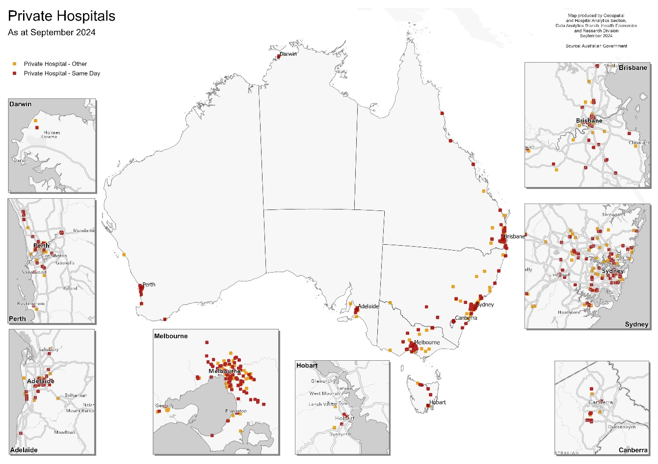

## How was the Health Check conducted?

### Approach

The Health Check assessed private hospital financial data for the period 2017–18 to 2023–24. Financial data was voluntarily provided by 243 out of 647 hospitals, representing 58% of private hospital separations and 63% of hospital revenue in 2022–23.

In addition to voluntarily submitted financial data, several administrative collections were used in the Health Check, these included:

* Hospital Casemix Protocol (HCP) data (2014–15 to 2022–23)
* Private Hospital Data Bureau (PHDB) data (2014–15 to 2022–23)
* National Hospital Cost Data Collection (NHCDC) data (2015–16 to 2021–22)
* Australian Institute of Health and Welfare (AIHW) data
* Medicare Benefits Schedule (MBS) data
* the Commonwealth List of Declared Hospitals.

The department’s quantitative analysis was supplemented by discussions with a range of stakeholders and groups, including a CEO Forum, which met on three occasions, and a Reference Group that provided technical guidance which met on six occasions.

### Confidentiality provisions of the Health Check

Financial data voluntarily submitted by hospital operators to the Health Check is commercially sensitive and was provided on the basis it would remain confidential and not be published. The release of this information would be commercially prejudicial and harm the interests of the private hospitals.

Data from administrative collections used in the Health Check is also subject to use conditions that restrict publication.

### Important caveats

Aspects of the quantitative analysis undertaken was limited due to:

* data sources, including the financial data submitted by private hospitals, that covered different time periods and different private hospitals
* potential selection bias exists due to the incomplete submission of financial data across the private hospital sector
* no episode level cost data available for day hospitals.

## What did we find?

### Activity

There has been a shift away from overnight separations towards same-day separations. Between 2018–19 and 2022–23, the Compound Annual Growth Rate (CAGR) for overnight separations was 0.22% compared to 2.66% for same-day separations.

The increased share of same-day separations has largely been taken up by overnight hospitals rather than a shift to day hospitals.

**Figure 2:** Number of overnight and same-day separations in private hospitals between   
2014–15 and 2022–23.

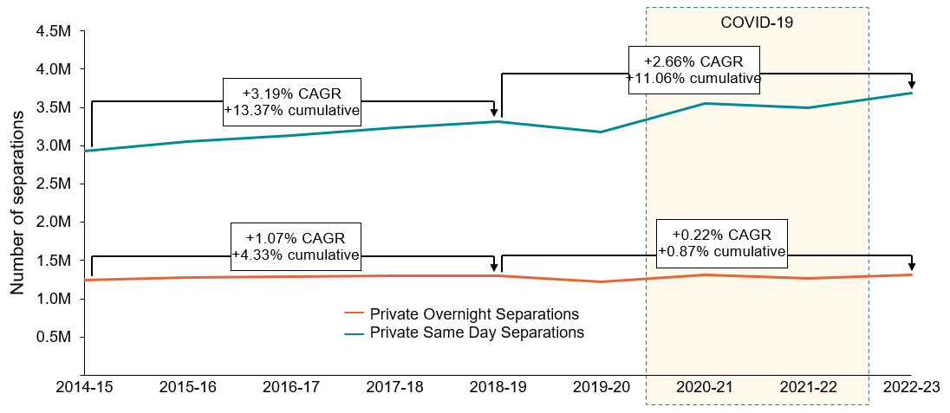

*Source: Australian Institute of Health and Welfare,* [*Admitted Patient Care 2022–23 2 – How much activity was there?*](https://www.aihw.gov.au/reports-data/myhospitals/sectors/admitted-patients)*, My Hospitals.*

### Earnings

There has been significant variability in the sector’s operating environment over the period the Health Check assessed operators’ financial data. Factors contributing to the variability include:

* workforce shortages, notably for mental health
* increases in the cost of key inputs not being matched by increases in revenues
* changes in demand for certain types of services and reductions in lengths of stay
* the COVID-19 pandemic and associated restrictions on elective surgery introduced in early 2020.[5]

While the financial information submitted by private hospitals to the Health Check was sufficiently detailed to enable financial analysis to account for differences in size, type and locations of private hospitals, disaggregated financial detail has been withheld to ensure:

* commercially sensitive information is not released; and
* the presentation of incomplete data is not misinterpreted.

In assessing the NHCDC and PHDB for private hospital cost, activity and price data, and taking into account patient activity and changes in casemix,[6] expenditures were found to increase at a CAGR of 4.1% and revenues were found to have increased at a CAGR of 2.9% between 2018-19 to 2021-22. These results are for 89 overnight hospitals, representing 38% of private hospital separations and 50% of private hospital revenue in 2022–23.

For private hospitals that submitted financial data to the Health Check, there was a decline in the weighted average Earnings Before Interest, Tax and Depreciation (EBITDA) margins[7] from 8.7% in 2018-19 to 4.4% in 2022-23. As noted above, the financial data provided to the Health Check covered 58% of private hospital separations and 63% of private hospital revenue in 2022-23. Taking into account other publicly available financial data, the department estimates that the sector’s weighted average EBITDA margin is likely to have been between 7% and 8% in 2022-23.

**Figure 3:** EBITDA margins of private hospital sample between 2017–18 and 2023–24Q2.

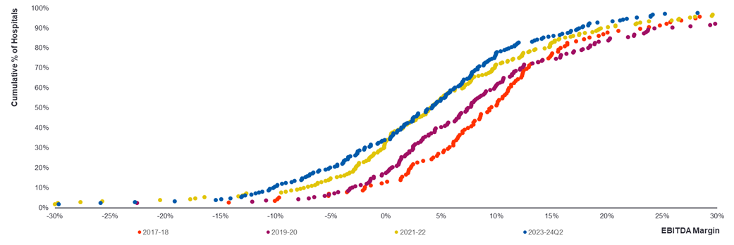

*Source: Private Hospital Sample submissions to the department*

*Notes: Hospital sites: 115 in 2017-18 (26% of separations) growing to 209 (48% of separations) in 2023-24Q2*

Data from the Australian Bureau of Statistics (ABS), also shows private hospitals have experienced a decline in both profit margins and capital replacement rates, indicating reduced investment and suggesting potential longer-term risks of asset deterioration.

**Figure 4:** Capital replacement and profit margins for Australian private sector industries (ex.mining and real-estate) in 2020–21 and 2022–23.

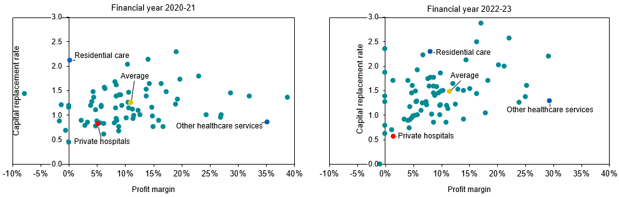*Source: Australian Bureau of Statistics,* [*Australian Industry*](https://www.abs.gov.au/statistics/industry/industry-overview/australian-industry/latest-release#data-downloads)*, catalogue 8155.0.*

*Notes: Capital replacement measures the adequacy of replacing capital assets to cover depreciation. The average includes mining and real-estate services, although they are not shown in the scatterplot datapoints.*

**Services under particular pressure**

In undertaking the Health Check, healthcare providers identified a number of services that were increasingly difficult to offer. Two particular services of concern are obstetrics and mental health.

#### Obstetrics

The number of childbirth separations has declined in both public and private hospitals. There was a decline of 5.9% in public hospitals compared to 4.7% in private hospitals from 2018–19 to 2022–23.[8] Out of pocket charges for consultation with a specialist for the planning and management of a pregnancy have increased by almost 8% between 2018–19 and 2022–23 to a median of $2,615. Between 2015–16 and 2022–23, 9 private hospitals closed their maternity wards, and 2 hospitals with maternity services ceased operating. The profit margins for maternity services for private hospitals are now lower than a decade ago. The sector expressed concerns about the further closure of private hospital maternity wards due to the financial viability of the service and the challenges operators face in attracting and retaining the required specialised workforce, including specialist nurses, mid-wives, paediatricians, and anaesthetists.

#### Mental Health

The number of Medicare-subsidised psychiatric services delivered has increased 18.9% from 2018–19 to 2021–22, supported by an increase in the total number of psychiatrists employed since 2018-19 by approximately 15%. However, the number of services delivered in a private hospital setting has declined by about 15% over the same period. There has also been an increase in the weighted average out-of-pocket gap that psychiatrists charge for telehealth and rooms‑based services. The sector expressed concerned about access to private hospital psychiatric services noting the difficulty in attracting and retaining psychiatrists prepared to work in a hospital setting.

### Concluding observations

The private hospital sector is an important part of the Australian health system, offering patient’s choice, providing the hospital sector additional capacity and a complementary workforce for public hospitals.

This public summary of the Health Check provides only highly aggregated data to ensure commercially sensitive information is not disclosed and the data provided is not misinterpreted.

The data assessed by the Health Check shows the private hospital sector has faced a number of shocks including the COVID-19 pandemic and it continues to experience a degree of volatility, due to inflationary pressures and workforce challenges which are working through the system. There are some positive signs of growth in admissions, and more recently indications that a number of private health insurers have offered additional funding to some private hospitals. Data is not yet available to the department to determine whether this will significantly improve profitability. Looking forward there will be both robust funding negotiations between hospitals and private health insurers and market corrections, requiring the continued close monitoring of the sector.

Critically, all market participants who have a long-term financial interest in the sustainability of the sector must work together to ensure the private hospital sector remains financially viable in the short term but also continues to adapt and innovate to deliver efficient and contemporary acute care into the future.

The sector engaged constructively with the department through the course of the Health Check. Strengthening the collection and analysis of key operational and performance data will enable the department to work closely with the sector for the benefit of the Australian health system.

### Further information

A copy of the data request that was sent to private hospitals is included and can be found at <https://www.health.gov.au/resources/publications/data-request-for-the-private-hospital-sector-financial-health-check>

### Appendices

1. Health Check – Overview.
2. CEO Forum and Reference Group Membership

# Appendix 1: Health Check – Overview

## Objectives

Understand the current state of the private hospital market and viability of the sector by:

* Establishing a robust evidence base regarding financial performance, financial pressures and profitability accounting for heterogeneity.
* Identifying preliminary drivers contributing to financial challenges, including whether private hospitals should be expected to take responsibility for these matters.

## Scope

Analysing existing data and collecting new data to assess:

* components and operating models of the private hospital market
* financing requirements and funding streams and arrangements
* costs and revenue, noting the range of services and treatments provided by the sector
* profitability of the sector including assessment of viability and investability
* key market challenges, the adequacy of arrangements for monitoring viability (including data availability and coverage) and broad directions for further consideration.

## Approach

* focus on quantitative data analysis
* supported by qualitative inputs
* capturing heterogeneity
* undertaking sensitivity and scenario analysis to the current state.

**Appendix 2: CEO Forum and Reference Group Membership**

**Table 1:** Membership of CEO Forum

|  |  |
| --- | --- |
| **Member** | **Organisation** |
| Mr Blair Comley PSM | Department of Health and Aged Care (Chair) |
| Mr James Downie | Department of Health and Aged Care (Lead Advisor) |
| Mr Greg Horan | Healthscope​ |
| Ms Carmel Monaghan​​ | Ramsay​ Health Care |
| Ms Sue Williams​​ | Cabrini​ Health |
| Mr Martin Bowles​ AO PSM​ | Calvary Health Care​ |
| Mr Matt Kelly | PresMed​ Australia |
| Mr David Koczkar​ | Medibank​ Private Limited |
| Ms Sheena Jack | Hospitals Contribution Fund of Australia (HCF) |
| Dr Lachlan Henderson | HBF Health Limited |
| Professor Steven Robson​ | Australian Medical Association (AMA) |
| Ms Sam Reinhardt​ | Treasury​ |
| Ms Naomi Bromley | Department of Health, Victoria |

**Table 2:** Membership of Reference Group

|  |  |
| --- | --- |
| **Member** | **Attendance Type** |
| Professor Emily Lancsar​  (Department of Health and Aged Care) | Chair​ |
| Mr James Downie​  (Department of Health and Aged Care) | Lead Advisor​ |
| Mr Scott Bell​ | Member​ |
| Ms Caitlin O’Dea​ | Member​ |
| Ms Andrea Selleck​ | Member​ |
| Professor Brian Owler​ | Member​ |
| Dr Elizabeth Deveny​ | Member​ |
| Independent Health and Aged Care Pricing Authority (IHACPA) | Participants |
| Australian Institute of Health and Welfare (AIHW) | Participants |
| Treasury | Participants |

1. Beds include chairs and trolleys and is estimated from the number of licenced beds as at July 2024.
2. Australia's hospitals at a glance, Hospital activity, available at: www.aihw.gov.au/reports/hospitals/australias-hospitals-at-a-glance/contents/hospital-activity
3. Australia's hospitals at a glance, Hospital activity, available at: www.aihw.gov.au/reports/hospitals/australias-hospitals-at-a-glance/contents/hospital-activity
4. Quarterly private health insurance statistics, available at www.apra.gov.au/quarterly-private-health-insurance-statistics
5. Elective admissions involving surgery in private hospitals decreased by 5.7% between 2018–19 and 2019–20.
6. Casemix refers to the diversity and complexity of patient cases that a hospital treats.
7. Average EBITDA margins are weighted by total operating revenue.
8. Australian Institute of Health and Welfare, published admitted patient care data: Multiple tables and years from *5 –* *What services were provided?*