National Immunisation Program logo Shingles vaccination from September 2024

# Program advice for health professionals

From September 2024, there are changes to the shingles vaccination eligibility under the National Immunisation Program (NIP).

## Key points

* Free shingles vaccination under the NIP has been expanded to include people at moderate to high-risk of severe infection and complications from shingles.
* A 2-dose schedule of Shingrix® is available for free to eligible cohorts:
* 65 years and over
* Aboriginal and Torres Strait Islander people 50 years and over
* eligible people 18 years and over considered at increased risk of herpes zoster due to an underlying condition and/or immunomodulatory/immunosuppressive treatments*
* Health professionals can order supplies of Shingrix® through the usual NIP vaccine ordering channels.

*Please refer to [The Australian Immunisation Handbook (AIH)](https://immunisationhandbook.health.gov.au/contents/vaccine-preventable-diseases/zoster-herpes-zoster) for the full list.

| **NIP-funded shingles vaccination: 2-dose schedule with Shingrix® 0.5ml vial (GSK) given intramuscularly.** | |
| --- | --- |
| Eligible groups | Dosing schedule / Dose intervals |
| People 65 years and over (non-Indigenous) | 2-6 months apart in immunocompetent people |
| Aboriginal and Torres Strait Islander people 50 years and over | 2-6 months apart in immunocompetent people |
| Eligible people 18 years and over with increased risk due to underlying conditions and/or immunomodulatory /immunosuppressive treatments* | 1-2 months apart in immunocompromised people |
| **REPORT** all NIP and privately purchased vaccinations to the Australian Immunisation Register (AIR). | |

Note: There is currently no recommendation for booster doses of Shingrix® vaccine.

### People aged 65 years and over

Shingles can occur at any age after primary infection, but the risk increases with age. The likelihood and severity of complications also increases with age. A 2-dose vaccination schedule administered 2-6 months apart is recommended.

Further information and resources, including posters and frequently asked questions, are available on the Department of Health and Aged Care website [health.gov.au/immunisation](https://www.health.gov.au/resources/collections/shield-yourself-from-shingles-resources-collection?language=en).

### Aboriginal and Torres Strait Islander people aged 50 years and over

Aboriginal and Torres Strait Islander people aged 50 years and older are more likely to experience complications and higher rates of hospitalisation from shingles. A 2-dose vaccination schedule administered 2-6 months apart is recommended.

Resources to support conversations with Aboriginal and Torres Strait Islander people about vaccination is available at [health.gov.au/immunisation](https://www.health.gov.au/shield-yourself-from-shingles).

### Immunocompromised people aged 18 years and over

Compared with immunocompetent people, people who are immunocompromised have higher rates of shingles and complications. Shingles can occur at a younger age in people who are immunocompromised, and there is also a higher risk of recurrence. A 2-dose vaccination schedule administered 1-2 months apart is recommended.

### Co-administration with other vaccines

People can receive Shingrix® at the same time as other inactivated vaccines, pneumococcal vaccines, influenza vaccines and COVID-19 vaccines. However, it is preferable to administer Shingrix® by itself where possible.

### Vaccine safety

Shingrix® recipients may experience minor side effects after vaccination such as:

* pain, redness and swelling at the injection site
* tiredness, muscle aches, headaches and fever
* gastrointestinal symptoms.

Generally, these only last a few days and can be treated symptomatically.

Health professionals should advise their patients of expected reactions before vaccination and the importance of completing the 2-dose schedule. Two doses of Shingrix® are required for optimal protection.

#### Adverse events following vaccination

Report all adverse events following immunisation to the Therapeutic Goods Administration (TGA) through the usual state or territory reporting mechanisms, or directly to the [TGA](https://aems.tga.gov.au/), depending on specific regulatory requirements. See the Department of Health and Aged Care’s [Reporting and managing adverse vaccination events](https://www.health.gov.au/topics/immunisation/immunisation-information-for-health-professionals/reporting-and-managing-adverse-vaccination-events).

### Contraindications/precautions

Shingrix® is contraindicated in people who have had anaphylaxis after:

* a previous dose of Shingrix®
* any component of Shingrix®

### Vaccination after Zostavax® or an episode of shingles

Patients who have previously received Zostavax® free under the NIP cannot receive Shingrix® for free under the NIP until at least 5 years after the Zostavax® dose. The patient will still need to complete the 2-dose schedule of Shingrix®.

Patients who have previously purchased Zostavax® privately are eligible to receive Shingrix® free under the NIP. An interval of at least 12 months is recommended between receiving Zostavax® and a subsequent dose of Shingrix®. The patient will still need to complete the 2-dose schedule of Shingrix®.

People who have had shingles are still at risk of future episodes. Immunocompetent people should delay Shingrix® for at least 12 months after an episode of shingles. Immunocompromised people can receive Shingrix® from 3 months after the acute illness, following an individualised risk-benefit discussion.

### Vaccine supply

Health professionals can order supplies of Shingrix® through the usual NIP vaccine ordering channels.

Vaccines past their expiry date should be disposed of in accordance with state or territory clinical waste disposal requirements.

### Further information

Read this program advice in conjunction with updated clinical guidance for herpes zoster in the [Australian Immunisation Handbook](https://immunisationhandbook.health.gov.au/contents/vaccine-preventable-diseases/zoster-herpes-zoster) online.

Information and resources for health professionals is available at [health.gov.au/immunisation](https://www.health.gov.au/topics/immunisation/immunisation-information-for-health-professionals)

|  |  |
| --- | --- |
| **State and territory health department contact numbers:** | |
| **ACT** 02 5124 9800 | **SA**  1300 232 272 |
| **NSW** 1300 066 055 | **TAS** 1800 671 738 |
| **NT**  08 8922 8044 | **VIC**  immunisation@health.vic.gov.au |
| **WA**  08 9321 1312 | **QLD**  Contact your local Public Health Unit |

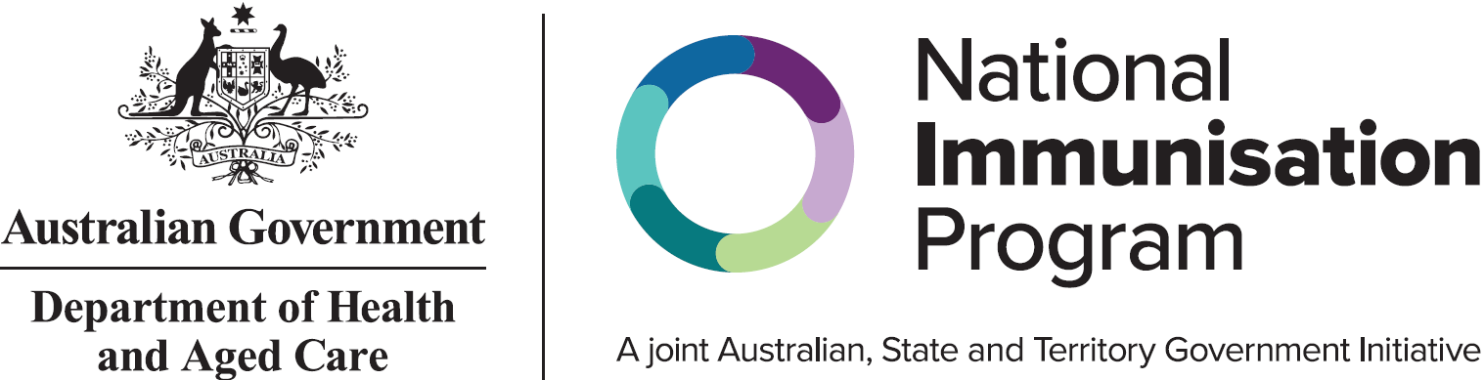

All information in this fact sheet is correct as of November 2024.