60-day prescriptions
Information kit for prescribers
November 2024 update
Contents
What is changing? 2
Medicines eligible for 60-day prescriptions 3
Frequently asked questions 4
Case studies 7
Resources 9

What is changing?
There are now almost 300 Pharmaceutical Benefits Scheme (PBS) medicines available for 60-day prescriptions. This will give many Australians twice the amount of their medication on a single prescription.
Medical practitioners are permitted to prescribe PBS medicines and can make the clinical decision about whether 60-day prescriptions are appropriate for patients with stable ongoing health conditions. A PBS prescriber is defined under Part VII of the National Health Act 1953.
Prescribing software is automatically updated and included medicines have an additional PBS item code for 60-day (or 56-day) prescriptions, as well as the current code for 30-day (or 28-day) prescriptions.
Where a prescriber considers a 60-day prescription appropriate for a patient, it may reduce both time spent in consultations to renew prescriptions and the patient’s annual medication costs.

60-day prescriptions have been introduced gradually in 3 stages over 12 months on:

1 September 2023

1 March 2024

1 September 2024.

Communication resources
The information resources in this kit are designed to be shared with your patients. They cover a range of topics relating to the PBS and provide answers to commonly asked questions.

Further information
- For further information on 60-day prescriptions visit the Cheaper Medicines website
- For a searchable list of medicines available for 60-day prescriptions visit PBS medicines and current item codes
- For a full list of medicines recommended by the Pharmaceutical Benefits Advisory Committee as suitable for increased dispensing quantities visit the PBS website: Increased Dispensing Quantities – List of Medicines
- Resources for patients are available on the Cheaper Medicines website and 60 Day Scripts – developed by Consumers Health Forum
- Therapeutic Goods Administration medicine shortage reports database
If you have questions or require further information you can email the Department at: Enquiries@health.gov.au

Medicines eligible for 60-day prescriptions
Medicines available for 60-day prescriptions support patients living with stable ongoing health conditions such as:
Stage 1 | Stage 2 | Stage 3
- cardiovascular disease  - Crohn’s disease  - gout  - heart failure  - high cholesterol  - hypertension  - osteoporosis  - ulcerative colitis | - androgen deficiency  - arthritis  - bipolar disorder  - breast cancer  - diabetes  - epilepsy  - hypothyroidism  - incontinence  - menopause  - migraine  - prostate cancer  - prostate enlargement | - acne  - anxiety disorders  - asthma  - chronic obstructive pulmonary disease (COPD)  - constipation  - depression  - dry eyes  - gastro-oesophageal reflux disease (GORD)  - glaucoma  - Parkinson disease

How to check if a medicine is available for 60-day prescriptions:
- For a searchable list of medicines available for 60 day-prescriptions, visit PBS medicines and current item codes.
- Browse the list or input the name of a specific medicine into the search box to see if it is on the list.

Frequently asked questions

Will people need a new prescription to obtain a 60-day supply of their current medication?
Yes, patients with stable ongoing health conditions should talk to their prescriber if they are eligible for a 60-day prescription. Prescribers will use their best professional judgement to prescribe medicines for either 30 or 60 days. Pharmacists can then supply the increased quantity as specified on the new prescription. This prescription is still valid for a maximum of 12 months. Patients need to talk to their doctor to see if they are eligible.
Do patients require a Concession Card to be eligible for a 60-day prescription?
Patients do not need a concession card to access a 60-day prescription. Doctors and other prescribers (optometrists and nurse practitioners) retain full clinical discretion over what quantity of medicine is prescribed for their patients based on their assessment of their patient’s condition at the time.

Can prescribers still write a one month’s supply prescription?
Yes, prescribers retain full clinical discretion over what quantity of medicine is prescribed for their patients, based on their assessment of a patient’s condition at that time.
For example, a prescriber may choose to write a 30-day rather than a 60-day prescription or may choose to write a 60-day prescription with an appropriate number of repeats, depending on their clinical assessment of patient needs.

How does this impact on prescribing PBS medication?
As with all PBS listed medicines, the prescriber must be satisfied that the patient meets the eligibility requirements for the subsidy.
The PBS restriction for all items with increased 60-day quantities include an additional clinical criterion: “The condition must be stable for the doctor to consider the listed maximum quantity of this medicine suitable for this patient”.
A prescriber can continue to apply for a PBS Authority where a patient needs increased quantity of a medication. They can do so by calling the Services Australia Telephone Authority Applications Freecall service on Ph:1800 888 333, or by using the Services Australia PBS authorities website.

How are patients saving with 60-day prescriptions?
The fundamental principle of the change is that patients will get twice the amount of their medication on a single prescription. When a PBS medicine can be prescribed for 60-days patients can save:
- up to $189.60 a year, per medicine for Medicare card holders (non-concessional)
- up to $46.20 a year, per medicine for concession card holders.
A patient taking only medicines that have a 60-day prescription can halve their number of trips to the pharmacist to fill a script for that medicine. This will also free up appointments with prescribers to focus on other aspects of patient care.

How does this work with the PBS Safety Net?
The PBS Safety Net will continue to support general patients who spend more than $1,647.90 on PBS medicines in a year (or $277.20 for concession card holders).
With a 60-day prescription, patients could save on their medicines so that they won’t need the Safety Net. Others will reach the Safety Net later in the year, having spread their medicine costs over a longer period.
The benefit for patients is that their total annual medicines cost will be spread out over a greater period of time, resulting in a lower monthly medicines cost. If patients don’t reach or hit the threshold later in the year, it means they have saved money throughout the year.

How were these changes determined?
Clinical experts from the independent Pharmaceutical Benefits Advisory Committee (PBAC) recommended introducing 60-day prescriptions for patients with stable ongoing health conditions.
In making its recommendations, the PBAC applied the following guidance criteria to identify medicines that should not be listed with higher quantities:
- medicines where being able to stockpile large quantities could pose a risk to patient safety (for example: narcotics, paracetamol/codeine, psychostimulants, psycholeptics and psychoanaleptics)
- medicines with a requirement for regular monitoring and frequent dose titration
- medicines where the drug regimen is associated with management of progressively worsening disease or the symptoms are associated with relapse of disease and the patient is not expected to be stable for the next 12 months
- medicines prescribed for short term management of symptoms in chronic diseases
- medicines in the Palliative Care section of the Schedule
- medicines where the PBAC has recommended a listing that enables prescribers to prescribe less than six months therapy per prescription.
In addition, medicines must have been PBS listed for five or more years, or generics of medicines which have been listed for five or more years, as severe but rare adverse effects frequently become evident during the first few years a drug is widely available.
View the PBAC outcome statement for more information.

Will 60-day prescriptions affect the supply of medicine?
To date there have been no medicine shortages because of 60-day prescriptions. The new policy spreads out when patients fill their prescription and does not add to overall demand. This means that patients will be prescribed the same amount of medication overall each year.
Medicines recommended by PBAC for 60-day prescriptions are not in short supply in Australia. If shortages do occur, alternative brands and/or strengths of the same medicine are usually available. We have monitored the list of recommended medicines for inclusion in each stage to reduce the risk of shortage.
Pharmaceutical companies must tell the Therapeutic Goods Administration (TGA) of expected medicine shortages. The Medicines Supply Security Guarantee changes commenced on 1 July 2023. Medicine manufacturers must have more stock onshore for some brands of PBS medicine, helping ensure any temporary rise in demand for those brands is met.
Wholesalers must deliver to any pharmacy in 24 hours (excluding weekends or public holidays) if they are running low on medicine. This applies for most medicines.

Does Regulation 49 apply?
This regulation remains unchanged.
Regulation 49 (previously Regulation 24), permits in certain circumstances, a PBS prescription to be endorsed by the prescriber for “one supply” to allow the quantities for the original prescription and repeats to be supplied at the same time.
The below criteria must be met for a Regulation 49 Provision, and is made at the request of the medical practitioner, midwife or nurse practitioner:
- the maximum PBS quantity is insufficient for the patient's treatment; AND
- the patient has a chronic illness or lives in a remote area where access to PBS supplies is limited; AND
- the patient would suffer great hardship trying to get the pharmaceutical benefit on separate occasions.
The patient will be charged a total equivalent to the PBS co-payment amount that would otherwise apply for the original and each repeat making up the total supply. There may also be brand or therapeutic group premiums charged for each quantity making up the total.

How have primary care and patient peak bodies reacted to this change?
60-day prescriptions have been welcomed by many medical, health and consumer groups including the Royal Australian College of General Practitioners, Rural Doctors Association, the Australian Medical Association, the Heart Foundation, the Lung Foundation, Breast Cancer Network, Consumers Health Forum of Australia and many others. Read the open letter to all Federal Parliamentarians.

Case studies

Case study 1

Couple who are Medicare card holders (non-concessional)
William has a heart condition that increases his risk of developing a stroke, so he takes apixaban twice daily. William’s partner, Sandra, has ulcerative colitis and takes the anti-inflammatory medication mesalazine granules each day.
William and Sandra pay $31.60 per prescription in 2024 as non-concessional Medicare card holding patients for these PBS medications.
With each medication having 12 prescriptions per year, their combined cost for PBS medications in a year is currently $758.40.
William and Sandra’s doctors finds them suitable for 60-day prescriptions for the medicines used to manage their stable ongoing health conditions. William and Sandra can now receive twice the amount of their medication on a single prescription. William and Sandra will now have only six prescriptions per year for each medication and pay only $379.20 in PBS co-payments for their medications, a saving of half ($379.20) of their annual PBS costs.

Case study 2

Elderly couple with Pensioner Concession Cards
Frank and Judy are a couple with Pensioner Concession Cards, providing them access to PBS medicines for $7.70 per script in 2024.
As a couple they would receive 40 scripts in a year and reach the PBS Safety Net, paying $277.20 across 36 prescriptions to reach the Safety Net and then four free Safety Net prescriptions.
Judy’s doctor finds her suitable for a 60-day prescription for the treatment of high cholesterol. Instead of getting one prescription per month to treat the condition (12 per year), Judy will get one prescription every two months (6 per year).
As a couple Frank and Judy will now receive 34 prescriptions, meaning they will no longer reach the $277.20 PBS Safety Net because they will be paying less for their medications overall.

Case study 3

Couple with Health Care Cards
Tony and Jack are a couple with Health Care Cards, providing them access to PBS medications for $7.70 per prescription in 2024.
As a couple they fill 50 prescriptions in a year and reach the PBS Safety Net, paying $277.20 across 36 prescriptions to reach the Safety Net and then receive 14 free safety net prescriptions.
Jack’s doctor finds him suitable for 60-day prescriptions for two medicines used to manage his stable ongoing health conditions. Instead of getting one prescription per month to treat each condition (24 per year), Jack will get one prescription every two months (12 per year).
As a couple Tony and Jack now fill 38 prescriptions in total rather than 50. They pay $277.20 in co-payments, then reach the PBS Safety Net. They now reach the PBS Safety Net later in the year, making the same number of co-payments but spread across a longer period of time, meaning they pay fewer co-payments in the first half of the year. They pay no additional cost for their PBS medications and receive two free Safety Net prescriptions.

Case study 4

Individual who is a Medicare card holder (non-concessional)
Anne lives with type 2 diabetes, and she needs to take one vildagliptin 50mg with metformin hydrochloride 1g tablet every day, which means filling 12 prescriptions per year.
The combination treatment vildagliptin with metformin is an essential medicine for many people living with type 2 diabetes, and it is listed on the Pharmaceutical Benefits Scheme (PBS).
In 2024, Anne paid $31.60 for each script as non-concessional Medicare card holding patient for this PBS medication. Having to refill 12 prescriptions per year, the total cost is $379.20 per year.
Anne’s doctor advised her that because her diabetes is a stable ongoing health condition, and her medication is available for a 60-day prescription, she is suitable for a 60-day prescription. She can now receive twice the amount of her medication on a single prescription and will need only six prescriptions per year for her medication.
Anne now pays only $189.60 in PBS co-payments for her medication, a saving of half ($189.60) on her annual PBS costs.

Resources
- Resources have been created to comply with AAA criteria for accessibility.
- Preview images used below are for reference only. High-resolution copies of the below resources and written case studies can be downloaded from the Resources page on health.gov.au/cheaper-medicines/resources
- Translated versions of resources can be downloaded from health.gov.au/cheapermedicines/translated
- Materials for First Nations audiences and the Closing the Gap Concession card are also available at health.gov.au/cheaper-medicines/first-nations
- If you have any issues accessing resources please contact healthcare.comms@health.gov.au
Resource | Preview | Title | Suggested use
FAQ | 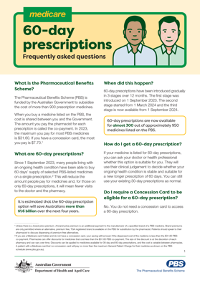 | 60-day prescriptions – Frequently asked questions | For distribution to eligible patients
GP setting poster | 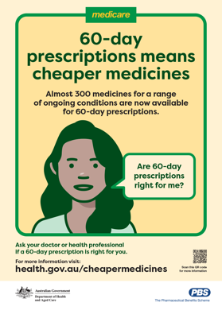 | 60-day prescriptions poster | For display in reception or waiting areas
Postcard | 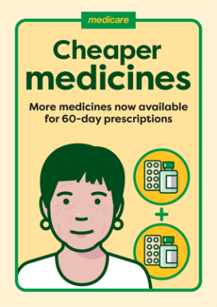 | GP Postcard | For display in reception or waiting areas
Animation video | 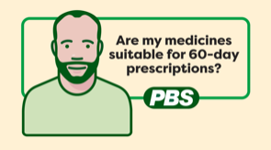 | Are my medicines suitable for 60-day prescriptions? | Embed on your website, in patient newsletter, or share on social media
Patient FAQ with Dr Nicole Higgins – Episode 2 | 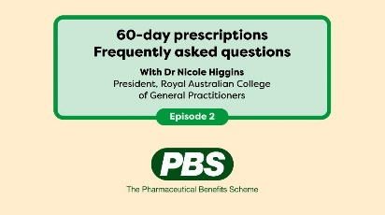 | 60-day prescriptions patient frequently asked questions – Episode 2 | Embed on your website, in patient newsletter, or share on social media
First nations poster | 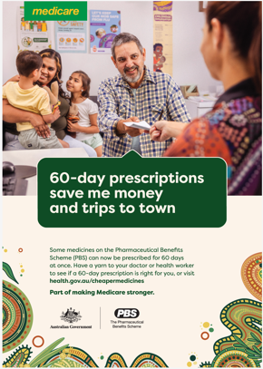 | 60-day prescriptions poster – First Nations | For display in reception or waiting areas

