Australian Government crest
Department of Health and Aged Care logo

# GUIDE TO HEALTH PROMOTION INSERTS

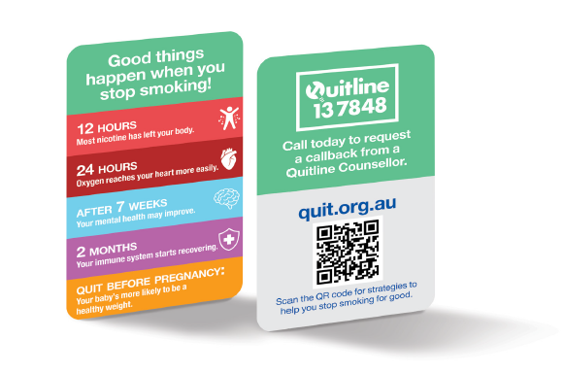

ISBN: 978-1-76007-438-8

Online ISBN: 978-1-76007-439-5

**Copyright**

© 2024 Commonwealth of Australia as represented by the Department of Health and Aged Care

This work is copyright. You may copy, print, download, display and reproduce the whole or part of this work in unaltered form for your own personal use or, if you are part of an organisation, for internal use within your organisation, but only if you or your organisation:

1. do not use the copy or reproduction for any commercial purpose; and
2. retain this copyright notice and all disclaimer notices as part of that copy or reproduction.

Apart from rights as permitted by the *Copyright Act 1968* (Cth) or allowed by this copyright notice*,* all other rights are reserved, including (but not limited to) all commercial rights.

Requests and inquiries concerning reproduction and other rights to use are to be sent to the Communication Branch, Department of Health and Aged Care, GPO Box 9848, Canberra ACT 2601, or via e-mail to [copyright@health.gov.au](mailto:copyright@health.gov.au).

**DISCLAIMER**

All manufacturers, packagers, suppliers and retailers (including importers and wholesalers) of tobacco and e-cigarette products should ensure they understand all of the requirements in the *Public Health (Tobacco and Other Products) Act 2023* and Public Health (Tobacco and Other Products) Regulations 2024.

This guide does not itemise all of the requirements under the Public Health (Tobacco and Other Products) legislation. The requirements that are not itemised in this guide are not any less important or significant than those that are displayed.

The guide does not provide legal advice and is not to be relied upon as a source of legal advice. It is provided for general information and as such any person reading this guide should rely upon their own judgement and make their own inquiries seeking relevant professional advice.

There are additional requirements under the Commonwealth Public Health (Tobacco and Other Products) legislation for tobacco products and packaging. Anyone who possesses, manufactures, packages, purchases, sells or supplies (including import, wholesale and retail), tobacco products or tobacco product accessories in Australia, must ensure they comply with these requirements.

There are some limited exceptions for personal use or export out of Australia of tobacco products and tobacco accessories.

Nothing in this guide should be taken in any way to replace the provisions of the *Public Health (Tobacco and Other Products) Act 2023* and Public Health (Tobacco and Other Products) Regulations 2024.

The Department of Health and Aged Care (the department) does not certify compliance with any tobacco legislation. The department does not undertake a review or approval scheme for tobacco packaging and the associated health warnings, tobacco product safety, tobacco advertising, or any other tobacco legislation issues.

For complete requirements refer to the legislation available at <http://www.legislation.gov.au>.

## **Contents**

**Introduction 5**

Purpose of the guide 5

**Health promotion inserts for tobacco products 6**

Requirements for health promotion inserts 8

Images for health promotion inserts 8

How to access images 9

Retail packaging of cigarette packs 9

Retail packaging of pipe tobacco or other loose processed tobacco 9

**Enforcing the Public Health (Tobacco and Other Products) legislation 10**

## Introduction

### Purpose of the guide

The Australian Government Department of Health and Aged Care (the **department**) has produced this guide to help the public understand the Commonwealth *Public Health (Tobacco and Other Products) Act 2023* (the **Act**) and the Public Health (Tobacco and Other Products) Regulations 2024 (the **Regulations**), specifically the requirements for health promotion inserts. This guide is not intended to comprehensively cover all health promotion insert requirements. The images in this guide are an example of how the health promotion inserts may look.

This guide does not contain tobacco product requirements, tobacco packaging requirements, or the requirements relating to health warnings or advertising and sponsorship. Other guides available include:

* [Guide to Tobacco Product Requirements](https://www.health.gov.au/resources/publications/guide-to-tobacco-product-requirements?language=en)
* [Guide to Tobacco Packaging Requirements](https://www.health.gov.au/resources/publications/guide-to-tobacco-packaging-requirements)
* [Guide to Health Warnings](https://www.health.gov.au/resources/publications/guide-to-health-warnings?language=en)
* [Guide to Advertising and Sponsorship Prohibitions](https://www.health.gov.au/resources/publications/guide-to-advertising-and-sponsorship-prohibitions)
* [Guide to Online Point-of-Sale Advertising Requirements](https://www.health.gov.au/resources/publications/guide-to-online-point-of-sale-advertising-requirements?language=en)

All of these resources will be available from <https://www.health.gov.au/>.

You are encouraged to download an up-to-date version of the Act and Regulations from the Federal Register of legislation website (www.legislation.gov.au).

### Definitions

‘**Public Health (Tobacco and Other Products) legislation**’ means the *Public Health (Tobacco and Other Products) Act 2023* and the Public Health (Tobacco and Other Products) Regulations 2024.

‘**Tobacco product**’ means the following designed or intended for human consumption or use:

1. processed tobacco in any form;
2. a product that contains tobacco as an ingredient.

‘**Primary packaging**’ means any container in which the tobacco product is directly placed.

*The definitions used in the Public Health (Tobacco and Other Products) legislation can be viewed in section 8 of the Act, and section 5 of the Regulations. The above definitions are provided to assist in understanding this guide.*

## Health promotion inserts for tobacco products

Health promotion inserts are small information cards required to be placed inside the retail packaging for cigarettes, pipe tobacco and loose tobacco being sold and supplied in Australia. Health promotion inserts provide information on the health and social benefits of quitting tobacco use and promote resources and strategies to help people to quit.

* Requirements for health promotion inserts do not apply to cigars or shisha tobacco products.
* From 1 July 2025[1], all tobacco products and retail packaging must comply with the requirements in the Public Health (Tobacco and Other Products) legislation.
* Each item of primary packaging must include one health promotion insert[2].
* Health promotion insert images will be distributed to entities who are involved in the packaging of tobacco products in retail packaging, upon request.
* There are a number of physical and placement requirements for health promotion inserts, which are outlined below.

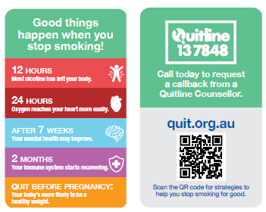

**Figure 1**: Image of health promotion insert front (left) and back (right)

### Requirements for health promotion inserts

Schedule 8 of the Regulations prescribes the health promotion insert series to be included in the primary packaging of cigarettes, pipe tobacco and loose processed tobacco products.

There are 10 different health promotion inserts contained in Schedule 8, with front and back images. Each item of primary packaging must include one health promotion insert. These must be included in the primary packaging of tobacco products of the same kind as nearly as possible in equal numbers.

For example, it would be compliant if, in any random sample of 4 cartons of cigarettes, the same health promotion insert is included in no more than two cigarette packs within a carton.

Health promotion inserts **must**:

* be printed on recycled paper, the paper weight must be between 150 and 200 grams per square metre
* not be printed using inks or coatings that prevent them from being recycled
* be coated with a clear, protective matt finish
* for cigarette packs—be rectangular or tapered so that they are wider at the top than at the bottom
* for the retail packaging of all other kinds of tobacco to which the requirement applies—be rectangular
* comply with the dimension requirements:

| **Height** | **Width** |
| --- | --- |
| Between 79mm and 85mm | Between 47mm and 55mm |

Health promotion inserts **may** have rounded edges but **must not** be bevelled or otherwise shaped or embellished in any way that is inconsistent with the requirements in the Regulations.

Health promotion inserts should be easily removable from the retail packaging of a tobacco product without damaging the insert, the packaging, or the tobacco product when the packaging is opened in the normal way. A health promotion insert **must not** be obscured or obliterated in any way at the time of the sale or supply of the tobacco product.

### Images for health promotion inserts

The images used on health promotion inserts **must** be sourced from the supplied file that can be requested from the department and be displayed at the same resolution as the supplied file. The images on health promotion inserts **must**:

* appear only in portrait orientation
* fill the surface area of the insert
* not be distorted in any way.

#### How to access images

Electronic files containing health promotion insert images are available on request, free of charge, for people involved in the packaging of tobacco products in retail packaging or the retail sale of regulated tobacco items. A copy of the files containing health promotion inserts can be requested from the department by completing the webform available on the [department’s website](https://www.health.gov.au/topics/smoking-vaping-and-tobacco/tobacco-control/health-warnings/request-form).

#### Retail packaging of cigarette packs

* A health promotion insert included in a cigarette pack **must**:
* be inserted in the front of the flip-top pack
* be located in front of the cigarettes and the lining (if any) of the pack
* be visible when the cigarette pack is opened in the normal way
* be easily removable to allow reading of both sides of the insert
* not be folded inside the cigarette pack.

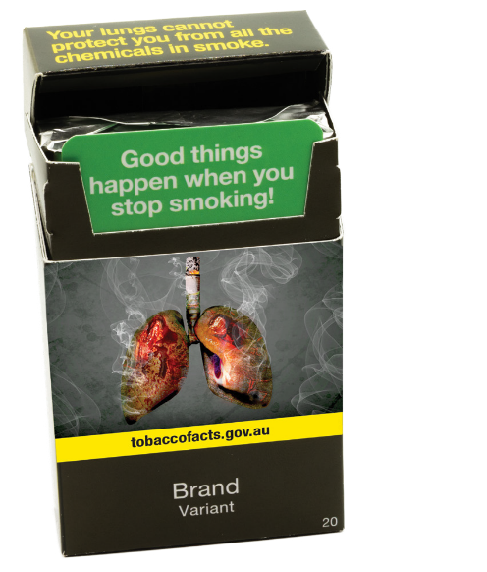

**Figure 2:** Image of open cigarette pack showing health promotion insert placement

#### Retail packaging of pipe tobacco or other loose processed tobacco

A health promotion insert included in the retail packaging of pipe tobacco or other loose processed tobacco **must** either:

* be inserted inside the packaging, and located in front of, or on top of, the tobacco product; **or**
* be fixed with soft adhesive:

1. in the case of retail packaging that is a pouch—to the hidden flap of the pouch; **or**
2. in the case of retail packaging that is a cylinder—to the inner surface of the lid of the cylinder.

* In addition, the health promotion insert **must**:
* be visible when the packaging is opened in the normal way
* be easily removable so as to permit reading of both sides of the insert
* not be folded when placed inside a pouch that contains pipe tobacco or other loose processed tobacco
* not obscure or obliterate any health warning.

*Note: A health promotion insert may be folded once for inclusion in a small cylinder of loose processed tobacco, or in other retail packaging, if the dimensions are such that the insert cannot otherwise be included.*

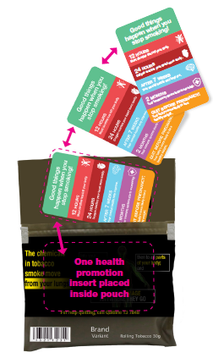

**Figure 3:** Image of open pouch of loose tobacco showing health promotion insert being placed inside pouch

## Enforcing the Public Health (Tobacco and Other Products) legislation

The Government takes breaches of the Act seriously. The department is responsible for investigating reported breaches of the Public Health (Tobacco and Other Products) legislation. The department’s [Tobacco Control Enforcement Policy](https://www.health.gov.au/resources/publications/tobacco-control-enforcement-policy) outlines the principles used to guide the department’s decisions and actions in enforcing these laws.

Any person who possesses, manufactures, packages, purchases, sells or supplies (including import, wholesale and retail) tobacco products in Australia which do not comply with the Public Health (Tobacco and Other Products) legislation may face significant criminal or civil penalties. A range of options are available to enforce the Public Health (Tobacco and Other Products) legislation, including issuing infringement notices, seeking enforceable undertakings or injunctions, or referring the matter to the Australian Federal Police who may, in turn, refer the matter to the Commonwealth Director of Public Prosecutions.

As at publication, the maximum penalty for contravening the tobacco product requirements is 2,000 penalty units ($660,000) for individuals and 20,000 penalty units ($6.6 million) for bodies corporate.[3]

If you wish to report a potential breach of the Public Health (Tobacco and Other Products) legislation, please contact the department. Reports of breaches can be submitted in writing through the [make a complaint](https://www.health.gov.au/topics/smoking-vaping-and-tobacco/tobacco-control/plain-packaging/complaints-form) link on the department’s website or by emailing [TobaccoCompliance@health.gov.au](mailto:TobaccoCompliance@health.gov.au). Please include sufficient information to enable the department to investigate the alleged breach, including images or document copies demonstrating the allegation where possible.

[www.health.gov.au](http://www.health.gov.au)

11890 NOV 2024

1. There are transitional arrangements that are in place from 1 April 2024 to 31 March 2025, whereby retail packaging that previously complied with provisions of the *Tobacco Plain Packaging Act 2011* (Cth) is taken to comply with the requirements of the *Public Health (Tobacco and Other Products) Act 2023* (Cth) and the Public Health (Tobacco and Other Products) Regulations 2024 (Cth). The Public Health (Tobacco and Other Products) (Consequential Amendments and Transitional Provisions) Rules 2024 allow for health promotion inserts to be inserted in retail packaging during the main transition period as well as for retailers to sell through regulated tobacco items that were compliant with the *Tobacco Plain Packaging Act 2011* (Cth). For more information on transition periods, see [Transition Periods Fact Sheet](https://www.health.gov.au/resources/publications/information-on-transition-periods-for-manufacturers-importers-wholesalers-and-retailers).
2. Primary packaging means the container for retail sale in which the tobacco product is directly placed. Examples of primary packaging include cigarette packs and roll-your-own tobacco pouches.
3. Since 7 November 2024, the value of one penalty unit is $330.00. This amount may be subject to increase in the future.