**Government Provider Management System**

**User Guide**

**November 2024**

**Version 5.2**

This Government Provider Management System (GPMS) User Guide provides users with an overview of how to login to the GPMS portal and outlines how Organisation Administrators can add, edit and remove users.

Contents

1. Introduction 3

1.1 Purpose 3

1.2 Before proceeding 3

1.3 Login to the GPMS portal 4

2. GPMS Portal Access 4

2.1 Troubleshooting myID or VANguard issues 4

2.2 Terms of use 4

3. Organisation Administrators 6

3.1 The Manage Users screen 7

3.2 Adding a new user 7

3.2.1 Adding a user at the Organisation level 8

3.2.2 Adding a user at the Provider level 11

3.3 Existing users 14

3.4 Editing access roles 14

3.5 Removing Users 16

4. Switching providers 18

# Introduction

The Government Provider Management System (GPMS) is a flexible IT (Information Technology) system which is a critical part of the Aged Care Digital Transformation Initiative underway to support aged care reform through better technology.

GPMS provides greater connectivity and data sharing between aged care providers and government.

## Purpose

This User Guide has been designed to support providers in understanding how to access and login to the GPMS portal for the first time.

It also provides an overview of the Organisation Administrator role and associated functionality, including the ability to:

* add or remove users to the GPMS portal; and
* edit user roles which allow users to access applications within the GPMS portal.

## Before proceeding

Please be advised of the following:

The Department of Health and Aged Care will retain records of your access to GPMS and when prompted, you must accept the *GPMS Terms of Use* to be able to access the system.

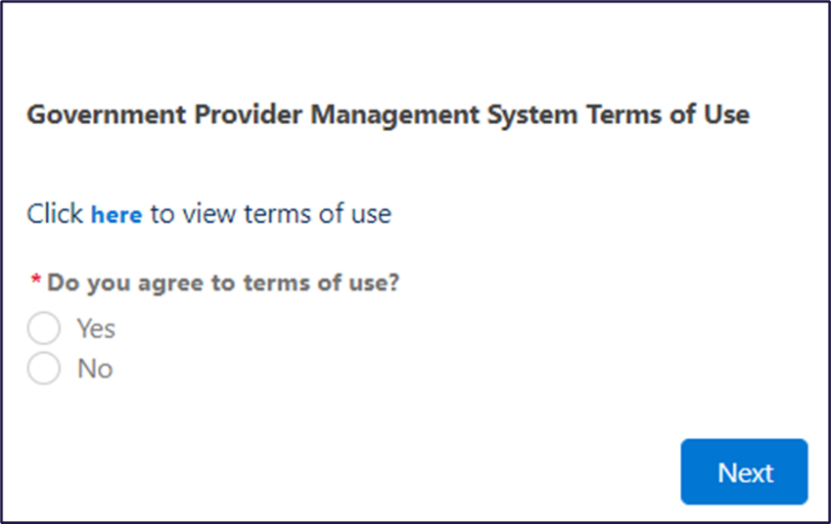

## 1.3 Login to the GPMS portal

To login to the GPMS portal please visit [Log In Using | Service Provider Portal](https://provider.health.gov.au/serviceproviderportal/login?ec=302&startURL=%2Fserviceproviderportal%2Fs%2F).

If you require assistance to login to the GPMS portal, please refer to the GPMS [Logging in to Aged Care Systems](https://www.health.gov.au/resources/publications/logging-in-to-the-aged-care-systems).

# GPMS Portal Access

To access the GPMS portal, each staff member must have a My Aged Care portal user account linked to a supported third-party authentication service.

For more information regarding setting up users and logging into the system please refer to [Logging in to Aged Care Systems](https://www.health.gov.au/resources/publications/logging-in-to-the-aged-care-systems).

## Troubleshooting myID or VANguard issues

If you encounter any issues with logging in with myID or VANguard refer to [Logging in to Aged Care Systems](https://www.health.gov.au/resources/publications/logging-in-to-the-aged-care-systems).

If the issue persists, please contact your organisation’s technical support for assistance or call the My Aged Care service provider and assessor helpline on **1800 836 799**.

## Terms of use

When logging on for the first time you will need to agree to the *Government Provider Management System - Terms of Use (Terms of Use)* and enter a Verification Code.

To agree, complete the following steps:

1. Select the word [**here**](https://www.health.gov.au/resources/publications/government-provider-management-system-terms-of-use) to navigate to the Terms of Use.

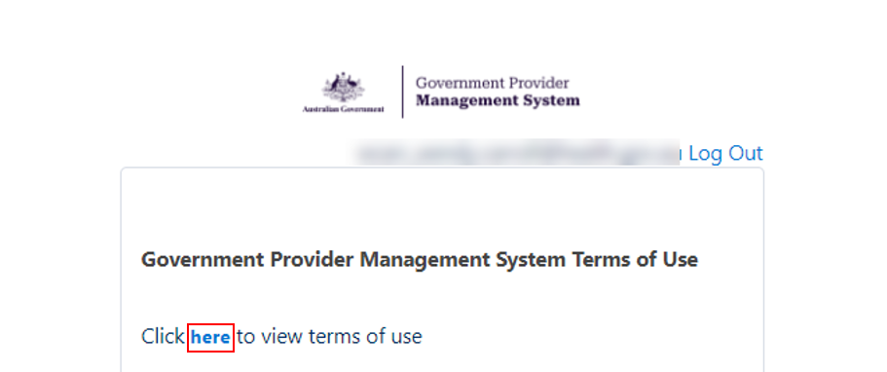

1. If you agree to the terms of use, select the **Yes** radio button and then select **Next**.

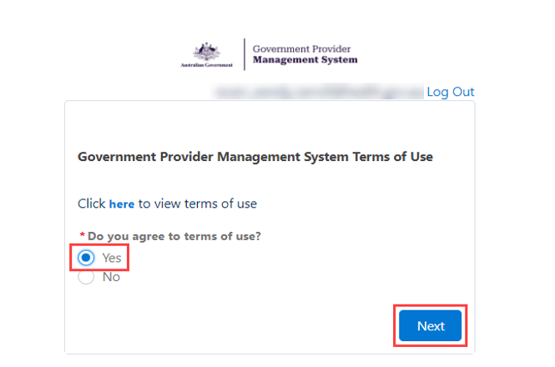

**Please note:**

If you do not agree to the terms of use, selecting ****No**** will prevent you from being able to have access to the portal.

1. If you accepted the GPMS Terms of Use by selecting **Yes,** the Enter Verification Code screen will display.

Screenshot showing the Enter Verification Code screen


An eight-digit verification code will be sent to your company email address.

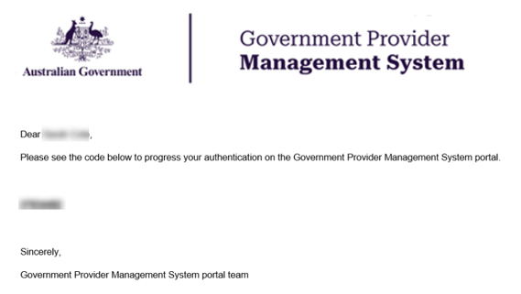

1. In the **Enter Verification Code** field, enter the eight-digit code you received in your notification email, and select **Next**.

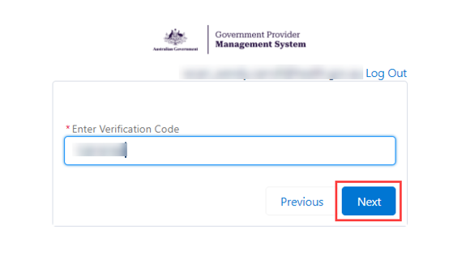

The GPMS portal landing page will display.

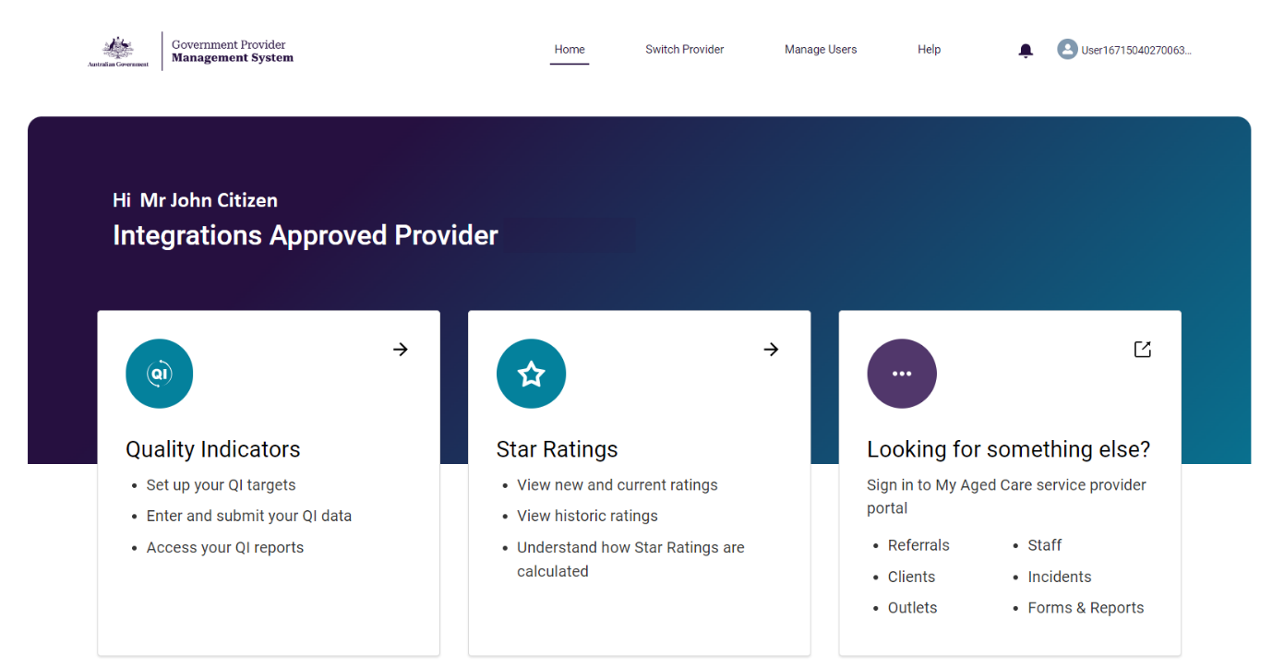

# Organisation Administrators

The Organisation Administrator is nominated by the organisation as someone who can perform the following administrative functions:

* Add additional users.
* Edit user access roles.
* Remove users who no longer require GPMS portal access.

The Organisation Administrator role in the My Aged Care system is not interchangeable with the Organisation Administrator role in the GPMS System

If this role is not set up for GPMS for your organisation, your organisation will need to nominate an Organisation Administrator for GPMS.

The following information relates to tasks that the Organisation Administrator can undertake in the GPMS portal.

## The Manage Users screen

The Manage Users screen is where Organisation Administrators will perform administrative functions, such as adding users and editing user access roles.

Only users assigned “Organisation Administrator” access to the GPMS portal will be able to carry out these functions.

To access the Manage Users functionality, select **Manage Users** in the top menu on the GPMS portal landing page.

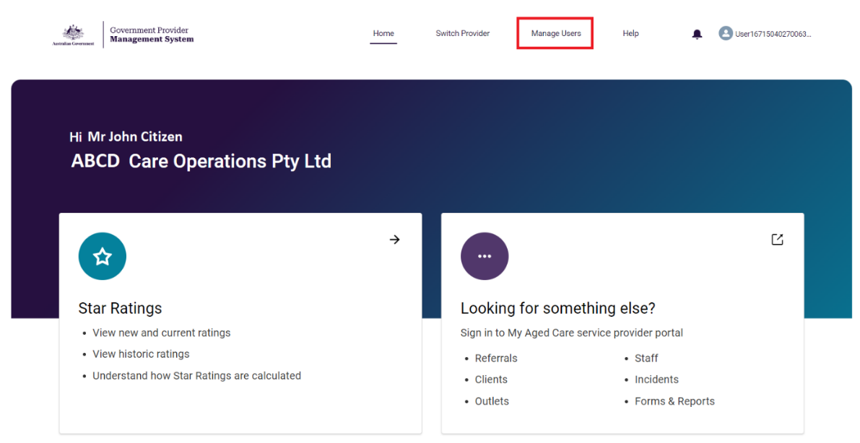

The Manage users screen will display.

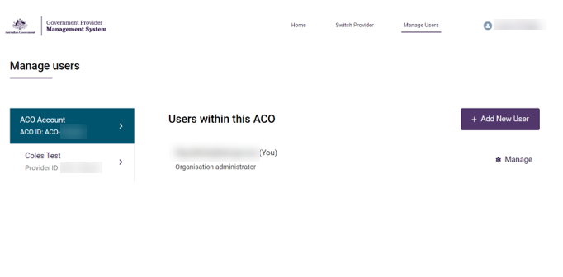

## Adding a new user

Organisation Administrators can add new users to the GPMS portal. These users can be added either at the organisation (org) level or at the provider (service) level.

The level the new users are added to will determine what kind of access roles can be attributed to them.

**Please note:**

Before they login to GPMS for the first time, please ensure that your new user follows the necessary steps to have their identity verified in the myID or Vanguard FAS systems in accordance with your organisation’s IT policies.

For further information please refer to:

[Logging in to Aged Care Systems](https://www.health.gov.au/resources/publications/logging-in-to-the-aged-care-systems)

If you are adding a user as an Organisation Administrator in GPMS, it is important the user is also set up as an Organisation Administrator in My Aged Care Service and Support Portal.

This will need to be done manually by you in the My Aged Care Service and Support portal.

### Adding a user at the Organisation level

Users added at the organisation level can be given the Organisation Administrator role access as well as other access roles.

To add a new user at the organisation level, complete the following steps:

1. In the **Manage users** screen, select the **+** **Add New User** button.

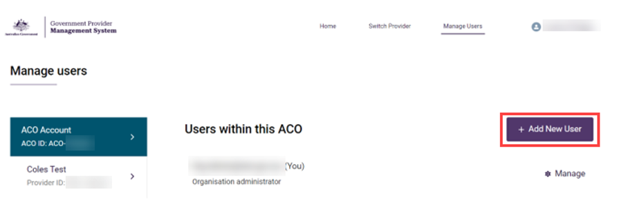

The Add new ACO user screen will then display.

1. In the **User details** section, enter the user’s company email address in the **Email** field, then select the **Next** button.

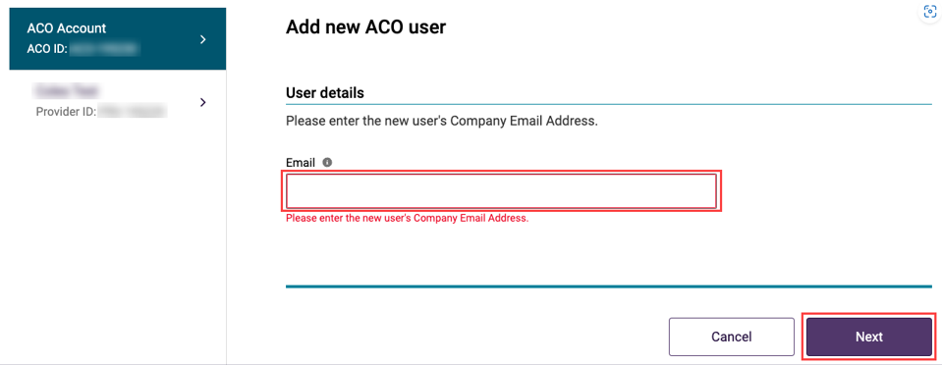

Additional fields will display to add the new user’s information.

**Please note:**

It is important the new user’s company email address is entered correctly.

If the email address is entered incorrectly, it will prevent the user from being able to access the portal.

Add the new user’s Salutation, First name, Surname and Date of birth details.

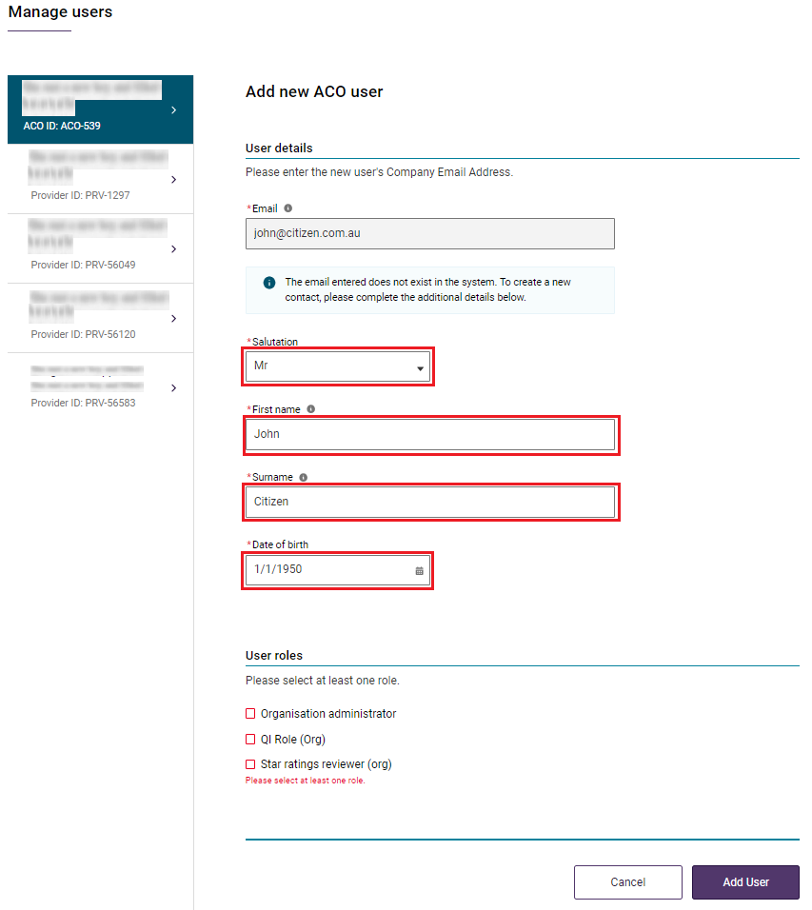

**Please note:**

Organisation Administrators can add, manage and remove users.

This level of access can onlybe added at the Organisation level.

Even as an Organisation Administrator, you will need to be allocated other access roles if you require access to other GPMS applications.

The Organisation Administrator role does not automatically provide access to other GPMS applications on its own.

1. Select the role(s) you want to provide to the new user. Next, select that you agree to the **Declaration** and then click **Add User**.

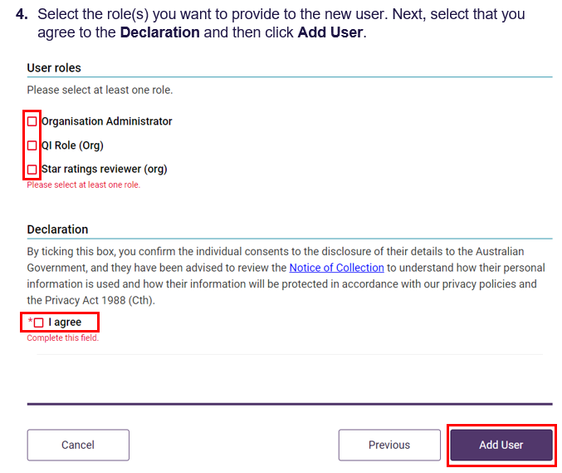

The Manage user screen will display.

The GPMS portal will display a green banner informing that an invitation email has been sent to the new user.



The newly added user will have a status of (Pending).

This status will remain until the newly added user receives their notification email and selects the link to login to the GPMS portal for the first time.

Once their first login has been completed the (Pending) status will disappear.

### Adding a user at the Provider level

As an Organisation Administrator, you may give a user access against a specific provider. This limits their access to those Providers only.

**Please note:**

Organisation Administrators must be allocated at the Aged Care Organisation (ACO) level. Provider level users cannot be Organisation Administrators.

To add a new user at the Provider level, complete the following steps:

1. In the **Manage Users** screen, select the Provider that you want to add the user to, and select the **+ Add New User** button.

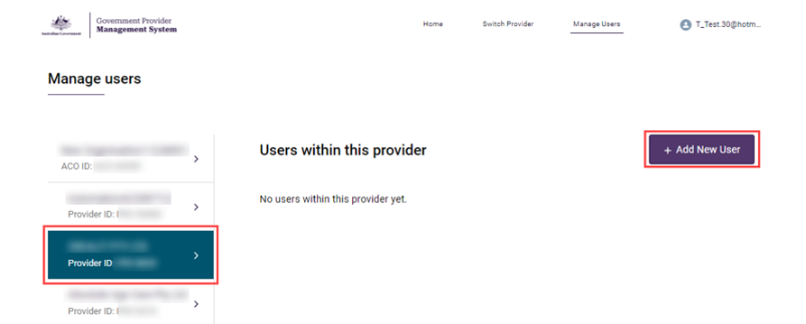

The Add new provider user screen will display.

1. In the **User details** section, enter the user’s company email address in the **Email** field, then select the **Next** button.

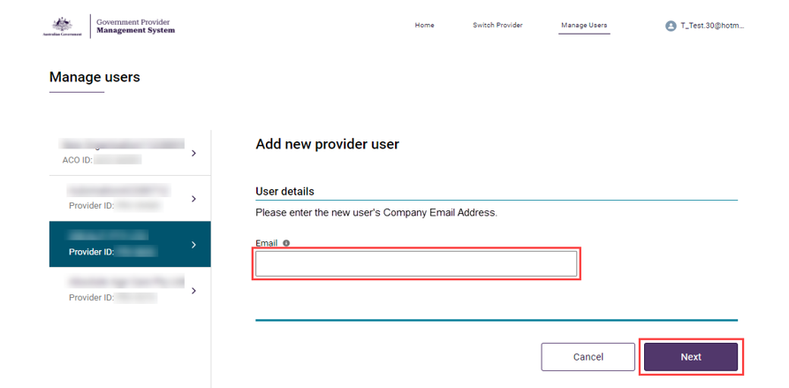

Additional user information fields will then display.

**Please note:**

It is important the new user’s company email address is entered correctly.

If the email address is entered incorrectly, it will prevent the user from being able to access the portal.

1. Enter the additional user information. Under User roles, select the **check boxes** of the access roles you wish to add.

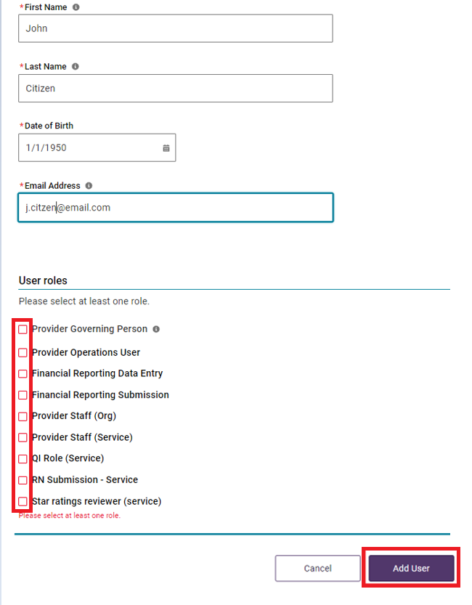

**Please note:**

Only certain users can be assigned a Provider Governing Person access role. This is because the term ‘Governing Person’ is defined under the *Aged Care Quality and Safety Commission Act 2018.* See sections 7 *Definitions* and 8B(1)(a) or (b).*Meaning of key personnel of a person or body.*

This means that users assigned this role must be key personnel but cannot be those responsible for the day to day nursing services. This role assignment is important for submission of an Approved Provider Notification or Governing Body Determination which require that only a person meeting the governing person definition to endorse/submit those forms.

1. Some access roles will require additional information. For example, a user with the access role of Star ratings reviewer (service) will also list residential services operated by the selected provider.
2. Select the check boxes of the services you want the user to have access to, then select the **Add User** button.

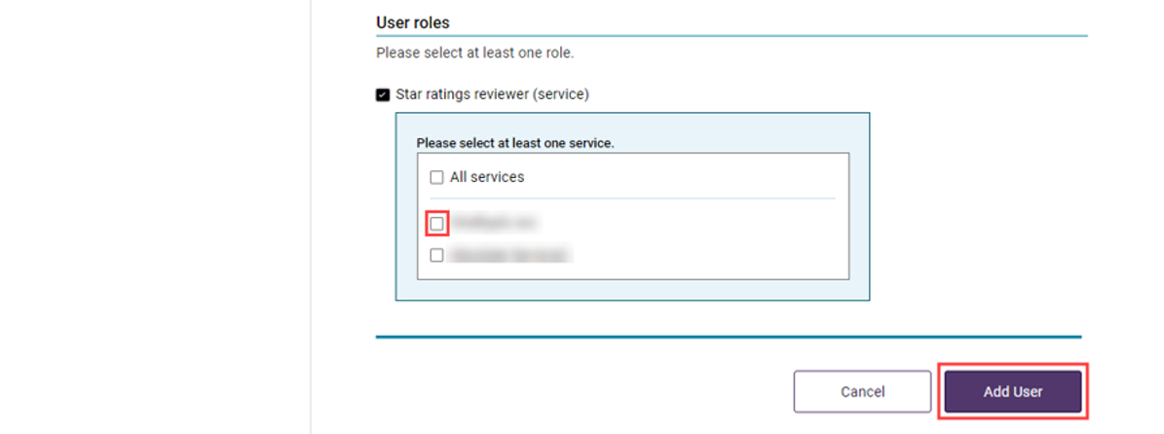

The Manage user screen will display again and the GPMS portal will display a green banner informing that an invitation email has been sent to the new user.



## Existing users

If you enter an email address for a user who has already been added to GPMS you will receive the following message:

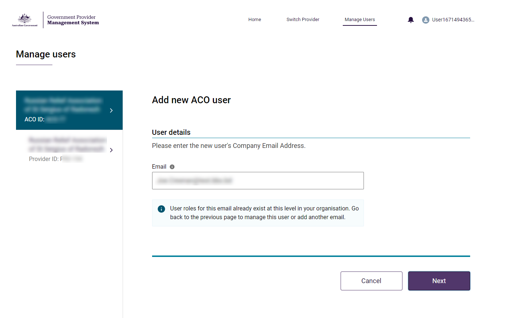

As the user already exists, you will need to find the user’s profile and edit their access roles instead.

## Editing access roles

Organisation Administrators are able to edit users’ access roles at any time.

To edit access roles, complete the following steps:

1. Select the user that you want to edit the access for, and select **Manage.**

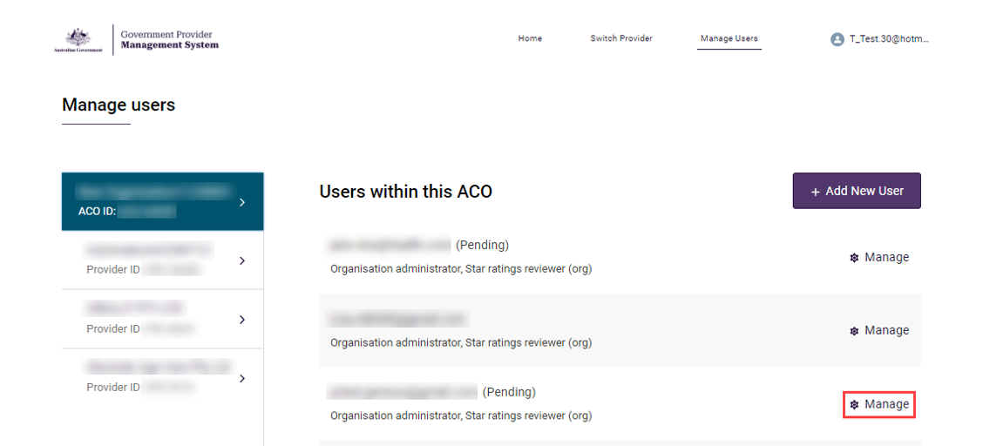

The **Managing: [user name]** screen will display.

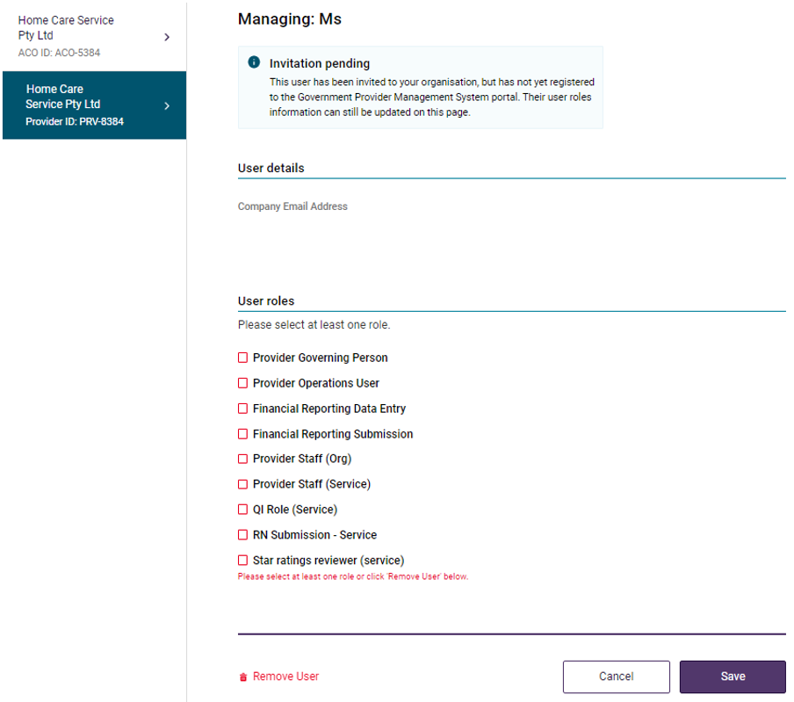

1. Scroll down the screen to the **User roles** section and select or deselect the check box/es for the role/s you wish to add and/or remove.
2. Select the **Save** button.

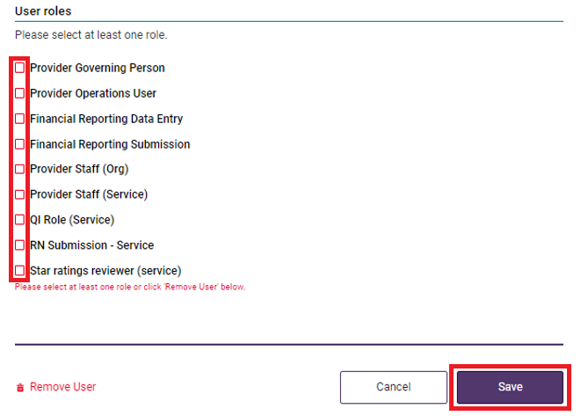

The Manage users screen will display again. The edited role/s will be displayed.

An email notification will be sent to the user with the edited roles advising a change has been made.

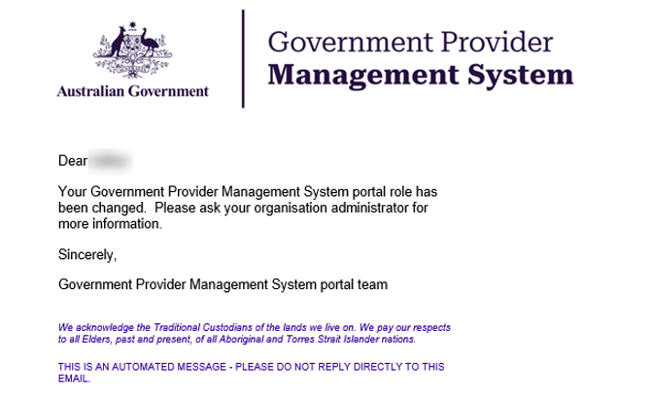

## Removing Users

Users can be removed from the GPMS portal. Removing a user takes away their ability to access the GPMS portal

**Please note:**

The user’s account details and action history will be retained in system audit history.

To remove a user, complete the following steps:

1. Select the user you wish to remove by selecting **Manage** as highlighted below (with the cog in front).

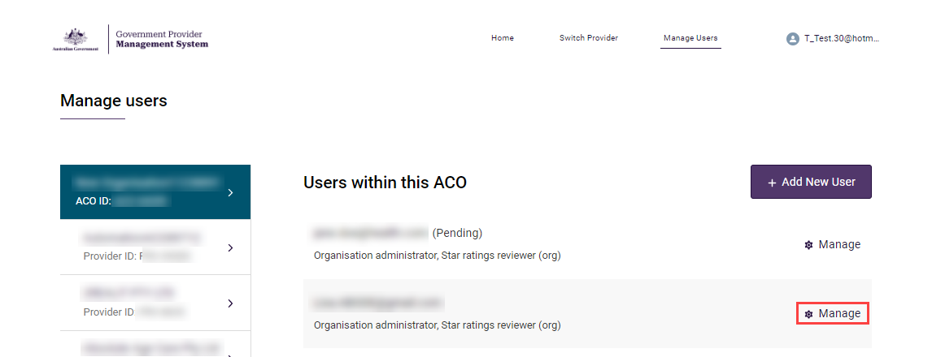

When you select a specific user, the Manage users, Managing: [user name] screen **will display.**

**Please note:**

Users are listed by Provider.

You can view the users of other Providers within the organisation by selecting a different Provider from the list at the left of the screen.

1. In the **Managing: [user name]** screen, select **Remove user** and press **Save**.

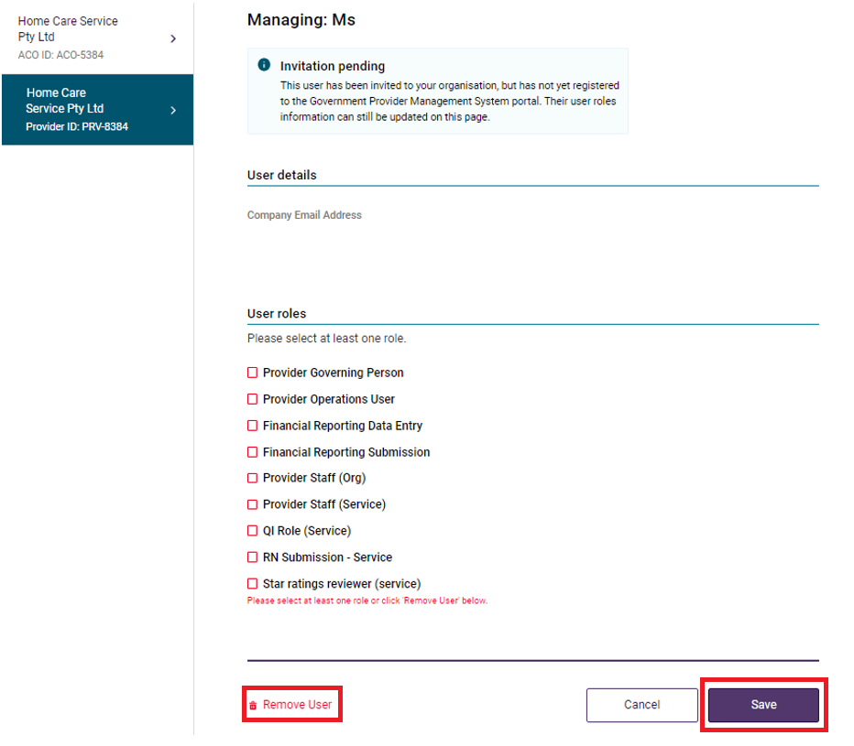

1. A pop-up will display advising you are removing this user at this level of your organisation and that the action cannot be undone.
2. Select the **Remove** button.

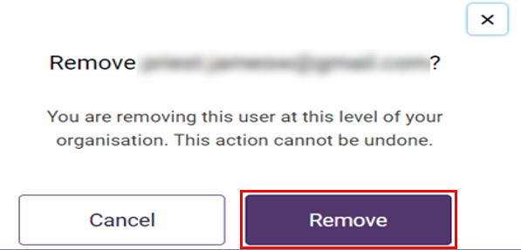

The **Manage users** screen will display again.

The user will no longer be listed against that provider.

# Switching providers

If you work across more than one provider within your organisation, you can switch between the providers within the GPMS portal.

**Please note:**

As an Organisation Administrator, your authenticated login is at the Aged Care Organisation (ACO) level.

Using the Switch Provider functionality will only allow you to switch to other providers within that same Aged Care Organisation.

If you work for more than one organisation you will need to log out and re-authenticate under the other Aged Care Organisation in order to view other providers.

To switch providers, complete the following steps:

1. In the **GPMS portal** landing page, select the **Switch Provider** option.

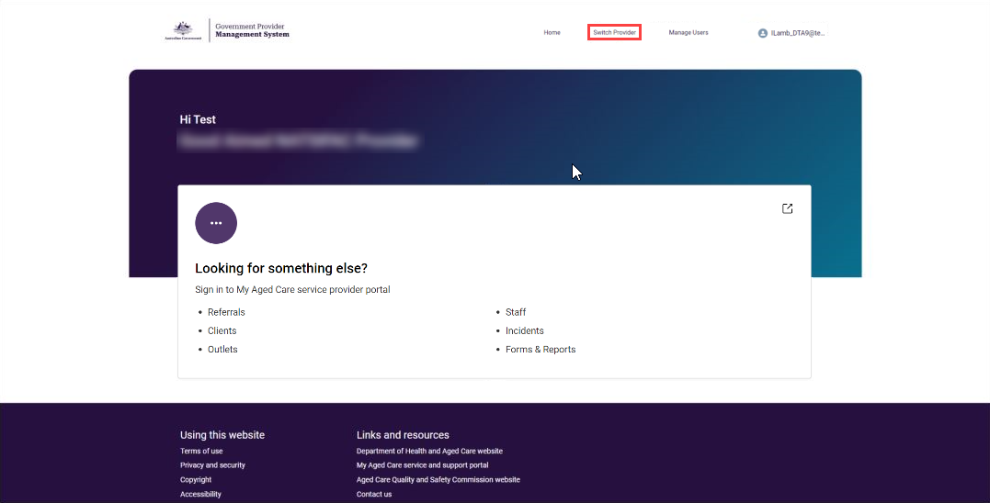

1. In the **Switch Provider** screen, select the **Choose your provider** drop down menu.

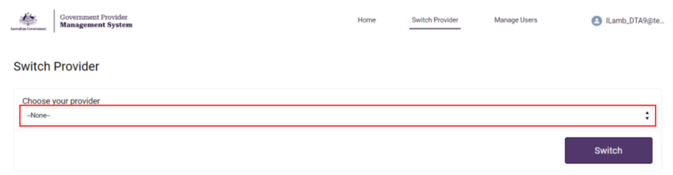

A list of other selectable providers within your organisation will display.

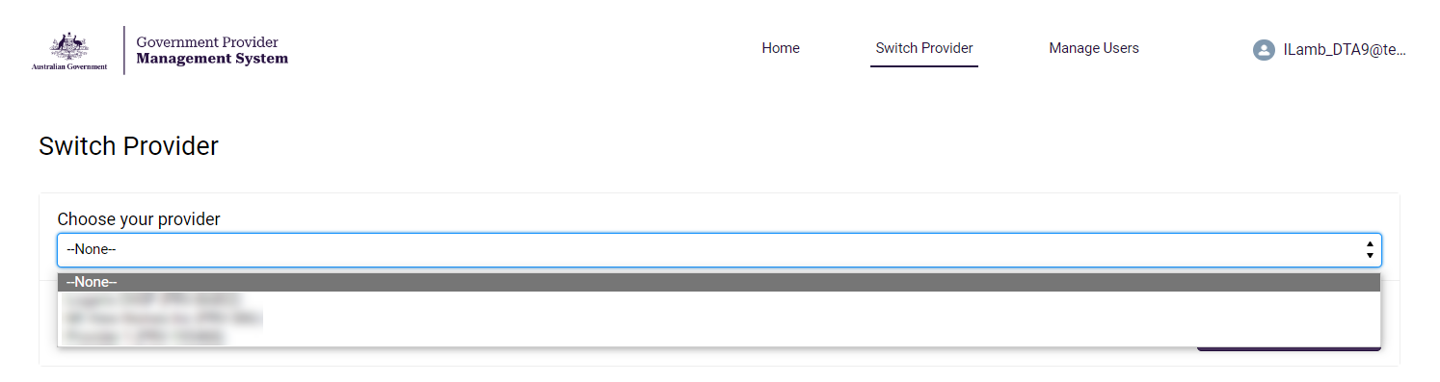

1. Select the provider you want to switch to, then select the **Switch** button at the bottom right hand side of the screen

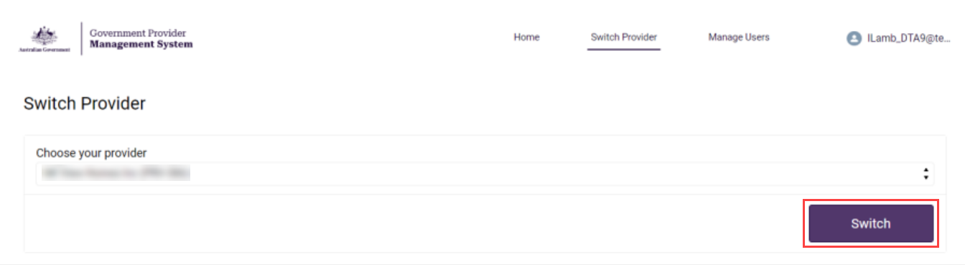

**Please note:**

A banner appears if there is a delay displaying the new provider.

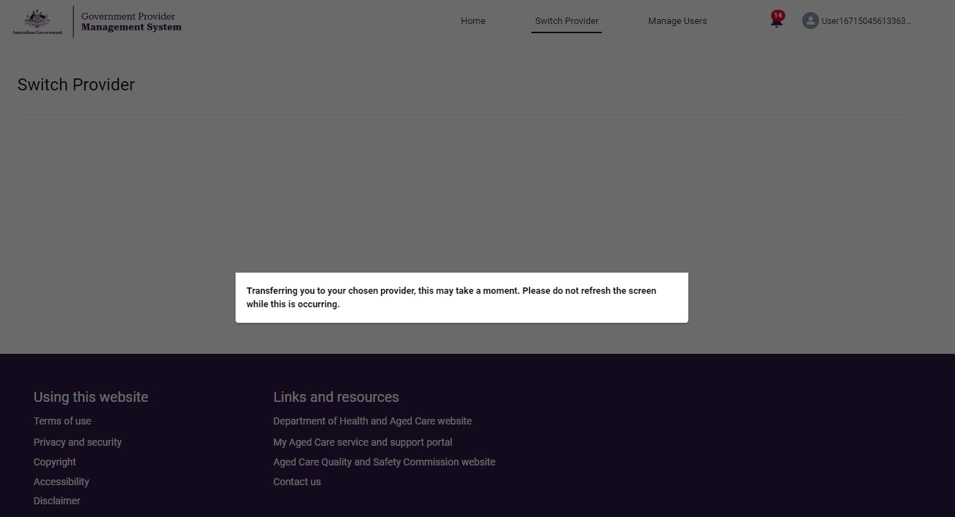

The home screen for the selected provider will display.

