  As of 14 November 2024 | Pfizer (COMIRNATY) JN.1  6 months – 4 years  3 mcg/0.3 mL  concentrated suspension for injection multi-dose vial  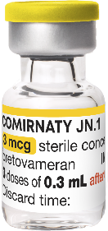 | Pfizer (COMIRNATY) JN.1  5 – 11 years  10 mcg/0.3 mL  suspension for injection  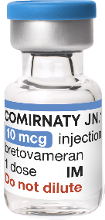  single-dose vial | Pfizer (COMIRNATY) JN.1  12 years+  30 mcg/0.3 mL  suspension for injection  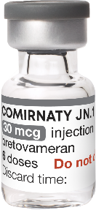  multi-dose vial | Pfizer (COMIRNATY) JN.1  12 years+  30 mcg/0.3 mL  suspension for injection  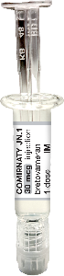  single-dose glass prefilled syringes | Pfizer (COMIRNATY) Omicron XBB.1.5  6 months – 4 years  3 mcg/0.2 mL  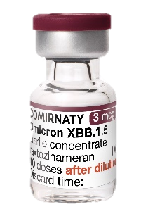  concentrated suspension for injection multi-dose vial | Pfizer (COMIRNATY) Omicron XBB.1.5  5 – 11 years  10 mcg/0.3 mL  suspension for injection  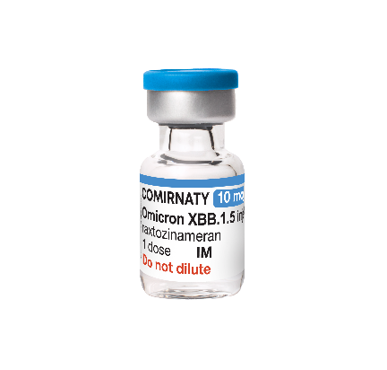  single-dose vial | Pfizer (COMIRNATY) Omicron XBB.1.5  12 years+  30 mcg/0.3 mL  suspension for injection  multi-dose vial  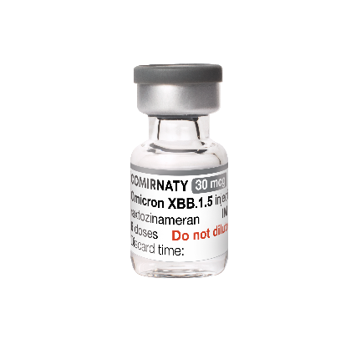
CVAS naming convention | Pfizer (JN.1) 6 months – 4 years (Yellow) | Pfizer (JN.1) 5 – 11 years  (Light Blue) | Pfizer (JN.1) 12 years+  (Dark Grey) | Pfizer (JN.1) 12 years+  (PFS) | Pfizer (XBB.1.5) 6 months - 4 years (Maroon) | Pfizer (XBB.1.5) 5 - 11 years (Light Blue) | Pfizer (XBB.1.5) 12 years+ (Grey)
Vaccine type | mRNA (nucleic acid) | mRNA (nucleic acid) | mRNA (nucleic acid) | mRNA (nucleic acid) | mRNA (nucleic acid) | mRNA (nucleic acid) | mRNA (nucleic acid)
Approved age | 6 months – 4 years | 5 – 11 years | 12 years and older | 12 years and older | 6 months to 4 years | 5 to 11 years | 12 years and older
Dose volume | 0.3 mL | 0.3 mL | 0.3 mL | 0.3mL | 0.2 mL | 0.3 mL | 0.3 mL
Doses per vial | 3 | 1 | 6 | 1 | 10 | 1 | 6
Dilution required | Yes (1.1 mL) | No | No | No | Yes (2.2 mL) | No | No
ULT freezer storage time | 18 months (shelf life) at  -90°C to -60°C | 18 months (shelf life) at  -90°C to -60°C | 18 months (shelf life) at  -90°C to -60°C | NA | 24 months (shelf life) at  -90°C to -60°C | 24 months (shelf life) at  -90°C to -60°C | 24 months (shelf life) at  -90°C to -60°C
Freezer storage time (unopened) | DO NOT STORE at  -25°C to -15°C | DO NOT STORE at  -25°C to -15°C | DO NOT STORE at  -25°C to -15°C | DO NOT FREEZE | DO NOT STORE at  -25°C to -15°C | DO NOT STORE at  -25°C to -15°C | DO NOT STORE at  -25°C to -15°C
Refrigeration storage time (unopened)¹ | 70 days (+2°C to +8°C) within the 18-month shelf life | 70 days (+2°C to +8°C) within the 18-month shelf life | 70 days (+2°C to +8°C) within the 18-month shelf life | Expiry date printed on the carton and syringe label | 70 days (+2°C to +8°C) within the 24-month shelf life | 70 days (+2°C to +8°C) within the 24-month shelf life | 70 days (+2°C to +8°C) within the 24-month shelf life
Room temperature storage time (unopened) | 24 hours pre- and post- dilution (up to +30°C) | 24 hours pre- and post-initial puncture (up to +30°C) | 24 hours pre- and post-initial puncture (up to +30°C) | 12 hours (up to +30°C) | 24 hours pre- and post-dilution (up to +30°C) | 24 hours pre- and post-initial puncture (up to +30°C) | 24 hours pre- and post-initial puncture (up to +30°C)
Storing opened vials | 6 hours (up to +30°C) | 6 hours (up to +30°C) | 6 hours (up to +30°C) | NA | 6 hours (up to +30°C) | 6 hours (up to +30°C) | 6 hours (up to +30°C)
Storing pre-drawn doses | 1 hour (up to +30°C) or 6 hours (+2°C to +8°C) | 1 hour (up to +30°C) or 6 hours (+2°C to +8°C) | 1 hour (up to +30°C) or 6 hours (+2°C to +8°C) | NA | 1 hour (up to +30°C) or 6 hours (+2°C to +8°C) | 1 hour (up to +30°C) or 6 hours (+2°C to +8°C) | 1 hour (up to +30°C) or 6 hours (+2°C to +8°C)
TGA Product Information (PI) and Consumer Medicine Information (CMI) | PI  CMI | PI  CMI | PI  CMI | PI  CMI | PI  CMI | PI  CMI | PI  CMI
Notes:
For the latest information on COVID-19 primary course and additional doses advise, please refer to the Australian Immunisation Handbook:
- All adults aged 18 years and over are recommended a single primary dose. Children and adolescents aged under 18 years are not routinely recommended a primary dose.
- People with severe immunocompromise conditions, who are over 6 months of age or older are recommended 2 primary doses and are eligible for a 3rd primary dose based on an individual risk-benefit assessment.
- Infants, children and adolescents aged 6 months to <18 years with conditions other than severe immunocompromise that may increase the risk of severe COVID-19 are eligible for primary dose(s) based on a risk benefit assessment.
If vaccines are stored or handled outside the conditions listed, complete the Cold Chain Breach (CCB) reporting form and email it to the Vaccine Operations Centre (VOC) COVID19VaccineOperationsCentre@health.gov.au.
It is mandatory under the Australian Immunisation Register Act 2015 for vaccination providers to report all vaccinations administered in Australia to the AIR. For more information, please visit Advice for COVID-19 vaccine providers and administrators.
Images © 2024 Pfizer Inc. All rights reserved.

