



# Why it is important for children to get vaccines

This information is about why it is important for children to get **vaccines**.

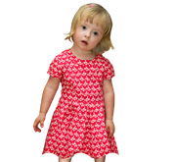

**Vaccines** are medicines that can help stop children from getting sick.



Vaccines have been very good for Australia.



1

They have helped stop people from getting very sick from **diseases**.



**Diseases** are things your body gets and makes you sick.

When your child gets a vaccine it can also stop others getting sick like

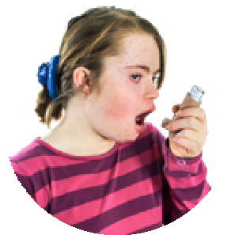

* Older people
* People who are pregnant
* People with health issues.

2

When lots of people have vaccines it is harder for a disease to spread around.



This helps keep people safe who can not get vaccines.



It helps people like

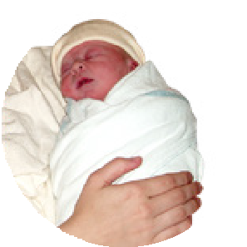

* Babies who are too young to get a vaccine
* People who can not get a vaccine because of a health reason.

Council for Intellectual Disability made this document Easy Read. **CID** for short. You need to ask CID if you want to use any pictures in this document.  
You can contact CID at [**business@cid.org.au**.](mailto:business@cid.org.au)