



# Where to get information about vaccines for children

This information is about where you can find out about **vaccines** for children.



**Vaccines** are medicines that can help stop children getting sick.



The Government has information that can help you decide about vaccines.

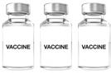

You can look at the information on the Government website at

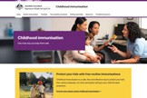

[**www.health.gov.au/childhood-immunisation**](https://www.health.gov.au/childhood-immunisation)**.**

This website is not Easy Read. You can ask for support to read it.



Sharing Knowledge About Immunisation

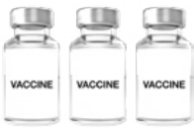

is a service that has information about

* All the different vaccines
* How you can support your child with the vaccines.

You can go to their website at

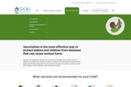

[**www.skai.org.au/childhood**](https://www.skai.org.au/childhood)**.**

The website is not Easy Read. You can ask for support to read it.

You can get free information and support about health from **HealthDirect**.



You can call **HealthDirect** at any time on



1800 022 222

1800 022 222.

You can go to their website at



[**www.healthdirect.gov.au**](https://www.healthdirect.gov.au/)**.**

The website is not Easy Read. You can ask for support to read it.

# Before your child gets a vaccine



You can talk to your doctor or health worker about vaccines before your child gets a vaccine.

You can tell them if you are worried about your child getting a vaccine.



# After your child gets a vaccine

If you are worried about your child after they get a vaccine you can get support from

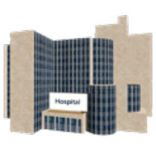

* Your doctor or health worker
* A hospital near where you live.

Council for Intellectual Disability made this document Easy Read. **CID** for short. You need to ask CID if you want to use any pictures in this document.

You can contact CID at [**business@cid.org.au**.](mailto:business@cid.org.au) 5