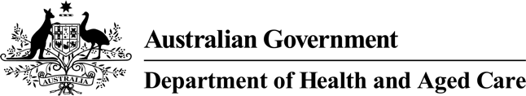



# What vaccines children should have

This information is about what **vaccines**

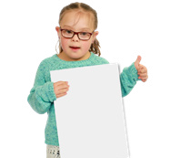

children should have.

**Vaccines** are medicines that can help stop children from getting sick.

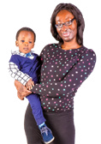

Children get the vaccine

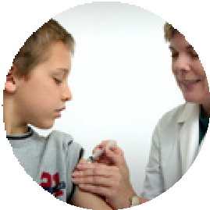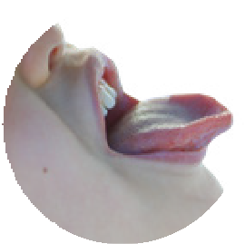

* With a needle in their arm or leg
* Or drops in their mouth.

1

Most of the time children get vaccines from a

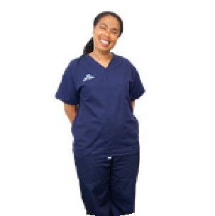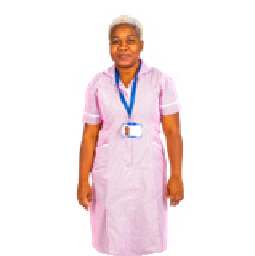

* Doctor
* Nurse
* Health worker.

There are vaccines that children should get when they are at a certain age.

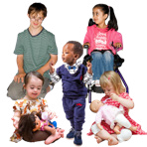

There is a Government program that pays for these vaccines.



2

It is called the **National Immunisation Program**.

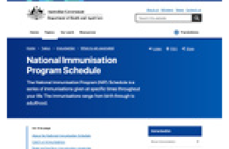

We will say **NIP** for short.

The NIP has a list that shows

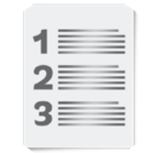

* What vaccines your child should get
* When your child should get each vaccine.

You do not have to pay for vaccines that your child should get at this age.



You might have to pay for the time you meet with your doctor or health worker.

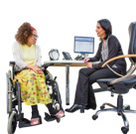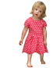

This is called a **consultation fee** or

administration fee. 3

Some children may need to get extra vaccines.



You can talk to your doctor or health worker about what vaccines your child needs.

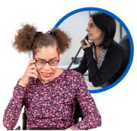

Vaccines work best if your child has each one at the right age.

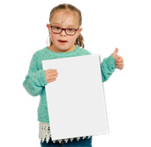

This helps keep them safe from getting very sick from **diseases**.

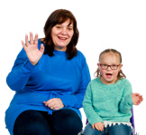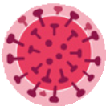

4

**Diseases** are things your body gets and makes you sick.

There are some vaccines that have medicine to stop lots of diseases.



When you meet with your health workers you do not need to tell them all the vaccines your child needs.

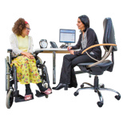

You just need to tell them your child needs the vaccines for their age.

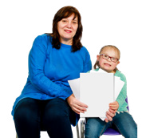

Council for Intellectual Disability made this document Easy Read. **CID** for short. You need to ask CID if you want to use any pictures in this document.

You can contact CID at [**business@cid.org.au**.](mailto:business@cid.org.au) 5