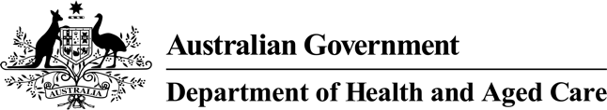



# What are vaccines for children

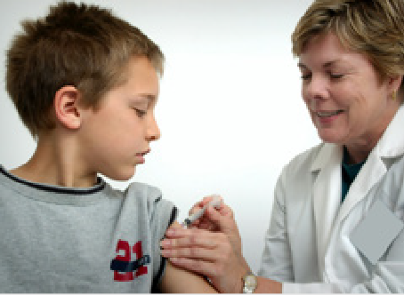This information is about **vaccines** for children.

**Vaccines** are medicines that can help stop children getting sick.

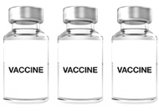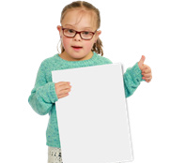

There are different vaccines for different diseases children might get.

Each vaccine can stop the child from getting a **disease**.

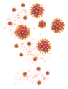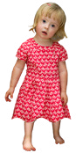

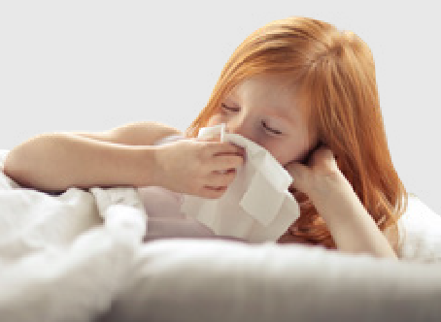A **disease** is something your body gets and makes you sick.

It is safe for children to get vaccines.

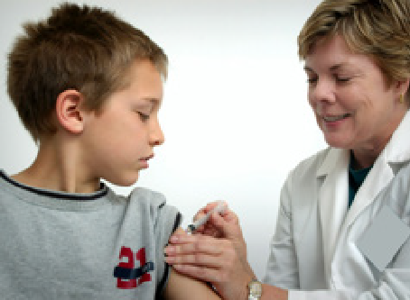

**What is in vaccines**

Vaccines have things in them to make sure they

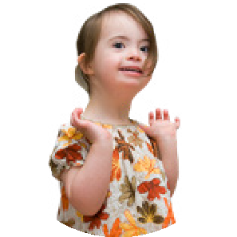

* Are safe
* Work well.

You might not have heard of the things that are in a vaccine.

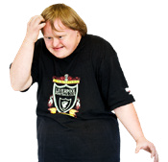

But lots of the things in vaccines are also in

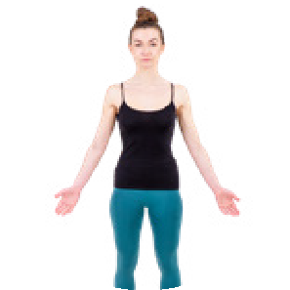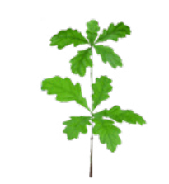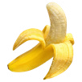

* Foods we eat
* Our bodies
* The land.

Everything in the vaccine is tested to make sure it is safe.

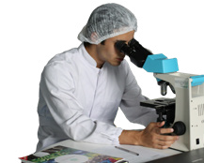

Council for Intellectual Disability made this document Easy Read. **CID** for short. You need to ask CID if you want to use any pictures in this document.  
You can contact CID at [**business@cid.org.au**.](mailto:business@cid.org.au)