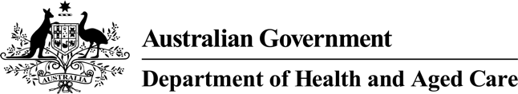



# Vaccines are safe for children

This information is about how **vaccines** are safe for children.

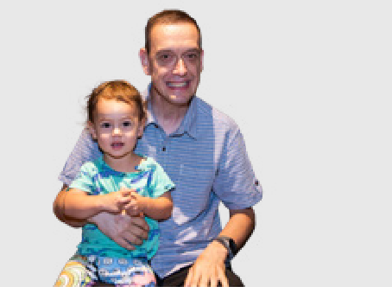

**Vaccines** are medicines that can help stop children getting sick.

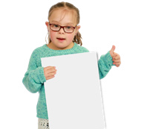

Children get the vaccine

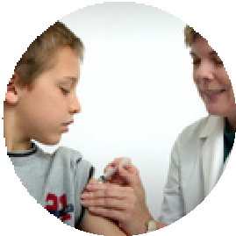

* With a needle in their arm or leg
* Or drops in their mouth.

1

Most of the time children get their vaccines from a

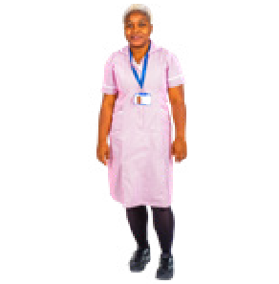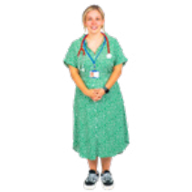

* Doctor
* Nurse
* Health worker.

You might worry if vaccines are safe or not.

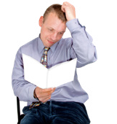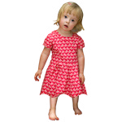

There are things the Government does to make sure vaccines are safe for children.

They test all vaccines before children get them in Australia.



This is to make sure the vaccines

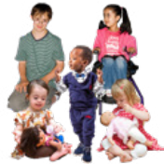

* Are safe for children
* Work well.

They test the vaccines on groups of people who agree to it.

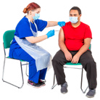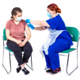

Sometimes the Government finds out a vaccine is not safe when they test it.

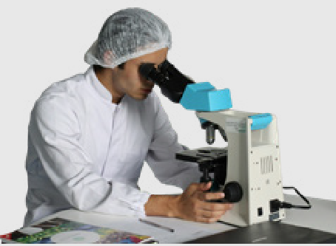

The vaccine will not be used in Australia if it is not safe.



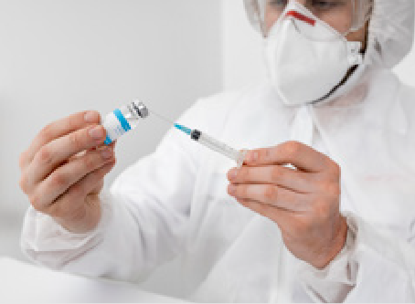The Government keeps testing the vaccine after children start to get it.

This is to check it is still safe to use.



# Getting more than 1 vaccine at a time

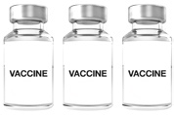

It is safe for your child to get more than 1 vaccine at a time.

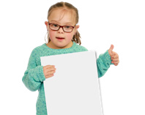

There are good things about your child getting more than 1 vaccine at a time.

We wrote some information about this.

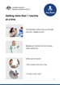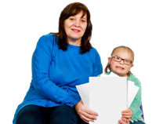

You can read our information sheet called **Getting more than 1 vaccine at a time.**

Council for Intellectual Disability made this document Easy Read. **CID** for short. You need to ask CID if you want to use any pictures in this document.  
You can contact CID at [**business@cid.org.au**.](mailto:business@cid.org.au)