

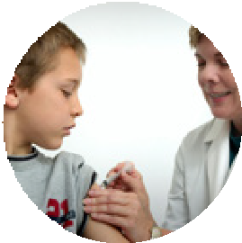

# Side effects from vaccines

This information is about side effects children can get from **vaccines**.



**Vaccines** are medicines that can help stop children from getting sick.

Children get the vaccine

* With a needle in their arm or leg
* Or drops in their mouth.

Most of the time children get vaccines from a



* Doctor
* Nurse
* Health worker.

# Side effects

Some children can have **side effects** from a vaccine.



A **side effect** is something that can happen to children after they have a vaccine.

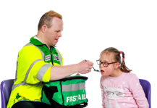

Most side effects will not be very bad.

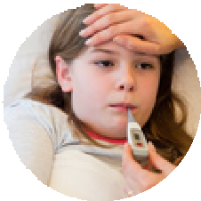

Your child might have a side effect like

* Red sore skin where the needle went in
* Feeling cranky, sad or tired
* A little fever.

Side effects might last for 1 or 2 days and then go away on their own.



If you are worried about the side effects talk to your health worker.

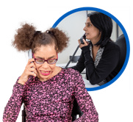

You can check with your health worker if it is okay for your child to have **pain relief**.

**Pain relief** are medicines that help your child feel better from pain or fever.

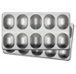

# Very bad side effects

Sometimes children have very bad side effects from a vaccine.



This does not happen often.



Your health worker will ask you to stay for 15 minutes after your child got the vaccine.

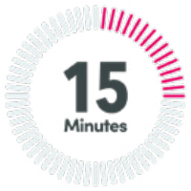

This is to keep them safe in case they get a very bad side effect.



You should go to the hospital right away if



* Your child has a very bad side effect
* Your child has a side effect you did not know about
* You worry about how your child feels after the vaccine.

# Report side effects

You can make a report about any side effects your child gets from the vaccine.

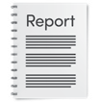

This helps the Government to understand if the vaccine is safe.



You can report the side effects to the health department in your State.

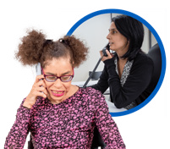

To find the phone number for the health department in your state go to this website.

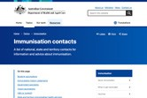

[**www.health.gov.au/topics/immunisation/**](https://www.health.gov.au/topics/immunisation/immunisation-contacts)[**immunisation-contacts**](https://www.health.gov.au/topics/immunisation/immunisation-contacts)

You can also report side effects to the



**Therapeutic Goods Administration.**

The **Therapeutic Goods Administration** are part of the Government.



They make sure things like vaccines are safe for everyone.



There are a few ways you can make a report to the Therapeutic Goods Administration.



You can

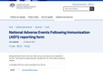

1300 633 424

* Call them on **1300 633 424**
* Fill in an online form at

[**www.aems.tga.gov.au**](https://aems.tga.gov.au/).

The form is not Easy Read.



You can ask for support to fill it in.

Council for Intellectual Disability made this document Easy Read. **CID** for short.

You need to ask CID if you want to use any pictures in this document.

You can contact CID at [**business@cid.org.au**.](mailto:business@cid.org.au)