Cervical screening for people with disability

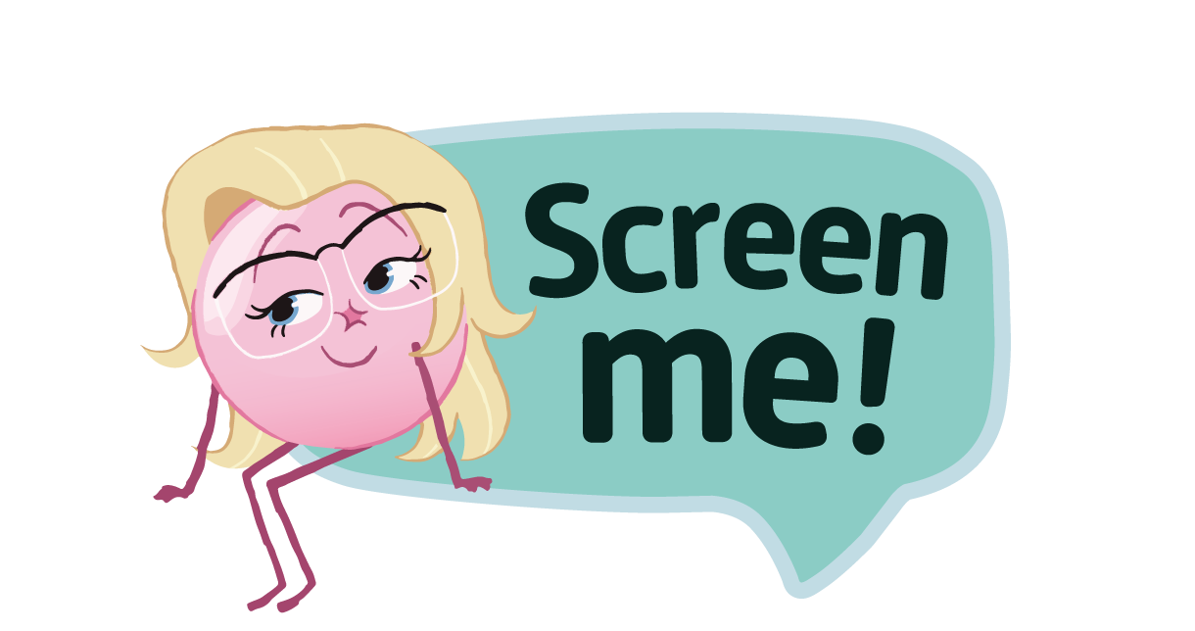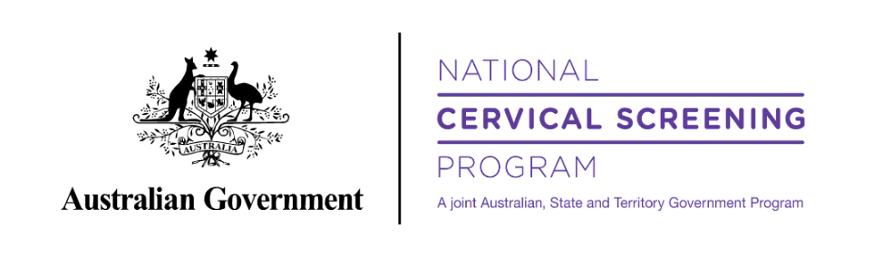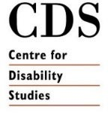Toolkit for health organisation stakeholders and partners

# About this toolkit

The Toolkit is designed to equip stakeholders with communication tools and resources to promote cervical screening and further the reach of the Screen Me! short film and campaign.

These materials are provided on the condition that they must be used for their intended purpose of promoting cervical screening.

Cast/ Talent’s images have been obtained with consent specific to promoting cervical screening and the Screen Me! campaign.

These images and quotes are not for use outside the specifics of this campaign.

# Also included in the pack

See attachment/zip file on [Screen Me resource](https://www.health.gov.au/screen-me/resources) page for poster, images, and QR codes.

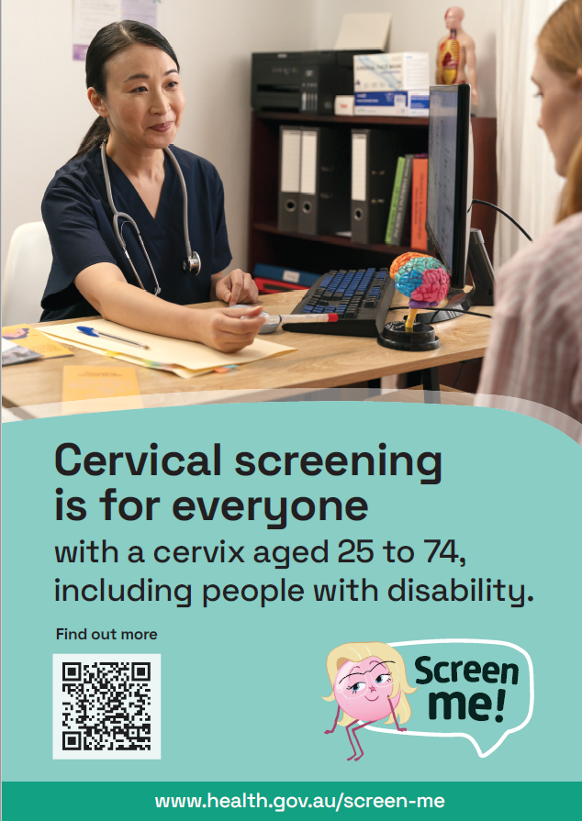 Poster 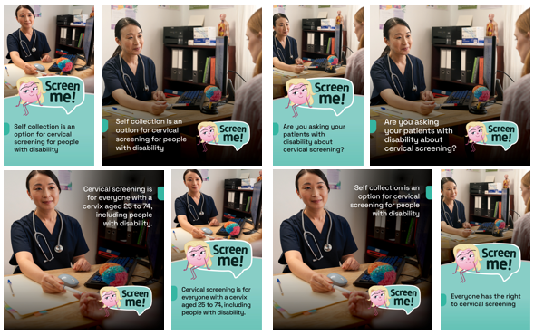 Social media images

Contents

Contents 02

About Screen Me! 04

Screen Me! films 05

Screen Me! – host a screening 06

Social media content 09

Suggested eDM or newsletter content 11

Website 13

Resources 14

Links 16

Other stuff 17

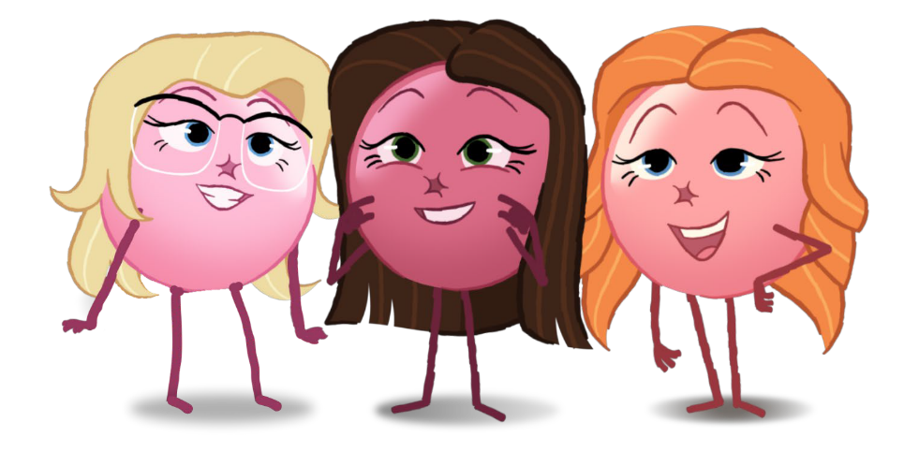

# About Screen Me!

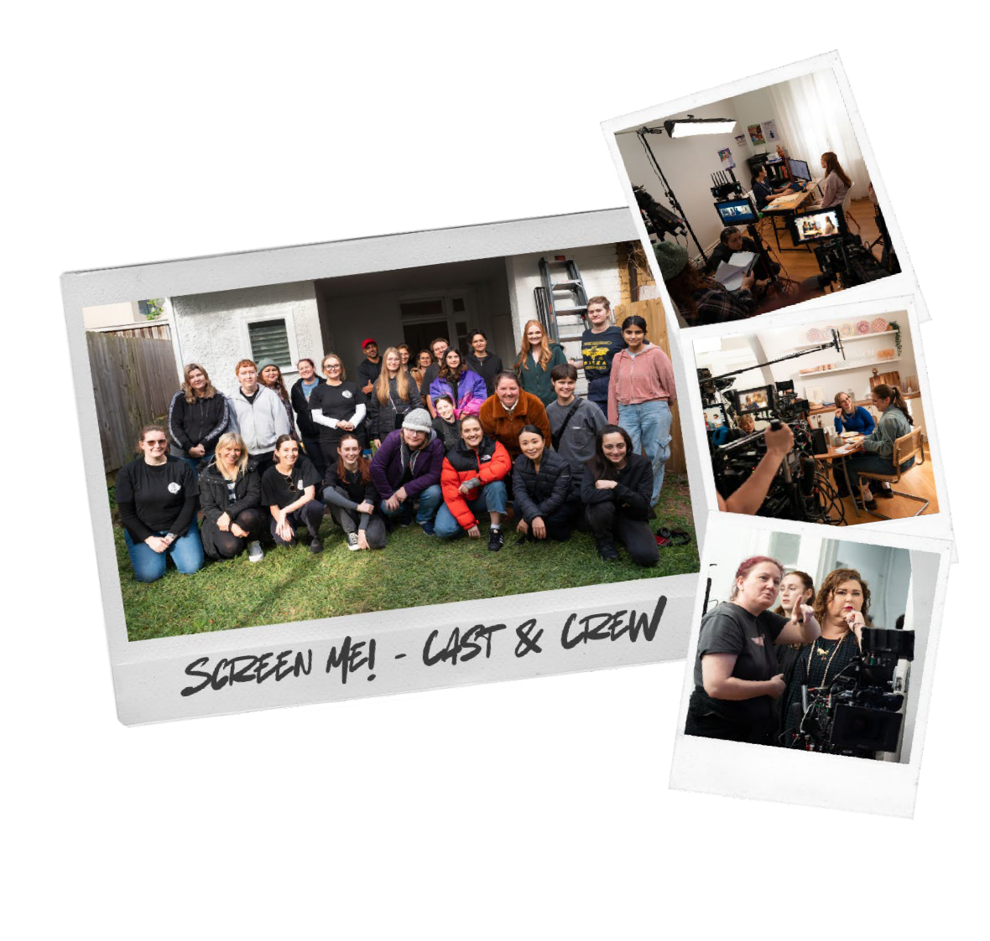Funded by the Department of Health and Aged Care, the Screen Me! film and other content for this campaign was developed by:

* [The Daffodil Centre](https://daffodilcentre.org/), a joint venture between Cancer Council NSW and the University of Sydney
* [The Centre for Disability Studies](https://cds.org.au/), a research affiliate of the University of Sydney

The Screen Me! short film was developed by [Bus Stop](https://busstopfilms.com.au/) [Films](https://busstopfilms.com.au/), an Australian disability led not for profit social enterprise.

Directed by Kate Vinen and written by Stephanie Dower and Nicolette Minster, production of the Screen Me! film had a cast and crew of majority women, many of them women with disability.

# Screen Me! films

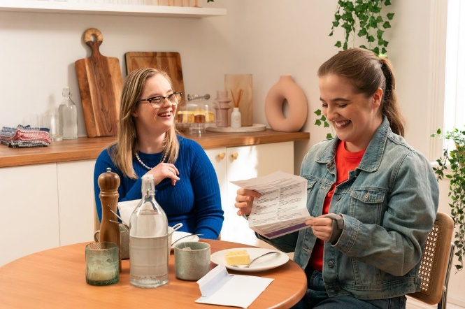All videos are available on the [Screen Me! website](http://www.health.gov.au/screen-me) and on YouTube.

## Short Film

[www.health.gov.au/screen-me/resources/videos/screen-me-a-short-](http://www.health.gov.au/screen-me/resources/videos/screen-me-a-short-film-about-cervical-screening-with-disability) [film-about-cervical-screening-with-disability](http://www.health.gov.au/screen-me/resources/videos/screen-me-a-short-film-about-cervical-screening-with-disability)

<https://youtu.be/QHXuhqrwwlQ>

## Short Film [with audio description]

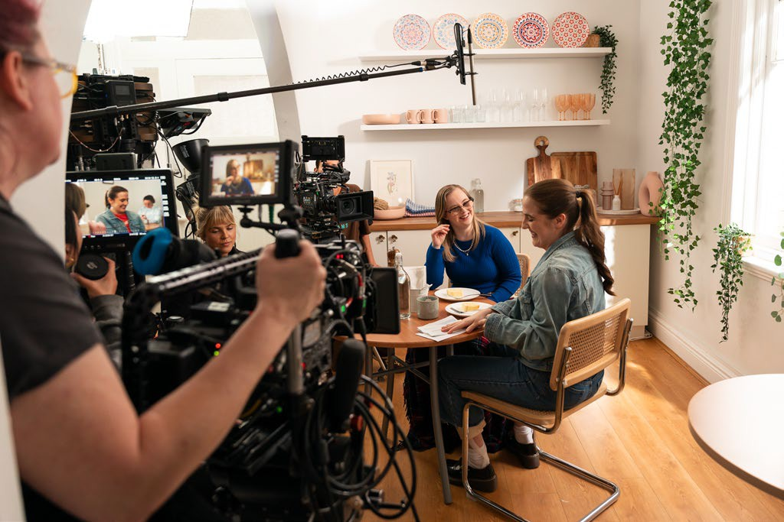[www.health.gov.au/screen-me/resources/videos/screen-me-short-film-](http://www.health.gov.au/screen-me/resources/videos/screen-me-short-film-on-cervical-screening-for-people-with-disability-with-audio-description) [on-cervical-screening-for-people-with-disability-with-audio-description](http://www.health.gov.au/screen-me/resources/videos/screen-me-short-film-on-cervical-screening-for-people-with-disability-with-audio-description)

<https://youtu.be/zkfHukG8ExM>

## Behind the scenes video

[www.health.gov.au/screen-me/resources/videos/behind-the-scenes-](http://www.health.gov.au/screen-me/resources/videos/behind-the-scenes-of-screen-me) [of-screen-me](http://www.health.gov.au/screen-me/resources/videos/behind-the-scenes-of-screen-me)

<https://youtu.be/E-BXidjlJyM>

# Screen Me! – host a screening

We encourage you to show the short, 7-minute film and, if appropriate to also show the Behind-The-Scenes film, to your clients, colleagues and staff.

We’ve created this short guide to help.

## Preparing to show the film

* Make a time and find a place to show the [Screen Me! short film](https://www.health.gov.au/screen-me/resources/videos/screen-me-a-short-film-about-cervical-screening-with-disability?language=en). It could be during a regular staff meeting, or regular gathering of the people you and your organisation work with, or you could make a specific time to show the film.
* Ask people to come. Tell them there’s a new film to watch with an important, but fun, health message about cervical screening for people with disability.
* Make sure you have everything set up to show the film. You can easily watch it on a computer or handheld device if it’s a small group, or you can connect your computer to a television or big screen to show it to a bigger gathering of people. Check the audio levels to make sure everyone can hear it. There are subtitles for those hard of hearing and there is an [audio-description version](https://www.health.gov.au/screen-me/resources/videos/screen-me-short-film-on-cervical-screening-for-people-with-disability-with-audio-description) of the film too.
* If you can, make it a fun event! If appropriate, serve popcorn or other traditional movie treats.
* Make sure you have the links to the [Screen Me! website](http://www.health.gov.au/screen-me) so you can help people find more information at the end. This is also where you’ll find helpful answers to frequently asked questions.

# Screen Me! – host a screening

## Showing the film

Welcome everyone to the film screening and explain that the film is part of a new campaign to encourage people with disability to do their routine cervical screening.

|  |  |
| --- | --- |
| Hi everyone. Thank you so much for coming to see this new short film today.  This is a film about cervical screening. Cervical screening is a test to check that your cervix is healthy and helps to prevent cervical cancer. The test changed in 2017 from a Pap smear to a more accurate test for the human papillomavirus (HPV).  Australia is on track to be one of the first countries in the world to eliminate cervical cancer, but there are some groups of women and people with a cervix who could be left behind. That includes people with disability.  Cervical screening is for everyone with a cervix aged 25 to 74 every five years. It’s a short, easy test that can be done by your doctor or your nurse, or you have the option to do the test yourself through self- collection. Whatever is most comfortable for you – it’s your choice.  The film is part of a new campaign to encourage people with a disability to get their regular screenings. | Suggested words |

# Screen Me! – host a screening

## After the film

Ask if anyone has any questions (don’t forget to check out the [Screen Me! website](https://www.health.gov.au/screen-me) for more information and help for answering questions) and prompt discussion.

|  |  |
| --- | --- |
| What did you think of the film? Did anyone know that self-collection is an option for cervical screening?  What would you need to be comfortable getting a cervical screen?  Do you think you would talk about cervical screening with someone you know or love?  Does anyone have any questions? | Suggested words |

Once discussion has finished give people details about where to get more information and find out how to make an appointment for a Cervical Screening Test: [www.health.gov.au/screen-me](http://www.health.gov.au/screen-me)

## After the event

If appropriate, you might like to email the people who came to see the film to share a link to the film so they can watch it again or send it to friends and family.

You can also send the link to the Screen Me! Website – [www.health.gov.au/screen-me](http://www.health.gov.au/screen-me) – where people can take the time to find out more information for themselves.

# Social media content

Below are some sample social media posts. You can copy and paste these posts or write your own using the same messaging and links.

|  |  |
| --- | --- |
| A doctor in medical scrubs sitting at a desk, she hands a self-collection swab to a patient. Text reads: Self-collection is an option for cervical screening for people with a disability. | Cervical screening is for everyone with a cervix aged 25 to 74, including people with disability.  People with disability may also ask you to help them take a sample from the vagina if they have difficulty doing it themselves.  When you’re talking about cervical screening, make sure you’re discussing your patient’s accessibility requirements and let them know they have the choice about how their test is done.  Find out more at health.gov.au/screen-me |

|  |  |
| --- | --- |
| Australia is on track to eliminate cervical cancer by as soon as 2035, due to our strong vaccination program and the high rate of participation in the National Cervical Screening Program. But people with disability are at risk of being left behind.  When you’re discussing the importance of cervical screening, ask your patients about their accessibility needs and if they would prefer to collect the sample themselves.  Find out more at www.health.gov.au/screen-me | A doctor in medical scrubs sitting at a desk, she hands a self-collection swab to a patient. Text reads: Self-collection is an option for cervical screening for people with disability. |

# Social media content

Below are some sample social media posts. You can copy and paste these posts or write your own using the same messaging and links.

|  |  |
| --- | --- |
| A doctor in medical scrubs sitting at a desk, she hands a self-collection swab to a patient. Text reads: Cervical screening is for everyone with a cervix aged 25-74, including people with disability. | Australia is on track to one day eliminate cervical cancer, but we need to make sure no-one is left behind.  We know that people with disability are less likely to receive cervical screening than the general population.  Make sure you discuss cervical screening with your patients with disability.  Find out more at www.health.gov.au/screen-me |

|  |  |
| --- | --- |
| Australia is on track to eliminate cervical cancer by as soon as 2035, due to our strong vaccination program and the high rate of participation in the National Cervical Screening Program. But people with disability are at risk of being left behind.  When you’re talking to your patients with disability, make sure you discuss the importance of cervical screening.  Find out more at www.health.gov.au/screen-me | A doctor in medical scrubs sitting at a desk, she hands a self-collection swab to a patient. Text reads: Are you asking your patients with disability about cervical screening? |

# Suggested eDM or newsletter content

This template text is intended to be an email to be sent to any of your regular networks, be they people with disability, staff, stakeholders or family and friends. It’s suggested copy and can be easily edited to suit your organisation and the folks on your regular email list. If appropriate, you can use any of the graphics or videos supplied with this pack to make it more interesting.

|  |
| --- |
| **A new film we would love you to see!**  There’s a new short, 7-minute film that we would love you to see.  It’s a short movie that shares the journey of four people with disability as they find out more about cervical screening, make an appointment to be screened and support each other through the process.  The film is part of a new campaign called Screen Me! aiming to raise awareness about the importance of cervical screening and to encourage women and people with a cervix with disability to make an appointment and get their regular cervical screen.  You can watch the film here <www.health.gov.au/screen-me OR embed video into email>  Australia is on track to one day eliminate cervical cancer, but we need to make sure no-one is left behind. We know that people with disability are less likely to receive cervical screening than the general population. While this is due in part to low awareness of the importance of cervical screening among the general population, including people with disability, it is also related to factors that can be addressed by health practitioners.  Poor physical accessibility in clinical spaces, and lack of time to discuss accessibility needs and concerns with health practitioners  Hesitation in discussing or disclosing sexual activity to health practitioners.  Incorrect assumptions about the sexual activity of people with disability.  Women and people with a cervix with disability live rich and full lives, including being in and enjoying sexual relationships. Sadly, they’re also more likely to be impacted by sexual assault.  Screen Me! is a reminder that people with a disability have the same right to preventative healthcare as anyone else.  Alongside the film and social media campaign, the project has also provided professional education opportunities for health practitioners. We encourage you to view the webinar recording, [*Optimising Cervical Screening for People with Disabilities*](https://www.health.gov.au/resources/videos/optimising-cervical-screening-for-people-with-disability?language=en), which was delivered in partnership with the RACGP.  You and your patients can find out more about Screen Me! at www.health.gov.au/screen-me. |

# Suggested newsletter content

This template text is intended for any newsletters or bulletins you may regularly publish. It’s suggested copy and can be easily edited to suit your organisation and the folks in your networks.

|  |
| --- |
| Headline: New campaign highlights importance of cervical screening for people with disability  A new campaign, Screen Me! is encouraging women and people with a cervix with disability to make an appointment and get their regular cervical screen. It’s a joint project between the Daffodil Centre, a joint venture between Cancer Council NSW and The University of Sydney, and the Centre for Disability Studies, an affiliate of the University of Sydney.  Australia is on track to one day eliminate cervical cancer, but we need to make sure no-one is left behind. We know that people with disability are less likely to receive cervical screening than the general population. While this is due in part to low awareness of the importance of cervical screening among the general population, including people with disability, it is also related to factors that can be addressed by health practitioners.   * Poor physical accessibility in clinical spaces, and lack of time to discuss accessibility needs and concerns with health practitioners * Hesitation in discussing or disclosing sexual activity to health practitioners. * Incorrect assumptions about the sexual activity of people with disability.   Women and people with a cervix with disability live rich and full lives, including being in and enjoying sexual relationships. Sadly, they’re also more likely to be impacted by sexual assault.  Screen Me! is a reminder that people with a disability have the same right to preventative healthcare as anyone else.  The campaign has created a new film that features the stories of four women and people with a cervix with disability discuss the importance of cervical screening. They each make an appointment and support each other to get screened.  Alongside the film and social media campaign, the project has also provided professional education opportunities for health practitioners. We encourage you to view the webinar recording, [*Optimising Cervical Screening for People with Disabilities*](https://www.health.gov.au/resources/videos/optimising-cervical-screening-for-people-with-disability?language=en), which was delivered in partnership with the RACGP.  You and your patients can find out more about Screen Me! at www.health.gov.au/screen-me. |

# Website

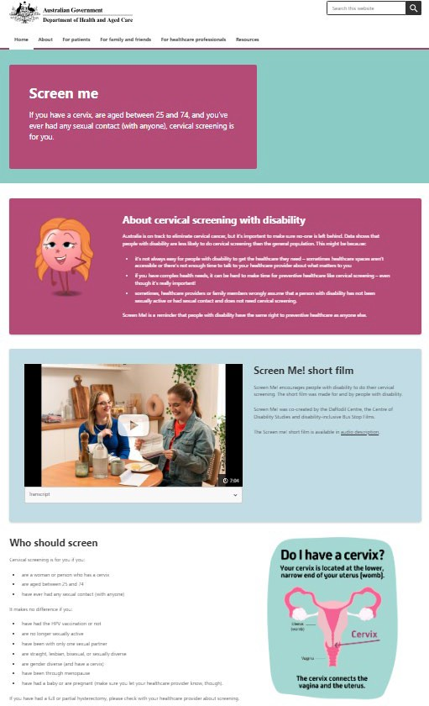

Resources can be accessed from tab up the top on a desktop, or from the menu on a mobile

The film can be watched on the main page and there is a link to the audio-description version.

On the website you can find:

* The Screen Me! short film
* The Screen Me! behind-the-scenes short film
* Information on cervical screening with disability for patients, support people, and healthcare providers
* Resources

Visit the Screen Me! website: [www.health.gov.au/screen-me](http://www.health.gov.au/screen-me)

# Resources

## Easy-read

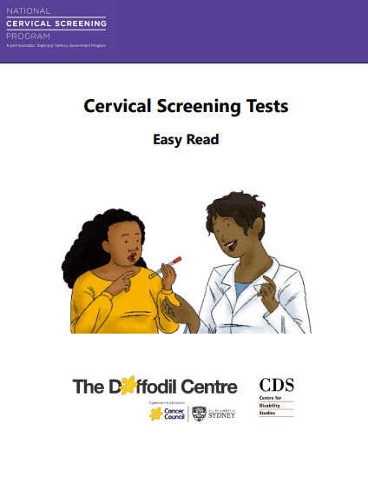

[Easy-read guide to Cervical Screening Tests](https://www.health.gov.au/screen-me/resources/publications/national-cervical-screening-program-the-cervical-screening-test-easy-read?language=en)

## Instruction guides

**Available in 20+ languages**

[Self-collected](https://www.health.gov.au/resources/publications/national-cervical-screening-program-how-to-collect-your-own-sample?language=en) [Doctor collected](https://www.health.gov.au/resources/publications/national-cervical-screening-program-what-happens-when-my-healthcare-provider-collects-my-sample?language=en)

**[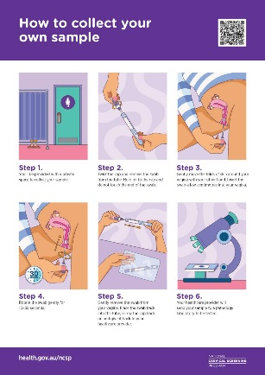](https://www.health.gov.au/resources/publications/national-cervical-screening-program-how-to-collect-your-own-sample?language=en)** [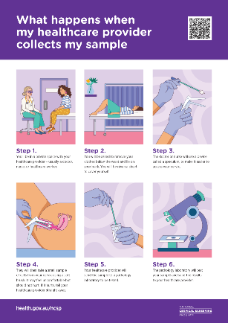](https://www.health.gov.au/resources/publications/national-cervical-screening-program-what-happens-when-my-healthcare-provider-collects-my-sample?language=en)

## Videos

[Cervical screening explained](https://www.health.gov.au/resources/videos/national-cervical-screening-program-cervical-screening-explained?language=en) [How to do your own test](https://www.health.gov.au/resources/videos/national-cervical-screening-program-video-how-to-take-your-own-cervical-screening-test-sample-easy-read-0?language=en)

[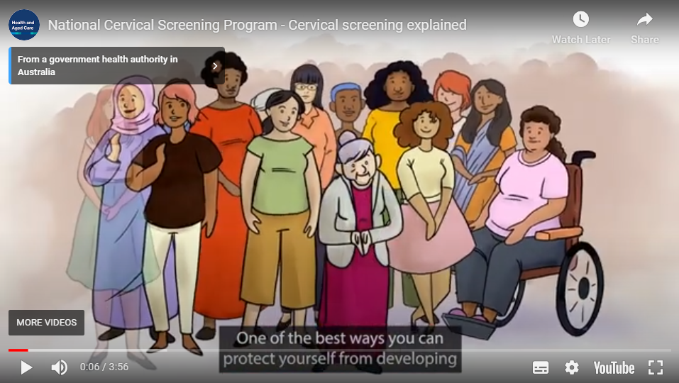](https://www.health.gov.au/resources/videos/national-cervical-screening-program-cervical-screening-explained?language=en) 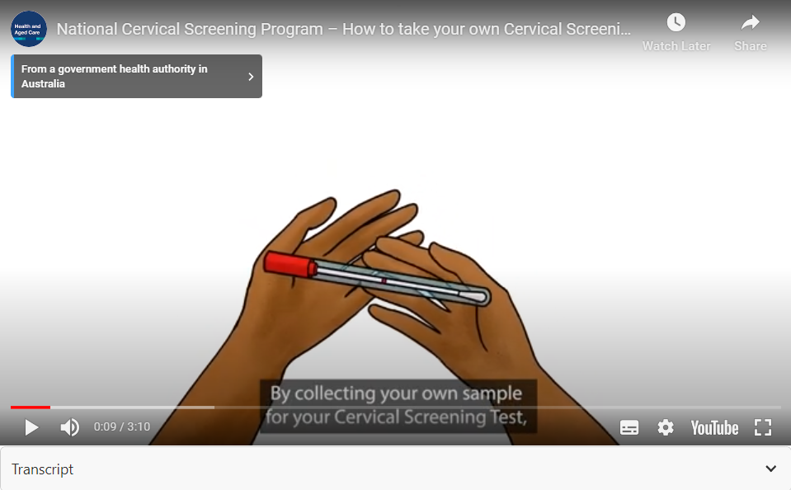

Video – 03:55 Video – 03:55

Available in 10+ languages (incl AusLan)

# Links

**Campaign website:** [www.health.gov.au/screen-me](http://www.health.gov.au/screen-me)

**Partner websites:**

National Cervical Screening Program: [www.health.gov.au/ncsp](http://www.health.gov.au/ncsp)

Daffodil Centre: [www.daffodilcentre.org](http://www.daffodilcentre.org)

Centre for Disability Studies: [www.cds.org.au](http://www.cds.org.au)

**Other useful websites:**

[Optimising cervical screening for people with disability](https://www.health.gov.au/resources/videos/optimising-cervical-screening-for-people-with-disability?language=en) – webinar hosted by RACGP and presented in partnership with the Daffodil Centre and the Centre for Disability Studies

Australian Centre for the Prevention of Cervical Cancer: [www.acpcc.org.au](http://www.acpcc.org.au)

Blue Knot Foundation: [www.blueknot.org.au](http://www.blueknot.org.au)

# Other stuff

|  |  |  |  |  |  |  |
| --- | --- | --- | --- | --- | --- | --- |
| The campaign colours feature a selection of pastel shades and one darker shade.  Text should be black except when the background is too dark.  Find out more about colour contrasting and accessibility.   |  |  | | --- | --- | | **#de8aa1** | **#8ccbc4** | | **#b44b77** | | | The main font used for headings is **Alwyn New Rounded**  **Aa Bb Cc Dd Ee Ff Gg Hh Ii Jj Kk Ll Mm Nn Oo Pp Qq Rr Ss Tt Uu Vv Ww Xx Yy Zz** | QR Codes are included in the images pack on [the Screen Me resources page](https://www.health.gov.au/screen-me/resources)  QR codes |

