Cervical screening for people with disability

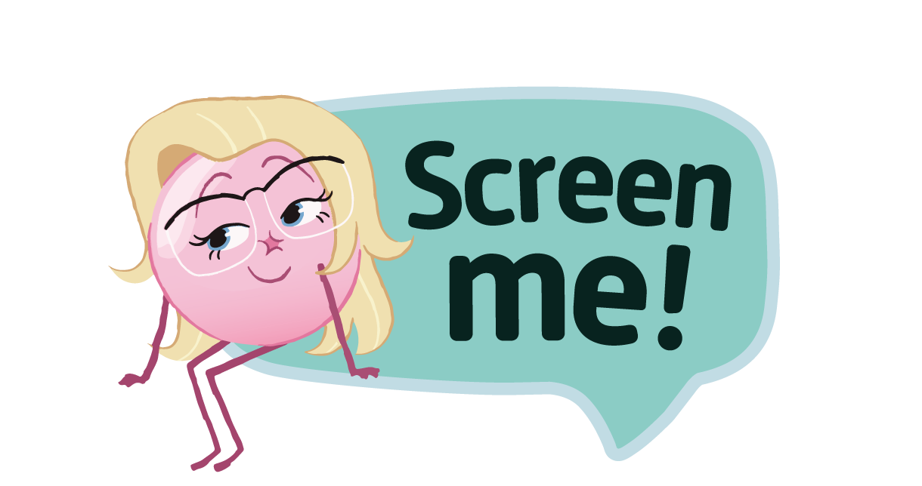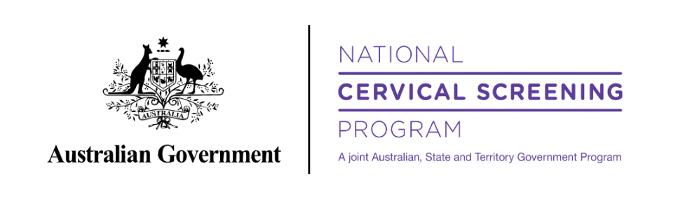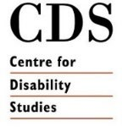Toolkit for disability organisation stakeholders and partners

## About this toolkit

The Toolkit is designed to equip stakeholders with communication tools and resources to promote cervical screening and further the reach of the Screen Me! short film and campaign.

These materials are provided on the condition that they must be used for their intended purpose of promoting cervical screening.

Cast/ Talent’s images have been obtained with consent specific to promoting cervical screening and the Screen Me! campaign.

These images and quotes are not for use outside the specifics of this campaign.

## Also included in the pack

See attachment/zip file on [Screen Me resource](https://www.health.gov.au/screen-me/resources) page for poster, images, and QR codes.

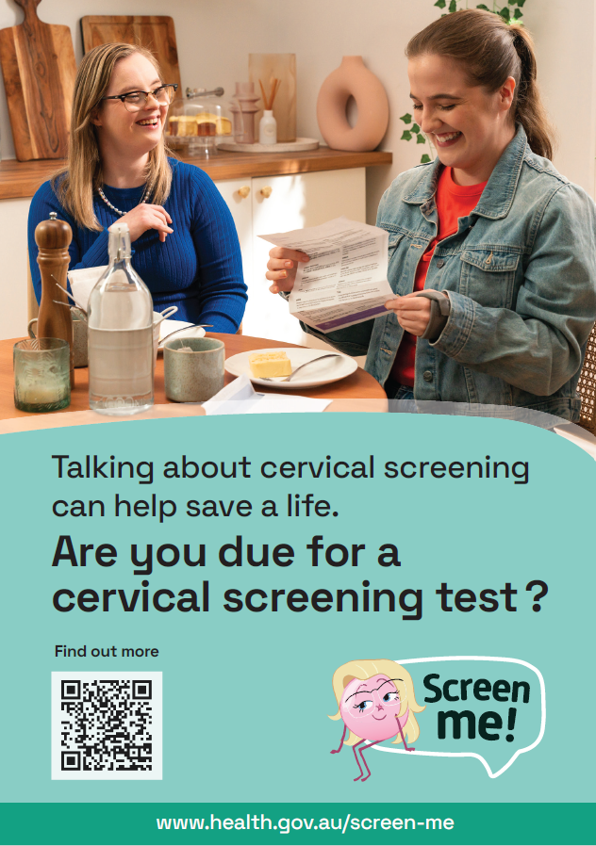 Poster 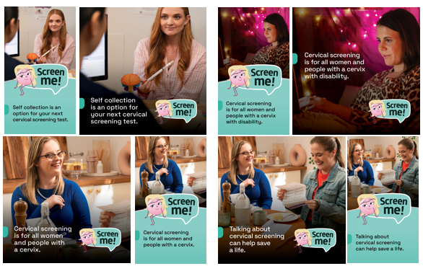 Social media image

# Contents

Contents 02

About Screen Me! 05

Screen Me! films 06

Screen Me! – host a screening 07

Social media content 10

Suggested eDM or newsletter content 12

Website 14

Resources 15

Links 16

Other stuff 17

# About Screen Me!

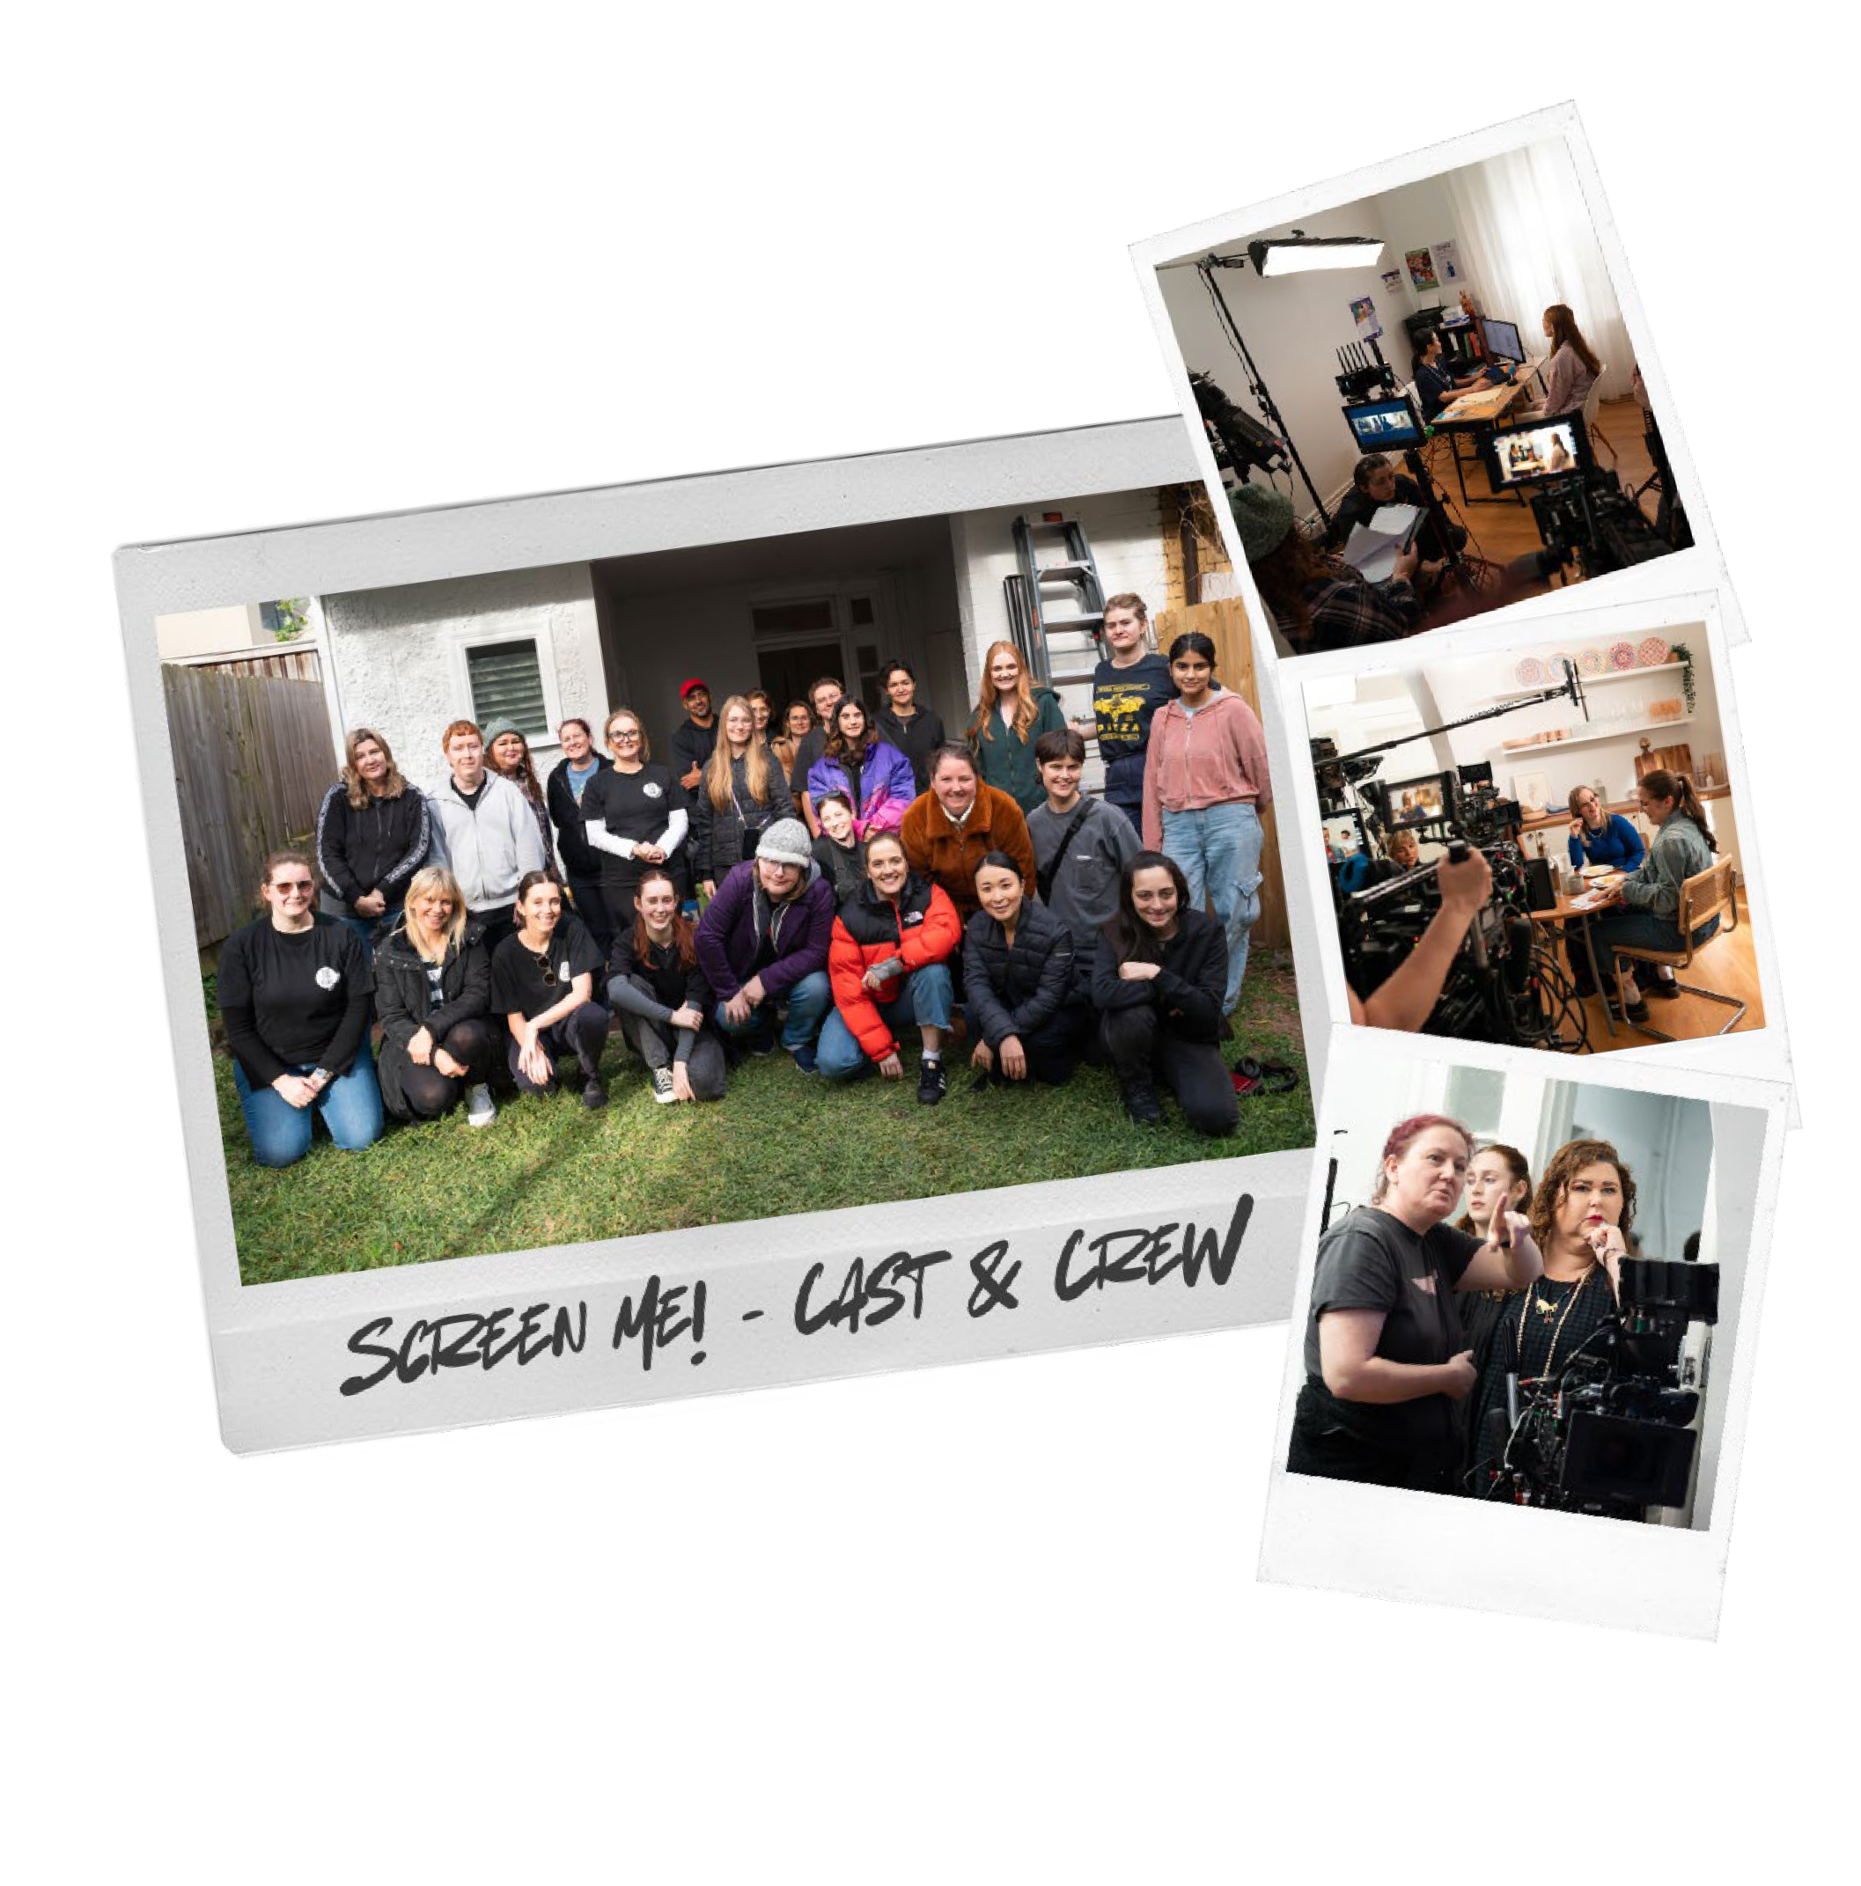Funded by the Department of Health and Aged Care, the Screen Me! film and other content for this campaign was developed by:

* [The Daffodil Centre](https://daffodilcentre.org/), a joint venture between Cancer Council NSW and the University of Sydney
* [The Centre for Disability Studies](https://cds.org.au/), a research affiliate of the University of Sydney

The Screen Me! short film was developed by [Bus Stop](https://busstopfilms.com.au/) [Films](https://busstopfilms.com.au/), an Australian disability led not for profit social enterprise.

Directed by Kate Vinen and written by Stephanie Dower and Nicolette Minster, production of the Screen Me! film had a cast and crew of majority women, many of them women with disability.

# Screen Me! films

All videos are available on the [Screen Me! website](http://www.health.gov.au/screen-me) and on YouTube.

## Short Film

[www.health.gov.au/screen-me/resources/videos/screen-me-a-short-](http://www.health.gov.au/screen-me/resources/videos/screen-me-a-short-film-about-cervical-screening-with-disability) [film-about-cervical-screening-with-disability](http://www.health.gov.au/screen-me/resources/videos/screen-me-a-short-film-about-cervical-screening-with-disability)

<https://youtu.be/QHXuhqrwwlQ>

## Short Film [with audio description]

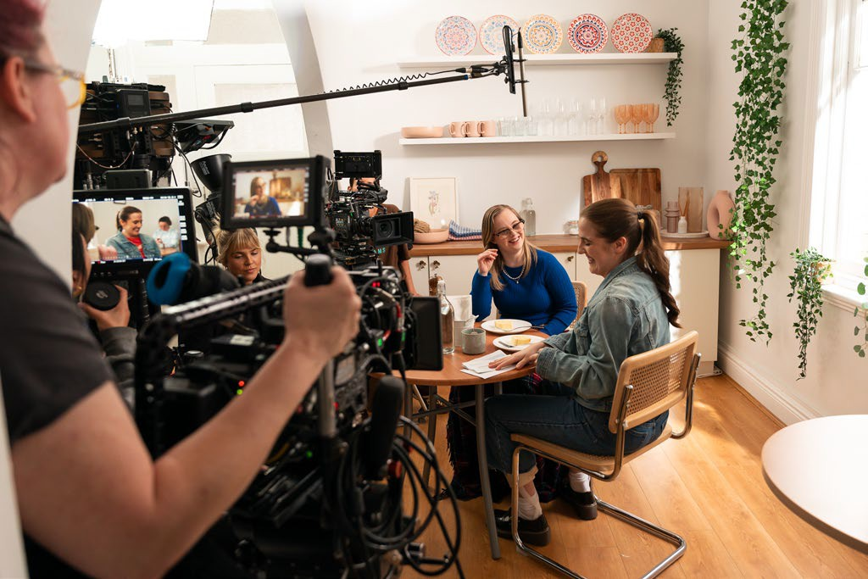[www.health.gov.au/screen-me/resources/videos/screen-me-short-film-](http://www.health.gov.au/screen-me/resources/videos/screen-me-short-film-on-cervical-screening-for-people-with-disability-with-audio-description) [on-cervical-screening-for-people-with-disability-with-audio-description](http://www.health.gov.au/screen-me/resources/videos/screen-me-short-film-on-cervical-screening-for-people-with-disability-with-audio-description)

<https://youtu.be/zkfHukG8ExM>

## Behind the scenes video

[www.health.gov.au/screen-me/resources/videos/behind-the-scenes-](http://www.health.gov.au/screen-me/resources/videos/behind-the-scenes-of-screen-me) [of-screen-me](http://www.health.gov.au/screen-me/resources/videos/behind-the-scenes-of-screen-me)

<https://youtu.be/E-BXidjlJyM>

# Screen Me! – host a screening

We encourage you to show the short, 7-minute film and, if appropriate to also show the Behind-The-Scenes film, to your clients, colleagues and staff.

We’ve created this short guide to help.

## Preparing to show the film

* Make a time and find a place to show the [Screen Me! short film](https://www.health.gov.au/screen-me/resources/videos/screen-me-a-short-film-about-cervical-screening-with-disability?language=en). It could be during a regular staff meeting, or regular gathering of the people you and your organisation work with, or you could make a specific time to show the film.
* Ask people to come. Tell them there’s a new film to watch with an important, but fun, health message about cervical screening for people with disability.
* Make sure you have everything set up to show the film. You can easily watch it on a computer or handheld device if it’s a small group, or you can connect your computer to a television or big screen to show it to a bigger gathering of people. Check the audio levels to make sure everyone can hear it. There are subtitles for those hard of hearing and there is an [audio-description version](https://www.health.gov.au/screen-me/resources/videos/screen-me-short-film-on-cervical-screening-for-people-with-disability-with-audio-description) of the film too.
* If you can, make it a fun event! If appropriate, serve popcorn or other traditional movie treats.
* Make sure you have the links to the [Screen Me! website](http://www.health.gov.au/screen-me) so you can help people find more information at the end. This is also where you’ll find helpful answers to frequently asked questions.

# Screen Me! – host a screening

## Showing the film

Welcome everyone to the film screening and explain that the film is part of a new campaign to encourage people with disability to do their routine cervical screening.

|  |  |
| --- | --- |
| Hi everyone. Thank you so much for coming to see this new short film today.  This is a film about cervical screening. Cervical screening is a test to check that your cervix is healthy and helps to prevent cervical cancer. The test changed in 2017 from a Pap smear to a more accurate test for the human papillomavirus (HPV).  Australia is on track to be one of the first countries in the world to eliminate cervical cancer, but there are some groups of women and people with a cervix who could be left behind. That includes people with disability.  Cervical screening is for everyone with a cervix aged 25 to 74 every five years. It’s a short, easy test that can be done by your doctor or your nurse, or you have the option to do the test yourself through self- collection. Whatever is most comfortable for you – it’s your choice.  The film is part of a new campaign to encourage people with a disability to get their regular screenings. | Suggested words |

# Screen Me! – host a screening

## After the film

Ask if anyone has any questions (don’t forget to check out the [Screen Me! website](https://www.health.gov.au/screen-me) for more information and help for answering questions) and prompt discussion.

|  |
| --- |
| What did you think of the film? Did anyone know that self-collection is an option for cervical screening?  **Suggested words**  What would you need to be comfortable getting a cervical screen?  Do you think you would talk about cervical screening with someone you know or love?  Does anyone have any questions? |

Once discussion has finished give people details about where to get more information and find out how to make an appointment for a Cervical Screening Test: [www.health.gov.au/screen-me](http://www.health.gov.au/screen-me)

## After the event

If appropriate, you might like to email the people who came to see the film to share a link to the film so they can watch it again or send it to friends and family.

You can also send the link to the Screen Me! Website – [www.health.gov.au/screen-me](http://www.health.gov.au/screen-me) – where people can take the time to find out more information for themselves.

# Social media content

Below are some sample social media posts. You can copy and paste these posts or write your own using the same messaging and links.

|  |  |
| --- | --- |
| Social media tile: A person smiling at a table with the text 'Cervical screening is for all women and people with a cervix' | Do you get your regular cervical screening?  It’s easy, it’s quick and it could help save your life.  Cervical screening is a test to check that your cervix is healthy. Screening helps identify the virus that causes almost all cervical cancers before it has a chance to develop.  If you are aged 25-74, and you have ever had any sexual contact (with anyone), ask your doctor or nurse if you’re due for a screen.  Watch the film and find out more at www.health.gov.au/screen-me. |

|  |  |
| --- | --- |
| If you’re a woman or person with a cervix, aged 25-74, cervical screening is for you. It’s a test to make sure your cervix is healthy. Screening every five years can help prevent cervical cancer.  The way we do cervical screening has changed. It’s a more accurate test and you now have the option to collect the sample yourself. You can ask your doctor or nurse to help you with this if you prefer. The choice is yours.  Watch the film and find out more at [www.health.gov.au/screen-me](http://www.health.gov.au/screen-me) | A woman holding the self-swab - long and thin, similar to a COVID-19 swab. Text on the image reads: Self-collection is an option for your next Cervical Screening Test. |

# Social media content

Below are some sample social media posts. You can copy and paste these posts or write your own using the same messaging and links.

|  |  |
| --- | --- |
| Two women sitting at a table, one is reading a letter. Text on the image reads: Talking about cervical screening can help save a life. | Cervical screening is for everyone with a cervix aged 25 to 74, including people with disability.  Cervical screening helps identify the virus that causes almost all cervical cancers before it has a chance to develop.  Start the conversation. Ask your friends, have they been screened recently? Watch the film and find out more at www.health.gov.au/screen-me |

|  |  |
| --- | --- |
| Cervical screening is for all women and people with a cervix with disability.  It’s a test to check that your cervix is healthy and helps identify the virus that causes almost all cervical cancers before it has a chance to develop. It can help save your life.  The first step is to get the information you need. Find that and more at www.health.gov.au/screen-me | A person in a bed using their laptop. Text on screen reads: Cervical screening is for all women and people with a cervix with disability. |

# Suggested eDM or newsletter content

This template text is intended to be an email to be sent to any of your regular networks, be they people with disability, staff, stakeholders or family and friends. It’s suggested copy and can be easily edited to suit your organisation and the folks on your regular email list. If appropriate, you can use any of the graphics or videos supplied with this pack to make it more interesting.

|  |
| --- |
| **There’s a new movie that we would love you to see.**  It’s a 7-minute short film that shares the journey of four people with disability as they find out more about cervical screening, make an appointment to be screened and support each other through the process.  We want you to see it because it’s important that everyone knows that cervical screening is for all, including people with disability.  Cervical screening is a test to make sure your cervix is healthy and that can help prevent cervical cancer.  It is for everyone with a cervix aged 25 to 74 every five years.  It’s a short, easy test that can be done by your doctor or your nurse, or you have the option to do the test yourself through self-collection. Whatever is most comfortable for you – it’s your choice.  You can watch the film here <[www.health.gov.au/screen-me OR embed video into email](http://www.health.gov.au/screen-meORembedvideointoemail)> The film is part of a new campaign called Screen Me!  The campaign is aiming to raise awareness about the importance of cervical screening and to encourage women and people with a cervix with disability to make an appointment and get their regular cervical screen.  We know it can be an awkward topic to discuss, but talking about cervical screening is often the first step to getting the healthcare everyone needs. We encourage you to talk to your friends and family and your healthcare workers about cervical screening.  Find out more about Screen Me! and how to make an appointment for cervical screening at [www.health.gov.au/screen-me](http://www.health.gov.au/screen-me). |

# Suggested newsletter content

This template text is intended for any newsletters or bulletins you may regularly publish. It’s suggested copy and can be easily edited to suit your organisation and the folks in your networks.

|  |
| --- |
| **Headline: New campaign highlights importance of cervical screening for people with disability**  A new campaign, Screen Me! is encouraging women and people with a cervix with disability to make an appointment to get their regular cervical screen.  Cervical screening is a test to check that your cervix is healthy and helps identify the virus that causes almost all cervical cancers before it has a chance to develop.  and to help identify the risk of cervical cancer early. It’s a test that helps save lives.  Cervical screening is for everyone with a cervix aged 25 to 74 every five years. It’s a short, easy test that can be done by your doctor or your nurse, or you have the option to do the test yourself through self-collection. Whatever is most comfortable.  Screen Me! is a new short film that follows four people with disability as they discuss the importance of cervical screening. They each make an appointment and support each other to get screened.  You can watch the 7-minute film and learn more about cervical screening at [www.health.gov.au/screen-me](http://www.health.gov.au/screen-me).  Sometimes these can be awkward conversations, but talking about cervical screening is often the first step to getting the healthcare everyone needs. We encourage you to talk to your friends and family and your healthcare workers about cervical screening. |

# Website

On the website you can find:

* The Screen Me! short film
* The Screen Me! behind-the-scenes short film
* Information on cervical screening with disability for patients, support people, and healthcare providers
* Resources

Visit the Screen Me! website: <http://www.health.gov.au/screen-me>

# Resources

## Easy-read

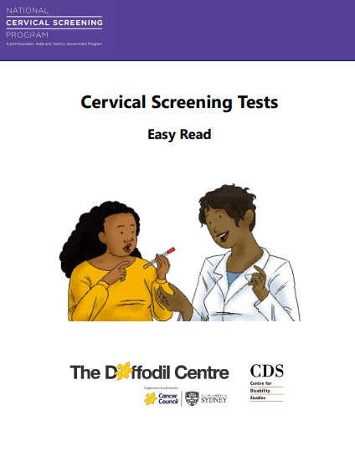

[Easy-read guide to Cervical Screening Tests](https://www.health.gov.au/screen-me/resources/publications/national-cervical-screening-program-the-cervical-screening-test-easy-read?language=en)

## Instruction guides

**Available in 20+ languages**

[Self-collected](https://www.health.gov.au/resources/publications/national-cervical-screening-program-how-to-collect-your-own-sample?language=en) [Doctor collected](https://www.health.gov.au/resources/publications/national-cervical-screening-program-what-happens-when-my-healthcare-provider-collects-my-sample?language=en)

**[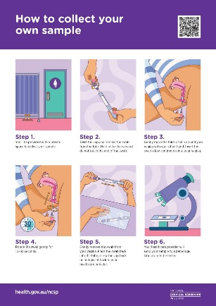](https://www.health.gov.au/resources/publications/national-cervical-screening-program-how-to-collect-your-own-sample?language=en)** [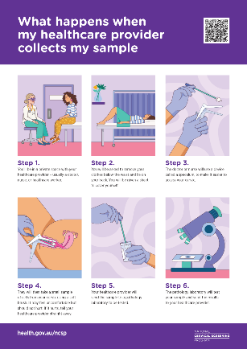](https://www.health.gov.au/resources/publications/national-cervical-screening-program-what-happens-when-my-healthcare-provider-collects-my-sample?language=en)

## Videos

[Cervical screening explained](https://www.health.gov.au/resources/videos/national-cervical-screening-program-cervical-screening-explained?language=en) [How to do your own test](https://www.health.gov.au/resources/videos/national-cervical-screening-program-video-how-to-take-your-own-cervical-screening-test-sample-easy-read-0?language=en)

[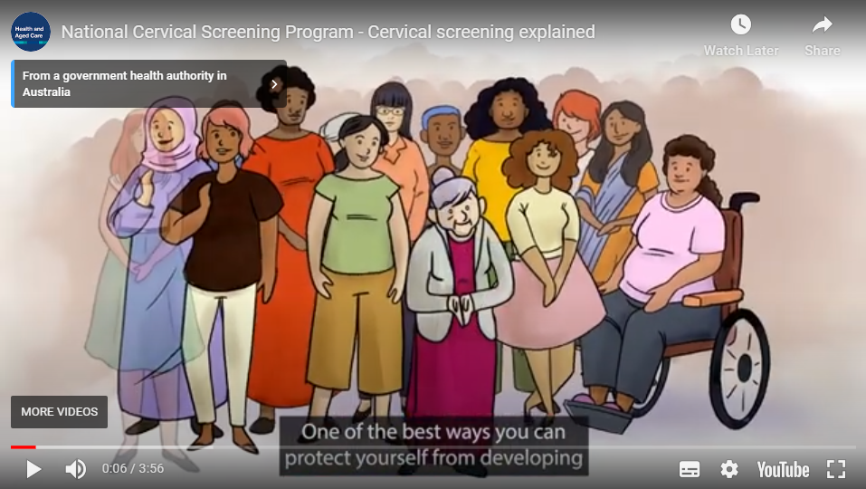](https://www.health.gov.au/resources/videos/national-cervical-screening-program-cervical-screening-explained?language=en) 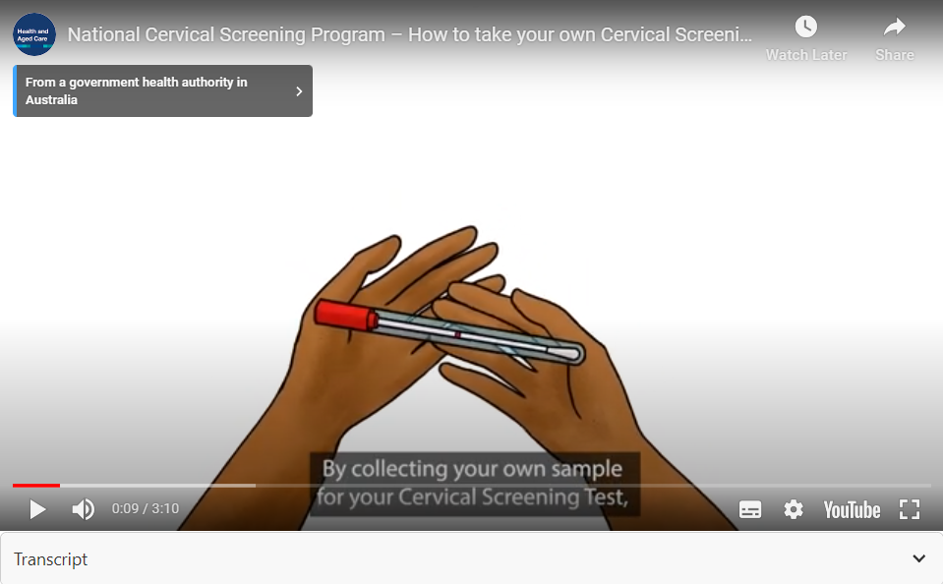

Video – 03:55 Video – 03:55

Available in 10+ languages (incl AusLan)

# Links

Campaign website: [www.health.gov.au/screen-me](http://www.health.gov.au/screen-me)

## Partner websites:

National Cervical Screening Program: [www.health.gov.au/ncsp](http://www.health.gov.au/ncsp)

Daffodil Centre: [www.daffodilcentre.org](http://www.daffodilcentre.org)

Centre for Disability Studies: [www.cds.org.au](http://www.cds.org.au)

## Other useful websites:

[Optimising cervical screening for people with disability](https://www.health.gov.au/resources/videos/optimising-cervical-screening-for-people-with-disability?language=en) – webinar hosted by RACGP and presented in partnership with the Daffodil Centre and the Centre for Disability Studies

Australian Centre for the Prevention of Cervical Cancer: [www.acpcc.org.au](http://www.acpcc.org.au)

Blue Knot Foundation: [www.blueknot.org.au](http://www.blueknot.org.au)

# Other stuff

|  |  |  |  |  |  |  |
| --- | --- | --- | --- | --- | --- | --- |
| The campaign colours feature a selection of pastel shades and one darker shade.  Text should be black except when the background is too dark.  Find out more about colour contrasting and accessibility.   |  |  | | --- | --- | | **#de8aa1** | **#8ccbc4** | | **#b44b77** | | | The main font used for headings is **Alwyn New Rounded**  Aa Bb Cc Dd Ee Ff Gg Hh Ii Jj Kk Ll Mm Nn Oo Pp Qq Rr Ss Tt Uu Vv Ww Xx Yy Zz | QR Codes are included in the images pack on [the Screen Me resources page](https://www.health.gov.au/screen-me/resources)  A qr code |



