REVIEW OF THE WATER AND SNOW SAFETY PROGRAM AND THE SURF LIFE SAVING AUSTRALIA TRAINING MEASURE

DEPARTMENT OF HEALTH AND AGED CARE – FINAL REPORT

REPORT PERIOD: 19 FEBRUARY 2024

Acknowledgments

This work was completed with the assistance of Charles Edlington, Vicki Sweeney, Megan Nihill and Truc Vo from the Office of Sport at the Australian Government Department of Health and Aged Care.

We would also like to thank the key stakeholders who participated in the review. We thank them for their time and insights, and trust that their views are adequately represented in this report.

**ARTD consultancy team**

Andrew Hawkins

Lia Oliver

Simon Alaba

Keely Mitchell

**Acknowledgement of Country: We recognise the diversity of Aboriginal and Torres Strait Islander peoples across this country and acknowledge their sovereignty was never ceded.

We pay our respects to Elders past and present, and acknowledge their continued custodianship and care for the many lands and waterways that support life.

We acknowledge the untold histories and injustices of the past and present. We respect the value and ongoing contribution that Aboriginal and Torres Strait Islander people make to our communities and to wider Australia.**

CONTENTS

Executive summary i

Policy context i

The Water and Snow Safety Program and the Surf Life Saving Australia Training Measure i

The project ii

Key findings ii

Findings per key review question iv

Conclusions viii

Implications ix

1. Background 1

1.1 Policy context 1

1.2 The Water and Snow Safety Program and the Surf Life Saving Australia Training Measure 1

2. The Review 5

2.1 Purpose and scope 5

2.2 Key review questions 5

2.3 Methods 6

3. Appropriateness 7

3.1 Are activities delivered remaining relevant to address safety issues and areas of concern? 7

3.2 Are opportunities to advance water and snow safety being identified, developed and implemented? 10

3.3 What are the enablers and barriers to program delivery? 12

4. Effectiveness 14

4.1 How do we know? To what extent are water and snow safety outcomes attributable to the funded programs and activities? 14

4.2 To what extent are the programs meeting the Australian Government’s Close the Gap and gender equality targets? 34

5. Efficiency 36

5.1 Would greater contestability support value for money? 36

5.2 To what extent is there cross-over between the funded activities/ functions and other programs delivered by Australian Government departments and state and territory governments? 38

Tables and figures

Tables

Table 1. RLSA Performance Indicators in FY 2021–22 and FY 2022–23 15

Table 2. SLSA WSSP Performance Indicators in FY 2021–22 and FY 2022–23 18

Table 3. SLSA Training Measure Performance Indicators in FY 2021–22 and FY 2022–23 20

Table 4. AUSTSWIM Performance Indicators in FY 2021–22 and FY 2022–23 22

Table 5. Laurie Lawrence Performance Indicators in FY 2021–22 and FY 2022–23 24

Table 6. ASPA Performance Indicators in FY 2021–22 and FY 2022–23 25

Table 7. Water safety impacts by sector 39

Table 8. Pros and cons of funding the SLSA Training Measure 42

Figures

Figure 1. WSSP Performance Indicators for grantees in FY 2021–22 and FY 2022–23 vi

Figure 2. WSSP Program Logic outputs and short-term outcomes vii

Figure 3. Funding under the WSSP and the SLSA Training Measure 2

Figure 4. Timeline of actions relating to inland waterways 11

Figure 5. RLSA Performance Indicators in FY 2021–22 and FY 2022–23 15

Figure 6. SLSA WSSP Performance Indicators in FY 2021–22 and FY 2022–23 18

Figure 7. SLSA Training Measure Performance Indicators in FY 2021–22 and FY 2022–23………… 19

Figure 8. AUSTSWIM Performance Indicators in FY 2021–22 and FY 2022–23 22

Figure 9. Laurie Lawrence Performance Indicators in FY 2021–22 and FY 2022–23 23

Figure 10. ASPA Performance Indicators in FY 2021–22 and FY 2022–23 25

Figure 11 . Jurisdictional water safety funding landscape 40

# Executive summary

## Policy context

Water-based and snow-based sports and physical activity are widely enjoyed recreationally in Australia. However, these environments can carry significant risk of injury and death. In Australia, approximately 280 people die from drowning every year,[1] and as many as 3 times more are hospitalised from non-fatal drownings.[2] Approximately 300 severe injuries occur each year from snow-related activities.

Water safety activities in Australia are guided by the *Australian Water Safety Strategy 2030* (AWSS 2030).[3] This strategy, developed by the Australian Water Safety Council (AWS Council), sets out a drowning prevention framework to inform the priorities and actions of governments and organisations involved in water safety. There is no equivalent strategy or council for snow-related safety.

## The Water and Snow Safety Program and the Surf Life Saving Australia Training Measure

The Water and Snow Safety Program (WSSP) is a Commonwealth-funded program that aims to reduce the incidence of water-related and snow-related injury and death. It aims to enhance the safety of water and snow environments and improve people’s behaviour in and around water and snow in Australia. The program is intended to align with the priority areas, guiding principles and goals outlined in the AWSS 2030; however, the funding is not intended to be sufficient to achieve the strategy in full.

The WSSP provides $39.1 million over 3 years (FY 2021–22 to FY 2023–24) in non-contestable or closed non-competitive processes grants to 5 organisations: Surf Life Saving Australia (SLSA) ($22.8m), Royal Life Saving Australia (RLSA) ($10.5m), Laurie Lawrence Swimming Enterprises (Laurie Lawrence) ($3.2m), the Australasian Council for the Teaching of Swimming and Water Safety (AWSTSWIM) ($2.0m) and the Australian Ski Patrol Association (ASPA) ($0.8m). These organisations were selected based on their existing infrastructure, relationships, experience and capability to deliver the program objectives.

The SLSA Training Measure, which is also Commonwealth-funded, aims to provide vocational education and training opportunities to surf lifesaving volunteers; expand recruitment and recognition of supervisors, trainers and assessors at clubs across the country; and enable IT upgrades. The SLSA Training Measure provides $3.3 million to SLSA for the 2023–24 financial year.

## The project

The Australian Government Department of Health and Aged Care engaged ARTD Consultants to conduct a review of the WSSP and the SLSA Training Measure. The purpose of the review was to assess the extent to which the program and training measure were achieving intended outcomes, and to provide information and recommendations to the Department regarding future funding arrangements. The review was conducted between October 2023 and January 2024, and sought to address 3 key questions.

* Appropriateness – How well are the programs being delivered?
* Effectiveness – To what extent are the programs meeting their outcomes?
* Efficiency – Do the programs provide value for money?

These questions were answered through a document review and interviews with key stakeholders (n=22), including grantee and non-grantee AWS Council members and ministerial advisors (n=3).

## Key findings

There is an ongoing role for Commonwealth funding of key organisations responsible for national water safety strategy, national research, and national campaigns for consistency, equity and economies of scale in water safety. The water safety strategy and grants programs are a practical arrangement to address an issue of national significance. Water safety is associated with recreation, primary prevention, education and emergency management. The overlapping and complex nature of the issue means it is not possible to neatly delineate funding responsibilities across departments or jurisdictions. It is a public safety issue that concerns all levels of government.

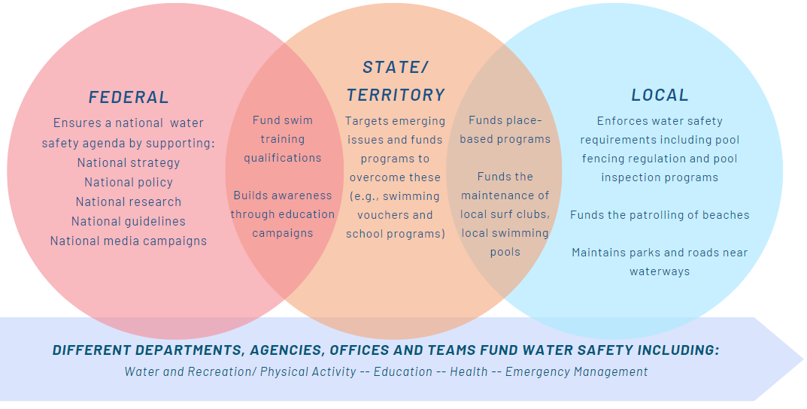

The quantum of Australian Government funds is modest in relation to other major causes of preventable death in Australia, such as road traffic accidents. The Australian Government budget allocates about $13 million per annum to the WSSP and the SLSA Training Measure, and around $1 billion per annum to road safety.[4] Each year, there are around 280 deaths by drowning[5] compared to around 1200 deaths on the road.[6]

The program of grants is working largely as intended. The WSSP is meeting or partially meeting the outputs and outcomes set out in the WSSP Program Logic, and grantees are meeting the Performance Indicators set out in the WSSP Grant Opportunity Guidelines. AWS Council members who did not receive grants had no significant issues with the lack of contestability given their acknowledgment of the value generated by the grantees.

There could be greater accountability for grantees to demonstrate how they are evaluating and generating evidence about the activities they are delivering, and how they are using that evidence to make decisions about the need for these activities moving forward. This would support program funders, AWS Council members and all key stakeholders with their decisions about scaling out (reaching more people with existing initiatives), scaling up (impacting law and regulation as a result of key findings), scaling deep (changing hearts and minds, or finding new ways to address deeper root causes of problem behaviours) or scaling back (reallocating resources to other initiatives) to align activity and areas for collaboration with emerging priorities for water and snow safety.

Through the SLSA Training Measure and the WSSP, funding is provided to address skills shortages. For SLSA, the funding provides volunteers with the skills to be training and assessing each state. We heard that this training is required to ensure SLSA volunteers are compliant, and that it allows SLSA to provide nationally accredited qualifications to members on a cost-recovery basis (i.e., at no cost to the members). Enabled by WSSP funding, ASPA is a registered training organisation that provides training to ski patrollers. We heard that ongoing training is needed in order to continue to maintain the skill levels of ski patrollers, who addressed 8,000 ski incidents across Australia in 2023, equating to 26 injuries per 1,000 skiers. The funding also allows for the training to be updated so as to remain current and to meet regulatory requirements set out by the Australian Skills Quality Association.

## Findings per key review question

### KRQ 1: Appropriateness: How well are the programs being delivered?

**The programs are being delivered largely as intended.** The funding enables grantees to address safety issues and areas of concern identified in the AWSS 2030. The funding is mostly used to produce and disseminate research and educational resources, and to provide accredited training to swimming instructors.

**Activities delivered through the programs remain appropriate for addressing water safety issues because they are selected based on needs identified through routinely collected data.** The AWS Council uses RLSA’s annual *National Drowning Reports* to identify the most significant water safety issues that need to be addressed. This informs the council’s activities – such as delivering targeted programs, conducting research on specific water safety issues, developing educational resources, and running public awareness campaigns.

**For the most part, opportunities to advance water safety are being appropriately identified, developed and implemented. However, there is room for improvement regarding the breadth and specificity of data collection, and the evaluation of prevention efforts.** There are gaps in the data collected on non-fatal drownings and rescues. These data are needed to develop and implement more specific and targeted interventions. There is also a greater need to evaluate the effectiveness of prevention campaigns, particularly for issues that have not seen a significant reduction over a substantial period of time (e.g., drowning deaths in inland waterways).

**Having an industry-led strategy supported by consistent national funding program has helped to progress water safety in Australia. However, a lack of awareness about the grants among AWS Council members was identified as an issue.** Most non-grantee council members were unaware of the WSSP. While this was not an issue, it would be beneficial if all council members were aware of the grants (e.g., who receives funding, how much they receive and how they were selected), given their involvement in developing the AWSS 2030.

### KRQ 2: Effectiveness: To what extent are the programs meeting their outcomes?

**There is extensive work being done by all levels of government in water and snow safety, and therefore it is difficult to pinpoint improvements in water and snow safety outcomes that are specific to the work of the WSSP or the SLSA Training Measure.** While the WSSP aligns to the AWSS 2030, the funding is not intended to be sufficient to achieve the strategy in full.

**The review used a program logic-driven approach to measure effectiveness. This included agreed Performance Indicators (set out in the WSSP Grant Opportunity Guidelines and aligned to the WSSP Program Logic), and outputs and short-term outcomes described in the WSSP Program Logic.** This approach allowed us to evaluate outcomes in relation to agreed funding targets, as well as the overarching purpose of the programs.

**From the perspective of the Department of Social Services’ Community Grants Hub, all Performance Indicators were met, so the funding for the WSSP and the SLSA Training Measure was administered.** Any issues raised by the Community Grants Hub around funding administration were common issues affecting all grants, such as the need for further clarification around reporting or COVID-19 implications.

Available data and documentation were reviewed to provide further analysis about the Performance Indicators, which is provided in detail per grantee in Figure 1. **Across the financial years, all grantees increased the number of Performance Indicators that were met.** In all instances where a Performance Indicator was not met, there was evidence of the grantee progressing work that had yet to be completed; or evidence of work having been completed, but the measure attached to the Performance Indicator not being met.

Figure 1. WSSP Performance Indicators for grantees in FY 2021–22 and FY 2022–23[7]

Pie charts showing WSSP grantees performance indicators and the percentage of which were complete and almost complete in the 2021-22 Financial Year and 2022-23 Financial Year.

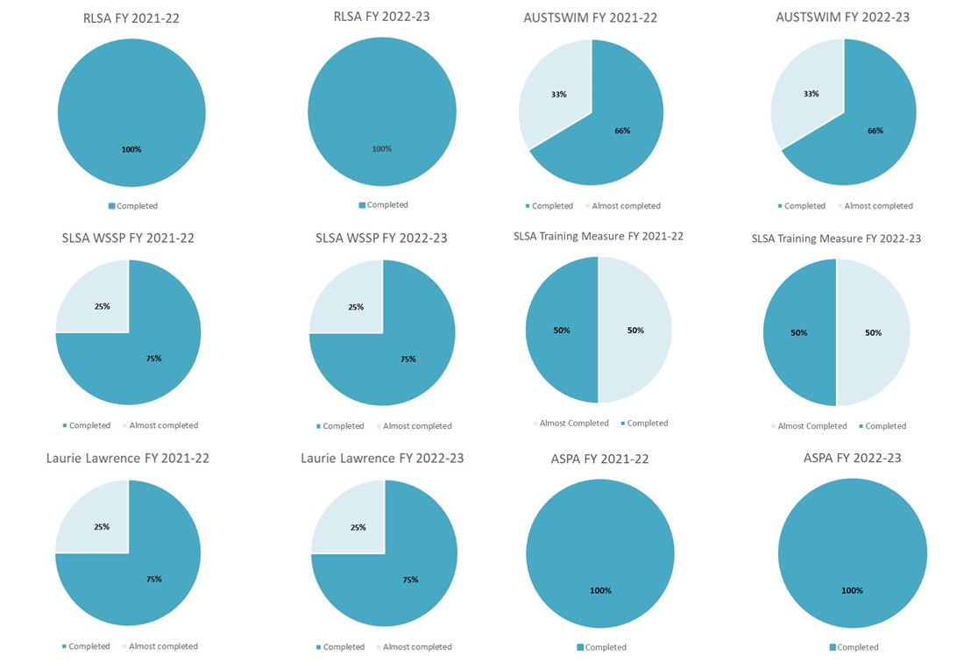

**As shown in Figure 2, the WSSP is meeting (as indicated by green shading and bold text) or partially meeting (as indicated by yellow shading) the outputs and short-term outcomes set out in its Program Logic**. There were no instances where the WSSP had not been working on, and therefore had not met, the outputs and short-term outcomes at all. In instances where the program was partially meeting an output or short-term outcome, additional information was requested from grantees, or this output or short-term outcome was identified as having implications for the review (see ‘Implications’, below).

Figure 2. WSSP Program Logic outputs and short-term outcomes

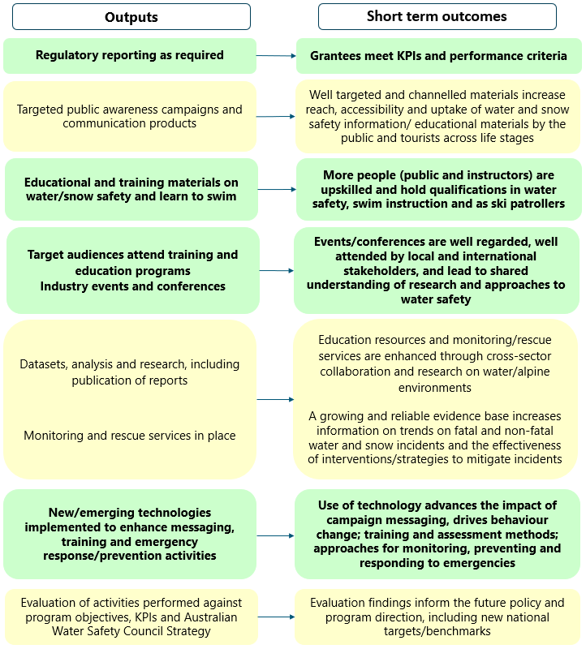

### KRQ 3: Efficiency: Do the programs provide value for money?

**The funding delivered through WSSP has provided value for money as it has ensured that the national issue of water safety can be addressed somewhat consistently across Australia**. Interviewees who were aware of the grants considered that the grants were valuable in driving a national strategy, ensuring that water safety priorities were aligned across states and territories, and providing clear roles and responsibilities across the nation. A small proportion of interviewees mentioned that consistency was increasingly important, and noted the differing capacities to deliver water safety programs at state, territory and local government levels.

**The Commonwealth’s role in funding water safety is an important role, but not a stand-alone one. All levels of government need to work together to deliver water safety initiatives, messaging and strategies.** Water is a cross-sectoral issue that falls into sports and recreation, health and physical activity, education, and emergency management. This makes it difficult to delineate funding responsibilities. The WSSP creates efficiencies that allow organisations to operate nationally by supporting a national strategy, and national policy, research, guidelines and media campaigns, and by funding swim training qualifications; while state, territory and local governments work to target emerging issues, drive place-based approaches and enforce water safety measures.

**The lack of contestability ensured clear leadership of the AWSS 2030.** The non-contestable nature of the grants allowed the Commonwealth to ensure there was clear leadership of the industry-led AWSS 2030. Most non-grantees did not appear to have any issues with those that had received the non-contestable grants, although they would have liked to have received funding themselves to better deliver water safety programs nationwide. We note that previously, in NSW, a Water Safety Council was set up that had control of the funding provided; this later failed, as the focus for members was on winning contestable grants instead of cooperating on policy and research.

## Conclusions

Water safety is a complex multi-sectoral and multi-jurisdictional issue with significant contributions made by industry and not-for-profit organisations. It includes elements of sport and physical activity, education and preventive health, as well as emergency management. The issues are not clearly identifiable with a federal, state/territory or local responsibility, or to a sport, physical activity, health, vocational education or emergency management portfolio. While a case may be made that aspects of funding may sit in different policy portfolios, we believe the current arrangement provides a pragmatic, stable and holistic approach that minimises inefficiency, and avoids a regulatory burden that might be associated with a more fragmented approach to funding across different agencies that have different priorities and reporting requirements.

The WSSP and the SLSA Training Measure enable the water safety system (i.e., the work of the AWS Council and its members) to operate with a consistent national focus on research, policy development and equity, in terms of the skills, information and training required across Australia.

It is not possible to draw direct causal links between the WSSP and the SLSA Training Measure, in part due to the magnitude and complexity of the issue and in part because the Commonwealth funding provides core support to enable a broader system. The program and training measure are meeting their funded objectives. Effectiveness may be gained by more formal interrogation of the grounds for continuation, or the scale of funded activities, especially in cases where there appears to be little change in behaviour. Efficiencies may be gained by introducing a degree of contestability into grants associated with behaviour change campaigns.

## Implications

**The review has drawn 2 main implications.**

**Contestability of grants.** Non-contestable grants to RLSA appear to be necessary to support national research and systems coordination. They appear to be appropriate for SLSA, as it is the only AWS Council member that can provide emergency or preventative actions as required in areas and at times patrolled by surf clubs. The use of non-contestable or closed non-competitive processes for grants allows for a balance to be made ‘between the desire to maximise the access to a grant and the need for a timely and cost-effective decision making process’.[8] As outlined in the *Commonwealth Grants Rules and Guidelines*, there are circumstances where a non-contestable or closed non-competitive process may be appropriate for the allocation of grants.[9] These include instances when the number of service providers is very limited and providers have a well-established record of delivering grant activities.[10] In these situations, it is always advisable to set out the logic for a non-contestable grant as it should be clearly understood and documented why this approach has been undertaken.[11] This might start with setting out clear objectives of a grant in terms of the WSSP Program Logic and emerging findings from RLSA’s annual *National Drowning Reports*. Each objective may be operationalised into a set of criteria by which a grant will be awarded. In cases where it is clear that only one AWS Council member can meet all criteria, then a direct grant would be appropriate. In cases where no AWS Council member can meet all criteria, it may be appropriate to invite collaborative partnerships between council members. In cases where it is likely that several organisations may meet or exceed the criteria for example provision of education materials), then it would be appropriate to open grants to a more competitive process. This may occur, for example, when the grant is focused on education, training or behaviour change.

**Evaluation of grantee activities.** Measuring the impact of individual initiatives on improving water safety is not a straightforward task. Requiring grantees to measure their impact using sophisticated program evaluation techniques – or, conversely, with less-rigorous methods promoted as ‘impact measurement’ – may generate relatively little value at substantial cost. Instead, we recommend that grantees be encouraged to develop a culture of questioning, reflection and reporting on the value of initiatives. This may be achieved by requiring grantees to provide evidence that they will track the progress of their funded activity, and that they can identify risks and set out mitigation plans (the domain of monitoring). It may also include requiring grantees to demonstrate how they used data for continuous improvement, and to question the ongoing value of a particular initiative (the domain of evaluation). For example, it may be that a certain public education campaign is not associated with substantial behaviour change for the intended cohort. This may relate to a lack of reach, or it may be that the countermeasure is not effective, and some other countermeasure should be evaluated as an alternative approach. Grantees should be expected to provide not only a clear rationale for the ongoing need for a grant in terms of the AWSS 2030 and the *National Drowning Reports*, but also an explanation as to why a particular approach remains the most appropriate in terms of feasibility, cost and likely impact – or how it may be modified or re-targeted to provide enhanced value for money.

# Background

## Policy context

Water-based and snow-based sports and physical activity are widely enjoyed recreationally in Australia. However, these environments can carry significant risk of injury and death.

In Australia, approximately 280 people die from drowning every year,[12] and as many as 3 times more are hospitalised from non-fatal drownings.[13] The incidence of drowning is considerably higher for males and outside of major cities. In the 2020–21 financial year, there was a 20% increase in drowning deaths (294 total), which was an 8% increase on the 10-year average. (Royal Life Saving Australia, 2021; Surf Life Saving Australia, 2021).

Snow safety – related to avalanches, hypothermia, frostbite and snow sport-related injuries – remains a key concern in Australia’s alpine environments. Approximately 300 severe injuries occur each year from snow-related activities. Rescue operations have been on the rise due to the increasing popularity of backcountry skiing and snowboarding, with a total of 2.9 million skier visits recorded in 2019, and an estimated 3.2 million in 2021. Trauma is the leading cause of death among skiers and snowboarders, and knee injuries, shoulder injuries and head injuries are the most common types of injuries. (Australian Ski Areas Association, 2021).

Water safety and snow safety are key public health issues in Australia – with a focus on reducing water-related and snow-related injuries and deaths, improving safety conditions, and promoting more responsible behaviour within these environments. (Australian Water Safety Council, 2021). Water safety activities in Australia are guided by the *Australian Water Safety Strategy 2030* (AWSS 2030).[14] This strategy, developed by the Australian Water Safety Council (AWS Council), sets out a drowning prevention framework to inform the priorities and actions of governments and organisations involved in water safety. There is no equivalent strategy or council for snow-related safety.

## The Water and Snow Safety Program and the Surf Life Saving Australia Training Measure

The Water and Snow Safety Program (WSSP) is a Commonwealth-funded program that aims to reduce the incidence of water-related and snow-related injury and death, enhance the safety of water and snow environments, and improve people’s behaviour in and around water and snow in Australia (see section 1.2.1). The program is intended to align with the priority areas, guiding principles and goals outlined in the AWSS 2030; however, the funding is not intended to be sufficient to achieve the strategy in full. The WSSP was established in 2018, consolidating 4 former water safety programs/ measures into one program to reduce administrative burden and streamline program management.

The WSSP provides $39.1 million over a period of 3 years (FY 2021–22 to FY 2023–24) in non-contestable grants or closed non-competitive processes to 5 organisations: Surf Life Saving Australia (SLSA) ($22.8m), Royal Life Saving Australia (RLSA) ($10.5m), Laurie Lawrence Swimming Enterprises (Laurie Lawrence) ($3.2m), the Australasian Council for the Teaching of Swimming and Water Safety (AUSTSWIM) ($2.0m), and the Australian Ski Patrol Association (ASPA) ($0.8m). These organisations were selected based on their existing infrastructure, relationships, experience and capability to deliver the program objectives.

Figure 3. Funding under the WSSP and the SLSA Training Measure

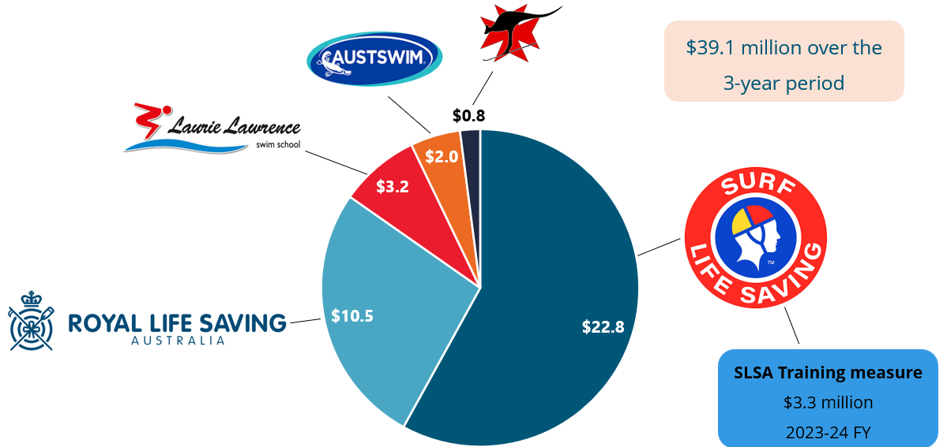

In addition to the WSSP, the Australian Government also provides funding for the SLSA Training Measure. The SLSA Training Measure aims to provide vocational education and training opportunities to surf lifesaving volunteers; expand recruitment and recognition of supervisors, trainers and assessors at clubs across the country; and enable IT upgrades. The SLSA Training Measure provides $3.3 million to SLSA for the 2023–24 financial year.

### Program logic

Provided below is the WSSP Program Logic, which outlines the outputs and short-term outcomes intended to occur. As part of KRQ 2, we have assessed the progress against outputs and short-term outcomes.

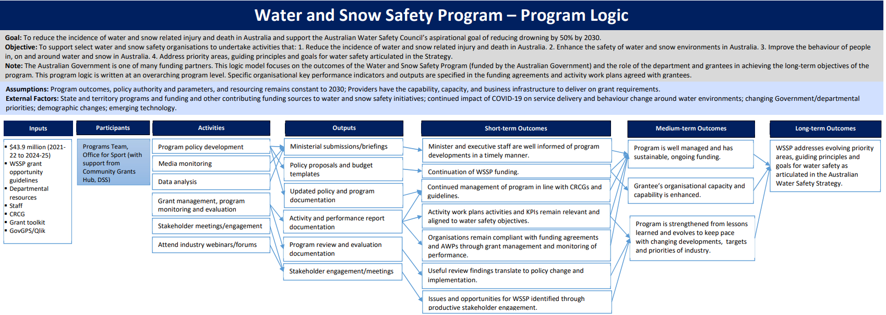

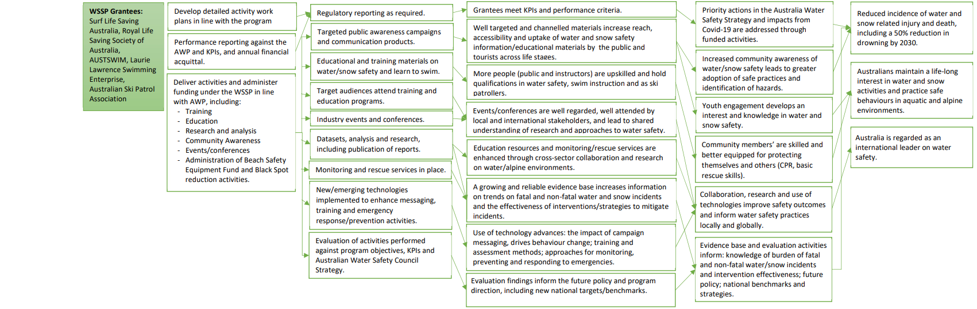

# The Review

## Purpose and scope

The Australian Government Department of Health and Aged Care has engaged ARTD Consultants to conduct a comprehensive review of the WSSP and the SLSA Training Measure.

The last review of the WSSP was conducted in 2017, and there has not been a review of the SLSA Training Measure. With recent program extensions and increases in funding, and the expiration of funding agreements on 30 June 2024, it is timely to undertake this review to inform future program arrangements from 1 July 2024.

The objectives of the review are twofold:

* to assess the extent to which the programs are achieving their intended outcomes, with a specific focus on appropriateness, effectiveness and efficiency
* to provide information and recommendations to the Australian Government regarding future funding and arrangements for the programs.

## Key review questions

The review will answer the following questions and sub-questions relating to appropriateness, effectiveness and efficiency.

| Key review question | Sub-question | Section |
| --- | --- | --- |
| 1. Appropriateness - How well is the program being delivered? | 1.1. What are the enablers and barriers to this? | 3.3 |
| 1.2. Are activities delivered remaining relevant to address safety issues and areas of concern? | 3.1 |
| 1.3. Are opportunities to advance water and snow safety being identified, developed and implemented? | 3.2 |
| 1.4. How could the program be improved? Among other factors, this should consider contemporary issues and the role of the Australian Government. | See Conclusions and implications |
| 2. Effectiveness -  To what extent is the program meeting its outcomes? | 2.1. How do we know? To what extent are water and snow safety outcomes attributable to the funded programs and activities? | 4.1 |
| 2.2. To what extent are the programs meeting the Government's Close the Gap and gender equality targets? | 4.2 |
| 3. Efficiency -  Does the program provide value for money? | 3.1. Would greater contestability support value for money? | 5.1 |
| 3.2. To what extent is there cross-over between the funded activities/functions and other programs delivered by Australian Government departments and state and territory governments? | 5.2 |

## Methods

The table below outlines the methods used to answer the key review questions.

|  |  |  |  |  |
| --- | --- | --- | --- | --- |
| Data source | Description | Sample | Timing | Notes |
| Scoping interviews | Interviews with:   * departmental staff (n=2) * grantees (n=5) | n=7 | October 2023 | These interviews provided key context for the review and helped refine the design of the review. |
| Document review | Documents included: activity work plans, performance reports, annual reports, strategies, the WSSP Grant Opportunity Guidelines, financial declarations, executed agreements and contracts. | n=66 | Oct – Dec 2023 | Most documents were provided by the Office of Sport. Some documents were obtained from publicly available sources (e.g., grantees’ annual reports). |
| Stakeholder interviews | Interviews with:   * grantees (n=5) * non-grantee AWS Council members (n=5) * ministerial staff (n=3) * Department of Social Services’Community Grants Hub staff (n=1) * National Indigenous Australians Agency staff (n=1) | n=15 | 16 Nov – 20 Dec | All AWS Council members were invited to participate in the review. Three members declined to be interviewed. |

### Limitations

The methods were implemented largely as intended, and sufficient data were collected to answer each review question. There are no significant limitations to consider when interpreting the findings presented in the following chapters.

# Appropriateness

This chapter addresses KRQ 1 – How well are the programs being delivered? This is done by answering 3 sub-questions:

* Are activities delivered remaining relevant to address safety issues and areas of concern?
* Are opportunities to advance water and snow safety being identified, developed and implemented?
* What are the enablers and barriers to program delivery?

Key findings in relation to these sub-questions are provided below.

## Are activities delivered remaining relevant to address safety issues and areas of concern?

|  |
| --- |
| Key findings   * Activities delivered through the programs remain appropriate for addressing water safety issues because they are selected based on needs identified through routinely collected data. * The AWS Council uses research generated by RLSA (e.g., the *annual National Drowning Reports*) and SLSA to identify the most significant water safety issues that need to be addressed. * This informs the council’s activities – such as delivering targeted programs, conducting research on specific water safety issues, developing educational resources, and running public awareness campaigns. |

### Funded activities

The WSSP funds baseload capacity of 4 water safety organisations and 1 snow safety organisation: RLSA, SLSA, AUSTSWIM, Laurie Lawrence and ASPA. This funding enables the 4 water safety organisations to address safety issues and areas of concern identified in the AWSS 2030, and enables ASPA to manage snow safety in Australia.

*Federal funding provides a core funding that allows us to be able to service the industry to make sure everyone understand what their roles and responsibilities are.   
– AWS Council member (Non-grantee)*

The WSSP funding is largely used to conduct and disseminate research and educational resources through SLSA and RLSA. Laurie Lawrence provides educational materials about water safety, targeting children from 0 to 5 years of age, and AUSTSWIM provides accredited swimming training to both new and existing swimming instructors. While the work of AUSTSWIM does not constitute research and education, it responds to an ongoing and critical need for accredited swimming instructors. The WSSP funding supports ASPA to train ski patrollers to address ski incidents, and to maintain its status as a registered training organisation.

The SLSA Training Measure provides additional funding to SLSA to maintain trainers and assessors to deliver accredited awards.

### Are activities appropriate to address key safety concerns?

Activities delivered through the WSSP remain appropriate for addressing water safety issues because of the focus on, and use of, routinely collected data. The AWS Council uses RLSA’s annual *National Drowning Reports* to identify the most significant water safety issues that need to be addressed. When an area of concern is identified, the council discusses what can be done about it and which organisations are best placed to develop or tailor an intervention. This then informs the council’s activities – such as delivering targeted programs, conducting research on specific water safety issues, developing educational resources, and running public awareness campaigns.

An example of this is drowning fatalities among young children aged 0 to 4 years in Australia. There has been a consistent reduction over the past decade, with the most recent *National Drowning Report* showing a significant 33% decrease below the 10-year average.[15] This positive trend can be attributed to focused research efforts leading to a multifaceted approach involving state/ territory pool fencing legislation, public awareness campaigns, and targeted water safety education.

|  |
| --- |
| Keep watch to prevent drowning logo  Thumbnail of report 'Review of pool fencing legislation in Australia' by Royal Life Saving Australia  Young children aged 0 to 4 years – case study  Over the past decade, there has been a significant reduction in drowning fatalities among young children aged 0 to 4 years in Australia. The most recent *National Drowning Report* found a 33% decrease below the 10-year average.[16]  This positive trend can be attributed to a multifaceted approach involving state/ territory pool fencing legislation, public awareness campaigns, and targeted water safety education. This approach was informed by research that identified the 2 main risk factors for drowning among young children as lapses in adult supervision and a lack of appropriate barriers around water.[17]  Changes in pool fencing legislation have contributed to the reduction in drowning fatalities among young children. A study conducted in Queensland assessed the impact of revised legislation that introduced a regular inspection program, and strengthened policy regarding non-climbable zones and fencing materials.[18] The study found a substantial decrease in child drownings in private pools, demonstrating the effectiveness of the revised legislation.  Despite the known positive impact, legislation regarding pool fencing requirements differs across Australia. This legislation is governed at a state/ territory level, with each state and territory responsible for its own compliance laws, swimming pool registers and inspection regimes. Other studies have recommended the need for greater enforcement to enhance compliance rates.[19]  Programs such as RLSA’s Keep Watch campaign have also played an important role in providing water safety education to young children and their parents and caregivers. Keep Watch consists of a set of educational resources about the importance of constant adult supervision of children while they are swimming, and of ensuring that children do not have unrestricted access to water. The campaign advocates for 4 essential actions: supervise (actively supervise children around water); restrict (implement measures to restrict children’s access to water); teach (provide children with water safety skills through education); and respond (equip parents and caregivers with emergency response knowledge). The Keep Watch campaign reached over 4.5 million people in the 2022–23 financial year.[20]  RLSA has also used grant funding to undertake research on emerging safety issues.  Furthermore, during the funding period, Laurie Lawrence has delivered several child drowning prevention programs that raise awareness of the importance of pool fencing, such as Kids Alive, Story Time With Famous Friends and Check Your Pool Gate Day.  Given the information available, we are unable to directly attribute the decrease in drowning fatalities among young children to any specific activities. However, it appears likely that these interventions, often supported by WSSP funding, have contributed to this positive trend.  By leveraging public awareness campaigns, educational initiatives and legislation, these interventions serve as an exemplar of taking a multifaceted approach to addressing water safety issues. |

There is little evidence regarding whether activities delivered by ASPA through WSSP funding remain relevant to address snow safety issues. This is partly because there is no strategy or council for snow safety in Australia equivalent to the AWSS 2030 and the AWS Council. ASPA focuses its prevention efforts on training ski patrollers and maintaining their capacity to respond to emergency incidents. Given the prevalence of snow-related incidents,[21] these efforts appear to be well targeted. We also heard from ASPA about how it has responded to emerging safety issues, such as head injuries. Through targeted messaging about the importance of helmets for safety, it was able to significantly increase the number of people wearing helmets.

## Are opportunities to advance water and snow safety being identified, developed and implemented?

|  |
| --- |
| Key findings   * For the most part, opportunities to advance water safety are being appropriately identified, developed and implemented. * However, there are some gaps regarding the evidence available to inform approaches to address emerging safety issues, and to assess the efficacy of current activities. * Comprehensive evidence about emerging safety issues is important for developing appropriate interventions. * There is also a greater need to evaluate the effectiveness of prevention efforts, particularly for issues that have not seen a significant reduction (e.g., drowning deaths in inland waterways). |

There is evidence that opportunities to advance water safety are being appropriately identified through research (as described in section 3.1). However, there is less evidence that opportunities to advance water safety are being appropriately developed and implemented. There are gaps regarding the evidence available to inform approaches to address emerging safety issues. Comprehensive evidence about these issues is important for developing appropriate and effective interventions.

A few AWS Council members mentioned non-fatal drownings as a significant evidence gap. Non-fatal drownings account for approximately three-quarters of all drownings, and can have lifelong impacts.[22] Another evidence gap mentioned by some council members concerned rescues. These council members believed that more detailed evidence (e.g., demographics and location) was needed in order to develop more specific and targeted interventions.

There are also gaps regarding the evidence available to assess the efficacy of current activities. Evaluating prevention efforts aids understanding of whether interventions have been implemented as intended and support expected outcomes.

The need for this evidence is highlighted by the case of drowning fatalities in inland waterways. Despite extensive efforts to address the issue, inland waterways have consistently accounted for the highest proportion of drownings in Australia. Evaluating the campaigns, programs and services focused on drowning prevention in inland waterways will help to refine and enhance interventions.

Figure 4. Timeline of actions relating to inland waterways

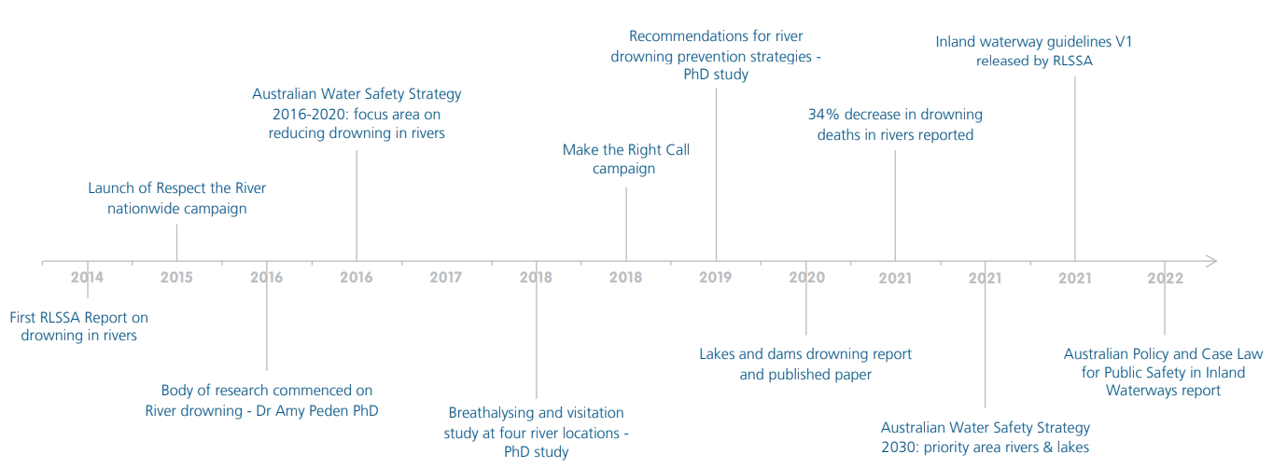

Note: Figure copied from Pidgeon, S. (2023). *Drowning in Rivers, Creeks, Lakes and Dams: A 10-year analysis 2011/12 to 2020/21*. Royal Life Saving Society – Australia: Sydney, p 8.

|  |
| --- |
| Respect The River — Royal Life Saving South Australia  Inland waterways – case study  Inland waterways, including rivers, creeks, lakes and dams, have consistently accounted for the highest proportion of drownings in Australia, despite extensive efforts to address the issue.[23]  Royal Life Saving's Make the Right Call Campaign 2020 | Royal Life Saving  Society - Australia  In 2014, RLSA published its first report focusing on drowning deaths in rivers,[24] which led to a body of further research developed in collaboration with James Cook University. This research in turn laid the foundation for a comprehensive national river drowning prevention campaign, Respect the River, as well as subsequent inland waterway campaigns such as Make the Right Call.  Respect the River, which began in 2015, operates nationwide, engaging various communities and demographics at risk of drowning in rivers. It provides tailored water safety skills and information through face-to-face events, training programs and safety messages, and has reached hundreds of thousands of people, the overall drowning rates in inland waterways have not seen a significant reduction.  Make the Right Call, now in its fourth year, targets males aged 25 to 45 years to encourage responsible behaviour around water. The campaign focuses on avoiding alcohol, wearing life jackets, and avoiding solitary water activities. Make the Right Call reached almost 6 million people through traditional and social media in the 2022–23 financial year.  Despite these targeted interventions, the rates of drowning in inland waterways have not shown a marked decline over the past decade.  RLSA’s most recent report on inland waterways, *Drowning in Rivers, Creeks, Lakes and Dams*,[25] provides detailed data on visitation patterns and further emphasises the need for targeted prevention strategies. The report provides several recommendations, including: [26]   * ‘Evaluate the effectiveness of relevant campaigns, programs and services focused on drowning prevention at inland waterways’ * ‘Pilot and evaluate the use of technology for drowning prevention at inland waterways, including … locational QR codes, apps, push notifications, geo-fencing/ geo-mapping’ * ‘Pilot and evaluate the use of public-access rescue equipment at inland waterways’ * 'Evaluate the feasibility, effectiveness and sustainability of lifeguard based responses at high use or high risk inland waterways locations’.   It is hoped that these recommendations will help refine and enhance strategies to address the persistent challenges associated with water safety in Australia’s inland waterways.  Respect the River, Make the Right Call and RLSA’s *Drowning in Rivers, Creeks, Lakes and Dams* report were all funded in part by the WSSP. |

## What are the enablers and barriers to program delivery?

|  |
| --- |
| Key findings   * Having an industry-led strategy supported by consistent national funding through this program has helped to progress water safety in Australia. * A lack of awareness about the WSSP grants among AWS Council members was identified as an issue. Most non-grantee council members were unaware of the program. It would be beneficial if all council members were aware of the grants, given their involvement in developing the AWSS 2030. |

### Enablers

**Consistent national funding** and having **an industry-led strategy** were seen by AWS Council members as the most important enablers to program delivery. The WSSP grant offers consistent funding over a 3-year period, providing grantees with certainty for the planning and delivery of safety activities. This is particularly important for research activities, which often require longer timeframes to plan and conduct. Council members also considered that having an industry-led strategy was effective for promoting a sense of ownership among council members. Council members have a vested interest in working towards the goals of the AWSS 2030, given their contribution to developing the strategy.

### Barriers

The most significant barrier that emerged was regarding **awareness of the WSSP among AWS Council members**. Most non-grantee council members were unaware of the program prior to the review. They considered it would be beneficial if all council members were made aware of the grants, including who receives funding, how much they receive and how they were selected. These non-grantee council members believed this was important given the WSSP funding supports the implementation of the AWSS 2030, and several of them were involved in developing the strategy.

I would have liked to have known how they got the funding, how it’s managed, what they got their funding to do, where’s the accountability and reporting, where’s that transparency?   
– AWS Council member (Non-grantee)

Some grantees noted **staff turnover in both the Department of Social Services’ Community Grants Hub (day-to-day managers) and the Department of Health and Aged Care** as another barrier. They believed this led to changing expectations around reporting requirements over the grant period. However, Department of Health and Aged Care staff advised that these changes happened in order to more strongly align with meeting performance measures.

# Effectiveness

This chapter addresses KRQ 2 – To what extent are the programs meeting their outcomes? This is done by answering 2 sub-questions:

* How do we know? To what extent are water and snow safety outcomes attributable to the funded programs and activities?
* To what extent are the programs meeting the Australian Government’s Close the Gap and gender equality targets?

Key findings in relation to these sub-questions are provided below.

## How do we know? To what extent are water and snow safety outcomes attributable to the funded programs and activities?

|  |
| --- |
| Key findings   * There is extensive work being done by all levels of government in water and snow safety, and therefore it is difficult to pinpoint improvements in water and snow safety outcomes that are specific to the work of the WSSP or the SLSA Training Measure. While the WSSP aligns to the AWSS 2030, the funding is not intended to be sufficient to achieve the strategy in full. * The review used 2 measures – Performance Indicators (found in the WSSP Grant Opportunity Guidelines) and the outputs and short-term outcomes outlined in the WSSP Program Logic – to identify the program outcomes. This approach allowed us to evaluate outcomes in relation to the funding administered, as well as the overarching purpose of the programs. * From the perspective of the Department of Social Services’ Community Grants Hub, all Performance Indicators and measures were met, so the funding for the WSSP and the SLSA Training Measure was administered. * Any issues raised by the Community Grants Hub around funding administration were common issues affecting all grants, such as the need for further clarification around reporting or COVID-19 implications. * Available data and documentation were reviewed to provide further analysis about the Performance Indicators and measures, which is provided in detail per grantee in this section. Across the 2021–22 and 2022–23 financial years, all grantees increased the number of Performance Indicators that were met. In all instances where a Performance Indicator was not met, there was evidence of the grantee progressing work that had yet to be completed; or evidence of work having been completed, but the measure attached to the Performance Indicator not being met. * The WSSP is meeting or partially meeting the outputs and short-term outcomes set out in its Program Logic. There were no instances where the WSSP had not been working on and therefore had not met the outputs and short-term outcomes at all. |

### Performance indicators and measure

The WSSP Grant Opportunity Guidelines provide Performance Indicators and measures for each of the grantees. From the perspective of the Department of Social Services’Community Grants Hub, all Performance Indicators and measures were met, so the funding for the WSSP and the SLSA Training Measure was administered. Any issues raised by the Community Grants Hub around funding administration were common issues affecting all grants, such as the need for further clarification around reporting or COVID-19 implications.

There was feedback from the grantees that the Performance Indicators and measures were considered right at the end of the grant period, and it was suggested that refinement could be considered as part of the next round. Grantees also mentioned changes in expectations and reporting requirements over the grant period which they believed were due to **staff turnover in both the Department of Social Services’ Community Grants Hub (day-to-day managers) and the Department of Health and Aged Care**.

As part of this review, available data and documentation were reviewed to provide further analysis about the Performance Indicators and measures, which is provided in detail per grantee in this section. For each Performance Indicator/measure, a rating has been provided:

* insufficient information
* not completed
* almost completed
* completed.

Also as part of this review, we reached out to grantees to provide additional information in instances where there was insufficient information, or where the Performance Indicator was not completed or almost completed at the time of the draft report. *The final report has been updated to reflect any additional information provided by grantees.*

#### Royal life saving australia

Based on current available data and documentation, RLSA met all Performance Indicators in the 2021–22 and 2022–23financial years: see Figure 5. Table 1 provides evidence against each of the Performance Indicators across these financial years.

Figure 5. RLSA Performance Indicators in FY 2021–22 and FY 2022–23

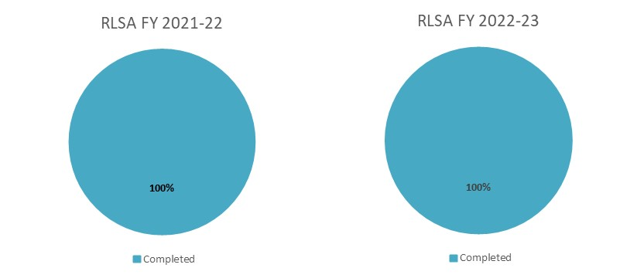

1. RLSA Performance Indicators in FY 2021–22 and FY 2022–23

|  |  |  |  |
| --- | --- | --- | --- |
| Action | PI & measure | FY 2021–22  Progress against actions | FY 2022–23  Progress against actions |
| Production of the *National Drowning Report* based on information from the National Fatal Drowning Database | Annually | **Completed** – The annual *National Drowning Report* was published. | **Completed** – The annual *National Drowning Report* was published. |
| Production of water safety research papers/ reports on issues identified in the AWSS 2030 | At least 3 per annum | **Completed** – RLSA published several research reports, including on: (a) risk factors for drowning among older adults (falls into water); (b) drowning among children aged 5 to 14 years; (c) social and health impacts of non-fatal drowning; (d) health, social and economic benefits of the National Aquatic Industry; (e) social impact of the National Aquatic Industry; and (f) equal access to public aquatic facilities. | **Completed** – RLSA published several research reports, including on: (a) children 0 to 4 years; (b) multicultural communities; (c) swimming and water safety skills; (d) the role of learn to swim; (e) the state of aquatic infrastructure in Australia; (f) Australian policy and case law for public safety in inland waterways; and (g) supervision of children at public pools.  Timeframes for two reports have been adjusted based on changing stakeholder requirements: (a) risk taking (youth); and (b) alcohol and drugs. |
| Number of children participating in the Swim and Survive program and provision of instructional material to support lifesaving in high schools | At least 250,000 children per annum | **Completed** – In the first 6 months of FY 2021–22, more than a 1,000 delivery partners, particularly in NSW and Vic, were closed due to public health orders. Notwithstanding, the RLSA ‘Performance Report – Summary 2021–22 Actuals’ document stated that there were still 255,064 children who participated in Swim and Survive nationally. The RLSA annual report stated that 363,698 Swim and Survive awards were issued. | **Completed** – The RLSA ‘Activity Workplan Summary 2022–2023’ document stated that 385,768 children participated in Swim and Survive nationally. The RLSA annual report stated that over 450,540 Swim and Survive awards were issued. |
| Number of schools or teachers registered for the Water Smart education program | At least 3,000 schools or teachers per annum | **Completed** – The RLSA ‘Performance Report – Summary 2021–22 Actuals’ document stated that 3,104 schools or teachers were registered for Water Smart. | **Completed** – TheRLSA ‘Activity Workplan Summary 2022–2023’ document stated that 3,417 schools or teachers were registered for Water Smart and provided with resources.  The ‘adjusted’ reference in that document related to a project to develop further/ expanded resources and provide additional communications support to schools and teachers. RLSA has since developed a database and an electronic direct mail strategy for ongoing communication and engagement with schools and teachers relating to water safety classroom resources. |
| Number of water safety media campaigns towards ‘at risk’ groups | At least 4 per annum | **Completed** – Several water safety media campaigns were delivered, including: (a) No Child Should Miss Out (swim advocacy campaign); (b) Summer Safety; (c) Make the Right Call; and (d) Inland Waterways Regional and Remote. | **Completed** – Several water safety media campaigns were delivered, including: (a) Multicultural Communities; (b) Inland Waterways; (c) We Swim; (d) Keep Watch; and (e) Make the Right Call. |
| Maintain guidelines for safe aquatic venues (swimming pools, parks and inland waterways) and ensure guidelines are available to registered users | Provide to at least 200 users per annum | **Completed** – TheRLSA ‘Performance Report – Summary 2021–22 Actuals’ document stated that there were 780 registered users.  This is also detailed in the annual report and internal database reporting. | **Completed** – 815 aquatic facilities had actively subscribed to and were using the guidelines for safe pool operations. |

#### Surf life saving australia

SLSA receives funding under both the WSSP and the SLSA Training Measure. The associated Performance Indicators and measures for each funding source are provided below.

#### Water and Snow Safety Program

Based on current available data and documentation, SLSA met three-quarters of Performance Indicators for the WSSP in the 2021–22 and 2022–23financial years: see Figure 6. Table 2 provides evidence against each of the Performance Indicators across these financial years.

Figure 6. SLSA WSSP Performance Indicators in FY 2021–22 and FY 2022–23

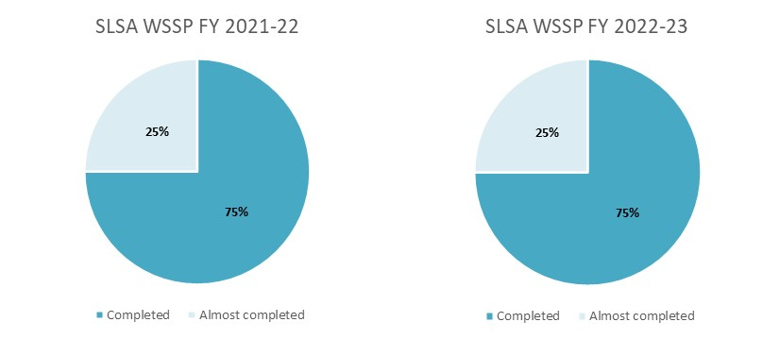

1. SLSA WSSP Performance Indicators in FY 2021–22 and FY 2022–23

| Action | PI & measure | FY 2021–22  Progress against actions | FY 2022–23  Progress against actions |
| --- | --- | --- | --- |
| Complete emergency actions as required in areas and at times patrolled by surf clubs | As required | **Completed** – SLSA (clubs, support operations and lifeguards) performed 8,916 rescues and 58,390 first aid treatments. | **Completed** – SLSA (clubs, support operations and lifeguards) performed 9,297 rescues and 40,574 first aid treatments. |
| Complete preventative actions, such as issuing public warnings to avoid dangerous and/or unpatrolled areas that increase the change of harm, or result in distress or drowning | Over 1,000,000 preventative actions | **Completed** – SLSA (clubs, support operations and lifeguards) performed 1,634,223 preventative actions. | **Completed** – SLSA (clubs, support operations and lifeguards) performed 1,921,916 preventative actions. |
| Number of surf lifesaving club affiliations | At least 250 clubs | **Completed** – There are 314 clubs across all states and territories. | **Completed** – There are 315 clubs across all states and territories. |
| Number of qualified lifesavers across beaches and coastal water recreation areas | Maintain current numbers | **Almost completed** – The total number of qualified lifesavers for FY 2021–22 was 44,272, which is less than the number for FY 2020–21 (45,205). | **Almost completed** – The total number of qualified lifesavers for FY 2022–23 was 41,504, which is less than the number for FY 2021–22 (44,272).  Note: Although the number of qualified lifesavers has decreased, there has been a 2% increase in active members aged 15–18 years. The number of patrol hours also increased from over 1.3 million hours in FY 2021–22 to more than 1.4 million patrol hours in FY 2022–23. |

#### Surf Life Saving Australia Training Measure

Based on current available data and documentation, SLSA met half of Performance Indicators for the SLSA Training Measure in the 2021–22 and 2022–23financial years: see Figure 7. Table 3 provides evidence against each of the Performance Indicators across these financial years.

Figure 7. SLSA Training Measure Performance Indicators in FY 2021–22 and FY 2022–23

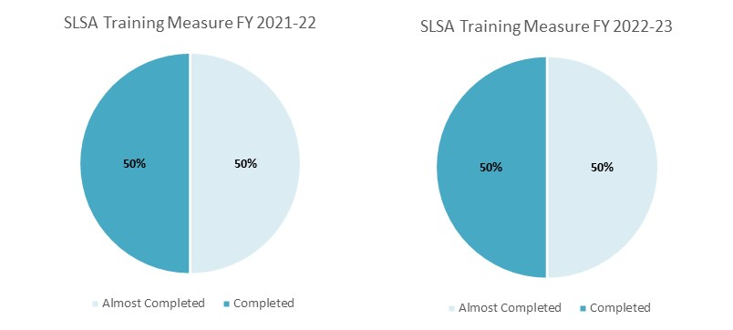

1. SLSA Training Measure Performance Indicators in FY 2021–22 and FY 2022–23

| Action | PI & measure | FY 2021–22[27]  Progress against actions | FY 2022–23  Progress against actions |
| --- | --- | --- | --- |
| Annual increase in trained patrolling members (aligned with the Certificate II in Public Safety) | 650 additional members | **Completed** – There was an increase in patrolling members as at both 1/7/2021 (45,205 members) and 30/6/2022 (44,748 members). | **Almost completed** – There was a decrease in patrolling members of 458 members – there were 44,272 members as at 1/7/2022 and 43,814 members as at 30/6/2023.  The overall membership of SLSA increased by 1.59%. The decrease in patrolling membership can be attributed to the effects of COVID-19, an older cohort of members who are less likely to patrol, and the possible duplication of patrolling members in the national SurfGuard database.  There has been substantial work completed in SurfGuard to ensure the integrity of the data contained within. This has included the merging of duplicate memberships.. |
| Annual increase in number of accredited awards | Increase of 1,650 | **Almost completed** – The number of accredited awards delivered was 63,509 as at 1/7/2021 and 60,743 as at 30/6/2022.  Award numbers were inflated in FY 2020/21 due to assessments that could not take place at the end of FY 2019/20 due to COVID-19 being completed the following year. | **Almost completed** – There was a decrease in number of accredited awards delivered: 60,743 were delivered as at 1/7/2022 and 53,924 were delivered as at 30/6/2023. This decrease was reflective of Vic and WA not issuing the Certificate II in Public Safety along with the Bronze Medallion in lifesaving, which has contributed to a decrease in the number of accredited courses being delivered overall.  SLSA is currently working with Vic to offer the Certificate II to members who complete the Bronze Medallion through the articulated credit model. SLSA has been working with Tas and, for the past 12 months, has been offering the Certificate II to members who complete the Bronze Medallion through the articulated credit model. |
| Maintenance of existing number of trainers, assessors and facilitators |  | **Almost completed** – The number of trainers, assessors and facilitators was 1,682 as at 1/7/2021 and 1,479 as at 30/6/2022. This represents a decrease of 203. However, there are additional trainers, assessors and facilitators who are yet to be endorsed.  SLSA completed targeted exit surveys with those who were not endorsed to better understand the specific barriers.  There was an increase in the number of trainers, assessors and facilitators delivering multiple awards. | **Completed** – The number of trainers, assessors and facilitators was 1,479 as at 1/7/2022 and 2,203 as at 30/6/2023. This represents an increase of 724.  SLSA is now seeing the results of the funded courses that have been provided over the past years come through as endorsed trainers, assessors and facilitators. The entire process can take one to 5 years. |
| Maintenance of paid staff in each regional and/or state centre as a dedicated resource for volunteer training and staff |  | **Completed** – There were 28 paid staff as at 1/7/2021 and 29 paid staff as at 30/6/2022. | **Completed** –There were 29 paid staff as at 1/7/2022 and 29 paid staff as at 30/6/2023.  Some of these staff have been employed specifically to support and deliver the Certificate IV in Training and Assessment and its components across the country on behalf of Surf Life Saving Queensland, reducing the cost of the course and ensuring that it is contextualised to surf lifesaving. |

#### Australasian council for the teaching of swimming and water safety (AUSTSWIMM)

Based on current available data and documentation, AUSTSWIM met two-thirds of Performance Indicators in in the 2021–22 and 2022–23financial years: see Figure 8. Table 4 provides evidence against each of the Performance Indicators across these financial years.

Figure 8. AUSTSWIM Performance Indicators in FY 2021–22 and FY 2022–23

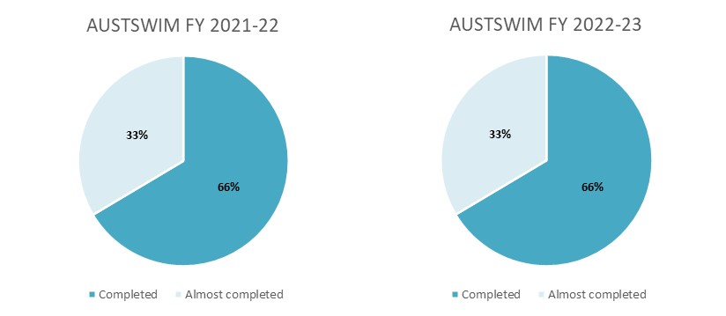

1. AUSTSWIM Performance Indicators in FY 2021–22 and FY 2022–23

| Action | PI & measure | FY 2021–22  Progress against actions | FY 2022–23  Progress against actions |
| --- | --- | --- | --- |
| Maintain current AUSTSWIM licence holders | A minimum of 20,000 | **Completed** – There were 37,000 AUSTSWIM licence holders as at December 2021 and 31,010 as at June 2022. | **Completed** – There were 23,315 AUSTSWIM licence holders as at December 2022 and 21,791 as at June 2023.  Both figures are above the minimum target of 20,000. |
| Re-accredit AUSTSWIM licence holders annually | At least 3,000 per annum | **Completed** – There was a total of 4,093 re-accreditations (1,093 above the target of 3,000):   * Between July and December 2021, there were 1,657 re-accreditations. * Between January and June 2022, there were 2,436 re-accreditations. | **Completed** – There was a total of 3,241 re-accreditations (241 above the target of 3,000):   * Between July and December 2022, there were 1,603 re-accreditations. * Between January and June 2023, there were 1,638 re-accreditations. |
| Provide accreditation training to new AUSTSWIM licence holders annually | At least 8,000 per annum | **Almost completed** – There was a total of 6,942 accreditations (1,058 below the target of 8,000):   * Between July and December 2021, there were 3,266 accreditations. * Between January and June 2022, there were 3,676 accreditations.   AUSTSWIM fell short in its progress against this action because of the impacts of COVID-19, which caused closures to aquatic facilities during the period. | **Almost completed** – There was a total 7,919 of accreditations (81 below the target of 8,000):   * Between July and December 2022, there were 3,835 accreditations. * Between January and June 2023, there were 4,084 accreditations. |

#### Laurie Lawrence swimming enterprises

Based on current available data and documentation, Laurie Lawrence met three-quarters of Performance Indicators in the 2021–22 and 2022–23financial years: see Figure 9. Table 5 provides evidence against each of the Performance Indicators across these financial years.

Figure 9. Laurie Lawrence Performance Indicators in FY 2021–22 and FY 2022–23

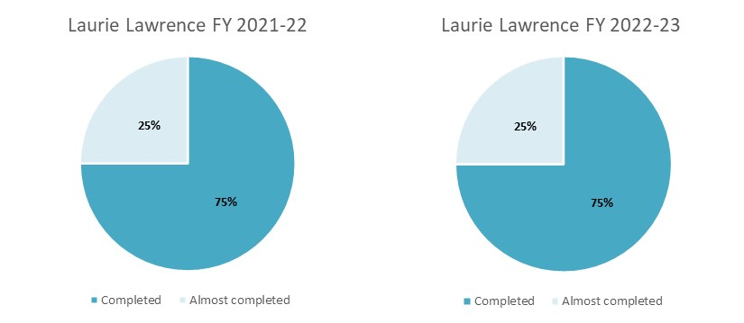

1. Laurie Lawrence Performance Indicators in FY 2021–22 and FY 2022–23

| Action | PI & measure | FY 2021–22  Progress against actions | FY 2022–23  Progress against actions |
| --- | --- | --- | --- |
| Provide evidence-based water safety education resources and materials targeted to children aged 5 and under in line with the AWSS 2030 | As required | **Completed** –   * The Kids Alive campaign had nationwide coverage via multiple platforms (radio, television and print). * The Kids Alive team worked alongside Professor Robyn Jorgensen (Canberra University) to ensure that Kids Alive is an evidence-based program. | **Completed** –   * The Kids Alive campaign had nationwide coverage via multiple platforms (radio, television and print). * Significant progress was made in the development of toddler books, Living with Water books and the Wise Owl series for early learners. |
| Produce and distribute educational materials that are updated to be relevant in an appropriate format, e.g., social media platforms, face-to-face training and paper materials | At least 50,000 pieces | **Completed** –   * 50,000 Living with Water packs were produced, and were distributed to education services and key stakeholders. * 276,000 Living with Water books were produced. * 240,000 Living with Water books were distributed via the New Parent Bounty Bag. | **Completed** –   * 135,000 Living with Water books were distributed between July and December 2022. * 241,136 Living with Water books were distributed via the New Parent Bounty Bag between January and June 2023. * 55,000 items in the Wise Owl series were distributed between January and June 2023. |
| Number of appearances by the Kids Alive costume characters at appropriate events, such as swim schools, early learning services and community groups | At least 8 in each state and territory | **Almost completed** –   * Kids Alive costume characters appeared at least 8 times in most states/ territories; however, this target was not met in SA, Tas, the NT or the ACT. * COVID-19 impacted the Kids Alive teams’ ability to travel interstate and safely share costumes amongst swim schools, early learning centre | **Almost completed** –   * Kids Alive costume characters appeared at least 8 times in most states/ territories; however, this target was not met in Tas, the NT or the ACT. * Puppets and mascots were used at national media events, photoshoots, social campaigns and appropriate physical events. * Accessed by early learning services, dance studios, swim schools and playgroups. |
| Number of promotional activities and media events for the Kids Alive water safety resources | 2 in each state and territory | **Completed** –   * National initiatives receiving coverage in each state and territory included Ready Set Dance, Spring Warnings, Learn2Swim Week, Check Your Pool Gate Month, Responsible Pool Person, April Pools Day, MATES Promotion, and Yoga Resources for Winter. | **Completed** –   * National initiatives and local collaborations exceeded media coverage in each state and territory. * Notable national initiatives included Ready Set Dance, Sensory Sessions, Learn2Swim Week, Check Your Pool Gate Month, the Watch Your Mate Medal, April Pools Day and Kids Alive in Concert. |

#### Australian ski patrol association

Based on current available data and documentation, ASPA met all of the Performance Indicators in the 2021–22 and 2022–23financial years: see Figure 10. Table 6 provides evidence against each of the Performance Indicators across these financial years.

Figure 10. ASPA Performance Indicators in FY 2021–22 and FY 2022–23

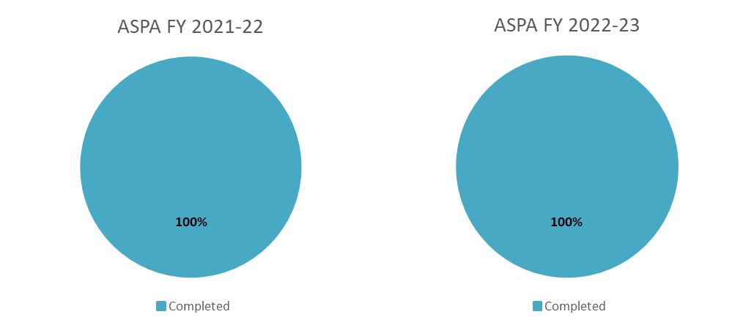

1. ASPA Performance Indicators in FY 2021–22 and FY 2022–23

| Action | PI & measure | FY 2021–22  Progress against actions | FY 2022–23  Progress against actions |
| --- | --- | --- | --- |
| Provide accredited training or re-certification to ski patrollers | A minimum of 150 ski patrollers per annum | **Completed** – ASPA provided accredited training to at least 150 ski patrollers, as indicated below.  Number of trained ski patrollers:   * 2021 – 379 * 2022 – 350.   Number of trainers:   * 2021 – 33 * 2022 – 46. | **Completed** – ASPA provided accredited training to at least 150 ski patrollers, as indicated below.  Number of trained ski patrollers:   * 2022 – 350 * 2023 – 384.   Number of trainers:   * 2022 – 46 * 2023 – 53. |
| Deliver Advanced Emergency Care training to ski instructors | At least 25 ski instructors per annum | **Completed** – ASPA delivered Advanced Emergency Care training to at least 25 ski instructors (the exact number was not reported). | **Completed** – ASPA delivered Advanced Emergency Care training to at least 25 ski instructors (the exact number was not reported). |
| Ensure ASPA-trained ski patrollers attend and provide medical assistance to injured skiers | At least 1,000 injured skiers per annum | **Completed** – ASPA-trained ski patrollers provided medical assistance to 2,989 injured skiers (1,989 more than the target of 1,000).  It is not possible to receive releasable stats from the resorts but based off available data there are roughly 8,000 snow and 3,000 bike incidents per annum. | **Completed** – ASPA-trained ski patrollers provided medical assistance to 3,087 injured skiers (2,087 more than the target of 1,000).  It is not possible to receive releasable stats from the resorts but based off available data there are roughly 8,000 snow and 3,000 bike incidents per annum. |

### Outputs and short-term outcomes outlined in the water and snow safety Program logic

The table below assesses the extent to which grantees have achieved the outputs and short-term outcomes outlined in the WSSP Program Logic. For each of the outputs and short-term outcomes, an overall rating is provided in the ‘evidence’ column using the following scale:

* Met (green) – There is evidence that the output and short-term outcome have been met.
* In progress (yellow) – There has been progress made against meeting the output and short-term outcome.
* Not met (red) – The output and short-term outcome have not been met.
* Not applicable – The work of the grantee is not applicable to the output or short-term outcome.

The table also provides evidence for how each grantee has contributed to each of the outputs and short-term outcomes.

| Outputs | Short-term outcomes | Evidence |
| --- | --- | --- |
| Regulatory reporting as required | Grantees meet Performance Indicators and performance criteria | There is evidence that the output and short-term outcome have been met. |
|  | *RLSA* | RLSA provided Activity Work Plans, Performance Reports and Financial Acquittal Reports for the WSSP. |
|  | *SLSA* | SLSA provided Activity Work Plans, Performance Reports and Financial Acquittal Reports for the WSSP and the SLSA Training Measure. |
|  | *Laurie Lawrence* | Laurie Lawrence provided Activity Work Plans, Performance Reports and Financial Acquittal Reports for the WSSP. |
|  | *AUSTSWIM* | AUSTSWIM provided Activity Work Plans, Performance Reports and Financial Acquittal Reports for the WSSP. |
|  | *ASPA* | ASPA provided Activity Work Plans, Performance Reports and Financial Acquittal Reports for the WSSP. |
| Targeted public awareness campaigns and communication products | Well-targeted and well-channelled materials increase reach, accessibility and uptake of water and snow safety information/ educational materials by the public and tourists across life stages | There has been progress made against meeting the output and short-term outcome. |
|  | *RLSA* | RLSA delivered several water safety media campaigns each year, targeting ‘at risk’ groups (campaigns included Multicultural Communities, Inland Waterways, We Swim, Keep Watch and Make the Right Call). There is insufficient information about the number of children who participate in the Swim and Survive program, and the number of schools registered for the Water Smart education program. |
|  | *SLSA* | Not applicable |
|  | *Laurie Lawrence* | Laurie Lawrence provided several appearances by the Kids Alive costume characters, and delivered promotional activities and media events for the Kids Alive water safety resources. Additional information has been requested to provide further detail about its public awareness campaigns.  Laurie Lawrence provided the following educational and training materials:   * + - * 135,000 Living with Water books were distributed between July and December 2022.       * 241,136 Living with Water books were distributed via the New Parent Bounty Bag between January and June 2023.       * 55,000 items in the Wise Owl series were distributed between January and June 2023. |
|  | *AUSTSWIM* | Not applicable |
|  | *ASPA* | Not applicable |
| Educational and training materials on water/ snow safety and learning to swim | More people (public and instructors) are upskilled and hold qualifications in water safety, in swim instruction and as ski patrollers | This output and short-term outcome have been met. |
|  | *RLSA* | RLSA produced the annual *National Drowning Reports*, several research reports (e.g., on risk factors for drowning among older adults, drowning among children aged 5 to14 years, and social and health impacts of non-fatal drowning) and a number of water safety media campaigns. |
|  | *SLSA* | SLSA provided qualified lifesavers across beaches and coastal water recreation areas. Their training was aligned with the Certificate II in Public Safety. SLSA also provided accredited awards, and maintained its existing number of trainers, assessors and facilitators. |
|  | *Laurie Lawrence* | Laurie Lawrence provided the following educational and training materials:   * + - * 135,000 Living with Water books were distributed between July and December 2022.       * 241,136 Living with Water books were distributed via the New Parent Bounty Bag between January and June 2023.       * 55,000 items in the Wise Owl series were distributed between January and June 2023. |
|  | *AUSTSWIM* | AUSTSWIM maintained the existing number of AUSTSWIM licence holders (21,7981 as at June 2023), re-accredited 3,241 AUSTSWIM licence holders during FY 2022–23, and provided accredited training to 7,919 new AUSTSWIM licence holders during FY 2022–23. |
|  | *ASPA* | ASPA provided accredited training to at least 150 ski patrollers, and delivered Advanced Emergency Care training to at least 25 ski instructors. |
| Target audiences attend training and education programs, industry events and conferences | Events/ conferences are well regarded, well attended by local and international stakeholders, and lead to shared understanding of research and approaches to water safety | This output and short-term outcome have been met. |
|  | *RLSA* | RLSA co-hosted the World Conference on Drowning Prevention in Perth during December 2023. This globally significant event focused world attention on drowning prevention. The conference gathered together experts in drowning prevention, lifesaving and water safety, with the goal of shaping global strategy and mobilising for action. |
|  | *SLSA* | SLSA-qualified lifeguards (trainers, assessors and facilitators) participated in accredited training. There was an increase in the maintenance of existing number of trainers, assessors and facilitators. |
|  | *Laurie Lawrence* | Not applicable |
|  | *AUSTSWIM* | Not applicable |
|  | *ASPA* | Not applicable |
| Datasets, analysis and research, including publication of reports  Monitoring and rescue services in place | Education resources and monitoring/ rescue services are enhanced through cross-sector collaboration and research on water/ alpine environments  A growing and reliable evidence base increases information on tends on fatal and non-fatal water and snow incidents and the effectiveness of interventions/ strategies to mitigate incidents. | There has been progress made against meeting the output and short-term outcome. |
|  | *RLSA* | RLSA produced the annual *National Drowning Report* and several water safety research papers/ reports on issues identified in the AWSS 2030. This research contributes to the growing evidence base. |
|  | *SLSA* | SLSA completed emergency actions as required in areas and at times patrolled by surf clubs. |
|  | *Laurie Lawrence* | Not applicable |
|  | *AUSTSWIM* | Not applicable |
|  | *ASPA* | ASPA-trained ski patrollers attended and assisted injured skiers. |
| New/ emerging technologies implemented to enhance messaging, training and emergency response/ prevention activities | Use of technology advances the impact of campaign messaging, drives behaviour change, improves training and assessment methods, and improves approaches for monitoring, preventing and responding to emergencies | This output and short-term outcome have been met. |
|  | *RLSA* | RLSA’s research reflects current issues in water safety that have been identified in the AWSS 2030 or issues identified in the National Fatal Drowning Database. |
|  | *SLSA* | SLSA continued to update accredited training and associated materials to ensure that its training was up to date and still met current needs. For example, SLSA continued to update its BeachSafe site (beachsafe.org.au) and BeachSafe app for beachgoers, as well as its Patrol Opps app and SurfCom system for its members. |
|  | *Laurie Lawrence* | Laurie Lawrence updated its educational materials, and ensured these materials were in different formats for different audiences, e.g., Living with Water books were distributed via the New Parent Bounty Bag, and the Kids Alive song was distributed using Spotify. |
|  | *AUSTSWIM* | AUSTSWIM continued to update its accredited training and associated materials to ensure that its training was up to date and still met current needs. |
|  | *ASPA* | ASPA continued to update its accredited training and associated materials to ensure that its training was up to date and still met current needs. |
| Evaluation of activities performed against program objectives, Performance Indicators and AWSS 2030. | Evaluation findings inform the future policy and program direction, including new national targets/ benchmarks. | There has been progress made against meeting the output and short-term outcome. |
|  | *RLSA* | RLSA participated in evaluation activities as part of the review and also provided regulatory reporting, including Activity Work Plans, Performance Reports and Financial Acquittal Reports. |
|  | *SLSA* | SLSA participated in evaluation activities as part of the review and also provided regulatory reporting, including Activity Work Plans, Performance Reports and Financial Acquittal Reports. |
|  | *Laurie Lawrence* | Laurie Lawrence participated in evaluation activities as part of the review and also provided regulatory reporting, including Activity Work Plans, Performance Reports and Financial Acquittal Reports. |
|  | *AUSTSWIM* | AUSTSWIM participated in evaluation activities as part of the review and also provided regulatory reporting, including Activity Work Plans, Performance Reports and Financial Acquittal Reports. |
|  | *ASPA* | ASPA participated in evaluation activities as part of the review and also provided regulatory reporting, including Activity Work Plans, Performance Reports and Financial Acquittal Reports. |

## To what extent are the programs meeting the Australian Government’s Close the Gap and gender equality targets?

|  |
| --- |
| Key findings   * The reduction in drownings among Aboriginal and Torres Strait Islander peoples suggests that RLSA’s research, policy and advocacy efforts have so far been effective. * However, Aboriginal and Torres Strait Islander communities remain a priority population, and further work is required to ‘close the gap’ in drownings. * The WSSP and the SLSA Training Measure are less relevant to the government’s gender equality targets, as water-related and snow-related injuries and deaths disproportionately affect males. |

Aboriginal and Torres Strait Islander people are disproportionately impacted by drowning.[28] Swimming and water safety education is often less accessible for Aboriginal and Torres Strait Islander people who live in rural and remote communities and lower socioeconomic areas. It is for these reasons that Aboriginal and Torres Strait Islander peoples are one of 3 priority populations listed in the AWSS 2030.

The WSSP addresses this primarily through research, and targeted water safety campaigns and programs for Aboriginal and Torres Strait Islander communities. RLSA has worked with partners and communities to develop programs specifically tailored for Aboriginal and Torres Strait Islander communities. Other interventions include the construction of swimming pools in rural and remote communities to minimise the risks associated with swimming in inland waterways.

In late 2020, RLSA published research showing a 47% decrease in drowning deaths among Aboriginal and Torres Strait Islander people since 2010.[29] Despite this positive longer-term trend, Aboriginal and Torres Strait Islander peoples remain a priority population, and further prevention efforts are required to reduce the impacts of drowning for Aboriginal and Torres Strait Islander communities.

National Indigenous Australians Agency (NIAA) staff we interviewed noted the importance of continuing to prioritise Aboriginal and Torres Strait Islander peoples, given they are overrepresented in drowning data. They believed that more could be done in terms of specific strategies, and by directly funding Aboriginal Community Controlled Health organisations to support drowning prevention efforts.

If we think about Closing the Gap and [the] National Agreement. There is [a] clause in relation to applying a meaningful proportion of funding to … Aboriginal Community Controlled organisations and a meaningful proportion going to Aboriginal communities  
– NIAA staff member

The WSSP and the SLSA Training Measure are less relevant to the government’s gender equality targets because water-related and snow-related injuries and deaths disproportionately affect males.

# Efficiency

This chapter addresses KRQ 3 – Do the programs provide value for money? This is done by answering 2 sub-questions:

* Would greater contestability support value for money?
* To what extent is there cross-over between the funded activities/ functions and other programs delivered by Australian Government departments and state and territory governments?

Key findings in relation to these sub-questions are provided below.

## Would greater contestability support value for money?

|  |
| --- |
| Key findings   * Given the reasons for key organisations receiving water and snow safety grants, it seems the non-contestable nature of the grant provides the greatest value for money. * Opportunities to have collaborative funding could also be considered, as multiple AWS Council members could work together to achieve an outcome from the AWSS 2030. |

### Water safety programs and the Surf Lifesaving Australia training measure

#### No significant issues were raised about the non-contestability of the grants, and most interviewees valued the leadership it cultivated

Non-contestable grants were provided to 5 organisations through the WSSP. Reasons for these organisations being chosen to receive the grants included them having:[30]

* the capability to deliver the project activities, including existing infrastructure and relationships to support the project activities
* experience, knowledge and capability to deliver the project objectives and outcomes
* a strong history of working together.

In addition, they were viewed as strong candidates because they were well-established organisations.

Once aware of which organisations had been successful, non-grantees did not raise any significant issues with the lack of contestability of the grants. In contrast, most AWS Council members interviewed considered that the Department of Health and Aged Care had chosen clear leaders that supported the coordination of the council and implementation of the AWSS 2030. This was especially the case for organisations such as RLSSA and SLSA, which were viewed as obvious choices.

*I think Royal Life and Surf Life seem reasonable. They are the two key bodies involved in those areas.   
– AWS Council member (Non-grantee)*

One interviewee reflected that the leadership provided by these organisations was an important component of the grant, providing a point of coordination for the broader industry.

*[I]f [grants were] contestable, there is a loss of control. The requirement to have some leadership, responsibility and [a] point of coordination is really important.   
– AWS Council member (Non-grantee)*

However, a small number of non-grantees believed that the reasons for some organisations receiving grants were not as compelling, particularly those that delivered services. Some other organisations could deliver the same services, such as teaching certifications. There could be an opportunity for collaborative funding opportunities that would allow for multiple AWS Council members to deliver outcomes that achieve the same goal.

Other council members were not sure why some organisations were funded for specific priorities (e.g., child safety), when other priorities were just as important (e.g., the safety of young men). They believed their organisations could use national funding to deliver programs that equally supported outcomes of the AWSS 2030.

#### Communication about the criteria for selection of grantees could have been improved and, if not, a level of contestability or collaboration could be considered

To reduce confusion as to why some grantees were chosen, most non-grantees suggested that a greater level of communication could be beneficial. This would include providing details of the criteria for choosing grantees and metrics used beyond these criteria, such as the AWSS 2030.

*[They] could look to improve [contestability], [by] being open about who is funded in the council through the [WSSP].   
– AWS Council member (Non-grantee)*

In addition to this, 2 interviewees suggested that there may be an opportunity to improve questions around non-contestability by providing partial contestability or more collaborative funding opportunities. One interviewee mentioned that this could include the Department of Health and Aged Care providing funding through the AWS Council, so that the council could meet the strategic goals set out in the AWSS 2030. They considered that this may drive greater collaboration between council members. However, it was also identified by an interviewee that delivering funding through the council could be detrimental, as it could pose a distraction from goals and strategy.

### Snow safety programs

#### The Australian Ski Patrol Association is the only appropriate option for the snow safety grant and therefore should remain non-contestable

For snow safety, a non-contestable grant provides the greatest value for money due to there being no organisations other than ASPA that represent ski patrollers nationally and would be able to deliver the training. This provides value through the removal of costs associated with administering grants.

## To what extent is there cross-over between the funded activities/ functions and other programs delivered by Australian Government departments and state and territory governments?

|  |
| --- |
| Key findings   * Water safety is associated with recreation, primary prevention, education and emergency management. The overlapping and complex nature of the issue means it is not possible to neatly delineate funding responsibilities across departments or jurisdictions. * WSSP funding provides incremental value to the water safety funding landscape, and supports national strategies and training that support consistency across the nation, provide some level of equity and, as a result, influence better water safety outcomes. |

### Water safety programs

#### There is some cross-over of funded activities/ functions delivered by Australian Government Departments and State/ territory and Local governments

Water safety is a cross-sectoral issue. Table 7 illustrates how water safety crosses a range of sectors. An example of this is how water impacts sports and recreation/ physical activity through people participating in activities such as swimming, surfing and fishing. Partaking in these activities may result in water safety issues that impact emergency management resourcing.

1. Water safety impacts by sector

| Sectors | Impact of water safety |
| --- | --- |
| Sports and recreation/ physical activity | People go into the water to partake in sporting, recreational and physical activities such as swimming, surfing and fishing. These lead to water safety risks. |
| Transport | Transport includes boats, which lead to water safety risks (e.g., falling overboard). Their role is to reduce water safety risks though boat ramp outreach and advocating for the wearing of life jackets. |
| Land and environment | Land and environment include the waterways and maintenance surrounding the waterways. |
| Education | Education is needed to build awareness and educate young people about water safety requirements. |
| Emergency management | Police traffic the waters, and emergency responders – including ambulances – respond to water safety incidents. |
| Health | The health sector – in particular, hospitals – deals with the aftermath of water safety risks (e.g., hospital care after non-fatal drownings) |

The cross-sectoral nature of water safety makes it difficult to neatly delineate funding responsibilities across sectors, and often results in water safety roles and responsibilities shifting between departments, agencies and levels of government.

*State government budgets are smashed and [we’re] seeing them walking away from funding [water safety] … [State governments’] water safety funding is moving towards emergency services.   
– AWS Council member (Grantee)*

This has meant that there is some overlap between the funding of water safety initiatives across jurisdictions. Despite this, interviewees also identified distinct and important roles of different levels of government, as shown in Figure 11.

Figure 11 . Jurisdictional water safety funding landscape



Knowing how to clearly delineate the funding responsibilities of water safety initiatives is a common challenge that also impacts countries such as Canada and the UK. A brief desktop review showed that the funding of water safety initiatives in these countries regularly shifts between departments and levels of government. This is often in response to political, economic and emerging factors.

#### The Commonwealth’s role in funding water safety is important in providing incremental value to the water safety landscape

Figure 11 illustrates how federal, state/ territory and local governments work together to support water safety across Australia. It highlights the complexity of the water safety landscape. Interviewees mentioned that this complexity contributed to the need for all levels of government to have an important role in supporting water safety initiatives, messaging and strategies. They added that while some roles were overlapping and others distinct, all funding for water safety provided incremental value rather than duplicative value.

*One of the outcomes that is funded federally through [WPSS] funding is different to other outcomes that might be funded at a state level for our state organisations … [W]e make sure we work with [government] to make sure that it’s not [duplicative]. There’s no replication or double dipping or anything like that.  
– AWS Council member (Grantee)*

#### Interviewees considered that the funding delivered through the WSSP has ensured that the national issue of water safety can be addressed somewhat consistently across Australia

Most interviewees considered that WSSP grants were valuable in driving consistency across the nation – especially as it was identified that different state, territory and local governments have varied capabilities to fund water safety initiatives, resulting in inequities. Differences between local government areas such as City of Brisbane and Katherine Town Council highlight these inequities, with City of Brisbane having greater capacity and funding to deliver water safety initiatives.

*The problem is that I can’t run programs without funding … setting targets on what we could try [to] achieve … [T]he rest of Australia don’t received as much funding – it is at a state level. National funding means everyone has the same training.– AWS Council member (Non-grantee)*

Interviewees believed that WSSP funding led to a level of consistency in research, messaging and training that hopefully reduced some of these inequities across the nation. The funding also promoted the consistent advocacy of water safety, ensured that water safety priorities were aligned across states/ territories, and provided clear roles and responsibilities for organisations throughout the nation in delivering the AWSS 2030.

#### Funding water safety at a national level is also important to gain efficiencies where possible (e.g., research)

A small number of interviewees also identified that national funding provided greater levels of efficiency in tackling water safety issues. Efficiencies included:

* streamlining research: having research at a national level had downstream impacts, as it could then be used by all levels of government
* reducing costs: having a larger sum of money rather than short bursts of small amounts of funding (often received through state/ territory grants) meant that organisations were able to achieve economies of scale across the nation, and did not need to spend a substantial proportion of their income organising funding.

I thought that's where the federal funding is good because it creates a sort of critical mass of research and a centre of knowledge. I think there is place for both [federal and state funding]. I think the federal funding going into activities that are nationwide [is] awesome.   
– AWS Council member (Non-grantee)

#### Funding was instrumental for grantees in delivering activities that aimed to support outcomes associated with research, advocacy and awareness of water safety issues

Most grantees mentioned that WSSP funding was instrumental in supporting them to deliver their work to large cohorts, including training, advocacy and building awareness of water safety. If WSSP funding was not available, a small number of grantees said that they would not have been able to prioritise, develop and deliver the AWSS 2030, which would have had flow-on impacts on the rest of the industry. Another grantee said that, without the WSSP funding, they would have had to revert back to acting like a private business, which would have resulted in them pushing programs rather than supporting outcomes that were better for the industry.

*You take away the federal funding and absolutely … we would act like a for-profit business … [Other for-profits] don’t care about advocacy [for their industry]. They care about advocating for their shareholders.  
– AWS Council member (Grantee)*

*I just think for the stability of the aquatic industry and what the aquatic industry [represents], … continual investment and long-term strategic planning in this space is so critical, and we talk about … the impact of what this all means … it’s literally life and death.  
– AWS Council member (Grantee)*

### The Surf Life Saving Australia Training Measure

The SLSA Training Measure provides funding for accredited awards for SLSA volunteers, including trainers, assessors and facilitators. While funding of training often falls within the remit of state and territory governments, the grantee receiving the grant believed it could not survive without it, as trainers, assessors and facilitators need to be up to standard. They believed volunteers would otherwise not feel incentivised to do this.

Arguments for and against continuing to fund the SLSA Training Measure are outlined in Table 8.

1. Pros and cons of funding the SLSA Training Measure

|  |  |
| --- | --- |
| Pros | Cons |
| * Without the training measure, SLSA may not receive adequate funding to support volunteer training, which would affect the number of volunteers that can be trained and assessed, and therefore patrol beaches. The training measure provides incremental value. * Based on the SLSA annual reports, money received from states and territory governments is insufficient to fund training. * It is efficient to fund the training measure, as SLSA is already funded through the WSSP. There is limited appetite for other departments at the Commonwealth level to take on the responsibility of funding the training measure. | * It is not normally within the remit of the Department of Health and Aged Care to fund accredited vocational training. |

There is a need for accredited awards for SLSA volunteers to be funded and, in the absence of any strong reason for state/ territory to fund it, the Department of Health and Aged Care should continue to do so. This is supported by the efficiencies gained by the training measure being funded in addition to the WSSP.

### Snow safety programs

#### The Water and Snow Safety Program provides ASPA with all of its snow safety funding

ASPA does not receive funding beyond the WSSP, indicating that no funds are being provided by states and territories. While snow safety is not necessarily a national issue, the removal of funding would impact ASPA’s ability to delivery snow safety training and supports.

1. There has been an average of 279 drowning deaths per year over the past 10 years in Australia: Royal Life Saving Society – Australia (2023). *National Drowning Report 2023*. Royal Life Saving Society – Australia: Sydney, p 2.
2. Power, J. (11 December 2023). The unseen and unheard victims of drowning. *The Sydney Morning Herald*.
3. Australian Water Safety Council (2021). *Australian Water Safety Strategy 2030*. Australian Water Safety Council: Sydney.
4. Minister for Infrastructure, Transport, Regional Development and Local Government (2023). Budget 2023–24: Strengthening Australia’s $120 billion infrastructure pipeline. *Media Release*, 9 May 2023.
5. Royal Life Saving Society – Australia (2023). *National Drowning Report 2023*. Royal Life Saving Society – Australia: Sydney, p 2.
6. Bureau of Infrastructure and Transport Research Economics (2023). *Road Deaths Australia – Monthly Bulletins*, ISSN 1449-1168.
7. As part of the review, we reached out to grantees to provide additional information in instances where there was insufficient information, or where the Performance Indicator was not completed or almost completed at the time of the draft report. *The final report has been updated to reflect any additional information provided by grantees.*
8. Department of Finance, *Commonwealth Grants Rules and Guidelines 2017*, clause 13.13. Retrieved from https://www.finance.gov.au/sites/default/files/2019-11/commonwealth-grants-rules-and-guidelines.pdf
9. Ibid, clause 13.11.
10. Ibid, clause 11.5.
11. Ibid, clause 13.13.
12. There has been an average of 279 drowning deaths per year over the past 10 years in Australia: Royal Life Saving Society – Australia (2023). *National Drowning Report 2023*. Royal Life Saving Society – Australia: Sydney, p 2.
13. Power, J. (11 December 2023). The unseen and unheard victims of drowning. *The Sydney Morning Herald*.
14. Australian Water Safety Council (2021). *Australian Water Safety Strategy 2030*. Australian Water Safety Council: Sydney.
15. Royal Life Saving Society – Australia (2023). *National Drowning Report 2023*. Sydney, p 4.
16. Royal Life Saving Society – Australia (2023). *National Drowning Report 2023*. Sydney, p 4.
17. Peden, A.E., & Mahony, A. (2018). *Trends in Child Drowning Over the Last 25 Years*. Royal Life Saving Society – Australia: Sydney.
18. Franklin, R., & Peden, A.E. (2017). Improving pool fencing legislation in Queensland, Australia: Attitudes and impact on child drowning fatalities. *International Journal of Environmental Research and Public Health*; 14(12).
19. Lawes, J. (2021). Tourism and recreation. In: Clark, G., Fischer, M., & Hunter, C. (eds). *Australia: State of the Environment 2021*: *Coasts*. Independent report to the Australian Government Minister for the Environment. Commonwealth of Australia: Canberra.
20. *Royal Life Saving Annual Report 2022/23*. Royal Life Saving Society – Australia: Sydney.
21. There were approximately 8,000 incidents in ski resorts across Australia in 2023, which equates to 26 injuries per 1,000 skiers.
22. This issue was also highlighted at the 2023 World Conference on Drowning Prevention in Perth.
23. Pidgeon, S. (2023). *Drowning in Rivers, Creeks, Lakes and Dams: A 10-year analysis 2011/12 to 2020/21*. Royal Life Saving Society– Australia: Sydney.
24. Peden, A. E., & Queiroga, A.C. (2014). *Drowning Deaths in Australian Rivers, Creeks and Streams: A 10 year analysis*. Royal Life Saving Society – Australia: Sydney.
25. Pidgeon, S. (2023). *Drowning in Rivers, Creeks, Lakes and Dams: A 10-year analysis 2011/12 to 2020/21*. Royal Life Saving Society– Australia: Sydney, p 48.
26. Ibid, p 48.
27. The provided SLSA Performance Report covers January to July 2022 not the entirety of the FY in 2021-22.
28. Aboriginal and Torres Strait Islander people represent 3.3% of the Australian population, but account for 5.5% of drowning deaths: Pidgeon, S., & Nimmo, L. (2020). *Drowning Deaths Among Aboriginal and Torres Strait Islander People: A 10-year analysis 2008/09 to 2017/18*. Royal Life Saving Society – Australia: Sydney, p 14.
29. Ibid, p 4.
30. WSSP Grant Opportunity Guidelines, p 10.