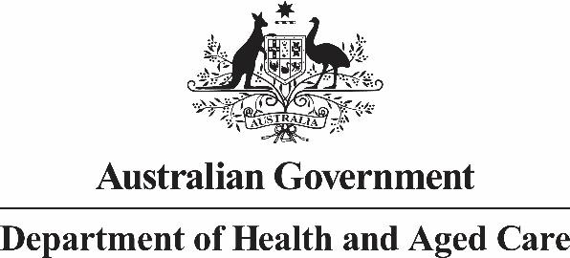

# LGBTIQA+ Health and Wellbeing 10-Year Action Plan Expert Advisory Group18 October 2024 Meeting Communiqué

The Australian Government is continuing to progress work in improving access to care, support, and better physical health, mental health, and wellbeing outcomes for LGBTIQA+ people.

The fifth meeting for the LGBTIQA+ Health and Wellbeing 10-Year National Action Plan Expert Advisory Group (Expert Advisory Group) was held online today. Assistant Minister Ged Kearney, Chair of the EAG, opened the meeting and acknowledged she joined from the land of the Wurundjeri People of the Kulin Nation and the traditional lands across Australia Members were dialling in from. The Chair reflected on the progress of the development of Australia’s first 10-Year National Action Plan for the Health and Wellbeing of LGBTIQA+ people (Action Plan), since the previous EAG meeting on 19 September 2024.

Expert Advisory Group Members considered the draft Action Plan. A particular focus of discussion was ensuring the Action Plan does not homogenise the experiences of LGBTIQA+ people. Members reiterated the importance of recognising the diversity of experiences and priorities to address the health and wellbeing needs across LGBTIQA+ communities.

The Chair reflected on how proud she has been to work with Members and thanked them for their contributions to the Expert Advisory Group since its inception, including their invaluable support to the national consultations with LGBTIQA+ people and development of the draft Action Plan.

Members recognised the significance of the development of the first ever national Action Plan as a landmark achievement.

## Next steps

The Action Plan is expected to be released by Government later this year.

**Chair**

**The Assistant Minister for Health and Aged Care and Assistant Minister for Indigenous Health, the Hon Ged Kearney MP**

**18 October 2024**

**Melbourne, Victoria**