Effectiveness Review of General Practice Incentives

March 2024

Acknowledgement   
of Country

KPMG acknowledges Aboriginal and Torres Strait Islander peoples as the First Peoples of Australia. We pay our respects to Elders past, present, and future as the Traditional Custodians of the land, water and skies of where we work.

At KPMG, our future is one where all Australians are united by a shared, honest, and complete understanding of our past, present, and future. We are committed to making this future a reality. Our story celebrates and acknowledges that the cultures, histories, rights, and voices of Aboriginal and Torres Strait Islander People are heard, understood, respected, and celebrated.

Australia’s First Peoples continue to hold distinctive cultural, spiritual, physical and economic relationships with their land, water and skies. We take our obligations to the land and environments in which we operate seriously.

We look forward to making our contribution towards a new future for Aboriginal and Torres Strait Islander peoples so that they can chart a strong future for themselves, their families and communities. We believe we can achieve much more together than we can apart.

Acknowledgements

The Department and KPMG express gratitude to all contributors to this Review. Stakeholders from across Australia generously shared their experiences through face-to-face meetings, focus groups, survey responses, and written submissions. The insights and perspectives provided by these contributors were integral to the completion of this Review.

Disclaimer

Inherent Limitations

This review has been prepared as outlined with the Department of Health and Aged Care in the engagement contract dated 17 October 2023. The services provided in connection with this engagement comprise an advisory engagement, which is not subject to assurance or other standards issued by the Australian Auditing and Assurance Standards Board and, consequently no opinions or conclusions intended to convey assurance have been expressed.

No warranty of completeness, accuracy, or reliability is provided regarding statements, representations, information, or documentation from the Department of Health and Aged Care management, personnel, or stakeholders. Sources of information have been indicated within this review, with no independent verification unless noted otherwise.

While we have generally assessed reasonableness and consistency, we have not independently verified data and information. This review assumes prima facie accuracy and completeness of provided data and information.

KPMG is under no obligation in any circumstance to update this review, in either oral or written form, for events occurring after the report has been issued in final form.

Third Party Reliance

This deliverable and the technical supplementary papers have been prepared at the request of the Department of Health and Aged Care in accordance with the terms of KPMG’s engagement contract dated 17 October 2023 and is not to be used for any other purpose or distributed to, or relied upon by, any other party without KPMG prior written consent.

Other than our responsibility to the Department of Health and Aged Care, neither KPMG nor any member or employee of KPMG, undertakes responsibility arising in any way from reliance placed by a third party on this deliverable. Any reliance placed is that party’s sole responsibility.

Accessibility

To comply with the Commonwealth Government’s accessibility requirements for publishing on the internet, two versions of this Report are available: a KPMG-branded, PDF version and an unbranded, Microsoft Word version. The KPMG-branded, PDF version of this Report remains the definitive version of this Report.

Suggested citation

Suggested citation: KPMG, Effectiveness Review of General Practice Incentives (2024) KPMG Sydney, New South Wales.

Contents

1 Executive Summary 2

2 Introduction 11

3 Overview 15

4 Methodology 27

5 Expenditure 35

6 Impact 41

7 Effectiveness 49

8 Efficiency 54

9 Sustainability 63

10 Practice Incentives Program 67

11 Workforce Incentive Program 86

12 Summary of insights 98

Appendix A : List of figures and tables 111

Appendix B : List of acronyms 113

Appendix C : Glossary 114

Appendix D : Consultation overview 118

Appendix E : List of stakeholders 125

Appendix F : List of written submissions received 127

Appendix G : Survey questions 129

Appendix H : Data and information 135

Appendix I : Review framework models 137

Appendix J : Incentive program logic model(s) 139

Appendix K : References 153

For a complete list of Figures and Tables see Appendix A..

Executive Summary

# Executive Summary

## Background

The rapid, retrospective Effectiveness Review of General Practice Incentives (the Review) has been prepared for the Department of Health and Aged Care (the Department) as part of a broader effort to reform primary health care in line with the Strengthening Medicare Taskforce Report (the Report). The Review considers the Practice Incentive Program (PIP) and Workforce Incentive Program (WIP).

## Scope

This Review encompasses a total of 11 general practice incentives, comprising eight from the PIP (Indigenous Health, Quality Improvement, After Hours, General Practitioner Aged Care Access, eHealth, Teaching Payment, Procedural General Practitioner Payment, and Rural Loading Incentive), and three from the WIP (the Practice Stream, the Doctor Stream, and the Rural Advanced Skills Payment).

Figure 1 PIP and WIP incentives

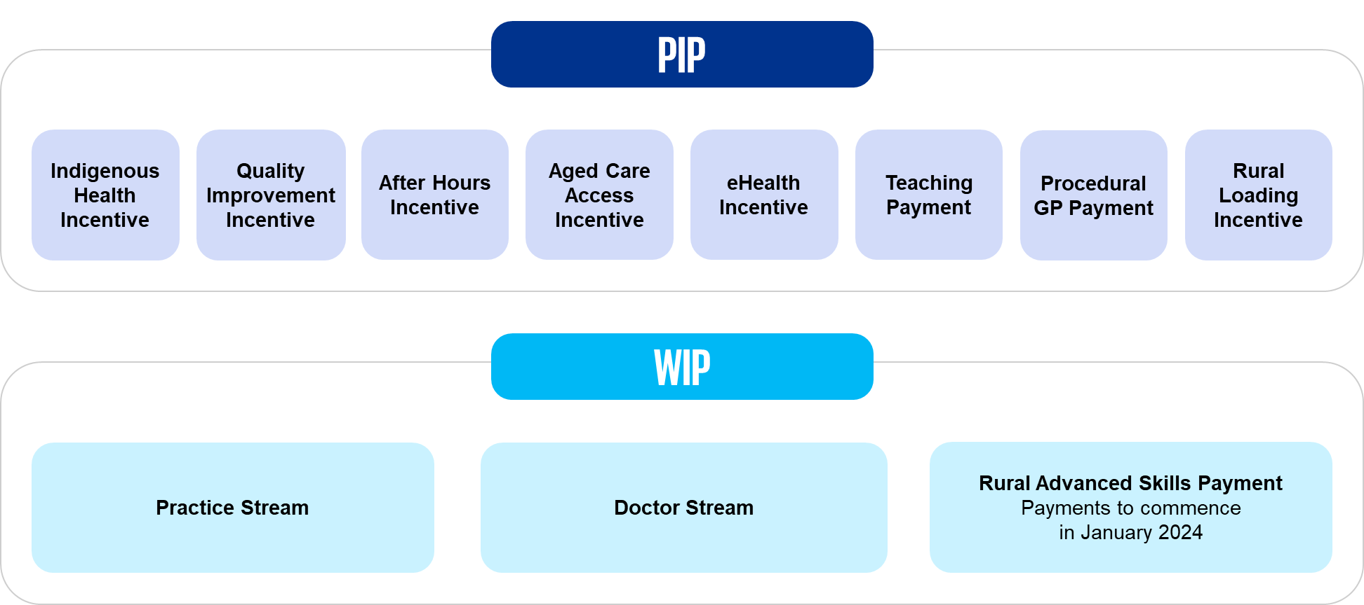

## Approach

This Review incorporates findings from a desktop review, consultation with the primary healthcare sector, and PIP and WIP payment data. A review framework guided the content analysis of insights. For further detail, see Section 4 Methodology.

### Desktop review

This Review considers findings from a desktop review of existing policy documentation, prior reviews of general practice incentive programs and relevant incentive guidelines.

### Consultation

This Review consolidates insights obtained through engagement with Primary Health Networks (PHNs), peak bodies, and the Australian primary healthcare workforce. Surveys, written submissions, and insights shared through consultations contributed to this Review.

### Data analysis

This Review presents information from both qualitative (e.g., stakeholder consultations, surveys, etc) and quantitative (e.g., payments data) sources. To complement qualitative information, a quantitative evidence base was established by analysing available data to understand payment volume and geographical distribution of incentive payments, and observing how these trends have evolved over time.

#### Data sources

##### Practice Incentive Program

Quantitative data was provided to the Department from Services Australia, with two data sets which were extracted on different dates. The first data set, data set “A”, contained payment data including quarterly information about each incentive, including payment tiers for each payment, aggregated at the postcode level. The second set of data, data set “B”, contained payment information for each incentive, aggregated at the practice level (but without information about payment tiers). All the charts and tables rely on information for data set “B” unless otherwise stated.

Please note that there may be differences in the total figures between the two data sets resulting from adjustments made to the underlying data during the period between data extraction dates.

##### Workforce Incentive Program

Similarly, data for the WIP was provided in two distinct reports. One report contained data for the WIP Practice Stream, and another combined data from the WIP Doctor Stream and General Practice Rural Incentives Program from 2020.

#### Survey data

This Review draws on data collected from a survey administered through the Department’s Consultation Hub. The survey featured questions tailored to each PIP and WIP incentive, utilising both multiple-choice and Likert scale formats. Where "survey respondents" are referenced in this Report, it specifically pertains to those respondents who selected to respond to a particular incentive. Data distinguishing respondents was based on whether or not they receive the incentive. There were varying numbers of respondents for each incentive in the survey. The findings and conclusions drawn from the survey data may not represent the perspectives of all survey participants, rather only those who opted for the specific incentives under examination.

Detailed survey findings, including the number of respondents, can be found in Appendix E : List of stakeholders.

### Review framework

This Review provides a summary of findings across four review domains: impact, effectiveness, efficiency, and sustainability. Each domain is associated with a set of primary review questions, sub‑questions, indicators, and relevant data sources.

### Strength of Evidence

This Review has applied the following guide in assessing the strength of evidence in determining the findings for each of the review domains:

* **Sufficient evidence**: The evidence is sufficient to draw a largely unqualified conclusion regarding the review question because either there is a single source of quality data or multiple sources of data, which have no major quality issues and that consistently support the conclusion reached.
* **Some evidence**: The evidence suggests the finding is reasonable and there is a supporting theoretical rationale but there are data limitations, such that the finding is qualified and further and/or different data (which may have been unavailable to this Review) would need to be sourced in order to be more confident in the conclusion reached.
* **Weak evidence**: The evidence is indicative of a finding but there are major shortcomings in the data, such that limited confidence can be placed on the conclusion.
* **No evidence**: No data exists upon which to make any finding. Note that there are no such examples of this in this Review.

The assessment of strength of evidence only relates to those review questions that require a conclusion to be drawn and not to review questions that require facts to be stated.

### Limitations

It is important to acknowledge data limitations in both qualitative and quantitative analyses. Stakeholders self-reported gaps in their awareness and understanding of general practice incentives, and highlighted insufficiently mature data collection methodologies for multiple incentives which hinders the establishment of connections between incentives and consumer health outcomes.

This Review had limitations regarding the scope of data analysis, primarily focusing on historical payments data. Analysing historical data alone can restrict the ability to draw conclusive insights about the impact, effectiveness, efficiency, or sustainability of incentive programs. To address key questions more directly, a more comprehensive quantitative analysis would necessitate additional data from various facets of the healthcare system. For instance, to assess the impact and effectiveness of a specific incentive payment, a quantitative approach could involve linking payment data to individual practices and then further connecting this to consumer data. This linkage would enable a deeper understanding of how incentive payments influence a consumer’s risk of avoidable hospitalisation, while accounting for potential confounding factors.

Similarly, to gauge incentive efficiency, data could be collected on administrative activities within primary healthcare practices. By quantifying the administrative burden associated with incentive reporting requirements, the efficiency of incentive programs could be assessed more accurately. This approach would provide valuable insights into the resource allocation and operational effectiveness of incentive schemes within the healthcare system.

For more detail regarding the review limitations of incentive evolution, causation and attribution, and data availability, refer to Limitations in the body of the Report.

## 

## Findings

This Review presents findings regarding general practice incentives. It also identifies overarching themes common to all incentives, followed by a detailed examination of the PIP and WIP.

Figure 2 Key review findings and strength of evidence

| Impact | Effectiveness | Efficiency | Sustainability |
| --- | --- | --- | --- |
| The PIP and WIP have limited impact. | The PIP and WIP have limited efficacy. | The PIP and WIP are perceived as inefficient. | The PIP and WIP do not support sustainable outcomes |
| * Incentives are perceived as complex and lacking clear alignment with broader policy objectives. * There is limited evidence of incentives contributing to consumer health outcomes or driving improvements in population health. * Incentives are not sufficiently responsive to accommodate emerging sector trends, such as workforce shortages. | * Incentives have limited influence on behaviour in general practices. * In general practices, there is variable awareness of incentives due to broader contextual factors. * Smaller practices, particularly those in rural areas, lack the administrative capacity to fully participate in general practice incentives. | * Administration is described as challenging and burdensome. * General practices reported difficulties reconciling incentive payments in business accounting, which was linked to a lack of understanding the outcomes of incentives. | * General practices rely on incentive payments for the sustainability of daily practice operations. * Stakeholders expressed concerns about how unintended consequences from other government initiatives could restrict both the immediate and long-term outcomes of incentives. |
| There is **weak evidence** to support these findings. | There is **some evidence** to support these findings. | There is **some evidence** to support these findings. | There is **some evidence** to support these findings. |

### Impact

#### Complexity of general practice incentive programs

Stakeholders acknowledged the policy objectives underlying individual PIP and WIP incentives but expressed uncertainty about the overall purpose of the programs. Each incentive serves a slightly different purpose, and there is a perceived need for incentives to adapt to better align with the current healthcare policy landscape. This lack of coherence contributes to the complexity of understanding and navigating general practice incentives.

#### Linkage to consumer health outcomes

Stakeholders, including PHNs and peak bodies, raised concerns regarding the lack of a clear linkage between the current incentive structures and improvements in consumer health outcomes. This disconnect presents challenges in accurately assessing the effectiveness of incentives and in fostering continuous improvement in healthcare delivery. To address these concerns, stakeholders advocated for the development of robust monitoring and evaluation frameworks tailored to each incentive program. These frameworks should incorporate metrics directly related to consumer health outcomes, enabling a more objective assessment of the impact of incentives on overall healthcare quality and effectiveness. Additionally, stakeholders emphasised the importance of ongoing monitoring and evaluation efforts to identify areas for improvement and inform potential adjustments to incentive structures to better align with desired health outcomes. Any design or implementation of monitoring frameworks should be balanced against practice data maturity and capacity to take on further administrative processes regarding linking incentive activities to consumer health outcomes.

#### Keeping pace with sector or practice trends

Stakeholders, including peak bodies and members of the primary healthcare workforce, highlighted the need for PIP and WIP incentive structures to evolve in response to the complex challenges facing the healthcare sector. These challenges include workforce shortages, changing dynamics in the General Practitioner (GP) workforce, such as increased focus on work-life balance, rising operational costs and wages, and the transformation of general practices from small to large businesses.

### Effectiveness

#### Limited influence on provider behaviour

Qualitative evidence suggests that incentives have a moderate or limited impact on individual provider behaviour. Some general practices reported prioritising the minimum requirements for incentivised activity to secure payment, reflecting the mitigating effect of time constraints on GPs and staff. Additionally, stakeholders perceived incentive values as somewhat inadequate to drive significant behavior change, indicating a slight misalignment between the value of incentives and desired outcomes.

#### Variable awareness and understanding

The primary healthcare workforce reported that general practice incentives are not universally understood across the sector, and that awareness of specific incentive purposes and structures is low even among GPs. Stakeholders emphasised the need for improved communication and awareness efforts.

#### Geographical disparities

Access to incentives improves with administrative sophistication, disadvantaging smaller practices that struggle to keep up with administrative demands. Furthermore, smaller practices, more commonly found in outer metropolitan, regional, rural, and remote areas, face challenges when accessing resources.

### Efficiency

#### Administration challenges

The complexity of incentive structures, coupled with varying administrative requirements and benefits, presents challenges for general practices. General practices described administration challenges resulting from diverse objectives, eligibility criteria, and payment calculations across the incentives, and requiring specialised knowledge and adaptable systems.

General practices emphasised that the funding received does not adequately compensate for the administrative burden associated with many of the incentives. Suggestions were made to streamline administrative processes accordingly and to increase select incentives to account for this burden. While the majority of stakeholders consulted feel that the benefits of incentives outweigh administrative costs, there is still a desire for greater value, reflecting a non-satiation problem.

#### Payment calculation differences

The calculation of payments under each incentive is not uniform and is contingent on various factors. General practices need to understand and adapt to the intricacies of payment calculations specific to each incentive, which may include performance metrics, consumer numbers, or other qualifying measures. Furthermore, there are discrepancies between the manner in which incentives are paid (e.g., lump sums) and their intended incentives (e.g., employing practice nurses or physiotherapists), highlighting a need for alignment in incentive design.

### Sustainability

#### Reliance on incentives for sustainability of practice operations

During consultation, all stakeholder groups emphasised that many healthcare practices rely on incentive payments for their financial sustainability. PHNs, peak bodies, and workforce focus groups highlighted how thin markets and workforce shortages in rural areas are placing pressure on healthcare practices in rural and remote communities to deliver affordable care despite rising costs. Many healthcare practices reported using incentive payments to offset the expenses associated with daily operations.

#### Crowded programmatic space

Stakeholders raised concerns about how unintended consequences from other government initiatives could constrain both the immediate and long-term outcomes of incentives. The incentive landscape is increasingly crowded, marked by numerous state-based incentives and overlapping programs. This saturation adds significant complexity, making it difficult for stakeholders to navigate and fully grasp the array of available incentives. Moreover, the overlapping nature of these programs complicates matters further, necessitating careful coordination and strategic decision-making to ensure optimal resource utilisation and alignment with practice objectives. As a result, stakeholders must contend with the complexities of this crowded, programmatic space to effectively leverage incentives and achieve desired outcomes.

### Future considerations for PIP Incentives

#### Indigenous Health Incentive

Aboriginal Community Controlled Health Services (ACCHS), Aboriginal Medical Services (AMS) and general practices largely agreed with the linking between the Indigenous Health Incentive and MyMedicare, however suggested broadening and enhancing the cultural safety training required as part of the incentive. The streamlining of administration processes was also suggested.

#### Quality Improvement Incentive

PHNs and peak bodies suggested aligning the preventative care incentive activities with broader strategic priorities, such as those outlined in the Primary Health Care Ten Year Plan, to better focus on chronic conditions. To facilitate the quality improvement intent of the incentive, practices also requested the incentive ensure that primary healthcare practices receive feedback from PHNs regarding the data they submit.

#### After Hours Incentive

Workforce focus groups suggested increasing the tiers of the After Hours Incentive or introducing a lower payment value ’Extended Hours PIP‘ to support practices in the time period before official after hours start but after employed practice staff receive overtime rates. To assist in workforce planning and consumer awareness of services, PHNs and peak bodies requested introducing data visibility mechanisms for both incentives.

#### GP Aged Care Access Incentive

Workforce focus groups suggested alternate incentive structures that might better reflect travel time and the requirements of consumers living in residential aged care facilities, and incorporation of a monitoring framework to measure the impact of reduced hospital admissions due to the incentive. PHNs also suggested that gaps in primary healthcare services in aged care facilities could be addressed through PHN commissioning models.

The GP Aged Care Access Incentive is being replaced by the General Practice in Aged Care Incentive from 1 August 2024.

#### eHealth Incentive

All stakeholder groups suggested improving data transparency mechanisms to ensure quality of My Health Record uploads, enhanced support for technology uptake, and streamlining of administration processes related to My Health Record uploads by integrating systems with practice workflows.

#### Teaching Payment

Workforce focus groups requested that the incentive payment value be increased to offset the opportunity cost of seeing fewer consumers, along with adjusting incentive guidelines to allow for ‘small groups’ of medical students and to encourage quality teaching, rather than having students ‘observe from the corners’. Peak bodies suggested broadening the incentive scope to include nurses, nurse practitioners, and midwives. All stakeholder groups suggested streamlining administrative processes.

#### Procedural GP Payment

PHNs and rural workforce focus groups suggested expanding the range of eligible services to increase incentive uptake, support rural healthcare delivery, and address workforce shortages. There were also calls to support the upskilling of Rural Generalists through this incentive.

### considerations for WIP Incentives

#### Practice Stream

PHNs, peak bodies, and workforce focus groups suggested alternative incentive structures to prioritise multidisciplinary team-based care, such as networking local practices or commissioning teams that can address need, rather than reliance on the current medically-led model.

#### Doctor Stream

Peak bodies and rural GPs identified multifaceted factors (i.e. accommodation, partner’s career, and schooling) that influence where people choose to work and suggested exploring alternate incentive mechanisms for attracting doctors to rural and remote communities.

#### Rural Advanced Skills Payment

Given the timing of the Review and commencement date of the Rural Advanced Skills payment, this Review was not able to provide a comprehensive understanding of the effectiveness of the payment.

### Future considerations for PIP Incentives

#### Indigenous Health Incentive

Aboriginal Community Controlled Health Services (ACCHS), Aboriginal Medical Services (AMS) and general practices largely agreed with the linking between the Indigenous Health Incentive and MyMedicare, however suggested broadening and enhancing the cultural safety training required as part of the incentive. The streamlining of administration processes was also suggested.

#### Quality Improvement Incentive

PHNs and peak bodies suggested aligning the preventative care incentive activities with broader strategic priorities, such as those outlined in the Primary Health Care Ten Year Plan, to better focus on chronic conditions. To facilitate the quality improvement intent of the incentive, practices also requested the incentive ensure that primary healthcare practices receive feedback from PHNs regarding the data they submit.

#### After Hours Incentive

Workforce focus groups suggested increasing the tiers of the After Hours Incentive or introducing a lower payment value ’Extended Hours PIP‘ to support practices in the time period before official after hours start but after employed practice staff receive overtime rates. To assist in workforce planning and consumer awareness of services, PHNs and peak bodies requested introducing data visibility mechanisms for both incentives.

#### GP Aged Care Access Incentive

Workforce focus groups suggested alternate incentive structures that might better reflect travel time and the requirements of consumers living in residential aged care facilities, and incorporation of a monitoring framework to measure the impact of reduced hospital admissions due to the incentive. PHNs also suggested that gaps in primary healthcare services in aged care facilities could be addressed through PHN commissioning models.

The GP Aged Care Access Incentive is being replaced by the General Practice in Aged Care Incentive from 1 August 2024.

#### eHealth Incentive

All stakeholder groups suggested improving data transparency mechanisms to ensure quality of My Health Record uploads, enhanced support for technology uptake, and streamlining of administration processes related to My Health Record uploads by integrating systems with practice workflows.

#### Teaching Payment

Workforce focus groups requested that the incentive payment value be increased to offset the opportunity cost of seeing fewer consumers, along with adjusting incentive guidelines to allow for ‘small groups’ of medical students and to encourage quality teaching, rather than having students ‘observe from the corners’. Peak bodies suggested broadening the incentive scope to include nurses, nurse practitioners, and midwives. All stakeholder groups suggested streamlining administrative processes.

#### Procedural GP Payment

PHNs and rural workforce focus groups suggested expanding the range of eligible services to increase incentive uptake, support rural healthcare delivery, and address workforce shortages. There were also calls to support the upskilling of Rural Generalists through this incentive.

### Future considerations for WIP Incentives

#### Practice Stream

PHNs, peak bodies, and workforce focus groups suggested alternative incentive structures to prioritise multidisciplinary team-based care, such as networking local practices or commissioning teams that can address need, rather than reliance on the current medically-led model.

#### Doctor Stream

Peak bodies and rural GPs identified multifaceted factors (i.e. accommodation, partner’s career, and schooling) that influence where people choose to work and suggested exploring alternate incentive mechanisms for attracting doctors to rural and remote communities.

#### Rural Advanced Skills Payment

Given the timing of the Review and commencement date of the Rural Advanced Skills payment, this Review was not able to provide a comprehensive understanding of the effectiveness of the payment.

Introduction

# Introduction

The rapid, retrospective Effectiveness Review of General Practice Incentives (the Review) has been prepared for the Department of Health and Aged Care (the Department) as part of a broader effort to reform primary health care in line with the Strengthening Medicare Taskforce Report (the Report). The Report made recommendations for reform of primary health care, including that the Government support general practice in managing complex chronic diseases through blended funding models integrated with fee-for-service, with funding for longer consultations and general practice incentives that better promote quality bundles of care for people who need it most (DoHAC 2023e).

This Review consolidates insights gathered through a range of consultations, including workshops and focus groups with Primary Health Networks (PHNs), peak bodies, and the primary healthcare workforce in general practices across Australia. Additionally, it incorporates findings from a desktop review of existing policy documentation, previous reviews and evaluations, and relevant incentive guidelines.

To support the qualitative data acquired from stakeholder consultations and desktop analysis, limited quantitative analyses were also performed on available data in order to understand both the volume and geographical distribution of payments across various incentive programs, as well as examining how these trends have evolved over time.

This Review offers a summary of findings, encompassing background and policy context, and insights across the four domains of inquiry of: impact, effectiveness, efficiency, and sustainability. Each domain is linked to a set of key review questions, sub-questions, indicators, and data sources, as detailed in Appendix I : Review framework models..

### Scope of the Effectiveness Review

This Review encompasses a total of 11 general practice incentives, comprising eight from the PIP (Indigenous Health, Quality Improvement, After Hours, GP Aged Care Access, eHealth, Teaching Payment, Procedural GP Payment, and Rural Loading Incentive) and three from the WIP (the Practice Stream, Doctor Stream, and the Rural Advanced Skills Payment).

This Review examined PIP and WIP incentives in the context of the policy objectives of each incentive, the current state of primary health care in Australia, and the strategic direction informing the primary healthcare sector. Findings from surveys, written submissions, and consultations, along with data analysis on incentive payment values and distributions, contributed to the Review.

Figure 3 PIP and WIP incentives



## Considerations and limitations

Considerations and limitations provided essential insights into the factors that influenced the findings of this Review. This section outlines relevant considerations and limitations regarding the scope and methodology used in conducting the Review.

### Evolution of the PIP and WIP over time

One potential limitation arises from the individual implementation of each incentive, addressing specific needs of the primary healthcare system at different times. Additionally, the unique policy journeys and refinement processes for each incentive have taken place independently. Only in their most recent iteration have some incentives been consolidated under the PIP and WIP. The changes to incentive programs and guidelines over time may present a limitation, as some feedback from PHNs and the primary healthcare workforce describes current incentives using terminology and mechanisms from previous incentive designs. See Figure 4 in General practice incentive programs for a detailed timeline regarding individual incentive establishment.

### Causation, attribution and contribution

PIP and WIP incentives and their payments are only one mechanism to achieve the distinct outcomes sought through each incentive. Causal inference is a crucial component of linking inputs to outcomes, as illustrated by the program logic models for the PIP and WIP.

With such programs, the following principles are useful for determining outcomes:

* To determine the causation of a specific outcome, there needs to be a demonstrated causal link between the outcome and evaluated program or behaviour
* The causal link does not have to be demonstrated with 100 per cent certainty; the level of certainty should match the context of decision making and outcomes
* A mix of strategies (qualitative and quantitative) should be used to infer causation.

Contribution analysis can support the assessment of causal questions and inferring causality in the review of general practice incentives. It is particularly useful in providing evidence and a line of reasoning from which we can draw a plausible conclusion that, within some level of confidence, the incentive has made an important contribution to the documented results. It is important to note that contribution analysis is less suitable for traditional causality questions, such as: ‘Has the program caused the outcome?’. It is more appropriate to pose contribution questions, such as: ‘Has the program influenced the observed result?’ or ‘Has the program made an important contribution to the observed result?’.

Given the context in which each incentive has been implemented, contribution analysis is the most appropriate means to infer causality.

### Data availability

The availability, quality, and granularity of data significantly influenced the depth of quantitative insights attainable. Due to project timeframe constraints and data availability, this Review’s data analysis scope was limited to high-level aggregations at the regional level. These were intended to complement information gathered from stakeholder consultations.

However, the impact of direct measurement of incentive payments on intended outcomes was constrained by the lack of linked data. For instance, determining whether the After Hours Incentive effectively reduced the burden on nearby emergency departments was not feasible due to the absence of consumer-level linked data.

Stakeholder perceptions regarding the PIP and WIP data collections, as well as considerations for future data availability, are taken into account in the body of this Report.

Furthermore, it is important to mention that full-year data across all relevant incentives was only accessible from 2021 to 2023, which further limited the scope of the analysis.

## How to navigate this Review

This Review is structured as follows:

| Chapter title | Chapter description |
| --- | --- |
| **Overview** | This section provides policy context for general practice incentives, offering background information on the incentive programs. |
| **Methodology** | This section outlines the approach taken to develop the Review, including details on consultation methods, data collection processes, and analysis methodologies employed. |
| **Expenditure** | This section presents expenditure data across both the PIP and the WIP to assess their impact on the healthcare system. Total expenditure for each program was disaggregated and analysed to understand their respective contributions.  Detailed expenditure data for the PIP and WIP can be found in PIP and WIP Summary Findings. |
| **Impact** | This section summarises findings related to the Impact domain. It includes an assessment of incentive alignment with broader policy objectives and their contributions to the healthcare system. |
| **Effectiveness** | This section summarises findings related to the Effectiveness domain. It includes an assessment of the overall effectiveness of general practice incentives in achieving their intended goals and influencing behavior in general practice. |
| **Efficiency** | This section summarises findings related to the Efficiency domain. It includes an assessment of administrative efficiency factors such as burden, complexity, payment mechanisms, and overall efficiency of the programs. |
| **Sustainability** | This section summarises findings related to the Sustainability domain. It includes an assessment of the sustainability of incentive-driven consumer health outcomes and incentive programs within the broader policy context. |
| **PIP Summary Findings** | This section summarises key insights and conclusions pertaining to the PIP, offering a comprehensive overview of its impact, effectiveness, efficiency, and sustainability. |
| **WIP Summary Findings** | This section summarises key insights and conclusions pertaining to the WIP, offering a comprehensive overview of its impact, effectiveness, efficiency, and sustainability. |
| **Summary of Insights** | This section offers a comprehensive synthesis of key findings and takeaways from the Review, reflecting actionable insights shared by stakeholders to inform future policy and programmatic decisions relating to general practice incentives. |

### A note on language

Throughout this document, the words ‘health care’ are used when referring to a noun (for example, ‘the state of primary health care in Australia’) and ‘healthcare’ is used when referring to an adjective (for example, the ‘primary healthcare workforce’ or ‘healthcare services’).

Overview

# Overview

This chapter provides an overview of the policies and strategies that intersect with and shape the incentive programs under consideration in this Review (refer to Figure 3 PIP and WIP incentives). It assesses their alignment with government policy in light of the Primary Health Care Ten Year Plan 2022 2032 and the Strengthening Medicare Taskforce report.

## Policy context

### Key government policies and strategies

Within the primary healthcare sector, several Commonwealth Government policies and strategies play a pivotal role in guiding its direction. It is imperative that the objectives of general practice incentive programs align with these overarching policies and incorporate recent recommendations aimed at reforming primary healthcare.

This chapter delves into the key policies and frameworks that shape the landscape and set the tone for incentive program alignment with broader policy objectives.

|  |  |
| --- | --- |
| The Primary Health Care Ten Year Plan  [The Primary Health Care Ten Year Plan](https://www.health.gov.au/resources/publications/australias-primary-health-care-10-year-plan-2022-2032) (the Plan), spanning 2022 to 2032, outlines national aims and objectives for the primary healthcare sector. The plan utilises the Quadruple Aim, which covers consumer experience of care, population health, health system cost-efficiency, and the work experiences of healthcare providers. Objectives of the Plan include access to health care, Closing the Gap, managing both health and wellbeing in communities, continuity of care, health system integration, future focus, and continual safety and quality improvement. |  |
| The Strengthening Medicare Taskforce report  [The Strengthening Medicare Taskforce report](https://www.health.gov.au/sites/default/files/2023-02/strengthening-medicare-taskforce-report_0.pdf), released in January 2023, made recommendations for reform of primary health care. These included recommendations that the Government support healthcare providers in the management of complex chronic disease through blended funding models, integrating incentive payments with fee-for-service and funding quality bundles of care for people who need it most. |  |
| The National Digital Health Strategy  [The National Digital Health Strategy](https://www.digitalhealth.gov.au/about-us/strategies-and-plans/national-digital-health-strategy-and-framework-for-action) outlined seven strategic priority outcomes to be achieved by 2022. The strategy highlighted the need for greater availability of health information, exchanged securely and commonly understood information, and promoted digitally enabled models of care, along with electronic prescribing. Other outcomes included upskilling the health workforce in digital health technology and supporting innovation throughout the industry. |  |
| The Digital Health Blueprint and Action Plan  [The Digital Health Blueprint and Action Plan](https://www.health.gov.au/resources/publications/the-digital-health-blueprint-and-action-plan-2023-2033?language=en) together outline the 10‑year vision for Australia’s digital health from 2023 to 2033. The vision focuses on connected health and wellbeing experiences underpinned by trusted, timely, and accessible use of digital health and data. The Blueprint’s guiding principles and outcomes are relevant to the primary healthcare sector, along with various initiatives of the Action Plan, including MyMedicare and the conversion of My Health Record into a data-rich platform. |  |
| National Aboriginal and Torres Strait Islander Health Plan 2021-2031  [The National Aboriginal and Torres Strait Islander Health Plan 2021-2031](https://www.health.gov.au/resources/publications/national-aboriginal-and-torres-strait-islander-health-plan-2021-2031?language=en) is the new guiding document to improve health and wellbeing outcomes for Aboriginal and Torres Strait Islander peoples. Acknowledging cultural and social determinants of health, the plan describes 12 priorities and two implementation plans, covering 2022 to 2026 and 2027 to 2031 respectively. Key themes of the plan include a focus on prevention, improving the health system for First Nations consumers, and enabling change through genuine shared decision making and growing the Aboriginal health sector. |  |
| The Stronger Rural Health Strategy  [The Stronger Rural Health Strategy](https://www.health.gov.au/topics/rural-health-workforce/stronger-rural-health-strategy) aims to build the health workforce in rural, regional, and remote areas, recognising the challenges in attracting healthcare professionals to these areas. The strategy has three streams, each encompassing multiple initiatives to improve health workforce supply across the country. These streams are: Teach, Train, Recruit and Retain. |  |
| The National medical Workforce Strategy 2021-2031  [The National Medical Workforce Strategy 2021-2031](https://www.health.gov.au/our-work/national-medical-workforce-strategy-2021-2031) describes the current state of Australia’s medical workforce. The strategy’s five priorities are: 1) workforce planning and design, 2) rebalancing supply and distribution, 3) reforming training pathways, 4) building generalist capability, and 5) building a flexible and responsive workforce. |  |
| The National Rural Generalist Pathway  Established in response to calls in 2018 by the National Rural Health Commissioner, the [National Rural Generalist Pathway](https://www.health.gov.au/our-work/national-rural-generalist-pathway) provides specific training for rural generalists to ensure that GPs and registrars have the right skills to practice in rural settings and can address the shifting needs of regional, rural and remote communities. The goals of the national pathway are to: formally recognise the role and skills of rural generalists, improve training coordination and other support, increase opportunities for doctors to train, and to keep doctors working in regional, rural, or remote communities. |  |
| The Nurse Practitioner Workforce Plan  [The Nurse Practitioner Workforce Plan](https://www.health.gov.au/our-work/nurse-practitioner-workforce-plan) outlines the need to utilise Nurse Practitioners (NPs) to their full potential in Australia’s healthcare system, specifying four overarching outcomes: increase NP services across the country, improve community awareness and knowledge of NP services, support NPs to work to their full scope of practice, and grow the NP workforce to reflect the diversity of the community and improve cultural safety. |  |
| The National Rural and Remote Nursing Generalist Framework  [The National Rural and Remote Nursing Generalist Framework](https://www.health.gov.au/resources/publications/the-national-rural-and-remote-nursing-generalist-framework-2023-2027?language=en) provides guidance for Registered Nurses in rural and remote contexts, covering four domains, including culturally safe practice; critical analysis; relationships, partners and collaboration; and capability for practice. The framework intends to support nurses to work at their full scope of practice, including in the primary healthcare sector, and acknowledges the legacy experienced in rural and remote areas that have historically been under‑served by the healthcare system. |  |
| Strategic Directions for Australian Maternity Services  [The Strategic Directions for Australian Maternity Services](https://www.health.gov.au/resources/publications/woman-centred-care-strategic-directions-for-australian-maternity-services?language=en) provides overarching national strategic directions to support the delivery of maternity services from conception until 12 months after the pregnancy or birth. These directions apply across the primary healthcare sector, including GP Obstetricians, primary healthcare practices employing midwives, and Aboriginal community controlled birthing on country programs. The directions include four values and principles of safety, respect, choice, and access, as well as a monitoring and evaluation framework for sector and service assessment. |  |

|  |
| --- |
| The Primary Health Care Ten Year Plan  In August 2019, the Australian Government initiated the development of a 10 year plan for primary health care, aiming to enhance the nation’s health system. It emphasises various types of primary healthcare services and aims to integrate primary health care with other parts of the health system, aged care, disability care and social care systems. The plan adopts the Quadruple Aim framework, focusing on improving care experience, population health, cost-efficiency, and the work life of healthcare providers. The objectives include:   * Access: Support equitable access to the best available primary healthcare services * Close the Gap: Reach parity in health outcomes for First Nations peoples * Keep people well: Manage health and wellbeing in the community * Continuity of care: Support continuity of care across the health care system * Integration: Support care system integration and sustainability * Future focus: Embrace new technologies and methods * Safety and quality: Support safety and quality improvement.   The Plan’s objectives are supported by six enablers: People – at the centre of care, Funding reform, Innovation and technology, Research and data, Workforce, and Leadership and culture. These actions span areas such as telehealth, data-driven insights, funding reform, multidisciplinary team-based care, community control, rural access improvement, and empowering individuals in preventative health. The overarching goal is to achieve a significant transformation in primary health care delivery and community engagement over the next decade.  The Strengthening Medicare Taskforce report  To ensure Australia’s primary care system can meet the current and future challenges and reflect new models of care, the Minister for Health and Aged Care brought together a group of health leaders to form the Strengthening Medicare Taskforce (the Taskforce). The Taskforce was charged with identifying the most pressing investments needed in primary care, building on the direction outlined in Australia’s Primary Health Care 10 Year Plan 2022–2032 (DoHAC, 2023e).  The Strengthening Medicare Taskforce report was released in January 2023. The report examined the challenges and opportunities presented by the evolving nature of primary care, acknowledging the shifting burdens of disease and other population health needs increasing demand for general practice. The report addressed critical aspects, such as changes to meet health needs regardless of consumer background, including multidisciplinary care, digital health services and technology, and alignment across current reform processes.  In this context, the Taskforce recognised the need for adaptability and responsiveness in incentive programs to address emerging challenges, including the impact of technological advancements, workforce shortages, and the unique healthcare needs of diverse populations. The report identifies where Government needs to invest to re‑build primary care as the vibrant core of an effective, modern health system (DoHAC, 2023e). The recommendations outlined in the report aimed to lay the foundation for a resilient and consumer-centred primary care system, where incentives act as strategic drivers, rather than as mere financial supports. Recommendations included that the Government should endeavour to support health care providers in the management of complex chronic disease through blended funding models, integrating incentive payments with fee-for-service, and funding quality bundles of care for people who need it most.  In response to the recommendations of the Strengthening Medicare Taskforce report, the Effectiveness Review of Incentives Programs was announced in the 2023-24 Budget. The Review’s findings will inform future redesign of the current general practice incentive programs. The ultimate aim is to provide high‑quality, consumer-centred primary care delivered by multidisciplinary teams in accredited general practices, including those led by Nurse Practitioners. New blended payment models will also be directly linked to better care and outcomes for consumers registered with MyMedicare. |

### Expenditure in primary care

The Australian Government is the main funder of primary care in Australia. This system offsets costs to consumers, as most primary care is delivered through small to large private businesses, including general practice clinics, pharmacies, and allied health practices. In addition to services offered through private general practice and state and territory funded services, First Nations peoples may also access primary healthcare through ACCHS, which receive Australian Government funding along with grants from state and territory governments.

The presence of parallel projects funded by the Australian Government significantly impacts the functioning and effectiveness of the PIP and WIP incentives. Among the various initiatives, the rollout of Medicare Urgent Care Clinics and the Strengthening Medicare General Practice Grants Program are notable examples. These strategic investments have implications for general practice incentives, as highlighted by feedback from peak bodies and practices during consultations and surveys.

For instance, the introduction of Medicare Urgent Care Clinics provides consumers with an alternative for after hours care, causing some confusion regarding the place of general practice after hours service provision. This influences practices’ decisions regarding engagement with the PIP After Hours Incentive. The interaction between these government initiatives and primary care incentives underscores the complexity and interdependency within the healthcare funding landscape, highlighting the need for coordinated approaches to achieve optimal outcomes.

## General practice incentive programs

General Practice Incentive Programs, comprising the WIP and the PIP, are integral components of Australia’s healthcare framework. The PIP serves as an incentivising mechanism for general practices, encouraging sustained delivery of quality care, expansion of operational capacity, and improved accessibility and health outcomes for consumers. The WIP aims to enhance access to quality medical, nursing, midwifery, and allied health services in regional, rural, and remote areas.

Established at varying points in time, these programs are structured to bring about positive changes within the primary healthcare sector. Figure 4 shows the full list of dates when PIP and WIP incentives were established**.** Previous iterations of PIP and WIP incentives, such as the Practice Nurse Incentive Program preceding the current WIP Practice Stream, are not included in the timeline.

Figure 4 Timeline of PIP and WIP incentive program establishment

Source: Department of Health and Aged Care.

Timeline of PIP and WIP incentive establishment.
August 1999: PIP commenced, Rural Loading established, After Hours Incentive established.
May 2000: Teaching Payment established.
March 2003: Procedural GP Payment established.
July 2008: GP Aged Care Access Incentive established.
August 2009: eHealth Incentive established.
May 2010: Indigenous Health Incentive established.
July 2015: After Hours Incentive redesigned and introduced.
August 2019: Quality Improvement Incentive commenced.
January 2020: WIP Doctor Stream commenced.
February 2020: WIP Practice Stream commenced.

### The Practice Incentive Program

#### Overview

The PIP was established in 1998 based on recommendations from the General Practice Strategy Review Group, aiming to enhance general practice, improve consumer outcomes, and provide financial incentives. The PIP is a set of incentive payments available to general practices to encourage continued quality care, enhance capacity and improve consumer health outcomes (Services Australia, 2023e). The PIP recognises general practices that provide comprehensive, quality care and that are accredited or working towards accreditation against the Royal Australian College of General Practitioners (RACGP) Standards for General Practice.

Since its inception, the PIP has undergone multiple changes, including consolidations and discontinuations of individual incentives.

#### Design

There are currently three streams of incentives under the PIP:

* Quality stream
* Capacity stream
* Rural support stream.

##### *Quality Stream*

Practice incentive payments are made to practices undertaking quality improvement activities with a focus on quality provision of care. Quality stream payments include the Quality Improvement Incentive and the Indigenous Health Incentive.

##### *Capacity stream*

Capacity stream payments are designed to boost the capacity of general practice for specific purposes or to address gaps. Payments include the After Hours Incentive, eHealth Incentive, and Teaching Payment. The GP Aged Care Access Incentive, a SIP, also falls under this stream.

In 2021-2022, temporary COVID-19 vaccine payments were also included under this stream to incentivise general practices to participate in the COVID-19 vaccination program and also to compensate general practices for providing in-reach vaccination clinics in the disability and aged care sectors. However, this incentive is not in scope for this Review.

##### *Rural support stream*

Rural support payments are made to practices whose main practice location is outside a capital city or other major metropolitan centre. This recognises the difficulties and higher cost of providing care in rural and remote areas. Payments include the Procedural GP Payment and the Rural Loading.

PIP incentives may be paid either to practices, as practice incentive payments, or directly to GPs, as service incentive payments. The payments are administered by Services Australia on behalf of the Department.

Practice Incentive Payments

Practice incentive payments contribute to quality care. A practice may use the payment for new equipment, to upgrade facilities or increase pay for practitioners.

Service Incentive Payments (SIPs)

SIPs recognise and encourage GPs to provide specific services to consumers.

Table 1 List of individual incentive programs under the PIP

Source: Services Australia.

| Stream | Incentive programs |
| --- | --- |
| **Quality Stream** | * Indigenous Health Incentive (PIP IHI) * Quality Improvement Incentive (PIP QI) |
| **Capacity Stream** | * After Hours Incentive (PIP AH) * GP Aged Care Access Incentive (PIP GP ACAI) * eHealth Incentive (ePIP) * Teaching Payment |
| **Rural Support Stream** | * Procedural GP Payment * Rural Loading Incentive |

To qualify for the PIP, practices must meet certain eligibility criteria, including accreditation or registration for accreditation against the RACGP Standards. Additionally, they are required to have public liability insurance and professional indemnity insurance covering all GPs and NPs.

To apply for the PIP, practices and individuals can submit their applications online through the Health Professional Online Services (HPOS) using their Provider Digital Access (PRODA) account. To ensure eligibility, applicants must meet the specified criteria, provide necessary documentation, and maintain records for the individual incentives they wish to access.

The PIP aims to provide a flexible, cost-effective mechanism for the Government to encourage both short and long-term changes to general practice, to support quality care, and to improve access and health outcomes with minimal red tape. Each incentive program has its own unique aim, as described below.

Table 2 PIP incentive aims

Source: PIP Incentive Guidelines.

| Incentive | Aim |
| --- | --- |
| **Indigenous Health** | The Indigenous Health Incentive (PIP IHI) supports general practices and Indigenous health services to provide better health care for their Aboriginal and/or Torres Strait Islander consumers, including best practice management of chronic diseases and mental disorders (Services Australia, 2023d). |
| **Quality Improvement** | The Quality Improvement Incentive (PIP QI) is a payment to general practices that participate in quality improvement to improve consumer outcomes and deliver best practice care (Services Australia, 2023g). |
| **After Hours** | The After Hours Incentive (PIP AH) supports general practices to provide their consumers with appropriate access to after hours care (Services Australia, 2023a). |
| **GP Aged Care Access** | The GP Aged Care Access Incentive (GP ACAI) aims to encourage GPs to provide increased and continuing services in residential aged care facilities (Services Australia, 2023c). |
| **eHealth** | The eHealth Incentive (ePIP) aims to encourage general practices to keep up to date with the latest developments in digital health and adopt new digital health technology as it becomes available (Services Australia, 2023b). |
| **Teaching Payment** | The Teaching Payment aims to encourage general practices to provide teaching sessions to undergraduate and graduate medical students preparing to enter the Australian medical profession (Services Australia, 2023i). |
| **Procedural General Practitioner** | The Procedural GP Payment aims to encourage GPs and Rural Generalists in rural and remote areas to maintain local access to surgical, anaesthetic and obstetric services (Services Australia, 2023f). |
| **Rural Loading** | The PIP Rural Loading recognises the difficulties of providing care, often with little professional support, in rural and remote areas (Services Australia, 2023h). |

### The Workforce Incentive Program

#### Overview

The WIP was introduced as a key component of the 10-year Stronger Rural Health Strategy 2018-2019. Implemented in January 2020. The WIP emerged as a successor to General Practice Rural Incentives Program (GPRIP) and Practice Nurse Incentive Program (PNIP). This transition included the initiation of the WIP Doctor Stream and the incorporation of the PNIP into the WIP Practice Stream. Subsequent updates, such as the 2023–24 Budget’s Strengthening Medicare package, led to further WIP iteration, emphasising the Australian Government’s commitment to multidisciplinary care through increased incentives and targeted measures effective from 1 July 2023. See the section entitled Previous reviews of general practice incentives for more information regarding previous reviews into WIP Streams.

#### Design

Administered by Services Australia on behalf of the Department, the program has three incentive streams with a total of seven payment mechanisms, including rural payment scaling mechanisms. The calculation and payment of incentives are retrospective, based on practice applications, subsequent amendments, and Medicare/DVA data. Each WIP incentive has an individual aim, as outlined in Table 3.

Table 3 WIP Stream aims and payment systems

Source: WIP Incentive Guidelines.

| Stream | Aim | Payment System |
| --- | --- | --- |
| **Practice Stream** | The Practice Stream (WIP PS) provides financial incentives to help general practices with the cost of engaging nurses, midwives, allied health professionals, paramedics, and/or Aboriginal and Torres Strait Islander health workers and practitioners. | * Quarterly incentive payments * Quarterly rural loading payments * Annual Department of Veterans’ Affairs (DVA) loading payments. |
| **Doctor Stream** | The Doctor Stream (WIP DS) promotes careers in rural medicine by giving doctors, including Rural Generalists, financial incentives to practise in regional, rural and remote communities. | * Central Payment System (CPS) for doctors billing under the Medicare Benefits Schedule (MBS) * Flexible Payment System (FPS) for doctors providing services or training not reflected in the MBS. |
| **Rural Advanced Skills Payment\***  *commenced January 2024 | The Rural Advanced Skills Payment (WIP RAS) rewards investment in specialist qualifications and advanced skills and encourages more doctors to work in a variety of settings using these skills in regional, rural and remote areas. | * Emergency Medicine for doctors providing emergency care and after hours services * Advanced Skills for doctors with recognised qualifications providing specialised services. |

### Alignment with policy context

The PIP and WIP demonstrate alignment with the country’s national health policies and strategies. Both incentive programs converge on thematic aims and targets that emphasise rural and remote health, improved access to services, and comprehensive workforce development and training as shown in Figure 5. These incentive programs also closely mirror priorities outlined within key Australian national health plans and strategies. This includes the Primary Care 10-Year Plan, the Strengthening Medicare Taskforce report, and various national workforce strategies. Select incentive programs directly reinforce specific aims or objectives within these strategies as demonstrated in Figure 6.

Figure 5 Thematic analysis of national policies to WIP and PIP aims

Figure 5 is a visual analysis presenting how federal government health policies share areas of policy focus and map to PIP and WIP incentive programs.

Figure 6 Alignment of aims between GP incentives and national policies

Figure 6 is a visual analysis showing how PIP and WIP incentives align to national health policies and strategies through a table with tickboxes.

### Previous reviews of general practice incentives

Since the inception of the PIP and the WIP, several reviews have been undertaken to assess their effectiveness and impact. The extent and depth of these reviews have varied widely, with select programs and incentives not being evaluated.

Of the eight incentives under the PIP, seven have previously been reviewed, including the PIP AH Incentive, Indigenous Health Incentive, Quality Improvement Incentive, eHealth Incentive, Teaching Payment, Procedural GP Payment, and Rural Loading Incentive. The first formal review of the PIP AH incentive took place in 2013, marking the beginning of an ongoing assessment process. The GP Aged Care Access Incentive has not previously been subjected to evaluation.

In response to a 2003 Productivity Commission report revealing significant administrative costs across general incentive programs, adjustments were made to the PIP as a whole. In 2010, the Australian National Audit Office recommended further changes to focus on monitoring of quality health care. Subsequently, in 2016-17, five PIP incentives were consolidated into the PIP QI Incentive, emphasising continuous quality improvement and discontinuing specific incentives for chronic disease treatment. The new PIP QI was implemented in 2019 following consultation.

Before the inception of the WIP in 2020, the GPRIP, now referred to as the Doctor Stream, had undergone progressive iterations since 1992. The GPRIP, along with the PNIP, were reviewed as part of the Review of Australian Government Health Workforce Programs in 2013, which made a range of recommendations to support healthcare professions, including updating rurality measures.

Table 4 Reviews of PIP and WIP Incentives

Source: Department of Health and Aged Care.

| Program | Incentive | Review |
| --- | --- | --- |
| **PIP** | **Indigenous Health** | 2019 |
| **Quality Improvement** | 2020 |
| **After Hours** | 2014 |
| **GP Aged Care Access Incentive** | N/A |
| **eHealth** | 2021, 2023 |
| **Teaching Payment** | 2023 |
| **Procedural GP** | 2022 |
| **Rural Loading** | 2023 |
| **WIP** | **Practice Stream** | N/A |
| **Doctor Stream** | N/A |
| **Rural Advanced Skills Payment (commenced January 2024)** | N/A |

Methodology

# Methodology

This section outlines the approach taken to develop the Review. Key elements of the project approach are described, including the adoption of a mixed methods approach (involving quantitative and qualitative research):

• The review framework, which serves as a structured guide, outlining the key domains and indicators used to assess program effectiveness

• The consultation process, involving PHNs, peak bodies and the primary healthcare workforce focus groups, engaged to capture diverse experiences

• The data analysis process, providing insights into how both quantitative and qualitative data are processed and synthesised.

The chapter concludes by explaining how collected insights are utilised to form a cohesive narrative to ultimately support the Review.

## Review design

### Initial desktop review

In the initial phase, a desktop review was conducted, encompassing policy documents, reports, and reviews pertinent to PIP and WIP incentives. This preliminary stage facilitated a comprehensive examination of the available information, ensuring alignment with the Review’s predefined scope.

### Development of a review framework

To support the Review, a rapid review framework (the framework) was developed. The framework was rooted in a standard evaluation protocol, facilitating the document analysis across four Review domains: impact, effectiveness, efficiency, and sustainability (see Figure 7 Rapid Review domains).

Figure 7 Rapid Review domains

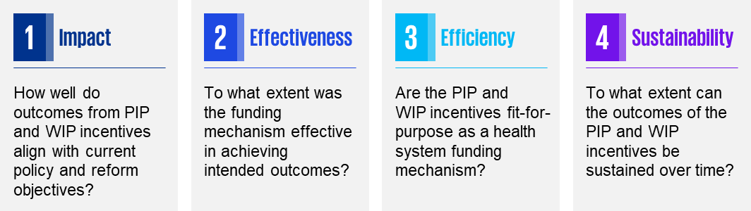

A logic model was employed to enhance comprehension of the PIP and WIP incentives within the identified domains. This model facilitated a comprehensive understanding of program operations, covering inputs, activities, outputs, outcomes, and impacts. The goal was to capture a holistic overview of the program’s functionalities within the specified domains. A detailed review framework and logic model for each of the PIP and WIP incentives can be found in Appendix J : Incentive program logic model(s).

## Review domains

This Review is informed by four domains: impact, effectiveness, efficiency, and sustainability. Expenditure, while not a formal review domain, provides insights into the investment patterns within these programs, offering context for the subsequent examination of impact, effectiveness, efficiency, and sustainability. Each of these domains is linked to specific review questions, sub-questions, indicators, and data sources, as outlined in the Review framework models provided in Appendix I : Review framework models.

### Expenditure

#### Investment in incentives

This section provides insights into the expenditure of incentive programs over time, including expenditure: in FY23, over time, and in incentive tiers (where relevant). The distribution of payments is also presented, considering state or territory geographies, Modified Monash Model (MMM)/Rural, Remote and Metropolitan Area (RRMA) location ratings and practice type.

Analysis of PIP and WIP expenditure by rurality (MMM or RRMA) can be found in sections 10 and 11, respectively.

### Impact

The Impact domain evaluates the degree to which incentive payments align with overarching policy objectives, such as the recommendations of the Strengthening Medicare Taskforce and the Primary Health Care Ten Year Plan 2022-2032. It also assesses how these incentives address other needs within the primary healthcare sector, particularly concerning emerging trends such as workforce challenges.

#### Alignment with Strategic Aims

This section describes how incentives align with various strategic aims, including the Quadruple Aim of the Primary Health Care Ten Year Plan 2022-2032, and recommendations from the Strengthening Medicare Taskforce report.

#### Alignment with sector needs

This section examines how incentives align with the broader needs of the primary healthcare sector and workforce.

### Effectiveness

The Effectiveness domain describes the extent to which incentive payments are effective as a funding mechanism in influencing systemic reform, including the extent to which incentives within the General Practice Incentive Programs are achieving their individual aims and objectives and the extent to which these objectives are met across different populations, settings, and geographic areas.

#### Achievement of Incentive Objectives

This section considers how well incentive programs meet their intended goals, and includes the sub‑themes of understanding and awareness and influence on behaviour and practice.

### Efficiency

The Efficiency domain refers to the ability of the incentive payments to achieve their objectives with the optimal use of resources.

#### Fit-for-Purpose as a health system funding mechanism

This section explores the suitability of incentive programs as a health system funding mechanism, considering perspectives on the appropriateness of incentive programs in fulfilling their intended purpose and the identification of any duplication with other programs or grant funding.

#### Administrative burden

This section details the impact of administrative burdens on general practices, describing common issues and challenges faced by providers. This section reflects how administrative overheads influence practice participation and provider satisfaction.

#### Payment mechanism

This section describes the overall efficiencies of incentive payment mechanisms, including when payments are made to practices or directly to GPs and challenges with payments calculated with Standardised Whole Patient Equivalent values.

### Sustainability

The Sustainability domain considers the ability of the incentive programs to endure over an extended period of time. It involves maintaining the program’s impact and effectiveness over time, ensuring that its benefits continue to be realised as well as adapting to changing circumstances, resource availability, and needs of the primary healthcare sector. This section will describe the extent to which incentive payments are sustainable over time.

#### Sustainability of consumer health outcomes and access to care

This section considers whether consumer health outcomes and access to care can be maintained at current levels without incentive programs.

#### Program sustainability in broader policy context

This section examines the extent to which incentive programs contribute to the sustainability of the broader primary healthcare sector and the long-term achievement of sector-wide policy objectives.

## 

## Data collection and analysis

The data utilised for this Review was provided in Excel spreadsheet format by the Department . The primary objective was to conduct analyses that would complement insights obtained from stakeholder consultations.

### Data collection

Quarterly payment data received from the Department for PIP and WIP formed the basis of the analysis. The data sets covered various streams and timeframes, as outlined in Table 5 on the following page. PIP data included payment information at the postcode/provider level, while WIP data was aggregated, providing information at the Year/Quarter and MMM/State categories.

Table 5 Data sets received

Source of data sets: Services Australia.

| Data set | Time period |
| --- | --- |
| PIP Data (excluding Aged Care Incentive) | February 2000 to August 2023 |
| PIP Data (Aged Care Incentive) | February 2009 to August 2023 |
| WIP Doctor Stream & GPRIP | March 2020 to September 2023 |
| WIP Practice Stream | May 2020 to August 2023 |

### Data preparation and cleaning

The data received underwent a process of cleaning and de-identification to ensure its integrity. This involved removing any inconsistencies, errors, or personally identifiable information. The cleansed data was then mapped to known geographies, allowing for geospatial visualisation of payment information.

### Data analysis and interpretation

The scope of the data analysis for this Review encompassed several key aspects, including examining the number and amount of payments by state, analysing time series trends per financial year disaggregated by state, visualising volumes of payments for each incentive type by state per head of population, and understanding the number of practices supported by the PIP and WIP Practice Streams.

To enrich insights, publicly available population and demographic information from the Australian Bureau of Statistics (ABS) was integrated. The analysis was conducted at both the aggregate level, examining trends and patterns across primary care incentive programs, and at a more granular level, exploring details such as the number of consumers per population by area and the number of practices supported by the WIP Practice Stream.

### Limitations of data collection and analysis

The data used for this Review has certain limitations. The data collected is based on the existing processes and structures for the PIP and WIP. Any biases or limitations in these processes, such as under‑reporting, misclassification, or payment timings, may be reflected in the data set. While efforts have been made to supplement this data with publicly available population and demographic information, the completeness and timeliness of such external data sources may vary, introducing uncertainties in the comprehensive understanding of trends.

The data sets reviewed were influenced by external factors such as changes in policy, healthcare landscape, and socio-economic conditions. These external factors may not be fully accounted for in the data analysis, thereby affecting the interpretation of trends and patterns.

The following analyses were in-scope for this review:

* Number and amount of payments by state and, where available, by region
* Number of participating practices, by practice type
* Time series trends per FY, disaggregated by state / region
* Visualisation of volumes of payments for each incentive type by state per head of population
* Number of practices supported by WIP Practice Stream.

Note that a more comprehensive analysis would allow for linkage of data across the health system. For example, starting with historic health and demographic information about the consumer, and then linking this through to GP (MBS claims) data, then linked to emergency department (ED) and hospitalisation data, which would allow for the measurement of the effect of the incentive payment on consumer health outcomes, in the presence of confounding factors, and after adjusting for the consumers’ existing risk factors.

## 

## Consultation

Stakeholder consultation served as a crucial step to validate findings from the desktop research and to gather first-hand perspectives from across PHNs, peak bodies, Aboriginal health services, and other members in the primary care sector. The objective was to extract additional insights regarding the utilisation, impact, and effectiveness of the incentives.

Consultation involved engaging with individual representatives and small groups of GPs, practice managers, and practice owners through both in-person sessions and virtual meetings. To ensure comprehensive coverage across the primary healthcare sector, multiple feedback mechanisms were employed. A survey was administered through the Department’s Consultation Hub, featuring questions tailored to each PIP and WIP incentive, utilising both multiple-choice and Likert scale formats.

Furthermore, a written submission process was facilitated via the Department’s Consultation Hub, where stakeholders were invited to submit documents of up to four pages detailing their experiences with incentives and providing perspectives on the role of incentives within the primary health system.

A detailed description of the consultation approach, including demographic information on survey respondents, can be found in **Table 6**.

Table 6 Consultation overview

| **16 Primary Health Networks** | **2 Aboriginal Health Networks** | **19 Peak Bodies** | **14 Primary Care Focus Groups** |
| --- | --- | --- | --- |
| Sixteen Primary Health Network CEOs and relevant senior staff were engaged to provide initial feedback regarding utilisation of incentives, support survey and written submission process distribution, and facilitate focus groups with the primary healthcare workforce within their catchment. | Two Aboriginal health alliances and councils were consulted and focus groups established to learn how Aboriginal Medical Services and Aboriginal Community Controlled Organisations utilise the PIP and WIP, along with their perspectives on the impact and effectiveness of incentives across the Aboriginal Health sector. | Nineteen peak bodies were invited to provide written submissions and consulted to gather feedback regarding the current state of incentives per the review domains, and to support distribution of the survey. | Fourteen focus group workshops involving the workforces of each nominated PHN were conducted largely virtually and after hours to allow general practitioners and practice managers to provide feedback. |

### Limitations of consultation

The consultation process aimed to involve representatives from various sectors of primary care, including general practices, ACCHS, and other primary care clinics. However, it is important to note that the information gathered from these consultations is solely based on the views expressed by participants. Their views, ideas, and aspirations were recorded in good faith without individual verification and are therefore unattributable. This Review presents an overview and synthesis of the collective views shared by participants, without attributing insights to any single individual or organisation. Additionally, the views expressed were self-selected and voluntary, and thus do not represent a statistically tested sample of the community..

#### First Nations engagement

There was an under‑representation of First Nations perspectives in survey responses. The lack of diverse representation hampers the ability to fully grasp the unique challenges and needs of Indigenous communities, which may have distinct experiences with healthcare incentives and require tailored solutions. As a result, the Review’s findings may not fully capture the effectiveness of incentives in addressing health disparities among Indigenous populations.

These limitations underscore the importance of broadening stakeholder engagement efforts to ensure a more inclusive and representative assessment of healthcare incentive programs. Efforts to enhance consumer involvement and actively seek input from under‑represented communities, such as First Nations Aboriginal groups, are crucial for promoting equity, cultural sensitivity, and the effectiveness of healthcare interventions.

Expenditure

# Expenditure

This section provides insights into the expenditure of investment in PIP and WIP incentives. Analysis includes expenditure over time for the total PIP and breakdowns for PIP and WIP incentives, as well as distribution of total incentive payments across states and territories.

Further detail about the PIP and WIP are presented in later chapters.

## General practice incentive expenditures

Across the examined period, payment trends across all streams exhibit relative stability. Specifically, the WIP Practice Stream shows a modest increase from $383.60 million to $393.62 million from 2021 to 2023. In contrast, both the WIP Doctor Stream and the PIP display minor fluctuations, with marginal variations observed over the same timeframe. Further detail about the PIP and WIP, including distribution by rurality, are presented in later chapters.

It is important to note that the financial years of incentives are not all mapped to the June – July financial year of the broader economy. The financial year of the WIP Doctor Stream starts on 1 July, with the first quarter being 1 July to 30 September. The first quarter of the PIP financial year spans from 1 May to 31 July, with Q2 spanning from 1 August to 31 October, and so on. The WIP Practice Stream follows the same financial year and quarter period as the PIP.

In 2023, the PIP received $467.61 million, while the WIP, encompassing the Practice and Doctor Streams, received a larger sum of $518.2 million. The total expenditure for incentives was $985.81 million in 2023. Figure 8 provides an overview of the aggregate of incentive payments made to GP practices and Aboriginal Medical Services (AMS) and ACCHs over a three-year financial period spanning from FY2021 to FY2023.

Figure 8 Expenditure ($) in GP Incentive Programs for financial years 2021-2023

Source: Services Australia.

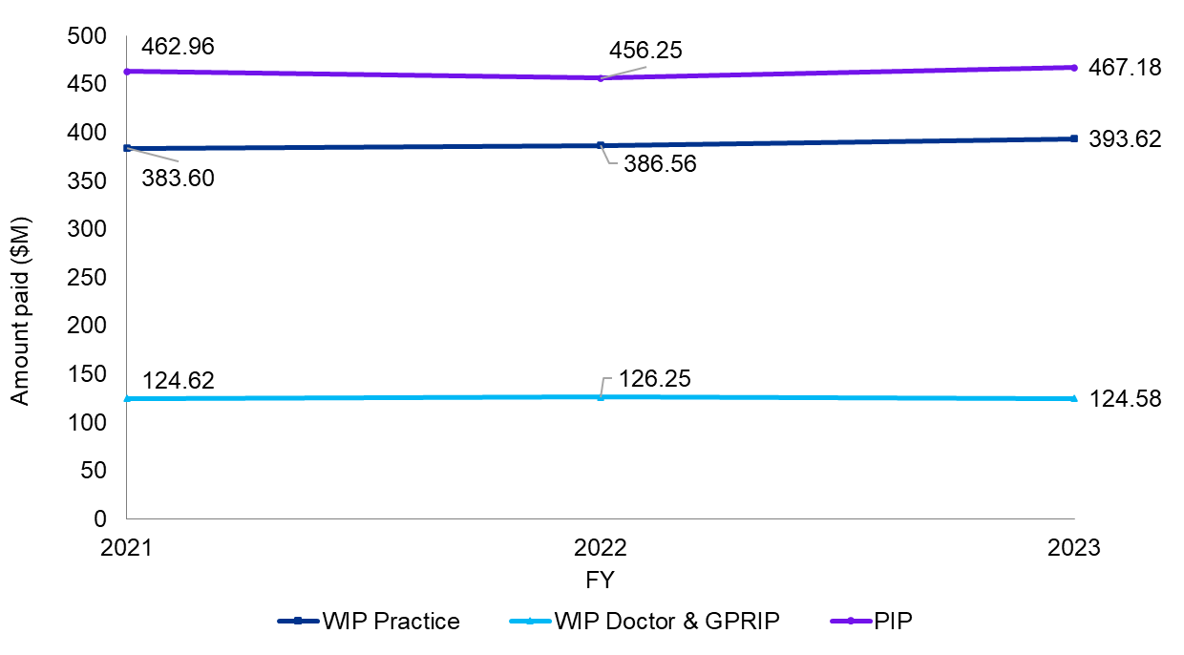

Further detailed analysis of the trends of the PIP and WIP individually are presented later in this Report, revealing fluctuations in funding levels across different incentives over time. Analysis of expenditure by rurality (MMM or RRMA) can be found in sections 10 for the PIP, and 11 for the WIP. The key message conveyed is that, while overall program funding remains stable, there is significant year-on-year variability in funding levels across individual PIP incentives.

## Distribution of incentive payments

Analysis of disparities in payment amounts highlights the correlation between expenditure and population size, particularly for New South Wales.Figure 9illustrates the amounts of PIP and WIP payments across states and territories in FY2023 per 1,000 population to provide a visual snapshot of the financial support allocated to different jurisdictions.

The darkest blue shade representing the Northern Territory signifies the highest total payment amount of $37,662 over the 2022-23 financial year. This funding distribution aligns with the higher proportion of First Nations and rural populations in the Northern Territory, and the incentive payments targeted to those groups.

Conversely, the lighter shades in Western Australia, Victoria, and the Australian Capital Territory suggest that these states and territory receive comparatively lesser financial incentives. This may indicate a relationship between rural population density and incentive payments.

Figure 9 Total incentive payments across all Australian states and territories for financial years 2021‑2023 per 1,000 population

Source: Services Australia.

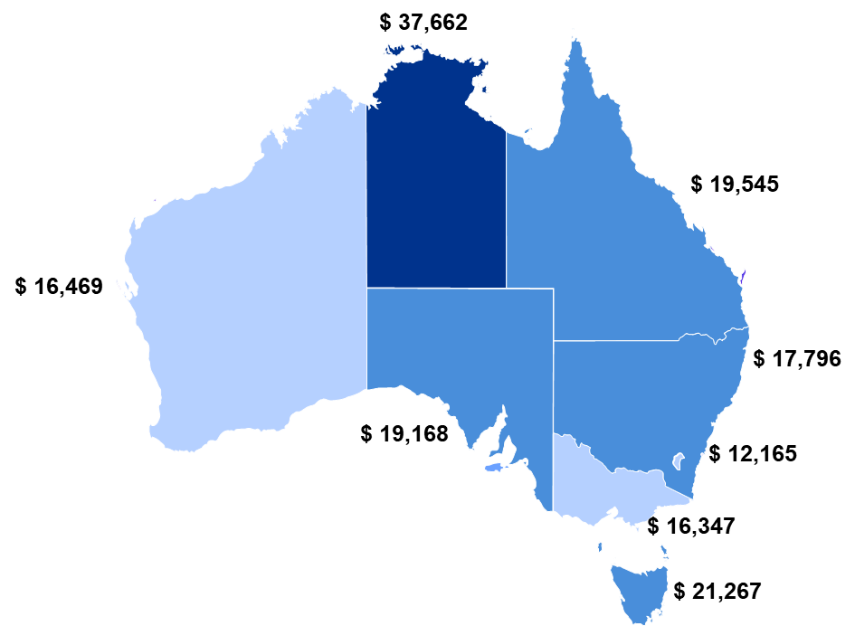

Due to the PIP and WIP using different measures of rurality, the distribution of incentive payments is not presented across both programs. Analysis of PIP and WIP expenditure by rurality (MMM and RRMA respectively) can be found in sections 10 and 11, respectively.

## Expenditure in the PIP

### Expenditure over time

Total PIP expenditure has varied slightly over time, but has most recently experienced a slight increase. Figure 10 shows the total PIP expenditure from 2020 to 2023. In 2020, total PIP investment was $439.12 million, which increased in 2021, then again in 2023 to $467.61 million.

Figure 10 Total PIP expenditure from 2020 to 2023

Source: Services Australia.

Figure 10  is a bar chart showing the total PIP expenditure from 2020 to 2023

### Expenditure by incentive

Individual PIP incentive expenditures have remained relatively stable over time, apart from a minor increase in the PIP QI Incentive in 2021 due to Australian Government efforts to keep general practices open during the COVID-19 pandemic (DoHAC, 2023b). This increase was primarily aimed at ensuring continuous healthcare services amidst the disruptions caused by the pandemic. Figure 11 shows levels of expenditure from 2020 to 2023 for individual PIP incentives.

Figure 11 Expenditure per PIP incentive from 2020 to 2023

Source: Services Australia.

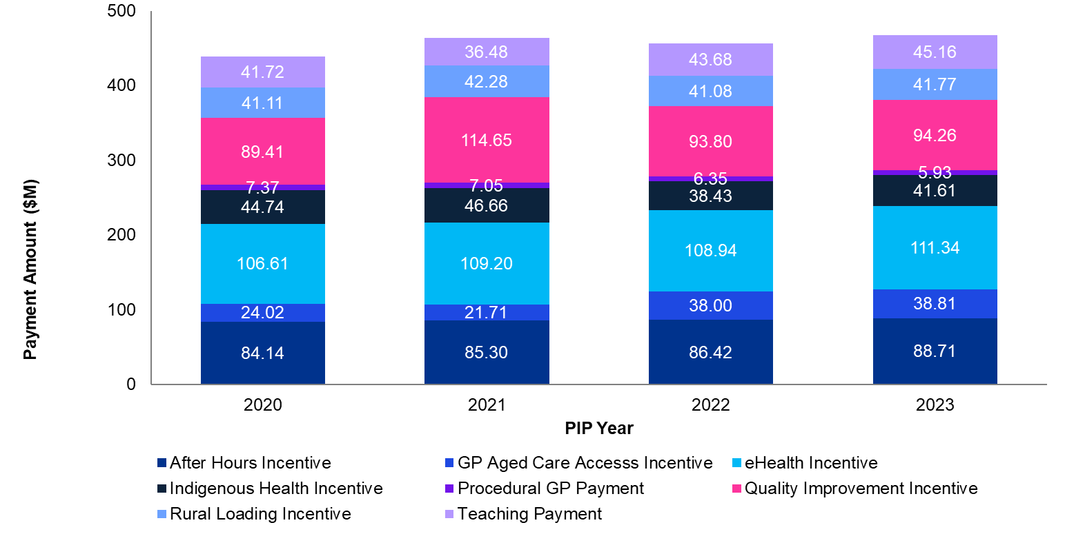

## Expenditure in the WIP

### Expenditure over time

WIP expenditure has remained relatively stable since the WIP was introduced. Figure 12 shows total expenditure in the WIP Practice and Doctor Streams from 2021 to 2023.

Total WIP expenditure in 2021 was $508.22 million. Expenditure has increased linearly to $518.2 million in 2023. Most of the total WIP investment is composed of the Practice Stream, which increased to $393.62 million for the four quarterly payments from August 2022 to May 2023. This increase is the main driver of the total WIP expenditure increase. WIP Practice Stream payments were counted from May 2022 to April 2023, and include $17.1 million of withheld payments. Adjusted for withheld payments, total WIP Practice Stream expenditure over the quarterly payments from August 2022 to May 2023 is $376.49 million. Note that 2023 expenditure totals published by Services Australia may vary from Department of Health and Aged Care figures due to the timing of extraction of the figures and the period covered (Aug-May totalled), and may not reflect the increased payments budget measure.

The Doctor Stream and historical GPRIP investment was $124.62 million in 2021 and, after a slight increase to 126.25 million in 2022, returned to $124.58 million in 2023. Doctor Stream expenditure is based on payments made to doctors, which may not match the number of payments earned by doctors due to issues with bank accounts. Such issues may cause payments to be made at a date after they were earned by the rules of the Doctor Stream, but the difference between total payment values is marginal.

Figure 12 Expenditure in the WIP Practice and Doctor Streams from 2021 to 2023. (Note that “FY” refers to the four quarterly payments from August prior year to May in the year indicated)

Source: Department of Health and Aged Care, Workforce Incentive Program Doctor Stream & General Practitioner Rural Incentives Program [data set],

Figure 12 Expenditure in the WIP Practice and Doctor Streams from 2021 to 2023. (Note that “FY” refers to the four quarterly payments from August prior year to May in the year indicated)

Impact

# Impact

This chapter considers the alignment of existing incentives with key primary healthcare strategies and policies. The assessment focuses on their correlation with the Primary Health Care Ten Year Plan and Strengthening Medicare Taskforce Recommendations. The overarching objectives of enhancing the quality, accessibility, and affordability of primary healthcare services are scrutinised within the context of these incentives.

Impact is the extent to which incentives support the achievement of broader policy objectives (i.e., recommendations of the Strengthening Medicare Taskforce and priorities of the Primary Health Care Ten Year Plan), as well as how incentives meet other demands and emerging trends of the primary healthcare sector.

Analysis of insights and data relating to the impact of the PIP and WIP focused on consultation feedback and survey data, as historical data linking population health trends and outcomes to incentive activities is not available. While survey questions related to specific incentives, most consultation feedback regarding incentive impacts was presented wholistically, about general practice incentives or primary healthcare initiatives as a whole. As such, findings relating to the impact of the PIP and WIP are general in nature.

Summary of findings

The review found that the PIP and WIP have limited impact, particularly concerning their connection to consumer health outcomes and reflection of recent trends in the primary healthcare sector. There is **weak evidence** to support the strength of these findings.

Stakeholders, including peak bodies and primary healthcare professionals, perceived some incentives as not keeping pace with trends in the primary healthcare sector. This was partially attributed to previous sector reform not being fully comprehensive, resulting in misalignment of incentives with recommendations from the Strengthening Medicare Taskforce Report and the Primary Health Care Ten Year Plan. Consequently, PHNs and general practices viewed many incentives as inadequately addressing current sector needs, contributing to the complexity of the healthcare system.

Key findings in the impact domain include:

• Incentives are perceived as complex and lacking clear alignment with broader policy objectives.

• There is limited evidence of incentives contributing to consumer health outcomes or driving improvements in population health.

• Incentives are not sufficiently responsive to accommodate emerging sector trends, such as workforce shortages.

## Alignment with the Strengthening Medicare Taskforce recommendations

Peak bodies expressed concerns about the alignment of PIP and WIP incentives with the strategic goals of Strengthening Medicare Taskforce reforms. Feedback highlights the need for alignment within and between these programs.

It was observed that, while the PIP and WIP aim to increase primary healthcare access, non-cost-related barriers, such as workforce shortages and time pressures on primary healthcare practices, hinder full achievement. PHNs and many members of the primary healthcare workforce also noted that incentives such as the eHealth Incentive are no longer considered effective in achieving their intended objectives of modernising care models.

Peak bodies and workforce focus groups questioned the extent to which the WIP Doctor Stream encourages recruitment of young doctors and Rural Generalists and whether participating GPs remained in rural or remote communities instead of acting as locums. PHNs perceived the Doctor Stream as aiding in GP retention, but not increasing access to primary healthcare in rural and remote areas, suggesting that despite the incentive’s design, the outcomes indicated a potential misalignment with Strengthening Medicare Taskforce objectives.

For detailed incentive alignment, refer to Figure 13 Retrospective mapping of stakeholder perception of PIP and WIP incentive alignment with the Strengthening Medicare Taskforce recommendations.

## Alignment with the Primary Health Care Ten Year Plan

All stakeholder groups discussed the alignment of PIP and WIP incentives with the Primary Health Care Ten Year Plan. There was a prevailing sentiment that these incentives may not closely adhere to the Plan’s objectives, with concerns about their legacy structure being less suited to current strategic goals in primary healthcare.

Many peak bodies reported that PIP and WIP incentives do not robustly align with the Plan’s Quadruple Aim – enhancing consumer experience, improving population health, reducing costs, and supporting healthcare providers’ well-being. While stakeholders acknowledge indirect alignment with the Plan’s second aim - enhancing population health - concerns persisted regarding incentive design and structure. Specifically, limited incorporation of consumer experience components in incentives was noted, with the Indigenous Health Incentive a commonly cited exception. Stakeholders did not provide insight into how to offset increased burdens on GP time or primary healthcare practice administration.

The WIP Practice Stream does not directly facilitate multidisciplinary teams due to low payment values. PHNs, peak bodies, and the primary healthcare workforce shared perceptions that the incentive was primarily used for employing primary healthcare nurses, with concerns about its structure hindering multidisciplinary care.

It was acknowledged that incentives align, albeit indirectly, with specific aspects of the Primary Health Care Ten Year Plan. Many stakeholders, including all members of workforce focus groups, recognised their role in improving access to primary health care, especially in rural areas. Comparisons with the Plan’s recommendations reveal some alignment but with notable gaps in current incentives.

Figure 13 Retrospective mapping of stakeholder perception of PIP and WIP incentive alignment with the Strengthening Medicare Taskforce recommendations

Source: KPMG qualitative analysis.

| Strengthening Medicare Taskforce recommendations | PIP | WIP |
| --- | --- | --- |
| Support general practice in management of complex chronic disease through blended funding models | Quality Improvement Incentive  Indigenous Health Incentive | Practice Stream |
| Support better continuity of care | eHealth Incentive | Doctor Stream |
| Develop new funding models that are locally relevant for sustainable rural and remote practice |  | Rural Advanced Skills Payment |
| Grow and invest in Aboriginal Community Controlled Health Organisations | Indigenous Health Incentive | Practice Stream |
| Strengthen funding to support more affordable care |  |  |
| Improve access to primary care in the after hours period and reduce pressure on emergency departments | After Hours Incentive  GP Aged Care Access Incentive | Rural Advanced Skills Payment |
| Improve the supply and distribution of GPs, rural generalists, nurses, and other members of the healthcare workforce |  | Practice Stream  Doctor Stream  Rural Advanced Skills Payment |
| Review barriers and incentives for all professionals to work to their full scope of practice |  |  |
| Increase investment in the WIP to support multidisciplinary teams in general practice |  | Practice Stream |
| Support local health system integration and person‑centred care |  |  |
| Increase commissioning of allied health and nursing services by PHNs to supplement general practice teams |  |  |
| Modernise My Health Record to increase the health information available |  |  |
| Better connect health data across all parts of the health system | Quality Improvement Incentive  eHealth Incentive |  |
| Invest in better heath data for research and evaluation of models of care | Quality Improvement Incentive |  |
| Provide an uplift in primary care IT infrastructure | eHealth Incentive |  |
| Make it easier for all Australians to access, manage, understand, and share their own health information |  |  |
| Put consumers and communities at the centre of primary care policy design and delivery | Indigenous Health Incentive | Practice Stream |
| Learn from both international and local best practice |  |  |
| Help providers effectively manage change and transition to new ways of working |  |  |
| Support the continued development of practice management as a profession |  |  |
| Implement a staged approach to reform |  |  |

Figure 14 Retrospective mapping of stakeholder perception of PIP and WIP incentive alignment with the Primary Health Care Ten Year Plan

Source: KPMG qualitative analysis.

| Primary Health Care Ten Year Plan recommendations | PIP | WIP |
| --- | --- | --- |
| Support safe, quality telehealth and virtual health care | eHealth Incentive  After Hours | Doctor Stream  Rural Advanced Skills Payment |
| Improve quality and value through data-driven insights and digital integration | eHealth Incentive  Quality Improvement Incentive |  |
| Harness advances in healthcare technologies and precision medicine | eHealth Incentive |  |
| Incentivise person-centred care through funding reform | Indigenous Health Incentive | Practice Stream |
| Boost multidisciplinary team-based care |  | Practice Stream |
| Close the gap through a stronger community-controlled sector | Indigenous Health Incentive | Practice Stream |
| Improve access to primary health care in rural areas | Procedural GP Payment  Rural Loading Incentive | Doctor Stream  Rural Advanced Skills Payment |
| Improve access to appropriate care for people at risk of poorer outcomes | Indigenous Health Incentive  Quality Improvement Incentive  GP Aged Care Access Incentive | Practice Stream  Doctor Stream  Rural Advanced Skills Payment |
| Empower people to stay healthy and manage their own health care | eHealth Incentive |  |
| Joint planning and collaborative commissioning |  | Practice Stream |
| Research and evaluation to scale up what works | Quality Improvement Incentive |  |
| Cross-sectoral leadership |  |  |

### Improving consumer access to general practice

Improving consumer access to general practices remains a key consideration in evaluating the impact of PIP incentives. Peak bodies and general practices emphasised that these incentives play a role in maintaining expanded access to general practice services, however, they also noted that many practices do not conduct services beyond the minimum reporting requirements. In rural and remote areas, a prevailing perspective is that incentives’ primary function in the primary healthcare system is sustaining the fundamental operations of a practice, ensuring ongoing consumer access rather than significantly expanding the access.

A crucial factor repeated in feedback is the multifaceted nature of the decision by a GP or other professional workforce member to move to regional and rural locations, which extends beyond financial considerations. PHNs and the primary healthcare workforce underscored the need to consider factors such as accommodation, schools, partner employment opportunities, and wider family supports. Recognising the complexity of these decisions is vital in understanding the challenges associated with addressing GP and other health professional workforce shortages in rural and remote communities.

The impact of the Doctor Stream and Rural Loading Incentive appears positive, with GPs and peak bodies remarking that these incentives are crucial to ensuring consumer access to general practice in regional, rural, and remote areas. However, PHNs noted that GPs may not be fully aware of specific implications, as these factors are often bundled into contracting arrangements. This lack of awareness highlights the need for clear communication and transparency in conveying the benefits associated with these incentives, particularly in addressing the shortage of GPs in rural areas.

In terms of after hours access, divergent views exist among practices regarding the effectiveness of incentives. However, a consensus emerges that most challenges related to having GPs on after hours rosters are not primarily financial. Rather, general practices report that GPs are increasingly prioritising a healthy work-life balance over greater income, which may also affect any after hours care provided in residential aged care clinics through the GP ACAI, or the Emergency Medicine Stream of the WIP Rural Advanced Skills Payments. Also of note is how practices can receive After Hours Incentive payments without expanding rosters for their own clinics, for example, through the use of medical deputising services. Rural and remote areas face further challenges stemming from GP workforce shortages, which significantly impact already-limited after hours access to general practice services.

### Improving consumer access to GP-led multidisciplinary team care

The WIP Practice Stream was introduced to improve consumer access to GP-led multidisciplinary team care. Although the incentive provides flexibility for GPs to allocate payments, feedback from practices and peak bodies indicates that practices predominantly use it to employ Registered Nurses (RNs) rather than fostering broader care models.

Feedback on the WIP Practice Stream reveals a perceived limitation in its effectiveness in promoting multidisciplinary team care. All stakeholder groups acknowledge that this limitation is not solely due to the incentive structure but is influenced by broader system constraints. Notably, lower MBS rates for nurses and allied health professionals impact the financial viability of hiring these professionals in general practices.

Workforce shortages, particularly in rural and remote areas, are a significant further influence on hiring and rostering decisions. Challenges associated with a limited pool of healthcare professionals lead practices to prioritise familiar roles, such as RNs, over a more diverse multidisciplinary team.

It is crucial to note that the WIP Practice Stream allows practices autonomy in deciding how to use the payment, aligning with requests from peak bodies and general practices for flexibility in incentive funding. However, the observed trend towards using the incentive for RNs raises questions about whether incentives can be more targeted, considering broader systemic factors influencing general practice decisions. PHNs, peak bodies, and workforce focus groups raised options of non-GP led models of multidisciplinary care that may better integrate allied health professionals or supply multidisciplinary care in rural or remote communities without a GP.

### Prevention and management of ongoing and chronic conditions

Practices report that, while the PIP QI Incentive has increased the adoption of preventative models of care, it has not significantly influenced the management of complex conditions. The primary healthcare workforce reported that the previous iteration of the QI Incentive was better targeted to assist chronic disease management, suggesting that future incentive design could be better aligned to areas of care with current and emerging demand increases, such as mental health, diabetes, asthma, heart disease, and palliative care. The PIP IHI focuses on supporting treatment for chronic disease management in First Nations populations, however workforce focus groups described barriers to following up on treatments with First Nations consumers of primary health care.

PHNs proposed that incentive structures which target innovation and quality improvement in specific areas of care may lead to more impactful improvements in consumer outcomes.

Practice policies regarding management of chronic conditions appear to be highly influenced by practice managers and incentive requirements, however the way GPs are contracted by general practices, rather than being directly employed, can limit how prescriptive a practice’s recommended model of care can be. Furthermore, practice owners determine access to multidisciplinary models of care through staffing decisions.

### Improving the cost effectiveness of the system

#### Affordability for consumers

PHNs and the primary healthcare workforce described PIP and WIP incentives as not having a direct impact on the affordability of primary health care, describing inconsistency regarding whether practices pass on PIP payments through proportionate reductions in consumer fees or treat incentives as additional revenue.

PHNs and workforce focus groups stated that while some incentives, such as the PIP AH incentive, decrease ED visits, practices often employ private billing during after hours consultations. Members of the primary healthcare workforce were proud that their services could prevent hospital admissions and save the healthcare system money, however they noted that costs were often partially shifted on to consumers. General practices suggested that consumer choice in after hours services, influenced by the direct costs they experience, plays a pivotal role in PIP AH incentive outcomes and ED admissions.

#### Affordability for the system / reducing pressure on hospitals

Practices highlighted indirect benefits of incentives, such as the GP ACAI and Procedural GP Payment in reducing healthcare system costs by preventing hospital admissions. It was also suggested that the upcoming WIP Rural Advanced Skills Payment could alleviate pressure on hospitals. However, quantifying the overall system cost reduction from a consumer avoiding the ED is challenging due to diffuse costs through MBS items and received incentives.

A consistent feedback point is the heavy pressure on GP time due to high demand in the primary healthcare sector. Many GPs reported reducing their personal engagement with PIP and WIP incentives due to increasing pressures on GP time and the lack of indexation causing incentives to have relatively lower payment values. This trend is observed across general practices, with noticeable impacts in small or solo practices.

## Alignment with sector needs

### Keeping pace with contemporary sector needs

According to PHNs, both PIP and WIP incentives face limitations attributed to outdated designs, a predominantly medical focus, and the failure to effectively address broader sector pressures. Feedback from various stakeholders, including practices, PHNs, and peak bodies, highlighted questions about the role and function of incentives within the broader policy context. Additionally, stakeholders noted duplication related to some incentive objectives, as state and territory governments also offer similar incentives to enhance rural health workforces and promote multidisciplinary, team-based care.

The primary healthcare workforce consistently asserted that the original design of incentive programs no longer aligns with the evolving dynamics of the primary healthcare sector. Over the last decade, the shift from small group or solo practices to larger practice groups or corporates spanning multiple PHN regions has rendered the historical design of incentive structures to be no longer suited to the current and future primary healthcare landscape. An example cited throughout consultation was the suggestion that other policy initiatives may have a duplicative effect on general practices providing after hours services.

### Measurement of the alignment and impact of incentives

According to PHNs and peak bodies, PIP and WIP incentive intentions and design do not incorporate the monitoring of incentive effectiveness and impact. Practices, particularly regarding PIP incentives, expressed challenges in linking collected data on incentive activities to consumer health outcomes. It was reported that data often focused on practices’ activities rather than consumer outcomes, allowing measurement of practice and behaviour change quantity but not its direct impact on consumer health. Several stakeholders advocated for improved data collection to address this, but no feedback was provided regarding the capability of primary healthcare practices to engage consumers in data collection efforts.

### Addressing consumer-centred care

PHNs, AMS, and ACCHS underscored the limited incorporation of consumer experience components within the incentives, singling out the Indigenous Health Incentive as the only incentive to include a consumer experience component through requirements for cultural safety training. Improving consumer experience is a key objective of both the Primary Health Care Ten Year Plan and Strengthening Medicare Taskforce’s recommendations. Stakeholders did not offer suggestions regarding including consumer experience components in the future design of any PIP or WIP incentives.

# 

Effectiveness

# Effectiveness

This chapter considers the effectiveness of the PIP and WIP incentives in achieving their policy objectives, the extent to which the primary healthcare workforce understands general practice incentives, and how incentives influence behaviour in general practices. Feedback regarding the structures and payment values of general practice incentives is summarised in this chapter, along with consolidated survey data.

Effectiveness is the extent to which the PIP and WIP achieve their intended outcomes, accounting for factors such as accessibility and equity in addressing specific healthcare needs.

Findings relating to the effectiveness of the PIP and WIP are sourced from consultation feedback and supported by survey data, due to historical data linking consumer health outcomes to incentivised activities or payments being unavailable. Survey questions and consultation feedback related to individual incentives, with common themes emerging within and across the PIP and WIP. As such, findings regarding incentive effectiveness are general in nature.

Summary of findings

The review found that the PIP and WIP incentives demonstrate limited effectiveness in achieving their intended outcomes. While the awareness and understanding of these incentives is broadly positive, incentives appear to have variable influence on practice behaviour across the primary healthcare sector. There is some evidence to support the strength of these findings.

PHNs, peak bodies, and general practices often perceive incentives primarily as revenue sources, rather than as catalysts for new care models. Many GPs are unaware of incentive details due to time constraints, leading practice managers or nurses to handle incentivised activities. Rural practices in particular described time spent on administration to be a barrier to full engagement with incentives and sometimes to daily practice operation. Overall, stakeholders perceived many possible improvements to the design of PIP and WIP incentives.

Key findings in the effectiveness domain include:

• Incentives have limited influence on behaviour in general practices.

• There is variable awareness of incentives due to broader contextual factors.

• Smaller practices, particularly those in rural areas, lack the administrative capacity to fully participate in general practice incentives.

## Achievement of incentive policy objectives

General practices identified several barriers that hinder the effectiveness of PIP and WIP payments in achieving program objectives. These barriers include incentive structures, understanding and awareness, effort compared to benefit, and the broader policy context.

Stakeholder perceptions of incentive outcomes is variable, with not all general practices having a comprehensive understanding of the policy objectives of each incentive. As such, many peak bodies and members of the primary health workforce articulated both that incentive programs are a positive influence in the primary health sector and that individual incentives are failing in their objectives. Figure 15 presents survey data regarding the extent to which each PIP and WIP incentive is believed to be achieving its policy objectives.

Figure 15 Consolidated survey results for incentive effectiveness in achieving policy objectives

Source: KPMG analysis.

**Question: The incentive is an effective funding model for achieving its policy objective**

| Incentive | Disagree | Neither Agree or Disagree | Agree |
| --- | --- | --- | --- |
| Indigenous Health Incentive | 31% | 31% | 38% |
| Quality Improvement Incentive | 12% | 20% | 68% |
| After Hours Incentive | 32% | 17% | 51% |
| GP Aged Care Access Incentive | 39% | 18% | 44% |
| eHealth Incentive | 30% | 18% | 52% |
| Teaching Payment | 22% | 14% | 64% |
| Procedural GP Payment | 20% | 32% | 48% |
| Rural Loading Incentive | 23% | 21% | 57% |
| Doctor Stream | 32% | 11% | 57% |
| Practice Stream | 31% | 17% | 53% |

A common piece of feedback linked the payment and administrative structures of an incentive with the ability of an incentive to meet its outcomes, including perceived burden or effort compared with the value of the incentive. A majority of workforce focus groups stated that many PIP and WIP incentives do not effectively target program objectives and outcomes due to a lack of targeting in incentive structures, such as the ePIP only requiring the upload of My Health Records, rather than broader digital health technology uptake.

The broader policy context of the primary health sector, including elements such as workforce shortages and the different rates at which various health practitioners can claim MBS items, can create further barriers to maximising the utilisation of incentives.

### Understanding and awareness

According to workforce focus group feedback, awareness of PIP and WIP incentives appears to be highest among medium to large practices which can employ experienced practice managers who are more likely to fully utilise and understand PIP and WIP incentives and employ them to build capacity in the practice. Smaller practices and solo GP clinics have relatively lower awareness and understanding of incentives, as do GPs contracted by medium or large clinics, who report minimal involvement in incentive processes due to time pressures of consumer demand.

This lack of awareness is attributed by stakeholders to the perception of incentives as inadequately driving desired behavioural changes in primary healthcare practices. Additionally, a considerable portion of the primary health workforce only possesses peripheral knowledge of incentives, lacking awareness of practice eligibility criteria and funding mechanisms. Survey results averaged across both PIP and WIP incentives show that 20 per cent of respondents responded ‘neither agree nor disagree’ when asked whether each incentive was an effective funding model for achieving its policy objective. (See Figure 15 above for detailed survey data.) Additionally, 14 per cent of respondents (averaged across PIP incentives) indicated they were unsure whether their practice received a PIP incentive. This limited understanding is viewed by PHNs and peak bodies as a barrier to achieving behaviour change-related policy objectives.

It is important to note that not all general practices operate under the same contracting arrangements which, as well as GP Registrars being considered employees, may be a source of confusion regarding PIP and WIP incentives.

#### Awareness of activity requirements

Awareness of activities required by relevant incentives appears high throughout the primary healthcare workforce. Figure 16 displays survey results regarding the awareness of required incentive activities for each PIP and WIP incentive. Given the proportion of practice owners and managers among survey participants, these results may not be reflective of awareness amongst the broader primary healthcare workforce.

Figure 16 Consolidated survey results for awareness of incentive obligations

Source: KPMG analysis.

**Question: I/My practice is aware of what activity the practice or GP has to undertake to receive and maintain the payment.**

| Incentive | Disagree | Neither Agree or Disagree | Agree |
| --- | --- | --- | --- |
| Indigenous Health Incentive | 14% | 16% | 70% |
| Quality Improvement Incentive | 9% | 16% | 76% |
| After Hours Incentive | 14% | 10% | 76% |
| GP Aged Care Access Incentive | 11% | 11% | 78% |
| eHealth Incentive | 8% | 11% | 81% |
| Teaching Payment | 5% | 10% | 85% |
| Procedural GP Payment | 20% | 28% | 52% |
| Rural Loading Incentive | N/A | N/A | N/A |
| Doctor Stream | N/A | N/A | N/A |
| Practice Stream | 9% | 14% | 76% |

GPs and practices demonstrated high awareness of activities linked to incentive payments, mainly due to the tie-in with initial or ongoing eligibility requirements. However, it was suggested that some GPs may perform activities without specific knowledge of their relationship to a particular incentive, instead believing that activities may be part of their practice’s model of care or another policy. For instance, GPs or other practice staff might conduct additional preventative screenings or upload electronic health records based on managerial directives without associating these activities with the PIP QI or eHealth Incentives.

Peak bodies and general practices noted that recent turnover in practice administration staff nation‑wide has contributed to a decrease in the general awareness of incentive eligibility requirements among practice managers.

### Influence on behaviour and practice

Peak bodies expressed concerns about the lack of precise targeting in incentive payments to effectively influence health outcomes.

According to PHNs and the primary healthcare workforce, the behavioural impact of PIP and WIP incentives is limited across general practices and other service settings. Most practices, some self-reporting, were seen as performing only the minimum required activities for payment, with few individual GPs personally embracing certain activities, such as uploading digital health records. However, many peak bodies and PHNs stated that incentive structures could be improved to drive more substantial behavior change. Survey results support this finding, with only 55 per cent of survey respondents (averaged across WIP Streams) agreeing that WIP incentives were effective funding models, and 56 per cent agreeing in terms of PIP incentives (averaged from PIP incentive questions).

Practice feedback highlighted the need for user-centric incentive design, considering factors such as payment values, travel time (GP ACAI), workforce supply (PIP AH incentive), and administrative burdens. Clarity in incentive objectives was desired by the entire sector, with a focus on overarching outcomes, such as expanded service provision and facilitation of multidisciplinary teams.

Stakeholders stressed the interconnectedness of incentives with overall revenue, salary, MBS payments, and lifestyle considerations for both practices and GPs. Due to the nature of general practices as private businesses and most GPs having contractual arrangements, incentives need to be attractive to both the practice and individual GPs to be effective in influencing behaviour change.

PHNs and workforce focus groups described that, due to time pressures on GPs, engagement with incentives and incentive activities is often directed by practice managers or owners, with many decisions stated to be made on the basis of financial viability. Much of the administration was reported to be the responsibility of practice managers, often with nurses assisting when reporting requirements have high burdens.

#### Insufficient incentive value for behaviour change

The majority of practices and numerous peak bodies have expressed concerns regarding the adequacy of incentive payment values. This feedback often coincided with discussions about practices relying on these payments for financial sustainability. Many within the primary healthcare workforce reported that current payment amounts are insufficient in incentivising desired behavior change. This sentiment was largely attributed to issues with the incentive structures, particularly the lack of payment indexation and recent increases in the costs of medical equipment, clinical and administrative staff wages and, in rural areas, the cost of shipping single-use equipment.

Peak bodies have also highlighted a perceived lack of alignment between incentive payment values and specific activities or outcomes. For example, the WIP Practice Stream payment is seen as not being directly correlated with the value gained from employing a practice nurse, primarily because payments are lump sums that do not break down to full-time equivalent (FTE). Additionally, some practices have reported under‑utilisation of certain incentives due to non-financial barriers, such as staff discomfort in discussing a consumer’s Aboriginal or Torres Strait Islander status.

Efficiency

# Efficiency

This chapter considers whether PIP and WIP incentives are fit for purpose as a health system funding mechanism, the suitability of incentive administrative processes, how PIP and WIP incentives drive and relate to general practice accreditation, and the efficiency of incentive payment mechanisms. This chapter contains stakeholder feedback and consolidated survey data regarding administration and eligibility requirements.

Efficiency explores the administrative burden and cost-effectiveness of the PIP and WIP, assessing whether the programs are fit-for-purpose as health system funding mechanisms.

Consultation feedback and survey data informed findings relating to the efficiency of the PIP and WIP. Efficiency is assessed at the individual incentive level, due to variability in incentive structures and payment mechanisms, with findings synthesised from insights across all incentives.

Summary of findings

The Review found that the PIP and WIP are perceived as inefficient. Stakeholders noted how the administrative burdens associated with individual incentives compounded across incentives, describing overall program inefficiency and difficulties with payment mechanisms. There is some evidence to support the strength of these findings.

PHNs and peak bodies reported that some general practices opt out of engaging with PIP and WIP incentives due to their complexity and perceived time-consuming nature of administration. A majority of workforce focus groups reported that managing PIP and WIP incentives as a whole was burdensome and diverted time away from delivering health care. Practice managers also cited challenges in understanding and reconciling incentive payments, hindering the linkage between incentive payments’ health outcomes.

Key findings in the efficiency domain include:

• Administration is described as challenging and burdensome.

• General practices reported difficulties reconciling incentive payments in business accounting, which was linked to a lack of understanding the outcomes of incentives.

## Fit-for-purpose as a health system funding mechanism

PIP and WIP incentives are perceived to be not fully suitable for funding the primary healthcare system. Stakeholders identified reasons for this limitation, including outdated incentive designs, a predominantly medically-led structure, and the perception that incentives do not adequately address broader sector pressures.

A common theme in feedback from practices, PHNs, and peak bodies was questioning the role and function of incentives within the broader policy context. Multiple workforce focus groups noted redundancy in incentive intentions, as many state and territory governments also offered incentives to support rural health workforces and promote multidisciplinary, team-based care.

Practices and the primary healthcare workforce frequently emphasised the overlap between incentive programs and other ongoing reform processes. Many GPs and peak bodies expressed the need for reform to encompass the entire primary health system and sector. Further feedback highlighted the importance of aligning future incentives and other reforms in design to prevent potential competition between initiatives.

## Administrative burden and complexity

Providers and provider organisations commonly cited administrative burden as a significant issue, leading some practices to not apply for or claim incentives. Practices and GPs consistently expressed dissatisfaction with the associated administrative overhead costs across both the PIP and WIP.

Some practices reported that the time required to meet incentive reporting requirements and engage with incentive activities affected their decisions on whether to apply for or claim incentives. Some opted out of incentive programs due to this burden. This underscores the significant impact administrative processes can have on a practice’s willingness to participate in incentive programs. Furthermore, many PHNs and general practices stated that the complexity associated with incentive administration means that barriers to access are relatively higher for smaller practices in thin markets, for example in rural and remote areas.

Consultation with workforce focus groups revealed a prevalent issue where practices often neglected to register all current healthcare providers, leading to payment discrepancies. All stakeholder groups emphasised the importance of a streamlined eligibility and application process for incentives to guarantee accurate claims by practices.

Figure 17 shows survey results regarding the administrative complexity of individual incentives.

Figure 18 shows survey results regarding the perceived administrative burden of individual incentives.

Figure 20 provides an overview of the incentive administration requirements as of 1 January 2024 for all WIP and PIP incentive programs.

Figure 17 Consolidated survey results regarding incentive administrative complexity

Source: KPMG analysis.

**Question: Administrative processes and eligibility requirements for the incentive are clear/appropriate and user-friendly.**

| Incentive | Disagree | Neither Agree or Disagree | Agree |
| --- | --- | --- | --- |
| Indigenous Health Incentive | 35% | 32% | 33% |
| Quality Improvement Incentive | 23% | 35% | 42% |
| After Hours Incentive | 22% | 36% | 42% |
| GP Aged Care Access Incentive | 16% | 40% | 44% |
| eHealth Incentive | 17% | 31% | 51% |
| Teaching Payment | 21% | 28% | 51% |
| Procedural GP Payment | 12% | 52% | 36% |
| Rural Loading Incentive | N/A | N/A | N/A |
| Doctor Stream | 27% | 30% | 43% |
| Practice Stream | 19% | 33% | 47% |

Figure 18 Consolidated survey results regarding incentive administrative burden

Source: KPMG analysis.

**Question: Administrative requirements are worth the benefit to me/my practice.**

| Incentive | Disagree | Neither Agree or Disagree | Agree |
| --- | --- | --- | --- |
| Indigenous Health Incentive | 31% | 31% | 38% |
| Quality Improvement Incentive | 16% | 35% | 49% |
| After Hours Incentive | 23% | 26% | 51% |
| GP Aged Care Access Incentive | 23% | 28% | 50% |
| eHealth Incentive | 16% | 24% | 60% |
| Teaching Payment | 19% | 24% | 58% |
| Procedural GP Payment | 16% | 40% | 44% |
| Rural Loading Incentive | N/A | N/A | N/A |
| Doctor Stream | 17% | 32% | 51% |
| Practice Stream | 14% | 25% | 61% |

## Accreditation against RACGP Standards

Accreditation against the RACGP Standards is a prerequisite for practices aspiring to receive PIP incentives and the WIP Practice Stream. This mandatory requirement ensures that accredited practices adhere to the highest standards of general practice, promoting quality healthcare delivery.

The Department maintains oversight not only of the accreditation process itself but also of the accreditation agencies responsible for conducting evaluations. Accreditation agencies transmit data to Services Australia on a monthly basis. This data exchange ensures that the accreditation status of practices is continuously monitored and updated, contributing to a real-time understanding of a practice’s compliance.

Accreditation as an eligibility requirement for incentives is assessed at specific times each quarter, aligning with payment cycles. This quarterly assessment serves as a snapshot evaluation, determining a practice’s eligibility for incentives during that period. Practices must align their accreditation status with each quarter’s assessment to secure timely payments.

Peak bodies and some workforce focus groups noted that having accreditation as an eligibility requirement for PIP incentives and the WIP Practice Stream was a core driver of general practice quality improvement efforts. However, it was noted that some practices were unable or chose not to meet RACGP Standards, thus being unable to claim PIP and WIP incentive payments regardless of their engagement with incentivised activities, such as uploading My Health Records.

Stakeholder feedback focused on RACGP Standards, and did not specifically mention Australian Commission on Safety and Quality In Health Care Standards.

### Impact of lapsed accreditation

PHNs and practice managers shared that a lapse in accreditation can have significant consequences on a practice’s incentive income. Even if all other eligibility criteria are met, the absence of valid accreditation can lead to a pause in incentive payments without practices seeking temporary exemptions. Some practices emphasised the critical role that accreditation plays in the financial sustainability of general practices and broader quality improvement efforts.

Accreditation is typically valid for a period of three years. Practices must actively ensure the continual maintenance of their accreditation status to avoid interruptions in incentive payments. Practices emphasised the burden that ongoing compliance can have, framing this as hidden administration requirements for general practice incentives.

All consulted PHNs reported that achieving 100 per cent accreditation among practices is unattainable. This is particularly relevant for smaller practices that may face challenges in meeting accreditation requirements, resulting in ceasing incentive payments. This insight underscores the need for a more inclusive approach to accreditation, considering the diverse demographics and circumstances of GPs.

### Exemptions for lapses in accreditation

Practices experiencing a lapse in accreditation have the option to proactively request an exemption from the Australian Commission for Safety and Quality in Health Care. This exemption allows practices to maintain their eligibility for incentive payments during affected quarters while they work to rectify accreditation deficiencies.

Stakeholders have noted that the provision of exemptions acknowledges that unforeseen circumstances can impact accreditation timelines. This approach is seen as supportive, enabling practices to address challenges without risking their eligibility for crucial incentive payments.

It is important to recognise that the eligibility and reporting requirements governing incentive payments may impede practice innovation, especially in under‑served areas. A key example from rural practices was how time pressures from incentive administration could cause some practices to lapse in accreditation and associated quality improvement efforts. Workforce focus groups also stated that incentives could be more flexible, to allow practices to implement innovative solutions to address local healthcare needs more effectively. Consequently, despite the availability of incentives, practices may encounter difficulties in meeting community healthcare demands and fostering tangible improvements in consumer care.

## Payment mechanisms

Incentive payments for PIP incentives and the WIP Practice Stream are paid to practices in accordance with each incentive’s payment schedule. Many payments are consolidated in quarterly statements, which provide practices only with total payments per incentive that are often unable to be reconciled for business accounting. Incentive payments are paid by Services Australia, that also process the reporting of incentive activities and monitor practice eligibility.

### Awareness of payment values

Workforce focus groups exhibited a slight lack of awareness of the payment values of PIP and WIP incentives. Figure 19 on the following page presents survey data regarding primary healthcare workforce awareness of incentive payment values, and suggests that broader awareness of incentive payment values is reasonably high.

Practices reported that the weight of administrative tasks frequently affected their strategic decisions. Some practice managers and owners consistently expressed a strong awareness of the overall value of payments received under the PIP. However, practices noted a limitation in the PIP incentive payment statements as lacking a breakdown of funding. Consequently, practices find it challenging to reconcile incentive payments with GP activities or other associated costs. This gap in information has led to a lack of understanding regarding fluctuations in payments during specific periods.

For the WIP Practice Stream, practices report having a clear awareness of payment values, facilitated by receiving total payments in quarterly statements. Yet, these statements do not specify the amount allocated per nurse or other eligible staff when a practice employs multiple individuals.

PHNs and peak bodies further highlighted a perceived disconnect between the monetary values of incentives and their impact on health outcomes. This disconnect is attributed to a significant number of GPs not actively participating in incentive processes.

Figure 19 Consolidated survey results regarding awareness of payment values

Source: KPMG analysis.

**Question: I/My practice is aware of the payment value for the incentive.**

| Incentive | Disagree | Neither Agree or Disagree | Agree |
| --- | --- | --- | --- |
| Indigenous Health Incentive | 15% | 19% | 67% |
| Quality Improvement Incentive | 10% | 16% | 73% |
| After Hours Incentive | 14% | 12% | 73% |
| GP Aged Care Access Incentive | 14% | 10% | 76% |
| eHealth Incentive | 10% | 10% | 81% |
| Teaching Payment | 7% | 6% | 87% |
| Procedural GP Payment | 24% | 24% | 52% |
| Rural Loading Incentive | N/A | N/A | N/A |
| Doctor Stream | N/A | N/A | N/A |
| Practice Stream | N/A | N/A | N/A |

### Allocation of payments

Whether a practice shares incentive payments with its contracted GPs or employed healthcare providers appears to a decision made internally within general practices. Incentive payments made to practices seem to, in general, be absorbed into a practice’s consolidated revenue. Thirty-nine per cent of survey respondents (averaged across PIP incentives) agreed that they or their practice passes on part or all of incentive payments. This can include payments that are designed to be passed on to general practitioners. The most common reasons reported by practices as to why they may or may not distribute incentive payments included a lack of understanding, financial pressures, and practices absorbing payments due to perceived extra work (for example, coordinating and supporting medical students to enable better experiences through the Teaching Payment).

### Suitability of the Single Whole Patient Equivalent (SWPE) mechanism

Stakeholders questioned the suitability of the SWPE methodology for payment calculation, for specific incentives such as the After Hours Incentive, Quality Improvement Incentive and the eHealth Incentive. The SWPE methodology was criticised for not aligning well with the broader objectives, as it does not accurately reflect the burden of disease in Indigenous populations.

Aboriginal and Torres Strait Islander peoples tend to experience chronic diseases and complex multi‑morbidity at a younger age, along with higher rates of poverty and social disadvantage (AIHW, 2015; AIHW and NIAA, 2023). This signifies that the care needs of an Aboriginal male patient are likely to be significantly higher than those of a non-Indigenous patient of the same age and gender. However, the SWPE funding mechanism does not account for this, as it only uses age and gender for weighting, not Indigenous status or disease burden.

Many stakeholders argue that this misalignment is seen as a potential health equity issue, as the SWPE fails to accurately represent the time commitment required for managing complex and chronic conditions in different Indigenous populations. One Aboriginal peak body suggested the SWPE should include weighting by Indigenous status by at least 50 per cent. The perceived misrepresentation of the burden of disease raises issues about skewed health management priorities and potential misallocation of resources.

Figure 20 Overview of Incentive administration requirements as of 1 January 2024

Source: PIP and WIP Incentive Guidelines.

Figure 20 is a visual map of PIP and WIP incentive administrative requirements, before and after claiming of the incentive.

Figure 21 Overview of incentive payment mechanisms

Source: PIP and WIP Incentive Guidelines.

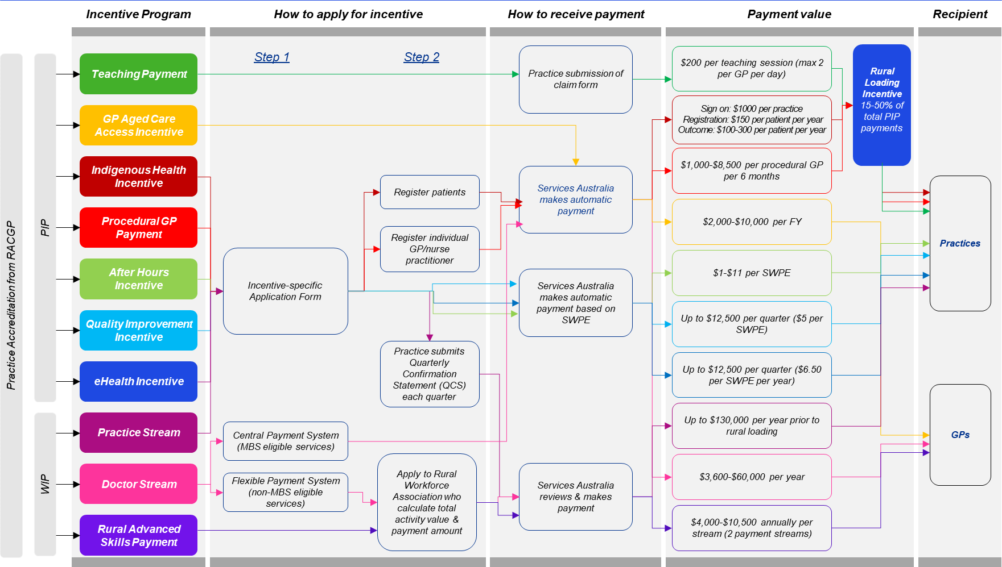

Sustainability

# Sustainability

|  |
| --- |
| This chapter considers the sustainability of PIP and WIP incentives regarding consumer health outcomes and access to care affected by the incentives, as well as the sustainability of both programs in a broader policy context. The chapter also covers feedback from general practices and survey data about financial viability in the primary healthcare sector. |

Sustainability assesses the PIP and WIP over the long term, looking at the viability and durability of incentive activities and intended outcomes, along with incentive programs’ ability to deliver benefits over longer time periods.

Findings regarding the sustainability of the PIP and WIP stem from survey data and consultation insights. Stakeholders provided feedback on the viability of the general practice itself, specific types of service provision, and the sustainability of incentive activities and outcomes without incentive payments. Sustainability-related findings are general in nature as feedback had a strong consensus, supported by survey data.

|  |
| --- |
| Summary of findings  The Review found that the PIP and WIP are not sustainable regarding long-term consumer outcomes. General practices report a reliance on incentives for the sustainability of practice operations instead of using incentives to drive outcomes. There is **some evidence** to support the strength of these findings.  Many peak bodies and PHNs highlighted the fragile financial viability of many general practices, which was loudly echoed by workforce focus groups. Other sustainability concerns focused on many initiatives from various governments, which were noted as leading to some level of duplication with PIP and WIP incentives, as well as having unintended consequences that influenced practice perception of incentive sustainability.  Key findings in the sustainability domain include:   * General practices rely on incentive payments for the sustainability of daily practice operations. * Stakeholders expressed concerns about how unintended consequences from other government initiatives could restrict both the immediate and long-term outcomes of incentives. |

## Sustainability of consumer health outcomes and access to care

Feedback regarding the sustainability of incentive effects on consumer health outcomes were closely tied to a practice’s or GP’s willingness to engage in incentive activities. All stakeholder groups described a prevalent trend of practices using incentives to sustain operations, rather than facilitating service expansion or supporting clinical upgrades. Peak bodies and GPs emphasised that PIP incentives in particular have become crucial for the financial viability of a majority of small, rural general practices.

The administration burdens and lack of awareness around incentive objectives described by all stakeholder groups under previous Review domains indicates that general practices would not engage with incentive activities or work to meet incentive objectives without incentive payments. Many PHNs and members of the primary healthcare workforce stated that reasons for this include the opportunity cost of time spent on incentive activities and gaps in awareness of how incentive activities can lead to consumer health outcomes. However, many practices that utilise incentives consider the administrative processes part of daily operations, and agree that incentive structures are largely sustainable once a practice is receiving payments. Figure 22 below shows survey data regarding whether current incentive reporting requirements are sustainable.

Specific examples were given regarding the GP ACAI and Teaching Payment, where incentive payments did not offset time factors involved in teaching or delivering services in aged care facilities. As a result, GPs appear to engage in either incentive due to having a passion in the area, treating incentives as support for pre-existing delivery of that service, rather than the reason they engage in teaching or service delivery in aged care facilities.

Figure 22 Consolidated survey results regarding sustainability of incentive reporting requirements

Source: KPMG analysis.

**Question: This incentive is structured in a way which is sustainable for me/my practice to continue to receive and to meet ongoing reporting requirements.**

| Incentive | Disagree | Neither Agree or Disagree | Agree |
| --- | --- | --- | --- |
| Indigenous Health Incentive | 31% | 38% | 31% |
| Quality Improvement Incentive | 25% | 30% | 45% |
| After Hours Incentive | 28% | 31% | 41% |
| GP Aged Care Access Incentive | 23% | 31% | 46% |
| eHealth Incentive | 21% | 28% | 50% |
| Teaching Payment | 26% | 16% | 58% |
| Procedural GP Payment | 16% | 44% | 40% |
| Rural Loading Incentive | 19% | 33% | 48% |
| Doctor Stream | 14% | 26% | 60% |
| Practice Stream | 26% | 28% | 47% |

## 

## Program sustainability in the broader policy context

Peak bodies and practices reported widespread perception of incentives among practices as revenue sources, rather than funding to enable innovation or new models of care. In particular, many rural and remote practices reported that incentive payments have become critical support for daily operations. A majority of general practices, as well as PHNs and peak bodies, stated that incentivised activities would not be performed without some form of financial motivation.

Many practices seemed to anticipate the continuity of incentive payments, with an apparent majority of practices utilising the same incentives for years. However, a few practices expressed that lapses in payments had been unexpected. In some cases, this was reportedly caused by a limited understanding of incentive reporting requirements, with the eHealth Incentive and Teaching Payment having highly specific requirements that practices may misunderstand or not be aware of. One example is the Teaching Payment’s requirement that the relevant university be the first signatory on a form that involves multiple parties.

Despite overall increases in incentive payments, peak bodies and workforce focus groups expressed concerns that incentive programs are not enough to address the demand for healthcare services and the needs of rural communities. Additionally, many peak bodies and practices highlighted that incentive payments lack indexing to inflation measures.

Figure 23 shows survey data regarding the willingness of a practice to continue performing incentive activities or maintain current levels of service provision without incentive payments.

Figure 23 Consolidated survey results regarding the sustainability of incentivised activity and service provision without an incentive payment

Source: KPMG analysis.

**Question: General practices can sustain incentivised activities without this incentive.**

| Incentive | Disagree | Neither Agree or Disagree | Agree |
| --- | --- | --- | --- |
| Indigenous Health Incentive | 66% | 21% | 13% |
| Quality Improvement Incentive | 77% | 14% | 9% |
| After Hours Incentive | 76% | 17% | 8% |
| GP Aged Care Access Incentive | 79% | 16% | 5% |
| eHealth Incentive | 73% | 17% | 10% |
| Teaching Payment | 86% | 7% | 7% |
| Procedural GP Payment | 64% | 36% | 0% |
| Rural Loading Incentive | 85% | 12% | 4% |
| Doctor Stream | 75% | 20% | 5% |
| Practice Stream | 88% | 7% | 6% |

Practice Incentives Program

# Practice Incentives Program

This chapter presents high-level findings regarding the PIP. Overview findings include expenditure and practice participation levels. Findings for specific Review domains include:

• Impact: Alignment of the PIP with overarching policy objectives and current sector trends

• Effectiveness: Achievement of incentive policy objectives and payment distribution

• Efficiency: The suitability of the PIP as a health system funding mechanism, the level of administrative burden, and feedback regarding payment mechanisms

• Sustainability: The sustainability of consumer health outcomes and the PIP within broader policy context.

Findings regarding the PIP are consolidated from consultations, survey results, and quantitative analysis.

## Overview

Over the 2023 PIP financial year, there was a total expenditure of $467 million across 6,622 practices. The average payment per practice was $70,613.The interquartile range was $22,827 to $89,585 across all practices in 2023. Of the total expenditure in the 2023 PIP financial year, 93.45 per cent ($437 million) went to general practices, and 6.5 per cent ($30.3 million) went to AMS and ACCHs.

Figure 24 Overview of PIP participation and expenditure ($) (FY23)

Source: Services Australia.

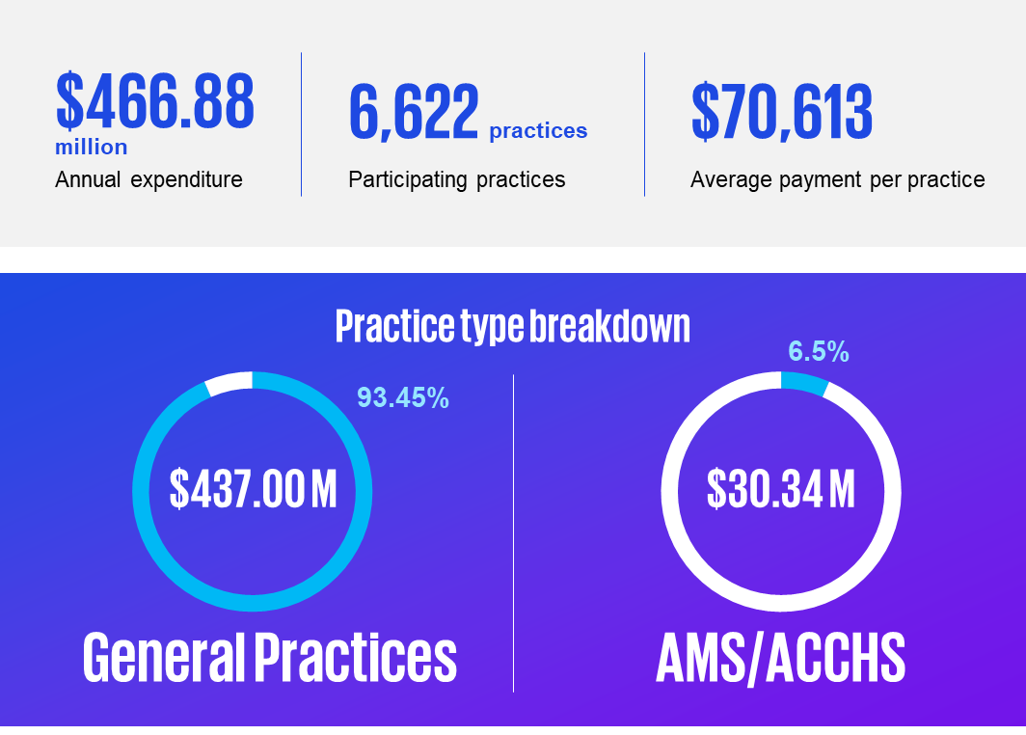

### Expenditure in the PIP

#### Expenditure over 2023

A total of $467 million was spent across the eight PIPs in FY2023. The highest expenditure is on the eHealth Incentive at $111.34 million in FY2023, followed by the PIP QI at $94.26 million. Comparatively, the Procedural GP payment had the lowest annual expenditure at $5.94 million. Table 7 displays the annual spends and practice participation numbers for PIP incentives in the 2022 financial year (participating GPs for the GP Aged Care Access SIP are counted from the number of paid payments).

Table 7 PIP FY23 payment values ($, m) and practice participation numbers per incentive (1 May 2022 – 30 April 2023)

Source: Services Australia.

| PIP Incentive | Measure | 2022-23 ($, million) |
| --- | --- | --- |
| Indigenous Health Incentive | Payment ($) (m) | $41.61 |
| Practices Participating | 3,576 |
| Quality Improvement Incentive | Payment ($) (m) | $94.26 |
| Practices Participating | 6,138 |
| After Hours Incentive (Total across Tiers) | Payment ($) (m) | $88.71 |
| Practices Participating | 6,073 |
| GP Aged Care Access Incentive (SIP) | Payment ($) (m) | $38.81 |
| Participating GPs | 2,351 |
| eHealth Incentive | Payment ($) (m) | $111.34 |
| Practices Participating | 6,066 |
| Teaching Payment | Payment ($) (m) | $45.16 |
| Practices Participating | 1,944 |
| Procedural GP Payment | Payment ($) (m) | $5.94 |
| Practices Participating | 246 |
| Rural Loading | Payment ($) (m) | $41.77 |
| Practices Participating | 1,969 |

#### Expenditure over time

PIP incentive payment values have remained relatively stable over time, with the most fluctuation occurring during the COVID-19 pandemic. Figure 25 shows these trends from the 2019 to 2022 financial years.

Consistent with participating practice findings, the eHealth Incentive has maintained high payment levels and steady growth from 2019 to 2023.

The PIP QI saw a rapid increase in payments throughout 2020-21 due to the temporary COVID-19 response. The payment was temporarily doubled for two quarters from $5 per SWPE to $10 per SWPE. In addition, the quarterly payment cap was raised from $12,500 to $25,000.

The PIP AH Incentive has shown consistent performance from 2019 to 2023, exhibiting a gradual increase over time. This pattern aligns with the trends observed in practice participation.

PIP IHI payments experienced a decrease between the 2020-21 and 2021-22 periods, and the current levels of payments are below those of 2019-20.

The Teaching Payment decreased in 2020-21 likely due to the impacts of the COVID-19 pandemic. Payments once again increased in 2021-22 onwards, likely as a result of the gradual easing of COVID-19 restrictions.

GP Aged Care Access Incentive payments saw a large increase from 2020-21 to 2021-22, likely as a result of the heightened focus on care within residential aged care facilities during the COVID-19 pandemic.

In parallel with the trend observed in practices’ participation over time, the GP Procedural Payment indicates limited growth since 2019-2020.

Figure 25 Payment Trends by Incentive

Source: Services Australia.

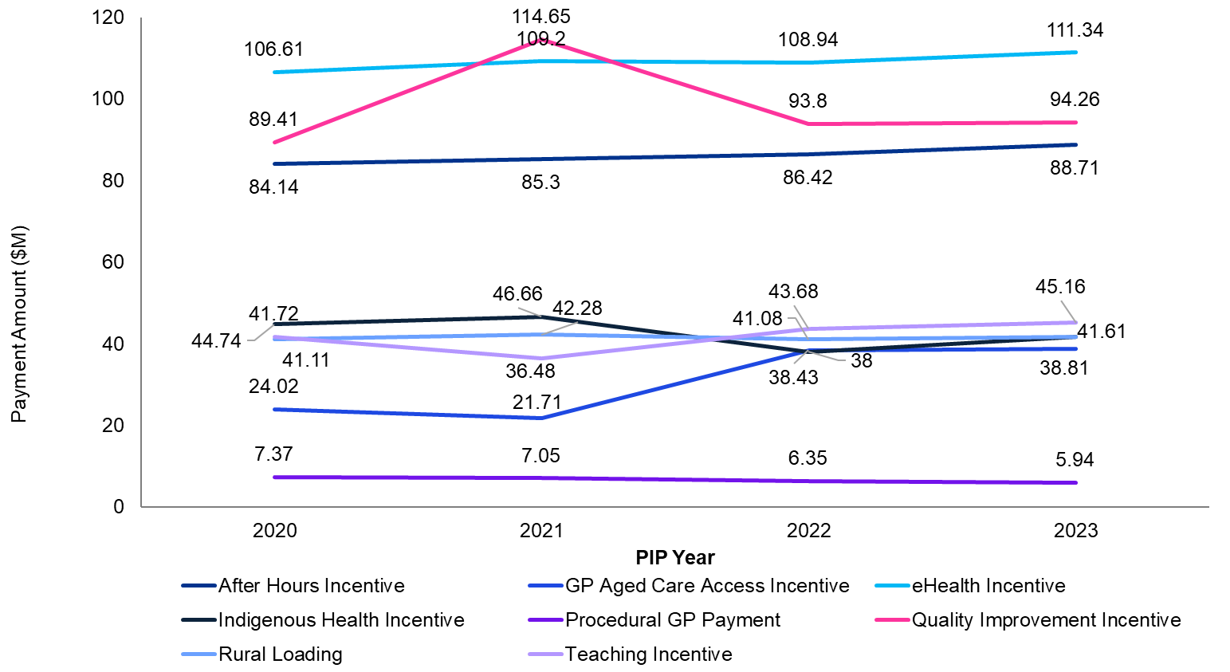

#### Payment value

##### Average payment value per practice

On average, practices claimed $70,613 through the PIP in FY2023, however the median claim of $44,000 is potentially more representative of the data due to a number of outliers at the higher end of the claim range.

##### Payment value by practice type

PIP payments are overwhelmingly distributed to general practices. Of the total PIP incentive payment value, 93.45 per cent, or $439436.99 million, was paid to general practices over the 2022-23 financial year. ACCHS received 4.49 per cent, with the remaining paid to AMS. When the proportion of the payment is compared to the proportion of ACCHS participating in the PIP, ACCHS appear to receive a proportion of payments higher than their participation share. This may be due to the Rural Loading Incentive and WIP Practice Stream rural loading. Figure 26 shows distribution of the total PIP payment value among practice types.

Figure 26 Payment value by practice type (1 May 2022 – 30 April 2023)

Source: Services Australia.

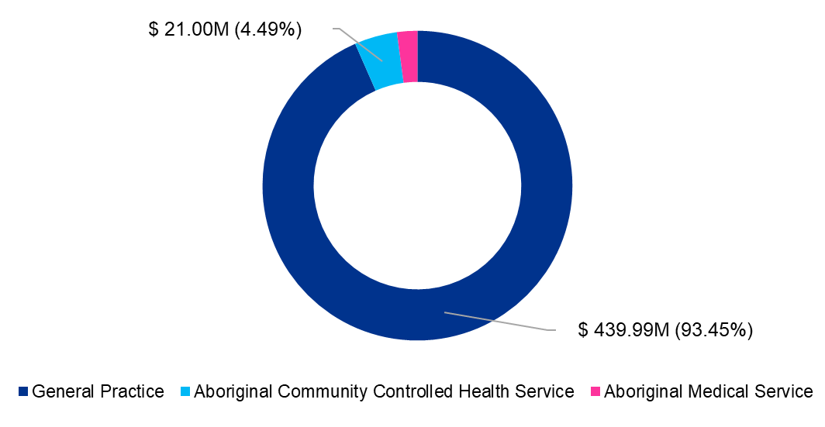

### Distribution of payments

#### Payment distribution by state and territory

The distribution of PIP payments (as depicted in Figure 24 for the 2023-24 financial year) underscores the nuanced interplay between population density, geographic location, and healthcare resource allocation across Australia.

In line with the distribution of population, New South Wales received the highest proportion of PIP funding (31.03 per cent, or $133.07 million). Queensland and Victoria followed closely with 22.77 per cent ($97.65 million) and 22.69 per cent ($97.30 million) respectively. Tasmania, Northern Territory, and Australian Capital Territory received the smallest shares, aligned with their lower populations and fewer number of general practices. This distribution aligns with the principle of catering resources to areas with higher population densities to meet the healthcare needs of a larger populace.

The distribution of PIP payments reflects geographic population density. Figure 27 displays PIP payment distributions from the 2023-24 financial year, by state and territory.

Geographically, New South Wales and other eastern states received the most payments. This aligns with RRMA analysis, where RRMA 1 (metropolitan centres) received the highest proportion of funding. When RRMA is adjusted per 1,000 population, the Northern Territory receives a much higher proportion than other jurisdictions, reflecting relative remoteness and population size.

Figure 27 PIP payments by states and territories (1 May 2022 – 30 April 2023)

Source: Services Australia.

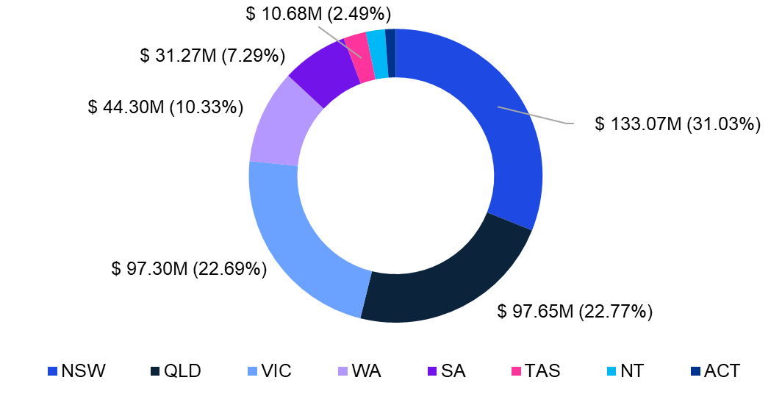

#### Payment distribution by RRMA

PIP incentive payments loosely reflect population density. Figure 28 shows the distribution of payment value per RRMA classification for the PIP.

RRMA 1 (metropolitan areas) received the largest share, totalling $211.79 million (or 48.8 per cent), reflecting higher healthcare demands in metropolitan centres. Conversely, RRMA 6 (remote regions) received the smallest share, with only a 3.56 per cent share totalling $16.65 million. However, payments to RRMA 5 areas (19.35 per cent) were proportionally larger than payments to other rural or remote RRMA classifications, with RRMA 6 receiving the smallest proportion of payments (1.93 per cent). This reflects consultation suggestions that RRMA is no longer suitable as a measure of rurality due to its data set being outdated.

When considering geographic distribution, New South Wales and other eastern states dominate in receiving PIP payments. This trend is in line with RRMA analysis, which indicates that metropolitan centres, typically located in these regions, tend to receive a higher proportion of funding.

Figure 28 Payment value per RRMA (1 May 2022 – 30 April 2023)

Source: Services Australia.

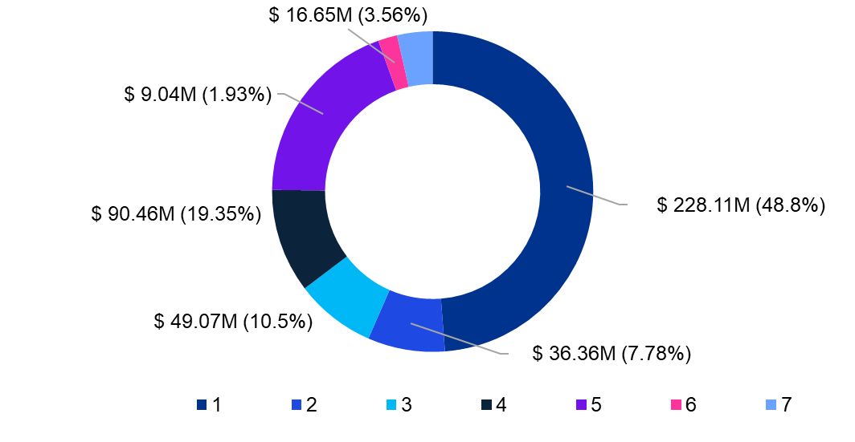

#### Payment distribution by 1,000 population

When population density is accounted for by measuring PIP incentive payment distribution per 1,000 population, payments per RRMA more closely reflect the proportion of rural and remote populations in states and territories. Figure 29 shows PIP payments by RRMA, adjusted for 1,000 population in the 2022-23 financial year, as displayed on the jurisdictional map of Australia.

Adjusting RRMA per 1,000 population highlights the unique case of the Northern Territory. Despite its lower population density compared to other jurisdictions, the Northern Territory received the highest share of PIP payments per 1,000 population at $37,662. This can be attributed to the Northern Territory’s population being relatively more remote and the need to provide adequate healthcare services to its dispersed population, which requires a higher allocation of resources per capita.

Tasmania received the second largest share of PIP payments per 1,000 population, with $21,267 being attributed to its status as the smallest and least populated state. In the Eastern Region (Queensland, New South Wales, Australian Capital Territory, and Victoria), payments ranged from $12,165 to $19,545 per 1,000 population, influenced by higher population density.

Figure 29 PIP payments per RRMA, by 1,000 population (1 May 2022 – 30 April 2023)

Source: Services Australia.

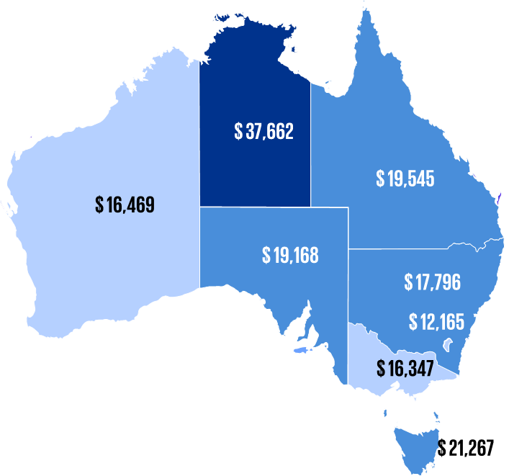

### Practice participation

#### Participation by state

Practice participation of PIP incentives varies by state. Figure 30 shows this variation between the states and territories. There were 6,622 PIP participating practices in FY2023. New South Wales had the highest number of participating practices at 2,176 in FY2023, followed by Victoria at 1,654. The Northern Territory and Australian Capital Territory had the lowest practice participation at 110 and 97 respectively. This reflects the distribution of practices and population density throughout the country.

Figure 30 Participation by state (1 May 2022 – 30 April 2023)

Source: Services Australia.

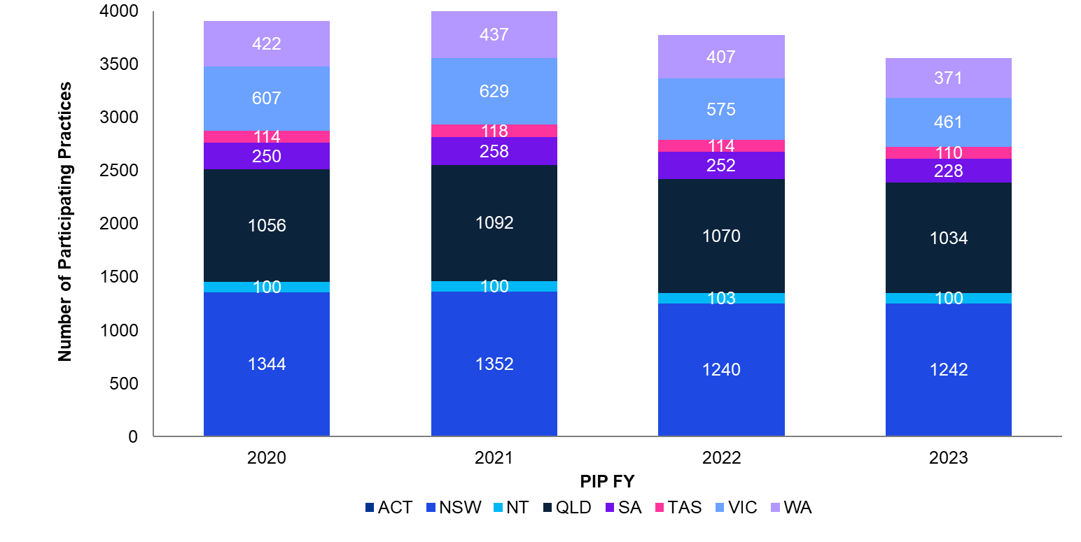

#### Participation by practice type

PIP participation data suggests that general practices are the majority of primary healthcare services in Australia. General practice made up 96.27 per cent of practice participation in the PIP, with a total of 6,375 practices. Figure 31 shows the participation across practice types for the 2022-23 financial year.

ACCHS accounted for 1.96 per cent with 130 practices participating in the PIP. ACCHS accounted for only 1.96 per cent with 130 practices participating in the PIP. ACCHS had a much smaller proportion of healthcare services in comparison to general practices, however delivered specialised care managed within First Nations communities.

AMS accounted for 1.31 per cent of practices participating in the PIP. Unlike ACCHS, AMS are not community controlled organisations. Rather, they are health services operated by state or territory governments.

Figure 31 Participation by practice type (1 May 2022 – 30 April 2023)

Source: Services Australia.

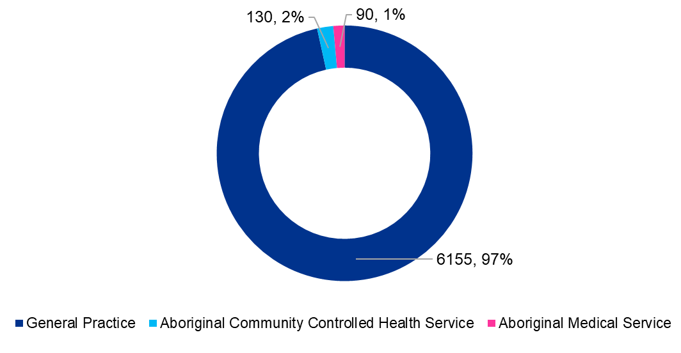

#### Participation by incentive

Over the period from 2019 to 2023, the PIP practice data reveals an upward trajectory in participation across the eHealth, PIP QI, and After Hours Incentive. Figure 32 illustrates the participation of practices in each PIP incentive from the 2019-20 to the 2022-23 financial years.

The eHealth Incentive stands out with one of the highest numbers of participating practices, consistently increasing over the observed period of time as digital health technologies have become increasingly prevalent. In contrast, the Procedural GP Payment exhibits the lowest participation among all incentives, maintaining a consistent participation rate.

The PIP QI demonstrates a high uptake and steady growth among participating practices. This trend is attributed to the straightforward eligibility criteria and the absence of specific targets for improvement measures. Similarly, the PIP AH Incentive is widely adopted, as indicated by the consistently high rate of practice participation, showing steady growth since 2019-2020.

Total PIP IHI payments show a slight decline, indicating a reduction in the number of participating practices over the observed period. The Teaching Payment saw a decrease in participation in 2020-21, likely due to COVID-19 restrictions. Although there is a gradual increase in participation in 2022-2023, it remains relatively low compared to other incentive types.

The variability in participation rates of PIP incentives is influenced by several factors identified through stakeholder feedback (see Effectiveness and Efficiency later in this chapter). Some incentives, such as the PIP IHI and PIP QI, are claimed by over 94 per cent of PIP participating practices, while others, like the rural loading incentive, are only claimed by 28 per cent of PIP participating practices due to stricter eligibility requirements. Refer to Figure 32 for the numbers and percentages of general practices claiming PIP incentives.

Figure 32 Practice participation by incentive over time (1 May 2022 – 30 April 2023)

Source: Services Australia.

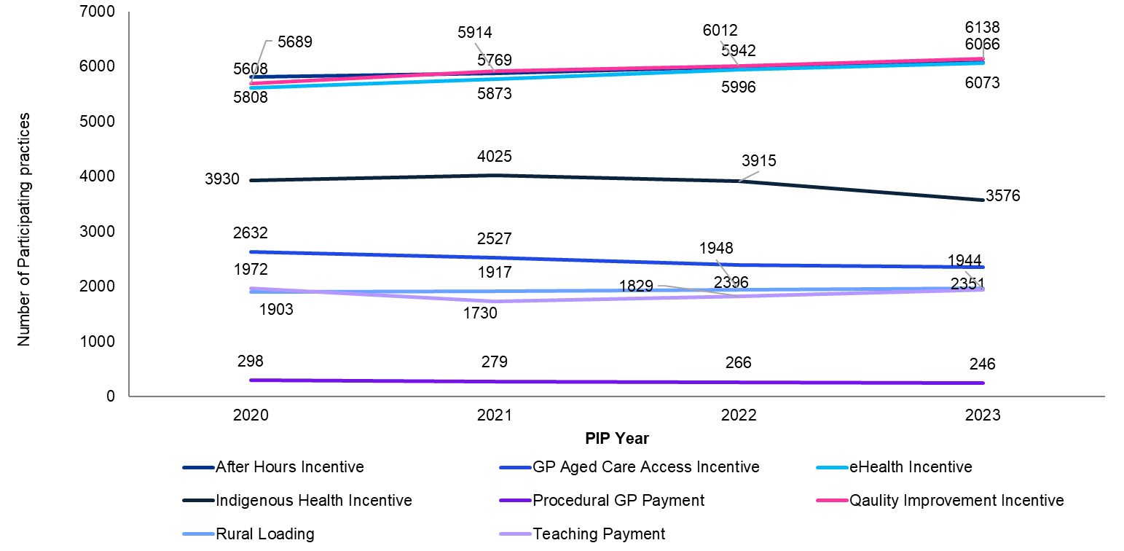

## Impact

### Alignment with policy objectives

There is considerable alignment between the PIP and policy objectives, such as the recommendations of the Strengthening Medicare Taskforce and the aims outlined in the Primary Health Care Ten Year Plan. Nevertheless, the program faces constraints in fully realising these objectives due to structural, financial, and systemic challenges. These limitations impede PIP incentive alignment with the current strategic aims of the healthcare sector.

Stakeholders identified under‑funded activities, eligibility processes, administrative burdens, infrastructure constraints, and workforce challenges as major obstacles (see Effectivenessand Efficiency later in this chapterfor more information). These challenges potentially discourage GPs from actively participating in incentives, hindering the achievement of policy recommendations; this issue also applies to Rural Generalists outside metropolitan areas.

#### Service provision in rural, and remote areas

While the PIP supports service provision in regional, rural, and remote areas by offering financial support, stakeholders noted its limitation in expanding overall healthcare services and hours. Workforce focus groups emphasised that, while these incentives play a role in maintaining expanded access to general practice services, many practices do not extend services beyond the minimum required levels. In rural and remote areas, the primary function of the PIP is perceived as sustaining basic practice operations rather than improving and expanding access, resulting in a misalignment with Strengthening Medicare Taskforce recommendations.

#### Outdated aspects

Some practices and PHNs indicated that specific elements of the PIP may be considered outdated and not in harmony with evolving healthcare demands, particularly concerning technological advancements and evolving care models like telehealth. Insights gathered through consultations highlighted practice and workforce perspectives on the importance of updating incentives to reflect changes in the digital health landscape, such as eHealth incentive and the PIP QI Incentive. This perspective aligns with strategic sector policy that underscores the imperative of leveraging progress in healthcare technologies.

#### Call for incentive expansion

Many peak bodies advocate for the expansion of PIP incentives to nurses, midwives, and allied healthcare providers. They argue that such an expansion could significantly advance broader sector policy objectives, including improving population health and promoting multidisciplinary team-based care, aligning with the aims and recommendations of the Primary Care Ten Year Plan.

#### Growth, sustainability, and quality

PHNs and peak bodies highlight that focusing PIP incentives solely on incentivising GPs limits opportunities for growth, sustainability, quality, and accessibility of primary care. In alignment with Strengthening Medicare Taskforce recommendations and broader reform efforts, there is a call for expanding PIP incentives to include nurses, midwives, and allied health providers.

#### Challenges in data linkage

PHNs and practices, particularly regarding PIP incentives, expressed challenges in linking collected data on incentive activities to consumer health outcomes. Current data often focuses on practices’ activities rather than consumer outcomes, hindering the ability to measure the direct impact of practice and behaviour changes on consumer health.

#### Concentration in densely populated areas

Data analysis of PIP payments reveals a concentration in more densely populated areas, aligning with population health needs. Metropolitan areas (RRMA 1) receive the largest share of PIP payments, accounting for nearly half of the total payments at $211.79 million.

## 

## Effectiveness

### Achievement of incentive program objectives

Many practices self-reported that PIP incentives vary in their effectiveness, with the most common feedback being that practices tend to participate minimally in incentive activities, resulting in only partial achievement of the intended incentive aims. Many stakeholders and survey respondents stated that many practices perform the minimum required amount of incentive activities in order to receive the payment, with key examples being the PIP QI and eHealth Incentives.

Feedback indicates that payment scaling could be adjusted to encourage greater engagement, as practices often perform the minimum required activities in order to receive payment. Survey results support these findings, with 56 per cent of survey respondents (averaged across PIP incentives) agreeing that PIP incentives have effective funding models for achieving their policy objectives. Outliers included the eHealth Incentive (81 per cent agree), the PIP QI Incentive (68 per cent agree), and the PIP IHI (38 per cent). See Figure 15 for further detail.

PHNs and peak bodies observed that PIP incentives improve primary healthcare through the incentive activities associated with each incentive, as well as the indirect effect of supporting general practices across Australia. Repeated feedback across consultation and survey comments focused on the increasing demands on GP time, and the balance many practices try to find between profitability and providing affordable healthcare. For many practices, PIP incentives were perceived more as a general support for daily service provision than as targeted programs to encourage behaviour change beyond the minimum required incentive activities. When feedback was provided about the effectiveness of individual PIP incentives, a majority of stakeholders focused on the design and structure of incentives.

Financial considerations do not seem to be the primary motivator for participation regarding incentives with more labour or time intensive activities, such as the GP ACAI or Procedural GP Payment, which respectively require travel time and further qualification.

#### Understanding and awareness

Survey data suggests that the primary healthcare sector has broad awareness of PIP incentives. Seventy‑four per cent of survey respondents (averaged across PIP incentives) agree that they or their practice are aware of the activities required to receive and maintain incentive payments. A low outlier is the Procedural GP Payment, with only 52 per cent of respondents agreeing that they understood the required activities. See Figure 16 Consolidated survey results for awareness of incentive obligations for detailed survey results.

Discussion in workforce focus groups revealed that, while practice managers and owners possess in-depth knowledge of PIP incentive payments, the broader GP and primary healthcare workforce are generally aware of incentive objectives but lack detailed structural and administrative understanding. GPs’ lack of awareness of certain incentives due to salary bundling is seen as a potential source of distortion in incentive outcomes. Furthermore, some incentives, notably the Indigenous Health Incentive, are not known of by some members of the primary healthcare workforces. PHNs suggested that a lack of awareness may impact program uptake and consumer access.

The prevailing sentiment is that most GPs, feeling time constraints, do not actively participate in incentive processes, particularly post-receipt of payments. This lack of awareness, especially among GPs, is perceived as a potential factor influencing incentive outcomes and feedback.

#### Influence on behaviour and practice

Practices tend to assess incentive payment values in relation to time spent on administrative processes, considering broader time pressures and increasing service demand. While payment values offset administrative requirements for most practices, practices described how certain incentives encouraged behaviour or that service provision could bring on unaccounted for costs to practices. See Section 8 Efficiency for more information.

## Efficiency

### Fit-for-purpose as a health system funding mechanism

The uptake across PIP incentives is generally high. Figure 33 below illustrates PIP incentive uptake rates. The average uptake, according to survey data, for PIP incentives is 65 per cent, or 75 per cent when the Procedural GP Payment and Rural Loading Incentive are excluded. This data matches stakeholder reports that the PIP as a whole is well-utilised.

Many practices and GPs perceived PIP incentives as funding to support the general practice’s daily service delivery and operations. A vast majority of stakeholders emphasised the importance of funding primary health care, with many stating that incentives can be incredibly useful for practices in covering the rising costs of medical equipment and wages. However, few practices or members of the primary healthcare workforce linked PIP payments to ongoing improvements in service delivery or the adoption of new models of care, instead framing PIP incentives as a supplementary funding stream.

Some PHNs highlighted a tendency for the primary healthcare sector to use collective language when referring to the PIP, treating the program as a unified entity, rather than distinguishing individual incentives with distinct reporting requirements and payment structures.

Figure 33 Survey results on uptake of PIP Incentives

Source: KPMG analysis.

Survey Question: Have you or your practice received, or considered applying for…

|  |
| --- |
| Survey results for whether participants utilise PIP incentives, presented as a horizontal stacked bar graph in percentages. |

### Administrative burden and complexity

Practices consistently voiced concerns about the administrative processes associated with the PIP, marking it as one of the most frequently discussed issues in the Review. The challenges stem from the distinct policy pathways of each incentive, resulting in duplicated processes and imposing significant time pressures on practices. Some smaller practices, overwhelmed by these challenges, choose to completely forgo engagement with PIP incentives. Survey data supports these findings, with 43 per cent (averaged across PIP incentives) of respondents agreeing that administrative processes were user-friendly. Fifty per cent of respondents (averaged across PIP incentives) agreed that the administrative requirements were worth the benefit provided to practices.

##### Encouraging general practice accreditation

Since 1999, a key aim of the PIP has been to encourage general practice accreditation across Australia, with the benefits outlined in previous reviews. PHNs and workforce focus groups reported that the extensive administrative and compliance effort required to qualify for PIP incentives is barely sufficient to justify the additional time and resources for participating practices. Many small and solo general practices decide not to apply for certain PIP incentives due to the administrative burden. The General Practice accreditation system, recognised as arduous and expensive, particularly for rural practices, presents an opportunity for simplification and streamlining. Some stakeholders reported that this requirement acted as a constraint on service model innovation and workforce participation, for example GPs who wished to focus on solo practice in residential aged care could not access the incentive without having to establish and accredit a practice at an address other than their home.

##### Overlapping reform processes and comprehensive system reform

Peak bodies and AMS frequently emphasised the overlap of concurrent and ongoing reform processes while providing feedback, underscoring the need for comprehensive reform across the entire primary healthcare system. Practices, for instance, considered the streamlining of incentive eligibility requirements through linkage with MyMedicare.

##### Alignment and prevention of competition between programs

A recurring theme in the feedback suggested that future incentives and initiatives should be carefully aligned in design to prevent potential competition between programs and minimise unintended consequences.

##### Variation in administrative burden across incentives

The administrative burden appears to vary across incentives, with some, such as the Aged Care Access and Teaching Incentives, stated by practices to have high activity requirements for eligibility. Others, such as the Quality Improvement and Rural Loading Incentives, have less labour or time-intensive requirements. Services Australia noted that verifying the eHealth Incentive poses the most significant challenge in determining payment eligibility. Timing challenges were also acknowledged, given that evidence is provided via PHNs to the Department, which then determines payment eligibility through Services Australia.

##### Streamlining administrative processes

To address these issues, all stakeholder groups recommended streamlining the administration of the PIP, advocating for a more unified process rather than individualised approaches for each incentive.

### Payment mechanism

Stakeholder feedback varied regarding PIP payment mechanisms. The central divide was over whether PIP incentive payments should continue to be paid to practices, who may then choose to pass payments on to contracted GPs, or whether more payments should be SIPs, paid directly to GPs. Reasoning from PHNs, peak bodies, and workforce focus groups revolved around the financial viability of practices and the increased likelihood of influencing GP behaviour if payments were made directly to GPs.

Survey data shows that a majority of practices are retaining incentive payments, rather than passing on payments to GPs. Thirty‑nine per cent of survey respondents (averaged across PIP incentives) agreed that they or their practice passes on part or all of the incentive payments. The Teaching Payment is an outlier, with 81 per cent of respondents agreeing that payment is passed on. Survey comments match consultation findings that the Teaching Payment is passed on because teaching medical students limits the number of consumers a GP can see in a day, thereby restricting income.

##### Lack of detailed payment breakdowns

Practice managers and owners expressed good overall awareness of PIP payment values, however they reported that the lack of detailed breakdowns in payment statements hinders their ability to reconcile payments with specific activities or costs.

### The Standardised Whole Patient Equivalent Value

#### SWPE value and PIP payments

The SWPE value serves as a measure of a practice’s patient load, independent of the number of services provided. It aims to ensure accurate and fair measurement of practice size, discouraging double counting of consumers and emphasising the quality over the quantity of care. PIP payments to practices are generally proportional to practice size, calculated using SWPE. SWPE values indirectly influence rural loading payments, dependent on practice participation in incentives and the rural or remote nature of the practice location. See Figure 21 for details on which PIP incentives use the SWPE and how it factors into payment mechanisms.

#### SWPE calculation for practice size

The SWPE for a practice is determined by summing fractions of care provided to each consumer, weighted based on age and gender. However, not all PIP incentives correlate with a practice’s SWPE value. Examples include the PIP Teaching Incentive and the PIP IHI. In addition, practices expressed concerns about the complexity of SWPE calculations, citing it as a barrier to practices’ comprehension of incentive programs and payment levels.

##### Limitations for certain service models

Common feedback indicates that SWPE may not accurately reflect patient loads in practices where non-MBS claimable services constitute the majority of care, such as nurse-centric clinics in AMS or ACCHs. For example, SWPE’s age and gender weighting overlooks the burden of chronic disease at a younger age in First Nations peoples. Peak bodies and AMS suggested calculating weighting based on gender, age, and Indigenous status to address this discrepancy. Practices highlighted challenges in changing their SWPE value, calling for a more adaptable approach tailored to the unique circumstances of different practices.

##### Disadvantages for practices with higher healthcare needs

Concerns were raised about potential disadvantages for practices serving populations with greater healthcare needs, suggesting limitations in the standardised approach. Rural practices, facing lower average SWPE values, encounter financial limitations, indicating potential inequities across geographical and healthcare settings.

##### Representation of non-MBS eligible services

Non-MBS eligible primary healthcare services often receive funding from federal or state and territory governments. This includes ACCHS and AMS, who are able to additionally claim some MBS funding and some incentives, such as the PIP IHI and WIP Practice Stream, due to exemptions. Non-MBS eligible services are still required to use SWPE calculations for some payment mechanisms. Feedback from ACCHS and AMS workforce focus groups perceived the SWPE as a measure intended for use in general practices, and that the increased complexity of care required for First Nations populations should result in some weighting or other understanding that First Nations consumers are not ‘standard’ patients.

## Sustainability

### Sustainability of consumer health outcomes and access to care

All stakeholder groups share a consensus that general practice cannot sustain the healthcare and services incentivised by PIP incentives without the financial support offsetting time-based opportunity costs. Survey data reflects this consultation finding, with seven per cent of respondents agreeing that incentivised activities can be sustained without incentive payments (averaged across PIP incentives).

Payment values for incentives are often considered as part of a general practice’s revenue, due to payments remaining relatively stable. However, incentives promoting specific care types are commonly perceived as insufficient in offsetting associated costs and time pressures. Practices often perceive incentives as revenue sources rather than as mechanisms aligning with each program’s goals. Rural and remote practices emphasise their financial dependence on PIP and WIP funding for viability.

Some practices have relied on the same set of incentives for years and expect continuity in payments. However, they reported that a lack of understanding of administrative or reporting requirements, including misinformation among new practice managers, can result in a lapse of payments.

Survey data supports consultation findings regarding the increasing costs and time pressures faced by general practices, with many practices depending on the continuity of incentive payments to remain financially viable. Forty‑five per cent of survey respondents (averaged across PIP incentives) agreed that PIP incentives are structured in a way that makes continuing to meet reporting requirements and receive payments sustainable. Many practices, especially small practices or practices located in rural and remote areas, reported being uncertain about the continued value of incentive payments compared to the trends of increasing demand they face in their communities. A common view among peak bodies and workforce focus groups was that the sustainability of existing general practices relies on the continued availability of incentive payments.

### Program sustainability in the broader policy context

Practices appear to self-report using incentives to sustain operations or fund existing models of care, rather than driving improvements in care quality and capacity. Many practices and PHNs stated that GPs engage in activities based on personal motivation, viewing incentives as supportive rather than the primary driver of decisions to provide certain types of health care.

#### Adapting to policy changes

The sustainability of GP incentive programs depends on adapting to changes in the broader health policy context. Some incentives, such as the After Hours Incentive, face competition with new healthcare services. PHNs, peak bodies, and many members of the primary healthcare workforce emphasised the need to update incentives like eHealth to reflect changes in the digital health landscape.

#### Expectations and challenges

In light of publicly available data showing steep increases in insurance costs and electricity, both of which impact the cost of business for GPs, the current PIP and WIP incentive structure may not adequately cover long-term operational expenses for many practices. Many practices express concerns regarding the sustainability of current incentive structures amidst these rising costs. GPs and practice managers are concerned that the existing incentive mechanisms may not sufficiently offset the financial burden imposed by escalating operational expenses. Furthermore, the challenges related to attracting medical students to choose careers in general practice and recruiting GP registrars for rural practices are compounded by disparities in remuneration compared to hospital positions.

Stakeholders within the healthcare sector have reported concerns about the sustainability of general practice in rural and remote areas. These concerns highlighted the broader challenges faced by the primary healthcare sector, including workforce shortages and their detrimental effects on incentive programs and overall sustainability. Addressing these challenges requires a concerted effort to re‑evaluate existing incentive structures and implement strategies to attract and retain healthcare professionals in primary care settings.

Workforce Incentive Program

# Workforce Incentive Program

This chapter presents high-level findings regarding the WIP. Overview findings include expenditure and practice participation levels. Findings for specific review domains include:

• Impact: Alignment of the WIP with overarching policy objectives and current sector trends

• Effectiveness: Achievement of incentive policy objectives and payment distribution

• Efficiency: The suitability of the WIP as a health system funding mechanism, the level of administrative burden, and feedback regarding payment mechanisms

• Sustainability: The sustainability of consumer health outcomes and the WIP within broader policy context.

Findings regarding the WIP are consolidated from consultations, survey results, and quantitative analysis.

## Overview

### Expenditure in the WIP

#### Expenditure over 2023

The WIP was worth a total of $518.20 million in funding over the 2023 financial year. This represents approximately 52 per cent of the total incentive expenditure across both PIP and WIP incentive programs. Figure 34 shows the breakdown of expenditure over 2023.

The WIP Practice Stream was worth approximately $393.62 million in funding in 2023, accounting for nearly 40 per cent of the expenditure of all incentive programs and around three-quarters of total WIP expenditure. Due to the incentive structure, WIP Practice Stream payments were counted from May 2022 to April 2023, and include approximately $17 million of withheld payments. Adjusted for withheld payments, total WIP Practice Stream expenditure over the 2023 financial year is $376.49 million[1]. In the August WIP quarter of 2023, there were 5,425 practices that received a payment for the Practice Stream.

The WIP Doctor Stream was worth approximately $124.58 million in funding in 2023 accounting for around 13 per cent of the expenditure of all incentive programs and nearly one-quarter of total WIP expenditure. Doctor Stream expenditure is based on payments made to doctors, which may not match the number of payments earned by doctors due to issues with bank accounts. Such issues may cause payments to be made at a date after they were earned by the rules of the Doctor Stream, but the difference between total payment values is marginal.

Figure 34 Overview of WIP Expenditure FY23 ($)

Source: Services Australia.

Figure 34 is an infographic showing the overview of WIP Expenditure FY23 ($)

#### Expenditure over time

WIP payment values have remained relatively stable over time. Figure 35 provides an overview of the total funding allocation for the WIP for the Practice Stream and Doctor Stream, spanning financial years 2021‑2023 and including withheld payments.

In 2023, the total WIP, encompassing both the Practice and Doctor Streams, received 518.2 million. This is an increase by approximately $10 million from 2021, where the streams totalled $508.2 million.

There has been a slight increase in funding in the Practice Stream from $383.60 million in 2021 to $393.62 million in 2023. This may suggest a strategic focus on bolstering the Practice Stream within the WIP framework.

The Doctor Stream experienced a small increase in funding from 2021-2022 where funding increased by $1.7 million from $124.62 million to 126.25 million in the 2022 financial year. In 2023, Doctor Stream funding returned to 2021 levels.

Figure 35 WIP Expenditure ($) from financial years 2021-2023

Source: Services Australia.

Figure 35 is a bar graph showing the WIP Expenditure ($) from financial years 2021-2023

#### Distribution of payments

##### Practice Stream

The allocation of funding for the WIP per MMM classification correlates with population in Australia. In the 2023 financial year, MMM 1 areas received over half of the total expenditure, amounting to $258.77 million out of a total of $393.62 million. Funding distribution across MMM 2 to 5 categories remained relatively similar, while MMM 6 and 7 categories received notably less funding. Refer to Figure 36 for a visual representation of WIP payments per MMM locations from 2021 to 2023, with Practice Stream rural loading payments included in the totals. When adjusting for population, this corresponds to $15.32 per person in MMM 1, up to $24.77 per person in MMM 7 in 2023.

Figure 36 WIP total payment per MMM Categories 2021 to 2023

Source: Services Australia.

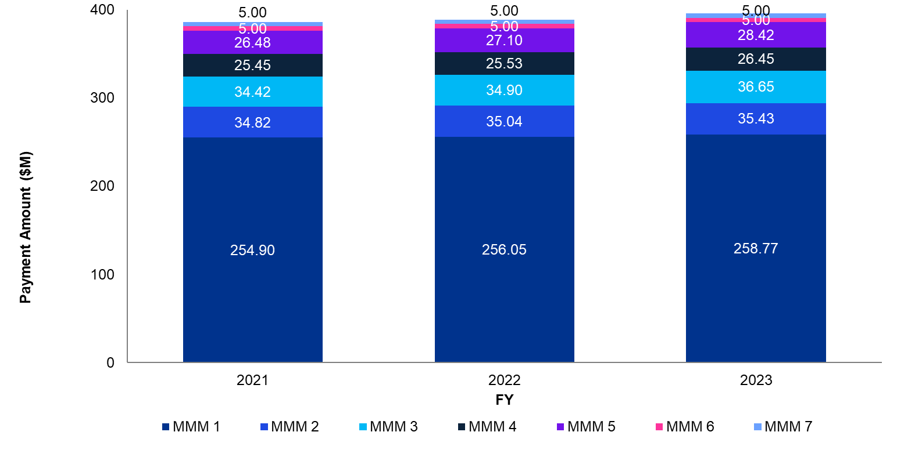

##### Doctor Stream

The distribution of WIP payments per MMM location reflects both the payment tiers of the incentive and population density. This distribution has remained relatively stable from 2020 to 2023. MMM 5 receives the largest proportion of payments, followed by MMM 3 then MMM 4. MMM 6 receives the least payments. Figure 37 shows WIP payments distributed by MMM classification from 2020 to 2023. When adjusting for population over these MMMs, we find that this translated to $24.25 per person in MMM 3, and up to $77.34 per person in MMM 7.

Figure 37 WIP payments per MMM categories

Source: Services Australia.

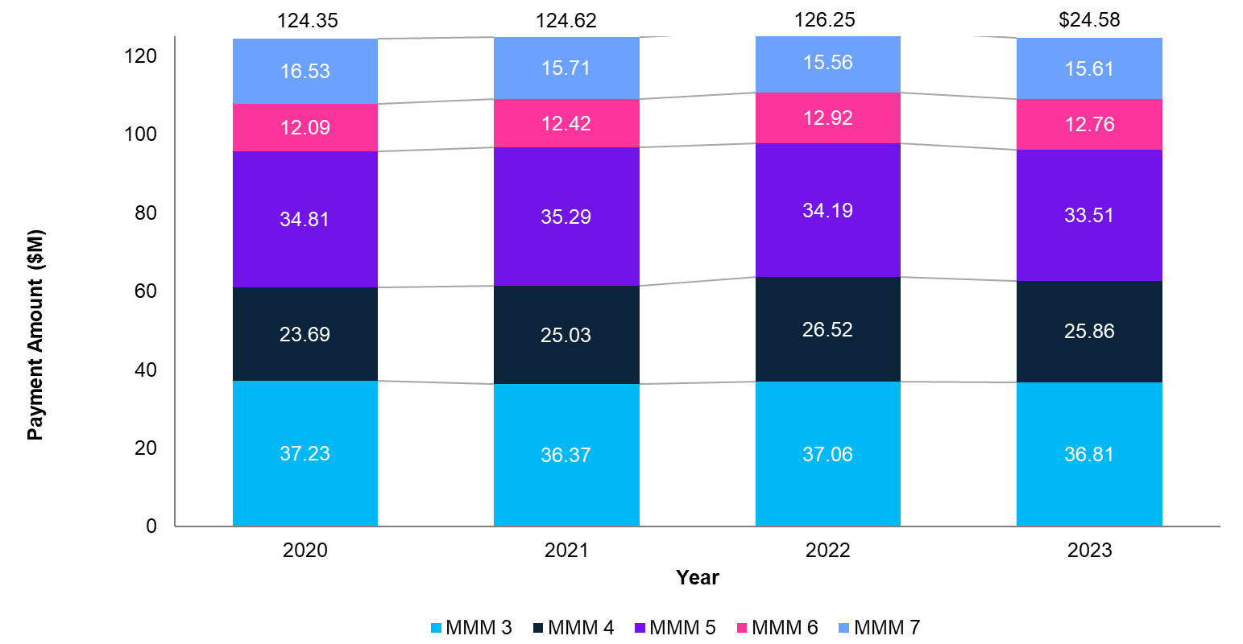

## Impact

### Alignment with policy objectives

The three streams of the WIP align closely with policy objectives related to multidisciplinary models of care and increasing access to health care, especially outside metropolitan areas. The program is well-aligned overall with the Primary Health Care Ten Year Plan and Strengthening Medicare Taskforce report. However, external constraints, including the structural and systemic challenges facing rural health care, constrain the broader impact of WIP Streams to advance broader strategic aims, such as improving the supply and distribution of healthcare professionals and increasing access to care. These limitations hamper the WIP’s ability to address the demands of healthcare workforces across Australia

PHNs and peak bodies highlighted how WIP Streams are impeded by the healthcare workforce issues they seek to address. For example, practices report that the WIP Practice Stream aim of increasing multidisciplinary care by engaging the non-medical healthcare workforce in general practice is impeded by the lack of allied health professionals in rural and remote areas. Across both the WIP Practice and Doctor Streams, stakeholders stated that incentives help more with retention and maintaining current levels of access to care than with recruiting new staff.

The WIP Doctor Stream aims to encourage medical practitioners to practise in regional, rural and remote communities. General practice and GP feedback suggests that the incentive is more supportive of retention for GPs already working regionally than for recruitment of new GPs and Rural Generalists. Consultations underscored the need for improved data collection, monitoring, and evaluation of WIP payments to better gauge their impact.

#### Alignment with the Primary Health Care Ten Year Plan

A critical examination of the WIP indicates potential gaps in congruence with the Primary Care Ten Year Plan. While the program presupposes that the optimal location for primary healthcare delivery is within general practices, developments in digital health technology were described by peak bodies as empowering nurses and allied health professionals to deliver quality primary care in community settings by linking GPs and specialists as needed. When asked whether the Practice Stream encourages practices to change service delivery approaches, 58 per cent of survey respondents agreed, with a further 24 per cent neither agreeing nor disagreeing. This broadly reflects Practice Stream data survey comments that reflected consultation findings that the WIP Practice Stream was primarily used to employ nurses, who appear to be supporting existing models of care.

#### Alignment with Strengthening Medicare Taskforce recommendations

The WIP is well-aligned with two points of the Strengthening Medicare Taskforce report’s four-point vision, however achievement of these policy objectives is constrained. All WIP streams aim to increase access to primary care, especially in regional, rural, and remote communities, however workforce focus groups suggest that the complexity of care in those communities and workforce issues impacting rural health care have resulted in the WIP streams maintaining current levels of service provision more than increasing service availability. Stakeholders suggested redesigns of the Practice and Doctor Streams, given that both incentives are well-established considering their evolution from the GPRIP and PNIP. Further targeting of incentive structures to encourage more models of multidisciplinary, team-based care and using non-financial levers to attract GPs and Rural Generalists to rural areas were key suggestions among all stakeholder groups.

The WIP Practice Stream directly aligns with the second point of the Taskforce’s vision: encouraging multidisciplinary, team-based care. However, a majority of stakeholders reported that general practices primarily use the incentive to employ nurses, rather than broader multidisciplinary teams. This is supported by survey data, with 63 per cent of respondents agreeing that the Practice Stream enables the hiring of nurses, but only 20 per cent agreeing when asked about hiring allied health professionals, and only 10 per cent for Aboriginal and Torres Straight Islander health workers and practitioners.

### Alignment with sector needs

Some PHNs and peak bodies expressed reservations about the WIP primarily serving as an employment support program and questioned its effectiveness in addressing the evolving needs of the healthcare sector, sharing perceived limitations within the Practice and Doctor Streams. Monitoring of the program, especially the Practice Stream, is limited as data is only collected on the headcount and average weekly hours of healthcare professionals employed under the incentive. The Practice Stream does not collect data on the types of work undertaken by employed healthcare professionals, which is also not well-covered by MBS item data. This leads to stakeholder doubt about the extent to which the Practice Stream incentivises interdisciplinary collaboration.

The Doctor Stream was also reported to be limited as a recruitment mechanism, with peak bodies and workforce focus groups suggesting that financial motivation to encourage GPs to move to rural communities is not an appropriate lever to increase access to primary healthcare. In addition, all stakeholder groups noted that broader workforce challenges and primary healthcare system trends are impacting the recruitment of GPs and other health professionals, particularly in rural and remote areas.

## 

## Effectiveness

Despite being deemed crucial for practice operations, PHNs, peak bodies, and workforce focus groups expressed doubts about the effectiveness of the WIP in driving behavior change or incentive goals due to external challenges. While the Practice Stream was found to be instrumental in enabling multidisciplinary teams and ensuring care continuity, thin markets are creating workforce challenges for hiring, including Aboriginal and Torres Strait Islander health practitioners. There have also been challenges in relation to how the incentive shapes practice employment models, with unintended consequences such as limitations to scope of practice, reduced earnings compared to hospital and metropolitan settings, and practices’ lack of clinical governance regarding allied health. The WIP incentives have not kept pace with inflation, and therefore struggle to cover rising costs. The imposed cap on payments further limits the effectiveness of the Practice Stream.

### Achievement of incentive objective

PHNs and peak bodies reported concerns about the effectiveness of WIP Streams achieving their individual objectives. Despite general practices considering the WIP to be crucial for their operations, doubts were stated regarding the program’s ability to drive behavior change due to broader contextual factors. The national shortage of GPs limits the Doctor Stream’s objective of improving the geographic distribution of GPs by supporting rural and remote communities that are under-served. The WIP Practice Stream also falls short of encouraging multidisciplinary team care due to workforce shortages, incentive value, and a lack of awareness. These factors appear to contribute to most practices utilising the Practice Stream to primarily employ primary healthcare nurses rather than other types of healthcare professionals.

#### Understanding and awareness

PHNs and some peak bodies expressed the importance of improving understanding and awareness surrounding the WIP. The consultations revealed doubts among peak bodies and practices about the effectiveness of the program in influencing behavior and practice. Stakeholders emphasised a need for enhanced communication and education to ensure a clearer understanding of the WIP’s objectives and impact.

Some PHNs, peak bodies, and self-reporting practices suggested that the primary healthcare sector still perceives the WIP Practice Stream through the lens of its previous iteration, the Practice Nurse Incentive Program. Survey data on which healthcare professionals are hired under the Practice Stream supports this feedback, with 63 per cent of respondents agreeing that the incentive enables the hiring of nurses, but only 20 per cent agreeing in terms of allied health professionals, and only 10 per cent for Aboriginal and Torres Straight Islander health workers and practitioners. During consultation, multiple stakeholders also referred to the WIP Practice Stream as the ‘Nurse’ Incentive.

The WIP Doctor Stream is the most well understood incentive among the primary healthcare workforce, seemingly due to the limited changes to the incentive structure from its previous iteration as the GPRIP and the automatic and directly-paid nature of the payment, which requires GPs, not practices, to apply.

A vast majority of stakeholders are aware of the Rural Advanced Skills Payment, but few practices or members of the primary healthcare workforce had awareness of details beyond the eligibility requirements for payment. Survey results reflected the level of understanding in consultation, with only 35 per cent of respondents agreeing that the payment guidelines were easy to understand.

#### Influence on behaviour and practice

Peak bodies and workforce focus groups suggested that, due to external factors, the incentive structures of the Practice and Doctor Streams are limited in influencing behaviour across the primary healthcare system. The values of incentive payments was commonly cited as a limitation, with general practices unable to offer nurses and allied health professionals wages that can compete with hospitals and aged care facilities, and GPs seeing Doctor Stream payments as percentages of their annual income making many GPs not motivated to relocate for relatively small salary increases.

Incentive design was also brought up in consultation. Many PHNs and peak bodies noted that the WIP Practice Stream lacks a sufficient funding mechanism to directly encourage multidisciplinary, team-based care. Most practices appear to utilise the incentive to hire registered nurses, who are often required to perform administrative duties for the practice or on behalf of GPs. The Practice Stream appears very useful at enabling multidisciplinary teams, but the adoption of new models of care is not a requirement or measurement of the incentive. Survey responses supported these findings, with 53 per cent of participants agreeing that the Practice Stream has led to changes in their practice’s models of care. Furthermore, 33 per cent of participants agreed that hiring an allied health professional allowed their practice to change service delivery approaches.

Rural workforce focus groups considered the WIP Doctor Stream useful for retention but less likely to influence new GPs to practice in rural and remote areas; higher salaries no longer seem effective in attracting and developing the rural health workforce. Some practices and PHNs also noted challenges in outer urban, lower-socioeconomic areas, which are not adequately addressed through this incentive. Concerns were also raised about the year levels of the Doctor Stream, with payment increases ceasing after five years of service. Some peak bodies and GPs pointed out that this may limit the incentive’s effectiveness in retaining GPs and Rural Generalists in rural and remote areas over the long term.

Robust data collection was also highlighted by PHNs and peak bodies as a necessity to measure and evaluate the number and proportion of nurses, allied health, and other health practitioners engaged in general practice. The current lack of data leaves a gap in knowledge regarding trends in the sector and the effectiveness of Practice Stream expenditure.

## 

## Efficiency

### Fit-for-purpose as a health system funding mechanism

PHNs and peak bodies suggested that elements of WIP payment structures have efficiency issues. They highlighted disparities between the nursing scope of practice and the work that nurses tend to perform in general practices. General practices stated that they are financially disincentivised to allow nurses to substitute tasks for GPs and use more efficient models of care due to the lower MBS item rates that nurses are able to claim. Workforce focus groups identified issues with the Doctor Stream’s payment mechanism not allowing for any leave, particularly mechanisms having negative effects for GPs who work part time or take maternity leave.

All stakeholder groups and many survey respondents emphasised how integral WIP Streams have become to the daily operation of general practice. Overall, the WIP has a high uptake among survey respondents, with the Practice Stream being received by 79 per cent of respondents, and the Doctor Stream by 58 per cent (survey responses include participants from all MMM locations).

### Administrative burden and complexity

Feedback regarding WIP administration was largely positive. This is supported in survey data, with 61 per cent of respondents agreeing that performance of Practice Stream administration processes were worth the benefit. Fifty‑one per cent of respondents agreed that Doctor Stream administration was worth the benefit, with a further 32 per cent neither agreeing nor disagreeing. GPs and peak bodies approved of the automatic nature of the ongoing payment.

In consultation, the WIP Practice Stream received more varied feedback regarding administration, however the majority of practices did not consider the administration a burden. Some PHNs and peak bodies suggested that, because data collection for the Practice Stream is a common issue, more data could be collected without imposing an undue burden on practices, provided general incentive administration was streamlined.

Both the Practice and Doctor Streams had less than half of survey respondents agree that administrative processes were clear and user-friendly (47 per cent and 43 per cent, respectively). However, each question also received a high proportion of results for ‘neither agree nor disagree’ − 33 per cent for the Practice Stream and 30 per cent for the Doctor Stream − which may be a result of gaps in understanding regarding general practice incentives among survey participants and the broader primary healthcare workforce.

Consultation findings and survey data were inconclusive regarding the Rural Advanced Skills payment, due to the consultation period taking place before the payment commenced on 1 January 2024. The lack of understanding was reflected in survey data, with only 35 per cent of survey respondents agreeing that the payment guidelines were easy to understand and 63 per cent neither agreeing nor disagreeing whether administration processes were worth the financial benefit.

### Payment mechanism

When asked, stakeholders approved of the payment mechanisms of WIP streams. The Practice Stream’s method of covering hours worked was appreciated, however many workforce focus groups highlighted the cap on the payment as unduly restricting large practice groups from employing multidisciplinary teams, as supporting every practice with a nurse was seen as a priority.

Feedback regarding the payment mechanism of the Doctor Stream emphasised appreciation that the payment was paid directly to GPs. Multiple GPs identified issues with the method of counting ‘active quarters’, stating that part-time GPs are disadvantaged, as well as female GPs who can miss out on an annual payment when on maternity leave for more than nine months.

## 

## Sustainability

Peak bodies, PHNs, practices, and the primary healthcare workforce raised concerns about the sustainability of consumer health outcomes and access to care within the context of the WIP. Challenges related to the incentive structure and external workforce pressures impacting the viability of sustaining positive consumer outcomes and ensuring continued access to care. Practices, particularly in rural and remote areas, expressed a perception that incentives primarily serve as revenue sources rather than mechanisms aligned with the goals of each incentive program.

### Sustainability of consumer health outcomes and access to care

PHNs and practices reported that WIP payments are critical to maintaining services, especially in rural and remote communities. Eighty‑eight per cent of survey respondents disagreed when asked whether they could sustain the employment of healthcare professionals without the Practice Stream, and 75 per cent disagreed when asked whether doctors could sustain delivery of primary healthcare in rural and remote areas without the Doctor Stream.

Many survey comments and feedback from all stakeholder groups emphasised how incentives have become increasingly integral to the financial viability of general practices in rural and remote communities, with small and solo practices in financially disadvantaged areas using WIP payments to offset costs of bulk billing.

### Program sustainability in broader policy context

GPs noted that incentives are not increasing in line with costs, including increased wages and medical consumables, thereby diminishing the financial viability of their practices over time. Feedback from PHNs and workforce focus groups regarding the long-term recruitment and retention of GPs to rural and remote communities was pessimistic, with a shared perception that financial motivation was not working to encourage GPs to relocate to practices outside metropolitan areas.

DoHAC primary healthcare general practice workforce data shows that the number of GP full time equivalent (FTE) in remote regions of Australia has decreased in the five-year period 2017 to 2022, by 14 per cent in MMM 6 and six per cent in MMM 7. This possibly reflects the 10 per cent decline in GP FTE in the Northern Territory in the same period (DoHAC, 2023c). Conversely, rural regions (MMM 3, 4 and 5) have seen a growth in GP FTE of six per cent, three per cent and 10 per cent respectively in the same period, compared to a rate of eight per cent in MMM 1 and 2 areas (DoHAC, 2023c). The variable increases and decreases of GP FTE rates across MMM support consultation findings that multiple factors influence a GP’s decision on where to practice. Peak bodies also stated that the multitude of rural recruitment incentives, such as the Australian General Practice Training program requirements of 50 per cent of training to occur in rural areas, make the effect of the Doctor Stream difficult to determine in isolation.

Regarding other healthcare professionals employed through the Practice Stream, roughly two-thirds of healthcare professionals work in practices located in MMM 1 areas. The proportion of professionals decreases with rurality, which aligns with population density and consultation findings about rural healthcare workforces, except for MMM 7 having a slightly higher proportion of total headcount than MMM 6, possibly due to ACCHS and AMS utilisation of the Practice Stream. The number of healthcare professionals employed through the WIP Practice Stream has fluctuated, potentially due to Covid-19 vaccination efforts. However, despite fluctuations in total headcount, the proportion of healthcare professionals per MMM classification has remained relatively stable, with overall trends of gradual increase in every MMM classification. Figure 38 below shows the total headcount of healthcare professionals engaged under the WIP by MMM classification.

Peak bodies and workforce focus groups also raised concerns about the wages offered to nurses in other settings, such as hospitals, aged care, and disability services, already being higher than what many rural and remote general practices can compete with.

All stakeholder groups emphasised the need for swift action to improve the supply and distribution of GPs and other healthcare professionals in currently under-served areas, particularly in MM6/MM7 regions with high Aboriginal populations where the burden of disease is most acute.

Figure 38 WIP Practice Stream quarterly total headcount of healthcare professionals by MMM

Source: Services Australia.

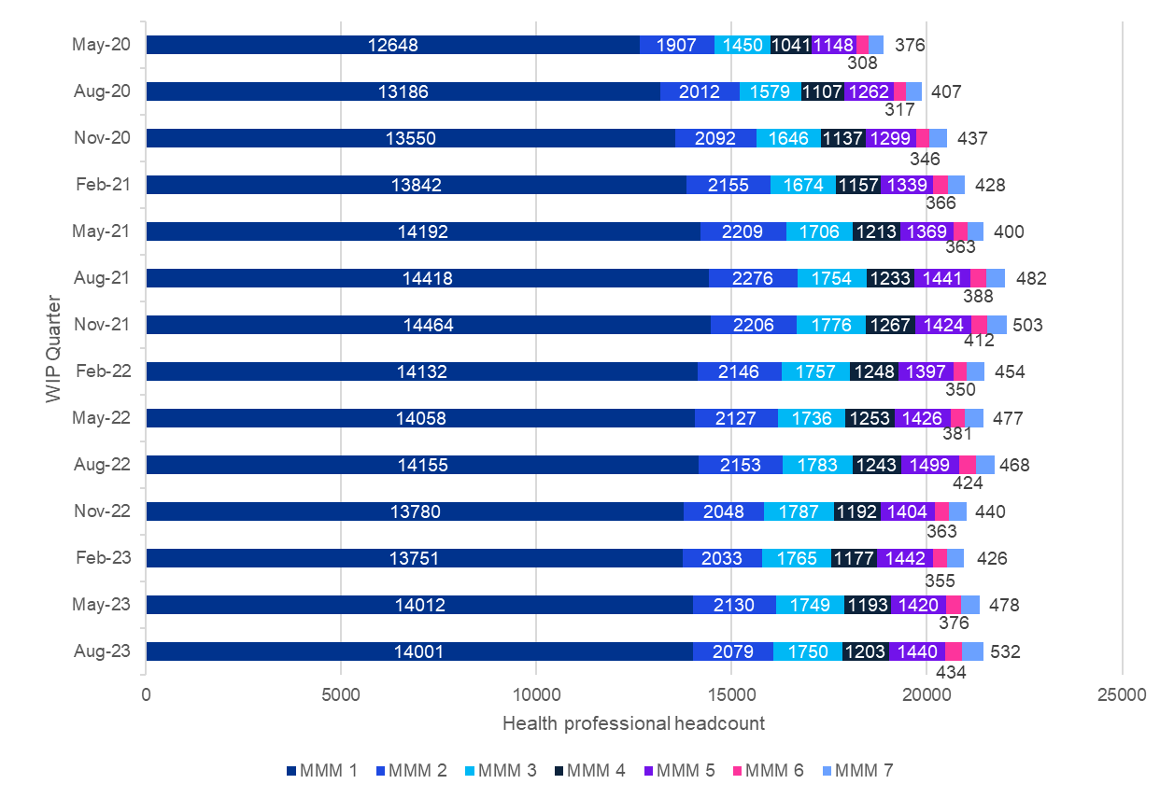

Summary of insights

# Summary of insights

This chapter offers a comprehensive synthesis of key findings and takeaways from the Review, reflecting actionable insights shared by stakeholders to inform future policy and programmatic decisions relating to general practice incentives.

## Summary of findings

This Review presents a comprehensive analysis of expenditure data from the PIP and the WIP. In terms of expenditure analysis, both the PIP and the WIP demonstrate substantial investment in various facets of general practice. This includes initiatives aimed at enhancing quality improvement efforts and incentivising workforce distribution, particularly in rural and under-served areas. Detailed examination of expenditure patterns within these programs reveals important insights into where expenditure is allocated and which areas receive the most emphasis.

Stakeholder perceptions regarding the effectiveness of PIP and WIP incentives varied. While some stakeholders viewed these incentives as supportive of baseline service provision, opinions were divided on their overall efficacy. Limited evidence suggested that these incentives had a significant impact on consumer health outcomes or contributed significantly to improvements in population health. Questions were raised about the extent to which the incentives aligned with broader policy objectives and addressed the complex challenges facing the healthcare sector.

Concerns were also raised about the efficiency and sustainability of the incentives. Stakeholders highlighted inefficiencies in incentive structures and administrative burdens associated with program participation, particularly for smaller practices and those in rural areas. These challenges were seen as potential barriers to realising the intended benefits of the incentives and that they could impact the long-term sustainability of general practice operations.

While general practice incentives played a role in supporting healthcare delivery, ongoing refinement was deemed necessary to address emerging challenges and ensure alignment with broader policy goals. The Review emphasised the importance of a nuanced approach to incentive design and implementation to maximise their impact and effectiveness in addressing the evolving needs of the healthcare system.

Figure 39 below outlines the key review findings and the strength of supporting evidence of those findings.

Figure 39 Strength of evidence and key review findings

| Impact | Effectiveness | Efficiency | Sustainability |
| --- | --- | --- | --- |
| The PIP and WIP have limited impact. | The PIP and WIP have limited efficacy. | The PIP and WIP are perceived as inefficient. | The PIP and WIP are do not support sustainable outcomes. |
| * Incentives are perceived as complex and lacking clear alignment with broader policy objectives. * There is limited evidence of incentives contributing to consumer health outcomes or driving improvements in population health. * Incentives are not sufficiently responsive to accommodate emerging sector trends, such as workforce shortages. | * Incentives have limited influence on behaviour in general practices. * In general practices, there is variable awareness of incentives due to broader contextual factors. * Smaller practices, particularly those in rural areas, lack the administrative capacity to fully participate in general practice incentives. | * Administration is described as challenging and burdensome. * General practices reported difficulties reconciling incentive payments in business accounting, which was linked to a lack of understanding the outcomes of incentives. | * General practices rely on incentive payments for the sustainability of daily practice operations. * Stakeholders expressed concerns about how unintended consequences from other government initiatives could restrict both the immediate and long-term outcomes of incentives. |
| There is **weak evidence** to support these findings. | There is **some evidence** to support these findings. | There is **some evidence** to support these findings. | There is **some evidence** to support these findings. |

### Impact

#### Complexity of general practice incentive programs

Stakeholders acknowledged the policy objectives behind individual PIP and WIP incentives however expressed uncertainty about the overall purpose of the programs. Each incentive serves a slightly different purpose, and there is a perceived need for incentives to adapt to better align with the current healthcare policy landscape. This lack of coherence contributes to the complexity of understanding and navigating the incentive system in general practice.

#### Linkage to consumer health outcomes

Stakeholders, including PHNs and peak bodies, raised concerns regarding the lack of clear linkage between the current incentive structures and improvements in consumer health outcomes. This disconnect presents challenges in accurately assessing the effectiveness of incentives and in fostering continuous improvement in healthcare delivery. To address these concerns, stakeholders advocated for the development of robust monitoring and evaluation frameworks tailored to each incentive program. These frameworks should incorporate metrics directly related to consumer health outcomes, enabling a more objective assessment of the impact of incentives on overall healthcare quality and effectiveness. Additionally, stakeholders emphasised the importance of ongoing monitoring and evaluation efforts to identify areas for improvement and inform potential adjustments to incentive structures to better align with desired health outcomes. Any design or implementation of monitoring frameworks should be balanced against practice data maturity and capacity to take on further administrative processes regarding linking incentive activities to consumer health outcomes.

#### Keeping pace with sector or practice trends

Stakeholders, including peak bodies and members of the primary healthcare workforce, highlighted the need for PIP and WIP incentive structures to evolve in response to the complex challenges facing the healthcare sector. These challenges include workforce shortages, changing dynamics in the GP workforce such as increased focus on work-life balance, rising operational costs and wages, and the transformation of general practices from small to large businesses.

### Effectiveness

#### Limited influence on provider behaviour

Qualitative evidence suggests that incentives have a moderate or limited impact on individual provider behaviour. Some general practices reported prioritising the minimum requirements for incentivised activity to secure payment, reflecting the mitigating effect of time constraints on GPs and staff. Additionally, stakeholders perceived incentive values as somewhat inadequate to drive significant behavior change, indicating a slight misalignment between the value of incentives and desired outcomes.

#### Variable awareness and understanding

The primary healthcare workforce reported that general practice incentives are not universally understood across the sector, and that awareness of specific incentive purposes and structures is low even among GPs. Stakeholders emphasised the need for improved communication and awareness efforts.

#### Geographical disparities

Access to incentives improves with administrative sophistication, disadvantaging smaller practices that struggle to keep up with administrative demands. Furthermore, smaller practices, more commonly found in outer metropolitan, regional, rural, and remote areas, face challenges accessing resources.

### Efficiency

#### Administration challenges

The complexity of incentive structures, coupled with varying administrative requirements and benefits, presents challenges for practices. General practices described administration challenges resulting from diverse objectives, eligibility criteria, and payment calculations across the incentives, requiring specialised knowledge and adaptable systems.

Practices emphasised that the funding received does not adequately compensate for the administrative burden associated with many of the incentives. Suggestions were made to streamline administrative processes accordingly and to increase select incentives to account for this burden. While the majority of stakeholders consulted feel that the benefits of incentives outweigh administrative costs, there is still a desire for greater value, reflecting a non-satiation problem.

#### Payment calculation differences

The calculation of payments under each incentive is not uniform and is contingent on various factors. Practices need to understand and adapt to the intricacies of payment calculations specific to each incentive, which may include performance metrics, consumer numbers, or other qualifying measures. Furthermore, there are discrepancies between the ways incentives are paid (e.g., lump sums) and their intended use (e.g., employing practice nurses or physiotherapists), highlighting a need for alignment in incentive design.

The use of the RRMA model was critiqued for its inconsistency with the WIP classifications and many other health workforce programs. Stakeholders suggested that adopting the MMM would be more efficient, allowing for better distribution of funding to rural and remote areas. The MMM was viewed as a more valid indicator of remoteness, aligning with the goal of achieving consistency with WIP classifications, which is perceived as a more streamlined system for health services.

### Sustainability

#### Reliance on incentives for sustainability of practice operations

During consultation, all stakeholder groups emphasised that many healthcare practices rely on incentive payments for their financial sustainability. PHNs, peak bodies, and workforce focus groups highlighted how thin markets and workforce shortages in rural areas are placing pressure on healthcare practices in rural and remote communities to deliver affordable care despite rising costs. Many healthcare practices reported using incentive payments to offset the expenses associated with daily operations.

#### Crowded programmatic space

Stakeholders raised concerns about how unintended consequences from other government initiatives could constrain both the immediate and long-term outcomes of incentives. The incentive landscape is increasingly crowded, marked by numerous state-based incentives and overlapping programs. This saturation adds significant complexity, making it difficult for stakeholders to navigate and fully grasp the array of available incentives. Moreover, the overlapping nature of these programs complicates matters further, necessitating careful coordination and strategic decision-making to ensure optimal resource utilisation and alignment with practice objectives. As a result, stakeholders must contend with the complexities of this crowded programmatic space to effectively leverage incentives and achieve desired outcomes.

## Future considerations

Future considerations for enhancing the effectiveness of the current general practice incentive structures were recommended by stakeholders and reflect suggestions shared by the sector. These considerations are not endorsed recommendations, however, they are important considerations for potential improvements in the incentive programs.

### Alignment with broader policy aims and enhanced measurement

Future incentive designs should be closely aligned with broader primary healthcare policy reform objectives. To accurately measure the impact of new incentives against overarching policy aims, it is crucial that these incentives are structured with a clear program logic consistent with the strategic direction of primary healthcare.

Stakeholders, including PHNs and peak bodies, have stressed the importance of embedding evaluation criteria and monitoring capabilities into new incentive designs. This will enable the assessment of individual incentive impacts and ensure alignment with intended objectives. Moreover, stakeholders recommend establishing a continuous evaluation system for all general practice incentives, integrated with robust feedback mechanisms. This system will facilitate the identification of evolving challenges and help maintain alignment with intended objectives over time. Stakeholders did not suggest methods of offsetting any expansion of incentive administration processes, focusing on better use of data that is already collected through the PIP QI Incentive or support for technological improvement through the eHealth Incentive.

It is noted that incentives must be considered within the broader context of revenue, salary, MBS payments, and lifestyle factors for healthcare providers. Stakeholders, including peak bodies, AMS, and the primary healthcare workforce, advocate for clearer incentive objectives and future designs that align with overarching outcome goals. This alignment includes facilitating expanded service provision for multidisciplinary teams.

### User-centred focus

Stakeholder recommendations for improving incentive effectiveness included adopting a user-centred focus, taking into account factors such as workforce supply for the PIP AH Incentive and addressing overall administrative burdens.

### Streamlined administrative processes

Efforts to refine administrative processes are imperative for reducing inefficiencies and enhancing the user‑friendliness of online platforms. It was indicated that clearer guidelines and improved platforms could streamline reporting requirements, making them more accessible for practices and ensuring efficient service delivery.

### Improving awareness and understanding

Stakeholders highlighted a lack of awareness and understanding for a number of incentives, and in particular of the Procedural GP Payment, particularly in certain regions. Recommendations included targeted efforts to enhance awareness among GPs and practices to maximise the impact of the program.

### Enhanced stakeholder communication

Stakeholders suggested that efforts should be directed towards improving awareness and understanding of the PIP QI incentive among GPs and practices through targeted communication strategies and training programs. Stakeholders also emphasised the need for better access to data, collaboration, and upskilling of PHNs to effectively interpret data, reducing duplication of effort and improving support for quality improvement activities in general practice.

### Enhancing financial incentives

Feedback indicated that the current payment values might not be motivating for GPs, leading to potential under‑utilisation of the incentive. Consideration of higher payment values or revised structures to better align with the effort and skills involved in procedural services was suggested. Peak bodies proposed a more balanced approach between reporting requirements and payment value in future incentive designs. The idea of administrative streamlining was introduced to enhance the value of existing payment amounts by freeing up a practice’s time for other initiatives.

### Sustainability of general practice

All stakeholder groups emphasised how many general practices rely on PIP and WIP incentives for financial viability, beyond the funding of each incentive’s activities. It was suggested that optimising the effectiveness of these incentives involves not only increasing their magnitude but also directing them more effectively towards supporting high-quality general practice or targeting preventative, coordinated, and proactive care that may not be a part of the ordinary operations of many practices.

### Continuous program evaluation

Stakeholders suggested that establishment of regular feedback mechanisms could provide practices with insights into their engagement with specific incentives. Regular assessments play a pivotal role in identifying evolving challenges, enabling timely adjustments to maintain alignment with the incentive's intended objectives. Timely feedback would also enable practices to identify areas for improvement and adjust strategies, fostering a continuous cycle of learning and enhancement.

## PIP-specific considerations

### Indigenous Health Incentive

#### Automatic enrolment in MyMedicare

Stakeholders advocated for automatic enrolment of practices in the PIP IHI into MyMedicare. This streamlining initiative aims to simplify administrative processes, fostering efficiency and reducing the burden on both clinical and administrative staff.

#### Enhanced Cultural Safety criteria

Addressing concerns raised by Indigenous peak bodies, there is a pressing need to redefine and enhance Cultural Safety criteria. Co-designed with input from ACCHS, AMS, and Indigenous peak bodies, these criteria should ensure meaningful impact on culturally safe care, aligning with the objectives outlined in the Primary Health Care Ten Year Plan.

#### Flexibility and support linkages

To improve the sustainability of the PIP IHI, stakeholders recommend incorporating flexibility into the 'usual provider' model and establishing support linkages. These adjustments could address challenges in chronic disease management and reduce competition ifor consumer registration, fostering ongoing engagement.

#### Modified payment structures

Consideration of modified payment structures, including rewards for ongoing chronic disease care, was identified as an area for enhancement. Stakeholders suggested that such adjustments can enhance the sustainability of the model by motivating practices to consistently translate funding into meaningful and enduring health outcomes.

#### Stakeholder communication and training

Efforts should be directed toward improving awareness and understanding of the PIP IHI among GPs and practices. Stakeholder communication strategies, coupled with targeted training programs, were suggested to address the current under‑utilisation and enhance the impact of the program.

#### Addressing eligibility challenges

Considering the eligibility challenges highlighted by GPs, it is considered that a comprehensive approach to ensure Indigenous consumers’ enrolment in the Medicare system is crucial. This step will streamline the administration of the PIP IHI, potentially expanding access for eligible consumers.

### Quality Improvement Incentive

#### Data integration and compatibility

Stakeholder feedback highlighted functional issues with data collection, recording, software, and reporting, affecting the full impact of the PIP QI Incentive. Disruptions in systems like Clinical Information Systems (CISs) and Data Extraction Tools (ETs), along with varied interpretations of PIP QI data specifications, resulted in non-standardised and non-comparable data outputs. Incompatibility between CISs and PHN systems, as well as a lack of national data standards, has led to challenges in data transmission, excluding significant data extracts from analysis.

#### Alignment with Taskforce recommendations

Stakeholders pointed out that, despite the PIP QI incentivising data uploads, it faced barriers in addressing recommendations from the 2022 Strengthening Medicare Taskforce, particularly in relation to data quality and software compatibility issues.

#### Focus on chronic conditions

Stakeholder reports indicated that, while the PIP QI Incentive increased adoption of preventative models of care, it had limited influence on managing complex conditions, unlike previous iterations targeting chronic diseases such as asthma and diabetes.

Stakeholders recommended aligning future incentive design with current and emerging health needs, suggesting a review of the 10 measures and incentive payment model to target the management of chronic diseases and focus on consumer outcomes.

#### Meaningful quality improvement

While the PIP QI Incentive initially effectively encouraged quality improvement activities, stakeholders noted that, in its current form, it primarily incentivises practices to focus on data submission, lacking emphasis on meaningful quality improvement activities aimed at improving consumer outcomes in collaboration with PHNs.

#### Streamlined administrative processes

Stakeholders reported that the administrative processes of the PIP QI Incentive were perceived as a burden, with less than half agreeing that the requirements were worth the financial benefit to the practice. PHNs and smaller practices faced challenges due to administrative demands, with some suggesting bundling PIP QI Incentive requirements with RACGP accreditation to reduce the overall burden.

#### Optimised payment mechanism

Stakeholders highlighted that the PIP QI Incentive, initially intended to encourage practice accreditation, faced challenges as it was capped and did not increase over time in line with indexation, leading to concerns about its effectiveness as an ongoing accreditation incentive.

#### Adaptability and long-term impact

Stakeholders expressed concerns about the sustainability of PIP QI Incentive outcomes, noting that a majority of practices did not continue incentive activities beyond the minimum threshold. Feedback indicated that the PIP QI Incentive, in its current form, may not be a strong driver for long-term behaviour change, and additional funding over time is needed for sustained impact and improvement.

### After Hours Incentive

#### Increased incentive value

Stakeholders highlighted that the current incentive value for after hours services falls short of covering the associated costs. They advocate for an increase in payment values to adequately offset additional expenses, such as nursing staff penalty rate wages, and overhead operating costs incurred by practices operating after hours, and to enable practices to offer incentives for GPs to work longer hours in the face of an increased workforce focus on work-life balance.

#### Consolidation of funding across Policies

Stakeholders emphasised the importance of considering the long-term sustainability of the After Hours Incentive, especially concerning the availability of alternative after hours services. They suggested that the funding approach for after hours services should consolidate funding, prioritising reducing consumer costs and focusing on one policy direction to address stakeholder confusion regarding policy aims. Identified policy directions included general practice after hours services, Urgent Care Centres, and primary healthcare telehealth services.

#### Local solutions through PHNs

Some workforce focus groups proposed leveraging PHNs to facilitate local solutions for addressing after hours cost burdens. They suggest encouraging collaboration among multiple practices to provide after hours services, thereby reducing staff costs. Additionally, PHNs could play a role in raising public awareness about the availability of after hours services, addressing the reported lack of knowledge among the general population. Awareness of existing PHN funded after hours services and programs appeared minimal.

### GP Aged Care Access Incentive

#### Data visibility enhancement

Stakeholders emphasised the need to enhance data visibility for the GP ACAI. They recommended implementing measures to improve understanding of the impact of the incentive on preventing hospital admissions and reducing overall healthcare system costs.

#### Refinement in GPACI

During consultations, stakeholders proposed specific adjustments to the upcoming General Practice in Aged Care Incentive (GPACI). Suggestions included reconsidering the face-to-face consultation requirement, particularly in metropolitan regions, to align with the broader adoption of telehealth in aged care.

#### Tailored support for mid-range providers

Stakeholders provided insights indicating a need for tailored support for mid-range providers managing 10 to 30 aged care residents. Recommendations included exploring adjustments to funding and requirements to ensure the continued viability of supporting consumers in residential aged care.

#### Payment mechanism

Stakeholders proposed recommendations specifically targeting the payment mechanism of the GP ACAI. Specific proposals involved exploring alternative reimbursement models that strike a balance between claiming MBS items and additional practice payments for coordination.

#### Comprehensive system impact assessment

Stakeholders highlighted the importance of conducting a comprehensive system impact assessment for the GP ACAI. They proposed a thorough evaluation considering various factors, such as MBS items and incentives received, to quantify the overall cost reduction in the healthcare system.

### eHealth Incentive

#### Enhanced data transparency and accessibility

Stakeholders indicated a need for improved transparency and accessibility of ePIP data for participating practices. Enhanced transparency ensures that practices have clear insights into their performance metrics, fostering a proactive approach to meeting ePIP requirements.

#### Tailored support mechanisms

Stakeholders indicated there should be continuous communication and an education framework for ePIP participants. Regular updates and educational sessions ensure that practices stay informed about program changes, requirements, and available resources, fostering ongoing engagement and compliance.

Stakeholders proposed implementing personalised support mechanisms for practices facing challenges in meeting ePIP targets. Recognising the diverse needs of practices, tailored support can address specific barriers and contribute to increased engagement and success.

#### Streamlined integration with practice workflow

Stakeholders suggested streamlining the integration of ePIP requirements with daily practice workflows. Simplifying the incorporation of ePIP activities into existing workflows can enhance efficiency and minimise disruptions, promoting greater adherence to program requirements.

#### Flexibility in target setting

Introducing a more flexible approach to setting ePIP targets was suggested which would consider the unique circumstances of individual practices. Recognising the diverse population groups across Australia and challenges faced by practices, a flexible target-setting approach allows for a more realistic and achievable goal-setting process.

#### Increased digital health literacy

Stakeholders proposed investing in programs to enhance digital health literacy among healthcare professionals. Improved digital health literacy ensures that practitioners can effectively leverage digital health tools, contributing to a more seamless integration of ePIP activities into their practice.

#### Incentives for quality improvement

It was suggested that exploring incentives tied to quality improvement initiatives within ePIP would incentivise practices to focus on quality improvement which can lead to more meaningful outcomes and better consumer care.

#### Collaborative learning platforms

Stakeholders suggested creating collaborative learning platforms from which ePIP participants could share best practices and insights. Facilitating a collaborative environment allows practices to learn from each other's experiences, promoting knowledge exchange and innovation.

### Teaching Payment

#### Increased incentive value

Stakeholders suggested a thorough examination of the incentive value, emphasising the need to consider augmentation to elevate motivation among GPs.

#### Broadening scope to include nurse practitioners, nurses, and midwives

Acknowledging the indispensable role of NPs, nurses, and midwives in multidisciplinary, team-based service delivery models, stakeholders proposed an expansion of the incentive framework. This inclusive approach recognises and incentivises the valuable contributions of NPs and nurses in the teaching domain.

#### Reducing administrative burden

Stakeholders proposed streamlining of administrative processes. This involves a concerted effort to reduce the existing administrative burden by identifying and eliminating unnecessary paperwork, simplifying the overall process for general practices, ACCHs, and GP supervisors. Recommendations emphasised the importance of automation to increase efficiency, advocating for a shift away from traditional paper forms and introducing flexibility in form submission.

### Procedural GP Payment

#### Expansion of eligibility and services

Stakeholders suggested expanding the scope of services that are eligible for the Procedural GP Payment beyond the current focus on surgery, anaesthetics, and obstetrics. The concept of incorporating additional services to align with the evolving needs of specific communities and locations was highlighted.

#### Support for Rural Generalist upskilling

Recognising the expanded scope of Rural Generalists, stakeholders emphasised the need for incentives supporting upskilling in various areas. Incentives to facilitate emergency upskilling placements were identified as crucial for fulfilling the Rural Generalist definition.

#### Addressing workforce shortages

Stakeholders underscored the ongoing challenges of workforce shortages in rural and remote areas, emphasising the need for targeted funding and support. Practical measures, such as increased incentives, rebates, and scholarships, were recommended to enhance the sustainability of procedural services in these regions.

### Rural Loading Incentive

#### Increased incentive value

Stakeholders reported that the incentive value is insufficient to attract GPs to work in rural and remote areas. They suggested increasing the incentive payment value, in particular the possibility of introducing extra loading for working in remote sites.

#### Addressing workforce shortages

Stakeholders underscored the ongoing challenges of workforce shortages in rural and remote areas, emphasising the need for targeted funding and support. Stakeholders also suggested other means of attracting and retaining doctors to rural and remote areas, including bonded places for GP registrars or medical students after graduation and placements in general practice settings during medical school training.

## WIP-specific considerations

Stakeholders proposed redesigning elements of the WIP Practice and Doctor Streams to improve workforce planning efforts across Australia. Key considerations from consultations include current gaps in data collection, the suitability of income-focused financial motivation to address primary healthcare workforce shortages in rural areas, and the scope of practice facilitated by the Practice Stream.

### Data collection

Feedback from PHNs and peak bodies regarding the WIP repeatedly emphasised the lack of available data regarding the distribution of the primary healthcare workforce. The Practice Stream, in particular, was highlighted, as PHNs reported a lack of visibility regarding the number or type of healthcare professionals employed under the incentive.

### Payment values

Peak bodies, practices, and the primary healthcare workforce suggested increasing WIP payments for both streams. The year-level tiers of the Doctor Stream were criticised for encouraging retention in MMM areas, rather than retention in specific communities. Alternate suggestions to direct increases of Doctor Stream payment tiers included Higher Education Loan Program debt offsets.

The cap on payments for the WIP Practice Stream was described as too low by many workforce focus groups. Stakeholders suggested that larger practice groups are unable to use the Practice Stream to support multidisciplinary teams, despite being the best-placed organisations to innovate with models of care, due to the payment cap being achieved through the wages of nurses throughout their clinics. Furthermore, multiple peak bodies and PHNs suggested that allied health professionals would be more willing to engage with programs that funded employment directly through commissioning models or payments that enabled allied health professionals to establish their practices, rather than operating within general practices.

### Practice Stream

#### Encouraging innovative models of multidisciplinary team-based care

All stakeholder groups acknowledged that providing multidisciplinary care is limited by broader system constraints. Notably, lower MBS rates for nurses and allied health professionals impact the financial viability of hiring these professionals in general practices. For example, the current regulation prohibits healthcare practices from claiming incentives for the time spent by nurse practitioners or midwives on specific Medicare services, despite their authority to prescribe medications and having their own provider numbers. By eliminating this regulation and allowing these non-medical practitioners to claim, practices would have the opportunity to access incentive funding that could contribute to subsidising the wages of nurse practitioners, nurse practitioner candidates, and endorsed midwives. This would allow the provision of person-centred, holistic, comprehensive care.

#### Alternate incentive structures

PHNs, peak bodies, and some written submissions suggested that, given that the aim of incentives is to enable access to primary healthcare services by those living in Australia, the Practice Stream would be more effective if reconfigured and used to employ nurses and other eligible health practitioners through other funding mechanisms, such as block funding models, that did not solely tie multidisciplinary teams to general practices. Under the current incentive, only the GP’s time spent with consumers can be used to claim the incentive. Stakeholders indicated that a different funding structure, or expansion of eligibility requirements to allow nurse-led practices would facilitate multidisciplinary models of care, such as allocating a proportion of total funding to be used specifically for employing allied health practitioners.

One stakeholder suggested that it would be beneficial to further investigate how flexible pooled funding for team care arrangements could fund clinician time (via the Practice Stream) with consumers, as well as funding care coordination activities. Concerns about the efficacy of the Practice Stream revolved around how the incentive structure does not require team care arrangements or activity, and that co‑location of health professionals alone does not ensure that team-based care will occur. Stakeholders suggested that the Practice Stream should encourage collaborative governance structures, drawing together the existing practices and practitioners in local communities whilst supporting the development of needed services.

### Doctor Stream

#### Alternate incentive structures

GPs and peak bodies suggested alternative incentive structures, including expanding current initiatives that offset Higher Education Loan Program debt, bond medical students and GP registrars to regional and remote practices after graduation, and expose more medical students and GP registrars to rural general practices during the course of medical degrees, which are currently hospital-focused.

A new payment tier or other financial consideration that explicitly recognises solo or small-team working that is independent of, and additional to, the separate incentives for remote work would help to better reward and incentivise remote, solo practice and ensure these services can be maintained in the longer term, and that consumers who live rurally and remotely can continue to access primary care.

#### Multifaceted influences for choosing where to work

Recognising the complexity of these decisions is vital in understanding the challenges associated with addressing GP and other health professional workforce shortages in rural and remote communities. Peak bodies and PHNs report that income increases appear to be exhausted as a method of encouraging healthcare professionals to work rurally, with existing incentives as well as grants from various jurisdictions not achieving their desired outcomes.

Some PHNS and peak bodies suggested that practices and GPs may not be fully aware of specific elements of WIP incentives. This lack of awareness highlights the need for clear communication and transparency in conveying the benefits associated with these incentives, particularly in addressing the shortage of GPs in rural areas.

#### Incentive duplication in broader policy context

Some GPs highlighted that the Doctor Stream may duplicate income from other government grants, and that even the combined programs are having limited widespread impact on the rural health professionals.

### Rural Advanced Skills Payment

Given the timing of the Review and commencement date of the payment, findings were not able to provide a comprehensive understanding of the effectiveness of the payment. As GPs with advanced skills apply for the Rural Advanced Skills Payment, their insights and experiences will contribute to future evaluation.

Appendix

1. : List of figures and tables
   1. List of Figures

Figure 1 PIP and WIP incentives 2

Figure 2 Key review findings and strength of evidence 5

Figure 3 PIP and WIP incentives 11

Figure 4 Timeline of PIP and WIP incentive program establishment 19

Figure 5 Thematic analysis of national policies to WIP and PIP aims 23

Figure 6 Alignment of aims between GP incentives and national policies 24

Figure 7 Rapid Review domains 27

Figure 8 Expenditure ($) in GP Incentive Programs for financial years 2021-2023 35

Figure 9 Total incentive payments across all Australian states and territories for financial years 2021‑2023 per 1,000 population 36

Figure 10 Total PIP expenditure from 2020 to 2023 37

Figure 11 Expenditure per PIP incentive from 2020 to 2023 38

Figure 12 Expenditure in the WIP Practice and Doctor Streams from 2021 to 2023. (Note that “FY” refers to the four quarterly payments from August prior year to May in the year indicated) 39

Figure 13 Retrospective mapping of stakeholder perception of PIP and WIP incentive alignment with the Strengthening Medicare Taskforce recommendations 43

Figure 14 Retrospective mapping of stakeholder perception of PIP and WIP incentive alignment with the Primary Health Care Ten Year Plan 44

Figure 15 Consolidated survey results for incentive effectiveness in achieving policy objectives 50

Figure 16 Consolidated survey results for awareness of incentive obligations 51

Figure 17 Consolidated survey results regarding incentive administrative complexity 56

Figure 18 Consolidated survey results regarding incentive administrative burden 56

Figure 19 Consolidated survey results regarding awareness of payment values 59

Figure 20 Overview of Incentive administration requirements as of 1 January 2024 60

Figure 21 Overview of incentive payment mechanisms 61

Figure 22 Consolidated survey results regarding sustainability of incentive reporting requirements 64

Figure 23 Consolidated survey results regarding the sustainability of incentivised activity and service provision without an incentive payment 65

Figure 24 Overview of PIP participation and expenditure ($) (FY23) 67

Figure 25 Payment Trends by Incentive 69

Figure 26 Payment value by practice type (1 May 2022 – 30 April 2023) 70

Figure 27 PIP payments by states and territories (1 May 2022 – 30 April 2023) 71

Figure 28 Payment value per RRMA (1 May 2022 – 30 April 2023) 72

Figure 29 PIP payments per RRMA, by 1,000 population (1 May 2022 – 30 April 2023) 73

Figure 30 Participation by state (1 May 2022 – 30 April 2023) 74

Figure 31 Participation by practice type (1 May 2022 – 30 April 2023) 75

Figure 32 Practice participation by incentive over time (1 May 2022 – 30 April 2023) 76

Figure 33 Survey results on uptake of PIP Incentives 80

Figure 34 Overview of WIP Expenditure FY23 ($) 86

Figure 35 WIP Expenditure ($) from financial years 2021-2023 86

Figure 36 WIP total payment per MMM Categories 2021 to 2023 87

Figure 37 WIP payments per MMM categories 88

Figure 38 WIP Practice Stream quarterly total headcount of healthcare professionals by MMM 95

Figure 39 Strength of evidence and key review findings 98

Figure 40 Map of Primary Health Networks engaged 117

Figure 41 Practice settings of survey respondents 119

Figure 42 Number of years surveyed practices have operated 119

Figure 43 Practice location of survey respondents per state and territory 120

Figure 44 MMM rating of survey respondent's current practice location 120

Figure 45 Number of FTE clinical staff employed or contracted by surveyed practices 121

Figure 46 Number of FTE administrative staff employed by surveyed practices 121

Figure 47 Types of health professionals employed or contracted at surveyed practices 122

Figure 48 List of Primary Health Networks engaged 124

Figure 49 List of Peak bodies consulted 124

Figure 50 List of Aboriginal primary healthcare peaks consulted 125

Figure 51 List of written submissions received 126

Figure 52 List of data received 133

Figure 53 List of MMM classifications 133

Figure 54 List of RRMA classifications 134

Figure 55 Conceptual framework for PIP review 135

Figure 56 Conceptual framework for WIP review 136

Figure 57 Overall general practice incentive program logic model 137

* 1. List of Tables

Table 1 List of individual incentive programs under the PIP 20

Table 2 PIP incentive aims 21

Table 3 WIP Stream aims and payment systems 22

Table 4 Reviews of PIP and WIP Incentives 25

Table 5 Data sets received 30

Table 6 Consultation overview 32

Table 7 PIP FY23 payment values ($, m) and practice participation numbers per incentive (1 May 2022 – 30 April 2023) 68

1. : List of acronyms

| Term | Description |
| --- | --- |
| ABS | Australian Bureau of Statistics |
| ACCHS | Aboriginal Community Controlled Health Service |
| AIHW | Australian Institute of Health and Welfare |
| AMS | Aboriginal Medical Services |
| CISs | Clinical Information Systems |
| CPS | Central Payment System |
| DVA | Department of Veterans' Affairs |
| ED | Emergency Department |
| ETs | Extraction Tools |
| FPS | Flexible Payment System |
| FTE | Full time equivalent |
| GP | General Practitioner |
| GP ACAI | GP Aged Care Access Incentive |
| GPACI | General Practice in Aged Care Incentive |
| GPRIP | General Practice Rural Incentives Program |
| HPOS | Health Professional Online Services |
| LHN | Local Health Network |
| MBS | Medicare Benefits Schedule |
| MMM | Modified Monash Model (MMM1-7) |
| NPs | Nurse Practitioners |
| PBS | Pharmaceutical Benefits Scheme |
| PHN | Primary Health Network |
| PIP | Practice Incentives Program |
| PIP AH | Practice Incentives Program After Hours Incentive |
| PIP IHI | Practice Incentives Program Indigenous Health Incentive |
| PIP QI | Practice Incentives Program Quality Improvement Incentive |
| PNIP | Practice Nurse Incentive Program |
| PRODA | Provider Digital Access |
| RNs | Registered Nurses |
| RACGP | Royal Australian College of General Practitioners |
| SIPs | Service Incentive Payments |
| SWPE | Standardised Whole Patient Equivalent |
| WHO | World Health Organisation |
| WIP | Workforce Incentive Program |

1. : Glossary

| Definitions | Description |
| --- | --- |
| Aboriginal Community Controlled Health Services (ACCHS) | A primary healthcare service initiated and operated by the local Aboriginal community to deliver holistic, comprehensive and culturally appropriate health care to the community which controls it, through a locally elected board of directors. ACCHS are principally funded by the Australian Government. |
| After hours | General practice after hours services are defined by the current RACGP Standard for general practices as a service that provides care outside the normal opening hours of a general practice. It does not matter if that service deputises for other general practices, or if it provides the care within or outside of the clinic. |
| Allied health services | Allied health professionals provide a broad range of diagnostic, technical, therapeutic and direct health services to improve the health and wellbeing of the people they support, working in a range of settings, including hospitals, private practice, community health and in-home care. They are health professionals, mostly with university qualifications, who are not part of the medical, dental or nursing or midwifery professions. Allied health represents the second-largest clinical workforce in Australia, after nursing and midwifery. |
| Blended funding | Blended funding encompasses a combination of different funding sources and mechanisms. |
| Block funding | Block funding is population-based funding of service providers based on the population served and the health needs of the community. The payments are paid in a lump sum on a periodic basis. |
| Chronic conditions | Various terminology is used to describe chronic health conditions, including ‘chronic diseases’, ‘non-communicable diseases’, and ‘long-term health conditions’. The term ‘chronic conditions’ encompasses a broad range of chronic and complex health conditions across the spectrum of illness, including mental illness, trauma, disability, and genetic disorders. Chronic conditions:   * have complex and multiple causes * may affect individuals, either alone or as co-morbidities * usually have a gradual onset, although they can have sudden onset and acute stages * occur across the life cycle, although they become more prevalent with older age * can compromise quality of life and create limitations and disability * are long-term and persistent, and often lead to a gradual deterioration of health and loss of independence * while not usually immediately life threatening, are the most common and leading cause of premature mortality. |
| Closing the Gap | The objective of Closing the Gap is to overcome the entrenched inequality faced by too many First Nations people so that their life outcomes are equal to all Australians. Progress was made under the Council of Australian Governments’ National Indigenous Reform Agreement (NIRA), known as Closing the Gap, which commenced in 2008. Acknowledging progress was too slow and had not delivered the results needed, in March 2019, the Australian Government entered into a formal Partnership Agreement on Closing the Gap with the Coalition of Aboriginal and Torres Strait Islander Community-Controlled Organisations (the Coalition of Peaks) and all jurisdictional governments to establish a new national approach to Closing the Gap. In July 2020, all Australian governments and the Coalition of Peaks, together, signed the new National Agreement on Closing the Gap. |
| Commissioning | A strategic approach to procurement that is informed by the baseline needs assessment undertaken by PHNs, Local Health Network (LHNs) or their equivalents in a state or territory and that aims towards a more holistic approach in which the planning and contracting of healthcare services are appropriate and relevant to the needs of their communities. |
| Digital health | Digital health is an umbrella term referring to a range of technologies, tools or capabilities that can be used to enhance the efficiency of healthcare delivery, make medicine more personalised and precise and support a learning health system.  It refers to health and wellbeing in a digital world. It is not separate but is part of creating a connected health system and experience between health professionals to health consumers. Referring to digital health includes new or changed ways of working and the cultural impact of digital enablement. It can extend to robotics and artificial intelligence. |
| Disability | Disability is an umbrella term for impairments, activity limitations and participation restrictions, all of which can interact with a person’s health condition(s) and environmental and/or individual factors to hinder their full and effective participation in society on an equal basis with others.  There are varying degrees of disability—from having no impairment or limitation to a complete loss of functioning. It can be associated with genetic disorders, illnesses, accidents, ageing, injuries or a combination of these factors.0F[2]  See also National Disability Insurance Scheme (NDIS). |
| Fee-for-service | Fee-for-service is an Australian primary healthcare funding method that pays for individual services through consumer benefits and out-of-pocket payments (e.g. MBS). Typically, this is transactionally based on single episodes of service. |
| Health literacy | Health literacy refers to the ability of people – their skills, knowledge motivation and capacity – to access, read, understand and use information about health and the healthcare system in order to make decisions that relate to their health. |
| Local Hospital Networks (LHNs) | LHNs refer to organisations which directly manage single or small groups of public hospital services and their budgets, and is directly responsible for hospital performance. A LHN can be defined as a business group, geographical area or community. Every Australian public hospital is part of a LHN. The title can vary from state to state, e.g. Queensland refers to 'Hospital and Health Services'; in Tasmania they are 'Tasmanian Health Organisations'. |
| Medicare Benefits Scheme (MBS) | Medicare is a national, government-funded scheme that subsidises the cost of personal medical services for all Australians and aims to help them afford medical care. The MBS is the listing of Medicare services subsidised by the Australian Government. |
| MMM classifications | The MMM classifies metropolitan, regional, rural and remote areas according to geographical remoteness, as defined by the ABS, and town size. It covers: MM1 Metropolitan; MM2 Regional centres; MM3 Large rural towns; MM4 Medium rural towns; MM5 Small rural towns; MM6 Remote communities; and MM7 Very remote communities. The MMM is used to determine eligibility for a range of health workforce programs, such as rural Bulk Billing Incentives, the WIP and the Bonded Medical Program. |
| My Health Record | My Health Record is an online platform for storing the health information of individuals, including their Medicare claims history, hospital discharge information, diagnostic imaging reports and details of allergies and medications. |
| Nurse practitioner | A nurse practitioner is a registered nurse endorsed as a nurse practitioner by the Nursing and Midwifery Board of Australia. The nurse practitioner practices at an advanced level, meets and complies with the nurse practitioner standards for practice, and has direct clinical contact and practices within their scope under the legislatively protected title ‘nurse practitioner’ under the National Law. |
| Person-centred | Person-centred describes treatment, care and support that places the person at the centre and in control of the design and delivery of their own care and considers the needs of the person’s carers and family. This is also referred to as person-led care. |
| Pharmaceutical Benefits Scheme (PBS) | The PBS is a national, Australian Government-funded scheme that subsidises the cost of a wide variety of pharmaceutical drugs, covering all Australians, to help them afford standard medications. The PBS lists all the medicinal products available under the PBS and explains the uses for which subsidies can apply. |
| Population health | Population health is typically the organised response by society to protect and promote health and to prevent illness, injury, and disability. Population health activities generally focus on:   * prevention, promotion, and protection rather than on treatment * populations rather than individuals * the factors and behaviours that cause illness.   The term can be used to refer to the health of particular sub-populations, and comparisons of the health of different populations. |
| Practice Incentives Program (PIP) | The PIP, part of the Stronger Rural Health Strategy, supports general practices to make ongoing improvements to enhance capacity, improve access and provide quality health outcomes for consumers. |
| Prevention | Prevention health care refers to approaches or activities aimed at preventing illness, assisting in the early detection of specific diseases and encouraging the promotion and maintenance of good health. Preventative health care refers to approaches or activities aimed at preventing illness, assisting in the early detection of specific diseases, and encouraging the promotion and maintenance of good health. Approaches and activities include reducing the likelihood that a disease or disorder will affect an individual, interrupting or slowing the progress of the disorder or reducing the disability.  Within this broad definition, there are some more specific characterisations, including:   * primary prevention, which reduces the likelihood of developing a disease or disorder * secondary prevention, which interrupts, prevents or minimises the progress of a disease or disorder at an early stage * tertiary prevention, which halts the progression of damage already done. |
| Primary health care | This is a whole-of-society approach to health that aims at ensuring the highest possible level of health and well-being and their equitable distribution by focusing on people’s needs, as early as possible along the continuum from health promotion and disease prevention to treatment, rehabilitation and palliative care, and as close as feasible to people’s everyday environment. |
| Primary Health Networks (PHNs) | PHNs are Australian Government funded primary health care organisations which coordinate primary health care delivery and address local health needs and service gaps. Their purpose is to drive improvements in primary health care and ensure that services are better tailored to meet the needs of local communities. |
| Workforce Incentive Program (WIP) | The WIP, part of the Stronger Rural Health Strategy, provides targeted financial incentives to encourage medical practitioners to deliver primary care services in regional, rural or remote Australia and to support eligible general practices to engage nurses, Aboriginal and Torres Strait Islander health practitioners and health workers, and eligible allied health professionals. |

1. : Consultation overview
   1. Consultation with Primary Health Networks

PHNs were consulted to discuss the current state of PIP and WIP incentives, support coordination of participants for focus group workshops and promote the survey and written submission process across their regions.

Sixteen PHNs were engaged to provide feedback regarding the uptake and utilisation of PIP and WIP incentives across Australia. PHNs were selected to ensure representation from each jurisdiction and a balance of rural and metropolitan areas, with the Modified Monash Model[3] (MMM) being used to determine PHNs that could help establish focus groups of rural doctors along with doctors and practice managers from urban locations.

Every effort was made to ensure coverage across various jurisdictions. However, in instances where there was no response from certain entities, alternate PHNs were consulted. These alternate PHNs were chosen to represent a similar rural, regional, or metropolitan profile to maintain a balanced and representative perspective.

A complete list of engaged PHNs is included in Appendix E : List of stakeholders.

Figure 40 Map of Primary Health Networks engaged

Source: KPMG.

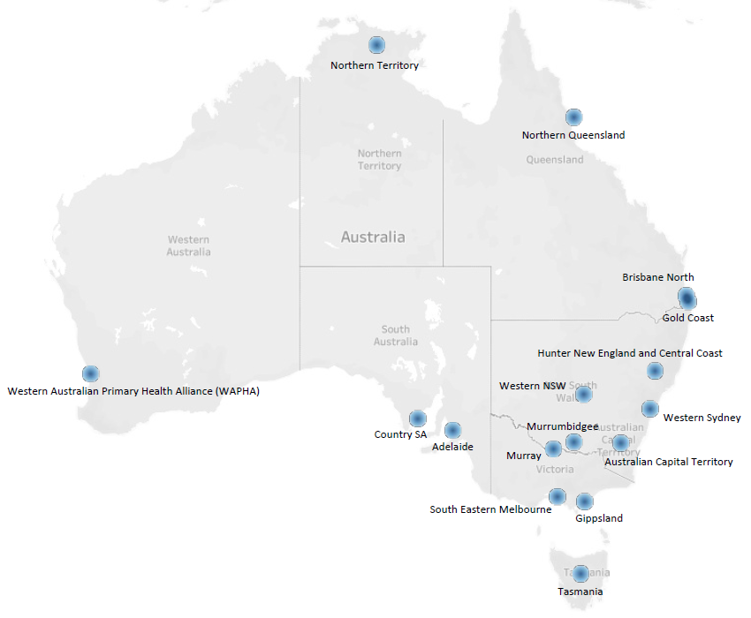

* 1. Consultation with peak bodies

Nineteen peak bodies were consulted to gather feedback regarding the current state of incentives in accordance with the Review domains, and to support distribution of the survey. Peak bodies provided insight into how their representative groups utilised incentives and how the role incentives have come to fill in the primary health system.

Direct consultations with CEOs and executive staff sought feedback regarding how each of the 11 incentives impacted each peak body’s members, and how these were perceived at a system-wide level. This approach was taken to ensure all healthcare professionals in primary care were represented and given opportunities to provide feedback for the Review.

Peak bodies were chosen to represent the broad range of the primary care sector workforce covering:

* General practitioners
* Primary healthcare nurses and NPs
* Allied health
* Indigenous Doctors and Aboriginal Health Workers and Practitioners
* Practice managers
* Rural GPs and broader primary healthcare workforce.
  1. Consultation with the primary care sector

Fourteen focus groups, comprising the workforces of each designated PHN, were primarily conducted in a virtual setting and scheduled to occur after regular working hours. This arrangement allowed GPs and practice managers to actively participate and share their feedback.

Participants were introduced to the Review, queried about the incentives utilised in their practices, and engaged in detailed discussions framed around the Review domains. These discussions encompassed both personal experiences within their practices and perspectives on how incentives have impacted the broader primary care system.

In addition to the focus groups, participants were apprised of the survey and written submission process, with an invitation extended for further feedback through these channels.

Two additional focus group workshops were specifically conducted with the workforces of AMS and ACCHS.

* 1. Written submissions

A written submission process was managed through the Department’s Consultation Hub. Survey responses were accepted over a six-week period, from 17 November to 22 December 2023. The Hub page provided a comprehensive overview of the Review's context and the broader consultation process, outlining the requirements for written submissions, capped at a recommended four A4 pages. A consultation paper attached to the page offered additional guidance on the Review domains for those stakeholders preparing submissions.

This written submission process was communicated to all stakeholders, including PHNs and peak bodies, who, in turn, extended their support in disseminating information through their communication networks. Stakeholders actively participated in sharing information about the Review and the written submission process with the broader primary care workforce.

Over the consultation period, 36 written submissions were received from various organisations and individuals (for more information, see Appendix F : List of written submissions received). Throughout this period, these submissions were systematically collated and coded into NVivo, following the Review framework. This coding approach facilitated content analysis of stakeholder feedback, organising comments based on the Review domains for each incentive and payment under the PIP and WIP.

* 1. Survey

The survey, hosted on the Department's Consultation Hub, provided a platform for diverse voices in the primary care sector to contribute their insights. Over the period from 17 November to 22 December 2023, the survey garnered 190 responses from various organisations and individuals.

Distributed through PHNs and peak bodies, the survey aimed to capture a comprehensive understanding of the experiences and perspectives of the primary care workforce regarding PIP and WIP incentives. Structured with multiple-choice and Likert scale formats, the survey included screening questions, Review domains for each incentive and payment, and a dedicated section for additional comments, recognising the distinct engagement levels of general practices with these incentives. For a full list of survey questions for both the PIP and WIP incentive, see Appendix G.

The subsequent collation and coding of survey responses using NVivo aligned with the Review framework, enabling a thorough analysis and interpretation of the collected data.

* 1. Overview of survey respondents

Survey demographics are illustrated throughout this section, with key metrics presented over seven diagrams.

* + 1. Practice setting

The most common practice setting of survey respondents was the private company or trust owned general practices (39 per cent), followed by general practice partnerships (20 per cent), Aboriginal health services (11 per cent), and ‘other’ (17 per cent). The majority of responses for ‘other’ were general practices of varying specialisations and corporate organisation, which included some general practices heavily engaged in telehealth. However, no purely digital health practices participated in the survey. Figure 41 shows the percentage breakdown of survey respondent practice settings.

Figure 41 Practice settings of survey respondents

Source: KPMG analysis.

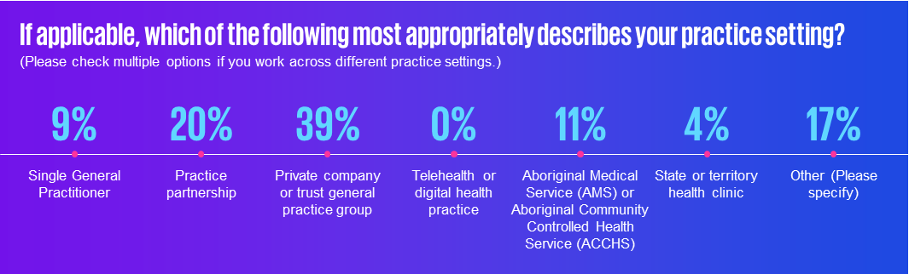

Seventy-four per cent of surveyed practices have been operating for 10 or more years. Eight per cent have been operating for five to nine years, with four per cent operating for two to five years and two per cent operating for less than two years. Figure 42 shows the percentage breakdown of the number of years that surveyed practices have operated.

Figure 42 Number of years surveyed practices have operated

Source: KPMG analysis.

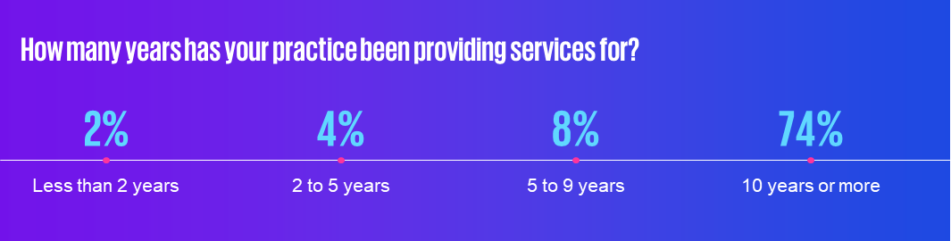

### 

* + 1. Practice location

Most surveyed practices were located in the eastern states, with 26 per cent from Queensland, 22 per cent from New South Wales, and 18 per cent from Victoria. Western Australia and South Australia were each represented by 13 per cent of respondents, with seven per cent from the Australian Capital Territory and only one per cent each from the Northern Territory and Tasmania. Figure 43 shows the percentage breakdown of the location of surveyed practices per state and territory.

Figure 43 Practice location of survey respondents per state and territory

Source: KPMG analysis.

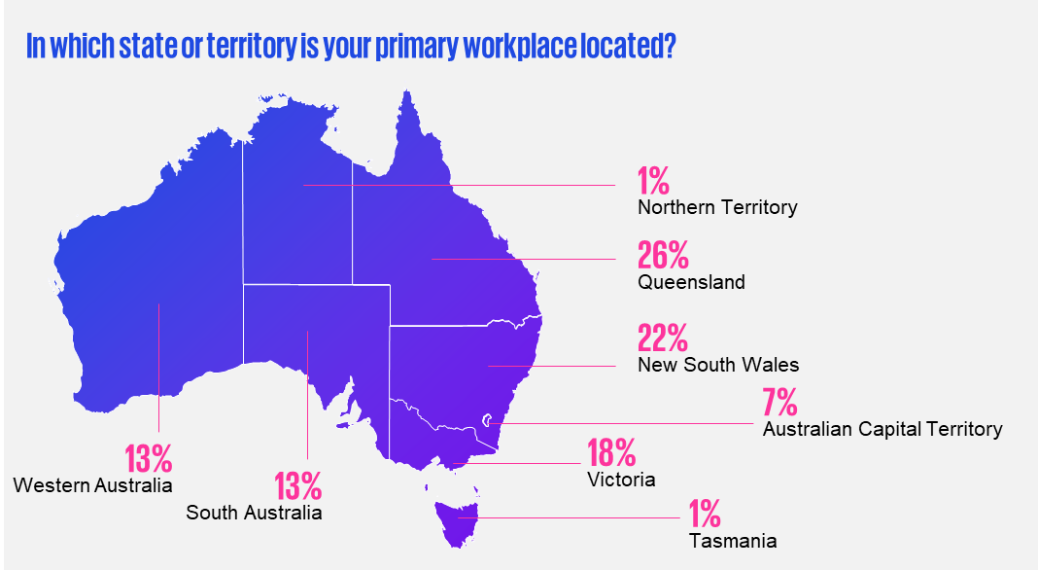

Thirty-nine per cent of surveyed practices were located in MMM 1 areas, with percentage rates declining with rurality: 14 per cent for MMM 2, 12 per cent for MMM 3, 10 per cent for MMM 4, nine per cent for MMM 5, and two per cent for MMM 6. MMM 7 locations were represented by seven per cent of survey respondents. Figure 44 shows the percentage breakdown of the location of surveyed practices per MMM area rating.

Figure 44 MMM rating of survey respondent's current practice location

Source: KPMG analysis.

**Pie chart displaying survey demographics, specifically the MMM classification of survey participants.**

* + 1. Practice staffing and contracting

Thirty per cent of surveyed practices either employed or contracted one to five clinical practitioners, with 26 per cent engaging five to 10, 19 per cent engaging 20 to 40, and four per cent engaging 40 or more clinical practitioners. Figure 45 shows the percentage breakdown of the number of FTE clinical staff employed or contracted in surveyed practices.

Figure 45 Number of FTE clinical staff employed or contracted by surveyed practices

Source: KPMG analysis.

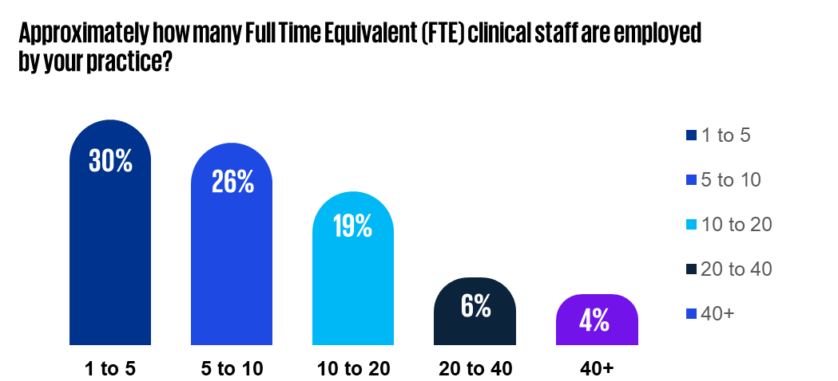

Thirty per cent of surveyed practices employed one to five administrative staff, with a further 30 per cent employing five to 10. Thirteen per cent of surveyed practices employed 10 to 20, with five per cent employing 20 to 40 and seven per cent employing 40 or more. Figure 46 shows the percentage breakdown of the number of non-clinical or administrative staff employed in surveyed practices.

Figure 46 Number of FTE administrative staff employed by surveyed practices

Source: KPMG analysis.

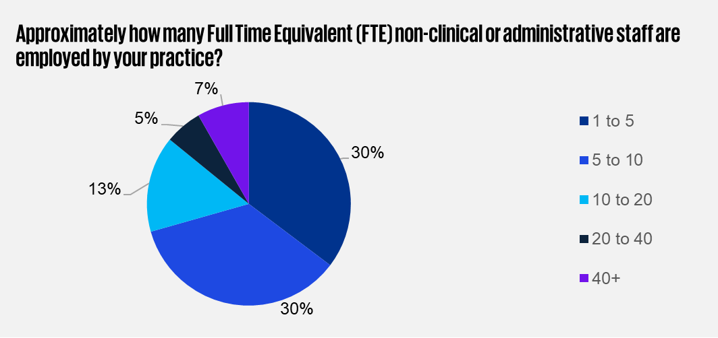

The most commonly employed or contracted health professionals in general practices were primary healthcare nurses (25 per cent). This is due to the survey question specifying between GPs (contracted by 21 per cent of practices) and GP Registrars and Rural Generalists (21 per cent). Ten per cent of practices employed allied health professionals, and two per cent employed nurse practitioners. Administrative staff were employed by 21 per cent of surveyed practices. Figure 47 shows the percentage breakdown of the types of healthcare professionals employed or contracted in surveyed practices, noting that survey respondents could make multiple responses to this question.

Figure 47 Types of health professionals employed or contracted at surveyed practices

Source: KPMG analysis.

Infographic displaying survey demographics, specifically the types of healthcare professionals employed across the practices of survey participants.

* 1. Content analysis

Upon gathering the documents, a content analysis approach was undertaken. A coding framework was developed to systematically categorise and interpret the information from the documents, aligning with the Review framework. This framework, inspired by the research questions and objectives, consisted of themes guiding the analysis process. NVivo, a qualitative analysis tool, was utilised for coding, ensuring a structured and comprehensive examination of the incentive programs.

In the coding process, documents were imported into NVivo, and the established framework was applied. Each text segment received a code corresponding to the predefined themes, facilitating a systematic analysis. This method enabled the identification of recurring themes and the formation of conclusions. Subsequently, the coded references were integrated into the Review, involving manual interpretation and synthesis of the coded data. This transformative phase converted raw desktop data into actionable insights, aligning with the rapid review questions within the framework and informing subsequent consultations.

* + 1. Limitations

While NVivo is commonly used for qualitative research, it has certain limitations. Firstly, its focus on coding and categorisation may overlook subtle variations, complexities, and alternative patterns within the data, potentially hindering a comprehensive understanding. Caution was exercised to ensure all essential details were captured, and critical thinking and content review were applied to guide in-depth analysis.

Secondly, NVivo may struggle to capture the overarching sentiments conveyed in text data, limiting the ability to interpret overall significance and meaning. Nonetheless, the importance of valuing these perspectives in the analysis was emphasised.

Lastly, NVivo analysis depends on the researcher's understanding and interpretation of the data, which may introduce bias and lack of objectivity, particularly with preconceived notions or hypotheses. However, the use of a desktop research-informed coding framework provided structured interpretation, and validation of findings by other team members and select stakeholders helped mitigate bias.

1. : List of stakeholders

Figure 48 List of Primary Health Networks engaged

|  |  |
| --- | --- |
| List of PHNs consulted | |
| 1 | Australian Capital Territory |
| 2 | Adelaide |
| 3 | Brisbane North |
| 4 | Country SA |
| 5 | Gippsland |
| 6 | Gold Coast |
| 7 | Hunter, New England and Central Coast |
| 8 | Murray |
| 9 | Murrumbidgee |
| 10 | Northern QLD |
| 11 | Northern Territory |
| 12 | South Eastern Melbourne |
| 13 | Tasmania |
| 14 | Western Australia Primary Health Alliance |
| 15 | Western NSW |
| 16 | Western Sydney |

Figure 49 List of Peak bodies consulted

|  |  |
| --- | --- |
| List of Peak Bodies Consulted | |
| 1 | Allied Health Professions Australia |
| 2 | Australian Association for Practice Managers |
| 3 | Australian College of Midwives |
| 4 | Australian College of Nurse Practitioners |
| 5 | Australian College of Rural and Remote Medicine |
| 6 | Australian General Practice Accreditation Limited |
| 7 | Australian Indigenous Doctors Association |
| 8 | Australian Medical Association |
| 9 | Australian Primary Healthcare Nurses |
| 10 | National Aboriginal Community Controlled Health Organisation |
| 11 | National Association of Aboriginal and Torres Strait Islander Health Workers and Practitioners |
| 12 | National Rural Health Alliance |
| 13 | National Rural Health Commissioner |
| 14 | Office of the Chief Nursing and Midwifery Officer |
| 15 | Royal Australian College of General Practitioners |
| 16 | Rural Doctors Association of Australia |
| 17 | Rural Workforce Agencies (contacted as single focus group) |
| 18 | Services Australia |
| 19 | Services for Australian Rural & Remote Allied Health |

Figure 50 List of Aboriginal primary healthcare peaks consulted

|  |  |
| --- | --- |
| List of Aboriginal primary healthcare peaks consulted | |
| 1 | Aboriginal Health Council Western Australia |
| 2 | Aboriginal Medical Services Alliance Northern Territory |

# 

1. : List of written submissions received

Figure 51 List of written submissions received

| List of written submissions received | |
| --- | --- |
| 1 | Adelaide PHN |
| 2 | Meridian Australian Capital Territory |
| 3 | Dr Pat Campbell |
| 4 | Australian Capital Territory Chief Nursing and Midwifery Office |
| 5 | Osteopathy Australia |
| 6 | Thrive Medical Cairns North |
| 7 | Victorian Aboriginal Community Controlled Health Organisation (VACCHO) |
| 8 | Associate Prof. Helen Wright |
| 9 | The Royal Australian College of General Practitioners (RACGP) |
| 10 | Anonymous |
| 11 | Australian Psychological Society (APS) |
| 12 | Queensland Office of the Chief Nursing and Midwifery Officer |
| 13 | Australian College of Midwives (ACM) |
| 14 | Australian Healthcare and Hospitals Association (AHHA) |
| 15 | Australian Institute of Health and Welfare (AIHW) |
| 16 | Australian Medical Association (AMA) |
| 17 | The Australian Orthotic Prosthetic Association (AOPA) |
| 18 | The Central and Eastern Sydney Primary Health Network (CESPHN) |
| 19 | Dieticians Australia |
| 20 | North Western Melbourne Primary Health Network (NWMPHN) |
| 21 | ForHealth |
| 22 | Associate Prof. Ray Bange OAM |
| 23 | The National Rural Health Alliance (NHRA) |
| 24 | The Queensland Nurses and Midwives’ Union (QNMU) |
| 25 | The Rural Doctors Association of Australia (RDAA) |
| 26 | WentWest Limited Western Sydney Primary Health Network |
| 27 | The Royal Flying Doctor Service (RFDS) |
| 28 | Services for Australian Rural and Remote Allied Health (SARRAH) |
| 29 | The Society of Hospital Pharmacists of Australia (SHPA) |
| 30 | The Australian Multicultural Health Collaborative |
| 31 | The Australian College of Rural and Remote Medicine (ACRRM) |
| 32 | Australian Nursing & Midwifery Federation |
| 33 | Aboriginal Medical Services Alliance Northern Territory (AMSANT) |
| 34 | Office of the National Rural Health Commissioner (ONRHC) |
| 35 | National Aboriginal Community Controlled Health Organisation (NACCHO) |
| 36 | Aboriginal Health and Medical Research Council of NSW (AHMRC) |

1. : Survey questions
   1. PIP survey questions
      1. Indigenous Health Incentive

| Survey question |
| --- |
| Have you or your practice received, or considered applying for, the PIP Indigenous Health Incentive payment? |
| Indigenous Health Incentive has enabled me/my practice to provide better care for Aboriginal and Torres Strait Islander patients. |
| Indigenous Health Incentive has encouraged me/my practice to develop and implement culturally safe models of care for Aboriginal and Torres Strait Islander patients. |
| Indigenous Health Incentive is effective in supporting better health care for Aboriginal and Torres Strait Islander patients. |
| Indigenous Health Incentive is an effective funding model that encourages practices to deliver better healthcare for Aboriginal and Torres Strait Islander patients. |
| I/My practice is aware of the payment value for the Indigenous Health Incentive. |
| I/My practice is aware of what activity the practice or GP has to undertake to receive and maintain the payment. |
| I/My practice passes on part or all of the incentive payment to GPs/other practitioners. |
| Administrative processes and eligibility requirements for the Indigenous Health Incentive are appropriate and user-friendly. |
| Administrative requirements are worth the benefit to me/ my practice. |
| Any concerns or difficulties I have with this payment can be easily raised and resolved with Government. |
| Indigenous Health Incentive is structured in a way which is sustainable for general practices to continue to receive and to meet ongoing reporting requirements. |
| General practices can sustain the delivery of best practice management of chronic diseases and mental health supports for Aboriginal and Torres Strait Islander patients WITHOUT the payments provided by the Indigenous Health Incentives |

* + 1. Quality Improvement Incentive

| Survey question |
| --- |
| Have you or your practice received, or considered applying for, the PIP Quality Improvement Incentive payment? |
| The Quality Improvement Incentive has led me/my practice to improve patient outcomes (including for patients with chronic disease). |
| The Quality Improvement Incentive has led me/my practice to improve data-informed decision-making. |
| Quality Improvement Incentive has enabled me/my practice to change service delivery approaches (For example performing more preventative screenings and/or primary health data collection and analysis.) |
| The Quality Improvement Incentive is effective in driving the adoption of best practice models of care. |
| The Quality Improvement Incentive is effective in driving the adoption of health data collection for the purposes of quality improvement. |
| The data my practice provides to the PHN is used effectively by the PHN to support data informed quality improvement in my practice. |
| I/My practice is aware of the payment value for the Quality Improvement Incentive. |
| I/My practice is aware of what activity the practice or GP has to undertake to receive and maintain the payment. |
| I/My practice passes on part or all of the incentive payment to GPs/other practitioners. |
| Administrative processes and eligibility requirements of the Quality Improvement Incentive are appropriate and user-friendly. |
| Administrative requirements are worth the benefit to me/my practice. |
| Any concerns or difficulties I have with this payment can be easily raised and resolved with Government. |
| The Quality Improvement Incentive is structured in a way which is sustainable for general practices to continue to receive and to meet ongoing reporting requirements. |
| General practices can sustain the delivery of quality improvements and health data monitoring WITHOUT the payments provided by the Quality Improvement Incentive. |

* + 1. After Hours Incentive

|  |
| --- |
| Survey question |
| Have you or your practice received, or considered applying for, the PIP After Hours Incentive payment? |
| After Hours Incentive has enabled me/my practice to deliver care outside normal hours. |
| After Hours Incentive has enabled my practice/me to change service delivery approaches and improve patient access outside of our normal hours. |
| After Hours Incentive is effective in providing increased access to after hours care in the community. |
| I/My practice is aware of the payment value for the After Hours Incentive. |
| I/My practice is aware of what activity the practice or GP has to undertake to receive and maintain the payment. |
| I/My practice passes on part or all of the incentive payment to GPs/other practitioners. |
| Administrative processes and eligibility requirements of the After Hours Incentive are appropriate and user-friendly. |
| Administrative requirements are worth the benefit to me/my practice. |
| Any concerns or difficulties I have with this payment can be easily raised and resolved with Government. |
| After Hours Incentive is structured in a way which is sustainable for general practices to continue to receive and to meet ongoing reporting requirements. |
| General practices can sustain the delivery of after hours service provision WITHOUT the payments provided by the After Hours Incentive. |

* + 1. GP Aged Care Access Incentive

| Survey question |
| --- |
| Have you or your practice received, or considered applying for, the PIP General Practice Aged Care Access Incentive payment? |
| GP Aged Care Access Incentive encourages me/my practice to provide services in residential aged care facilities. |
| GP Aged Care Access Incentive has improved access to health care within residential aged care facilities. |
| GP Aged Care Access Incentive is effective in providing increased access to health care in residential aged care facilities. |
| I/My practice is aware of the payment value for the GP Aged Care Access Incentive. |
| I/My practice is aware of what activity the practice or GP has to undertake to receive and maintain the payment. |
| Administrative processes and eligibility requirements of the GP Aged Care Access Incentive are appropriate and user-friendly. |
| Administrative requirements are worth the benefit to me/my practice. |
| Any concerns or difficulties I have with this payment can be easily raised and resolved with Government. |
| GP Aged Care Access Incentive is structured in a way which is sustainable for general practices to continue to receive and to meet ongoing reporting requirements. |
| General practices can sustain the delivery of service provision within residential aged care facilities WITHOUT the payments provided by the GP Aged Care Access Incentive. |

* + 1. eHealth Incentive

| Survey question |
| --- |
| Have you or your practice received, or considered applying for, the PIP eHealth Incentive payment? |
| eHealth Incentive motivates me/my practice to actively use and engage with My Health Record. |
| eHealth Incentive has enabled me/my practice to adopt new technologies such as telehealth and electronic prescriptions. |
| eHealth Incentive has motivated my practice to adopt best-practice policies in digital health and cybersecurity. |
| eHealth Incentive is fit-for-purpose as a funding mechanism. |
| eHealth Incentive is an effective funding model that encourages general practitioners in my practice to adopt new digital health technology. |
| eHealth Incentive drives adoption of technology and systems change beyond the minimum requirement to receive the eHealth Incentive. |
| I/My practice is aware of the payment value for the eHealth Incentive. |
| I/My practice is aware of what activity the practice or GP has to undertake to receive and maintain the payment. |
| I/My practice passes on part or all of the incentive payment to GPs/other practitioners. |
| Administrative processes and eligibility requirements of the eHealth Incentive are appropriate and user-friendly. |
| Administrative requirements are worth the benefit to me/my practice. |
| Any concerns or difficulties I have with this payment can be easily raised and resolved with Government. |
| eHealth Incentive is structured in a way which is sustainable for general practices to continue to receive and to meet ongoing reporting requirements. |
| General practices can sustain the adoption and implementation of digital health technologies WITHOUT the payments provided by the eHealth Incentive. |

* + 1. Teaching Payment

| Survey question |
| --- |
| Have you or your practice received, or considered applying for, the PIP Teaching Payment? |
| Teaching Payment encourages me/my practice to hold teaching sessions for medical students. |
| Teaching Payment supports me/my practice to contribute to the general practitioner training pipeline. |
| Teaching Payment is an effective funding model that encourages general practitioners to train medical students. |
| I/My practice is aware of what activity the practice or GP has to undertake to receive and maintain the payment. |
| I/My practice is aware of the payment value for the Teaching Payment. |
| I/My practice passes on part or all of the incentive payment to GPs/other practitioners. |
| Administrative processes and eligibility requirements for the Teaching Payment are appropriate and user-friendly. |
| Administrative requirements are worth the benefit to me/my practice. |
| Any concerns or difficulties I have with this payment can be easily raised and resolved with Government. |
| Teaching Payment is structured in a way which is sustainable for me/my practice to continue to receive and to meet ongoing reporting requirements. |
| General practices can sustain the training of medical students WITHOUT the incentives provided by the Teaching Payment. |

* + 1. Procedural GP Payment

|  |
| --- |
| Survey question |
| Have you or your practice received, or considered applying for, the PIP Procedural GP Payment? |
| I/my practice also benefits from the Rural Procedural Grants Scheme. |
| Procedural GP Payment encourages me/my practice to provide local access to procedural primary healthcare services. |
| Procedural GP Payment is effective in increasing access to procedural primary healthcare services in rural and remote areas. |
| Procedural GP Payment is an effective funding model that encourages general practitioners to deliver surgical, anaesthetic and obstetric services in rural and remote areas. |
| I/My practice is aware of the payment value for the Procedural GP Payment. |
| I/My practice is aware of what activity the practice or GP has to undertake to receive and maintain the payment. |
| Administrative processes and eligibility requirements for the Procedural GP Payment are appropriate and user-friendly. |
| Administrative requirements are worth the benefit to me/my practice. |
| Any concerns or difficulties I have with this payment can be easily raised and resolved with Government. |
| Procedural GP Payment is structured in a way which is sustainable for me/my practice to continue to receive and to meet ongoing reporting requirements. |
| GPs can sustain the delivery of surgical, anaesthetic and obstetric services in rural and remote areas WITHOUT the incentives provided by the Procedural GP Payment. |

* + 1. Rural Loading Incentive

| Survey question |
| --- |
| Have you or your practice received, or considered applying for, the PIP Rural Loading Incentive Payment? |
| Rural Loading Incentive encourages me/my practice and staff to remain in rural areas and provide general practice services. |
| Rural Loading Incentive has improved access to general practice services in rural and remote areas |
| Rural Loading Incentive is effective in improving service provision in regional, rural and remote areas of Australia. |
| Any concerns or difficulties I have with this payment can be easily raised and resolved with Government. |
| Rural Loading Incentive is structured in a way which is sustainable for general practices to continue to receive and to meet ongoing reporting requirements. |
| General practices can sustain the delivery of service provision in regional, rural and remote areas WITHOUT the payments provided by the Rural Loading Incentive. |

* 1. WIP survey questions
     1. Doctor Stream

|  |
| --- |
| Survey question |
| Have you or your practice received, or considered applying for, the WIP Doctor Stream payment? |
| WIP Doctor Stream payment has enabled me/my practice to hire more GPs to provide increased services in rural and remote areas |
| WIP Doctor Stream payment has encouraged me/doctors to practice in rural and remote communities (MMM3-7). |
| WIP Doctor Stream payment has encouraged me/doctors to practice for a longer period of time in rural and remote communities (MMM3-7). |
| WIP Doctor Stream payment supports the viability for me/doctors to deliver primary care services outside of metropolitan and large regional centres. |
| Administrative processes and reporting requirements for the WIP Doctor Stream are clear and user-friendly. |
| Administrative processes and reporting requirements are worth the benefit to me/my practice. |
| Any concerns or difficulties I have with this payment can be easily raised and resolved with Government. |
| Doctors in my practice value that the Doctor Stream is an ongoing program with predictable income stream for recipients. |
| Doctors can sustain the delivery of primary care in rural and remote areas WITHOUT the incentives provided by the WIP Doctor Stream. |

* + 1. Practice Stream

| Survey question |
| --- |
| Have you or your practice received, or considered applying for, the Workforce Incentive Program (WIP) Practice Stream payment? |
| The value of the incentive encourages me/my practice to change service delivery approaches and improve patient access to care. |
| The WIP Practice Stream payment has enabled me/my practice to hire more nursing staff to work in multidisciplinary teams. |
| Hiring this professional has allowed me/my practice to change serviced delivery approaches and improve patient access to care. |
| The WIP Practice Stream payment has enabled me/my practice to hire more allied health staff to work in multidisciplinary teams. |
| Hiring this professional has allowed me/my practice to change serviced delivery approaches and improve patient access to care. |
| The WIP Practice Stream payment has enabled me/my practice to hire more Aboriginal and Torres Strait Islander health staff to work in multidisciplinary teams. |
| Hiring this professional has allowed me/my practice to change serviced delivery approaches and improve patient access to care. |
| WIP Practice Stream payment has led to changes in the models of care that my practice uses. |
| I/my practice understands the program requirements of the WIP Payment Stream. |
| Administrative processes and reporting requirements for the WIP Practice Stream are clear and user-friendly. |
| Administrative processes and reporting requirements are worth the benefit to me/my practice. |
| Any concerns or difficulties I have with this payment can be easily raised and resolved with Government. |
| WIP Practice Stream payment is structured in a way which is sustainable for general practices to continue to receive and to meet ongoing reporting requirements. |
| General practices can sustain the employment of a diverse range of primary health professionals in multidisciplinary teams WITHOUT the incentives provided by the WIP Practice Stream. |

* + 1. Rural Advanced Skills Payment

|  |
| --- |
| Survey question |
| Have you or your practice considered applying for the WIP Rural Advanced Skills payment? |
| WIP Rural Advanced Skills Payment provides sufficient additional reward for doctors with advanced skills working in rural and remote locations. |
| WIP Rural Advanced Skills payment will encourage doctors in my practice to increase or amend their service offering to meet the minimum eligibility for the emergency stream. |
| WIP Rural Advanced Skills payment will encourage doctors in training to consider a career in rural medicine or increase their training to meet needs of rural communities. |
| WIP Rural Advanced Skills Guidelines is easy to understand. |
| Administrative processes and reporting requirements for the WIP Rural Advanced Skills payment are clear and user-friendly. |
| Administrative processes and reporting requirements are worth the benefit to me/ my practice. |
| Doctors in my practice will NOT change their service delivery arrangements for the eligible payment amount over a three year period. |

1. : Data and information
   1. Data Received

Figure 52 List of data received

|  |  |
| --- | --- |
| Data set | Time period |
| PIP Data (excluding Aged Care Incentive) | February 2000 to August 2023 |
| PIP Data (Aged Care Incentive) | February 2009 to August 2023 |
| WIP Doctor Stream & GPRIP | March 2020 to September 2023 |
| WIP Practice Stream | May 2020 to August 2023 |

* 1. Scope of analyses

The following analyses was undertaken:

* Number and amount of payments by state
* Number of patients per population by area
* Time series trends per financial year, disaggregated by state
* Visualisation of volumes of payments for each incentive type by state per head of population
* Number of practices supported by the WIP Practice Stream.

* 1. List of MMM classifications

2019 MMM classifications are used to determine payment scales for WIP incentives. An update of the MMM classification system with the latest Census data is in progress (DoHAC, 2023d).

Figure 53 List of MMM classifications

Source: Department of Health and Aged Care.

| Modified Monash Category | Description |
| --- | --- |
| MMM 1 | **Metropolitan areas**: Major cities accounting for 70 per cent of Australia’s population.  All areas categorised as ASGS-RA1. |
| MMM 2 | **Regional centres**: Areas categorised as ASGS-RA 2 and ASGS-RA 3 that are in, or within, 20km road distance of a town with a population greater than 50,000. |
| MMM 3 | **Large rural towns**: Areas categorised as ASGS-RA 2 and ASGS-RA 3 that are not in MMM 2 and are in, or within, 15km road distance of a town with a population between 15,000 and 50,000.**Large rural towns**: Areas categorised as ASGS-RA 2 and ASGS-RA 3 that are not in MMM 2 and are in, or within, 15km road distance of a town with a population between 15,000 and 50,000. |
| MMM 4 | **Medium rural towns**: Areas categorised as ASGS-RA 2 and ASGS-RA 3 that are not in MMM 2 or MMM 3 and are in, or within, 10km road distance of a town with a population between 5,000 and 15,000.**Medium rural towns**: Areas categorised as ASGS-RA 2 and ASGS-RA 3 that are not in MMM 2 or MMM 3 and are in, or within, 10km road distance of a town with a population between 5,000 and 15,000. |
| MMM 5 | **Small rural towns**: All other areas in ASGS-RA 2 and 3. |
| MMM 6 | **Remote communities**: All areas categorised as ASGS-RA 4 **and**islands that are separated from the mainland in the ABS geography and are less than 5km offshore.  Islands that have an MMM 5 classification with a population of less than 1,000 without bridges to the mainland (2019 Modified Monash Model classification only). |
| MMM 7 | **Very remote communities**: All other areas that are categorised as ASGS‑RA 5 **and** populated islands separated from the mainland in the ABS geography that are more than 5km offshore. |

* 1. List of RRMA classifications

The Rural, Remote and Metropolitan Area classification, used for many PIP incentives, divides Australia into three zones and seven classes based on 1991 Census data from the Australian Bureau of Statistics (DoHAC, 2023e).

Figure 54 List of RRMA classifications

Source: Department of Health and Aged Care.

|  |  |
| --- | --- |
| Zones | Classes |
| Metropolitan | RRMA 1 and 2 |
| Rural | RRMA 3 to 5 |
| Remote | RRMA 6 and 7 |

1. : Review framework models

Figure 55 Conceptual framework for PIP review

Source: KPMG.

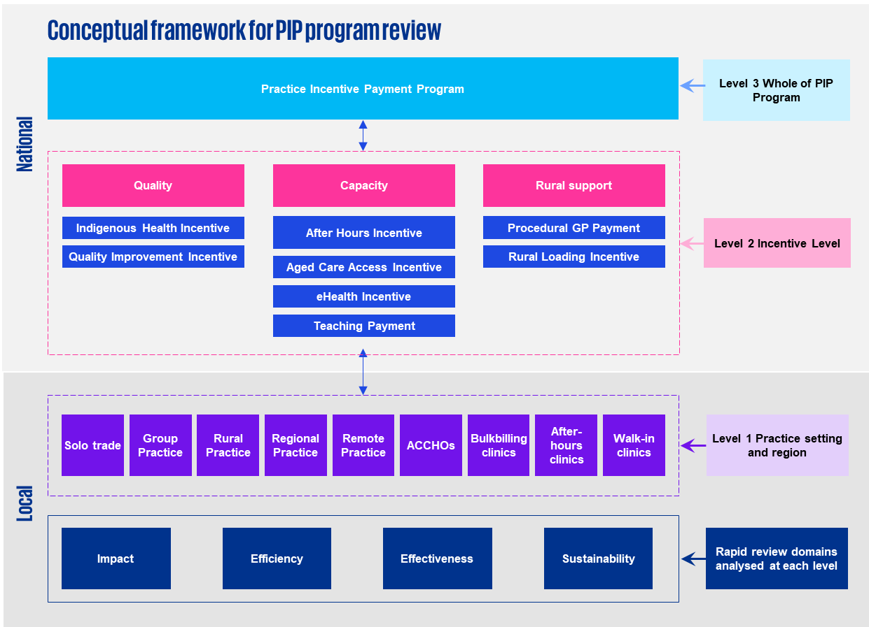

Figure 56 Conceptual framework for WIP review

Source: KPMG.

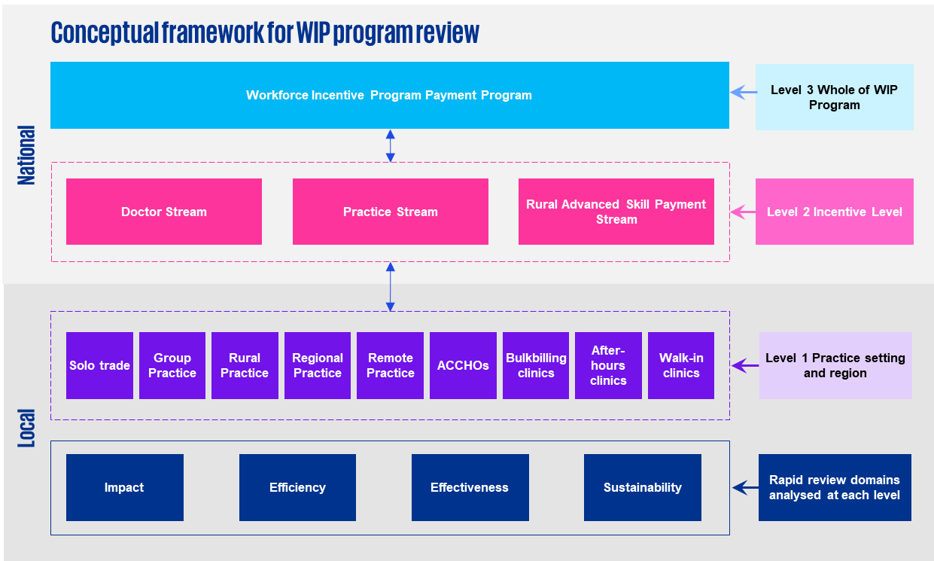

1. : Incentive program logic model(s)

Program logic models for individual incentives and overarching programs were developed to guide the Review.

Figure 57 Overall general practice incentive program logic model

Source: KPMG.

|  |  |  |  |  |
| --- | --- | --- | --- | --- |
| Inputs | Activities | Outputs | Outcomes | Impacts |
| * Policy objectives * Incentive guidelines * Eligibility criteria * Activity data * Funding data * Consultation findings | * Practice accreditation * Utilisation of incentive programs * Service delivery * After hours care * Allied health and nursing employment * Technology use * Collaboration with primary health networks | * GPs providing primary care * GPs providing emergency and/or advanced skills * GPs working in MMM3-7 locations * General practices that provide care after hours * General practices that actively engage in multidisciplinary care | * Provision of proactive, longitudinal care for people with acute and chronic illness * Locally relevant primary care services are available in rural and remote areas * Quality multidisciplinary team-based care | * Increased access to primary care * Reduction in cost of primary health care * Improved population health outcomes * Delivery of appropriate place-based approaches to health care |

* 1. Overarching PIP logic model

The PIP operates under a well-defined logic model, which ensures it can make structured progress towards meeting its program objectives and deliver measurable outcomes.

| Inputs | Activities | Outputs | Outcomes | Impacts |
| --- | --- | --- | --- | --- |
| * Funding * Program Authority * Program guidelines * Eligibility * Accreditation * Geographical location * Payment values, calculations and schedule | * Specific programs * Program assurance * Monitoring, evaluation and review * General practices and other healthcare providers deliver high-quality primary health care to all Australians * General practices and other healthcare providers participate in the PIP | * Indigenous Health Incentive * Quality Improvement Incentive * eHealth incentive * GP Aged Care Access Incentive * Teaching Payment incentive * After Hours Incentive * Procedural GP Payment * Rural Loading Incentive | * Increased number of general practices and other healthcare providers delivering high-quality primary health care services to all Australians. | * Improved access to quality PHC services for all Australians, regardless of where they live. * Improved health outcomes for all Australians, particularly those living in regional, rural, and remote areas. |

| Assumptions | External factors |
| --- | --- |
| * General practices and other healthcare providers will be willing to participate in the PIP * General practices and other healthcare providers will be able to effectively deliver high-quality PHC services to all Australians * Participating in the PIP will improve the quality of PHC services delivered by general practices and other healthcare providers | * The availability of resources to support general practices and other healthcare providers to deliver high-quality PHC services, such as funding for professional development and access to specialist services * The level of workforce capacity in the PHC sector * The attractiveness of PHC to healthcare professionals |

* + 1. Indigenous Health Incentive program logic

First Nations peoples experience poorer health outcomes than non-Indigenous Australians. The Indigenous Health Incentive supports practices and Indigenous health services to provide better health care for First Nations patients, including best practice management of chronic disease.

| Inputs | Activities | Outputs | Outcomes |
| --- | --- | --- | --- |
| * General practices, Aboriginal Medical Services and Aboriginal Community Controlled Health Organisations (ACCHOs) * PIP IHI Guidelines * PIP IHI Application Form * PIP IHI Funding * PIP IHI Funding Agreement * PIP IHI Reporting Form | * Sign-on – a practice registers to be a part of the PIP IHI scheme, and receives a sign-on payment of $1,000 * Compliant operation – the practice meets the obligations under the scheme (for example, providing a culturally safe environment, registering consenting, participating patients for the CTG PBS Co-payment, managing patient follow-up and delivering high-quality, compliant care) * Patient registration | * Patient receives supported chronic disease care management through one or more of the following: General Practice Management Plan (GPMP), Team Care Arrangements (TCA), GP Mental Health Treatment Plan * Patient may receive support for a multidisciplinary team care plan if living in a Residential Aged Care Facility | * Health outcomes of Aboriginal and Torres Strait Islander peoples with chronic diseases are improved * Improved access to healthcare and health education within Aboriginal and Torres Strait Islander communities * Improved chronic disease management for Aboriginal and Torres Strait Islander peoples |

| Assumptions | External factors |
| --- | --- |
| * Providers will be able to meet eligibility requirements * Patients will self-identify as Aboriginal and/or Torres Strait Islander * Patients will register with a practice and nominate them as their usual care provider | * The social determinants of health, such as housing, education, and employment, can have a significant impact on the health outcomes of Aboriginal and Torres Strait Islander peoples * The availability of other funding sources for Aboriginal and Torres Strait Islander healthcare services * The workforce capacity of the Aboriginal and Torres Strait Islander primary care sector * The regulatory environment for Aboriginal and Torres Strait Islander healthcare services |

* + 1. Quality Improvement Incentive program logic

The PIP QI Incentive is a payment to general practices that undertake quality improvement activities. It aims to support continuous improvement and better outcomes for patients through collection and analysis of practice data on specified improvement measures.

| Inputs | Activities | Outputs | Outcomes |
| --- | --- | --- | --- |
| * General practices * PHNs * PIP QI Incentive funding * PIP QI Incentive Guidelines * PIP QI Incentive Application Form * PIP QI Incentive Funding Agreement * PIP QI Incentive Reporting Form * 10 Improvement Measures * PIP Eligible Data Set Data Governance Framework * Data extraction tool | * GPs participate in quality improvement activities, such as:   + Collecting and reviewing data on patient care   + Identifying areas for improvement   + Implementing quality improvement initiatives   + Monitoring and evaluating the results of quality improvement initiatives * Practices submit their Eligible Data Set to their local PHN * GPs submit claims for the PIP QI Incentive to Services Australia. | * Improved uptake of evidence-based best practice for general practices and practitioners * Enhanced monitoring and evaluation of the quality of healthcare delivered to patients * Improved professional development for GPs * Advancements in clinical information system performance | * Quality care provided by accredited practices * Improved health outcomes as a result of best practice preventative care * Increased participation of general practices in quality improvement activities |

| Assumptions | External factors |
| --- | --- |
| * General practices will be willing to participate in quality improvement activities * General practices will be able to effectively implement quality improvement initiatives * Quality improvement initiatives will be effective in improving the quality of patient care | * The availability of resources to support quality improvement activities * The level of workforce capacity in the primary care sector * The regulatory environment for quality improvement activities |

* + 1. After Hours Incentive program logic

The aim of the After Hours Incentive is to provide additional incentives to support the provision of appropriate access to after hours primary care services for patients. This is because there is a shortage of after hours primary care services, which can lead to people being required to wait longer for care or having to travel long distances to access care.

| Inputs | Activities | Outputs | Outcomes |
| --- | --- | --- | --- |
| * Funding * Program Authority * Program guidelines * PIP After Hours Incentive Guidelines * PIP After Hours Incentive Application Form * National Health Services Directory (NHSD) * My Health Record | * Register with the NHSD * Complete the PIP After Hours Incentive Application Form and submit it to Services Australia * Provide after hours primary care services to eligible patients * Claim the incentive by submitting a claim form to Services Australia * Once approved, providers are required to meet obligations, such as keeping records of their after hours services and providing reports to Services Australia | * Access to primary health care weeknights, weekends and public holidays * After hours care delivered via: * Telephone/telehealth based services * Home visits * In-practice consultations * Consultations at hospitals/other local health care centres * Patients have access to after hours care in a range of locations | * Improved access to primary health care services including after hours * Improved quality of after hours primary care services leading to better health outcomes * Increase the availability of after hours primary care services * Reduced demand on emergency departments |

| Assumptions | External factors |
| --- | --- |
| * Providers will be willing to participate in the incentive * Providers will be able to meet the eligibility requirements for the incentive * Providers will be able to accurately claim the incentive * The incentive will be effective in increasing the availability of after hours primary care services * The incentive will be effective in improving the quality of after hours primary care services * The incentive will be effective in leading to better health outcomes for Australians | * The availability of other funding sources for after hours primary care services * The level of demand for after hours primary care services * The workforce capacity of the primary care sector |

* + 1. GP Aged Care Access Incentive program logic

The Australian Government has identified a need to encourage GPs to provide increased and continuing services in Australian Government funded residential aged care facilities. This is because older people living in residential aged care facilities have complex health needs and require access to high-quality, primary care services.

| Inputs | Activities | Outputs | Outcomes |
| --- | --- | --- | --- |
| * PIP General Practitioner Aged Care Access Incentive funding * General practitioners * PIP General Practitioner Aged Care Access Incentive Guidelines * PIP General Practitioner Aged Care Access Incentive Application Form * PIP General Practitioner Aged Care Access Incentive Funding Agreement * PIP General Practitioner Aged Care Access Incentive Reporting Form | * General practitioners provide increased and continuing services in Australian Government funded residential aged care facilities. These services may include:   + Conducting regular assessments of the residents' health needs   + Developing and implementing care plans for the residents   + Providing medical treatment and support to the residents   + Liaising with the residents' families and other healthcare providers | * Improved attendance of GPs at residential aged care facilities including for Department of Veterans Affairs patients * Creation and execution of individualised Care Plans * Provision of medical treatment including diagnosis and medication management * Review of residential medication management | * Improved health outcomes for older people living in residential aged care facilities * Increase in the number of general practitioners with strengthened geriatric care expertise and specialised knowledge |

| Assumptions | External factors |
| --- | --- |
| * GPs will be willing to provide services in Australian Government funded residential aged care facilities * GPs will be able to effectively provide services in Australian Government funded residential aged care facilities * GPs will be able to meet the complex health needs of the residents of Australian Government funded residential aged care facilities | * The availability of resources to support GPs in providing services in Australian Government funded residential aged care facilities, such as funding for training and support programs * The level of workforce capacity in the primary care sector * The regulatory environment for the provision of primary care services in Australian Government funded residential aged care facilities |

* + 1. eHealth Incentive program logic

The purpose of the PIP eHealth Incentive is to encourage clinical practices to keep up to date with the latest developments in digital health and adopt new digital health technology as it becomes available. It aims to help practices improve administration processes and patient care as digital health technologies have the potential to improve the quality, safety, and efficiency of healthcare delivery.

| Inputs | Activities | Outputs | Outcomes |
| --- | --- | --- | --- |
| * PIP eHealth Incentive funding * General practices * PIP eHealth Incentive Guidelines * PIP eHealth Incentive Application Form * PIP eHealth Incentive Funding Agreement * PIP eHealth Incentive Reporting Form | * General practices implement digital health technologies, such as:   + Electronic medical records   + ePrescribing   + Secure messaging   + My Health Record * General practices submit claims for the PIP eHealth Incentive to Services Australia at the end of each financial year | * Improved administration processes * Improved secure messages sent between healthcare providers * Uptake and use of ePrescription medication records * Improved transmission of patient data using My Health Record health and event summaries including test results and medication histories * Adoption of new developments in digital health technology | * Increased use of digital health technology * Improved administrative processes are achieved * Improved quality, safety and efficiency of healthcare delivery * Improved consumer outcomes |

| Assumptions | External factors |
| --- | --- |
| * General practices will be willing to adopt digital health technologies * General practices will be able to effectively implement digital health technologies * Digital health technologies will be effective in improving the quality, safety, and efficiency of healthcare delivery | * The rapid evolution of digital health technologies and increasing consumer expectations about their use in healthcare * The availability of resources including workforce to support general practices in adopting and implementing digital health technologies * The regulatory environment for the use of digital health technologies in healthcare * There is a movement of health information sharing across different parts of the healthcare system |

* + 1. Teaching Payment program logic

The PIP Teaching Payment is designed to encourage general practices to provide teaching sessions to undergraduate and graduate medical students preparing to enter the Australian medical profession.

| Inputs | Activities | Outputs | Outcomes |
| --- | --- | --- | --- |
| * PIP Teaching Payment funding * General practices * PIP Teaching Payment Guidelines * PIP Teaching Payment Application Form * PIP Teaching Payment Funding Agreement * PIP Teaching Payment Reporting Form * University medical schools | * Universities coordinate paperwork for matching medical students with practices or providers * General practices participate in teaching and training activities, such as:   + Training medical students   + Providing continuing professional development for general practitioners and other healthcare professionals   + Conducting research and publishing their findings * General practices submit claims for the PIP Teaching Payment to Services Australia | * Medical school student experience of general practice consultations * Mentorship, supervision, and evaluations of clinical skills * Increased number of teaching sessions delivered * Improved quality of teaching and training activities | * Improved quality of healthcare delivery * Increased access to healthcare services * Increased number of healthcare professionals appropriately trained and educated * Improved GP workforce pipeline |

| Assumptions | External factors |
| --- | --- |
| * General practices will be willing to participate in teaching and training activities * General practices will be able to effectively deliver teaching and training activities * Teaching and training activities will be effective in improving the quality of healthcare delivery | * The availability of resources to support general practices in undertaking teaching and training activities, such as funding for training and support programs * The level of workforce capacity in the primary care sector * The regulatory environment for teaching and training activities in general practice |

* + 1. Procedural GP Payment program logic

The Procedural GP payment encourages GPs in rural and remote areas to maintain local access to surgical, anaesthetic and obstetric services.

| Inputs | Activities | Outputs | Outcomes |
| --- | --- | --- | --- |
| * PIP Procedural GP Payment guidelines * General practices * GPs * Eligible procedural services (obstetrics, anaesthetics, surgery) * Hospital based emergency services * Health Professional Online Services (HPOS) * Provider Digital Access (PRODA) account * PIP Procedural GP Payment application form * Individual general practitioner or nurse practitioner details form | * Complete practice Incentives Program Procedural GP Payment application form * Complete individual general practitioner or nurse practitioner details form * To be eligible for payment, the practice must meet PIP and PIP Procedural Payment obligations and be able to substantiate its claim * Apply through HPOS – payments are made automatically every six months * Provide clinically relevant procedural services that are listed in the MBS and qualify for an anaesthetic fee * Participate in program audits | * Provision of clinically relevant procedural services * Improved provision of local surgical, anaesthetic and obstetric services in rural, regional and remote areas * Access to surgical services after hours including weeknights, weekends and public holidays | * Improved health outcomes in rural and remote areas * Increase in the number of skilled GPs retained in regional, rural and remote areas * Increase in the number of procedural services available to patients including obstetric deliveries, general anaesthesia, major regional blocks, abdominal surgery, gynaecological surgery, and endoscopy |

| Assumptions | External factors |
| --- | --- |
| * GPs will have access to local facilities with appropriate equipment * GPs will have the necessary skills and expertise to provide procedural services and participate in appropriate skills maintenance programs * Providers will be willing to participate in the incentive * Providers will be able to meet the eligibility requirements for the incentive * Providers will be able to accurately claim the incentive * The incentive will improve access and health outcomes for people in regional, rural and remote areas | * The availability of GPs with procedural service skills providing services in rural and remote areas * The availability of skills maintenance programs for GPs to participate in * The availability of appropriately equipped and accessible facilities |

* + 1. Rural Loading Incentive program logic

The Rural Loading Incentive provides practices participating in the PIP with payments to recognise the difficulties of providing care in rural and remote areas, often with little professional support. The payment is automatically paid to practices that participate in the PIP with a main practice located outside capital cities and other major metropolitan centres.

| Inputs | Activities | Outputs | Outcomes |
| --- | --- | --- | --- |
| * PIP registration through HPOS/PIP application form * RRMA classification and category | * Upon joining the PIP, practices must nominate an authorised contact person who will confirm on the practice’s behalf any changes to information for PIP claims and payments * The loading is automatically added to PIP payments * Practices must necessarily provide information as part of the ongoing audit process to ensure eligibility requirements have been met | * Increased funding delivered to rural and remote general practices * Better supported primary care services in rural and remote areas | * Practices continue to provide essential services to rural and remote communities despite limited resources * Increase in the number of practices operating in rural and remote areas |

| Assumptions | External factors |
| --- | --- |
| * Payments are automatically applied to eligible practices * Financial incentives address some of the challenges experienced by rural and remote practices, including attraction and retention * Financial incentives will maintain or improve the level of care provided in rural and remote areas | * Availability of qualified staff including doctors and practice managers in rural and remote regions * Despite available incentives, the financial stability of providing healthcare in rural and remote areas can still be challenging |

* 1. Overarching WIP Logic Model

The Australian Government has identified a need to improve access to quality medical, nursing, and allied health services in regional, rural, and remote areas. There is also a need to address the shortage of doctors and other healthcare professionals with advanced skills in these areas. The WIP is designed to address these challenges by providing financial incentives to attract and retain healthcare professionals in regional, rural, and remote areas.

| Inputs | Activities | Outputs | Outcomes | Impacts |
| --- | --- | --- | --- | --- |
| * WIP Funding * Program Authority * Program guidelines * Healthcare professionals | * General practices deliver high-quality primary health care to all Australians * General practitioners work in regional, rural, and remote areas * General practitioners use advanced skills in regional, rural and remote areas * General practitioners and practices submit claims for the WIP to Services Australia | * WIP Practice Stream * WIP Doctor stream and payment systems:   Central Payment System  Flexible Payment System   * Rural Advanced Skills Payment:   Stream 1: Emergency medicine  Stream 2: advanced skills | * Improved health outcomes for people living in regional, rural, and remote areas due to increased access * Reduced cost of healthcare for people living in regional, rural, and remote areas * Increased number of healthcare professionals working in regional, rural, and remote areas * Increase in access to multidisciplinary team-based care | * Improved quality of life for healthcare professionals working in regional, rural, and remote areas * Reduced workforce shortages in regional, rural, and remote areas * Improved access to healthcare services for people living in remote and isolated communities, people with disabilities, First Nations peoples, and people living in poverty |

| Assumptions | External factors |
| --- | --- |
| * Healthcare professionals will be willing to work in regional, rural, and remote areas * Healthcare professionals will be able to effectively deliver high-quality healthcare services in regional, rural, and remote areas * Working in regional, rural, and remote areas will not have a negative impact on the quality of life of healthcare professionals and their families | * The availability of resources to support healthcare professionals working in regional, rural, and remote areas, such as funding for professional development and access to specialist services * The level of workforce capacity in the regional, rural, and remote primary care sector * The attractiveness of regional, rural, and remote areas to healthcare professionals and their families |

* + 1. Doctor Stream program logic

The Australian Government has identified a need to address the shortage of doctors in regional, rural, and remote areas. The WIP Doctor Stream is designed to attract and retain doctors in these areas.

| Inputs | Activities | Outputs | Outcomes |
| --- | --- | --- | --- |
| * Workforce Incentive Program (Doctor Stream) funding Doctors * Workforce Incentive Program (Doctor Stream) Guidelines * Workforce Incentive Program (Doctor Stream) Application Form * Workforce Incentive Program (Doctor Stream) Funding Agreement * Workforce Incentive Program (Doctor Stream) Reporting Form | * Medical practitioners work in regional, rural and remote areas in MMM 3 – 7 locations delivering primary care services in eligible locations * Medical practitioner using MBS eligible services receive automatic payments through Services Australia * Non-MBS eligible services not reflected in the MBS are claimed through the Flexible Payment System (FPS) * To apply for a payment through the FPS, a medical practitioner must apply directly to the Rural Workforce Agency in the state in which the GP provided the majority of services | * Provision of clinical medical services in rural and remote areas including professional attendances, diagnostic procedures, therapeutic procedures and cleft lip and palate services * Attraction and retention of medical practitioners in regional, rural and remote communities | * Improved health outcomes for people living in rural and remote areas * Improved access to healthcare services for people living in regional, rural and remote locations * Increase in the quality of services accessible in rural, regional and remote Australia * Reduced cost of healthcare for people living in rural and remote areas |

| Assumptions | External factors |
| --- | --- |
| * Doctors will be willing to work in rural and remote areas * Doctors will be able to effectively deliver healthcare services in rural and remote areas | * The availability of resources to support doctors working in rural and remote areas, such as funding for professional development and access to specialist services * The level of workforce capacity in the rural and remote primary care sector * The attractiveness of rural and remote areas to doctors and their families |

* + 1. Practice Stream program logic

The Australian Government has identified a need to improve access to quality medical, nursing, and allied health services in regional, rural, and remote areas. The PIP Practice Stream is designed to support general practices to provide multidisciplinary, team-based care by engaging a range of health professionals.

| Inputs | Activities | Outputs | Outcomes |
| --- | --- | --- | --- |
| * WIP Practice Stream funding * General practices * WIP Practice Stream Guidelines * WIP Practice Stream Application Form * WIP Practice Stream Funding Agreement * WIP Practice Stream Reporting Form * Practice accreditation | * General practices employ eligible health professionals * General practices provide multidisciplinary team-based care to their patients * General practices submit claims for the PIP Practice Stream to Services Australia | * Employment of multidisciplinary team staff including nurses, midwives, allied health professionals, and Aboriginal and Torres Strait Islander health workers and health practitioners * Multidisciplinary care is delivered to patients in general practice settings * Tailored primary healthcare according to community health needs and gaps in community services | * Improved access to quality medical, nursing, and allied health services in regional, rural, and remote areas * Improved health outcomes for people living in regional, rural, and remote areas * Reduced cost of healthcare in regional, rural and remote areas * More culturally appropriate and safe care to First Nations peoples * Growth of team-based multidisciplinary care models in primary care * Better utilisation of primary health care nurses working to their full scope of practice |

| Assumptions | External factors |
| --- | --- |
| * General practices will be willing to employ eligible health professionals * General practices will be able to effectively provide multidisciplinary team-based care * Employing eligible health professionals and providing multidisciplinary team-based care will improve the quality of healthcare delivery in regional, rural, and remote areas | * The availability of resources to support general practices to employ eligible health professionals and provide multidisciplinary team-based care, such as funding for training and support programs * The level of workforce capacity in the regional, rural, and remote primary care sector * The attractiveness of regional, rural, and remote areas to healthcare professionals and their families |

* + 1. Rural Advanced Skills Payment program logic

Rural and remote areas of Australia have a shortage of healthcare professionals with advanced skills. This makes it difficult for people living in these areas to access high-quality healthcare services. The WIP Rural Advanced Skills Stream is a new program that aims to attract and retain healthcare professionals with advanced skills in rural and remote areas.

| Inputs | Activities | Outputs | Outcomes |
| --- | --- | --- | --- |
| * WIP Rural Advanced Skills Stream funding * Healthcare professionals with advanced skills * WIP Rural Advanced Skills Stream Guidelines * WIP Rural Advanced Skills Stream Application Form | * Healthcare professionals deliver emergency medicine or obtain advanced skills and work in rural and remote areas * Healthcare professionals with advanced skills submit claims for the Advanced Skills Stream to Rural Workforce Agencies | * Emergency care and/or emergency after hours services in hospital, urgent care centres, multipurpose services or in communities * Advanced service delivery including anaesthesia, mental health, First Nations, health, surgery and paediatrics and child health | * Improved health outcomes for people living in rural and remote areas * Improved access to primary healthcare for people living in rural and remote areas |

| Assumptions | External factors |
| --- | --- |
| * Healthcare professionals with advanced skills will be willing to work in rural and remote areas * Healthcare professionals with advanced skills will be able to effectively deliver high-quality healthcare services in rural and remote areas | * The availability of resources to support healthcare professionals with advanced skills working in rural and remote areas, such as funding for professional development and access to specialist services * The workforce capacity in the rural and remote primary care sector * The attractiveness of rural and remote areas to healthcare professionals with advanced skills and their families |

# 

1. : References

Australain Digital Health Agency (2023), [*National Digital Health Strategy 2023-2028*](https://www.digitalhealth.gov.au/national-digital-health-strategy/downloads), Australian Government, Sydney, accessed 15 January 2024.

Australian Insitute of Health and Welfare (2015), [*Cardiovascular disease, diabetes and chronic kidney disease—Australian facts: Aboriginal and Torres Strait Islander people 2015*](https://www.aihw.gov.au/reports/indigenous-australians/cardiovascular-diabetes-chronic-kidney-indigenous/summary), Australian Government, accessed 3 September 2023.

Australian Insitute of Health and Welfare & National Indigenous Australians Agency (2023). [*Aboriginal and Torres Strait Islander Health Performance Framework, 2.09 Index of disadvantage*](https://www.indigenoushpf.gov.au/measures/2-09-index-disadvantage), accessed 5 February 2024.

Australian National Audit Office (2010) [*Audit Report No.5 2010–11: Practice Incentives Program*](https://www.anao.gov.au/sites/default/files/ANAO_Report_2010-2011_5.pdf)*,* Department of Health and Ageing, Commonwealth of Australia, accessed 2 February 2024.

Department of Health (2022), [*Future focused primary health care: Australia’s Primary Health Care 10 Year Plan 2022–2032*](https://www.health.gov.au/resources/publications/australias-primary-health-care-10-year-plan-2022-2032), Australian Government, Canberra, accessed 14 January 2024.

Department of Health and Aged Care (2023a), [*Budget 2023-24: Strengthening Medicare and Rebuilding Primary Health Care: Summary of Package*](https://kpmgaust.sharepoint.com/sites/AU-GPIncentivesReview/Shared%20Documents/General/04%20Workpapers/06%20Draft%20Effectiveness%20Review%20report/Strengthening%20Medicare%20and%20rebuilding%20primary%20health%20care)*,* Australian Government, Canberra, accessed 16 January 2024.

Department of Health and Aged Care (2023b), [*Coronavirus (COVID-19) Primary Care Package – Practice Incentive Payments*](https://www.health.gov.au/resources/publications/coronavirus-covid-19-primary-care-package-practice-incentive-payments?language=en)*,* Australian Government, Canberra, accessed 6 February 2024.

Department of Health and Aged Care (2023c), [*General Practice Workforce providing Primary Care services in Australia*](https://hwd.health.gov.au/resources/data/gp-primarycare.html), accessed 18 December 2023.

Department of Health and Aged Care (2023d), [*Modified Monash Model*](https://www.health.gov.au/topics/rural-health-workforce/classifications/mmm), accessed 31 January 2024.

Department of Health and Aged Care (2023), [*National Aboriginal and Torres Strait Islander Health Plan 2021–2031*](https://www.health.gov.au/resources/publications/national-aboriginal-and-torres-strait-islander-health-plan-2021-2031?language=en), Australian Government, Canberra, accessed 17 January 2024.

Department of Health and Aged Care (2023), [*National Medical Workforce Strategy 2021-2031*](https://www.health.gov.au/our-work/national-medical-workforce-strategy-2021-2031), Australian Government, Canberra, accessed 17 January 2024.

Department of Health and Aged Care (2023), [*National Rural Generalist Pathway*](https://www.health.gov.au/our-work/national-rural-generalist-pathway), Australian Government, Canberra, accessed 17 January 2024.

Department of Health and Aged Care (2023), [*Nurse Practitioner Workforce Plan*](https://www.health.gov.au/resources/publications/nurse-practitioner-workforce-plan?language=en), Australian Government, Canberra, accessed 17 January 2024.

Department of Health and Aged Care (2023), [*The Digital Health Blueprint and Action Plan 2023–2033*](https://www.health.gov.au/resources/publications/the-digital-health-blueprint-and-action-plan-2023-2033?language=en), Australian Government, Canberra, accessed 17 January 2024.

Department of Health and Aged Care (2023), [*The National Rural and Remote Nursing Generalist Framework 2023-2027*](https://www.health.gov.au/resources/publications/the-national-rural-and-remote-nursing-generalist-framework-2023-2027?language=en), Australian Government, Canberra, accessed 17 January 2024.

Department of Health and Aged Care (2023e), [*Rural, Remote, and Metropolitan Area*,](https://www.health.gov.au/topics/rural-health-workforce/classifications/rrma) accessed 31 January 2024.

Department of Health and Aged Care (2023e), [*Strengthening Medicare Taskforce report*](https://www.health.gov.au/resources/publications/strengthening-medicare-taskforce-report?language=en), Australian Government, Canberra, accessed 5 February 2024.

Department of Health and Aged Care (2023), [*Stronger Rural Health Strategy*](https://www.health.gov.au/topics/rural-health-workforce/stronger-rural-health-strategy), Australian Government, Canberra, accessed 17 January 2024.

Department of Health and Aged Care (2023), [*Woman-centred care: Strategic directions for Australian maternity services*](https://www.health.gov.au/resources/publications/woman-centred-care-strategic-directions-for-australian-maternity-services?language=en), Australian Government, Canberra, accessed 17 January 2024.

Department of Health and Aged Care (2023f), [*Workforce Incentive Program Doctor Stream Guidelines*](https://www.health.gov.au/resources/publications/workforce-incentive-program-guidelines-doctor-stream), accessed 18 January 2023.

Department of Health and Aged Care (2023g), [*Workforce Incentive Program Practice Stream Guidelines*](https://www.health.gov.au/resources/publications/workforce-incentive-program-practice-stream-guidelines), accessed 18 January 2023.

Department of Health and Aged Care (2023h), [*Workforce Incentive Program Rural Advanced Skills Guidelines*](https://www.health.gov.au/resources/publications/workforce-incentive-program-rural-advanced-skills-guidelines), accessed 18 January 2023.

Department of Health and Ageing (2013), [*Review of Australian government health workforce programs*](http://www.health.gov.au/internet/main/publishing.nsf/Content/review-australian-government-health-workforce-programs), Australian Government, Canberra, accessed 23 Januar 2024.

Productivity Commission (2003), [*General practice compliance costs*](https://www.pc.gov.au/inquiries/completed/gp-compliance/report), Australian Government, Canberra, accessed 23 January 2024.

Services Australia (2023a), [*After Hours Incentive Guidelines*](https://www.servicesaustralia.gov.au/after-hours-incentives-for-practice-incentives-program?context=23046), Australian Government, Canberra, accessed 19 January 2024.

Services Australia (2023b), [*eHealth Incentive Guidelines*](https://www.servicesaustralia.gov.au/ehealth-incentives-for-practice-incentives-program?context=23046), Australian Government, Canberra, accessed 19 January 2024.

Services Australia (2023c), [*GP Aged Care Access Incentive Guidelines*](https://www.servicesaustralia.gov.au/general-practitioner-aged-care-access-incentive-for-practice-incentives-program?context=23046), Australian Government, Canberra, accessed 19 January 2024.

Services Australia (2023d), [*Indigenous Health Incentive Guidelines*](https://www.servicesaustralia.gov.au/indigenous-health-incentive-for-practice-incentives-program?context=23046), Australian Government, Canberra, accessed 19 January 2024.

Services Australia (2023e), [*Practice Incentives Program*](https://kpmgaust.sharepoint.com/sites/AU-GPIncentivesReview/Shared%20Documents/General/04%20Workpapers/06%20Draft%20Effectiveness%20Review%20report/Practice%20Incentives%20Program%20-%20Services%20Australia), Australian Government, Canberra, accessed 17 January 2024.

Services Australia (2023f), [*Procedural GP Payment Guidelines*](https://www.servicesaustralia.gov.au/procedural-general-practitioner-payment-for-practice-incentives-program?context=23046), Australian Government, Canberra, accessed 19 January 2024.

Services Australia (2023g), [*Quality Improvement Incentive Guidelines*](https://www.servicesaustralia.gov.au/quality-improvement-incentive-for-practice-incentives-program?context=23046), Australian Government, Canberra, accessed 19 January 2024.

Services Australia (2023h), [*Rural Loading Incentive Guidelines*](https://www.servicesaustralia.gov.au/rural-loading-incentive-for-practice-incentives-program?context=23046), Australian Government, Canberra, accessed 19 January 2024.

Services Australia (2023i), [*Teaching Payment Guidelines*](https://kpmgaust.sharepoint.com/sites/AU-GPIncentivesReview/Shared%20Documents/General/04%20Workpapers/06%20Draft%20Effectiveness%20Review%20report/Teaching%20Payment%20Guidelines), Australian Government, Canberra, accessed 19 January 2024.

Services Australia (2023j), [*Types of Practice Incentives Program Payments*](https://kpmgaust.sharepoint.com/sites/AU-GPIncentivesReview/Shared%20Documents/General/04%20Workpapers/06%20Draft%20Effectiveness%20Review%20report/Types%20of%20Practice%20Incentives%20Program%20payments%20-%20Practice%20Incentives%20Program%20-%20Services%20Australia), Australian Government, Canberra, accessed 17 January 2024.

1. Note that 2023 expenditure totals published by Services Australia may vary from Department of Health and Aged Care figures due to the timing of extraction of the figures and the period covered (Aug-May totalled), and may not reflect the increased payments budget measure. Note that “FY” refers to the four quarterly payments from August prior year to May in the year indicated
2. AIHW, People with disability in Australia 2020 in brief, p1. See: <https://www.aihw.gov.au/getmedia/7005c061-1c6e-490c-90c2-f2dd2773eb89/aihw-dis-77.pdf.aspx?inline=true>
3. The Modified Monash Model (MMM) is a scaled classification system measuring geographical remoteness and population size with MMM 1 being a major city and MMM 7 being very remote. Rural doctors are rural GPs, Rural Generalists and/or consultant specialists (resident and visiting) who provide ongoing medical services in MMM 3-7.