Portal user guide – Submit a claim

After you have provided a service for a client you can submit a claim for payment. A claim for payment form must be fully completed and kept on the client record. In order to submit a portal (or manual) claim, you must be linked to the client in the HSO portal. If the client has relocated away, you can submit the claim as part of a [batch](https://www.health.gov.au/resources/publications/hearing-services-program-portal-user-guide-upload-a-batch-claims-file) or email your completed claim form to [hearing@health.gov.au](mailto:hearing@health.gov.au).

# Access

## What access do I need?

SP Claims

# Open the client details screen

## Step 1

Log in to the portal, open the Client tab and search for a client.

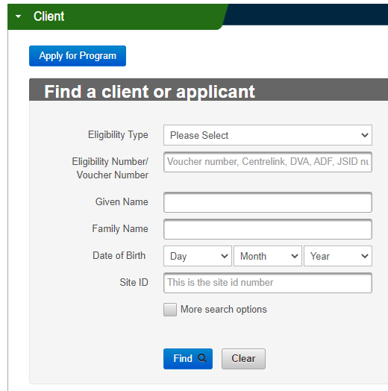

Opening the client’s page will bring up the client details screen.

To check what has been previously claimed, click the View All button under the Claims History tab.

# Entering a portal claim

## Step 2

In the Claims History tab, click the Manual Claim button to enter the claim details.

Under Client Details, please check the client details are correct.

Screenshot of the View All, Manual Claim and Export buttons in the Claims History accordion on the Hearing Services Online portal.

Select the correct voucher number**\***. Select the Date of Service**\***.

In the Provider Reference Number field, you can enter any reference used by your business for the claim.

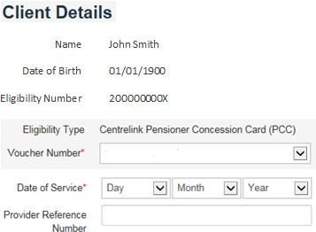

## Step 3

Under Service Provider Details, enter the first few digits of the Practitioner Number**\*** and select the correct practitioner from the options that appear. Select the Site ID**\***.

Screenshot of the Practitioner Number and Site ID fields on the Hearing Services Online portal. 

## Step 4

Under Claim Details, select Manual Claim**\*** and the Item Number**\***.

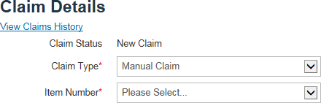

## Step 5

Under Fitting Details, select left or right. Select the Date of Fitting**\***.

Enter the first few digits of the Device Code**\***.

A code must be selected from the options that appear before you can proceed.

Enter the 3FAHLS**\*** for that ear. Repeat if the other ear has also been fitted.

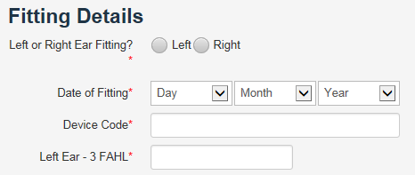

Please check that all information is correct, then read and tick the certification box before clicking the Submit button.

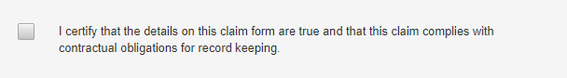

Note - [The Schedule of Service Items and Fees](https://www.legislation.gov.au/F2024N00985/latest/text) can assist with claim item numbers.