



# Getting more than 1 vaccine at a time



This information is about when your child gets more than 1 **vaccine** at a time.



**Vaccines** are medicines that can help stop children getting sick.



Children get the vaccine

* With a needle in their arm or leg
* Or drops in their mouth.

1

Most of the time children get vaccines from a



* Doctor
* Nurse
* Health worker.

Sometimes your child might get more than 1 vaccine at a time.



This might be if there is more than 1 vaccine your child needs at their age.

There are different ways children can get more than 1 vaccine at a time.



Your child might get 2 or more vaccines in 1 needle.



Or your child might get 2 or more vaccines in different needles at the same time.



# Getting more than 1 vaccine is safe

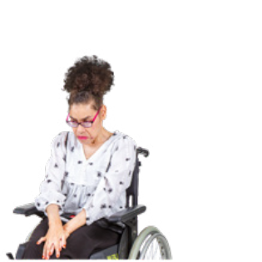

You might worry if it is safe for your child to get more than 1 vaccine at the same time.

It is safe for a child to have more than 1 vaccine at the same time.



This is because their **immune system** is very strong.



An **immune system** is the part of the body that keeps them from getting very sick.

# Good things about getting more than 1 vaccine at a time



There are good things about having more than 1 vaccine at the same time.

It means the vaccines will make your childs immune system stronger.



It means children can stay safe from many different **diseases**.

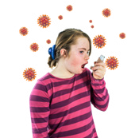

**Diseases** are things your body gets that make you sick.

It also means they do not have to go the doctor as much.



# More information

To get more information you can go to

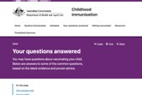

[**www.health.gov.au/childhood-**](https://www.health.gov.au/childhood-immunisation/your-questions-answered)[**immunisation/your-questions-answered**](https://www.health.gov.au/childhood-immunisation/your-questions-answered)

This website is not Easy Read. You can ask for support to read it.



Council for Intellectual Disability made this document Easy Read. **CID** for short. You need to ask CID if you want to use any pictures in this document.  
You can contact CID at [**business@cid.org.au**.](mailto:business@cid.org.au)