

Evaluation of the Embrace Multicultural Mental Health Project

Prepared for the Department of Health and Aged Care

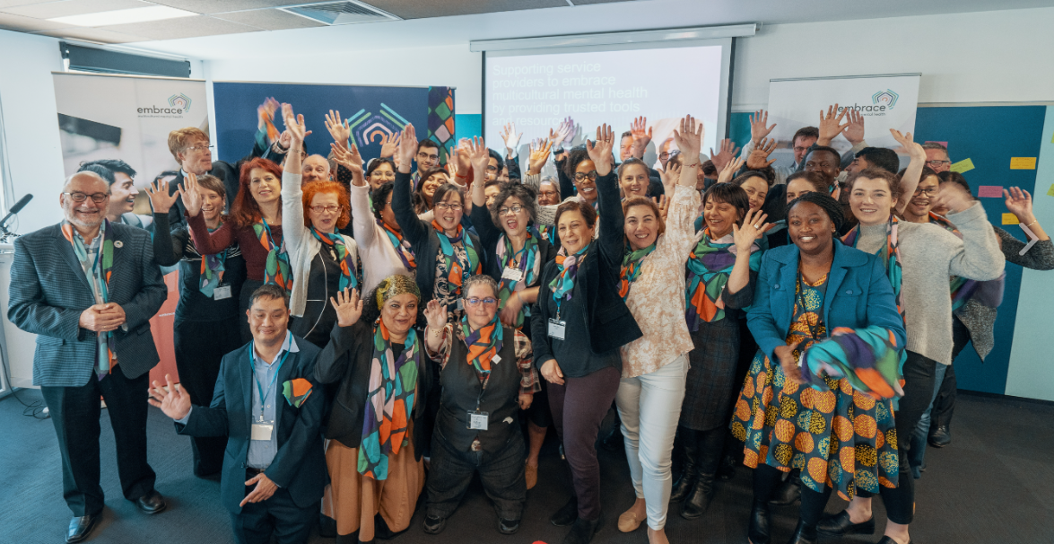28 June 2024

# Contents

Contents 2

Acknowledgements 4

Executive Summary 6

Embrace Multicultural Mental Health Project 18

Embrace Multicultural Mental Health Project 18

Evaluation of the Embrace Project 23

Key Evaluation Questions 23

Theory-Based Evaluation approach 24

KEQ 1: Appropriateness of project design 41

Overview of findings 41

How we answered KEQ 1 41

Findings for KEQ 1 42

Recommendations related to KEQ 1 51

KEQ2: Implementation efficiency and governance 52

Overview of findings 52

How we answered KEQ 2 52

Findings for KEQ 2 54

Recommendations related to KEQ 2 58

KEQ 3: Uptake of the Framework and CALD Community Engagement Project 60

Overview of findings 60

How we answered KEQ 3 60

Findings for KEQ 3 62

Recommendations related to KEQ 3 71

KEQ 4: Impact of the Framework on workforce cultural knowledge, skills, confidence, awareness, and collaboration 73

Overview of findings 73

How we answered KEQ 4 73

Findings for KEQ 4 75

Recommendations related to KEQ 4 81

KEQ5: Impact of the CCEP on CALD communities’ mental health literacy, skills, stigma, and awareness of support channels 84

Overview of findings 84

How we answered KEQ 5 84

Findings for KEQ 5 85

Recommendations related to KEQ 5 88

KEQ6: Impact of the Project on workforce motivation, agency, capacity, and diversity to deliver culturally competent mental health services 89

Overview of findings 89

How we answered KEQ 6 89

Findings for KEQ 6 92

Recommendations related to KEQ 6 101

KEQ 7: Impact of the Project on CALD community access to mental health care 102

Overview of findings 102

How we answered KEQ 7 102

Findings for KEQ 7 104

Recommendations related to KEQ 7 112

KEQ8: Impact of the Project on CALD mental health service design 114

Overview of findings 114

How we answered KEQ 8 114

Findings for KEQ 8 115

Recommendations related to KEQ 8 117

KEQ 9: Cost-effectiveness of the project 118

KEQ 9 could not be answered 118

Conclusion 120

Summary of recommendations 124

Summary of recommendations for DoHAC 125

Summary of recommendations for MHA 127

Appendix A: Data matrix 133

Appendix B: Coefficient matrix 172

Appendix C: Summary of Findings Against Process Tracing Hypotheses 196

Appendix D: PHN/Service provider survey script 198

Appendix E: Strategies used to increase response rate to PHN/service provider survey 210

Appendix F: Embrace website reach vs cultural diversity by PHN boundaries 211

Appendix G: Reviewed Project Documents 216

Appendix H: Hotjar ‘Heat Map’ 219

Appendix I: Usability testing discussion guide 220

Appendix J: Ethnography guide 224

Appendix K: Contacted mental health organisations and PHNs 229

# Acknowledgements

This work was completed with the assistance of the Commonwealth Department of Health and Aged Care and the Embrace Project team at Mental Health Australia. We thank Tara Swift, Kara Lengyel, Yaser Hussaini, Malvika Manoj and Sandra Aji (DoHAC) and Carolyn Nikoloski, Nikki Hogan, Crystal Halbmaier, Ruth Das, Ashumita Badhan, Michelle Possingham, and Samantha Lilley (MHA) for their assistance.

We also thank all stakeholders of the Embrace Project who provided their insights. We trust their views are adequately represented in this report.

## Verian Evaluation Team

Dr Kizzy Gandy, Miriam Jeyapalan, Will Hoare, Natalie Chan, Dr Thi Hoa (Hannah) Nguyen, and Dr Hannah Morgan.

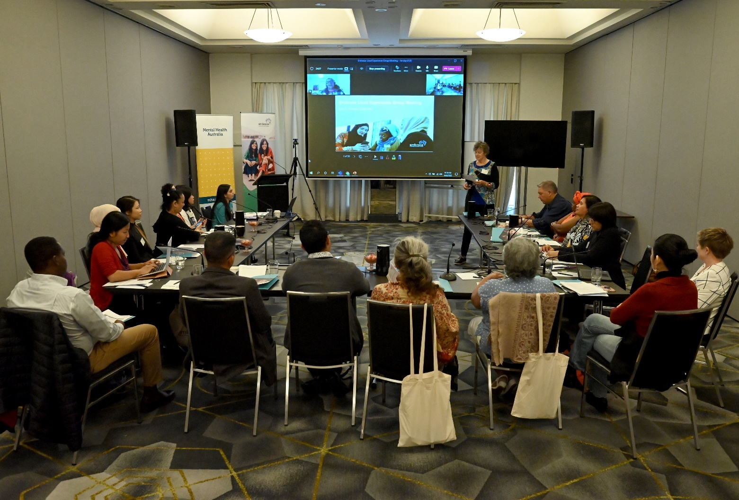

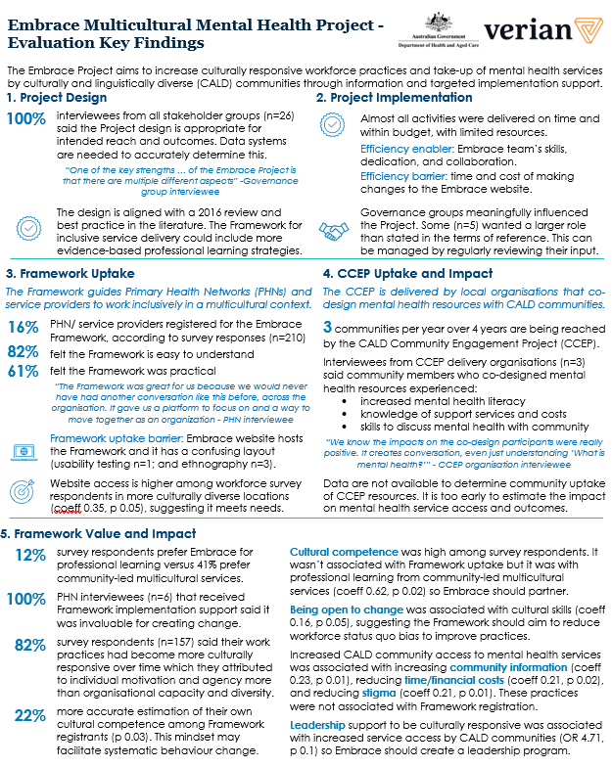

Embrace is competing with other professional learning in the market. With limited resources, it could reach scale more effectively by making the website and resources more user-friendly, providing self-service implementation tools, and embedding behaviour change strategies and monitoring and evaluation into the Project design.

Data sources: (i) Online survey of PHNs/ service providers (n=210), (ii) stakeholder interviews (n=26), (iii) project documents (n=36), (iv) ethnography (n=3), usability testing (n=1), user experience survey (n=11) of the Embrace website, Framework, and newsletter, (v) rapid evidence review. Abbreviations: odds ratio (OR), coefficient (coeff).

# Executive Summary

The Embrace Multicultural Mental Health Project

Embrace Multicultural Mental Health (the Embrace Project) aims to improve the quality and accessibility of mental health services for people from culturally and linguistically diverse (CALD) backgrounds. The Embrace Project is funded by the Department of Health and Aged Care (DoHAC), delivered by Mental Health Australia (MHA), and overseen by three governance groups.

The centrepiece of the Embrace Project is the Embrace website which offers free resources for mainstream mental health service providers to improve their cultural responsiveness and for multicultural communities to access information about mental health in different languages. The Embrace Project also delivers a number of related activities such as providing targeted support to Primary Health Networks to implement the Embrace Framework - a multi-module resource to work effectively in a multicultural context; commissioning research on best practice; funding multicultural community organisations to co-design new resources with and for community members as part of the CALD Community Engagement Project (CCEP); and general promotion of the Embrace Project.

The Embrace Project evaluation

In July 2023, DoHAC commissioned Verian to conduct an evaluation of the Embrace Project to inform future decisions around policy and funding. The evaluation answers nine Key Evaluation Questions (KEQs) about the Project’s appropriateness, implementation, outcomes, and cost-effectiveness.

To answer the KEQs, we used two Theory-Based evaluation approaches – Contribution Analysis and Process Tracing – with a mix of data collection and analysis methods. To implement these approaches, we co-designed a Theory of Change (ToC) for the Embrace Project which hypothesised pathways of change from activities to outputs, mechanisms of change and outcomes. A key feature of theory-based evaluation is examining mechanisms of change which are the cognitive and emotional reactions people have to the Embrace Project. Mechanisms drive outcomes and therefore provide explanatory evidence about how and why the project works.

Contribution Analysis allows claims that the Project contributed to observed outcomes if there is supporting evidence for the hypothesised pathways of change. Process Tracing increases the rigour of these causal claims by hypothesising alternative pathways of change and comparing the evidence for the core and alternative hypotheses to determine the likelihood the Project contributed to the outcomes.

We used a range of methods to collect data against the core and alternative hypotheses and answer the KEQs:

Rapid evidence review of international best practice in (1) building the cultural competency of the mental health workforce and (2) improving CALD community access and interventions for mental health support.

Online survey of Primary Health Networks (PHNs) and mental health service providers (SPs) about their cultural competency and changes to CALD community access to services in their area (n=210 responses). We embedded a quasi-experimental study in the survey to compare outcomes between respondents that had engaged with the Embrace Project (visited the website or registered for the Framework) and those that had not.

In-depth interviews with DoHAC (n=3), MHA (n=3), governance groups (n=9, from n=3 groups), PHNs that received Framework implementation support (n=6, from n=6 organisations), a service provider (n=2, from n=1 organisation), and organisations that delivered the CCEP (n=3, from n=3 organisations) about their views of the Embrace Project design and delivery, and barriers and enablers to outcomes.

Ethnography (n=3), usability testing (n=1), and a user experience survey (n=11) of the Embrace website, Framework, and newsletter.

Review of Embrace Project documents (n=36), including Activity Work Plans, Performance Reports, project budget and expenditure reports, and governance group Terms of Reference.

To conduct Contribution Analysis and Process Tracing, we analysed the data to examine the:

Presence of each ToC component. We used Framework Analysis for qualitative data, and descriptive statistics for quantitative data.

Relationships between theorised mechanisms of change and outcomes. We conducted correlations for quantitative data and used evaluator judgement for qualitative data.

Relationships between outcomes and engagement with Embrace versus alternative sources of professional learning about culturally responsive service delivery. We conducted regression analysis for quantitative data and used evaluator judgement for qualitative data.

Relationships between theorised changes in workforce practices and outcomes versus alternative reasons for outcomes. We conducted regression analysis for quantitative data.

Barriers and enablers to implementation and outcomes. We conducted emergent thematic analysis of qualitative data.

The evaluation design and data collection instruments were approved by the Bellberry Human Research Ethics Committee.

The evaluation findings are limited by a low response rate to the online survey of PHNs and SPs (210 usable responses from a sample of approximately 9,200, equivalent to 2.3%) and the usual risk of bias associated with self-reported data and a non-random sample, such as response bias and sample bias. It was also too soon to observe outcomes for the CCEP, so CCEP organisation interviewees were asked to predict outcomes based on early indicators of change.

Evaluation findings by KEQ

KEQ 1: Was the Embrace Project design effective and efficient to achieve the intended reach and outcomes? What else could be done to (a) support the mental health workforce to deliver culturally competent services? (b) increase CALD community access to mental health care? (c) improve mental health outcomes for CALD communities?

We found the Embrace Project design is informed by recommendations from a 2016 review of the Project and it is aligned with best practice in the literature. However, the Embrace Framework could include more evidence-based professional learning strategies to improve workforce practices. All interviewees from the Embrace governance groups (n=9), CCEP organisations (n=3), PHNs (n=6) and DoHAC and MHA (n=6) believe the Embrace Project design is appropriate but several interviewees across these groups (n=18) said they could not fully judge its reach and outcomes because monitoring and evaluation are not embedded in the Embrace Project design.

We looked for new ideas to support the workforce’s cultural competency and increase mental health service access and outcomes for CALD communities. Most of the interventions suggested in the literature are already being implemented by DoHAC via the Embrace Project or other programs of work. When PHNs and SPs were surveyed about how they would improve CALD community outcomes “If money and resources were no obstacle”, respondents (n=97) most frequently said they would hire more staff with CALD backgrounds (29%, n=28) and increase or improve language and interpretation services (20%, n=19). Among evaluation interviewees (n=18), the most common suggestions for improving the Embrace Project design were mandating PHN-funded mental health service providers show how they are being culturally responsive (n=7) and developing a national multicultural mental health strategy (n=5).

Some of these suggestions have been included in our recommendations based on the strength of evidence for likely impact and feasibility of implementation based on DoHAC’s sphere of influence.

We recommend DoHAC:

Recommendation 1.1: Include a clause in all PHN contracts with mental health service providers that the service must demonstrate how it is culturally responsive. DoHAC could support services to achieve this by identifying auxiliary supports that could be tied into current mental health services, such as providing transport to services or interpreters.

Recommendation 1.2: Develop and publish a national multicultural mental health strategy to facilitate a nationally consistent approach and set of performance indicators to aim for when developing, implementing, and evaluating culturally responsive service strategies. This would also provide a standard to operationalise recommendation 1.1.  
Recommendation 1.3: Require rigorous monitoring and evaluation systems across all Commonwealth CALD mental health funding to build the evidence base on what works. There is still a large gap in the literature on how to improve service access and outcomes for CALD communities. DoHAC could ask for support from the new Australian Centre for Evaluation in The Treasury given their mission is aligned.

We recommend the Embrace team:

Recommendation 1.4: Embed ongoing monitoring and evaluation in the Embrace Project design. This will enable more accurate and rapid assessments of the extent to which the Embrace Project is achieving its intended reach and outcomes to support continuous improvement. Verian will assist.

Recommendation 1.5: Incorporate evidence-based strategies for effective professional learning into the Framework and other cultural competency training Embrace provides. The purpose of this is to maximise professional practice outcomes from learning resources.

KEQ 2a: How efficiently were the Embrace Project’s activities implemented and what were the barriers and enablers to implementation, including stakeholder collaboration, skills, and resources?

According to the Embrace Project documents, almost all Embrace Project activities were delivered within intended timelines and budget. The CCEP was delayed by contracting processes but was brought back on schedule. For some activities, the allocated budget was disbursed in the following financial year due to delays in MHA receiving the grant agreement from DoHAC. The only activity that exceeded budget was engagement with the governance groups, due to increased travel costs after COVID-19 restrictions were lifted.

Governance group interviewees (n=9) confirmed the Embrace Project had mostly been delivered efficiently with the main area for improvement being the structure and format of meetings. Interviews with DoHAC and MHA staff (n=6) showed the Embrace team was understaffed for most of 2022-23, with only 2-3 FTE instead of the budgeted 4 FTE. Nevertheless, the Embrace team found efficient ways to stay on track through their skills and dedication, and the collaborative relationship between MHA and the governance groups. The main barrier to efficiency was the time and cost of making changes to the Embrace website as this had to be done through an IT developer. The Embrace team are assessing self-service options for the future.

KEQ 2b. Did the Alliance members (Federation of Ethnic Communities Councils of Australia and National Ethnic Disability Alliance), Lived Experience and Stakeholder Groups achieve influence and benefits? How and how much? Or why not?

According to interviews with governance group members (n=9) and MHA staff (n=3), and our review of the Terms of Reference for each governance group, members of the governance groups influenced the Embrace Project in meaningful ways. The Alliance Group advised on most Embrace Project activities and helped identify organisations to deliver the CCEP. The Stakeholder Group assisted in updating the Framework, identified CALD priority issues, and selected topics for commissioned research. The Lived Experience Group shared their experiences, reviewed draft resources, and provided feedback to external organisations on policies. All groups promoted the Embrace Project through their networks.

Some governance group members we interviewed (n=5) wanted their role to have a larger scope, such as attending conferences, which was outside the Terms of Reference. MHA interviewees (n=2) confirmed this was a known point of difference and they had been working to clarify governance group role expectations. Nevertheless, governance group interviewees reported personal benefits from participating in the Embrace Project such as growing their networks (n=6), learning more about what is happening in the mental health sector (n=5), and learning about mental health service design (n=4).

Recommendation 2.1: The Embrace team should seek individual feedback from members on an annual basis about how they would like to influence the Embrace Project and how this would contribute to achieving the Embrace Project’s objectives. This would assist in ensuring high-quality input from the governance groups continues and that members continue to feel valued. To enable honesty and openness, this could be done via an anonymous survey rather than during a governance group meeting.

KEQ 3: What was the level of uptake of the Framework and the CALD Community Engagement Project by target audiences? What were the barriers and enablers to uptake, including perceived accessibility/ usability/ relevance/ quality of the project outputs (website, communications, resources, and Community of Practice/training)?

The CALD Community Engagement Project (CCEP) is on track to meet its target of working with three CALD communities a year over four years. At the time of this report, data were not available to assess uptake of the CCEP resources by the relevant CALD communities but all three CCEP organisations interviewed believe community members involved in co-designing the resources valued the experience. An enabler of commissioned organisations wanting to deliver the CCEP was that they were already engaged with the targeted community groups.

The Embrace team does not have adequate data to determine uptake of the Framework across the mental health workforce, but we estimate this is low. Among respondents to our PHN/SP survey (n=210), only 16% (n=34) had registered for the Framework and only 9% (n=19) had promoted the Framework to others. Modules 1 and 2 had the highest completion rates.

Nevertheless, the Embrace Project is disproportionately reaching areas with higher need for resources and training in working with multicultural communities. We found a correlation between survey respondents saying they had visited the Embrace website and working in more culturally diverse geographic areas based on Australian Bureau of Statistics data, although this result was just below the threshold for statistical significance (coeff 0.35, p 0.054).

Almost half of all PHNs in Australia (n=13) participated in the Framework implementation support provided by the Embrace team. Interviews with PHNs that received this support (n=6) indicated that without the support, Framework implementation would have been slower and less comprehensive. All of these interviewees also highly valued the Embrace Framework and half had positive comments about the Community of Practice which the Embrace team facilitated.

The Framework received the highest share of votes (34%, n=21) when PHN/SP survey respondents were asked about the most valuable resource on the Embrace website. To calculate the extent to which respondents valued the Framework, the survey asked how much they would be willing to pay for it if it wasn’t free. The median response was $22.50 after excluding outliers. We did not find a relationship between respondents valuing the Framework more and greater completion of Framework modules.

We found two main barriers to Framework uptake, both of which relate to the Framework being hosted on the Embrace website. The first barrier was insufficient promotion of the Embrace Project in general. This was evidenced by annual website visits declining by 7,000 since 2016 and only 19% (n=39) of respondents to our PHN/SP survey saying they had visited the Embrace website. Some DoHAC, MHA and governance group interviewees (n=5) believed insufficient promotion of the Embrace Project was due to the Embrace team lacking staff.

The second barrier to Framework uptake was poor usability of the Embrace website. While survey respondents found the Framework itself to be easy to understand (82%, n=27) and practical to use (64%, n=21), it must be accessed via the website. Based on an ethnographic review of the website by three Verian evaluators, a 1.5-hour online usability testing session with one mental health service provider, and interviews with governance group members and PHNs (n=6), we concluded the website has a confusing layout for those not familiar with it.

Recommendation 3.1: Increase Framework uptake by developing and implementing a plan to promote the Framework to new audiences using existing resources. For example, workplace Employee Assistance Programs and school counsellors have not yet been targeted and may have capacity and interest in implementing the Framework.

Recommendation 3.2: Conduct a “sludge audit” of the Embrace website to improve its accessibility and usability. Sludge is defined as the excessive or unjustified frictions that make it harder for people to achieve their goals.

Recommendation 3.3: Continue to collect user feedback on the website and ensure the Embrace team can regularly make website improvements without needing the assistance of a developer.

KEQ 4. Did the Framework change the workforce’s: a) cultural knowledge and skills, and estimation of their own competence, to confront and change their construct systems to align with the needs of the client? B) awareness of existing CALD mental health support channels? C) collaboration? Does this vary by geographic area? What is the wider context for creating change, e.g., other programs, international practice shifts, competing priorities?

Respondents to the PHN/SP survey reported high levels of cultural knowledge and skills, awareness of existing support channels, and collaboration with other services or with CALD communities. For example, 69% (n=145) said they have the skills to provide culturally responsive mental health services. We also found high levels of both perceived and actual cultural competence and these outcomes were positively correlated, suggesting the workforce is correctly estimating their own cultural competence.

However, these outcomes were not associated with registering for the Framework or completing more Framework modules, so there is no evidence they were caused by the Framework. The only exception was Framework registrants more accurately estimated their own cultural competence compared to non-registrants. Our correlation test found Framework registration was associated with a 22% reduction in the difference between perceived and actual cultural competence (coeff -1.633, p 0.035). This is an important finding because being self-aware may improve interactions with CALD communities in many ways and lead to system change.

Improved organisational resourcing to be culturally responsive (e.g., interpreter service) is beyond the control of the Embrace Project but our PHN/SP survey found it was associated with awareness of existing CALD mental health support channels (coeff 0.355, p 0.024) and cultural skills (coeff 0.021, p 0.06).

It is possible the Framework was not statistically associated with most workforce outcomes because people are getting the same information somewhere else. When asked “which organisation best supports your learning needs about culturally inclusive mental health service delivery?”, the largest proportion of survey respondents said a community-led multicultural service (54%, n=74), followed by Embrace (16%, n=22). With many competing programs on offer, the Framework may be highly effective for those without access to other resources. Indeed, most PHN interviewees (n=5) believed the Framework had improved their skills and knowledge. Further, among survey respondents that registered for the Framework (n=34), a majority said it is high quality (70%, n=23).

A majority of all survey respondents said they are open to changing their work practices (92%, n=173). Being open to change was positively correlated with cultural skills (coeff 0.157, p 0.046). This validates the Theory of Change that the Framework must help people overcome the normal human tendency to stick with the status quo (status quo bias) to be effective.

Recommendation 4.1: Measure the difference between actual and perceived cultural competence as part of the Framework. It’s important for the workforce to accurately estimate their own cultural competence. The Framework seems to be having a positive impact in this regard, but the sample size was limited. Therefore, the Embrace team should systematically evaluate this outcome as people progress through the Framework modules.

Recommendation 4.2: Introduce activities into the Framework which encourage openness to working differently. Being open to change was associated with improved cultural skills so introducing evidence-based activities that increase openness can potentially increase the Embrace Framework’s impact. For example, the first module could start with a 10-minute values affirmation exercise where people write about their core values.

KEQ 5: Did the CCEP change the community’s: a) mental health literacy, skills, and stigma to access mental health support? b) awareness of existing CALD mental health support channels? Does this vary by cultural group? What is the wider context for creating change, e.g., community and system barriers, shifting norms in home countries?

The CALD communities receiving the CCEP are:

Round 1: Rohingya community in Melbourne, Chinese/Mandarin community in Sydney, and CALD youth in Darwin.

Round 2: Pasifika and Māori community in Queensland, Afghan community in Adelaide, and African women in Western Australia

Round 3: Tamil community in Sydney, Ezidi community in Armidale NSW, and CALD communities in Canberra.

Round 4 communities had not been confirmed at the time of the evaluation.

These communities were selected by MHA based on advice from the governance groups that they would benefit. This is consistent with the literature which finds these communities are associated with increased risk factors for poor access to health services in general.

Representatives from three organisations that delivered the CCEP said in interviews they believed the CCEP was contributing to increased mental health literacy, improved skills in discussing mental health within families and the broader community, increased awareness of support services, and increased knowledge of costs and referral processes involved in accessing care. However, their assessment was only based on their perceptions of the experiences of community members who participated in co-designing resources. This is because not enough time has passed since the resources were developed to measure outcomes among the wider CALD community who are the intended beneficiaries of the resources. It is also unclear whether CCEP organisations have monitoring and evaluation systems in place.

According to CCEP interviewees (n=3) mental health stigma is not significantly reducing in CALD communities’ home countries but the potential for the CCEP to impact stigma will vary for different age and ethnic groups and each person’s settlement journey (e.g., what age were they when they arrived in Australia, how long have they lived here, etc).

We found preliminary evidence the program meets the needs of CALD communities and reduces their status quo bias – these are the theorised mechanisms of change. All three CCEP organisation interviewees reported that community members who co-designed mental health resources valued the experience and their involvement had encouraged them to think differently about mental health. Experiencing the mechanisms of change may be a function of the co-design process and data are not available to determine whether passively receiving the resources will have the same effect. This finding is consistent with Verian’s evaluation of Embrace’s suicide prevention pilot, which found the co-design process increased participants’ awareness and understanding of mental health and suicide risk in their community and increased their confidence engaging in help-giving behaviours.

A key question for a future evaluation of the CCEP is whether CALD community members who use the resources experience the mechanisms of change and achieve the same level of outcomes as those that co-designed them.

See recommendation 1.4: Embed ongoing monitoring and evaluation into the Embrace Project design. This evaluation was not able to comprehensively evaluate medium-term or long-term CCEP outcomes, or mechanism-outcome links. Establishing the required data collection and analysis systems now (with data collected directly from CALD community members) will ensure an evaluation is feasible after all delivery has been completed and sufficient time has passed for the outcomes to be observed.

KEQ 6: Did the Embrace Project improve the workforce’s motivation, agency, capacity, and diversity to deliver culturally competent mental health services?

PHN/SP survey respondents had high levels of motivation and cultural competency, and lower levels of culturally responsive service delivery. For example, 89% (n=171) said working hard to be more culturally responsive feels good but only 47% (n=79) said they/their organisation reduced mental health stigma for CALD communities in their service area in the last two years.

We did not find an association between survey respondents that had visited the Embrace website and increased motivation to be culturally responsive (coeff 0.036, p 0.745). However, PHN interviewees (n=4) said the Framework self-assessment tool had helped to make improving cultural competence a strategic priority.

We also did not find an association between registering for the Framework and cultural competence (coeff -1.100, p 0.207). To examine whether alternative sources of professional learning were effective, we used a multiple-choice survey question that asked respondents to select the organisation that best meets their learning needs. The group that selected a community-led multicultural service had higher cultural competence than the group that selected any of the other choices (including Embrace), and this difference was statistically significant (coeff 0.616, p 0.024).

A high proportion of survey respondents (82%, n=157) said their workforce practices had become more culturally responsive in the last two years but tended to cite individual reasons (motivation and agency) than organisational factors (capacity and diversity). For example, 73% (n=114) said the change was attributed to them treating cultural responsiveness as an ongoing priority but only 22% (n=34) said the change was attributed to their organisation prioritising cultural diversity in its staff retention practices. This is consistent with most survey respondents demonstrating they have the right mindset to be culturally responsive. For example, 82% (n=158) said they actively self-evaluate their cultural humility.

Although the Embrace Project may not have had a unique impact in driving workforce outcomes compared to other sources of professional learning, the theory of how change occurs appears correct. We found PHN/SP survey respondents who estimated their cultural competence more accurately felt more agency over their cultural responsiveness (coeff 0.072, p 0.005), and those who were more culturally competent more strongly agreed that they update their beliefs when interacting with people from different cultural backgrounds (coeff 0.214, p <0.001).

Recommendation 6.1: Introduce more ways for the Embrace Project to increase the workforces’ self-awareness of their own cultural competence. Given the evidence that improved self-awareness of cultural competence is associated with greater sense of agency in delivering culturally responsive services, the Embrace Project should help individuals more accurately estimate their cultural competence. One of the best strategies to do this is simply to raise awareness of the cognitive bias that people with low competence in a particular domain tend to overestimate their ability.

Recommendation 6.2: Explore delivering the Embrace Project through partnerships with community-led multicultural services. Given the importance of community-led multicultural services for professional learning, Embrace should explore partnership opportunities to promote the Embrace Project. In addition, by collaborating with other organisations that offer professional learning about culturally responsive service delivery, Embrace could identify needs in the market that aren’t currently being met and develop new offerings to fill these gaps.

KEQ 7: Did the Embrace Project improve CALD community access to mental health care?

61% (n=88) of respondents to the PHN/SP survey said CALD community access to mental health services in their area had increased in the last two years while 12% (n=17) said it had decreased. We found a negative relationship between respondents using the Embrace website and increased CALD community access to mental health services (coeff -0.188, p 0.04). However, this can be interpreted as people going to the website when they identify a specific need with CALD community access rather than the website reducing CALD community access.

We did not find a relationship between respondents saying CALD community access to services in their area had increased and registering for the Framework (coeff 0.181, p 0.417) or completing more Framework modules (coeff -0.0016, p 0.95). However, the odds of respondents saying access had increased was almost five times higher among those that had improved leadership support to be culturally responsive compared to those that didn’t, but this was only statistically significant at the 10% level (OR 4.709, p 0.099). Leadership support to implement the Embrace Project is an assumption in the Theory of Change because it is recognised as important for outcomes to occur, but it is not directly influenced by the Project.

It is too early to assess the impact of the CCEP on mental health access and outcomes for CALD communities. It is also unclear whether CCEP organisations have monitoring and evaluation systems in place. Nevertheless, interviewees from the CCEP organisations (n=3) predict the program will increase community motivation and agency to access care and improve their ability to access it by knowing how to get a referral and where support services are located, and by reducing stigma. These outcomes need to be evaluated in the future with data collected directly from CALD community members.

Based on a multiple-choice question in the PHN/SP survey, the most common actions taken by the workforce to improve mental health outcomes for CALD communities in the past two years were developing policies (59%, n=99) and improving resources (60%, n=102), and the least common action was reducing the time or financial costs of accessing services (27%, n=46).

The survey data supported the hypothesis that improved CALD community access to mental health services is associated with increasing community information, e.g., translation services (coeff 0.231, p 0.008), reducing the time/costs of accessing services, e.g., taxi vouchers (coeff 0.206, p 0.023), and reducing mental health stigma, e.g., lived experience events (coeff 0.212, p 0.012). However, these practices were not associated with registering for the Framework.

Recommendation 7.1: Develop and deliver a specialised leadership program. Given leadership support to be culturally responsive appears to have a large impact on improving CALD community access to services, we recommend Embrace introduce a specialised leadership program for the mental health workforce.

KEQ 8: Did the Embrace Project build new knowledge about CALD mental health service design? How and how much? What was the contribution of the research reports and CALD community participation in service design, delivery, and evaluation?

The Embrace Project commissioned four research reports in 2022/23. We reviewed these reports and found each one provided clear findings, recommendations, and next steps. The reports also helped to fill a known gap in the literature about how specific CALD community groups view mental health. For example, one of the research projects was a literature review. The report provided insights into the different perspectives Arabic, African and Chinese communities have about causes and presentations of mental ill-health, mental health stigma, and preferences for help-seeking.

We asked governance group members about their views on the research projects. Some interviewees (n=3) described being consulted on research topics and said the Embrace team had selected topics to ensure representation of under-researched communities. While these three interviewees could also recall there had been two webinars to discuss the findings of the research, most governance group interviewees (n=6) were unaware of how the reports were being used.

The CCEP projects also generated new knowledge about how specific CALD communities view mental health and produced resources that reflect these learnings and can be used by other similar communities. CCEP organisation interviewees (n=3) believed co-design participants had increased personal competence and interest in future participation in service design and delivery. They also perceived that co-design participants would share their positive experience with the wider community, which would likely lead to increased interest and willingness to participate in future service design by others from the community.

Recommendation 8.1: Develop a comprehensive database of the new knowledge generated by all Embrace Project activities and ensure this knowledge has a tangible influence on future service design, delivery, and evaluation. Currently Embrace does not record the knowledge outcomes that are generated by Embrace activities.

Recommendation 8.2: Promote the use of co-design across the sector by publishing case studies of the CCEP and its outcomes. These case studies could highlight the benefits to all involved and the new knowledge outcomes that were generated.

KEQ 9: How cost effective is the Embrace Project’s impact on improving workforce cultural competence?

This KEQ could not be answered as the cost-effectiveness analysis was intended to measure the cost of improving workforce cultural competency, but our analysis found a null result.

Conclusion

This evaluation focused on the design, implementation and impact of the CCEP and Embrace Framework, with a smaller focus on other activities and resources delivered by the Embrace Project.

The Embrace Project design was appropriate based on existing evidence of best practice, but the current international evidence base of what works to improve mental health service access and outcomes for CALD communities is limited due to a lack of rigorous evaluations.

The Embrace team and governance groups responsible for delivering the Embrace Project were knowledgeable and committed. They implemented activities effectively and efficiently with their limited resource.

The CCEP is in its early stages of implementation so we could not rigorously evaluate its impact on CALD community outcomes. Interviews with CCEP organisations suggested co-designing resources with CALD community members is working well and those that participate in co-design are likely to experience improved mental health outcomes. These organisations also expect mental health outcomes to improve across the wider CALD community where the resources are being delivered. A rigorous monitoring and evaluation system needs to be put in place now to be able to assess this in the future.

We did not detect many statistically significant impacts of the Framework on workforce practices or CALD community outcomes. This may be because the workforce is using other sources of professional learning which are equally effective as the Embrace Project, or it could be because changing systems and processes takes time, and the effects of professional learning may take many years or a larger sample size to be detected.

A significant finding of the evaluation was that the Framework helped the workforce accurately estimate their cultural competence. Being self-aware may positively influence many small decisions in everyday practice with CALD communities. When this effect is aggregated across the workforce it could lead to positive system change which is the ultimate goal of the Embrace Project.

We found that one of the most important drivers of improved CALD community access to services appears to be workforce leadership support to deliver culturally responsive services. Therefore, creating a leadership program will be a valuable investment for the Embrace Project in the future.

PHNs highly valued the Framework implementation support provided by the Embrace team and said it helped their organisation put in place systems and processes to deliver culturally responsive services. However, providing this support to thousands of mental health service providers is not feasible so to better support self-servicing, it will be important for the Embrace team to improve the usability of the website and reduce the hassle of registering for the Framework. The effectiveness of the Framework could also be increased by including more evidence-based strategies for professional learning. In addition, some of the Framework implementation tools that the Embrace team provide to PHNs in the targeted support program, such as checklists, could be included in the Framework.

We conclude that the current theory of how to improve CALD community access to services is supported by the data. However, the effect sizes are relatively small. Therefore, there is a need to maximise outcomes through more strategic use of behavioural science.

Ultimately the Embrace Project is a behaviour change program – seeking to increase culturally responsive workforce practices and increase CALD community take-up of services. Greater focus on how behaviour change occurs, instead of only providing information to target audiences, should be the strategic focus of the Embrace Project in the future and doesn’t necessarily require large financial investment.

Two mechanisms of change in the Embrace Project ToC are a good place to start because they were associated with greater outcomes: openness to change and self-awareness of one’s own competence. Small changes to the Project design to integrate evidence-based strategies for triggering these mechanisms of change – both among both the workforce and CALD community members – could drive greater outcomes.

Finally, a consistent finding across this evaluation is that better monitoring and evaluation needs to be embedded in the Embrace Project design to enable continual optimisation and adaptation to the changing needs of Embrace’s audiences. This is something that Verian will assist with in the next phase of work.

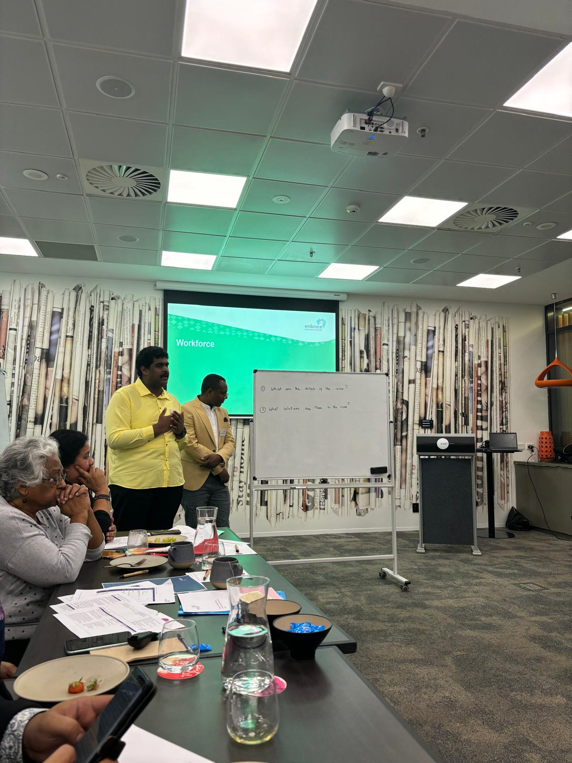

# Embrace Multicultural Mental Health Project

Australia is a multicultural country. The 2021 Census finds that almost thirty percent of the population were born overseas and almost a quarter use a language other than English at home.1

People from culturally and linguistically diverse (CALD) backgrounds often have different needs and experiences when it comes to mental illness compared to other Australians. These include:

* cultural beliefs about what constitutes mental illness and how to respond to it.[1]
* greater risk of mental illness due to the stresses of migration and adjustment to a new country, especially among refugees and asylum seekers with experiences of trauma.[2]
* less access to mental health services due to stigma, language barriers, and limited knowledge of available services.[3]
* poor outcomes from mental health services due to racism and discrimination, and lack of culturally appropriate services.[4]

There is a clear need to collaborate with CALD representatives to adapt mainstream mental health services, build the workforce’s cultural competence, and develop CALD-specific interventions to support the mental health of CALD communities in Australia.[5]

## Embrace Multicultural Mental Health Project

Embrace Multicultural Mental Health (the Embrace Project) is delivered by Mental Health Australia (MHA) and funded for the period 2018 – 2025 by the Department of Health and Aged Care (DoHAC). The Embrace project aims to improve the quality and accessibility of mental health services for people from CALD backgrounds. It provides a national platform for Australian mental health services and multicultural communities to access resources and information in a culturally accessible format, and link to services.

The key objectives of the project are to:

* Increase participation of consumers and carers from CALD backgrounds in mental health services,
* Improve outcomes for CALD mental health consumers, carers, and their families,
* Increase mental health awareness, knowledge, and capacity in CALD communities, and
* Improve the cultural responsiveness and diversity of the mental health workforce.

### Governance groups

The Embrace Project is overseen by three governance groups:

* Alliance Group – includes representatives from MHA, the Federation of Ethnic Communities’ Council of Australia (FECCA), the National Ethnic Disability Alliance (NEDA), and CALD mental health consumers and carers.
* Stakeholder Group – includes representatives with multicultural mental health expertise and links to CALD communities, such as Suicide Prevention Australia, Migration Council Australia, and Harmony Alliance.
* CALD Mental Health Consumer and Carer Lived Experience Group – includes representatives from each state and territory.

### Program design

The Embrace project takes a multipronged approach to improving mental health outcomes for multicultural communities. The three key areas of focus are:

1. Building the capability of the mental health workforce to be more culturally responsive through the website resources, the Framework for Mental Health in Multicultural Australia (the Framework), and by providing support to Primary Health Networks (PHNs) and mental health service providers to implement the Framework;
2. Reducing mental health stigma and improving access to services through the CALD Community Engagement Project (CCEP) and website resources; and
3. Building the knowledge base of the mental health sector about what works to support multicultural communities by commissioning research and engaging with the three governance groups.

### Project activities

#### The [Framework for Mental Health in Multicultural Australia](http://embracementalhealth.org.au/service-providers/framework)

The [Framework for Mental Health in Multicultural Australia](http://embracementalhealth.org.au/service-providers/framework) (the Framework) is a free resource available via the Embrace website. It was developed to support mainstream mental health services and practitioners, and PHNs who commission services, to evaluate their cultural responsiveness and enhance delivery of services for CALD communities. The Framework has been mapped against the National Standards for Mental Health Services (2010) and the National Safety and Quality Health Service Standards (2017) to help practitioners meet and report against their existing requirements.

The Framework is designed to support mental health services and PHNs in two distinct ways:

* At an organisational level, in relation to service design, delivery, and evaluation of culturally responsive care and practices.
* At an individual worker level, to enable individual reflection and delivery of culturally responsive care and practices (e.g., General Practitioners, mental health nurses, psychiatrists, psychologists, social workers, occupational therapists, and community workers).

The Framework consists of a set of modules and self-reflection tools tailored to the user-type (organisation or individual). It is designed so that users can build on their strengths and address areas for improvement in a self-paced way, accessing the modules and resources that are of relevance to them and the stage in their cultural competence journey.

* Introduction to Cultural Competence. This module is available to all users and is recommended to be completed by people who have not had any experience in cultural awareness or cultural competence training. Those with experience or previous training may choose to go straight to the service modules. The module is delivered by a third-party provider that the Embrace Project pays for Framework users to access.
* Self-reflection tool
* PHNs and services commissioned by a PHN are encouraged to begin with the PHN Self-Reflection Tool. This enables users to focus on specific service modules based on priorities identified through the self-reflection tool.
* Individual practitioners are encouraged to use the Individual Practitioner Self-Reflection Tool, which is designed as a quick and accessible way to identify which areas are strengths, and which areas might be a focus for further development.
* Four core service modules which together provide a comprehensive review of the cultural responsiveness of a mental health service.
* Service Module 1: Planning Strategically to Meet Multicultural Community Needs
* Service Module 2: Developing Safe, Quality & Culturally Responsive Services
* Service Module 3: Working Together to Promote Mental Health in Multicultural Communities
* Service Module 4: Building a Culturally Responsive Mental Health Workforce

The Embrace team also provide targeted support to PHNs to implement the Framework via monthly online meetings, case studies, and Community of Practice meetings. From April 2022 to April 2023, 13 PHNs received this targeted support.

Where a mental health service provider is interested, the Embrace team provides an orientation to the Framework and offers a webinar or other training to a larger group of staff from the service provider.

#### The CALD Community Engagement Project (CCEP)

The CCEP strives to improve mental health services access and outcomes for CALD communities. It involves commissioning CALD community organisations to collaborate with CALD community members to identify mental health issues and needs and co-design culturally responsive solutions and resources. Resources designed by and for these communities, such as videos, podcasts, and fact sheets, are made available via the Embrace website so they can be used by other communities.

The CCEP was launched in 2021 with the aim of engaging twelve communities over four years. In round 1, the CCEP was delivered to the Rohingya community in Melbourne, the Chinese/Mandarin community in Sydney, and CALD youth from different cultural groups in Darwin.

In round 2, the CCEP is working with the Pasifika and Māori community in QLD, the Afghan community in Adelaide, and African women in Western Australia.

In round 3, the CCEP is working with the Tamil community in Sydney, the Ezidi community in Armidale, and CALD communities in ACT.

The final three organisations that will deliver round 4 will be confirmed in mid-2024.

#### The Embrace website

The Embrace website provides resources for CALD mental health consumers and carers, CALD communities, and the mental health sector. Most resources have been translated into 31 languages and users can access multilingual information by selecting their chosen language when they first enter the website.

The website is intended to be a definitive online resource for those needing information and resources about multicultural mental health, and so requires regular updating to ensure all resources are current.

Some examples of resources on the Embrace website include the personal stories of CALD community members who have accessed mental health services, best practice examples of providers who are culturally responsive, resources for CALD community leaders, and a search function to find mental health services and multicultural and community groups.

#### Commissioned research projects

The Embrace Project commissions research projects to build the evidence base on improving CALD mental health in Australia. To date, four research projects have been commissioned and published on the Embrace Project website. The first article was also published in the BMC Public Health journal.

* Conceptualisations of mental illness and stigma in Congolese, Arabic speaking, and Mandarin speaking communities: a qualitative study. (2022)
* A Literature Review on Mental Health and Stigma in Three Specific Culturally and Linguistically Diverse Communities: Arabic, African and Chinese (2022).
* Understanding Mental Health and Stigma in Congolese, Arabic-speaking and Mandarin speaking Communities (2022).
* Mental Health during the COVID-19 Pandemic in Italian, Turkish and Vietnamese Communities (2022).



# Evaluation of the Embrace Project

In July 2023, DoHAC commissioned Verian to conduct an evaluation of the Embrace Project. The purpose of the evaluation was to inform future decisions around policy and funding, and to meet the requirement for all governments to measure and report on funded activities to improve transparency and accountability, under the National Mental Health and Suicide Prevention Agreement.

## Key Evaluation Questions

The evaluation sought to answer nine Key Evaluation Questions (KEQs) covering: appropriateness of the Project design; efficiency of implementation processes; outcomes achieved; and cost-effectiveness of the Project (see Table 1).

Table 1. Key Evaluation Questions

| KEQ category | KEQs |
| --- | --- |
| Appropriateness | Was the Embrace Project design effective and efficient to achieve the intended reach and outcomes?  What else could be done to:  support the mental health workforce to deliver culturally competent services?  increase CALD community access to mental health care?  improve mental health outcomes for CALD communities? |
| Process | How efficiently were the Embrace Project’s activities implemented and what were the barriers and enablers to implementation, including stakeholder collaboration, skills, and resources?  Did the Alliance members (Federation of Ethnic Communities Councils of Australia and National Ethnic Disability Alliance), Lived Experience and Stakeholder Groups achieve influence and benefits? How and how much? Or why not? |
| Short term outcomes | What was the level of uptake of the Framework and the CALD Community Engagement Project (CCEP) by target audiences?  What were the barriers and enablers to uptake, including perceived accessibility/ usability/ relevance/ quality of the project outputs (website, communications, resources, and Community of Practice/training)? |
| Medium term outcomes for workforce | Did the Framework change the workforce’s:  cultural knowledge and skills, and estimation of their own competence, to confront and change their construct systems to align with the needs of the client?  awareness of existing CALD mental health support channels?  collaboration?  Does this vary by geographic area?  What is the wider context for creating change, e.g., other programs, international practice shifts, competing priorities? |
| Medium term outcomes for community | Did the CCEP change the community’s:  mental health literacy, skills, and stigma to access mental health support?  awareness of existing CALD mental health support channels?  Does this vary by cultural group?  What is the wider context for creating change, e.g., community and system barriers, shifting norms in home countries? |
| Long term outcomes | Did the Embrace Project improve the workforce’s motivation, agency, capacity, and diversity to deliver culturally competent mental health services?  Did the Embrace Project improve CALD community access to mental health care? |
| Long term outcomes | Did the Embrace Project build new knowledge about CALD mental health service design?  How and how much?  What was the contribution of the research reports and CALD community participation in service design, delivery, and evaluation? |
| Cost effectiveness | How cost effective is the Embrace Project’s impact on improving workforce cultural competence? |

## Theory-Based Evaluation approach

We used a mixed-methods Theory-Based Evaluation approach to answer the KEQs.

### What is Theory-Based Evaluation?

Different evaluation designs support different claims about program performance. Experimental evaluations can make causal claims, but they are also the most challenging to deliver because they require a comparison group and large sample size.

Observational evaluation designs are the least rigorous and the easiest to deliver. These evaluations observe outcomes that occurred at the same time as the program but cannot account for other factors that may have caused the outcomes.

Theory-Based Evaluation can make observational data more rigorous and allows claims that the program contributed to observed outcomes. It also has the benefit of explaining how and why outcomes occurred which makes it more informative than experimental evaluation.

| EXPERIMENTAL EVALUATION:  Can demonstrate the program caused the observed outcomes | THEORY-BASED EVALUATION:  Can demonstrate the program contributed to observed outcomes (and explain how and why) | OBSERVATIONAL EVALUATION:  Can demonstrate an association between the program and observed outcomes |
| --- | --- | --- |

A theory-based evaluation approach involves collecting data to evidence causal pathways laid out in a Theory of Change (ToC) model. A ToC is a visual model that details the logical steps over time that link a program’s inputs and activities to the program’s ultimate goal. This includes the outputs, short-, medium-, and long-term outcomes, and any assumptions (factors that influence the outcomes but are beyond the program’s control). Importantly, because people, not programs, cause change, a ToC should include the ‘mechanisms of change’. These are the cognitive and emotional reactions people have to the program which generate the outcomes. The mechanisms of change often sit in between the outputs and outcomes but can occur anywhere along the pathways of change.

Evidencing the causal pathways in a ToC reduces uncertainty about the contribution a program is making to the observed results. With Theory-Based Evaluation, we are not just observing a correlation between a program and outcomes which could be spurious. Instead, we are observing the theory about how and why the program leads to outcomes which is a higher standard of evidence.

Theory-Based Evaluation can be used with all types of data collection and analysis, including surveys, interviews, focus groups, administrative data, ethnographic observations, case studies, and document reviews. Data can be analysed in many ways, including:

* Framework Analysis: Looks for indicators of the ToC Change components in qualitative data (pre-specified themes) rather than letting themes emerge from the data, to systematically reduce the data for analysis. This helps to validate the theory.
* Descriptive statistics: Summarises the percentage of the sample that achieved the ToC components in quantitative data. This helps to validate the theory.
* Contribution Analysis: Looks for qualitative or quantitative evidence to support pathways of change in the ToC model and considers the influence of other factors on the outcomes. This allows claims that the program contributed to the observed outcomes.
* Quasi-experimental study: Tests cause-and-effect hypotheses in the ToC by comparing outcomes between an intervention group and a comparison group that weren’t randomised. This further raises the standard of causal evidence within a theory-based approach.
* Process Tracing: Tests counterfactual or alternative pathways of change in a ToC using contribution analysis or a quasi-experimental study. This reduces evaluator confirmation bias (i.e., only looking for confirmatory evidence) which is a risk associated with observational data.

Theory-Based Evaluation provides explanatory evidence about how and why outcomes occurred. The approach emphasises that people produce outcomes, not programs. Therefore, for a program to lead to outcomes, it must trigger cognitive or emotional reactions in people. These reactions are the mechanisms of change. By understanding mechanism-outcome links, evaluators can develop practical recommendations to improve program performance and cost-effectiveness. Realist evaluation goes one step further and argues that mechanisms will only be triggered in certain contexts so context-mechanism-outcome links must be studied, especially to inform recommendations about scaling programs in new contexts.

Data is typically analysed in the following ways:

* Mechanism-outcome links: Examines relationships between mechanisms of change and outcomes to provide explanatory evidence about the drivers of outcomes that the program must generate to be successful. Relationships can be identified quantitatively (e.g., correlations) and qualitatively.
* Emergent Thematic Analysis: Identifies and codes themes in qualitative data as they emerge, and then creates higher order categories for analysis. These categories typically represent barriers and enablers to outcomes or new mechanisms of change that weren’t originally theorised.

The aims and benefits of a Theory-Based Evaluation are to:

1. Reduce uncertainty about the contribution a program is making to the observed results, i.e., raise the standard of evidence that can be achieved with observational data.
2. Open the black box about how and why the program works, i.e., provide explanatory evidence which is lacking in experimental evaluation.
3. Provide a Framework for understanding what works, what needs improvement and how to realise these areas for improvement.

### Conducting a Theory-Based Evaluation for the Embrace Project

#### Theory of Change

We started the Embrace evaluation by co-designing a ToC model that articulates how and why outcomes are expected to occur as a result of the Embrace Project activities.

In August 2023, Verian conducted a 3-hour online workshop with DoHAC, MHA and others involved with the Embrace Project, including members of the Lived Experience, Alliance groups, Stakeholder group, CCEP organisations that delivered the projects, and PHN representatives. During this workshop, the Embrace Project activities, intended outcomes, and mechanisms of change were discussed, and a detailed ToC was developed. Further iterations were made through follow-up conversations with MHA and DoHAC before finalising the ToC model (see Figure 1).

The ToC diagram presented in Figure 1 shows how activities at the bottom of the model lead to the ultimate goals of the Embrace Project at the top of the model. The key pathways of change for achieving workforce cultural responsiveness are depicted on the right side of the model and key pathways of change for achieving CALD community take-up of mental health services are depicted on the left side of the model. These workforce and CALD community pathways of change meet at top of the model to create sustainable behaviour change. This long-term outcome is theorised to lead to the ultimate goals of improved mental health outcomes and reduced costs burden on the mental health system which are above the line of accountability for the Embrace Project.

### Integrating behavioural science into the Theory of Change

Behavioural science can improve a Theory of Change by identifying relevant and evidence-based mechanisms of change. This has two key benefits for theory-based evaluation:

1. The utility of evidence: If relevant mechanisms of change aren’t included in the ToC, the evaluation won’t be able to fully explain why outcomes were or weren’t achieved.
2. The rigour of the evidence: If mechanisms of change are not grounded in the science of how people make decisions, causal inferences from mechanism-outcome correlations won’t be valid and therefore recommendations for program improvement based on those findings won’t be effective.

For the Embrace Project’s Theory of Change, we included two key concepts from behavioural science as mechanisms of change:

1. Reduced status quo bias
2. Reduced overestimation of one’s competence (i.e., reduced Dunning-Kruger effect)

#### Reduced status quo bias

Status quo bias is the tendency for people to prefer maintaining the current situation and oppose actions that lead to change.[6] Status quo bias is associated with loss aversion but ironically the preference for stability can lead people to miss out on valuable opportunities.[7]

In the context of mental health services, status quo bias may lead workers to reject learning how to be culturally responsive and reduce their ability to adapt to new processes and procedures. In the context of the CALD Community Engagement Project, status quo bias may lead CALD community members to reject learning about mental health and reduce their take-up of services. Therefore, the Embrace Project ToC shows that reduced status quo bias is a mechanism of change for increasing the cultural skills of the workforce and the mental health skills of the CALD community. This mechanism is theorised to be triggered by the workforce and CALD community valuing the Embrace Project.

#### Reduced overestimation of one’s competence

The Dunning-Kruger effect is a cognitive bias whereby people with low competence in a particular domain tend to overestimate their ability. For example, among over 1,100 medical students in an obstetrics/ gynaecology rotation, those receiving a grade of D+ or lower on their final exam thought on average they would get a much-higher B-. Those getting an A only slightly underestimated their grade as a B+.[8]

People who overestimate their own competence may fail to recognise their own mistakes and fail to recognise the genuine skill of other people. While the real-world impacts of the Dunning-Kruger effect are understudied, there are examples of it being associated with negative behaviours. For example, people who refuse vaccinations tend to overestimate their knowledge about vaccine safety.[9]

The Dunning-Kruger effect can also work in the opposite direction and discourage individuals with genuine abilities from applying their skills due to their underestimation of their own competence (i.e., imposter syndrome). One study found that women performed equally to men on a science quiz, but women underestimated their performance and as a result were less likely to enter a science competition.[10]

As the Dunning-Kruger effect has been observed in many domains, including logical reasoning and emotional intelligence, we can infer that in the context of mental health services, if a worker estimates their cultural competence to be higher than it is, they may be less likely to see the need to learn from the CALD community or to change their practices to be more culturally responsive. Equally, if a worker underestimates their cultural competence, they may hold back from actively engaging with the CALD community and promoting culturally responsive practices in their organisation.

Therefore, the Embrace Project ToC shows that the mental health workforce must accurately estimate their own cultural competence to deliver culturally responsive mental health services, and the Framework is theorised to trigger this mechanism of change by increasing cultural knowledge.

Figure 1. Embrace Project Theory of Change model.

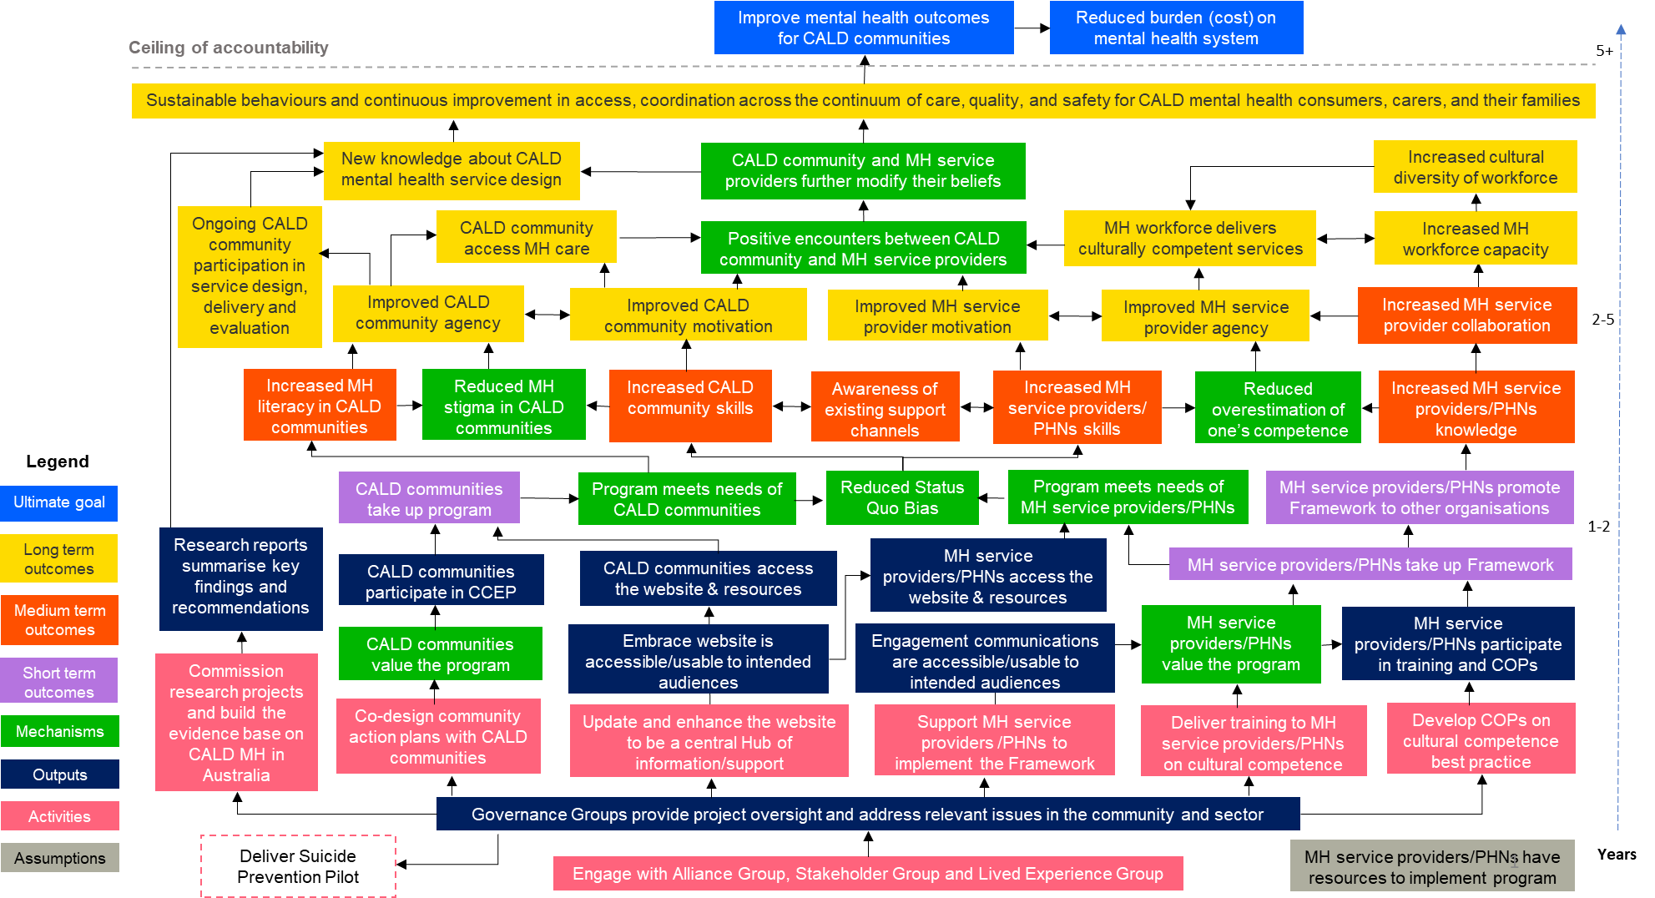

#### Data Matrix

We created a data matrix to organise how we would collect and analyse data against each component in the ToC and answer the KEQs (See Appendix A).

We worked with the Embrace team to define success for each ToC component. We also drew on our rapid evidence review, the Embrace Framework’s intended outcomes, and a conceptual model of cultural competence described in the literature.[11]

Figure 2 shows how the evidence described in the data matrix is laddered up to answer the Key Evaluation Questions. We developed one or more success indicators for each ToC component. We pre-specified how we would judge whether each ToC component was observed, partly observed or not observed in the data. We also pre-specified the analyses we would conduct to test the core and counterfactual hypotheses, validate theorised mechanism-outcome links, and identify unexpected barriers and enablers to achieving outcomes. The sum of this evidence was triangulated to comprehensively answer the KEQs.

Figure 2. Scaffolding approach to answering KEQs

### Figure 2 is a flowchart showing on the lowest level that we measure success indicators, then observe the presence or absence of the related Theory of Change components, conduct analysis using contribution analysis, process tracing, mechanism-outcome links, quasi-experimental study and emergent thematic analysis, and then answer the Key Evaluation Question. Data collection methods

#### Rapid evidence review

We conducted a rapid evidence review (RER) of international best practice in building the cultural competency of the mental health workforce and improving access and interventions for mental health supports for CALD communities. The findings were used to assess the appropriateness of the Embrace Project design. The full methodology and findings of the review are documented in Multicultural Mental Health: Rapid Evidence Review (provided to DoHAC on 30 November 2023).

#### Survey of PHNs and mental health service providers

We designed a 10-minute anonymous survey for the mental health workforce. The survey was open to anyone working in the mental health sector, not just those that had interacted with the Embrace Project. It asked questions about the individual respondent (e.g., cultural knowledge, skills), their organisation (e.g., policies, practices), and CALD mental health service access and outcomes in their service area.

The survey was programmed in Qualtrics and distributed to approximately 9,200 unique individuals who work for a PHN or mental health service provider via a number of avenues, including:

* Direct emails from DoHAC to PHN CEOs (n=1 email to n= 31 CEOs) and from MHA to the Stakeholder Group (n=2 emails to the Stakeholder Group) encouraging them to distribute the survey
* MHA’s weekly CEO email update (n=7,547 subscribers as of 2/11/23) for four weeks

An e-blast email to the Embrace Newsletter distribution list (n=4,023 subscribers as of 2/11/23). The survey was also posted in the December quarterly Embrace Newsletter

* Embrace’s Facebook, Instagram, and Twitter accounts on two occasions (17/11/23 & 20/12/23)
* Embrace News and Events website page, posted on 8/01/24 as an article.

To increase the sample size, snowball recruitment was used whereby recipients of the survey link were encouraged to forward it to colleagues and others in the mental health sector.

The survey was open from 3 November 2023 to 19 January 2024 (the survey was initially closed on 1 December 2023 but was relaunched on 11 December 2023 to increase the response rate).

A total of 276 responses were received. After the data were cleaned and incomplete and ineligible respondents were removed, 210 complete responses were analysed.

Appendix D provides the full survey script.

In-depth interviews with those involved with the Embrace Project

We conducted interviews with a range of people involved with the Embrace Project to understand their experience of the Embrace Project, perceived outcomes, and suggestions for improvement.

DoHAC and MHA assisted in identifying interviewees and invited them to participate via email. To maintain their confidentiality, participants contacted Verian directly to opt-in. The target and final sample sizes for each group are provided below.

Table 2. Interview sample

| Interviewee group | Target sample | Completed interviews |
| --- | --- | --- |
| Embrace Project administrator (DoHAC) | 1 | 3 |
| Embrace Project administrator (MHA) | 1 | 3 |
| Lived Experience Governance Group | 3 | 3 |
| Alliance Governance Group | 6 | 2 |
| Stakeholder Governance Group | 6 | 4 |
| PHNs that received targeted support to implement the Framework (1 representative per PHN) | 9 | 6 |
| Mental health service provider (2 representatives per organisation) | 2 | 2 |
| Organisations contracted to deliver the CCEP (1 representative per organisation) | 6 | 3 |
| TOTAL | 34 | 26 |

Interviews were conducted via video call on Microsoft Teams and ran for 45 – 60 minutes.

Interviewees from the Lived Experience Group, CCEP organisations, PHNs, and service providers were compensated for their time ($90). Interviewees from the Stakeholder group, Alliance group, MHA and DoHAC staff did not receive any financial compensation as participation in the evaluation was considered part of their usual role in the Embrace Project.

#### Ethnography of Embrace website, Framework, and communications

Ethnography involves researchers experiencing a program from the perspective of its intended users. Three Verian evaluators conducted ethnography on the Embrace website, Framework registration process, and an Embrace newsletter. The evaluators followed an ethnography guide (Appendix J) to complete tasks, rated the accessibility and usability of the website, Framework, and communications, and commented on aspects that worked well or needed improvement.

Each task was completed by at least two evaluators and the results were triangulated for robustness.

#### Website user experience survey

We placed a user experience survey on the [Community](https://www.embracementalhealth.org.au/index.php/community) and [Service Providers](https://www.embracementalhealth.org.au/service-providers) section of the Embrace website. It asked six simple questions about the website such as whether the information is easy to understand. The survey was hosted on Hotjar.[12] The full survey script can be found in Table 5 (under findings for KEQ 3).

The survey was live between 13 November 2023 and 29 January 2024 and received 11 completed responses.

#### Usability testing of Embrace website, Framework, and Communications

Usability testing is different to user experience research. User experience research gives you a deep understanding of users’ needs, behaviours, and their meaningful and personally relevant experiences using your product or service. Usability testing helps you find the usability issues in your design that you never expected – it is focused on identifying and solving problems to ensure your product or service works correctly.

Verian facilitated a 1.5-hour online usability testing session on 4 December 2023 via Microsoft Teams focused on the accessibility, usability, and relevance of using the Embrace website, registering for the Framework, and reading one of the Embrace newsletters hosted on the website. Refer to the usability testing guide in Appendix I.

To recruit participants to the usability testing session we embedded a pop-up survey on the Embrace website. The survey was hosted on Hotjar and was open from 13 November 2023 to 4 December 2023. Participants were only eligible to take part if they worked for a mental health service provider or a PHN and had visited the Embrace website at least once before. Participants were offered a $150 e-gift card for their time.

Three participants initially opted in and confirmed by email that they would be attending. However, only one participant attended on the day. Recruitment was reopened from 7 December 2023 until 31 January 2024 to attempt to recruit additional participants for a second usability testing session, but there were no further registrations.

### Causal attribution

To determine whether observed outcomes were caused by the Embrace Project, we conducted a quasi-experimental study, Process Tracing and Contribution Analysis.

#### **Quasi experimental study**

The survey of PHNs and mental health service providers facilitated a quasi-experimental study of the Embrace Project’s outcomes. By asking respondents whether they had engaged with the Embrace Project, and how much, it allowed us to compare outcomes between a “Treatment Group” and a “Comparison Group”, as well as conduct a dose-response analysis.

Depending on the KEQ, the treatment and comparison groups were defined as follows, and the analyses included relevant control variables:

| Treatment Group | Comparison Group | Control variables |
| --- | --- | --- |
| Self-reported registered for the Embrace Framework | Self-reported had not registered for the Embrace Framework | Date the respondent said they last accessed the Framework |
| Self-reported visited the Embrace website | Self-reported had not visited the Embrace website | Respondent reported in the last two years, they/their organisation had:  (1) improved leadership support to be culturally responsive  (2) improved resourcing to be culturally responsive. |

Note: Bar graphs showing the mean difference between the treatment group and control group throughout the report are based on OLS regression or logit regression with robust standard errors.

The dose response analysis was conducted as follows:

We defined ‘dose’ as extent of Framework use by assigning a score to respondents’ self-reported stage of progress against each of the six components of the Framework. The minimum score is 6 and the maximum score is 22. For example, a respondent that had registered for the Framework but not yet started any of the components was assigned the minimum score of 6, and someone that had completed all modules and was implementing follow-up actions would receive the maximum score of 22. The below table shows how the scoring was calculated.

| Framework component | Stage of progress |
| --- | --- |
| Self-reflection tool | Haven’t started  In progress  Completed |
| Introductory Module: Introduction to Cultural Competence | Haven’t started  In progress  Completed |
| Service Module 1: Planning Strategically to Meet Multicultural Community Needs | Haven’t started  In progress  Completed  Implemented follow up actions |
| Service Module 2: Developing Safe, Quality and Culturally Responsive Services | Haven’t started  In progress  Completed  Implemented follow up actions |
| Service Module 3: Working Together to Promote Mental Health in Multicultural Communities | Haven’t started  In progress  Completed  Implemented follow up actions |
| Service Module 4: Building a Culturally Responsive Workforce | Haven’t started  In progress  Completed  Implemented follow up actions |

The dose response analysis controlled for respondents saying that in the past two years their organisation had improved (a) resourcing to be culturally responsive; and (b) leadership support to be culturally responsive.

#### Process Tracing

Before commencing data collection, we developed core hypotheses about how the Embrace Project causes the program’s intended outcomes (based on the Theory of Change), and possible alternative (counterfactual) hypotheses about other factors that could cause these outcomes (based on the literature). We then defined the data we would use to test each of the core and alternative hypotheses. To draw conclusions about the causal impact of the program on the observed outcomes, we weighed up the amount of evidence supporting each hypothesis.

As the Theory of Change for the Embrace Project is complex and there are seven activities (pink boxes in the model) that drive outcomes, we did not test all pathways of change with Process Tracing. We focused on testing hypotheses about the impact of the Embrace Framework and CCEP as these are the two most significant activities undertaken by the Embrace Project.

The hypotheses we tested with Process Tracing are as follows:

|  | Core hypothesis | Alternative hypothesis |
| --- | --- | --- |
| KEQ5 | The CCEP reduced mental health stigma | Mental health stigma has reduced in CALD communities’ home countries. |
| KEQ6 | Cultural competence is higher among PHNs and service providers that have used the Embrace Framework vs those that haven’t | Cultural competence is higher among PHNs and service providers that used other forms of professional learning. |
| KEQ6 | At least 70% of PHNs and service providers who have registered for the Embrace Framework agree with these statements:  The Embrace Framework has helped me evaluate my cultural responsiveness.  The Embrace Framework has helped me enhance my cultural responsiveness. | The workforce believes their practices became more culturally responsive because of something else. |
| KEQ6 | The workforce believes their practices became more culturally responsive because of greater agency/ motivation/ capacity/ diversity. | The workforce believes their practices became more culturally responsive because of something else. |
| KEQ7 | Improvement in CALD community access to mental health services is higher among PHNs and service providers that have engaged with the Embrace Project vs those that haven’t. | Something else is driving improvement in CALD community access to mental health services. |
| KEQ7 | Improvement in CALD community access to mental health services is associated with increased availability of information and reduced costs and stigma. | Something else is driving improvement in CALD community access to mental health services. |

#### Contribution Analysis

Claims about outcomes that weren’t tested with Process Tracing were tested with Contribution Analysis. This involved looking for evidence of the theorised pathways of change in the Theory of Change model with all available data. While the influence of other factors on the outcomes was considered, we did not formally test alternative hypotheses.

Figure 3. Approach to evaluating the Embrace Project

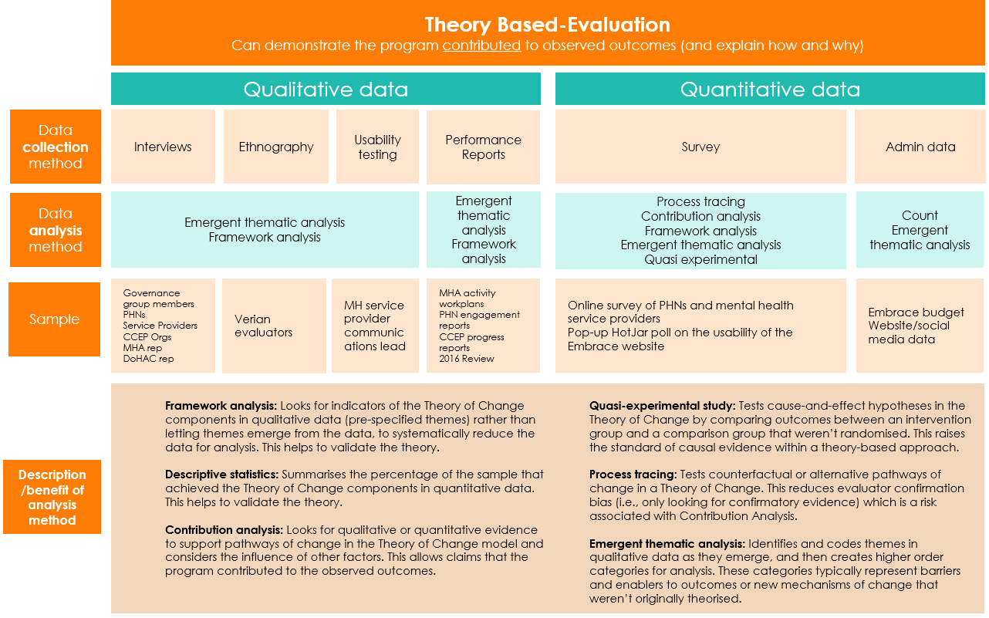

### Sample for primary data collection

Participation in the evaluation was voluntary so the final sample size for primary data collection was determined by the opt-in rate. This is described in the CONSORT diagram[13] presented in Figure 4.

Figure 4. CONSORT diagram for each primary data collection method

 Completed interview   
n = 26

**PHN/ service provider survey**

**Interviews**

**Usability testing**

Approx. sample invited to survey

n=9,200

Invited to interview

n = 64

Target sample size

n = 6 (recruitment via Embrace website)

Responses received n=276

Cleaned responses for analysis

n = 210

Target sample size

n = 34

Completed responses

n = 11

Usability testing participants

n = 1

**Website user experience survey**

Pop up survey on Embrace website 14/11/23 to 19/1/24

**Ethnography**

Verian evaluators

(n=3)

The final sample sizes for the PHN/service provider survey, usability testing, and website user experience survey are extremely small. Efforts to boost the response rate are described in Appendix E.

The PHN/service provider survey response rate of 2.3% suggests the findings are not representative and therefore cannot be generalised to the mental health workforce overall. The Embrace website receives approximately 6,800 visits per month. Only 11 people opted-in to the user experience survey suggesting this is not representative. We cannot estimate the opt-in rate for usability testing because participants had to meet the following criteria: (a) work for a mental health service provider or a PHN; and (b) visited the Embrace website at least once before. Regardless, generalisations cannot be made from one participant.

### Limitations

In addition to small sample sizes for some primary data collection methods described above, the following limitations suggest the findings of this evaluation should be interpreted with caution.

* Response bias: Self-reported data can be prone to different types of response bias such as social desirability bias (answering according to society’s expectations), recall bias (inaccurate or incomplete recollection of past events), acquiescence bias (the tendency to agree, regardless of the question content), and satisficing (giving the same answer to a battery of similar questions).
* Sample bias: Sample bias occurs when survey and interview respondents are systematically different to those who do not respond. For example, those that had an extremely positive experience or an extremely negative experience may be more motivated to opt-in to the evaluation than those who had an average experience.
* Lack of data: We were not able to collect outcome data from community members involved in the CCEP because the projects had not been completed or were only recently completed at the time of data collection. Therefore, our conclusions about the CCEP are based on the perceptions of the organisations that delivered the projects and their predictions about future outcomes.
* A planned cost-benefit analysis could not be undertaken. We had planned to assess the cost of the Embrace Project against the cultural competency outcomes achieved, and whether this ratio is comparable to other programs that improve cultural competency. However, we did not find evidence that the Embrace Project improved cultural competency so the analysis could not be conducted.

### Ethics and privacy considerations

An ethics protocol was prepared and submitted to the Bellberry Human Research Ethics Committee in September 2023 and was approved in October 2023.

Informed consent was collected for all participants. A Participant Distress Protocol was developed to ensure interviewers were observant and responsive to any signs of interviewee distress and able to manage this appropriately. However, no incidents occurred during the evaluation.

To comply with data protection and privacy standards, DoHAC signed a privacy protection protocol to confirm their authority to provide email addresses to Verian for participant recruitment. Verian also committed to delete all personal information associated with the evaluation 12 months after the project completion date.

### Reporting of findings

The answer to each KEQ is reported in its own chapter and follows a similar structure:

* Overview of findings
* How we answered the question
* Operationalise key concepts in the KEQ.
* ToC components related to the KEQ.
* Detailed findings
* Observed frequency of ToC components.
* Causal relationship between the observed outcomes and the Embrace Project.
* Evaluation interviewee and survey respondents’ perceptions of the value of the Embrace Project.
* Explanatory evidence about how and why intended outcomes were/weren’t achieved.
* Recommendations to improve the Embrace Project’s performance in the future.

# KEQ 1: Appropriateness of project design

Was the Embrace Project design effective and efficient to achieve the intended reach and outcomes? What else could be done to (a) support the mental health workforce to deliver culturally competent services? (b) increase CALD community access to mental health care? (c) improve mental health outcomes for CALD communities?

## Overview of findings

* There is evidence to indicate that the current project design has been informed by recommendations from the previous review of the Embrace Project.
* The project design is aligned with best practice described in the literature.
* Interviewees believe the design is appropriate for achieving intended reach and outcomes.
* Monitoring and evaluation needs to be embedded into the project design for Embrace administrators and governance groups to be able to assess reach and outcomes.

## How we answered KEQ 1

KEQ 1 is about whether the activities delivered by the Embrace team were appropriately designed to achieve their intended reach and outcomes.

We defined intended reach as meeting the audience engagement targets outlined in the project Activity Work Plans. We defined intended outcomes as the short-, medium- and long-term outcomes described in the ToC model.

### Related ToC components

The Embrace team delivers the following activities as part of the Embrace Project:

* Engage with Alliance Group, Stakeholder Group and Lived Experience Group – the Embrace team engages with each of these groups separately, through in person and/or online meetings, as well as out of session communications via email and phone calls.
* Deliver targeted support to interested PHNs on implementing the Framework – in 2022-23, 13 PHNs were provided with targeted support, involving monthly online meetings with each PHN, individual Framework workshops and training, two online Community of Practice meetings, and development of guided resources specific to PHNs.
* Orient interested mental health service providers to implement the Framework – while the Embrace team focuses their targeted support on PHNs because it is cost-efficient to reach multiple mental health services through one PHN, they provide some direct support to service providers that contact them with questions about the Framework. Where service providers are interested, the Embrace team provide guidance on the Framework and offer webinars.
* Commission organisations to co-design community action plans with CALD communities – the Embrace team funds community organisations that are suitable to deliver the CALD Community Engagement Project, and each of these organisations collaborate with a specific CALD community to identify mental health issues and needs, and co-design culturally responsive solutions and resources.
* Commission research projects and input into external research – research is conducted by external researchers and guided by the Embrace team and governance groups.
* Update and enhance the website to be a central hub of information/support – to remain current and useful, the Embrace website needs to be regularly reviewed, any technical or usability issues fixed, and the resources updated with the latest evidence.
* General promotion of the program to the sector – the Embrace team promotes the Project via social media, webinars, external and MHA newsletters, and attendance and presentations at conferences.

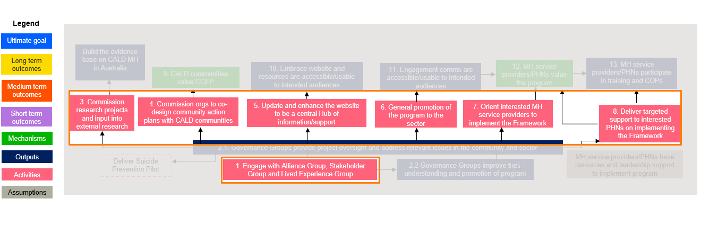

### Data sources

We used the following data sources to assess the design of the Embrace project activities:

* Review of the Framework for Mental Health in Multicultural Australia: Final Report[14] (the 2016 review). This review was of the Mental Health in Multicultural Australia (MHiMA) Project – a previous iteration of the Embrace Project. The review was commissioned by MHA as part of its planning after taking over the MHiMA project in 2015. The focus of the review was the Framework, but it also reported findings related to the MHiMA website, and project governance and management, as well as provided recommendations about the overall project design.
* Embrace Project Activity Work Plans for the evaluation period (FY 2022-23). These outlined each project activity, quality expectations and/or quantifiable targets for each (including, in some cases, target reach), and expected timelines.
* Verian’s rapid evidence review of international best practice in (1) building the cultural competency of the mental health workforce and (2) improving CALD community access and interventions for mental health supports.
* Interviews with Embrace program administrators (n=6), governance group members (n=9), and representatives from CCEP organisations (n=3, 1 per organisation) about whether the design of the project is suitable for achieving intended outcomes and reach.

## Findings for KEQ 1

### There is evidence to indicate that the current project design has been informed by recommendations from the previous review of the Project.

The Review of the Framework for Mental Health in Multicultural Australia: Final report (2016) made several recommendations for improving the Framework and the previous iteration of the website, as well as project design, governance, and management.

While not all the recommendations were actioned, the current design of the Embrace Project reflects several of the review recommendations. For example:

* Achieving transformational improvements in multicultural mental health requires a multipronged strategy: The Embrace Project uses several activities to achieve its objectives, each designed for and delivered to a different target audience (e.g., targeted support to PHNs, commissioning CCEP organisations, promoting the project to the sector).
* Focusing investments on improving community awareness and stigma reduction, culturally sensitive and appropriate mental health services, and competent mental health diagnosis and treatment services for CALD consumers: These objectives are directly addressed by project activities. For example, the CCEP project and “Community” section of the website focus on community awareness and stigma reduction. The Framework, targeted support for PHNs, orienting service providers, and the “Service providers and PHNs” section of the website all contribute to improving the workforce’s ability to deliver culturally sensitive, appropriate, and competent mental health diagnosis and treatment services for CALD consumers.
* A single organisation should be engaged to maintain and further develop the MHiMA Framework: Mental Health Australia was selected in 2015 to be the single organisation to maintain and develop the Framework.
* Maintain the MHiMA Framework as an online resource but restructure it into a series of modules, each of which can be accessed and completed on a standalone basis: The Framework is now available as an online resource and users are encouraged to engage with the modules that are relevant to their needs and interests.
* Develop the website into a clearinghouse and knowledge exchange with the aim of it being the definitive online resource for those needing information and resources about multicultural mental health. Have sections specific to health professionals and CALD community members: Our survey of PHNs and service providers suggests the Embrace Project website is not “the definitive online resource for those needing information and resources about multicultural mental health” because it ranked second below community-led multicultural services when respondents were asked “Which organisation best supports your learning needs about culturally inclusive mental health service delivery (discussed under the findings for KEQ6). In addition, our usability testing and ethnography suggest some improvements are needed to increase accessibility and useability (further explored under findings for KEQ 3). Nevertheless, the design of the website does reflect the recommendations of the review, with sections titled “Community” and “Service providers and PHNs”, and provision of a lot of information and resources about multicultural mental health in 31 languages.

### The Embrace Project design is aligned with best practice described in the literature.

We found that Embrace Project activities are well supported by the literature. For example, the design of the CCEP is supported by several academic articles that found co-design of mental health services improves access to services by ensuring services are relevant and relatable to the community.[15] Evidence also shows CALD community access to mental health services can be increased by providing localised services, which the CCEP does by working with community organisations that are located near to the specific community being engaged.[16]

Similarly, the commissioning of external research into multicultural mental health meets a need that is well-documented in the literature for a body of evidence specific to the needs of CALD communities to support health care providers to deliver culturally competent services.[17] The research commissioned by the Embrace Project fills this gap by providing insights into the values and needs of specific multicultural communities (e.g., Conceptualisations of mental illness and stigma in Congolese, Arabic-speaking, and Mandarin-speaking communities: a qualitative study).

One element of the Embrace Project design that could be better aligned with best practice is the way the Framework facilitates learning. In 2021, the UK Education Endowment Fund published a meta-analysis of 104 studies on what makes professional learning effective.[18] The authors found there are 14 strategies that can be incorporated in any form of professional learning to drive greater improvements in professional practice, e.g., goal setting, feedback, and self-monitoring.

While the authors were interested in professional learning for school teachers (to improve student outcomes), rather than for the mental health workforce (to improve consumer outcomes), the strategies are relevant to any domain. They could therefore be used to enhance the Framework and other cultural competency training Embrace provides. The Framework currently includes some of these strategies, such as the self-reflection tool, but the meta-analysis found the more strategies incorporated in professional learning, the more effective it is.

Table 3 provides further evidence that demonstrates the effectiveness and efficiency of the design of each Embrace Project activity.

Table 3. Effectiveness and efficiency of Embrace Project design.

| Activity | Design of activity effective (for improving CALD access to mental health services and/or improving workforce cultural competency) | Design of activity efficient (for achieving intended reach) |
| --- | --- | --- |
| Engage with Alliance group, Stakeholder group and Lived Experience groups | Yes: engaging with the three governance groups enabled the project to be informed by the unique perspectives and experiences of different groups, which is effective for improving CALD access to MH services. | Yes: Governance groups members provided information about emerging needs and current priority areas and shared their own experiences and the perspectives of their communities. This information would take MHA a lot longer to find through their own research. |
| Commission research projects and input into external research | Yes: The research projects addressed the need for a body of evidence specific to the needs of CALD communities to support health care providers to deliver culturally competent services.   By providing input into external research and advising on the scope of research topics, this research is likely to produce findings about key issues in the sector. | Yes: Published research is an efficient way to convey information to a large audience as the research can be promoted widely and made accessible via a range of avenues (e.g., Embrace website, other MH services websites, via community organisations that work with the specific communities involved with the research).   If the Embrace team advises on the scope of external research, it is less likely to duplicate what is already known and more likely to fill gaps in the knowledge base. |
| Commission organisations to co-design community action plans with CALD communities (CCEP) | Yes: Co-design of mental health services has been found to improve access to services by ensuring they are relevant and relatable to the community. Additionally, evidence shows CALD community access to mental health services can be increased by providing localised services (e.g., care provided at community centres). | Yes: The project commissioned community organisations already engaged with the target communities, which is an efficient way to reach these communities. |
| Update and enhance the website to be a central Hub of information/ support | Yes: The Embrace website provides resources in over 20 languages, which strengthens the effectiveness of mainstream health services for CALD communities. Continually updating the website is an effective way to meet existing and emerging needs of users and reflect the latest evidence. | Yes: Use of a website as a central repository of information that different types of users can access has the potential to achieve the desired reach to the Embrace Project’s intended audiences. Single Windows and one-stop portals are widely used by governments and businesses to make it easy for customers to access information. |
| General promotion of the program to the sector | Yes: Several different methods are being used to promote the Embrace Project such as social media, research and training webinars, email newsletters and magazines (MHA and external), MHA member events, conferences, and websites (MHA and external). This increases the likelihood intended audiences find at least one method engaging. However, use of behavioural science techniques could maximise the effectiveness of promotional activities.[19] | Yes: The methods of promotion are capable of reaching large numbers of people in short periods of time and at relatively low cost, compared with other methods of promotion such as paid advertising. |
| Orient interested MH service providers to implement the Framework | Yes: Training and implementation support have been shown to increase uptake of learning and the translation of learning to implementation.[20] | Yes: Given resources are not available to offer targeted support to all MH service providers, providing support to providers who have shown interest in the Framework is an efficient way to encourage Framework uptake. |
| Deliver targeted support to interested PHNs on implementing the Framework | Yes: Training and implementation support have been shown to increase uptake of learning and the translation of learning to implementation.10 | Yes: PHNs can influence multiple downstream mental health service providers which means it’s highly efficient to support them to implement the Framework, akin to a ‘train-the-trainer’ model. |

### Interviewees believe the design is appropriate for achieving intended reach and outcomes.

Interviewees (n=9) from the Embrace governance groups, CCEP organisations, DoHAC and MHA provided positive feedback about the project design. Two interviewees commented on the benefits of having a project tailored to multicultural mental health that is being delivered on a national level, rather than by individual states and territories. Another interviewee said the Embrace Project provides unique value as it is the only project that is both focussed on a specific health area and tailored to CALD communities.

It's very unique project and it’s one of a kind in Australia and I think there’s nothing really that is similar and there's no multicultural national project that that focuses on one particular health issue. – Project administrator

I can see the importance of having the Embrace Project and I'm very grateful the health department is actually using Embrace as an initiative to actually try to improve the mental health of CALD group communities. – Governance group interviewee

Something positive is that we have had conversations about common structural barriers that we see in each of the states. To give you an example, there is still lack of knowledge or confidence when working with mental health interpreters...we discussed ways of preparing services in each state to work with mental health interpreters and how this would be improving outcomes for CALD mental health consumers, carers, and their families.– Governance group interviewee

Embrace has given us a portal into what the sector is thinking, what the landscape is out in the community, what the current issues are, what some of the common challenges are, and the things that we need to focus on besides doing our desktop research and engaging with the stakeholders that are in our remit. – Project administrator

Some interviewees (n=3) commented on the multipronged approach of the project increasing its ability to meet a diverse range of needs in the mental health workforce and CALD communities. Interviewees said the project has interventions and resources for different audiences (e.g., CALD community leaders, CALD community members, service providers, PHNs) and to meet different needs (e.g., education and training materials for service providers, multilingual resources to support mental health literacy in CALD communities).

That is actually one of the key strengths of the Embrace Project, there are multiple different aspects. There’s the service provider working with them, and there's also the communities. You can get all of those different aspects of where people are looking for mental health support. Also, there was flexibility to develop the project to address emerging needs, not just things that were identified at the very beginning. That flexibility is another key strength. – Governance group interviewee

Practitioners particularly benefit from this sort of sharing of information and coming together and collaborating and so they have used the Framework, talked about the Framework, looked at the website in their meetings and gotten useful information and shared that information – PHN/MH service provider interviewee

### Monitoring and evaluation needs to be embedded into the project design for Embrace administrators and governance groups to be able to assess reach and outcomes.

When interviewees were asked whether the Embrace Project design is appropriate for achieving its intended reach and outcomes, many (n=18) said there is not sufficient data to make a judgement. Verian can confirm this based on the limited amount of administrative data available to conduct this evaluation. Interviewees from DoHAC, MHA, governance groups, PHNs and CCEP organisations (n=18) said monitoring and evaluation needs to be built into the project design.

A limitation [of the project design] in my mind is data and data collection which I feel that could potentially really strengthen any future projects the Department undertakes. Having those kinds of mechanisms in place so that you're not trying to collect data retrospectively or ad hoc, things around the Framework itself and the kind of reach and how people are using it. – Governance group interviewee

I do think the project design is fairly well suited [to Embrace's objectives] …at a high level it's aligned...it's why I've been so excited about this evaluation – I think that that's one of the biggest things that's lacking from the design is an actual monitoring and evaluation Framework. – Project administrator

The feedback that we are having from the community, they are really keen, and they appreciate the fact that there's actually something like this that is specifically focusing on the mental health of their specific community. But we don’t have any way to know if it has increased literacy or reduced stigma. – CCEP organisation interviewee

We would make sure we have an evaluation set up from the beginning rather than coming in now, just so we could make changes as things arose. Having that clear program Theory of Change from the beginning so that you can and see what outcomes you're trying to achieve, and you can see what activities are mapping towards those outcomes. – Project administrator

The input that I share is definitely valuable to Embrace, I’m keen to see when they take my input on board, how they're gonna use it, and what is the result will look like...I think from the project perspective, you need to have a mechanism to measure the success. – Governance group interviewee

A key reason for embedding monitoring and evaluation into the Embrace Project design is that it will facilitate continuous improvement. The Embrace Project needs to be continually updated based on monitoring data because the context will keep evolving, both in terms of CALD experiences and needs, and in terms of other professional learning offered in the market.

Verian will work with DoHAC and the Embrace team to identify options for ongoing and automated performance monitoring. For example, the user experience survey we temporarily placed on the Community and Service Providers section of the Embrace website could be retained. In addition, we will explore technological solutions to embed data collection in each Framework component and trigger a short survey to Framework registrants 6-12 months after they register to measure changes they made in their organisation.

What else could be done?

To answer the question about what else could be done to support the mental health workforce and improve access to mental health services and outcomes for CALD communities, we reviewed the literature and analysed data from n=18 evaluation interviews, as well as n=97 open-ended survey responses.

We limited our analysis to interventions that are practical for DoHAC to implement. Castillo (2019) provides a Framework to categorise interventions into different spheres of influence (Figure 5). DoHAC has influence over the organisational/institutional, community, and policy levels, whereas individual and interpersonal/family levels are the domain of states and territories through service delivery.

Figure 5. Spheres of Influence to improve mental health service access and outcomes

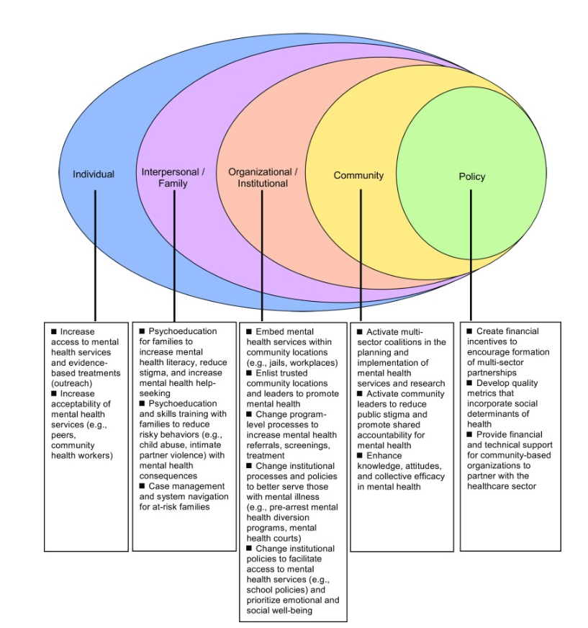

Source: Castillo, EG et al. (2019). Community Interventions to Promote Mental Health and Social Equity. Curr Psychiatry Rep. 2019 Mar 29;21(5):35.

Most of the interventions suggested in the literature to promote CALD mental health at the organisational/ institutional, community, and policy levels are already being implemented by DoHAC via the Embrace Project or other programs of work. One new idea we found in the literature at the community level is developing a CALD peer workforce to provide in-home services in CALD communities. The literature suggests this could increase service access by removing barriers related to transport, communication, and stigma.[21] The intervention could potentially be developed through the Embrace CALD Community Engagement Project. However, this requires further scoping for feasibility.

Survey respondents were asked “If money and resources were no obstacle, how would you improve the CALD community's mental health outcomes in your service area?” and n=97 respondents provided an answer to this question. The most common response was hiring more staff with CALD backgrounds (29% of respondents, n=28) to be involved in mental health service planning and delivery, followed by increase or improve language and interpretation services (20% of respondents, n=19), and increase or improve staff training (18% of respondents, n=17).

All interviewees were asked about ways they would improve the Embrace Project design to increase its effectiveness in achieving intended outcomes. Interviewees suggested mandating PHN-funded mental health service providers to show how they are being culturally responsive (7 interviewees), developing a national multicultural mental health strategy (5 interviewees), and setting up a national multicultural helpline (2 interviewees).

Some of these suggestions have been included in our recommendations based on the strength of evidence for likely impact and the feasibility of implementation based on DoHAC’s sphere of influence.

## Recommendations related to KEQ 1

While the project design is appropriate, small adaptations to the Embrace Project will likely increase its effectiveness and efficiency.

We recommend DoHAC:

Include a clause in all PHN contracts with mental health service providers that the service must demonstrate how it is culturally responsive. DoHAC could support services to achieve this by identifying auxiliary supports that could be tied into current mental health services, such as transport or interpreters.

* Develop and publish a national multicultural mental health strategy to facilitate a nationally consistent approach and set of performance indicators to aim for when developing, implementing, and evaluating culturally responsive service strategies. This would also provide a standard to operationalise recommendation 1.1.
  1. Require rigorous monitoring and evaluation systems across all Commonwealth CALD mental health funding to build the evidence base on what works. There is still a large gap in the literature on how to improve service access and outcomes for CALD communities. DoHAC could ask for support from the new Australian Centre for Evaluation in The Treasury given their mission is aligned.[22]

We recommend the Embrace team:

* 1. Embed ongoing monitoring and evaluation into the Embrace Project design. This will enable more accurate and rapid assessments of the extent to which the Embrace Project is achieving its intended reach and outcomes to support continuous improvement. Verian will assist.
  2. Incorporate evidence-based strategies for effective professional learning into the Framework and other cultural competency training Embrace provides. The purpose of this is to maximise professional practice outcomes from learning resources. The learning strategies identified by the UK Education Endowment Fund (mentioned above) would be a good place to start. Other strategies were identified in Verian’s rapid evidence review (which were less rigorously evaluated) such as short videos explaining key concepts, optional readings, quizzes to consolidate learnings, facilitation of interdisciplinary groups to discuss implementation in their setting.

# KEQ 2: Implementation efficiency and governance

KEQ 2a: How efficiently were the Embrace Project’s activities implemented and what were the barriers and enablers to implementation, including stakeholder collaboration, skills, and resources?

KEQ 2b. Did the Alliance members (Federation of Ethnic Communities Councils of Australia and National Ethnic Disability Alliance), Lived Experience and Stakeholder Groups achieve influence and benefits? How and how much? Or why not?

## Overview of findings

* Almost all Embrace Project activities were delivered both within intended timelines and intended budget.
* Governance group members perceive the Embrace Project has been delivered efficiently.
* The knowledge and dedication of the Embrace team and governance groups was a key enabler to efficient implementation.
* Each governance group provided unique and valuable input that influenced the Project design and/or implementation.
* Some governance group members expressed a desire for increased involvement in promoting the Project, but this was outside the scope of their role.
* Governance group members reported several personal benefits from their participation in the Project.

## How we answered KEQ 2

Similar to KEQ1, KEQ 2a also assessed the various activities delivered by the Embrace team (pink boxes in the ToC) but focussed on how efficiently these activities were implemented (as opposed to their design). KEQ 2b looked at the involvement of the governance groups in informing and influencing project activities.

### Related ToC components

This KEQ relates to seven activities and two outputs in the ToC. The activities are listed below and fully described in the previous chapter on KEQ1 (Project Activities).

* Engage with Alliance Group, Stakeholder Group and Lived Experience Group.
* Deliver targeted support to interested PHNs on implementing the Framework.
* Orient interested Mental Health service providers to implement the Framework.
* Commission organisations to co-design community action plans with CALD communities.
* Commission research projects and input into external research.
* Update and enhance the Embrace website to be a central Hub of information/support.
* General promotion of the program to the sector.

The two outputs related to this KEQ are:

* Governance Groups provide the Embrace Project oversight and address relevant issues in the community and sector: By seeking input from the governance groups, the Embrace Project is informed by the knowledge and experience of a diverse group of people, enabling the Embrace Project to be relevant and useful to its intended audiences.
* Governance Groups improve their understanding and promotion of the Embrace Project: It is expected that governance group members will benefit from their involvement in the Embrace Project by increasing their knowledge about mental health service design and current trends in the sector, and that through their networks they will promote the Embrace Project to relevant audiences.

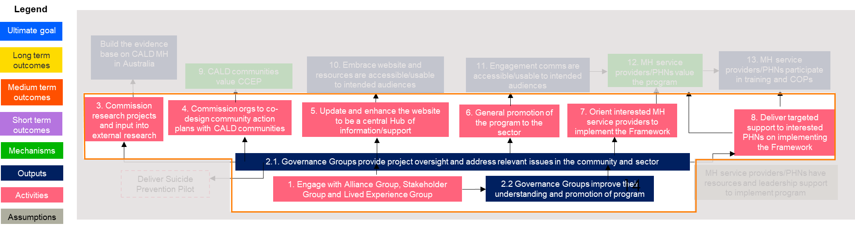

### Efficient implementation

We defined efficient implementation as delivery of Embrace Project activities within the intended timeline and within the intended budget. We compared project Activity Work Plans targets with Performance Reports to understand the extent to which activities were delivered as intended and any reasons for delays. We also reviewed the Embrace Project budget and expenditure to assess if activities were delivered within the intended budget and any reasons for overruns. Finally, we interviewed governance group members and Embrace team members to elicit their views on barriers and enablers to efficient implementation.

### Influence and benefits achieved by governance groups

We reviewed the Terms of Reference for the Stakeholder group and Lived Experience group to understand expectations for how governance groups would be engaged and what their role would be. We compared this with interview data from governance group members and the Embrace team, as well as project documents to understand the types of input and influence governance groups had, any challenges identified, and any personal benefits to members of their involvement.

## Findings for KEQ 2

### Almost all Embrace Project activities were delivered both within intended timelines and intended budget.

Our assessment of project implementation found almost all project activities were delivered within intended timelines. The exception was the CCEP, which had some grant initiation and contract delays within the evaluation period, but the Embrace team was soon able to bring it back on track.

Similarly, the Embrace Project activities were delivered within budget, but due to external factors such as delays in MHA receiving the grant agreement from DoHAC, some of the budget allocated to the 2022/23 year was disbursed in the 2023/24 year. The only activity that ran over budget was engagement with the governance groups, which is attributed to the period post-COVID when restrictions on movement were lifted and MHA focussed on restoring face-to- face meetings combined with significant increases in travel and accommodation costs. Table 4 provides more detail about the efficiency of implementation for all Embrace Project activities.

Table 4. Efficiency of implementing Embrace Project activities in 2022-2023.

| Activity | Efficient: met intended timeline | Efficient: met intended budget |
| --- | --- | --- |
| Commission research projects and input into external research | Yes. Two out of the four research papers commissioned by the Embrace Project were commissioned, published, and disseminated within the 12-month evaluation period. | Not available |
| Commission orgs to co-design community action plans with CALD communities | No. CCEP activities were not fully delivered within the evaluation period due to grant initiation and contract delays. Since the evaluation period, Embrace has caught up with this delay and the CCEP is on track. | Budget shifted into next FY due to contract delays so cannot assess whether budget has been met. |
| Update and enhance the website to be a central Hub of information/ support | Partially. While the website has been updated, we found some links took us to a page where a document was no longer available, and some documents have been superseded by more recent versions. Also, while MHA has identified issues with the website, the process of deciding whether a new IT developer is required and evaluating potential new website platforms has delayed substantial improvements to site functionality. | Yes. Due to delays in DoHAC administering the grant to MHA, only 20% ($15,103/ $75,000) of the budget for this activity was spent in the 22/23 FY. The rest of the allocated budget was spent in the 23/24 FY. |
| Deliver targeted support to interested PHNs on implementing the Framework AND  Orient interested MH service providers to implement the Framework | Yes. Embrace had a target to work with 10 PHNs and ended up engaging 13. Over the 12-month period, almost 100 online monthly meetings were held.  Yes. Interview data indicates that when service providers contacted Embrace about the Framework, they were offered support to implement the Framework. Training was provided to at least 4 interested MH service providers. | Yes. Only 48% ($4,776/ $10,000) of budget spent in the 22/23 FY due to DoHAC grant delays (as above) |
| General promotion of the program to the sector | Yes. Embrace promoted the program via social media, webinars, external newsletters (e.g., FECCA’s Mosaic Magazine) and MHA newsletters, conferences (e.g., The Mental Health Services conference), advisory groups, and online training. | Yes. Only 45% ($6,697/ $15,000) of budget spent in the 22/23 FY due to DoHAC grant delays (as above) |
| Engage with Alliance Group, Stakeholder Group and Lived Experience Group | Yes. Embrace engaged with all three groups on a regular basis. This included 2 meetings a year with each group and regular phone calls and emails to discuss state-specific issues. | No. Over budget by 77% ($185,929/ $104,500) |

### Governance group members perceive the Embrace Project has been delivered efficiently.

All governance group interviewees (n=9) said the project had mostly been delivered efficiently. Some governance group interviewees (n=3) noted areas that were not as efficient as they could be. Some of these views were contradictory to each other and highlight the importance of seeking feedback from the whole group before implementing efficiency solutions.

For example, two interviewees said meeting in person is a more efficient way to provide their input and for MHA to facilitate group discussions. However, another interviewee said they prefer the option of online meetings as they make better use of their time, rather than spending time travelling.

We had our 4-hour session just the other day…instead of face-to-face…and I brought up a couple of things that I was not happy with, and it was very well received, they were grateful to get the feedback…now the budget has been completely redone and now suddenly they don’t have any money for us to get together physically…I think that in itself is a priority feature of this team...they’ve taken that away from us…there’s no rapport building, you can’t give each other a hug.– Governance group interviewee

You know, most of us do our work online. We all have full time roles. It's very hard for us to take out like 3-4 days to do these in person meetings. A lot of the older members are pushing for like, only in-person meetings rather than online meetings but that doesn't really make it very accessible for many of us. – Governance group interviewee

One interviewee said they appreciate the intentions of the Embrace team to allow all members to share their experiences in a safe environment, but that sometimes they allowed meetings to go on a tangent. This interviewee felt this was an inefficient use of time and funding allocated to receiving advice and input from the whole group.

If they're not experienced with how to share purposefully, how to use their story to actually create effective change and make advisory change, you risk it just becoming essentially like a peer group of support for each other. – Governance group interviewee

### The knowledge and dedication of the Embrace team and governance groups was a key enabler to efficient implementation.

Based on interview data with governance group members (n=9), and DoHAC and MHA staff (n=6), we identified barriers and enablers to efficient implementation.

Interviews with DoHAC and MHA staff (n=6) showed the Embrace team was understaffed for most of 2022-23, with only 2-3 FTE instead of the budgeted 4 FTE. Nevertheless, the Embrace team found efficient ways to stay on track through their skills and dedication, and the collaborative relationship between MHA and the governance groups.

The main barrier to efficiency was the time and cost of making changes to the Embrace website as this had to be done through an IT developer. The Embrace team are assessing self-service options for the future.

### Each governance group provided unique and valuable input that influenced the Project design and/or implementation.

A review of the Terms of Reference (ToR) for the different governance groups showed that each group had a specific role and areas of input. Interview data indicates that each governance group achieved influence in a way unique to their experience and expertise.

According to the ToR for the Alliance group, it was intended to advise on project design and implementation, and partner with MHA in project delivery. FECCA and NEDA are member organisations of the Alliance group that work directly with multicultural communities. They were expected to support a connection between MHA and multicultural communities.

From our interviews with MHA and Alliance group members (n=5), as well as project Performance Reports, we found that the Alliance group had provided advice on the design and implementation of most Project activities, and particularly assisted in identifying suitable organisations to deliver the CCEP. However, interviewees from the Embrace team (n=2) said they expected FECCA would have more involvement in delivering the Embrace Project. At the time the interviews were conducted, MHA were considering ways to increase FECCA’s involvement going forward.

The Alliance certainly gives [the project] a broader perspective of the multicultural sector in terms of what the issues were, emerging issues and also enabled us to work in partnership with FECCA and NEDA...that's a really solid alliance partnership and certainly that's been really beneficial to the projects in terms of our reach and their guidance as well has been really good in terms of just having their backing with the project as well. I think it's been a struggle to know what, apart from their advisory role in terms of what their contributions can be to the project.– Project administrator

The ToR for the Stakeholder group outlined their purpose was to: “be a key source of advice: in relation to multicultural mental health expertise; to assist in project implementation and in ensuring meaningful project outcomes; to support dissemination of national approaches; and to provide links to local ethnic communities”.

From our interviews with MHA and Stakeholder group members, (n=6), as well as project Performance Reports, we found that the Stakeholder group fulfilled this purpose, and we noted specific input in updating the Framework, identifying current priority issues for CALD mental health and strategies to address these, which informed several project activities, including topics for commissioned research.

The Stakeholder group having that direct interaction with mental health services but also statewide services and their knowledge of state and territory mental health services and structures and systems that are operating and how we can tap into those…The Stakeholder group was also instrumental in redeveloping the Framework and giving us advice on the best way to do that. – Project administrator

The ToR for the Lived Experience Group outlined their role was to: “be a key source of advice for multicultural mental health expertise, particularly the views and interests of CALD mental health consumers and carers; assist in project implementation and in ensuring meaningful project outcomes; support distribution of national approaches; provide links to local multicultural communities; and review communication and documents as required”.

From our interviews with MHA and Lived Experience group members (n=4), as well as project Performance Reports, we found the Lived Experience group fulfilled this role by telling their own stories of accessing mental health care in Australia, reviewing draft resources, and advising external organisations on policies and strategies.

The Lived Experience group similarly has been really useful in giving us advice and input on to what their experiences are but also provided guidance into project activities. – Project administrator

### Some governance group members expressed a desire for increased involvement in promoting the Project, but this was outside the scope of their role.

Some interviewees (n=5) from the Lived Experience and Stakeholder groups expressed interest in increasing their contributions to the project and frustration that MHA was not financially supporting them to do this. This was mostly around doing more promotion of the project in the media, at conferences and events and asking MHA to fund registration fees or travel costs.

The other example is community radio stations. Let's maybe get us from the Embrace team out to our various community radio stations and do an interview and talk about why and how and all the rest of it. We're all on this team because we're not shy to share our journey. We realize that by sharing our journey, it's going to help our people. – Governance group interviewee

I do think that the videos that they put on social media and the website, where they ask us to talk about certain things, are really effective because everybody gets so happy to see a face that they're familiar with. What about putting it in an ad on mainstream TV, not just SBS. Put it on mainstream TV in an ad. – Governance group interviewee

A review of the ToR for these groups showed that some of the additional work they were interested in doing to promote the Embrace Project is not within the scope of their role. Interviews with MHA indicated a challenge of working with the governance groups was helping them to understand their specific role in the Embrace Project. The Embrace team have been proactively addressing this challenge by emphasising the role of the governance groups at meetings and by going through the ToR and discussing the items in detail.

### Governance group members reported several personal benefits from their participation in the Embrace Project.

The intention of the Embrace Project was that governance group members would benefit from their involvement in the Embrace Project, including improving their understanding of the program and learning about mental health service design for multicultural communities. Members of the governance groups (n=9) reported the following benefits they had achieved as a result of the Embrace Project:

* growing their networks (n=6)
* hearing a variety of perspectives on mental health issues and mental health service design (n=5)
* learning more about what is happening in the mental health sector (n=5)
* learning about mental health service design (n=4)
* receiving training such as on safe storytelling or advocacy (n=3)
* having a safe space to share their experiences and views (n=3).

I become more aware of what is happening in other states, which is something that I value, and I think that Embrace, it has been able to put together a platform for this type of exchange. – Governance group interviewee

Absolutely I learned through the group how to speak and how to advocate. – Governance group interviewee

## Recommendations related to KEQ 2

Recommendation 2.1: The Embrace team should seek individual feedback from members on an annual basis about how they would like to influence the Embrace Project and how this would contribute to achieving the Embrace Project’s objectives.

Governance groups have contributed to the efficient implementation of the program, and they have informed the design of project activities in useful ways. To ensure that this high-quality input continues and that governance group members continue to feel heard and valued, the Embrace team should seek individual feedback from members on an annual basis about how they would like to influence the Embrace Project and what they think the benefits will be in terms of achieving the Embrace Project’s objectives. This could be done via an anonymous survey rather than during a governance group meeting, to encourage honesty and openness.

If the suggested additional activities are incorporated into future budgets, the intended benefits should be evaluated and shared back with governance group members. This will help to manage governance group members’ expectations about how their future suggestions will be prioritised.

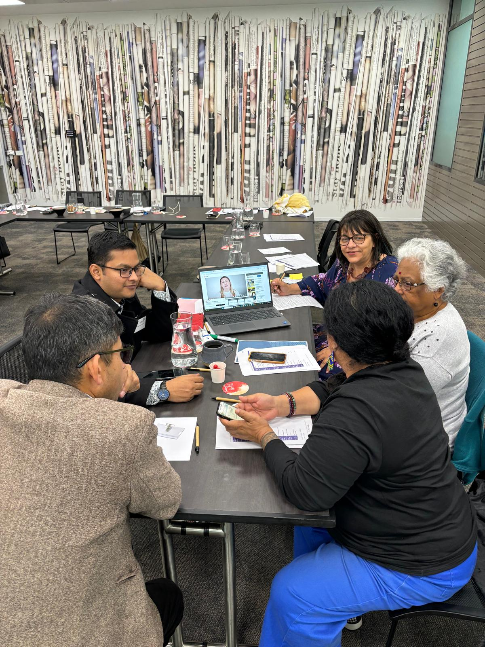

# KEQ 3: Uptake of the Framework and CALD Community Engagement Project

What was the level of uptake of the Framework and the CALD Community Engagement Project (CCEP) by target audiences? What were the barriers and enablers to uptake, including perceived accessibility/ usability/ relevance/ quality of the project outputs (website, communications, resources, CCEP, and Community of Practice/training)?

## Overview of findings

* The CCEP is meeting its target of working with three communities a year over four years.
* CCEP organisations perceived that community members involved in co-design valued the program.
* An enabler of commissioned organisations wanting to deliver the CCEP was that they were already engaged with the targeted community groups.
* Framework uptake and promotion to others was low among survey respondents.
* Embrace Project website engagement was higher among PHNs and service providers that work with more diverse communities.
* Almost half of all PHNs in Australia participated in the targeted support provided by the Embrace Project to facilitate Framework uptake and implementation.
* PHNs and service providers value the Framework, targeted support to implement it, and the Community of Practice.
* Valuing the Framework was not associated with greater completion of Framework components.
* Insufficient promotion of the Framework and poor usability of the Embrace website may have been barriers to higher Framework uptake.

## How we answered KEQ 3

This KEQ looked at uptake of two core Project activities – the CCEP and the Framework.

We were not able to assess uptake of the CCEP resources among the wider CALD community (a short-term outcome in the ToC) as not all CCEP organisations commissioned to develop resources have completed delivery. In addition, where delivery has been completed, there isn’t systematic data collection to measure community level uptake. Therefore, we assessed uptake of the CCEP by the number of communities the CCEP has been delivered to (an output in the ToC).

We were not able to assess uptake of the Framework among the wider mental health workforce because of data limitations. According to Embrace’s administrative data, there have been 2,035 Framework registrations. However, these data could not distinguish what proportion of registrants are individual users versus organisations who represent multiple individual users. Additionally, the Embrace Project Activity Work Plans do not specify a target for Framework uptake and MHA do not have data on the number of mental health service providers in Australia to set a realistic target.

Therefore, we assessed Framework uptake based on responses to our survey of PHNs and mental health service providers. However, the survey data are unlikely to be representative of the entire workforce because participation in the survey was voluntary (which leads to sample bias) and the sample size is small (n=210). We assume the survey probably over-estimates uptake of the Framework given it was distributed to MHA subscriber lists. Individuals on these lists are likely to be more engaged in professional learning than non-subscribers.

### **Related ToC components – CCEP**

Outputs:

* Embrace website and resources are accessible/usable to intended audiences: Community resources on the website are easy to understand and capable of being used (user-friendly).
* CALD communities participate in CCEP: For the evaluation, this refers to CALD community organisations that deliver the CCEP and members of the community that participate in co-designing resources. Data are not available to assess wider community participation.
* CALD communities access the website & resources: High rates of usage.

Mechanisms of change:

* CALD communities value CCEP: Perceive it to be beneficial.

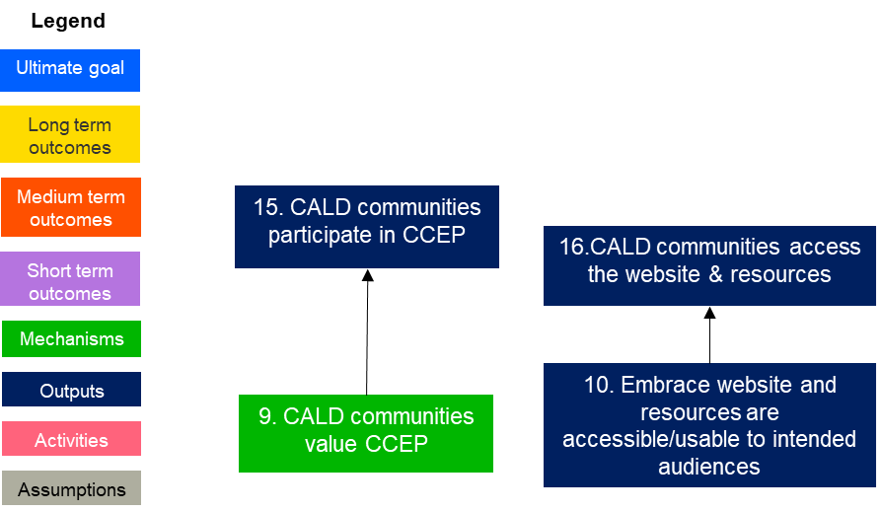

### Related ToC components – Framework

Outputs:

* Embrace website and resources are accessible/usable to intended audiences: Workforce resources on the website are easy to understand and capable of being used (user-friendly).
* Engagement comms are accessible/usable to intended audiences: The Embrace newsletter and other communications about the Embrace Project to the workforce are easy to understand and capable of being used (user-friendly).
* MH service providers/PHNs access the website & resources: High rates of usage.

Mechanisms of change:

* MH service providers/PHNs value the program: Perceive it to be beneficial.

Short-term outcomes:

* MH service providers/PHNs take up Framework. High rates of registration and completion.

MH service providers/PHNs promote Framework to other organisations.

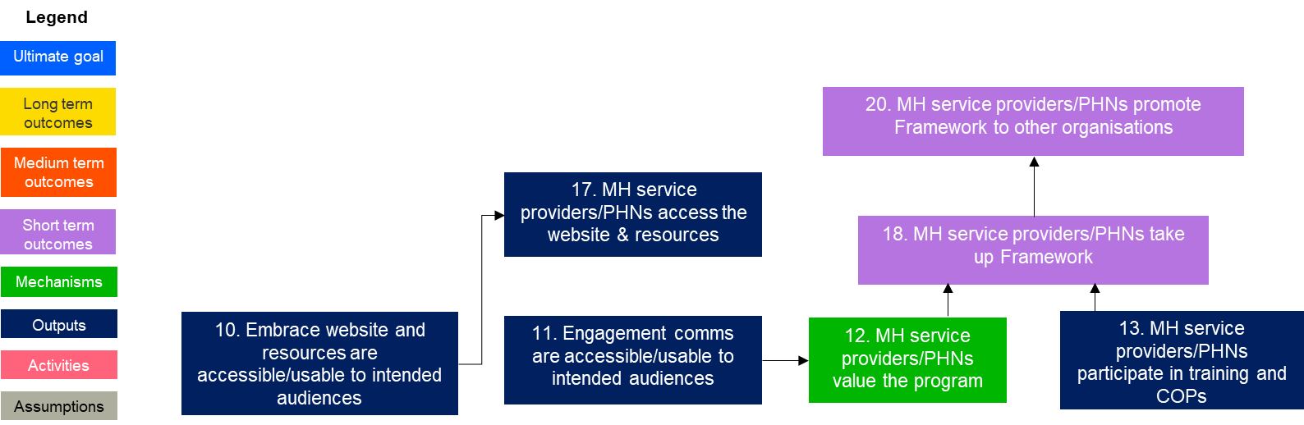

## Findings for KEQ 3

### The CCEP is meeting its target of working with three communities a year over four years.

In round 1, the CCEP was delivered to:

* Rohingya community in Melbourne, in partnership with Southern Migrant and Refugee Centre
* Chinese/Mandarin community in Sydney, in partnership with Chinese Australian Services Society
* CALD youth from different cultural groups in Darwin, in partnership with Melaleuca Australia

Resources developed by these communities are available on the Embrace website and include videos, a podcast series, and fact sheets.

In round 2, the CCEP is being delivered to:

* Pasifika and Māori community in Queensland, in partnership with Brisbane South PHN Ltd
* Afghan community in Adelaide, in partnership with Survivors of Torture and Trauma Assistance and Rehabilitation Service
* African women in Western Australia, in partnership with Ishar Multicultural Women’s Health Services

Resources developed by these communities are expected to be available on the Embrace website by September 2024.

Three more organisations were commissioned to deliver the CCEP in 2023, and the final three will be confirmed in 2024. CCEP delivery will be completed in 2025.

### CCEP organisations perceived community members involved in co-design valued the program.

All three CCEP organisation interviewees said the community they worked with to co-design culturally appropriate resources valued the program and remained engaged throughout. One interviewee said the co-design participants were proud of the resources they had developed. Another interviewee said that co-design participants appreciated that they could help their community through this experience.

### An enabler of commissioned organisations wanting to deliver the CCEP was that they were already engaged with the targeted community groups.

Embrace commissioned one organisation per CALD community group to deliver the CCEP. An enabler of commissioned organisations wanting to deliver the CCEP was their existing relationships with the targeted community groups. This meant that CCEP organisations approached to deliver the program were interested and motivated to work with these communities.

The [Embrace] Project has identified a local community organisation who knows this community, to deliver the project, which is very good. I can't imagine delivering the project to another community that I'm not familiar with. – CCEP organisation interviewee

Additionally, these organisations were easily able to recruit community members to be involved in the co-design process due to their existing relationships.

We have a long history of engaging with this community outside of this project, so we already had quite good connections with community leaders and prior to this I attended community events. So, when this project started, we already had those connections into the community, so it was quite easy to engage. – CCEP organisation interviewee

### Framework uptake and promotion to others was low among survey respondents.

Among respondents to our survey of PHNs and mental health service providers (n=210), uptake and promotion of the Framework was low. Only 16% (n=34) of all respondents said they had registered for the Framework and only 9% (n=19) said they had promoted the Framework to others (Figure 6).

Of the 34 survey respondents that had registered for the Framework, 59% (n=20) last accessed it in the past year and 42% (n=14) said they had completed the self-assessment tool. Modules 1 and 2 had the highest completion rates, with 36% (n=10) of Framework registrants saying they had completed or implemented follow-up actions for each of these modules (see Figure 7).

Figure 6. Embrace Framework Uptake

Figure 7. Embrace Framework Module Completion

* Respondents who had registered for the Embrace Framework (n=33)

### Embrace Project website engagement was higher among PHNs and service providers that work with more diverse communities.

Using Australian Bureau of Statistics (ABS) data on “The percentage of people born in predominantly non-English speaking countries” from The Social Health Atlas of Australia (2021), we were able to determine the levels of cultural diversity in each of the 31 PHN geographic areas in Australia. We compared these data to the location of respondents to our survey of PHNs and mental health service providers. We counted the number of respondents working in each PHN area that said they had used the Embrace website (not all of these had accessed the Framework). If a respondent said they worked statewide or in multiple PHN areas, they were counted in each PHN area.[23]

We found a positive correlation between using the Embrace website and working in locations with a higher percentage of people born in predominantly non-English speaking countries, although this result was just below the threshold for statistical significance (coeff 0.35, p 0.054). This suggests Embrace is reaching locations with the highest need for resources and training in working with multicultural communities.

Figure 8 shows the percentage of survey respondents from each NSW PHN geographic area that had visited the Embrace website, compared with the percentage of people born in predominantly non-English speaking countries. The darker the green area, the more cultural diversity in the population. (Maps for other states can be found in Appendix F).

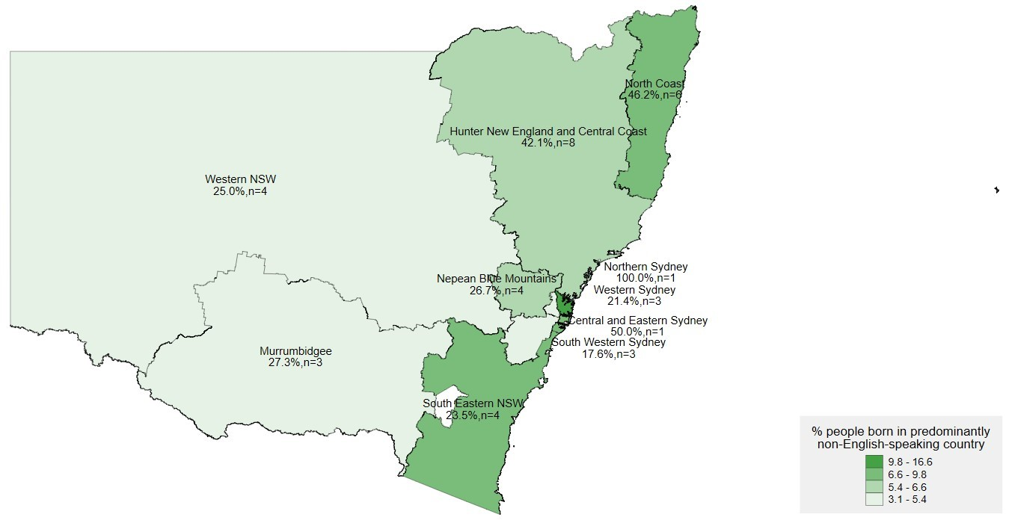

Figure 8. Reach of the Embrace website vs cultural diversity (NSW)

### Almost half of all PHNs in Australia participated in the targeted support provided by the Embrace Project to facilitate Framework uptake and implementation.

There are 31 PHNs across Australia and in 2022-23 the Embrace Project delivered targeted support to thirteen (42%). This targeted support was initially planned to be provided to ten PHNs, but more EOIs were received than expected so the Embrace team supported three additional PHNs.

Our interviews with PHNs (n=6) found that without this targeted support, implementation of the Framework would have been slower and less comprehensive. Some of these interviewees (n=4) also said that knowing support was available motivated them to take up the Framework to begin with.

### PHNs and service providers value the Embrace Framework, targeted support to implement it, and the Community of Practice.

Of the survey respondents that had visited the Embrace website, 34% (n=21) said the Framework was the most valuable resource, which meant the Framework was rated higher than any other Embrace resource (Figure 9).

Figure 9. Mental Health Resources

*Respondents who had visited the Embrace website (n=61).

All PHNs we interviewed (n=6) had very positive feedback about the Framework and the targeted support they received to implement it. PHN interviewees said the Framework had given them an excellent starting point to understand their level of cultural competence and to have conversations with their Executive and across their organisation about cultural competence.

It [the Framework] was a really good reality check for us. It was really great for us because we would never have had another conversation like this before across the organisation. So, kind of gave us a bit of a platform to focus on and really move together as an organisation. – PHN interviewee

I think it’s been a really good tool and process that we’ve taken that we’ve got key people from across the organisation, making them accountable for their actions. – PHN interviewee

Some PHN interviewees (n=3) had positive comments about the CoP and sharing of information. One interviewee said it is important to continue this in a more informal way.

Practitioners particularly benefit from this sort of sharing of information [CoP] and coming together and collaborating and so they have used the Framework, talked about the Framework, looked at the website in their meetings and gotten useful information and shared that information with each other. – PHN interviewee

You know, communities of practice don't have to just revolve around formal events. Communities of practice can operate through sharing of resources or discussions out of session. Something like an online chat forum. – PHN interviewee

### Valuing the Framework was not associated with greater completion of Framework components.

Willingness to pay questions are commonly used in the literature as a proxy for how much people value the benefits of a product, service, or investment.[24] In the survey of PHNs and service providers, we asked for a dollar figure in response to this question: “If the Embrace Framework wasn’t free, the maximum I would be willing to pay to access it is…”. After excluding outliers, the median response was $22.50. When we conducted correlation tests, willingness to pay was not associated with Framework dosage, i.e., level of module completion (coeff 0.004, p 0.417).[25]

Most PHN interviewees (n=4) said they had promoted the Framework to a range of other individuals and organisations, and one said it was because they “love it”.

We've certainly at every opportunity been trying to encourage services to do [the Framework]. Certainly, I'm trying to promote it also with state government. – PHN interviewee

We do promote it across our teams and across our other portfolios as well. I think we promoted to everybody that we can because we love it for mental health. – PHN interviewee

I've shared it with mental health providers, our commissioned mental health providers, and with our partners. – PHN interviewee

### Insufficient promotion of the Framework and poor usability of the Embrace website may have been barriers to higher Framework uptake.

Through interviews with governance group members, PHN staff, and mental health provider staff, our survey of PHNs and mental health service providers, usability testing, ethnography, and user experience survey, we identified two key factors that might have negatively impacted on Framework uptake: (1) Insufficient promotion of the Framework; (2) Poor usability of the Embrace website.

Insufficient promotion of the Framework

The first barrier to Framework uptake according to DoHAC, MHA and governance group interviewees (n=5) is that the Embrace Project and Framework have not been sufficiently promoted.

Low awareness of the Embrace Project within the mental health sector supports this view. As a byproduct of trying to increase the survey sample size, the Verian evaluation team phoned over 50 national and state-based mental health service providers and organisations (see Appendix H) to ask them to complete the survey and found that approximately half were not aware of the Embrace Project.

We also found evidence of low engagement with the website which is where the Framework is hosted and promoted. Only 19% (n=39) of respondents to our survey of PHNs and mental health service providers had visited the Embrace website. When we compared the number of website views documented in the 2016 review (n=88,974) to the evaluation period of 2022-23 (n=82,153) we found a decline of almost 7,000 views per year. We would have expected to see an increase because of factors such as:

* the mental health workforce has increased in number since 2016
* the 2016 review of the Project made several recommendations to increase accessibility and usability of the website, and
* the Embrace Project has more methods of promotion and a larger subscriber base to the quarterly newsletter in 2022-23 compared with 2016.

It is plausible that a decline in website views reflects an increase in alternative sources of information about multicultural mental health in the market which may have reduced Embrace’s market share.

However, a few DoHAC, MHA and governance group interviewees (n=5) said the Embrace Project and Framework had not been promoted as much as they should have, or as much as was intended by the Embrace team, for the following reasons:

1. Difficulty recruiting staff to the Embrace team - MHA had issues recruiting a Program Manager to the Embrace team and so for the duration of the evaluation period, the team was staffed by 2-3 FTE instead of 4. Given the many activities undertaken by the Embrace team, insufficient staffing meant it was not possible to dedicate more time to promotion.
2. Engagement with the sector is only online – pre-COVID the Embrace team ran a series of face-to-face workshops across Australia to promote the redeveloped Framework and found these very effective for engaging with the sector. After COVID travel restrictions were removed, MHA decided to continue running training via webinars as this is a more efficient use of funding and holding online training has become widely accepted across the sector. However, face-to-face training is known to be more effective for engagement and developing communities of practice[26] so the effectiveness of Embrace promotional activities has likely been reduced.

Poor usability of the Embrace website

The second barrier to Framework uptake is poor usability of the Embrace website. Of the survey respondents that had registered for the Framework and answered questions about its usability and accessibility (n=33), 82% (n=27) perceived it to be easy to understand, and 64% (n=21) said it was practical to use (Figure 10). However, the Framework is hosted and promoted on the Embrace website so users must navigate the website to access it.

Figure 10. Embrace Framework usability and accessibility

Some governance group and PHN interviewees (n=6) said the Embrace website may be a barrier to users accessing the Framework as it is not well structured or laid out. This makes it more difficult for users to find what they are looking for.

They would go to the website on their own and try to make sense of all this information. And it can be overwhelming and hard to navigate. – Governance group interviewee

The user experience survey we placed on the Embrace website received 11 completed responses. Most respondents (90%, n=10) thought the information on the website was easy to understand, and all respondents thought the website was relevant to their needs and would come back to the website to learn more.

While the results of the user experience survey were overwhelmingly positive, the sample size is extremely small and may not be representative of all website users. Respondents all spoke English very well and all considered themselves to have a good understanding of mental health prior to visiting the Embrace website.

| Question number | Question wording | Result |
| --- | --- | --- |
| 1 | I came to this website to find information for (a) myself (b) a friend or family member (c) my community (d) my organisation | 45% My organisation  10% My community  45% Myself |
| 2 | I speak English (a) very well (b) ok (c) not very well | 100% very well |
| 3 | Before I came to this website today, I had a good understanding of mental health (a) yes (b) no | 100% yes |
| 4 | The information on this website is easy to understand (a) yes (b) no | 90% yes |
| 5 | The information on this website is relevant to my needs (a) yes (b) no | 100% yes |
| 6 | I will come back to this website to learn more (a) yes (b) no | 100% yes |

Table 5. User experience survey script and results

The Hotjar application used to host the user experience survey generates ‘heat maps’ which show where users are clicking within the Embrace homepage (see Appendix H for a heat map). Between 13/11/23 and 05/04/24, the top three clicked items on the Embrace homepage (out of approximately 3,900 website visits recorded by Hotjar) were:

1. About us: 14.3% of all clicks (248 clicks)
2. Menu 8.4% of all clicks (146 clicks)
3. The Embrace Framework 7.7% of all clicks (133 clicks)

These items are all at the top of the homepage, and less than half of site visits scrolled past the ‘Community Information’ and ‘Service Provider/Health Professional’ hubs. In addition, there were significantly fewer clicks on Community information compared to the Framework which suggests the site might be accessed by the workforce more than by community members.

Hotjar also tracks ‘rage clicks’ and ‘U-turns’. Rage clicks are when a user clicks on the same thing five times within a short period of time, indicating something is not working. U-turns show when a user returns directly to a previous page within seven seconds. U-turns are an indicator of confusion.

Between 13/11/23 and 05/04/24 users of the Embrace website made 246 ‘U-turns’ and one ‘rage click’. These relatively low rates of rage clicks and U-turns suggest the website is working and people are not clicking back and forth trying to find information. However, different data are needed to assess how easily people can navigate to the information that is most relevant to them as they may simply exit the website altogether when the first click doesn’t provide information they need.

To explore the accessibility, usability, and relevance of the website and resources further, we (n=3 Verian evaluators) conducted an ethnographic review of the Embrace website, Framework registration process, and an Embrace newsletter.

We also conducted a 1.5-hour online usability testing session with one mental health service provider. The participant was asked to use the Embrace website, register for the Framework, and read one of the Embrace newsletters hosted on the website, and tell us about the accessibility, usability, and relevance.

* Usability was defined being user friendly. This included how easily the participant could navigate the website and Framework, complete simple tasks, and if they ran into any technical issues such as links not working on the site.
* Accessibility was defined as easy to understand. This included if simple language was used.
* Relevance was defined as appropriate and useful for their intended purpose. This included if the resources would assist service providers when working with CALD clients.

Table 6. Summary of usability testing and ethnography findings

|  | Website | Framework registration | Newsletter |
| --- | --- | --- | --- |
| Usability testing | Quality resources  Confusing layout  Unclear headings | Good/useful resource  Confusing multi-step registration process | Hard to read due to formatting |
| Ethnography | Confusing layout  Out of date information  Website may be hard to find using search terms | An easy to understand well designed resource  Confusing multi-step registration process. | Hard to read due to formatting  Confusing sign up |

The ethnography and usability testing found that the website is confusing, with generic tab names along the top of the home page that do not make it clear where a specific type of user should go. The Framework has its own tab but unless a user already knows what the Framework is about and is looking for it, it is unlikely they would click into that tab.

I've been to the website before and not realised that this is what this is… I've seen something about a Framework, but in terms of actually directing organisations to it…Now that I know it’s here, I'm going to send it to my helpline counsellors and say, “you need to do this!”.  
- Website usability testing participant

Registering for the Framework is a multi-step process, with those that are accessing the third-party owned introductory module having to create two sets of login details. This extra hassle may cause interested users to drop out during the process.

Indeed, during our usability testing session, the participant was unable to log in to access the introductory module of the Framework immediately after creating an account because the verification email got caught in their organisation’s spam filter. When asked how they would deal with this in the real world (outside of usability testing), the participant said they would have given up.

I would have contacted my digital manager and asked her to check our spam filter and release it if it was there, but at this time of night I'd have to wait till tomorrow. I may have just given up. – Website usability testing participant

In summary, according to the interviews, usability testing and ethnography we conducted, and responses to our user-experience survey, the following Theory of Change component was not fully observed: “Embrace website and resources are accessible/usable”.

## Recommendations related to KEQ 3

3.1 Increase Framework uptake by developing and implementing a plan to promote the Framework to new audiences using existing resources. Given the Embrace team already dedicate their limited resources as best they can to promoting the Framework to PHNs and mental health service providers, a possible avenue for greater uptake without requiring additional resource is to target new audiences with the same promotional materials. For example, workplace Employee Assistance Programs and school counsellors have not yet been targeted and may have capacity and interest in implementing the Framework.

3.2 Conduct a “sludge audit” of the Embrace website to improve its accessibility and usability. The behavioural science literature shows that “sludge” has a significant negative impact on the uptake of services.[27] Sludge is defined as “the excessive or unjustified frictions that make it harder for people to achieve their goals. It impacts satisfaction, trust, and access to services”.[28] Even removing very small amounts of seemingly inconsequential sludge can produce large positive behavioural impacts. For example, a study found that removing one click of a mouse to access an online tax form caused 20% more people to fill out the form.[29]

While our usability testing, ethnography, and user-experience survey identified some of the usability issues and sludge on the Embrace website, we expect there would be a high return on investment from procuring a UX expert to audit the entire website as part of Embrace’s planned procurement of a new IT service provider. The NSW Government’s Behavioural Insights Unit has a guide to conduct a website sludge audit, available at: <https://www.nsw.gov.au/sites/default/files/2022-08/BIA_%20Reducing_Sludge_on_Websites.pdf>

3.3 Continue to collect user feedback on the website and ensure the Embrace team can regularly make website improvements without needing the assistance of a developer. Embrace should implement continuous user experience improvements by keeping the user experience survey on the website and ensuring the platform that hosts the site allows Embrace staff without IT expertise to easily make adjustments based on the survey findings, without having to go through a website developer.

# KEQ 4: Impact of the Framework on workforce cultural knowledge, skills, confidence, awareness, and collaboration

Did the Framework change the workforce’s: a) cultural knowledge and skills, and estimation of their own competence, to confront and change their construct systems to align with the needs of the client? B) awareness of existing CALD mental health support channels? C) collaboration?

Does this vary by geographic area? What is the wider context for creating change, e.g., other programs, international practice shifts, competing priorities?

## Overview of findings

* The workforce has high levels of cultural skills, knowledge, collaboration, and awareness of existing support channels, and is correctly estimating their own cultural competence.
* Most observed workforce outcomes do not appear to be caused by the Embrace Framework, apart from improved self-awareness of one’s own cultural competence.
* Improved resourcing to be culturally responsive is associated with being aware of existing CALD mental health support channels and cultural skills.
* Other training and resources are often used by the mental health workforce beside the Embrace Project.
* Users of the Framework value it for improving their skills and knowledge.
* The Framework meets the needs of the workforce, and they are open to changing their work practices.
* There is evidence for the theorised link between being open to change and improved cultural skills.

## How we answered KEQ 4

KEQ4 looks at whether the Framework caused intended medium-term workforce outcomes; whether these varied by geographic area; and whether contextual factors influenced outcomes. We also examined the views of those involved with the Embrace Project on the Framework and the drivers of medium-term workforce outcomes.

### Related ToC components

KEQ4 is related to three mechanisms of change and four medium term outcomes. We also examined one assumption in the Theory of Change.

Mechanisms of change:

* Reduced status quo bias: Status quo bias is a preference for avoiding change. According to the ToC, the workforce needs to be open to changing their work practices to learn new skills. To be open to change, the Embrace Project must meet their needs.
* Program meets the needs of MH service providers/PHNs: The Embrace Project is aimed at a wide range of users within the mental health workforce, including individual practitioners, service organisations, and PHNs that commission services. The Framework, website and resources are intended to be used flexibly by the workforce to suit their needs.
* Improved self-awareness of low cultural competence: People with low competence in any area of expertise not only make mistakes but also can't recognise their mistakes, so they overestimate their ability. This is known as the Dunning-Kruger Effect. Improved self-awareness of low cultural competence means the workforce’s estimation of their own competence is accurate (i.e., their perceived and actual competence are aligned). According to the Theory of Change, this comes from developing cultural skills and knowledge.

Medium term outcomes:

* Awareness of existing support channels: Embrace encourages the workforce to find out about existing CALD mental health support channels to improve community access.
* Increased MH service providers/PHNs skills: Providers with cultural skills collect relevant cultural information to assess a client's presenting problem and provide appropriate services.
* Increased MH service providers/PHNs knowledge: Providers with cultural knowledge seek information about other cultures and different worldviews, how these views impact a client's health and wellbeing, and the service needs of the community.
* Increased MH service provider collaboration: Embrace encourages provider collaboration in planning or delivering services to CALD communities to improve access.

Assumption:

* MH service providers/PHNs have resources and leadership support to implement program: The Embrace Project only provides tools and resources, so implementation depends on the capacity of organisations.

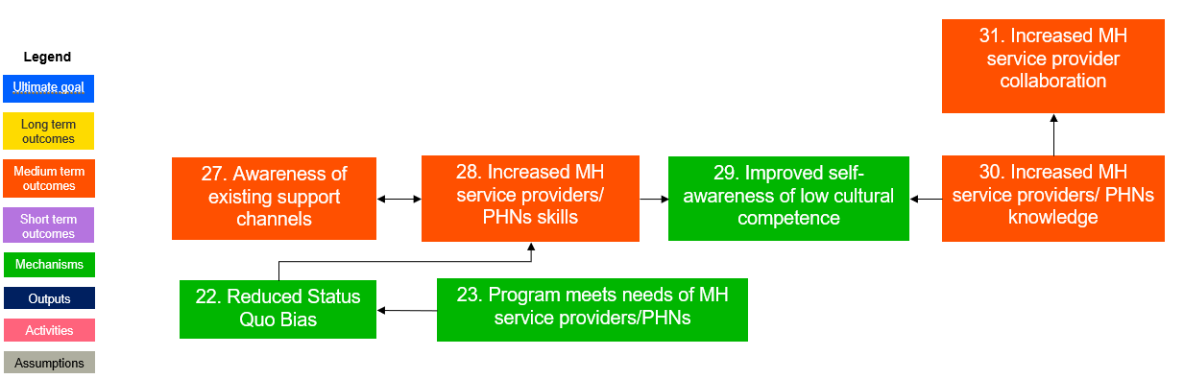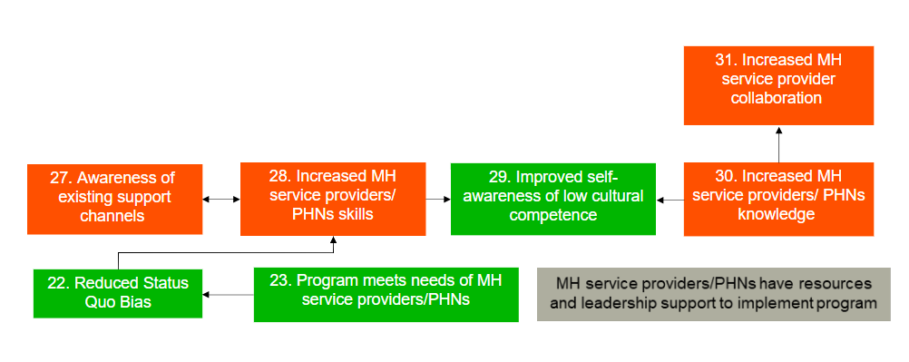

### Causal effect of the Framework on intended outcomes

Using quantitative data from the PHN/service provider survey, we compared outcomes between the treatment group (those that registered for the Framework, n=34) and comparison group (those that had not registered for the Framework, n=18) to estimate the treatment effect. We also correlated the level of Framework completion with outcomes to estimate the dose response function.

We could not compare outcomes by geographic area due to sample size limitations. Only 34 survey respondents had registered for the Framework so any subgroup analyses by state/territory or PHN area would have fewer than 10 respondents, which is too small to be able to draw meaningful comparisons.

### Contextual influences on outcomes

To identify contextual influences on medium term workforce outcomes we explored:

1. Organisational capacity: We examined the effect size of the two control variables in our dose response analysis of the PHN/service provider survey data. These variables reflect the ToC assumption that “MH service providers/PHNs have resources and leadership support to implement program”. We also conducted Emergent Thematic Analysis of n=6 interviews with PHN staff that had used the Embrace Framework about their organisational capacity to implement the Framework.
2. The market for information and resources: We asked survey respondents to select the organisation that best meets their learning needs about culturally inclusive mental health service delivery to rank the Embrace Project against other organisations. We also conducted Emergent Thematic Analysis of n=117 free text survey responses about the resources or training respondents had used. This involved grouping themes into higher order categories.

### Perceived value of the Framework

Beyond estimating the impact of the Embrace Framework, we also wanted to understand its perceived value. We conducted Framework Analysis of n=6 interviews with PHN staff that had used the Embrace Framework. This involved assessing whether the intended medium term workforce outcomes were observed for these users.

### Drivers of outcomes

To provide explanatory evidence about why medium-term workforce outcomes were or weren’t achieved we tested the mechanism-outcome links in the ToC. The theory predicts that reduced status quo bias leads to increased MH/Service Provider skills. We used our PHN/service provider survey data (n=210) to correlate these variables. We also conducted Framework Analysis of n=6 interviews with PHN staff that had used the Embrace Framework to compare their experience to this theorised mechanism-outcome link.

## Findings for KEQ 4

### The workforce has high levels of cultural skills, knowledge, collaboration, and awareness of existing support channels, and is correctly estimating their own cultural competence

From the PHN/service provider survey, we found high levels of achievement of the intended medium-term workforce outcomes from all survey respondents that answered these questions (n=199) (Figure 11). For example,

* Increased MH service providers/PHNs skills: 69% (n=137) of respondents said they have the skills to provide culturally responsive mental health services.
* Increased MH service providers/PHNs knowledge: 71% (n=150) of respondents said they use a variety of sources to learn about the cultural heritage of other people.
* Increased MH service provider collaboration: 60% (n=120) of respondents said they work closely with stakeholders from the sector to improve CALD mental health outcomes in their service area.

Awareness of existing support channels: 64% (n=128) said they are aware of existing CALD mental health support channels in their service area.

Figure 11. Medium-term workforce outcomes

We also found high levels of both perceived and actual cultural competence (Figure 12), and these outcomes were positively correlated (see Appendix B), suggesting the workforce is correctly estimating their own competence. This is important because if the workforce thinks they are more culturally competent than they are, they may miss out on opportunities to learn from others who are truly more skilled or knowledgeable, especially CALD community members. Equally, if the workforce isn’t recognising their capability (imposter syndrome) they may hold back from engaging with CALD community members in ways that could make a positive difference.

* Perceived cultural competence: 92% (n=176) of survey respondents said they have identified their own beliefs, values, and biases.
* Actual cultural competence: 85% (n=10) of survey respondents said they find ways to adapt their work practices to people’s cultural preferences.

Figure 12. Actual and perceived cultural competence

### Most observed workforce outcomes do not appear to be caused by the Embrace Framework, apart from improved self-awareness of one’s own cultural competence.

We did not find robust evidence of differences in medium-term workforce outcomes between the treatment group and comparison group, apart from accurately estimating their own cultural competence (Appendix B).

Figure 13 shows the difference between perceived cultural competence[30] and actual cultural competence is smaller for those that have registered for the Framework (5.6) compared to those that haven’t (7.2), and this result is statistically significant (p 0.03). Our correlation test found Framework registration was associated with a 22% reduction in the difference between perceived and actual cultural competence (coeff -1.633, p 0.035). Therefore, we conclude that the Framework had a positive impact on improving the workforce’s self-awareness of their own cultural competence.

Figure 13. Embrace Framework’s positive impact on improving self-awareness of cultural competence

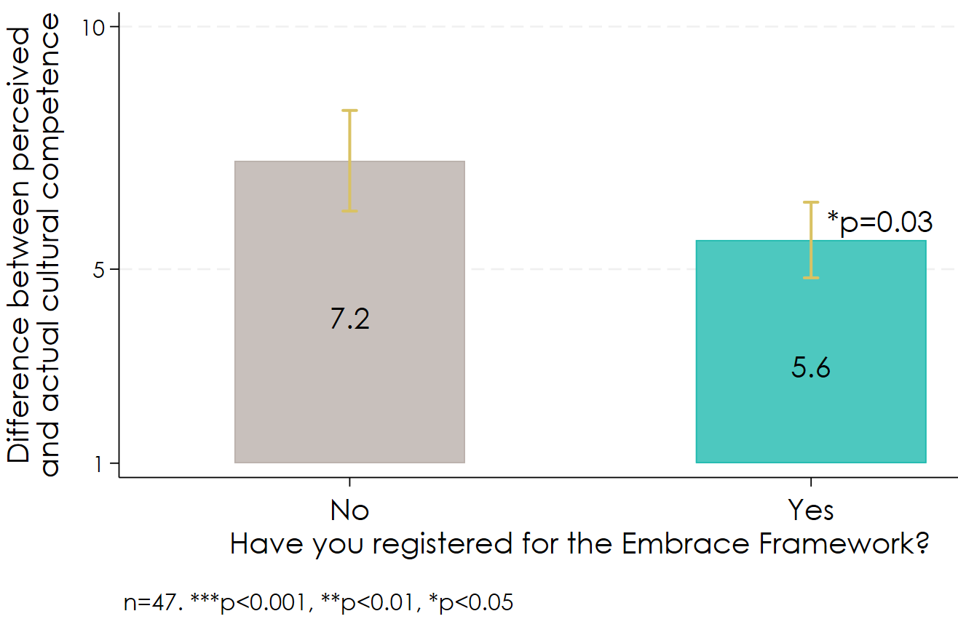

Being self-aware of one’s own cultural competence is a mindset that may influence millions of small decisions in everyday practice with CALD communities. When this impact is aggregated across the workforce it could lead to positive system change. Therefore, the Embrace Project’s impact on improving the workforce’s estimation of their own cultural competence is an important contributor to sustainably improving CALD outcomes.

Across all other medium-term workforce outcomes, we did not find a relationship with either registering for the Framework or dose of the Framework (see Appendix B for all results). For example, Figure 14 shows the treatment group and comparison group did not differ in having the skills to provide culturally responsive mental health services.

Figure 14. No relationship observed between Framework uptake and increased cultural skills

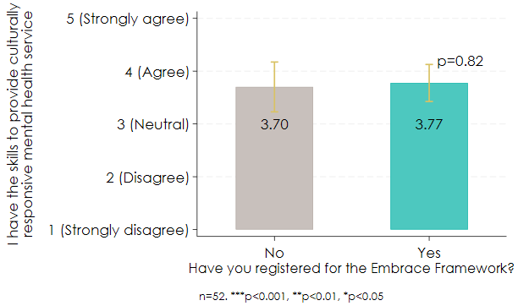

Overall, we conclude that the high rates of medium-term workforce outcomes observed in the survey don’t appear to be caused by the Framework apart from improved self-awareness of one’s own cultural competence. However, it is possible the Framework is having a small effect on some outcomes, but this cannot be detected because the sample size is too small. It is also possible that respondents that haven’t used the Framework learnt the same information somewhere else so the Framework may be impactful for those that don’t have other sources of information.

### Improved resourcing to be culturally responsive is associated with being aware of existing CALD mental health support channels and cultural skills.

Improving resourcing to be culturally responsive is an assumption in the ToC as this is beyond the control of the Embrace Project. Our analysis of the PHN/service provider survey found that respondents who said that in the past two years their organisation had improved resourcing to be culturally responsive (e.g., interpreter service), had higher levels of agreement that they were aware of existing CALD mental health support channels in their service area (coeff 0.355, p 0.024). Improved resourcing also had a small positive impact on cultural skills (coeff 0.021, p 0.06).

This finding is consistent with PHN interview data about the wider context for creating change, where PHNs interviewees said:

* Their organisation had low capacity to engage with training and organisational improvement activities (n=3)
* Their PHN did not have budget allocated to implement actions to improve their cultural responsiveness (n=2); and
* Support from leadership was important to be able to engage with the Embrace Framework and identify the service needs of the CALD community (n=1).

### Other training and resources are often used by the mental health workforce besides the Embrace Project.

We looked at the extent to which training and resources are being used by the mental health workforce to provide culturally inclusive mental health service delivery. Over a third of survey respondents (40%, n=47) said they had not used any resources or training in the past two years to learn about culturally inclusive service delivery.

Of the 60% (n=70) that had used resources or training:

* 31% (n=22) had attended either general cultural awareness training or training specific to meeting the needs of Indigenous Australians.
* 29% (n=20) had undertaken online training (e.g., online courses, certificate IV in mental health, training provided by Victorian Foundation for Survivors of Torture, etc.)
* 26% (n=18) had used CALD specific resources (e.g., Victorian Transcultural Mental Health, subscribing to mental health newsletters specific to CALD communities)

We also asked survey respondents “which organisation best supports your learning needs?”. Just over half of all respondents (54%, n=74) said a community-led multicultural service, followed by Embrace (16%, n=22) and then a state government agency (12%, n=16).

These findings indicate that Embrace is operating in a complex environment with many competing programs on offer. It is possible that we didn’t see an impact of the Framework on most workforce outcomes because our survey sample may be overrepresented by individuals who are highly engaged in training about multicultural mental health service delivery. Therefore, Embrace may have a larger impact on individuals and organisations that haven’t accessed other forms of training and resources.

### Users of the Framework value it for improving their skills and knowledge.

Most PHN interviewees (n=5) reported they had improved their skills and knowledge from using the Framework. Some of these stated specific ways they had used the Framework, including in the development of an organisational cultural competency Framework.

We thought actually that while it's a mental health framework and a lot of what we do is in the mental health field, we decided it was really relevant to the whole organisation, for our internal learnings, for our organisation to upskill ourselves internally and the importance of doing that, particularly in our position when we're commissioning services.– PHN interviewee

I've been in the multicultural health space for 10 years, so I came in with a lot of knowledge already, but I still learnt new things [from the Framework]. And seeing the process and seeing the indicators under it was a learning. – PHN interviewee

The information in the modules was really helpful in developing our cultural competency and capability frameworks, as well as a commissioning framework to sit alongside those. The indicators have proved very useful, we've adapted those for you know inclusion in that commissioning framework, several of those indicators for what we would expect commissioned services to do. – PHN interviewee

### The Framework meets the needs of the workforce, and they are open to changing their work practices.

From the PHN/service provider survey, we found high levels of achievement of the mechanisms of change (Figure 15). For example,

* Program meets the needs of MH service providers/PHNs: 70% (n=23) of Framework registrants said the Framework is high quality.
* Reduced status quo bias: 8% (n=15) of total survey respondents said they prefer to keep things as they are at work, equivalent to 92% (n=173) being open to changing their work practices.

These findings are consistent with PHN interview data, where n=6 PHN interviewees said they found the Framework high quality and useful. Only two PHN interviewees said the Framework was not completely relevant to their work as they felt it had been designed for service providers.

Figure 15. Mechanisms of change

### There is evidence for the theorised link between being open to change and improved cultural skills.

We correlated reduced status quo bias with increased MH service providers/PHNs skills and found a statistically significant positive relationship (coeff 0.157, p 0.046) (see Figure 16)[31] which suggests this aspect of the theory is correct. Being open to changing one’s work practices helps people learn new skills.

Figure 16. Positive correlation between reduced status quo bias and frequency of using cultural information to assess mental health needs.

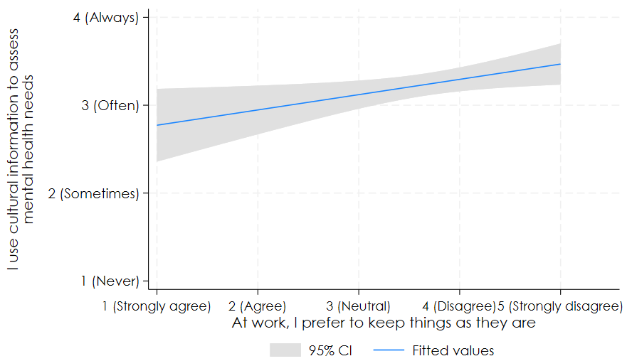

This is consistent with findings from the interviews with PHN staff that had used the Embrace Framework. All interviewees (n=6) said the Framework had made them realise where their organisation was in their cultural competence journey and made them want to implement actions to improve their organisation’s cultural competence.

## Recommendations related to KEQ 4

4.1 Measure the difference between actual and perceived cultural competence as part of the Framework. It’s important for the workforce to accurately estimate their own cultural competence. The Framework seems to be having a positive impact in this regard, but the sample size was limited. Therefore, the Embrace team should systematically evaluate this outcome as people progress through the Framework modules. Ideally actual cultural competence should be measured objectively by surveying third parties (e.g., colleagues and clients) whereas perceived cultural competence should be self-reported using the survey measures in this evaluation. Both surveys could be implemented by Framework users by including survey templates in the self-reflection tool.

4.2 Introduce activities into the Framework which encourage openness to working differently. Being open to change (reduced status quo bias) was associated with improved cultural skills so introducing evidence-based activities that increase openness can potentially increase the Framework’s impact. For example, the first module could start with a 10 min values affirmation exercise where people write about their core values.[32] This activity has been shown in many experiments to increase openness to new ideas and willingness to changing one’s mind.[33]

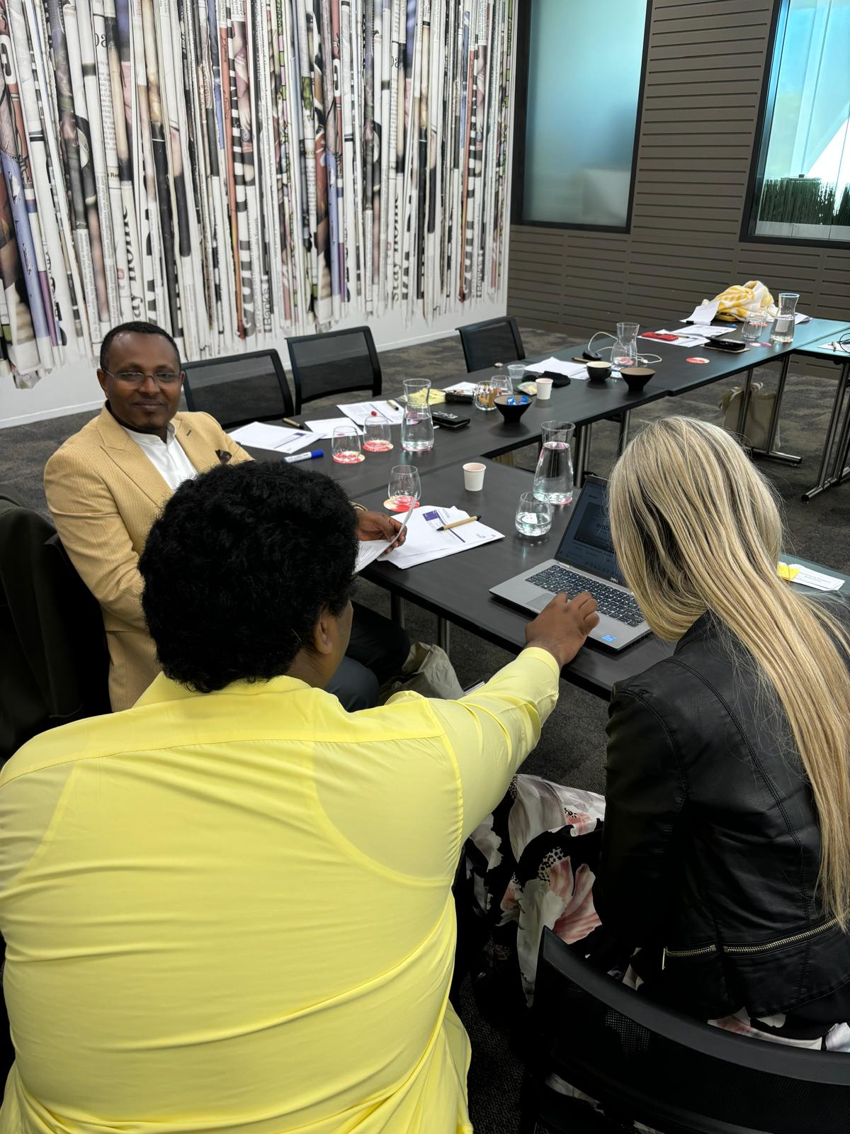

# KEQ5: Impact of the CCEP on CALD communities’ mental health literacy, skills, stigma, and awareness of support channels

Did the CCEP change the community’s: a) mental health literacy, skills, and stigma to access mental health support? b) awareness of existing CALD mental health support channels? Does this vary by cultural group? What is the wider context for creating change, e.g., community and system barriers, shifting norms in home countries?

## Overview of findings

* The CCEP is being implemented with CALD communities that have high need for the program.
* The CCEP may be contributing to CALD communities’ mental health literacy, skills, and awareness of support channels, but it is too early to assess.
* It is unclear whether the CCEP is reducing mental health stigma, but stigma does not appear to be reducing in CALD communities’ home countries.
* The CCEP appears to meet CALD community needs and may reduce status quo bias.
* A key driver of CCEP outcomes may be the co-design process itself.

## How we answered KEQ 5

KEQ5 looks at whether the CCEP caused intended medium-term CALD community outcomes; whether these varied by cultural group; and whether contextual factors influenced outcomes. We also examined the drivers of medium-term CALD community outcomes. To increase confidence in the findings, we tested the alternative process tracing hypothesis that mental health stigma has reduced in CALD communities’ home countries.

### Related ToC components

KEQ5 is related to three mechanisms of change and three medium term outcomes.

Mechanisms of change:

* Program meets the needs of CALD communities. Verian’s rapid evidence review found access to mental health services improves when services are perceived to be relevant and relatable.
* Reduced status quo bias: Status quo bias is a preference for avoiding change. According to the ToC, CALD community members need to be open to changing the way they approach the health system to learn new skills. To be open to change, the Embrace Project must meet their needs.
* Reduced mental health stigma in CALD communities: Stigma involves feelings of shame, fear, and failure. CALD community members may worry about being labelled ‘mad’ or ‘crazy’. They may also fear ramifications if they reveal their mental health issues, such as losing a job, losing status in their ethnic community and legal issues related to mental health, such as police and social justice department involvement. In addition, if community members suffering from stigma cloak the issues from family and other support networks, they may prolong their isolation which can worsen their mental illness.[34]

Medium term outcomes:

* Increased mental health literacy in CALD communities: Mental health literacy is composed of several components, including (a) the ability to recognise specific disorders of types of psychological distress; (b) knowledge and beliefs about risk factors and causes; (c) knowledge and beliefs about self-help interventions; (d) knowledge and beliefs about professional help available; (e) attitudes which facilitate recognition and appropriate help-seeking; and (f) knowledge of how to seek mental health information.[35] Mental health literacy helps to reduce stigma according to the ToC.
* Increased CALD community skills: The skills that CALD communities need to access mental health services include navigating the health system and articulating their needs to service providers. These skills improve access by reducing stigma according to the ToC.
* Awareness of existing support channels. Verian’s rapid evidence review found localised mental health services can increase access for CALD communities. Embrace aims to increase awareness of mental health support channels that already exist in CALD communities. According to the ToC, this requires CALD community members developing skills to navigate the health system. Equally, by being aware of existing support channels it helps individuals build skills to engage.

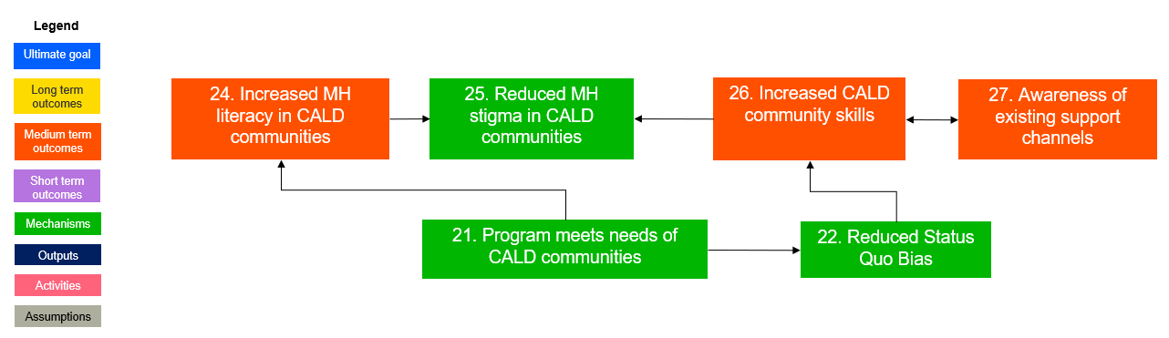

**Process tracing hypotheses**

|  | Core hypothesis | Alternative hypothesis |
| --- | --- | --- |
| KEQ5 | The CCEP reduced mental health stigma (interviews with CALD community leaders). | Mental health stigma has reduced in CALD communities’ home countries (interviews with CALD community leaders). |

**Limitations of the methodology**

Not all CCEP organisations commissioned to deliver the CCEP have completed delivery and among those that have, it is too early to assess medium-term CALD community outcomes. Therefore, we assessed the effect of the CCEP by asking n=3 commissioned organisations to predict future outcomes based on observed mechanisms of change. Given these predictions may not be accurate and the source of data is commissioned organisations rather than program beneficiaries, the results should be interpreted with caution. Where possible we triangulated findings with other sources.

## Findings for KEQ 5

### The CCEP is being implemented with CALD communities that have high need for the program.

The CALD communities that were selected to participate in the CCEP projects were identified by MHA through consultation with FECCA and NEDA, as well as advice from the Stakeholder group. The basis for selecting these communities was that they would significantly benefit from an intervention to improve mental health literacy and reduce stigma around mental health. This is consistent with the literature which finds these communities are associated with increased risk factors for poor access to health services in general.[36]

| **Selected CALD communities for CCEP** | **Risk factors for poor access to health services** |
| --- | --- |
| Rohingya | Multimorbidity and poor utilisation of health services |
| Chinese/Mandarin | Poor health literacy and limited English proficiency |
| CALD youth in Darwin | While one study found no meaningful difference in mental health help-seeking between mainstream and CALD youth populations[37], youth in the Northern Territory are at risk of socioeconomic disadvantage.[38] |
| Pasifika and Māori | Socioeconomic disadvantage[39] |
| Afghan | Multimorbidity and poor utilisation of health services |
| African | Multimorbidity and poor utilisation of health services |

#### The CCEP may be contributing to CALD communities’ mental health literacy, skills, and awareness of support channels, but it is too early to assess.

We interviewed representatives from three CCEP organisations, working with the following CALD communities:

* Chinese/Mandarin community in NSW
* CALD youth in the NT
* Afghan community in SA

All interviewees (n=3) believed the CCEP was contributing to:

* Increased mental health literacy about how common mental health issues present (e.g., symptoms of depression and anxiety) and what kinds of supports may help to manage these conditions.
* Improved skills in discussing mental health within families and the broader community.
* Increased awareness of support services suitable to their needs and increased knowledge about the costs and referral processes involved in accessing care.

However, their assessment was only based on their perceptions of the experiences of community members who participated in co-designing resources. This is because not enough time has passed since the resources were developed to measure outcomes among the wider CALD community who are the intended beneficiaries of the resources. It is also unclear whether CCEP organisations have monitoring and evaluation systems in place.

We know the impacts on the individuals that were part of [the CCEP] were really positive...it creates those conversations at the beginning, of understanding even just “What is mental health?”  
– CCEP organisation interviewee

We did not find any significant differences in predicted outcomes across the three cultural groups.

### It is unclear whether the CCEP is reducing mental health stigma, but stigma does not appear to be reducing in CALD communities’ home countries.

CCEP organisations believed that the experience of co-design reduced participants’ stigma around mental health because talking about mental health had normalised it. However, it is too early to assess whether stigma will be reduced among the wider CALD community as a result of accessing the resources that were developed through co-design.

Generally, [with] this community, we have observed that people don't want to be associated with any type of illness or disease, whether it's inside, infectious, or not. That's one thing or I would say the biggest stigma that we are dealing with, especially when it's about mental health.– CCEP organisation interviewee

This stigma and low mental health literacy, we're not too sure exactly which is affecting the other one, but we believe that they both have the same level impact on this community seeking support. I would say that's very commonly seen among this community, especially from first generation racial migrants.– CCEP organisation interviewee

As part of our Process Tracing tests to raise the standard of evidence when making claims about the program’s causal impact, we examined whether mental health stigma is reducing in CALD communities’ home countries. This was our alternative hypothesis to the ToC that predicts the CCEP will reduce stigma. If there is evidence for the alterative hypothesis, it is less likely the CCEP will have a significant impact on this mechanism of change.

We did not find evidence to support the alternative hypothesis. CCEP interviewees (n=3) said while there might be some improvement in stigma around mental health in the home countries of the communities they worked with, this was not something they had observed during their interactions with community members. These interviewees felt that other factors were probably more significant in affecting stigma around mental health, such as the specific ethnic group, gender, age, and where people were on their settlement journey (e.g., what age were they when they arrived in Australia, how long have they lived here, etc). This suggests there is potential for the CCEP to reduce mental health stigma, but the size of the impact may vary for different cohorts given different baseline levels.

There is a huge stigma around mental health, largely because in many cultures the word “mental health” doesn't even exist. So, the moment we say mental health, they’re automatically thinking about someone who's, you know, insane or crazy.– CCEP organisation interviewee

We've run a lot of consultations where some older people recognise that younger people are starting to become a bit more aware of mental health issues and a little bit more open to talking about them compared to the older generation. And men are less likely to talk about mental health issues compared to women.– CCEP organisation interviewee

"I believe it's improving, especially among the younger generation, and I'm talking about maybe 40-50 years or under…. we do see this subtle improvement over the years that some generations are starting to pick up their own emotional needs.– CCEP organisation interviewee

### The CCEP appears to meet CALD community needs and may reduce status quo bias.

Interviews with CCEP organisations (n=3) found strong perceptions that co-design participants experienced the mechanisms of change. While it is too early to assess whether the wider CALD community will have the same cognitive and emotional reactions to the CCEP, this is a promising sign.

We found preliminary evidence to confirm the mechanism of change that the program meets the needs of CALD communities. All three interviewees said co-design participants valued the experience.

Feedback from the participants is they really enjoyed the experience of co-design and learnt a lot in the process. – CCEP organisation interviewee

We found preliminary evidence to confirm the mechanism of change that the program reduced status quo bias. All three interviewees said the experience of co-design had encouraged participants to think and act differently.

In general, they believe that this type of support [for mental health] costs a lot of money, more than they can afford. This project helped them learn that is not true. – CCEP organisation interviewee

### A key driver of CCEP outcomes may be the co-design process itself.

Interviews with CCEP organisations (n=3) found they agreed with the theorised pathways of change in the ToC. However, mechanism-outcome links could not be tested given no data were collected directly from co-design participants or the wider CALD community.

CCEP organisation interviewees (n=3) all felt that the co-design process itself seemed to be a driver of outcomes among co-design participants. They believed this was enabled by seeking participants’ feedback throughout the project as this helped to maintain participants’ engagement in developing resources. Verian’s separate evaluation of Embrace’s suicide prevention project similarly found that the process of co-design appeared to increase participants’ awareness and understanding of mental health and suicide risk in their community, as well as increased their confidence engaging in help-giving behaviours.

A key question for a future evaluation of the CCEP is whether CALD community members who use the resources achieve the same level of outcomes as those that co-designed them.

## Recommendations related to KEQ 5

See recommendation 1.4: Embed ongoing monitoring and evaluation into the Project design. This evaluation was not able to comprehensively evaluate medium-term or long-term CCEP outcomes, or mechanism-outcome links. Establishing the required data collection and analysis systems now (with data collected directly from CALD community members) will ensure an evaluation is feasible after all delivery has been completed and sufficient time has passed for the outcomes to be observed. Verian will assist.

# KEQ6: Impact of the Project on workforce motivation, agency, capacity, and diversity to deliver culturally competent mental health services

Did the Embrace Project improve the workforce’s motivation, agency, capacity, and diversity to deliver culturally competent mental health services?

## Overview of findings

* The workforce has high levels of motivation and cultural competency, and lower levels of culturally responsive service delivery.
* Using the Embrace website does not appear to increase workforce motivation.
* PHN interviewees valued the targeted support for increasing their motivation and agency.
* Using the Embrace Framework does not increase cultural competency as much as professional learning by community-led multicultural services.
* In the last two years, workforce practices have become more culturally responsive, and this is due to individual motivation more than organisational factors.
* The workforce has the right mindset to improve CALD mental health outcomes.
* There is evidence for the theorised pathways of change to improve CALD mental health outcomes.

## How we answered KEQ 6

KEQ6 looks at whether workforce engagement with the Embrace Project overall (not just the Framework) caused intended long-term workforce outcomes. We also examined views of those involved with the Embrace Project on the Embrace Project and the drivers of long-term workforce outcomes.

### Related ToC components

KEQ 6 is related to six long term outcomes and three mechanisms of change.

Long term outcomes:

* Improved MH service provider motivation: Service providers enjoy working hard to deliver culturally responsive services and treat this as an ongoing priority.
* Improved MH service provider agency: Service providers feel they have control over their actions to deliver culturally responsive services.
* Increased MH workforce capacity: Service providers have sufficient personnel, with the right skills, to deliver against current workload.
* Increased cultural diversity of workforce: The workforce comes from a variety of backgrounds.
* MH workforce is culturally competent (cultural humility): Cultural competence means being aware of your own cultural beliefs and values and how these may be different from other cultures—including admitting that one does not know and is willing to learn from patients and those you work with about their experiences and honour their different cultures. We created an index of three survey items[40] about how often respondents say they do the following when interacting with people from CALD background at work (including colleagues, delivery partners, or clients):

1. I act to remove obstacles for people of different cultures when they identify such obstacles to me.
2. I welcome feedback from people about how I can better relate to others from different cultural backgrounds.
3. I find ways to adapt my work practices to people’s cultural preferences.

* MH workforce delivers culturally responsive services: We created an index of five survey items about how respondents say they/their organisation has worked to improve CALD community mental health outcomes in their service area in the past two years:

1. Developed policies/strategies (e.g., targeting groups most in need, tailoring services, measuring access).
2. Regularly reviewed policies/strategies.
3. Increased the availability of information for CALD communities.
4. Reduced the time or financial costs of accessing services for CALD communities.
5. Reduced mental health stigma for CALD communities.

Mechanisms of change:

* Improved self-awareness of low cultural competence: The workforce is correctly estimating their own cultural competence.
* Positive encounters between CALD community and MH service providers: During encounters between CALD community members and service providers, there is a meaningful connection which allows for constant learning.[41]
* CALD community and MH service providers further modify their beliefs: When CALD community members and service providers have positive encounters, service providers refine and modify their beliefs about CALD community stereotypes.[42]

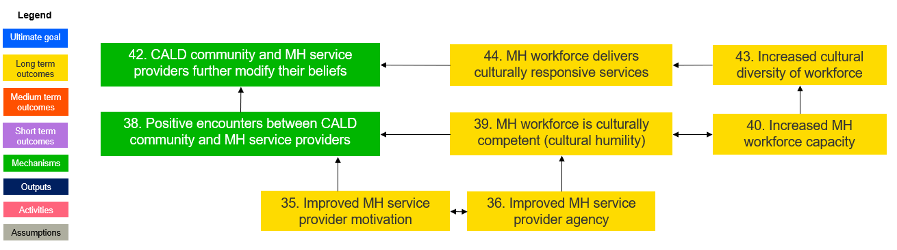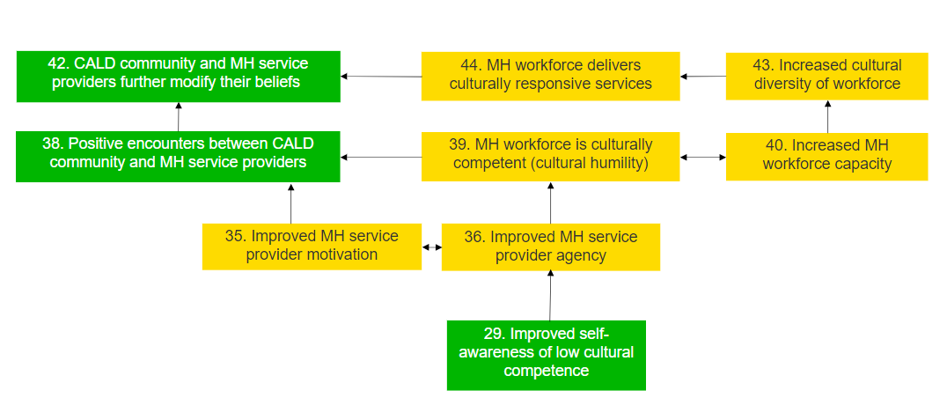

### Causal effect of the Embrace Project on intended long-term workforce outcomes

Using data from the PHN/service provider survey (n=210), we compared the difference in long-term workforce outcomes between the quasi treatment and comparison groups to estimate the treatment effect. For some outcomes, the treatment group is defined as those that had visited the Embrace website (n=61) and the comparison group is defined as those that had not visited the Embrace website (n=97). For other outcomes, the treatment group is defined as those that had registered for the Framework (n=34) and the comparison group is defined as those that had not registered for the Framework (n=18).

### Process tracing hypotheses about the impact of the Framework on cultural competence

We tested the following hypothesised pathways in the ToC, and alternative hypotheses, about whether and how the Framework changes the workforce’s cultural competence.

|  | Core hypothesis | Alternative hypothesis |
| --- | --- | --- |
| KEQ 6 | Cultural competence is higher among PHNs and service providers that have used the Framework vs those that haven’t (PHNs/service provider survey – correlation). | Cultural competence is higher among PHNs and service providers that used other forms of professional learning (PHNs/service provider survey – correlation). |
| KEQ 6 | At least 70% of PHNs and service providers who have registered for the Framework agree with these statements:  The Framework has helped me evaluate my cultural responsiveness.  The Framework has helped me enhance my cultural responsiveness.  (PHNs/service provider survey). | The workforce believes their practices became more culturally responsive because of something else (PHNs/service provider survey – free text responses). |
| KEQ 6 | The workforce believes their practices became more culturally responsive because of greater agency/ motivation/ capacity/ diversity (PHNs/service provider survey – multiple choice). | The workforce believes their practices became more culturally responsive because of something else (PHNs/service provider survey – free text responses). |

### Perceived value of the Embrace Project

To understand the extent to which the workforce values the Embrace Project, we analysed n=6 interviews with PHNs that had received targeted support from the Embrace team to implement the Framework.

Drivers of outcomes

To provide explanatory evidence of why long-term outcomes were or were not achieved, we tested the theorised relationships between mechanisms and outcomes in the ToC.

We tested the following mechanism-outcome links through correlation analysis:

* Improved self-awareness of cultural competence drives agency.
* Cultural competence drives positive encounters with CALD community members.
* Delivering culturally responsive services drives further modification of beliefs.

We also conducted emergent thematic analysis of free text survey responses about barriers to becoming more culturally responsive.

## Findings for KEQ 6

### The workforce has high levels of motivation and cultural competency, and lower levels of culturally responsive service delivery.

From the PHN/service provider survey, we found high levels of some long-term workforce outcomes (Figure 17). For example:

* Improved MH service provider motivation: 89% (n=171) said working hard to be more culturally responsive feels good.
* MH workforce is culturally competent (cultural humility): 90% (n=189) said they welcome feedback from people about how they can better relate to others from different cultural backgrounds.

However, we found moderate to low levels of culturally responsive service delivery. For example:

MH workforce delivers culturally responsive services: 38% (n=79) said they/their organisation reduced mental health stigma for CALD communities in their service area.

Figure 17. Motivation, cultural competence, and culturally responsive services

### Using the Embrace website does not appear to increase workforce motivation.

There was no significant difference between those that had visited the Embrace website and those that had not in agreeing with the statement “working hard to be more culturally responsive feels good” (coeff 0.036, p 0.745).

Figure 18. Correlation between Framework use and MH service provider motivation

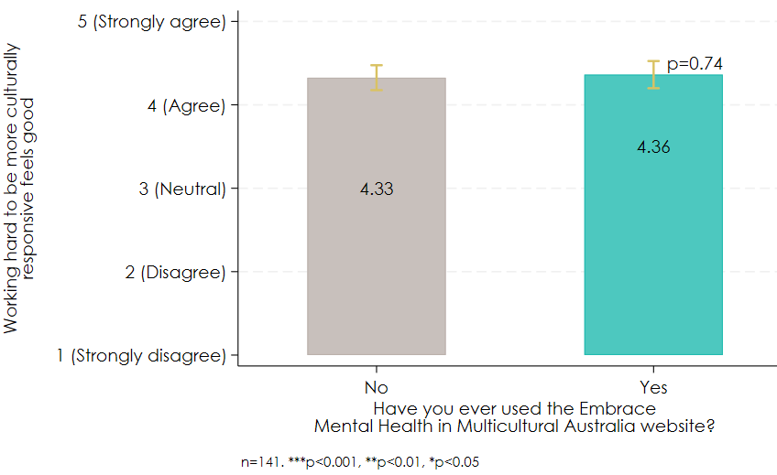

### PHN interviewees valued the targeted support for increasing their motivation and agency.

Most PHN interviewees (n=4) reported their involvement in the targeted support increased their motivation and agency to become involved in the process of becoming culturally competent. Some said that the self-assessment tool had made them aware of their organisation’s level of cultural competence and helped to make improving cultural competence a strategic priority.

I think the material was very useful, the written content was great, the self-assessments were particularly useful. It’s a foundational piece, that baseline self-assessment and then being able to look back on that as you go along and develop actions against those. – PHN interviewee

One of the first things it helped us identify was we actually need to have strategic intent in this area and now we have just launched a new strategic plan and we have cultural responsiveness as one of the pillars within the strategic plan. – PHN interviewee

One thing that we really learned through this journey was that our team does the support well, but if you measured against the organisation, we were not. But that was a good reality check for us, we've just gone ahead on our own and we needed to bring everyone along with us. In that sense, it was great for us because we would never have had another conversation like this before across the organisation. – PHN interviewee

### Using the Framework does not increase cultural competency as much as professional learning by community-led multicultural services.

We found evidence for the alternative hypothesis that cultural competence is higher among PHNs and service providers that used other forms of professional learning.

**Impact of the Embrace Framework on cultural competence**

We did not find a relationship between registering for the Framework or dose of the Framework and cultural competence (Appendix B). For example, Figure 19 shows there was not a statistically significant difference in cultural competence between survey respondents that had and hadn’t registered for the Framework (coeff -1.100, p 0.207).

Figure 19. Correlation between framework uptake and cultural competence

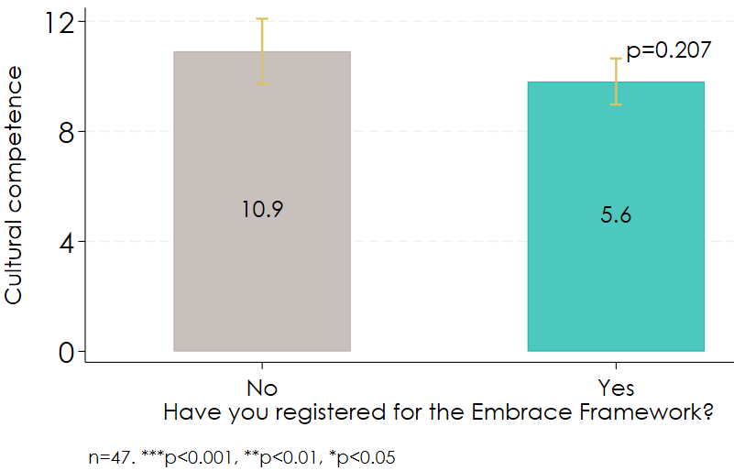

However, the more recently respondents had accessed the Framework, the higher their cultural competence and this result almost reached statistical significance (coeff 0.398, p 0.051). For each unit increase in how recently respondents said they accessed the Framework (e.g., from between 6-12 months to less than 6 months), their cultural competence increased by 0.398 units (on a 9-point scale ranging from 4 to 12), equivalent to 4.4%.

**Impact of other sources of professional learning on cultural competence**

Survey respondents were asked which organisation best supports their learning needs about culturally inclusive mental health service delivery. The following response options were randomly shown to avoid question order effects:

* Commonwealth Government e.g., Department of Health and Aged Care
* State Government agency
* Community-led multicultural services
* The Forum of Australian Services for Survivors of Torture and Trauma (FASSTT)
* Federation of Ethnic Communities’ Council of Australia (FECCA)
* Embrace Multicultural Mental Health
* Other (please specify)

A majority of respondents that selected “Other” (n=34/44) specified an organisation. The most common response was Victorian Transcultural Mental Health (n=8). Other responses included specialised trauma service for refugees and a PHN.

Those that said Embrace best supports their learning needs did not have higher cultural competence compared with those that selected any other organisation (coeff 0.212, p 0.592).

By comparison those that said community-led multicultural services best supports their learning needs had higher cultural competence compared with those that selected any other organisation, including Embrace. This finding was statistically significant (coeff 0.616, p 0.024) and supports the alternative hypothesis that cultural competence is higher among PHNs and service providers that used other forms of professional learning.

Figure 20. Community-led multicultural services best supports their learning needs had higher cultural competence

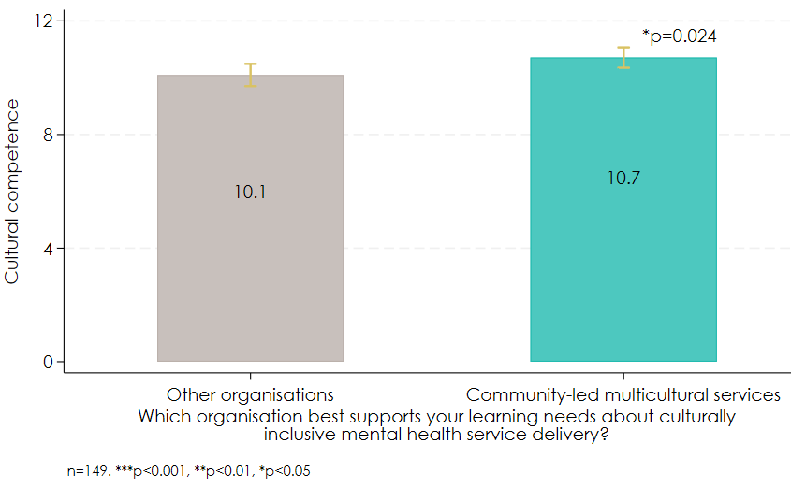  
Additional evidence to support the alternative hypothesis is that while 72% of survey respondents who registered for the Framework (n=23) agreed that “The Embrace Framework has helped me evaluate my cultural responsiveness”, only 56% (n=18) agreed that “The Embrace Framework has helped me enhance my cultural responsiveness”.

It is plausible that survey respondents that said community-led multicultural services best meets their learning needs might have sought information on a specific community group which is not what the Framework offers. Given these respondents represent just over half (54%, n=74) the sample, they may have skewed the results.

### In the last two years, workforce practices have become more culturally responsive, and this is due to individual motivation more than organisational factors.

82% (n=157) of survey respondents said their work practices had become more culturally responsive in the last two years. The survey asked, “What do you think is driving this change?”. Multiple choice options reflected workforce agency, motivation, capacity, and diversity (Figure 21).

Respondents tended to cite individual reasons (motivation and agency) rather than organisational factors (capacity and diversity). For example, 73% of respondents (n=114) said the change was attributed to them treating cultural responsiveness as an ongoing priority but only 22% (n=34) said the change was attributed to their organisation prioritising cultural diversity in its staff retention practices.

Respondents also provided free text responses to what they believed is driving this change. We conducted emergent thematic analysis on these responses (n=65) to test the alternative hypothesis. The most common response was increased education and awareness about CALD communities among service provider staff (n=27) followed by increased culturally sensitive programs and services (n=23) and increased staff from CALD backgrounds (n=9).

18% (n=35) of respondents said their work practices had become less culturally responsive or stayed the same. They were asked to state the main barrier to becoming more culturally responsive. Emergent thematic analysis of the free text responses (n=14) showed that some respondents do not see a need to become more culturally responsive (n=3), while others stated key barriers to be lack of resources/training (n=4), lack of direction from management (n=2) and not having enough time (n=2).

Figure 21. What is driving more culturally responsive workforce practices?

*Respondents that said their work practices had become more culturally responsive in the last two years

### The workforce has the right mindset to improve CALD mental health outcomes.

A majority of respondents to the PHN/service provider survey said they experienced the following mechanisms of change:

* Positive encounters between CALD community and MH service providers: 90% (n=172) said interacting with people from different cultural backgrounds leads them to update their beliefs.
* CALD community and MH service providers further modify their beliefs: 82% (n=158) said they actively self-evaluate their cultural humility.

These mechanisms are at the top of the Embrace Project Theory of Change and are considered necessary to improve CALD mental health outcomes.

Figure 22. Mechanisms of change

Note: It is not possible to calculate the frequency of “Improved self-awareness of low cultural competence” because this is calculated as the difference between perceived cultural competence and actual cultural competence.

### There is evidence for the theorised pathways of change to improve CALD mental health outcomes.

We used correlations between survey items to test the following theorised pathways of change and found supporting evidence:

* Improved self-awareness of cultural competence drives agency in delivering culturally responsive services (coeff 0.072, p 0.005).
* Cultural competence drives positive encounters with CALD community members (coeff 0.214, p <0.001).
* Delivering culturally responsive services drives further modification of beliefs about CALD community members (coeff 0.109, p < 0.001).

Figure 23. Positive correlation between self-awareness of cultural competence and agency

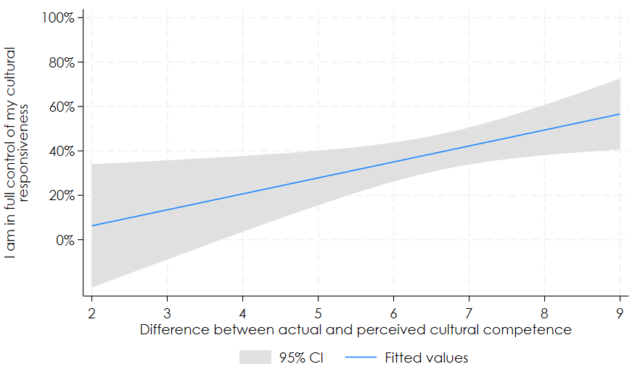

Note: In this graph, the binary outcome variable (“I am in full control of my cultural competence”) is treated as a continuous variable to better illustrate the correlation between this variable and self-awareness of cultural competence.

Figure 24. Positive correlation between cultural competence and encounters with CALD community members

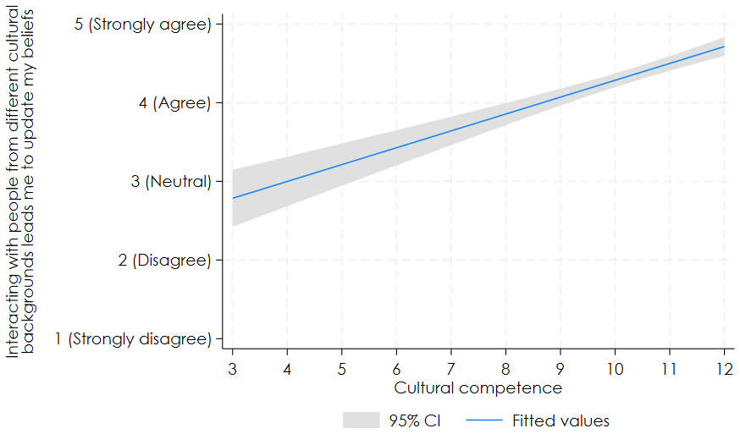

Figure 25. Positive correlation between cultural competence and modification of beliefs

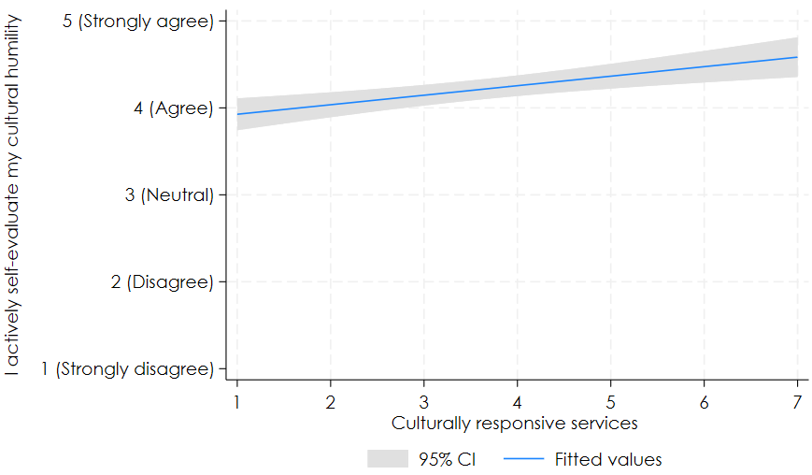

While other findings in this chapter suggest Embrace may not have a unique impact in driving workforce outcomes because other organisations also offer effective professional learning, these findings suggest the theory of how change occurs appears correct.

## Recommendations related to KEQ 6

6.1 Introduce more ways for the Project to increase the workforces’ self-awareness of their own cultural competence. Given there was evidence to support the theorised mechanism-outcome link that improved self-awareness of cultural competence is associated with greater sense of agency in delivering culturally responsive services, the Embrace Project should help individuals more accurately estimate their cultural competence. One of the best strategies to do this is simply to raise awareness of the Dunning-Kruger effect in psychology whereby people with low competence in a particular domain tend to overestimate their ability.[43] For example, the website could emphasise the complexity and uncertainty of delivering culturally responsive services and include a description of the Dunning-Kruger effect (with a link to research about it that is written for the general public[44]).

6.2 Explore delivering the Embrace Project through partnerships with community-led multicultural services. Given the importance of community-led multicultural services for professional learning, Embrace should explore partnership opportunities to promote the Embrace Project. In addition, by collaborating with other organisations that offer professional learning about culturally responsive service delivery, Embrace could identify needs in the market that aren’t being met and develop new offerings to fill these gaps, thereby increasing the impact of the Embrace Project.

# KEQ 7: Impact of the Project on CALD community access to mental health care

Did the Embrace Project improve CALD community access to mental health care?

## Overview of findings

* CALD community access to mental health services has improved in the last two years.
* Using the Embrace website or Framework does not appear to increase CALD community access to mental health services.
* Improved leadership to be culturally responsive is associated with increased CALD community access to mental health services.
* CCEP organisations believe the CCEP will lead to increased access to mental health services.
* To improve mental health outcomes for CALD communities, PHNs and services providers were twice as likely to develop policies or improve resourcing than reduce the time or financial costs of accessing services.
* There is evidence for the theory that increasing community information and reducing costs and stigma is associated with improved access to mental health services.

## How we answered KEQ 7

KEQ7 looks at whether workforce engagement with the Embrace Project (not just the Framework) caused intended long-term CALD community outcomes. We also explored predicted long-term outcomes for CALD communities from the CCEP. Finally, we examined the validity of the theorised drivers of long-term CALD community outcomes.

### Related ToC components

KEQ 7 is related to three long term outcomes and three mechanisms of change. We also examined one assumption in the Theory of Change.

Long term outcomes:

* Improved CALD community agency: Agency refers to feeling control over one’s actions and their consequences. CALD communities feel agency to access mental health services.
* Improved CALD community motivation: CALD communities are motivated to access mental health services.
* CALD community access MH care: Facilitating access is concerned with helping people to command appropriate health care resources in order to preserve or improve their health. Access measured in terms of utilisation is dependent on the affordability, physical accessibility, and acceptability of services and not merely adequacy of supply.[45]

Mechanisms of change:

* Positive encounters between CALD community and MH service providers: During encounters between CALD community members and service providers, there is a meaningful connection which allows for constant learning.[46]
* CALD community and MH service providers further modify their beliefs: When CALD community members and service providers have positive encounters, CALD community members refine and modify their beliefs about stigma from accessing care which prevents avoidance.
* Reduced MH stigma in CALD communities: See KEQ 5 for a definition. Stigma is a barrier to help-seeking in CALD communities.[47]

Assumption:

* MH service providers/PHNs have resources and leadership support to implement program: The Embrace Project only provides tools and resources, so implementation depends on the capacity of organisations.

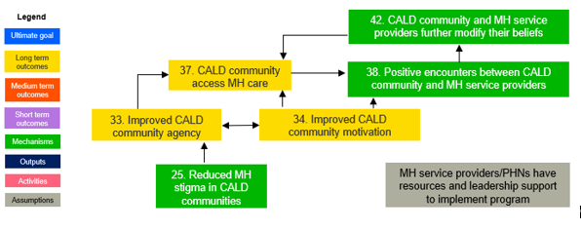

### **Causal effect of the Embrace Project on intended long-term outcomes for CALD communities**

Using data from the PHN/service provider survey (n=210), we compared the difference in long-term outcomes for CALD communities between the quasi treatment and comparison groups to estimate the treatment effect. For some outcomes, the treatment group is defined as those that had visited the Embrace website (n=61) and the comparison group is defined as those that had not visited the Embrace website (n=97). For other outcomes, the treatment group is defined as those that had registered for the Embrace Framework (n=34) and the comparison group is defined as those that had not registered for the Embrace Framework (n=18).

### Process tracing hypotheses about the impact of the Framework on CALD community access to mental health services

We tested the following hypothesised pathways in the ToC, and alternative hypotheses, about whether and how the Embrace Project changes CALD community access to mental health services.

|  | Core hypothesis | Alternative hypothesis |
| --- | --- | --- |
| KEQ 7 | Improvement in CALD community access to mental health services is higher among PHNs and service providers that have engaged with the Embrace Project vs those that haven’t (PHNs/service provider survey – correlation). | Something else is driving improvement in CALD community access to mental health services (PHNs/service provider survey – free text responses) |
| KEQ 7 | Improvement in CALD community access to mental health services is associated with increased availability of information and reduced costs and stigma (PHNs/service provider survey – correlation). | Something else is driving improvement in CALD community access to mental health services (PHNs/service provider survey – free text responses) |

### Drivers of outcomes

To provide explanatory evidence of how CALD community access to mental health services improves, we used data from the survey of PHNs and service providers.

We examined whether increasing community information and reducing the costs and stigma of care are associated with improved access to mental health services.

We also conducted emergent thematic analysis of free text survey responses about how the workforce increased information and reduced costs and stigma for CALD community members to access care, and any other drivers of improved access.

Limitations of the methodology for assessing CCEP long-term outcomes

Not all CCEP organisations commissioned to deliver the CCEP have completed delivery and among those that have, it is too early to assess long-term CALD community outcomes. Therefore, we assessed the effect of the CCEP by asking n=3 commissioned organisations to predict future outcomes based on observed mechanisms of change. Given these predictions may not be accurate and the source of data is commissioned organisations rather than program beneficiaries, the results should be interpreted with caution. Where possible we triangulated findings with other sources.

## Findings for KEQ 7

### CALD community access to mental health services has improved in the last two years.

Of n=145 respondents to our PHN/service provider survey question about changes to CALD community access to mental health services in their service area in the last two years (Figure 26):

* 61% (n=88) said CALD community access to mental health services in their area had increased in the last two years.
* 12% (n=17) said it had decreased.
* 27% (n=40) said it had stayed the same.

Figure 26. CALD community access MH care

### Using the Embrace website or Framework does not appear to increase CALD community access to mental health services.

Our correlation analysis of responses to the PHN/service provider survey found a negative relationship between using the Embrace website and increased CALD community access to mental health services (coeff -0.188, p 0.04). However, this can be interpreted as people going to the website when they identify a problem with CALD community access rather than the website reducing CALD community access (Figure 27).

Using the Framework was also not associated with increased CALD community access to mental health services when we examined both Framework registration (coeff 0.181, p 0.417) and Framework dosage (coeff -0.0016, p 0.95).

Therefore, we do not find support for the core Process Tracing hypothesis that improvement in CALD community access to mental health services is higher among PHNs and service providers that have engaged with the Embrace Project vs those that haven’t.

Figure 27. Negative correlation between using the Embrace website and CALD community access to mental health services

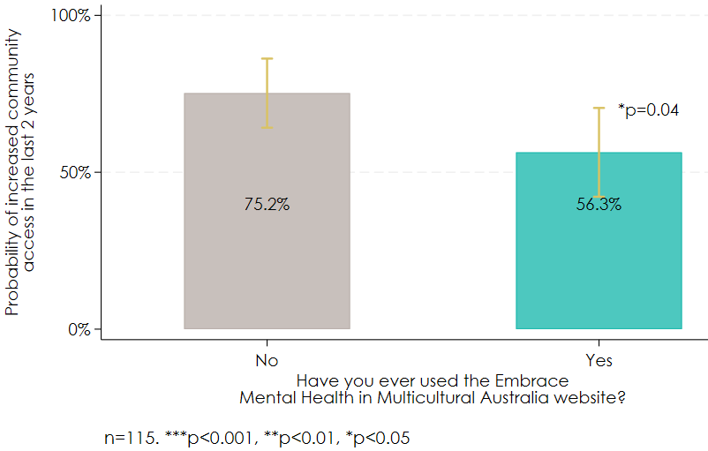

Note: This figure is based on a logit regression with robust standard errors. The bars represent the fitted probability (not the odds) of increased CALD community access at means of the treatment group (those who used the Website) and the control group (those who did not).

### Improved leadership to be culturally responsive is associated with increased CALD community access to mental health services.

The PHN/SP survey asked respondents whether they had improved leadership support to be culturally responsive in the past two years. Leadership support to implement the Embrace Project is an assumption in the Theory of Change because it is recognised as important for outcomes to occur, but it is not directly influenced by the Project.

The odds of respondents saying CALD community access to services had increased in the past two years in their service area was almost five times higher among those that had improved leadership support to be culturally responsive compared to those that didn’t, but this was only statistically significant at the 10% level (OR 4.709, p 0.099).

Figure 28. Positive correlation between leadership and CALD community access to mental health services

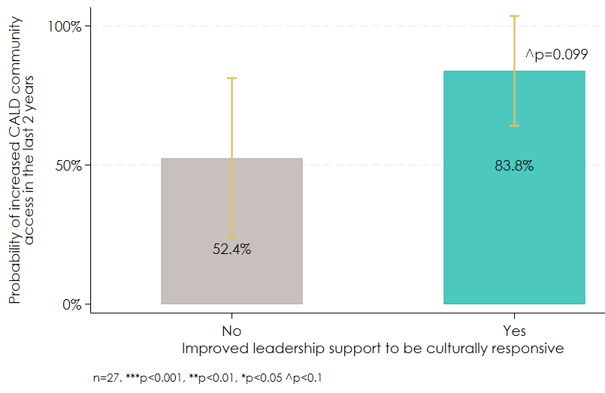

Note: This figure is based on a logit regression with robust standard errors. The bars represent the fitted probability (not the odds) of increased CALD community access at means of the treatment group (those who agreed with improved leadership support) and the control group (those who did not).

### CCEP organisations believe the CCEP will lead to increased access to mental health services.

It is too early to see any impact of the CCEP on CALD community access to mental health services. It is also unclear whether CCEP organisations have monitoring and evaluation systems in place. Nevertheless, CCEP organisations (n=3) perceived several benefits of community members’ involvement in the program that they believe will increase access to mental health services, including:

* Increased motivation to access care by increasing understanding of the importance of managing mental health issues and the value of professional support.
* Increased agency to access care by increasing community members’ confidence to ask for help if needed.
* Increased knowledge about when/how to get a referral for mental health care, costs involved with accessing mental health care, and different support channels in their area.
* Reduced stigma about mental health care through positive face-to-face interactions with service providers.

Given the small project that it was, you know and very limited in terms of time, it was only a 10-month project really. But yeah, those particular people involved with the project would have more access to mental health services. – CCEP organisation interviewee

These predictions support the hypothesised causal pathways in the ToC that involvement in the CCEP leads to increased mental health literacy, reduced stigma in CALD communities, improved CALD community agency, which leads to increased CALD community access to mental health care. However, these outcomes should be evaluated in the future with data collected directly from CALD community members.

### To improve mental health outcomes for CALD communities, PHNs and services providers were twice as likely to develop policies or improve resourcing than reduce the time or financial costs of accessing services.

PHN and service provider survey respondents were asked “In the past two years, have you/your organisation done any of the following to improve mental health outcomes for CALD communities in your service area?”.

Figure 29 shows the top two most popular responses were “Developed policies/strategies, e.g., targeting groups most in need, tailoring services, measuring access” (47%, n=99) and “Improved resourcing to be culturally responsive, e.g., interpreter service” (49%, n=102). The least popular response (22%, n=46) was “Reduced the time or financial costs of accessing services for CALD communities”.

Figure 29. Actions taken in the past two years to improve mental health outcomes for CALD communities

### There is evidence for the theory that increasing community information and reducing costs and stigma is associated with improved access to mental health services.

Verian’s rapid evidence review found that best practice to improve CALD community access to mental health services involves increasing the availability of information about mental health and reduce the costs (time or financial) and stigma associated with accessing mental health services.

We did not find evidence that these practices are associated with registering for the Framework (correlations in Appendix B). However, we did find evidence to support the theory itself which was a core Process Tracing hypothesis.

From our survey of PHNs and service providers, improved CALD community access to mental health services was associated with:

* Increasing the availability of information for CALD communities (coeff 0.231, p 0.008).
* Reducing the time or financial costs of accessing services for CALD communities (coeff 0.206, p 0.023).
* Reducing mental health stigma for CALD communities (coeff 0.212, p 0.012).

Figure 30. Positive relationship between increased availability of information for CALD communities and increased CALD community access to services

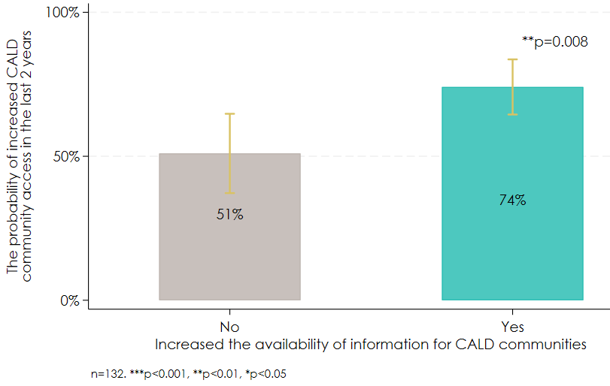

Note: This figure is based on a logit regression with robust standard errors. The bars represent the fitted probability (not the odds) of increased CALD community access at means of the Yes group (those who agreed with increased availability of information) and the No group (those who did not).

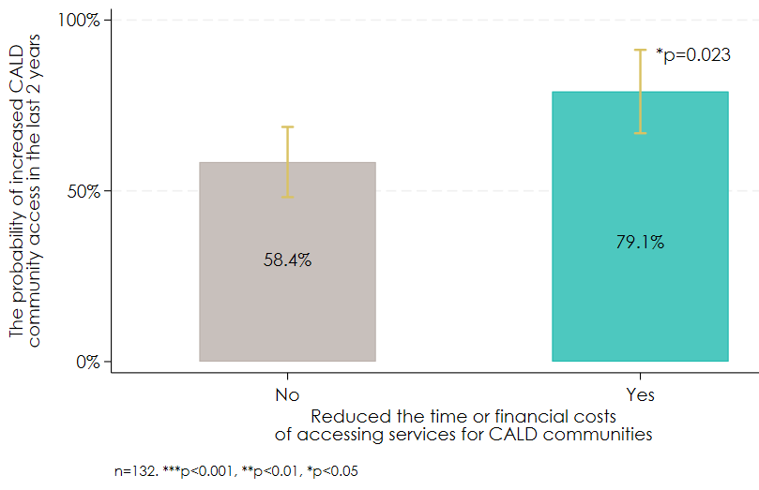

Figure 31. Positive relationship between reduced time and costs of accessing services for CALD communities and CALD community access.

Note: This figure is based on a logit regression with robust standard errors. The bars represent the fitted probability (not the odds) of increased CALD community access at means of the Yes group (those who agreed with reduced time and financial costs) and the No group (those who did not).

Figure 32. Positive relationship between reduced mental health stigma and increased CALD community access to services

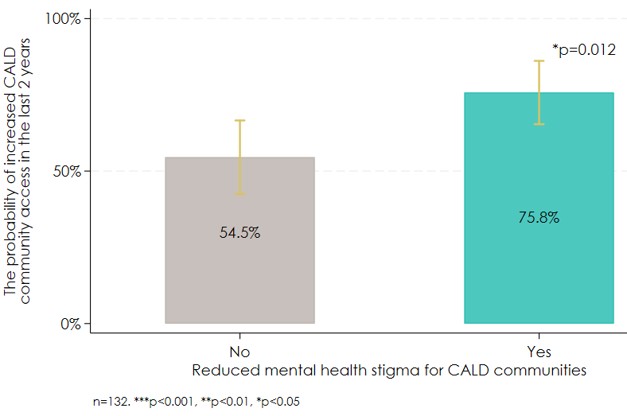

Note: This figure is based on a logit regression with robust standard errors. The bars represent the fitted probability (not the odds) of increased CALD community access at means of the Yes group (those who agreed with reduced MH stigma) and the No group (those who did not).

Implementation of improved information and reduced costs and stigma

The survey asked respondents how they/their organisation increased information and reduced costs and stigma for CALD communities. The most commonly cited reasons were as follows:

1. Increased the availability of service information for CALD communities (n=84) by:

* providing translation and interpretation services/ providing services and information in other languages (42% of respondents, n=35)
* engaging/working with CALD communities on outreach and service design (26% of respondents, n=22)

1. Reduced the time or financial costs to CALD communities (n=32) by:

* providing fee-free services (63% of respondents, n=20)
* seeking government funding, community fundraising or donations to fund services (25% of respondents, n=8)
* reducing transport costs by providing taxi vouchers, online/phone services, or community-based services (13% of respondents, n=4)

1. Reduced mental health stigma for CALD communities (n=46) by:

* providing mental health awareness and literacy workshops or information sessions for CALD communities (41% of respondents, n=19)
* running events focussed on lived experience, destigmatisation, help-seeking and encouraging conversations around mental health (26% of respondents, n=12)
* running campaigns via social media or posters to promote mental health services and anti-stigma messages to CALD communities (17% of respondents, n=8)
* providing information in other languages (15% of respondents, n=7).

Alternative hypothesis

We also tested the alternative Process Tracing hypothesis that something else is driving improvement in CALD community access to mental health services.

Survey respondents who said CALD community access to mental health services in their service area had increased or decreased were asked “What do you think is driving this change?”

We conducted emergent thematic analysis on the free text responses (n=87) and found the most cited reason for increased access was increased education and awareness around mental health among CALD communities and service providers (42%, n=27). The most cited reason for decreased access was lack of culturally responsive services/staff (32%, n=7).

These responses are consistent with the Theory of Change and therefore do not support the alternative hypothesis.

## Recommendations related to KEQ 7

7.1 Develop and deliver a specialised leadership program. Given leadership support to be culturally responsive may have a large impact on improving CALD community access to services, we recommend that Embrace introduce a specialised leadership program for the mental health workforce. This could include face-to-face meetings between the Embrace team and leaders to present benefits/ROI of engaging with the Framework; mentoring between a CALD CEO and a non-CALD CEO; training on how to role model cultural inclusion to staff; and an annual award to recognise culturally inclusive leaders. Leaders could also be given tools to reduce status quo bias among their staff as this was associated with cultural skills (coeff 0.157, p 0.046) in our survey analysis. One such tool is the REDUCE change management framework by the Wharton School.[48] It can be followed when leaders present a new idea to their team to get them excited about the possibility of change.

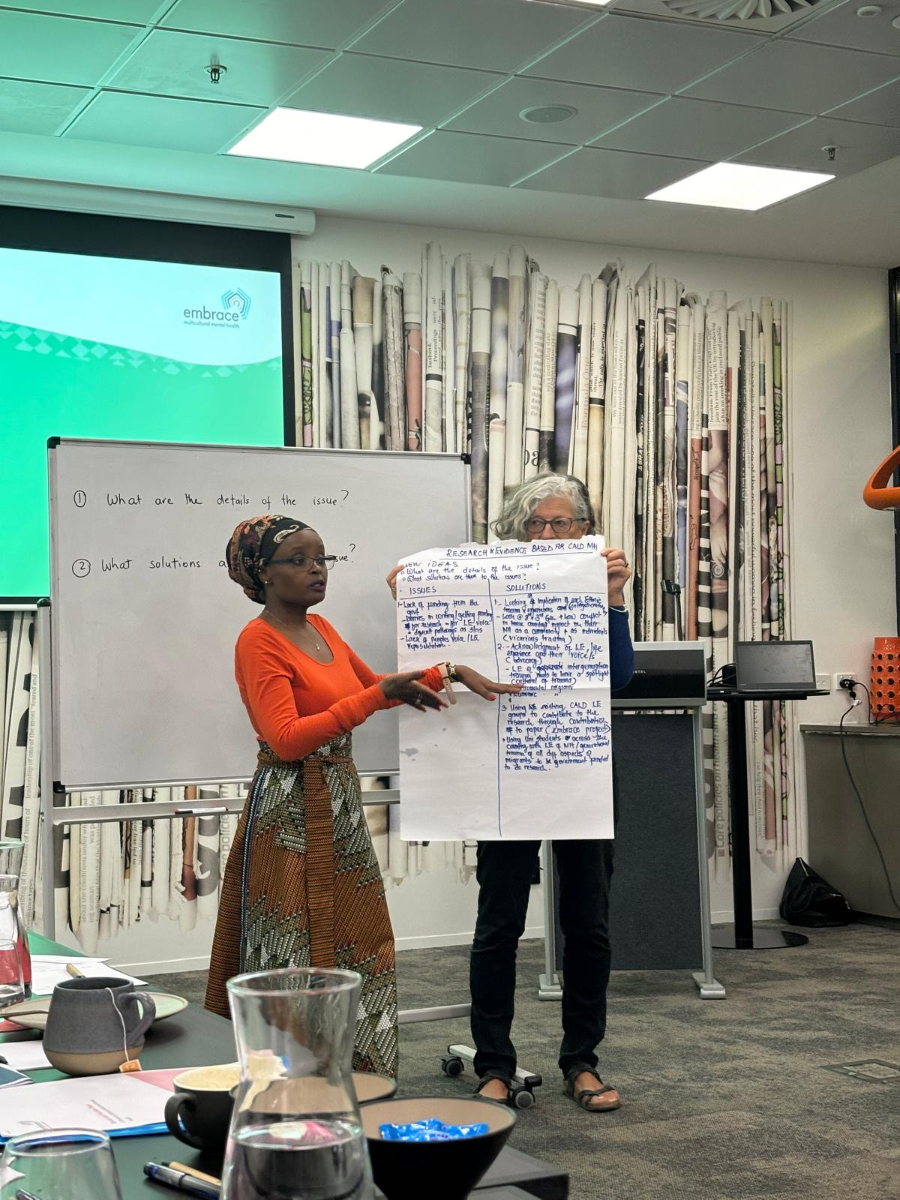

# KEQ8: Impact of the Project on CALD mental health service design

Did the Embrace Project build new knowledge about CALD mental health service design? How and how much? What was the contribution of the research reports and CALD community participation in service design, delivery, and evaluation?

## Overview of findings

* The commissioned research reports and CCEP generated new knowledge about how specific CALD communities view mental health.
* Governance group members said the research reports provided new knowledge about the views of specific community groups but were unsure how the research has been used.
* The CCEP promoted CALD community agency to participate in service design and delivery.

## How we answered KEQ 8

KEQ 8 examined learnings from the CCEP and commissioned research reports about how to design culturally inclusive mental health services.

### Related ToC components

KEQ8 is related to two long-term outcomes from the CCEP and one short-term outcome from the commissioned research reports.

Long-term outcomes from the CCEP:

* Ongoing CALD community participation in service design, delivery, and evaluation: Co-design is becoming a common global practice in health service design, delivery and evaluation as organisations and leaders recognise the value of lived experience. Co-design can enable consumers to become equal partners with service providers in the improvement process.[49],[50]
* New knowledge about CALD mental health service design: For continuous improvement in access to services, the Embrace Project aims to generate new knowledge about effective service design.

Short-term outcome from commissioned research:

* Build the evidence base on CALD mental health in Australia. Verian’s rapid evidence review identified a lack of evidence about what works to improve CALD mental health outcomes in Australia, and this is a key aim of the Embrace Project through commissioning research.

An output of commissioning research in the ToC is the “Research reports summarise key findings and recommendations”. This is discussed under KEQ2.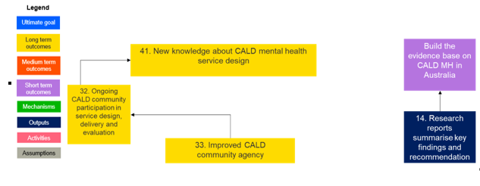

### Data sources

Embrace does not keep records of the new knowledge generated from various funded activities. Therefore, we could not objectively assess how much new knowledge has been generated by the Embrace Project.

To answer the KEQ, we analysed interview data from project administrators (n=6) and governance group members (n=9) to understand how topics for commissioned research were chosen and whether the findings of the research extended the evidence base on CALD mental health in Australia or reinforced existing knowledge.

We also reviewed the research reports and assessed how clearly the findings and recommendations were presented.

We asked CCEP organisations (n=3) and governance group members (n=9) about the extent to which CALD community involvement in the CCEP increased participants’ likelihood they will participate in service design and delivery in the future.

We also asked about the extent to which CALD community co-design in the CCEP generated new ideas to improve mental health services that had not previously been identified by the Embrace Project.

## Findings for KEQ 8

### The commissioned research reports and CCEP generated new knowledge about how specific CALD communities view mental health.

Between 2022-23 the Embrace Project commissioned four research reports. Our review of the reports found that each one clearly stated the findings, recommendations, and next steps.

These research reports generated new knowledge about how specific CALD community groups view mental health. For example, a literature review was conducted on mental health and stigma in Arabic, African and Chinese communities.[51] It found that:

* The Chinese community believe that people with mental illness are dangerous and untrustworthy, weak, and have a poor work ethic. The family lineage of a person with mental illness may be perceived as tainted which has also been reported to negatively affect romantic and marriage prospects. Having a mental illness diagnosis has been associated with loss of ‘face’, which, in the Chinese cultural context, refers to an individual’s social status, image, and integrity. Maintaining one’s social status and integrity is essential and can be a deterrent to admitting an experience of mental illness.
* The Arabic community explain mental illness as being caused by evil supernatural forces or religious reasons such as punishment from God, or as originating from personal weakness. They also perceive mentally ill people as dangerous and unpredictable. Professional help-seeking for mental illness is not accepted by the Arabic-speaking community and if an individual seeks help, they are perceived as “mad”. Rather, an individual with mental illness is kept within the home and professional help-seeking is discouraged to prevent others finding out about the presence of mental illness.
* The African community perceive that mentally ill people are strange and abnormal, dangerous to society, unpredictable, and hopeless. Fears of being socially isolated and ostracised due to mental illness as well as not wanting to bring shame to the family or community contributes to denial of symptoms.

The literature review also provided examples of ways to facilitate increased help-seeking in these communities. For example:

* The delivery of the African mental health learning circle established in 2016 in NSW provided community members, leaders, and service providers an opportunity to be involved in group discussions to learn about mental health issues as well as help-seeking options.
* For the Arabic community, as leaders are often the first point of contact for individuals experiencing mental health problems, increasing the mental health literacy of leaders has been shown to help facilitate professional help-seeking in the Arabic speaking community.
* Culturally appropriate modifications to an internet based Cognitive-Behavioural Therapy program was found to be successful in engaging Chinese individuals.

The CCEP projects also generated new knowledge about how specific CALD communities view mental health. For example, according to an interview the CCEP organisation that led the co-design activities with the Afghan community, the following insights were surfaced about how they view mental health:

* People with mental ill health are “crazy”, “insane”, “not normal”.
* Having a mental illness will lead to being ostracized from the community and social gatherings.

### Governance group members said the research reports focused on under-researched communities but were unsure how the research has been disseminated.

Some governance group interviewees (n=3) described being consulted on the topics for the commissioned research. They believed the process of selecting topics had been well thought-out by the Embrace team to ensure representation of under-researched communities.

We all had input, and we collectively chose the communities that were going to be researched. – Governance group interviewee

I think the COVID research was very relevant, I think the Arabic and Chinese are very relevant and they're very big language and community groups within the Australian context. – Governance group interviewee

Some governance group interviewees (n=3) could remember there had been two webinars to discuss the findings of the research, but most governance group interviewees (n=6) were not sure what the outputs of the research were and/or had not read the reports.

I never had the opportunity to see that research as a finished product, but we had influence in that [selecting the topics for the research]. – Governance group interviewee

I'm aware of the research reports but I've not read them. – Governance group interviewee

I don't know how far along that research is, or if there's any outcome yet. – Governance group interviewee

An MHA interviewee believed there was strong engagement in the dissemination of the research.

Certainly, the webinars we had to highlight the findings of that research were extremely well attended. – MHA interviewee

### The CCEP may enhance CALD community interest to participate in service design and delivery in the future.

CCEP organisations (n=3) believed the CALD community members that participated in the co-design activities had increased personal competence to participate in future service design and delivery. While they were unclear whether there would be future opportunities for co-design, all three CCEP organisations felt the community members that had initially participated would be interested in participating again. They also believed that co-design participants would share their experience with others from their community, which would lead to increased interest and willingness to participate in future service design by others from the community

Yes, I think it will increase the community’s interest to participate. I think it's the way forward. The co-design aspect is hard, we know it's hard in terms of it takes longer, but it is a good approach. – CCEP organisation interviewee

## Recommendations related to KEQ 8

8.1 Develop a comprehensive database of the new knowledge generated by all Embrace Project activities and ensure this knowledge has a tangible influence on future service design, delivery, and evaluation. Currently Embrace does not record the knowledge outcomes that are generated by Embrace activities. This knowledge represents return on investment. Therefore, Embrace should keep track of which activities generate better return (i.e., more knowledge). In addition, unless knowledge is applied it is useless. Therefore, Embrace should develop systematic processes to translate this knowledge into service design, delivery, and evaluation – both internally (i.e., Embrace funded activities) and externally (i.e., Embrace’s thought leadership and influence over sector such as attending conferences and advising organisations on service design).

8.2 Promote the use of co-design across the sector by publishing case studies of the CCEP and its outcomes. In advanced economies, co-design in health services is considered best practice but it is still under-utilised because it is hard. Co-design requires service providers to have strong leadership, to be brave and courageous, and to develop new infrastructure and governance systems. Embrace can help to tip the cost-benefit ratio so that the benefits are perceived to outweigh the costs, by publishing case studies about the CCEP co-design process. These case studies could highlight the benefits to all involved and the new knowledge outcomes that were generated. Over time and with an effective monitoring and evaluation system in place, these case studies could be updated to show how the application of the new knowledge in service design and delivery led to improved outcomes for CALD communities.

# KEQ 9: Cost-effectiveness of the project

How cost effective is the Embrace Project’s impact on improving workforce cultural competence?

## KEQ 9 could not be answered

We intended to conduct a cost-effectiveness analysis to measure the cost of achieving improvements in workforce cultural competency. However, as our analysis found a null result, we were unable to conduct a cost-effectiveness analysis.

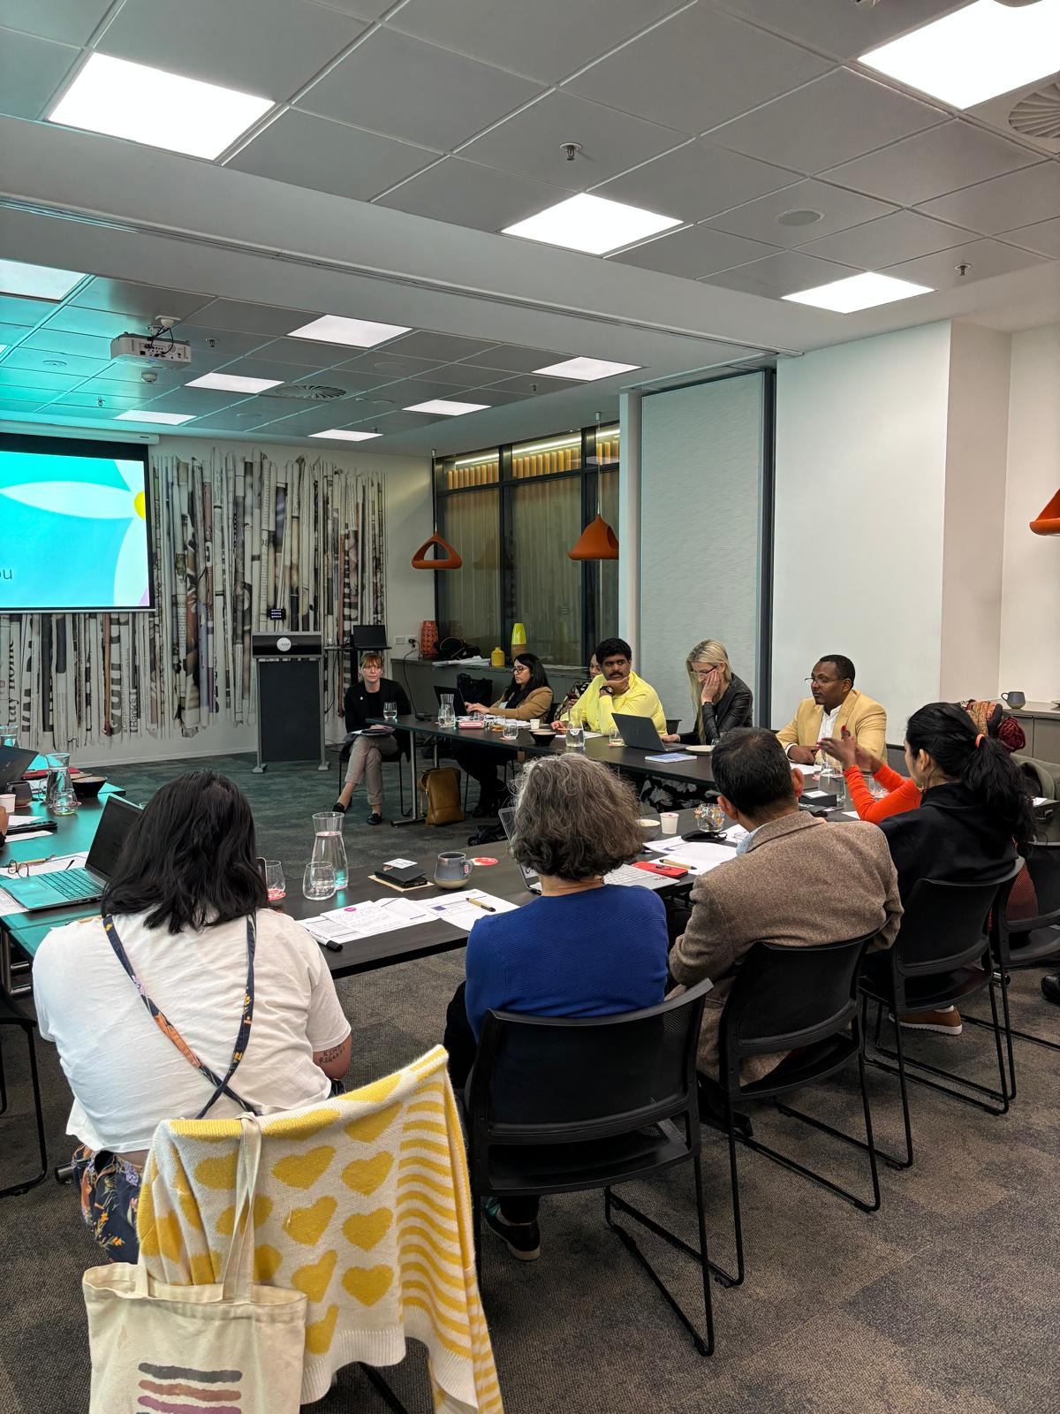

# Conclusion

This evaluation focused on the design, implementation and outcomes of the CCEP and Embrace Framework, with a smaller focus on other activities and resources delivered under the Embrace Project.

The Embrace Project design was appropriate based on existing evidence of best practice, but the current international evidence base of what works to improve mental health service access and outcomes for CALD communities is limited due to a lack of rigorous evaluations.

The Embrace team and governance groups responsible for delivering the Embrace Project were knowledgeable and committed. They implemented activities effectively and efficiently.

Given the scale of the problem the Embrace Project seeks to address, the breadth of activities being delivered under the Embrace Project may compromise depth. The Embrace team have limited resources to continually optimise outputs, such as the website, which is important if the Embrace Project is going to meet the changing needs of the workforce and CALD communities in Australia.

Audiences that have engaged deeply with the Embrace Project, such as through human-to-human interaction, find it extremely valuable. However, Embrace is operating in a complex and noisy digital environment of competing sources of information about multicultural mental health so capturing audience attention will become increasingly difficult. Carving out a unique offer that is scalable and building a rigorous monitoring and evaluation system around that offer, would ensure the Embrace Project stays relevant and delivers value for money into the future.

The Embrace Project is ultimately a behaviour change program – seeking to increase culturally responsive workforce practices and increase CALD community take-up of services. Focusing on how behaviour change occurs, instead of only providing information, should be the strategic focus of the Embrace Project in the future.

The behavioural science evidence shows knowledge is necessary but not sufficient to change behaviour. Behaviour change is most likely to occur when we make the right behaviours effortless through material incentives, social support and easier access.[52]

The findings of this evaluation are consistent with the behavioural science literature. We found that providing social support and improving program access through the targeted PHN support and community co-design were essential to the achievement of outcomes. However, these ways of working are very resource intensive, so the program can only scale through a self-service model. Therefore, improving the user experience of the Embrace website and developing a leadership program for organisations to create internal social support would help to maximise outcomes. In terms of material incentives, mandating mental health service providers under PHN-funded contracts demonstrate they are culturally responsive was a key suggestion from evaluation participants which should be explored.

This evaluation also found two other drivers of culturally responsive workforce practices – self-awareness of one’s own cultural competence and open mindedness to change. These mechanisms of change could be amplified in the Embrace Project design to further maximise outcomes. For example, the following short evidence-based interventions could be embedded within the Embrace Framework: (1) explain the cognitive bias in which people with limited competence in a particular domain overestimate their abilities (the Dunning-Kruger effect). By raising awareness of the bias, it can help people recognise it in themselves. (2) provide tools for people to measure their perceived and actual cultural competence. By comparing the difference, they can more recalibrate their self-awareness (3) ask people to briefly write about their core values (a values affirmation exercise) before learning about the behaviours they need to change to be more culturally responsive. By affirming their values, people feel less defensive to change.

Before implementing these and other strategies to increase the Embrace Project’s impact suggested in this report, the Embrace team should catalogue and assess the value of all the new knowledge generated by all Embrace Project activities to ensure this knowledge has a tangible influence on future service design, delivery, and evaluation. Currently Embrace does not record the knowledge outcomes that are generated by Embrace activities.

A summary of key evaluation findings for the CCEP and Embrace Framework follow.

CCEP

The CCEP is in its early stages of implementation and therefore we could not rigorously evaluate its impact on the CALD community. Interviews with the commissioned CCEP organisations suggest co-designing mental health resources with CALD community members is working well and those that participate in co-design are likely to experience improved mental health outcomes. These organisations also expressed positive expectations about the program improving mental health service access among the wider CALD communities where the CCEP is being delivered but a rigorous monitoring and evaluation system needs to be developed now to ensure hope and prediction are matched by actual outcomes.

Embrace Framework

The Embrace Framework allows organisations and individual practitioners to evaluate and enhance their cultural responsiveness, with access to a range of support and resources.

While the Framework itself did not have many statistically significant impacts on workforce practices or CALD community service access, it did help the workforce to evaluate their own cultural competence and become more self-aware of their strengths and weaknesses. Our survey of PHNs and mental health service providers found using the Framework improved self-awareness of one’s own cultural competence by 22%.

This improved self-awareness is critically important for the Embrace Project to achieve its ultimate goal. Being self-aware of one’s own cultural competence is a mindset that can influence millions of small decisions in everyday practice with CALD communities. When this impact is aggregated across the workforce it may lead to positive system changes. Therefore, the Embrace Project’s impact on improving the workforce’s estimation of their own cultural competence is an important contributor to sustainably improving CALD outcomes.

One of the barriers to changing work practice is that people may not be open to it. We found support for the theory that the workforce needs to be open to change to improve their cultural skills. Reduced status quo bias was positively correlated with cultural skills (coeff 0.157, p 0.046).

Two possible reasons why we didn’t detect a positive effect of the Framework on many workforce practices or CALD community outcomes is that:

1. There are other sources of professional learning in the market that appear to be equally effective. Because of the division of powers across Australia’s levels of government, services operating within a single state or at a local level may default to state-based or local-level sources of professional learning.

Survey respondents that said a community-led multicultural service best supports their learning needs about culturally inclusive mental health service delivery had higher cultural competence compared with those that said all other organisations, including Embrace. This finding was statistically significant (coeff 0.616, p 0.024).

1. Changing systems and processes to close the “research-practice gap” takes time so the effects of professional learning may not be seen for many decades. Research shows it takes an average of 17 years for best practice to be implemented at scale.[53] Furthermore, if incremental improvements are occurring, our survey sample may have been too small to detect an effect and more time may need to pass to see outcomes in the data.

Two interviewees summed up this sentiment well:

I wouldn't read any sort of lower-than-expected numbers or poor feedback about people using the Framework as a sign of failure. It's just a sign of it's just got more work to do. Definitely this kind of thing and any type of cultural change is a long game. – PHN/SP interviewee

They [Embrace intended outcomes] are big objectives and it’s important to remember it’s not something we complete but something we should always consider as on-going. Otherwise, we would create an illusion we could tick it off and it would be done. – Governance group interviewee

One of the most important drivers of improved CALD community access to services appears to be workforce leadership support to deliver culturally responsive services. The odds of survey respondents saying CALD community access to services had increased in their service area was almost five times higher among those that had improved leadership support to be culturally responsive compared to those that didn’t (OR 4.709, p 0.099).

A valuable investment for the Embrace Project will be to create a leadership program in the future to ensure organisational change has top-down buy-in. Our survey of PHNs and mental health service providers found most of the buy-in is currently bottom-up. When asked what caused their workforce practices to become more culturally responsive, most respondents cited individual reasons (motivation and agency) rather than organisational factors (capacity and diversity). For example, 73% of respondents (n=114) said the change was attributed to them treating cultural responsiveness as an ongoing priority but only 22% (n=34) said the change was attributed to their organisation prioritising cultural diversity in its staff retention practices.

Targeted support for PHNs to implement the Framework was highly valued and appears to have helped organisations put in place the necessary systems and processes to deliver culturally responsive services. This is consistent with evidence that there is greater adherence to continuous quality improvement guidelines when healthcare services are provided implementation support.[54]

The Embrace team is unlikely to ever have sufficient FTE to provide targeted support to the thousands of mental health organisations in Australia. Some ways to support organisations to start their implementation journey is to improve the usability of the website and reduce the hassle of registering for the Framework. Also embed into the Framework more evidence-based strategies for effective professional learning, promoting open mindedness, and helping the workforce correctly estimate their own cultural competence. In addition, some of the Framework implementation tools that the Embrace team provide to PHNs in the targeted support program, such as checklists, could be included in the Framework.

We conclude that the current theory of how to improve CALD community access to services is supported by the data. We found that:

* Improving CALD community access to mental health services is associated with increasing the availability of information about mental health (coeff 0.213, p= 0.008), reducing the time or financial costs of accessing services (coeff 0.206, p 0.023), and reducing mental health stigma (coeff 0.212, p 0.012).
* Having positive encounters with CALD community members is positively correlated with workforce cultural competence (coeff 0.214, p <0.001).
* Continuous belief updating is positively correlated with workforce cultural responsiveness (coeff 0.109, p < 0.001).

However, as these effect sizes are relatively small, there is a need to maximise outcomes though more strategic use of behavioural science. By focusing on how behaviour change happens, small changes at specific intervention points within the Embrace Project design can be leveraged to improve outcomes without requiring a large amount of new investment.

Finally, a consistent finding across this evaluation is that better monitoring and evaluation needs to be embedded in the Project design to enable continuous optimisation and adaptation to the changing needs of Embrace’s audiences. This is something Verian will assist with in the next phase of work.

# Summary of recommendations

We have provided a summary table of recommendations separately for DoHAC and MHA below. The recommendations have been prioritised based on their expected level of impact on the Embrace Project, the amount of time and resources that are required for each one, and the logical sequencing of each one relative to the others.

A priority rating of “1” represents a recommendation that is likely to have a medium to large impact on achieving the intended outcomes of the Embrace Project, requires a relatively low level of resources and/or can be achieved in less time, and/or should be logically completed before other recommendations.

A priority rating of “2” represents a recommendation that is likely to take a longer time and/or more resources to complete, but also may need another recommendation to be completed first, to optimise its effectiveness.

For example, increasing promotion of the Embrace Project is a high priority as is likely to lead to increased uptake of all resources and thus greater outcomes. However, it has been given a priority level of “2” as it would be inadvisable to increase visits to the website until the website has been updated to improve its accessibility and usability.

Only one recommendation received a priority rating of “3” and this was development of a leadership program, which will likely achieve huge impact for the Embrace Project but may take a significant amount of time and resources to plan, design and deliver.

# Summary of recommendations for DoHAC

| Rec # | Recommendation | Supporting evidence from this evaluation | Expected outcome | Priority level (1-3) |
| --- | --- | --- | --- | --- |
| 1.1 | Include a clause in all PHN contracts with mental health service providers that the service must demonstrate how it is culturally responsive. DoHAC could support services to achieve this by identifying auxiliary supports that could be tied into current mental health services, such as transport or interpreters. | We asked all evaluation interviewees (n=26) about ways they would improve the Embrace Project to increase its effectiveness in achieving intended outcomes. Several suggestions were made and the most common was mandating PHN-funded mental health service providers show how they are being culturally responsive (suggested by 7 interviewees). | More mental health service providers would put in place policies and practices to improve service access and outcomes for CALD communities. | 2 |
| 1.2 | Develop and publish a national multicultural mental health strategy to facilitate a nationally consistent approach and set of performance indicators to aim for when developing, implementing, and evaluating culturally responsive service strategies. This would also provide a standard to operationalise recommendation 1.1. | Similar to recommendation 1.1, this recommendation was developed based on responses to asking all evaluation interviewees (n=26) about ways they would improve the Embrace Project to increase its effectiveness in achieving intended outcomes. The second most common suggestion was developing a national multicultural mental health strategy (suggested by 5 interviewees). | More service providers will follow best practice when implementing strategies to be culturally responsive. | 1 |
| 1.3 | Require rigorous monitoring and evaluation systems across all Commonwealth CALD mental health funding to build the evidence base on what works. There is still a large gap in the literature on how to improve service access and outcomes for CALD communities. DoHAC could ask for support from the new Australian Centre for Evaluation in The Treasury given their mission is aligned. | Our rapid evidence review found very few evaluations of interventions to build workforce capability or improve mental health support for CALD communities were rigorous and often they focused on outputs not outcomes. | A stronger evidence base to inform future policy and funding and therefore greater return from investments. |  |

# Summary of recommendations for MHA

| Rec # | Recommendation | Supporting evidence from this evaluation | Expected outcome | Priority level (1-3) |
| --- | --- | --- | --- | --- |
| 1.4 | Embed ongoing monitoring and evaluation into the Project design. | Many interviewees (n=18) said there is not sufficient data to assess the Project’s reach and outcomes. Verian also found limited administrative data were available to conduct this evaluation. | More accurate and rapid assessments of the extent to which the Project is achieving its intended reach and outcomes, to support continuous improvement. | 1 |
| 1.5 | Incorporate evidence-based strategies for effective professional learning into the Framework and other cultural competency training Embrace provides. | In 2021, the UK Education Endowment Fund published a meta-analysis of 104 studies on what makes professional learning effective.[55] The authors found there are 14 strategies that can be incorporated in any form of professional learning to drive greater improvements in professional practice, e.g., goal setting, feedback, and self-monitoring. These strategies could be used to enhance the Framework and other cultural competency training Embrace provides. The Framework currently includes some of these strategies, such as the self-reflection tool, but the meta-analysis found the more strategies incorporated in professional learning, the more effective it is.  Verian’s rapid evidence review also identified potential strategies to improve professional learning resources such as short videos explaining key concepts, optional readings, quizzes to consolidate learnings, and facilitation of interdisciplinary groups to discuss implementation in their setting. However, these strategies have not been rigorously evaluated for impact on professional practice. | Professional learning will lead to greater changes in practice. | 2 |
| 2.1 | The Embrace team should seek individual feedback from members on an annual basis about how they would like to influence the Embrace Project and how this would contribute to achieving the Embrace Project’s objectives.  This would assist in ensuring high-quality input from the governance groups continues and that members continue to feel valued.  To enable honesty and openness, this could be done via an anonymous survey rather than during a governance group meeting. | Interviews with governance group members (n=5) and MHA (n=3) found misalignment between governance group members’ expectations/interests and their role as outlined in the ToR. | Governance group members will continue to feel valued and make productive contributions to the Embrace Project. | 1 |
| 3.1 | Increase Framework uptake by developing and implementing a plan to promote the Framework to new audiences using existing resources. For example, workplace Employee Assistance Programs and school counsellors have not yet been targeted and may have capacity and interest in implementing the Framework. | Framework uptake is low (16% of survey respondents), but the Embrace team lack resourcing to create new promotional materials (<4 FTE). | Greater return on investment from the Embrace Project. | 2 |
| 3.2 | Conduct a “sludge audit” of the Embrace website to improve its accessibility and usability. Sludge is defined as the excessive or unjustified frictions that make it harder for people to achieve their goals. | Governance group and PHN interviewees (n=6), usability testing, and ethnography found the Embrace website has a confusing layout, out of date information, and a confusing multi-step registration process for those wanting to complete module 1 of the Framework. This may have reduced Framework uptake. | Greater uptake of the Framework. | 1 |
| 3.3 | Continue to collect user feedback on the website and ensure the Embrace team can regularly make website improvements without needing the assistance of a developer. | According to MHA staff interviews (n=3) improvements to the Embrace website have been constrained by a lack of user experience data and the time and cost of engaging a website developer to make even small changes. | The website will be continuously improved to meet the changing needs of Embrace audiences, consistent with the aim of being a definitive online resource for those needing information and resources about multicultural mental health. There will also be greater uptake of the Framework. | 1 |
| 4.1 | Measure the difference between actual and perceived cultural competence as part of the Framework. It’s important for the workforce to accurately estimate their own cultural competence. The Framework seems to be having a positive impact in this regard, but the sample size was limited. Therefore, the Embrace team should systematically evaluate this outcome as people progress through the Framework modules. | The evaluation found that it’s important for the workforce to accurately estimate their own cultural competence to drive changes in behaviour. The Framework seems to be having a positive impact in this regard, but the sample size was limited. | Greater confidence that the Framework is improving the workforce’s self-awareness of their own cultural competence. If the Framework is not doing this, the content of the modules can be updated to achieve this aim. | 2 |
| 4.2 | Introduce activities into the Framework which encourage openness to working differently. Being open to change was associated with improved cultural skills so introducing evidence-based activities that increase openness can potentially increase the Embrace Framework’s impact.  For example, the first module could start with a 10-minute values affirmation exercise where people write about their core values. | Analysis of PHN/SP survey data found a statistically significant positive relationship between openness to working differently and cultural skills (coeff 0.157, p 0.046). | Greater skill development among Framework users. | 1 |
| 6.1 | Introduce more ways for the Embrace Project to increase the workforces’ self-awareness of their own cultural competence. Given the evidence that improved self-awareness of cultural competence is associated with greater sense of agency in delivering culturally responsive services, the Embrace Project should help individuals more accurately estimate their cultural competence. One of the best strategies to do this is simply to raise awareness of the cognitive bias that people with low competence in a particular domain tend to overestimate their ability. | Analysis of PHN/SP survey data found improved self-awareness of cultural competence was associated with greater agency in delivering culturally responsive services and this relationship was statistically significant (coeff 0.072, p 0.005). | Greater agency among Framework users. | 2 |
| 6.2 | Explore delivering the Embrace Project through partnerships with community-led multicultural services. Given the importance of community-led multicultural services for professional learning, Embrace should explore partnership opportunities to promote the Embrace Project. In addition, by collaborating with other organisations that offer progressional learning about culturally responsive service delivery, Embrace could identify needs in the market that aren’t currently being met and develop new offerings to fill these gaps. | We asked respondents to the PHN/SP survey: “which organisation best supports your learning needs?” and just over half of all respondents (54%, n=74) said a community-led multicultural service, followed by Embrace (16%, n=22). | Greater promotion of the Embrace Project and identification of new offers to fill gaps in the market. | 2 |
| 7.1 | Develop and deliver a specialised leadership program. Given leadership support to be culturally responsive appears to have a large impact on improving CALD community access to services, we recommend Embrace introduce a specialised leadership program for the mental health workforce. | Analysis of our PHN/SP survey data found that the odds of respondents saying service access had increased was almost five times higher among those that had improved leadership support to be culturally responsive compared to those that didn’t, but this was only statistically significant at the 10% level (OR 4.709, p 0.099). Leadership support to implement the Embrace Project is an assumption in the Theory of Change because it is recognised as important for outcomes to occur but it is not directly influenced by the Project. | Faster and more comprehensive workforce organisational changes. | 3 |
| 8.1 | Develop a database of knowledge generated by Embrace activities and establish processes to translate this knowledge into service design, delivery, and evaluation. | Currently Embrace does not systematically record the knowledge outcomes that are generated by activities, and it is unclear how this knowledge is being applied to new initiatives. For example, six governance group members said they did not know how the findings of commissioned research were used. | Greater return on investment from the Embrace Project. | 2 |
| 8.2 | Promote the use of co-design across the sector by publishing case studies of the CCEP and its outcomes. These case studies could highlight the benefits to all involved and the new knowledge outcomes that were generated.  Over time and with an effective monitoring and evaluation system in place, these case studies could be updated to show how the application of the new knowledge in service design and delivery led to improved outcomes for CALD communities. | Social proof can lead to uptake of best practice in health service design.[56]  Through case studies demonstrating effective co-design and its impact, Embrace can help other organisations to see the that the benefits of co-design outweigh the effort and resources involved. | Greater number of mental health organisations undertaking service co-design with CALD communities, which can improve outcomes for these communities. | 2 |

# Appendix A: Data matrix

| KEQ | ToC component | ToC Category | Data source | Measurable definition of success | Survey question wording | Metric: item number in data source | Analysis |
| --- | --- | --- | --- | --- | --- | --- | --- |
| 1. Was the Embrace Project design effective and efficient to achieve the intended reach and outcomes?  What else could be done to: (a) support the mental health workforce to deliver culturally competent services?  (b) increase CALD community access to mental health care? (c) improve mental health outcomes for CALD communities? | 3. Commission research projects and input into external research | Activity | Gov Group Interviews | Research is filling gaps in knowledge in a timely way | N/A | N/A | Framework Analysis |
| PM/Admin Interviews | N/A | N/A | Framework Analysis |
| Rapid evidence review | N/A | N/A | N/A |
| 4. Commission orgs to co-design community action plans with CALD communities | Activity | Gov Group Interviews | CCEP design is effective and efficient for achieving reach and outcomes | N/A | N/A | Framework Analysis |
| PM/Admin Interviews | N/A | N/A | Framework Analysis |
| CCEP Community orgs Interviews | N/A | N/A | Framework Analysis |
| Performance reports | Recommendations in review are reflected in current Embrace Project | N/A | 7 | Framework Analysis |
| 5. Update and enhance the website to be a central Hub of information/support | Activity | Gov Group Interviews | Website design is effective and efficient for achieving reach and outcomes | N/A | N/A | Framework Analysis |
| PM/Admin Interviews | N/A | N/A | Framework Analysis |
| Performance reports | Recommendations in review are reflected in current Embrace Project | N/A | 7 | Framework Analysis |
| 6. General promotion of the program to the sector | Activity | Gov Group Interviews | Promotion of program is effective and efficient for achieving reach and outcomes | N/A | N/A | Framework Analysis |
| Performance reports | N/A | 18; 30 | Framework Analysis |
| PM/Admin Interviews | N/A | N/A | Framework Analysis |
| 7. Orient interested MH service providers to implement the Framework | Activity | Gov Group Interviews | Support for MH Service providers is effective and efficient for achieving reach and outcomes | N/A | N/A | Framework Analysis |
| PM/Admin Interviews | N/A | N/A | Framework Analysis |
| PHN/SP Interviews | N/A | N/A | Framework Analysis |
| 8. Deliver targeted support to interested PHNs on implementing the Framework | Activity | Gov Group Interviews | Targeted support for PHNs is effective and efficient for achieving reach and outcomes | N/A | N/A | Framework Analysis |
| PM/Admin Interviews | N/A | N/A | Framework Analysis |
| PHN/SP Interviews | N/A | N/A | Framework Analysis |
| Performance reports | Recommendations in review are reflected in current Embrace Project | N/A | 7 | Framework Analysis |
| 2a. How efficiently were the Embrace Project’s activities implemented and what were the barriers and enablers to implementation, including stakeholder collaboration, skills, and resources?  2b. Did the Alliance members (Federation of Ethnic Communities Councils of Australia and National Ethnic Disability Alliance), Lived Experience and Stakeholder Groups achieve influence and benefits? | 1. Engage with Alliance Group, Stakeholder Group and Lived Experience Group | Activity | Gov Group Interviews | Implementation was efficient | N/A | N/A | Framework Analysis |
| PM/Admin Interviews | N/A | N/A | Framework Analysis |
| 2.1. Governance Groups provide project oversight and address relevant issues in the community and sector | Output | Gov Group Interviews | Alliance members had influence and achieved benefits from participation | N/A | N/A | Framework Analysis |
| 2.2. Governance Groups improve their understanding and promotion of program | Output | Gov Group Interviews | N/A | N/A | Framework Analysis |
| 3. What was the level of uptake of the Framework and the CALD Community Engagement Project (CCEP) by target audiences?   What were the barriers and enablers to uptake, including perceived accessibility/ usability/ relevance/ quality of the project outputs (website, communications, resources, CCEP, and Community of Practice/training)? | 19. CALD communities take up program | Short-term outcome | CCEP Community orgs Interviews | High rate of take-up of CCEP by CALD communities | N/A | N/A | Framework Analysis |
| Performance reports | N/A | 19 | Count |
| 10. Embrace website and resources are accessible/usable to intended audiences | Output | Usability Testing | Easy to understand and Practical to use | N/A | N/A | Framework Analysis |
| Ethnography | N/A | N/A | Framework Analysis |
| PHN/SP Interviews | N/A | N/A | Framework Analysis |
| CCEP Community orgs Interviews | N/A | N/A | Framework Analysis |
| PHN SP Survey | The Embrace Framework is: (1) Easy to understand [% yes] | C8_1 | Descriptive |
| PHN SP Survey | The Embrace Framework is: (4) Practical to use [% yes] | C8_4 | Descriptive |
| Hotjar Survey | The information on this website is easy to understand (a) yes (b) no | 4 | Descriptive |
| 11. Engagement communications are accessible/usable to intended audiences | Output | Ethnography | Easy to understand and Practical to use | N/A | N/A | Framework Analysis |
| Project documents | N/A | 18 and 24 | Framework Analysis |
| CCEP Community orgs Interviews | N/A | N/A | Framework Analysis |
| PHN/SP Interviews | N/A | N/A | Framework Analysis |
| 13. MH service providers/PHNs participate in training and COPs | Output | Performance reports | High rate of participation | N/A | 34-36 | Count |
| Output | PHN/SP Interviews | N/A | N/A | Framework Analysis |
| Output | PM/Admin Interviews | N/A | N/A | Framework Analysis |
| 15. CALD communities participate in CCEP | Output | Performance reports | Number of community organisations contracted | N/A | 2 | Count |
| 16. CALD communities access the website & resources | Output | Performance reports | High rate of engagement | N/A | N/A |  |
| Website/social media data | N/A | 31 and 32 | Count |
| 17. MH service providers/PHNs access the website & resources | Output | Website/social media data | N/A | 31 and 32 | Count |
| PHN SP Survey | Have you ever used the Embrace Mental Health in Multicultural Australia (Embrace Project) website? [% yes] | C3 | Descriptive |
| PHN SP Survey | Which online Embrace Project resource have you found most valuable? [list] | C4 | Count |
| Performance reports | N/A | N/A | Count |
| 18. MH service providers/PHNs take up Framework | Short-term outcome | Performance reports | High rate of take-up | N/A | 33 | Count |
| PHN SP Survey | Have you registered for the Framework for Mental Health in Multicultural Australia (the Embrace Framework)? [% yes] | C5 | Descriptive |
| PHN SP Survey | Have you completed these two components of the Embrace Framework? [% in progress/completed] | C7a | Descriptive |
| PHN SP Survey | Have you completed these service modules of the Embrace Framework? [in progress/completed/implemented follow up actions] | C7b | Descriptive |
| PHN SP Survey | When was the last time you accessed the Embrace Framework? [month/day] | C6 | Descriptive |
| 12. MH service providers/PHNs value the program | Mechanism | PHN/SP Interviews | Perceived value of program | N/A | N/A | Framework Analysis |
| PHN SP Survey | If the Embrace Framework wasn't free, the maximum I would be willing to pay to access it is… [$ enter] | C10 | Descriptive |
| 9. CALD communities value CCEP | Mechanism | CCEP Community orgs Interviews | Contracted org reports CALD community members value program | N/A | N/A | Framework Analysis |
| 20. MH service providers/PHNs promote Framework to other organisations | Short-term outcome | PHN/SP Interviews | Self-reported promotion | N/A | N/A | Framework Analysis |
| PHN SP Survey | I have promoted the Framework to other practitioners/services/organisations [% agree/strongly agree] | C9_3 | Descriptive |
| 4. Did the Framework change the workforce’s: a) cultural knowledge and skills, and estimation of their own competence, to confront and change their construct systems to align with the needs of the client? b) awareness of existing CALD mental health support channels? c) collaboration? Does this vary by geographic area? What is the wider context for creating change, e.g., other programs, international practice shifts, competing priorities? | 28. Increased MH service providers/ PHNs skills | Medium-term outcome (workforce) | PHN/SP Interviews | Providers collect relevant cultural data regarding the client's presenting problem | N/A | N/A | Framework Analysis |
| PHN SP Survey | I use cultural information to assess mental health needs [% often/always] | A1_6 | Descriptive; Correlate with C7a and b |
| PHN SP Survey | I have the skills to provide culturally responsive mental health services [% agree/strongly agree] | A2a_4 | Descriptive; Correlate with C7a and b |
| 22. Reduced Status Quo Bias | Mechanism | PHN SP Survey | Providers no longer have a preference for sticking with what they know | At work, I prefer to keep things as they are [% agree/strongly agree] | A2b_1 | Descriptive (reverse coded); Correlate with C7a and b |
| PHN/SP Interviews | N/A | N/A | Framework Analysis |
| 23. Program meets needs of MH service providers/PHNs | Mechanism | PHN SP Survey | Program is High quality and Relevant | The Embrace Framework is: (2) High quality [% yes] | C8_2 | Descriptive |
| PHN SP Survey | The Embrace Framework is: (3) Relevant to my work [% yes] | C8_3 | Descriptive |
| PHN/SP Interviews | N/A | N/A | Framework Analysis |
| 29. Improved self-awareness of low cultural competence (reduced Dunning-Kruger effect) | Mechanism | PHN SP Survey | The Dunning–Kruger effect says that people with low competence are unaware of it, so they overestimate their ability (i.e., they make mistakes and can't recognise their mistakes). If Dunning-Kruger is present we would expect high scores on perceived cultural competence and low scores on actual cultural competence. However, if there is improved self-awareness, then providers perceived and actual cultural competence should be aligned (i.e., they are correctly estimating their own competence) | (1) The way I interact with people from different cultural backgrounds tends to work well [% agree/strongly agree] | A2b_2 | Descriptive; Correlate with A1_3,4,5 |
| PHN SP Survey | (2) I have identified my own beliefs, values, and biases [% agree/strongly agree] | A2b_3 | Descriptive; Correlate with A1_3,4,5 |
| PHN/SP Interviews | N/A | N/A | Framework Analysis |
| 30. Increased MH service providers/PHNs knowledge | Medium-term outcome (workforce) | PHN/SP Interviews | Providers seek information about other cultures and different worldviews, and how these views impact a client's health and wellbeing | N/A | N/A | Framework Analysis |
| PHN SP Survey | (1) I seek information on cultural needs when I identify new people in my work environment [% often/always] | A1_1 | Descriptive; Correlate with C7a and b |
| PHN SP Survey | (2) I use a variety of sources to learn about the cultural heritage of other people [% often/always] | A1_2 | Descriptive; Correlate with C7a and b |
| PHN SP Survey | (3) I know the CALD community’s demographic profile in my service area [% agree/strongly agree] | A2a_1 | Descriptive; Correlate with C7a and b |
| PHN SP Survey | (4) I understand the service needs of the CALD community in my service area [% agree/strongly agree] | A2a_2 | Descriptive; Correlate with C7a and b |
| 31. Increased MH service provider collaboration | Medium-term outcome (workforce) | PHN/SP Interviews | Self-reported collaboration with other providers in planning or delivering services to CALD communities | N/A | N/A | Framework Analysis |
| PHN SP Survey | (1) I work closely with stakeholders from the sector to improve CALD mental health outcomes in my service area [% agree/strongly agree] | A2a_5 | Descriptive; Correlate with C7a and b |
| PHN SP Survey | (2) I work closely with the CALD community to improve CALD mental health outcomes in my service area [% agree/strongly agree] | A2a_6 | Descriptive; Correlate with C7a and b |
| 27. Awareness of existing support channels | Medium-term outcome (workforce) | PHN/SP Interviews | Self-reported awareness of existing CALD mental health support channels | N/A | N/A | Framework Analysis |
| PHN SP Survey | I am aware of existing CALD mental health support channels in my service area [% agree/strongly agree] | A2a_3 | Descriptive; Correlate with C7a and b |
| 5. Did the CCEP change the community’s: - mental health literacy, skills, and stigma to access mental health support? - awareness of existing CALD mental health support channels?  Does this vary by cultural group? What is the wider context for creating change, e.g., community and system barriers, shifting norms in home countries? | 24. Increased MH literacy in CALD communities | Medium-term outcome (community) | CCEP Community orgs Interviews | Contracted org predicts increased MH literacy in CALD communities as a result of the program | N/A | N/A | Framework Analysis |
| 26. Increased CALD community skills | Medium-term outcome (community) | CCEP Community orgs Interviews | Contracted org predicts increased CALD community skills to access MH support as a result of the program | N/A | N/A | Framework Analysis |
| 25. Reduced MH stigma in CALD communities | Mechanism | CCEP Community orgs Interviews | Contracted org predicts decreased stigma to access MH support in CALD communities as a result of the program | N/A | N/A | Framework Analysis |
| Counterfactual hypothesis | Mechanism | CCEP Community orgs Interviews | Mental health stigma reduced in home country | N/A | N/A | Framework analysis, process tracing |
| 22. Reduced Status Quo Bias | Mechanism | CCEP Community orgs Interviews | Contracted org predicts CALD community members no longer have a preference for sticking with what they know as a result of the program | N/A | N/A | Framework Analysis |
| 21. Program meets needs of CALD  communities | Mechanism | CCEP Community orgs Interviews | Contracted org predicts CALD communities believe program is High quality and Relevant | N/A | N/A | Framework Analysis |
| 27. Awareness of existing support channels | Medium-term outcome (community) | CCEP Community orgs Interviews | Contracted org predicts awareness of existing MH support channels by CALD community members as a result of the program | N/A | N/A | Framework Analysis |
| 6. Did the Embrace Project improve the workforce’s motivation, agency, capacity, and diversity to deliver culturally competent mental health services | 35. Improved MH service provider motivation | Long-term outcome | PHN SP Survey | Providers are motivated to become involved in the process of becoming culturally competent. | (1) Working hard to be more culturally responsive feels good [% agree/strongly agree] | A2b_4 | Descriptive; Correlate with C7a and b |
| PHN SP Survey | (2) I treat cultural responsiveness as an ongoing priority [% selected] | B1b_2 | Descriptive; Correlate with C7a and b |
| 36. Improved MH service provider agency | Long-term outcome | PHN SP Survey | Sense of agency refers to the feeling of control over actions and their consequences. Providers have agency to be culturally responsive | I am in full control of my cultural responsiveness [% selected] | B1b_1 | Descriptive; Correlate with C7a and b |
| 38. Positive encounters between CALD community and MH service providers | Mechanism | PHN SP Survey | Providers are involved in face-to-face interactions with clients from diverse cultures, which enables refinement and modification of their beliefs about cultural groups and prevents stereotyping. | Interacting with people from different cultural backgrounds leads me to update my beliefs [% agree/strongly agree] | A2b_5 | Descriptive; Correlate with C7a and b |
| 42. CALD community and MH service providers further modify their beliefs | Mechanism | PHN SP Survey | I actively self-evaluate my cultural humility [% agree/strongly agree] | A2b_6 | Descriptive; Correlate with C7a and b |
| 40. Increased MH workforce capacity | Long-term outcome | PHN SP Survey | Sufficient personnel, with the right skills, to deliver against current workload | My organisation ensures staff undertake ongoing professional development to improve cultural responsiveness [% selected] | B1b_3 | Descriptive; Correlate with C7a and b |
| 39. MH workforce is culturally competent (cultural humility) | Long-term outcome | PHN SP Survey | Cultural competency means being aware of your own cultural beliefs and values and how these may be different from other cultures—including admitting that one does not know and is willing to learn from patients and those you work with about their experiences, and honour their different cultures | (1) I act to remove obstacles for people of different cultures when they identify such obstacles to me [% often/always] | A1_3 | Descriptive; Correlate with C7a and b |
| PHN SP Survey | (2) I welcome feedback from people about how I can better relate to others from different cultural backgrounds [% often/always] | A1_4 | Descriptive; Correlate with C7a and b |
| PHN SP Survey | (3) I find ways to adapt my work practices to people’s cultural preferences [% often/always] | A1_5 | Descriptive; Correlate with C7a and b |
| 43. Increased cultural diversity of workforce | Long-term outcome | PHN SP Survey | Employees come from a variety of backgrounds | (1) My organisation prioritises cultural diversity in its staff recruitment practices [% selected] | B1b_4 | Descriptive; Correlate with C7a and b |
| PHN SP Survey | (2) My organisation prioritises cultural diversity in its staff retention practices. [% selected] | B1b_5 | Descriptive; Correlate with C7a and b |
| 44. MH workforce delivers culturally responsive services | Long-term outcome | PHN/SP Interviews | Providers develop and review organisational policies to improve CALD MH outcomes | N/A | N/A | Framework Analysis |
| PHN SP Survey | (1) Developed policies/strategies (e.g., targeting groups most in need, tailoring services, measuring access) [% select] | B3_1 | Descriptive; Correlate with C7a and b |
| PHN SP Survey | (2) Regularly reviewed policies/strategies [% select] | B3_2 | Descriptive; Correlate with C7a and b |
| PHN SP Survey | (3) Increased the availability of information for CALD communities [% select] | B3_5 | Descriptive; Correlate with C7a and b |
| PHN SP Survey | (4) Reduced the time or financial costs of accessing services for CALD communities [% select] | B3_6 | Descriptive; Correlate with C7a and b |
| PHN SP Survey | (5) Reduced mental health stigma  for CALD communities [% select] | B3_7 | Descriptive; Correlate with C7a and b |
| PHN SP Survey | How did you/your organisation increase the availability of service information for CALD communities? [open text] | B4 | Emergent thematic analysis |
| PHN SP Survey | How did you/your organisation reduce the time or financial costs to CALD communities? [open text] | B5 | Emergent thematic analysis |
| PHN SP Survey | How did you/your organisation reduce the mental health stigma for CALD communities? [open text] | B6 | Emergent thematic analysis |
| PHN SP Survey | In the last two years, how have your work practices changed? [% a little/a lot more culturally responsive] | B1a | Descriptive; Correlate with C7a and b |
| PHN SP Survey | What do you think is driving this change? [open text] | B1b | Count |
| PHN SP Survey | The Embrace Framework has helped me evaluate my cultural responsiveness [% agree/strongly agree] | C9_1 | Descriptive; Correlate with C7a and b |
| PHN SP Survey | The Embrace Framework has helped me enhance my cultural responsiveness [% agree/strongly agree] | C9_2 | Descriptive; Correlate with C7a and b |
| 7. Did the Embrace Project improve CALD community access to mental health care? | 37. CALD community access MH care | Long-term outcome | CCEP Community orgs Interviews | Contracted org predicts CALD community access will improve as a result of the program | N/A | N/A | Framework Analysis, Process tracing |
| PHN SP Survey | Providers report CALD community access has improved | In the last two years, how has CALD community access to mental health services in your service area changed? [% increased a little/a lot] | B2a | Descriptive; Correlate with C7a and b |
| PHN SP Survey | What do you think is driving this  change? [open text] | B2b | Emergent thematic analysis |
| 38. Positive encounters between CALD community and MH service providers | Mechanism | CCEP Community orgs Interviews | Contracted org predicts CALD community members are involved in face-to-face interactions with providers, which enables refinement and modification of their beliefs about stigma from accessing care and prevents avoidance | N/A | N/A | Framework Analysis |
| 42. CALD community and MH service providers further modify their beliefs | Mechanism | N/A | N/A | Framework Analysis |
| 34. Improved CALD community motivation | Long-term outcome | CCEP Community orgs Interviews | Contracted org predicts CALD community motivation to access care increased as a result of the program | N/A | N/A | Framework Analysis |
| 33. Improved CALD community agency | Long-term outcome | CCEP Community orgs Interviews | Sense of agency refers to the feeling of control over actions and their consequences. Contracted org predicts CALD community members have agency to access care as a result of the program | N/A | N/A | Framework Analysis |
| 8. Did the Embrace Project build new knowledge about CALD mental health service design? How and how much? What was the contribution of the research reports and CALD community participation in service design, delivery, and evaluation? | 41. New knowledge about CALD mental  health service design | Long-term outcome | PM/Admin Interviews | Self-reported new knowledge was generated by the program | N/A | N/A | Framework Analysis |
| Gov Group Interviews | N/A | N/A | Framework Analysis |
| 32. Ongoing CALD community participation in service design, delivery, and evaluation | Long-term outcome | Gov Group Interviews | Intention for future CALD community participation in service design | N/A | N/A | Framework Analysis |
| CCEP Community orgs Interviews | N/A | N/A | Framework Analysis |
| Performance reports | Observed in CEI evaluation report | N/A | N/A | Framework Analysis |
| 33. Improved CALD community agency | Long-term outcome | CCEP Community orgs Interviews | Sense of agency refers to the feeling of control over actions and their consequences. Contracted org predicts CALD community members have agency to participate in service design as a result of the program | N/A | N/A | Framework Analysis |
| 14. The sector uses evidence to inform investments | Short-term outcome | PM/Admin Interviews | Examples of how evidence generated by the program has informed investments (either Embrace investments or investments by others in the sector) | N/A | N/A | Framework Analysis |
| Gov Group Interviews | N/A | N/A | Framework Analysis |
| 9. How cost effective is the Embrace Project’s impact on improving workforce cultural competence? | 28. Increased MH service providers/ PHNs skills | Cost | Performance reports | Total expenditure from 1 July 2022 to 30 June 2023 | N/A | 1 | CBA |
|  | N/A | Efficiency | PM/Admin Interviews | MHA grant agreement delivered efficiently according to DOHAC Exec | N/A | N/A | Framework Analysis |
|  | MH service providers/PHNs have resources and leadership support to implement program | Assumption | PHN/SP Interviews | MH service providers/PHNs have an authorising environment to implement the program | N/A | N/A | Framework Analysis |
|  | PHN SP Survey | Providers have resources and leadership support to improve CALD outcomes | Improved leadership support to be culturally responsive [% select] | B3_3 | Descriptive; Correlate with C7a and b |
|  | PHN SP Survey | Improved resourcing to be culturally responsive (e.g., interpreter service) [% select] | B3_4 | Descriptive; Correlate with C7a and b |

# Appendix B: Coefficient matrix

| KEQ No. | Evaluation question wording | ToC component |  | Y variables (Outcome of interest) | Question | X variables (predictor of interest) | Coefficient | p-value | n | Key findings |
| --- | --- | --- | --- | --- | --- | --- | --- | --- | --- | --- |
| KEQ 4a | Did the **Framework** change the workforce’s cultural skills? | 28. Increased MH service providers/ PHNs skills |  | I use cultural information to assess mental health needs | A1_6 | Registered for the framework | -0.577 | 0.04 | 46 | NULL RESULT BUT RESOURCING MATTERS: Framework registration and framework dosage does not improve the workforce's cultural skills.  The negative correlation between registering for the framework and using cultural info to assess mental health needs could be caused by non-clinicians responding to the survey who interpreted the question in relation to patients.  Improved resourcing had a small positive impact on cultural skills (coeff 0.021, p 0.06) |
|  | I have the skills to provide culturally responsive mental health services | A2a_4 | 0.074 | 0.82 | 52 |
|  | I use cultural information to assess mental health needs | A1_6 | Framework dosage | -0.021 | 0.43 | 26 |
|  | I have the skills to provide culturally responsive mental health services | A2a_4 | -0.044 | 0.12 | 31 |
|  | I use cultural information to assess mental health needs | A1_6 | (Assumption B3_3) In the past two years, I/my organisation has improved leadership support to be culturally responsive | 0.366 | 0.43 | 26 |
|  | I have the skills to provide culturally responsive mental health services | A2a_4 | 0.021 | 0.954 | 31 |
|  | I use cultural information to assess mental health needs | A1_6 | (Assumption B3_4) In the past two years, I/my organisation has improved resourcing to be culturally responsive (e.g., interpreter service) | 0.065 | 0.327 | 26 |
|  | I have the skills to provide culturally responsive mental health services | A2a_4 | 0.021 | 0.06 | 31 |
| Did the **Framework** change the workforce’s status quo bias? | 22. Reduced Status Quo Bias |  | At work, I prefer to keep things as they are (reverse coding) | A2b_1 | Registered for the framework | -0.723 | 0.052 | 52 | **NULL RESULT:** Framework registration and framework dosage does not reduce status quo bias. |
|  | At work, I prefer to keep things as they are (reverse coding) | A2b_1 | Framework dosage | -0.023 | 0.575 | 31 |
| Did the **Framework** change estimation of their own competence? | 29. Improved self-awareness of low cultural competence (reduced Dunning-Kruger effect) |  | Cultural competence: Group of those who registered for the Framework | A2b_2 | Perceived cultural competence (1) The way I interact with people from different cultural backgrounds tends to work well | 0.275 | 0.664 | 30 | **POSITIVE RESULT:** For both groups (registered vs hadn't registered for the framework), perceived cultural competence is positively correlated with actual cultural competence. This means people are accurately estimating their own competence. The difference between perceived cultural competence and actual cultural competence is smaller for those that have registered for the Framework (7.2) compared to those that haven’t (5.6), and this result is statistically significant. This suggests that **the Framework improved self-awareness of one’s own cultural competence by 22%.** |
|  | Cultural competence: Group of those who had not registered for the Framework | 0.037 | 0.954 | 17 |
|  | Cultural competence: Group of those who registered for the Framework | A2b_3 | Perceived cultural competence (2) I have identified my own beliefs, values, and biases | 1.484 | 0.012 | 30 |
|  | Cultural competence: Group of those who had not registered for the Framework | 1.36 | 0.076 | 17 |
|  | Difference between perceived cultural competence (The way I interact with people from different cultural backgrounds tends to work well) and actual cultural competence |  | Registered for the framework | -1.633 | 0.035 | 47 |
| Did the **Framework** change the workforce’s cultural knowledge? | 30. Increased MH service providers/PHNs knowledge |  | (1) I seek information on cultural needs when I identify new people in my work environment | A1_1 | Registered for the framework | -0.066 | 0.859 | 50 | **NULL RESULT:** Framework registration and framework dosage does not improve workforce cultural knowledge. While framework dosage had a negative and statistically significant impact on two measures of cultural knowledge, these survey questions may have been interpreted as being about interacting with patients so the negative finding could be caused by non-clinicians responding to the survey. |
|  | (2) I use a variety of sources to learn about the cultural heritage of other people | A1_2 | -0.375 | 0.233 | 52 |
|  | (3) I know the CALD community’s demographic profile in my service area | A2a_1 | 0.083 | 0.874 | 52 |
|  | (4) I understand the service needs of the CALD community in my service area | A2a_2 | 0.416 | 0.367 | 52 |
|  | (1) I seek information on cultural needs when I identify new people in my work environment | A1_1 | Framework dosage | -0.096 | 0.002 | 30 |
|  | (2) I use a variety of sources to learn about the cultural heritage of other people | A1_2 | -0.061 | 0.031 | 31 |
|  | (3) I know the CALD community’s demographic profile in my service area | A2a_1 | 0.034 | 0.209 | 31 |
|  | (4) I understand the service needs of the CALD community in my service area | A2a_2 | -0.013 | 0.725 | 31 |
|  | (1) I seek information on cultural needs when I identify new people in my work environment | A1_1 | (Assumption B3_3) In the past two years, I/my organisation has improved leadership support to be culturally responsive | 0.593 | 0.062 | 30 |  |
|  | (2) I use a variety of sources to learn about the cultural heritage of other people | A1_2 | 0.455 | 0.137 | 31 |  |
|  | (3) I know the CALD community’s demographic profile in my service area | A2a_1 | (Assumption B3_4) In the past two years, I/my organisation has improved resourcing to be culturally responsive (e.g., interpreter service) | 0.445 | 0.193 | 31 |  |
|  | (4) I understand the service needs of the CALD community in my service area | A2a_2 | 0.299 | 0.426 | 31 |  |
| Did the **Framework** change the workforce’s collaboration? | 31. Increased MH service provider collaboration |  | (1) I work closely with stakeholders from the sector to improve CALD mental health outcomes in my service area | A2a_5 | Registered for the framework | -0.131 | 0.586 | 52 | **NULL RESULT:** Framework registration and framework dosage has no impact on workforce collaboration |
|  | (2) I work closely with the CALD community to improve CALD mental health outcomes in my service area | A2a_6 | -0.467 | 0.289 | 52 |
|  | (1) I work closely with stakeholders from the sector to improve CALD mental health outcomes in my service area | A2a_5 | Framework dosage | 0.026 | 0.569 | 31 |
|  | (2) I work closely with the CALD community to improve CALD mental health outcomes in my service area | A2a_6 | -0.015 | 0.74 | 31 |
|  | (1) I work closely with stakeholders from the sector to improve CALD mental health outcomes in my service area | A2a_5 | (Assumption B3_3) In the past two years, I/my organisation has improved leadership support to be culturally responsive | 0.029 | 0.928 | 31 |
|  | (2) I work closely with the CALD community to improve CALD mental health outcomes in my service area | A2a_6 | 0.361 | 0.366 | 31 |
|  | (1) I work closely with stakeholders from the sector to improve CALD mental health outcomes in my service area | A2a_5 | (Assumption B3_4) In the past two years, I/my organisation has improved resourcing to be culturally responsive (e.g., interpreter service) | -0.238 | 0.455 | 31 |
|  | (2) I work closely with the CALD community to improve CALD mental health outcomes in my service area | A2a_6 | -0.231 | 0.549 | 31 |
| Did the **Framework** change the workforce’s awareness of existing CALD mental health support channels? | 27. Awareness of existing support channels |  | I am aware of existing CALD mental health support channels in my service area | A2a_3 | Registered for the framework | -0.01 | 0.975 | 52 | **NULL RESULT BUT RESOURCING MATTERS:** Framework registration and framework dosage has no impact on workforce awareness of existing CALD mental health support channels  **Improved resourcing had a small positive effect on awareness of existing CALD MH support channels and this was statistically significant (coeff 0.355, p 0.024).** |
|  | I am aware of existing CALD mental health support channels in my service area | A2a_3 | Framework dosage | 0.006 | 0.774 | 31 |
|  | I am aware of existing CALD mental health support channels in my service area | A2a_3 | (Assumption B3_3) In the past two years, I/my organisation has improved leadership support to be culturally responsive | -0.125 | 0.417 | 142 |
|  | I am aware of existing CALD mental health support channels in my service area | A2a_3 | (Assumption B3_4) In the past two years, I/my organisation has improved resourcing to be culturally responsive (e.g., interpreter service) | 0.355 | 0.024 | 142 |
| KEQ6 | Did the Embrace **Project** improve the workforce’s motivation? | 35. Improved MH service provider motivation |  | Working hard to be more culturally responsive feels good | A2b_4 | Have you ever used the Embrace Mental Health in Multicultural Australia (Embrace Project) website? | 0.036 | 0.745 | 141 | NULL RESULT: Visiting the Embrace website had no impact on MH service provider motivation. |
|  | Working hard to be more culturally responsive feels good | A2b_4 | (Assumption B3_3) In the past two years, I/my organisation has improved leadership support to be culturally responsive | 0.219 | 0.062 | 141 |
|  | Working hard to be more culturally responsive feels good | A2b_4 | (Assumption B3_4) In the past two years, I/my organisation has improved resourcing to be culturally responsive (e.g., interpreter service) | 0.215 | 0.063 | 141 |
| Did the Embrace **Framework** change the workforce's cultural competence? (Alternative hypothesis is that cultural competence is higher among PHNs and service providers that used other forms of professional learning) | 39. MH workforce is culturally competent (cultural humility) |  | Cultural competence index (Sum of A1_3: I act to remove obstacles for people of different cultures when they identify such obstacles to me; A1_4: I welcome feedback from people about how I can better relate to others from different cultural backgrounds; and A1_5: I find ways to adapt my work practices to people’s cultural preferences) | Index | Registered for the framework | -1.100 | 0.207 | 47 | **NULL RESULT**: Framework registration and framework dosage do not improve the workforce's cultural competence. However, the more recently respondents had accessed the Framework, the higher their cultural competence and this result almost reached statistical significance (coeff 0.398, p 0.051). For each unit increase in how recently they accessed the Framework (e.g., from between 6-12 months to less than 6 months), cultural competence increased by 0.398 units (on a 9-point scale ranging from 4 to 12). **NEGATIVE RESULT (supports alternative hypothesis):** Survey respondents were asked which organisation best supports their learning needs about culturally inclusive mental health service delivery. Those that said Embrace did not have higher cultural competence compared with those that said any other organisation (coeff 0.212, p 0.592). **Those that said a community-led multicultural service had higher cultural competence compared with all other organisations, including Embrace. This finding was statistically significant (coeff 0.616, p 0.024).** |
|  | Index | Framework dosage | -0.068 | 0.284 | 27 |
|  | Index | Recently used the Framework (date last accessed) | 0.398 | 0.051 | 30 |
|  | Index | (Assumption B3_3) In the past two years, I/my organisation has improved leadership support to be culturally responsive | 0.948 | 0.339 | 27 |
|  | Index | (Assumption B3_4) In the past two years, I/my organisation has improved resourcing to be culturally responsive (e.g., interpreter service) | -0.193 | 0.937 | 27 |
|  | Index | (C2_6) Embrace is the organisation that best supports my learning needs about culturally inclusive MH service delivery (compared with all other organisations). | 0.212 | 0.592 | 164 |
|  | Index | (C2_3) A community-led multicultural service is the organisation that best supports my learning needs about culturally inclusive MH service delivery (compared with all other organisations). | 0.616 | 0.024 | 149 |
| KEQ7 | Did the Embrace **Project** improve CALD community access to mental health care? | 37. CALD community access MH care |  | In the last two years, CALD community access to mental health services in my service area **increased** | B2a | Have you ever used the Embrace Mental Health in Multicultural Australia (Embrace Project) website? | -0.188 | 0.04 | 115 | NEGATIVE RESULT (REVERSE CAUSALITY): There is a negative relationship between using the Embrace website and increased CALD community access to mental health services (coeff -0.188, p 0.04). However, this can be interpreted as people going to the website when they identify a problem with CALD access rather than the website reducing CALD access.   Among PHNs and SPs with improved leadership support to be culturally responsive, the odds of saying CALD community access to services had increased in their area in the past two years was almost five times higher compared to those that didn't, but this was only statistically significant at the 10% level (OR 4.709, p 0.099). |
|  | In the last two years, CALD community access to mental health services in my service area **increased** | B2a | (Assumption B3_3) In the past two years, I/my organisation has improved leadership support to be culturally responsive | OR 4.709 | 0.099 | 27 |
|  | In the last two years, CALD community access to mental health services in my service area **increased** | B2a | (Assumption B3_4) In the past two years, I/my organisation has improved resourcing to be culturally responsive (e.g., interpreter service) | OR 2.393 | 0.361 | 27 |
|  | Did the Embrace **Framework** improve CALD community access to mental health care? |  | In the last two years, CALD community access to mental health services in my service area **increased** | B2a | Registered for the framework | 0.181 | 0.417 | 44 | **NULL RESULT:** Framework registration (coeff 0.181, p 0.417) and framework dosage (coeff -0.0016, p 0.95) do not improve CALD community access to mental health services. |
|  |  | In the last two years, CALD community access to mental health services in my service area **increased** | B2a | Framework dosage | -0.0016 | 0.95 | 27 |
|  | Did the Embrace **Framework** increase actions to improve mental health outcomes for CALD communities? | 44. MH workforce delivers culturally responsive services |  | (1) In the past two years, I/my organisation have developed policies/strategies (e.g., targeting groups most in need, tailoring services, measuring access) | B3 | Registered for the framework | OR 1.071 | 0.94 | 49 | **NULL RESULT:** Framework registration does not increase workforce actions to improve mental health outcomes for CALD communities. |
|  |  | (2) In the past two years, I/my organisation have regularly reviewed policies/strategies | B3 | OR 1.750 | 0.569 | 43 |
|  |  | (3) In the past two years, I/my organisation have improved leadership support to be culturally responsive | B3 | OR 0.667 | 0.658 | 49 |
|  |  | (4) In the past two years, I/my organisation have improved resourcing to be culturally responsive (e.g., interpreter service) | B3 | OR 0.844 | 0.853 | 49 |
|  |  | (5) In the past two years, I/my organisation have increased the availability of information for CALD communities | B3 | OR 0.280 | 0.195 | 46 |
|  |  | (6) In the past two years, I/my organisation have reduced the time or financial costs of accessing services for CALD communities | B3 | OR 0.186 | 0.557 | 46 |
|  |  | (7) In the past two years, I/my organisation have reduced mental health stigma for CALD communities | B3 | OR 0.667 | 0.658 | 49 |
| KEQ3 | MH service providers/PHNs valuing the program drives take up of Framework | 18. MH service providers/PHNs take up Framework |  | Framework dosage | C7 | Willingness to pay | 0.004 | 0.417 | 32 | **NULL RESULT:** Valuing the program does not drive take up of the Framework (coeff 0.004, p 0.417) |
| KEQ4 | Program meets needs of MH service providers/PHNs drives reduced status quo bias | 22. Reduced Status Quo Bias |  | At work, I prefer to keep things as they are [reverse coded] | A2b_1 | The Embrace Framework is: High quality | N/A | N/A | N/A | **ANALYSIS COULD NOT BE CONDUCTED:** No respondents said the Framework is poor quality so regression could not be conducted because it requires variability in responses. Of the 33 respondents, n=23 chose “Yes” and the remaining n=10 chose "no opinion". |
|  | The Embrace Framework is: Relevant to my work | N/A | N/A | N/A | **ANALYSIS COULD NOT BE CONDUCTED:** Only n=2 respondents said the Framework is not relevant so regression could not be conducted because it requires variability in responses. Of the 33 respondents, n=28 chose “Yes” and n=3 chose "no opinion". |
| Reduced status quo bias drives MH service providers/PHNs skills | 28. Increased MH service providers/ PHNs skills |  | I use cultural information to assess mental health needs | A1_6 | At work, I prefer to keep things as they are [reverse coded] | 0.157 | 0.046 | 146 | **POSITIVE RESULT:** Reduced status quo bias is positively correlated with cultural skills (coeff 0.157, p 0.046) |
|  | I have the skills to provide culturally responsive mental health service | A2a_4 | -0.017 | 0.854 | 166 |
| KEQ6 | Cultural competence drives positive encounters | 38. Positive encounters between CALD community and MH service providers |  | Interacting with people from different cultural backgrounds leads me to update my beliefs | A2b_5 | Cultural competence index (sum of A1_3: I act to remove obstacles for people of different cultures when they identify such obstacles to me; A1_4: I welcome feedback from people about how I can better relate to others from different cultural backgrounds; A1_5: I find ways to adapt my work practices to people’s cultural preferences) | 0.214 | 0.000 | 175 | **POSITIVE RESULT:** Workforce cultural competence is positively correlated with having positive encounters with CALD community members (coeff 0.214, p <0.001) |
| Culturally responsive services drives modifying beliefs | 42. CALD community and MH service providers further modify their beliefs |  | I actively self-evaluate my cultural humility | A2b_6 | Cultural responsiveness index (sum of B3_1: Developed policies/strategies (e.g., targeting groups most in need, tailoring services, measuring access); B3_2: Regularly reviewed policies/strategies; B3_5: Increased the availability of information for CALD communities; B3_6: Reduced the time or financial costs of accessing services for CALD communities; B3_7: Reduced mental health stigma for CALD communities) | 0.109 | 0.000 | 168 | **POSITIVE RESULT:** Workforce cultural responsiveness is positively correlated with continuous belief updating (coeff 0.109, p < 0.001) |
| Self-awareness of own cultural competence drives MH service provider agency | 36. Improved MH service provider agency |  | I am in full control of my cultural responsiveness | B1b_1 | Difference between perceived cultural competence and actual cultural competence | 0.072 | 0.005 | 142 | **POSITIVE RESULT:** Workforce agency is positively correlated with accurate estimation of own cultural competence (coeff 0.072, p 0.005) |
| KEQ7 | Is improvement in CALD community access to mental health services associated with increased availability of information and reduced costs and stigma? | 37. CALD community access MH care |  | In the last two years, CALD community access to mental health services in my service area **increased** | B2a | (B3_5) Increased the availability of information for CALD communities | 0.231 | 0.008 | 132 | **POSITIVE RESULT**: Increasing the availability of information for CALD communities is associated with improved CALD community access to mental health services (coeff 0.213, p= 0.008). Similarly reducing the time or financial costs of accessing services for CALD communities (coeff 0.206, p 0.023) and reducing mental health stigma for CALD communities (coeff 0.212, p 0.012) are positively associated with improved CALD community access to mental health services. |
|  | In the last two years, CALD community access to mental health services in my service area **increased** | B2a | (B3_6) Reduced the time or financial costs of accessing services for CALD communities | 0.206 | 0.023 | 132 |
|  | In the last two years, CALD community access to mental health services in my service area **increased** | B2a | (B3_7) Reduced mental health stigma for CALD communities) | 0.212 | 0.012 | 132 |

# Appendix C: Summary of Findings Against Process Tracing Hypotheses

|  | Core hypothesis | Alternative hypothesis | Evidence |
| --- | --- | --- | --- |
| KEQ5 | The CCEP reduced mental health stigma | Mental health stigma has reduced in CALD communities’ home countries. | Inconclusive: It is unclear whether the CCEP is reducing mental health stigma, and stigma does not appear to be reducing in CALD communities’ home countries |
| KEQ6 | Cultural competence is higher among PHNs and service providers that have used the Embrace Framework vs those that haven’t | Cultural competence is higher among PHNs and service providers that used other forms of professional learning. | Weak support for alternative hypothesis: Using the Embrace Framework does not increase cultural competency as much as professional learning by community-led multicultural services. However, the survey sample was small and may be skewed by respondents who sought information on a specific community group which is not what the Embrace Framework offers. |
| KEQ6 | At least 70% of PHNs and service providers who have registered for the Embrace Framework agree with these statements:  The Embrace Framework has helped me evaluate my cultural responsiveness.  The Embrace Framework has helped me enhance my cultural responsiveness. | The workforce believes their practices became more culturally responsive because of something else. | Weak support for both the core and alternative hypotheses: Workforce practices became more culturally inclusive due to individual motivation more than organisational factors. The Embrace Framework mostly helped with evaluating cultural responsiveness rather than enhancing it. |
| KEQ6 | The workforce believes their practices became more culturally responsive because of greater agency/ motivation/ capacity/ diversity. | Weak support for both the core and alternative hypotheses: Workforce practices became more culturally inclusive due to individual motivation more than organisational factors. The Embrace Framework mostly helped with evaluating cultural responsiveness rather than enhancing it. |
| KEQ7 | Improvement in CALD community access to mental health services is higher among PHNs and service providers that have engaged with the Embrace Project vs those that haven’t. | Something else is driving improvement in CALD community access to mental health services. | Weak support for both the core and alternative hypotheses: Using the Embrace website or Framework does not appear to increase CALD community access to mental health services. However, there is evidence for the theory that CALD access improves with increased availability of information and reduced costs and stigma. |
| Improvement in CALD community access to mental health services is associated with increased availability of information and reduced costs and stigma. | Something else is driving improvement in CALD community access to mental health services. |

# Appendix D: PHN/Service provider survey script

Note: At the time the PHN/service provider survey was distributed, Verian was still operating under our previous company name of Kantar Public. The survey below reflects this previous brand name.

Embrace Multicultural Mental Health Evaluation

Participant information sheet

Hi, we are Kantar Public - an independent research and evaluation company that only works with the public sector.

We value your feedback

You have been invited to complete a 10-minute online survey because you either work for a Primary Health Network or mental health service provider, or you are an individual practitioner working in the mental health space.

The survey will ask you questions about:

* Your knowledge, skills, and experiences improving the quality and accessibility of mental health services for culturally and linguistically diverse (CALD) communities.
* What you think could be done to improve CALD communities’ mental health outcomes.

[hover here for a definition of CALD]

What is the study about?

We are conducting an evaluation of the Embrace Multicultural Mental Health Project on behalf of the Department of Health and Aged Care (the department). The evaluation involves this survey, as well as interviews, and analysis of secondary quality assurance data to determine how appropriate and effective the Embrace Project is. Your participation in the survey will help to inform future funding decisions to improve mental health outcomes for CALD communities.

Privacy and confidentiality

You can be really honest because:

* Survey responses will be recorded anonymously.
* We will delete all survey files from our system 12 months after the evaluation is completed.
* When we report the evaluation findings to the department, all quantitative data will be presented in aggregate, and we will ensure all verbatims from free text responses are not identifiable.

You can always change your mind

You don’t have to participate, but if you start the survey, you can stop at any time. This won’t affect your relationship with the department, or any organisation involved with the Embrace Project. As the survey responses are anonymous, if you do withdraw from the survey at any point, it will not be possible to identify your responses and remove them from the system.

How will your information be used?

Our evaluation report will be used by the department to improve the Embrace Project. The department might share it with their stakeholders or publish the results on their website or on other public platforms so others can also learn from it.

If you agree to the information above and consent to participate in the evaluation, please select 'I agree to the information provided and wish to start the survey' below.

Feedback or complaints

This evaluation has been approved by the Department of Health and Aged Care. Ethical approval was provided by Bellberry Limited on 11/10/2023. You can contact Bellberry at bellberry@bellberry.com.au or on 08 8361 3222. For further information and any questions about the evaluation, please contact:

* Principal Investigator: Kizzy Gandy, National Director of Program Evaluation ([kizzy.gandy@kantar.com](mailto:kizzy.gandy@kantar.com))

If you have any feedback or complaints, please contact either:

* Project Manager: Natalie Chan, Evaluator ([natalie.chan@kantar.com](mailto:natalie.chan@kantar.com))
* Department of Health and Aged Care: Kara Lengyel, Assistant Director of Priority Populations Mental Health, and Suicide Prevention Section ([PriorityPopulationsMH@health.gov.au](mailto:PriorityPopulationsMH@health.gov.au))

As you move through the survey, please use the ‘NEXT’ and ‘BACK’ buttons at the bottom of the page (do not use the browser buttons).

Please complete this survey in one sitting.

| **CODE** |  | **INSTRUCTION** |
| --- | --- | --- |
| 1 | I agree to the information provided and wish to start the survey | GO TO S1 |

SCREENERS

To get started…

S1. Segment

Where do you work? S/R

| CODE | ITEM | INSTRUCTION |
| --- | --- | --- |
| 1 | Primary Health Network (PHN) |  |
| 2 | Mental health service (commissioned by a PHN) |  |
| 3 | Mental health service (not commissioned by a PHN) |  |
| 4 | Other service organisation (please specify the type of organisation) | OPEN TEXT -FORCE VALIDATION |
| 5 | I work for myself in the mental health sector (freelance) |  |
| 98 | Other | TERMINATE |

S2a. PHN mapping

ONLY ASK IF S1=1 OR 2

Which state do you work in? S/R

CODE DROP DOWN LIST OF STATES

S2b-S2h. PHN mapping

Which Primary Health Network (PHN) are you associated with? S/R

CODE DROP DOWN LIST OF PHNs based off what state was selected in S2a

S3a. MH service provider mapping

ONLY ASK IF S1=3, 4, 5

Where do you operate? S/R

CODE LIST OF STATES + ‘ALL OF AUSTRALIA’ OPTION

S3a_1-4. Which area(s) in [STATE] do you service?

Please choose as many areas as relevant M/R

IF SELECTED STATE IN S3a CODE DROP DOWN LIST OF PHNs FOR EACH STATE EXCEPT FOR ACT, TAS AND NT

SECTION A: MEDIUM TERM OUTCOMES

A1. Cultural Competence Assessment – VALIDATED SCALE

ASK ALL RESPONDENTS

RANDOMISE CODES

How often do you do the following when interacting with people from a Culturally and Linguistically Diverse (CALD) background at work? This can be anyone such as colleagues, delivery partners, or clients. S/R

**SCALE**

| 1 | 2 | 99 | 3 | 4 |
| --- | --- | --- | --- | --- |
| Never | Sometimes | Not sure | Often | Always |

| CODE | ITEM | INSTRUCTION | INDICATOR/TOC COMP |
| --- | --- | --- | --- |
| 1 | I seek information on cultural needs when I identify new people in my work environment |  | 30. Increased MH service providers/PHNs knowledge |
| 2 | I use a variety of sources to learn about the cultural heritage of other people |  |
| 3 | I act to remove obstacles for people of different cultures when they identify such obstacles to me |  | Objective cultural competence instrument from 'Psychometric Evaluation of the Cultural Competence Assessment Instrument Among Healthcare Providers' Doorenbos et al 2005  + 39. MH workforce is culturally competent (cultural humility) |
| 4 | I welcome feedback from people about how I can better relate to others from different cultural backgrounds |  |
| 5 | I find ways to adapt my work practices to people’s cultural preferences |  |
| 6 | I use cultural information to assess mental health needs |  | 28. Increased MH service providers/PHNs skills  (Framework principle 8.2) |

A2a. Framework for Mental Health in Multicultural Australia (the Framework) learning objectives

ASK ALL RESPONDENTS

Please select how much you agree or disagree with each of these statements S/R

SCALE

| 1 | 2 | 3 | 4 | 5 |
| --- | --- | --- | --- | --- |
| Strongly disagree | Disagree | Neither agree nor disagree | Agree | Strongly agree |

| CODE | ITEM | INSTRUCTION | INDICATOR/TOC COMP |
| --- | --- | --- | --- |
| 1 | I know the CALD community’s demographic profile in my service area |  | 30. Increased MH service providers/PHNs knowledge (Framework principle 2.1) |
| 2 | I understand the service needs of the CALD community in my service area |  |
| 3 | I am aware of existing CALD mental health support channels in my service area |  | 27. Awareness of existing CALD MH support channels (Framework principle 6.1) |
| 4 | I have the skills to provide culturally responsive mental health services |  | 28. Increased MH service providers/PHNs skills  (Framework principle 4.1-3) |
| 5 | I work closely with stakeholders from the sector to improve CALD mental health outcomes in my service area |  | 31. Increased MH service provider collaboration  (Framework principle 6.1-2) |
| 6 | I work closely with the CALD community to improve CALD mental health outcomes in my service area |  |

A2b.

ASK ALL RESPONDENTS

Please select how much you agree or disagree with each of these statements S/R

**SCALE**

| 1 | 2 | 3 | 4 | 5 |
| --- | --- | --- | --- | --- |
| Strongly disagree | Disagree | Neither agree nor disagree | Agree | Strongly agree |

| CODE | ITEM | INSTRUCTION | INDICATOR/TOC COMP |
| --- | --- | --- | --- |
| 1 | At work, I prefer to keep things as they are |  | 22. Reduced Status Quo Bias |
| 2 | The way I interact with people from different cultural backgrounds tends to work well |  | 29. Improved self-awareness of low cultural competency (reduced Dunning-Kruger effect) |
| 3 | I have identified my own beliefs, values, and biases |  |
| 4 | Working hard to be more culturally responsive feels good |  | 35. Improved MH service provider motivation |
| 5 | Interacting with people from different cultural backgrounds leads me to update my beliefs |  | 38. Positive encounters between CALD community and MH service providers |
| 6 | I actively self-evaluate my cultural humility |  | 42. CALD community and MH service providers further modify their beliefs |

SECTION B: LONG TERM OUTCOMES

B1a. Workforce long term outcomes

ASK ALL RESPONDENTS

In the last two years, how have your work practices changed? S/R

**SCALE**

| 1 | 2 | 3 | 4 | 5 |
| --- | --- | --- | --- | --- |
| A lot less culturally responsive | A little less culturally responsive | Stayed the same | A little more culturally responsive | A lot more culturally responsive |

B1b. Drivers to Workforce long term outcomes

ONLY ASK IF B1a=4 OR 5

What do you think is driving this change? Please select all that apply M/R

Please refer to your own practice if you don’t belong to an organisation.

| CODE | ITEM | INSTRUCTION | INDICATOR/TOC COMP |
| --- | --- | --- | --- |
| 1 | I am in full control of my cultural responsiveness |  | 36. Improved MH service provider agency |
| 2 | I treat cultural responsiveness as an ongoing priority |  | 35. Improved MH service provider motivation |
| 3 | My organisation ensures staff undertake ongoing professional development to improve cultural responsiveness |  | 40. Increased MH workforce capacity |
| 4 | My organisation prioritises cultural diversity in its staff recruitment practices |  | 43. Increased cultural diversity of workforce  (Framework Principle 9.1) |
| 5 | My organisation prioritises cultural diversity in its staff retention practices. |  |
| 98 | Something else (Please specify) | OPEN TEXT – FORCE VALIDATION | Process tracing hypotheses |

B1c. Reasons for no or negative change

ONLY ASK IF B1a=1, 2 OR 3

Please state the main barrier to becoming more culturally responsive.

OPEN TEXT

B2a. CALD community access to MH care (TOC 37)

ASK ALL RESPONDENTS

In the last two years, how has CALD community access to mental health services in your service area changed? S/R

SKIP to B3 if B2a=3 or 99

SCALE

| 1 | 2 | 3 | 4 | 5 | 99 |
| --- | --- | --- | --- | --- | --- |
| Decreased a lot | Decreased a little | Stayed the same | Increased a little | Increased a lot | Unsure |

B2b. Drivers to CALD community access to MH care - PROCESS TRACING HYPOTHESES

What do you think is driving this change? S/R

OPEN TEXT

B3. Service outcomes

In the past two years, have you/your organisation done any of the following to improve mental health outcomes for CALD communities in your service area? M/R

Please select all that apply

| CODE | ITEM | INSTRUCTION | INDICATOR/TOC COMP |
| --- | --- | --- | --- |
| 1 | Developed policies/strategies (e.g., targeting groups most in need, tailoring services, measuring access) |  | 44. MH workforce delivers culturally responsive services (Framework principle 3.6) |
| 2 | Regularly reviewed policies/strategies |  |
| 3 | Improved leadership support to be culturally responsive |  | Assumption (Framework principle 1 and 10) |
| 4 | Improved resourcing to be culturally responsive (e.g., interpreter service) |  |
| 5 | Increased the availability of information for CALD communities |  | Process tracing test of causal link between increased community access and Embrace Project & 44. MH workforce delivers culturally responsive services |
| 6 | Reduced the time or financial costs of accessing services for CALD communities |  |
| 7 | Reduced mental health stigma for CALD communities |  |

B4. Increased availability of info for CALD community

IF B3_3= 4 OR 5

How did you/your organisation increase the availability of service information for CALD communities?

OPEN TEXT

**B5. Reduction of costs for CALD community access**

**IF B3_4= 4 OR 5**

How did you/your organisation reduce the time or financial costs to CALD communities?

OPEN TEXT

**B6. Reduction of costs for CALD community access**

**IF B3_5= 4 OR 5**

How did you/your organisation reduce the mental health stigma for CALD communities?

OPEN TEXT

SECTION C: SHORT TERM OUTCOMES

C1. PROCESS TRACING HYPOTHESIS 1

In the last two years, what resources or training, if any, have you used to learn about culturally inclusive service delivery?

If you haven't used any, please type 'none' S/R

OPEN TEXT

C2. PROCESS TRACING HYPOTHESIS 2

Which organisation best supports your learning needs about culturally inclusive mental health service delivery? S/R

DROP DOWN LIST OF CODES

RANDOMISE CODES

| CODE | ITEM | INSTRUCTION | INDICATOR/ TOC COMP |
| --- | --- | --- | --- |
| 1 | Commonwealth Government e.g., Department of Health and Aged Care |  | Process tracing hypotheses +  12. MH service providers/PHNs value the program |
| 2 | State Government agency |  |
| 3 | Community-led multicultural services |  |
| 4 | [The Forum of Australian Services for Survivors of Torture and Trauma (FASSTT)](https://www.fasstt.org.au/) |  |
| 5 | [Federation of Ethnic Communities’ Council of Australia (FECCA)](https://fecca.org.au/) |  |
| 6 | [Embrace Multicultural Mental Health](https://embracementalhealth.org.au/) |  |
| 98 | Other (please specify) | OPEN TEXT – FORCE VALIDATION |

C3. Website uptake

HYPERLINK EMBRACE WEBSITE IN QUESTION

Have you ever used the Embrace Mental Health in Multicultural Australia (Embrace Project) website? S/R

| CODE | ITEM | INSTRUCTION | INDICATOR/ TOC COMP |
| --- | --- | --- | --- |
| 1 | Yes |  | 17. MH service providers/PHNs access the website & resources |
| 2 | No | SKIP TO C11 |  |
| 99 | Unsure | SKIP TO C11 |  |

C4. Embrace resources used

IF C3=1

Which online Embrace Project resource have you found most valuable? S/R

RANDOMISE CODES

HYPERLINK ALL CODES TO EMBRACE WEBSITE

| CODE | ITEM | INSTRUCTION | INDICATOR/TOC COMP |
| --- | --- | --- | --- |
| 1 | Framework for Mental Health in Multicultural Australia (the Embrace Framework) |  | 17. MH service providers/PHNs access the website & resources |
| 2 | Personal stories |  |
| 3 | Multilingual information |  |
| 4 | Webinars |  |
| 5 | Knowledge Hub |  |
| 6 | Policies |  |
| 7 | Best practice |  |
| 8 | Mental Health Services |  |
| 9 | Community organisations |  |
| 10 | Gallery |  |
| 11 | Resources for leaders in the community |  |
| 98 | Other (Please specify) | OPEN TEXT – FORCE VALIDATION |

C5. Framework uptake

Have you registered for the Framework for Mental Health in Multicultural Australia (the Embrace Framework)? S/R

| CODE | ITEM | INSTRUCTION | INDICATOR/TOC COMP |
| --- | --- | --- | --- |
| 1 | Yes |  | 18. MH service providers/PHNs take up Framework |
| 2 | No | SKIP TO C11 |  |
| 99 | Unsure | SKIP TO C11 |  |

C6. Framework access

ONLY ASK IF C5=1

When was the last time you accessed the Embrace Framework?

OPEN TEXT – DATE PICKER QUESTION TYPE [month and year only]

C7a. Framework dosage

ONLY ASK IF C5=1

Have you completed these two components of the Embrace Framework? S/R

SCALE

| 1 | 2 | 3 |
| --- | --- | --- |
| Haven’t started | In progress | Completed |

| CODE | ITEM | INSTRUCTION |
| --- | --- | --- |
| 1 | Self-reflection tool |  |
| 2 | Introductory Module: Introduction to Cultural Competence |  |

C7b. Framework dosage/uptake

ONLY ASK IF C5=1

Have you completed these service modules of the Embrace Framework?

| 1 | 2 | 3 | 4 |
| --- | --- | --- | --- |
| Haven’t started | In progress | Completed | Implemented follow up actions |

| CODE | ITEM | INSTRUCTION |
| --- | --- | --- |
| 1 | Service Module 1: Planning Strategically to Meet Multicultural Community Needs |  |
| 2 | Service Module 2: Developing Safe, Quality and Culturally Responsive Services |  |
| 3 | Service Module 3: Working Together to Promote Mental Health in Multicultural Communities |  |
| 4 | Service Module 4: Building a Culturally Responsive Workforce |  |

C8. Framework accessibility/usability/relevance/quality

ONLY ASK IF C5=1

The Embrace Framework is… S/R

SCALE

| 1 | 2 | 99 |
| --- | --- | --- |
| Yes | No | No opinion |

| CODE | ITEM | INSTRUCTION | INDICATOR/TOC COMP |
| --- | --- | --- | --- |
| 1 | Easy to understand |  | 23. Program meets needs of MH service providers/PHNs  10. Embrace website and resources are accessible/usable to intended audiences |
| 2 | High quality |  |
| 3 | Relevant to my work |  |
| 4 | Practical to use |  |

C9. Framework impact and promotion

ONLY ASK IF C5=1

Please select how much you agree or disagree with each of these statements S/R

SCALE

| 1 | 2 | 3 | 4 | 5 |
| --- | --- | --- | --- | --- |
| Strongly disagree | Disagree | Neither agree nor disagree | Agree | Strongly agree |

| CODE | ITEM | INSTRUCTION | INDICATOR/TOC COMP |
| --- | --- | --- | --- |
| 1 | The Embrace Framework has helped me evaluate my cultural responsiveness |  | 44. MH workforce delivers culturally responsive services |
| 2 | The Embrace Framework has helped me enhance my cultural responsiveness |  |
| 3 | I have promoted the Framework to other practitioners/services/organisations |  | 20. MH service providers/PHNs promote Framework to other organisations |

C10. Value the program (TOC COMP 12)

ONLY ASK IF C5=1

If the Embrace Framework wasn't free, the maximum I would be willing to pay to access it is…

OPEN TEXT – $ SYMBOL AT BEGINNING OF BOX WITH NUMERICAL VAIDATION

C11. Blue sky thinking

If money and resources were no obstacle, how would you improve the CALD community's mental health outcomes in your service area?

OPEN TEXT

THANK AND CLOSE

Thank you for taking the time to complete our survey. Your responses will help improve the Embrace Project and support CALD communities’ mental health outcomes.

The survey is now complete. You can now close this tab.

If any of the questions have raised an issue for you, here are some free organisations that may be able to help.

* Lifeline 13 11 14 | text 0477 13 11 14 | lifeline.org.au | available 24 hours 7 days a week
* Suicide Call Back Service 1300 659 467 | suicidecallbackservice.org.au | available 24 hours 7 days a week
* StandBy - Support After Suicide 1300 727 247 | standbysupport.com.au | available 6am – 10pm 7 days a week
* Beyondblue 1300 22 4636 | beyondblue.org.au | available 24 hours 7 days a week
* headspace (12-25 years) 1800 650 890 | headspace.org.au | available from 9am – 1am 7 days a week
* MensLine Australia 1300 78 99 78 | mensline.org.au | available 24 hours 7 days a week
* Transcultural Mental Health Line (NSW only) | 1800 648 911 | available from 9am – 4:30pm Monday to Friday

# Appendix E: Strategies used to increase response rate to PHN/service provider survey

We employed several techniques to boost the response rate to the PHN/service provider survey, often with the assistance of DoHAC and MHA staff members.

These strategies included:

* Initially extending the survey close date by two weeks to enable potential respondents more time to complete the survey, then extending it for a further two weeks.
* Drafting an Embrace newsletter e-blast exclusively about the survey.
* Drafting an advertisement for the MHA CEO weekly email update (the ad appeared in n=4 weekly updates).
* Providing draft text and advice to the Embrace team on placement and imagery for social media posts advertising the survey (n=2 post on Facebook, Instagram, and Twitter).
* Drafting an email for DoHAC to send to the CEOs of all PHNs to explain the purpose and importance of the survey and asking CEOs to distribute the survey to all staff in their organisation. (n=1 email was sent).
* Contacting previous and current Verian clients working in the mental health sector to encourage them to complete the survey (20 were contacted).
* Sending the survey via email to mental health providers that were suggested by PHN and governance group interviewees. Interviewees suggested these mental health providers as they knew them to either be using the Framework or to have an interest in multicultural mental health (n = 4 were sent the survey).
* Provided draft text to the Embrace team for stakeholder group email and News and Events section of website explaining the purpose and importance of the survey and encouraging recipients to complete the survey and/or pass it on to others in their networks who also work in mental health.
* Phoned MH service provides and PHNs that were identified through internet searches (n=58), to encourage them to respond to the survey and also distribute it to their colleagues.

# Appendix F: Embrace website reach vs cultural diversity by PHN boundaries

Each state/territory map distinguishes PHN geographic areas and shows the percentage of survey respondents from that area who have used the Embrace website. The darker the green shade, the higher the level cultural diversity in that area.

Embrace website reach vs cultural diversity (NSW)



Embrace website reach vs cultural diversity (VIC)

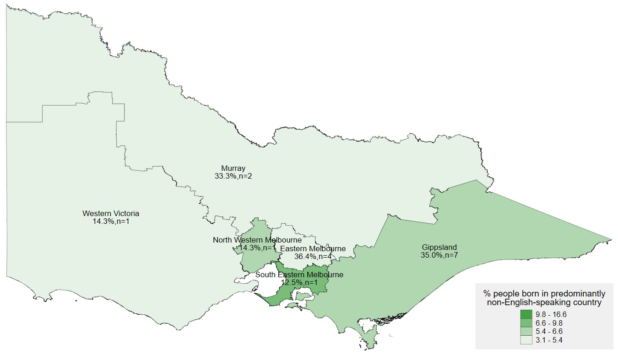

Embrace website reach vs cultural diversity (QLD)

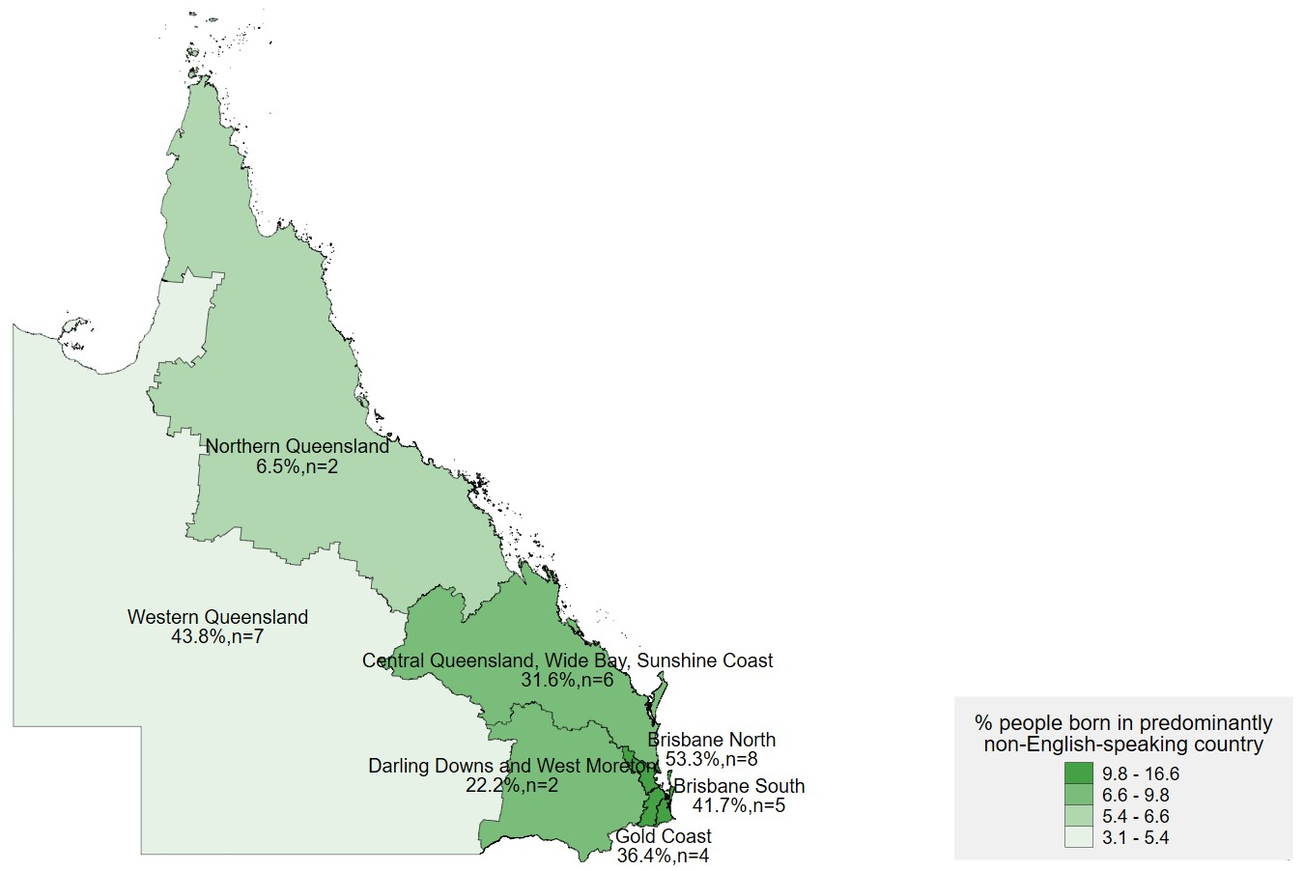

Embrace website reach vs cultural diversity (WA)

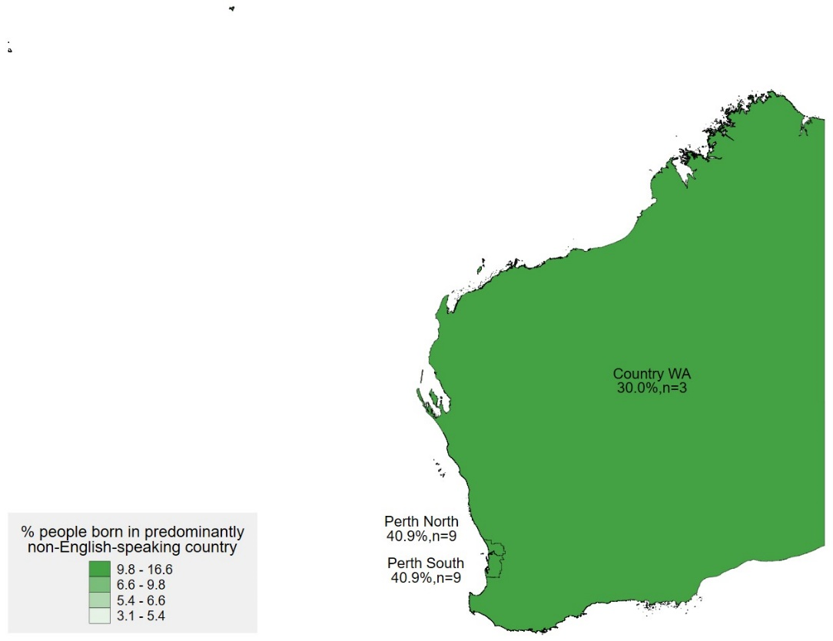

Embrace website reach vs cultural diversity (SA)

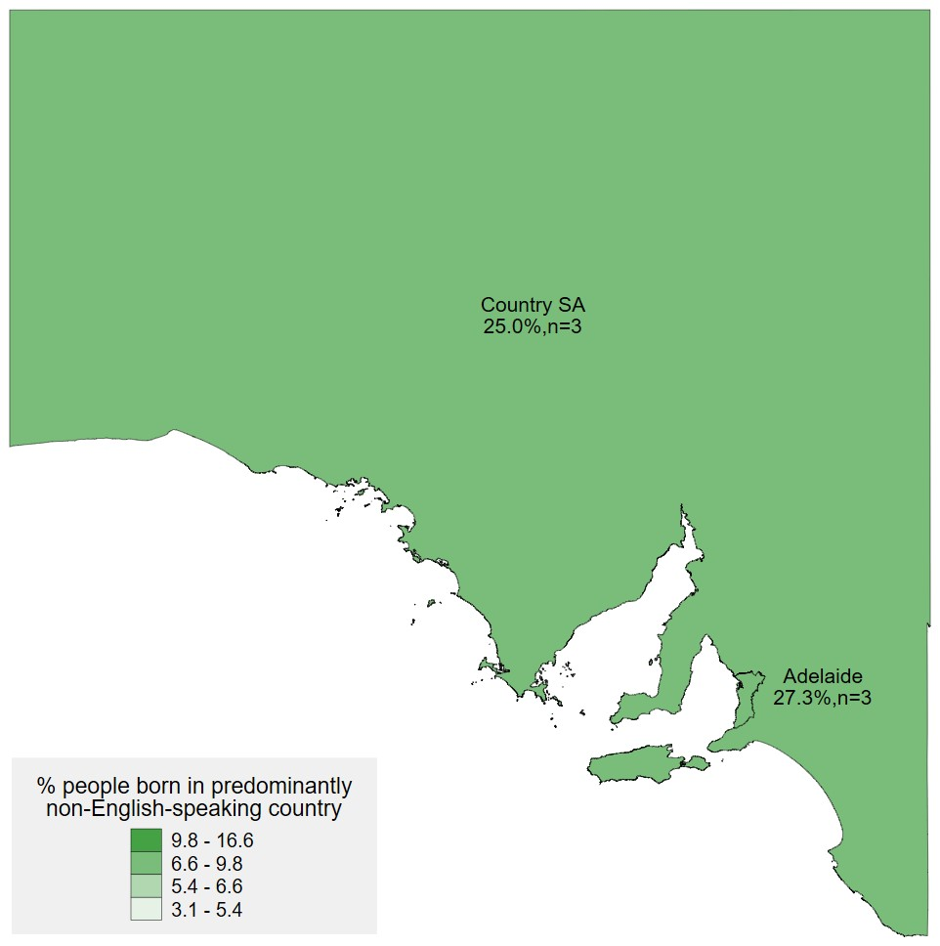

Embrace website reach vs cultural diversity (TAS

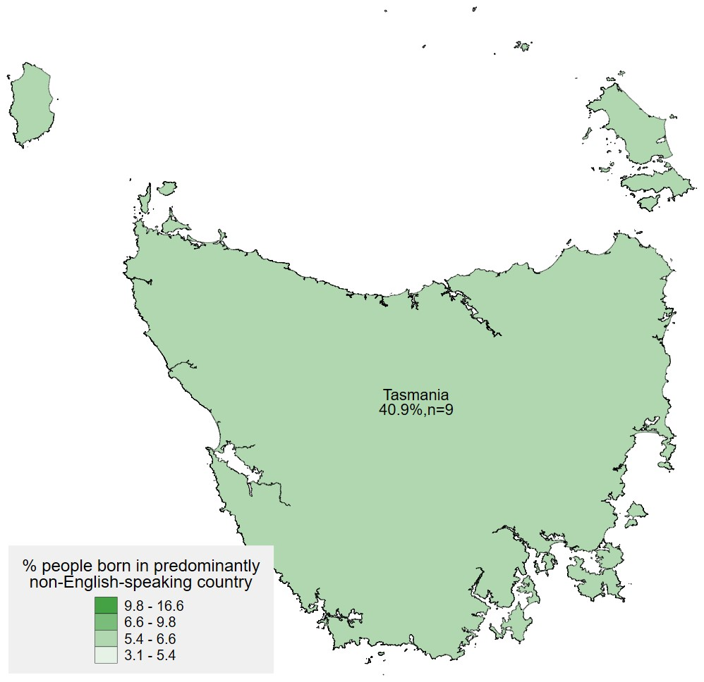

Embrace website reach vs cultural diversity (ACT)

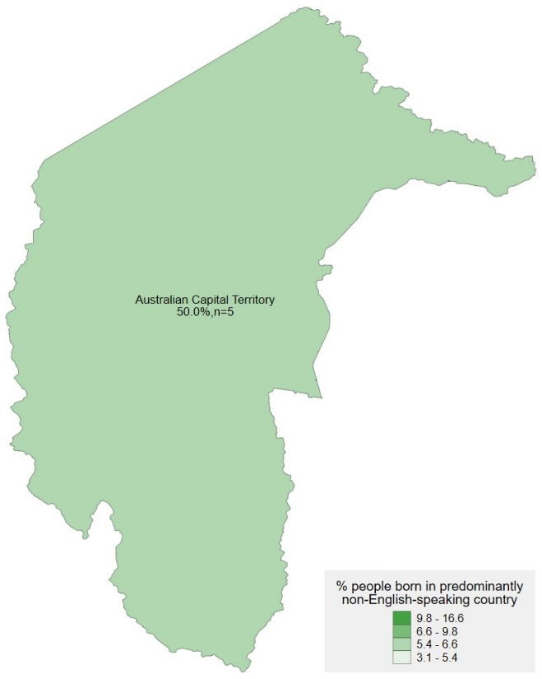

Embrace website reach vs cultural diversity (NT)

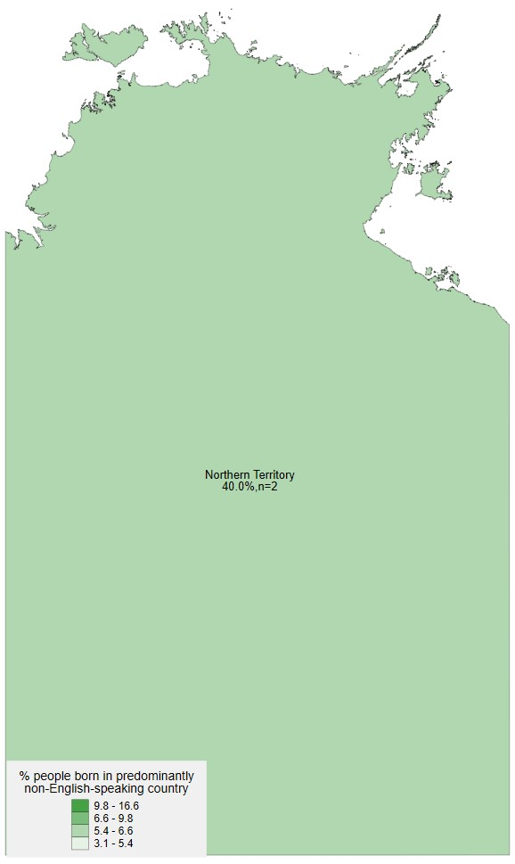

# Appendix G: Reviewed Project Documents

| File name | Date | Category |
| --- | --- | --- |
| Mental Health Australia - Embrace Performance report 1 July 2022 to 31 December 2022 Finance Report | 31/12/2022 | Performance Reports |
| Performance Report - 1 July 2022 to 31 December 2022 | 31/12/2022 | Performance Reports |
| Mental Health during the COVID-19 Pandemic in Italian, Turkish and Vietnamese Communities Final Report | 30/06/2022 | Project Documents |
| Research infographic - Mental health among Italian, Turkish and Vietnamese communities during the pandemic | N/A | Project Documents |
| Research Project - Understanding Mental Health and Stigma in Congolese, Arabic-speaking and Mandarin-speaking Communities | Aug-22 | Project Documents |
| Understanding Mental Health and Stigma in Congolese, Arabic-speaking and Mandarin-speaking Communities Report | Aug-22 | Project Documents |
| Review of the Framework for Mental Health in Multicultural Australia - March 2016 | Mar-16 | Performance Reports |
| Operating Guidelines - Stakeholder Group | Nov-21 to Nov-25 | Project Documents |
| Terms of Reference - Stakeholder Group | Nov-21 to Nov-26 | Project Documents |
| 2022 MHA Embrace Project - Proposed Budget for Suicide Pilot 6.9.22 | 6/09/2022 | Project Documents |
| 2022 MHA Embrace Project - Proposed Budget for Suicide Pilot | N/A | Project Documents |
| 2022-06-17 MHA -Embrace Project - Budget_1_July22-30_June23 | 30/06/2022 | Project Documents |
| AWP - 1 November 2021 to 30 June 2022 | 30/06/2022 | Project Documents |
| AWP - 30 June 2022 to 30 June 2023 | 30/06/2022 | Project Documents |
| AWP and Budget - 1 July 2023 to 30 June 2024 | 1 July 23 - 30 June 24 | Project Documents |
| Budget 1 July 2022 to 30 June 2023 | 30/06/2022 | Project Documents |
| Embrace Project Budget_1_July22-30_June23 | 30/06/2022 | Project Documents |
| Communication and Engagement Strategy_Nov 2021 - Jun 2025 | Nov 21 to Jun 25 | Project Documents |
| Embrace Project Review report Nov 22_Melaleuca House | Oct-22 | Performance Reports |
| Good Practice Engaging CALD infographic | N/A | Project Documents |
| Targeting Diversity within Diversity A plan for engaging the Chinese community in mental health services | N/A | Project Documents |
| Toolkit for engaging with CALD communities | N/A | Project Documents |
| P3720 - Mental Health Australia Ltd - 4-GFBSZ3G - Standard Grant Agreement | Sep-19 | Project Documents |
| Primary Health Networks- review Feb 2023 | Feb-23 | Performance Reports |
| Embrace Std Slides_Acknowledgments and Safety_Living Master_July 2023 | Jul-23 | Project Documents |
| Operating Guidelines_Embrace Lived Experience Group_March 2022 | Mar-22 | Project Documents |
| Terms of Reference_Embrace Lived Experience Group_March 2022 | Mar-22 | Project Documents |
| CALD Community Engagement Project Summary | N/A | Project Documents |
| Evaluation of the CALD Community Engagement Project - summary for Kantar | N/A | Project Documents |
| Communications Record _Embrace Project | Aug-22 | Performance Reports |
| Embrace Social Media channels tracker_As of 3 August 2023 | 3/08/2023 | Website/social media data |
| Embrace website tracker_As of 3 August 2023 | 3/08/2023 | Website/social media data |
| Framework monthly users&registrations spreadsheet_As of 3 August 2023 | 3/08/2023 | Website/social media data |
| PHN EOI_Targeted Framework Support Process_Communication Record_2022-2023 | Jun-23 | Website/social media data |
| PHN Mid-Term Report Summary_December 2022 (5) | Dec-22 | Project Documents |
| Primary Health Network Survey Summary Report_Jan 2022 | Jan-22 | Project Documents |

# Appendix H: Hotjar ‘Heat Map’

The Hotjar application used to host the user experience survey generates ‘heat maps’ which show where users are clicking within the Embrace homepage. This image below is an example of a ‘heat map’ of the Embrace website homepage. The shaded areas indicate where users are clicking, with the red and yellow areas being hotspots.

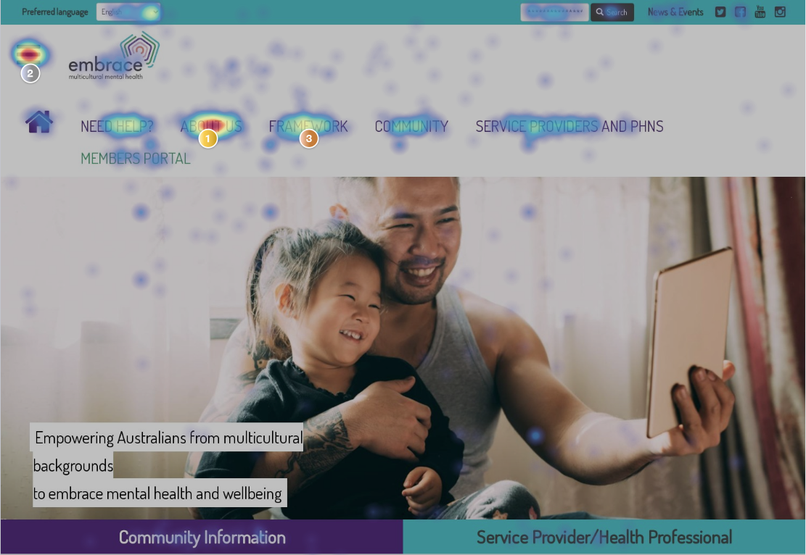

# Appendix I: Usability testing discussion guide

| EMBRACE PROJECT EVALUATION: USABILITY TESTING  FOCUS GROUP DISCUSSION GUIDE  Version: 1 | |
| --- | --- |
| Project number:  Project name: | 263407908  Embrace Multicultural Mental Health Project Evaluation |
| Client: | Department of Health and Aged Care |
| Researcher contacts: | Kizzy Gandy and Natalie Chan |
| Fieldwork timing:  Length:  Incentives:  Sample size:  Recruiter: | October 2023  60-90 minutes  $150 e-gift card  Mental Health Service Providers/PHNs n=6  Hotjar or survey |

Key Evaluation Questions

This guide is answering the following KEQ.

What were the barriers and enablers to uptake of the Project, including perceived accessibility, usability and relevance of the Embrace website and Framework?

For this guide, usability is defined as how user friendly the Embrace website and Framework is. This may include how easy participants can navigate the website and Framework, complete simple tasks, and if they run into any technical issues such as links not working on the site.

Accessibility is defined as how easy the website and Framework is to understand, this could include if simple language is used and if the website in general is easy to operate and access.

Relevance is defined as if the website and resources are appropriate and useful for their intended purpose i.e. for CALD clients and for service providers in their job.

Moderator notes

Headings are not read out and text in italics relate to moderator instructions.

Try to use conversational language that’s easily accessible to all.

This discussion guide is intended as an outline only. It sets out the proposed lines of enquiry for the usability testing and is intended as a tool to guide discussion flow. Questions and timings are indicative only of subject matter to be covered and are not word for word descriptions of the moderator’s questions. The moderator will allow the discussion to flow where the information is relevant, and therefore, the order of coverage may differ considerably between groups.

RESEARCH INTRODUCTION AND CONTEXT

Thank participants for involvement and introduce yourself as moderator and role of Kantar Public as an impartial evaluator. Introduce the purpose of the session.

* Thank you for making the time to speak with me about the Embrace website. My name is X, and this is my colleague X we are part of the Evaluation team at Verian. We are an independent research company, conducting an evaluation of the Embrace Project on behalf of the Department of Health and Aged Care (DoHAC).
* The purpose of this evaluation is to understand if and how the Embrace Project improves the quality and accessibility of mental health services for people from culturally and linguistically diverse backgrounds (CALD). Part of the evaluation is looking at the usability of the Embrace website and its resources.

Briefly explain the nature of the in-depth interview and inform about note taking/video recording.

* This focus group will take approximately 60-90 minutes and will be video recorded. The recording will only be used by the evaluation team to analyse the results, and for reporting for the evaluation.
* Are you all comfortable with this?

Inform about participant confidentiality.

* Verian adheres to the Research Society’s Code of Professional Behaviour, which guarantees you, as a participant, the right to confidentiality. Any information you provide in this focus group will be reported in such a way that you can’t be personally identifiable.
* Any recording or transcript of this interview will NOT be shared with DoHAC, or any other party involved with this research. We are also independent and impartial evaluators so you can provide honest feedback about your experience.

Do you have any questions before we start the interview?

INTRODUCTION 5 mins

1. To begin, in the past, what reasons have brought you to the Embrace website? (Prompt: find a resource, find contact details, access the Embrace Framework)
2. Now we’d like you to take a look at the Embrace website. (Prompt: Google search, URL entry, was it bookmarked already?)

Was it easy or hard to find? What was hard?

If participants have difficulty finding the website paste link to Embrace website to Teams chat

Activity 1 Warm up - Embrace website/resources is accessible/usable/relevant (for CALD clients) 10 Mins

Once all participants have the Embrace website open

1. Now that we all have the website open, we just want you to spend 5 or so minutes exploring the site, while you are doing that have a think about how easy or hard it is to navigate.

After 5 minutes…

1. Thanks everyone, let’s go around the group and give our first impressions of the site…

* Was it easy or hard to use the website, did you encounter any issues?
* What did you like about the website? What didn’t you like about it?
* What page did you end up on? Is that where you wanted to be, or did you struggle to find what you wanted?
* What would make your experience on the website more enjoyable?
* Is there anything missing that you would like to see? Or anything you’d remove?

1. If you were working with a CALD client, is there any resources on the website you would direct them to use?

* Prompt: Community section/multilingual information section
* If so, what are they? How helpful do you think they would be for your clients?
* If you were in their shoes, how would you find navigating these resources? Is it accessible or easy to use for people from all different backgrounds (i.e. ESL or no English)

Activity 2 – Embrace website/general resources is accessible/usable/relevant 10 Mins

1. Now can everyone please return to the homepage. Once there could everyone please find the service providers section of the Embrace website. We’d like you to just spend a few minutes exploring this section.

After 5 minutes…

1. As service providers, what do you think about this section?

* How did you find navigating this section?
* What is the first thing that strikes you about this section?
* What parts of this section feel relevant to your needs and what parts don’t?
* Are there any resources that you would potentially access/use in your role?
* Prompt: webinars, knowledge hub, best practice
* How is this relevant or useful to your role?
* Can you try accessing it, how did you find that? Were there any issues?
* Did the resource seem easy to understand from your first impression?

Activity 3 - Embrace Framework are accessible/usable/relevant 45 Mins

1. Now, can everyone try to find the Embrace Framework on the website and try to access it? I’ll give everyone 5 minutes to do this.

(if participants ask if they should create an account, say yes)

After 5 minutes…

1. Thanks everyone, did everyone manage to find the Framework and access it? What did you have to do? How did you find this? Was there anything, even minor, that felt effortful?

Now, could you try to find out what the Framework is about? I’ll give you 5 minutes…

After 5 minutes…

1. How would you do this? How did you find this out?

* Prompt the four guides: User guide, background, rationale, and summary
* What resources about the Framework appear helpful? Were they easy or difficult to understand?
* Is there anything missing that you would like to see? Is there anything you’d remove because it’s not relevant?

1. Now that you know a little bit about the Framework, how useful do you think this would be for your practice?

Now, can you all please start the Introductory Module in the Framework. We will stop you after 5 minutes, we don’t expect you to complete the module just get as far through as you can. If you need any help let us know.

After 5 minutes…

1. What did you think of the process to access the introductory module?

* Was it straight forward? Or was it more complicated than you would expect?
* What impression did it leave with you?
* If you had to give it an emoji rating to express your feelings about it, which emoji would you give it?

Prompt creating an account for the introductory module.

Now can you please find the self-assessment tool and action plan tool? Spend 5 minutes exploring this tool, you don’t need to fully complete it.

(if participants ask about the video and there is time, encourage them to watch it)

1. Did you try using the self-assessment tool and action plan tool? How did you find that?

* Was it clear and easy to understand or difficult?
* Was there anything missing or anything that you’d remove?
* What did you learn from it?
* If a colleague asked you what it was, how would you describe it?

Now let’s look at the first service module. I’ll give you 10 minutes go through the module.

1. What are your initial thoughts about the layout of the module?

* Is it easy to navigate the module? Are the instructions clear?
* What can be improved? Is there anything missing or anything redundant?
* In what ways, if any, did the module change your thinking?

1. Did you try accessing the resources? How did you find that?

* Which resources did you look at? What drove you to look at those?
* How would you use them in your work?
* Are there any aspects that could be improved?

Close: Thank you for taking the time today to complete this usability testing. By taking part today, you will help improve the Embrace Project and support CALD communities’ mental health outcomes.

# Appendix J: Ethnography guide

| ETHOGRAPHY GUIDE  Embrace website/Framework: PHN/service Provider Version 1 | |
| --- | --- |
| Project number:  Project name: | 263407908  Embrace Evaluation |
| Researcher contacts: | Kizzy Gandy  Will Hoare  Natalie Chan |
| Fieldwork timing: | w/c 9th – 16th October |
| Participants: | KP Ethnographer from the perspective of PHN persona |

Overview

This guide is focused on answering part of the following Key Evaluation Question:

What were the barriers and enablers to uptake, including perceived accessibility/ usability/ relevance/ quality of the project outputs (website, communications, resources, CCEP, and Community of Practice/training)?

We will use ethnography to measure the usability and accessibility of the Embrace Project: (1) Framework, (2) website, and (3) communications. This will be done from the perspective of a PHN – see persona below.

Definitions

Usability: Easy to use to achieve a defined goal

Accessibility: Easy to understand

Ethnographic approach

We combine ethnography with our expertise in behavioural science to increase the insights we gather. Behavioural science enables “cognitive ethnography” which involves identifying and elaborating hidden cognitive processes that occur when an individual engages in a system.

We will focus on recording any examples of ‘friction costs’ (small hassles) that could lead to drop-off, and messaging that could lead to psychological barriers to engagement (emotions, beliefs about consequences, identity, belief in abilities, perceived accountability).

Persona

PHN program manager

Defined goal: Improve service access for CALD communities

Background understanding: No past experience of culturally responsive mental health care (pre-entry on Embrace maturity model)

Key Findings

| Date |  |
| --- | --- |
| Name of ethnographer |  |
| What works well: (1) Framework, (2) website and (3) communications. |  |
| Areas for improvement: (1) Framework, (2) website and (3) communications. |  |

Framework

Tasks: Register for Framework, Complete introductory module, Use self-assessment tool

| Task | Reference: URL / page / quote | Usability (how easy is it to achieved defined goal?) | Accessibility (how easy is it to understand?) | Metrics |
| --- | --- | --- | --- | --- |
| Registration |  | what works well:  friction costs:  psychological barriers: | what works well:  friction costs:  psychological barriers: | Time to complete task:  Perceived hassle (1-5 where 1 is none and 5 is high): |
| Introductory module |  | what works well:  friction costs:  psychological barriers: | what works well:  friction costs:  psychological barriers: | Time to complete task:  Perceived hassle (1-5 where 1 is none and 5 is high): |
| Service modules |  | what works well:  friction costs:  psychological barriers: | what works well:  friction costs:  psychological barriers: | Time to complete task:  Perceived hassle (1-5 where 1 is none and 5 is high): |
| Self-assessment tool |  | what works well:  friction costs:  psychological barriers: | what works well:  friction costs:  psychological barriers: | Time to complete task:  Perceived hassle (1-5 where 1 is none and 5 is high): |

Website

Tasks: Find the website from Google search of “mental health and [name of ethnic community]”, Use one resource for service providers.

| Task | Reference: URL / page / quote / screenshot | Usability (how easy is it to achieved defined goal?) | Accessibility (how easy is it to understand?) | Metrics |
| --- | --- | --- | --- | --- |
| Search: Mental health and:  Chinese Vietnamese Khmer |  | what works well:  friction costs:  psychological barriers: | what works well: (in relation to the Transcultural Mental Health Centre NSW)  Friction costs: n/a  psychological barriers: | Time to complete task:  Perceived hassle (1-5 where 1 is none and 5 is high): |
| Resource: Policies |  | what works well:  friction costs:  psychological barriers: | what works well:  friction costs:  psychological barriers: | Time to complete task:  Perceived hassle (1-5 where 1 is none and 5 is high): |

Communications

Tasks: Sign up to receive newsletters, read newsletter on Embrace website.

| Task | Reference: URL / page / quote | Usability (how easy is it to achieved defined goal?) | Accessibility (how easy is it to understand?) | Metrics |
| --- | --- | --- | --- | --- |
| Newsletter sign-up |  | what works well:  friction costs:  psychological barriers: | what works well:  friction costs:  psychological barriers: | Time to complete task:  Perceived hassle (1-5 where 1 is none and 5 is high): |
| Newsletter: [insert issue number] |  | what works well:  friction costs: psychological barriers: | what works well:  friction costs: psychological barriers: | Time to complete task:  Perceived hassle (1-5 where 1 is none and 5 is high): |

# Appendix K: Contacted mental health organisations and PHNs

Mental Health related organisations who were contacted to receive the PHN/service provider survey.

| State | Organisation | Date survey sent |
| --- | --- | --- |
| AUS | Assets | 21/11/23 |
| AUS | Red Cross | 21/11/23 |
| AUS | SSI | 21/11/23 |
| AUS | Forum of Australian Services for Survivors of  Torture and Trauma (FASSTT) | 21/11/23 |
| AUS | Mental Health Foundation Australia | 21/11/23 |
| AUS | Mental Health Carers Australia | 21/11/23 |
| AUS | Community Mental Health Australia | 21/11/23 |
| AUS | LGBTIQ+ Health Australia | 21/11/23 |
| AUS | Way Ahead | 19/12/23 |
| AUS | Sane | 15/01/2023 |
| AUS | Beyond Blue | 19/12/23 |
| AUS | Mind | 20/12/23 |
| AUS | Black Dog | 09/01/23 |
| AUS | Mental Illness Fellowship Australia | No answer twice |
| AUS | Community Mental Health Australia | No answer twice |
| AUS | Australia and New Zealand Mental Health Association | No answer twice |
| WA | Western Australia Association for Mental Health | 15/01/23 |
| WA | Mental Illness Fellowship of Western Australia | No answer twice |
| WA | Mental Health Commission of Western Australia | No answer twice |
| WA | Chief Psychiatrist of Western Australia | 09/01/23 |
| TAS | Office of the Chief Psychiatrist | 09/01/23 |
| TAS | Mental Health Council of Tasmania | 20/12/23 |
| SA | Mental Health Coalition | 20/12/23 |
| SA | South Australia Mental Health Commission | 09/01/23 |
| SA | Office of the Chief Psychiatrist | 20/12/23 |
| QLD/NSW | Open Minds | 20/12/23 |
| QLD/NSW | Head to Health | 11/01/24 |
| AUS | Multicultural Connect Line | 11/01/24 |
| AUS | Problem Management Plus—World Wellness Group | 11/01/24 |
| QLD | Brisbane MIND—Culturally and Linguistically Diverse  populations | 11/01/24 |
| QLD | Qld Transcultural Mental Health Centre | 11/01/24 |
| QLD | Queensland Program of Assistance to Survivors of  Torture and Trauma | 11/01/24 |
| AUS | Women's Mentoring Foundation (WMF) | 11/01/24 |
| AUS | Australian Multicultural Foundation (AMF) | 11/01/24 |

PHNs who had not completed the survey as of 01/01/2024 who were contacted and sent the survey

| State | PHN | Date survey sent |
| --- | --- | --- |
| NSW | Hunter New England & Central Coast | Unable to be contacted |
| NSW | Murrumbidgee | 10/01/24 |
| NSW | Nepean Blue Mountains | 10/01/24 |
| NSW | North Coast | 10/01/24 |
| NSW | Northern Sydney | 10/01/24 |
| NSW | Western Sydney | 10/01/24 |
| VIC | Eastern Melbourne | Unable to be contacted |
| VIC | Murray | 10/01/24 |
| VIC | South Eastern Melbourne | 10/01/24 |
| VIC | Western Victoria | 10/01/24 |
| QLD | Central QLD, Wide Bay, Sunshine Coast | 10/01/24 |
| QLD | Gold Coast | 10/01/24 |
| QLD | Northern Queensland | 10/01/24 |
| QLD | Western Queensland | 10/01/24 |
| WA | Perth North | 10/01/24 |
| WA | Perth South | 10/01/24 |
| WA | Country WA | 10/01/24 |
| SA | Country SA | Unable to be contacted |
| ACT | ACT PHN | 10/01/24 |
| NT | Northern Territory PHN | 10/01/24 |
| TAS | Tasmania PHN | 10/01/24 |

1. Radhamony, R., et al. (2023). Perspectives of culturally and linguistically diverse (CALD) community members regarding mental health services: A qualitative analysis. Journal of Psychiatric and Mental Health Nursing, 30.
2. Khatri RB and Assefa Y (2022) ‘Access to health services among culturally and linguistically diverse populations in the Australian universal health care system: issues and challenges’, BMC Public Health 22.
3. Fozdar F and Salter K (2019) A Review of Mental Ill Health for Culturally and Linguistically Diverse Communities in Western Australia, The University of Western Australia.
4. Rathod S, Gega L, Degnan A, Pikard J, Khan T, Husain N, Munshi T and Naeem F (2018) ‘The Current Status of Culturally Adapated Mental Health Interventions: A Practice-Focused Review of Meta-Analyses’, Neuropsychiatric Disease and Treatment, 14.
5. Radhamony R, Cross WM, Townsin L and Banik B (2023) ‘Perspectives of culturally and linguistically diverse (CALD) community members regarding mental health services: A qualitative analysis’, Journal of Psychiatric and Mental Health Nursing, 30
6. Samuelson, W., & Zeckhauser, R. (1988). Status quo bias in decision making. Journal of risk and uncertainty, 1, 7-59.
7. <https://www.behavioraleconomics.com/resources/mini-encyclopedia-of-be/status-quo-bias/>
8. Edwards, R.K., Kellner, K.R., Sistrom, C.L. & Magyari, E.J. (2003). Medical student self-assessment of performance on an obstetrics and gynecology clerkship. American Journal of Obstetrics and Gynecology, 188(4), 1078-1082
9. Motta, M., Callaghan, T., & Sylvester, S. (2018). Knowing less but presuming more: Dunning-Kruger effects and the endorsement of anti-vaccine policy attitudes. Social Science & Medicine, 211, 274-281.
10. Ehrlinger, J., & Dunning, D. (2003). How chronic self-views influence (and potentially mislead) estimates of performance. Journal of personality and social psychology, 84(1), 5.
11. Dune, T., Caputi, P., Walker, B. M., Olcon, K., MacPhail, C., Firdaus, R., & Thepsourinthone, J. (2021). Australian mental health care practitioners’ construing of non-White and White people: implications for cultural competence and therapeutic alliance. BMC psychology, 9(1), 85.
12. Hotjar is an application that can be loaded onto a website to collect data on the way users interact with the website. It can also collect data directly from users via pop-up surveys on the website.
13. CONSORT (Consolidated Standards of Reporting Trials) is a protocol developed by a group of researchers, that includes a flow diagram which provides the reader with information about how the research was conducted, recruitment procedures and sample sizes. Falci SG, Marques LS. CONSORT: when and how to use it. Dental Press J Orthod. 2015 May-Jun;20(3):13-5.
14. Eagar K and Steele P (2016). Review of the Framework for Mental Health in Multicultural Australia. Australian Health Services Research Institute, University of Wollongong.
15. Hawke LD et al (2024). Experience-based co-design of mental health services and interventions: A

    scoping review. SSM-Mental Health, Vol 5. June 2024. Elsevier.
16. Blignault, I., Saab, H., Woodland, L. et al. Effectiveness of a Community-based Group Mindfulness Program tailored for Arabic and Bangla-speaking Migrants. Int J Ment Health Syst 15, 32 (2021).
17. Minas, Harry. (2021). Mental Health in Multicultural Australia. 10.1007/978-981-10-2366-8_10.
18. Sims, S., Fletcher-Wood, H., O'Mara-Eves, A., Cottingham, S., Stansfield, C., Van Herwegen, J., & Anders, J. (2021). What Are the Characteristics of Effective Teacher Professional Development? A Systematic Review and Meta-Analysis. Education Endowment Foundation.
19. <https://medium.com/@a.h.noferesti/behavioural-science-and-marketing-data-analysis-driving-effective-brand-management-5705b5bd28ed>
20. Bullock, H.L., Lavis, J.N. Understanding the supports needed for policy implementation: a comparative analysis of the placement of intermediaries across three mental health systems. Health Res Policy Sys 17, 82 (2019).
21. Blignault I, Saab H, Woodland L, Giourgas K, Baddah H. Promoting Mental Health and Wellbeing in Multicultural Australia: A Collaborative Regional Approach. Int J Environ Res Public Health. 2022 Feb 26;19(5):2723
22. “We seek to improve the volume, quality, and use of evaluation evidence to support better policy and programs that improve the lives of Australians”. <https://evaluation.treasury.gov.au/>.
23. Nine respondents who listed their location as ‘All of Australia’ were excluded from the map. Five of these respondents had used the Embrace website.
24. Turner, H. C., Archer, R. A., Downey, L. E., Isaranuwatchai, W., Chalkidou, K., Jit, M., & Teerawattananon, Y. (2021). An introduction to the main types of economic evaluations used for informing priority setting and resource allocation in healthcare: key features, uses, and limitations. Frontiers in public health, 9, 722927.
25. JJust over half the respondents to this question answered $0 and one answered $1,000. When these outliers were excluded, the average ‘willingness to pay’ is $122.50 and the median is $22.50.
26. Zhi et al (2023). The Effectiveness of Face-to-Face versus Online Delivery of Continuing Professional Development for Science Teachers: A Systematic Review. Educ. Sci. 2023, 13(12), 1251
27. Sunstein, C. R., & Gosset, J. L. (2020). Optimal sludge? The price of program integrity. Duke LJ Online, 70, 74.
28. <https://www.nsw.gov.au/departments-and-agencies/behavioural-insights-unit/sludge-toolkit>
29. <https://www.bi.team/publications/east-four-simple-ways-to-apply-behavioural-insights/>
30. “Perceived cultural competence” was defined here as “The way I interact with people from different cultural backgrounds tends to work well”.
31. The estimated coefficient (coeff 0.157, p 0.046) is from an OLS regression with robust standard errors, the dependent variable being how often respondents used cultural information to assess mental health needs and the explanatory variables being reduced status quo bias, leadership support, and resourcing to be culturally responsive. Figure 16 plots the relationship between reduced status quo bias and using cultural information without control variables.
32. Some values affirmation exercises are described here <https://teaching.berkeley.edu/news/values-affirmations-social-belonging-interventions>
33. Hanel, P. H., Roy, D., Taylor, S., Franjieh, M., Heffer, C., Tanesini, A., & Maio, G. R. (2023). Using self-affirmation to increase intellectual humility in debate. Royal Society open science, 10(2), 220958.
34. Radhamony, R., Cross, W. M., Townsin, L., & Banik, B. (2023). Perspectives of culturally and linguistically diverse (CALD) community members regarding mental health services: A qualitative analysis. Journal of Psychiatric and Mental Health Nursing, 30(4), 850-864.
35. Sampaio, F., Gonçalves, P., & Sequeira, C. (2022). Mental health literacy: it is now time to put knowledge into practice. International journal of environmental research and public health, 19(12), 7030.
36. Khatri, R. B., & Assefa, Y. (2022). Access to health services among culturally and linguistically diverse populations in the Australian universal health care system: issues and challenges. BMC Public Health, 22(1), 880.
37. Shepherd, S., Harries, C., Spivak, B., Pichler, A. S., & Purcell, R. (2021). Exploring presentation differences in multi-cultural youth seeking assistance for mental health problems. BMC psychology, 9(1), 63.
38. <https://www.pc.gov.au/inquiries/completed/nt-children/report/nt-children-overview.pdf>
39. <https://www.health.qld.gov.au/__data/assets/pdf_file/0037/385867/qh-response-data.pdf>
40. Our index comprises a sub-set of items from a validated cultural competence instrument reported in: Doorenbos, A. Z., Schim, S. M., Benkert, R., & Borse, N. N. (2005). Psychometric evaluation of the cultural competence assessment instrument among healthcare providers. Nursing Research, 54(5), 324-331.
41. Schmidt, M., Stjernswärd, S., Garmy, P., & Janlöv, A. C. (2020). Encounters with persons who frequently use psychiatric emergency services: healthcare professionals’ views. International Journal of Environmental Research and Public Health, 17(3), 1012.
42. Dune, T., Caputi, P., Walker, B. M., Olcon, K., MacPhail, C., Firdaus, R., & Thepsourinthone, J. (2021). Australian mental health care practitioners’ construing of non-White and White people: implications for cultural competence and therapeutic alliance. BMC psychology, 9(1), 85.
43. Sawler, J. (2021). Economics 101-ism and the Dunning-Kruger effect: Reducing overconfidence among introductory macroeconomics students. International Review of Economics Education, 36, 100208.
44. <https://www.bps.org.uk/psychologist/dunning-kruger-effect-and-its-discontents>
45. Gulliford, M., Figueroa-Munoz, J., Morgan, M., Hughes, D., Gibson, B., Beech, R., & Hudson, M. (2002). What does' access to health care' mean?. Journal of health services research & policy, 7(3), 186-188.
46. Schmidt, M., Stjernswärd, S., Garmy, P., & Janlöv, A. C. (2020). Encounters with persons who frequently use psychiatric emergency services: healthcare professionals’ views. International Journal of Environmental Research and Public Health, 17(3), 1012.
47. <https://embracementalhealth.org.au/service-providers/knowledge-hub/understanding-mental-health-and-stigma-congolese-arabic-speaking>
48. The REDUCE framework focuses on breaking down common barriers to change. It stands for Reactance, Endowment, Distance, Uncertainty, and Corroborating Evidence. <https://online.wharton.upenn.edu/blog/reduce-framework-for-change-management/>
49. <https://aci.health.nsw.gov.au/__data/assets/pdf_file/0013/502240/Guide-Build-Codesign-Capability.pdf>
50. Hawke, L. D., Sheikhan, N. Y., Bastidas-Bilbao, H., & Rodak, T. (2024). Experience-based co-design of mental health services and interventions: A scoping review. SSM-Mental Health, 100309.
51. A Literature Review on Mental Health and Stigma in Three Specific Culturally and Linguistically Diverse Communities: Arabic, African and Chinese (2022). Western Sydney University.
52. Albarracín, D., Fayaz-Farkhad, B., & Granados Samayoa, J. A. (2024). Determinants of behaviour and their efficacy as targets of behavioural change interventions. Nature Reviews Psychology, 1-16.
53. Robinson, T., Bailey, C., Morris, H., Burns, P., Melder, A., Croft, C., ... & Teede, H. (2020). Bridging the research–practice gap in healthcare: a rapid review of research translation centres in England and Australia. Health Research Policy and Systems, 18, 1-17.
54. Bailie, R., Matthews, V., Larkins, S., Thompson, S., Burgess, P., Weeramanthri, T., ... & Clark, L. (2017). Impact of policy support on uptake of evidence-based continuous quality improvement activities and the quality of care for Indigenous Australians: a comparative case study. BMJ open, 7(10), e016626.
55. Sims, S., Fletcher-Wood, H., O'Mara-Eves, A., Cottingham, S., Stansfield, C., Van Herwegen, J., & Anders, J. (2021). What Are the Characteristics of Effective Teacher Professional Development? A Systematic Review and Meta-Analysis. Education Endowment Foundation.
56. Robert GC et al (2015). Patients and staff as codesigners of healthcare services. BMJ.