RISK COMMUNICATION ASSESSMENT TOOL & GUIDANCE (RCAT)

September 2024

# Introduction

This document comprises a risk communication assessment tool (RCAT) and guidance on the use of the tool. It supports and should be utilised in conjunction with the [enHealth guidance – Risk Communication Principles](https://www.health.gov.au/sites/default/files/documents/2022/07/enhealth-guidance-risk-communication-principles.pdf) (enHealth Risk Communication Guidance). The tool has been primarily developed for those with environmental public health responsibility and is designed to help **identify the approach to risk communication** for any given situation potentially impacting the community, especially where outrage may occur. The assessment can be done at any time in a project’s life, but it is worth noting that any assessment is a snapshot in time and a situation can change and evolve rapidly. Please refer to section 3 of the [enHealth Risk Communication Guidance](https://www.health.gov.au/sites/default/files/documents/2022/07/enhealth-guidance-risk-communication-principles.pdf), which describes how a situation can change over time.

Prior to using the RCAT, identify and **list the stakeholders** that may be impacted or interested in the situation (issue, incident, event or project). Ensure you are clear on which **stakeholder group/s you are assessing**. Remember that where it is important to do so, the community can be split into specific subgroups, for example, directly impacted residents may be identified separately to residents in the surrounding localities and both may have some interest in the issue. The RCAT can be used and repeated for different stakeholder groups or subgroups. Refer below for an example list of possible stakeholders, and the ‘Next Steps’ section for more information.

The RCAT broadly uses a **qualitative assessment of both hazards and level of outrage**. The assessment can be done at any stage of an issue or event, whether in assisting in preparation for risk communication (assessing potential for outrage) or used during the height of an event. It can be used to gauge how much anger or outrage may be present in the future and subsequently identify the risk communication principles in the [enHealth Risk Communication Guidance](https://www.health.gov.au/sites/default/files/documents/2022/07/enhealth-guidance-risk-communication-principles.pdf) that may be most effective to minimise this.

**Note:** If it is not clear what [outrage management quadrant](https://www.health.gov.au/sites/default/files/documents/2022/07/enhealth-guidance-risk-communication-principles.pdf) you are currently in (or may be in the future), then this tool should be used. The descriptor boxes of Dr Peter Sandman’s outrage quadrants (refer to the enHealth Guidance on pages 3 and 4) can be utilised to assist in the process. **The RCAT is a guide** and should not be relied upon for an absolute outcome of the assessment. Communication always requires thought and consideration. Seeking advice from a knowledgeable and experienced risk communicator may help prevent unintended consequences. Also note, that although it is encouraged to do so, not every question requires answering; answering the most relevant should indicate the likely quadrant you are in.

# The assessment process

The assessment process works best when carried out by a **multidisciplinary team** to both gain and provide broad insight into the situation[1].

**List of possible stakeholders:**

**By category: By interest:**

The community/public Those who have shown interest in the past

Media Those who are directly affected

Businesses and service providers Those who will (or are likely to) influence the outcome

Customers of businesses and service users and clients

Emergency responders

Health and community service organisations

Experts, peak bodies, community groups and advocates

Local, state, and federal government agencies

Ministers of Parliament

Stakeholder identification[2] will help you make informed decisions about who to engage with and how best to do so. For information on kinds of stakeholders and types of ‘publics’ when engaging with the community, refer to Dr Peter Sandman’s column on ‘Stakeholders’[3]:

**There are three steps to the assessment:**

* Step 1: outrage assessment
* Step 2: hazard assessment
* Step 3: Plot on the graph

The RCAT is also available as an [interactive spreadsheet (RCATi)](https://www.health.gov.au/resources/publications/enhealth-risk-communication-assessment-tool-rcat-and-guidance-and-interactive-rcati?language=en). The interactive spreadsheet allows you to select a rating for each outrage/hazard factor and provide a description; it then automatically calculates your likely outcome (i.e. resultant outrage quadrant).

## STEP 1 OUTRAGE ASSESSMENT

Outrage is demonstrated by the following:

* existing community groups mobilising on the issue
* new community groups forming
* individuals and groups contacting elected officials and government officials
* articles appearing in newspapers
* social media becoming active with specific campaigns
* protest marches
* lack of engagement

### OUTRAGE FACTORS

People’s perception of risk is influenced by ‘outrage factors’. Dr Peter Sandman’s book, [*Responding to Community Outrage: Strategies for Effective Risk Communication*](https://psandman.com/media/RespondingtoCommunityOutrage.pdf), can be referred to for further information on this topic. The list below highlights outrage factors that can contribute to either low or high-risk perceptions. They are adapted from Dr Peter Sandman and form the basis of the outrage assessment on the following pages.

| **‘lower’ risk perceptions** | **higher’ risk perceptions** |
| --- | --- |
| Voluntary | Coerced |
| Certainty of risk | Uncertainty of risk |
| Fair (ethical/just) | Unfair (unethical/unjust) |
| Responsive and adaptive action | Unresponsive action |
| Natural | Processed, synthetic or manufactured |
| Familiar | Exotic |
| Not memorable | Memorable |
| Chronic | Catastrophic |
| Controlled by me | Controlled by others |
| That I can Trust you | No trust |
| Responsive and adaptive action | Not responsive or adaptive |
| Effect on others (e.g. workers) | Effect on vulnerable/sensitive populations |
| Immediate effects | Delayed effects |
| No effect on future generations | Effect on future generations |
| Reversible | Not reversible |
| No individuals identified | Media identified individuals |
| Hazard elimination | Hazard reduction |
| Little media attention | Much media attention |
| No collective action | Collective action |

### OUTRAGE ASSESSMENT

This component of the RCAT asks you to think about and assess the outrage factors when a hazard has been identified. You may be about to tell people about the situation, or the situation has changed, and you need to re-assess the outrage factors, for example, when a hazard level is likely to increase in the near future. It also relates to situations when the anger or upset is obvious and occurring right now and management of this is required. The assessment will help you get a sense of the level of outrage you are dealing with or may deal with in the future. Put yourself in the position of the stakeholder group that you are assessing and attempt to feel what they might be experiencing.

The assessment utilises the key outrage factors listed above and helps identify the likely level of outrage for each factor. The points for consideration are provided to help generate deeper thought and to facilitate discussion. **Mark the relevant outrage factor rating (low, medium, or high) for the questions below.** Keep notes for each level of outrage you have identified; they can be referred to throughout the event and can aid in formulating a communications and engagement strategy.

|  | Outrage factor rating | | |  |
| --- | --- | --- | --- | --- |
| Outrage factor | LOW | MEDIUM | HIGH | Points for consideration |
| 1. a. Stakeholders’ trust in your competence to manage the situation well   b. Stakeholders’ trust in your integrity to tell them the truth | High trust in your competence  Perceived as very truthful | Some trust in your competence  Perceived as somewhat truthful | Don’t have trust in your competence  Perceived as not truthful | Increase/decrease of trust depends on prior experience/s.  May be useful to ask this question for each stakeholder group (e.g. community/health/EPA or other). Think about the role of your agency in the situation. |
| 1. Familiarity of this issue (how much is this hazard ‘known’ or experienced by those who are impacted (the community) | Very familiar/known | Somewhat familiar | Unfamiliar/new/unknown | Defining the issue is a good idea, for example, the difference between the event and hazard (e.g. CCA treated timber burning in a bushfire). The level of outrage can depend on the level of understanding of the hazard and community awareness of the magnitude of the hazard |
| 1. Level of choice people have had with this issue | Lots of choice | A little bit of choice | No choice | In some ways, this may also relate to attribution of blame – bushfire when living in bushland, vs industrial fire next door. |
| 1. Stakeholders’ sense of their own control over the situation | Voluntary involvement | Some control over their involvement | Forced upon them | Different for each stakeholder (e.g. agencies versus community; the community is most critical).  Sense of control can change depending on the length of time it takes to respond to the event.  Voluntariness is who decides. Control is who implements. Sharing control reduces outrage.  If the behaviour is voluntary (i.e. resulting in voluntary risk) then its more acceptable than if it is coerced. |
| 1. How **natural** does the issue seem? | Natural (not synthetic) | Both natural and synthetic (Some involvement of people) | Synthetic, manufactured, industrial (caused by people) | For comparison: A fire at a chemical facility is synthetic or industrial. A bushfire is natural; but it could also be both natural and have un-natural consequences, such as causing a fire in an industrial facility. |
| 1. **How memorable** is or could this issue/event be | Not memorable | Somewhat memorable | Very memorable | Memorable risks are the ones that linger in people’s minds. The best source of memorability is personal experience (e.g. people who live through floods/bushfires take floods/bushfires more seriously). Others include news media, symbols (e.g. chemical hazards), and signals (e.g. odour).  High memorability can be particularly destructive when paired with low familiarity. |
| 1. How easy is it (or was it) to **envision/foresee**something going wrong | Not foreseeable | Somewhat foreseeable | Very foreseeable | An additional point to consider is detectability. For example, radiation is not readily ‘detectable’. Undetectable risks generally create more outrage than if they were more detectable. |
| 1. Is the issue/event **on-going** and affecting a number of people spread out over time or affecting a number of people at one time. | There will be an ongoing impact spread out over time  (consider the stakeholder’s perception of the hazard) | There will be an ongoing impact spread out over time  (consider the stakeholder’s perception of the hazard) | Impacts are happening to people all at once | People share a societal value that catastrophe is more serious than chronic risk – refer to [Peter Sandman’s 6th component of outrage](https://psandman.com/media/RespondingtoCommunityOutrage.pdf).  Therefore, think about this question from the viewpoint of how the event/issue might be affecting people because it is either happening on an on-going basis (chronic-like), or it is affecting many people all at once (catastrophic-like). |
| 1. Stakeholders’ view on how **responsive and adaptive** you or others have been to the issue and their concerns | Process perceived as responsive and adaptive | Process perceived as partly responsive and adaptive | Process perceived as not responsive and adaptive | A responsive process includes: openness; timeliness; adaptive to changing information; courtesy; sharing community values; hearing & listening to the people; compassion; and an apology (for mistakes).  How you engage with the community, and your action and response taken to address an issue has a substantial impact on people’s perception of risk. |
| 1. What is the level ofrisk **uncertainty** (for decision-makers/authorities)? | Low level of risk uncertainty | Moderate level of uncertainty | High level of risk uncertainty | When there is a high level of risk uncertainty amongst the experts, this increases outrage potential (when the risk is imposed by others as opposed to controlled by the individual). Expert or agency disagreement implies uncertainty and therefore increases outrage. Acknowledging uncertainty however reduces outrage.  A community is less likely to be outraged if authorities are more certain about the harm and the risk is well understood, even if the harm is likely to be great. |
| 1. Does the issue seem **fair** or **unfair** | Fair | Somewhat unfair | Unfair | Considerations can include, whether it is viewed as: Wrongful; unethical; immoral; inequitable; or unjust. |
| 1. Are vulnerable/sensitive populations affected? | None or low/minimal impacts to sensitive populations | Some additional/moderate impacts to sensitive populations | High impact to sensitive populations. | The effect on **children or other vulnerable/sensitive populations** **such as people who are pregnant and older or first nations people**, will generally drive more outrage than the effect to the environment or workers (and environmental risk generally captures more attention than occupational risk). |
| 1. What is the **level of emotion** (fear incl. dread, anxiety, frustration, anger) and, what is driving their emotion or their level of emotion? | Calm and accepting or uninterested | Concern over issue or emotional response likely | High/demonstrable level of emotional response | There may be variations in emotion; proximity to the issue/event is a factor. Are they uninterested & inattentive (i.e. causing low outrage), interested and attentive, or outraged and frightened? |
| 1. How engaged are public facing (media and social media) channels and what do you think is their level of impact. | Low media interest in issue. | Moderate media interest in issue | High level of media involvement | The question indicates the extent of the outrage; accuracy of information; potential for misinformation (this and inaccurate information generates high outrage); how far people’s voices will be heard; best channels of communication; and level of response. This will help to better gauge the potential work ahead. Media attention is more of a result of outrage but amplifies it. Medium outrage could be expected with media mostly reporting fairly and not ‘front page’. Emotion communicated through many channels can increase outrage; conversely, the number of channels may not matter if it is intensive in just one (or more); furthermore, social media is a very prevalent channel. |
| 1. Is there much collective action (or opportunity for it)? How much are advocacy groups seizing on the issue? | No collective action from existing advocacy groups | Existing advocacy groups taking an interest or new groups being formed. | High level of interest/activity from advocacy groups | It is important to know who has the emotion and who they are influencing. Consider what you understand their concerns/expertise/potential to influence are. Activists or the media feed the outrage, but friends and neighbours can feed it even more. Local collective action can include a neighbourhood meeting. |
| 1. If known, are the effects immediate or delayed? | No effects/effects are immediate (or have occurred) but are not noticeable/are minor/have little impact/are reversible | Immediate effects have occurred or are imminent, but are (or are expected to be) less serious / have a moderate impact | Delayed effects (ie. beyond imminent), and/or immediate effects that have a major impact, and/or the effects are not reversible | Cancer and birth defects are examples of delayed effects (beyond imminent). Delayed effects, including potential long-term effects or impacts, are often taken more seriously and increases outrage potential (with the exception of catastrophes). Consider if there could be impacts on future generations, (for example will it be an issue in 25, 50, 100 or 200 years or even longer?).  Effects or impacts that are not reversible will likely cause more outrage than effects than are. |
| 1. Are there **individuals** in the affected population who have been publicly **identified in media?** | No identifiable individuals | Identifiable individuals with potential impacts | Identifiable and impacted individuals | If so, this increases the level of outrage. Inferred/population level health effects based on statistical data create less outrage than a person you can *see* or *hear* on TV, newspapers, social media or the radio. Also, the environment could be considered as identifiable, as well as pets or other animals. |
| 1. Can the hazard be eliminated or reduced? | Hazard can and will be eliminated, or, is reduced to **agreed acceptable levels with stakeholders**. | Hazard can be (or could have been) eliminated but is reduced (or will be) to below relevant guideline levels or standards | Hazard is reduced but will still be present at unacceptable levels. | Outrage typically increases if the issue or risk is **reduced** instead of being **eliminated**, especially when it is perceived that the risk could be eliminated. Prevention is generally preferred (e.g. addressing the issue at the planning stage) and avoids the outrage |
| TOTALS |  |  |  | Overall rating: |

1. Count the number of outrage factor ratings (for Low, Medium and High) for the 18 questions above, and insert these in the last row of the table (above). The rating with the highest number will indicate the overall rating (likely outrage level). Mark this in the relevant box (L, M or H) in the blank graph below, and this will be used to plot on the graph in step 3.

The example to the right of the blank graph shows the outrage level of ‘high’ as the box with the highest number

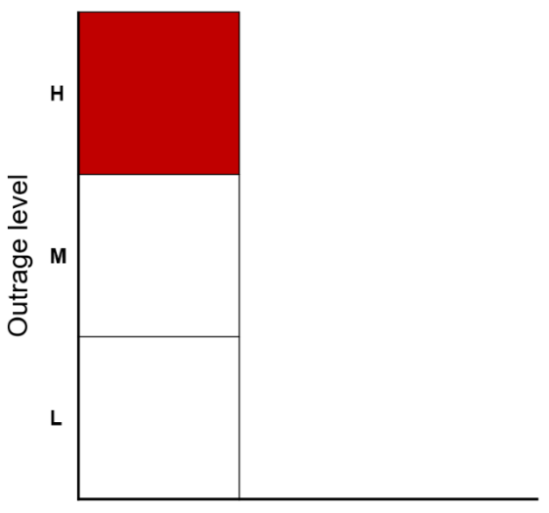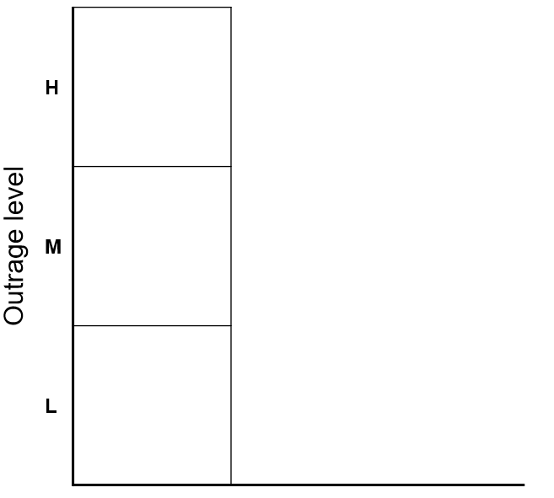

## STEP 2: QUALITATIVE HAZARD ASSESSMENT

The qualitative hazard assessment is an indicative process specifically to assist in risk communication and does not replace a technical human health risk assessment, which is a scientific assessment where necessary, for impacts on public health. From ‘*What is Risk Communication?*’ on page 2 of the [enHealth Risk Communication Guidance](https://www.health.gov.au/sites/default/files/documents/2022/07/enhealth-guidance-risk-communication-principles.pdf), **for the purposes of risk communication, ‘*Hazard*’ is the ‘actual harm’ – mortality, morbidity, ecosystem damage[4]**.

A rapid risk assessment can also be done, in terms of scientifically assessing the hazard, and in most cases where a contaminant is involved in an issue or event, will be done anyway. Although detail on how to do this is beyond the scope of the RCAT, if information from that process is available, then it obviously can and should be used in informing risk communication. Collaboration with the relevant experts may be required and conversation with relevant colleagues is encouraged. **Mark the relevant hazard factor rating (low, medium, or high) for the questions below.**

|  | **Hazard Factor Rating** | | |  |
| --- | --- | --- | --- | --- |
| Hazard Factor | LOW | MEDIUM | HIGH | Points for consideration |
| 1. Scale of people exposed/potentially exposed | 0 to 10’s | 100’s to 1000’s | 10,000’s | Sometimes the level of outrage can be more just for a low number. How many people exposed relates to the source of exposure. |
| 1. Magnitude – actual/potential level of consequences on the public/stakeholders | Little consequence | Some consequence | High consequence | How many people could be harmed/hurt, level of property damage or impact on property value, amenity, disruption to normal activities, psychological impact etc. This is more than the direct health impact. |
| 1. Probability – how likely is it that consequences will occur? | Not likely to happen | May happen | Very likely to happen/happening currently | How likely is it that there will be a negative impact? |
| 1. Complexity of issue – number of stakeholders, places, issues | Nil – low complexity | Some complexity | High level of complexity | What is known? What is the ability to mitigate the hazard? Think about the consequences of the mitigation too. Unravel the issues that are impacting. |
| 1. How imminent are the consequences? | A long time from now | In the foreseeable future | Imminent/Current | How soon are the negative impacts going to happen? (if it were to occur, when will it occur?) |
| TOTALS |  |  |  | Overall Rating: |

1. As for the outrage criteria, repeat the process, i.e. count the number of hazard factor ratings (for Low, Medium and High) for the 5 questions above, and insert these in the last row of the table (above). The rating with the highest number will indicate the overall rating (likely hazard level). Mark this in the relevant box (L, M or H) in the blank graph below, and this will be used to plot on the graph in step 3.

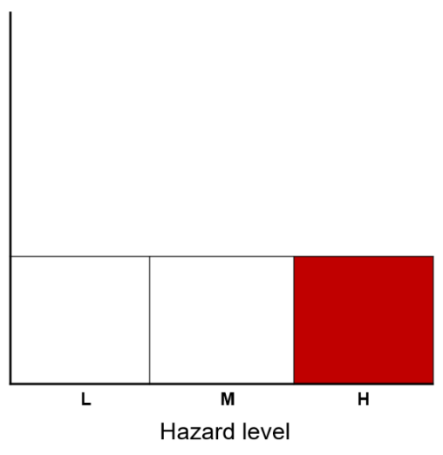The example to the right of the blank graph shows the hazard level of ‘high’ as the box with the highest number

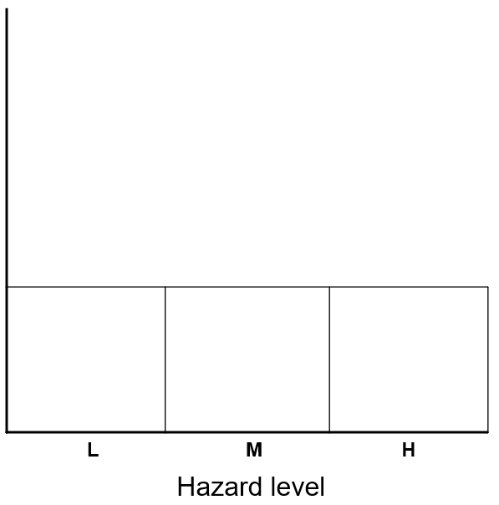

**Note**: **For situations where there are equal numbers for your totals** (e.g. for *Hazard*: 1 Low, 2 Mediums, and 2 Highs. Or, for *Outrage*: 7 Lows, 7 Mediums, and 5 Highs) – depending on the issue itself, you may wish to be more conservative and opt for the higher rating (eg High Hazard, and Medium Outrage for the example highlighted in the previous sentence) or make a judgement and decide depending on the current situation, and/or re-visit later.

The interactive spreadsheet automatically defaults to the higher rating (for hazard and outrage), but in these instances it is encouraged that consideration be given as to why there are equal values and to re-visit the questions and explore your responses further. This process may provide greater insight and very well alter the outcome. Remember – collaborate with colleagues where possible.

For equal values, consider:

* If you need to split your stakeholder group and target specific community groups separately (eg. starting with the group you are currently communicating with)
* Overall, how high do you think the hazard is (or is likely to be)? And how high do you think the outrage is (or is likely to be)?
* Giving more thought on the ‘hazard’ (where the hazard has equal values). Use the estimated risk, if known (via a rapid risk assessment as described above under Step 2), to influence your decision.

If you still end up with equal values, consider the possible outcomes and refer to the descriptor boxes of Sandman’s outrage quadrants (refer to the [enHealth Risk Communication Guidance](https://www.health.gov.au/sites/default/files/documents/2022/07/enhealth-guidance-risk-communication-principles.pdf), on pages 3 and 4) to guide your assessment. Remember, the RCAT is designed as a guide, provoking thought and to assist with assessing which quadrant you are most likely in, if it is not already obvious. Outcomes should be viewed as indicators (not as absolutes) that can change over time.

## STEP 3: PLOT ON THE MAP

1. Now plot on the blank graph below, using the outcomes from steps 1 and 2: use the hazard (likely impacts) and outrage (based on both likely and perceived impact) boxes on the X and Y scales to see where your outrage management outcome lies. This will be the intersection of the hazard and outrage boxes. Choose the corresponding dropdown option from the centre of the intersecting box.

The example provided on right shows the intersection of the hazard and outrage results from 1 and 2 above, being the ‘crisis communication’ quadrant.

Label your assessment with: (a) the name of issue, and (b) the stakeholder group being assessed.

Date your assessment to identify the stage of event/issue.

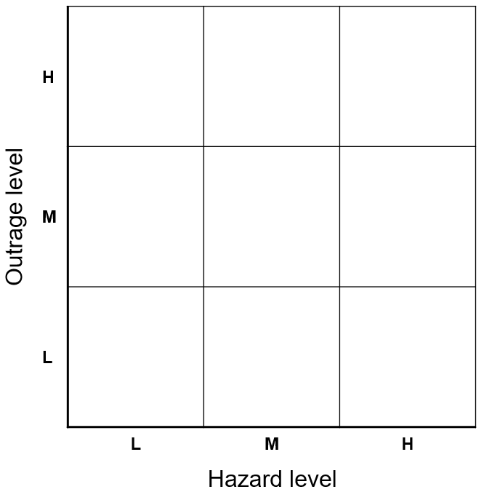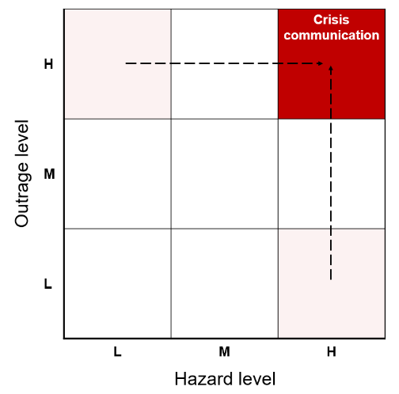

### Risk Communication Matrix

The four key quadrants (described by Dr Peter Sandman) for risk communication are: **Outrage management**; **Crisis communication**; the **Sweet Spot**; and **Precaution advocacy** – refer to the [enHealth Risk Communication Guidance](https://www.health.gov.au/sites/default/files/documents/2022/07/enhealth-guidance-risk-communication-principles.pdf).

Where the hazard and outrage are both low (ie bottom left corner), the level of engagement is minimal, and monitoring of the situation should be done to adjust if needed (avoiding escalation).

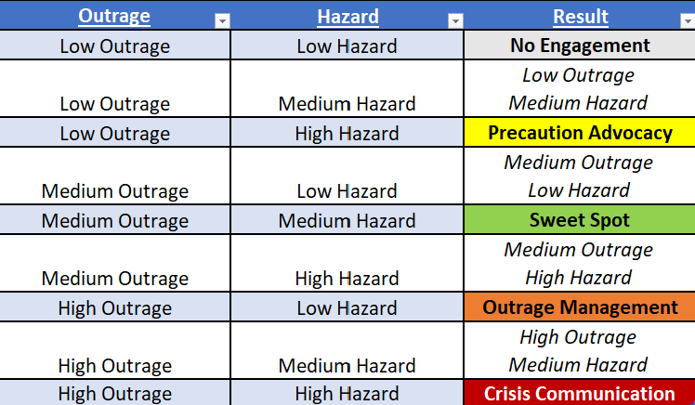 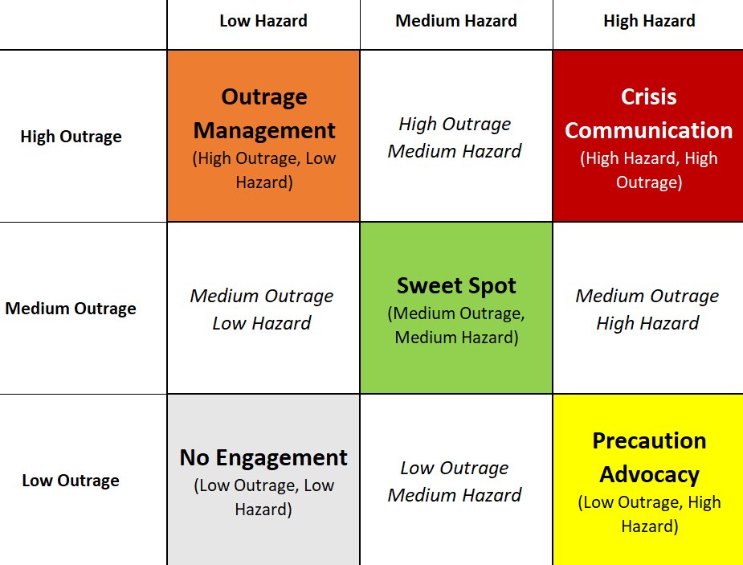

Landing between quadrants is a possibility but is not ideal and presents a problem when determining the course of action. In this case you should consider re-evaluating the questions and answers. Ideally, it is most helpful to have an outcome in one of the four quadrants. For example, in the scenario where there is high hazard / medium outrage: re-evaluation of the outrage may lead to the assessment indicating it is more likely the outrage will be high, and thus, your overall outcome is ‘Crisis communication’, which is definitive.

Sometimes changes to only a few questions will change your overall outcome, which is why thoughtful re-consideration of the answers is important, which includes collaborating with peers. Remember: overall, how high do you think the hazard is (or is likely to be)? And how high do you think the outrage is (or is likely to be)? Also remember to use the over-arching principles regardless of which quadrant you are in.

In general, the aim is to be in the 'Sweet Spot’ unless you are in ‘No Engagement’ and this is where you want to be.

### NEXT STEPS:

* **Compare** with the descriptor boxes of Sandman’s quadrants (refer to the [enHealth Risk Communication Guidance](https://www.health.gov.au/sites/default/files/documents/2022/07/enhealth-guidance-risk-communication-principles.pdf), on pages 3 and 4)
* **Utilise** the relevant risk communication principles (pages 5 to 9 of the enHealth Risk Communication Guidance) to minimise the level of outrage (or avoid it completely!)
* **Prepare** a plan for the actual communication

Discuss your assessment results amongst your team to help ensure consistency and to minimise increased risk perceptions. Apply the RCAT as a learning experience: applying it as a team effort and learning from each other and each application, is encouraged.

Nuances in outrage within different groups at any one time may become apparent when undertaking an assessment (e.g. you may land in more than one quadrant for risk communication), particularly for larger issues/incidents/events. For example, community perceptions of those that live/work closer to the issue may be different to those that live/work further away. In these cases, it is recommended to assess each sub-group separately as it will likely impact risk communication. When doing the assessment, it may become apparent that one particular factor is the main cause of the outrage, and it could be compounded by other factors or issues/events.

After going through the process of assessing the likely level of outrage resulting from an issue or event, it is important to prepare an actual communication plan to decide on how to approach and address the community and proceed with implementing the risk communication strategy. Using the risk communication principles (refer to the [enHealth Risk Communication Guidance](https://www.health.gov.au/sites/default/files/documents/2022/07/enhealth-guidance-risk-communication-principles.pdf)), collaborate with relevant communications colleagues and prepare for ‘how are we going to do this?’[5]. This process may involve other relevant agencies that are involved (or likely to be), such as EPA, local government, emergency and health care services. Remember to check-in with the affected community/communities during and after this communication process.

It is useful to discuss whether your agency/organisation (or you or your unit) is the most appropriate to lead the communication process. In some cases, it will be obvious through existing plans and arrangements but there may be occasions where responsibility is grey – collaboration with the relevant stakeholders is key in these instances. It should also be noted that shared responsibility and supportive roles are also important.

The risk communication principles form the foundation of an organisational culture that treats trust building as a legitimate task. This is fundamental to risk communication, which to be effective, is a collaborative process. Viewing people’s outrage as real problems to be addressed, will help demonstrate your understanding and receptivity of their outrage and ability to be empathetic to their concerns, worries, stresses and losses.

The risk communication assessment process is also available as an [interactive spreadsheet tool (RCATi).](https://www.health.gov.au/resources/publications/enhealth-risk-communication-assessment-tool-rcat-and-guidance-and-interactive-rcati?language=en)

1. A diverse assessment group could include Public/Environmental Health professionals, including medical officers, scientists/technical specialists, and nurses, communications specialists, indigenous representation, and could extend to relevant colleagues from other agencies, associations or groups (eg. Local Council, EPA, agencies comprising the emergency services)
2. An example toolkit for further information on stakeholder identification and mapping can be sourced from this [Stakeholder engagement toolkit](https://www.dhhs.vic.gov.au/sites/default/files/documents/201802/Stakeholder%20Engagement%20Toolkit%2020181202%20external.docx) (*Department of Health and Human Services, Victoria, 2018*)
3. Peter Sandman provides [four guidelines for public ‘stakeholder’ involvement in risk controversies](http://www.psandman.com/col/stakeh.htm): 1. Ignore the inattentives; 2. Use the media to reach the browsers, and to a lesser extent the attentives; 3. Focus on the fanatics; 4. Make it easy to switch groups. (Accessed July 2023).
4. To risk experts broadly, the risk is the level of consequence and probability of an event or something occurring. In a science related setting, the assessment of risk to human health is a function of hazard and exposure. In terms of risk communication, it is a function of hazard and outrage. Risk management includes all of these. For further information on the re-definition of ‘risk’ in terms of risk communication, refer to Chapter 1 of Peter Sandman’s book, [*Responding to Community Outrage: Strategies for Effective Risk Communication*](https://psandman.com/media/RespondingtoCommunityOutrage.pdf)
5. This [Stakeholder engagement toolkit](https://www.dhhs.vic.gov.au/sites/default/files/documents/201802/Stakeholder%20Engagement%20Toolkit%2020181202%20external.docx) (*Department of Health and Human Services, Victoria, 2018*) provides an example of a step-by-step guide to develop and implement a successful stakeholder engagement plan, including defining the purpose of your engagement (why do you need to engage and will you need to engage in more than one way?) and identifying/mapping your stakeholders.