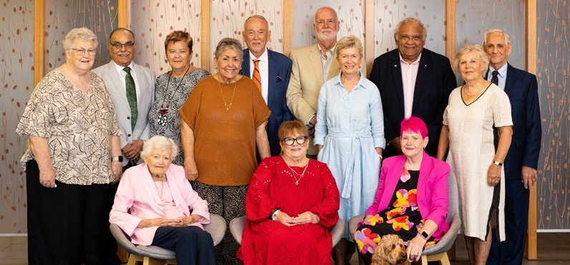

**Council of Elders**

DT0004137-1024

Vale Major General (Ret’d) Vikram Maden OAM, 20 March 1948 – 17 August 2024 (pictured: second from left). Vikram’s contribution to aged care and his dedication to a life of service is deeply respected and appreciated.

(Not pictured: Julie Rankin)

Let’s change aged care together

The Aged Care Council of Elders are a group of older people from diverse backgrounds with lived experiences of ageing and aged care. We help to improve the aged care system by informing older people about the changes to aged care, and providing advice to the government about aged care reform and ageing well.

We talk to older people about changes being made to aged care and listen to their experiences.



**Have your say**

There are plenty of opportunities for you to have your say about the changes to aged care:

* Sign up to receive *EngAged*, the monthly newsletter for older people: [**health.gov.au/**](http://health.gov.au/aged-care-newsletter-subscribe)[**aged-care-newsletter-subscribe**](http://health.gov.au/aged-care-newsletter-subscribe)
* Visit the Aged Care Engagement Hub to find out about the latest consultation opportunities and outcomes: [**AgedCareEngagement.health.gov.au/**](http://AgedCareEngagement.health.gov.au/get-involved)[**get-involved**](http://AgedCareEngagement.health.gov.au/get-involved)

We use this information to give independent advice to government about the aged care system and ageing well. When providing our advice, we

consider the views of older people across Australia.

Our goal is for all older people to feel confident about accessing high quality and safe aged care, where and when they need it.

To contact us:

 [**CouncilOfElders@health.gov.au**](mailto:CouncilOfElders@health.gov.au)  **02 6289 8769**

**facebook.com/groups/AgedCareCouncilOfElders**