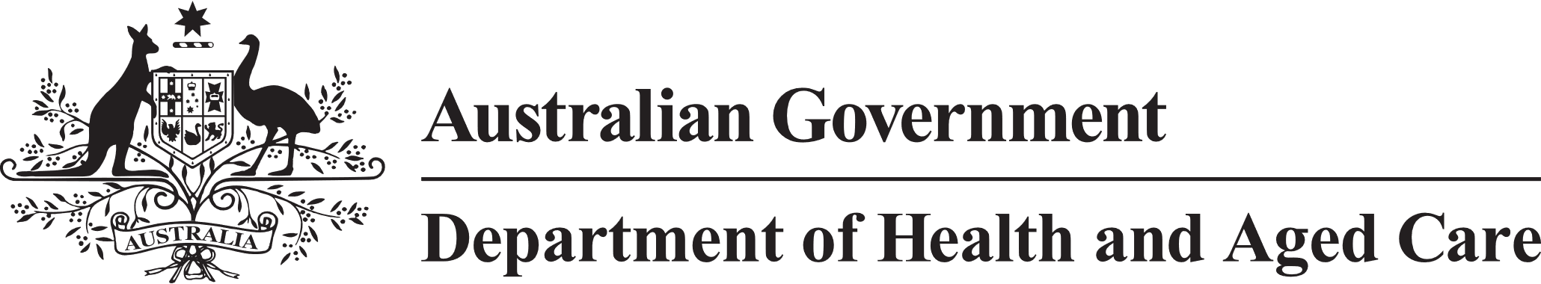

Council of Elders

# Communique – 18 September 2024

**Vale – Major General (Ret’d) Vikram Madan OAM –** It is with great sadness that we announce the passing of Council of Elders member Major General (Ret’d) Vikram Madan OAM.

South Australia-based Vikram was a passionate advocate of aged care and valuable member of the Council. Migrating to Australia in 2007 following a distinguished military career in India spanning 4 decades, Vikram found his calling in aged care.

Vikram shared his insights into the needs and experiences of older people, particularly advocating for those from culturally and linguistically diverse backgrounds since joining the Council in December 2023. On Australia Day 2019, Vikram was awarded the Medal in the Order of Australia (OAM) for his significant contributions to multicultural affairs.

Vikram’s contribution to aged care and his dedication to a life of service is deeply respected and appreciated.

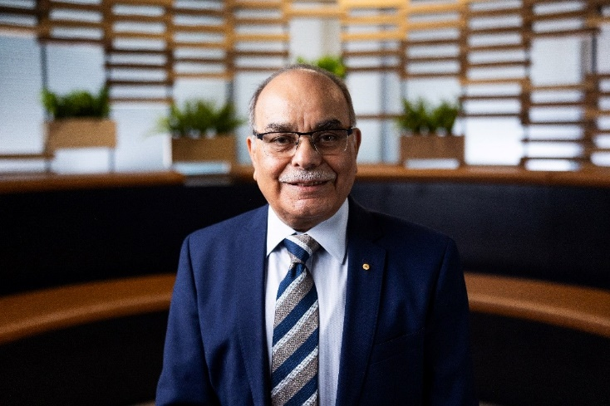

Aged Care Bill 2024 - The Council warmly welcomed the Government’s introduction of the Aged Care Bill 2024 to Parliament, the announcement of the response to the Aged Care Taskforce and details of the Support at Home program.

Members had a detailed discussion with senior officials from the Department of Health and Aged Care about the process for the introduction of the Aged Care Bill 2024 into Parliament and relevant content. They shared the concerns and questions that many older people have about services and costs that will affect them. The Council understands that helpful information about proposed changes is currently available online, and suggested areas where more information could be useful.

The Council is looking forward to further discussions on the Bill and subsequent Rules as they are developed and on the details of how the Support at Home program will work. Council was pleased to be informed of additional funding for home care packages and acknowledge wait times for these packages remain a concern for older people.

The next Council meeting is scheduled for Wednesday 23 and Thursday 24 October 2024.