**Baseline Evaluation of the Prostheses List Reforms**

Department of Health and Aged Care

29 April 2024

****Nous Group** acknowledges Aboriginal and Torres Strait Islander peoples as the First Australians and the Traditional Custodians of country throughout Australia. We pay our respect to Elders past, present and emerging, who maintain their culture, country and spiritual connection to the land, sea and community.

This artwork was developed by Marcus Lee Design to reflect Nous Group’s Reconciliation Action Plan and our aspirations for respectful and productive engagement with Aboriginal and Torres Strait Islander peoples and communities.

*Disclaimer:*

*Nous Group (****Nous****) has prepared this report for the benefit of the Department of Health and Aged Care (the* ***Client****).*

*The report should not be used or relied upon for any purpose other than as an expression of the conclusions and recommendations of Nous to the Client as to the matters within the scope of the report. Nous and its officers and employees expressly disclaim any liability to any person other than the Client who relies or purports to rely on the report for any other purpose.*

*Nous has prepared the report with care and diligence. The conclusions and recommendations given by Nous in the report are given in good faith and in the reasonable belief that they are correct and not misleading. The report has been prepared by Nous based on information provided by the Client and by other persons. Nous has relied on that information and has not independently verified or audited that information.*

© Nous Group

Contents

List of Terms and Abbreviations 1

Executive Summary 2

1 Introduction 5

1.1 The Prostheses List 5

1.2 The evaluation context 6

1.3 Purpose and contents of this baseline report 6

2 Overview of the PL reforms 7

2.1 History of the PL prior to the reforms 7

2.2 The impetus for the PL reforms 8

2.3 The objectives and projects of the reforms 12

3 Baseline of identified reform objectives 14

3.1 Objective 1: Improve the alignment of the scheduled benefits of the PL with the prices paid in more competitive markets 15

3.2 Objective 2: Maintain no additional out-of-pocket costs associated with the PL devices for consumers 19

3.3 Objective 3: Maintain clinician choice of appropriate prostheses for their patients 21

3.4 Objective 4: Improve the affordability and value of PHI for privately insured Australians 23

3.5 Objective 5: Clarify the purpose, definition and scope of the PL in legislation 26

3.6 Objective 6: Implement new PL assessment pathways aligned to Health Technology Assessment principles and streamline the application process through simple and robust IT infrastructure 30

3.7 Objective 7: Develop and implement PL listing reviews and PL compliance frameworks to safeguard the PL Reforms 33

3.8 Objective 8: Ensure ongoing financial sustainability of PL administration through effective and efficient cost recovery arrangements that are compliant with the Australian Government Charging Framework 35

Appendix A Overview of indicators and measures 37

Appendix B Measurement guides and baseline values 39

Indicator 1: Reduction in benefits 39

Indicator 2: Change in the size of the gap between PL benefits and prices paid in more competitive markets 41

Indicator 3: Change in out-of-pocket expenses related to PL items 48

Indicator 4: Change in clinician experience of choosing prostheses 52

Indicator 5: Change in utilisation of PL items 53

Indicator 6: Change in PHI premium increases 54

Indicator 7: Change in PHI coverage and for whom 56

Indicator 8: Legislative changes to the PL 60

Indicator 9: Implementation of PL regrouping 61

Indicator 10: Implementation of changes to general use items 64

Indicator 11: Assessment of legislative changes to the PL 64

Indicator 12: Assessment of PL regrouping 65

Indicator 13: Assessment of changes to general use items 66

Indicator 14: Implementation of new assessment processes 66

Indicator 15: Assessment of new assessment processes 67

Indicator 16: Change in listing review and compliance frameworks 69

Indicator 17: Assessment of listing review and compliance frameworks 70

Indicator 18: Implementation of cost recovery arrangements 73

Indicator 19: Financial sustainability of PL administration 73

Appendix C Mapping of objectives to reform projects and key evaluation sub-questions 75

Appendix D Method 77

Quantitative data collection and analysis 77

Qualitative data collection and analysis 85

Appendix E Public benchmark approximation 88

Appendix F Note on international comparisons 89

Appendix G Utilisation of PL items 90

Appendix H HCP1 completeness rate 91

Appendix I Prostheses List Reform Program Logic 92

Appendix J Causal logic diagram 93

Appendix K Baseline date of the evaluation 94

# List of Terms and Abbreviations

|  |  |
| --- | --- |
| Term | Definition |
| CAG | Clinical Advisory Group |
| GUI | General Use Item |
| IHACPA | Independent Hospital and Aged Care Pricing Authority.  Previously known as the Independent Hospital Pricing Authority or IHPA, however IHACPA is used through this report. |
| KEQ | Key Evaluation Question |
| MoU | Memorandum of Understanding |
| MSAC | Medical Services Advisory Committee |
| PHI | Private Health Insurance |
| PL | Prostheses List. The PL has been renamed to the Prescribed List of Medical Devices and Human Tissue Products, however PL or Prostheses List is used through this report. |
| PLAC | Prostheses List Advisory Committee |
| PLRT | Prostheses List Reform Taskforce |
| Prostheses | The term ‘prostheses’ is used to mean surgically implanted prostheses, human tissue items and other medical devices, as listed on the PL. Unless otherwise specified, we use ‘prostheses’, ‘items’ and ‘devices’ in this report to describe the medical devices and human tissue products listed on the PL. |

# Executive Summary

The Prostheses List (PL) was established in 1985 to set minimum benefits that private health insurers must pay to hospitals for surgically implanted prostheses[1] used in privately insured episodes of care. Since its introduction, the PL has undergone several reforms, reviews and changes. On 11 May 2021, a new set of reforms to the PL were announced in the Australian Federal Budget, seeking to “reduce the cost of medical devices used in the private health sector and streamline access to new medical devices”[2].

The purpose of this evaluation is to examine the way in which these reforms are implemented, the extent to which the reform activities achieve their intended outcomes, and to provide recommendations regarding future directions and considerations for the PL. This baseline report establishes the opening position, prior to any reform activities, of the relevant components of the PL.

Two key drivers sat behind the introduction of these reforms. Firstly, the reforms sought to reduce the cost of prostheses to insurers to alleviate upward pressure on private health insurance (PHI) premiums for consumers. Benefits relating to prostheses represented approximately 14% of all PHI benefits paid in 2019-20.[3] PL benefits at this time outweighed the prices of the same items in other systems, with the gap between the listed PL benefit and the price paid in the public system as high as 145% for some devices.[4]

Secondly, the PL reforms sought to address existing concerns expressed by a range of stakeholders including a lack of clarity regarding the purpose and structure of the PL, a lack of formal compliance and post-listing mechanisms, and insufficient transparency in decision-making and clinical governance. These concerns balanced reported strengths of the model including the benefits to consumers of no-gap arrangements, clinician choice and guaranteed stable pricing.

To respond to these two drivers and implement the reform program announced on May 2021, the Department of Health and Aged Care (the Department) committed to nine key projects within the PL reforms to undertake in partnership with the Independent Health and Aged Care Pricing Authority (IHACPA) and in consultation with stakeholders. The projects within the PL reforms are:

1. Reductions to listed benefit levels,
2. Clarification of the PL’s purpose, definition and scope,
3. Regrouping of the items on the PL,
4. A review of the inclusion of General Use Items on the PL,
5. Establishment of modernised assessment pathways,
6. Revised governance arrangements,
7. Formalisation of post-listing review functions and capabilities,
8. Establishment of a compliance strategy and associated functions, and
9. A review of the cost recovery fees associated with PL listings.

These projects within the PL reforms are intended to lead to the achievement of eight reform objectives. These objectives, their baseline state, the way in which the reforms intend to achieve them, and the way in which they will be evaluated over the course of the reform period are captured in Table 1 below.

Table 1 | Overview of reform objectives, the baseline state, rationale, and how they are intended to be achieved and evaluated

|  |  |  |  |  |
| --- | --- | --- | --- | --- |
| Reform objective | Baseline state | Rationale for objective | How it is intended to be achieved | How it will be evaluated |
| 1. Improve the alignment of the scheduled benefits of the PL with the prices paid in more competitive markets | PL benefits are significantly higher than prices in comparable markets. | High PL benefits contribute to PHI costs and issues of affordability. | PL benefits to be reduced incrementally over reform period in reference to IHACPA’s public benchmark prices (by 80% of the gap or within a 7% floor for most items). | Description of benefit reduction process.  Analysis of gap between PL benefits and public prices, and between PL benefits and international comparators. |
| 2. Maintain no additional out-of-pocket costs associated with the PL devices for consumers | Out-of-pocket costs for devices are charged in <1% of episodes. | Minimising out-of-pocket expenses is important for maintaining access to devices. | Maintaining minimal out-of-pocket costs establishes guardrails for the benefit reduction exercise and other policy decisions. | Analysis of out-of-pocket costs for devices paid by consumers. |
| 3. Maintain clinician choice of appropriate prostheses for their patients | Clinicians have a choice of PL-listed items. | Ensuring clinician choice is a core principle of the PL design. | Maintain policy position enabling clinician choice of appropriate prostheses. | Clinician assessment of any changes in choice.  Analysis of device utilisation. |
| 4. Improve the affordability and value of PHI for privately insured Australians | PHI affordability is currently an issue of concern, participation rates are decreasing and risk profiles increasing. | Low PHI participation places strain on the rest of the health system. | Reduction in PL benefits while maintaining device availability and access. | Analysis of PL contribution to PHI costs.  Analysis of PHI coverage rates. |
| 5. Clarify the purpose, definition and scope of the PL in legislation | Only high-level definition of PL in legislation.  Expanding PL scope over time is seen as a major driver of costs.  PL structure has become complex and difficult to navigate. | Lack of clarity and complex structure leads to reduced effectiveness and unwanted outcomes. | Establishment of new legislation regarding the PL.  PL groups to be reviewed and restructured.  General use items (GUIs) to be removed from the PL. | Description and review of new definitional documents.  Description and review of regrouping exercise.  Description and review of GUI removal process. |
| 6. Implement new PL assessment pathways aligned to Health Technology Assessment principles and streamline the application process through simple and robust IT infrastructure | No distinct assessment pathways based on complexity.  Assessment process has mixed alignment with HTA principles. | Effective and efficient assessment crucial to maintain integrity of the PL. | Multi-tiered application process to be established.  Changes to assessment governance processes. | Description and review of new assessment processes.  Description and review of new governance processes.  *\*Technology implementation not part of reforms.* |
| 7. Develop and implement PL listing reviews and PL compliance frameworks to safeguard the PL Reform | No formal compliance strategy.  No formal post-listing review framework. | Effective compliance crucial to safeguard the PL reform.  Post-listing review mechanisms important to maintaining the integrity of the PL. | Development of formal compliance strategy and associated functions.  Development of post-listing review framework and completion of pilots. | Assessment of compliance strategy and associated functions.  Assessment of post-listing review framework. |
| 8. Ensure ongoing financial sustainability of PL administration through effective and efficient cost recovery arrangements that are compliant with the Australian Government Charging Framework | Historically established cost recovery arrangements are non-sustainable and misaligned with Australian Government Charging Framework. | PL administration should be cost-neutral to Government. | Cost recovery arrangements to be revised. | Description of change to administrative effort.  Analysis of impact of revised cost recovery arrangements.  *\*Financial sustainability of cost recovery arrangements to be established in separate review.* |

# Introduction

## The Prostheses List

The Prostheses List (PL) is a schedule of prostheses[5] that sets the minimum price a private health insurer must pay a hospital for surgically implanted devices received by private patients in privately insured episodes of care.

The PL was introduced in 1985 under the *Health Legislation Amendment Bill 1985* to regulate the benefits paid for prostheses for patients with private health insurance (PHI).[6] By mandating payments and controlling benefit levels for prostheses, the introduction of the PL also aimed to make private health insurance attractive to patients by removing out-of-pocket costs, thereby reducing public hospital waiting lists for procedures involving surgically implanted prostheses.[7]

The Australian Government is responsible for maintaining the PL. Prior to the reforms being announced in May 2021, the Department of Health and Aged Care (the Department) processed medical device sponsors’ applications (approvals, variations, deletions); supported Health Technology Assessments undertaken by external consultants; supported the Prostheses List Advisory Committee (PLAC) and its subcommittees, the Clinical Advisory Groups (CAGs) and the Panel of Clinical Experts (the Panel); and performed other administrative functions to maintain the PL.

PL arrangements and its scope were set out in *Division 72 of the Private Health Insurance Act 2007* and the *Private Health Insurance (Prostheses) Rules*. The PL is the schedule to the Rules and was established with three parts:

* Part A – Prostheses that are used as part of hospital or hospital-substitute treatment where a Medicare benefit must be paid to the doctor for the procedure performed. The device must be surgically implanted, enable another device to be implanted or allow an implant to continue to function after surgery.
* Part B – Human tissue products that are substantially derived from human tissue where the tissue has been subject to processing or treatments, and whose supply (however described, including trade, sell, give or gift) is governed by state or territory law.
* Part C – Medical devices that do not meet the criteria for Part A, but the Minister for Health considers suitable for benefit payments by private health insurers.

The PL arrangements directed private health insurers to pay a specified minimum benefit for a product if:

* The product was on the PL;
* The patient received the product as part of hospital treatment or hospital substitute treatment;
* The patient had appropriate health insurance to cover the treatment; and,
* A Medicare benefit was payable for a service associated with the provision of the product.

Since its introduction, the PL has undergone various modifications and reforms (see section 2), but its purpose remains to “ensure that privately insured Australians have access to clinically effective prostheses that meet their health care needs.”[8] The PL continues to aim to provide privately insured patients with choice of prostheses recommended by their doctors, with no out-of-pocket expenses.

## The evaluation context

This evaluation focuses on the PL reforms announced on 11 May 2021 as part of the Australian Federal Budget and running from 1 July 2021 to 30 June 2025. Evaluation of these reforms will determine whether the reform program is being implemented as intended, whether it is delivering on its intended objectives, and provide any insights to improve the reform program’s impact.

Nous Group (Nous) was commissioned to undertake the evaluation of the PL reforms. Nous is undertaking the evaluation from 2023 to 2026 in accordance with an evaluation framework that the Department developed in consultation with the PL Reform Taskforce Project Board. The framework informed the development of the Evaluation Plan for the reforms and the Reform Program Logic Model (see Appendix I).

Changes to the reform program since May 2021 require revision to the evaluation framework as below:

* The Reform Program Logic Model includes reference to the implementation of HPP as a reform activity. It has since been clarified that this is a BAU activity and not a part of the reforms itself.
* The Reform Program Logic Model includes an outcome (outcome 6) which is ‘Improving transparency of setting PL benefits’. While there are no projects within the PL reforms that will specifically affect the transparency of benefit setting, many seek to increase clarity and understanding of the PL. Additionally, undertaking the reforms in a transparent and consultative manner is seen as essential to the success of the reforms. As such, the extent and way stakeholders are engaged in the reform projects will be evaluated.
* A separate review has been established to determine the financial impacts of changes to cost recovery arrangements. The achievement of outcome 15 (‘Administration of the PL is cost neutral to the government’) will be determined by that review.

There are three key evaluation questions (KEQs) for the evaluation:

1. Is the PL Reform Program being implemented as intended?
2. Is the PL Reform Program achieving the expected outcomes?
3. What are the ongoing and future directions, opportunities and priorities for the PL Reform?

It should be noted that this is an evaluation of the specific set of reforms within the current PL Reform Program, and not an evaluation of the PL as a whole or its suitability as a funding mechanism.

The evaluation is employing a mixed methods approach drawing on literature, documentation, stakeholder consultation and existing quantitative data. See Appendix D for further detail regarding the evaluation methodology.

## Purpose and contents of this baseline report

This report establishes the baseline for the evaluation of the PL reforms.

Section 2 provides an overview of the reforms, establishing the rationale for the reforms and the issues they were intended to address. It outlines the PL reform program, including its objectives and related projects, to enable later assessment of its implementation and outcomes.

Section 3 provides a baseline description of each of the eight reform objectives, incorporating the key projects within the PL reforms against each objective. Most of the information used to describe the baseline is qualitative in nature. Quantitative data is used where relevant to measure the baseline benefit levels against which the reductions will be evaluated. Section 3 also outlines how each objective and project will be monitored and measured throughout the evaluation.

Appendix A and Appendix B of this report describe the indicators and measures that will be used to evaluate the reforms over the 3 year period.

# Overview of the PL reforms

The Australian Government’s 2021-22 Budget committed $22 million over four years to a reform program designed to reduce the cost of medical devices used in the private health sector and streamline access to new medical devices. Building on earlier reforms and benefit reductions, these reforms seek to address several longstanding issues wmithin the Australian health system related to the cost and accessibility of medical devices. Most significantly, benefits for prostheses in the private system being higher than the prices of the same items in the public system and internationally.[9] In addition, the PL had grown over time in its size and complexity with a lack of agreement to its optimal purpose and scope.[10]

The reforms are being implemented by the Department in conjunction with the Independent Health and Aged Care Pricing Authority (IHACPA) and in collaboration with stakeholders.[11]

This section provides an overview of the PL reforms, including:

* historical background to the reforms
* impetus for the reforms
* the objectives and projects introduced by the reforms.

Further information on the detail of the reforms is set out in section 3 as it relates to each of the objectives and projects of the reforms.

## History of the PL prior to the reforms

#### Since its introduction, the PL has undergone various modifications and reviews

In 1999, some fourteen years after the introduction of the PL, the PL benefit amounts were deregulated in response to concerns from the private health industry about the rate at which benefit amounts were increasing. Under this new arrangement, private health insurers negotiated prices directly with device manufacturers, with the requirement there be no out-of-pocket expenses payable by patients.

This led to a rapid increase in the benefits paid for prostheses, many of which almost doubled from 2000-01 to 2002-03.[12] In 2005, PL benefit amounts were re-regulated, with arrangements put in place to ensure independent clinical advice underpinned assessments of the clinical effectiveness of prostheses.[13]

Numerous subsequent reviews relevant to the PL have been conducted since then. These include:

* Review of the Prostheses Listing Arrangements (2007)
* Review of Health Technology Assessment in Australia (2009)
* Performance of Public and Private Hospital Systems Research Report (2009)
* Review of Medicines and Medical Device Regulation (2015)
* Industry Working Group on Private Health Insurance Prostheses Reform (2016)
* Prostheses Benefit Setting Framework: Comparative analysis of benefit setting models (2017)
* Senate Community Affairs Reference Committee: Price regulation associated with the PL Framework (2017)
* Review of the General Miscellaneous Category of the PL (2020)
* Industry Working Group on Cardiac Technical Support Services (2020)
* Industry Working Group on Revised Benefit Setting and Review Framework (2020)
* Consultation paper titled “Options for Reforms and Improvements to the Prostheses List (2020).

The 2016 Industry Working Group on Revised Benefit Setting and Review Framework summarised the strengths of the existing PL framework and identified several issues (see Table 2).[14]

Table 2 | Strengths and issues with the existing PL framework

|  |  |
| --- | --- |
| Strengths of the existing PL framework | Issues with the existing PL framework |
| * Recognition of clinical differences – enabling differentiation between product groups/sub-groups, incorporation of new technologies, and recognition of improvements in value. * Patient choice of healthcare – allowing doctors to choose the most appropriate prostheses on behalf of patients. * Pricing transparency – providing transparent pricing for prostheses listed on the PL. * No patient out-of-pocket expenses – providing access to clinically useful prostheses with no out-of-pocket expenses. * Incorporation of expert clinical input – considering independent clinical perspectives as part of the assessment process via Clinical Advisory Groups and the Panel of Clinical Experts. | * Different pricing of prostheses between the private health sector and other markets – with minimum benefit amounts for prostheses listed on the PL in many cases exceeding prices paid in the public system and internationally. * Complex arrangements for medical devices in the private sector – with complexity existing at the level of the health system (e.g., multiple levels of government, private providers, insurers, and care pathways), patient (e.g., varying demographic characteristics, co-morbidities and treatment histories) and device (e.g., technical characteristics). * Lack of oversight – with no role for the Australian Government in compliance * Differing understandings of the purpose and scope of the PL – with, for example, disagreement about the appropriateness of including various types of items. |

Also significant in the development of the PL reforms was the Australian Government’s 2017 Strategic Agreement with the MTAA. The purpose of the agreement was to:[15]

* Promote the sustainability of privately insured health care by rebalancing the costs of medical devices to privately insured patients.
* Support a viable, innovative and diverse medical technology sector in Australia including local jobs.
* Improve the value of PHI for consumers by reducing benefits for prostheses on the PL.

The Department has described this agreement as underpinning the current PL reforms.[16]

## The impetus for the PL reforms

Two key drivers sat behind introduction of the reforms in 2021. These were the high costs of prostheses and growing stakeholder concerns. These two drivers are discussed below.

#### The reforms sought to reduce the cost of prostheses to insurers to alleviate upward pressure on PHI premiums for consumers

The cost of prostheses was identified as a contributor to rising PHI premiums. In 2019-20, for example, over three million items on the PL were provided at a cost to insurers of around $2.1 billion, representing around 14% of the PHI benefits paid that year.[17] PL benefits at this time far outweighed the prices of the same items in the public system and internationally, with this gap being as high as 145% for some devices in 2019-20.[18] Measurement of the gap between PL items in the private sector and more competitive markets is set out in section 3.1.

High prostheses benefits were one of several factors threatening the long-term sustainability of the PHI sector, along with declining rates of participation in PHI (particularly among younger Australians), increasing use of health services (particularly among older Australians and people with chronic disease) and a resulting worsening of the risk pool for PHI.[19]

#### The PL reforms also sought to address a range of concerns from stakeholders

A range of stakeholders are involved in the provision, acquisition, funding and receipt of medical devices. These include the Department, private healthcare insurers, private healthcare providers (i.e., private hospitals and day hospitals), medical technology companies, clinicians, and consumers.

These stakeholders have varied interests in the PL including many with a financial stake in the outcomes of these reforms. Successful implementation of identified projects in this context is challenging and requires careful and deliberate engagement. Government has committed to progress this reform program with high levels of engagement and co-design with these stakeholder groups in response to this environment. Stakeholder’s interactions with the PL are summarised in Table 3.

Table 3 | Interaction of different stakeholder groups with the PL process

|  |  |  |
| --- | --- | --- |
| Stakeholder group | | Baseline interaction with the PL |
|  | Department of Health | * The Department is responsible for regulating the PL. * The Department/Minister make decisions about which items should be listed on the PL, and their associated benefits, using the advice provided by the PLAC. * The Department administers the PL, including coordinating assessment and listing processes, publishing the PL, and undertaking ongoing maintenance activities. |
| *An icon of a person with a circle around them.* | Consumers | * The PL provides a mechanism through which consumers with PHI can access PL products with no out-of-pocket expenses. * The PL determines which medical devices and human tissue products consumers can access through the private health system. * Despite not paying out-of-pocket costs, the cost of benefits for items listed on the PL is indirectly borne by consumers through their PHI premiums. |
|  | Private healthcare providers | * A PL listing removes the barrier of hospitals having to negotiate separate funding arrangements with insurers which provides hospitals more freedom to select products based on their clinical benefit without additional switching costs. * Insurers are required to reimburse providers the benefit amount of a PL item, but there is no requirement for the price at which providers purchase the PL item from a supplier. This means that the full value of the PL benefit is shared between medical technology companies and providers based on their relative bargaining power. |
|  | Private health insurance providers | * Insurers review claims relating to PL listed devices. * Private health insurers are required to pay prescribed benefits to private healthcare providers when a PL-listed item is used for an insured patient. * While insurers directly bear the financial burden of having to pay PL benefits, this cost is indirectly borne by consumers through PHI premiums. |
| *An icon of a microscope.* | Medical technology companies | Device sponsors apply to list billing codes (potentially comprising many individual devices with common clinical use) on the PL.   * The PL streamlines sponsors’ ability to supply products to the Australian private health care system. * The PL provides a degree of pricing certainty for sponsors, which encourages the upfront investment required to enter Australian market. * The PL benefits are set at a level that promotes and supports medical technology innovation in Australia. |
| *An icon of a clinician.* | Clinicians | Clinicians can select PL-listed items for use in privately funded episodes of care.   * The PL provides a mechanism through which access to medical devices and human tissue products is ensured. * In some settings, the clinician is not financially involved in the supply and reimbursement arrangements, however in other settings, the clinician might have a degree of ownership of the clinic or practice, or otherwise have an interest in the profitability of the health services they provide. |
| *An icon of a group of people.* | Prostheses List Advisory Committee | * The PLAC exists to provide advice to the Department and Minister regarding the devices that should be listed on the PL, and the appropriate benefit levels for them. * Clinical Advisory Groups (CAGs) are subcommittees of the PLAC that undertake health technology assessments and provide advice to the full PLAC. |

These stakeholders have expressed a range of perspectives on the PL as it existed prior to the reform program. This occurred through formal responses to public consultation papers and inquiry processes (such as those listed in section 2.1). As part of the development of this baseline report, the evaluation team has reviewed these submissions and spoken directly to representatives of each stakeholder group.

In general, all stakeholder groups were able to point to both positive and negative elements of the PL arrangements. Proposed reform arrangements were contentious, with strong support and fierce criticism varying by stakeholder group depending on the proposed reform. A summary of written stakeholder statements summarising some of these different positions can be found in Figure 1.

*“There is general support for reform, [but] there is little agreement on the areas that require reform and how this should be achieved”*

**Report of the 2017 Senate Inquiry into the Prostheses List Framework**

Medical device companies were generally supportive of the overall pre-reform PL arrangements. In their submission to the 2017 Senate Inquiry into the Prostheses List Framework, the MTAA (which represents the manufacturers and suppliers of medical technology) wrote that, “The introduction of the PL framework has successfully addressed the earlier policy failures relating to certainty, cost and inflation”.

In contrast, private health insurers and consumer groups were highly critical of the way in which these arrangements had led to high device prices relative to the public sector and international comparators. In their submission to the 2017 Senate Inquiry into the Prostheses List Framework, Private Healthcare Australia (which represents insurers) wrote that, “While the PL may or may not have been useful at a point in the past, it has been on ‘set and forget’ for a long period of time and now is being gamed by providers”.

Figure 1 | Stakeholder perspectives on the pre-reform PL

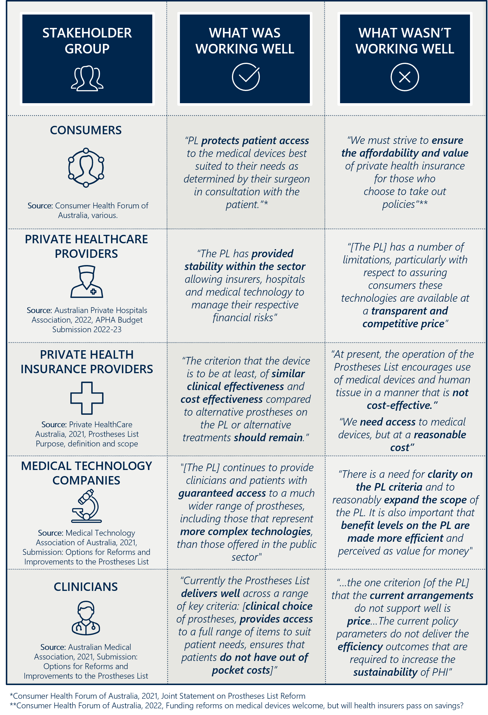

## The objectives and projects of the reforms

The PL reforms seek to modernise and improve the PL by reducing the cost of medical devices used in the private health sector and streamlining access to new medical devices, thereby improving the affordability and value of PHI. The reforms seek to achieve this through eight objectives, as shown in Figure 2.

Figure 2 | Eight objectives informing the PL reforms

A figure showing the eight objectives informing the PL reforms. The objectives are 1. Improve the alignment of the scheduled benefits of the PL with the prices paid in more competitive markets; 2. Maintain no additional out-of-pocket costs associated with the PL devices for consumers; 3. Maintain clinician choice of appropriate prostheses for their patients; 4. Improve the affordability and value of PHI for privately insured Australians; 5. Clarify the purpose, definition and scope of the PL in legislation; 6. Implement new PL assessment pathways aligned to Health Technology Assessment principles and streamline the application process through simple and robust IT infrastructure; 7. Develop and implement PL listing reviews and PL compliance frameworks to safeguard the PL Reforms; 8. Ensure ongoing financial sustainability of PL administration through effective and efficient cost recovery arrangements that are compliant with the Australian Government Charging Framework.


To achieve these objectives the Department has undertaken a program of work. The activities underpinning this program of work have been consolidated into nine thematic projects – see below.

Figure 3 | Projects of the PL reforms

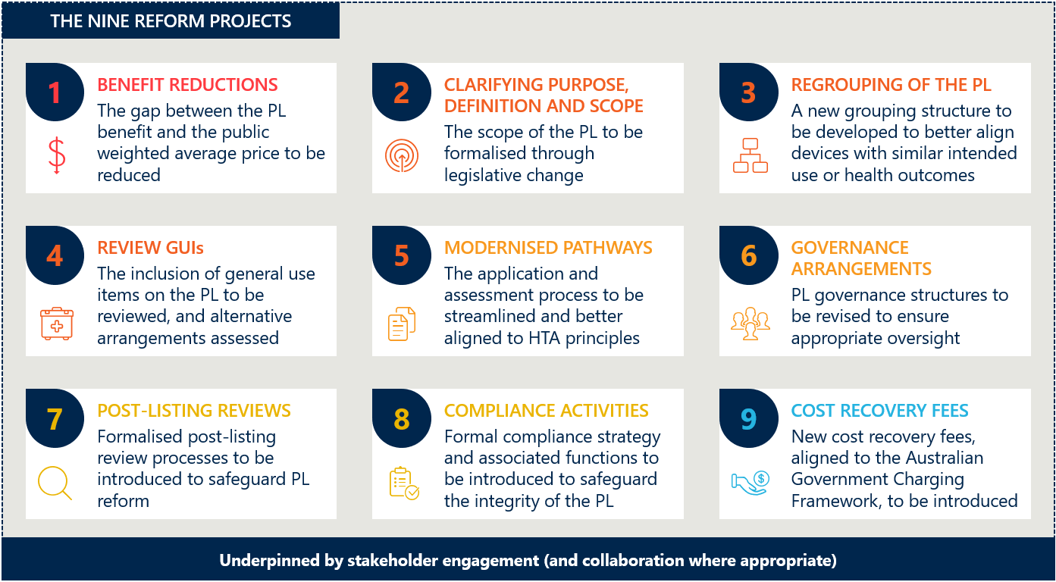

The Department established the PL Reform Taskforce (PLRT) to implement these projects, in collaboration with existing PL teams, related groups in the Department, IHACAP and other stakeholder groups. As noted at the bottom of Figure 3, to deliver these reform projects, each one requires effective and proactive engagement with all stakeholders in the sector. The success of these reforms for all parties' hinges on the reform projects being delivered in a transparent and responsive way. Stakeholder engagement is, therefore, a crucial component of all projects, and will be reviewed across all components of the evaluation.

# Baseline of identified reform objectives

This section provides a detailed examination of each of the eight reform objectives, outlining for each:

* A description of the baseline position prior to reform
* The rationale for a reform to that baseline state
* The reform projects and other activities that are intended to achieve the objective
* How the objective will be evaluated across the reform period.

Nous has set 10 May 2021 as the overall baseline date for this evaluation. However, we have used discretion in some cases to determine the baseline date for specific activities (see Appendix K for more detail). Appendix A contains a summary of the indicators and measures to be used, and Appendix B has a detailed examination of all indicators and measures.

Figure 4 | Reform projects intended to achieve reform objectives

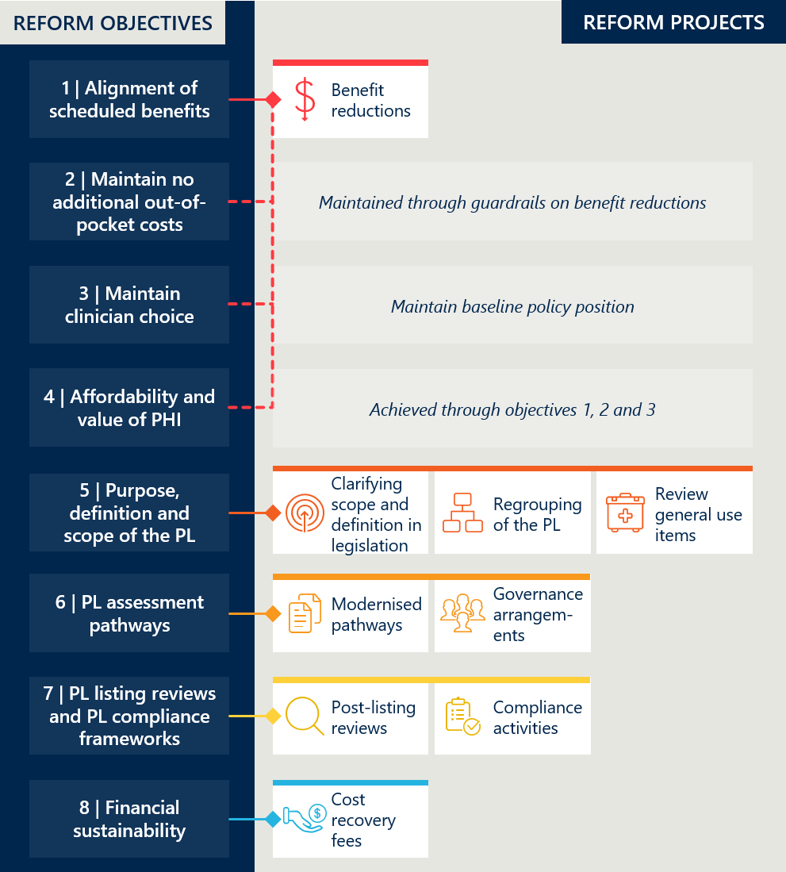

## Objective 1: Improve the alignment of the scheduled benefits of the PL with the prices paid in more competitive markets

Figure 5 | Reform projects related to reform objective 1

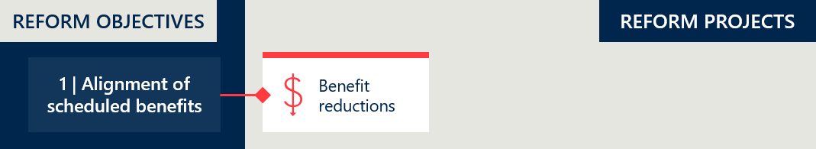

### Baseline position

#### PL benefits are generally higher than prices in the Australian public sector and comparable international markets

In 2021, the Department stated that, “It is agreed by all stakeholders that prices paid in the public hospital sector in Australia are, on average, lower than private hospital prices and the PL benefits paid by insurers”.[20] Analysis undertaken by IHACPA at the time estimated this gap to be 130% in 2017-18 and up to 145% for some devices in 2019-20.[21] (See measure 2.2 in Appendix B for analysis on the gap.)

Stakeholders also generally agree that PL benefits are higher than comparable international markets, though some dispute the validity of this gap, given the differences in health systems across countries. Analysis commissioned by Private Healthcare Australia comparing a sample of some of the largest PL items by value to the price of the same products overseas, showed that PL benefits are on average 21.2% higher than the UK (as priced by the National Health Service), 36.7% higher than New Zealand (as listed by Pharmac) and 38.4% higher than South Africa (prices provided by Discovery Health, a private health insurer).[22],[23] Others have also pointed to specific cases where PL benefits are substantially higher than the same product overseas.[24],[25] However, some stakeholders propose that there are genuine drivers of price differentials between the Australian private sector and international markets.[26]

The Department has made efforts to address high PL benefits in the past, however reductions have not been commensurate with the gap between the PL and more competitive markets. In February 2017, the Government reduced the minimum benefit amount paid for four categories of products on the PL by between 7.5% and 10% as recommended by an Industry Working Group.[27] Most recently, the Government entered into an Agreement with the MTAA in October 2017 that implemented a series of benefit reductions across the PL from February 2018 to February 2020.[28],[29]

However, at the time these PL reforms were announced, there remained a notable gap between PL benefits and prices in the public system. The median gap between items on Part A of the March 2022 PL and public benchmark prices supplied by industry in November 2021 was 25% (excluding CIED items).[30] Further to this, Figure 6 below shows the percentage gap between PL benefits and public benchmark prices at baseline (see measure 2.2 in Appendix B for more detail).

Figure 6 | Percentage gap between PL benefits and public benchmark prices (Part A, excluding CIED items)[31]

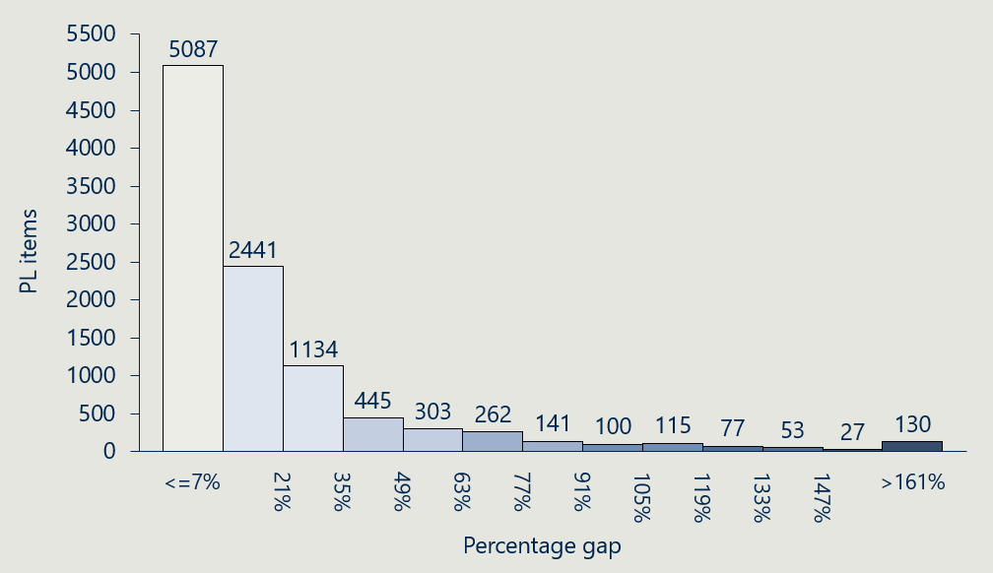

### Rationale for reform

#### PL benefits that are set above competitive market prices create an unnecessary cost to the health system that is borne by consumers

The PL mechanism ensures that the cost to consumers via private health insurance premiums remains fixed, even when a competitive market would dictate a lower cost (e.g., as indicated by a sponsor supplying the same product to the public sector at a price significantly below the PL benefit). This contributes to unnecessary costs in the PHI system (discussed further in section 3.4).

Private health insurers must pay the scheduled benefits for products listed on the PL to appropriately insured persons, however the prices sponsors supply products to private hospitals is not regulated.[32] Any surplus generated from cost-efficiencies over time is split solely between sponsors and private hospitals; it is not passed onto consumers. This had raised concerns about the extent to which the Australian system is contributing to multinational sponsors, as the disparity in prices could be construed as “Australian consumers disproportionately subsidising the cost of technology innovation for other countries”.[33]

### How the reforms intend to achieve this objective

#### The Department has committed to reducing benefits according to a process established in consultation with IHACPA and stakeholders

A Memorandum of Understanding (the MoU) between the Honourable Greg Hunt MP and the MTAA lists an agreed schedule of benefit reductions to occur between 1 July 2022 and 30 June 2025.[34] The MoU outlines that each PL benefit group will be reduced relative to a ‘Weighted Average Price’—a relevant benchmark price in Australian public hospitals.[35] All benefits that are at least 7% above their public benchmark will be reduced, but they will not be reduced any further than 7% above their public benchmark.

With some exceptions, PL items will be reduced by 80% of the gap between the current benefit and the public benchmark over three years. The Department will reduce benefits by 40% of their respective gaps on 1 July 2022, 20% on 1 July 2023 and 20% on 1 July 2024. No reductions are to occur in FY26, with the remaining 20% of the gap being retained as ‘private adjustment factor’.[36] The following products are exceptions to this schedule of reductions:

* General use items (GUIs) – The Department will reduce the benefits of GUIs by 60% of the gap on 1 July 2022 and the remaining 40% on 1 March 2023. GUIs were to be removed from the PL on 1 July 2023,[37] at which point separate funding arrangements for these are intended to be implemented.
* Cardiac Implantable Electronic Devices (CIEDs) – The Department would defer benefit reductions of CIEDs by one year to allow for further consultation on the value of technical support services. These are included in the benefit in a way that is not easily comparable to public sector pricing. Commencing on 1 July 2023, the benefits of CIEDs will be reduced by 40% of the gap (after accounting for the value of technical support services) and then continue with the standard reduction schedule, one year delayed.

IHACPA was agreed to determine the public benchmark price for each PL benefit group. A first benchmarking exercise using FY21 data will inform the first and second rounds of reductions (1 July 2022 and 1 July 2023). A second exercise will use FY23 data to inform the remaining reductions (1 July 2024, and 1 July 2025 for CIED items). The MoU stated IHACPA was to determine ‘the most appropriate data’ to use for benchmarking.[38] Following a period of consultation with stakeholders, IHACPA published a methodology for determining the Weighted Average Prices using sponsor-supplied data collected by MTAA.[39],[40]  The public benchmarking was to cover all PL items except for human tissue products.

Figure 7 overleaf shows the proportion of Part A PL items that would be subject to reform reductions, not subject to reform reductions and removed by July 2023.

Figure 7 | PL items subject to reductions (Part A, excluding CIED items)[41]

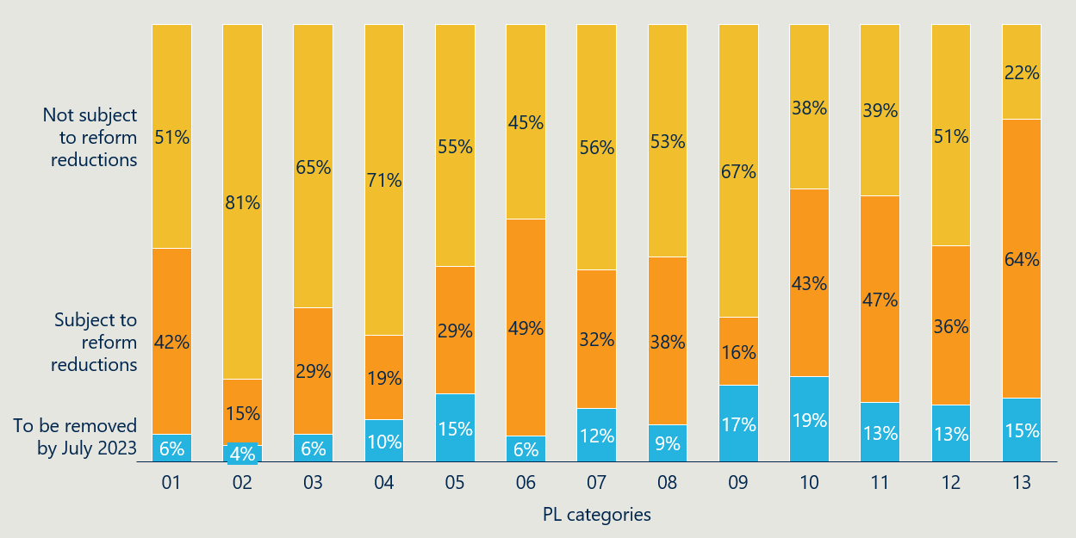

### How this will be evaluated

#### The reduction in benefit levels and resulting change in gap to other markets will be tracked directly

The achievement of this objective will be evaluated through the review of two indicators. Indicator 1, *Reduction in benefits*, will be used to provide evidence that the activities that drive this objective have been completed. This indicator will directly track the activities involved, looking at both the specific steps that have been taken to reduce the benefits, as well as the resulting changes in benefit levels.

Indicator 2, *Change in the size of the gap between PL benefits and prices paid in more competitive markets*, will be used to examine the extent to which the activities have caused the objective to be realised. This indicator tracks the objective directly, looking at the changing level of alignment between PL benefits and the public prices, and PL benefits and international markets.

See Appendix B for a detailed description of these indicators, the component measures, and the baseline data available for them.

## Objective 2: Maintain no additional out-of-pocket costs associated with the PL devices for consumers

Figure 8 | Reform projects related to reform objective 2

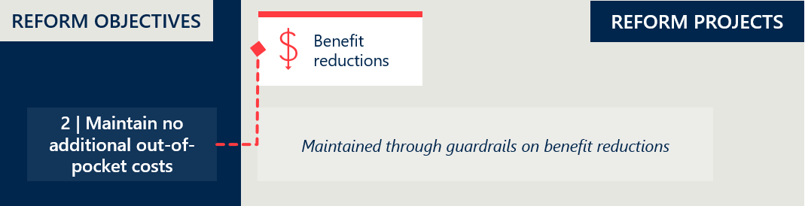

### Baseline position

#### The PL was designed, in part, to act as a mechanism to ensure that consumers experience no out-of-pocket costs associated with devices

From the outset, PL policy was designed to ensure that consumers with PHI had guaranteed access to the most appropriate medical devices. Preventing significant out-of-pocket costs being charged to consumers is an important component of enabling this access, as individuals might otherwise have been unable to afford these costs. The PL sought to ensure this by setting benefits that cover the full cost of the device, and place substantial downward pressure on the costs that would be charged to consumers.

This requirement for no additional out-of-pocket expenses for prostheses on the PL was more formally noted by the HTA Review in 2009.[42] This review stated that “the price that sponsors are allowed to charge for a product should be equal to the benefit that insurers are legally obliged to reimburse”.[43] There was, however, no legislative mechanism by which the PL could guarantee no out-of-pocket costs.

Evidence shows that the PL prevents out-of-pocket costs being charged to consumers in most cases. In 2021, at most 0.23% of episodes involving a PL-listed item included an out-of-pocket cost to the consumer[44]. In these rare cases when an out-of-pocket cost is charged, it is often sizable. In 2021 the average gap payment[45] (when one was charged) was $270. See Appendix B (indicator 3) for a more detailed examination of baseline out-of-pocket costs.

### Rationale for reform

#### This objective is important for maintaining a key feature of the PL and the benefit it provides

Ensuring minimal out-of-pocket expenses associated with items on the PL is a key component of the policy’s purpose. Maintaining this function throughout all changes is important for ensuring that the PL’s benefit is not diminished through the reform process. This objective aligns closely with *Objective 3: Maintain clinician choice of appropriate prostheses for their patients,* in aiming to ensure that the PL reforms should not negatively impact either the out-of-pocket costs associated with PL items for patients, nor a clinician’s choice of prostheses.[46]

### How the reforms intend to achieve this objective

#### This objective sets guardrails for the benefit reductions, as well as all other reform projects

No reform projects are being implemented solely for the purpose of this objective, rather this objective stands as a policy goal to be maintained throughout the reforms. As the primary mechanism for preventing out-of-pocket costs to consumers is through the benefits being set at a level that covers the full cost of the device, the main activity with the potential to impact out of pocket costs is the benefit reductions.

The benefit reduction exercise has been designed with the intention of ensuring that benefit levels remain at or above the price of the device (using the public benchmark as an indicator of this price). If benefits are reduced too much, private hospitals may consider out-of-pocket costs associated with prostheses necessary for covering costs and staying in business. As such, this objective seeks to ensure that improving the affordability and value of PHI (objective 4) results in a net saving to consumers, not just a shifting of costs from premiums to hospital bills.

While it is not anticipated that other reform projects will lead to a change in out-of-pocket costs, the PLRT have also indicated that they intend to take explicit consideration of this objective in the planning of all other reform projects. If other activities are seen to have the potential to impact this, they will take steps to mitigate any impact, and these steps will be documented.

### How this will be evaluated

#### Both the frequency and size of any out-of-pocket expenses will be monitored for any changes

Indicator 3, *Change in out-of-pocket expenses related to PL items,* aims to track the volume and size of out-of-pocket expenses paid for PL items by appropriately insured Australians. If the PL reforms are achieving their expected outcomes, we expect to see out-of-pocket expenses remain constant, with very minimal, if any, change to their frequency or their size. This indicator will therefore look at:

1. The prevalence of out-of-pocket expenses for PL-listed items
2. The average out-of-pocket expense for PL-listed items.

## Objective 3: Maintain clinician choice of appropriate prostheses for their patients

Figure 9 | Reform projects related to reform objective 3

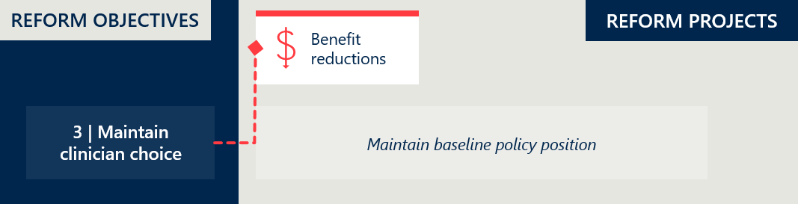

### Baseline position

#### Ensuring access to the most appropriate medical devices is a key feature of the PL

The PL was established to ensure that privately insured Australians can access the medical devices that are the most appropriate for their needs. For this to be the case, it is essential that clinicians have freedom of choice to select the device that they deem to be clinically indicated. The PL provides clinicians with this freedom of choice by:

* Having all devices (that are deemed to be safe for use) able to be listed on the PL, and
* Ensuring that any device listed on the PL can be paid for, as the scheduled benefit will cover the device cost.

In total, if these hold, then it logically follows that clinicians will have freedom of choice to select the device which is most clinically appropriate.[47]

While the PL enables choice not to be constrained, there remains influences on clinicians' selection of devices. Private hospitals, often in consultation with clinicians, enter supply arrangements with select sponsors, effectively making a subset of PL items available for clinicians to choose from. Consignment arrangements are commonplace in private hospitals, which further creates barriers to clinicians’ ability to choose any item listed on the PL.

The PL separates the payment of the cost of the device from the patient and clinician, removing any incentive to compromise on device selection for reasons of price. It does not, however, have a way to remove financial incentive from the procurement and negotiation process between private practices and device suppliers.

### Rationale for reform

#### This objective is important to ensure that the PL continues to be able to fulfill its core function

Similar to objective 2, this objective is intended to ensure the preservation of an existing, and fundamental, feature of the PL. Maintaining clinician choice of device is essential for ensuring that the PL reforms do not undermine the key functionality of the PL in providing privately insured Australians guaranteed access to appropriate medical devices.[48]

### How the reforms intend to achieve this objective

#### The implementation of each project within the PL reforms is designed to not impact clinician choice of devices

There are no projects within the PL reforms that are being implemented solely for the purpose of this objective, rather this objective will be maintained as a matter of priority throughout PL reform.

The benefit reduction exercise has been designed with the intention that benefits remain at or above the price of the device. Provided this is maintained, and benefit levels are sufficient to cover the costs of the devices, there should be no impact on clinician choice from the reforms.

Other reform projects, notably the revised assessment processes, re-structuring, post-listing reviews and compliance frameworks have been designed with the intention that they do not reduce the ability for appropriate devices to be listed on the PL. They are intended to only remove, or prevent the inclusion of, devices that are inappropriate for listing on the PL. The PLRT have indicated that they will take consideration of any impacts on clinician choice into account in the implementation of all reform projects.

### How this will be evaluated

#### In addition to assessing any potential impacts on clinician choice resulting from specific reform projects, broader qualitative and quantitative evidence for changes in selection behaviour will also be examined

Any potential impacts on clinician choice will be monitored by reviewing the implementation and documentation of reform projects and conducting consultations across the sector. Engaging with clinicians directly is an important aspect of this approach, to understand their perceptions of choice and how, if at all, this has changed. While evaluation of this objective will be driven primarily by qualitative evidence, we will consider using utilisation data to supplement our analysis of changes in clinician choice of appropriate prostheses, or to trigger qualitative investigation.

Indicator 4 will gather this qualitatively directly from clinicians, using consultation to understand if they perceive there to have been any impact on their level of choice of devices. Indicator 5 will look at device utilisation, particularly in places with substantial changes in benefit levels, to assess whether there are any notable, significant changes in utilisation (that cannot be otherwise explained). These indicators are examined in more detail in Appendix B.

## Objective 4: Improve the affordability and value of PHI for privately insured Australians

Figure 10 | Reform projects related to reform objective 4

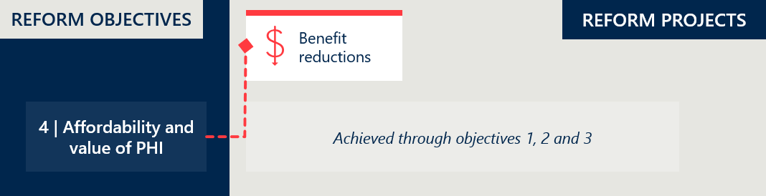

### Baseline position

#### PHI prices have increased consistently and significantly, leading to overall reductions in participation rates

Private health insurance (PHI) enables privately-insured Australians to get quicker access to the care they need and have more choice about how they receive it. [49] Consumers take up PHI policies to support their access to treatment and clinical expertise that they may not otherwise have been able to access, or access in a timely way. Government supports the role of PHI in the health system as, when it is operating efficiently, it can provide better welfare outcomes for individuals and society on aggregate.[50]

Rising medical costs and increased utilisation of private health services have put pressure on private health insurers, which is exacerbated by declining participation rates of PHI.[51], [52] An increasing proportion of PHI policies are for older Australians with more complex health needs[53], including higher-than-average use of medical devices[54]. This drives further cost pressures for private health insurers, resulting in substantial annual premium increases.[55] These high premiums can turn away a broader and increased membership base, challenging the sustainability of the PHI sector into the future.[56]

Expenditure on prostheses adds to the pressure on private health insurers as the total benefits paid for listed prostheses increased by 2.28% year on year from FY16 to FY21 (see Figure 11 overleaf). Between FY17 and FY20, however, prostheses benefits paid by PHI held steady, coinciding with benefit reduction activities prior to the current PL reforms.

It should be noted that multiple drivers influence prostheses utilisation and expenditure. These include changes to the proportion of older PHI holders, changes to medical technology and advancements in the sector, changes to the mix of products used, and macroeconomic trends.

Figure 11 | Total prostheses benefits paid ($'000)[57]

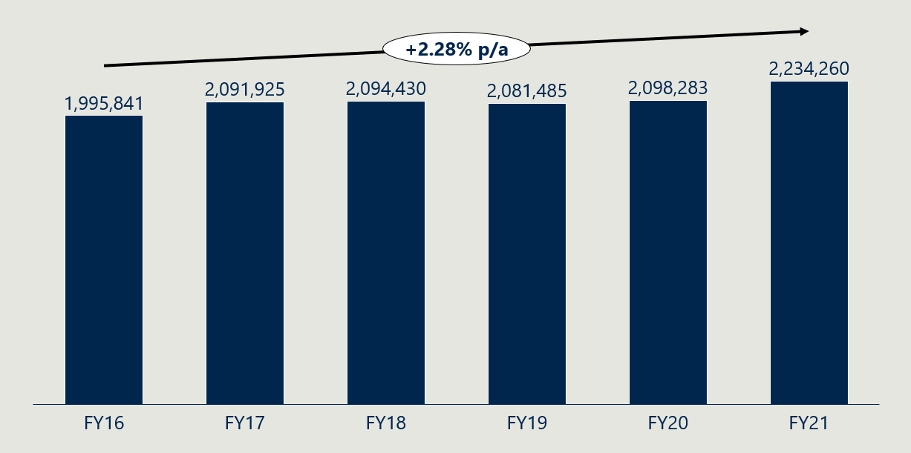

In the five years leading up to baseline, PHI premiums increased by an average of 3.88% annually, 2.30 points above the Consumer Price Index, which increased by an average of 1.58% in the same period. However, Figure 12 shows that the rate of annual premium increases declined across this time.

Across this five-year period, PHI participation rates dropped from 47.01% to 44.55%, reaching a low of 43.66% in June 2020.[58]

Further detail about PHI premiums and participation rates is captured in Appendix B (Indicators 6 and 7).

Figure 12 | Average year-on-year insurance premium price changes (as % of prior year premiums)[59]

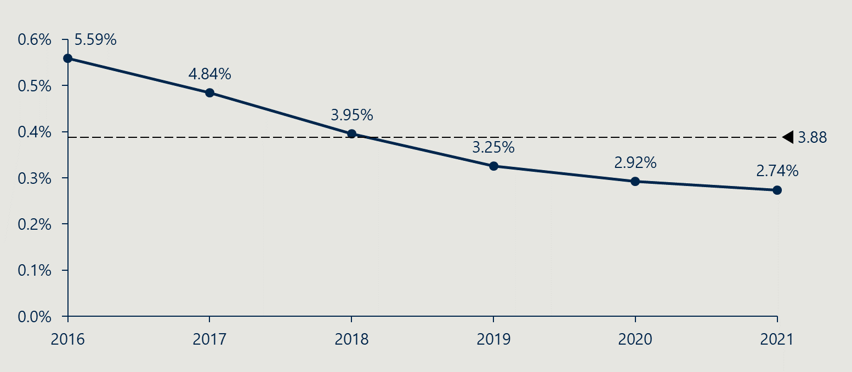

### Rationale for reform

#### Reforms to the Prostheses List are part of a broader PHI reform agenda to incentivise uptake of PHI by increasing its affordability while maintaining its value for consumers

The Australian Government determining to reduce PL benefits is part of a larger reform agenda to improve the affordability of PHI. It identified that the costs of prostheses in the private sector is a key driver of PHI premium levels, and reductions to these costs have the potential to support the overall sustainability of PHI.[60]

For this reform to result in increased uptake of PHI, measures to improve affordability must not reduce PHI’s value to consumers. This reform has identified two core functions of the PL providing value to privately-insured Australians that ought to be maintained. The first is that consumers do not need to pay additional out-of-pocket expenses related to PL products, and the second is that the PL ensures that patients can receive the most clinically appropriate medical devices and human tissue products (as selected by their clinician).

### How the reforms intend to achieve this objective

#### Improved PHI affordability and value is expected to follow directly from the achievement of objectives 1, 2 and 3

The achievement of objective 1, which seeks to reduce the difference between PL benefits paid by PHI and prices in more competitive markets, should place downward pressure on premium growth. If insurers are paying lower benefits for devices, and demand for devices remains stable, then the costs to insurers per policy will decrease. It is assumed that these savings would be passed on to consumers, at least in part, as private health insurers are subject to regulations and competitive scrutiny regarding the reasonableness of premium increases and the adequacy of benefits provided to policy holders. It is unlikely lower benefits will result in reduced premiums as prostheses are only one component of the costs incurred by insurers. However, if the logic of the reforms is sound, any subsequent increases in premiums could be expected to be smaller than they otherwise would have been without the reforms.

While objective 1 addresses the affordability of PHI, the achievement of objectives 2 and 3 is intended to address its value. The reform program has been structured to prevent increased PHI affordability being driven simply by diminishing its value. Objectives 2 and 3 aim to maintain the key functions of the PL in creating value for privately-insured customers through maintaining the absence of out-of-pocket costs and maintaining clinician choice. If these objectives are achieved, then PHI will continue to allow access to the same medical devices, and with no additional costs to consumers, representing at least a maintained level of value associated with PHI.

### How this will be evaluated

#### Notable changes in PHI pricing and coverage will be monitored, and evidence gathered to assess the relative contribution of the PL reforms to any changes

The achievement of this objective will be assessed through looking at:

1. The change in PHI premium increases, which aims to track changes in affordability
2. The change in PHI coverage and for whom, which aims to track changes in perceived value
3. Any evidence for the contribution of the PL reforms to changes to points 1 or 2.

If PHI premiums increase by lower amounts than would have otherwise been expected, and there is reason to attribute that change to the projects of the PL reforms, then there is reason to believe that the first part of this objective, improving affordability, has been achieved. Similarly, if PHI coverage increases, this would indicate that consumers see PHI as more valuable relative to its cost.

Indicators 6 and 7, outlined in Appendix B, will be used to monitor these and evaluate the PL reform program’s contribution.

## Objective 5: Clarify the purpose, definition and scope of the PL in legislation

Figure 13 | Reform projects related to reform objective 5

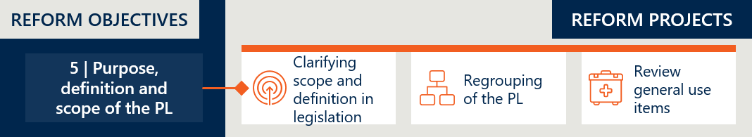

### Baseline position

#### The arrangements of the PL were set in legislation, however its purpose, scope and definition were outlined separately in guidance documentation[61]

Legislation is the mechanism that dictates private health insurers are to pay the PL benefit for PL items when used on appropriately insured persons. At the baseline date (11 May 2021), the PL was Schedule 1 of the *Private Health Insurance (Prostheses) Rules*. This was a legislative instrument made under the *Private Health Insurance Act 2007*. This would legislate that private health insurers pay at least the minimum benefit accorded to each prosthesis listed on the PL.[62]

Further detail about the PL was expounded in the Prostheses List Guide 2017 (PL Guide). Notably the stated purpose of the PL, to “ensure that privately insured Australians have access to clinically effective prostheses that meet their health care needs”[63] was not defined in this legislation, rather it was stated in the PL Guide as the basis of decisions about device listings.[64] ​

Similarly, the PL Guide provided the only available guidance regarding the scope of the PL, by articulating the criteria for listing products on the PL. This differed across the three parts of the PL:[65]

Part A – Prostheses that satisfy the criteria for listing agreed by PL Advisory Committee and approved by the Minister. The listing criteria for Part A is provided in the PL Guide, and narrows the scope to include;

* Prostheses entered and current on the Australian Register of Therapeutic Goods.
* Prostheses that are used as part of hospital or hospital-substitute treatment where a Medicare benefit must be paid to the doctor for the procedure performed.
* Prostheses that are surgically implanted, enable another device to be implanted or allow an implant to continue to function after surgery.
* Prostheses that have been compared to alternative products on the PL or alternative treatments.

Part B – Human tissue (includes products that are substantially derived from human tissue where the tissue has been subject to processing or treatments, and whose supply [however described, including trade, sell, give or gift] is governed by state or territory law). Unless explicitly identified, human tissue products are not addressed in this guide.

Part C – Medical devices that do not meet the criteria for Part A, but the Minister for Health considers suitable for benefit payments by private health insurers. The listing criteria for Part C was confined in the *Private Health Insurance (Prostheses) Rules*. There was no defined process for listing products covered under Part C.

The Department has proposed the scope of the PL be limited specifically to high-cost implantable medical devices where there is intention that the listed device be used in a procedure with a therapeutic purpose.[66] The MTAA and APHA disagree with this proposal but agree a discussion is warranted to clarify the scope of the PL.

#### The PL groups listed items according to similar product characteristics and clinical effectiveness but there were concerns about the level of complexity

Prostheses in benefit groups that were assessed as having superior clinical outcomes to prostheses in comparator benefit groups were assigned a higher benefit. Part A of the PL was divided into 13 categories of prostheses. Each category was subsequently split into sub-categories, groups and sub-groups, which were identified numerically. Some prostheses also had suffixes that were descriptive text or letters to designate additional characteristics. All prostheses within a benefit group, that is, all items sharing a category, sub-category, group, sub-group and suffix, were assessed as having similar clinical effectiveness, and so were assigned the same benefit. Part C of the PL shared the same grouping structure as Part A, while Part B had a separate grouping structure and benefit levels were set for individual products (see Appendix B, indicator 9 for more detail).

Over time, the PL has increased in complexity, with the number of items increasing nearly tenfold from 1997 to the baseline year of 2021.[67] At baseline, there were 10,902 billing codes listed on Parts A and C of the PL, and 759 on Part B.[68] Within Parts A and C, there were a total of 1,680 benefit groups with an average of 6.49 billing codes in each.[69] This highlights the fine-grained structure of the PL, where each benefit group holds (on average) just a small number of billing codes. See Appendix B, measure 9.2 for more detail regarding the number of benefit groups and billing codes listed on the PL at baseline.

#### There was growing concern that the PL’s scope was ill-defined, with many items, particularly in the General Miscellaneous category, not according with the original intent of the PL[70]

The Department noted the scope of the PL lacked specificity and there were no clear bounds of what could and could not be listed on the PL.[71] The increasing complexity could be seen in the increase in number of items and benefit groups over time. This increase reflects the introduction of new and innovative medical technology, however stakeholders note the expansion of the PL can also be attributed to items ‘which could be better funded by other avenues, or are already funded through other means’ (explored further in section 3.5.2 below).[72] At baseline, the PL included general use items (GUIs), which are items used in a broad range of surgeries, not necessarily only surgeries involving prostheses.

### Rationale for reform

#### Diverse stakeholder groups described problems associated with the PL lacking a clearly defined purpose

*“Advances in technology mean that medical devices that are used in effective and clinically proven surgical procedures are not eligible for listing on the PL because they are not implanted”*

**MTAA, 2017 Senate Submission**

**MTAA, 2017 Senate Submission**

The purpose of the PL is not defined in legislation and stakeholders had divergent views about the types of medical devices and human tissue products that should be listed on the PL. Given the PL impacts an array of stakeholders, it is important that its purpose scope is clear, to be certain in the value the PL provides to the private health sector.

Medical device companies argue, for example, because the arrangements do not allow for the listing of non-implantable devices with a clear clinical benefit, that this has limited patient access to more contemporary models of care.[73]

#### The PL’s grouping structure, based on clinical use, created a mechanism for new groupings to proliferate and benefit levels to escalate

As noted, PL groups, and their associated benefit levels, are established based on product characteristics and clinical benefits. Doing this has caused the structure of the PL to grow in complexity over time, as new groups are established for any items with novel features. Some stakeholders have indicated that this has resulted in a lack of clarity due to shifting definitions of the PL groups.[74] Other stakeholders have raised concerns that this has created a system that can be ‘gamed’ by device sponsors, by targeting differential benefits in a favourable way, or applying to list devices with small, incremental changes, resulting in higher benefit levels without a corresponding uplift in clinical benefits for consumers.[75] While promoting and rewarding clinical innovation is the intention, there are concerns the system incentivises other unintended listing behaviours, in which sponsors have reason to list items to target specific benefit groups.

#### The lack of a clear scope has led to disagreement between stakeholders regarding the listing of certain item types, in particular consumable GUIs

Stakeholder interpretations as to the scope of the PL varied greatly.[76] For instance, some stakeholders believed that if ‘consumable’ items such as sutures and staples were on the PL, then so should other ‘consumable’ items such as the camera used for capsule endoscopy. Alternatively, other stakeholders believe staples and sutures should not be on the PL at all.

Another objection to the inclusion of consumable items like staples and sutures is that they are procured in groups rather than individually for a specific operation. It has been argued that these are not suitable for funding via a mechanism like the PL, which associates a benefit to be paid with a specific episode of care.[77]

An external review of the General Miscellaneous category on the PL was conducted in 2020[78], resulting in several recommendations, including tightening listing criteria and removing some miscellaneous items to be funded by an alternate mechanism. The review was initiated in response to concerns regarding the increasing utilisation of items in the General Miscellaneous category, and if these items met the appropriate listing criteria.[79]

### How the reforms intend to achieve this objective

#### The scope and definition of the PL are to be formalised through legislative change

Given the lack of clarity regarding the precise scope, definitions and purpose of the PL, the reforms seek to define and formalise the PL in more detail. The Government will consult with stakeholders to support consideration of all perspectives of the PL’s function, role and eligibility, and how this might be implemented in delegated legislation.[80]

#### A new grouping structure is to be developed to better align items with similar intended use

Given concerns that have been raised about both the complexity of the list, as well as the scrutiny regarding the connection between groups and clinical use, the PL reforms include a comprehensive review and update to the grouping structure of the PL. This regrouping aims to align the structure of the PL directly with clinical use of the device groups, to streamline the list and make it simpler to navigate for insurers and hospitals.

It is important to note that the MoU between the Minister and the MTAA stipulates that the regrouping shall not be designed in a way that further reduces benefit levels for devices beyond the specific benefit reductions planned through other projects of the reforms.[81]

#### The inclusion of general use items (GUIs) on the PL will be reviewed, and alternative arrangements assessed

There will be explicit changes to the listing of GUIs. This category includes items such as sponges, patches, staples, and sealants which are used across a broad range of surgeries.

These items were originally set to be removed completely from 1 March 2022; however, this process was delayed to provide time for the Clinical Implementation Reference Group (CIRG) to review the potential impacts of the removal of these items.[82]

In the interim, a gradual reduction of the difference between the benefit and the public weighted average price was to be put in place, followed by the eventual removal of the items from the PL. The schedule of these changes is:

* A reduction of 60% of the difference between the PL benefit and the weighted average price from 1 July 2022
* A reduction of 40% of the difference between the PL benefit and the weighted average price from 1 March 2023
* The removal of GUIs from the PL from 1 July 2023 (since revised).

The Government has separately committed to ensuring that funding arrangements for these items are put in place, to be confirmed in an amendment to the Private Health Insurance Act (Benefit Requirements) Rules 2011.[83]

### How this will be evaluated

#### Evidence of implementation, as well as stakeholder perspectives and qualitative assessment will be used to evaluate the overall impacts of definitional and structural changes

For each of the reform projects that will drive this objective, documentation and evidence of any changes and activities will be reviewed to establish what has been done. Indicators 8, 9 and 10 will look at evidence of the implementation of any legislative changes, the PL regrouping, and the removal of general use items, respectively.

In addition, stakeholder perspectives on the degree to which these changes address concerns regarding the clarity and function of the PL, as well as any other impacts of these activities, will be gathered through interviews. Indicators 11, 12 and 13 will provide assessment of these changes drawn qualitatively from consultation and document reviews.

It should be reiterated that this is not an evaluation of the broader suitability of the PL as a funding mechanism or its impacts on the health system as a whole. This is an evaluation of a specific set of reforms, and their impacts on the structures, functions and objectives of the PL. Accordingly, this evaluation is not intended to review any mechanisms or agreements relating to the funding of GUIs once they are removed from the list, and the broader health system impacts of these changes.

See Appendix B for more information about each of the six indicators under this objective.

## Objective 6: Implement new PL assessment pathways aligned to Health Technology Assessment principles and streamline the application process through simple and robust IT infrastructure

Figure 14 | Reform projects related to reform objective 6

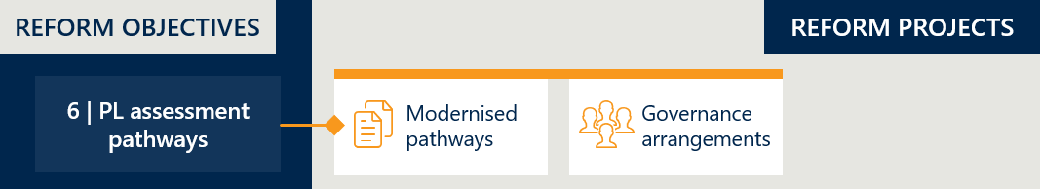

### Baseline position

#### Applications follow the same assessment processes regardless of their levels of complexity, and governance processes that are determined by their clinical use

Medical device sponsors apply to add billing codes to the PL, to allow for the items under these codes to be reimbursed by private health insurers.[84] The sponsor would apply to list new billing codes, or to vary, transfer or delete existing listings, through the Prostheses List Management System (PLMS). They would propose groupings (group, sub-group, suffix) for new and amended billing codes, and where applicable, also propose a benefit level.

Applications were reviewed via a process of clinical assessment by the relevant Clinical Advisory Group (CAG) or by the Panel of Clinical Experts (the Panel). The CAGs would meet to discuss applications put to them, and the Panel would assess applications to list products that did not fit into the clinical categories for which the CAGs were established.[85]

Applications requesting an increased benefit, or the creation of a new group, sub-group or suffix, required an assessment of the clinical evidence and an economic evaluation. Items expected to have significant financial impact on the health system were referred to the Medical Services Advisory Committee (MSAC) for health technology assessment. MSAC would then provide advice to the Prostheses List Advisory Committee.[86]

The PLAC would consider advice from clinicians, the CAGs and the Panel in order to advise the Minister for Health on whether to proceed with proposed additions or changes to billing codes on the PL, and the appropriate benefit level for each where applicable. The Minister is ultimately responsible for determining whether to grant, or not to grant, each application, and for setting benefit levels, based on the information and advice provided to them.

### Rationale for reform

#### Effective and efficient assessment is essential for ensuring the proper functioning of the PL

The assessment process is the mechanism for determining which items are listed on the PL and the benefit level that will be applied to them. Performing this function effectively, including ensuring that appropriate devices are listed and at benefit levels that truly reflect their clinical use, is crucial. If devices are listed with benefit levels that are not appropriate, this has the potential to undermine the function of the PL, which is specifically designed to have benefit levels that reflect clinical effectiveness.

Efficient assessment processes are also important. Inefficiencies could lead to unnecessary costs for government and clinical advisors where they are not resourced to assess devices in a manner commensurate to the complexity of the device, rather assess all devices similarly. Inefficiencies also have the potential to cause additional costs to device sponsors, and to cause delays in devices being listed.

Another component of efficiency relates to the processes and technologies that are used to implement the assessments. IT infrastructure that makes the application and assessment process more streamlined and sustainable plays a key role in the overall efficiency of the process.

The Department is guided by a set of Health Technology Assessment (HTA) principles that define the way that assessment processes like this should occur. The report *Review of health technology assessment in Australia* established the principles that should guide HTAs in Australia.[87] These principles are:

1. Sustainable
2. Transparent, accountable and independent
3. Consultative and reflective of Australian community values
4. Administratively efficient
5. Flexible and fit for purpose
6. Informed by robust and relevant evidence.[88]

These principles guide how HTAs should be undertaken to ensure they are effective and efficient, and avoid the potential negative outcomes discussed above.

### How the reforms intend to achieve this objective

The reforms seek to co-design and implement distinct PL assessment pathways and review existing governance arrangements

The reform program includes the review of two key components of the assessment process: the pathways by which applications are submitted for assessment, and the governance processes that drive the assessment of medical devices. As part of this reform program, the Department has committed to having independent reviews of each of these components, and following these, implementing changes to each component, as necessary.

The MoU outlines that PL listing pathways are to be co-designed by the MTAA and the Department, for approval by the Minister.[89] A co-design process was undertaken by Adelaide Health Technology Assessment from the School of Public Health at the University of Adelaide. This resulted in proposed pathways split into three tiers:[90]

1. Tier 1: Departmental Assessment Pathway: Intended for devices with an existing comparator already on the PL. A device taking this pathway is expected to share the existing market with the proposed comparator (or other interchangeable devices in the same PL benefit group).
2. Tier 2: Clinical / Focused HTA Pathway: Intended for applications that require external expert advice to perform a partial HTA in regard to the clinical aspects of the device and its use and in some cases cost-effectiveness.
3. Tier 3: Full HTA Pathway: Intended for novel devices requiring the provision of a new or amended MBS item number (if required), and/or robust evidence to inform benefit setting for the subject device.

Establishing theses differential pathways for assessment has the potential to increase the efficiency of the assessment process, by allowing resources to be distributed across applications according to their relative complexity.

Reviewing governance arrangements (the role, function and membership of the PLAC, and its subcommittees) involved in the assessment of applications has the potential to increase the effectiveness of the assessments, by encouraging the right level of clinical expertise to be brought to the consideration of each application and enhancing collaboration and knowledge-sharing within groups involved in the assessment process.

#### Concurrent implementation of new software is not in scope for this evaluation

At the same time as the reform program is being undertaken, the software in which the PL is managed (the Prostheses List Management System, or PLMS) is set to be replaced by new software (Health Products Portal, or HPP). This is not being undertaken as a reform activity, but as part of regular business improvement work. As such, it’s implementation is not in scope for this evaluation. However, the resulting application and assessment process, taken as a whole, is to be evaluated. This will include looking at the way the technology used for the process supports or hinders the process. In other words, this evaluation will not be assessing the way in which HPP has replaced PLMS, or the process to make this transition, however it will take a holistic view of the application and assessment process as it exists at the end of the reforms.

### How this will be evaluated

Implementation of this part of the PL reforms will be evaluated by looking at all changes to assessment pathways and governance processes. These will describe the state and changes to the assessment processes that occur, and how these changes are implemented. Indicator 14, described in Appendix B, captures these components.

In addition to these, looking at the volume of applications processed through each assessment tier allows for a picture of the way in which the changes are being used post-implementation. An assessment of any change in alignment with HTA principles will also be made qualitatively, through consultation with the department, device sponsors and other stakeholders. Indicator 15, described in Appendix B, will be used for both of these measures.

## Objective 7: Develop and implement PL listing reviews and PL compliance frameworks to safeguard the PL Reforms

Figure 15 | Reform projects related to reform objective 7

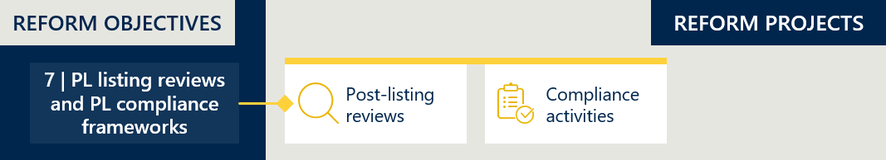

### Baseline position

#### Post-listing reviews have been conducted on an ad-hoc basis as resourcing allowed, while compliance requirements have been undefined without any formal compliance framework

The PL has no formally documented framework to outline the conditions that sponsors and/or devices must meet to maintain listing on the PL. There have been limited occasions in which the continued listing of items have been reviewed. Each of these occurred in circumstances where a number of stakeholders had raised concerns, and where the Department was able to allocate resources to undertake the review. There is no formal mechanism for these, and no guidance regarding the conditions under which they should be undertaken. Stakeholders have suggested that for the most part, PL billing codes are ‘set and forget’, with insufficient reviews to assess how technology and market conditions changed after the initial listing of a device or the creation of a benefit group.[91]

### Rationale for reform

#### To ensure the PL remains sustainable and in line with contemporary evidence, compliance requirements should be clear, and review mechanisms robust

The PL groupings reflect the clinical differences between products and the associated benefits reflect its relative value to the consumer. As new health technology is introduced over time, or new clinical practice or evidence comes to light, the value of previously listed products may change. However, products remain listed on the PL indefinitely, with the same benefit and grouping, unless one of three actions occur:

1. A sponsor applies for a product to be removed or amended,
2. A regulatory matter triggers a product’s removal (e.g., becomes no longer listed on the Australian Register of Therapeutic Goods), or
3. The Department intervenes to remove or amend it.

That is, in situations where a sponsor is willing to continue supplying a product and the Therapeutic Goods Administration continues to deem it safe for supply, it is the responsibility of the Department to determine whether the product is still fit for purpose and has an appropriate benefit. This necessitates a robust post-listing review framework, and adequate capacity to enact it, to maintain the integrity of the PL funding mechanism and safeguard its value to the healthcare system.

For the system to be sustainable and robust, there needs to be a process to deal with any non-compliant behaviour. The value of the PL as a funding mechanism relies on sponsors, private hospitals and private health insurers understanding and adhering to legislated rules and policy requirements that govern the settings of the PL[92]. As a result, there is a need for the Department’s compliance and enforcement functions and obligations to be well-defined, and supported with adequate Departmental capacity, to take the necessary steps to address non-compliance activities. This is important for ensuring consumers with private health insurance can access clinically appropriate and cost-effective medical devices and human tissue products.

### How the reforms intend to achieve this objective

#### The Department will develop formal compliance and post-listing review functions

As part of the reform program, the Department has committed to developing a formal compliance strategy and associated compliance mechanisms. There are four key areas of priority the Government seeks to ensure adequate compliance is established[93]:

1. Benefit setting and claiming – relative to more efficient markets.
2. Scope and definition – ensuring eligibility requirements are met.
3. Consolidation of the PL – simplified structure, aligned to clinical application.
4. Listing conditions – intended use and cost-effectiveness.

Additionally, the Department will develop a post-listing review framework, and conduct four pilot reviews to establish the function. These will be conducted using a working version of the framework, and the Department intends for these trials to then inform its further development[94]. The PLAC has supported a trial of the post-listing review process being conducted for products in four device types[95]:

1. Surgical guides and bio-models
2. Spinal cord stimulators
3. Metal-backed patellae
4. Urogynaecological mesh devices.

### How this will be evaluated

#### Review of resulting strategies and frameworks, as well as consultation with stakeholders and experts, will inform the evaluation of this objective

All evidence for the implementation of the compliance strategy and post-listing review framework will be reviewed, including the formal documentation itself, as well as any evidence of compliance activities taken and outputs from post-listing reviews. Stakeholder and expert opinions on these strategies, frameworks and processes will be gathered qualitatively, through interviews with the Department, sponsors and other expert groups. Indicator 16 will look at the implementation of these activities, and Indicator 17 will provide an assessment of their effectiveness and impact (see Appendix B).

## Objective 8: Ensure ongoing financial sustainability of PL administration through effective and efficient cost recovery arrangements that are compliant with the Australian Government Charging Framework

Figure 16 | Reform projects related to reform objective 8

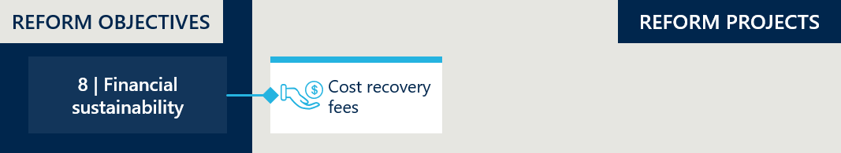

### Baseline position

#### The PL cost recovery arrangements are outdated and in breach of the Australian Government Charging Framework

The schedule of fees that device sponsors pay to the Department in order to have a billing code listed on the PL is:[96]

* Application fee – $600 fee for each new application (excluding applications associated with amendments, deletions of listings, or duplications, expansions, compressions or transfers of existing billing codes.
* Initial listing fee – $200 fee once the Minister grants the application to list a product (excluding Part B items and products that were listed as a result of duplicating, expanding, transferring or compressing existing billing codes).
* Ongoing listing fee – $200 fee due 15 March and 15 September each year (excluding Part B items and products listed as a result of duplicating, expanding, transferring or compressing existing billing codes).

These cost recovery arrangements were established in 2009 and have remained unchanged since. [97] The cost recovery arrangements do not align with the Australian Government Charging Framework[98], as they are not commensurate to the size and complexity of the Department’s administration activities associated with the PL.

### Rationale for reform

#### The Department requires sustainable administration of the PL to support its activities in maintaining it

The Department has a range of responsibilities in maintaining the PL, the costs of which should be recovered through cost recovery arrangements. At baseline, the administrative functions of the Department included:

* Update the PL three times a year and publish updates onto the Department website
* Maintain and update the PL Guide
* Ad-hoc review of benefit levels (where stakeholders raised concerns and subsequent investigation by the PLAC or CAGs deemed it necessary)
* Providing secretariat support to the PLAC, the CAGs and the Panel
* Undertaking (or commissioning) Health Technology Assessment
* Contributing to the development of policy on PHI funding of prostheses
* Providing advice about legislation, regulation and other government programs, such as the Medicare Benefits Schedule (MBS) that affect the use and funding of prostheses
* Managing sponsors’ applications to list products and amend existing listings, including providing advice to sponsors about applications and amendments.

### How the reforms intend to achieve this objective

#### Rationalised cost recovery arrangements are to be established

The administrative costs required to manage and maintain the PL are to be reviewed in detail and new cost recovery arrangements will be established that are appropriate for covering these costs. The design of these new cost recovery arrangements is intended to ensure alignment to the Australian Government Charging Framework. It is expected that these arrangements will increase cost to industry associated with having devices listed on the PL.

### How this will be evaluated

#### An independent review will be assessing the appropriateness of cost-recovery arrangements

The new cost recovery arrangements are the subject of a separate external review intended specifically to determine whether they are sufficient and appropriate to cover the Department’s administrative costs and comply with the Australian Government Charging Framework. As such, this evaluation will leverage the findings of that review in order to evaluate the achievement of this objective. Indicator 18 describes the new cost recovery arrangements and the way in which they are implemented, and Indicator 19 assesses the overall change in administrative effort resulting from the reforms and leverages the external review and other consultation with stakeholders in order to establish how appropriate and sustainable these arrangements are (see Appendix B).

1. Overview of indicators and measures

|  |  |  |  |
| --- | --- | --- | --- |
| Objective | KEQ | Indicators | Key evaluation sub-questions |
| 1. Improve alignment of the scheduled benefits of the PL with the prices paid in more competitive markets such as the public hospital system and comparable international markets | 1 | Indicator 1: Reduction in benefits | * Measure 1.1: Change in PL benefits * Measure 1.2: Benefit reduction methodology |
| 2 | Indicator 2: Change in the size of the gap between PL benefits and prices paid in more competitive markets | * Measure 2.1: Overall savings associated with benefit reductions * Measure 2.2: Gap between PL benefits and prices in Australian public hospitals * Measure 2.3: Gap between PL benefits and prices on the Liste des Produits et Prestations (LPP) and Pharmac Hospital Medical Devices Schedule * Measure 2.4: Stakeholder perspectives on the gap between PL benefits and prices in more competitive markets |
| 2. Maintain no additional out-of-pocket costs associated with the PL devices for consumers | 1 | *No activity directly associated* |  |
| 2 | Indicator 3: Change in out-of-pocket expenses related to PL items | * Measure 3.1: Prevalence of a gap payment for PL items * Measure 3.2: Average gap payment for PL-listed items |
| 3. Maintain clinician choice of appropriate prostheses for their patients | 1 | *No activity directly associated* |  |
| 2 | Indicator 4: Change in clinician experience of choosing prostheses | * Measure 4.1: Clinician perspectives on the level of clinician choice |
| Indicator 5: Change in utilisation of PL items | * Measure 5.1: Utilisation of PL items |
| 4. Improve the affordability and value of private health insurance for privately insured Australians | 1 | *No activity directly associated* |  |
| 2 | Indicator 6: Change in PHI premium increases | * Measure 6.1: PHI premium price changes over time * Measure 6.2: Change in PHI premiums related to PL item expenditure * Measure 6.3: Stakeholder perspectives on the drivers of change in PHI premiums |
| Indicator 7: Change in PHI coverage and for whom | * Measure 7.1: PHI coverage by demographic group * Measure 7.2: Utilisation of PL items by privately insured patients * Measure 7.3: Stakeholder perspectives on the drivers of change in PHI coverage |
| 5. Clarify the purpose, definition, and scope of the PL in legislation | 1 | Indicator 8: Legislative changes to the PL | * Measure 8.1: Description of the PL's purpose, definition and scope in legislation |
| Indicator 9: Implementation of PL regrouping | * Measure 9.1: Changes made to the PL grouping structure and PL item categorisation * Measure 9.2: Number of PL items and benefit groups |
| Indicator 10: Implementation of changes to general use items | * Measure 10.1: Description of changes to general use items |
| 2 | Indicator 11: Assessment of legislative changes to the PL | * Measure 11.1: Stakeholder perspectives on the level of clarity in the PL's purpose, definition and scope |
| Indicator 12: Assessment of PL regrouping | * Measure 12.1: Stakeholder perspectives on PL regrouping |
| Indicator 13: Assessment of changes to general use items | * Measure 13.1: Stakeholder perspectives on changes to general use items |
| 6. Implement new PL assessment pathways aligned to Health Technology Assessment Policy Branch principles and streamline application process through simple and robust IT infrastructure | 1 | Indicator 14: Implementation of new assessment processes | * Measure 14.1: Description of assessment pathways * Measure 14.2: Description of governance processes |
| 2 | Indicator 15: Assessment of new assessment processes | * Measure 15.1: Volume of PL applications per tier * Measure 15.2: Stakeholder perspectives on the assessment pathways and listing process |
| 7. Develop and implement PL listing review and PL compliance frameworks to safeguard the PL reforms | 1 | Indicator 16: Change in listing review and compliance frameworks | * Measure 16.1: Description of post-listing review framework * Measure 16.2: Description of compliance strategy |
| 2 | Indicator 17: Assessment of listing review and compliance frameworks | * Measure 17.1: Description of post-listing reviews conducted * Measure 17.2: Stakeholder perspectives on post-listing reviews * Measure 17.3: Description of compliance activities conducted * Measure 17.4: Stakeholder perspectives on PL compliance |
| 8. Ensure ongoing financial sustainability of PL administration through effective and efficient cost recovery arrangements that are compliant with the AGCF | 1 | Indicator 18: Implementation of cost recovery arrangements | * Measure 18.1: Description of cost recovery arrangements |
| 2 | Indicator 19: Financial sustainability of PL administration | * Measure 19.1: Change in PL administrative effort * Measure 19.2: Stakeholder perspectives on the financial sustainability of PL administration |

1. Measurement guides and baseline values

## Indicator 1: Reduction in benefits

#### Measure 1.1: Change in PL benefits

###### Measurement guide

This measure will track changes to PL benefits. If the reforms are being implemented as intended, all PL benefits of items eligible for reductions will occur as per the reduction schedule described in section 3.1.3. This will be determined by comparing the benefits of benefits groups across the PL updates and showing the reduction. While the evaluation team does not have access to the public benchmark prices to do a product-by-product reconciliation, we have developed an approximation of these values that will enable us to determine at a higher level whether the benefit reductions have occurred as intended. Moreover, the Department has supplied a summary of the median gap across PL categories (see measure 2.2).

###### Baseline value

The baseline value for this measure is the schedule of benefits for the 10719 billing codes on the March 2022 PL (excluding Part B – human tissue products).[99] These billing codes map to 1665 benefit groups[100] from the November 2021 PL, for which IHACPA has determined a national public benchmark price to aid the calculation of the benefit reductions.

Table 4 below shows the benefit groups and items on Part A of the March 2022 PL that were to be subject to reductions by July 2023. This complements Figure 7 (in section 3.1.3), which shows the proportion of PL items that would be subject to reform reductions, not subject to reform reductions and removed by July 2023.

Table 4 | Benefit groups subject to reductions (Part A, excluding CIED items)[101]

|  |  |  |
| --- | --- | --- |
| Categories | Benefits groups subject to reductions | Items subject to reductions |
| 01 - Ophthalmic | 26 | 148 |
| 02 - Ear, Nose & Throat | 6 | 25 |
| 03 - General Miscellaneous | 68 | 238 |
| 04 - Neurosurgical | 25 | 96 |
| 05 - Urogenital | 11 | 53 |
| 06 - Specialist Orthopaedic | 177 | 1757 |
| 07 - Plastic and Reconstructive | 75 | 267 |
| 08 - Cardiac | 3 | 21 |
| 09 - Cardiothoracic | 8 | 20 |
| 10 - Vascular | 37 | 249 |
| 11 - Hip | 44 | 422 |
| 12 - Knee | 23 | 363 |
| 13 - Spinal | 51 | 1520 |
| Total | 554 | 5179 |

#### Measure 1.2: Benefit reduction methodology

###### Measurement guide

This measure will look at the methodology by which the Department, with IHACPA, and in agreement with the MTAA, determined and applied the scheduled of reductions. This measure is an important complement to measure 1.1 (what reductions occurred) and measure 2.2 (the extent to which the reductions closed the gap with prices in the public sector) as there could be unintended outcomes or limitations to certain approaches of applying benefit reductions. These could be present, and significant, and not be captured by looking at the overall changes in the aggregate. Looking at this measure will provide a more complete answer to whether this element of the reform program was implemented as intended.

This assessment of the benefit reduction methodology will be predominantly a qualitative measure, reviewing consultation documentation and drawing upon stakeholder perspectives about the methodology. It will be guided by the following lines of enquiry:

* Did the chosen reference pricing align with reform objectives? Did the benchmarking exercise produce reference prices that were reflective of a more competitive market?
* Did the scope of products included in the reduction exercise align with reform objectives?
* Did the chosen magnitude and phasing of benefit reductions align with reform objectives?
* Did the applied reduction methodology (as opposed to the effects of reductions in general) change the competitive landscape or health system in any way?

Whether they continued with the same methodology. Follow up stakeholder opinions about the methodology, how the methodology shifted behaviour (e.g., weighted average price: within a category, some sponsors are losers, some are winners as their products are more attractive to buyers).

###### Baseline value

For this measure, we treat the baseline value as the benefit reduction methodology documented in the MoU between the Minister and the MTAA[102] and in documents published by IHACPA[103],[104]. We have summarised the intended approach in section 3.1.3.

## Indicator 2: Change in the size of the gap between PL benefits and prices paid in more competitive markets

#### Measure 2.1: Overall savings associated with benefit reductions

###### Measurement guide

This measure will calculate the overall savings associated with the benefit reductions of this reform. It will be calculated by aggregating the following for each PL device: current utilisation volume multiplied by the current benefit level less the current utilisation volume multiplied by the baseline benefit level. It assumes that utilisation is independent of benefits; that without the reforms, consumers would have required the same volume of devices and clinicians would have chosen devices in the same benefit groups to meet this demand. Utilisation volumes for each PL billing code can by attained from Hospital Casemix Protocol (HCP) data.

This analysis will be done at the individual item level, which will enable the evaluation team to look at total benefits and savings associated with subsets of PL items and different reform scenarios. Some stakeholders have raised concerns about the impact of deferring reform processes, that this represents a cost to the health system that should be measured. [105] While a full economic analysis is not in scope for the evaluation, and decisions on the timing of reform actions may have legitimacy and merit beyond their impact on consumer net savings, this measure will also seek to outline forgone savings as a result of delayed benefit reductions for certain devices.

###### Baseline value

There is no baseline value for this measure, given that it will be used to retrospectively calculate savings based on actual utilisation data (rather than forecast savings using projected utilisation data).

IHACPA estimated the projected benefits and savings associated with the PL reforms benefit reductions in October 2022.[106] It estimated the projected savings throughout the four-year reform period to be $873.4 million assuming a 3% annual utilisation growth and $941.8 million assuming a 5% annual utilisation growth[107] (noting that the compounded annual growth rate of PL item utilisation for the five years to the baseline year is 5.2%).[108]

#### Measure 2.2: Gap between PL benefits and prices in Australian public hospitals

###### Measurement guide

This measure will track the gap between the PL benefits of items listed in Parts A, C and D of the schedule and the prices of the same products in the Australian public system. If the reforms are achieving the objective of aligning scheduled benefits of the PL with the prices paid in more competitive markets, we would expect the percentage gap to decrease across the categories and benefit groups of the PL.

The primary source of data for the Australian public system will be the Weighted Average Prices from IHACPA’s public benchmarking exercises in 2021 and 2024. Nous does not and will not have access to the actual public benchmark Weighted Average Price for each benefit group. Instead, the gap between PL benefits and the public benchmark prices will come from two sources:

1. The first source is an aggregated summary showing the $ and % median gap for benefit groups in each of the 13 categories, provided by the Department. This summary compares Part A of the March 2022 PL to the November 2021 public benchmark prices compiled by IHACPA (excluding CIED items). The Department will update this summary, including using updated public benchmark prices when available, for Nous to use in reporting throughout the evaluation.
2. The second source is Nous estimates of the gap for each of the 1665 billing groups in Parts A and C of the November 2021 PL using a close approximation[109] of the 2021 public benchmark prices. We have backcalculated an upper and lower bound for each Weighted Average Price using publicly available sources (see Appendix E for Nous’ approximation methodology). Due to the nature of the backcalculation methodology, we will not be able to approximate the updated public benchmark prices with the same degree of accuracy.

###### Baseline value

As shown in Figure 6 in section 3.1.1, the gap between PL benefits and public benchmark prices is significant in the aggregate but varies across items. Around half of the items were not subject to reductions and so, were equal to or below 7% of the public benchmark. The gap of the remaining items varied widely, as shown in the long tail in Figure 6. The March 2022 PL was used as the baseline for this measure as it was the schedule used by IHACPA to calculate the first round of benefit reductions for the July 2022 PL.[110]

Table 5 shows the median dollar and percentage gap of Part A items subject to reductions on the March 2022 PL compared to the November 2021 public benchmark prices (excluding CIED items). The median gap is $177 and median gap percentage is 25%.

Table 5 | Gap between PL benefits and public benchmark prices of items subject to reductions (Part A, excluding CIED items)[111]

|  |  |  |
| --- | --- | --- |
| Categories | Median gap $ | Median gap % |
| 01 - Ophthalmic | $58 | 27% |
| 02 - Ear, Nose & Throat | $44 | 18% |
| 03 - General Miscellaneous | $29 | 12% |
| 04 - Neurosurgical | $218 | 21% |
| 05 - Urogenital | $44 | 31% |
| 06 - Specialist Orthopaedic | $165 | 44% |
| 07 - Plastic and Reconstructive | $140 | 28% |
| 08 - Cardiac | $1,497 | 187% |
| 09 - Cardiothoracic | $656 | 23% |
| 10 - Vascular | $273 | 45% |
| 11 - Hip | $214 | 16% |
| 12 - Knee | $232 | 10% |
| 13 - Spinal | $239 | 18% |
| Total | $177 | 25% |

We have not included the gap of CIED items in the above table or other figures comparing PL benefits and comparable markets. We note the PL benefits of CIED items have a significant service component that is not reflected in the public benchmark prices, and this distorts the calculation of the gap. MSAC is engaging in ongoing work to establish the reasonable cost of CIED technical services to inform future CIED benefit reductions.[112]

To establish a baseline for these items, we have approximated the gap using the Department’s estimate of the value of the CIED device component used for the July 2023 reductions.[113] By backcalculating the public benchmark prices for the 226 out of 259 CIED items on the November 2021 PL that were subject to reductions and were not removed by July 2023, we estimate the median gap for these items to be $19,611 and the median gap % to be 188%.[114] The lower bound of the approximation is $17,557 (144% gap) and the upper bound is $21,655 (235%).

#### Measure 2.3: Gap between PL benefits and prices on the Liste des Produits et Prestations (LPP) and Pharmac Hospital Medical Devices Schedule

###### Measurement guide

This measure compares PL benefits to prices in international markets, based on objective 1, “Improve the alignment of the scheduled benefits of the PL with the *prices paid in more competitive markets*”. No markets are identical, and so this is not an exact comparator, but this measure will seek to demonstrate the comparative effect the reforms have on benefit levels.

For the baseline, we have conducted three case studies showing the gap between PL benefits and prices on the Liste des Produits et Prestations (LPP)[115] and the Pharmac Hospital Medical Devices Schedule (Pharmac)[116]. The benefits/prices are compared from 2016 to 2021, and these will be measured and updated throughout the evaluation to give an indication of change, if any, in the gap between the PL and the comparable international markets for France and New Zealand. Additionally, we will continue to investigate the feasibility of including additional cases, and to test how representative these studies are of the broader markets.

Given limitations in accessing and comparing products across these lists[117], as well as complexities as to how to interpret differences across markets (explored in Appendix F), we have chosen a case study approach to isolate the scenarios in which we can ensure a direct comparison, rather than perform a complete analysis comparing the markets, which would be confounded by these differences. Within the three PL benefit groups chosen as case studies, products were selected on the basis that we could find and confirm exact matches on both comparison lists[118].

###### Baseline value

Figure 17 below shows a comparison of four products from the 12.08.01 PL category at baseline. The PL benefit group is higher than the corresponding LPP price group, while the products on the Pharmac list are priced both above and below the PL level.

Figure 17 | International case study 1 (knee implant) – Product comparison in 2021[119]

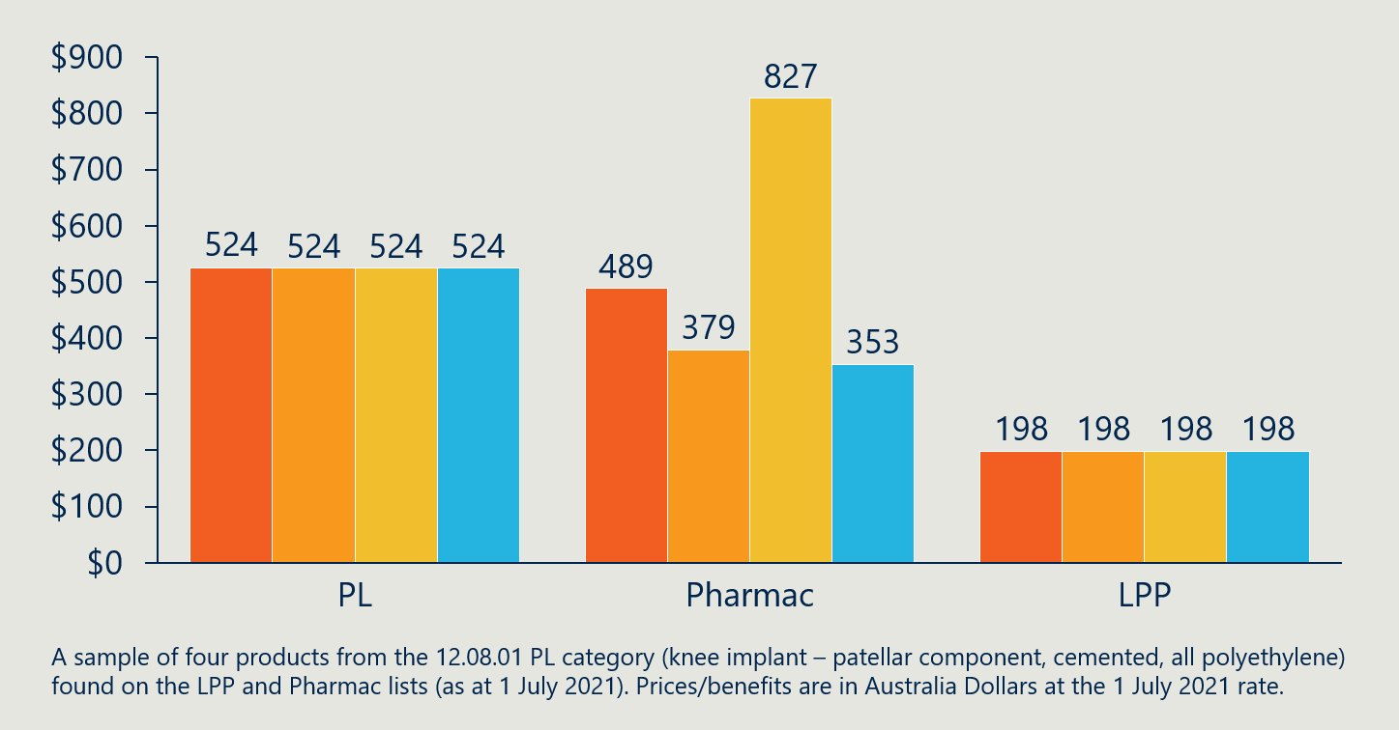

Figure 18 shows the benefit and pricing level history of these four knee implant products as a category. The PL benefit has reduced since 2016 – as has the LPP to a lesser extent. While the Pharmac series (median price) shows movement as products were introduced to the list, the price of each of the four constituent products have not changed since being introduced.

Figure 18 | International case study 1 (knee implant) – Category comparison over time[120]

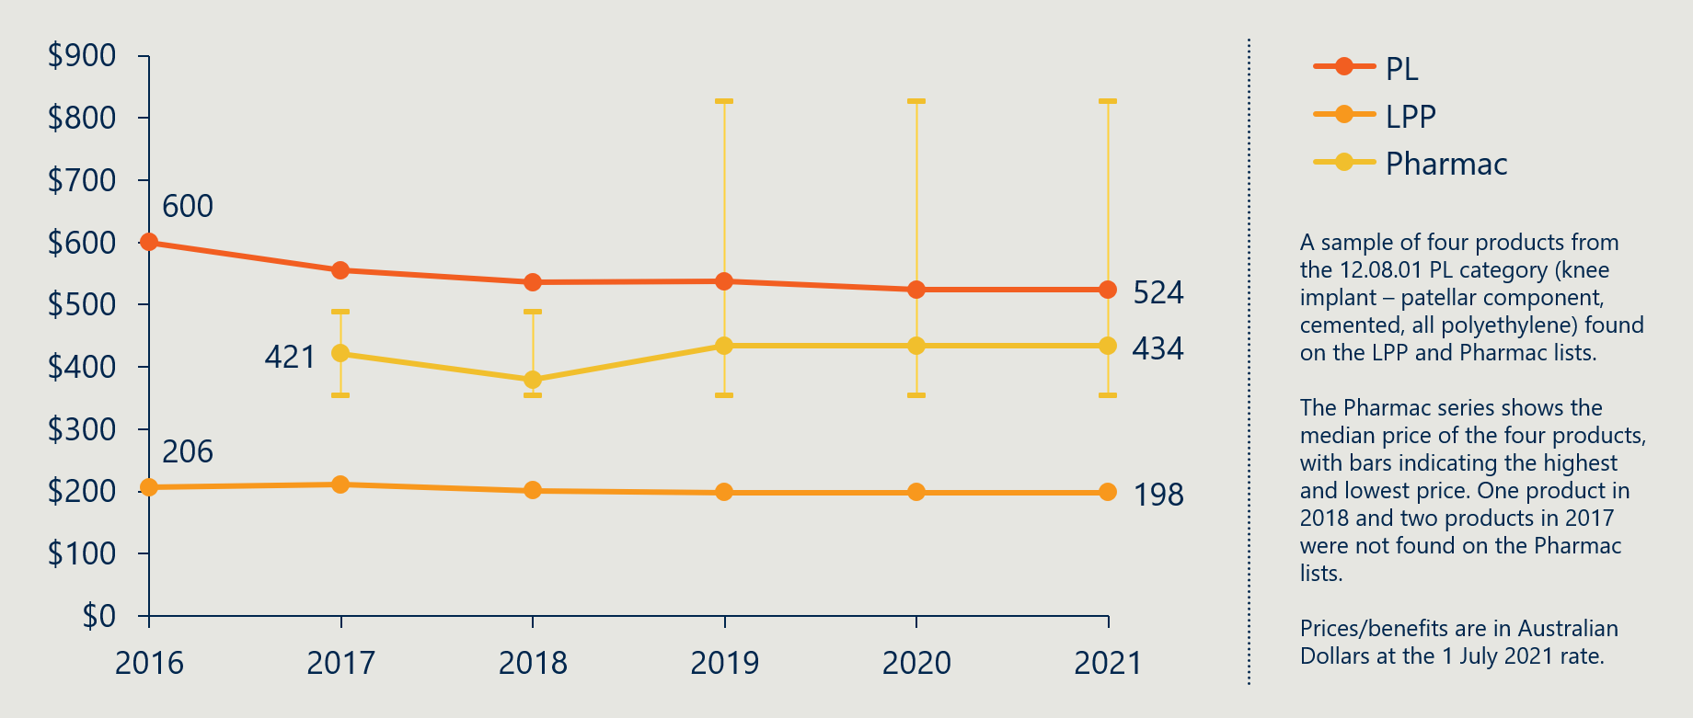

Figure 19 introduces case study 2, six hip joint implants from the 11.02.02.05 PL benefit group. Similar to case study 1, the PL benefit is higher than the LPP and Pharmac category prices on average, though is lower than some Pharmac products.

Figure 19 | International case study 2 (hip joint implant) – Product comparison in 2021[121]

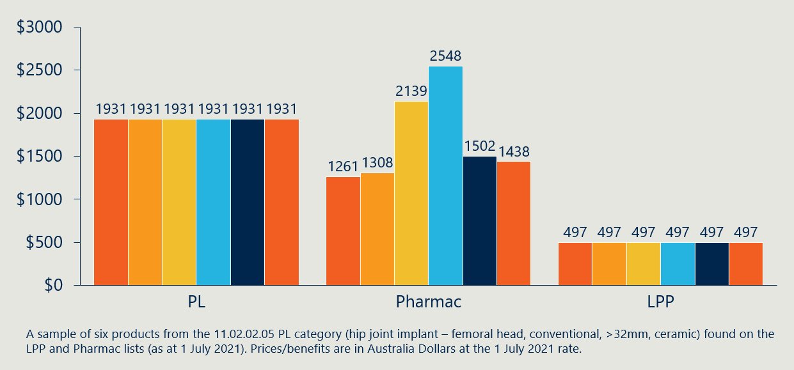

Figure 20 shows a similar benefit and pricing history to case study 1. A gradual decline in benefits/prices is mirrored across the PL and LPP, while individual products on the Pharmac list have not changed in price since their introduction, and the median has changed only through the addition of new products.

Figure 20 | International case study 2 (hip joint implant) – Category comparison over time[122]

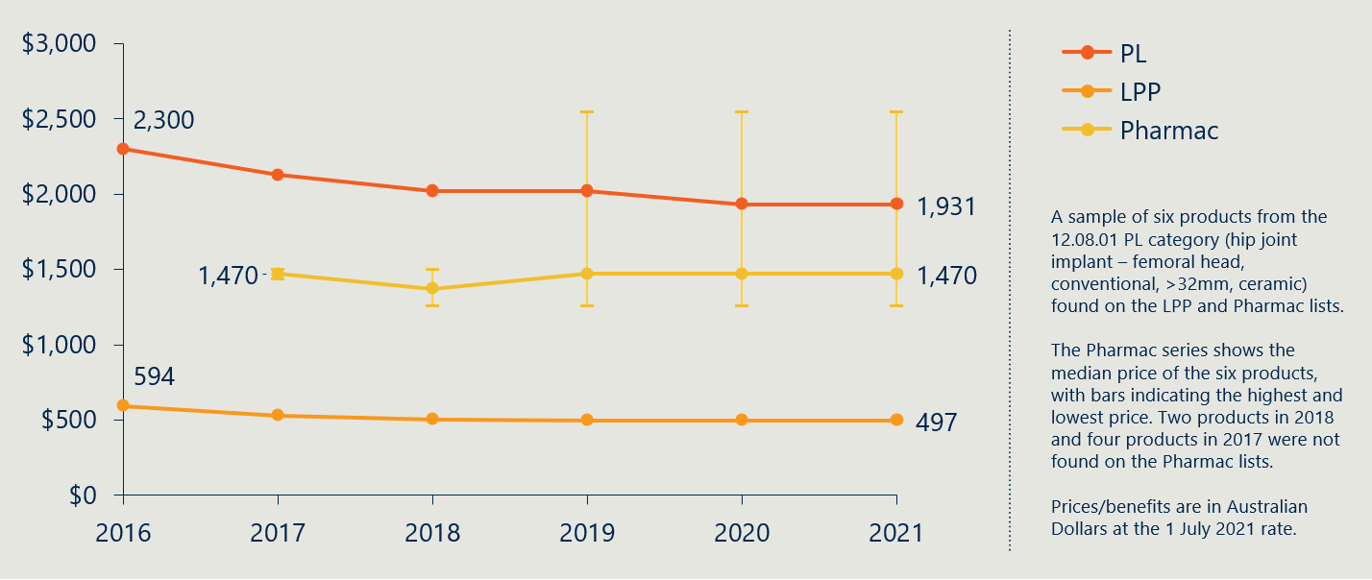

Case study 3, in Figure 21 and Figure 22 below, relates to three products from the 13.10.01.02 PL category. Prices vary across the three Pharmac products, but all comparison products remain under the PL benefit.

Figure 21 | International case study 3 (spinal fusion cage) – Product comparison in 2021[123]

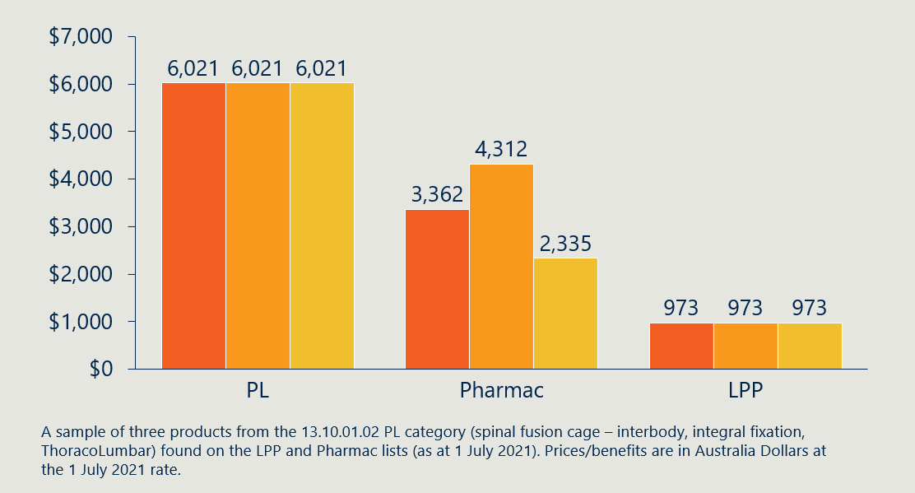

As with the other case studies, the PL benefit level has declined from 2016 to 2021. The Pharmac series (the median price of the case study products that were listed in that year) shows little movement. Pricing data for the LPP was not available prior to 2021 for the product category.

Figure 22 | International case study 3 (spinal fusion cage) – Category comparison over time[124]

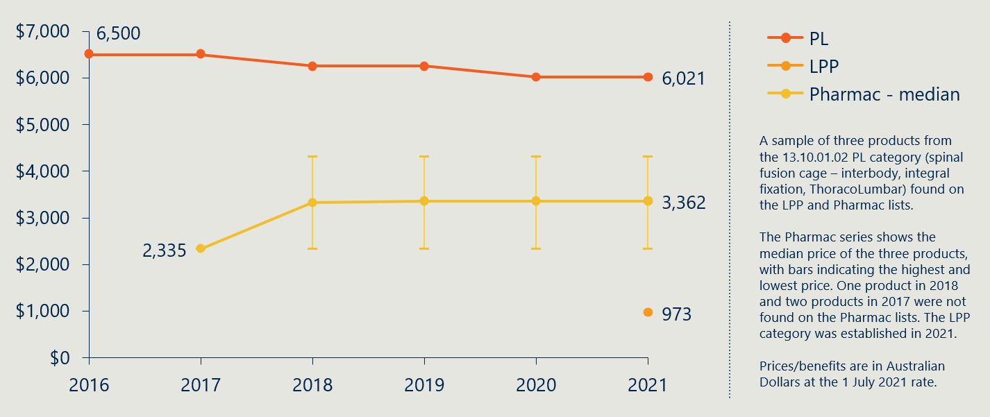

#### Measure 2.4: Stakeholder perspectives on the gap between PL benefits and prices in more competitive markets

###### Measurement guide

This measure will look at stakeholder opinions on the alignment of PL benefits to more competitive markets such as the Australian public hospital system, and Pharmac and LPP. This is to triangulate findings from the previous two measures and seek to account for differences between the Australian private hospital market and other markets (as discussed in measure 2.2).

Discussions with stakeholders, as well as analysis of available stakeholder submissions and documentation, will inform this measure throughout the evaluation. We will use stakeholder consultation to explore changes to the case studies provided at baseline and identify other relevant case studies throughout the evaluation. They will continue to provide nuance to the differences being identified in the data between the Australian private hospital system and other competitive markets.

###### Baseline value

Stakeholder perspectives on the *changing* gap between PL benefits and other markets post-reform is the focus of this measure. However, at baseline, stakeholder views on PL benefits relative to other markets is well established.

*“Both international and domestic weighted price benchmarks and comparisons suggest that the Australian private health system and its members are paying twice as much as they should on average for prostheses”*

**PHA, 2017 Senate Submission**

The most significant criticism of the pre-reform PL arrangements raised by stakeholders, particularly private health insurers[125] and consumer groups,[126] was that benefit levels were set well above the prices paid for prostheses in both the public sector and in other countries. While medical technology companies pointed to differences in the structure of these markets[127] (due to regulatory differences between countries), and in the nature of the transactions (e.g., differences in the volume of devices purchased in the public and private sectors),

private health insurers, clinicians,[128] private healthcare providers and consumer groups have argued that these high prices have diminished the value that PHI offers to consumers. This is because higher prices for medical devices is passed onto consumers through higher PHI premiums.[129]

## Indicator 3: Change in out-of-pocket expenses related to PL items

#### Measure 3.1: Prevalence of a gap payment for PL items

###### Measurement guide

This measure will look at the absolute number, as well as the share of PL-listed item uses for which a gap payment is recorded. A gap payment occurs when the amount that a health provider charges for a device exceeds the benefit paid by the private health insurer for that device. The data for the share of PL-listed items is obtained by dividing the number of items for which a gap is billed by the total number of items used. These data fields are available from the prosthesis table of the Hospital Casemix Protocol (HCP) dataset.[130] There is a significant number of cases in which very small gap payments are charged and so a fuzz factor has been applied so that gap payments are only counted when gaps are greater than $1.

It should be noted that the prevalence of gap payments may differ from the prevalence of out-of-pocket charges in some circumstances because it is possible that patients are compensated for the gap by a third party such as the Department of Veteran’s Affairs, workers’ compensation insurers, and third-party motor vehicle insurance providers. There are also quality limitations for the data in the HCP dataset due to unspecified billing codes, the presence of cases in which benefits exceed charges as well as cases in which there are missing charge and benefit amounts. The HCP dataset is also incomplete in its coverage (see Appendix H). These limitations will be considered when analysing changes in this indicator over the course of the evaluation.

###### Baseline value

Figure 23 below shows that the prevalence of gap payments is very low for devices on the PL, reflecting the fact that the PL benefit has been sufficient to cover the cost of medical devices in over 99% cases.[131] Gap payments have been consistently rare across financial years, however, there has been fluctuation in the prevalence of gaps, with gap prevalence increasing from FY16 to FY18 and then falling from FY18 to FY21.

When analysed by category at baseline in FY21, significant differences between PL categories in the prevalence of gaps across different PL categories become evident (as shown in Table 6). For example, the prevalence of a gap payment is comparatively high for cardiothoracic and cardiac devices, with prevalence rates of 2.28% and 0.89% respectively. In contrast, gaps are very rare for hip devices (0.04% prevalence) and general miscellaneous items (0.05%).

Over the course of the evaluation, trends in the prevalence of gap payments will be examined at the category level (and potentially at an even more disaggregated level if required) to ascertain if there is any evidence that the PL reforms have had an impact on this measure for any category of device. In particular, the evaluation will seek to look specifically at the items that have been most impacted by the reforms (i.e., devices that have seen a benefit reduction) and examine whether these items have seen their gap prevalence change in ways that are different to the changes seen for items that have been less impacted by the reforms (i.e., those items that have not seen a benefit reduction).

Figure 23 | Prevalence of a gap payment for PL item billings[132]

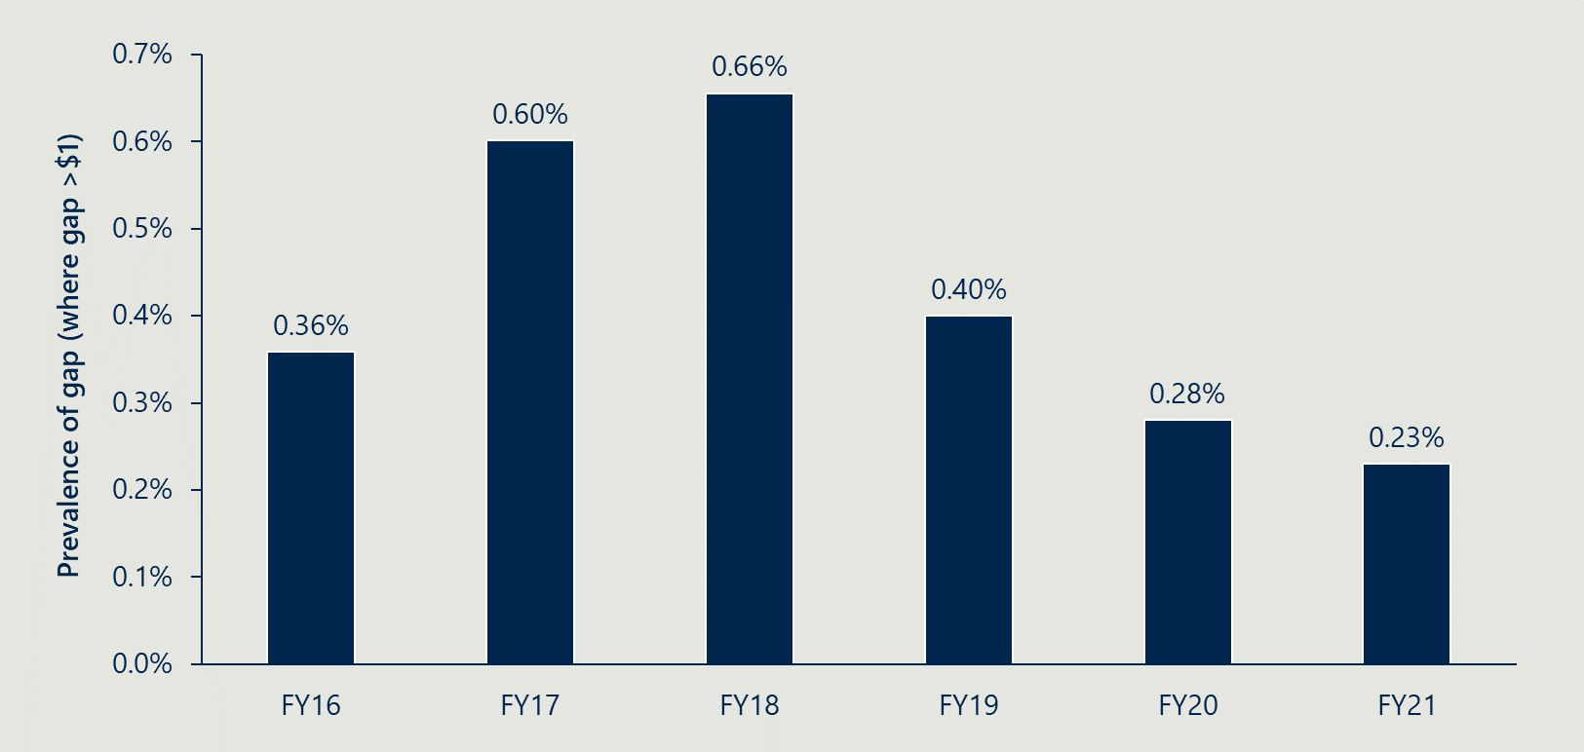

Table 6 | Gap payment numbers and prevalence by PL category in FY21[133]

|  |  |  |
| --- | --- | --- |
| Categories | # of gaps | Prevalence (% of total uses) |
| 01 - Ophthalmic (Part A and C) | 1271 | 0.36% |
| 02 - Ear, Nose & Throat (Part A and C) | 25 | 0.09% |
| 03 - General Miscellaneous (Part A and C) | 534 | 0.05% |
| 04 - Neurosurgical (Part A and C) | 36 | 0.11% |
| 05 - Urogenital (Part A and C) | 105 | 0.25% |
| 06 - Specialist Orthopaedic (Part A and C) | 528 | 0.09% |
| 07 - Plastic and Reconstructive (Part A and C) | 267 | 0.23% |
| 08 - Cardiac (Part A and C) | 1040 | 0.89% |
| 09 - Cardiothoracic (Part A and C) | 201 | 2.28%[134] |
| 10 - Vascular (Part A and C) | 113 | 0.13% |
| 11 - Hip (Part A and C) | 58 | 0.04% |
| 12 - Knee (Part A and C) | 119 | 0.08% |
| 13 - Spinal (Part A and C) | 103 | 0.07% |
| Part B (all categories) | 14 | 0.06% |

#### Measure 3.2: Average gap payment for PL listed items

###### Measurement guide

This measure is calculated as the average difference between the PHI benefit paid for a PL-listed item, and the amount charged by hospitals, across all item usages in which this difference is greater than $1. This measure can be obtained by filtering and aggregating billing-code level data, from the HCP dataset, for the charges and benefits associated with the utilisation of PL items (in cases in which an item is used more than once for a particular billing, the gap between benefits and charges is divided by the number of items used).

Analysis of this measure in future stages of the evaluation will need to account for the fact that it is subject to the same limitations as measure 3.1 regarding the possibility of a third party covering a gap payment (resulting in a gap being recorded even in a circumstance in which there are no out-of-pocket costs for patients). The data quality constraints present for measure 3.1 will also be considered when analysing changes in this measure. Values for the average gap have also been rounded in line with HCP requirements.

The selection of this measure reflects the fact that most of the time PL items do not incur a gap, and so the average overall gap for a particular category will be negligible (when only gaps <$1 are included). As a result of this, the average gap across all PL listed items is indistinguishable from zero in the HCP1 dataset once rounding requirements are applied. This obscures the fact that, when a gap is charged (as in the small number of cases shown in Figure 23), patients can still be subjected to material out of pocket expenses. Average gaps are calculated in cases in which gaps are > $1, as opposed to > $0, because there are many cases in which very small gaps are charged. Given that these payments are negligible, the data still provides an indication of the prevalence of material gaps between item benefits and charges.

When analysing this measure, particular attention will be given to changes in the average gap payment for the subset of items that are subject to benefit reductions, as these are the items that are most likely to show a change that can reasonably be attributed to the PL reforms. Changes in the average gap payment for other items will still be measured so that they can be used as a point of comparison.

###### Baseline value

Figure 24 below shows how the average gap payment for different PL items has changed between FY16 and FY22. The figure shows that gap payments can impose a material financial burden on patients in the small number of cases in which they are present, with average gap payments (in cases in which a gap is present) being equal to $270 at baseline in FY21. Interestingly, the trend is the reverse of that shown in Figure 23 with average gap payments falling between FY16 and FY18 and then rising between FY18 and FY21. This could suggest that increases in the prevalence of gap payments generally involve a larger number of low value gaps that lower the average gap payment.

Over the course of the evaluation changes in the average value of gap payments will be examined at the category level (and if needed at an even more granular level). Table 7 shows that different categories of devices incur different levels of gap payments when gap payments are made. For instance, in the plastic and reconstructive category, average gap payments can be quite large in absolute terms ($770) and as a percentage of the average value of benefits of items in that category.**[135]** In contrast, the average gap when present in the ear, nose and throat category is only equal to $50 in absolute terms, or 7.0% of the average value of benefits paid for items in that category.

Figure 24 | Average gap payment for PL items, across episodes with a gap > $1[136]

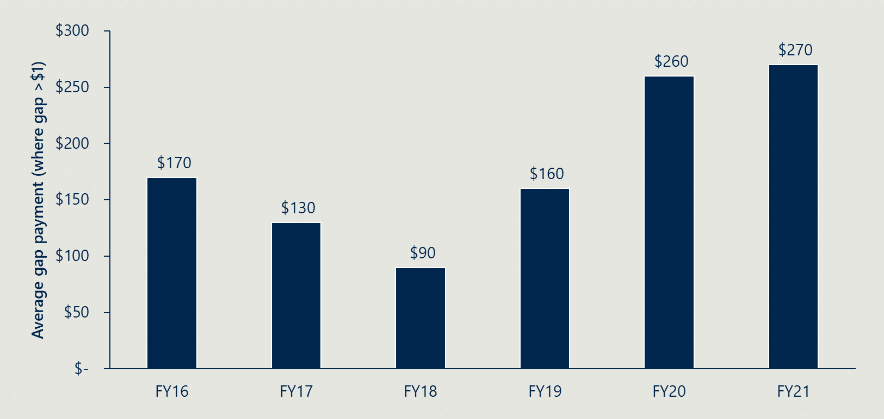

Table 7 | Average gap payments by PL category in FY21[137]

|  |  |  |
| --- | --- | --- |
| Categories | Average gap when present ($) | Average gap as % of average benefit of items in category |
| 01 - Ophthalmic (Part A and C) | $100 | 34.5% |
| 02 - Ear, Nose & Throat (Part A and C) | $50 | 7.0% |
| 03 - General Miscellaneous (Part A and C) | $240 | 104.3% |
| 04 - Neurosurgical (Part A and C) | $1,600 | 69.6% |
| 05 - Urogenital (Part A and C) | $180 | 21.7% |
| 06 - Specialist Orthopaedic (Part A and C) | $210 | 55.3% |
| 07 - Plastic and Reconstructive (Part A and C) | $770 | 187.8% |
| 08 - Cardiac (Part A and C) | $420 | 11.7% |
| 09 - Cardiothoracic (Part A and C) | $1,100 | 44.0% |
| 10 - Vascular (Part A and C) | $530 | 75.7% |
| 11 - Hip (Part A and C) | $850 | 50.0% |
| 12 - Knee (Part A and C) | $890 | 52.4% |
| 13 - Spinal (Part A and C) | $630 | 69.2% |
| Part B (all categories) | $420 | 12.7% |

## Indicator 4: Change in clinician experience of choosing prostheses

#### Measure 4.1: Clinician perspectives on the level of clinician choice

###### Measurement guide

This measure will look at perspectives on the level of clinician choice and examine any drivers and effect of changes in perceived choice. Fundamental to PL is that it enables clinicians the choice of any listed prostheses on the PL as it is guaranteed the private health insurer will pay the scheduled benefit and therefore cover the cost.[138] While the reforms are not expected to change this important function, the clinician *experience* of choice may be affected. This measure will document clinician perspectives of whether they are capable of obtaining the most appropriate prostheses or human tissue product, and what constraining factors impact this. Important to this measure is separating what are existing attributes of healthcare procurement (for example, the influence private hospitals have on what devices are made available to their clinicians) and what might be a change that is attributable to PL reform.

###### Baseline value

At baseline, stakeholders described how the PL arrangements helped secure patient access to appropriate medical devices. Diverse groups of stakeholders described how the PL arrangements mean that all privately insured patients have access to the medical devices and human tissue products listed on the PL if they are chosen for them by their clinician.[139] This is because private health insurers were required to pay the benefit for these devices when used in a procedure involving a patient that they insured. Under this arrangement, the PL separated the decision of which device to use (made by the clinician) from the payment (borne by the insurer).

*“The PL arrangements ensure that patients in the private sector have access to a greater range of prostheses, including those that represent more complex technologies than those offered in the public sector”*

**Medical Technology Association of Australia**

These arrangements meant that a surgeon was free to pick the device that is clinically most appropriate and/or effective, without the need to compromise based on financial concerns. Reflecting this, the MTAA argued that “The current arrangements for private hospitals do not incentivise surgeons to consider cost when determining which prostheses to use for their particular patient as the cost of PL prostheses is borne by the private health insurer”.[140]

The MTAA has argued that there was a greater variety of devices available on the PL for privately insured patients than were available for patients receiving care in the public system, meaning that devices could be selected based on the specific characteristics of a patient and their condition.[141] The corresponding suggestion is that, in the absence of the PL, private healthcare providers and clinicians would have additional requirements to negotiate and acquire devices on an individual basis, which would in practicality mean that in very few cases would the full range of PL-listed devices have been available to privately insured patients. As a result of this, stakeholders suggested that the greater access to devices, relative to the public system, is a key part of the value proposition of PHI.

## Indicator 5: Change in utilisation of PL items

#### Measure 5.1: Utilisation of PL items

###### Measurement guide

This measure will examine the volume of PL items used by clinicians and funded by PHI, in relation to building an evidence base for specific lines of enquiry. The primary research question this relates to is *Have the reforms had any impact on the selection and utilisation of products, and has this change generated any changes in clinical outcomes?* (research sub-question 2.4). Where we observe any significant shift in the utilisation of a benefit group, we will take a case study approach to investigate whether this has resulted in a decline in clinical outcomes. Triggers to guide inclusion of case studies under this measure are:

1. We observe in HCP data a 20% change in utilisation of a benefit group relative to the product category it belongs to.
2. Stakeholders present to us anecdotal evidence of sub-optimal clinical outcomes as a result of a change in the selection and utilisation of products.

Our approach to developing these case studies will be to consult with clinicians, and other stakeholders where appropriate. We will also use HCP data to measure any effect on clinical outcomes for items subject to investigation. We will look at the share of separations, using the PL items in question, which involve an ICU admission, involve an unplanned re-admission, involve an unplanned theatre visit, or result in death.[142] We will consider how to use statistical analyses to help establish attribution of effects to the reforms, and where possible, triangulate with expert stakeholder perspectives.

Examining the utilisation of PL items, either in the aggregate or by targeting certain benefit groups, may also be useful for validating other measurements or for observing unintended consequences. We will track PL utilisation over the course of the evaluation and include it in our analyse where appropriate.

###### Baseline value

A baseline value is not relevant for this measure as the scope for utilisation case studies will be determined at future reporting points. See Appendix G for an overview of total PL utilisation at baseline.

## Indicator 6: Change in PHI premium increases

#### Measure 6.1: PHI premium price changes over time

###### Measurement guide

This measure will look at the changes to premiums that are charged for PHI. If the reforms are achieving the objective of improving affordability of PHI, we would expect premiums to increase at a lower rate than they otherwise would have. While it is not possible to establish an exact counterfactual for this measure, significant changes compared to the historical trend, not otherwise explainable by other changes to PHI, will be notable. Other measures in this indicator will seek to establish the relevant contribution attributable to the PL reforms.

Data for this measure is sourced from Department reports on historical premium changes[143], and Australian Prudential Regulation Authority (APRA) annual reports on the operations of private health insurers[144].

###### Baseline value

In the years leading up to baseline, PHI premiums increased at a steadily declining rate. As shown previously in Figure 12 in section 3.4.1, the year-on-year insurance premium price changes for the Australian PHI industry moved from 5.59% in 2016 to 2.74% in 2021.

Looking specifically at Hospital Treatment (HT) policies (being those with the potential to include provision for prostheses), the average premium revenue per policy and per person provides a direct view of the overall cost to consumers of relevant PHI policies. Figure 25 shows the same trend as with premium prices, above, with a large premium revenue increase in FY16, and gradually smaller increases each year up to FY21.

Figure 25 | Average year-on-year premium revenue changes for HT PHI (as % of prior year)[145]

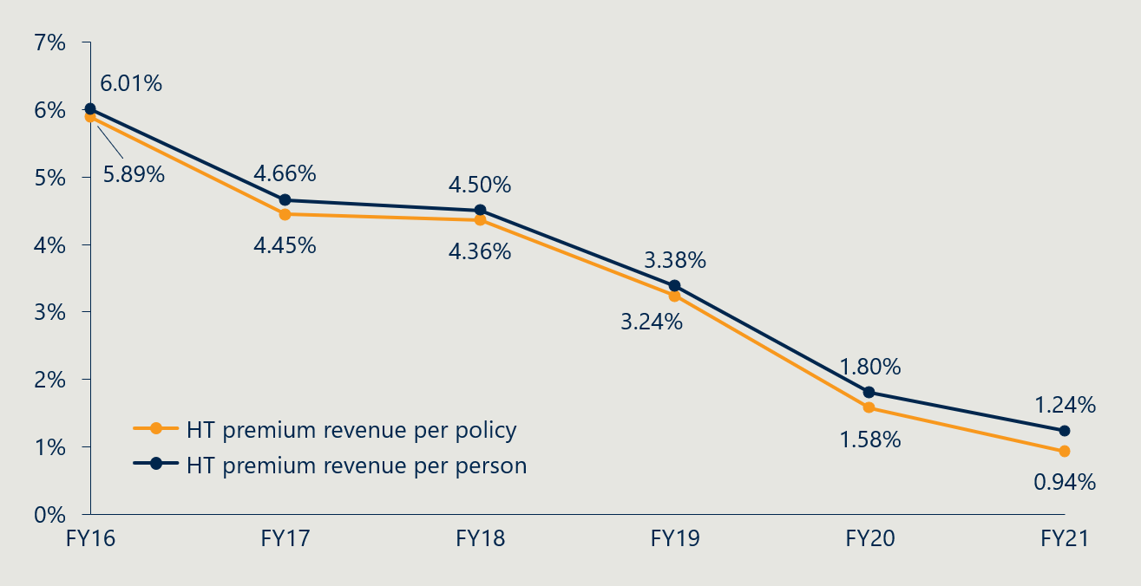

#### Measure 6.2: Change in PHI premiums related to PL item expenditure

###### Measurement guide

This measure will look at the total and proportion of health insurance benefits payments that are directly associated with payment for prostheses. This measure is important for isolating the impact of the PL reforms from other changes to PHI that occur simultaneously. A reduction in the total benefits paid for prostheses is the main way in which the PL reforms seek to improve affordability. Looking at these also as a proportion of all benefit payments contextualises any changes that we see within any other changes to insurance benefit payments being made.

This will be used to quantify the extent to which other changes in PHI value and coverage can be attributed to the reforms. The reform logic states that if the total benefits paid for prostheses decrease, we should expect to see more affordable premiums.

###### Baseline value

In FY21, private health insurers paid $2.23 billion in prostheses benefit payments.[146] Figure 11 (in section 3.4) shows that this represents a 2.28% compounding annual growth rate over the previous five years. Figure 26 shows that the proportion of prostheses benefits to total benefits has decreased gradually over the five years leading up to the baseline, with a slight increase again in the baseline year. Across that time, however, the percentage contribution remained in the range of 12.5-14.5%.

Figure 26 | Prostheses benefits paid as a percentage of total HT benefits[147],[148]

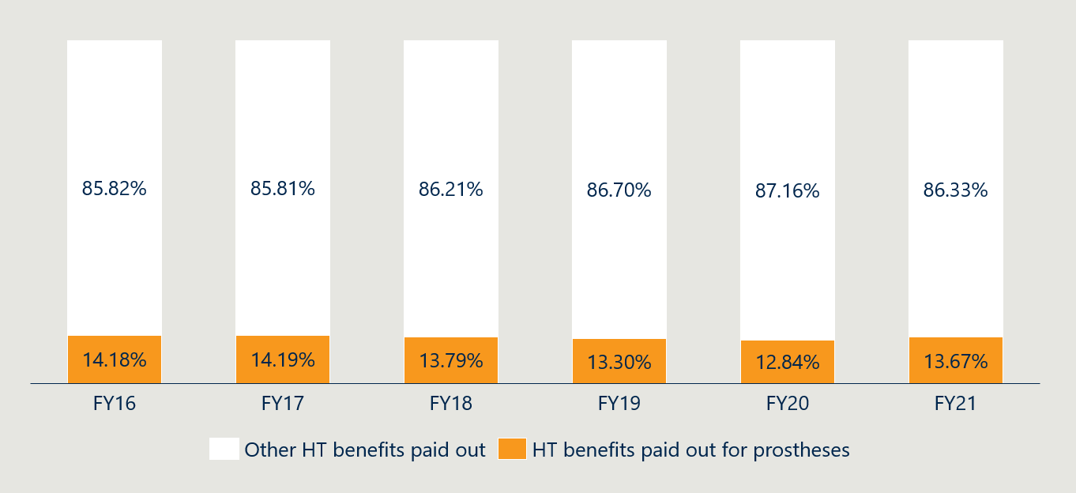

#### Measure 6.3: Stakeholder perspectives on the drivers of change in PHI premiums

###### Measurement guide

A final source of evidence that the PL reforms have contributed to any reductions in PHI premiums (against the theoretical level they might otherwise have risen to) will be derived qualitatively from consultation with stakeholders. Regardless of whether we see any notable changes to measures 6.1 and 6.2, we will use consultation with experts in the Department and private health insurance industry to establish if the PL reforms are likely to have impacted PHI premiums in actuality.

###### Baseline value

There is no baseline value for this measure, given that it will be used to retrospectively assess the impact and contribution of the reform activities to any changes in PHI premiums. It should be noted, however, that early consultation has indicated some level of disagreement regarding the extent to which the reforms are likely to impact premiums.

## Indicator 7: Change in PHI coverage and for whom

#### Measure 7.1: PHI coverage by demographic group

###### Measurement guide

This measure will track the proportion and distribution of Australians covered by PHI policies. Coverage numbers will be used to indicate the extent to which consumer perceptions of the value of PHI changes. Demographic decomposition will be used to check the extent to which this occurs in groups with higher-than-average utilisation of prostheses, as coverage changes in these groups are more likely to be the result of the PL reforms.

We are able to decompose this measure by age, gender and state, however as measure 6.2 indicates no difference in prostheses use between males and females, we have not included a gender breakdown for this measure.

For this baseline report we have included only measures specific to HT PHI policies as these are most relevant, however if subsequent analysis shows that including reference to other policy types or the distribution of different policy types, this will be added.

###### Baseline value

At baseline, 44.5% of Australians had HT PHI coverage. The level of coverage of the Australian population with HT PHI leading up to this baseline date is shown Figure 27 below.

Figure 27 | Percentage of Australian population with Hospital Treatment PHI[149]

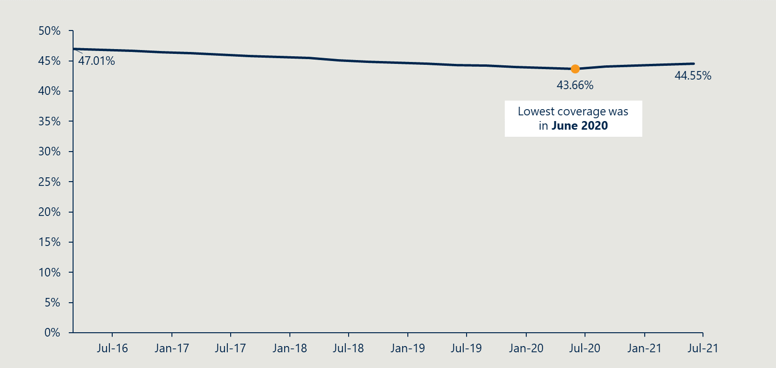

The decomposition of this data by state and age groupings can be seen in Figure 28 and Figure 29 respectively.

Figure 28 | Percentage of Australian population with Hospital Treatment PHI by state and territory[150]

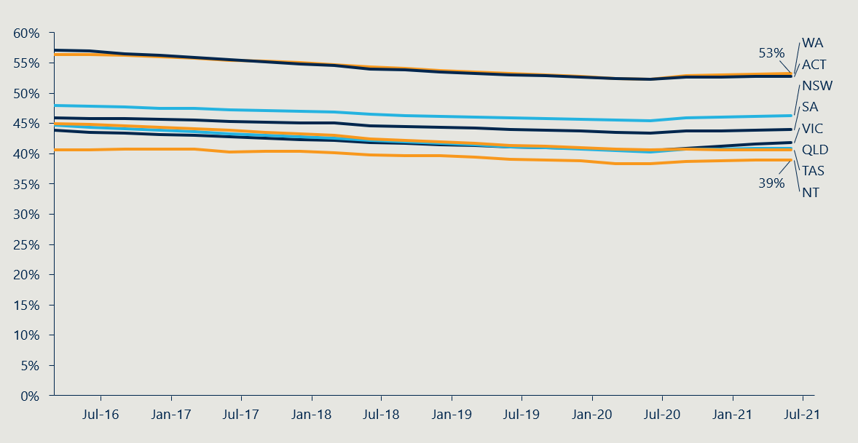

Figure 29 | Percentage of Australian population with Hospital Treatment PHI by age[151],[152]

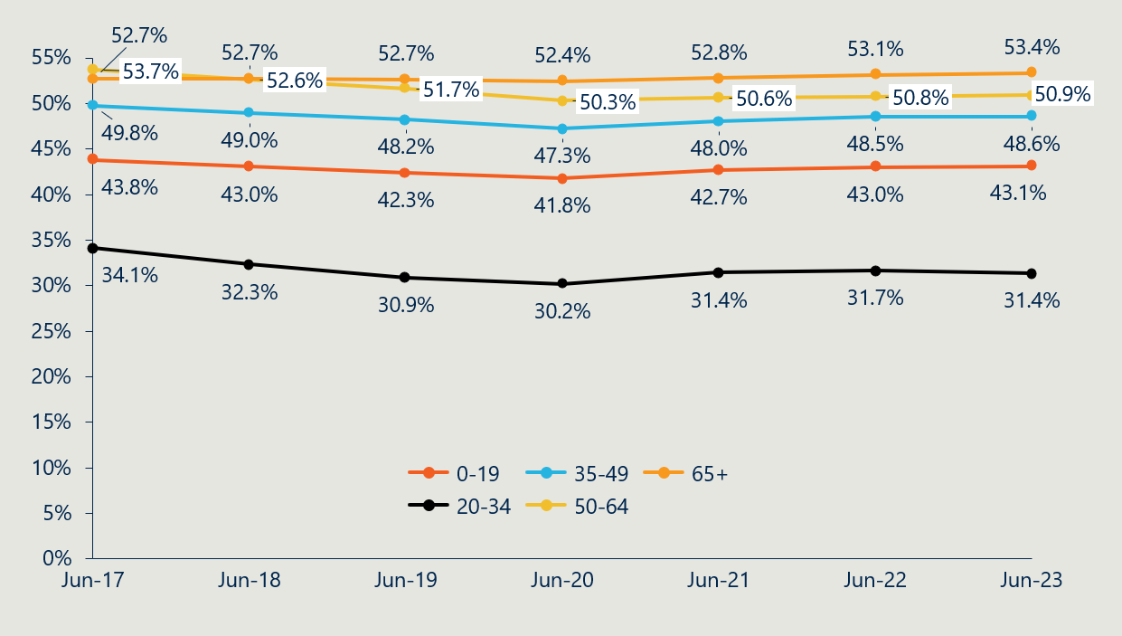

#### Measure 7.2: Utilisation of PL items by privately insured patients

###### Measurement guide

This measure will look at PL item utilisation by groups of PHI members, calculated as the number of PL items used divided by the total number of people with PHI coverage. This measure will help establish attribution of any changes in value to the reforms in two ways. First, any change to this measure might indicate a change in value (an increase in devices used might indicate that PHI is being used more frequently by those who are likely to need medical devices). Second, this measure allows us to understand which demographic groups are most likely to use PL items, which is used to inform our understanding of measure 7.1.

###### Baseline value

Figure 30 below shows the number of PL items used per 1000 people with HT PHI coverage, broken down by PL category. Notably, the total number of items used increased by roughly 20% between FY17 and FY21. To explain this, Figure 31 shows an increase in prostheses utilisation is driven by people over 65 years of age—though all age brackets have had increased utilisation to some extent. In addition, Figure 29 shows that this age group is an increasingly large share of the total number of policies, increasing approximately 3 percentage points between 2016 and 2021. As a greater proportion of HT PHI policies are for people who have a significantly higher likelihood of using PL items, we would expect the item usage per member to increase.

Figure 30 | Prostheses utilisation per 1000 HT PHI members by PL category[153],[154]

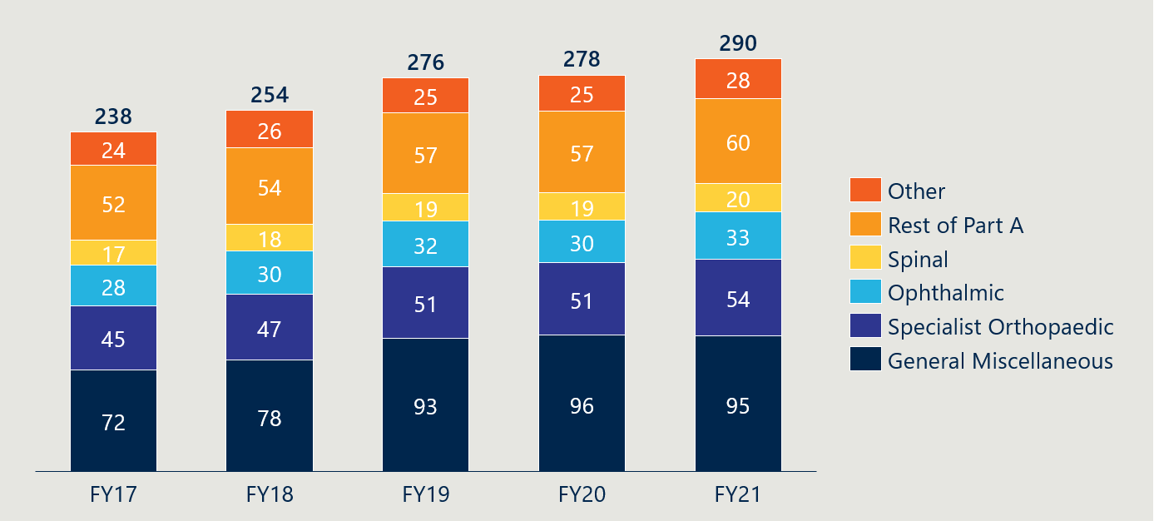

Figure 31 shows that there is significantly higher use of prostheses in people over 65, and to some extent in those between 50 and 64, than in any other age group. On this basis, changes in coverage detected in measure 7.1 that do not relate to these age groups are less likely to be driven by a perceived change in the value of PHI due to the PL reforms.

Figure 32 shows that there is a marginal difference in prostheses usage by males and females, and for this reason we have not included this breakdown in measure 7.1.

Figure 31 | Average prostheses utilisation per 1000 HT PHI members by age[155],[156]

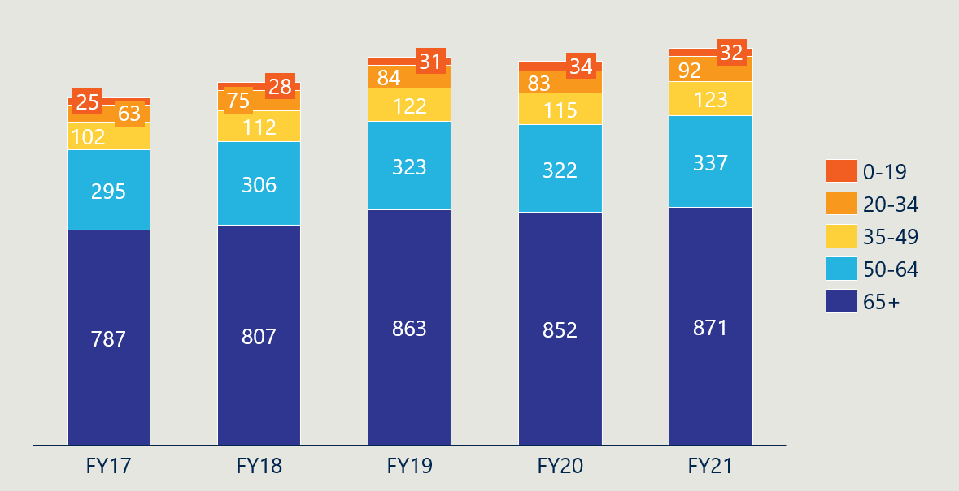

Figure 32 | Average prostheses utilisation per 1000 HT PHI members by gender[157],[158]

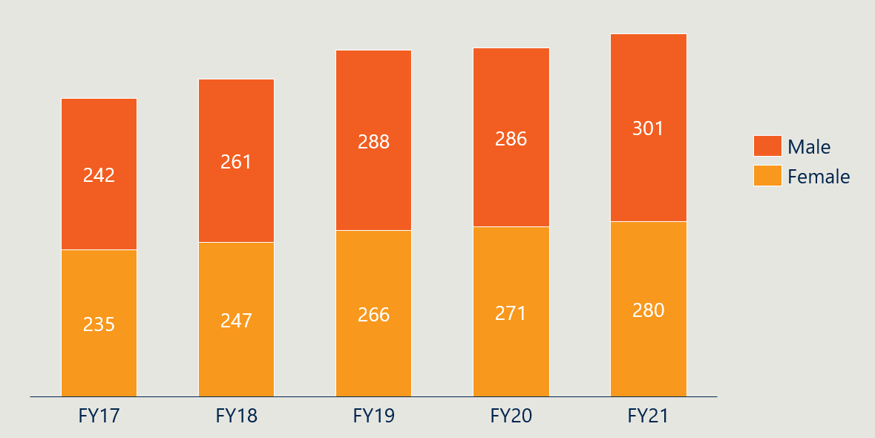

#### Measure 7.3: Stakeholder perspectives on the drivers of change in PHI coverage

###### Measurement guide

A final source of evidence that the PL reforms have caused any change in perceived value of PHI will be derived qualitatively from consultation with stakeholders. Regardless of whether we see any notable changes to measures 7.1 and 7.2, we will use consultation with experts in the Department, PHA and the consumers to assess whether there is in actuality any perceived change in value that can be attributed to the reforms.

###### Baseline value

There is no baseline value for this measure, given that it will be used to retrospectively assess the impact and contribution of the reform activities to any changes in value.

## Indicator 8: Legislative changes to the PL

#### Measure 8.1: Description of the PL's purpose, definition and scope in legislation

###### Measurement guide

This measure will track if changes have been made to legislation in regard to the purpose, definition and scope of the PL. Review of legislation and supporting documentation will inform this measure.

###### Baseline value

At the baseline date (11 May 2021), the stated role of the PL was to “ensure that privately insured Australians have access to clinically effective prostheses that meet their health care needs”.[159]

This was not defined in legislation, rather it was stated in the Prostheses List Guide as the basis of decisions about device listings[160]. ​

PL arrangements and its scope were set out in *Division 72 of the Private Health Insurance Act 2007 and the Private Health Insurance (Prostheses) Rules*. Items listed on the PL had to have had a therapeutic purpose and be implanted or remain in the body. The PL was the schedule to the Rules and was in three parts.[161]

* Part A – Prostheses that are used as part of hospital or hospital-substitute treatment where a Medicare benefit must be paid to the doctor for the procedure performed. The device must be surgically implanted, enable another device to be implanted or allow an implant to continue to function after surgery.
* Part B – Human tissue products that are substantially derived from human tissue where the tissue has been subject to processing or treatments, and whose supply (however described, including trade, sell, give or gift) is governed by state or territory law.
* Part C – Medical devices that do not meet the criteria for Part A, but the Minister for Health considers suitable for benefit payments by private health insurers.

Prostheses referred to items that met the criteria to be listed on the PL. that is they were surgically implanted; or were essential to and specifically designed for an integral single-use aid for implanting such a product; or were critically important to the ongoing function of a surgically implanted product.[162] External prostheses were not included on the PL.

## Indicator 9: Implementation of PL regrouping

#### Measure 9.1: Changes made to the PL grouping structure and PL item categorisation

###### Measurement guide

This measure will look at the changes made to the grouping structure of the PL and track where items have been re-categorised as part of a reform initiative. While legislation will define the purpose of the PL and set bounds on its overarching scope, looking to the grouping structure itself gives detail as to what products are funded through the PL. It will further be used to show whether the planned regrouping exercise as part of the reform has been implemented. Comparative analysis of schedules of PL benefits will inform this measure, supported by PHI circulars made available on the Department’s website.[163]

###### Baseline value

At baseline, Part A of the PL was divided into 13 categories of prostheses (see Table 8 below). Each category was subsequently split into sub-categories, groups and sub-groups, which were identified numerically. Some prostheses also had suffixes that were descriptive text or letters to designate additional characteristics. All prostheses within a benefit group, that is, all items sharing a category, sub-category, group, sub-group and suffix, were assessed as having similar clinical effectiveness, and so were assigned the same benefit. Prostheses in benefit groups that were assessed as having superior clinical outcomes to prostheses in comparator benefit groups were assigned a higher benefit.

Part C of the PL shared the same grouping structure as Part A, but only had items in three of the 13 categories: Cardiac, Cardiothoracic and General Miscellaneous. Part B had a separate grouping structure, with four categories: Cardio-thoracic, Dermatologic, Ophthalmic and Orthopaedic. Part B did not feature benefit groups (categories were not split into sub-categories, groups, etc.) and benefit levels were set for individual products.

The measurement of PL items that have been re-categorised as part of the reforms will use the July 2021 PL as a baseline.

#### Measure 9.2: Number of PL items[164] and benefit groups

###### Measurement guide

This measure will track the number of PL items (i.e., billing codes) and benefit groups[165] listed on the PL throughout the evaluation. It will also track the average number of PL items per benefit group. Together with measure 9.1, this will be used to assess the impact that the reforms have on the structure, complexity and consistency of the PL.

###### Baseline value

The total number of items per category at baseline are presented below in Table 8. Parts A and C are represented as separate to Part B given the nature of items in Part B (human tissue products) differ substantially in kind and in categories from those in Parts A and C (medical devices).

Table 8 | Number of items per category in the July 2021 PL[166]

|  |  |  |  |  |  |
| --- | --- | --- | --- | --- | --- |
|  | Category | Part A | Part B | Part C | Total |
| Parts A and C | 01 - Ophthalmic | 330 | - | - | 330 |
| 02 - Ear, Nose & Throat | 165 | - | - | 165 |
| 03 - General Miscellaneous | 825 | - | 10 | 835 |
| 04 - Neurosurgical | 469 | - | - | 469 |
| 05 - Urogenital | 168 | - | - | 168 |
| 06 - Specialist Orthopaedic | 3546 | - | - | 3546 |
| 07 - Plastic and Reconstructive | 708 | - | - | 708 |
| 08 - Cardiac | 334 | - | 70 | 404 |
| 09 - Cardiothoracic | 101 | - | 12 | 113 |
| 10 - Vascular | 457 | - | - | 457 |
| 11 - Hip | 804 | - | - | 804 |
| 12 - Knee | 858 | - | - | 858 |
| 13 - Spinal | 2045 | - | - | 2045 |
| Part B | 01 - Cardio-thoracic | - | 18 | - | 18 |
| 02 - Ophthalmic | - | 16 | - | 16 |
| 03 - Orthopaedic | - | 711 | - | 711 |
| 04 - Dermatologic | - | 14 | - | 14 |

Figure 33 below shows a steady net increase of 1.09% p/a in the number of items on Parts A and C of the PL from August 2012 to July 2021. However, this trend has not been consistent across the PL categories. For example, the number of items in the 13 – Spinal category increased from 1,292 to 2,045 (+5.3% p/a) while the number of items in the 11 – Hip category decreased from 1,143 to 804 (-3.6% p/a) over the same time period[167].

Figure 33 | Number of PL items over time[168]

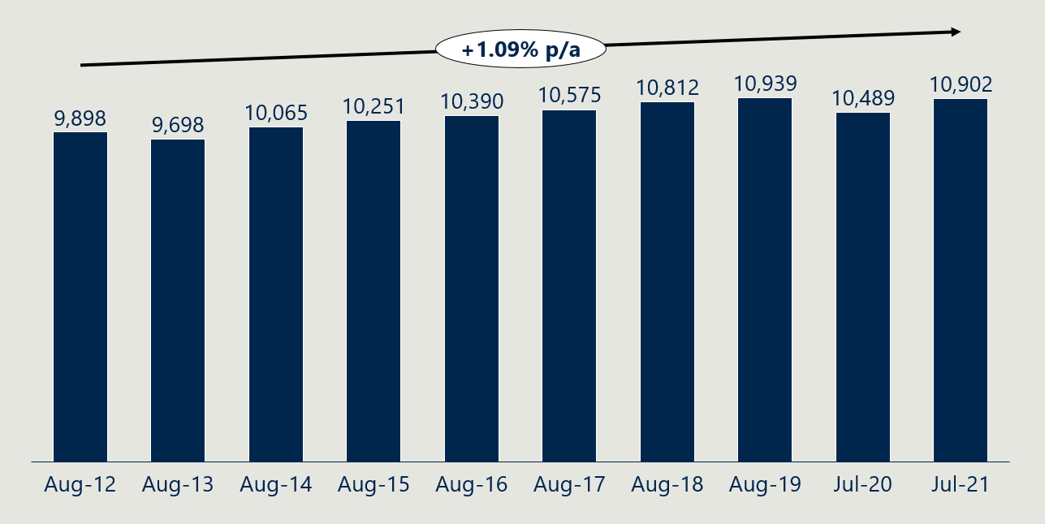

At baseline, there were 1,680 benefit groups in Parts A and C. Figure 34 below shows that for the four years from August 2013, the number of benefit groups grew before declining again in the years leading up to the July 2021 update. The number of benefit groups in August 2012 is inflated due labelling and categorisation errors that were corrected by August 2013.

Figure 34 | Number of benefit groups over time[169]

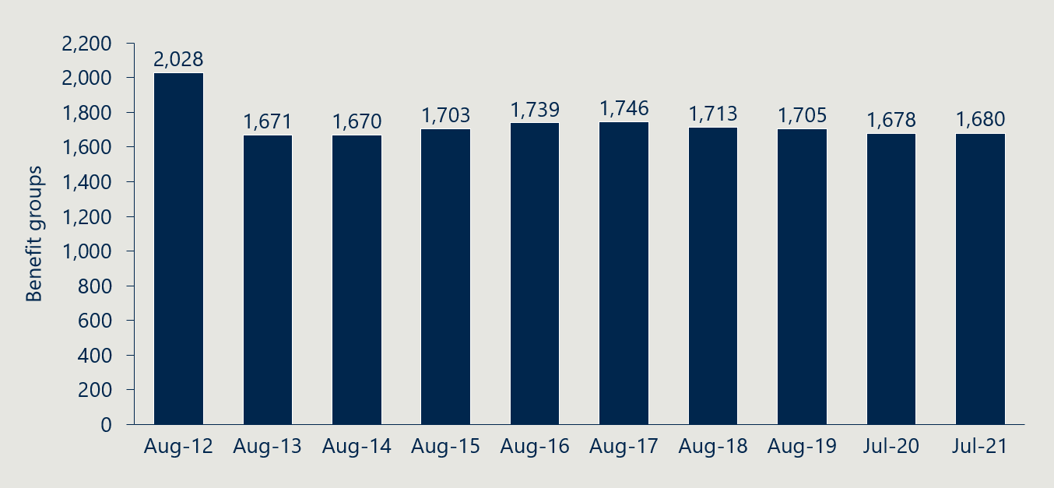

Consistent with Figure 33 and Figure 34, Figure 35 shows the average items per benefit group increased in the years leading up to baseline.

Figure 35 | Average items per benefit group[170]

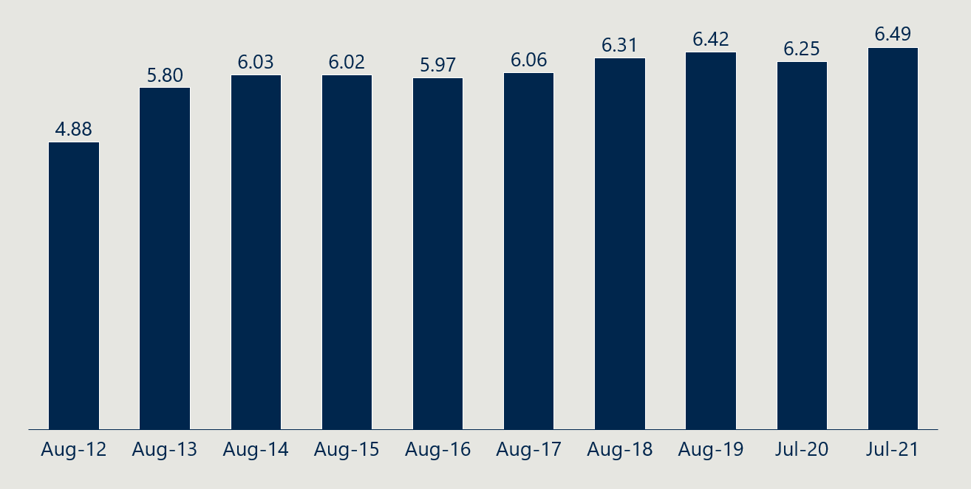

## Indicator 10: Implementation of changes to general use items

#### Measure 10.1: Description of changes to general use items

###### Measurement guide

This measure will look at the changes to GUIs. It will seek to describe whether GUIs were removed from the PL and what alternative arrangements were put in place for the funding of these items as part of the reforms.

###### Baseline value

In April 2022, the Department identified 494 PL items as GUIs due for future removal.[171] The majority of these items are in the 03 – General Miscellaneous category and some items are in the 04 – Neurosurgical and 10 – Vascular categories.

## Indicator 11: Assessment of legislative changes to the PL

#### Measure 11.1: Stakeholder perspectives on the level of clarity in the PL's purpose, definition and scope

###### Measurement guide

This measure will look at stakeholder opinions on the clarity of the PL’s purpose, definition and scope as defined in legislation. Stakeholder consultations and analysis of available stakeholder submissions and documentation will inform this measure throughout the evaluation.

###### Baseline value

At baseline, diverse stakeholder groups described problems associated with the PL lacking a clearly defined purpose and scope. Stakeholders noted that the purpose of the PL is not defined in legislation and different stakeholders had different views regarding the types of medical devices and human tissue products that should be listed on the PL. While some stakeholders believed that items such as sutures and staples should be included on the PL (as is the case pre-reform), others disagreed[172]. Medical device companies have also suggested that the fact that the arrangements do not allow for the listing of non-implantable devices that offer a clear clinical benefit has limited patient access to more contemporary models of care.[173]

*“Advances in technology mean that medical devices that are used in effective and clinically proven surgical procedures are not eligible for listing on the PL because they are not implanted”*

**MTAA, 2017 Senate Submission**

**MTAA, 2017 Senate Submission**

## Indicator 12: Assessment of PL regrouping

#### Measure 12.1: Stakeholder perspectives on PL regrouping

###### Measurement guide

This measure will look at stakeholder opinions on regrouping activities carried out during the reforms. It will support other measures in evaluating changes that have been made to the PL’s purpose, definition and scope. It will assess whether the structure of the PL aligns with the clinical use of the device groups, and whether the regrouping supports the easy navigation of the PL by its users. Stakeholder consultations and analysis of available stakeholder submissions and documentation will inform this measure throughout the evaluation.

###### Baseline value

Stakeholders expressed concerns that the current system of benefit groups did not always accurately reflect clinical differences between products. In in interviews conducted by the evaluation team, stakeholders expressed that this function of the PL was not always working effectively or as intended[174]. Stakeholders claimed that benefit groups with higher benefit levels were not always clinically superior to comparable benefit groups with lower benefit levels[175]. Clinicians suggested that, in some cases, different benefits for clinically comparable benefit groups had stemmed from benefit setting being based on advice from clinicians who had no first-hand knowledge of the device type or had an unrelated specialty[176].

Where the relative benefit setting is poorly tied to meaningful clinical differences, the way in which medical device manufacturers are incentivised to innovate can be skewed away from solely developing products that increase the clinical benefits of a procedure or surgery. This creates unintended consequences further downstream as sponsors make strategic decisions about which products to sell. Multiple stakeholders described sponsors' ability to 'game the system' by exploiting differential benefit levels within similar product groupings as a result ineffective grouping[177]. This views support the need for a review of the PL grouping structure.

*“We are concerned that this gaming and resultant growing cost inefficiencies to insurers (and consumers) has continued to occur despite medical device makers’ pledge to promote the sustainability of private health care”*

**MHFA, Letter to the Department of Health, 2020**

## Indicator 13: Assessment of changes to general use items

#### Measure 13.1: Stakeholder perspectives on changes to general use items

###### Measurement guide

Following on from the description of changes to GUIs in measure 10.1, this measure will look at stakeholder opinions of changes to GUIs. The assessment will involve documenting stakeholder perspectives on the removal of (or other actions towards) GUIs but will not look closely at the broader health system impacts (external to the funding mechanism of the PL) of such changes. The data sources for this measure are Departmental documentation including consultation papers on the topic and stakeholder consultations.

###### Baseline value

Some stakeholders described how the PL created an environment where there was limited financial accountability or incentive for providers to consider the costs to the health system in the choice and utilisation of medical devices.[178]They cited GUIs in particular as being conducive for this profit-maximising activity. Stakeholders pointed to health system inefficiencies as a result of general-use items being over-utilised compared to the value they provided to consumers.[179]

Other stakeholders have expressed concerns that without alternative funding arrangements that facilitate continued, guaranteed access to these items at a reasonable price, the cost to perform certain kinds of surgeries that rely on specific GUIs will significantly increase.[180] They emphasise that while the medical device itself might remain accessible to clinicians (and their patients by extension), increased cost or difficulty in acquiring necessary GUIs might result in certain procedures becoming prohibitively expensive or difficult to perform.[181] This would constitute an undermining of the purpose of the PL in ensuring that privately insured patients have access to the devices and procedures that are most appropriate. At baseline, no such alternative funding arrangements have been agreed to by all parties.

## Indicator 14: Implementation of new assessment processes

#### Measure 14.1: Description of assessment pathways

###### Measurement guide

This measure will describe the assessment pathways, how these change over time, and the steps that have been taken to change them.

###### Baseline value

At baseline, there were no distinct application pathways for different levels of complexity or kinds of devices. Sponsors applied to list new billing codes, or to vary, transfer or delete existing listings, through the Prostheses List Management System (PLMS). They proposed groupings (group, sub-group, suffix) for new and amended billing codes, and where applicable, also propose a benefit level.

#### Measure 14.2: Description of governance processes

###### Measurement guide

This measure will describe the governance processes for assessments, how these change over time and the steps that have been taken to change them.

###### Baseline value

The PLAC considered advice from clinicians, Clinical Advisory Groups (CAGs) and a Panel of Clinical Experts (the Panel) in order to advise the Minister for Health on whether to proceed with proposed additions or changes to billing codes on the PL, and the appropriate benefit level for each where applicable. The Minister was ultimately responsible for determining whether to grant, or not to grant, each application, and for setting benefit levels, based on the information and advice provided to them.

Applications were reviewed via a process of clinical assessment by the relevant CAG or by the Panel. The CAGs met to discuss applications put to them, and the Panel would assess applications to list products that did not fit into the clinical categories for which the CAGs were established.[182] Applications requesting an increased benefit, or the creation of a new group, sub-group or suffix, required an assessment of the clinical evidence and an economic evaluation. Items expected to have significant financial impact on the health system were referred to the Medical Services Advisory Committee (MSAC) for health technology assessment. MSAC would then provide advice to the Prostheses List Advisory Committee.[183]

An external party reviewed the governance structure in July 2021 and provided options and recommendations for the future governance of the PL for the Department’s consideration.

## Indicator 15: Assessment of new assessment processes

#### Measure 15.1: Volume of PL applications per tier

###### Measurement guide

This measure will look at the number of applications that go through each tier of the new assessment process. This will be used to estimate the impact of the establishment of the tier system on the efficiency of the application process. Once the new three-tiered assessment process has been fully implemented, we will use a summary of applications data from HPP to inform this measure.

###### Baseline value

The evaluation team has not been able to access PLMS applications data to establish a baseline volume of applications. As there were no tiers and applications proceeded through the same process at baseline, this does not represent a significant issue for the evaluation.

#### Measure 15.2: Stakeholder perspectives on the assessment pathways and listing process

###### Measurement guide

This measure will look at stakeholder opinions on the assessment pathways and listing processes. It will be used to provide an assessment of the extent to which the PL assessment processes described by measures 14.1 and 14.2 are aligned to HTA principles. It will also capture broader insights from stakeholders about the application process, assessment pathways and governance structures that may be formative to the ongoing administration of the PL.

This measure will draw from consultation with the Department and key stakeholder groups, and review of available documentation and processes. Notably, the Quality of Information and Guidance Industry Working Group (QIGIWG) [184] and Benefit Setting & Review Framework Industry Working Group (BSRIWG) [185] have conducted their own analysis of the PL assessment process, the findings of which will be referenced. We will also capture broader insights from stakeholders about the application process, assessment pathways and governance structures. We will also analyse feedback from any public consultation run by the Department regarding the application and assessment process.

###### Baseline value

Stakeholders have argued that the assessment processes and Prostheses List Advisory Committee structure are insufficient. Consumer groups, clinicians and insurers have all argued that sponsors have excessive sway over the pre-listing review process and the advice provided through the PL Advisory Committee.[186] Clinician groups suggested that the representation of medical experts needed to be bolstered, while consumers suggested the same for consumer representation.[187] Clinicians have argued that the range of clinical expertise on the Committee does not accurately reflect the range of devices it assess. Insurers have argued that existing decision-making processes need to be more streamlined, more transparent, and better aligned to the principles of Health Technology Assessment (HTA).

*“Does the PLAC have the right representations of clinicians, payers, hospitals, etcetera? Right governance? Do they have the right information they need? ... I'm not sure.”*

**Stakeholder interview (clinician), 2023**

Stakeholders have also expressed concerns that the current system of assigning groupings and benefits does not always accurately reflect clinical differences between products. While PL benefit groups and associated benefit levels were developed to reflect clinical differences between products, stakeholders reported this was not always working effectively or as intended[188]. Clinicians suggested that, in some cases, different benefits for clinically comparable price groups had stemmed from benefit setting being based on advice from clinicians who had no first-hand knowledge of the device type or had an unrelated specialty[189]. Where relative benefits do not reflect clinical differences, the way in which medical device manufacturers are incentivised to innovate can be skewed away from solely developing products that increase the clinical benefits of a procedure or surgery.

Further to these stakeholder views, a summary of the current state as aligned to HTA principles is summarised in Table 9 below.

Table 9 | Baseline description of PL pathways as aligned to HTA principles

|  |  |
| --- | --- |
| Principle | Baseline description |
| Sustainable | *A formal review of the economic sustainability of the PL (and its components) is not in scope for this evaluation. Separate from this evaluation, an independent review is being conducted of the cost recovery arrangements associated with the application process. The economic sustainability of the administration of the PL is an important consideration, and where stakeholders opinions about this surface, we will seek to document them.* |
| Transparent, accountable and independent | * PLAC deliberations and recommendations are recorded and not published, however are subject to provisions of the *Freedom of Information Act 1982*.[190] A PLAC Communique is published after each meeting. The Minister’s decisions in amending the PL are published. * There are no formal mechanisms by which members of the CAGs, Panel or PLAC are accountable for the listing of devices on the PL. Ultimate responsibility for adjustments to the PL rests with the Minister. * Advice from CAG, Panel and PLAC members is independent of the Department, however their recommendations do not need to be taken, and ultimate responsibility for adjustments to the PL rest with the Minister. * Members of the PLAC included stakeholders representing industry (medical technology, private hospitals and private health insurance) as invited guests which saw potential for real or perceived conflicts of interest.[191] |
| Consultative and reflective of Australian community values | * The CAGs, Panel and PLAC represent the extent to which the assessment process involves consultation. The Panel has been criticised for the fact that it does not formally convene to discuss applications.[192] |
| Administratively efficient | * The PLMS has been identified as putting an administrative burden on both sponsors and the Department. Both groups have suggested that it has become out-of-date as the PL has evolved over time.[193] |
| Flexible and fit for purpose | * The PL assessment process does not take significant account of the level of complexity that each application requires, with all assessments undergoing the same overall process. While the administrative burden of applications still varies based on their complexity, there is limited flexibility present at the structural level. * The PLAC draws upon expert advice from a CAG or Panel based on the category of the device or associated specialty. Stakeholder have questioned whether the right representation, expertise and information feeds into these convening groups.[194] |
| Informed by robust and relevant evidence | * The setting of benefits for billing codes on the PL is based on the available evidence, clinical advice and the collective judgement of the PLAC about relative cost and effectiveness. * Information provided in some PL applications is considered irrelevant and lacks synthesis of the evidence to enable committees to effectively assess the application, making the process inconsistent in quality and content.[195] * The function of the Panel has also been criticised, with concerns raised that the lack of direct engagement and discussion with other members of the Panel reduces how robust the advice it provides is and means that the expertise of Panel-members is not fully leveraged.[196] * There is, in general, no formal assessment of comparative cost-effectiveness. There are occasions when the Medical Services Advisory Committee (who appraise new medical services proposed for public funding) provided advice to PLAC regarding a cost-effective price for a “first-in-class”[197] prostheses. |

## Indicator 16: Change in listing review and compliance frameworks

#### Measure 16.1: Description of post-listing review framework

###### Measurement guide

This measure will describe what post-listing review framework is in place and how it is being used. We note that at the time of writing, the Department has already published a working version of the framework[198]. We will review this document and consult with the Department on its use.

###### Baseline value

At baseline, there was no structured mechanism for regularly reviewing benefits paid for items listed on the PL, nor was there a formal processes for undertaking reviews. This meant, in general, the benefits of items were not reviewed once on the PL, except where stakeholders raised concerns or subsequent investigation by the PLAC or CAGs deemed it necessary. Such work was highly dependent on resource availability and limited resources were available[199].

Moreover, any ad hoc listing reviews were paused during 2020 and 2021, as agreed between government and industry in response to the COVID-19 pandemic[200].

#### Measure 16.2: Description of compliance strategy

###### Measurement guide

This measure will describe the compliance strategy that the Department has adopted and its role in shaping compliance, assessment and enforcement functions supporting the PL. At the time of writing, the Department has already published its compliance strategy[201]. We will review this document and consult with the Department on its use.

At reform commencement, the Department noted that legislative change may be required to support a new compliance framework, allowing it to enact new compliance and enforcement functions[202]. We will also consult with the Department about any broader reform activities that support the implementation of the new compliance strategy.

###### Baseline value

At baseline, the Department did not have a systematic or well-documented compliance approach. While action was taken in clear cases, there was only limited scope to investigate claims of stakeholders not using the PL as it was intended. There was also limited clarity in the Department’s enforcement functions for addressing illegal and non-compliant behaviour.

## Indicator 17: Assessment of listing review and compliance frameworks

#### Measure 17.1: Description of post-listing reviews conducted

###### Measurement guide

This measure will track the post-listing reviews conducted, which will confirm the presence of the reviews and contribute to an understanding of their impact (where we might see changes in other measures as a result of these reviews occurring). It will also be used to understand the impact on PL administration that conducting these reviews incurs.

At baseline, the Department has indicated it will conduct four post-listing reviews to service as pilots for a new post-listing review framework[203]. We will focus on monitoring the progress of these four reviews, while also examining any additional post-listing reviews that might occur.

###### Baseline value

Post-listing reviews, as formalised and structured by a guiding framework, are to be newly developed and implemented through the reforms. As such, there is no baseline data for this measure.

#### Measure 17.2: Stakeholder perspectives on post-listing reviews

###### Measurement guide

This measure will outline stakeholder perspectives on post-listing reviews after the reform initiative has been implemented. We will consult with all key stakeholders groups about post-listing reviews throughout the evaluation period, with a focus on the perspectives of the Department and sponsors (those most directly affected by the process and outcome of post-listing reviews). Key lines of enquiry will be:

1. Are the Department’s review efforts being focused on the right areas (i.e., addressing the most important issues first)?
2. Is there enough post-listing review activity? Is there adequate Departmental capacity to implement the framework and meet the ongoing review requirements of the PL?
3. What is the experience of sponsors engaging with post-listing reviews?
4. How could post-listing reviews better safeguard the integrity of the PL?

The Department also already engaged with stakeholders about its working framework. We will review and incorporate these perspectives in this measure.

###### Baseline value

Stakeholders pointed to insufficient post-listing review processes at baseline. Some saw benefits as ‘set and forget’, with insufficient reviews to assess how technology and market conditions changed after the initial listing of a device or the creation of a benefit group.[204] This had the potential to lead to benefits not continuing to reflect the actual cost of a device where these costs might go down, or how the relative value of a device might change given other procedures, technologies and devices that enter the market. If this were to occur, the benefit paid would exceed the actual value of the device, and not represent good market value. This contrasted the public system that enabled more dynamic price setting in line with real-time costs for medical technology organisations and hospitals.[205]

#### Measure 17.3: Description of compliance activities conducted

###### Measurement guide

This measure will track the compliance activities that have been conducted to confirm the compliance strategy is in effect and indicate whether it is contributing towards achieving its intended outcomes. While reviewing the compliance strategy and other Departmental documentation will frame this measure, there is a need to verify and document what compliance activity has actually occurred.

It may be difficult for us to document the extent of what compliance activity has occurred. In conversations with the Department, we understand there to be no register of compliance-related actions or another mechanism by which they are formally recorded, say for example, in meeting minutes. As such, this measure will be a qualitative description of compliance activities that have been conducted using information gathered in consultation with the Department. We will consult with other stakeholders, as necessary.

###### Baseline value

A framework to formalise the Department’s compliance approach is to be newly developed through the reforms. Baseline compliance activities are not captured in policy documents or transparent to the sector.

#### Measure 17.4: Stakeholder perspectives on PL compliance

###### Measurement guide

This measure will add to measure 17.3 in evaluating the impact of PL compliance. Understanding stakeholder perspectives on the compliance activities enacted by the Department will help us understand how the compliance strategy is being implemented and to what extent it is contributing towards maintaining the integrity of the PL through addressing non-compliant behaviour. It may also include perspectives on the complexity or regulatory burden associated with its implementation. Key lines of enquiry will be:

1. How has the compliance strategy directed compliance action? Do the compliance activities that have occurred reflect the strategy the Department has adopted?
2. Is there enough compliance activity? Is there adequate Department compacity to carry out its compliance and enforcement priorities?
3. Is PL compliance safeguarding the integrity of the PL in the areas of benefit setting and claiming, scope and definition, consolidation of the PL and listing conditions?
4. Have compliance activities resulted in additional regulatory burden for stakeholders? If so, have these been reasonable?
5. How could PL compliance better safeguard the integrity of the PL?

At the time of writing, the Department has already consulted with stakeholders about new data sharing and compliance powers, and again on further proposed measures for compliance, assurance and information sharing[206]. This measure will also incorporate the perspectives shared in these consultations.

###### Baseline value

Stakeholders expressed a limited understanding of the Department’s compliance activities and approach, beyond what occurs during listing and assessment processes. However, stakeholders from different groups criticised the behaviour of others in their interactions with the PL, which reflects an insufficiency in the Department’s compliance and enforcement functions.

Stakeholders described sponsors' ability to 'game the system' by exploiting differential benefit levels within similar product groupings[207]. In these instances, the marginal cost of the more expensive product is associated with no, or a smaller amount of, marginal clinical benefit for the consumer. Members Health Fund Alliance stated in 2020, “We are concerned that this gaming and resultant growing cost inefficiencies to insurers (and consumers) has continued to occur despite medical device makers’ pledge to promote the sustainability of private health care”[208]. While arguably such claims would be better addressed proactively during listing and assessment, it also reflects an ineffective compliance capability to reactively address these matters.

Stakeholders also reported a needless increase of costs throughout the health system as a result of non-compliant behaviour. Stakeholders pointed out that sponsors, private hospitals, and in some cases, clinicians, were ‘free’ to maximise profits by increasing the volume of PL-listed items used or otherwise influence a more profitable mix of PL items[209]. A PHI stakeholder described providers purchasing ‘loan kits’ from sponsors—a bundle of items that providers could ‘unbundle’ and bill PHI for each of the individual item’s PL benefits[210]. Another PHI stakeholder expressed sympathy for some private hospitals that had “grown dependant” on the profit from PL items, saying these items were cross-subsidising other hospital activity and it would be difficult to stop[211].

## Indicator 18: Implementation of cost recovery arrangements

#### Measure 18.1: Description of cost recovery arrangements

###### Measurement guide

This measure will look at the cost recovery arrangements of the PL and how these change over time. An assessment or measurement of the efficiency of the cost recovery model is out of scope for the evaluation, and as such, this will be a descriptive measure only.

###### Baseline value

At baseline, sponsors encounter fees throughout the listing process, which were paid to the Department and included: [212]

* Application fee – $600 fee for each new application (excluding applications associated with amendments, deletions of listings, or duplications, expansions, compressions or transfers of existing billing codes.
* Initial listing fee – $200 fee once the Minister granted the application to list a product (excluding Part B items and products that were listed as a result of duplicating, expanding, transferring or compressing existing billing codes).
* Ongoing listing fee – $200 fee due 15 March and 15 September each year (excluding Part B items and products that were listed as a result of duplicating, expanding, transferring or compressing existing billing codes).

## Indicator 19: Financial sustainability of PL administration

#### Measure 19.1: Change in PL administrative effort

###### Measurement guide

This measure will describe the administrative activity required to maintain the PL and track changes in the level of effort over the course of the evaluation. PL tasks and staffing estimates are made annually by the Department in support of its charging framework, and this data will be used to quantitatively reflect changes in PL administrative effort. Based on the activities of the 2023-24 charging model, the following categories of effort will be tracked:

* General administration
* Department assessment
* Granting decision
* Prostheses Rules
* Invoicing
* Tier 2 assessment
* Tier 3 assessment
* CAG meetings
* PLAC meetings
* Deletions applications
* Transfer applications
* Stakeholder engagement
* Compliance.

###### Baseline value

As the baseline cost recovery framework was not aligned with the Australian Government Charging Framework[213], the evaluation team does not have activity-based estimates in the categories described above for the baseline year.

#### Measure 19.2: Stakeholder perspectives on the financial sustainability of PL administration

###### Measurement guide

This measure will look at stakeholder opinions on the financial sustainability of maintaining and administrating the PL. This will involve consulting with the Department and conducting a desktop review of appropriate documents. As noted with measure 18.1, an assessment or measurement of the efficiency of the cost recovery model itself is out of scope for the evaluation, and as such, this measure will note high-level findings of any external reviews into the cost recovery model and document stakeholders views more broadly on the PL’s financial sustainability.

###### Baseline value

At baseline, the Department noted its cost recovery arrangements had not changed since 2009 and its application fees had been the same since 2007.[214] As noted, these arrangements did not align with the Australian Government Charging Framework[215], as they were not commensurate to the size and complexity of the Department’s administration activities associated with the PL. With expenses exceeding recovered fees by millions of dollars[216], the financial sustainability of the PL was of concern.

1. Mapping of objectives to reform projects and key evaluation sub-questions

|  |  |  |
| --- | --- | --- |
| Objective | Reform projects | Key evaluation sub-questions |
| 1. Improve alignment of the scheduled benefits of the PL with the prices paid in more competitive markets such as the public hospital system and comparable international markets | Benefit reductions | * 2.1 Has there been a reduction in prostheses prices paid by private hospital system compared to prosthesis prices paid by public hospitals and comparable international markets? |
| 2. Maintain no additional out-of-pocket costs associated with the PL devices for consumers | *No specific project* | * 2.2 Have prostheses related to out-of-pocket expenses for consumers been maintained since the introduction of PL reforms? |
| 3. Maintain clinician choice of appropriate prostheses for their patients | *No specific project* | * 2.3 Has prostheses availability, accessibility and clinician/consumer choice in Australia been maintained since the introduction of PL reforms? * 2.4 Have the reforms had any impact on the selection and utilisation of products, and has this change generated any changes in clinical outcomes? |
| 4. Improve the affordability and value of private health insurance for privately insured Australians | Benefit reductions | * 2.6 Are any reductions of PL benefits resulting in reductions of PHI premium increase rates? * 2.7 Has increased awareness of PL reforms and increased value of PHI resulted in higher uptake of PHI? * 2.10 In what population groups are PL Reform benefits realised most significantly? |
| 5. Clarify the purpose, definition, and scope of the PL in legislation | Clarifying purpose and scope  Regrouping of PL  General use items | * 1.2 Has there been a reduction in PL categories / subcategories and groupings / subgroupings? Is this reducing complexity of the PL? * 1.3 What, if any, changes have been made to the PL scope, definition and purpose? How is this reflected in guidance and process documents? * 2.5b Have changes to the PL groupings streamlined the application process? How? |
| 6. Implement new PL assessment pathways aligned to Health Technology Assessment Policy Branch principles and streamline application process through simple and robust IT infrastructure | Modernised pathways  Updated technology  Governance arrangements | * 1.4 Are the PL assessment pathways and application process more aligned to HTA principles adopted by the Department? * 2.5a Have changes to the PL pathways streamlined the application process? How?   *1.6 Has the PLMS been replaced with HPP and has this streamlined the internal administrative processes?\** |
| 7. Develop and implement PL listing review and PL compliance frameworks to safeguard the PL reforms | Compliance activities | * 1.5 Have changes occurred in the post-listing activities, including post-listing reviews and compliance activities? |
| 8. Ensure ongoing financial sustainability of PL administration through effective and efficient cost recovery arrangements that are compliant with the AGCF | Cost recovery fees | * *2.8 Is PL administration cost neutral to the Government?\** |
| *No specific objective* | *No specific project* | * 1.1 Are the new PL benefits processes being established on time and according to plan? * 1.7 Have stakeholders been engaged appropriately in the design, implementation, and evaluation of the PL Reforms? * 1.8 What factors have enabled or constrained implementation of the PL Reforms? * 2.9 Has PL Reform produced any unintended positive or negative outcomes? |

*\*No longer in scope for this evaluation.*

1. Method

Appendix D summarises our evaluation methodology, as presented in the evaluation plan in August 2023. Please note that in some instances, the data sources and our approach to analysing them have evolved as the evaluation has progressed.

The evaluation will adopt a ‘mixed methods’ approach

Evaluating a broad-reaching policy change, such as the PL Reforms, is a complex task. This is due to the large and diverse number of stakeholders involved, the nuanced dynamics of the prostheses market, the intricate dependencies between the reform initiatives and the intangibility of several of the intended outcomes. To overcome these challenges, the evaluation will take a principles-based approach that is grounded in the KEQs and the program logic. This will ensure the evaluation gives deliberate attention to the intent of the reforms.

The evaluation will use methodologies based on the collection, and analysis, of qualitative and quantitative data from interviews, focus groups, desktop research, surveys and existing data – also defined as a ‘mixed methods’ approach. Data will be analysed through a combination of thematic analysis, and descriptive and inferential techniques. Using this approach, findings will be triangulated based on the evidence provided through multiple different sources.

## Quantitative data collection and analysis

### Quantitative analysis will inform an assessment of the extent to which the reforms have delivered their intended financial, administrative and health outcomes

To assess the performance of the PL Reforms, analysis will be undertaken on a range of quantitative indicators. This will involve compiling and assessing relevant descriptive statistics to develop hypotheses pertaining to the KEQs and sub-research questions. Where feasible, inferential methods (such as general linear modelling and a difference-in-difference approach) will also be used to add rigour to the analysis and support efforts to attribute changes to the reforms.

By undertaking comparisons, and examining correlations, across different cohorts and in indicators over time, quantitative analysis will also be used to assess the extent to which the program is delivering the outcomes predicted by the program logic in an appropriate, efficient and effective manner. As part of this, the analysis will employ graphs to visualise, develop and convey important findings.

### The availability of data, and the existence of confounding factors, will limit the ability of quantitative analysis to establish a causal relationship

It is important to note that the quantitative analysis will generally not be able to definitively “prove” a direct causal relationship between the reform program and all desired outcomes. This is because there are data limitations and confounding factors that cannot be entirely controlled for and because there are also intangible outcomes that may take many years to establish fully.

Figure 37 presents a hypothetical example of a health or financial indicator that changes as a result of the PL Reforms. In this example, the indicator’s value increases prior to any policy shift associated with the PL Reforms, due to confounding factors, unrelated to the reform process. At the time “ $t_{0}$”, a policy change, such as a benefit reduction or the removal of an item from the PL, takes place. After this point, the indicator’s value begins to increase at a rate that is faster than the pre-reform trend until “ $t_{1}$”.

In this example, it would be inappropriate to attribute the total change in the indicator’s value between $t_{0}$ and $t_{1}$ to the PL Reforms. This is because, in the absence of the PL Reforms, the indicator may have still changed for some reason unrelated to the reforms. Instead, to determine the extent to which changes can be attributable to the reforms, it is necessary to identify a plausible “counterfactual trend”.

This counterfactual trend is the trend that the indicator would have taken if the intervention being examined had not taken place.

Figure 36 | The challenge of attribution

A graph showing health/financial indicator on the y-axis and time on the x-axis. Arrows illustrate the challenge of attribution.

### Inferential methods and the triangulation of evidence from other sources, including qualitative analysis, will support efforts to attribute changes in variables to the reforms

While measurement against the counterfactual trend provides the strongest evidence of attribution, it cannot be directly observed. To address this constraint, inferential methods (such as regression analysis or the difference-in-difference approach) can be used to infer the size of the change in a variable, relative to what would have happened in the absence of the reform, under a set of defensible assumptions. Consequently, the results produced by these methods, while subject to limitations and a degree of inherent uncertainty, may be used to make the case that a certain proportion of the change in an indicator can be attributed to the reforms.

In many cases, it will be important to view the quantitative analysis as one source of evidence that must be combined with qualitative evidence to glean a full picture of the impact of the PL Reforms. To this end, the evaluation will make findings about attribution based on logical interpretations of both the qualitative and quantitative data that are consistent with the theory of change articulated in the program logic as well as plausible counterfactuals.

### Data sets

## Quantitative data will be consolidated from official sources

The evaluation will draw on several different data sources to answer the KEQs as thoroughly as possible. Triangulating data from different sources will also help to provide a more robust estimate of the outcomes of the reforms and fill inevitable gaps between data sources.

Given the importance of the reform process, and the need to secure buy-in from a broad range of stakeholders, it is important that the data used is considered reputable. To this end, official data will be drawn from the sources summarised in Figure 37 (see overleaf).

Figure 37 | Data sources

A figure showing five data sources. These are 1. IHACPA data; 2. APRA data; 3. HCP/PHDB data; 4. Periodic review data; 5. PLMS/HPP data.

### Data for both financial and health outcomes will be considered as part of the evaluation

The evaluation will try to assess the tangible outcomes associated with the PL Reforms – including financial outcomes, such as the benefit reductions in PL listed items – as well as less tangible outcomes such as the health status of patients who undergo a medical procedure involving a PL listed item. An indicative list of the key indicators that could be used to assess these outcomes can be found in Table 10.

For each of the indicators listed in Table 10, where possible (noting that data limitations may be present for some indicators), and relevant to the analysis, the aggregate indicator will be decomposed into indicators that reflect developments across:

* Time, specifically financial years
* The different PL-listed items, or groups of items (noting that data should be considered for items that were on the PL pre-reform, as indicators for items that were removed from the PL may show significant changes that can be more readily attributed to the reforms)
* States and territories
* Different patient demographics (e.g., age, gender)
* Other available variables relevant to specific indicators.

Table 10 | Key financial and health indicators

|  |  |
| --- | --- |
| Indicator | Purpose |
| Number of devices used/sold in the public system | As a reference group to support analysis of changes in the utilisation of prostheses in the private health system and to analyse for evidence of cross-sector dependence in prostheses pricing and utilisation between the public and private sectors. |
| Number of devices used/sold in the private system by financial year and PL price group1 | To assess the existence of any impact of the reforms on the utilisation of different prostheses (i.e., is physician/patient choice changing in response to the reforms). |
| Weighted average price for prostheses in the public system | As a reference group to support analysis of changes in the pricing of prostheses in the private health system. |
| Prostheses list benefits schedule | To consider how benefit reductions vary across items and the extent to which the size of the reduction is associated with other outcomes. |
| Sale prices of prostheses list items paid by private health providers to medical device sponsors | To assess the extent to which the reduced benefit payments from private health insurers is impacting the prices of devices hospitals, their profitability, as well as the extent to which benefit reductions are passed onto medical device sponsors. |
| Separations involving admission to the ICU for procedures involving listed items | To help inform an assessment of whether there is any positive or adverse impact of the reforms on surgical outcomes. |
| Readmitted patients for procedures involving PL listed items | To help inform an assessment of whether there is any positive or adverse impact of the reforms on surgical outcomes. |

### The evaluation will monitor for unintended outcomes

The PL reforms have been designed to help slow the growth of PHI premiums, without interfering with the ability of doctors and patients’ ability to choose their preferred device. As a result, in addition to assessing whether the reforms achieve the desired outcomes (such as those that could be measured using the indicators described in Table 10), the evaluation will also seek to use quantitative data to assess whether there have had any unintended consequences associated with the reforms. Amongst other consequences, these unintended effects could potentially include:

* Increased out-of-pocket costs for patients | Under the reforms, some items are being removed from the PL, with prices to be set under alternate arrangements. One unintended side-effect of the reforms could be an increase in out-of-pocket costs for consumers if arrangements that provide gap-free access to these devices are not established. Data on the out-of-pocket costs for items that were listed on the PL, pre-reform, could help to confirm or refute whether this occurs.
* Sponsors not applying to have clinically effective devices listed on the PL | It is possible that the benefit reductions and new cost-recovery processes could lower the incentives for medical device sponsors to apply to list an item on the PL. This would deny patients of access to potentially beneficial new devices. Data on the number of new applications and listing could be used to help monitor whether this is occurring.
* Private patients having reduced access to items previously listed on the PL | It is possible that alternative payment arrangements for devices that are removed from the PL are not established, leading to reduced access. This could be monitored using utilisation data for the delisted devices.
* Benefit reductions not being fully passed on to private health customers | This would occur if there were insufficient competition in the PHI market. Data on average premiums and profit margins in the industry could be used to monitor this (noting that these will also be influenced by other confounding factors).

### Analytical methods

#### The evaluation will use both descriptive and inferential statistical methods

The evaluation will draw upon both inferential and descriptive statistics when examining the PL Reforms. A summary of the difference between these approaches can be found in Figure 38. Methods relying on inferential statistics, such as regression and the application of a difference-in-difference methodology are likely to be more applicable than descriptive statistics to building evidence for attribution (noting that even these techniques will generally be unable to definitively “prove” causation outright).

Despite this, descriptive statistics will be useful for providing background context to the readers of evaluation reports and can also be used to identify areas that should be subject to further investigation. Descriptive statistics, when used appropriately, can powerfully convey insights quickly and in a way that is likely to be understood by a diverse range of stakeholders.

Figure 38 | Inferential and descriptive statistics

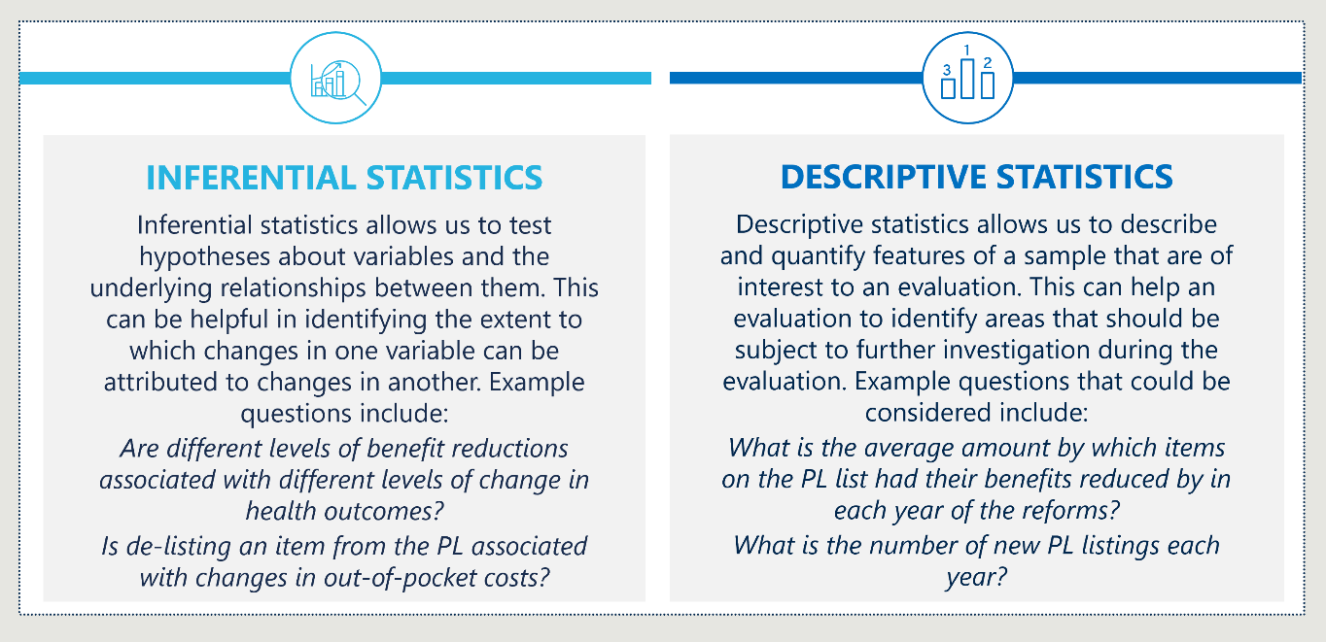

#### Difference-in-difference and regression analysis can help attribute changes to the reforms

To answer the KEQs, the evaluation team will need to make assessments regarding the extent to which outcomes can be attributed to the reforms. In the context of public policy, it is impossible to obtain “experimental settings” in which causation can be directly determined by examining the impact of a change in one variable on another variable in an environment in which confounding factors are controlled.

Instead, the evaluation team will draw considered judgements based upon the triangulation of evidence derived from the toolkit of analytical techniques available. Inferential methods, such as the difference-in-difference approach and general linear models, are particularly powerful tools in identifying systemic relationships between variables.

#### Difference-in-difference analysis considers the difference between the size of the changes in the indicators of “treatment” and “comparison” groups

Applied in the context of this evaluation, the difference-in-difference methodology involves estimating the share of the change (or “difference”) in an indicator’s value for a “treatment group” that can be attributed to a particular component of the PL Reforms. This “treatment group” is a data series that has the potential to be impacted directly by the reforms (for example the utilisation of prostheses in the private sector).

This is accomplished by subtracting the change of the indicator of a comparison group, which is a data series that it is assumed will be unaffected by the reforms, from the change in the indicator of the treatment group. This logic is depicted in Figure 39.

Figure 39 | Difference-in-difference methodology

A graph showing health/financial indicator on the y-axis and time on the x-axis. Arrows illustrate a difference-in-difference methodology by comparing the change in a  treatment group to a comparison group before and after a policy change.

As shown, the difference-in-difference methodology assumes that the counterfactual trend of the treatment group, in absence of reform, would be the same as the comparison group (this is known as the “parallel trends assumption”). In the context of the PL Reforms, examples of groups that may satisfy the parallel trends assumption, and which could be considered through this sort of analysis, could be indicators relating to:

* A group of prostheses in both the private (treated) and public (comparison) sectors
* Items on the PL pre-reform that are subject to a benefit reduction (treated) and items that do not have a benefit reduction (comparison).

#### A general linear model can be used to control for the effects of confounding factors

In some cases, the difference-in-difference approach will not be appropriate because a comparison group that satisfied the parallel trend assumption cannot be identified. Alternatively, there may not be a clear distinction between “treated” and “control” groups because there could be varying levels of treatment (e.g., benefit reductions of different amounts). In these cases, general linear modelling is another inferential technique that could be used to make judgements about attribution. This approach is summarised in Figure 40 (see overleaf).

Despite their power as an analytical approach, general linear models are still subject to several limitations. One limitation is the potential for reverse causation, with the dependent variable causing the explanatory variable.

Reverse causality is not likely to be a major issue in the context of the PL Reforms, as the reforms originate with policy changes set by the Commonwealth Government. Additionally, the theory of change articulated with the program logic explicitly represents the assumptions that are made about the pathways of causality – allowing for assumptions to be transparently tested with stakeholders.

Alternatively, it is possible that there are confounding factors (other explanatory variables) that cannot be identified, or for which data is not available. As a result of these limitations, the evaluation team will apply their discretion when making any assessments relating to attribution and will transparently document the limitations of any analysis.

Figure 40 | General linear modelling

A graph showing health/financial indicator on the y-axis and time on the x-axis. Arrows illustrate general linear modelling.

#### The evaluation will use the analytical tool appropriate to the outcome and reform component being considered

Both descriptive statistics and inferential statistics – in both the form of the difference-in-difference methodology and general linear models – are important tools. Over the course of the evaluation, they will be applied, alongside qualitative methods, to help answer the KEQs.

Throughout the term of the evaluation, the evaluation team will need to make decisions about the appropriate combination of quantitative analytical techniques, based on the availability, quality and characteristics of data. The team will also consider how the evaluation’s findings can be presented in a way that is as compelling as possible – for example by using graphs to convey key messages that are reinforced by regression analysis.

At this stage, the evaluation team has not been able to access and examine all the raw datasets to consider their suitability for each of the different approaches. Cumulative data and trends across some datasets have been provided by the Department as these have already been cleansed, matched, interrogated and analysed by IHACPA. The suitability of different approaches depends on several factors including:

* The availability of data | To be effective, the difference-in-difference and general linear modelling approaches require access to more than one data series to show insights.
* The quality of data | If data quality is not high, it is harder to draw inferences from the difference-in-difference approach and from general linear modelling. This is because the parameter estimates are unlikely to be statistically significant.
* Evidence for the key assumptions required by different approaches | In particular, to justify using the difference-in-difference approach, it is important to establish evidence for the parallel trends assumption.

With these considerations in mind, the evaluation team will make decisions about the appropriateness of different methods, with reference to advantages, limitations and applicability of the different models. These factors are outlined in Table 11 overleaf.

Table 11 | Comparison of analytical tools

|  |  |  |  |
| --- | --- | --- | --- |
|  | Descriptive statistics | Difference-in- difference | General linear  model |
| Advantages | * Easy to understand for a broad range of audiences * Can be visualised easily * Helps identify areas for further exploration (either through qualitative or quantitative methods) | * Accounts for time-invariant differences between the treatment and control groups * Accounts for confounding factors that impact the treatment and control data series in the same way | * Is applicable across a diverse range of contexts * Can control for multiple time-varying variables * Can be used to consider the effects of different levels of treatment |
| Limitations | * Does not establish the extent to which changes in variables can be attributed to reforms * High-level, meaning that it does not always convey the nuances of a dataset * Open to differences in subjective interpretation | * Does not account for time varying compounding factors that are different across data series * Requires a comparison data series that satisfied the parallel trends assumption * Does not account for differences in treatment intensity within the treatment data series | * Subject to omitted variable bias * Typically requires more data than other methods * Can be sensitive to changes in specification * Can be biased by reverse causality * Requires specialised statistical software (e.g., R) |
| Applications | * When limited data is available * To provide context on a particular area of the reforms * When it is important to convey findings to a broad range of stakeholders in a simple way * To identify trends and differences in outcomes across groups that provide initial evidence for a hypothesis that can be tested through qualitative methods * Likely to be used in some form for most research questions for which quantitative data is used | * To estimate the degree to which changes in an outcome can be attributed to the reforms * When the parallel trends assumption is satisfied * When there is no need to account for differences in treatment intensity within the treatment data series * May be relevant for sub-research questions 2.1, 2.2, 2.3, 2.8 and 2.9 | * To estimate the degree to which changes in an outcome can be attributed to the reforms * When the assumptions required by the difference-in-difference approach are not satisfied * When there are multiple variables that are likely to have an impact on a particular indicator * May be relevant for sub-research questions 2.2, 2.3, 2.8 and 2.9 |

#### The evaluation will involve producing an estimate of the extent to which the reforms have contributed to lower rates of growth in PHI premiums

The PL Reforms have been developed to improve the value proposition of PHI in Australia. The intent is that this will be accomplished by lowering the benefits paid for medical devices, which represent one component of medical insurance claims, while simultaneously preserving gap-free patient access to the devices selected by their doctor.

To this end, the evaluation will produce a quantitative estimate of the additional value that has been delivered for private health customers. This estimate will be a key part of answering sub-research question 3.1 and can be calculated on a per-policy, per-person, or aggregate basis. At a high level, the estimation process will involve:

Table 12 | High-level approach to estimating the value delivered by the reforms

|  |  |
| --- | --- |
| 1. Estimating the savings delivered through reductions in the price of PL listed items For Part A items, savings can be estimated by combining data on the utilisation of the different PL listed items, with data on the benefit reductions for each of these items. Similarly, for items removed from the PL list, savings can be calculated by combining data on the price that insurance companies pay for these items post-reform, with utilisation data. |  |
| 1. Estimating the share of these savings that is passed onto consumers The estimates obtained in step one will need to be adjusted based on assumptions about the share of savings that are passed onto consumers. This share could be estimated by considering a range of evidence including data on premium reductions, data for profit margins in the health insurance industry and information gathered through stakeholder consultations. |  |
| 1. Considering changes in consumer value, arising from outcomes other than changes to premiums Value is not the same as price, as it is also influenced by the accessibility and quality of services that customers receive through their private health provider. To account for this, the estimates obtained in step two will need to be adjusted to account for changes in the accessibility of care and in the outcomes delivered. Some outcomes (such as out-of-pocket costs) can be readily quantified in dollar terms, however other outcomes are likely to be intangible, and so work to quantify their value in dollars will need to rely on evidence from available from existing research (e.g., estimates of the non-monetary benefits associated with avoiding hospital readmission). |  |

There will inherently be a degree of uncertainty associated with each stage of the process described above and it is likely that alternate methodological decisions could be considered valid for different reasons. As a result, the evaluation team will test core assumptions with the PLRT and PLREAG to facilitate transparency and ensure that the design of the estimation process is as realistic as possible. Sensitivity analysis will also be undertaken to examine the impact of changes in key parameters, where this is appropriate.

## Qualitative data collection and analysis

### Qualitative analysis will supplement quantitative analysis by informing findings relating to intangible outcomes and causal channels that cannot be directly observed

On its own, quantitative analysis will be unable to satisfactorily answer all the evaluation’s sub-research questions. In many circumstances, quantitative data will be missing or of inadequate quality, requiring a qualitative approach that allows the evaluation team to hear directly from stakeholders. Even when sufficient quantitative data is available, qualitative evidence can bolster the evidence base underpinning the evaluation’s findings, by allowing insights to be triangulated from different sources of information.

Qualitative research methods – including surveys, interviews and workshops – are also ideal for understanding individual stakeholder perspectives, experiences and sensitivities in depth, especially in relation to the “how” and “why” elements of our KEQs which cannot be adequately answered with reference to quantitative data. This process will help to build buy-in for the evaluation’s findings and recommendations, by facilitating forums for those impacted by the reforms to have their perspective heard.

### Engagement mechanisms

To engage effectively during the evaluation, we will:

* Rapidly identify stakeholders with the Department to ensure no critical views are missed.
* Ensure a dedicated ‘owner’ is driving the schedule (the Project Manager Casey Merrick) and is supported by a dedicated project coordinator to manage logistics to progress at pace and manage risks.
* Provide a clear purpose to maintain focus on what matters most in each engagement and reduce duplication.
* Leverage a proven process to capture information across engagements to allow for rapid synthesis of themes, triangulation of views and identification of gaps to be filled in follow up engagements if needed.

We expect to engage stakeholders through interviews, workshops and surveys throughout the evaluation. Table 13 details a high-level stakeholder engagement plan, setting out the stakeholder groups, how we expect to engage with each group and the purpose behind engagement.

Table 13 | Indicative stakeholder engagement plan

|  |  |  |  |
| --- | --- | --- | --- |
| Stakeholder group | | Mode | Purpose |
|  | Department of Health | Weekly check-in meetings (Phase 1)  Monthly check-in meetings (Phase 2)  Fortnightly updates | * Provide insight on the context and facilitate access to stakeholders and data. * Discuss emerging findings and potential risks. * Advise on and approve deliverables. |
| An icon of a person with a circle around them. | Consumers | Survey and interviews | * Provide insights on end user impact and perception of the reforms. * Provide insights on the public and private systems, and associated challenges. |
| An icon of a hospital. | Public healthcare providers | Survey and  interviews | * Provide insights on the public system and associated challenges. * Provide insights on the impact of reforms. |
|  | Private healthcare providers | Survey and  interviews | * Provide insights on the private system and associated challenges. * Provide insights on the impact of reforms. |
|  | Private health insurance providers | Interviews | * Provide insights on the current system and associated challenges. * Provide insights on the impact of reforms. |
| An icon of a microscope. | Medical technology companies | Interviews | * Provide insights on the impact of reforms on medical technology companies. * Provide insights on the impact of reforms (particularly as it relates to medical technology in Australia). |
| An icon of a clinician. | Clinicians | Interviews | * Provide insights on the impact of reforms as it relates to access of choice. * Provide insights on knowledge and understanding of the reforms. |
| An icon of a group of people. | Prostheses List Reform Evaluation Advisory Group | Workshops | * Discuss emerging findings and interim reports prior to their finalisation. * Provide insight on stakeholder contexts and perspectives. |

### Analytical methods

#### Thematic analysis will be the main technique for monitoring qualitative data

Thematic analysis is a rigorous and fit-for-purpose approach to synthesising qualitative data from different data sources, including those outlined above, to gain key insights and understand emerging messages. There are five key steps in conducting thematic analysis which are summarised in Figure 41.

Figure 41 | Steps in thematic analysis

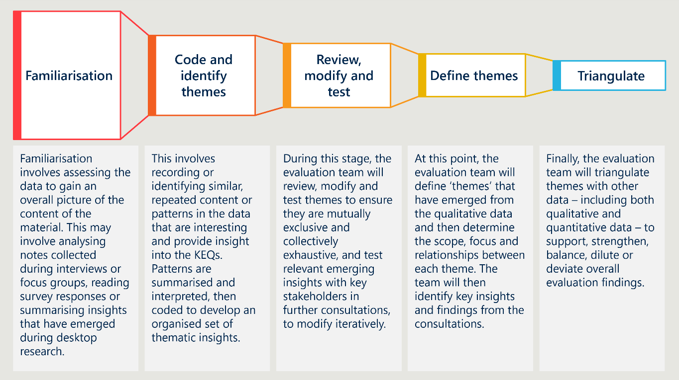

#### Qualitative insights will be triangulated based on multiple sources of evidence

To make findings and develop recommendations using the evidence provided by the diverse range of stakeholders, the evaluation will have to distil information into meaningful insights. To do this, evidence will be triangulated to obtain robust insights that consider the limitations on various types of data, and which rely upon the concurrence of multiple sources. This approach is summarised in Figure 42 overleaf.

Figure 42 | Principles for triangulating insights from qualitative sources

A figure of principles for triangulating insights from qualitative sources. Depth of source knowledge, timing of observation and independence of source connect in a triangle with weight of evidence in the centre.

1. Public benchmark approximation

The evaluation team approximated the Weighted Average Prices (WAP) for each of the 1665 benefit groups on Parts A and C of the November 2021 PL. We did this by performing a backcalculation exercise following IHACPA’s published methodology[217] using the baseline November 2021 PL and the first two years of benefit reductions (July 2022 and July 2023 updates).

This represents a limitation compared to having access the actual WAP of benefit groups in three ways:

* Lower accuracy – We can only calculate a range of benefits for benefit groups in some cases. Across all PL items, the average uncertainty is +/- 2.5%. Moreover, the level of accuracy is unevenly distributed across the PL categories. Notably, the average uncertainty for CIED devices is +/- 33.2% as a result of only one year of benefit reduction being available for these items in March 2024.
* Baseline comparison only – The backcalculation of the 2021 public benchmark prices is just one point-in-time reference for public prices. In March 2024, IHACPA is currently performing a pricing review to recalculate the public benchmark prices for the 1 July 2024 benefit reductions. The evaluation team will not be able to conduct the same exercise on the revised public benchmark prices as our methodology requires two years of reductions to backcalculate.
* Assumption that PL benefits are not less than their public benchmarks – In order to establish reasonable lower and upper bounds to our estimates, we assume that public benchmark prices are at most equal to their corresponding PL benefits. If public benchmark prices were to be higher than PL benefits, this assumption would marginally distort our analysis for these items. We understand this to be very rare.

1. Note on international comparisons

Stakeholders have articulated considerations and concerns over the use of international data sources in the setting of benefits as part of this reform[218]. Stakeholders propose genuine drivers of price differentials such as varying purchasing arrangements and market segmentation, level of technical manufacturer support provided and the level of regulatory hurdles; point to differences in private health insurance markets; and put forward potential unintended consequences as reasons to avoid using international comparisons[219]. Other stakeholders have recommended international benchmarking, suggesting its use in validating benefit setting within existing processes[220] or as a basis for a different approach to the pricing of prostheses in Australia[221].

We acknowledge that comparing products across international price lists to quantify the relative expense of medical devices is difficult given differences in market conditions and the nature of the international lists themselves. Moreover, this evaluation is not of the PL list itself or the need for reforms, but whether the projects of the current PL reforms achieve their intended outcomes and objectives. As such, we are using case studies in measure 2.3 to compare PL benefits to prices in international markets, not to comment on the *absolute difference*, but to observe *how the gap changes over time*.

1. Utilisation of PL items

Figure 43 below shows that there were over three million PL items used in 2021. Growth in utilisation across all PL categories in the five years prior was 28.9% (which corresponds with a compounded annual growth rate of 5.2%).

Figure 43 | Total utilisation of PL items[222]

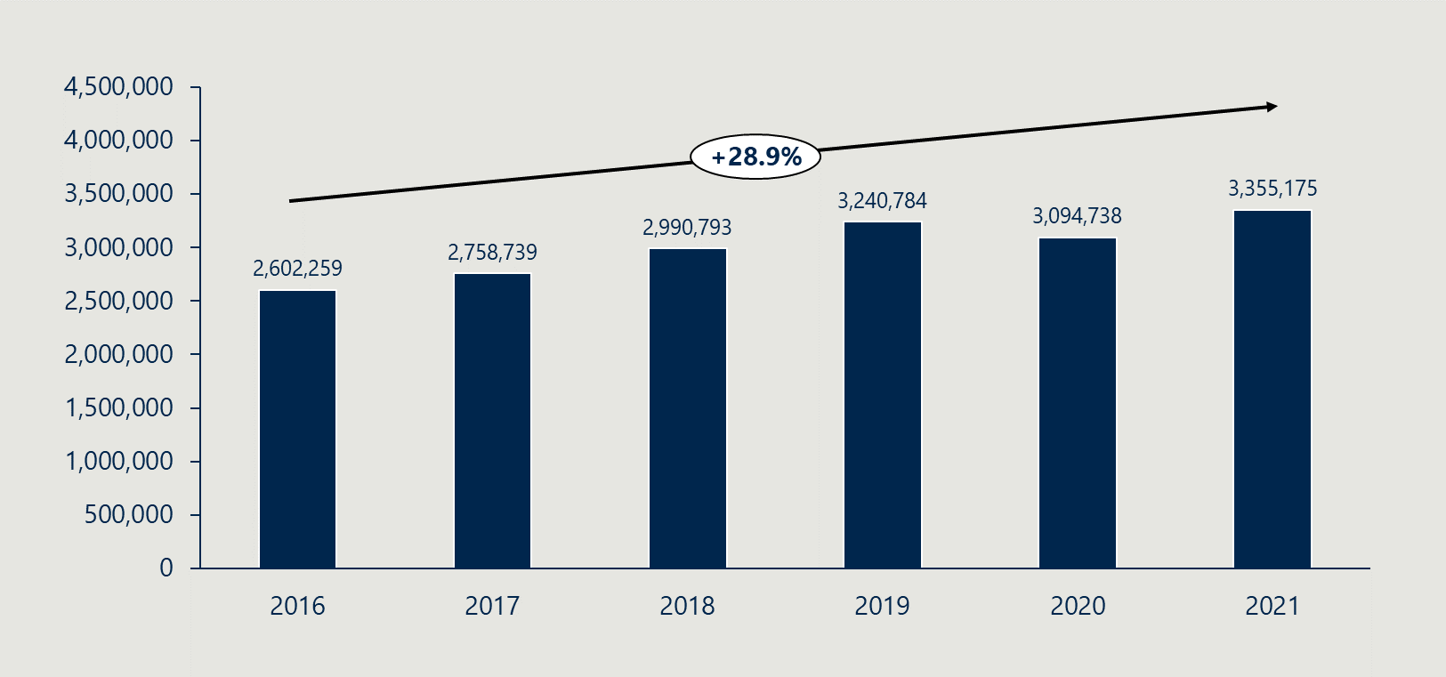

Figure 44 shows how he composition of PL item utilisation has changed over time. The shares in total utilisation of the largest categories of items (by volume of items used) have remained relatively stable over the five years to baseline, suggesting that the growth in utilisation has been distributed across all categories.

Figure 44 | Prostheses utilisation by category[223]

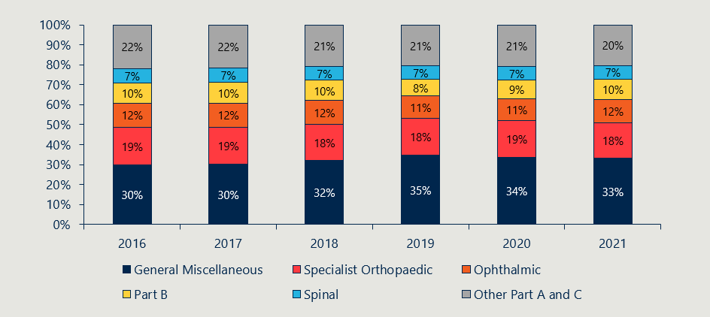

1. HCP1 completeness rate

Hospital Casemix Protocol – Inpatient (HCP1) data is not a complete representation of private hospital activity. The Department has compared the volume of separations and prostheses items between HCP1 data and APRA published figures to determine a completeness rate. The completeness rates below are the overall rate and completeness may vary across categories.

Table 14 | HCP1 estimated completeness compared to APRA published figures

|  |  |  |  |  |  |  |  |  |
| --- | --- | --- | --- | --- | --- | --- | --- | --- |
|  | 2016-17 | 2017-18 | 2018-19 | 2019-20 | 2020-21 | 2021-22 | 2022-23[224] | |
| Separations | 96.0% | 96.4% | 96.4% | 95.7% | 99.1% | 95.1% | 87.8% |
| Prostheses items | 88.9% | 89.2% | 90.6% | 89.7% | 92.0% | 91.6% | 84.3% |

1. Prostheses List Reform Program Logic

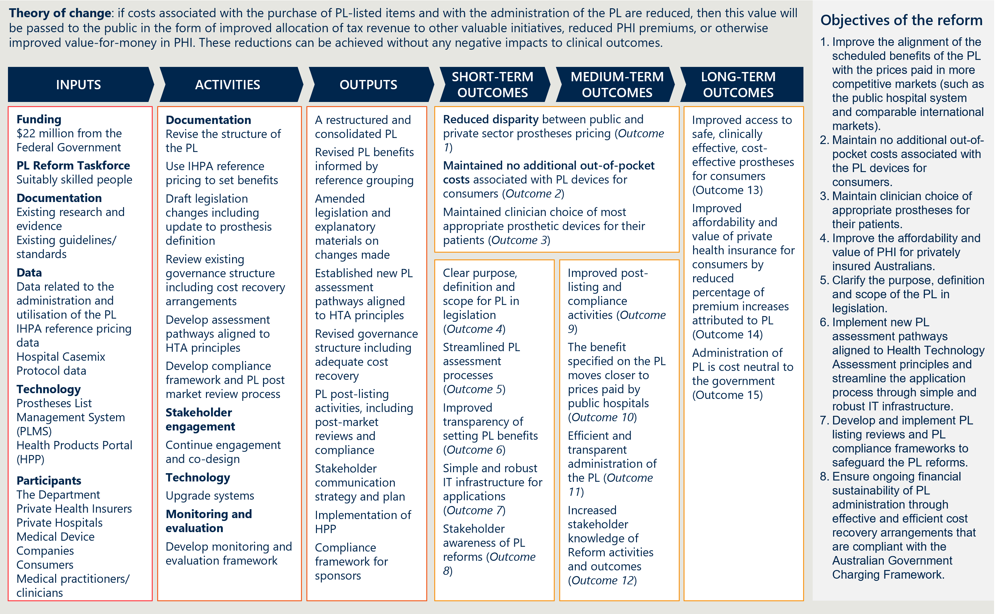

1. Causal logic diagram

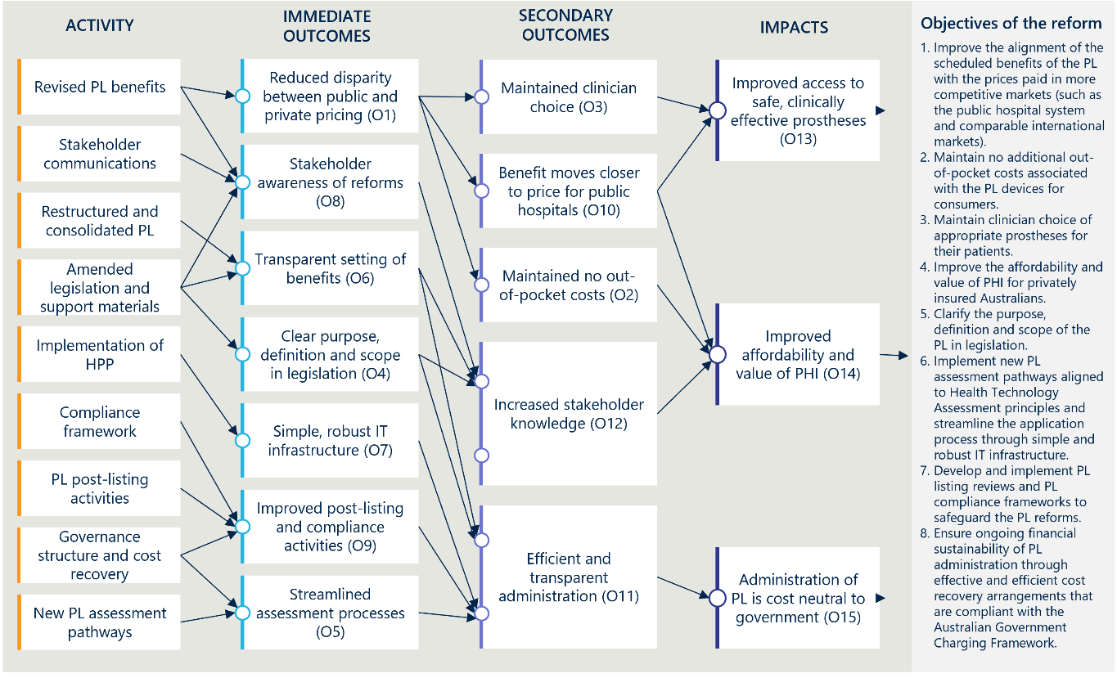

1. Baseline date of the evaluation

While the overall baseline date is set prior to first announcement of the reforms, analysis of any given activity will need to factor in the date that the activity occurred

The 2021 Australian Federal Budget, released on 11 May 2021, included a commitment of $22 million over four years for the purposes of reducing the cost of medical devices used in the private health sector and streamlining access to new medical devices.[225] For this reason, we are taking 10 May 2021 as the overall baseline date for the evaluation, in order to establish the state of all measures and understanding of the PL itself prior to any possible behaviour change from stakeholders anticipating the reforms. This is the date that will be used as the overall baseline date when assessing the outcomes and impacts of the reform activities *as a whole.*

The nature of the reform activities, however, is that many incremental changes are being made over time, and so for any individual activity we will need to establish the intervention date that is appropriate to that change. For example, to understand the impacts of restructuring the categories in the PL, we take the latest version of the PL prior to the restructuring as the most relevant baseline for that particular activity. And for incremental benefit reductions, we will need to look individually at the dates of each reduction to understand the impact that each has.

In the selection of baseline and intervention dates, we seek to balance:

* Baseline measures being independent of reform activities (whether directly or indirectly), e.g., preferring an earlier date to avoid anticipatory behaviour change; and
* Baseline measures being relevant and a reasonable depiction of the before state for a particular change, e.g., preferring a later date to help isolate only the effects of a specific reform activity.

For individual, point-in-time changes, for example changes to benefit levels, we will use the date at which that change was officially introduced. For changes that occur over time, like consultation processes, or progressive changes to processes and procedures, we will take the earliest possible date on which stakeholders could have been aware of the nature of the change. In many cases, this will be the overall baseline date, when the reforms were announced, or the date of the MoU, in which further detail about the scope and boundaries of the reforms were committed. However, it should be stressed that overall evaluation of the reform activities in their totality will be measured with regard to the overall baseline date.

1. The term ‘prostheses’ in this context includes surgically implanted prostheses, human tissue items and other medical devices. Unless otherwise implied, we use ‘prostheses’, ‘items’ and ‘devices’ in this report to describe the medical devices and human tissue products listed on the PL.
2. Department of Health and Aged Care, Historical background of the 2021-2025 Prostheses List Reform, 2022.
3. Department of Health, Regulation Impact Statement (RIS): Improving the Private Health Insurance Prostheses List, 2021.
4. Ibid.
5. The term ‘prostheses’ in this context includes surgically implanted prostheses, human tissue items and other medical devices. Unless otherwise implied, we use ‘prostheses’, ‘items’ and ‘devices’ in this report to describe the medical devices and human tissue products listed on the PL.
6. Department of Health and Aged Care, Historical background of the 2021-2025 Prostheses List Reform, 2022.
7. Parliament of Australia, Senate Standing Committees on Community Affairs, Price regulation associated with the Prostheses List Framework, 2017.
8. Department of Health and Aged Care, Prostheses List: Guide to listing and setting benefits for prostheses, 2020.
9. Department of Health, Regulation Impact Statement (RIS): Improving the Private Health Insurance Prostheses List, 2021.
10. Ibid.
11. Department of Health and Aged Care, Private Health Insurance – Modernising and improving the private health insurance Prostheses List, 2021.
12. Department of Health and Aged Care, Historical background of the 2021-2025 Prostheses List Reform, 2022.
13. Ibid.
14. Menzies Centre for Health Policy, Options for a Revised Framework for Setting and Reviewing Benefits for the Prostheses List: Report of the Menzies Centre for Health Policy, University of Sydney, on proceedings of the Prostheses List Revised Benefit Setting & Review Framework Industry Working Group (BSRIWG) and options for reform, 2020.
15. MTAA, Improving access to breakthrough medical technology and affordability of medical devices for privately insured Australians: Agreement between the Government and the Medical Technology Association of Australia, 2017.
16. Department of Health and Aged Care, Historical background of the 2021-2025 Prostheses List Reform, 2022.
17. Department of Health, Regulation Impact Statement (RIS): Improving the Private Health Insurance Prostheses List, 2021.
18. Ibid.
19. Ibid.
20. Department of Health, Regulation Impact Statement (RIS): Improving the Private Health Insurance Prostheses List, 2021.
21. Department of Health, Regulation Impact Statement (RIS): Improving the Private Health Insurance Prostheses List, 2021. The analysis conducted by the Independent Hospital Pricing Authority is in an unpublished report, *Prostheses Costs in the private and public sector* (December 2019). The evaluation team has not seen this report to be able to verify the findings.
22. Evaluate, The Prostheses List: Is it cost effective and what recommendations could improve its quality as a tool for reimbursement?, March 2021, https://www.privatehealthcareaustralia.org.au/wp-content/uploads/Evaluate-international-prices-for-medical-devices.pdf.
23. Of the top 283 largest products by value on the PL, the analysis compared 216 products with NHS (UK), 99 products with Pharmac (New Zealand) and 213 products with Discovery Health (a South African private health insurer). It also compared at least 64 products with France’s List of Products and Services Refundable, and of a subset of 64 of them, the French prices were 110.6% higher. However, as there were no details about which French products were included in the comparison and no overall price comparison, we did not include the France comparison in the body of our report. It should also be noted that we did not independently validate the data used for this analysis. However, the magnitude of gap between PL benefits and the New Zealand and French prices in 2021 broadly aligns with our own sampling. We do not have access to UK or South Africa’s pricing data to validate these.
24. Department of Health, Regulation Impact Statement (RIS): Improving the Private Health Insurance Prostheses List, 2021.
25. Bupa, Submission to the Senate Inquiry into Price Regulation Associated with the Prostheses List Framework, 2017.
26. MTAA, Submission to the Senate Inquiry into the Prostheses List Framework, 2017.
27. Menzies Centre for Health Policy & University of Sydney, Options for a revised framework for setting and reviewing benefits for the Prostheses List, 2020.
28. Department of Health, Regulation Impact Statement (RIS): Improving the Private Health Insurance Prostheses List, 2021.
29. Menzies Centre for Health Policy & University of Sydney, Options for a revised framework for setting and reviewing benefits for the Prostheses List, 2020.
30. Data supplied by the Department on 20/03/2024.
31. Data supplied by the Department on 20/03/2024. The analysis compares the benefits of Part A items on the March 2022 PL with the public benchmark Weighted Average Prices collected by IHACPA (excluding CIED items).
32. Department of Health, Prostheses List – Guide to listing and setting benefits for prostheses, 2017.
33. Menzies Centre for Health Policy & University of Sydney, Options for a revised framework for setting and reviewing benefits for the Prostheses List, 2020.
34. The Honourable Greg Hunt MP & the Medical Technology Association of Australia Limited, Memorandum of Understanding for the policy parameters of the Prostheses List Reforms, 2022.
35. Ibid.
36. Ibid.
37. We note that removal date has been revised since the MoU.
38. The Honourable Greg Hunt MP & the Medical Technology Association of Australia Limited, Memorandum of Understanding for the policy parameters of the Prostheses List Reforms, 2022.
39. Independent Hospital and Pricing Authority, Methodology for Determining the Benchmark Price for Prostheses in Australian Public Hospitals, December 2021.
40. Independent Hospital and Pricing Authority, Benchmark Price for Protheses in Australian Public Hospitals 2020-21, March 2022.
41. Data supplied by the Department on 20/03/2024.
42. Menzies Centre for Health Policy & University of Sydney, Options for a revised framework for setting and reviewing benefits for the Prostheses List, 2020.
43. Department of Health and Ageing, Review of Health Technology Assessment in Australia, 2009.
44. 0.23% of episodes had some level of gap payment, but some of these may have been paid by other parties (like the Department of Veterans Affairs) rather than the consumer.
45. See Appendix B for a description of the use of gap payments as a proxy for out-of-pocket expenses.
46. Menzies Centre for Health Policy & University of Sydney, Options for a revised framework for setting and reviewing benefits for the Prostheses List, 2020.
47. Ibid.
48. Menzies Centre for Health Policy & University of Sydney, Options for a revised framework for setting and reviewing benefits for the Prostheses List, 2020.
49. Melbourne Economic Forum, The value of private healthcare, 2019.
50. BUPA, A sustainable private health sector: an economic study, 2021.
51. Department of Health, Regulation Impact Statement (RIS): Improving the Private Health Insurance Prostheses List, 2021.
52. Australian Prudential Regulation Authority, Financial sustainability challenges in private health insurance, 2019.
53. See Figure 29 in Appendix B.
54. See Figure 31 in Appendix B.
55. Australian Medical Association, Time to bite the bullet on private health reforms, 2023.
56. Australian Prudential Regulation Authority, Financial sustainability challenges in private health insurance, 2019.
57. Australian Prudential Regulation Authority, Quarterly Private Health Insurance Statistics Prostheses, June 2023.
58. Australian Prudential Regulation Authority, Quarterly Private Health Insurance Statistics Membership Trends, June 2023. See also Figure 27 in Appendix B.
59. Department of Health and Aged Care, List of historical premium price changes by insurer for 2023, 2023.
60. Department of Health, Regulation Impact Statement (RIS): Improving the Private Health Insurance Prostheses List, 2021.
61. Department of Health and Aged Care, Historical background of the 2021-2025 Prostheses List Reform, 2022.
62. Department of Health, Regulation Impact Statement (RIS): Improving the Private Health Insurance Prostheses List, 2021.
63. Department of Health, Prostheses List – Guide to listing and setting benefits for prostheses, 2017.
64. Menzies Centre for Health Policy & University of Sydney, Options for a revised framework for setting and reviewing benefits for the prostheses list, 2020.
65. Department of Health, Prostheses List – Guide to listing and setting benefits for prostheses, 2017.
66. Menzies Centre for Health Policy & University of Sydney, Options for a revised framework for setting and reviewing benefits for the prostheses list, 2020.
67. Department of Health, Regulation Impact Statement (RIS): Improving the Private Health Insurance Prostheses List, 2021.
68. Department of Health and Aged Care, Prostheses List Part A (Prostheses), Part B (Human Tissue List) and Part C (Other), July 2021 edition.
69. Ibid.
70. Stakeholder consultation, 2024.
71. Ibid.
72. Department of Health, Regulation Impact Statement (RIS): Improving the Private Health Insurance Prostheses List, 2021, page 9.
73. Medical Technology Association of Australia, Submission to the Committee Inquiry into the Prostheses List Framework, 2017.
74. Stakeholder feedback on draft baseline evaluation report, 2024.
75. Stakeholder interviews, 2023.
76. Menzies Centre for Health Policy & University of Sydney, Options for a revised framework for setting and reviewing benefits for the prostheses list, 2020.
77. Stakeholder consultation, 2024.
78. Ernst & Young, Review of the General Miscellaneous Category of the Prostheses List, 2020.
79. Department of Health and Aged Care, Historical background of the 2021-2025 Prostheses List Reform, 2022.
80. Department of Health, Prostheses List Reforms – Consultation Paper No 1, 2021.
81. Ibid.
82. We have taken a broader view of the baseline period for GUIs, noting their potential removal was the subject of consultations and reports prior to the announcement of the PL reforms in 11 May 2021, and these continued into 2022. Notwithstanding further changes that were to come, the MoU between the Minister and the MTAA in March 2022 formalised an agreed process for how GUIs were to be treated as part of the reform agenda, and we have documented these in section 3.5.3. See Appendix K for a discussion on the baseline date of the evaluation.
83. The Honourable Mark Butler MP, New funding arrangement for surgical consumables, accessed at: https://www.health.gov.au/ministers/the-hon-mark-butler-mp/media/new-funding-arrangement-for-surgical-consumables.
84. Menzies Centre for Health Policy & University of Sydney, Options for a revised framework for setting and reviewing benefits for the prostheses list, 2020.
85. Department of Health, Prostheses List - Guide to listing and setting benefits for prostheses, 2017.
86. Department of Health, Prostheses List - Guide to listing and setting benefits for prostheses, 2017.
87. Department of Health and Aged Care, ‘Health Technology Assessments’, 2022.
88. Department of Health and Ageing, Review of health technology assessment in Australia, 2009.
89. The Honourable Greg Hunt MP & the Medical Technology Association of Australia Limited, Memorandum of Understanding for the policy parameters of the Prostheses List Reforms, 2022.
90. Tamblyn, D, Parsons, J, Salinger, K & Merlin, T, Co-design of pathways for the applications to the Prostheses List, 2022.
91. Private Healthcare Australia, Submission: Senate Community Affairs References Committee, Inquiry into price regulation associated with the Prostheses List Framework, 2017.
92. Department of Health and Aged Care, Prostheses List Compliance Strategy, April 2023.
93. Ibid.
94. Department of Health and Aged Care, The Prostheses List reforms, https://www.health.gov.au/topics/private-health-insurance/the-prostheses-list/the-prostheses-list-reforms, accessed 14 February 2024.
95. Ibid.
96. Department of Health, Prostheses List Guide, 2017.
97. Conn, Private Health Insurance (Prostheses Application and Listing Fees) Amendment (Cost Recovery) Bill 2022 [and associated bills], 2023.
98. Department of Health, Regulation Impact Statement (RIS): Improving the Private Health Insurance Prostheses List, 2021.
99. Department of Health and Aged Care, Prostheses List Part A (Prostheses) and Part C (Other), March 2022 edition.
100. For indicators 1 and 2, we have used ‘benefit groups’ to refer to all items within a category, sub-category, group and sub-group that share the same benefit, within $2 (e.g., two items in A.01.01.01.01 with a benefit of $100 are considered as being in one benefit group, even if they have different suffix values). This is to align with IHACPA’s methodology for calculating the Weighted Average Prices and benefit reductions.
101. Data supplied by the Department on 20/03/2024.
102. The Honourable Greg Hunt MP & the Medical Technology Association of Australia Limited, Memorandum of Understanding for the policy parameters of the Prostheses List Reforms, 2022.
103. Independent Hospital and Pricing Authority, Methodology for Determining the Benchmark Price for Prostheses in Australian Public Hospitals, December 2021.
104. Independent Hospital and Aged Care Pricing Authority, Benchmark Price for Protheses in Australian Public Hospitals 2020-21, March 2022.
105. Stakeholder interviews, 2023 and 2024.
106. Independent Hospital and Aged Care Pricing Authority, Estimates of projected benefits and savings associated with Prostheses List reforms, October 2022.
107. Ibid.
108. Australian Prudential Regulation Authority, Quarterly Private Health Insurance Prostheses September 2023, 2023.
109. Across all PL item, the average uncertainty of our approximation is +/- 2.5%. See Appendix E for the approximation methodology.
110. Note: IHACPA used the November 2021 PL as a basis for the first public benchmarking activity and the March 2022 PL as the basis for the first round of benefit reduction calculations.
111. Data supplied by the Department on 20/03/2024.
112. Department of Health and Aged Care, PHI 29/23 Benefit reductions to Cardiac Implantable Electronic Devices, 10 May 2023, https://www.health.gov.au/news/phi-circulars/phi-2923-benefit-reductions-to-cardiac-implantable-electronic-devices.
113. Department of Health and Aged Care, PHI 29/23 Benefit reductions to Cardiac Implantable Electronic Devices, 10 May 2023, https://www.health.gov.au/news/phi-circulars/phi-2923-benefit-reductions-to-cardiac-implantable-electronic-devices.
114. See Appendix E for more details about Nous’ public benchmark approximations.
115. l'Assurance Maladie, Liste des Produits et Prestations, http://www.codage.ext.cnamts.fr/codif/tips/index.php?p_site=AMELI. The Liste des Produits et Prestations (LPP) is a list of medical device and human tissue products that guides reimbursement for the French national health insurance system. It has a comparable scope to the PL and it prices products at a higher level of grouping than the PL.
116. Pharmac, Hospital Medical Devices Schedule, July 2016, July 2017, July 2018, July 2019, July 2020 and July 2021 editions. The Pharmac Hospital Medical Devices Schedule (Pharmac) is a list of contracted medical devices products for New Zealand public hospitals. It has a narrower scope than the PL at baseline—noting it is in the process of being expanded—and it prices products on an individual basis, not in concert with equivalent products within a group like the PL and LPP.
117. There are no unique identifiers or other fields that are common across the PL and LPP or Pharmac lists, requiring manual comparison and fuzzy matching. This is complicated by all three lists grouping and pricing products at different levels and the LPP being in French.
118. Nous does not claim the three benefit groups selected as international comparison case studies are representative of the overall or average gap between the selected markets. We selected these case studies, before observing any difference in benefit/price, based on four criteria: data availability (at least three products within the PL benefit group found on both the LPP and Pharmac schedule), matching certainty (evidence that two products are a true comparison by cross-referencing sponsor product information, model numbers, sizing information, etc.), volume (i.e., avoiding low-volume benefit groups that could be pricing/benefit outliers) and pricing history (established products with multiple years of pricing history to provide meaningful comparisons).
119. Department of Health and Aged Care, Prostheses List Part A (Prostheses), August 2016, August 2017, August 2018, August 2019, July 2020 and July 2021 editions; Pharmac, Hospital Medical Devices Schedule, July 2016, July 2017, July 2018, July 2019, July 2020 and July 2021 editions; l'Assurance Maladie, Liste des Produits et Prestations, http://www.codage.ext.cnamts.fr/codif/tips/index.php?p_site=AMELI.
120. Department of Health and Aged Care, Prostheses List Part A (Prostheses), August 2016, August 2017, August 2018, August 2019, July 2020 and July 2021 editions; Pharmac, Hospital Medical Devices Schedule, July 2016, July 2017, July 2018, July 2019, July 2020 and July 2021 editions; l'Assurance Maladie, Liste des Produits et Prestations, http://www.codage.ext.cnamts.fr/codif/tips/index.php?p_site=AMELI.
121. Ibid.
122. Department of Health and Aged Care, Prostheses List Part A (Prostheses), August 2016, August 2017, August 2018, August 2019, July 2020 and July 2021 editions; Pharmac, Hospital Medical Devices Schedule, July 2016, July 2017, July 2018, July 2019, July 2020 and July 2021 editions; l'Assurance Maladie, Liste des Produits et Prestations, http://www.codage.ext.cnamts.fr/codif/tips/index.php?p_site=AMELI.
123. Ibid.
124. Department of Health and Aged Care, Prostheses List Part A (Prostheses), August 2016, August 2017, August 2018, August 2019, July 2020 and July 2021 editions; Pharmac, Hospital Medical Devices Schedule, July 2016, July 2017, July 2018, July 2019, July 2020 and July 2021 editions; l'Assurance Maladie, Liste des Produits et Prestations, http://www.codage.ext.cnamts.fr/codif/tips/index.php?p_site=AMELI.
125. Private HealthCare Australia, Submission: Senate Community Affairs References Committee, Inquiry into price regulation associated with the Prostheses List Framework, 2017.
126. Consumers Health Forum of Australia, Submission into the Senate Inquiry into Price Regulation associated with the Prostheses List Framework, 2017.
127. Medical Technology Association of Australia, Submission to the Committee Inquiry into the Prostheses List Framework, 2017.
128. Australian Medical Association, 2017, AMA submission to the Inquiry into the price regulation associated with the Prosthesis List Framework in Australia
129. Private HealthCare Australia, Submission: Senate Community Affairs References Committee, Inquiry into price regulation associated with the Prostheses List Framework, 2017.
130. Department of Health and Aged Care, Hospital Casemix Protocol Dataset, 2023.
131. It should be noted that there are a large number of datapoints for which a gap is recorded but it is less than one. In the HCP data, these gaps are recorded as zero.
132. Department of Health and Aged Care, Hospital Casemix Protocol Dataset, 2023.
133. Ibid. Note that the average prevalence rates shown in the figure may differ from the weighted average of the prevalence rates shown in the table because the prevalence rates shown in the figure reflect the prevalence across all PL items (including unclassified items).
134. The minimum benefit for a combination of cardiac ablation devices (listed in both Cardiac and Cardiothoracic categories) used in a single procedure cannot exceed $6,399. This may explain a higher gap prevalence for these categories. PHI 24/19 Prostheses List benefits for surgical cardiac ablation devices, https://www.health.gov.au/news/phi-circulars/phi-4219-prostheses-list-benefits-for-surgical-cardiac-ablation-devices.
135. Note that this is the average gap as a share of the average benefit for all items in each category (unweighted for the extent to which different items within categories incur a gap).
136. Department of Health and Aged Care, Hospital Casemix Protocol Dataset, 2023.
137. Ibid. Note that the averages shown in the figure may differ from the weighted average of the values shown in the table because the values shown in the figure reflect the average gap across all PL items (including unclassified items).
138. Menzies Centre for Health Policy & University of Sydney, Options for a revised framework for setting and reviewing benefits for the Prostheses List, 2020.
139. Medical Technology Association of Australia, Submission to the Committee Inquiry into the Prostheses List Framework, 2017.
140. Ibid.
141. Ibid.
142. Note that we will not be analysing any patient-identifying data.
143. Department of Health and Aged Care, List of historical premium price changes by insurer for 2023, 2023.
144. Australian Prudential Regulation Authority, Operations of Private Health Insurers Annual Report, 2015-16 to 2020-21.
145. Australian Prudential Regulation Authority, Operations of Private Health Insurers Annual Report, 2015-16 to 2020-21.
146. Australian Prudential Regulation Authority, Quarterly Private Health Insurance Statistics Prostheses, June 2023.
147. Australian Prudential Regulation Authority, Operations of Private Health Insurers Annual Report, 2015-16 to 2020-21.
148. Australian Prudential Regulation Authority, Quarterly Private Health Insurance Statistics Prostheses, June 2023.
149. Australian Prudential Regulation Authority, Quarterly Private Health Insurance Statistics Membership Trends, June 2023.
150. Australian Prudential Regulation Authority, Quarterly Private Health Insurance Statistics Membership Trends, June 2023.
151. Ibid.
152. Australia Bureau of Statistics, Quarterly Population Estimates (ERP), by State/Territory, Sex and Age.
153. Australian Prudential Regulation Authority, Quarterly Private Health Insurance Prostheses, June 2023.
154. Australian Prudential Regulation Authority, Quarterly Private Health Insurance Membership Coverage, June 2023.
155. Australian Prudential Regulation Authority, Quarterly Private Health Membership and Benefits, June 2021.
156. Australian Prudential Regulation Authority, Quarterly Private Health Insurance Prostheses, June 2023. Note: Utilisation is calculated here by dividing HT prostheses benefits of each category by the average prostheses benefit across all categories for the given financial year (as APRA does not publish prostheses utilisation by age and gender). HT population coverage for these age brackets are then divided by the utilisation to get the average.
157. Australian Prudential Regulation Authority, Quarterly Private Health Membership and Benefits, June 2021.
158. Australian Prudential Regulation Authority, Quarterly Private Health Insurance Prostheses, June 2023. Utilisation is calculated here by dividing HT prostheses benefits of each category by the average prostheses benefit across all categories for the given financial year (as APRA does not publish prostheses utilisation by age and gender). HT population coverage for each gender is then divided by the utilisation to get the average.
159. Department of Health, Prostheses List – Guide to listing and setting benefits for prostheses, 2017.
160. Menzies Centre for Health Policy & University of Sydney, Options for a revised framework for setting and reviewing benefits for the prostheses list, 2020.
161. Ibid.
162. Department of Health, Prostheses List: Guide to listing and setting benefits for prostheses, 2017.
163. Department of Health and Aged Care, PHI circulars, https://www.health.gov.au/news/phi-circulars.
164. In this measure, the term ‘items’ is used to mean PL billing codes.
165. In this measure, ‘benefit groups’ are all items within a category, sub-category, group and sub-group that share the same suffix. This is a slightly different definition of ‘benefit group’ used in indictors 1 and 2, as this was to capture items that have the same benefit within a sub-group, as aligned with IHACPA’s benefit reduction methodology.
166. Department of Health and Aged Care, Prostheses List Part A (Prostheses), Part B (Human Tissue List) and Part C (Other), July 2021 edition.
167. Department of Health and Aged Care, Prostheses List Part A (Prostheses) and Part C (Other), August 2012 and July 2021 editions.
168. Department of Health and Aged Care, Prostheses List Part A (Prostheses) and Part C (Other), August 2012, August 2013, August 2014, August 2015, August 2016, August 2017, August 2018, August 2019, July 2020 and July 2021 editions.
169. Department of Health and Aged Care, Prostheses List Part A (Prostheses) and Part C (Other), August 2012, August 2013, August 2014, August 2015, August 2016, August 2017, August 2018, August 2019, July 2020 and July 2021 editions.
170. Department of Health and Aged Care, Prostheses List Part A (Prostheses) and Part C (Other), August 2012, August 2013, August 2014, August 2015, August 2016, August 2017, August 2018, August 2019, July 2020 and July 2021 editions.
171. Department of Health and Aged Care, General use items to be removed from the Prostheses List by group, https://www.health.gov.au/resources/publications/general-use-items-to-be-removed-from-the-prostheses-list-by-group.
172. Stakeholder interviews, 2023.
173. Medical Technology Association of Australia, Submission to the Committee Inquiry into the Prostheses List Framework, 2017.
174. Stakeholder interviews, 2023.
175. Ibid.
176. Ibid.
177. Ibid.
178. Stakeholder interviews, 2023.
179. Ibid.
180. Stakeholder interviews, 2023.
181. Australian Private Hospital Association, Prostheses List Reform – Scope and Definition (Response), 2021.
182. Department of Health, Prostheses List - Guide to listing and setting benefits for prostheses, 2017.
183. Ibid.
184. Department of Health, Prostheses List - Guide to listing and setting benefits for prostheses, 2017.
185. Menzies Centre for Health Policy & University of Sydney, Options for a revised framework for setting and reviewing benefits for the prostheses list, 2020.
186. Private HealthCare Australia, Submission: Senate Community Affairs References Committee, Inquiry into price regulation associated with the Prostheses List Framework, 2017.
187. Consumers Health Forum of Australia, Submission into the Senate Inquiry into Price Regulation associated with the Prostheses List Framework, 2017.
188. Stakeholder interviews, 2023.
189. Ibid.
190. Department of Health, Prostheses List - Guide to listing and setting benefits for prostheses, 2017.
191. Tamblyn, D, Parsons, J, Salinger, K & Merlin, T, Options for a Reformed Prostheses List Pre-Listing Assessment Framework and Governance Structure, 2022.
192. Stakeholder interviews, 2024.
193. Stakeholder interviews, 2023.
194. Ibid.
195. Tamblyn, D, Parsons, J, Salinger, K & Merlin, T, Options for a Reformed Prostheses List Pre-Listing Assessment Framework and Governance Structure, 2022.
196. Stakeholder interviews, 2024.
197. Menzies Centre for Health Policy & University of Sydney, Options for a revised framework for setting and reviewing benefits for the prostheses list, 2020.
198. Department of Health and Aged Care, Prostheses List Post-Listing Review Framework: Information for Stakeholders, June 2022.
199. Stakeholder interviews, 2023.
200. Stakeholder interviews, 2024.
201. Department of Health and Aged Care, Prostheses List Compliance Strategy, April 2023.
202. PL Project Board Consolidated Papers, February 2022.
203. Department of Health and Aged Care, The Prostheses List reforms, https://www.health.gov.au/topics/private-health-insurance/the-prostheses-list/the-prostheses-list-reforms.
204. Private Healthcare Australia, Submission: Senate Community Affairs References Committee, Inquiry into price regulation associated with the Prostheses List Framework, 2017.
205. Menzies Centre for Health Policy & University of Sydney, Options for a revised framework for setting and reviewing benefits for the prostheses list, 2020.
206. Department of Health and Aged Care, Prostheses List Reform Consultation Paper 4(a) and 4(b) – Stakeholder feedback report, February 2023; Prostheses List Reforms – Consultation Paper 7, July 2023.
207. Stakeholder interviews, 2023.
208. Members Health Fund Alliance, Letter to the Department of Health, 2020.
209. Stakeholder interviews, 2023.
210. Ibid.
211. Ibid.
212. Department of Health, Prostheses List Guide, 2017.
213. Department of Health, Regulation Impact Statement (RIS): Improving the Private Health Insurance Prostheses List, 2021.
214. Conn, Private Health Insurance (Prostheses Application and Listing Fees) Amendment (Cost Recovery) Bill 2022 [and associated bills], 2023.
215. Department of Health, Regulation Impact Statement (RIS): Improving the Private Health Insurance Prostheses List, 2021.
216. An estimate based on the Department’s activity-based estimates informing its 2023-24 charging model.
217. Independent Hospital Pricing Authority, Benchmark Price for Prostheses in Australian Public Hospitals 2022-21, 2022.
218. Independent Health Pricing Authority, Methodology for Determining the Benchmark Price for Prostheses in Australian Public Hospitals, 2021.
219. MTAA, Submission to the Senate Inquiry into the Prostheses List Framework, 2017.
220. Independent Health Pricing Authority, Methodology for Determining the Benchmark Price for Prostheses in Australian Public Hospitals, 2021.
221. Private Health Australia, Surgically Replacing the List: a Roadmap for Prostheses List Reform, 2020.
222. Australian Prudential Regulation Authority, Quarterly Private Health Insurance Prostheses September 2023, 2023.
223. Ibid.
224. The 2022-23 completeness rates are preliminary and are subject to change.
225. Department of Health, Private Health Insurance – Modernising and improving the private health insurance Prostheses List, 2021.