Evaluation to support the review of primary care after hours programs and policy
Findings report

02 October 2024


Acknowledgement
Allen + Clarke Consulting would like to thank all the stakeholders and consumers who contributed to the review.
Disclaimer
All due care and responsibility have been taken in the preparation of this report. This report (including any enclosures and attachments) has been prepared for the exclusive use and benefit of the addressee(s) and solely for the purposes for which it is provided. Allen + Clarke Consulting accepts no liability or responsibility if this report is used for an alternative purpose from which it is intended, or by any third party. The information contained in this report is confidential and commercially sensitive.
Use of quotations
Quotations used in this report have been deidentified. They have not been verified with the stakeholder.


Contents
Executive summary 13
Methodology 14
Findings 15
Introduction 18
Background and context 18
The After Hours Review 20
Methodology 21
Reading this report 28
Current state of after hours service provision (KEQ 1) 30
Map of the after hours primary care system 30
After hours primary care system dynamics 40
Demand for after hours primary care services 42
Workforce 56
Funding 78
KEQ 1: Findings 93
The need for after hours primary care (KEQ 2) 95
Drivers of consumer help seeking behaviour 95
Specific consumer cohorts 116
KEQ 2: Findings 159
Successful models of primary care after hours services (KEQ 3) 161
Matching care to need 161
Health technologies and digital transformation 166
Navigation 174
System planning and evidence 182
KEQ 3: Findings 188
Conclusion 190
Bibliography 191
Appendix A: List of organisations consulted 204
Appendix B: Consultation Hub Survey Questions 207
Appendix C: After Hours PIP Levels 226

Table of figures
Figure 1: Key evaluation questions 13
Figure 2: Timeline of major reforms in after hours primary care 18
Figure 3: Snapshot of Consultation Hub Survey respondents 23
Figure 4: System map of after hours services in Australia 31
Figure 5: Survey respondent perspectives on planning and coordination of after hours services (n=191) 40
Figure 6: Medicare-subsidised services by after hours category, 2022–23 41
Figure 7: Calls to healthdirect by helpline and time of day (24 hour clock), 2020-2023 42
Figure 8: Percentage of people who had an after hours GP service by age, 2022-2023 43
Figure 9: GP services per 100 people (age standardised) by location, 2022-23 44
Figure 10: Proportion (%) of emergency department presentations, by hour of presentation for each triage category (24 hour clock) 46
Figure 11: Lower-urgency emergency department demand during usual and after hours period as proportion of all emergency department demand, 2022-2023 47
Figure 12: Lower urgency emergency department presentations by remoteness area, 2022-23 48
Figure 13: Volume of emergency department presentations for lower-urgency care by PHN, 2022-23 49
Figure 14: Proportion of ABS Patient Experience respondents who needed to see a GP, 2013-2023 52
Figure 15: Practitioner and practice manager/owner perception of need for after hours services and whether this need is currently being met (n=194) 53
Figure 16: GP FTE per 100,000 population by state and year 55
Figure 17: Practitioner 5-year intentions for after hours work (n=66) 56
Figure 18: Number of trainees and non-vocationally registered GPs in Australia, 2015-2022 58
Figure 19: Annual expenditure on selected after hours MBS items for non-vocationally registered doctor attendances, 2018-2023 59
Figure 20: Nursing and midwifery FTE per 100,000 population, 2017-2022 60
Figure 21: Weekly hours worked by GPs and nurses and midwives, 2017-2022 61
Figure 22: Pharmacy and medical radiation practitioner workforce, 2022 62
Figure 23: Average total hours worked per week, 2023 63
Figure 24: Practitioner and practice owner/manager perception of the extent to which the after hours system supports practitioners, other than medical practitioners, to provide after hours services (n=180) 65
Figure 25: Reasons practitioners choose not to do after hours work (n=41) 67
Figure 26: Reasons practitioners currently doing after hours work do not do more (n= 59) 67
Figure 27: Weekly hours worked by GPs, 2017-202310F 68
Figure 28: The most important factors preventing practitioners from doing more after hours work, by gender (n=59)11F 69
Figure 29: GP FTE per 100,000 population by MMM area, 2015-2022 71
Figure 30: GP FTEs by Local Government Area, 2022 71
Figure 31: Nurse and midwife FTE per 100,000 population by MMM, 2017-202212F 72
Figure 32: Average total hours worked per week by GPs by Remoteness Area, 2015-2020 74
Figure 33: Government funding snapshot 76
Figure 34: Practice owner/manager perception of the effectiveness of current funding arrangements (n=183) 77
Figure 35: Practice owner/manager perception of the effectiveness of the After Hours PIP (n=90) 79
Figure 36: Proportion of After Hours PIP practices in tiers 4 and 5 by RRMA, May 2023 – April 2024 80
Figure 37: GP perceptions of the effectiveness of current after hours MBS items (n=62) 82
Figure 38: Potential influence of financial reward on after hours service delivery by mode (n=65) 83
Figure 39: Potential influence of financial reward on after hours service delivery by time period (n= 64) 85
Figure 40: Practice owner/manager perception of the effectiveness of current financial arrangements in supporting multidisciplinary team based care, by practitioner type (n=91) 85
Figure 41: Practice owner/manager perception of the effectiveness of current financial arrangements in supporting practitioners other than medical practitioners, by practitioner type (n=91) 86
Figure 42: Drivers of consumer help seeking behaviour 93
Figure 43: Practitioner and practice owner/manager perception of reasons for consumer help seeking after hours (n=168) 94
Figure 44: Patient reported reasons for choosing the specific service they attended, from most commonly reported reason to least (n=1992) 95
Figure 45: Practitioner and practice owner/manager perception of the reliability of their after hours referral mechanisms (n=175) 103
Figure 46: Practitioner and practice owner/manager perception of the extent to which the after hours system supports continuity of care (n=175) 104
Figure 47: Practitioner and practice owner/manager perspective on the importance of allied health (n=190) 112
Figure 48: After hours GP services per 100,000 population by Remoteness Area, 2022-23 115
Figure 49: Rural and remote practitioner (MMM3-7) perceptions of the extent to which the current after hours system meets the needs of rural and remote communities (n=35) 119
Figure 50: GP after hours service per 100 people by age group, 2022-23 120
Figure 51: Emergency department presentations by triage category and age group, 2022-23 124
Figure 52: Practitioners and practice owners/manager perception of the extent to which the current after hours system meets the needs of residential aged care (n=172) 125
Figure 53: Aboriginal and/or Torres Strait Islander status of healthdirect callers 127
Figure 54: Practitioner and practice owner/manager perception of the extent to which the after hours system meets the needs of people with chronic illness (n=170) 137
Figure 55: Practitioner and practice owner/manager perception of the extent to which the after hours system meets the needs of people with disability (n=172) 141
Figure 56: Practitioner and practice owner/manager perception of the extent to which the after hours system meets the needs of people with palliative care needs (n=170) 146
Figure 57: Healthdirect caller patient by age group for calls made between January 2019 and June 2023 152
Figure 58: Practitioner and practice owner/manager perception of the extent to which the current after hours system meets the needs of families with young children (n=171) 154
Figure 59: Lower urgency emergency department presentations by socioeconomic status (SES) and ATS (per 1000 population), 2022-23 156
Figure 60: Proportion of consumers who reported seeing an after hours GP when needed by quintile of socioeconomic disadvantage, 2022-23 158
Figure 61: Number of GP after hours services per 100 people and median decile of socioeconomic disadvantage by SA3 and Remoteness Area, 2022-23 159
Figure 62: Practitioner and practice owner/manager perception of the extent to which the current after hours system meets the needs of people in precarious or less flexible employment (n=170) 160
Figure 63: Stakeholder-identified dimensions of patient-centred service design 164
Figure 64: Practitioner and practice owner/manager perception of the accessibility of home visits (n=190) 166
Figure 65: Healthdirect calls by helpline and hour of call, 2020-2023 179
Figure 66: Healthdirect helpline calls received in the after hours period by call outcome, 2019 - 2022 180
Figure 67: Healthdirect GP helpline calls received in the after hours period by call outcome, 2019 - 2022 180

Glossary
Term | Definition
ACCHSs | Aboriginal Community Controlled Health Services.  ACCHSs are primary health care services initiated and opewrated by the local Aboriginal community to deliver culturally safe health care to their community.
After hours period | Refers to the time period in which a higher MBS subsidy is provided for in-clinic, home visit and RACH attendances: 24-hours on Sundays and public holidays, Saturdays from noon and before 8:00 am, weekdays after 6:00 pm and before 8:00 am.
After hours primary care | Refers to care provided outside a patient’s regular primary care provider’s opening hours. This varies between providers, as opening hours are private business decisions. A regular primary care provider can provide after hours care to their own patients, or this can be provided by another primary healthcare provider.
After Hours PIP | After Hours Practice Incentive Payment.  The After Hours PIP supports GPs to provide their patients with appropriate access to after hours care. Participating practices receive payments for ensuring that their patients have access to care during the after hours periods.  There are 5 payment levels available, depending on the level of after hours care being provided and the arrangements in place.
After Hours PIP periods | The After Hours PIP provides incentives for service delivery in either a ‘sociable’ after hours period (6:00 pm to 11:00 pm on weeknights) or an ‘unsociable’ after hours period (11:00 pm to 8:00 am on weekdays, outside 8:00 am to 12:00 pm on Saturdays, and all-day Sunday and public holidays).
AHOMP | After Hours Other Medical Practitioners program.
AIHW | Australian Institute of Health and Welfare.
AMDS | Approved Medical Deputising Service.  The AMDS program enables non-vocationally recognised doctors to access some MBS items for medical practitioners to provide after hours services on behalf of other doctors.
AMA | Australian Medical Association.
ATS | The Australasian Triage Scale (ATS) is a clinical tool used to establish the maximum waiting time for medical assessment and treatment of a patient. The categories are:  - Resuscitation (triage category 1)  - Emergency (triage category 2)  - Urgent (triage category 3)  - Semi-urgent (triage category 4)  - Non-urgent (triage category 5).
CALD | Culturally and linguistically diverse.
CAVUCS | Child and Adolescent Virtual Urgent Care Service.  CAVUCS is a South Australian service connecting parents with emergency doctors and nurses who can assess and provide medical advice for children. Patients access the service directly, free of charge.
Consultation Hub Survey | The Consultation Hub Survey was an online survey open on the Department’s Consultation Hub from 20 April 2024 to 20 May 2024. It formed one part of a broader consultation process. While the survey was open to the public, input was sought especially from primary care providers.
Consumer | A consumer is a person who uses (or may use) a health service, or someone who provides support for a person using a health service (Australian Commission on Safety and Quality in Health Care, 2020).  The term ‘consumer’ is used in this document when discussing need for services, and drivers of behaviour and choice. ‘Patient’ is used when discussing medical treatment, or where this terminology is used in the literature or by convention (such as when referring to patient contributions).
Deeble Review | The Review of after hours service models: Learning for regional, rural and remote communities (Armstrong et al., 2016a).
Department | Department of Health and Aged Care.
Emergency department | An emergency department is part of a hospital that provides 24-hour emergency care to patients who need urgent medical attention for a serious injury or illness.
ECP | Extended care paramedics.
eNRMC | Electronic National Residential Medication Chart.
FTE | Full time equivalent.
GP | General practitioner.
Healthdirect | Healthdirect Australia is funded by all Australian governments to provide free health information and service to all Australians. Service offerings include a 24/7 nurse triage line (the healthdirect helpline) and GP helpline, a website with general health advice, a symptom checker, and health services directory listing primary, secondary and tertiary care services.  In Victoria, the healthdirect helpline is known as NURSE-ON-CALL.  In Queensland, the Queensland Government operates 13 HEALTH which is a substitute service to the healthdirect helpline.
IUIH | Institute of Urban Indigenous Health.
MBS | Medicare Benefits Schedule.
MBS item | An administrative object listed in the MBS and used to claim and pay Medicare benefits, comprising an item number, service descriptor and supporting information, schedule fee and Medicare benefits.
MDS | Medical Deputising Service.  An MDS is an organisation responsible for directly arranging for medical practitioners to provide after hours services to consumers on behalf of practice principals.
Medical chests | Medical Chests contain a range of pharmaceutical and non-pharmaceutical items, which enable emergency and non-emergency treatment to be given to people living and working in remote areas where there is no access to a hospital or clinic.
Medicare UCCs | Medicare Urgent Care Clinics.  Medicare UCCs provide walk-in, bulk billed healthcare for urgent medical issues that do not require an emergency department. They are usually run by GPs, and open 7 days a week with extended hours.
MMM | Modified Monash Model.  The MMM measures remoteness and population size on a scale of MM 1 (a major city) and MM 7 (very remote). The MMM is used widely by the Department, including for workforce programs.
MED | My Emergency Doctor.  MED is a 24/7 health advice service available via phone or video where patients are provided health advice from a qualified Senior Emergency Specialist Doctor.
NPHCDC | National Primary Health Care Data Collection.
NCH | National Coronavirus Helpline.  NCH is an additional service offered by Healthdirect Australia which provides general and clinical advice related to COVID-19.
PHN | Primary Health Network.  PHNs are independent organisations that are funded by the Australian Government to manage health regions. There are currently 31 PHN regions across Australia.
Non-vocationally registered GP | Non-vocationally registered general practitioner.  Non-vocationally registered GPs are doctors who have not undertaken the appropriate training and continuing development to be considered a fellow of the Royal Australian College of General Practitioners or the Australian College of Rural and Remote Medicine. These doctors are not eligible to access the higher MBS rebates for consultations unless they are part of a workforce program such as the AHOMP or ROMP programs.
RACH | Residential aged care home.  A special-purpose facility that provides accommodation and other types of support, including assistance with day-to-day living, intensive forms of care, and assistance towards independent living, to frail and aged residents.  Residential aged care homes are referred to as ‘residential aged care facility’ in the Medicare Benefits Schedule.
RACGP | Royal Australian College of General Practitioners.
RRMA | Rural, Remote and Metropolitan Area.  RRMA classifications divide Australia into rural, remote, and metropolitan zones. They are used as a general purpose tool for policies and programs related to rural and remote areas.
Review | Review of Primary Care After Hours Programs and Policy.
PRIMM | Primary Care Rural Innovative Multidisciplinary Models.
SAVC | South Australian Virtual Care Services.  SAVC provide virtual, personalised assessments via video link for urgent patients on-scene with SA Ambulance crews, regional clinicians or aged care staff.
SWPE | Standard Whole Patient Equivalent.  SWPE is the basis for determining PIP payment amounts for some PIP incentives. SWPE is a calculation of practice size.
Usual hours | Refers to those hours which are not in the after hours period. Different terminology is used across the literature to refer to this time period: ‘usual hours’, ‘normal hours’, ‘business hours’, and ‘in hours’.  This report refers to ‘usual hours’, except where citing literature which has used different terminology.
VVED | Victorian Virtual Emergency Department.  VVED operates 24-hours a day to triage and treat patients who have a ‘non-life-threatening health emergency’. Services are provided virtually via video call by nurses and doctors. Patients are not charged for the service. Operated across Victoria by Northern Health, it is funded by the Victorian Government.
WAVED | Western Australia Virtual Emergency Department.  WAVED is available to patients 16 years and over within the Perth metropolitan area. The service is accessible where an ambulance crew has attended a patient and determined that their condition is lower urgency and that they are suitable for a virtual assessment by an emergency physician.
WIC | Walk-in clinic.  Walk-in clinics are medical services that accept patients on a walk-in basis without a requirement for an appointment.



Executive summary

Executive summary
The provision of after hours primary care services in Australia is complex. Services are delivered by a multidisciplinary health workforce in a range of in-person and virtual settings. Services reflect a variety of service models, including private general practices, primary care clinics and hospital services, Medicare Urgent Care Clinics (Medicare UCCs), Healthdirect Australia’s virtual platforms, residential aged care homes (RACH), Aboriginal Community Controlled Health Services (ACCHSs), and Medical Deputising Services (MDSs). Service models, settings and accessibility vary across communities and geographies.
Funding for after hours services is similarly multifaceted and fragmented. The Australian Government funds after hours primary care through a range of supports including Medicare benefits, the After Hours Practice Incentive Program (After Hours PIP), and other funding administered by Primary Health Networks. State and territory governments are responsible for planning and funding the emergency system (including hospital emergency departments) and provide funding for a variety of hospital-aligned, urgent care clinics and other initiatives. General practices are private businesses and provide after hours primary care as part of commercial business models.
Consumer and community expectations for the provision of primary care after hours services have also evolved, accelerated by the changes in service provision during the COVID-19 pandemic. Consumer and community expectations are influenced significantly by geographical location and by the intersectional needs of consumers. However, consumer behaviour in accessing primary care after hours services is broadly influenced by accessibility, affordability, awareness, assurance that their needs will be met and levels of health and technological literacy.
Allen + Clarke was commissioned to support the Department of Health and Aged Care in its Review of Primary Care After Hours Programs and Policy (the Review) in response to the recommendations made in the Strengthening Medicare Taskforce Report (2023) and Australia’s Primary Health Care 10-Year Plan 2022-2032. The Review has been conducted in parallel to – and with awareness of - other primary care reform initiatives, including the Unleashing the Potential of our Health Workforce – Scope of Practice Review, the Working Better for Medicare Review, and the Effectiveness Review of General Practice Incentives. The findings outlined in this report should be considered alongside any findings or recommendations arising from those other reviews, with a view to ensuring a consistent and aligned reform agenda.
The Review considered 4 questions outlined in Figure 1 below. This report considers Key Evaluation Questions 1 to 3.
Figure 1: Key evaluation questions

KEQ 1: What is the current state of after hours service provision?
KEQ 2: What is the need for primary care after hours services?
KEQ 3: What are successful models of primary care after hours service provision?

KEQ 4: What are the options for reforming after hours service?
(This KEQ is being led by the Department and is out of scope for Allen + Clarke)

Methodology
A comprehensive mixed-method approach to data collection and analysis was undertaken. This included:
- a rapid literature review of over 138 documents including peer reviewed academic articles, as well as reports of previous reviews of after hours primary care and related services, and other grey literature
- analysis of 13 quantitative datasets relating to after hours service need and provision
- five focus groups, one workshop and 23 individual interviews with over 34 organisations. These organisations included medical, nursing and other colleges and associations, peak bodies and other sector organisations representing or with insight into consumer needs and experiences, and primary care operators
- eleven focus groups with 61 healthcare consumers and inputs from 5 focus groups facilitated by the Department and other partners
- a public survey which received 457 responses from practitioners, practice owners/managers, Primary Health Networks, peak bodies, colleges and members of the public
- receipt and analysis of 42 written submissions from organisations and individuals.

Findings
This report presents the following findings relating to the current state and need for after hours service provision and successful models of after hours care.
- 1 | - The after hours system is complex and difficult to navigate – there are a wide range of different service models, providers and funding sources. Clear articulation of the objectives of after hours care is critical to inform policy design.
- 2 | - The design of the after hours system should ensure that primary care needs are met, without directing need into hospital emergency departments.
- 3 | - Workforce challenges are a significant barrier to after hours care, and are exacerbated in rural and remote areas.
- 4 | - GPs are insufficiently incentivised to support a robust after hours system.
- 5 | - The current after hours funding system disincentivises multi-disciplinary models of care. Nurse practitioners, nurses, and other health professionals are not incentivised or supported to participate fully and to their full scope of practice.
- 6 | - While an effective support for practice viability, the After Hours PIP is not optimally incentivising after hours service provision in an equitable way across Australia.
- 7 | - 6:00 pm to 8:00 pm is a peak period for after hours service demand. This is an important consideration in future system design and funding approaches.
- 8 | - There is a need for specific funding approaches to enhance access to appropriate after hours care in thin markets.
- 9 | - Consumer awareness of how to access the right after hours care from the right provider at the right time is low, particularly among some patient cohorts. Some consumers choose to attend hospital emergency departments because they are confused about, or lack confidence in, after hours primary care services.
- 10 | - Consumers often find it difficult to find reliable, comprehensive information on available primary care after hours services, and internet search engines do not always surface complete and reliable information.
- 11 | - Available and accessible allied health services (in particular pharmacy and imaging) are an important aspect of effective after hours care, and influence where consumers seek help in the after hours period.
- 12 | - Out-of-pocket costs incurred by consumers when accessing after hours care can act as a barrier to access.
- 13 | - Continuity of care is both critically important and challenging to sustain in the after hours context. Effective information sharing between after hours services, regular GPs and other care team members is essential to support high-quality, personalised care that meets consumer needs.
- 14 | - Continuity of care and information sharing is undermined by lack of interoperability across health record systems and by the lack of access which many primary care and allied health services have to patient records.
- 15 | - Services should be patient centred and responsive to the needs of particular cohorts and geographic locations. The development of specific funding, workforce and service delivery strategies for priority populations should be explored, and tailored after hours models of care for some cohorts may be required. These strategies should be developed with a view to coordinating with and bolstering existing local service providers.
- 16 | - Virtual services including telehealth play an important role in improving access to primary care after hours. However, they can only be one component of the broader primary care after hours landscape and require complementary supports to ensure they are fit for purpose.
- 17 | - Stakeholders had mixed views on the use of a single entry point to the after hours system. Nevertheless, a single entry point warrants further consideration as streamlined access and navigation needs to be an important feature of after hours service design.
- 18 | - Improved system planning and coordination is needed. This should be supported by more strategic collection, governance and use of primary health data, and by ongoing research to better understand the effectiveness and efficiency of after hours primary care programs and policies.



Part 1: Introduction

Introduction
This part provides an overview of the background and context of the Review, the purpose of this report, the methodology and limitations.

Background and context
After hours primary care services are intended to assist consumers with non-emergency health issues outside of normal general practice opening hours and outside of hospital emergency departments (Hong et al., 2020). After hours services are provided outside 8:00 am to 6:00 pm on weekdays, outside 8:00 am to 12:00 pm on Saturdays, and all day on Sundays and public holidays. This is further broken down for practices receiving the Practice Incentive Payment (After Hours PIP) payment into ‘sociable’ after hours periods (6:00 pm to 11:00 pm on weeknights) and ‘unsociable’ after hours periods (11:00 pm to 8:00 am on weekdays, outside 8:00 am to 12:00 pm on Saturdays, and all-day Sunday and public holidays).
After hours services operate within an evolving system and are delivered by a multidisciplinary health workforce in multiple physical and virtual settings. These include private general practices, primary care clinics and hospital services, Medicare Urgent Care Clinics (Medicare UCCs), Healthdirect Australia’s virtual platforms, residential aged care homes (RACH), Aboriginal Community Controlled Health Services (ACCHSs), and Medical Deputising Services (MDSs). This results in a patchwork of services which differ by state, territory and region.
Funding for after hours services is similarly multifaceted and fragmented. The Australian Government funds after hours primary care through a range of supports including Medicare benefits, the After Hours PIP, and other funding administered by Primary Health Networks. State and territory governments are responsible for planning and funding the emergency system (including hospital emergency departments) and provide funding for a variety of hospital-aligned, urgent care clinics and other initiatives. General practices are private businesses and provide after hours primary care as part of commercial business models.
Consumer and community needs for, and expectations of, after hours care are complex. The accessibility of after hours care varies considerably across the country and different population groups, as do needs and expectations of services. Consumer behaviour in accessing after hours care is informed by a wide range of considerations, including affordability, accessibility, and levels of health and technological literacy.
The Strengthening Medicare Taskforce Report (2022) recommended improving access to primary care in the after hours period and reducing pressure on emergency departments by increasing the availability of primary care services. Research emerging from the Australian context highlights the opportunities to improve the efficacy and efficiency of after hours primary health care coverage across the country (Armstrong et al., 2016b; Jackson, 2014a) through reduced emergency department presentations (Ifediora & Rogers, 2017). Figure 2 sets out a timeline of major reforms since 1998 in after hours primary care for the Australian health system.
Figure 2: Timeline of major reforms in after hours primary care
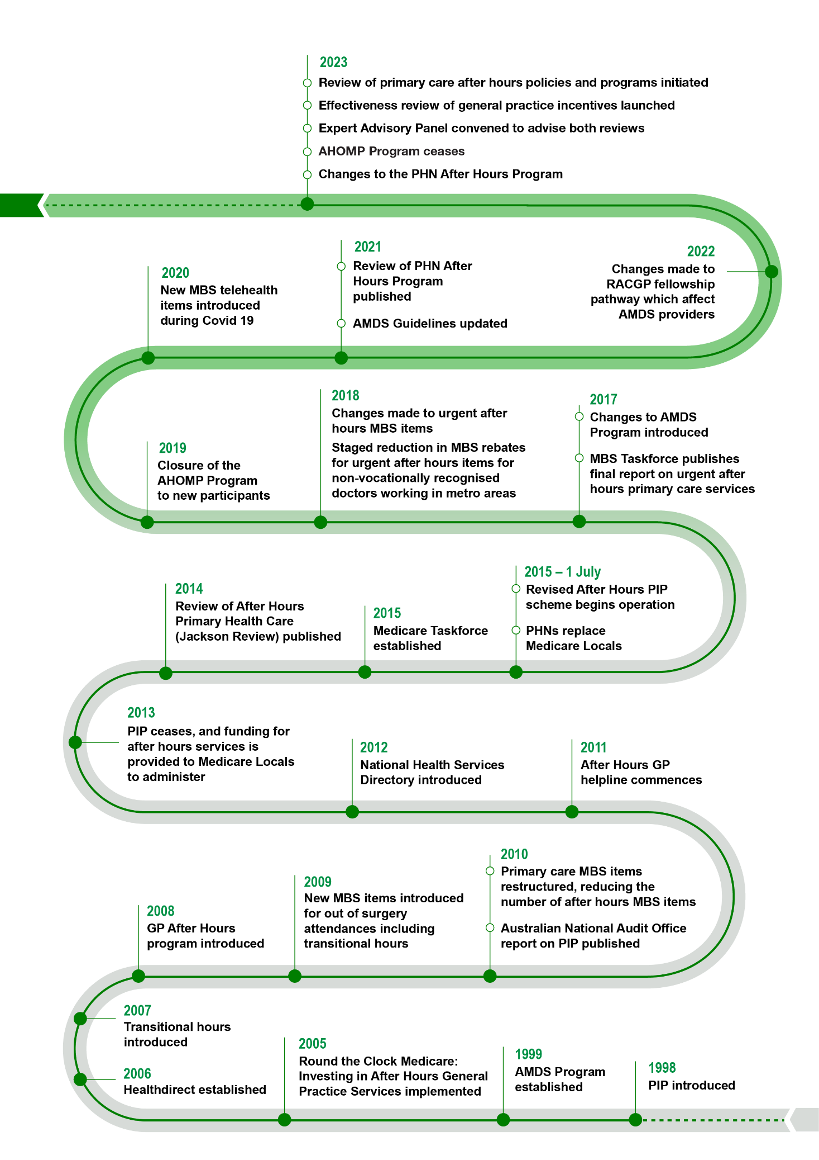

The After Hours Review
The Department of Health and Aged Care (the Department) has initiated the Review of Primary Care After Hours Programs and Policy (the Review) in response to recommendations of the Strengthening Medicare Taskforce Report (2022), as well as other recent initiatives such as the development of Future Focused Primary Health Care: Australia’s Primary Health Care 10 Year Plan 2022-2032. The Review also follows widespread changes to after hours services in response to the COVID-19 pandemic.
The Review is considering the efficiency and effectiveness of the current after hours primary care system, including:
- subsidies provided under the Medicare Benefit Schedule (MBS)
- the After Hours PIP
- Healthdirect Australia
- the PHN After Hours Program
- MDSs, including the AMDS Program
- Medicare UCC program
- other programs identified in the course of the Review.
The Review addresses the following Key Evaluation Questions (KEQs):
KEQ 1: What is the current state of after hours service provision?

KEQ 2: What is the need for primary care after hours services?

KEQ 3: What are successful models of primary care after hours service provision?

KEQ 4: What are the options for reforming after hours service?
(This KEQ is being led by the department and is out of scope for Allen + Clarke)

Scope and purpose of this report
Allen + Clarke was commissioned by the Department to undertake consultation, research and analysis activities (the Project) to support the Review. These activities seek to address KEQs 1, 2 and 3. This report synthesises data and insights collected over the course of the Project, which underpin 18 findings presented in this report. KEQ 4 - which considers options for reforming after hours services – is being led by the Department and is out of scope for the Project and this report.
The scope of the Project and this report also excludes:
- consideration of the effectiveness of after hours service provision in acute care and community health settings such as mental health and domestic violence helplines and services. These services are however considered as part of the overall after hours landscape.
- economic modelling and evaluation of the efficiency of existing or potential models of after hours primary care.
The findings outlined in this report should be considered alongside any findings or recommendations arising from other contemporary Department reviews related to primary care, including the Unleashing the Potential of our Health Workforce – Scope of Practice Review, the Working Better for Medicare Review, and the Effectiveness Review of General Practice Incentives.

Methodology
The Project employed a comprehensive mixed-method approach to data collection and analysis. The approach included quantitative analysis of health and workforce data sets and of survey data, as well as thematic analysis of qualitative data collected through interviews, focus groups, written submissions, and survey responses.
Project inception and planning commenced in October 2023. The Project closed with the delivery of the final report and findings in August 2024. The Project comprised four Phases:
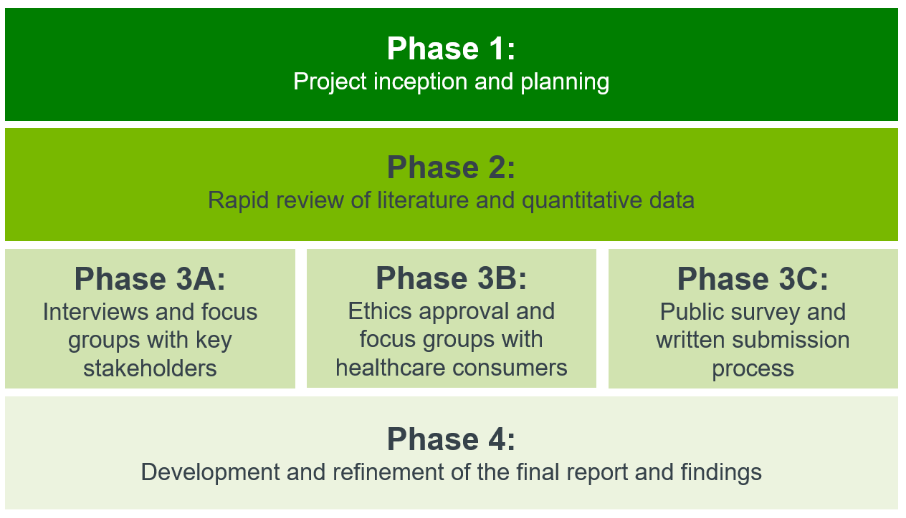

Desktop analysis
Allen + Clarke undertook a rapid literature review and analysis of quantitative data to examine the current evidence base on after hours primary care. The rapid literature review considered two key questions:
- What does the available evidence say about the need for primary care after hours services?
- What does the available evidence say about the effectiveness of current primary care after hours services?
As part of the rapid literature review, 138 documents were reviewed. These included peer reviewed academic articles, as well as reports of previous reviews of after hours primary care and related services, and other grey literature including reports of previous reviews of after hours primary care and related services. The majority of the relevant literature was provided by the Department to Allen + Clarke. Other literature was identified and reviewed where gaps in evidence emerged, using a snowball method whereby the references cited in the documents reviewed are used to identify additional relevant literature.
Allen + Clarke also analysed 13 quantitative data sets relating to after hours service need and provision. While some data sets were provided by the Department, most were drawn from publicly available sources.

Stakeholder engagement
The input of organisational stakeholders was critical to the Project, and was used to validate desktop research and to provide pragmatic, contemporary insights into the KEQs. A variety of stakeholder engagement methods were used, with stakeholders invited at various stages to participate in focus groups, interviews, a survey, and/or to provide written submissions. Organisations which provided input through an interview or focus group, or by written submission, are listed in Appendix A.

Stakeholder focus groups and interviews
Allen + Clarke worked with the Department to identify organisational stakeholders with an interest in after hours primary care. Five focus groups and 23 interviews were held with more than 34 key stakeholder organisations including:
- medical, nursing and other colleges and associations
- peak bodies and other sector organisations representing or with insight into consumer needs and experiences
- primary care operators.
With the support of Palliative Care Australia, the Project team also held a workshop for over 40 palliative care stakeholders. Engagements were conducted based on semi-structured consultation questions underpinned by the KEQs.

Consultation Hub Survey and written submissions
Data was also collected through a survey hosted on the Department’s Consultation Hub from 20 April to 20 May 2024. While the survey was open to the public, input was sought especially from primary care providers. Survey logic was used to present respondents with questions relevant to them and not all respondents provided answers to all survey questions. The Consultation Hub Survey questions are included at Appendix B.
457 analysable responses were received, including:
- 253 from practice owners/managers and primary health practitioners (such as GPs, non-vocational doctors, nurse practitioners, nurses, allied health practitioners, Aboriginal Health Workers and Aboriginal Health Practitioners, and administrators)
- 51 from PHNs
- 58 from peak bodies, colleges, or other organisations
- 95 from others, primarily members of the public
A breakdown of survey respondent characteristics by profession, location, age, and gender is visualized in Figure 3.

Figure 3: Snapshot of Consultation Hub Survey respondents
The number of respondents in each graph varies as not all respondents answered all survey questions.
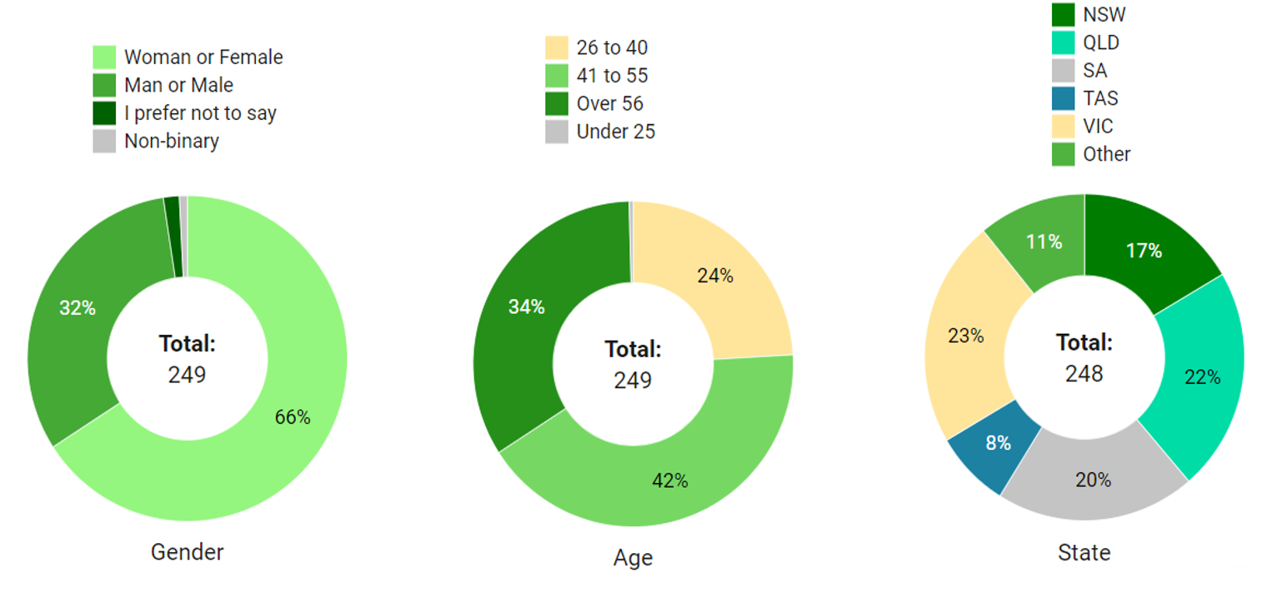
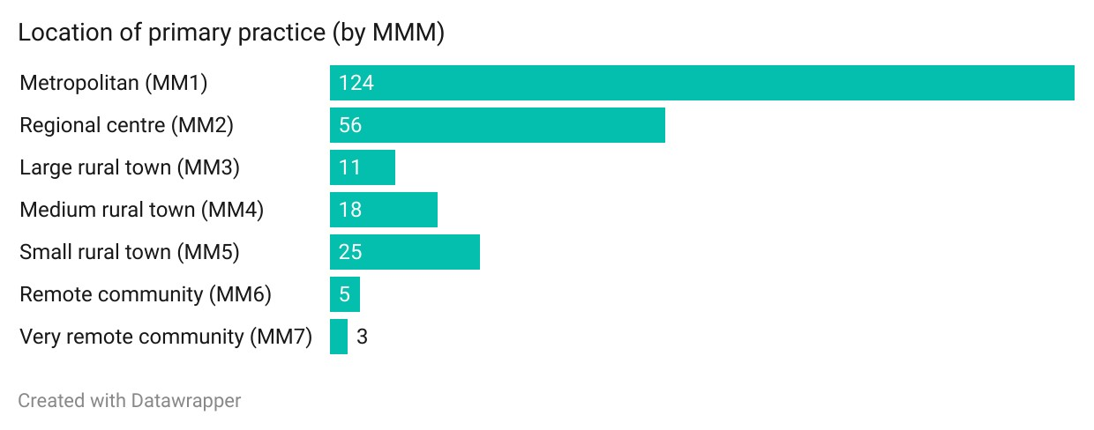
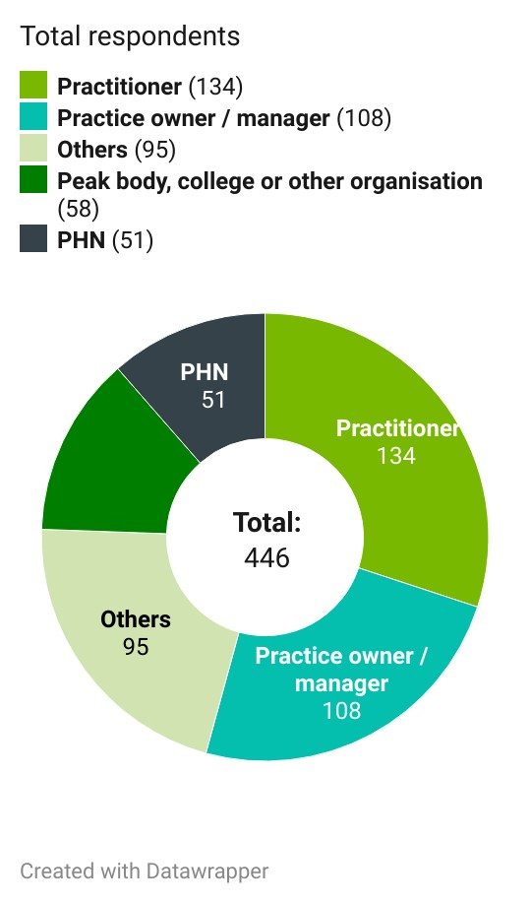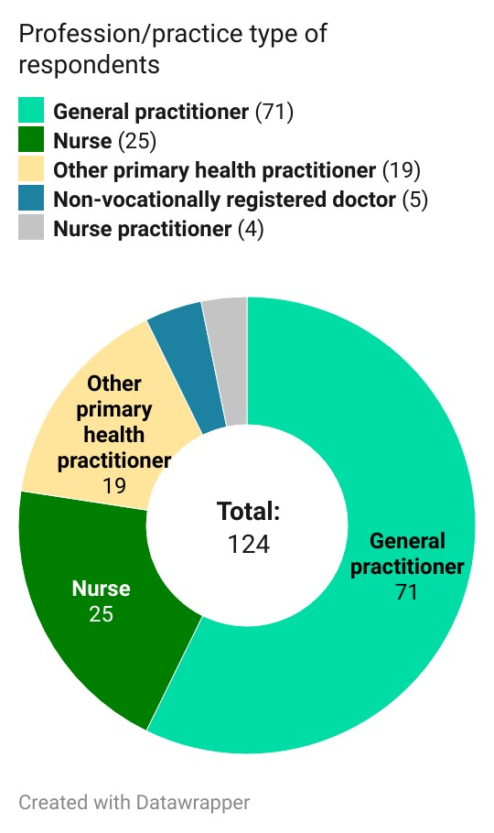

Written submissions
Stakeholders were also provided with the opportunity to provide written submissions, either as an attachment to their survey response or directly to Allen + Clarke by email. A Consultation Paper was published on the Consultation Hub and included information and questions to guide stakeholders’ written submissions. A total of 42 written submissions were received from organisations and individuals.

Consumer engagement
A priority of the Project was to reflect the experiences and perspectives of healthcare consumers. Allen + Clarke engaged consumers through Consumers Health Forum Australia, and several peak bodies, to hold 11 focus groups with 61 healthcare consumers.
The Project also aimed to elicit input from priority population cohorts. These priority population cohorts were identified following the rapid literature review and initial stakeholder engagements. Targeted focus groups were held with:
- consumers living with chronic illness
- consumers from culturally and linguistically diverse backgrounds
- older consumers
- mental health consumers and carers
- adult consumers receiving palliative care, and parents/carers of children who have received or are receiving palliative care.
Discussions were guided by semi-structured questions tailored to specific cohorts, but stakeholders were welcome to raise other relevant issues that were within scope.
The Department commissioned an Aboriginal supplier to undertake a separate consultation process with Aboriginal and Torres Strait Islander consumers. This Aboriginal-led consultation honoured Aboriginal and Torres Strait Islander ways of knowing, being and doing to ensure culturally safe engagement and thematic analysis of feedback. More about the approach and methodology can be found here: First Nations Yarning Circle Consultation for After Hours Review – Final Report.
The Department also conducted a consultation with rural and remote consumers in collaboration with the Office of the National Rural Health Commissioner. Transcripts and reports from these consultations were analysed by the Project team, and the contributions of the consumer participants are reflected in this report.

Ethics approval
The Project team received ethics approval for consumer consultation from the Human Research Ethics Committee (HREC) Bellberry Limited on 2 May 2024 (application ID: 2024-02-216). Bellberry Limited is a national, private not-for-profit organisation providing scientific and ethical review of human research projects across Australia.

Data sources
Table 1 provides an overview of the data sources analysed during the Project.
Table 1: Summary of Project data sources
Desktop analysis   - 138 documents  - 13 quantitative data sets | Consumer consultation   11 focus groups were held with 61 healthcare consumers.  + inputs from 5 focus groups facilitated by the Department and other partners
Stakeholder consultation   Five focus groups, one workshop and 23 interviews with over 34 key stakeholder organisations | Written submissions   42 written submissions from organisations and individuals as part of the Consultation Hub process
Online survey   457 responses, including:  - 253 from practice owners/managers and primary health practitioners  - 51 from PHNs  - 58 from peak bodies, colleges, or other organisations  - 95 from others, primarily members of the public | 

Limitations
Allen + Clarke acknowledges the following Project limitations which should be taken into consideration when interpreting the Project findings.

Stakeholder engagement
Engagement with sector stakeholders and consumers was non-random, self-selected and voluntary. The findings emerging from these engagements are not generalisable. Peak bodies and other stakeholders were identified by the Department. Consumers were referred by participating sector organisations and by Consumers Health Forum Australia.
Specific focus groups were not held with parents and carers of young children, or with LGBTIQA+ consumers. Several consumers identifying as belonging to one or more of these cohorts participated in other consumer focus groups, and their insights have been incorporated into the analysis informing this report.

Desktop analysis
The desktop analysis adopted a pragmatic snowball approach informed by material provided by the Department and should not be considered systematic. A paucity of available data and literature on the after hours care needs and behaviour drivers of several consumer cohorts was identified, including:
- people with disabilities
- people with mental health issues
- people with chronic illnesses
- people from culturally and linguistically diverse (CALD) backgrounds.

Quantitative data
The datasets available for quantitative analysis also have limitations. The Project was largely limited to publicly available data. The completeness of this data varied depending on factors such as publication timing, demographic information, and reporting and data collection processes.

Reading this report
This report comprises four parts, each aligned to one of the KEQs in scope for the Project:
- Part One provides background on after hours primary care and the Review, and explains the methodology used to undertake the work.
- Part Two provides an overview of the current state of after hours service provision (KEQ 1). It includes a map of the after hours system, as well as overviews of after hours primary care and hospital emergency department access, workforce considerations, and funding mechanisms.
- Part Three explores the need for after hours primary care in Australia (KEQ 2), including the drivers of consumer help-seeking behaviour in the after hours period, and the needs of specific priority cohorts.
- Part Four considers successful models of primary care after hours services (KEQ 3). It outlines key system design considerations, and examines in depth several key models of service delivery.
Quotes are used to illustrate key themes. All quotes have been deidentified to protect the privacy of individuals who shared their perspectives with the Project team. To contextualise quotes, general information on the source has been included. This includes identifying the relevant data collection source (for example written submission, interview/focus group or Consultation Hub Survey) and the type of stakeholder who provided it, for example:
- a workforce stakeholder or organisation (including peak bodies, colleges and professional associations)
- a sector stakeholder (including peak bodies and organisations representing sectors such as the disability sector, aged care sector, and chronic diseases sector)
- a service provider (includes individuals representing service delivery organisations and PHNs delivering after hours programs)
- healthcare practitioners and practice owners/managers
- consumers.

Part 2: Current state of after hours service provision

Current state of after hours service provision (KEQ 1)
This part addresses the question – ‘What is the current state of after hours primary care services?’ by reviewing components of the after hours system. The components include the range and types of services available; system-wide dynamics such as integration and coordination; measures of service demand and after hours and hospital emergency department presentations; and current workforce and funding.

Map of the after hours primary care system
The provision of after hours primary care in Australia is multifaceted. It encompasses GPs providing care through extended hour practices, home visits and telehealth, GP cooperatives, MDSs, urgent care and walk-in clinics, community health services (including ACCHS), and virtual triage services. These services are designed to provide urgent care for issues that cannot wait for treatment in usual hours.
In 2016, the Review of after hours service models: Learnings for regional, rural and remote communities by Armstrong et al (the Deeble Review) identified 7 after hours service models in use in Australia. The service models identified in the Deeble Review were:
- practice-based services – where GPs provide services to their patients within their practices
- GP cooperatives – where groups of GPs provide after hours care to patients within a specific area using a roster system
- co-location with hospitals – where GPs provide services at or near hospital emergency departments
- MDSs – where companies directly supply medical practitioners on contract to practices to cover the after hours period
- telephone triage and advice services – a Government-funded national telephone service staffed by trained nurses who use a triage protocol to assess callers and direct them to appropriate pathways of care
- web-based services – specifically Healthdirect Australia’s online health information
- The Royal Flying Doctor Service – which provides urgent medical attention to remote and very remote communities, including 24-hour telehealth services and medical chests.
In the year following the Deeble Review, a review of the PHN after hours program by Ernst & Young (2016) added:
- minor injury and walk-in centres
- hospital emergency departments
- after hours home visiting services.
Since these reviews, there have been several policy, technological and cultural changes along with the Australian health system experience of and response to COVID-19. This have led to changes in after hours service delivery, and consumer preferences and expectations. These include:
- the rise of telehealth and other virtual models of healthcare delivery. While use of these technologies was already increasing, this trend accelerated during the COVID-19 pandemic. Almost half of survey respondents to the 2021 Australian Health Consumer Sentiment Survey (46.7%) reported using digital health technologies (including telehealth, help-lines, mobile phone applications and websites) in 2021, an increase from 11.8% in 2018 (Zurynski et al., 2022)
- a trend towards more integrated and coordinated models of care
- increasing government (both Australian and state) investment in urgent care clinics, with this model of care taking on an enhanced role within the after hours primary care landscape
- increasing pressures on the health workforce, leading to strain across the system.
The following system map (Figure 4) identifies current after hours primary care programs, organised under 5 broad models of care:
- virtual triage and advice services
- extended hours GP clinics
- after hours specific GP services
- urgent care services
- targeted initiatives.
These service models are supplemented by auxiliary primary health care services. These models consolidate and elaborate on the previous care models outlined in the Deeble and PHN reviews.

Figure 4: System map of after hours services in Australia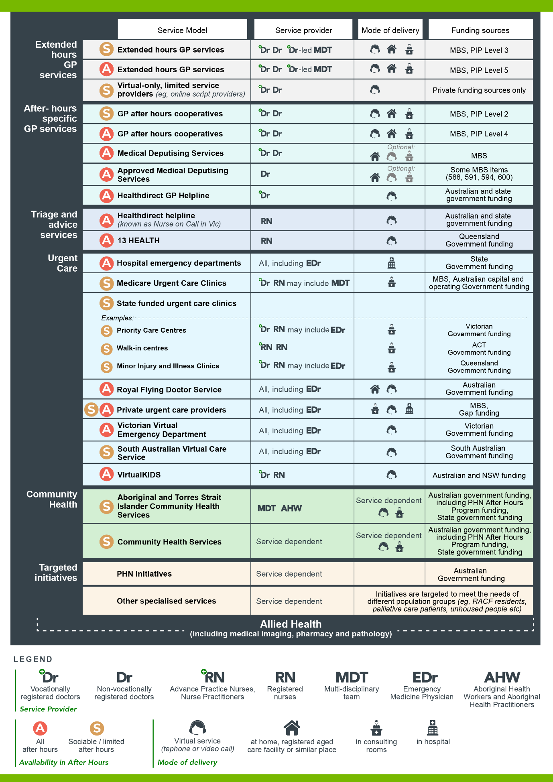

Overview of after hours primary care services

Virtual triage and advice

Healthdirect helpline
Healthdirect Australia is the Australian Government-funded provider of telephone and virtual health services. The healthdirect helpline, known as NURSE-ON-CALL in Victoria, is available 24-hours a day to provide health advice and guidance to individuals in most Australian states and territories, except Queensland where the Queensland Government’s Health Contact Centre operates nurse-led telephone triage through its 13 HEALTH line.0
The healthdirect helpline is staffed by registered nurses who assist callers to assess whether they need medical attention or can manage their health concern with self-care. Healthdirect Australia also operates a Pregnancy, Birth and Baby helpline, which is staffed by maternal child health nurses. These nurses offer advice on matters related to pregnancy and family planning, make referrals to local healthcare services, and operate from 7:00 am to midnight every day. Additionally, Healthdirect Australia offered the National Coronavirus Helpline (NCH) for general and clinical inquiries related to COVID-19. This service was rolled into Healthdirect Australia’s regular services from 4 October 2023.

In FY23, healthdirect telephone lines received 5.6 million calls. 69% of helpline calls were received in the after hours period, and 29% were received from rural Australians. – Healthdirect Australia Annual Report, 2022-2023

13 HEALTH
13 HEALTH is the telephone health advice service operating in Queensland. Registered nurses provide assessment and advice. The line is open 24-hours a day. 13 HEALTH is funded by the Queensland Government and is operated by the Health Contact Centre.

Doctor-led primary care services

Extended hours GP services
Some regular GP clinics offer appointments in the after hours periods. These clinics will generally operate for only part of the after hours period, most often in the sociable hours by remaining open into weekday evenings. Extended hours clinics will generally see patients regardless of acuteness, and often operate to meet client demand. While some GPs conduct home visits to their patients or to older people after hours, this is uncommon and occurs primarily in rural or remote areas where there are limited after hours care alternatives.
In 2022-23, GPs delivered over 8,002,000 after hours services to more than 4,264,000 people (16.4% of the population). – AIHW, Medicare subsidised services by PHN: 2022-20231F

Virtual only service providers
In recent years, an increasing number of privately operated service providers offering a specific suite of virtual services have entered the after hours landscape. The most common services offered are online prescriptions, provision of medical certificates, and referrals to specialists. Virtual only service providers are generally private providers with no Medicare rebates available to consumers using this service.

GP cooperatives
Groups of GPs may combine to provide after hours care to patients, often using a roster system. Cooperatives may provide care in clinics, at home or via telehealth.

Medical Deputising Services
A MDS is a service that arranges, or facilitates, the provision of medical services to a patient by a practitioner (deputising doctor) during the absence of, and at the request of, the patient’s regular GP (Royal Australian College of General Practitioners, 2018). By definition, MDSs are not intended for routine or regular care. MDSs may visit homes and RACHs and may also provide clinic and telephone triage or medical advice services. MDSs operate and provide access to care, including home visits, for the whole of the after hours period and may also provide services during usual hours.
A MDS is not eligible to receive PIP After Hours payments as MDSs are not considered to be general practices.

Approved Medical Deputising Services
The AMDS program enables non-vocationally recognised doctors to access some MBS items to provide after hours services on behalf of other doctors subject to Section 19AA of the Health Insurance Act 1973 (Cth). Eligible MBS providers are required to enter into a Deed of Agreement with the Department.
Since reforms to MBS items in 2018, which restricted access to urgent after hours MBS items, the number of AMDSs have dropped significantly.
Expenditure on selected after hours attendance MBS items by non-vocationally registered practitioners dropped by 63.24% between 2018-19 and 2022-23. – Data provided by the Department

Healthdirect GP helpline
Healthdirect’s GP helpline is available in all Australian states and territories, except Tasmania. Eligible callers are those triaged by the healthdirect helpline or 13 HEALTH as requiring an urgent telehealth GP consultation (via telephone or video call back) within 24 hours, in the after hours period and with no alternative available. The healthdirect GP helpline was established in 2011 to provide access to a GP during some after hours periods. Access to the after hours GP helpline was amended in 2015 to prioritise consumers calling from outside metropolitan cities. Since July 2023, nurses have been able to triage New South Wales, South Australian and Victorian callers to the GP helpline 24-hours a day.

Urgent care services

Medicare UCCs
Medicare UCCs are funded by the Australian Government to provide bulk billed urgent health care. These walk-in clinics are established in existing general practice clinics, community health centres and ACCHSs across Australia. Medicare UCCs are open extended hours, with the opening hours of each Medicare UCC informed by the local context. Medicare UCCs are intended to be GP-led, with the staffing mix based on availability, local need and context. As of 2023, the Australian Government had established 58 Medicare UCCs across the country including 14 in New South Wales, ten in Victoria, 11 in Queensland, 7 in Western Australia, 5 in South Australia, 4 in Tasmania, 5 in the Australian Capital Territory and 2 in the Northern Territory. In the 2024-25 Budget, the Australian Government announced funding to support a further 29 Medicare UCCs, which will take the program to a total of 87 Medicare UCCs across Australia.

State and territory-funded urgent care clinics
The Victorian Government currently funds and operates Priority Primary Care Centres across the state. In 2023-24, ten of these Priority Primary Care Centres were transitioned to the Medicare Urgent Care Clinic Program. All PPCCs align with the Medicare Urgent Care Clinic Operational Guidance. These centres partner with hospital emergency departments to provide care for people with conditions that ‘require urgent attention but not an emergency response’. Opening hours vary across centres, but all centres are open for some part of the after hours period. Priority Primary Care Centres accept walk-ins, referrals, and pre-booked appointments. They also offer pathology and imaging services.
The New South Wales Government currently funds and operates 9 urgent care services across the state.
The Queensland Government funds and operates Minor Injury and Illness Clinics in Queensland’s 7 Satellite Hospitals and some other locations. These clinics are open 7 days a week, are free for Medicare card holders and are accessible without an appointment.
The South Australian Government in partnership with the Adelaide Primary Health Network and general practices, has established 4 Priority Care Centres across metropolitan Adelaide. There is an additional Priority Care Centre located in Mount Barker. The centres are led by GPs with additional care from emergency and acute care trained nurses. Centres are open 7 days a week. Consumers must be referred to a Priority Care Centre. Referrals can be made by hospital emergency departments, paramedics, GPs, healthdirect (in some circumstances), the Child and Adolescent Virtual Urgent Care Service, or other community services. The ACT Government operates 5 Walk-In Centres (WICs) which provide care for non-life-threatening injuries and illnesses to anyone who is over one year of age. Since October 2023, the Australian Government co-funds the ACT WICs which are co-branded as Medicare UCCs. These clinics are staffed by Advanced Practice Nurses and Nurse Practitioners and are open from 7:30 am until 10:00 pm every day.

Hospital emergency departments
In Australia, there are 293 public hospitals that have purpose-built emergency departments that are staffed 24-hours a day (Australian Institute of Health and Welfare, 2023b). Emergency departments are always open, provide ready access to imaging and pharmacy services, and are free.
While emergency departments are not intended to be primary care providers, many consumers present at emergency departments for assessment and treatment of conditions which could be managed in a primary care setting, such as by a GP. In some rural and remote locations, emergency departments are run by local GPs. Emergency departments therefore, form an important part of the after hours primary care landscape.
In 2021-22, over 45% of ED presentations were triaged as either non-urgent or semi-urgent. – AIHW, Emergency department presentations by triage category, 2021-222.

Virtual emergency departments
In recent years, virtual emergency departments have emerged as a distinct and rapidly evolving service model.
The Victorian Virtual Emergency Department (VVED) operates 24-hours a day to triage and treat patients who have a ‘non-life-threatening health emergency’. Patients are not required to make an appointment, but instead register online to join the virtual waiting room. Services are provided virtually via video call by emergency nurses and doctors. Patients are not charged for the service. The VVED began as a pilot in October 2020 to help patients in the north of Victoria with COVID-19 symptoms, relieve pressure on emergency waiting rooms, and treat more people from the comfort of their home. The program is now open to patients across Victoria. The service supported more than 241,223 patients between October 2020 and January 2024. Of the patients seen by VVED, 86% did not require transport to, or care at a physical hospital. The VVED is operated by Northern Health and is funded by the Victorian Government (Victorian Public Sector Commission, 2024).
South Australia funds 2 virtual emergency departments. South Australia’s Child and Adolescent Virtual Urgent Care Service (CAVUCS) connects parents with emergency doctors and nurses who can assess and provide medical advice for children aged between 6 months and up to 18 years. Patients access the service directly, free of charge. The service operates 7 days a week from 9:00 am to 9:00 pm. CAVUCS saw more than 24,320 patients between August 2021 and June 2023, with 90% of patients avoiding an attendance at the emergency department (Government of South Australia, 2023).
The South Australian Virtual Care Service (SAVCS) provides services via video link. Unlike the VVED, patients do not access the service directly, but instead are referred to the SAVCS. The service provides an individualised assessment service via video link for urgent patients on-scene with ambulance crews, regional clinicians or aged care staff. The service operates from 8:00 am to 10:00 pm every day, and there is no cost to the patient for the virtual consult. SAVCS also services RACH patients for RACHs that register with the service. SAVCS commenced operations in December 2021, and around 18,000 patients used the service between December 2021 and June 2023 (Government of South Australia, 2023). Approximately 70% of SAVCS patients avoided admission to the ED (SA Health, 2024).
The Western Australia Virtual Emergency Department (WAVED) is available to patients 16 years and over within the Perth metropolitan area. The service is accessible where an ambulance crew has attended a patient and determined that their condition is lower urgency and that they are suitable for a virtual assessment by an emergency physician. Residents of aged care homes are prioritised. WAVED was launched in September 2023 as a ‘proof of concept’ and is being implemented in a phased approach.
Queensland’s Virtual Emergency Care service operates from 8:00 am to 10:00 pm, 7 days a week. Consumers may be referred directly to the service through the healthdirect online symptom checker or 13 HEALTH. GPs and Queensland Ambulance Service clinicians can also contact the service. The Virtual Emergency Care service is part of the Queensland Virtual Hospital initiative.

Private urgent care
A variety of private operators have emerged in recent years which provide an urgent care service in part or all the after hours period. These operators generally describe their business as ‘urgent’ or ‘emergency’ care. The operating models for these services vary, and include:
- clinics staffed by doctors (GPs and/or specialists depending on the service), nurses and nurse practitioners. They generally offer imaging, plaster casting, crutches, splints, and wound care equipment on-site, and (in some cases) pathology. These services are open for extended hours on a walk-in basis. Services attract an out-of-pocket fee, with some services eligible for some Medicare rebates
- an emergency telemedicine provider, offering on-demand telephone and video call consultations with specialist emergency doctors. The service operates 24-hours a day, 7 days a week, and Medicare rebates do not apply.

Royal Flying Doctor Service
The Australian Government funds the Royal Flying Doctor Service (RFDS) to provide emergency aeromedical and primary healthcare services. The RFDS deliver these services to rural and remote communities in areas of market failure or beyond the normal medical infrastructure. The RFDS’ after hours primary health services include the provision of telehealth consultations and medical chests. The chests contain a secure package of pharmaceutical and non-pharmaceutical items, medical supplies and medical equipment. These items enable emergency and non-emergency treatment to be given to people living and working in remote areas with limited access to health professionals and pharmaceuticals. The medical chest items are prescribed by an RFDS doctor (or other authorised person) in the course of a remote consultation. The chests are used for management of acute conditions. Where possible, the patient will be seen for follow up treatment, in person or via telehealth. In 2022-23, the RFDS placed 2,051 medical chests in locations around Australia (Royal Flying Doctor Service, 2022).

VirtualKIDS
The New South Wales (NSW) Government funds VirtualKIDS Urgent Care Service, Australia’s first paediatric specific virtual healthcare service. This service provides video consultations for children (aged up to 16 years) and their families/carers with non-life-threatening health concerns, located in NSW and some border areas. It is delivered by the Sydney Children’s Hospital Network and Hunter New England Local Health District, and staffed by senior paediatric nurses with paediatricians rostered on to consult as needed. There is some follow up care possible by video call, where necessary, for up to 3 days.
VirtualKIDS cannot be accessed directly by members of the public. Rather, it is accessible by referral through healthdirect services (NSW Health, 2024b).

Targeted initiatives
During the course of the Project, a broad range of services have been identified that have been designed to meet the needs of specific population groups, including RACH residents, people receiving palliative care, and people who are homeless. These services may be administered and funded at the Commonwealth, state, PHN or other level.
A broad range of targeted initiatives are delivered through community health services. Aboriginal and Torres Strait Islander Community Health Services play a critical role in delivering after hours primary care services to Aboriginal and Torres Strait Islander people across Australia, with an especially high concentration of services in remote areas. These services are designed to be culturally safe and meet the specific needs of community.

Primary Health Network initiatives
Targeted initiatives, including those delivered through community health organisations, may draw upon a range of funding sources. PHNs play a central role in commissioning, funding and partnering with community health and other service providers to design and implement tailored, local initiatives. PHNs receive flexible funding from the Australian Government to improve access to after hours primary care in their region. This involves working with local stakeholders to plan, coordinate and support population-based after hours health services. PHNs work with after hours service providers to improve service integration as well as address gaps in after hours service provision. PHNs were established in 2015 and replaced Medicare Locals. There are 31 PHNs across Australia.

Allied health care services
While not in scope of the Review, allied health services are an important aspect of the after hours primary care landscape. The accessibility in the after hours period of services such as pharmacy, imaging, pathology, physiotherapy and psychology can impact the effectiveness of after hours primary care and consumer decision-making about where to seek help (see section 3.1.12).

After hours primary care system dynamics
The after hours primary care system is complex and its dynamics are influenced by several factors including for example need and demand, workforce supply and system integration and coordination. These factors, as well as other key barriers and enablers influencing the broader dynamics of the system are considered in this section.

Defining the purpose of the after hours primary care system
…the aims and objectives of after hours initiatives lack coherence and logic. An overarching objective of after hours primary care is to reduce lower urgency emergency department presentations and hospitalisations. However, the program objectives are not clear as to whether this should be through focusing on after hours attendances or by allowing people to access routine care at a time that is possibly more convenient for them. – Service provider, written submission
Consultations with stakeholders, primary care providers, and consumers revealed divergent perceptions of the objectives and intent of the after hours primary care system and policy. Stakeholders regularly described the purpose of the system as addressing urgent, episodic clinical need, and considered that policy and resourcing should be directed squarely at achieving this objective. Others expressed the view that the primary care after hours system has an important role to play in the provision of more routine care, and that the clinical, cultural, lifestyle, and economic factors which shape where and when consumers seek help must be considered. This tension was evident in stakeholders’ queries about the extent to which diverting lower-urgency presentations away from hospital emergency departments is – and should be – the primary objective of the after hours system.
[There is a] question of definition – of the difference between after hours care and urgent care. And I … think those get confused sometimes or are used interchangeably where we see them as subtly different. I think [the Department’s] intent is to improve access to urgent care rather than necessarily after hours care, but I think that's worth digging apart a little bit. – Workforce stakeholder, interview
Several stakeholders expressed the view that a clearer articulation of the objectives of the primary care after hours system (and after hours policy) would support targeted and efficient allocation of limited resources, and manage consumer and community expectations of what the system can reasonably deliver.

System integration and coordination
It's big, it's complex, it's fragmented, and there's multiple buckets of money… – Service provider, interview
Stakeholders generally indicated that the after hours primary care system is complex and fragmented. As shown in the system map in section 2.1, the system comprises a multitude of service models involving different health care practitioners, modes of delivery, and funding mechanisms. This landscape is evolving rapidly including the introduction of a variety of new private services, Australian and state and territory funded urgent care models, and large corporate investment in telehealth.
Adding to this complexity are state and territory government initiatives to meet need and reduce demand on emergency departments, including the establishment of state-based urgent care clinics and hospital avoidance schemes. These developments were seen by some stakeholders as further complicating health system coordination, navigation, and integration, whilst simultaneously ‘blurring responsibility’ for after hours delivery. Complex funding and governance mechanisms were said to make it difficult for practitioners to flexibly work across different healthcare systems.
This complexity was seen by some stakeholders as both a product and cause of poor coordination and communication at local, regional, state/territory and national levels leading to service duplication, system fragmentation and service gaps, and limited flow of patient information with subsequent fragmented health journeys. One service provider described the lack of coordination across different service providers and stakeholders in the following terms:
I was frequently left feeling that there wasn't an overall lack of resources being applied to the areas that I was working in, but it was just a herd of cats. … there was no systematic - well, that's unfair - I'm sure there was some systematic planning. But it didn't feel like that. – Service provider, interview
Workforce stakeholders referred positively to recent Government efforts to streamline and systematise the planning and delivery of primary care services but suggested that on the ground implementation was uneven. This included coordination for the timely transfer of patient information between after hours service providers and regular primary care providers (information sharing is discussed in more detail at section 3.1.7). Stakeholders recommended that protocols be established to formalise information sharing, referrals, and continuity of care processes to ensure ‘seamless transitions between different levels of care.’
A lot of access points do not communicate with regular GPs. Services like Healthdirect…, hospital settings, are not communicating that they have been in contact [with a patient] to the GP. Be wary of providing more alternative care options. – Workforce stakeholder, interview
Several workforce organisations and PHN stakeholders identified the need for better planning and integration across the after hours system, as well as with the broader health system. Some concern was expressed that there was lack of communication between different after hours service providers creating a patchwork of, at times, duplicative services, which were not aware of each other’s existence. While it was broadly agreed that more service offerings are required – for example diagnostic, pharmacy, community, and support services – it was cautioned that adding more services without consideration for integration and cross-system communication and coordination would further exacerbate fragmentation.
Workforce organisations and PHNs identified the need for increased collaboration between local communities, health care providers, emergency services, government agencies, and commissioning services. The focus of these relationships should be to ensure after hours funding streams and resources are more effectively aligned, coordinated, and implemented to address ongoing service gaps and consumer navigation and accessibility issues. One stakeholder also emphasised the need for improved intergovernmental clarity and cohesion on funding, service expectations and implementation, and promotional and other messaging.
The prevailing view among practitioner and practice owner/manager respondents to the Consultation Hub Survey was that there is room to improve planning and coordination. Respondents from Modified Monash Model2F (MMM) areas 3-7 were more likely to agree that after hours services in their community are well-planned (Figure 5). The data collected through the Survey does not indicate the reasons for this variation. One possibility is that the smaller number of after hours providers in rural and remote areas means that planning and coordination is more straightforward, and that practitioners are more involved in planning activities or have more insight into the activities undertaken by PHNs and others.
Figure 5: Survey respondent perspectives on planning and coordination of after hours services (n=191)
Survey text: After hours services in my local community are well-planned and coordinated
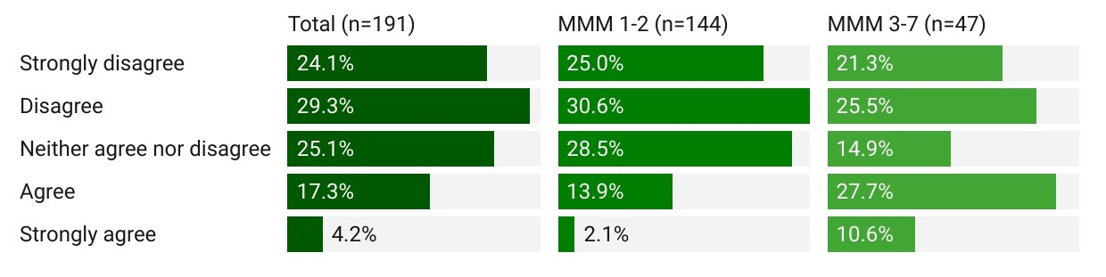Source: Consultation Hub Survey (2024)

Demand for after hours primary care services
During 2022-23, 16.4% of Australians received an after hours service from a GP in a clinic, or other setting such as a home or RACH, or by telehealth (Figure 6). GP after hours attendances billed as ‘urgent’ accounted for 6% of all attendances in 2022–23, a decrease from 10% in 2018-19 (Australian Institute of Health and Welfare, 2022a).3F The 2020 Australia’s Health Panel Survey (respondents n=5,100) showed that 67% of respondents had accessed after hours primary health care at least once in the previous 5 years. Of these, 58% received care from a general practitioner, 25% from a nurse and 35% accessed pharmacy services.
Figure 6: Medicare-subsidised services by after hours category, 2022–23
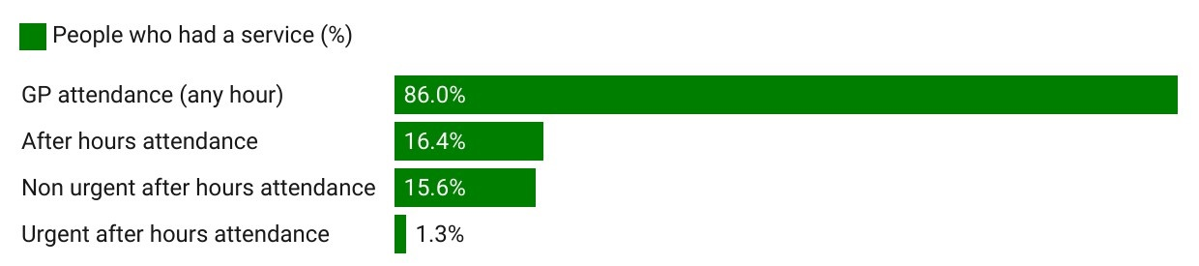
Source: AIHW, Data Tables: Medicare-subsidised GP, allied health and specialist health care across local areas: 2022–23

Access by time of day
Data relating to MBS after hours items does not identify the specific time the service was delivered. There is, however, evidence that need for after hours services peaks on weekday early evenings. A broad range of stakeholders and practitioners described elevated demand in this period, and a previous review described most presentations across all after hour care services occurring during weekday sociable hours (6:00 pm to 11:00 pm), followed by week-day unsociable (11:00 pm to 8:00 am), with a slightly smaller amount on weekends across all hours (Health Policy Analysis, 2020). The 2020 Australia’s Health Panel Survey also showed that care was accessed across the after hours period (35% between 6:00 pm and 8:00 pm, 43% between 8:00 pm and 11:00 pm, 20% between 11:00 pm and 7:00 am, and 12% between 7:00 am and 8:00 am).
Several stakeholders indicated that after hours need varies across different times of the day. A number of stakeholders indicated that after hours primary care services tend to see a higher volume of relatively minor illnesses and injuries in the early evening hours, driven in particular by children requiring care after the school day has ended, and by spillover as primary care clinics and other health care facilities close for the day. Stakeholders considered that need overnight and in the early hours of the morning is characterised by a smaller volume of more serious presentations overnight. Several stakeholders also suggested that weekend days (in particular Saturday afternoons) are notable for the high proportion of sports injuries. Stakeholders indicated that after hours policies and programs should be aligned with the specific needs that arise at different phases of the after hours period.
Data from Healthdirect Australia’s helplines indicate a significant surge in demand across all helplines in the early evening period – in particular for the helpline and National Coronavirus Helpline (Figure 7).
Figure 7: Calls to healthdirect by helpline and time of day (24 hour clock), 2020-2023
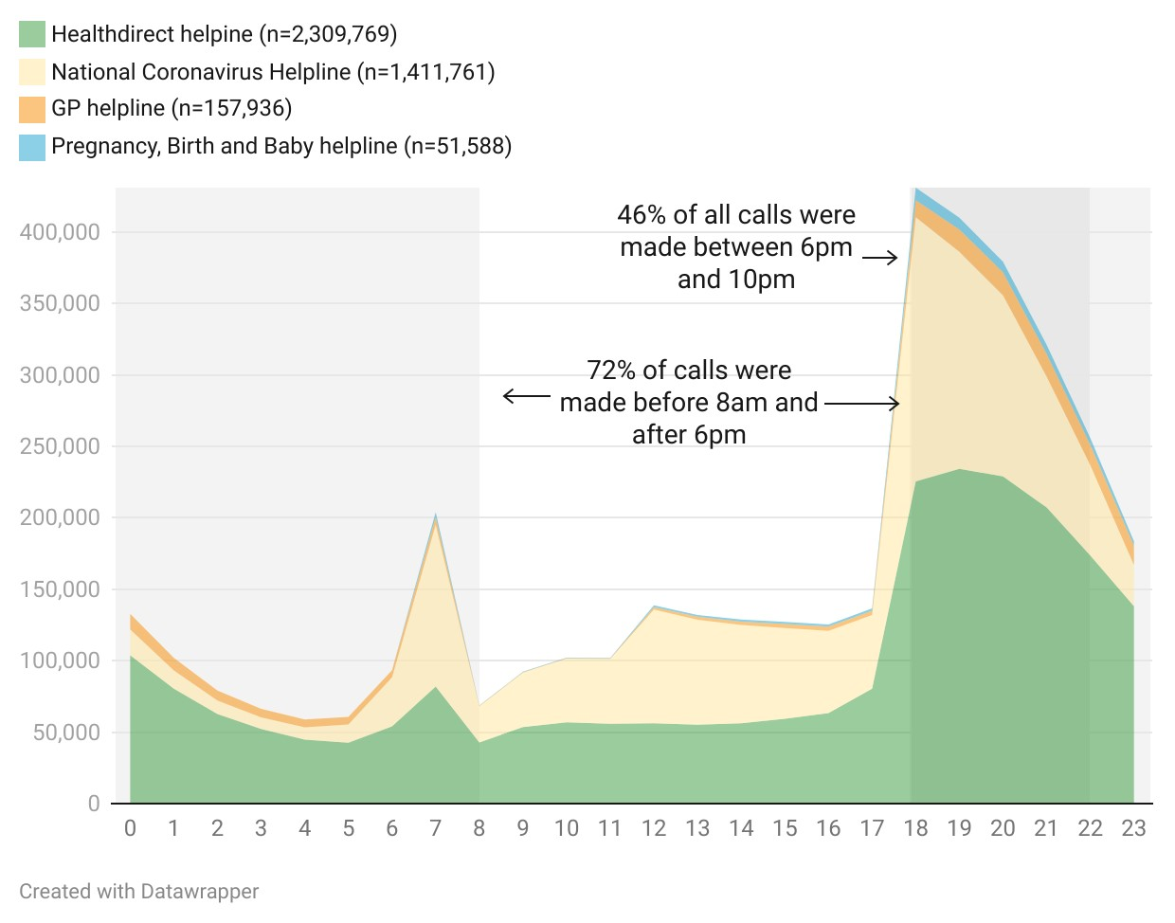
Source: Internal data provided by the Department of Health and Aged Care. Data reflects calls made across all days of the week (including weekends).

This is consistent with stakeholder and practitioner feedback, which described high community need for services in the early weekday evening period.
I think we should be encouraging practices to stay open and provide a level of service… From 4:00 pm, 5:00 pm kids will be getting home from school. After school, they're home for a couple of hours, their parents keep an eye on them and then go ‘hang on, you're not well’, and then it's the hospital. And for adults, they get home from work and their partner says, ‘You're really unwell. You need to see your doctor. – Workforce stakeholder, interview

Consumer profile and clinical presentations
According to recent MBS data, people aged over 80 are most likely to receive an after hours GP service (and in particular, an urgent after hours GP service), followed by those aged under 14 (Figure 8).
Figure 8: Percentage of people who had an after hours GP service by age, 2022-2023
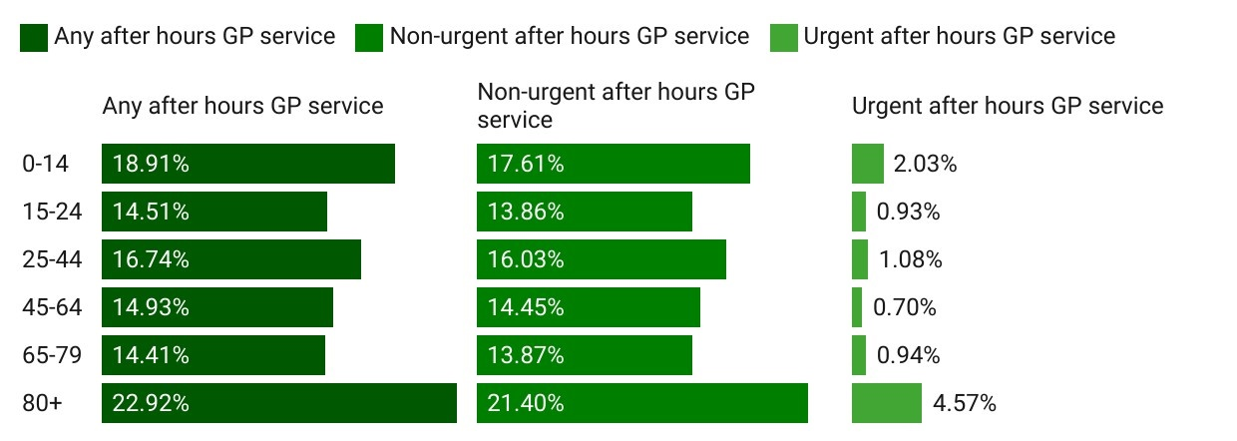
Source: AIHW, Data Tables: Medicare-subsidised GP, allied health and specialist health care across local areas: 2022–23
The data also indicate that males are slightly more likely to have an after hours GP service than females (17.5% compared to 15.3% respectively) (Australian Institute of Health and Welfare, 2024).4F
Location also has a strong bearing on after hours GP service delivery. When standardised for age, consumers who live outside metropolitan areas are 62% less likely than their metropolitan counterparts to receive an after hours GP service – but only 14% less likely to receive a GP service at any time of day (Figure 9).
Figure 9: GP services per 100 people (age standardised) by location, 2022-23
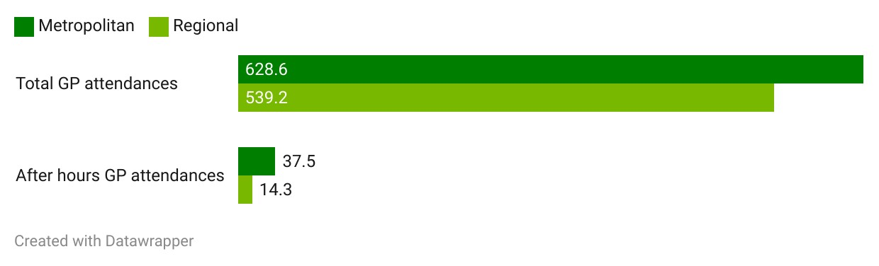
Source: AIHW, Data Tables: Medicare-subsidised GP, allied health and specialist health care across local areas: 2022–23
The literature paints a nuanced picture of the demographic characteristics of consumers who use after hours primary care services. A 2020 study on presentation profiles during usual hours and after hours showed that after hours GP services are more often accessed by males aged 15 – 64 who were new to the practice. This age group were more likely to be occupied with work commitments during usual hours which may explain the higher rate of attendance after hours. The same study also highlighted that female patients, and people aged over 65 years, accounted for fewer after hours presentations at GP services (J. Baker et al., 2020). Conversely, several earlier studies found women are more likely to attend after hours primary care, with one Australian study finding that females were the majority of after hours presentations to an after hours urgent care clinic, whilst males made up the majority in non-urgent emergency department presentations (Payne et al., 2017). A 2017 study on presentations to an East Melbourne after hours clinic found that over 30% of presentations were by patients under 18 years (L. R. Turner et al., 2017). The variability demonstrated by the data may indicate considerable local variation arising from factors including community demographics, service accessibility and service design. Further research is needed to understand what service models are accessible and attractive to different demographics, and under what conditions.
There is greater consensus in literature on the clinical presentations to after hours services. The most common issues presented at after hours GPs are infection or injury to the respiratory system or skin, as well as gastrointestinal system disease and eye and ear problems (L. R. Turner et al., 2017). However, respiratory presentations are likely to have changed since COVID-19, and the introduction of additional services in response to the pandemic (Barnes, Agostino, et al., 2022). The type of conditions being treated after hours likely coincides with the higher rate of prescribing antibiotics during these periods (J. Baker et al., 2020). By contrast, there appears to be a lower rate of psycholeptic/psychoanaleptic0F5F prescribing after hours, despite presentation rates for depression and anxiety being relatively consistent between normal hours and after hours. This may be reflective of GPs wishing to be familiar with a patient and their medical history before prescribing such drugs (J. Baker et al., 2020)
On average, fewer problems were managed at after hours encounters and a smaller proportion of after hours encounters involved one or more chronic problems (J. Baker et al., 2020). A comparison between presentations at different after hours primary care services in the ACT suggests that generally GPs are responding to a greater proportion of long-term and lower urgency problems than other after hours services (Barnes, Agostino, et al., 2022).
The needs and experiences of specific priority consumer cohorts, including people living in rural and remote areas, older people, and people living with chronic illness, are discussed in detail in section 3.2.

Lower-urgency emergency department presentations
A key priority from a clinical and government perspective for primary care in the after hours period is to divert non-acute and inappropriate presentations from emergency departments. Inappropriate use of emergency departments is associated with increased cost, poorer health outcomes (Department of Health and Human Services, USA, 2021) and reduced continuity of care (Karam et al., 2019). This was also a key recommendation of the Medicare Taskforce, to: ‘Improve access to primary care in the after hours period and reduce pressure on emergency departments by increasing the availability of primary care services for urgent care needs’ (Department of Health and Aged Care, 2022a).6F
Lower-urgency emergency department presentations in Australia are defined by the AIHW as those which are categorised as Australian Triage Scale (ATS) 4 (semi-urgent) and 5 (non-urgent), who did not arrive in an ambulance, police, or correctional services vehicle, were not admitted to hospital or referred to another hospital and did not die. In much of the literature, presentations triaged as ATS 4 and 5 are considered lower-urgency. Divergence of patient and clinician perceptions regarding the urgency of matters has been attributed as one of the primary causes for low-urgency presentations in the after hours period (Barnes et al., 2023).
In 2020-2021, lower-urgency presentations accounted for over 42% of all presentations to emergency departments, with almost half of Australian after hours emergency department presentations rated as ‘non-urgent’ by clinicians (Barnes, Ceramidas, et al., 2022). In Victoria, the number of presentations to emergency departments was projected to increase by 2.7% per annum between 2012-13 to 2026-27, which is an overall increase of 44.2% (North Western Melbourne Primary Health Network, 2018). It is anticipated that this growth will coincide with a rise in lower-urgency and after hours presentations. The literature assumes this trend to be similar across Australia.
This is in line with global trends where the prevalence of inappropriate emergency department utilisation ranges from 20% to 40% (Hong et al., 2020). Inappropriate emergency department presentations may also result in emergency department crowding, which leads to reduced ability of staff to deliver good quality of care, and may impact quality of health care provision (Idil et al., 2023). It also negatively impacts on the continuity of care that people could normally get from regular primary care providers, further impacting the quality of care (U.S. Department of Health and Human Services, 2021).
Overall, the proportion of lower-urgency presentations to higher-urgency presentations is lower in the after hours period than in usual hours (Australian Institute of Health and Welfare, 2024a) (see Figure 10). It is possible that this reflects consumers’ ‘higher threshold’ for calling an ambulance or leaving home to attend an emergency department during the night.
Figure 10: Proportion (%) of emergency department presentations, by hour of presentation for each triage category (24 hour clock)
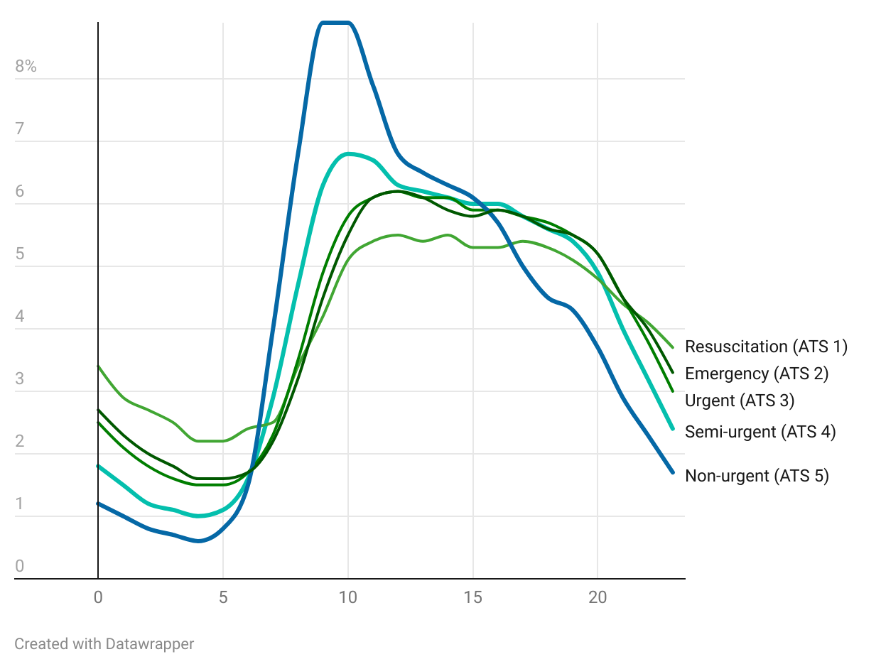
Source: AIHW, Data Tables: Emergency Department Care 2022–23
Data on the timing of lower-urgency emergency department attendances confirms that most presentations occur during the day, with attendances dropping considerably from around 8:00 pm before rising again from around 6:00 am (Australian Institute of Health and Welfare, 2024a). It is interesting to note a peak in lower-urgency attendances between 9:00 am and 12:00 pm. The data does not indicate the cause of this pattern. It may reflect consumers waking up unwell, waiting overnight to access care in the morning, or presenting after being unable to secure a timely GP appointment.
There is some variation in lower-urgency presentations depending on the remoteness of the emergency department. Figure 11 illustrates after hours and usual hours lower-urgency presentations as a proportion of all emergency department demand. It reveals that lower-urgency presentations overall represent a smaller proportion of emergency department presentations in regional areas than they do in metropolitan areas. However, the split of after hours and usual hours lower-urgency presentations is similar across metropolitan and rural areas.
Figure 11: Lower-urgency emergency department demand during usual and after hours period as proportion of all emergency department demand, 2022-2023
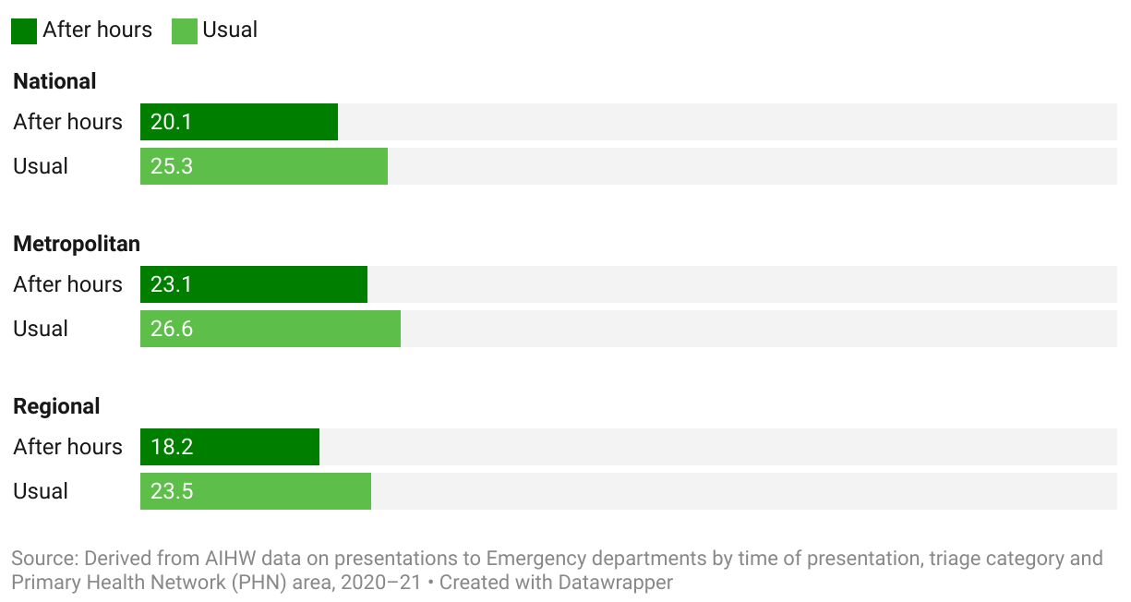
Source: Derived from AIHW data on presentations to emergency departments by time of presentation, triage category and PHN area, 2022-2023
ATS 5 presentations increase when compared to ATS 4 presentations as rurality increases (Figure 12). This suggests that lower-urgency presentations are generally less urgent in more remote areas and may be driven by the low number of primary care alternatives to hospitals in rural and remote areas, or by the fact that in some locations GPs staff emergency departments (making the emergency department the only after hours option).
Figure 12: Lower urgency emergency department presentations by remoteness area, 2022-23
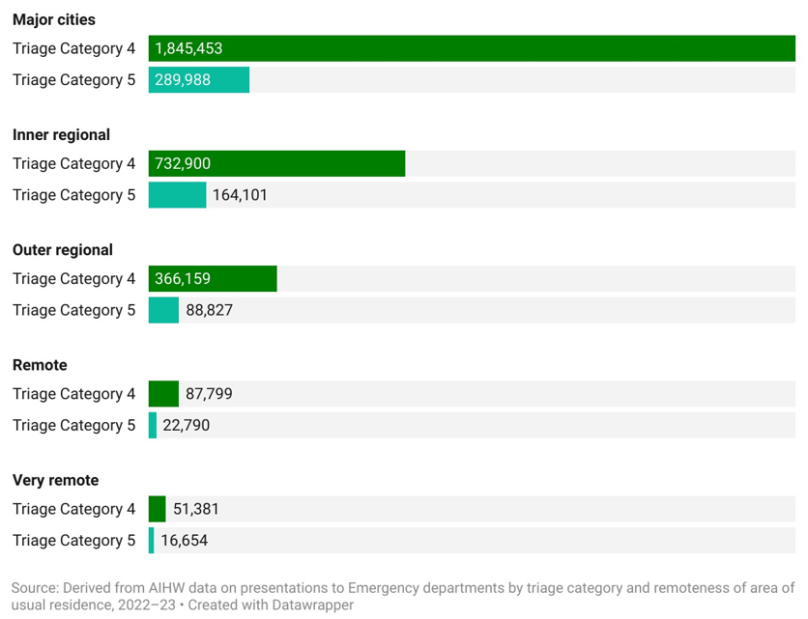Source: AIHW, Data Tables: Emergency Department Care 2022–23

Figure 13 illustrates the variable volume of lower-urgency emergency department presentations across all Australian. A selection of PHNs are highlighted and named to illustrate the trend of presentations across the day. Presentations to the emergency department for lower-urgency care were generally highest during usual GP practice hours (8:00 am to 6:00 pm). This was observed in regional NSWs’ Hunter New England and Central Coast, Western NSW, Northern Sydney PHN and Brisbane North. Country WA PHN also recorded a high volume of presentations. This suggests individuals, particularly in select PHNs are using the emergency department as an alternative to visiting their GPs for lower-urgency issues, even during regular GP practice hours. Regional differences in the volumes of presentation (both in rural and metropolitan settings) and limited availability of same-day appointments with GPs may prompt patients to opt for the emergency department. This may indicate GP shortages and/or wait times to see a GP are more acute in some PHNs than others.
Figure 13: Volume of emergency department presentations for lower-urgency care by PHN, 2022-23
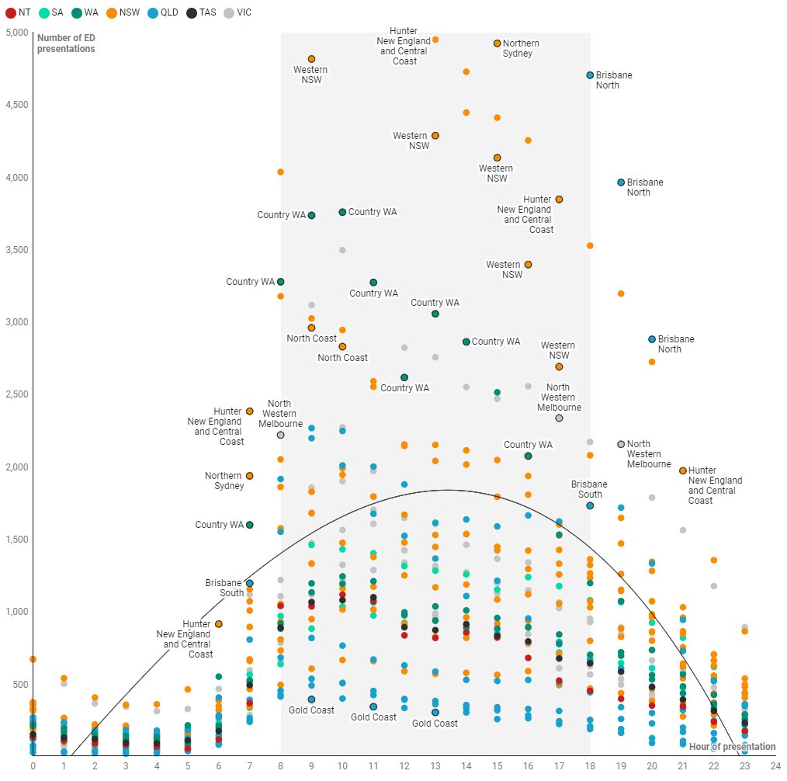
AIHW, Data Tables: Emergency Department Care 2022–23

Relationship between emergency department presentations and after hours primary care services
There is some evidence that improved after hours access to primary care reduces less urgent presentations to emergency departments (Jones et al., 2020). In this regard, some evidence estimated that between 7% and 40% of emergency department presentations could be avoided if patients had access to appropriate primary care services (Willson et al., 2022).
Nevertheless, the current evidence on the impact of particular models of after hours primary care on emergency department presentations is limited. Some studies have cast doubt over the premise that a significant proportion of lower-urgency emergency department presentations are, in fact, suitable for general practice care (Nagree et al., 2013; Wu & Mallows, 2023). A retrospective chart review of emergency department patients triaged as meeting the AIHW definition of lower-urgency concluded that 77.5% were in fact unsuitable for general practice care. This may be because the AIHW definition of lower-urgency does not consider the nature of the presenting condition(s), diagnostic requirements, or treatment pathways, resulting in overestimating the proportion of general practice-type patients in emergency departments (Wu & Mallows, 2023).
A systematic review by Hong et al. (2020), on the impact of improved access to after hours clinics on emergency department utilisation, found that generally, the introduction of after hours services does not automatically lead to reduced presentations to emergency departments. However, the study notes that the lack of impact observed by some studies may owe to these studies not categorising the conditions, and timing for presentations, which potentially hides the reduction of non-or semi urgent presentations due to the introduction of after hours services (Hong et al., 2020). Contextual factors such as location (rural and regional particularly), and coverage (i.e., existence of other after hours service), and service user biases may be important determinants for the impacts of after hours services on emergency department presentations (Hong et al., 2020).
For example, a study investigating the introduction of the Bathurst after hours GP clinic, the only after hours service in the Australian regional town of Bathurst, found that the availability of after hours clinics in a rural and regional area led to a significant reduction in non-urgent emergency department presentations (Payne et al., 2017). While the study found that the introduction of the after hours clinic made no difference in semi-urgent emergency department visits, 60% of participants highlighted they would have presented to emergency departments had the clinic not existed, while 27% would have postponed seeking health care services (Payne et al., 2017).
Similarly, another study found that introducing an after hours clinic in Wagga Wagga, a regional town in NSW, led to a statistically significant reduction in lower-urgency emergency department visits by 8.2% at any time of day, generally, and an increase in urgent emergency department visits by 1.6% (Buckley et al., 2010). The lack of coverage, including lack of any after hours service prior to the introduction of the clinics, was found to be an antecedent for most non-urgent presentations to emergency departments in the region (Buckley et al., 2010). Nevertheless, caution is drawn to the lack of generalisabilty of these findings as the studies focused on specific geographic regions.
A 2008 review found that telephone triage and advice call services, minor injury units and walk-in centres were most effective in reducing emergency department activity (Fry, 2008). Further to this, a 2013 review of healthdirect’s GP helpline concluded that the service had a modest but significant impact on health service utilisation by callers with reductions in emergency department usage as well as face‑to-face after hour primary care presentations (McKenzie et al., 2013).1F7F
Therefore, for the development of a coordinated health care system, it is important to note that while:
Improved access to after hours primary care may potentially shift patient care from the emergency department toward primary care in some institutional settings… stronger evidence of the effectiveness of improved access to after hours primary care is required. Policymakers must recognize the impact of the organization of the primary care and emergency department systems within the environment prior to implementing policies or changes to after hours primary care provision. – (Hong et al., 2020)

Unmet need
There is evidence that not all need is being met by the after hours system. The ABS Patient Experience Survey 2022-2023 indicated that a small but significant percentage (8.8%) of consumers needed after hours GP services. Of those, 37.8% reported that they did not see an after hours GP at all, while 62.2% saw a GP. 46.9% of respondents indicated that they did not see an after hours GP when needed on at least one occasion. Figure 14 illustrates the trend in the need for after hours GP services – and whether this need was met – as reported in the ABS Patient Experience Survey between 2013 and 2023.
Figure 14: Proportion of ABS Patient Experience respondents who needed to see a GP, 2013-2023
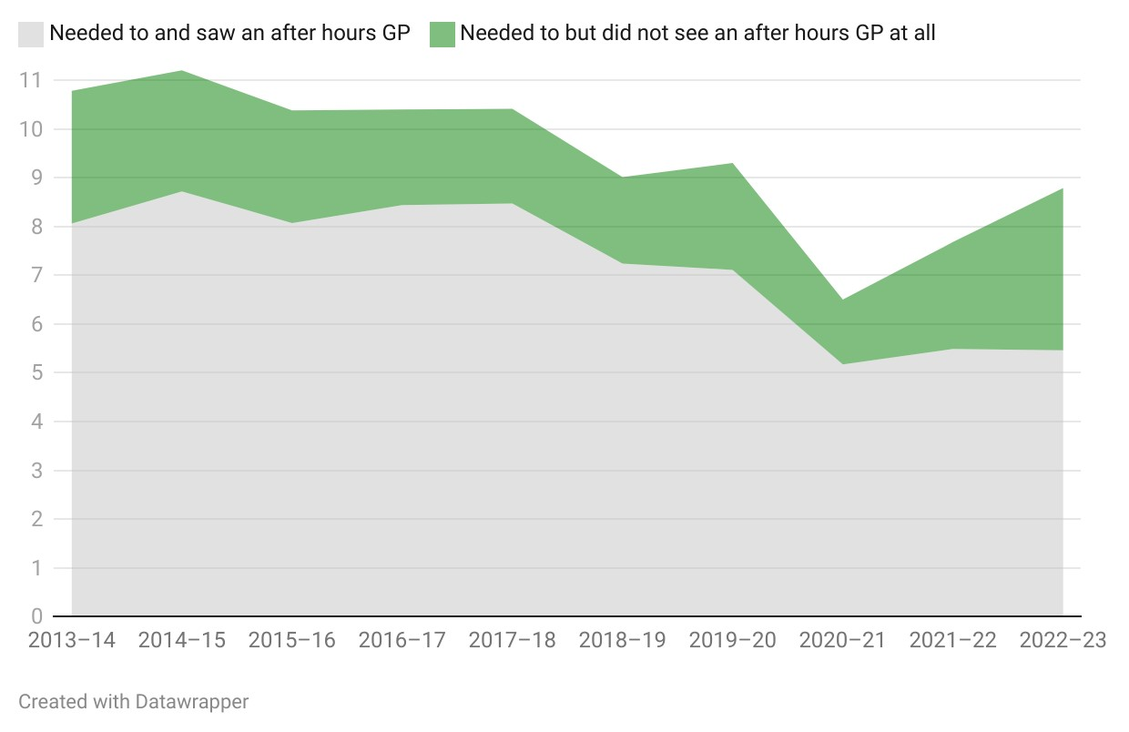
Source: Derived from Australian Bureau of Statistics, Patient Experiences 2022-23.
There is a perception amongst practitioners, workforce and sector stakeholders that consumer need and demand for after hours services do not align with what is actually available in their local communities. Practitioner and practice manager/owner survey respondents mostly agreed that there was a clear need for after hours services in their community. However, they were divided on whether their local communities’ needs were being met by the currently available after hours services (Figure 15). This is indicative of the current strengths and weaknesses of the after hours system across different jurisdictions, for example through the mixed availability of urgent care clinics and assorted telehealth services, and its ability to meet needs of specific population cohorts.8F

Figure 15: Practitioner and practice manager/owner perception of need for after hours services and whether this need is currently being met (n=194)
Survey text: The following questions focus on the need for after hours care in your community
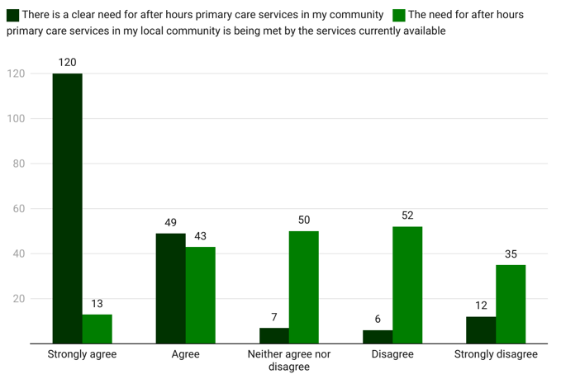 Source: Consultation Hub Survey (2024)
Several consumers and sector stakeholders recounted stories of people delaying or avoiding seeking care in the after hours period. As one chronic diseases sector stakeholder observed:
I would suspect there would be a large cohort of people [with chronic disease] who would choose not to access after hours care because they have that preference to just have that continuity of care with their local person. That's not great when… it's Friday afternoon to Monday morning, because a lot can go wrong in that time. – Sector stakeholder, interview.
The reasons that consumers do not obtain care when they need it are complex and vary across geographic locations, time of day, and population groups. There is some evidence that after hours services are not consistently available. For example, in some remote locations there may be no after hours primary care services and consumers have no alternative to attending the hospital. Similarly, alternatives to emergency departments diminish and become less available in the unsociable hours. In other locations and time of day, after hours services may exist but be inaccessible to many because demand outstrips supply. This is particularly the case in the 6:00 pm to 8:00 pm period.
Feedback from stakeholders and consumers indicates however that even where after hours primary care services are available, consumers may not attend them. Consumers experience a range of barriers, including a lack of knowledge of available services and how to navigate them, cost, stigma and discrimination, concerns about continuity of care and information sharing, lack of access to allied health services, wait times and accessibility. These are explored in detail in section 3.1.

Workforce
A key influence on the availability, accessibility, and effectiveness of after hours primary care is the primary care workforce. Australia, like many countries, faces significant challenges in meeting primary care workforce needs. These general trends in the number and distribution of GPs, nurses, nurse practitioners and other primary care workers are exacerbated by dynamics specific to the after hours period.

General Practitioners
‘General practice is at the heart of primary care provision’ (Department of Health and Aged Care, 2022a), and GPs are the predominant providers of after hours primary care. Australia is, however, facing a significant and well-documented shortfall in GPs (Department of Health and Aged Care, 2022a). GP full time equivalent staffing (FTEs) per 100,000 have decreased slightly across all states between 2019-20 and 2021-22, with NSW, VIC and QLD having the highest GP FTEs per 100,000 people, and the NT the lowest (see Figure 16).
Several factors have been identified as contributing to this trend. The Royal Australian College of General Practitioner’s (RACGP) Health of the Nation Report shows that fewer doctors are entering the Australian General Practice Training Program, with approximately 4 in 10 practising GPs likely to recommend their profession to junior colleagues. The report further shows that 64% of practising GPs are considering reducing the time they spend practising or are considering stopping practising altogether. Compliance burdens, burnout and workload issues, the ability to earn more elsewhere and other financial concerns, and the increasing complexity of general practice all feature as factors leading GPs to consider withdrawing from practice (Royal Australian College of General Practitioners, 2023). A 2021 Australian study found that GP registrars participate in their practice's after hours care roster in 48.6% of registrar terms, and that those working in regional, rural or remote practices, and those training in the rural pathway were the most likely to participate. Those at small or bulk billing practices were least likely to participate (T. Morgan et al., 2022).
Figure 16: GP FTE per 100,000 population by state and year
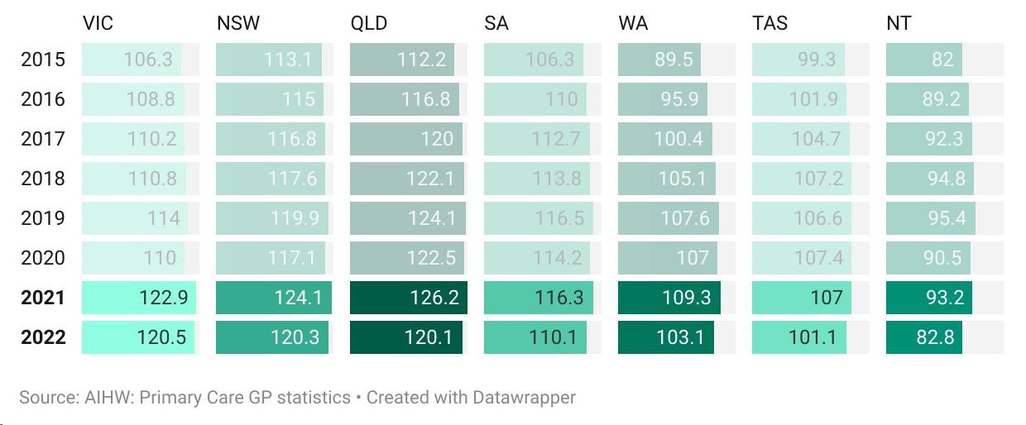
Source: AIHW, Data Tables: Primary Care GP Statistics by Calendar Year (2023)
There is some evidence that the overall trend towards a shortage of GPs may have a particularly large impact on after hours services. In Australia, GPs aged 60 years or older are more likely to provide after hours services than other age groups, and 63% of GPs aged 45 -65 say that they do not intend to work past the age of 65 (J. Baker et al., 2020). Over a third (38%) of practitioners responding to the Consumer Hub Survey indicated that in the next 5 years, they intend to decrease the amount of after hours work that they do. Less than 5% expressed an intention to increase their after hours work in that time. The proportion of GPs intending to reduce their after hour work load was substantially higher in rural and remote areas (Figure 17). Respondents provided a number of reasons for this, including workforce shortages related to a lack of willingness by some practitioners to do after hours work, burnout, insufficient funding, lack of after hours pharmacy and nursing support, and lack of recognition and support.
Studies in comparable jurisdictions such as the United Kingdom have found that the shortage of GPs in general, and the shortage of GPs engaging in after hours care specifically, has a significant impact on emergency department presentations and places increased burden on the wider health system (T. Morgan et al., 2022).

Figure 17: Practitioner 5-year intentions for after hours work (n=66)
Survey text: In the next five years I intend to:
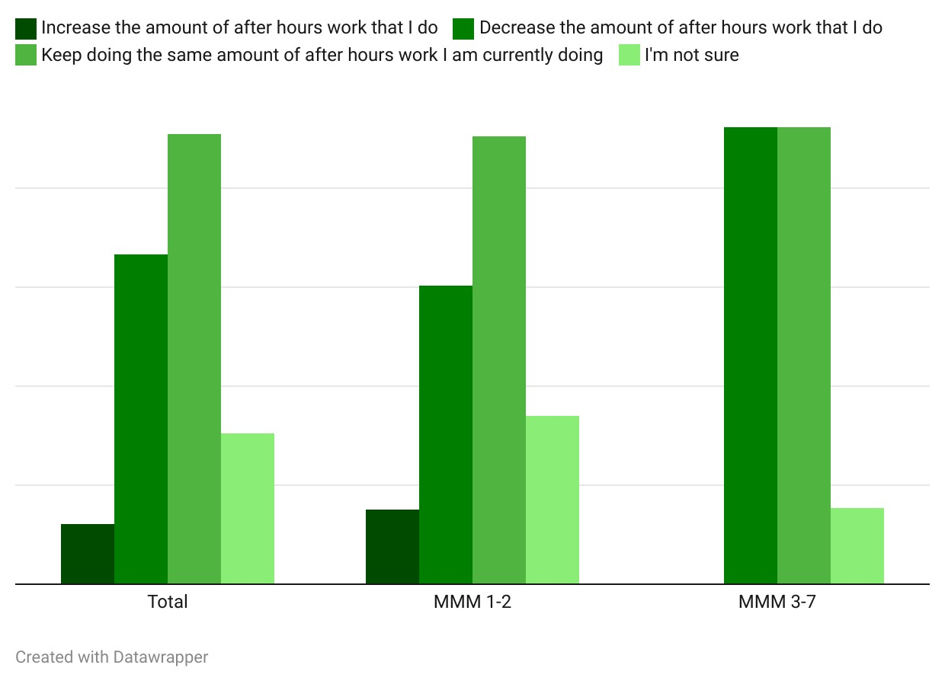Source: Consultation Hub Survey (2024)
Many of these issues are also identified in the National Medical Workforce Strategy 2021-2031 (NMWS) (Australian Government Department of Health, 2021). This recognises that an effective and efficient medical workforce requires a balance of doctors with varying scopes of practice across primary, secondary and tertiary care. It includes a range of actions that address imbalances in the scope of practice of some medical practitioners that currently favours subspecialisation, and seeks to shift the balance towards generalists. This includes growing the number of GPs and rural generalists, and increasing opportunities and recognition for doctors to supplement their skills and broaden their scope of practice. This may better enable doctors to adjust their scope of practice to meet changing service needs, and to work more effectively in regional and rural areas.
Improving doctor wellbeing is a cross-cutting theme in the NMWS. Burnout and dissatisfaction are increasingly recognised as ongoing causes of morbidity in doctors. Career uncertainty is also a major stressor for doctors in training. There are a number of actions in the NMWS that are directed at improving the wellbeing of doctors.

Medical Deputising Services
MBS data does not capture whether services are provided by MDSs or other practice type, making it difficult to obtain a clear view of the role which MDSs play in the after hours primary care landscape. It is clear from stakeholder input that MDSs are more likely to operate in metropolitan areas, where population density makes their operations more viable than in regional, rural and remote areas. Stakeholders also indicated that MDSs play an important role in providing face-to-face services to residents of aged care homes and supported accommodation (see section 3.2.2). MDSs and peak bodies suggested that MDSs play a particularly significant role in providing services in lower socioeconomic areas, where residents are more likely to have accessibility barriers (such as lack of transport, language or digital literacy barriers) and to require a bulk billing service.

The Approved Medical Deputising Service Program
The AMDS program enables non-vocationally recognised doctors to access some MBS items to provide after hours services on behalf of other doctors - while being subject to section 19AA of the Health Insurance Act 1973 (Cth).
In 2018, the Government introduced a suite of reforms to the AMDS program which had the effect of providing vocationally registered, and vocationally recognised GPs with a higher MBS rebate for urgent after hours visits, compared with non-vocationally recognised doctors working in metropolitan areas. Access to MBS items with high rebates for urgent after hours services was restricted. The changes were recommended by the Medicare Benefits Schedule Review Taskforce, which concluded that a growth in use of urgent after hours services appeared not to be driven by increasing clinical need for these services. Instead, it was shown to be driven by the entry of new businesses into the market with models which promote these services to consumers by emphasising convenience and no out-of-pocket cost (Medicare Benefits Schedule Review Taskforce, 2017). Stricter limits were also placed on advertising by MDSs directly to consumers. These reforms were followed by further changes in 2019, which further limited access to non-urgent after hours MBS items for non-vocationally registered doctors participating in the After Hours Other Medical Practitioners (AHOMPs) Program.
Since the reforms were implemented, the number of non-vocationally registered primary care doctors has dropped significantly (see Figure 18). Between 2015 and 2022, the number of non-vocationally registered GPs in Australia dropped from 5,295 to 1,632 – or a 69% reduction (Australian Government Department of Health and Aged Care, 2023). The drop in the number of non-vocationally registered FTE was even greater – an almost 75% reduction (Australian Institute of Health and Welfare, 2023b). Conversely, the number of GP trainees has increased, particularly since 2020. As part of the 2018-19 Stronger Rural Health Strategy, the Australian Government announced a $48.8m investment in the non-vocationally registered Fellowship Support Program to subsidise non-vocationally registered doctors to train to achieve GP Fellowship.
Figure 18: Number of trainees and non-vocationally registered GPs in Australia, 2015-2022
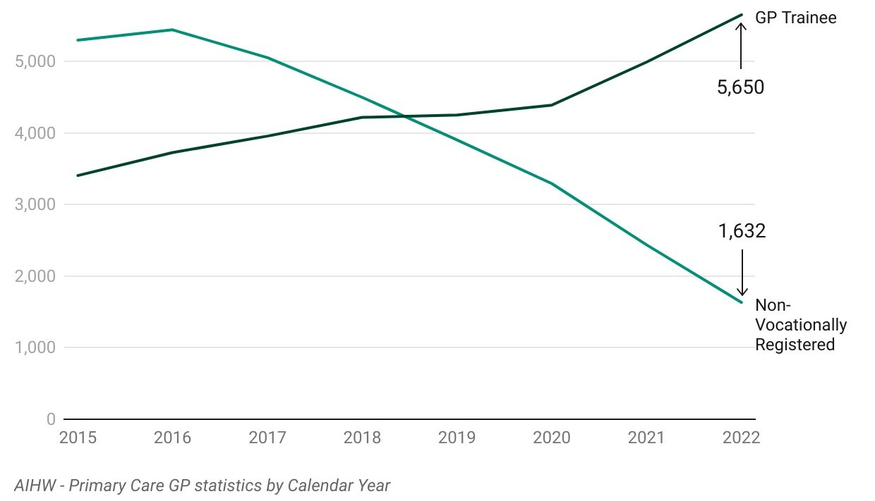
Source: Department of Health and Aged Care, Primary Care GP Statistics by Calendar Year (2023)
There was some feedback from MDS stakeholders that the changes to rebates for non-vocationally registered doctors means that after hours primary practice through MDSs is no longer financially competitive with other options, such as working as a medical officer in the hospital system. This is seen as compounding existing recruitment and retention challenges. In describing the mismatch between consumer demand and staffing, one stakeholder stated that their MDS is unable to answer 35-40% of the calls they receive from consumers. The same stakeholder expressed the view that the profitability and viability of MDSs has been compromised. Another stakeholder commented, ‘Workforce issues are dire, without a solution in sight.’
MBS data and stakeholder feedback illustrate the impact these changes have had on service provision. Expenditure on after hours services by non-vocationally registered practitioners has fallen by more than 63% since 2018-19. While there has been a general reduction in expenditure across all MBS categories except telehealth (which was introduced in 2020-21), the biggest impacts have been felt in expenditure on attendances in non-rural areas. Figure 19 displays the reduction in expenditure across different after hours services provided by non-vocationally registered doctors (described as medical practitioners or ‘MPs’ in the MBS).
Figure 19: Annual expenditure on selected after hours MBS items for non-vocationally registered doctor attendances, 2018-2023
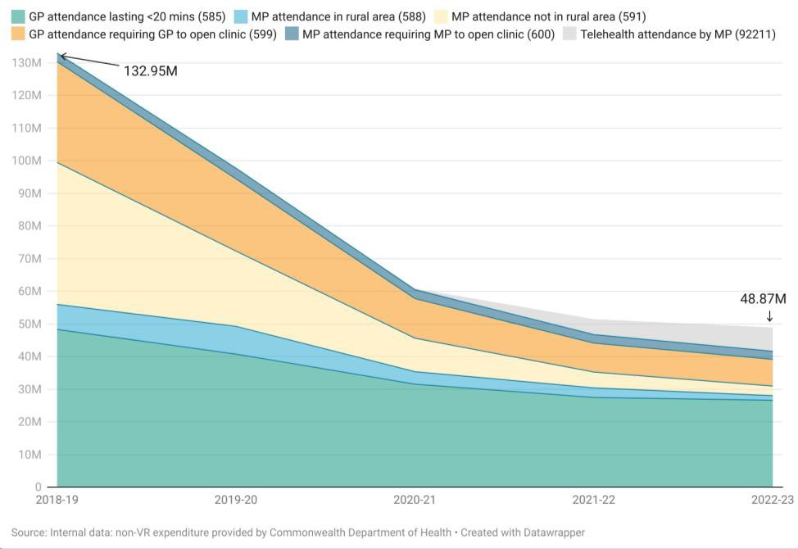
Source: Internal data provided by the Department of Health and Aged Care
While consumers and sector stakeholders did not generally refer to MDSs or AMDSs, several described the increasing difficulties of obtaining a home visit after hours. Consumers and stakeholders also provided mixed feedback about the quality of services received from MDS doctors. One consumer living with a chronic condition and carer to family members with complex needs spoke in positive terms about the responsiveness of the MDS which has visited her home to provide after hours services several times within the past year. The same consumer observed however that the same MDS had misdiagnosed her condition, after which she deteriorated and had to be admitted to hospital. Another stakeholder suggested that while MDSs have an important role to play in the after hours ecosystem, they did not feel that they are adequate for complex patients.

Nurses and midwives
Nurses, nurse practitioners, Aboriginal Health Workers and Aboriginal Health Practitioners are also vital to the delivery of after hours primary care in Australia. The proportion of nursing and midwifery FTE per 100,000 increased slightly between 2017 and 2022, with marked increases in the proportion of Aboriginal and Torres Strait Islander Health Workers and nurse practitioners. However, it is important to note that First Nations Australians are under-represented in the general health workforce (Lai et al., 2018).The proportion of nurses and midwives practicing principally in primary care dipped significantly during the Covid 19 pandemic and has not recovered (Figure 20).
Figure 20: Nursing and midwifery FTE per 100,000 population, 2017-2022
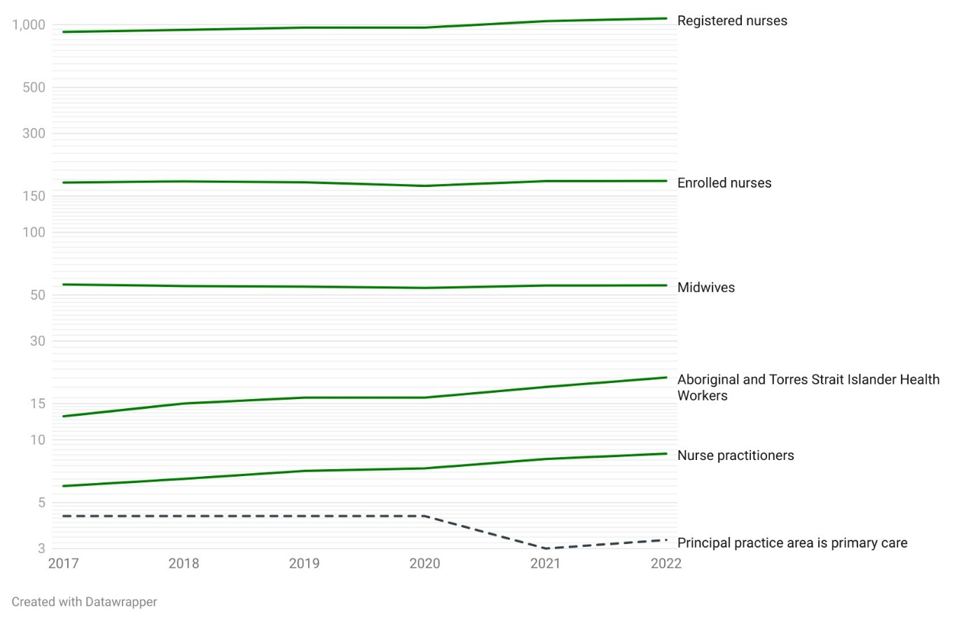
Source: The National Health Workforce Data Set
A number of workforce stakeholders described the regular hours and lack of shift work in primary care as a key drawcard for nurses and nurse practitioners. These same stakeholders nonetheless suggested that, with sufficient incentive, many nurses and nurse practitioners working in primary care would be willing to undertake after hours work. These stakeholders identified flexibility in working hours, effective multidisciplinary teams and support, and sufficient remuneration as central considerations for nurses when deciding whether to work in primary care after hours.
I think we need to be a little more open minded about what it is people are actually seeking and I think it's not necessarily time of day or even day of the week. Sometimes it's flexibility and shift length as well, and it's [having] a little bit more control over what you do and often people will step out of the hospital system into primary care because they have that. – Workforce stakeholder, focus group
I think it's more than just the hours you're working. I know it definitely comes into it, but it's a bit simplistic because as a nurse…, if you get value out of what you're doing, you don't care what time of day you're doing it… So if you're working with a really good team, multidisciplinary team, you've got those hours and they're set hours - which can be quite attractive for people too… – Workforce stakeholder, focus group
While weekly hours worked by GPs have decreased in recent years (in line with medical practitioners more generally), average weekly hours worked by nurses and midwives have increased, including for those working in primary care (Figure 21).
Figure 21: Weekly hours worked by GPs and nurses and midwives, 2017-2022
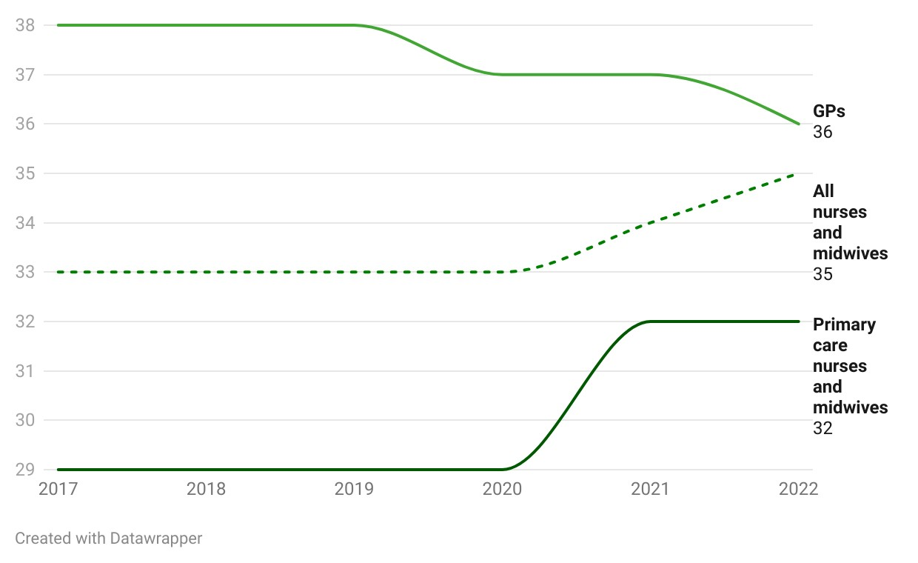
Source: The National Health Workforce Data Set

Allied health practitioners
The availability and accessibility of allied health services after hours is an important driver of consumer help-seeking behaviour, and is relevant to the effectiveness of the after hours primary care system. This is discussed in detail in section 3.1.12.
There is a paucity of data on after hours service provision by allied health workers. However, feedback from workforce stakeholders and consumers suggests that community pharmacies play an especially important role in the effectiveness of after hours primary care and in meeting consumer need, and that many already open beyond usual business hours. According to the Pharmacy Guild, 2,127 pharmacies are open after hours, including on weekends. This constitutes 36% of all community pharmacies in Australia (The Pharmacy Guild of Australia, 2024). There is also evidence that, while overall pharmacist numbers do not indicate a shortage, distribution of the workforce may be contributing to localised workforce shortages, particularly in rural and remote areas (Figure 22). 77% of pharmacists and 79% of medical radiation practitioners practice primarily in metropolitan areas, compared to 55% of GPs.
Figure 22: Pharmacy and medical radiation practitioner workforce, 2022
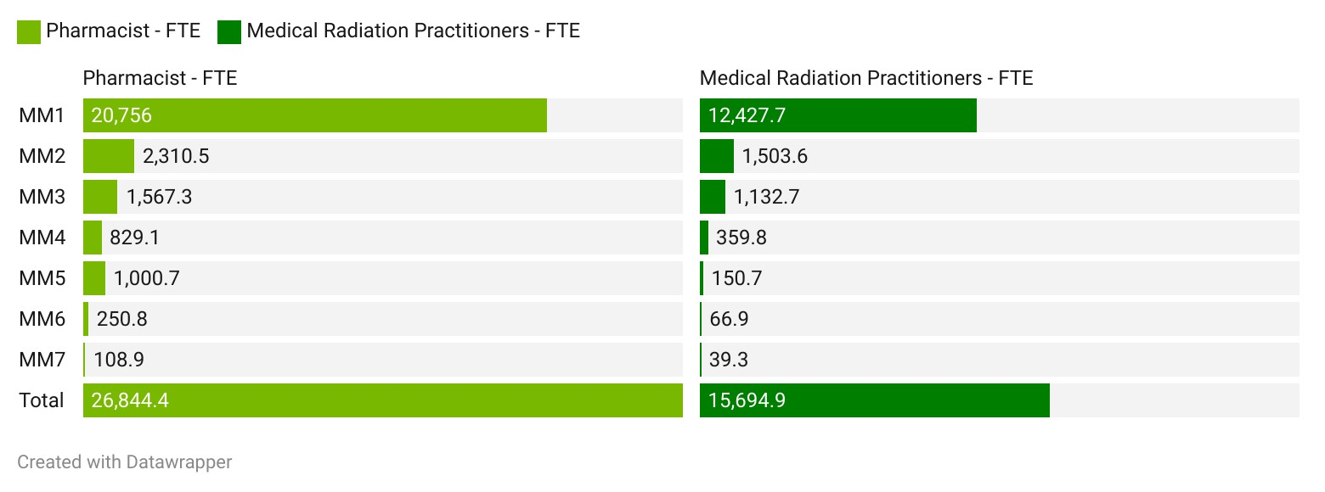
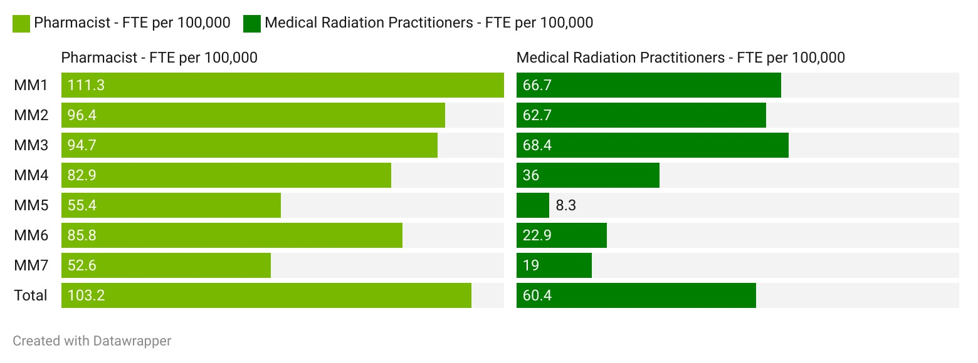Source: National Health Workforce Data Set, 2023
Similar to medical practitioners, pharmacists and medical radiation practitioners working in more remote areas work longer hours than their metropolitan counterparts (see Figure 23). This may impact their ability and willingness to increase their out of hours services. A 2021 systematic review of factors contributing to the recruitment and retention of the rural pharmacist workforce found that there are commonalities between pharmacists and other healthcare professionals (Terry et al., 2021). Motivators for pharmacists to work in rural areas are linked to the extent to which the setting caters to their individual and family needs, especially in terms of financial benefits, lifestyle, education and career development, recreation, and community support, as well as by enhanced practice scope and experiences, positive inter- and intra-disciplinary relationships (Terry et al., 2021).

Figure 23: Average total hours worked per week, 2023
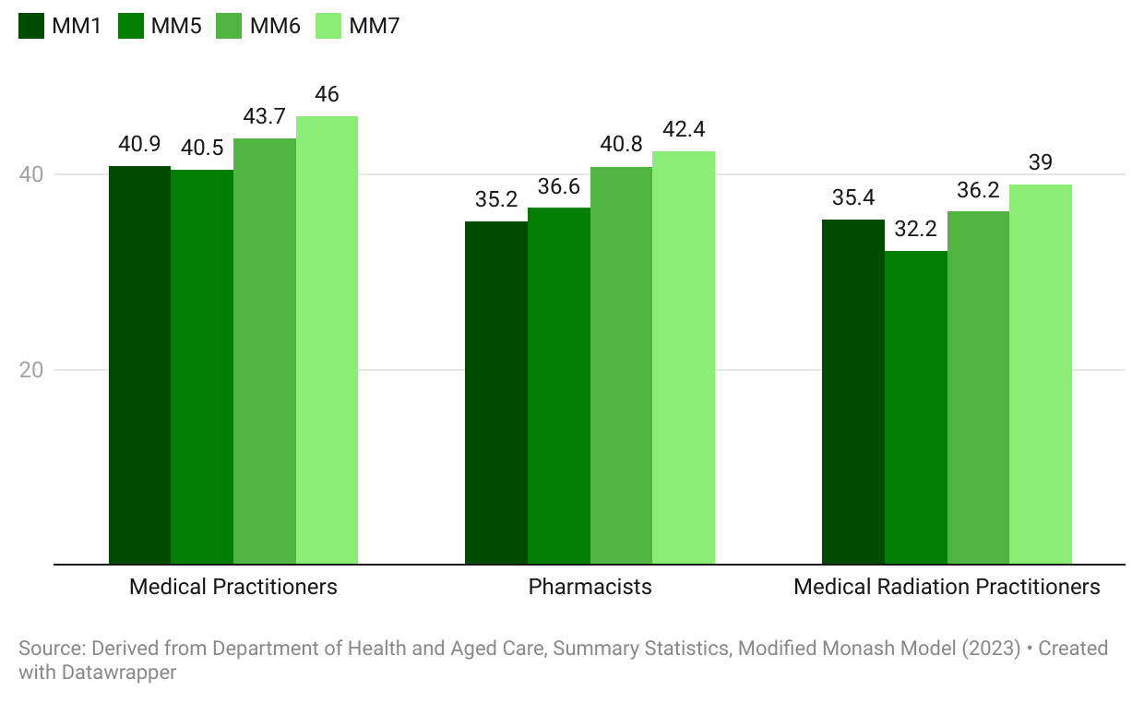 Source: Derived from Department of Health and Aged Care, Summary Statistics, Modified Monash Model (2023)

The role of multidisciplinary team-based care
It’s all GP centric. And I understand and respect the role of the GP. But we’re putting extraordinary pressure on that workforce. Extraordinary pressure on junior GPs... We hear it from RACGP and AMA all the time – the doctor is the lynchpin, the leader, the gatekeeper. But they don’t acknowledge that by keeping them in that position, we’re putting so much pressure on the profession that no one wants to do it anymore. – Workforce stakeholder, focus group.
Enabling all health care professionals to work to their full scope of practice will provide consumers with greater choice and access to after hours health care. – Workforce stakeholder, interview
Encouraging multidisciplinary team-based care is a focus of the Strengthening Medicare Taskforce and the Ngayubah Gadan (Coming Together) Consensus Statement (Department of Health and Aged Care, 2023a), and was posited by a broad range of stakeholders as a key to addressing some of the workforce challenges facing after hours primary care. Stakeholders articulated several advantages to better supporting the participation of a diverse health workforce other than GPs in after hours service provision, including nurses, nurse practitioners, midwives, pharmacists, allied health professionals, Aboriginal Health Workers and Aboriginal Health Practitioners, paramedics, and those with lived experience, among others.
These advantages included:
- reducing healthcare costs
- addressing workforce shortages
- increasing consumer access to culturally safe and responsive after hours health care and providing greater choice
- advancing health equity for vulnerable populations
- ensuring consumers receive appropriate and culturally safe care
- facilitating culturally safe and appropriate care where, for example, Aboriginal Health Workers and Aboriginal Health Practitioners are supported to provide after hours care.
These benefits align closely with those identified to date by the independent Scope of Practice Review currently underway (Department of Health and Aged Care, 2024).
Workforce stakeholders and practitioners also described the camaraderie, support, and enjoyment which many practitioners – including GPs – can derive from working as part of a team. These stakeholders suggested that after hours work can be isolating, lonely and high pressure, particularly for less experienced clinicians. Multidisciplinary team-based after hours practice has the potential to mitigate these disadvantages and increase practitioner job satisfaction.
We identified particular days/times where we got a lot of sports injuries – [we] got an advanced practice physio to join the team – absolutely brilliant. [We were] able to work seamlessly as a team – all learnt from each other. If you told me I could work in a team like that – it works so well. The opportunity to work in that environment again – I’d be there. I was able to deliver [a] consumer model of care – I could leave at the end of the day, knowing I felt good. These environments don’t exist in the current health system. – Workforce stakeholder, focus group
However, a clear theme to emerge from stakeholder consultation is that the current after hours system does not adequately support the diverse health workforce to participate fully in after hours service provision, and to their full scope of practice. Figure 24 illustrates the extent to which health practitioners responding to the Consultation Hub Survey agreed with the statement that the current after hours system supports practitioners other than medical practitioners to provide after hours services.
Figure 24: Practitioner and practice owner/manager perception of the extent to which the after hours system supports practitioners, other than medical practitioners, to provide after hours services (n=180)
Survey text: The current after hours system supports practitioners other than medical practitioners to provide after hours services:
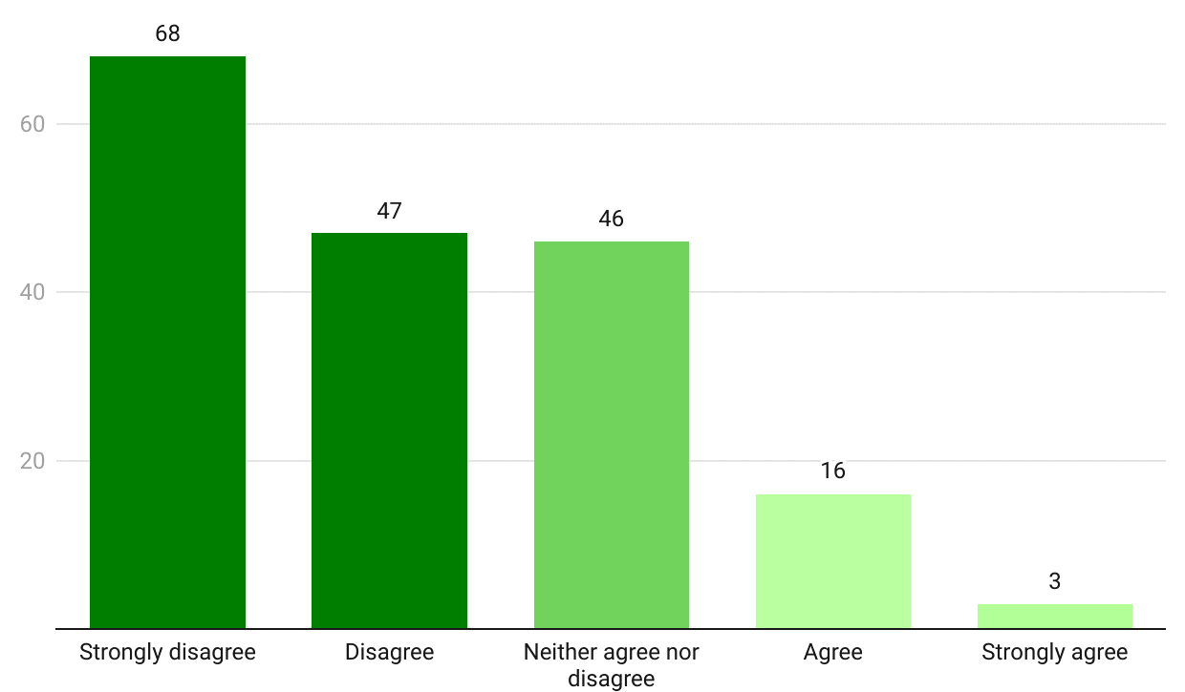Source: Consultation Hub Survey (2024)
Stakeholders identified that the primary barrier to harnessing the skills and capacity of the broader health workforce is the lack of financial incentives. As one stakeholder suggested:
Current funding and incentives are mostly supporting General Practitioners, and therefore almost exclusively, after hours services are GP dependent. – Workforce organisation, written submission
Funding mechanisms – including stakeholder feedback on incentivising a broader range of health professionals to provide after hours services – are discussed in section 2.5. Several other factors which could support effective multidisciplinary team-based care in the after hours period were also identified by stakeholders. These include the removal of regulatory barriers, improved information sharing, and enhanced education and professional development for clinicians and support staff in leadership, teamwork, cultural safety and clinical skills necessary for after hours care. Some stakeholders also called for expanded procedural items and prescribing by nurse practitioners and registered nurses.
While there was broad consensus across stakeholders in favour of multidisciplinary team-based after hours primary care, a variety of views were expressed about what these models of care should look like. Specifically, there was mixed feedback on the appropriate centrality of GPs and the scope afforded to other health professionals including nurse practitioners, nurses, and allied health practitioners. Some stakeholders envisaged greater support for nurses and nurse practitioners working within general practice to undertake triage, support patient self-management, and treat minor cuts, abrasions, bruises, lesions or burns or illnesses. This view placed GPs at the centre of any multidisciplinary team. According to one stakeholder:
GPs and general practices must be incorporated into any service offering care after hours. Best practice multidisciplinary care teams include GPs working alongside other healthcare professionals to optimise patient outcomes. – Workforce stakeholder, focus group
At the other end of the spectrum, several stakeholders advocated for greater autonomy for non-medical professionals in the provision of after hours care, including through the expansion of nurse- and nurse practitioner-led services such as urgent care and walk-in clinics. One recent study suggests that nurse-practitioner led services could help reduce the burden on rural and remote GPs and improve health outcomes overall. However, some caution was highlighted in relation to integrating this model into the complexities of the rural context (Wilson et al., 2021).
Several stakeholders suggested consideration of hub and spoke models of care – whereby non-medical health care professionals provide face-to-face care with access to GPs or other medical practitioners via telehealth where the circumstances are outside the treating professional’s scope of practice. One stakeholder emphasised that the holder of liability must be clear, and clinical governance robust.
An independent Scope of Practice Review, led by Professor Mark Cormack, is currently underway. The review is examining the barriers and incentives for primary health care professionals working to their full scope of practice and will provide its report and implementation plan to the Government in October 2024. The outcomes of the Scope of Practice Review will be relevant to the issues raised in this section.

Barriers to after hours service provision
The literature and consultation with primary care practitioners reveal a range of financial and non-financial factors which act as barriers to practitioners undertaking after hours work or increasing their after hours workload. Lifestyle factors (including work life balance and caring responsibilities), the financial returns of after hours work, and the impact of after hours work on employment in usual hours are key factors. Feedback from practitioners through the Consultation Hub Survey suggested that these factors interact in complex ways – and practitioners are often weighing them to reach an equilibrium which works for them at a given point in time (see Figure 25 and Figure 26).
Figure 25: Reasons practitioners choose not to do after hours work (n=41)
Survey text: I choose not to do after hours work because (Rank 1 being most important).
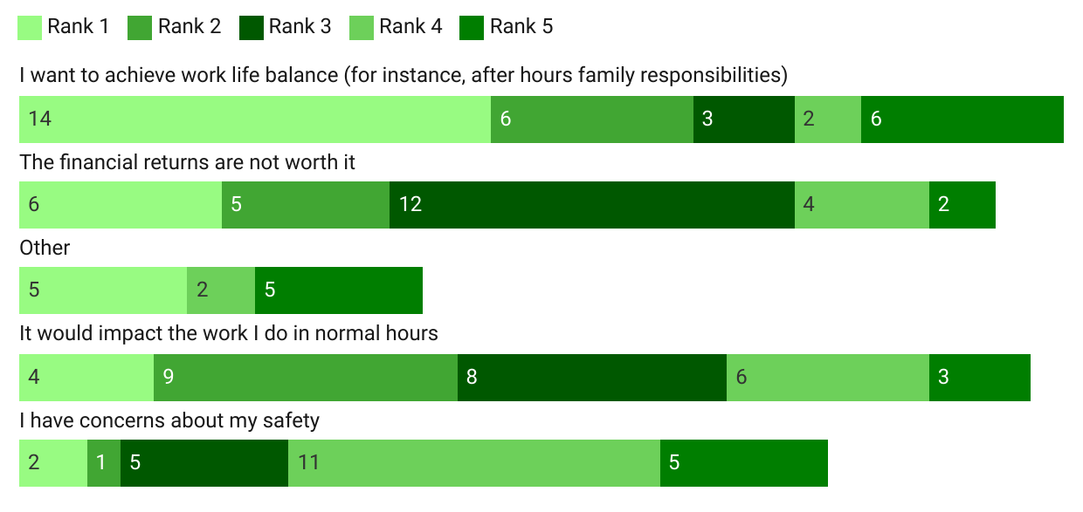Source: Consultation Hub Survey (2024)
Figure 26: Reasons practitioners currently doing after hours work do not do more (n= 59)
Survey text: The most important factors preventing me from doing more after hours work are (Rank 1 being most important).
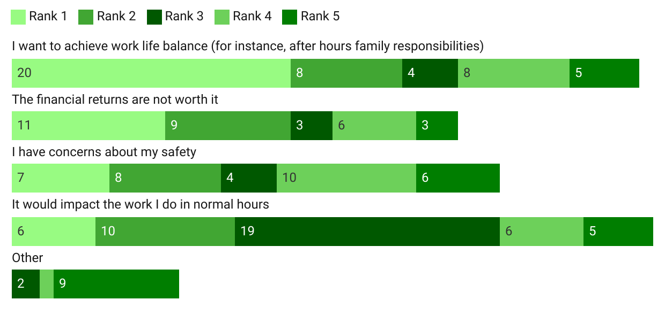Source: Consultation Hub Survey (2024)

Work life balance
The Consultation Hub Survey and feedback from workforce stakeholders identified lifestyle considerations as a key barrier to practitioners undertaking after hours work. This feedback is consistent with the findings of previous reviews, which have proposed that changes in the profile and attitudes of the general practice workforce present additional challenges for after hours service provision (Armstrong et al., 2016a; Health Policy Analysis, 2020).
The PHN and Deeble Reviews suggested that there is a growing focus on work-life balance and reluctance to commit to a traditional 24-hour care model, particularly among younger doctors (Armstrong et al., 2016a; Health Policy Analysis, 2020). This is reflected in research undertaken by the RACGP, which identified ‘anticipated regular hours and quality of life’ as the primary motivating factor among pre-fellowship doctors and new fellows for choosing to become a GP, with ‘ability to balance family and career’ ranking second among these cohorts (The Royal Australian College of General Practitioners (RACGP), 2018).9F
While the trend across all medical practitioners has been a decline in the average of weekly hours in recent years, this has been more pronounced among GPs (Figure 27).
Figure 27: Weekly hours worked by GPs, 2017-202310F
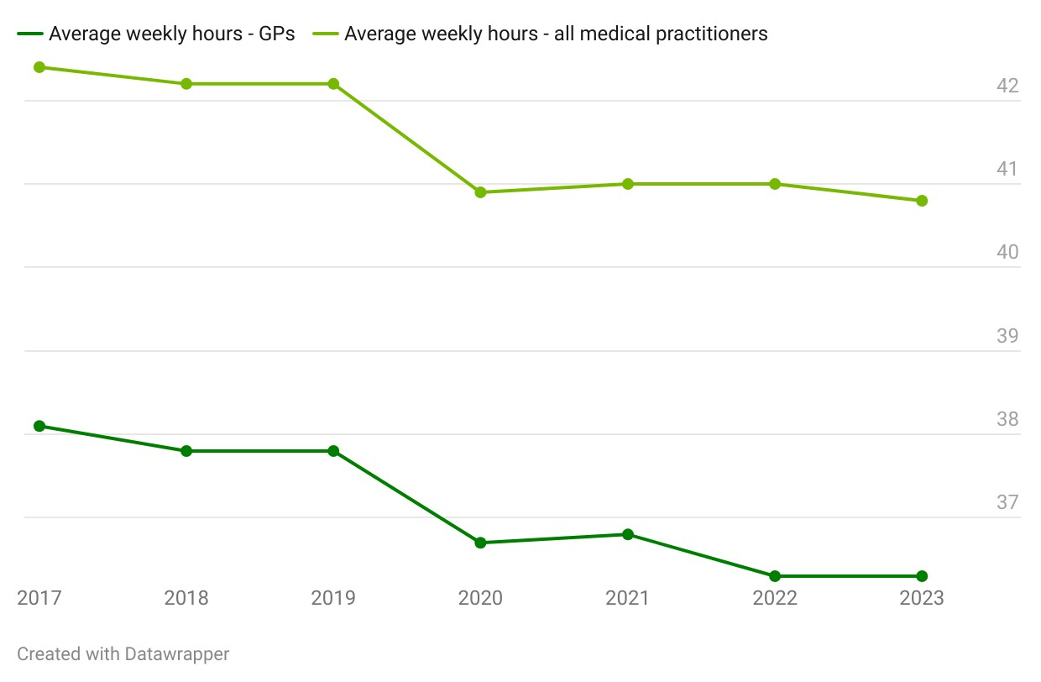
Source: National Health Workforce Data Set (2022)
Caring responsibilities, and a desire to spend adequate time with family, were frequently cited as a reason for not doing any – or more - after hours work. As one practitioner stated in the Consultation Hub Survey, ‘I have two young kids and I value my family time - this has greater value to me than any financial remuneration for out of hours work at this stage in my life.’
There is some evidence of a gender dimension to this trend. GP work hours have decreased in recent years, a trend the Deeble Review attributes to women working part time (Armstrong et al., 2016a). Female practitioners responding to the Consultation Hub Survey were 7 times more likely than their male counterparts to identify the desire to achieve work-life balance as the number one factor preventing them from doing more after hours work (see Figure 28). Research supports this notion, finding that female GPs’ probability of providing after hours care is reduced by childcare responsibilities while there is no such effect on male GPs (Broadway et al., 2016).
Figure 28: The most important factors preventing practitioners from doing more after hours work, by gender (n=59)11F
Survey text: The most important factors preventing me from doing more after hours work are (select up to three).
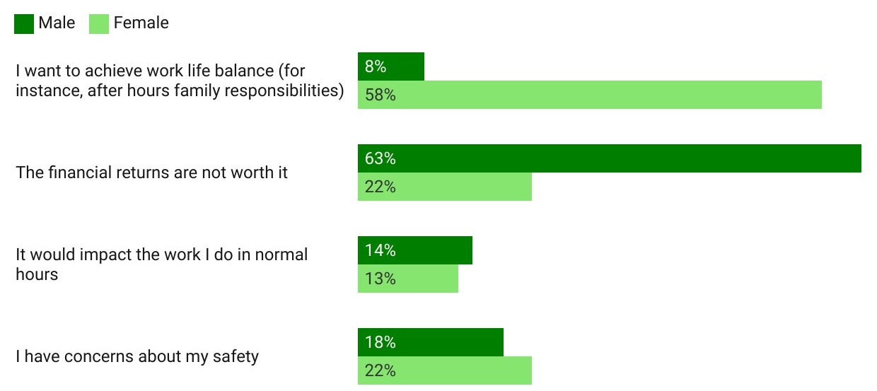
Source: Consultation Hub Survey (2024)

Financial returns
In the Consultation Hub Survey, practitioners identified inadequate financial returns as the other key barrier to doing after hours work. An insufficient value proposition for GPs and practice owners, along with insufficient incentives for other health professionals, emerged as the main concerns. After hours primary care funding mechanisms are discussed in detail in section 2.5 of this report.

Safety
Several workforce stakeholders, practice managers/owners and practitioners raised the heightened risks facing service providers and their staff in the after hours period as a barrier to delivering after hours services. According to one stakeholder:
After hours is just a very different environment and there's definitely a lot more aggression... So, there is a massive safety factor. – Workforce stakeholder, interview
Several stakeholders identified that emergency departments have a range of measures in place to manage risks to safety, and that these measures are not generally in place in primary care environments. The need to roster on additional staff (to ensure staff are not working alone) and/or contract dedicated security – and the costs associated with these measures – were identified as disincentives for practices to operate in the after hours period.

Impact on service provision in usual hours
Some stakeholders also raised the potential for after hours service provision to impact a practitioner’s capacity to provide services in usual hours. One practitioner stated that, ‘I am already fully booked during the day. If I worked after hours I would have to cut down my normal hours, which would simply shift the same total amount of patients from one time to another.’ A small number of stakeholders suggested that this is a particular consideration in locations where the supply of practitioners is especially limited, such as some rural and remote areas.
There are only so many hours in the day. It's usually family life commitments and having to work the next day in another role that prevent me from taking on more after hours work. – Practitioner, Consultation Hub Survey

The rural and remote primary care workforce
Capturing an accurate snapshot of the after hours workforce landscape (or landscapes) in rural and regional Australia is complicated by data gaps and the variety of service providers, models, and funding arrangements in place. In addition to medical practitioners (in particular GPs and Rural Generalists), advanced care nurses, nurse practitioners, Aboriginal Health Workers and Aboriginal Health Practitioners, the Royal Flying Doctor Service, and paramedics may all play important roles in delivering after hours primary care in some rural and remote settings.
Nonetheless, there is strong evidence that workforce maldistribution means that the workforce pressures experienced across the after hours primary health system are exacerbated in regional, rural, and remote parts of Australia (Australian Government Department of Health, 2021; Australian Institute of Health and Welfare, 2018; NSW Rural Doctors Network, 2022). There are proportionally fewer GPs working in small rural towns and remote areas of Australia than in metropolitan and regional areas (Figure 29), and most students graduating from rural clinical schools are most likely to quickly relocate to metropolitan areas. In 2022, there were 65.4 full time equivalent (FTE) GPs per 100,000 in very remote areas, in comparison to 119 FTE per 100,000 in metropolitan areas (Australian Institute of Health and Welfare, 2023a).
Figure 29: GP FTE per 100,000 population by MMM area, 2015-2022
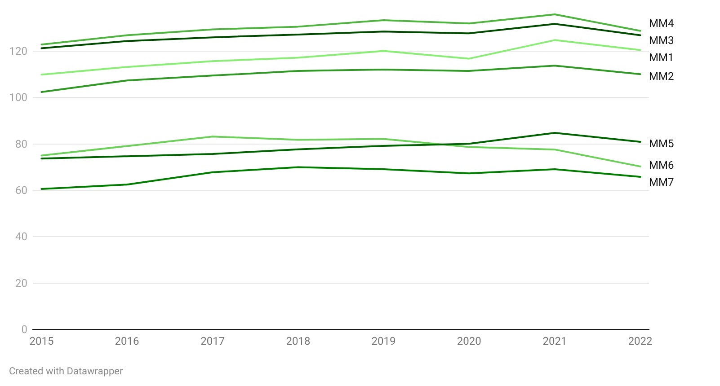
Source: Derived from AIHW data on the primary care GP workforce 2015-2022
Figure 30 illustrates the distribution of GP FTE across Australia, with significant swathes of the country covered by a very low concentration of GP FTE (fewer than 20 within the PHN).
Figure 30: GP FTEs by Local Government Area, 2022
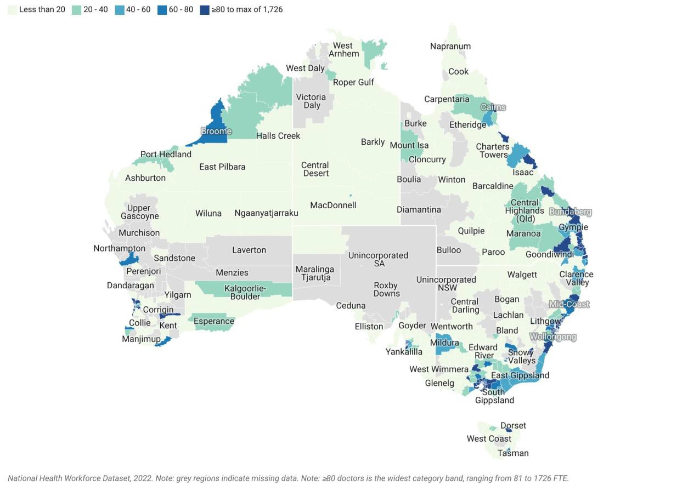Source: National Health Workforce Dataset, 2022. Note: grey regions indicate missing data. Unincorporated areas have no direct local government.
The picture is slightly different for nurses and midwives. Nurse and midwife FTE per 100,000 population is highest in regional centres and rural towns, and higher in remote and very remote communities than in metropolitan areas. However, it is noteworthy that an increase in the overall ratio of nurses and midwives since 2020 has been driven by increases in MMM 1-3, with the rate of increase modest in remote and very remote areas (Figure 31).
Figure 31: Nurse and midwife FTE per 100,000 population by MMM, 2017-202212F
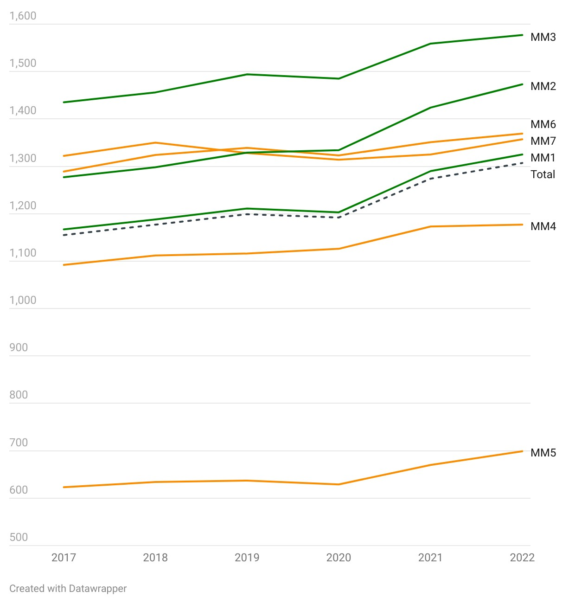Source: Derived from the National Health Workforce Data Set
Stakeholders contended that rural practice differs from general practice in metropolitan areas in ways which impact the after hours workforce. A 2008 Australian study found that models of rural and remote primary care may include virtual outreach services, outreach services, comprehensive primary health care services, integrated services, and discrete services (Wakerman et al., 2008). In the after hours context, discrete services include GP clinics, nurse-led clinics and primary care delivered at and through rural hospitals. These are complemented by virtual outreach services such as the healthdirect GP helpline, comprehensive services including those provided by Aboriginal Health Services, and outreach services such as hub-and-spoke, visiting, and fly-in, fly-out services (including a range of services provided by the Royal Flying Doctor Service).
Nonetheless, after hours primary care in rural Australia is heavily reliant on the services of local GPs (including GPs on call, GP cooperatives, and GPs in emergency departments), alongside other health workers such as registered nurses and Aboriginal Health Workers and Aboriginal Health Practitioners who may liaise with, and escalate to, GPs. A recent study found that GP registrars in regional and remote practices are over 50% more likely to participate in their practice’s after hours roster than their metropolitan peers, and those registrars training on the rural pathway are also more likely to participate (T. Morgan et al., 2022). Rural and remote emergency departments are often staffed by local GPs, meaning they play dual roles in the after hours system. This, together with the ongoing maldistribution which is resulting in health workforce shortages in rural and remote communities, means that providing essential after hours services place a significant additional burden on these practitioners. Moreover, the way in which practitioners are remunerated for this work can vary across jurisdictions depending on the interaction between Australian Government and state-based funding systems. This dual role was identified by some workforce consumers as a central consideration in the design of after hours primary care policy in rural and remote areas.
I work in MMM 5-7. These regions are too far away from big hospitals NOT to have GPs covering the after hours work. – Practitioner, Consultation Hub Survey
In country areas, fewer and fewer GPs are providing after hours services to their patients. In years gone by, people living in South Australian country towns had an expectation that they would be able to receive after hours medical care from their local GPs in their local hospitals. In rural SA, it has become harder and harder to recruit GPs to work in rural communities which means that there are fewer GPs providing after hours services. Those that have continued to do so are getting burnt out or retiring because of age. There are fewer (if any) of the old school multi-skilled GPs who could set a fracture or take out an appendix. Patients often have to travel to Adelaide for these services. – Practitioner, written submission
In addition to the varied models of care, stakeholders also reported that rural and remote GPs typically have a heavier and more complex workload than their urban counterparts. They often work in resource limited circumstances; and are called upon to make decisions in professionally isolated situations across the whole scope of primary care. Indeed, due to the depth of issues in rural and remote settings, they have been identified as appropriate settings for localisation and implementation of reform options (Department of Health and Aged Care, 2024).
In rural, you're everything… You're the hospital emergency doctor, you're the GP on call, you're also the obstetrician after hours… So the after hours work, whether it's procedural or emergency or the GP type presentations, it also has a flow on impact… because, if you're at a delivery from 2 o'clock till 7 o'clock in the morning, chances are you're going to have to go to bed and therefore you can't see patients and you lose money. – Workforce stakeholder, interview
As remoteness increases, so do the hours worked by GPs (see Figure 32). Combined with changing GP expectations on work-life balance, these factors may make both after hours work and work in rural and remote areas less appealing.
Figure 32: Average total hours worked per week by GPs by Remoteness Area, 2015-2020
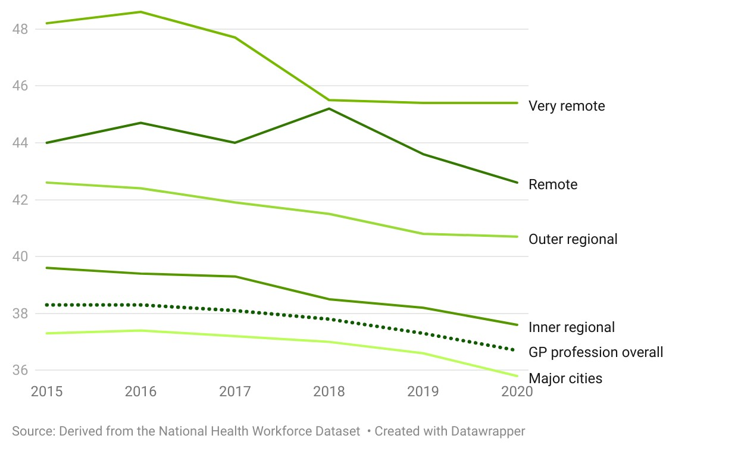Derived from AIHW data on the primary care GP workforce 2015-2022
Rural and remote practitioner and practice owner/manager respondents indicated that they face the following challenges in providing afters hours services:
- geographic isolation
- workforce shortages including resulting staff burnout and lack of nursing support
- lack of funding and restrictions around claims on PIP payments
- lack of security
- lack of pharmacies
- inability to deal with certain medical presentations relative to service capabilities.
Stakeholders identified several measures to ameliorate the workforce challenges in regional, rural and remote areas and improve after hours primary care availability. These included:
- enhanced support for the Rural Generalist model of practice, in which doctors are specifically trained and assessed to work in rural and remote, low resource environments and provide a scope of practice which extends beyond office based general practice to afterhours care, emergency care, and other areas or secondary and other advanced specialised care. The value of the Rural Generalist model and the pathway for its development were articulated by the National Rural Generalist Taskforce in 2018 advice to the National Rural Health Commissioner (National Rural Health Commissioner, 2018).
- extending Council of Australian Government exemptions to funding restrictions related to section 19(2) of the Health Insurance Act 1973 (Cth) to include additional sites recognising that the only option available for many regions without access to primary health services within a reasonable distance is to receive primary health care in an emergency department or outpatient clinic; alternatively, section 19(2) exemption arrangements may be tied to health practitioners (for example., a Rural Generalist), rather than assigned to a specific practice or facility, to increase the flexibility of providing health care services across different settings. Currently, section 19(2) precludes state and territory funding for health services claiming Medical Benefits for non-admitted, non-privately referred services delivered in hospitals, multipurpose services and community clinics.
- expanding the Single Employer Model trials, which support GP trainees by providing them with a single employer arrangement throughout their training rotations. This allows them greater access and accrual of employment entitlements (such as personal leave, recreation leave and parental leave), and provides increased certainty of training arrangements.

Funding
The Australian Government funds after hours primary care services through a variety of fundings streams, including after hours MBS items, the After Hours Practice Incentive Payment, and the PHN After Hours Program, funding to support the healthdirect helpline and GP helpline, and funding to support Medicare Urgent Care Clinics. State and territory funding for hospitals and community health also plays a role in the after hours primary care landscape.
Figure 33: Government funding snapshot

There was a strong view among workforce stakeholders, practice owners / managers and practitioners that current funding arrangements do not reflect the true costs of providing after hours care, are insufficient to support a sustainable workforce and accessible care, and lead to the imposition of large out-of-pocket costs on consumers.
Figure 34: Practice owner/manager perception of the effectiveness of current funding arrangements (n=183)
Survey text: Overall, the current funding arrangements for after hours care are effective in supporting me to deliver after hours services which meet the needs of my community.
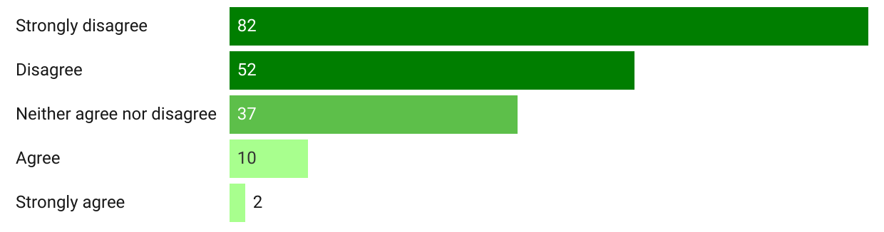Source: Consultation Hub Survey (2024)
Stakeholders suggested that current MBS and After Hours PIP settings do not adequately incentivise GPs and practices to operate in the after hours period, and that this is exacerbated by factors specific to after hours service provision, and by broader financial pressures. Many stakeholders identified the design of current incentives and remuneration as a key barrier to the participation of health workers other than GPs in after hours service provision.
Addressing the effectiveness of financial arrangements for after hours primary care services requires a comprehensive approach that considers the unique challenges faced by practitioners and communities across different regions. By implementing targeted strategies and making appropriate adjustments to reimbursement mechanisms and incentive programs, policymakers can better support a broader range of practitioners in delivering high-quality after hours care. – Workforce organisation, written submission

Funding for practices
The incentives aren't big enough for the practices as small businesses […] to want to keep their doors open to pay for the additional costs that are involved in providing that care. – Workforce stakeholder, interview
Stakeholders indicated that current funding settings, combined with workforce and other challenges, mean the value proposition for practices to operate in the after hours period is lacking. While insufficient revenue through after hours MBS items and the After Hours PIP were identified as the primary issues, compounding factors were identified including penalty rates, payroll tax, and increased overheads. More generally, stakeholders indicated that shrinking margins for practices across all hours, driven by increasing costs (of staffing, medical supplies, consumables, rent, accreditation, and insurance) make after hours practice even less viable. In its written submission, one after hours service provider indicated that:
… most clinics have ceased most after hours services. [Our clinic] remains open given our mission; but observe it is 5x less profitable to operate after hours services. – Service provider, written submission
Several workforce organisations and practitioners also voiced concern that the fragmentation of funding across the after hours landscape could distort demand across services and across times of day. This concern was specifically raised in relation to Medicare UCCs, which workforce organisations and practitioners commonly identified as enjoying advantageous funding arrangements.
Some stakeholders also cautioned about the risk of displacing demand from usual hours into the after hours period if bulk bulk billing options become easier to access than in usual hours.
the risk of potentially increasing demand and utilisation for bulk billed services in the after hours time period as the availability of bulk billed services in the ‘in-hours’ period is eroded. – Workforce stakeholder, interview

The After Hours PIP
The After Hours PIP is designed to support general practices to provide their patients with appropriate access to after hours care. There are 5 payment levels available, depending on the level of after hours care being provided and the arrangements in place. Some payment levels don’t require the practice to provide care themselves if formal arrangements exist for patients to access care through a third party, such as through a MDS. A summary of After Hours PIP levels and arrangements is provided at Appendix C.
Stakeholder feedback on the After Hours PIP was mixed. Several stakeholders discussed the important role which the After Hours PIP plays in supporting general practices; with one observing:
Practice Incentive Payments do keep GP practices engaged. In our observation, many GPs factor the PIP into their budget planning. That said, many will also seek to do the bare minimum in order to satisfy the PIP requirements. – Workforce stakeholder, interview
More stakeholders – including from practice owners and managers – suggested that the After Hours PIP could be more effective in incentivising more active and better distributed after hours service provision. As one stakeholder observed:
I don't think the incentive is enough for people to want to keep their doors open. – Workforce stakeholder, interview

Figure 35: Practice owner/manager perception of the effectiveness of the After Hours PIP (n=90)
Survey text: The After Hours PIP is effective in supporting me to deliver after hours services which meet the needs of my community.
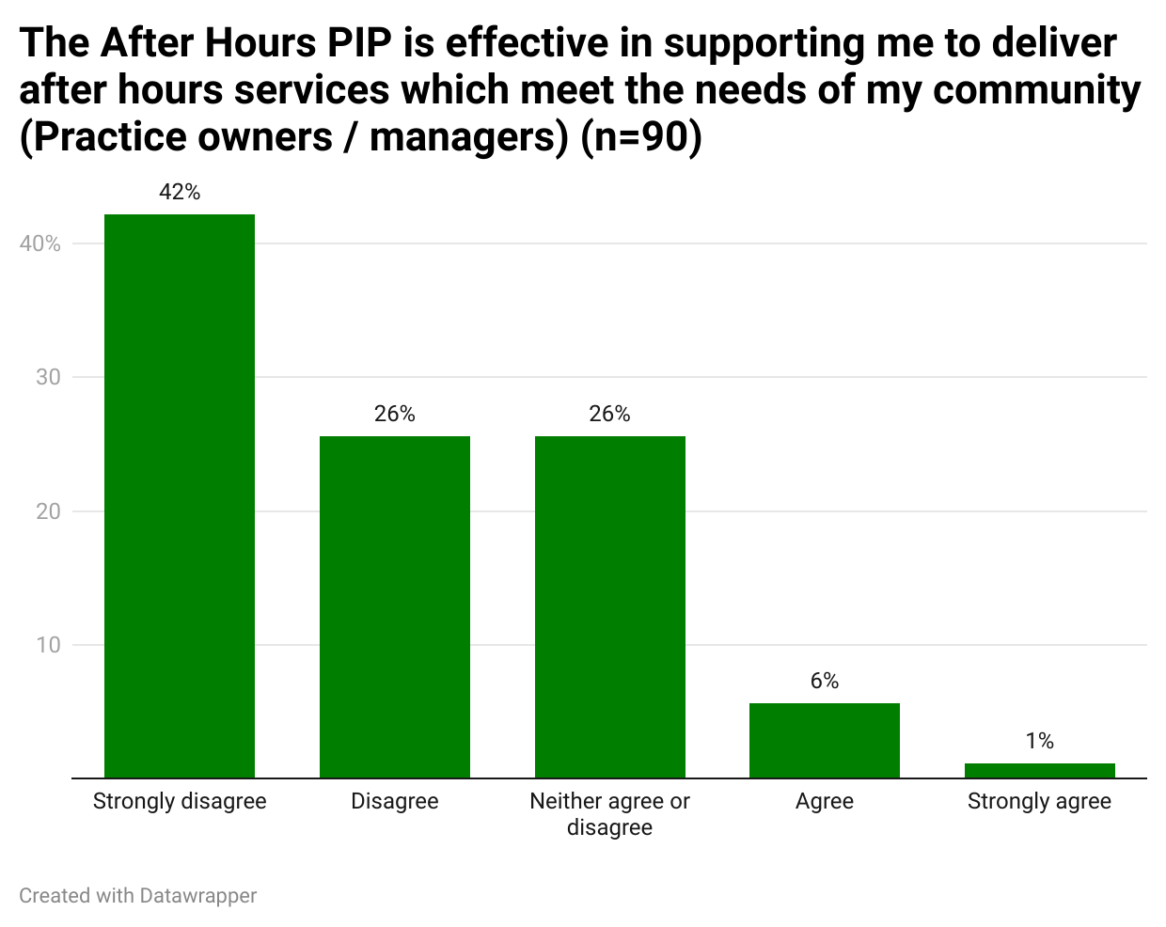Source: Consultation Hub Survey (2024)
Alongside general feedback that the value of the payments is inadequate to offset after hours costs, stakeholders also provided feedback on 3 key aspects of the design of the After Hours PIP, which are discussed in further detail below:
- the After Hours PIP is not fit for purpose in rural and remote areas
- the structure of payment levels warrants reconsideration
- the target of the incentive is unclear.

The After Hours PIP is not fit for purpose in rural and remote areas
The After Hours PIP was seen by multiple stakeholders as disadvantageous to small practices and regional, rural, and remote practices. The Deeble Review contends that financially, rural practices are at a disadvantage as it costs more to run clinics in isolated regions, and it is more difficult to attract quality staff. This makes rural practices especially dependent on purpose-specific after hours funding supplementation and incentives (Armstrong et al., 2016a). However, several stakeholders considered that the use of the Standardised Whole Patient Equivalent (SWPE) as a basis for funding leads to greater payments for larger practices. In rural practices, the smaller number of GP FTE leads to lower SWPEs (Neil et al., 2016). Lower population density may also lead to fewer after hours services (or patchy demand), meaning lower revenue through MBS. One stakeholder observed that:
Practices that have limited patient activity are at a disadvantage even though the GP/[rural generalist] has to commit to the same period of time of availability. – Workforce organisation, written submission
The distinction between cooperative arrangements and single practice service provision was also regarded as disadvantaging rural practices. The view was advanced by more than one stakeholder that often the only way for smaller rural practices to provide service coverage is to act cooperatively. In reality, an individual doctor working through a cooperative may be providing a greater share of after hours services on the cooperative’s roster than a doctor working in a single large practice. However, in these circumstances the doctors working in the cooperative are precluded from accessing the highest level of PIP payments.
It is possible that these factors have contributed to lower uptake of higher level PIP payments in rural and remote areas than in metropolitan areas (Figure 36), suggesting the After Hours PIP is not working as effectively as intended in these areas.
Figure 36: Proportion of After Hours PIP practices in tiers 4 and 5 by RRMA, May 2023 – April 2024
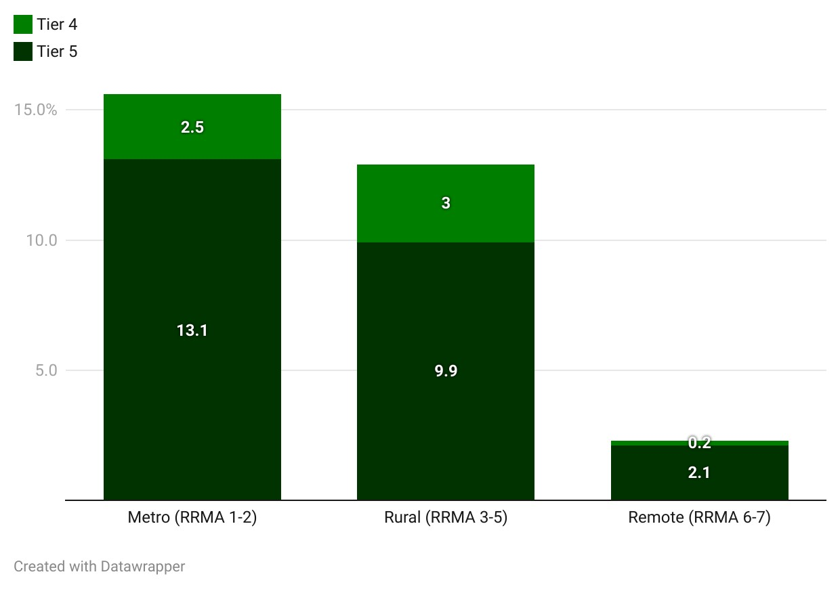Source: Internal data provided by the Department of Health and Aged Care

The structure of payment levels warrants reconsideration
Several stakeholders raised concerns about the current after hours payment levels and eligibility criteria. The Level 1 PIP was considered particularly problematic, with one stakeholder suggesting that:
…no practice should receive an incentive for not providing a service. A message on the phone, or redirection of a call and a sign on the practice door does not constitute an after hours service. – Workforce organisation, written submission
Concerns were also raised that the current structuring of payment levels around ‘sociable’ after hours or the complete after hours period is ‘all or nothing’. As a result, practices are not incentivised to open for shorter windows of time in which demand may peak in their communities. One workforce organisation suggested an After Hours PIP option that incentivises practices to provide a minimum number of hours of after hours services, with stepped funding to support practices for each additional hour of after hours care provided.
Several stakeholders also expressed concern that the design of the After Hours PIP was not being used for its intended purpose by some practices. Several indicated that a small number of practices claim After Hours PIP payments while failing to deliver the required services. One stakeholder claimed that misuse can be more subtle, such as practices which claimed a high level of After Hours PIP and charged prohibitive fees of several hundred dollars to consumers, thereby undermining the purpose of the incentive.
Several workforce stakeholders suggested that a block payment, tiered by MMM and stepped to reflect the different phases of the after hours period, would act as a more effective incentive than the current After Hours PIP. One service provider also proposed the underwriting of certain rural practices to overcome supply gaps.
Several stakeholders emphasised that any recalibration of the After Hours PIP must properly account for the administrative and staffing costs associated with after hours service provision.

The target of the incentive is unclear
Stakeholders expressed diverging opinions about whether the After Hours PIP should be directed solely to the practice (as is the current arrangement), should be redirected towards GPs, or a hybrid (such as directing the After Hours PIP to practices with requirements around its disbursement). One workforce organisation suggested that there is significant variation across practices in how the payment is used and disbursed, and a lack of transparency about what is reasonable. There was a common view that greater clarity would be useful.
The effectiveness of the After Hours PIP is being examined in detail as part of a separate and parallel review being undertaken by the Department: the Effectiveness Review of General Practice Incentives.

Funding for GPs
A wide range of stakeholders and practitioners contended that current funding arrangements are ineffective in incentivising enough after hours work by enough GPs to support a sustainable system which meets consumer needs.

Medicare Benefits Scheme
Medicare aims to provide Australians with equitable access to healthcare by providing consumers with financial assistance (in the form of a rebate) towards the costs of a range of medical services. Medicare rebates are therefore critical to general practice viability and influence where, when and how GPs offer services to consumers.
Stakeholder and practitioner feedback focused squarely on the overall financial value proposition for GPs – and on rebate amounts – rather than on the design of after hours MBS items (except for the definition of after hours, which is addressed separately below). The clear consensus from GPs is that after hours MBS items could more effectively support GPs to meet the after hours needs of their communities (Figure 37), with many GPs elaborating that the central issue with the items is that they do not pay enough
Figure 37: GP perceptions of the effectiveness of current after hours MBS items (n=62)
Survey text: The current after hours MBS items are effective in supporting me to deliver after hours services which meet the needs of my community.
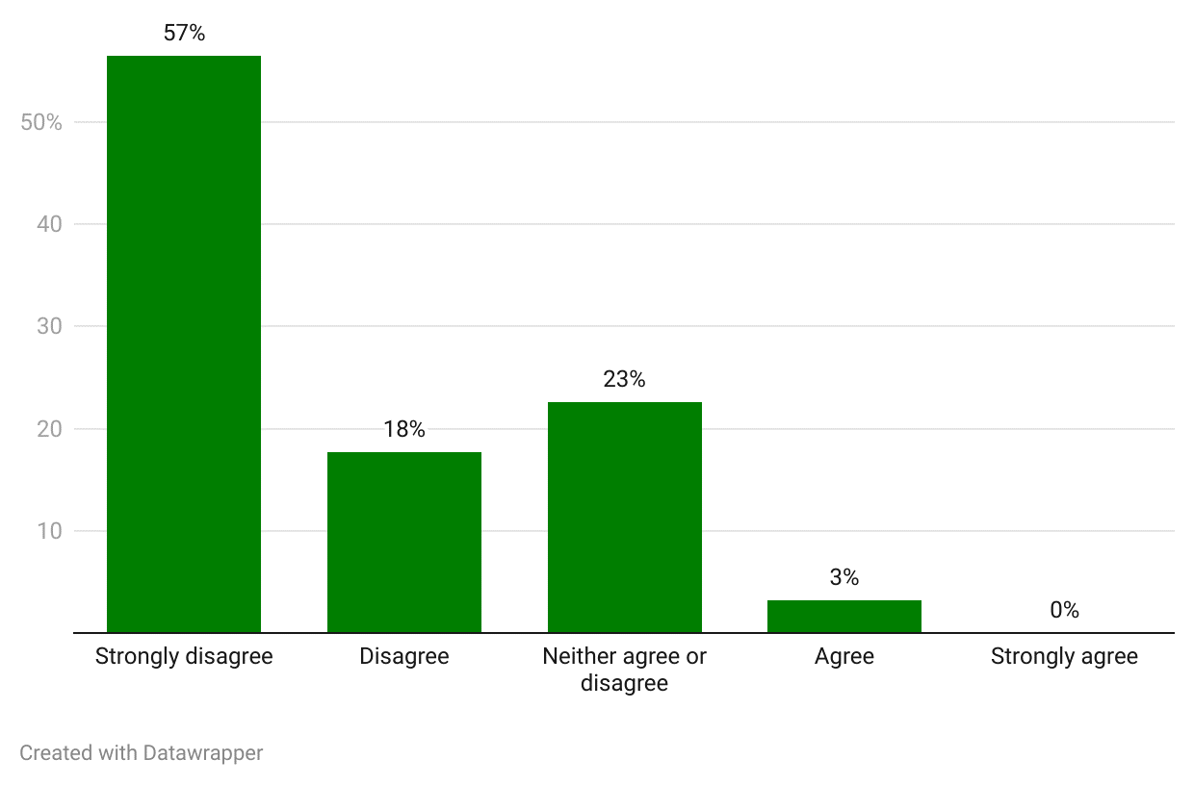
Source: Consultation Hub Survey (2024)
The majority (n=65, 76%) of practitioners responding to the Consultation Hub Survey indicated they would provide more after hours services if there was greater financial reward. GPs expressed greatest willingness to deliver telehealth and in clinic services, and the least willingness for conducting home visits (Figure 38).
Figure 38: Potential influence of financial reward on after hours service delivery by mode (n=65).
Survey text: Thinking about services I do not currently deliver, I would consider delivering the following services after hours if there was greater financial reward
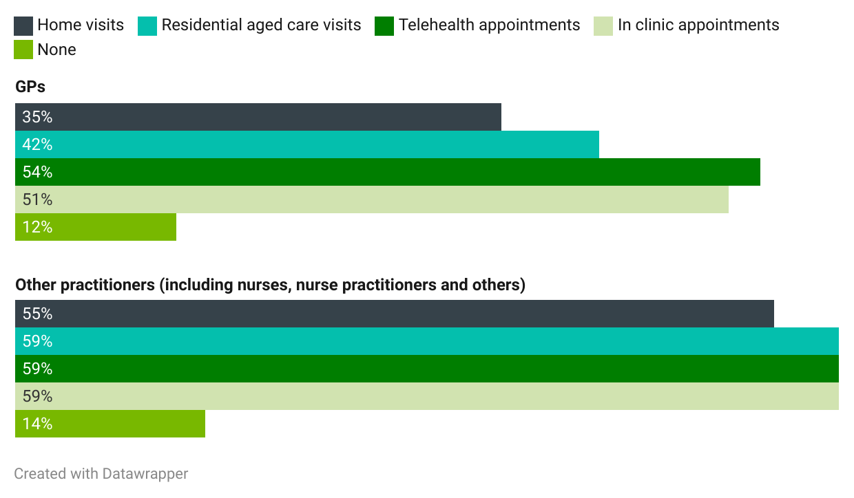
Source: Consultation Hub Survey (2024)
It is unclear how much additional remuneration would be required to overcome the various lifestyle barriers to after hours work (see section 2.4.6.1) and incentivise a meaningful increase in participation. Some evidence suggests that physicians are not particularly responsive to earnings changes, and any policy that increases the hourly earnings for after hours care is unlikely to significantly increase participation in after hours care (Broadway et al., 2016). Several stakeholders and practitioners observed that to achieve the aim of incentivising after hours service provision, any increase to the relevant MBS items would need to be meaningful.13F
Moreover, it is clear that increased financial incentives are unlikely to be equally effective across GPs with different family circumstances and GPs working in different locations. Particular complexities exist in rural and remote areas and those with low workforce supply, where the pool of GPs is limited and where increasing the financial returns of after hours work may have the unwanted effect of redistributing the workforce away from work in usual hours, as well as the desired effect of supporting the viability of those practitioners already providing services.
In order to justify working after hours, which would affect the time I am available for my family, there would need to be a reasonable financial incentive. Current MBS rebates do not reflect this. – Practitioner, Consultation Hub Survey
A broad range of stakeholders considered the fee-for-service MBS model unfit for some after hours purposes, specifically in thin markets (including many rural and remote areas), and for some priority populations (such as residents of aged care homes or consumers receiving palliative care). In these contexts, the volume of consumers is often insufficient to support business viability. As one stakeholder noted, in a fee-for-service model an ‘empty appointment slot represents a lost source of revenue.’ While some areas have consistently low patient volumes, others (in particular tourism hot spots) experience significant fluctuations across the year.
While most stakeholders focused on restructured incentives to support equitable access to after hours primary care, some advocated for a shift towards value-based payments, in which incentives are aligned with the delivery of best practice care and patient outcomes. Several identified a role for bundled payments, while one suggested a capitation approach.

Redefining the after hours period
A very large number of stakeholders and practitioners called for after hours MBS rebates to be available for in-consulting room services provided by practitioners from 6:00 pm on weeknights to support greater access to primary care services in the peak evening period. Under current arrangements, after hours items can only be claimed from 8:00 pm in consulting rooms, while after hours items can be claimed from 6:00 pm outside consulting rooms. One of the core principles for MBS after hours items is that the rebate structure for after hours services should not provide perverse incentives to divert services from usual hours to after hours or to drive utilisation that is not commensurate with clinical need.
Weeknight evenings represent a period of peak demand for after hours primary care services. A significant proportion of practitioners responding to the Consultation Hub Survey indicated that they would consider working during the 6:00 pm to 8:00 pm period if the financial reward was greater (Figure 39). This was particularly the case for GPs.
Figure 39: Potential influence of financial reward on after hours service delivery by time period (n= 64)
Survey text: Thinking about services I do not currently deliver, I would consider delivering services in the following time periods if there was greater financial reward.
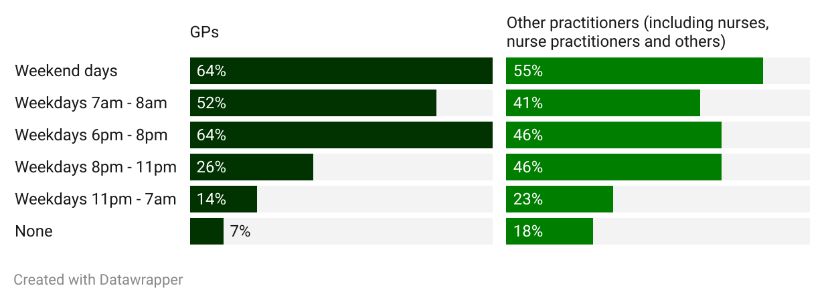
Source: Consultation Hub Survey (2024)

Funding for non-medical health practitioners
The fundamental premise of this conversation is that after hours incentives need to not simply be a GP question. – Workforce stakeholder, focus group
While stakeholders were in agreement regarding the merits of multidisciplinary, team-based care (see section 2.4.5), there was clear feedback that the current primary care after hours funding mechanisms do not effectively support this approach to care (Figure 40).
Figure 40: Practice owner/manager perception of the effectiveness of current financial arrangements in supporting multidisciplinary team based care, by practitioner type (n=91)
Survey text: The current financial arrangements are effective in supporting the provision of multidisciplinary team based care to consumers in the after hours period.
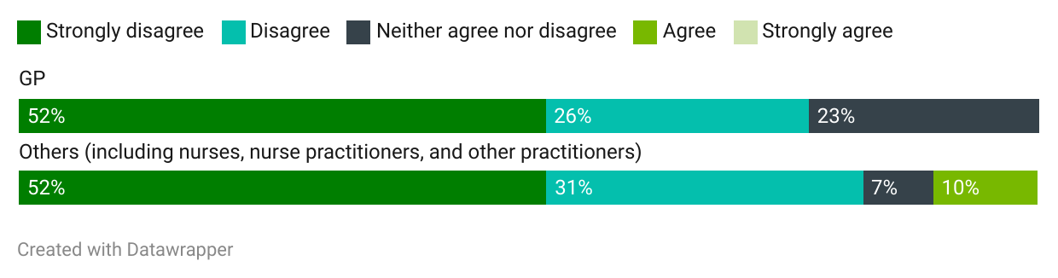Source: Consultation Hub Survey (2024)
A broad range of stakeholders and practitioners contended that the primary barrier to multidisciplinary, team-based care in the after hours period is funding arrangements which do not adequately support nurses, nurse practitioners, midwives, and other non-medical practitioners. Practitioner agreement with the survey proposition that current financial arrangements support practitioners other than medical practitioners to provide after hours care is illustrated in Figure 41. There was considerable agreement across stakeholders that supporting and incentivising a range of healthcare practitioners to work in after hours primary care should be a future priority. One stakeholder observed that:
The current funding model results in GPs being the gate keepers of primary care and limits the scope for nurse and midwife-led services as these practitioners are not able to access the funding required. – Workforce organisation, written submission
Figure 41: Practice owner/manager perception of the effectiveness of current financial arrangements in supporting practitioners other than medical practitioners, by practitioner type (n=91)
Survey text: The current financial arrangements support practitioners other than medical practitioners to provide after hours services.
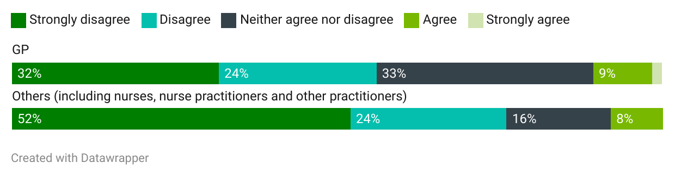Source: Consultation Hub Survey (2024)
A variety of approaches to better remunerating and incentivising non-medical practitioners were advanced by stakeholders. Several stakeholders and practitioners emphasised the value in incentivising health practitioners to work to their full scope of practice, and remuneration commensurate with service delivery and skill.
We need to fund the care not the practitioner. – Workforce stakeholder, focus group
A range of workforce and sector stakeholders and survey respondents (including several GPs) considered that nurses should be given access to MBS after hours items, and that MBS rebates for nurse practitioners should be increased to cover costs associated with providing after hours care. Under current MBS arrangements, after hours items are accessible only to doctors. Several workforce and sector stakeholders also advocated for the extension of MBS after hours items to other health practitioners, including midwives, certified diabetes educators and others.
Support for extending MBS items was not universal. Some of the peak bodies representing GPs favoured providing enhanced funding for non-medical staff through an expanded and/or redesigned After Hours PIP or another funding mechanism, rather than through the MBS. A small number of GPs responding to the Consultation Hub Survey (n>5) did not support the premise that greater incentive is warranted for non-medical staff, suggesting that current incentives are sufficient or that non-medical staff should not play an enhanced role in after hours service delivery.
A small number of specialists also observed that the MBS items they can claim for providing after hours care without a GP referral attract a significantly lower rebate than those for GPs, and that this represents a barrier to specialists playing a greater role in after hours primary care.
You can't get a nurse practitioner really to work after hours in a GP clinic… There [are] 2 main reasons. One is, there's no after hours items for a nurse practitioner. So if I do a 20 minute consult at 10:00 am, the rebate is $19.00. If I do a 20 minute consult at 11:00 pm, the rebate is… $19.00… It's pretty, pretty lousy. So why would I leave my family and go and work at night? But the other thing is the practice will say to me, ‘How can I have you in my clinic?’... If you've got a GP that's getting a $60.00 rebate and they are bulk billing a patient and the practice is taking 30%, they're already getting a heck of a lot more towards their admin than what they're getting off a nurse practitioner.
Practices are saying it's not worth having anybody except for a GP after hours because we can't support the admin that they need. We can't provide the reception staff… We're actually disincentivising the development of multidisciplinary teams and you could apply that across midwifery, and allied health. We should be having advanced practice physiotherapists in some after hours clinics depending on the area, the demographics.- Workforce stakeholder, interview

Primary Health Network funding
There was a view among a broad range of stakeholders that ensuring appropriate and equitable after hours service coverage requires innovative and tailored service delivery and funding mechanisms. At present, the PHN After Hours Program is the key funding arrangement for achieving this.

Background and context for PHNs
Under the PHN After Hours Program, the Australian Government provides funding to PHNs to provide or commission after hours services tailored to the needs of their geographical area and communities. The PHN After Hours Program commenced in 2015-16, when PHNs were established to replace Medicare Locals. The broad aims and objectives of the PHN After Hours Program are to:
- increase the efficiency and effectiveness of after hours primary health care for patients, particularly those with limited access to health services
- improve access to after hours primary health care through effective planning, coordination and support for population-based after hours primary health care
- improve the availability of after hours GP services through working collaboratively (Health Policy Analysis, 2020).
PHNs may also receive funding under other programs which they apply to activities which support after hours service delivery. For example, as part of the response to The Royal Commission into Aged Care Quality and Safety, the Australian Government is providing $178.7 million over 4 years to PHNs to coordinate better access to the interface of the aged care and primary health care systems at the local level. This funding will support PHNs to work with RACHs to ensure comprehensive after hours care plans and supports for residents. Measures include environmental scans to ensure participating RACHs have an up to date after hours action plan, providing education and training to staff on after hours health care options, and encouraging RACHs to implement procedures for keeping residents’ digital medical records up to date.
PHNs commission a wide range of after hours services, depending on local need. These include consumer awareness and health literacy programs, workforce and capacity building initiatives, face-to-face and telehealth services for the general population, and targeted services for specific populations (for example, residents of aged care homes, services for people at risk of homelessness, and mental health services). Examples of services funded or jointly funded with PHN After Hours Program grants include:
- an after hours telephone support solution for registered palliative care patients
- an after hours telehealth service providing after hours services to the community, including to residents of aged care homes
- two services which offer after hours clinical and peer support for those with mental health distress as an alternative to presenting to the hospital emergency department
- a mobile health clinic providing after hours medical care for people with or at risk of homelessness and for clients of community service providers. Scheduled, bulk billed after hours health clinics are delivered by doctors and nurse practitioners at the location of partnered community service providers.
PHNs adopt a range of strategies in delivering the PHN After Hours Program. In general, a 2020 review found that PHNs covering more rural/remote areas adopted strategies that were focused on tackling barriers to accessing services and supporting practices to extend their provision. Metropolitan PHNs’ strategies were more concerned with vulnerable groups and providing alternatives to mainstream after hours services (Health Policy Analysis, 2020).
A comprehensive review of the PHN After Hours Program undertaken by the Department in 2020 found a program addressing local gaps and needs in after hours primary care was needed, and the objectives of the PHN After Hours Program remained relevant. It also found that changes in the way the Program operates were required (Health Policy Analysis, 2020).
Following the 2020 review, the PHN After Hours Program was reformed to ensure it focussed exclusively on supporting access to primary care services in the after hours period. Two additional programs were created, one to support access to primary care services for multicultural populations and another to support access to primary care services for people experiencing or at risk of experiencing homelessness. Grant Guidelines for each program were developed to support PHNs to commission activities that focussed on improving access to primary care services.
In 2023, several PHNs received short-term 12-month funding to transition out-of-scope activities and/or undertake needs assessments to identify and commission new activities that aligned with the new grant program intent. Since the transition, several PHNs have decommissioned activities that were out of scope and commissioned activities that align with the respective Grant Guidelines, and also meet the identified needs of their local PHN region.

Stakeholder perspectives on the PHN After Hours Program
Stakeholders provided mixed feedback about the PHN After Hours Program. The operation of section 19(2) of the Health Insurance Act 1973 (Cth) was identified by several workforce stakeholders and PHNs as a significant limitation. Section 19(2) precludes the PHN After Hours Program from providing a salary supplement to clinicians without seeking an exemption. This effectively prevents the PHN from providing salary supplementation to GPs in areas that have low volumes of patient after hours care needs. As well as limiting the options available to PHNs, some workforce stakeholders expressed the view that this prevents PHNs from supporting the viability of existing after hours services provided by clinicians.
There is a perverse incentive that the PHN will only step in and provide funding when the local GPs no longer provide after hours coverage. – Workforce organisation, written submission
It is important to recognise market forces are not working in rural and remote. We need to support services that are already there and target investment at that, instead of going for new ones which can be disruptive to communities. – Workforce stakeholder, focus group
Several workforce and other stakeholders considered the outcomes and impact of the Program to be variable depending on the PHN, or as one stakeholder described it, ‘hit and miss.’ PHNs and some other stakeholders suggested that the short-term and unpredictable nature of PHN funding has:
… hindered PHN’s ability to design and commission long-term services and affected commissioned providers’ capacity to deliver sustainable, consistent and well-organised after hours services. – Service provider, written submission
Funding to PHNs around after hours support at the moment is sporadic, unpredictable and cannot be used to plan any long-term initiative. – Sector stakeholder, focus group
Short funding agreements make recruitment of skilled staff challenging and can lead to new services being frequently added and withdrawn from the service system. This can, according to one stakeholder, lead to system disruption rather than integration. The same stakeholder observed:
…financial uncertainty has resulted in inconsistent service delivery, challenges in retaining skilled staff, and limited opportunities for program development and innovation. – Service provider, written submission
It was also suggested that the amount of funding provided under the PHN After Hours Program is insufficient to address many identified needs, making health needs assessments:
more… an academic exercise as opposed to an authentic approach to comprehensively addressing regional after hours needs. – Service provider, written submission
Stakeholders suggested that more flexible and sustained funding is necessary for the PHN After Hours Program to meet its objectives, and for PHNs to meet community needs. Several also spoke in favour of a move away from activity-based funding towards an outcome or value-based commissioning framework. This feedback is broadly consistent with the findings of the 2020 review of the PHN After Hours Program. One stakeholder called for the current review and implementation, where necessary, of the recommendations of the 2020 review of the PHN After Hours Program and the recent audit of the performance management of PHNs. Several stakeholders suggested that PHNs have been less successful in ensuring after hours services in very rural and remote communities. This was generally attributed to the challenges of commissioning services in thin markets, which affects program implementation across non-emergency service responses.

KEQ 1: Findings
- 1 | - The after hours system is complex and difficult to navigate – there are a wide range of different service models, providers and funding sources. Clear articulation of the objectives of after hours care is critical to inform policy design.
- 2 | - The design of the after hours system should ensure that primary care needs are met, without directing need into hospital emergency departments.
- 3 | - Workforce challenges are a significant barrier to after hours care, and are exacerbated in rural and remote areas.
- 4 | - GPs are insufficiently incentivised to support a robust after hours system.
- 5 | - The current after hours funding system disincentivises multi-disciplinary models of care. Nurse practitioners, nurses, and other health professionals are not incentivised or supported to participate fully and to their full scope of practice.
- 6 | - While an effective support for practice viability, the After Hours PIP is not optimally incentivising after hours service provision in an equitable way across Australia.
- 7 | - 6:00 pm to 8:00 pm is a peak period for after hours service demand. This is an important consideration in future system design and funding approaches.
- 8 | - There is a need for specific funding approaches to enhance access to appropriate after hours care in thin markets.


Part 3: The need for after hours primary care

The need for after hours primary care (KEQ 2)
This part addresses the question – ‘What is the need for after hours primary care?’ It analyses the drivers of consumer after hours behaviours and decision-making, and includes analysis of the needs of specific consumer cohorts.

Drivers of consumer help seeking behaviour
During the course of the desktop review and stakeholder engagement, the Project team identified a broad and complex array of factors which influence when, where and whether consumers access primary health care in the after hours period. Figure 42 illustrates these drivers, which relate to perceived urgency and clinical need, service availability and accessibility, health literacy and capacity to navigate the health system, cost, cultural and emotional safety, and competing demands and preferences.
Figure 42: Drivers of consumer help seeking behaviour
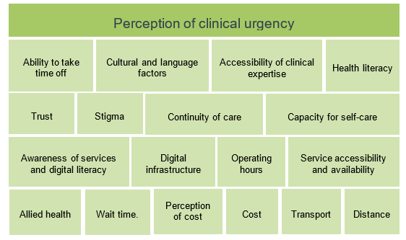
Practitioners and practice owners/managers responding to the Consultation Hub Survey identified several of the drivers in Figure 42 as key reasons consumers seek help from them after hours. The main reason identified by respondents is a consumer’s condition worsening or onset during the after hours period, followed by spillover from usual hours and a consumer’s ability to attend a service in usual hours because of caring, work or other responsibilities (Figure 43).
Figure 43: Practitioner and practice owner/manager perception of reasons for consumer help seeking after hours (n=168)
Survey text: In your experience, what are the main reasons that consumers seek help from your practice in the after hours period? (Select up to three).
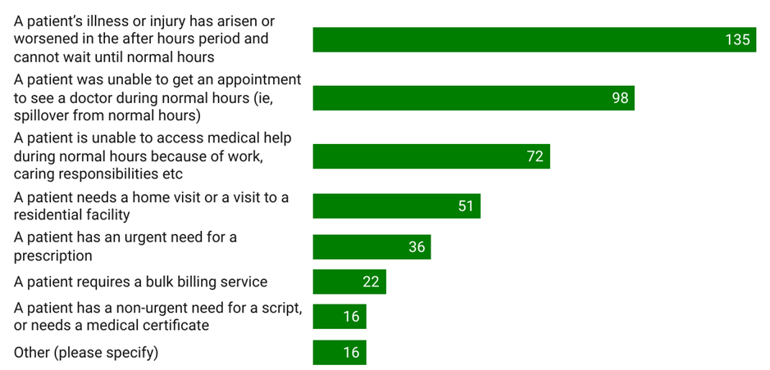
Source: Consumer Hub Survey (2024)
As indicated in Figure 42, a variety of drivers of consumer help-seeking behaviour are identified in the literature. Willson et al., 2022 identify 4 key drivers for patients choosing emergency departments instead of a primary care service:
- timely access – no need to wait for an available appointment
- convenience – ability for emergency department to provide multiple services such as imaging and pathology
- cost – the emergency department is free
- perception of primary care skill – belief that primary care practitioners are unable to manage a condition because of lack of skill or resources (Willson et al., 2022).
A cross-sectional survey of patients across the ACT suggests that similar factors weigh into consumer choices about which service to choose once they have opted to seek help (Barnes, Ceramidas, et al., 2022).4F Respondents were most likely to opt to see a GP because it was their regular GP, most likely to opt to attend a WIC because they could drop in and be seen without an appointment, and most likely to see a MDS because their regular GP service was closed and they could make an appointment. Almost 40% of respondents indicated they chose the emergency department because it had the services they needed, and almost one third of respondents identified as a reason for choosing the emergency department their perception that there are no other services which could help them (see Figure 44). This could indicate either the unavailability or inaccessibility of after hours primary care services in respondents’ locations, low levels of awareness of available options, and/or high actual or perceived clinical need.
Figure 44: Patient reported reasons for choosing the specific service they attended, from most commonly reported reason to least (n=1992)
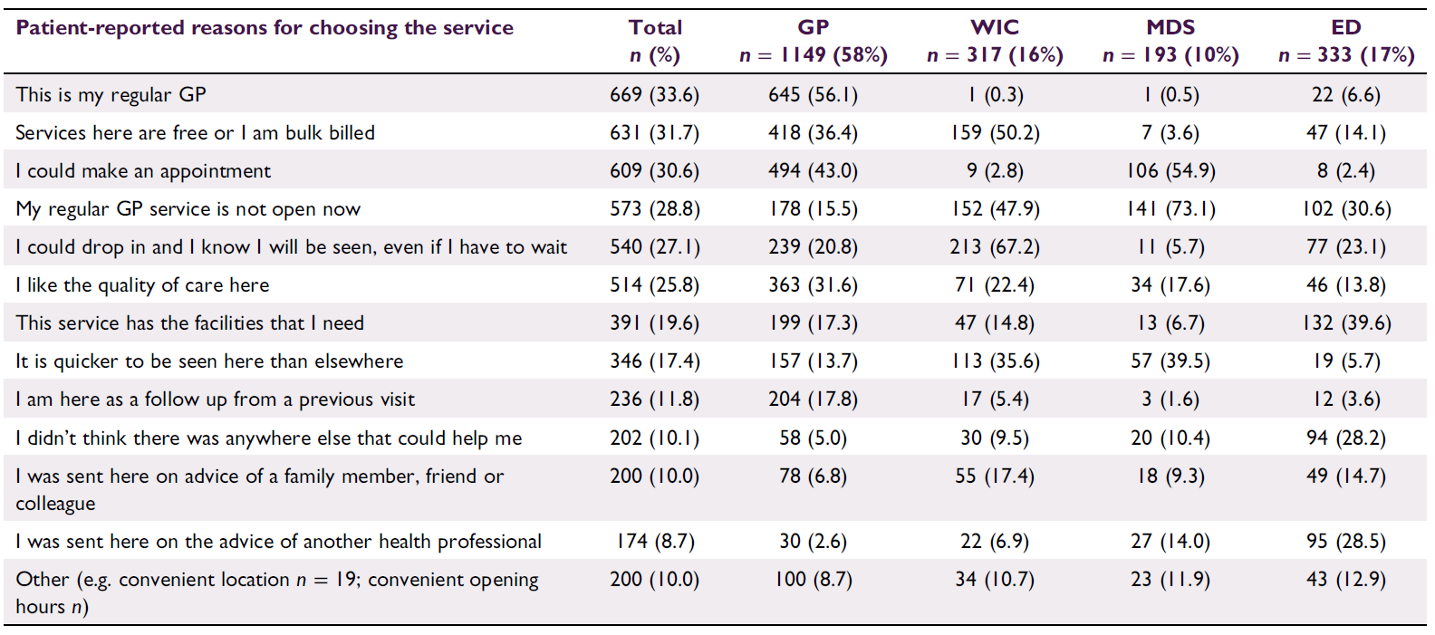Source: Barnes, Ceramidas, and Douglas (2022)

Perceptions of clinical need
Consumers’ perception of urgency emerged from the literature and stakeholder engagement as the key deciding factor when accessing after hours services, with most consumers accessing after hours services because their issue occurred or was exacerbated outside of hours, or they were too concerned to wait (Barnes, Ceramidas, et al., 2022; Health Policy Analysis, 2020).
According to Barnes, Ceramidas, et al. (2022):
- the availability of after hours GP services influenced where people presented, but not why patients were presenting after hours. Of patients attending a non-GP after hours medical service, half reported accessing the service because their usual GP was not available. However, there was no discernible difference in the types of presentations.
- most patients were presenting to extended hours GPs with long-term issues, and lower urgency or preventive health issues.
Perception of clinical need is also a key influencing factor as to where people seek help. International and Australian studies and reviews have found that the most common reasons for after hours emergency department presentations include patient-perceived need for care and high patient-perceived urgency (Masso et al., 2007; O’Cathain et al., 2020; Toloo et al., 2020).
Consumer decision-making is also influenced by the perceived quality of care which a service can offer – including its capacity to address the consumer’s clinical needs. Consumer perception of quality of care is contingent on several factors including timely access, clinical skill, cost, location, continuous care, and integrated service offers with these characteristics often attributed to emergency departments (Barnes, Ceramidas, et al., 2022; Wilson et al., 2021). During consultation, consumers and sector stakeholders highlighted the importance of a practitioner’s clinical skill and capability as a priority consideration for many consumers, particularly where a consumer has a chronic condition or other health complexities.
An Australian study from 2015 suggested that regardless of cost and waiting time, the Australian public has a clear preference for treatment by a doctor as opposed to models which are led by other emergency care practitioners. The study suggested that other doctor-led models, including integration of GP clinics within emergency departments, extended hours of GP cooperatives and in-home care, and redesigning patient flow processes (for example, fast-track streams for chronic-disease-related issues) could gain public acceptance in the future (Harris et al., 2015). Sector stakeholders echoed these findings, noting that for some cohorts such as Aboriginal and Torres Strait Islander communities and people with chronic illnesses, access to a GP was preferred as it was indicative of high-quality care. In contrast, other research found that walk-in clinics staffed by Aboriginal health workers are vital to Aboriginal consumers for increasing accessibility (Freeman et al., 2014; Warwick et al., 2021). This includes ‘hybrid models’ like that of the Central Australian Aboriginal Congress with ‘walk‐in visits, practitioner‐made appointments, and advanced access appointments where appointments are only released on the day – a system found to improve timeliness, patient satisfaction and continuity of care’ (Freeman et al., 2014).
The need for immediate attention and/or a perceived urgency appears to be the primary reason why patients choose to attend emergency departments. Associated with this perception of urgency is a belief amongst patients that their conditions required further investigation which could best be undertaken in an emergency department (for example, imaging) or were too complex to be treated elsewhere (Masso et al., 2007; North Western Melbourne Primary Health Network, 2018). Several sector stakeholders and consumers made similar observations about emergency department attendance, stating emergency departments were attractive due to perceived shorter wait times, integrated services, cost-effectiveness, and perceived higher quality care.

Health literacy and self-care capabilities
I guess that comes down again to health literacy, knowing what you need. So, it sort of goes both ways that they might seek after hours services at times when they don’t necessarily need to and then the other side is not seeking it when they should be. – Sector stakeholder, interview
Sector stakeholders highlighted that consumer perception of need is linked to consumers’ awareness and understanding of their own health and their capacity for self-care (including the knowledge, skills, and confidence to participate in their own health care journey), otherwise referred to as health literacy. This includes understanding when it is ‘appropriate’ or ‘necessary’ to seek certain types of care.
While consumers’ perceptions of clinical urgency are powerful influences on help-seeking behaviour, the extent to which these perceptions align with clinicians’ assessments is contested. A number of studies have found a disconnect between consumer and clinician assessments (Masso et al., 2007; O’Cathain et al., 2020; Toloo et al., 2020). This disconnect can be seen from the results of a 2020 review of a national telephone triage advice service providing 24-hour nurse and/or GP services. The review found that a significant number of people who believed that they required urgent attention were advised to access low-urgency care (Siddiqui et al., 2020). Other studies have affirmed considerable alignment between patient and clinician perceptions, and the appropriateness of presentations to after hours services (Payne et al., 2017).
Several sector stakeholders discussed the importance of providing ‘reassurance’ to consumers as lack of knowledge and confidence in the after hours health system can drive people to either attend emergency departments or delay care seeking altogether. Studies have shown managed care and pre-hospital diversion of low-acuity patients to be successful in reducing emergency department use (S. R. Morgan et al., 2013).
Some consumers said they were aware of the significant burden across the health system, particularly in emergency care. These stakeholders reflected that this made them reluctant to seek care after hours even if advised to by a GP or after hour triage service as they were uncertain if they really needed to, and they did not want to take up beds and space unnecessarily.

So the other situation that I had, was recently my son, … he had bad stomach cramps, but he'd had an accident that morning and he'd written his car off. And so I couldn't decide whether it was just from the accident. The ambulance had checked him out and there [were] no physical injuries from after the accident. But then he came down with these really bad stomach cramps and so I'm like, oh, … it's not [an] emergency. So we found this medical centre, there was an emergency medical centre next to the hospital and I thought that's a great idea. So we went in there and she said ‘oh, all our doctors have gone home for today and we don't have x-ray facilities so you're going to have to go to emergency’. So we ended up at emergency in that situation. But he wasn't in any critical emergency, so I suppose I don't know how to define emergency, and I'm wary of clogging up the system. OK, we hear all these reports about, you know, ambulances being backed up and things like that so when you can walk and you can talk and you’re not in an emergency situation I don't know whether we should be using the emergency services. – Consumer, focus group
There is evidence that consumers' level of health literacy impacts their perception and articulation of need. The 2021 Consumer Sentiment Survey determined that 21.5% of respondents had a low capacity for self-care. The survey found that higher activation levels were associated with older age, having a university education, having private health insurance, earning over $2000 per week, not living with a mental disorder, and not having a chronic condition. It concluded that ‘communities of people living with chronic conditions, especially those with mental health disorders, and people living with socioeconomic disadvantage may need additional support to maintain their health and wellbeing’ (Zurynski et al., 2022). It may be that higher levels of patient activation and health literacy influence whether a need for after hours care arises, how the consumer defines and articulates the need (and its urgency) and how a consumer navigates the after hours service system.
Stakeholders and consumers made several suggestions for supporting patient activation and decision-making, including triaging through ‘single front door’ telehealth services that can offer reassurance, direction and education about the best way forward. It was claimed that this would increase consumer confidence and ability to self-manage or ‘triage’ their and others’ health needs. It is noteworthy that the service envisaged by stakeholders and consumers closely resembles the current healthdirect helpline. This potentially indicates a lack of familiarity with Healthdirect Australia’s service offering. Other suggestions included offering consumers ‘care plans’ about what to do in after hours circumstances.
After hours service planning needs to incorporate empowering consumers to self-manage after hours care by providing health education, digital promotion, and clear health care materials, so people can make informed decisions and manage their health effectively. This leads to efficient resource utilisation and strengthens the healthcare system. – Sector stakeholder, interview

Competing demands, lifestyle and convenience
The literature and stakeholder feedback described competing demands, lifestyle, and convenience as strong factors in consumer decision-making. Work and life commitments can mean that consumers cannot or do not wish to access primary care services in usual hours (Health Policy Analysis, 2020). In addition, other research has identified a preference of parents of children to visit emergency departments due to dissatisfaction with family medical services, inability to get appointments and inability to get time off work, perceived advantages of accessing ‘superior’ emergency department services, alleviation of child suffering, and alleviation of parental stress and anxiety (Butun & Hemingway, 2018). Similarly, practitioners and practice owners/managers responding to the Consultation Hub Survey identified a consumer’s inability to seek medical help in usual hours due to work, caring responsibilities or other factors as the third most important reason for after hours attendances at their clinic (Figure 43). This aligns with other studies which suggest that the most common reason for seeking after hours GP care in the ACT was that a person could not afford to take time off work/life to be seen in usual hours (Barnes, Ceramidas, et al., 2022).
Changing work patterns (flexible work arrangements, extended working hours, shift-work etc) mean people increasingly need to access care in the after hours period. Government needs to recognise the value in patients accessing care when required rather than being focussed on when that care is accessed given economic and health benefits of timely care. – Sector stakeholder, interview
During consultation, many sector stakeholders and consumers similarly emphasised the impact of work, education, and carer commitments on consumer help-seeking behaviour. This, partnered with rising cost-of-living pressures and changing work and lifestyle demand, were said to make attending services in usual hours difficult. Some also identified a lack of available usual hours appointments with their GP as a barrier. Collectively, these were said to push people to seek after hours care for a range of urgent, non-urgent and routine health needs.
The current system fails to take into account the way in which people’s lives and work are changing. People expect to be able to access services in a reasonable after hours period in primary care – both before and after work. The fact there are limited primary care services open after 5.00 pm or before 8.00 am is challenging. There is also a cohort of people who are the ‘working poor’ who often can’t afford to take time off between 9.00 am to 5.00 pm to seek healthcare and have no choice but to attend after hours services. – Service provider, written submission

Changing consumer expectations
Stakeholder consultation indicated the importance of accounting for how consumer expectations of after hours services have shifted over time and may be misaligned with policy intent and service capacity. Findings from the Consumers Health Forum indicate that after hours care services should be widely available at all times for a broad range of unexpected medical situations. The expectation of being able to access medical care 24-hours a day is particularly prominent amongst rural and remote communities, which may be reflective of an expectation of parity between rural and metropolitan services (Zeitz et al., 2006). One sector stakeholder suggested that the introduction of telehealth and other digital health technology advancements as a result of COVID-19 has led to increasing expectations for immediate and timely appointments. This was said to be further complicated by the trend of many consumers accessing health information online.
Workforce stakeholders and practitioners expressed concern about the gap between consumer expectations and what can ‘reasonably’ be delivered by clinicians and the after hours service system. The concept of ‘gaps’ in service provision was said to be dependent on the level of expectations of communities and consumers. One group of workforce stakeholders identified gaps between clinician and consumer perception of ‘urgent need’, indicating that often consumers attended after hours clinics for non-urgent needs including medical prescriptions and medical testing. This stands in contrast to several sector stakeholders who described obtaining medical prescriptions as an urgent and pressing after hours need for some consumer groups.
In 2024 perhaps the time has come where different arrangements for primary care depending on time of day and day of week is no longer feasible given the consumer demand for healthcare, the complexities of health conditions significant proportions of the population have and the working lives of consumers. – Government stakeholder, written submission

These issues were illustrated in consumers’ discussions of the need to fill routine prescriptions in a timely manner. For example, one consumer recounted their experience of getting non-urgent heart pressure medication via an after hours service. They said that the service was ‘not happy’ about providing the script due to the apparent lack of urgency, and that whilst they were provided with a script they were not supported to have it filled, meaning they had to wait until the morning. In addition, consumer and sector stakeholders noted that peoples’ perceptions and sense of urgency may be heightened in certain contexts. For example, some consumers raised that people recently diagnosed with chronic conditions may be uncertain about medications or may be more likely to forget to have a script filled or attend appointments as they adjust their lifestyle. This can result in them seeking additional care or support in after hour settings, which in some instances may not be deemed clinically urgent.

Spillover from unmet need in usual hours
There is some evidence that unmet need in usual hours contributes to demand in the after hours period. According to the 2022-23 Patient Experience, 45.6% of respondents who required urgent medical care during the prior 12 months waited 24 hours or more between making an appointment and seeing a GP (Australian Bureau of Statistics, 2023). Practitioners perceive ‘spillover’ from usual hours as the second most important reason that consumers seek after hours care (Figure 43). Several stakeholders connected this phenomenon to the surge in demand for after hours assistance in the early evening. One stakeholder indicated that for MDSs:
One of the biggest issues we've had is the day work flowing into after hours. Once it gets to 3:00 o'clock, the practice is closed. Kid is screaming with an earache. The general practice will say we can't accommodate you. Ring the locum service after hours. So, there's a lot of stuff in hours that actually just gets pushed into the after hours. – Sector stakeholder, interview

A 2015 Queensland study suggested that better access to after hours care does not appear to affect utilisation of daytime GPs (Keneally, 2016). However, the MBS Review Taskforce highlighted that MBS data shows that ‘of the over 180,000 patients who received 3 or more urgent after hours services in a 12 month period between 2014 and 2016, over 10,000 received no standard, in-hours GP care at all. This suggests that some patients are substituting after hours home visits for routine general practice care’ (Medicare Benefits Schedule Review Taskforce, 2017).
Data from a 2011/2012 English General Practice Patient Survey found that worse usual hours access was associated with greater use of after hours primary care for each of 5 different ‘in-hours access measures’. These measures were:
- ease of getting through to the practice on the telephone
- frequency of seeing or speaking to preferred GP (interpersonal continuity of care)
- ability to book an appointment within 2 working days (urgent)
- ability to get an appointment 2 days ahead or more (routine)
- convenience of opening hours (Zhou et al., 2015).

Navigating the after hours system
Previous reviews have found that the after hours system is confusing for many consumers (Armstrong et al., 2016a; Jackson, 2014b), and that consumer awareness of service options is a deciding factor when accessing after hours services (Barnes, Ceramidas, et al., 2022). The Deeble Review found in 2016 that the understanding of available and appropriate options for accessing primary care in the after hours period is low (Armstrong et al., 2016a), and the 2020 PHN Review suggested that there was no evidence that the situation has greatly improved since the 2014 and 2016 reviews (Health Policy Analysis, 2020).
There is evidence that consumer capacity to navigate the after hours system is mixed. A 2004 survey showed that 46% of people in Australia reported that it was very or somewhat easy to get medical care in the evenings, on weekends or on holidays without going to the emergency department (After Hours Primary Health Care Working Party, 2005). In 2020, a repeat of the survey found 58% said it was very or somewhat easy to get medical care in the evenings, on weekends or on holidays without going to the emergency department (Commonwealth Fund, 2021). This is broadly consistent with the perceptions of practitioner and practice owner/manager respondents to the Consultation Hub Survey. 47% strongly agreed or agreed that patients in their local community were aware of available after hours options, and only 32% disagreed or strongly disagreed (the remainder neither agreeing nor disagreeing) (n=175). Nearly half (43%) agreed or strongly agreed that consumers in their local community are able to navigate the after hours system to get the help they need, when they need it (n=175).
Sector stakeholders, practitioners, and consumers provided strong feedback that consumers often do not understand what after hours services are available, the benefits and limitations of different services, associated costs, and how to find more trustworthy information. Consumers are not always aware of the ‘right place’ to attend for their specific health need, noting in some instances that the ‘right place’ is not accessible or does not exist. This leads to some people relying on emergency departments as the most recognisable and better understood after hours service. According to some consumers, the downsides of attending the emergency department are outweighed by the benefits, described variously as knowing that they will be seen by practitioners with the right skills, access to the full suite of services needed including pharmacy, pathology and allied health, and knowing there will be no out-of-pocket costs.
Several stakeholders emphasised that the complex and fragmented nature of the after hours system makes it difficult for consumers to understand and navigate it. Consumers reported seeking care in a confusing and shifting after hours landscape, with considerable local variation and opaque service offerings. High turnover of after hours services (particularly in rural and remote areas) can result in gaps in available care (Consumers Health Forum of Australia, 2020). The Consumers Health Forum suggested that this makes it hard for consumers to know what services are available and to rely on them with confidence. In these instances, consumers’ default preference is to present at emergency departments (Consumers Health Forum of Australia, 2020). Noting the complex array of after hours services and providers in any given location, previous reviews have highlighted the need for more integrated service delivery (Fry, 2008; Health Policy Analysis, 2020; Jackson, 2014b).

…For my mum, I recently had a situation where she fell over and hurt her knee, fell straight on her knee and hurt her knee. We just didn't know where to turn, you know she was walking on it, but very painfully. So, we were thinking. Well, it's not broken. You couldn't see anything obvious… My sister looked at [place name redacted]. There's an urgent care place there but you know, there was an 8 hour wait or something like that there. So there was nowhere really to turn. That was Saturday. The GPs didn't have any available appointments. She's 76. So it wasn't urgent. It wasn't an emergency. And so you just don't know where to turn when it's a non-urgent situation that needs attention before Monday.
… The fracture clinics had hours [long] wait lists as well. I think my sister has looked into that. And then in the end she said, ‘Look, it's not too bad.’ She had a Panadol. We put her on the sofa and put her leg up and waited till Monday, got an appointment with the GP on Monday. They sent her to get an x-ray. So that was Monday morning. The GP didn't get [the] result or claim[ed] they didn't get results back that day. We kept calling them into the afternoon, so the next morning they called. So we've got your results, you've got a fracture of the patella. You need to go to emergency. We could have done [that on] Saturday, and so I said to the to the clinic ‘Why emergency? … it's clearly not an emergency’ and she said, ‘Well, there's nowhere else I can send you. You need it to be looked at.’ So I thought that was a big gap and that GP was adamant that there was nowhere else that she could go other than emergency…They put her in a brace, told her go and see an orthopaedic surgeon and charged $800.00. So, I mean, she chose to go to private, but there just seemed to be a gap there…I don’t know where we should have gone. – Consumer, focus group
Consumers and sector stakeholders also highlighted the difficulty for consumers of accessing reliable, trustworthy information about after hours services. When asked how they would find out information about after hours services in their areas, almost all consumers said they would turn first to Google. There was broad consensus that search engine results do not always surface complete and reliable information. One stakeholder highlighted that in some regions, Google searches do not yield ‘Healthdirect’ as a result, or it appears far down the list of results. This suggests that search engine optimisation plays a significant role in which services are brought to consumers’ attention.
Navigation of health services available continues to be a huge issue. Many people are unaware of what services are available and how to access them, with it changing all the time. Emergency departments have not changed, they are known and easy to find. – Sector stakeholder, interview
Consumers did not commonly report receiving proactive guidance from their regular GP on after hours care options and the extent to which practitioners and practice owners/managers reported having reliable mechanisms in place to refer patients to appropriate after hours care was variable (Figure 45). This suggests that GPs may have an enhanced role to play in raising awareness among their patients of after hours care options, and providing them with information and advice to support informed and confident consumer decision-making.
Figure 45: Practitioner and practice owner/manager perception of the reliability of their after hours referral mechanisms (n=175)
Survey text: I have reliable mechanisms in place to refer patients for appropriate after hours help when I can’t provide it.
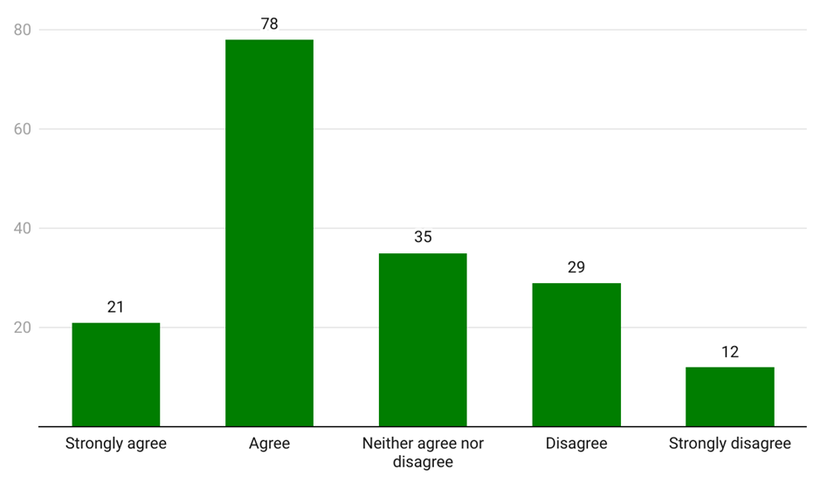Source: Consultation Hub Survey (2024)

Continuity of care and information sharing
Continuity of care is seen as part of a desirable model of after hours care (Hofer & McDonald, 2019) and is a major factor in GPs’ perceptions of quality care (Crossland & Veitch, 2005). Continuity of care is generally seen as quality care that extends over time and between illness episodes. From a primary health perspective, the relational aspect established through continuity of care is seen as being particularly important in improving health outcomes. Relational continuity has been defined as ‘a therapeutic relationship between a patient and one or more providers that spans various health events and results in an accumulated knowledge of the patient and care consistent with the patient’s need’ (Chan et al., 2021). A high level of continuity of care is associated with lower mortality, fewer hospitalisations, lower health-care expenses and higher patient satisfaction (Chan et al., 2021).
There is some evidence that continuity of care in primary care in Australia is being eroded. Measuring continuity of care is complex and there is a lack of agreement in the literature on measures and data. However, the RACGP reports that 34% of very high and frequent GP attendees see 3-4 GPs annually, and a further 36% see 5 or more GPs annually (Wright et al., 2018). A cohort of patients appear to be receiving all their primary care through after hours services without receiving mainstream GP services. MBS data shows that ‘of the over 180,000 patients who received 3 or more urgent after hours services in 12 months between 2014 and 2016, over 10,000 received no standard, in-hours GP care at all. This suggests that some patients are substituting after hours home visits for routine general practice care.’ (Medicare Benefits Schedule Review Taskforce, 2017) More recent studies show that males aged 15 - 64 are most likely to be within this cohort as they do not have a regular GP (J. Baker et al., 2020).
Several stakeholders, particularly workforce stakeholders, expressed concern that some after hours service models may undermine continuity of care. Two-thirds of practitioner and practice owner/manager respondents to the Consumer Hub Survey disagreed or strongly disagreed that the after hours system adequately supports continuity of care (Figure 46).
Figure 46: Practitioner and practice owner/manager perception of the extent to which the after hours system supports continuity of care (n=175)
Survey text: Overall, the current after hours system adequately supports continuity of care for patients.
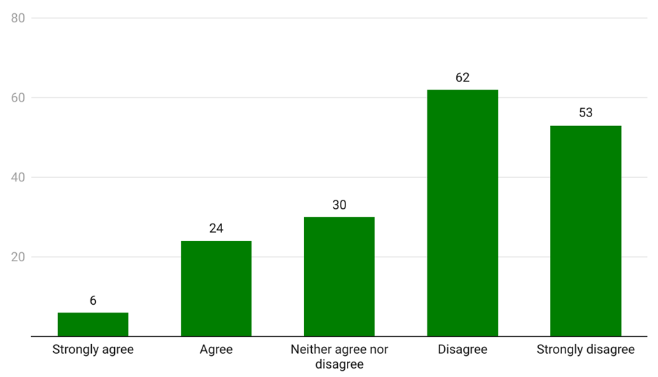
Source: Consultation Hub Survey (2024)
The level of continuity of care offered by after hours services varies across service models. In many instances after hour services provide good access to continuity of care (Jackson, 2014b). At one end of the spectrum, extended hours GP services, which enable a consumer to see their regular GP out of hours, ensure a high degree of continuity of care. At the other end, it is often highlighted that emergency departments, particularly those where there is high staff workload, often cannot deliver person centred practices which leads to lower continuity of care (Karam et al., 2019; U.S. Department of Health and Human Services, 2021). Additionally, episodic care models have also been perceived to potentially have negative implications for continuity of care (McCracken et al., 2023).
Continuity of care in the after hours period was a central concern for most consumers and sector stakeholders and organisations. Many consumers expressed a preference for seeing their regular GP or care team, or at least a GP from their usual clinic, in the after hours period. Consumers articulated several downsides to seeing a practitioner who was not part of their usual care team in the after hours period. These included:
- having to ‘retell’ their health story, including being required to recount traumatic experiences like domestic violence or sexual assault, or having particular health issues missed during an after hours appointment
- having to be the single source of truth about their medical history and health information, including in circumstances where their capacity to communicate this accurately might be impaired
- the possibility that the after hours practitioner may have limited experience or knowledge of a consumer’s health needs (such as having limited experience with an underlying chronic condition). Several consumer stakeholders provided examples of conflicting or inappropriate treatment they received when attending an after hours service, including being prescribed unnecessary medication which had to then be revised by their regular GP
- the risk of judgment, discrimination or stigmatisation by an unknown provider, or of not being believed or listened to
- a lack of follow-up or additional support following after hours appointments.
About 4 years ago I had a specialist appointment at 4:30 with a physician and by the time I got out, it was after 7:00 o'clock at night, and he had completely changed all the medication that I was on. My cardiologist had stressed to me I needed to be on this and this, you know, you must be on them. And [the physician had] taken me off them and he'd put me on this and he'd left me on some of the others. So, I came out completely bamboozled. What am I going to do here? I didn't know. So there was no minor injury or illness clinic then in those days... I knew if I rang 13 Health it's really not what they're for. So I actually rang the poisons information line because I wanted to know about … medicine interaction before I started this new regime, and she … was quite curt and said you're ringing me at this time at night. And I thought, well, I just got out of the physician’s surgery. And she was no help to me at all. So I just decided I'd stay on the old regime until I saw my GP, which of course was quite a few weeks. And when I got to see her, she was most annoyed with what had happened … So, yes, it's just confusing. You really don't know what to do. I really felt, am I doing the wrong thing here? – Consumer, focus group

Some consumers and sector stakeholders were firmly of the view that the downsides lead some consumers to delay seeking care until they can see their regular care provider.
I would suspect there would be a large cohort of people who would choose not to access after hours because they have that preference…[for] continuity of care with their local person, but that’s not great when…it’s Friday afternoon to Monday morning because a lot can go wrong in that time. – Sector stakeholder, interview
...Particularly if I'm feeling unwell, my ability to be able to relay that history can be impaired and so then things get missed. I also feel like a lot of the time if it's not written down and visible for them in that history that sometimes I'm not believed. The last time I went and I said I had 3 strokes and the nurse said to me, ‘Oh, I think you mean TIA’ and I said ‘No, I am 100% sure about what has happened to me in my history. I had a stroke.’ But I guess because I present so physically well, I was dismissed as being not able to relay my own history, or to have not understood what had happened to me when I clearly do. So that can play a real part for me as to whether I go to urgent care or to the emergency department. – Consumer, focus group
Across the literature and stakeholder engagement it was generally acknowledged that relational continuity of care is frequently not possible in the after hours period, despite the importance placed on it by consumers and practitioners. Instead, the literature and stakeholders emphasised the importance of reconnecting with regular providers after accessing after hours services, along with the need for ongoing, shared access to consumers’ health information (Banfield et al., 2015; Consumers Health Forum of Australia, 2020). Given the episodic nature of many after hours services, the importance of efficient transfer of information between providers and integration across services cannot be understated (Adeniyi, 2024; After Hours Primary Health Care Working Party, 2005; Banfield et al., 2015).
Sector stakeholders and consumers discussed the difficulties and frustrations some consumers experienced with ‘retelling their story’ and needing to explain their specific health needs that were not otherwise accessible through health records. Continuity of information extended to the ability of after hours services to access records to deliver care, and for this care provision to be logged in records for future reference.
…putting trust that there was some continuity of information [and] care…It would just reduce that psychological barrier to seeking help outside of hours. And again, seeking help or… seeking medical advice in the moment and early on is always better than delaying. – Sector stakeholder, interview
Some sector and workforce stakeholders claimed continuity of information and care is undermined by lack of interoperability across health record systems and by the lack of access which many primary care and allied health services have to patient records. As one consumer stakeholder stated:
…My Health Record…even the hospitals in [place name redacted] don't share medical records for you… So, I actually have lung cancer and you need to be careful where you go to emergency services because … they don't have a history for you… Information filtering between the hospital and my GP is critically important and it just doesn't happen. – Consumer, focus group
One consumer stakeholder also identified the need to ensure that any information recorded and shared was accurate. This included practitioners and other health professionals checking with consumers that information recorded is correct, thereby avoiding misdiagnosis and misunderstanding.
It is important to recognise not only the potential, but also the limitations, of information sharing as a means to achieving quality and continuity of care. A qualitative study of information continuity in 4 Australian primary healthcare models found that whilst accessibility and continuity of information are important they are not sufficient for coordination of care for complex conditions (Banfield et al., 2013). Instead, care providers need to be actively involved in case management-type roles to ensure collaborative care occurs through information transfer and access. During the course of consumer consultation, consumers with disability and complex chronic conditions were the most outspoken about the importance of continuity of care and their frustrations in managing the flow of information across a range of health care providers. This suggests that where consumers have more complex needs, a case management approach may be optimal.

Cost
In addition to ‘right care, right time, right place’, we need to add ‘right price’ as this is a deciding factor for people on where and when to seek care – Service provider, written submission
Cost considerations arose as a significant theme for practitioners, stakeholders, and consumers. Many identified the preference or need for low- or no-cost services, the increasing lack of bulk billing options, and the rising cost-of-living as factors in consumer help-seeking behaviour and decision-making. This is supported in the literature, which demonstrates that high out-of-pocket costs are a significant barrier to people accessing certain health care services in Australia (North Western Melbourne Primary Health Network, 2018). For example, whether care services were free or bulk billed was found to be the second most common reason for participants in one study seeking help from specific care services, including emergency departments or MDSs (Barnes, Ceramidas, et al., 2022). Similarly, increasing costs-of-living have been found to induce material hardships, which include deferred health seeking behaviour (Black et al., 2024).
Some sector stakeholders and consumers highlighted that cost concerns were exacerbated for highly vulnerable consumer cohorts. Literature supports the notion that among Australia’s population, high out-of-pocket costs are the biggest challenge to accessing health care services for people living in low-income households and those living with chronic illnesses (Select Committee on Health, 2016).
Financial considerations are another significant factor affecting patient decisions. The cost implications can sway individuals towards utilising after hours services or opting for other avenues, such as waiting until regular hours or seeking care from non-emergency sources. – Workforce organisation, written submission
Consumers perceived that cost considerations extend beyond out-of-pocket costs, and include costs associated with attending services.
Towards the end of the day, I get extremely tired. It's often been unsafe to drive myself [to an after hours service]. We don't … have many bus routes and where I live we don't have buses at all. And as someone else has mentioned, I would have to wait for my husband. Otherwise, it's forking out for a taxi. – Consumer, focus group
One consumer noted that out-of-pocket costs associated with accessing telehealth and other health services were higher for people outside of metropolitan areas. The higher out-of-pocket costs for people living in rural and remote areas makes them more likely to forgo their health care needs, and less likely to present to health care facilities (Select Committee on Health, 2016).
Telehealth's good in the context of yes… you can access the GP online, but then there's a lot of out-of-pocket expenses... If you want to access telehealth, you've got to have the money to do so. So it's a real socioeconomic discrimination factor…But there’s eye specialists - you can’t do those by telehealth, so there’s certain things you can’t do that require an examination. I think it's good from the point of view that you know, yes, we have got those options, but probably the affordability for regional because the cost of living is higher anyway, you know, than living in the metro. Those type of things are more challenging and I think a lot of the older generation … they're very technically challenged. – Consumer, focus group
Nevertheless, the evidence in the literature about the influence of cost on consumer decision-making is mixed. Of the respondents to the ABS 2022-223 Patient Experiences survey, 46.9% indicated that they did not see an after hours GP when needed on at least one occasion. Of this 46.9%, only 4.4% cited cost as the reason they didn’t see an after hours GP, with the remainder citing unspecified non-financial reasons (Australian Bureau of Statistics, 2023). Some studies suggest that the introduction of a fee would have little impact in diverting consumers to other services (Bingham et al., 2015; North Western Melbourne Primary Health Network, 2018). The generalisability of these findings may, however, be limited by research design. For example, the 2015 study presumed a $7.00 co-payment which is significantly lower than the usual patient co-payment at non-bulk billing GPs in 2023 (Bingham et al., 2015). Other research suggests that the availability of free treatment at an emergency department is rarely mentioned by patients as a reason for attending (Masso et al., 2007).
This is inconsistent with feedback from consumers and sector stakeholders during consultations, who cited out-of-pocket costs as a significant factor in driving consumers towards emergency departments.
We certainly see that through hospitals as well, people going into the emergency department for things that they don't need to go to the emergency department for. But it's because it's free and going to the GP is not necessarily free. – Sector stakeholder, focus group
In addition to actual cost, consumers also identified uncertainty about cost as an influence on where to seek help. Consumers noted that many services are not transparent about out-of-pocket costs. Uncertainty and fear of hidden or unexpected costs can inhibit consumers from contacting unfamiliar service providers.

Proximity and accessibility
Proximity to home and transport access have each been identified in previous consumer surveys as barriers to accessing care in the after hours period (Dawn & Briant, 2018). Sector stakeholders and consumers confirmed this, and highlighted lack of access to private or public transport options as especially influential. Parking, weather conditions, physical service layouts and design were also identified by consumers as potential barriers to accessing some services. These issues were said to be exacerbated for rural and remote communities, people from CALD backgrounds, people with disabilities, and older people.
Especially after hours, and especially if you've got a sick person - how do you get to the service? That's a big thing that comes up over and over again – Sector stakeholder, interview
Some sector stakeholders and consumers raised physical accessibility considerations including the availability of disabled parking, free parking, and service wait times, particularly for people with dementia or disability.
…the overriding comment is that all models need to be accessible both in the nature of the communication you have with them and … your experiences in those settings. – Sector stakeholder, interview
The increased availability of telehealth was said to alleviate some of these accessibility concerns, allowing consumers to access triage and clinical assessment services more easily. However, several workforce and sector stakeholders, as well as consumers, raised concerns about reliance on telehealth to fill service gaps, including its inappropriateness for dealing with certain health issues (see section 4.2.1 for a discussion of telehealth).

Wait time
Previous consumer sentiment surveys have identified long wait times as a barrier to accessing after hours care (Consumers Health Forum of Australia, 2020; Dawn & Briant, 2018). Many sector stakeholders and consumers similarly identified extended wait times as a significant factor driving consumer behaviour. Shortened wait times, alongside well-located after hours services which do not require appointments have been identified previously as factors improving service access (Fry, 2008).
…if you could assure a person that … when they got to the service, the service would be provided within a certain window, say a 30-minute window, that'd be really important to people. – Sector stakeholder, interview

Stigma, discrimination and cultural safety
Experiences of stigma and discrimination have been identified as barriers to accessing health care and lower quality care with subsequent poor health outcomes (J. Baker et al., 2020; Bastos et al., 2018; Kang et al., 2020). Discrimination on the grounds of race and class as well as other forms of discrimination have all been identified as barriers to accessing healthcare (K. B. Baker et al., 2022). Crucially, embedding cultural safety rather than cultural competency at the individual health practitioner and organisational level has been identified as key to achieving health equity for Aboriginal and Torres Strait Islander people (Curtis et al., 2019). As defined under the Cultural Respect Framework for Aboriginal and Torres Strait Islander Health 2016-2026 cultural safety is determined by individual health consumers rather than health professionals. It involves health professionals considering ‘power relations, cultural differences, and patients’ rights’ and how their approach to this is shaped by ‘their own realities, beliefs, and attitudes’ (Cultural Respect Framework for Aboriginal and Torres Strait Islander Health 2016-2026 | Gayaa Dhuwi, 2023). Under this Framework, all federal, state and territory governments have been committed to embedding cultural safety in their health systems at all levels from policy development to organisational and service delivery.
A significant number of sector stakeholders and consumers recounted experiences of judgment, stigmatisation or discrimination when accessing after hours services. This included negative judgment for accessing the ‘wrong service’ in the ‘wrong way’, as well as stigmatisation based on their medical condition or identity. Several sector stakeholders emphasised that this can drive consumers to delay care seeking either altogether or until they can see their regular, trusted GP.
Several sector stakeholders suggested after hours services could be made more welcoming and safer by embedding interpreter services, cultural safety workforce training, nurse and peer navigators, and a more representative workforce.
… not just … interpreting and translating services, but culturally competent services that are able to engage with the person and check in with them about what their understanding of their health condition is, in taking into account their cultural background their level of education, their religion, their level of health literacy and all those sorts of things. – Sector stakeholder, interview
One workforce organisation highlighted that after hours services would require funding to effectively deliver on these sorts of activities:
…it’s a lack of resourcing, not a lack of will. – Workforce stakeholder, interview

Availability of allied health services
Difficulty accessing allied health has been identified in the literature and previous evaluations as a key barrier to meeting consumer needs in the after hours periods (Armstrong et al., 2016a). Several workforce and sector stakeholders verified the ongoing importance of access to allied health services - pharmacy, medical imaging and pathology in particular - in effective after hours service provision. This was consistent with feedback from practitioner and practice owner/manager respondents to the Consultation Hub Survey (see Figure 47).
Figure 47: Practitioner and practice owner/manager perspective on the importance of allied health (n=190)
Survey text: The availability and accessibility of allied health services such as pharmacy, imaging and pathology alongside general practice is necessary to providing effective after hours services.
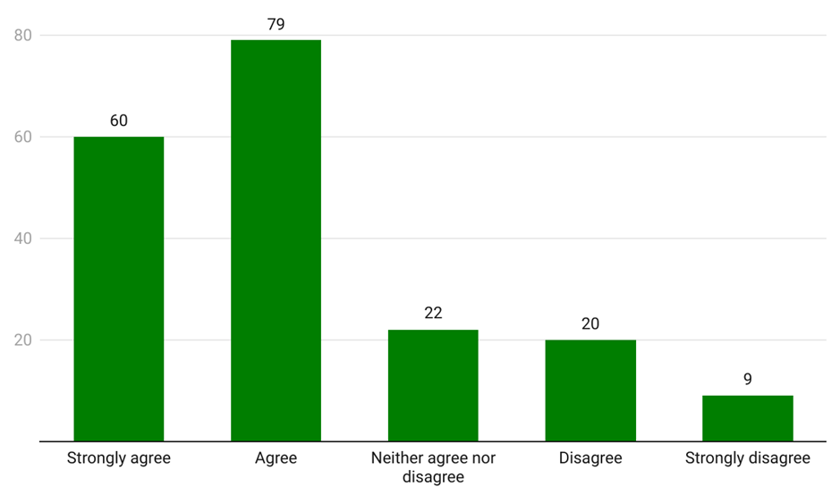Source: Consumer Hub Survey (2024)
The importance of being able to access after hours pharmacies in particular was emphasised by a range of stakeholders and consumers. Several observed that the utility of attending an after hours primary care service could in some circumstances hinge on whether pharmacy services (or other relevant allied health services) were accessible at the same time.
…for something like a urinary tract infection and a number of other conditions, you not only need a medical professional, you actually need an open pharmacist as well or their capacity to at least give you what you [need]… – Sector stakeholder, interview
If you do need any medication after hours, it's basically, I mean, you may go up to the hospital and they may prescribe something better until the pharmacists are actually there in the morning. You just, you basically haven't got anything. – Consumer, focus group
I think it's nurse on call. When I tested positive for COVID and it was a Saturday night and I was away on holiday somewhere… And [it’s] 5:00, 6:00 o'clock at night, they were fantastic. And she just sent me through to 24 hour telehealth points of contact that were both actually ironically located in [location redacted] and all the information about the local chemists to where I needed antivirals, obviously, [given I have a] lung condition. So I had an appointment within 20 minutes of contacting the telehealth and they were fantastic. They just went through and said right, you're on rituximab. Ding, Ding, Ding. Here's your E script for your antivirals. That was fine. Come Sunday, the two chemists in that town did not have the stock. So I've got a script, but no drug. So I think, where else has a pharmacy in town? The hospitals have pharmacies. So I went to the emergency at the hospital and I was seen there and I was given the antivirals there. – Consumer, focus group
One workforce organisation identified a number of challenges in pharmacists’ interactions with after hours providers, and highlighted the importance of pharmacists being able to contact after hours providers easily:
[Our] members report it is not uncommon for prescriptions from after hours prescribers to be non-compliant with legal requirements or present significant medication safety issues because the prescribers don’t have access to the full patient history. Further, after hours prescribers do not routinely access real time prescription monitoring systems that are now available nationwide to provide information about [a] patient’s history and use of controlled medicines. Members report substantial difficulties contacting the prescribers so have no options to resolve safety issues other than recommending a second prescriber, resulting in delayed treatment, or enacting other measures such as emergency supply or continued dispensing, if available. – Workforce organisation, written submission
Several stakeholders suggested the value in supporting pharmacists to work to their full scope of practice (including by applying additional subsidies to after hours service fees), and to play a fuller role in directing consumers to appropriate care options in the after hours period. A small number of stakeholders also raised the potential for autonomous pharmacists prescribing to meet some community need and relieve demand for after hours primary care. A number of state governments have conducted or are conducting pilots to allow pharmacists to dispense medication for uncomplicated UTIs (Australian Health Practitioner Regulations Agency, 2022). Under the Queensland Community Pharmacy Scope of Practice Pilot, currently underway, pharmacists are able to prescribe medications for 16 acute conditions.
Stakeholders also highlighted that the lack of after hours availability of diagnostic services such as pathology or radiology requires people to attend the emergency department or for primary health clinicians to make an interim diagnosis for treatment.
It is possible that the ability to access a full suite of services is a driver for non-urgent presentations at emergency departments (Masso et al., 2007). Several consumers and sector stakeholders expressed the view that consumers often have insight into the services they are likely to need, and will attend an emergency department where they know they can access these services rather than attend an after hours primary care provider and risk being simply referred to the emergency department or another service.
I'm a nurse so I have some understanding or knowledge of… [that] this problem or these symptoms could mean this or this or this, which means that they'll want to do that test or this scan. And so, then I will look at it and think there's no point. There's no point going to [urgent] care because they're going to say you have to have a CT scan given your history, and they can't do that at urgent care. So, if they can't do the scan or the test or something, I think, well, urgent care doesn't have that facility I might as well just go to the emergency department and start my wait time there rather than spend time at urgent care and then go to emergency and start my wait time from scratch. – Consumer, focus group
Some sector and workforce stakeholders posited that consumers would prefer integrated after hours services where there is access to a range of diagnostic and other services, and that the availability and accessibility of after hours allied health services should be considered in the planning of after hours services.
Locally, our pharmacists are working really well with the GPs and aged care providers to ensure that they have whatever medicine they need … and if that can be done in-house that also takes the pressure off our GPs having to do late night call outs. So I think we should be really acknowledging and celebrating those relationships between the aged care centres and the pharmacies to make sure that there are adequate medicines available for those late nights. – Consumer, focus group

Specific consumer cohorts
This section discusses the after hours primary care needs and experiences of specific consumer cohorts. These cohorts were identified during the course of data collection as priority groups for consideration in the design and delivery of after hours primary care services. While the following section addresses each cohort separately, it is important to account for the intersections that exist across each group and how this can impact accessibility and consumer behaviour.

People living in rural and remote Australia
Consumers in rural and remote parts of Australia face particular barriers to accessing after hours primary care due to lack of availability of services, limited transport and vast distances (Armstrong et al., 2016a; Consumers Health Forum of Australia, 2020; Zeitz et al., 2006). Increasing remoteness has a direct impact on after hours attendances at GP practices (Neil et al., 2015). This is evident in the data, which demonstrates that a lower proportion of people see a GP after hours as remoteness increases, and that the proportion of GP services which occur after hours is also lower in remote areas (Figure 48). It is important to note that MBS data does not capture many services delivered by other primary health care workers (such as Aboriginal Health Workers and Aboriginal Health Practitioners, nurses and nurse practitioners) or doctors and health care workers funded through other means, such as salaried positions. These funding and service models may be more prevalent in rural and remote communities. It also does not capture all services provided by GPs and other medical doctors in hospital settings, which may or may not be funded through Medicare depending on hospital funding arrangements which vary across jurisdictions.
Figure 48: After hours GP services per 100,000 population by Remoteness Area, 2022-23
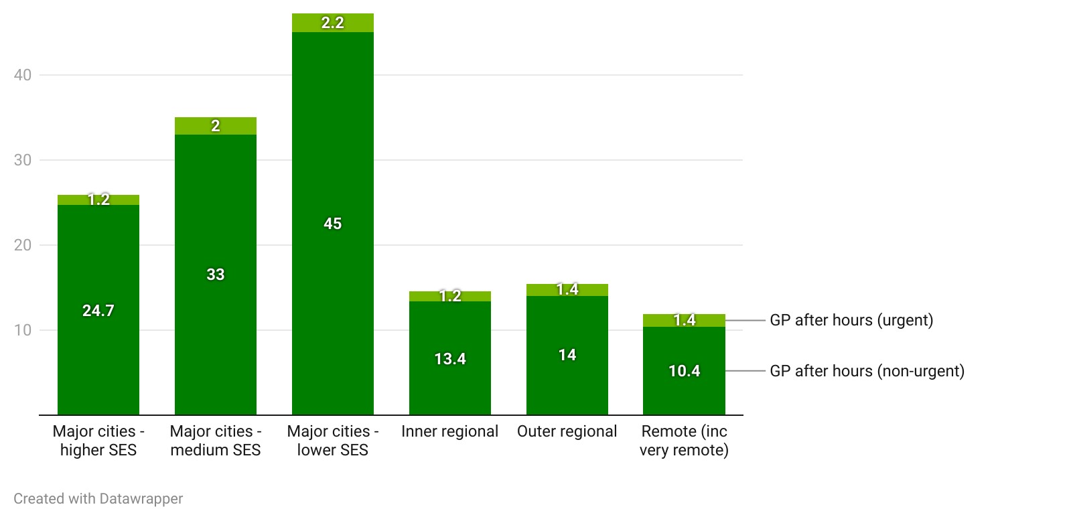
Source: AIHW, Data Tables: Medicare-subsidised GP, allied health and specialist health care across local areas: 2022–23
Several stakeholders highlighted that the need for - and usage of - after hours primary care varies across different rural and remote populations. The workforce and population profiles of rural and remote communities can vary significantly, and stakeholders identified a number of populations with particular after hours needs. These included small, dispersed populations; some Aboriginal and Torres Strait Islander populations; hidden and underserviced populations including pastoralists, farm workers, and migrant workers not eligible for Medicare; as well as mobile and itinerant populations.
The farming community I developed my practice in – they’re working all day. They hurt their leg at the farm and rock up at the hospital at 9:00 pm with a gash they’ve wrapped up with a bandage – they have the same needs but in some respects for a variety of reasons, they have delays, due to distance, lack of healthcare providers, options etc. They have the same needs if not greater. They often get to us with more complexity. - Workforce stakeholder, focus group
Stakeholders identified the lack of available after hours primary care services as the prevailing challenge to meeting the needs of rural and remote consumers. Many stakeholders and consumers described either an absence of any after hours services, an absence of alternatives to attending the hospital, or services which operate for very limited hours. Service availability is exacerbated by limited transport options and inaccessible allied health, including pharmacies.
The major gap that exists within [the state] is the limited number of accessible after-hours clinics located in regional, rural, and remote areas... Although telehealth and the Royal Flying Doctor Service are available, this does not meet all needs of the communities served. Additionally, the state experiences unreliable internet services which can severely affect access to telehealth and metropolitan support for the sick and vulnerable communities in regional, rural and remote communities. - Government stakeholder, written submission
Rural and remote consumers described a tendency to attend the hospital, including in situations where an alternative primary care service might be available. Stakeholder and consumer feedback is consistent with recent research on the reasons that consumers attend emergency departments for primary care type problems in remote communities. A 2021 study found the key drivers to be service availability and access, rational decision-making (in particular decision-making based on cost and the availability of allied health services), and self-perceived urgency (in particular poor health literacy, limited understanding of the difference between primary and emergency care, and greater confidence in hospital systems) (Fatima et al., 2022). Consumers and other stakeholders suggested frequent change and turnover in service options in rural and remote areas may contribute to people defaulting to their local hospital. It was suggested that greater education and awareness of after hours options could be useful in some communities.
We’ve had an urgent care clinic that opened in [regional town] – a regional centre with a population of about 80,000, but it probably looks after a 150 to 200 kilometre radius further around. It is not available all the time and to attend, you would have already driven past an [emergency department] in a small hospital, so I would say that people in the small and rural towns that are feeding into the regional centre such as [regional town], they are still presenting at their local hospital in the after hours.’ – Consumer, focus group
Several stakeholders and a consumer highlighted the risks to consumers of having to relocate for health care. The consumer relayed that members of their community will avoid seeking after hours care because they expect to be flown to the nearest major town, where they may be released from care quickly without transport home or accommodation.
It is known, consumers from [priority population groups], especially those living in rural and remote communities, delay treatment due to unavailability of healthcare practitioners, with the result being by the time they seek help, there is notable disease/illness progression which may require more involved care. If an individual must be relocated to a metropolitan site for treatment, there are many implications for them and their family. These include loss of income, separation from family, friends, country and communities, and increased costs to family members. - Government stakeholder, written submission
Stakeholders and consumers provided varied and nuanced feedback on the role of virtual services in rural and remote areas. Many acknowledged the value and potential of virtual services to provide service coverage in areas where an in-person after hours presence is not feasible. Stakeholders were particularly positive about the potential for ‘hub-and-spoke’ or facilitated telemedicine to play an enhanced role in after hours primary care in rural and remote areas. These stakeholders envisaged nurses or other appropriate health professionals face-to-face with a consumer, connected virtually to a GP.
I worry for these telephone services who provide advice to country patients without any regard for what services they might be able to access near to where they live. Too often their advice ends with telling the patient to travel to a city hospital ED when there might be other care available nearby. I think that the SAVES system (SA Virtual Emergency Service) is a success story because it supports rural nursing staff overnight to deal with minor problems so that rural GPs can sleep better, only being disturbed about the seriously ill. – Service provider, interview
However, some workforce stakeholders cautioned against seeing virtual health as a panacea. These stakeholders emphasised the need for face-to-face clinical assessments in some circumstances, and expressed concern that telehealth models would be used to plug service gaps in lieu of providing localised in-person services. Poor digital infrastructure in some rural and remote areas was said to further limit the usefulness of telehealth as an after hours option. Further, several workforce and sector stakeholders highlighted that often telehealth services lacked the requisite place-based knowledge to provide high-quality relevant care. Some consumers also expressed scepticism about virtual service options.
There is a virtual care service and 99% of people won’t go for virtual care, they want to see a doctor… which I know is impossible to get because of the shortage of doctors. We can’t even get one doctor here. I know people are not confident of the virtual care model. They would drive out of the community seeking to see a doctor elsewhere, but 90% of people in this town are underprivileged and don’t have car transport to even get out of town. – Consumer, focus group
While several stakeholders called for the expansion of fly-in, fly-out models of care in remote and rural areas, others considered that they undermined the provision of timely after hours care, and continuity of care. One stakeholder observed that because of this reliance on weekly or monthly visiting health services in some areas, the definition of after hours is substantially wider than in other places.
[As a mobile health service] you’re there on Monday…[which] means ‘after hours’ is the entirety of the week [where no other service exists] until [you return] next Monday. – Service provider, interview
Practitioner and practice owner/manager respondents to the Consultation Hub Survey who identified as working in rural and remote regions mostly disagreed that the current after hours system meets the needs of rural and remote communities (Figure 49).

Figure 49: Rural and remote practitioner (MMM3-7) perceptions of the extent to which the current after hours system meets the needs of rural and remote communities (n=35)
Survey text: To what extent do you agree the current after hours system meets the needs of rural and remote communities.
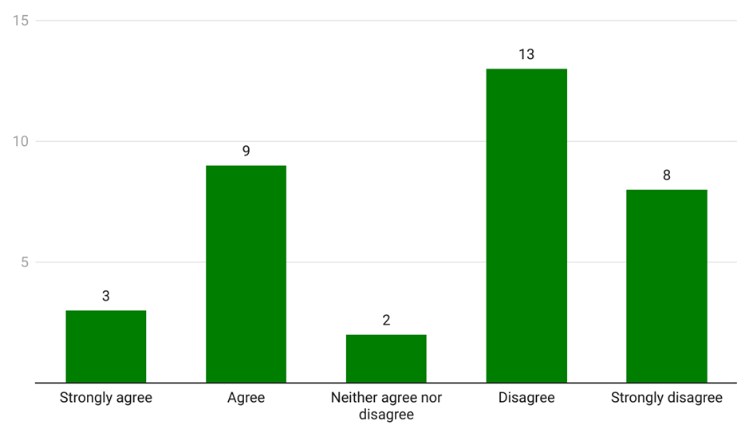Source: Consultation Hub Survey (2024)
A systematic review into primary health care delivery models in rural and remote Australia highlighted the need for a comprehensive range of primary health care services in rural and remote areas. It recognised that ‘while larger rural communities are generally able to support a greater variety of local, discrete, more specialised health care services, increasing remoteness and diminishing population size and density constrain service model options and increase the impetus for the development of more integrated and comprehensive primary health services in order to maximise the economies of scale and use of existing health workforce’ (Wakerman et al., 2008). This review highlights enablers for sustainable primary health care services for rural and remote communities, including: a supportive policy which ensures sustained service funding, policy and funding coordination nationally and across states and territories and community readiness for planning, implementation and monitoring (Wakerman et al., 2008). A study highlighting evaluations of new models in rural and remote primary healthcare highlighted the importance of shared decision-making, negotiation and consultation with impacted communities (Lyle et al., 2017).
The Australian Primary Care Rural Innovative Multidisciplinary Models (PRIMM) funds rural and remote communities to work out their primary health care needs and design appropriate healthcare. The funding is not for implementation but rather to support communities to consider issues and develop solutions. The aim of the funding is to encourage communities to work together to design primary healthcare services with a view that this may achieve viability of private practices (Department of Health and Aged Care, 2023b).

Older people
There is some evidence that age influences both need for after hours care, and where people seek it. Older people are more likely to present at after hours primary care services (Barnes, Agostino, et al., 2022; Barnes, Ceramidas, et al., 2022) and more likely to see a GP after hours for an urgent issue. In 2021/22, people over 80 were 2.5 times more likely to have received an urgent after hours GP service than children aged 1-14, and were 5 times more likely than those aged 15-79 (Australian Institute of Health and Welfare, 2022a). The disproportionate number of people aged 80 years and over seeking urgent after hours GP help is evident when the data are adjusted to reflect the number of services per 100 people (Figure 50).
Figure 50: GP after hours service per 100 people by age group, 2022-23
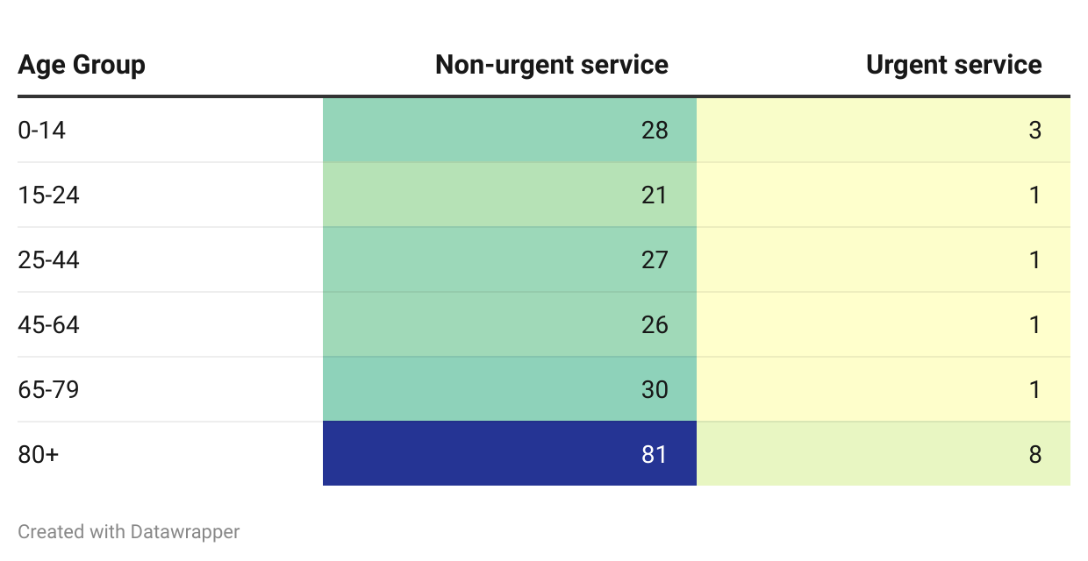
Source: AIHW, Dataset: Medicare-subsidised GP, allied health and specialist health care across local areas: 2022–23
It is possible that these data reflect the high number of GP visits made to RACH residents. In 2021/22, patients residing in RACHs received on average 16.8 GP visits per year.5F This would explain the much lower proportion of people aged 65-79 accessing urgent after hours GP services, as this age group is less likely than those over 80 to reside in a RACH. A 2021 survey found only 45% of older Australians reported that it was very or somewhat easy to get medical care in the evenings, on weekends or on holidays without going to the emergency department (Commonwealth Fund, 2021). 6F
Some sector stakeholders highlighted that older people face increased accessibility issues for after hours services due to their limited access to transport, including reliance on public transport, subsidised taxis, or carers, and increased cost barriers in part due to increase health needs. One stakeholder observed:
...non-PBS medications is one of the areas that people are finding impacts affordability for them and just the volume…of healthcare that a lot of older people are consuming. – Sector stakeholder, interview
A number of the consultations…we've had with…older people… [some have] put their hands up to cutting back on medication, cutting back on visits to [the] GP and you know, just because they … can't afford the out-of-pocket costs. – Sector stakeholder, interview
Other stakeholders highlighted the unique considerations taken into account by older people when deciding whether to access clinic-based after hours services including weather and time of day; with both cold weather and extremely hot weather likely to lead to people delaying care seeking. Furthermore, it was observed that many are not aware of available after hours options.
Many aged individuals do not like driving at night and are reluctant to ‘inconvenience’ friends or family as it’s ‘probably nothing’. Another factor is many aged Australians may not want to go to hospital for fear of catching COVID or other airborne viruses or the long wait to be seen. Often sitting in uncomfortable chairs that are not conducive to those with varying forms of arthritis…. and many people are unaware of the options available to them. – Sector stakeholder, interview
Many consumers and sector stakeholders highlighted the preference among many older people for home visits and expressed reservations about virtual health. Telehealth services were often seen as impersonal or lower-quality. This stands in contrast to data from the 2022-23 ABS Patient Experience Survey which found that people aged 65-74 were more likely than those aged 15-24 to have had a telehealth consultation (31.6% compared to 20.9%) (Australian Bureau of Statistics, 2023). Further, those aged 85 and over were more likely to report having had a positive experience with telehealth than those aged 15-24 (93.8% compared to 74.4%), always being shown respect (94.3% compared to 71.9%) and always having enough time spent with the provider (91.2% compared to 71.9%). Despite this, respondents aged 75 and over were the least likely to say they would use telehealth again for a consultation if it was offered. In fact, this age group was twice as likely than any age group under 55 to indicate that they would not use telehealth again for consultation if offered (Australian Bureau of Statistics, 2023).
I would go preferably to [a service] that brings a doctor to my house rather than telehealth or “through the phone health”. They call it telehealth but half the time it's just a phone, [you] can't even see their face. I'd much prefer if I don't know the doctor to at least see them. – Consumer, focus group
The importance of home visits was emphasised for older people living with dementia or other conditions impacting their ability to attend out of home services. Some consumers and sector stakeholders also noted that older people are often carers for spouses or other family members, compounding their inability to easily leave home to attend services.
I was basically … looking after Mum [who] had dementia for 8 years and the situation … was realistically there was absolutely nothing after hours at all. The only way you could get anything was to - I'd either take mum up to the hospital to emergency or [call] an ambulance and that was it, basically. None of the doctors will do home visits. And we even struggled to get a doctor. So for rural areas it's basically non existent.... And for someone with dementia to actually take them to an emergency department is just frightening. And I visited that hospital over 8 years, probably 33 times… and [sometimes] you could be in and out within an hour and a half…. But generally, it was between 3 to 4 hours before mum would even get seen and generally, what would be happening would be a UTI. We knew exactly what it was, but for whatever reason, they had to go through their protocol and generally we'd just get a junior doctor. We'd have to [go over] all the history over and over again, and it was basically a scary situation for my mum.’ – Consumer, focus group
More generally, older consumers and peak bodies emphasised the need to guard against ‘second rate’ services for older people – either in their mode of delivery, or in service quality. As one stakeholder stated, older people want:
… a proper gerontological workforce that’s actually trained and interested in the care of older people rather than seeing it as a stepping stone to something else. – Sector stakeholder, interview

Aged care residents
A strong theme to emerge across stakeholder consultation was the specific after hours needs of residents of aged care homes. While residents of aged care homes were not engaged during the consumer consultation phase of the Project, several stakeholders emphasised the particular and complex health needs of residents, including the high proportion living with dementia and multimorbidity. One service provider reported that:
- common reasons for hospitalisations include infections, pneumonia and minor falls
- the most common time for call bells and falls among residents is between 5:00 pm and 9:00 pm
- there can be long wait times for an after hours provider to attend a RACH
- difficulties accessing bulk billed GP services in usual hours can be a barrier to obtaining timely care from a usual GP, and this can make a RACH more reliant on after hours services.
Stakeholders also described the challenges of ensuring access to GP care in the residential aged care setting. One sector stakeholder described persistent difficulties aged care operators face in attracting GPs to provide services to residents, and the disinclination of some GPs to continue providing services to their patients once they enter long-term residential care. Several stakeholders highlighted that visits to RACHs are often unprofitable for GPs, when factoring in travel, logistics, the complexity of the patients and presentations, and the existing funding arrangements. The General Practice in Aged Care Incentive (GPACI) which commenced in August 2024 seeks to incentivise general practices to provide their registered patients in aged care with regular visits and care planning.
GPs want to dictate when they go to nursing homes, so they'll go regularly once a week and if the patient's sick, they'll see them. But if they turn up Tuesdays but the patient’s sick on Thursday, well, that's not the day that the GP goes to the nursing home so the nursing home is scrambling for the patient to be seen by a doctor. – Sector stakeholder, interview
Another stakeholder suggested that operational issues such as providing GPs access to a facility and clinical information can impact after hours care, and is partly driven by challenges in rostering aged care staff over the early evening peak period. Stakeholders also observed that aged care residents often have limited autonomy over their own healthcare both in and out of hours, and are less able to access alternative services or to advocate for themselves.
Coordination with facility staff, access to medical records, and availability of transportation can impact the ability to provide after hours care in aged care facilities, especially during evenings and weekends when staffing levels may be lower. Registered nurses in aged care facilities need access to senior health practitioners after hours to provide care and avoid hospital transfers. Further and ongoing evaluation of virtual services is required. – Workforce organisation, written submission
Despite these challenges, it is clear that residents of aged care homes receive after hours GP services at a rate higher than the rest of the community, including people of the same age living in the community. Recent Australian research indicates that both after hours GP/medical practitioner attendances and urgent after hours GP/medical practitioner attendances increase almost two-fold in the 3 months after a person enters into long-term residential aged care. Following the first 3 months, after hours attendances continued at the same rate (Caughey et al., 2024). On the other hand, less than 3% of the study cohort accessed MBS-funded geriatric, pain and palliative medicine or mental health attendances, with access to these services decreasing even further following entry into long term residential aged care (Caughey et al., 2024).
Several stakeholders emphasised the importance of ensuring adequate access for residents of aged care homes to after hours primary care to minimise unnecessary transfers to hospital. The literature suggests after hours GP care may reduce reliance on hospital attendances (Inacio et al., 2023; Payne et al., 2017), and notes that higher rates of emergency department attendance by residents of aged care homes are associated with negative outcomes including: longer hospital stays; iatrogenic illness, for example, infection, functional and cognitive decline, medication errors, and ulceration; and higher mortality (O’Cathain et al., 2020). While O’Cathain et al contend that a high proportion of hospital visits by RACH residents are potentially avoidable, hospital emergency department data suggests that when older people present to the emergency department, they do so for higher acuity issues than other age groups.
Figure 51: Emergency department presentations by triage category and age group, 2022-23
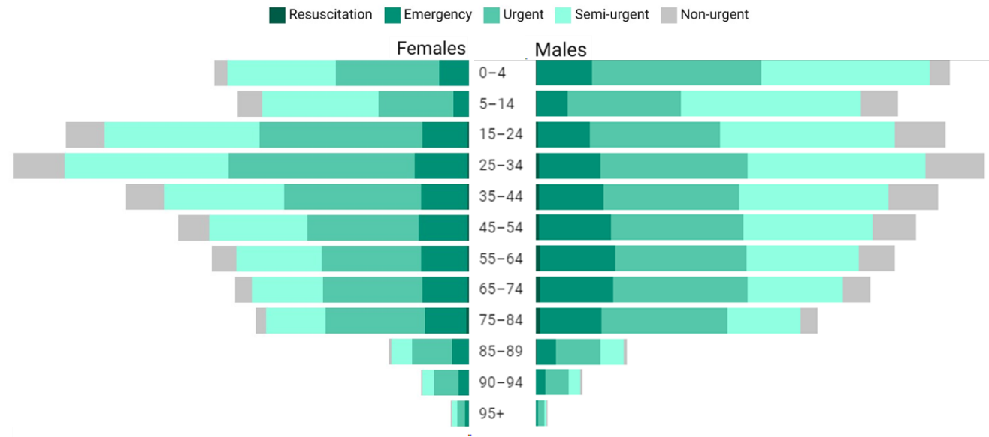Source: AIHW, Data Tables: Emergency Department Care 2022–23
There is, however, some evidence in the literature that the high level of reliance on GP after hours attendances in RACHs may be influenced by a lack of active preventive and management care by primary care providers and allied health providers (Inacio et al., 2023). This may indicate a need for more efficient care delivery models, a need for increased access to structured assessment, care planning and management, and improved access to specialist services (Caughey et al., 2024; Inacio et al., 2023).
Concerns have been raised about sub-optimal care (particularly in relation to dementia and associated behaviours, mental health and palliative care) and the role of MDSs (Caughey et al., 2024). There is some evidence in the literature that RACH residents are more likely to receive a service from a MDS. One service provider reported during consultations that 45% of its home visits in Victoria are to aged care homes and 25% in South Australia are to aged care homes. Similarly, a 2016 study examining a MDS in Melbourne found that 81% of services were provided to RACH residents (Joe et al., 2016). The study found a higher booking rate for residents of aged care homes than for those in private dwellings, which may reflect residents’ frailty and poorer health, the lower number of GPs providing care to people living in RACHs, and/or lack of knowledge about alternative after hours primary care services among people not living in RACHs (Joe et al., 2016).
Most practitioner and practice owner/manager respondents to the Consumer Hub Survey indicated that current after hours services do not meet the needs of residents of aged care homes (Figure 52).
Figure 52: Practitioners and practice owners/manager perception of the extent to which the current after hours system meets the needs of residential aged care (n=172)
Survey text: To what extent do you agree the current after hours system meets the needs of residential aged care facilities:
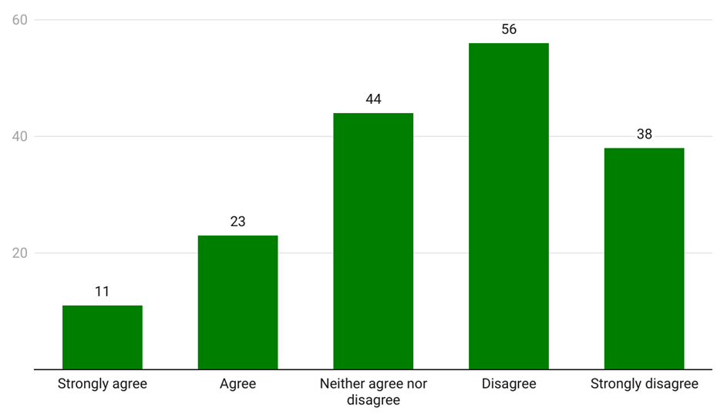
Source: Consumer Hub Survey (2024)

Aboriginal and Torres Strait Islander people17F
Aboriginal and Torres Strait Islander consumers were consulted through a separate consultation process. This Aboriginal-led consultation honoured Aboriginal and Torres Strait Islander ways of knowing, being and doing to ensure culturally safe engagement and thematic analysis of feedback. Yarning circles with Aboriginal and Torres Strait Islander people were held by a separate organisation, First Peoples Health Consulting. The approach, methodology and analysis can be found here: First Nations Yarning Circle Consultation for After Hours Review – Final Report.
Aboriginal and Torres Strait Islander people attend emergency departments at 2.5 times the rate of non-Aboriginal and Torres Strait Islander people (Australian Institute of Health and Welfare, 2022b). However, data shows they are only slightly more likely to attend for a lower-urgency problem than non-Aboriginal and Torres Strait Islander people. For example, in 2021-22, 49% of emergency presentations by Aboriginal and Torres Strait Islander people were triaged as semi-urgent or non-urgent, compared to 45% for non-Aboriginal and Torres Strait Islander people (Australian Institute of Health and Welfare, 2022b). There is a lack of data to determine whether Aboriginal and Torres Strait Islander people have different patterns of attendance at emergency departments during the after hours period specifically.
Available data indicates lower rates for after hours GP attendance by Aboriginal and Torres Strait Islander people. Nationally, Aboriginal and Torres Strait Islander peoples’ rate of after hours MBS service claims per 1000 is 0.8 times that of non-Aboriginal and Torres Strait Islander people with claim rates particularly low in remote and very remote areas (397 compared with 492 claims per 1000 population) (Australian Institute of Health and Welfare, 2024d). While the drivers behind after hours GP usage by Aboriginal and Torres Strait Islander people are not known, it is possible that access has an impact. Service data on GP encounters between April 2010 and March 2015 indicate that Aboriginal and Torres Strait Islander patients are less likely to have a GP that offers medical deputising and after hours services. Specifically, 96% of non-Aboriginal and Torres Strait Islander peoples’ encounters were with GPs with some form of after hours care arrangement compared with 86% for Aboriginal and Torres Strait Islander people’s encounters.
A lack of culturally safe services and providers, and subsequent lack of trust, has been identified as a significant barrier to accessing healthcare (Nolan-Isles et al., 2021), although no literature has been identified relating to cultural safety in after hours settings specifically. Factors that reduce cultural safety include: linguistic discrepancies between consumers and healthcare services; differences in cultural identity and healthcare approaches based in Aboriginal and Torres Strait Islander understandings, and inappropriate cultural stereotypes and racial discrimination (De Zilva et al., 2022; Li, 2017). Factors providing culturally safe health care include relationship and trust-based communication and service delivery, well-resourced Aboriginal and Torres Strait Islander health workforce and services, and mainstream services that are responsive to Aboriginal and Torres Strait Islander cultural knowledge, belief, and values, (Cultural Respect Framework for Aboriginal and Torres Strait Islander Health 2016-2026 | Gayaa Dhuwi, 2023; De Zilva et al., 2022) and that account for social, political, and historical determinants of health and wellbeing (Brumpton et al., 2023).
Telehealth services such as the healthdirect helplines have the potential to improve healthcare access for remote and underserved populations, including Aboriginal and Torres Strait Islander communities. Analysis of Healthdirect Australia data indicates strong uptake by Aboriginal and Torres Strait Islander callers (see Figure 53) who make up at least 6% of callers on the healthdirect helpline and GP helpline despite making up just 3.8% of the general Australian population.
Figure 53: Aboriginal and/or Torres Strait Islander status of healthdirect callers
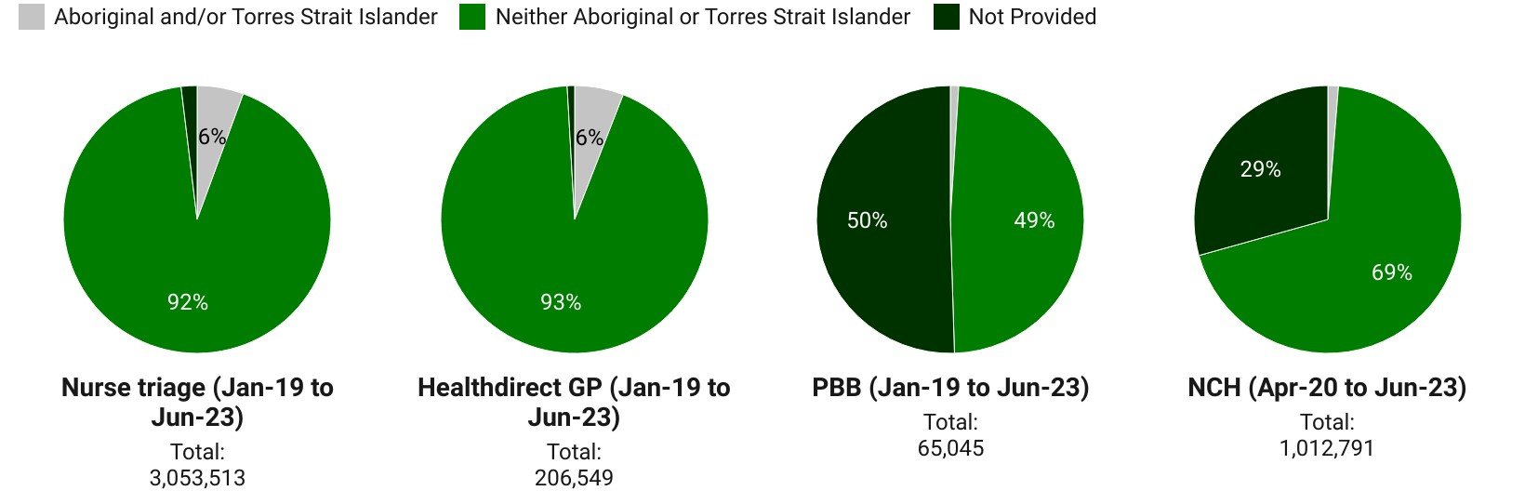
Source: Internal data provided by the Department of Health and Aged Care
Aboriginal and Torres Strait Islander people have been found to value care provided by ACCHSs in comparison to mainstream/general practitioner services, on the basis that they provide welcoming social spaces and additional service offerings, culturally safe care, and appropriate and holistic models of care (Gomersall et al., 2017). Reflecting this, AIHW data indicates that ACCHSs provide a culturally determined suite of services ranging from transport to social and emotional wellbeing counselling to substance abuse and tobacco programs (Australian Institute of Health and Welfare, 2024d). However, the majority of services surveyed (53%) do not provide any form of after hours service, suggesting a potential service gap.

Table 2: Number and proportion of Aboriginal and Torres Strait Islander primary healthcare organisations that provided care outside of normal operating hours, by type of service, 2017-18
Type of after hours service | Number of services | %
Transport | 67 | 72.0
Treatment of injury | 64 | 68.8
Diagnosis and treatment of infectious illness/diseases | 57 | 61.3
Social and emotional well-being/mental health/counselling | 53 | 57.0
Antenatal care | 36 | 38.7
Care in police station/lockup | 34 | 36.6
Maternal and child health care | 29 | 31.2
Diagnosis and treatment of chronic illness/diseases | 27 | 29.0
Substance use/drug and alcohol programs | 22 | 23.7
Hospital inpatient/outpatient care | 14 | 15.1
Tobacco programs | 7 | 7.5
Other | 17 | 18.3
Total after hours services | 93 | 100.0
Provided after hours services | 93 | 47.0
Did not provide after hours services | 105 | 53.0
Total primary health care services | 198 | 100
Source: AIHW, 3.16 Access to after hours primary healthcare
Less than half of [ACCHSs] provide comprehensive services outside business hours like transport, medical treatment, mental health support, and management of chronic illnesses. This lack of accessible, culturally appropriate after hours primary care often forces Aboriginal and Torres Strait Islander peoples to either go without timely care or turn to already overstretched emergency departments. Addressing these service gaps will require funding to expand [ACCHSs] after hours service availability, improving cultural responsivity in mainstream services, and facilitating stronger integration between the primary health care sector and hospital systems. – Sector organisation, written submission
Stakeholders similarly highlighted that Aboriginal and Torres Strait Islander people face the same access challenges for after hours as the general population, though these are heightened by factors including overrepresentation in casual jobs without sick leave benefits. Peak bodies and Aboriginal and Torres Strait Islander community members consulted emphasised the significant role health system mistrust, stigmatisation, and cultural safety played in impacting after hours care seeking behaviour. This is reflected in literature which highlights racial discrimination as an impediment to health service access (Bastos et al., 2018; Elias & Paradies, 2021).
One stakeholder also highlighted the importance of funding models supporting Aboriginal and Torres Strait Islander healthcare practices and ways of communicating including extended appointment times to provide culturally safe, holistic forms of healthcare.
The funding model needs to recognise the time for a yarn, particularly if you’re not seeing your regular GP, you have to build in the time for the yarn. You may also be dealing with a family, rather than one patient. We spend a lot of time with our clinicians teaching them to do active listening. – Service provider, interview

LGBTIQA+ people
AIHW studies have found that young LGBTIQA+ people may not always consider health services culturally safe, relevant or accessible. A 2024 study has found that LGBTIQA+ Australians experience barriers in accessing healthcare resulting in low levels of use and satisfaction and that ‘members of the LGBTIQA+ community frequently experience care that is not appropriate, inclusive or affirming’ (Saxby & Stephens, 2024). AIHW reports that LGBTIQA+ Australians may face discrimination and unique challenges to their health and wellbeing, including access to health services (Australian Institute of Health and Welfare, 2024c). Further, discrimination has been shown to play an important role in predicting healthcare outcomes and access for LGBTIQA+ Australians, and can deter access to the health system, underscoring the importance of ensuring appropriate and safe care (Saxby & Stephens, 2024).
I want the government to know how judgmental [health services] can be. If they say the wrong word it hurts someone. They need training including pronouns and [appropriate] use of acronyms. – Consumer, focus group
This was substantiated in stakeholder engagements where consumers shared accounts of discrimination including misgendering and several stakeholders indicated that they experience homophobia or transphobia when accessing care outside of usual channels, or that they do not disclose because they feel that they will be discriminated against. The importance of gender affirming care is known, and has been found to ‘dramatically improve the health and wellbeing of trans and gender diverse individuals’ (Saxby & Stephens, 2024).
It was my partner who I was with at the time, he either had some kind of allergic reaction or something … and we had to call home doctors, they refused to send anyone because the woman we spoke to was homophobic and [my] partner had a gender neutral name, I kept saying “he” “he” to make it obvious – she said “Sorry we don’t do that, we don’t look after you people” I was like “you people?” They said “we are not […] LGBT friendly” – so I know it was just her because they’ve seen me before. When we called the ambulance, three of them showed up and one of them refused to walk in the door because of my partner. The other two didn’t care. The one who refused to enter the house did everything possible to show he was uncomfortable there. Snide remarks, for instance. I was getting agitated because we weren’t moving. The ambo in the back with us, he was like “we’ll deal with him”. He was telling the person to quit it, that they are patients, they need help. He was stepping up for my partner. Advocating that it doesn’t make us less than human. The comments were getting worse and worse. – Consumer, focus group

People from culturally and linguistically diverse backgrounds
People from culturally and linguistically diverse (CALD) backgrounds may face a number of barriers to accessing primary care in the after hours period. A 2021 study commissioned by the North Western Melbourne Primary Health Network found that some barriers to access may include:
- English language proficiency as a requirement to access and use the system
- cultural differences between service providers and consumers
- lack of public or private transport
- inadequate interpretation services and poor cultural competency of providers
- type of employment and variable working hours (Plowman & de Vries, 2021).
Consumers confirmed that there are members of CALD communities who may be disinclined to attend a primary care provider in the after hours period. Consumers and sector stakeholders from CALD backgrounds highlighted cost as a barrier in some instances, including for people without access to Medicare and who need access to certain medications. Stakeholders also observed that many primary care services lacked appropriate language services, and some CALD consumers felt ‘fear’ when accessing care because of difficulties with expressing themselves and understanding what they perceived to be technical and complex questions from providers. Stakeholders also considered that CALD consumers were often concerned about cultural awareness and practices; that ‘[they] don’t understand me, don’t understand my needs.’ One stakeholder observed a need to move beyond interpreting services to ensure services are culturally safe through cultural safety training and having a representative workforce, including peer navigators.
I think this [has] got to do with… getting the person, whether it's a GP or clinician who speaks the same language or I think it's just a matter of cultural identity that a person feels safe, like for my mum, right? She has a GP who actually understands her language and speaks the same language. There's no problem. I think the problem is that when she need a home visit, when they allocate the GP to visit her at home, that's where the challenge is, because it's very hard to get access to a GP, who can understand [the] culture and language, so unless there's someone else with her during home visitation, [it] is very hard. And also during the [visit it] is hard… because she's a very independent person and wants to kind of speak [to] represent herself. But when there is an interpreter available, she finds that [they are] not able to translate the concern she has, even though that person is a certif[ied] interpreter. But sometimes in our own culture a word that we use ha[s] different meaning, I think. And I think that's why it can be very complex. – Consumer, focus group
While data on service usage are lacking (MBS data does not capture a patient’s cultural and linguistic background), a 2015 Australian study found that immigrants and linguistic and ethnic minorities in Queensland tend to use emergency department services for lower-urgency conditions. The study concluded that patients from non-English speaking backgrounds in triage categories 3 to 5 were far less likely than those patients with an English-speaking background to consider contacting a GP before attending the emergency department (Mahmoud et al., 2015a). Patients’ reported reasons for not contacting a GP were that they do not have a regular GP or that it can take a long time to obtain an appointment with their GP (Mahmoud et al., 2015a).
The 2021 study commissioned by the North Western Melbourne Primary Health Network also found that CALD consumers have high levels of trust in hospital emergency departments and the ambulance service. This was consistent with feedback from a sector stakeholder, which attributed elevated trust in emergency departments to their provision of multiple services on site, perceived quality of care and prestige, and to the fact that in many countries, hospitals are the entry point for most health complaints (including those considered to be GP-type presentations in Australia). Sector stakeholders highlighted the need to communicate more effectively with CALD communities - including to raise awareness of after hours primary health options and their merits compared to emergency departments. Plowman and de Vries suggest that co-locating primary health hubs adjacent to hospitals may be effective in reducing low level emergency department visits by CALD consumers, and would also open up access to primary care for consumers who were unfamiliar with the system (Plowman & de Vries, 2021).
100%. My CALD grandmother would attend hospital rather than an after hours GP because her perspective is that it is the only way to get quality care. – Sector stakeholder, interview
Lack of awareness of service availability and a lack of knowledge about Australia’s health system also act as powerful barriers to access primary care after hours (Mahmoud et al., 2015b; Plowman & de Vries, 2021). Several CALD consumers described accessing emergency department care because they did not know about primary care alternatives, or how to seek out information about them.
My experience with after hours care was basically mainly for children – [I have] two boys and when they were young, [they were] very active. And the reason for using after hours care was maybe fevers, high fevers and also injuries. But because we didn't have the knowledge about other care [services], we always went to the emergency… So we just waited for hours and hours. If there isn't any issue that might be it. And the conditions were generally, you know, well looked after afterwards. And so… recently we have more knowledge about after hours care… so we use other resources. But it's only because we have a nurse friend who told us what sort of services are available. And also I started doing health advocacy activities and through that I gained some knowledge about after hours care. – Consumer, focus group
One consumer described in some detail the way in which many CALD consumers rely on their community for information and advice about where to seek help.
When we first migrated here… the children were very young. They were about 5… and when they fell sick after hours it was very difficult to actually access any information [about] what was available for these kind of ailments... [A]s multicultural communities because we are small… everybody knows everybody almost at that time. So therefore we had some medical doctors among our […] friendship circle. So therefore we relied on them to assist us in terms of actually asking for certain prescriptions and so on now. [W]e were actually dealing with [a] lack of information on how as young parents [to] deal with these non-emergency situations at the same time, relying on social networks in order to help us. The younger members of the community – CALD community, multicultural communities - start ringing me up and saying, ‘Hello, do you know anybody? Do you have information on after hours care […] we [can] please access?’– Consumer, focus group
Stakeholders provided mixed feedback on the potential for telehealth to facilitate access to after hours services for CALD consumers. Stakeholders identified advantages such as the availability of e-scripts, and the potential for artificial intelligence tools to provide real time translation for telehealth services.
There’s an opportunity in virtual services to provide more languages in a way that you just can't do [face-to-face]. You can't have 196 languages available in a hospital or practice…so that's a real advantage of virtual. – Service provider, interview
Others noted that awareness of virtual health – and in particular interpreter – options were low among many CALD communities, and digital infrastructure could be difficult to use for certain groups in certain instances, requiring the use of subtitles or captions to alleviate misunderstandings. A consumer from a CALD background raised a note of caution about the use of interpreter and health workers from local communities, noting that given the small size of the communities this could raise privacy concerns. Further, concern was raised about the quality of some interpreter services. It was emphasised that cultural considerations need to also be sensitive to gender and aged-based cultural dynamics, and that this was currently lacking. These observations are not unique to the after hours system and were said by stakeholders to apply to the healthcare system as a whole.
I used healthdirect online consultation service for my own injury during the weekend and it was a video conference so that I… was able to show the affected area [on] my foot. … That was one concern.
For us with, you know, English as the second language, audio quality is very important and without, you know, good quality sound, I wouldn't be able to understand what… the healthcare providers want to tell me. – Consumer, focus group
One consumer identified language barriers leading to extended appointment times, misdiagnosis and associated cost barriers and health system disengagement:
People who don't have English as the first language, and it might be their third and fourth language here and there's just so much time trying to communicate their needs through. And if they have additional communication issues, they can spend almost all of their 15 minutes trying to just simply be understood and then that can lead into … additional costs for a longer appointment time, or even just completely wrong diagnosis given. So, there are a lot of those [consumers] who have reported just giving up… – Consumer, focus group

People with chronic conditions
The needs of people with chronic conditions in accessing after hours care was not widely addressed in the literature reviewed. Stakeholders and consumers identified a number of features of chronic conditions which can intersect to create elevated needs in the after hours period. These include the fact that many chronic conditions can flare up out-of-hours, that they may require regular monitoring and management, and that many consumers experience chronic condition multimorbidity. This can lead to increased demand for after hours services, as well as greater complexity in presentations and heightened anxiety for consumers. At least one stakeholder also noted the development of preventative guidelines to identify risk, which may have the capacity to decrease the need for after hours care. However, when trusted care is not available or accessible this can lead to people delaying care and health issues escalating. One consumer reflected on this, sharing:
Last year I was getting really bad upper chest pains… my doctor rings me up at 8:00 pm at night. He’s not working then. He said get straight to hospital…. I said I’m in pain and my doctor sent me. I had… the results. We had […] a three and a half hour wait. I asked how much longer and they said there’ll be another three hours before a doctor sees you… [it was] freezing cold… and so I went home. I just said to my husband I’ll take my chances that I’m not going to die tonight…they said come back before 6:00 am that’s when it’s pretty quiet…so I did and then I got treated like a queen. – Consumer, focus group
One stakeholder observed that people living with a chronic condition often deprioritise anything that is not an acute emergency, leading to conditions escalating.
I think people see out of hours care as being for an acute situation, not for the regular: “I need to get my script filled”.
Consumers and sector stakeholders considered continuity of care to be especially important for people with chronic disease, a finding which is reflected in the literature (see Song et al., 2020). Continuity of care concerns for people with chronic conditions in rural and remote locations are heightened by insufficient care coordination and lack of available resources and services (Street et al., 2019). Sector stakeholders and consumers described reluctance to attend service providers who might not understand the consumer’s medical history or have access to their medical records. Consumers recounted experiences of being prescribed medication during the after hours period without adequate explanation of how that would interact with other forms of medication and without clear explanation of where to go for answers.
I don't think you can separate out continuity of information from continuity of care. But I think that if someone had a chronic disease and they needed to seek medical advice outside of business hours they could be inhibited, too, because they might think, look, that person, that GP, maybe they're a new graduate or, you know, why are they doing … after hours work. They might have a lack of confidence in them as well as their ability to understand all of their medical needs and to know [their] medical history. … Someone might have a cough and that could be tied to their chronic disease or it might not. It could be obvious, or it might not. But that healthcare provider would really need to be able to see their history. – Sector stakeholder, interview
Consumers and sector stakeholders also described consumer experiences of being stigmatised when seeking help from unknown healthcare professionals through either after hours services or emergency departments. One consumer described waiting for 3 weeks to see their regular, trusted GP rather than seek help from an unknown practitioner.
So the other thing we hear a lot from people living with [a chronic condition] is about stigma and the stigma that's associated with having [this condition], … that really does inform their decision-making on a day to day basis about who they're going to choose to speak to and particularly in an after hours care setting where you're not going to be speaking to your normal doctor or necessarily a doctor that you've ever seen before. – Sector stakeholder, interview
Sector stakeholders and consumers highlighted that people with chronic illnesses face increased cost concerns due to their higher health needs which in some instances reduce their ability to undertake paid work and increase their need to access a range of primary and allied health services. One stakeholder observed that this can drive consumers with chronic conditions to use emergency departments because they are free of charge. One stakeholder described emergency departments as a ‘safety net’ for people with chronic conditions when they are uncertain of what to do or whether to seek help.
…they do face financial pressures when they're on, you know, sometimes up to 20 different medications and they're having to choose which ones they can afford to buy at the pharmacy. They just don't have the spare $30, $40, $50 to go and pay the out-of-pocket expense of seeing a GP and so on. – Sector stakeholder, interview
In addition, one consumer with lymphoma highlighted that her condition limited her ability to access primary care services.
For myself, if I'm feeling unwell or anything, I've been given a little card. … So I've got access to a nurse from the cancer clinic so I can ring him and also if it was urgent, we'd call an ambulance and I'll go to the hospital. And with my blue card, they can identify that I've had chemotherapy … A couple of times, last year we've had to call the ambulance because I had shortness of breath and it turned out to be pneumonia. So the after hours clinic wouldn't have been able to help me or a doctor coming home. And another time I had an ear infection and my GP when he saw it, he said just go straight to the hospital. – Consumer, focus group

Another consumer shared:
My GP is the same. She's like - you have to promise me that if this happens or that happens … you have to go to emergency. Given that I have said to her a number of times, ‘That's it, I'm never going back there’, she makes me promise that I will go there if something serious happened. – Consumer, focus group
The majority of practitioner and practice owner/manager survey respondents disagreed that the current after hours system met the needs of people with chronic illness (see Figure 54).
Figure 54: Practitioner and practice owner/manager perception of the extent to which the after hours system meets the needs of people with chronic illness (n=170)
Survey text: To what extent do you agree the current after hours system meets the needs of people with chronic illness
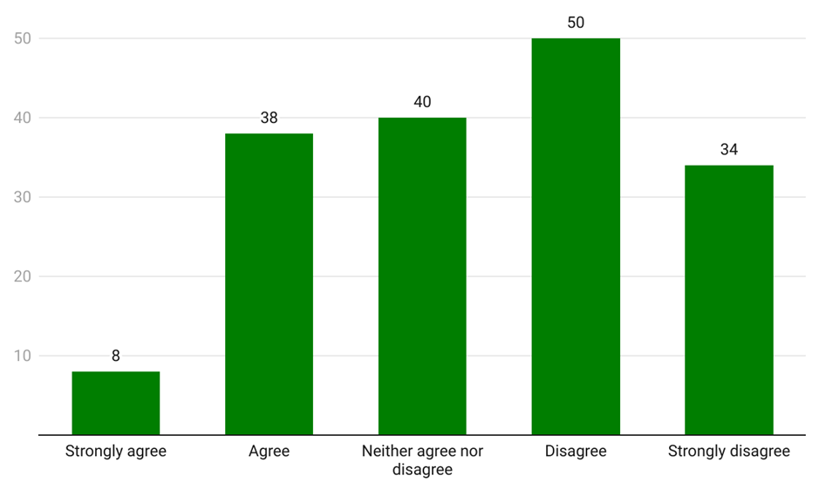
Source: Consultation Hub Survey (2024)

People with disability
Evidence relating to the after hours primary care needs and experiences of people with disability is limited. AIHW analysis of data from the 2018 ABS Survey of Disability, Ageing and Carers indicates that 11.2% of people with disability felt that a GP could have provided care for their latest visit to the emergency department (Australian Institute of Health and Welfare, 2023b). In the same survey, 13.8% of people with disability reported that they had difficulty accessing medical facilities (GP, dentist, hospital) in the last 12 months. Reported rates of difficulty were highest for:
- People in NSW (17%)
- People aged 65 and over (16.6%)
- CALD people with low English proficiency (23.7%)
- People with sensory or speech disability (16.9%) and other disability (17%).
Sector stakeholders and consumers highlighted the importance of accessibility considerations in the design of after hours services. Consumers described the increased accessibility issues they face. These include: limited transport options due to reliance on public transport, taxi vouchers, or carers; the physical inaccessibility of health services including lack of adequate parking and sensory appropriate waiting rooms; and heightened cost barriers. Several consumers noted that this led to increased reliance on family and carers to facilitate access, and sometimes meant not attending after hours care because they did not want to be a ‘burden’ to their families.
…the vast majority is medical appointments, pharmaceuticals and transport, [its] massive for them in terms of, you know, if you can imagine taking the person you care for to multiple appointments, it's finding parking, paying for parking...It's another reason why in home services [are] so useful. – Sector stakeholder, interview
Consumers emphasised the importance of people with disability having ready access to modes of service delivery which are most suitable for them at a given point in time, including virtual health options and home visits. Several peak stakeholders discussed a preference for home visit models, noting that there was limited availability (including visits to shared accommodation), whilst also recognising the value of telehealth and in-person services in some instances. Other useful services discussed included triage and follow-up services that support people to manage their disability independently, including education on where to safely access care after hours.
I think availability is probably the first one because disability is one of those very hard areas where you basically have so many more complicated sensitivities around the care you provide and what you need. Cause a lot of kids… interact with the health system like this, and they're sort of … trying to distinguish… is this about the… disability? Is this about their health? Is it about the interaction of the two? You know they have a […] list of diagnoses and some are relevant, some are not… It really is the responsibility of the health professional to actually make the decision as to what matters rather than me. Part of their risk management is to work out, you know, there's this… person presenting to me but what do I really know about them before I can write a script …? – Consumer, focus group
The importance of continuity of care and information for people with disability emerged as a consistent theme. Several consumers with disability highlighted that various after hours services did not have access to their medical records. This means consumers must relay important information and act as the single source of truth for their medical history. Several consumers described the difficulty of accurately recalling complex medical histories while ill, and having to rely on family members and carers to fill in gaps. Consumers described this experience as exhausting, leading some of them to delay care in some instances until they could see their regular health practitioner. One stakeholder said this issue was exacerbated in places like the Northern Territory where they identified issues with high workforce turnover.
… I found … needing to use the service after hours or on the weekend, you don't necessarily get to go to the same place that you [normally] would, [where] they do have a comprehensive medical history. And so therefore, you're talking to new doctors that you've never seen before and because it's generally bulk billing or what have you, they have about 5 minutes for you and that's it. So, I've found that…then if you start getting into more of a history, they get really ‘Oh, that's too much, that's too much. I don't want to hear about all these. I don't have time for this’, you know. So, yeah, that's what I've experienced just in the last 3 or 4 times that I've gone. – Consumer, focus group
Several consumers expressed frustration that when receiving care from an unfamiliar practitioner, the practitioner was often unable to disentangle their acute illness from their disability – or to see past their disability. In some instances, this resulted in their disability or condition being dismissed and in other instances focused on when it was unrelated to their presenting condition. Reflecting findings that 11.2% of people with disability felt that a GP could have provided care for their latest visit to the emergency department (Australian Institute of Health and Welfare, 2023b), one consumer observed a trend of health professionals sending people with disability to emergency departments. This was attributed to ‘a fear of taking responsibility.’ These after hours care seeking experiences were described by several consumers as emotionally and physically ‘exhausting’ leading them to either delay seeking care or to attend emergency departments which they felt were better positioned to deal with their situation.
Some stakeholders observed that health professionals lacked skills in communicating appropriately and effectively with people with disability, with one identifying a need for services with ‘compassionate communication’ to help people with disability, their carers, and families navigate when, where and how to access care. One consumer stakeholder relayed that at times all that was needed in an after hours care session was reassurance that everything was okay rather than having concerns dismissed and being sent back home.
… I tend to avoid after hours. There's no history, and they say to me, are you slurring? And I'm like, well, that's normal for me. Because they don't know me. It's a waste of energy and time. Only about 2 months ago, I was really sick with [what I] now know was bacterial meningitis, but I've just had a corneal graft so I was wearing an eye patch. My dad came with me to the after [hours] care and they communicated with him because they thought that … was my normal … when in fact it was not. It was not my eye. It was that I was quite unwell. And for them, they didn't know me, so they thought that was my norm. So really… there's no history. I'd rather skip after [hours] care and go straight to the emergency department, because it's a waste of time. It just causes more frustration. – Consumer, focus group

Most practitioner and practice owner/manager survey respondents disagreed that the current after hours system met the needs of people with disability (Figure 55).
Figure 55: Practitioner and practice owner/manager perception of the extent to which the after hours system meets the needs of people with disability (n=172)
Survey text: To what extent do you agree the current after hours system meets the needs of people with disabilities
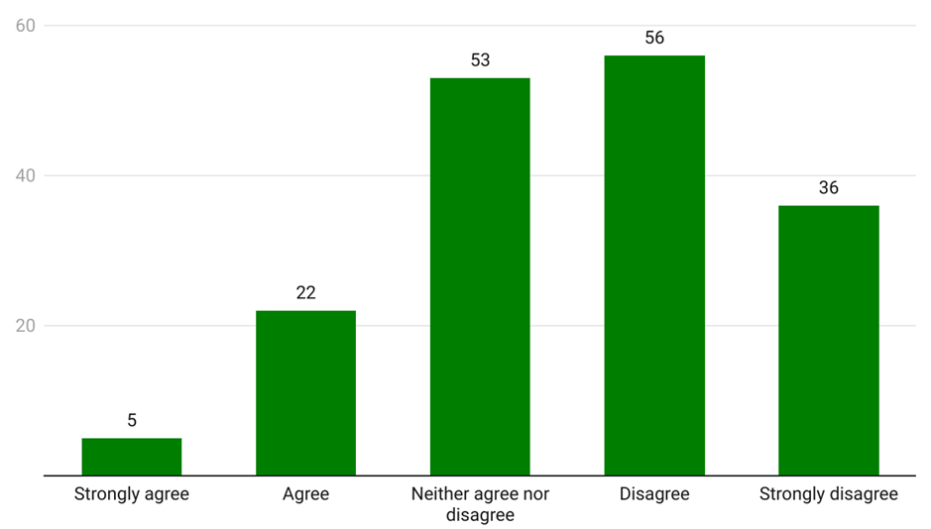Source: Consultation Hub Survey

People with palliative care needs
Palliative care is person and family-centred treatment, care and support for people living with a life-limiting illness and can begin at the point of diagnosis, and continue to be provided while a patient undergoes treatment for an illness which may last years. End-of-life care is provided to individuals who are at the end of their life, and is a component of palliative care (Department of Health and Aged Care, 2023c).
In order to provide adequate after hours care for a person receiving palliative care, a multidisciplinary approach is required. This includes access to prescribers for pain and other medications in the after hours period to prevent delays in pain and symptom relief. This access is particularly pertinent for end-of-life care to manage rapid deterioration. Further, longer consultations may be required in the after hours period to accommodate the complex needs of patients, and practitioners providing consultations should be skilled and equipped to understand the complex challenges faced by patients receiving palliative, including end of life care. The risk (including exposure to infectious diseases) as well as the wait-times involved in accessing the emergency department for palliative care patients is also a critical factor to be considered in informing the design of service provision for patients in the after hours period. The need for culturally safe services for First Nations people with palliative care, and end-of-life care needs was also highlighted by consumers. Further, the needs of patients in RACHs was also raised as a specific need and is considered further at section 3.2.2.1. However, it is important to note that with the changes to the Support at Home program from 1 July 2025, this may change demand for the provision of after hours care in the home.
The World Health Organization has emphasised the global need for 24-hour palliative care (Low et al., 2023). In general, GPs are the predominant service accessed for after hours palliative care services. The literature shows that other services including nurses, palliative care specialists, pharmacists and increasingly, the emergency care team also contribute to after hours palliative care, indicating a growing need for a broader team of care providers to support palliative care patients in the after hours period (Low et al., 2023). The critical role of nurse practitioners in the provision of after hours service provision was also an emerging theme during stakeholder engagement.
There is mixed evidence on the merit of telehealth for patients with palliative care needs. Some studies have indicated that the use of telehealth to provide after hours palliative care has been largely effective in managing patients’ physical and emotional symptoms and provided the tools for patients to self-manage their illness and symptoms (Gordon et al., 2021). However, there were contradicting views on the effectiveness of telephone services in enhancing the quality of life of palliative care patients (Steindal et al., 2020). Telephone services were generally not seen as an appropriate substitute for other services when discussing serious diagnosis or end of life issues (Namasivayam et al., 2022). Most evidence showed that improved outcomes for patients were achieved where a combination of both hands-on clinical and advisory care were used (Firth et al., 2023).
During the course of engagement, several sector stakeholders and consumers emphasised that palliative care requires a 24-hour service delivery model. Several stakeholders indicated that primary-care led interventions and palliative care support can reduce avoidable hospitalisations. A theme that emerged was also that extended wait times are problematic for palliative care patients who can deteriorate further and require additional medical attention.
Some services have been established to provide extended hours to patients with palliative care needs. For example, the Home Based Palliative Care Program (HBPC) funded by the ACT Government provides after hour services for eligible palliative care patients between 7:00 am and 10:00 pm. Outside of these operating hours, the phone number for the HBPC program is diverted to community nursing services. An evaluation of a pilot after hours palliative care medicines program in the ACT found that the program made a monthly average of 126.9 after hours home deliveries of specialist palliative care medicines. South Australia has established an extended care paramedic (ECP) service that provides urgent after hours interventions for palliative care patients, primarily those in RACHs. This 24-hour service works collaboratively with other health care professionals, including GPs, aged and home care providers, home support services, palliative care services, plastic surgery, and sports medicine (SA Ambulance Service, 2022). Whilst ECP vehicles do not transport patients, they do carry equipment and medication suited to support palliative care patients.
The importance of ensuring that primary care after hours services are provided to patients with palliative care needs by health care professionals with appropriate skills and expertise was highlighted by consumers. The prescriptions and medicine required by patients with palliative care needs are complex and not routinely available at most pharmacies. The lack of stock of these medicines and lack of accessible options can push people to hospitals and other acute service settings. Consumers and sector stakeholders identified the need for certain medications to be made more widely available at pharmacies through changes to prescribing regulations to increase their accessibility, particularly for people living in rural and remote areas where certain medications are harder to come by. Stakeholders simultaneously cautioned that this must be done in way that mitigates any risks associated with loosening regulations.
Some stakeholders indicated that some patients with palliative care needs also required reassurance in the after hours period, with one stakeholder suggesting:
Because you still get…those issues with people seeking access to care, who don't necessarily need access to care in the after hours, but they do need reassurance. They do need someone to talk to them, to listen to them, to hear their worries and concerns and potentially, you know, make an appointment for them at their preferred healthcare provider for the next morning and so that people feel comforted and reassured. – Sector stakeholder, interview
The length of appointments required to provide appropriate services for patients with palliative care needs, particularly those who are home-bound or living in RACHs was also raised as a barrier to access, with one practitioner highlighting:
The problems are often the reporting requirements to comply with the billing structure to make it legitimate. The structure of long consults is very much directed toward “medical” complexity. Often the long consultation is not about complex pharmacology or investigations - it is about dealing with the psychosocial and spiritual aspects of the person, their family, and their dying. Medicare does not necessarily see that as “medical", but you can't manage the patient without going into those areas. If the patient is not conscious, they can't consent to the consult, so theoretically the consult cannot be billed. If the patient is not present (lengthy family meeting, or bereavement follow up), the patient cannot be billed, and so on… – Sector stakeholder, interview
Stakeholders highlighted that the need for primary care palliative care provision in the after hours period must be articulated and needs to be distinguished from specialist palliative care. One service provider highlighted that there is a lack of GPs who have the ‘capacity or capability to provide primary care whilst a person dies at home either in or out of their usual hours’. A parent who had cared for a child with palliative care needs outlined the importance of an understanding of patients with palliative care needs, highlighting
I don’t think a lot of people realise unless they have been a parent or worked very closely with parents of children in palliative care, that generally we actually want to do everything […] every moment of the day to keep them here longer and as long as we possibly can. So, to give you an example, we once had an after hours GP who came to our house, and the [GP] was so sick and was coughing all over our daughter who could die from a respiratory infection and it never even crossed her mind … so I think there has to be that different level of care and respect for the situation by any external service that provides that care and maybe some educational training on that or you know, clients having a flag on their card that that child is in that situation. I think there are a lot of little things that could be done that would make it a lot better. – Consumer, focus group
Consumers and sector stakeholders also highlighted the importance of continuity of care for patients with palliative care needs. One sector stakeholder highlighted that:
… it comes back to [..] shared decision-making and urgent prescribing, ultimately asking a new professional who doesn’t know the patient to prescribe urgent backup opioids and sedatives or decide that […] there’s no more investigation or treatment to be done is just a very big ask and it is often most efficient if the person who knows the patient is available to be participating in that. – Sector stakeholder, focus group
Some consumers felt fortunate that their regular GP was able to provide primary care after hours assistance which meant that they were able to receive the services they needed without exposing themselves to unnecessary risk in the emergency department: ‘I had to negotiate with [my GP] that I would only call when absolutely needed and we had to build this trust over time before he gave me his mobile number…because the alternative would have been going to the emergency department’. However, there was recognition amongst consumers that this level of service provision by a patient’s regular GP was rare. The importance of continuity of care was also highlighted by carers of paediatric patients with palliative care needs.
It makes such a difference when you are talking to someone who is caring, calm and familiar with your child in a scary situation. – Consumer, interview
The importance of awareness of clinical history in the context of paediatric palliative care was also a key theme that emerged through stakeholder engagement: ‘it’s exhausting and retraumatising every single time you have to repeat the story’ with some consumers highlighting the additional emotional toil required to ensure that all the relevant details are communicated.
The load is on the parent to make sure nothing is missed. – Consumer, interview
Some consumers highlighted the importance of care plans and the importance of ensuring that care plans can be accessed by all treating practitioners. Stakeholders also indicated that the provision of after hours primary care to patients with palliative care needs also requires tailored design to support intersectional needs. Some stakeholders highlighted the need for place-based programs to support cultural and diverse needs. Stakeholders also highlighted that consideration of the needs of First Nations communities in the design of after hours responses for patients with palliative care needs is also critical. A workforce stakeholder highlighted the ‘critical need for culturally appropriate end-of-life care that respects Indigenous traditions, values and spiritual beliefs.’ One stakeholder observed that:
…at a recent trip to a remote community, the Aboriginal people that I talked with, highlighted that they do not want to die in their house due to the cultural impact/family needing to move out but do want to die on country so facilities such as a room in the clinic/community hospital may support these needs but would require community engagement. – Service provider, interview
Three-quarters of people accessing MBS-subsidised palliative medicine attendances are aged over 65, with the population rate increasing steeply from age 55 (Australian Institute of Health and Welfare, 2024e). While data on the need and receipt of palliative care among people accessing both home-based and residential aged care services is limited (Australian Institute of Health and Welfare, 2024e), a recent Australian study suggests that palliative care attendances are similar between RACH residents and the general population. Although RACH residents can also access palliative care services from aged care providers or through in-patient services, very few do, despite this cohort's higher mortality rate, and that this low utilisation of palliative care suggests unmet needs for these individuals (Inacio et al., 2023). After hours primary care need and service usage are discussed in detail in section 3.2.2.1.
Practitioner and practice owner/manager survey respondents were divided on whether the current after hours system met the needs of people with palliative care needs (Figure 56). This may reflect the fractured and varied availability of after hours services across state and territories and between regional and metropolitan areas.
Figure 56: Practitioner and practice owner/manager perception of the extent to which the after hours system meets the needs of people with palliative care needs (n=170)
Survey text: To what extent do you agree the current after hours system meets the needs of people with palliative care needs:
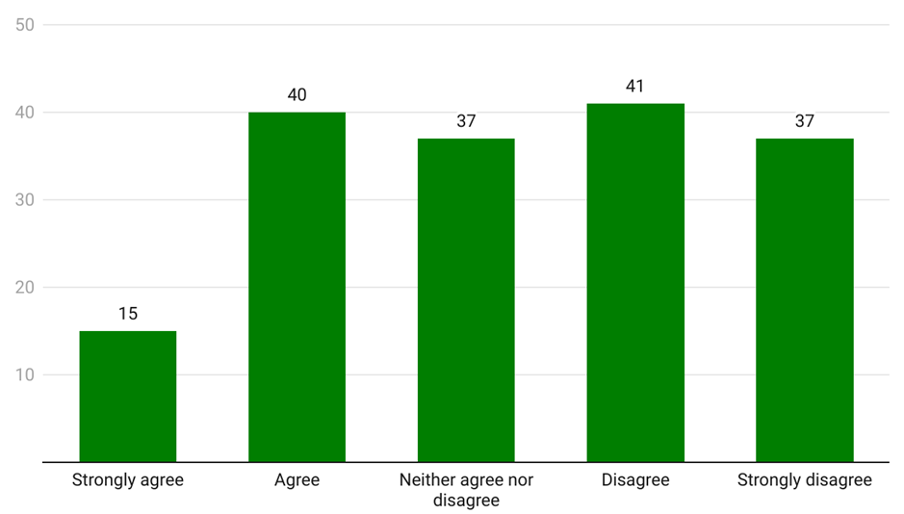
Source: Consultation Hub Survey (2024)

People with mental illness
Research on the needs and experiences of people with mental illness in the after hours period is limited. A report commissioned by the Australian College for Emergency Medicine indicates that emergency departments have become the first point of access for people needing mental health crisis support in the after hours period, even though they are not specifically designed or resourced for this purpose. This was attributed to a range of systemic and structural issues across the mental health and wider health and associated social and allied health ecosystem including insufficient funding, financial and geographical barriers, lack of available and appropriate mental health after hours services, and lack of staff with mental health expertise (Duggan et al., 2020).
Sector stakeholders highlighted that there was growing after hours demand for non-crisis related and crisis-related mental health services, particularly amongst children and adolescents in rural and remote areas with a skew towards Aboriginal and Torres Strait Islander youths. One stakeholder with lived experience of mental ill health also suggested that mental health crisis might be more likely to arise in the after hours:
Socioeconomic factors, substance use, and relationship issues can often become more evident after hours. - Sector stakeholder, interview
Due to a lack of available non-crisis services, people were said to be pushed into emergency departments when this was not clinically necessary. It was observed that whilst telehealth played a role in some instances, including providing ongoing support and monitoring during wait periods for in-person services, there was still insufficient early intervention support. This included accessing medication prescriptions when people ran out but were unable to obtain a new prescription in usual hours because of other commitments.
One thing that we know from our lived experience group… is that I think there are a lot of people [whose needs are…] after hours care, not necessarily crisis related… So people who might [not have] filled their prescription in time and… it's very important that they continue their medication, you know and not have a break from it. [There are] people who just need advice or people who might be experiencing… a mental health situation that's difficult for them that doesn't sort of reach that threshold where a crisis team would actually get involved. To speak to… a [consultant] psychiatrist, for example, is something that would exclusively only happen in an emergency department. But if there was, you know if that service existed within an urgent care clinic type scenario they would probably take advantage of that. - Sector stakeholder, interview
One consumer described their own difficulties accessing mental health support after 6:00 pm, sharing that long wait times exacerbated mental health issues in the after hours period and this had wider complications as it impacted not only the person who needed support but also their families. Another consumer recounted his experience trying to access support for his sister who was experiencing an episode related to schizophrenia. He attempted to access a 24-hour mental health helpline but no one answered the phone, requiring him to escalate the situation to emergency care.
A service provider from a rural and remote area described accessing mental health services in rural and regional areas as ‘diabolical’ with limited service options that were expensive; and a small mental health workforce which for lifestyle reasons had elected to not provide after hours services.
Several stakeholders identified that some services existed in their communities, but they had limited opening hours and high demand. Without available services – both in usual and after hours – people were said to rely on emergency departments or telehealth for support which were either inappropriate for non-acute mental health needs or provided counterproductive emergency-focused or discriminatory care experiences. One stakeholder indicated that providing people with alternative mental health support options in the after hours period had reduced demand on emergency departments in their local area.
The only other thing that came to mind was when I lived in rural [area], I presented to [an] emergency department … There was no other option and I guess I just had that really kind of typical negative experience…Honestly, unless it was life or death, I certainly wouldn't recommend it to anyone that I know or care about to be really honest, I think they could do a lot of damage to be really frank and it seems to be luck of the draw where you get someone who's great and is [trauma] informed or you know, I guess, understands mental health or if you're unlucky. In my case you get someone who's really condescending and just need you out of there because it's not a physical health issue and so that's something that I always try and be really vocal on because it seems to be complete luck on who you get at the time and also whether you have someone with you who's able to advocate on your behalf. And so at the time I had someone there who was able to advocate for me because I wasn't in a great way, and the second that my advocate mentioned that I was undertaking a [masters degree] I very clearly, despite how unwell I was at the time, I really clearly saw a switch in them taking me seriously. All of a sudden they're willing to help me. It was like they saw that I had some type of value and all of a sudden they were talking to me very differently, and that has just sat with me because I've never experienced something so disgusting to be really honest. – Consumer, focus group
Two consumers identified a reluctance to use clinical-based health services due to their reliance on referrals to emergency departments and contacting police for support.
Just in relation to mental health for my son over the years I’ve had to call 000 and I vowed to try not to do that because …. they bring the police. Sometimes they just leave us there, sometimes they take us to ED. So, you just never know what reaction, what outcome you're going to get. So, I called the mental health line, which is a 24/7 line as well for advice but again, they can just make a unilateral decision that we're calling 000. So, I don't really like doing that either. – Consumer, focus group
A service provider noted that whilst telehealth increased accessibility of mental health services in the after hours period, people living in rural and remote areas and older people had a preference for in-person services that facilitated building rapport. Several consumers were supportive of mental health telehealth services as they were said to have significantly improved access to providers, although the introduction of fees for telehealth had reduced their accessibility.
Mental health consumers really wanted that person to person contact and continuity of care was a real barrier for getting their needs met in those [telehealth] services. - Sector stakeholder, interview
Telehealth really took off during the pandemic and it was amazing as a carer so all of my son's [mental health] services and health professionals became available via telehealth, and often it was much more flexible too. So it was out of hours, which was fantastic and it was free for a while, so that helped a lot. It's not free now, so that's a big issue in terms of access. So, I think it's vitally important to keep telehealth going and to keep it accessible and free if possible. – Consumer, focus group
Consumers from rural and remote areas identified the need for community-based mental health services and telehealth support and advice lines run by peer support and lived experience workers.
…a warm line, so it's run by people with lived experience and so you can call it just to talk about how you're feeling when you're distressed… So it's run by people, peer workers, people with a lived experience... it's not that medical model and it's not risk averse, which is what happens when you're ringing mental health line or 000 obviously... it's an in between. Often you don't need the emergency response and you don't need to go to hospital or ED, but you just need somebody on the phone who understands and can be with you after hours. So more warm lines, more peer workers would be great. – Consumer, focus group
Continuity and quality of care was highlighted as particularly important for people with mental health needs given concerns for stigmatisation and quality of care. One sector stakeholder discussed consumers as lacking confidence and agency in their ability to navigate the health system both in usual and after hours:
…not being as informed and not having that sense of agency was actually a barrier to seeking after hours care. So, if you’re thinking about ways to facilitate help seeking in the mental health community, it might be like the opposite of that - having ways of helping people get the knowledge that they need to navigate the system and then feel confident to make whatever call that they need to make. – Sector stakeholder, interview
Some consumer stakeholders said that experiences of stigma and discrimination when attempting to access mental health support through emergency departments and other after hours services lead to people choosing not to seek help, with issues then escalating.
On the issue of stigma, that's a major issue for my son. He'll often refuse to access any help because of previous treatments and biases and lack of trauma informed… person centred care. So often that will result in the situation escalating, and then you're left with, well, now we do need to go to ED. And you know that that's just the worst place to go. So stigma really needs to be addressed. It is a huge factor in not accessing help or when you get to that point of having help, being able to be believed and treated with compassion. It's very haphazard, it seems to be just luck if you get treated with respect and compassion. – Consumer, focus group
Several consumer stakeholders expressed concern about privacy, confidentiality, and accountability for mental health-based information, with some refusing to share information due to privacy concerns.
It seems … to get services you have to trade away privacy in the public health system and there's no way of avoiding that even in some of the private services or non-government services and that's problematic because I've had my privacy breached quite regularly. That makes it very difficult for me going around my environment and has impacts on my mental health – Consumer, focus group
Another consumer suggested that there needs to be more transparency around what information is collected, where it is stored, and what is done with it to increase trust in digital health record systems, thereby facilitating increased care continuity.
I think collaboration and continuity is really, really important, but also privacy and confidentiality is as well and being really upfront with the types of information that is being collected, why it's being collected and who it's going to be shared with. People tend not to be really upfront about that, so it needs to be much more transparent because I know my son just refuses to have his information shared anywhere. But I don't think that that's actually adhered to. So yes, [there] needs [to be] a lot more accountability and also the limits of confidentiality need to be really clearly stated as well. And they're usually not. And every time you go to hospital, whatever you've been there for forever, whether it's a sore throat or a mental health admission, it's all readily accessible to every health professional that's looking after you.
So, there's no privacy there at all. – Consumer, focus group
Stakeholders identified the need to recognise how mental illness and psychosocial disability intersected with identity categories, including Aboriginal and Torres Strait Islander status and gender. Combinations of these features impact how people are treated in crisis situations, leading to a reluctance to seek after hours care for fear of poor quality care. One consumer identified that high intensity emergency department crisis responses may not be appropriate with a preference for ‘gentler’ forms of assistance:
I am a carer and my adult child … is often so traumatised by those factors they withdraw - which is interpreted as crisis stabilised. And my child has been through this cycle so many times, they know the three things to say to get out: “I am no longer suicidal I have no plans. I will get a mental health plan via my GP, and I have a supportive home to go home to.” The crisis is never dealt with, and I return with [my child] traumatised by the experience – Consumer, focus group
In an effort to improve access to high-quality mental health care for non-acute or emergency needs, the Australian Government has launched the Better Access to Psychiatrists, Psychologists and General Practitioners through the MBS (Better Access) initiative, and is rolling out a national network of 61 Medicare Mental Health Centres (building on existing Head to Health centres) to provide free community-based services for people with moderate to complex mental health needs. A number of existing Head to Health centres already operate on weekday evenings and on Sundays.

Families with young children
Young children are more likely to present to healthcare facilities with non-urgent needs than any other age groups (Freed et al., 2015). Young children attend after hours GP appointments (urgent and non-urgent) at a higher rate than other age groups other than those aged over 80 (Australian Institute of Health and Welfare, 2024b). Analysis of the age profile of the patients of the healthdirect helpline and GP services indicate highest demand among the 0-4 and 30-54 year-old age group (Figure 57). When analysed alongside Australian population data (Australian Bureau of Statistics, 2024), patients aged 0-4 emerge as by far the most likely cohort to receive a healthdirect helpline service, with one call to the helpline for every 1.02 children aged 0-4 in Australia. By contrast, one call is made for every 5.5 people aged 30-54.
Figure 57: Healthdirect caller patient by age group for calls made between January 2019 and June 2023
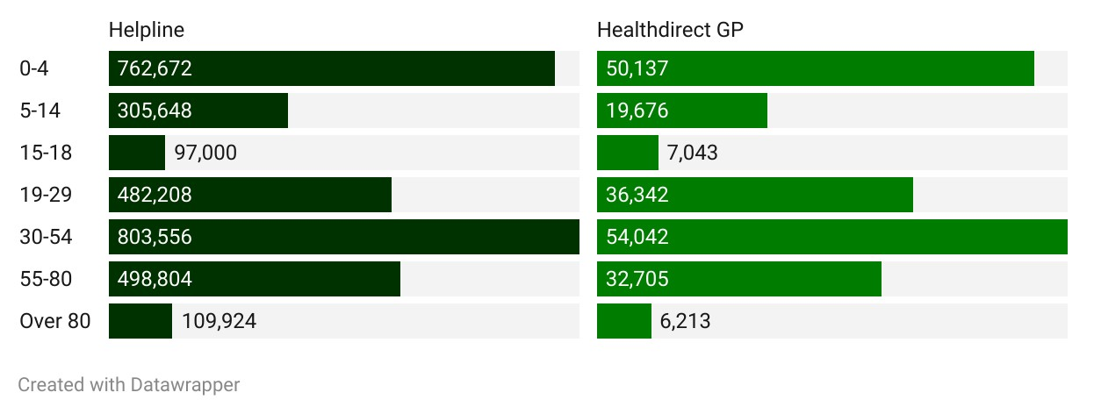
Source: Internal data provided by the Department of Health and Aged Care
There is a paucity of literature to explain these data. It is possible that children are predisposed to certain types and causes of injury compared to adults, for example head injuries, or drowning and submersion injuries. Head injuries represent urgent issues that require urgent attention, instead of being dismissed as parent/carer perceptions of urgency. (Australian Institute of Health and Welfare, 2022). There are also more bulk billing incentives for under 16 year olds compared to adults (Department of Health and Aged Care, 2024). This could lead to increased presentation at after hours services.
Several consumers and sector stakeholders emphasised the importance of reassurance for parents and carers of young children. One stakeholder working within a paediatric after hours service observed that:
The striking thing is that the vast majority of what we do is reassurance – it’s a paediatric service. The problem is that this sort of thing takes time and it’s hard to measure the benefits. But if you can educate the parents about what’s normal and what needs escalating that can have flow through benefits to future presentations. - Workforce stakeholder, interview
This is consistent with a 2013 review of the healthdirect GP service, which identified a major benefit of the service as ‘emotional’, and found that the service provided particular comfort to parents of young children (McKenzie et al., 2013).
It is a big thing just to get that reassurance. Take new mothers. They had never had a baby before. They don’t know if that baby is going to die, they don’t know what is an emergency and what is considered “primary care”. – Consumer, focus group
Consumers discussed the complexities of seeking care for children in the after hours period. They noted the challenge of finding available doctors when children returned from school sick with described confusion about which services to use. Carers with young children emphasised the difficulty of accessing in-person after hours services when this meant bringing multiple children with them to the service, as either the children were not old enough to be left home alone or there was no one else to care for them.
In the last month I’ve had two children with possible broken bones. One was a Friday night after 6:00, and I thought, oh goodness, the only place we're going to be able to go is the hospital! And I thought Friday night she wasn't that bad, so it might have been broken, it might not have, but I wasn't going near the hospital, so I left it until Saturday morning. And then I thought, well, I could get into a doctor, but can I get into an x-ray on a Saturday morning and then get back to the doctor for the results and then you know, so you had a very small window of trying to get into somebody on a Saturday [and] nobody was available.
So, in the end, we ended up going to the hospital but then I had another possible broken bone from football. And it was actually a paramedic who was at our football [game] that suggested we go to another place that's run by nurse practitioners on a Saturday. And they said, look, … they'll do the same as what you would in a hospital. But I wouldn't have known that that was available. It was that he told me [to] go there instead, and they do exactly the same thing. But then they still had to send it to a radiologist to assess, I guess, whether or not he had a broken bone.
And again, my daughter was very, very unwell for 7 days with a high temperature and nobody really knew whether it was bacterial or viral … [which] was very unusual for her. And then my son started becoming very unwell and he has had a history of being in hospital for an infection… So, he woke up on a Sunday morning with a stiff neck … we need[ed] antibiotics ASAP and where am I going to find a GP opened on a Sunday? The only one that I could see in [place name redacted] that was open had bulk billing, but only from 7:30 am to 1:00 pm. So, I rocked up, but if it had been Sunday afternoon, who do I go to? Do I go to the hospital to possibly get antibiotics? – Consumer, focus group
There is consistent evidence that parents or guardians attend emergency departments due to a perceived lack of capacity amongst after hours primary care services. Many parents and guardians believe that they will be referred to an emergency department by their GP anyway (Berry et al., 2008; Williams et al., 2009). Practitioner and practice owner/manager survey respondents mostly disagreed that the current after hour system met the needs of families with young children (Figure 58).
Figure 58: Practitioner and practice owner/manager perception of the extent to which the current after hours system meets the needs of families with young children (n=171)
Survey text: To what extent do you agree the current after hours system meets the needs of families with young children:
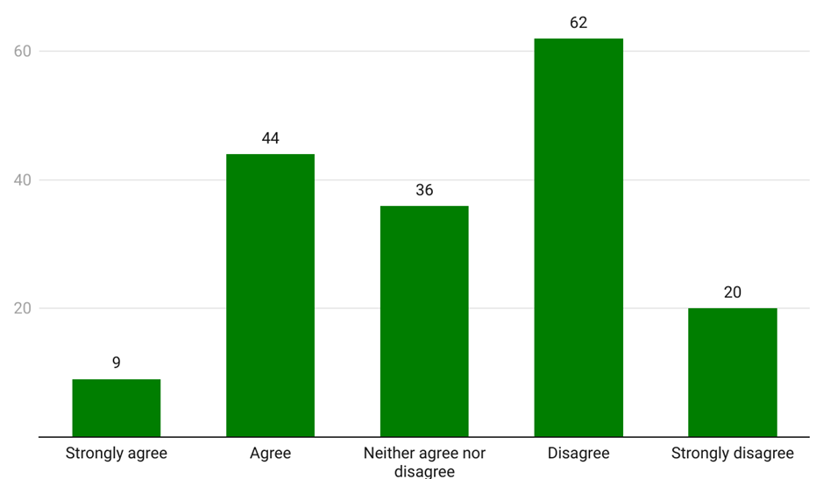
Source: Consultation Hub Survey

Carers
Many sector stakeholders and consumers recognised the need to account for carers when considering the after hours needs of people with disability, families with young children, people with chronic illness, older people, and people with acute mental health issues. These stakeholders emphasised the practical and emotional challenges faced by carers navigating complex health systems on behalf of the person they care for. Carers play an important role in making or influencing decisions about where a consumer seeks help in the after hours period. This means that a carer’s knowledge of service options and the accessibility and user-friendliness of those options to the carer are critical factors in whether the consumer receives appropriate and timely help.
From a carers point of view… they’re time poor, some work… One of their greatest complaints is navigating systems on behalf of themselves and the person they care for. Just aside from [providing care], it eats up all their time. – Sector stakeholder, interview
Consumers also highlighted the crucial role which carers play as a source of information about the patient’s medical history, particularly in circumstances where the patient is unable to communicate this information themselves and where the after hours service provider is unfamiliar with the patient and lacks access to their medical records.
… having someone in an after hours situation who can promptly access the information, they have the skill set to distil down to the relevant stuff…I've been known to forget to tell people that [my child] has an atrial septal defect…because it doesn't cause her any day-to-day issues but as far as an emergency physician is concerned, they would like to know that. You know [some children with disability] have a […] list of diagnoses, and some are relevant, some are not. It really is the responsibility of the health professional to actually make the decision as to what matters rather than me [as a carer]. – Consumer, focus group
Some carers also described the sense of responsibility which comes with caring, and how this can contribute to a lower tolerance for risk and an increased need for reassurance. Conversely, it was said that carers often deprioritised their own care simultaneously placing pressure on the health system through increased hospitalisation.
If you are looking after a child or an older person or someone who has a chronic health condition and you wait for the next day (for 5, 6 hours) you might not even get an appointment the next day. I do think people do know there’s [a] difference between urgent and emergency care in most situations, but I think that the problem is compounded when they care for another person and particularly a person whose health may not be at optimal level. We all know the concept of ‘risk’ and I think people very much want to manage the risk in a way they feel responsible, and that behaviour demonstrates real concern for others. – Consumer, focus group

Socioeconomic disadvantage
A large number of consumers and sector stakeholders emphasised the extent to which social determinants of health impact consumer behaviour in the after hours period, thereby impacting health outcomes. The connection between socioeconomic disadvantage and poor health is well-established. People in lower socioeconomic groups are at greater risk of poor health and have higher rates of illness, disability and death. When compared with people living in the highest socioeconomic areas, people living in the lowest socioeconomic areas are twice as likely to self-report having chronic obstructive pulmonary disease, 1.9 times as likely to have diabetes, and 1.6 times as likely to self-report having coronary heart disease (Australian Institute of Health and Welfare, 2022c).
There is evidence that people experiencing socioeconomic disadvantage are more likely to attend emergency departments, including for lower-urgency presentations (Figure 59).
Figure 59: Lower urgency emergency department presentations by socioeconomic status (SES) and ATS (per 1000 population), 2022-23
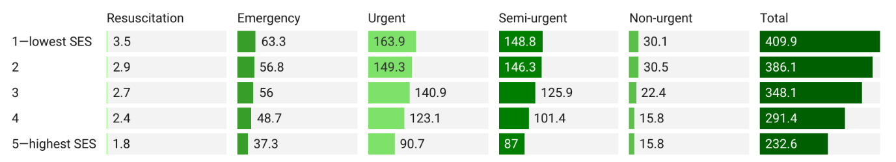Source: AIHW, Data Tables: Emergency Department Care 2022–23
As outlined in section 3.1.8, cost is seen as a significant driver of help-seeking in the after hours period, potentially pushing people to low or no-cost services including emergency departments. Rising cost-of-living pressures were said to exacerbate this situation. Stakeholders observed that people in low-income casualised or precarious employment may prioritise work attendance over seeking healthcare due to lack of sick leave entitlements and an inability to forego income. People experiencing socioeconomic disadvantage may face other barriers to accessing after hours care, such as difficulty accessing private or public transport and lower levels of health literacy.
…even if they do know [about after hours services, they] are cost-prohibitive to a lot of lower socioeconomic [groups]. – Sector stakeholder, interview

…funding needs to be of sufficient quantum and nature to avoid unnecessary out of pocket costs to those most in need, whilst simultaneously reducing barriers to care and enabling high value care. – Service provider, written submission
Discussion of low-income/cost of living pressures intersected with discussions of other factors. Carers, single parents, recently arrived migrants and refugees, people with disability and older people relying on the pension were all identified as cohorts more likely to experience socioeconomic disadvantage and increased barriers to accessing after hours primary care.
When examined through a lens of socioeconomic advantage/disadvantage, the data on the use of after hours GP services paints a less than straightforward picture. According to the Australian Bureau of Statistics’ 2022-23 Patient Experiences Survey, the proportion of consumers reporting that they needed to see an after hours GP was almost the same irrespective of socioeconomic disadvantage (9% of the most disadvantaged consumers and 8.8% of the least) (Australian Bureau of Statistics, 2023). However, of those who reported needing to see an after hours GP, the most socioeconomically disadvantaged consumers were less likely to report actually seeing an after hours GP (Figure 60).
Figure 60: Proportion of consumers who reported seeing an after hours GP when needed by quintile of socioeconomic disadvantage, 2022-23
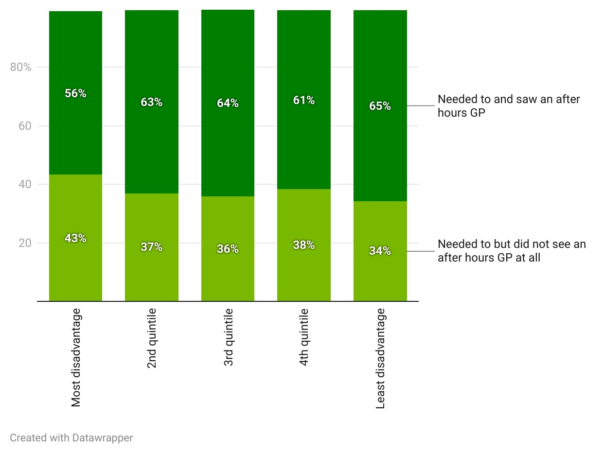
Source: ABS Patient Experiences Survey, 2022-23
Data on Medicare-subsidised after hours services suggests that rurality and socioeconomic disadvantage act together to shape after hours GP access. Figure 61 compares the number of GP after hours services per 100 people in each Australian Statistical Area Level 3 (SA3), with the SA3’s median decile of socioeconomic disadvantage. Areas of relative socioeconomic disadvantage in metropolitan areas generally receive more services per 100 people than higher socioeconomic areas. Conversely, areas of relative socioeconomic disadvantage in remote and regional areas receive the least services. There may be a number of factors behind these trends. The low proportion of services in rural and regional areas may reflect insufficient services to meet need, and/or that services are being provided in other settings such as ACCHSs and hospitals. The high proportion of services among disadvantaged, metropolitan SA3s may be influenced by limited availability of usual hour appointments in more disadvantaged areas, a higher proportion of people unable to attend appointments in usual hours due to, for example, precarious or inflexible work or caring responsibilities. Importantly, the data may indicate an increased need for services in areas of greater socioeconomic disadvantage driven by the higher burden of disease experienced in these communities (Australian Institute of Health and Welfare, 2022c).
Figure 61: Number of GP after hours services per 100 people and median decile of socioeconomic disadvantage by SA3 and Remoteness Area, 2022-23
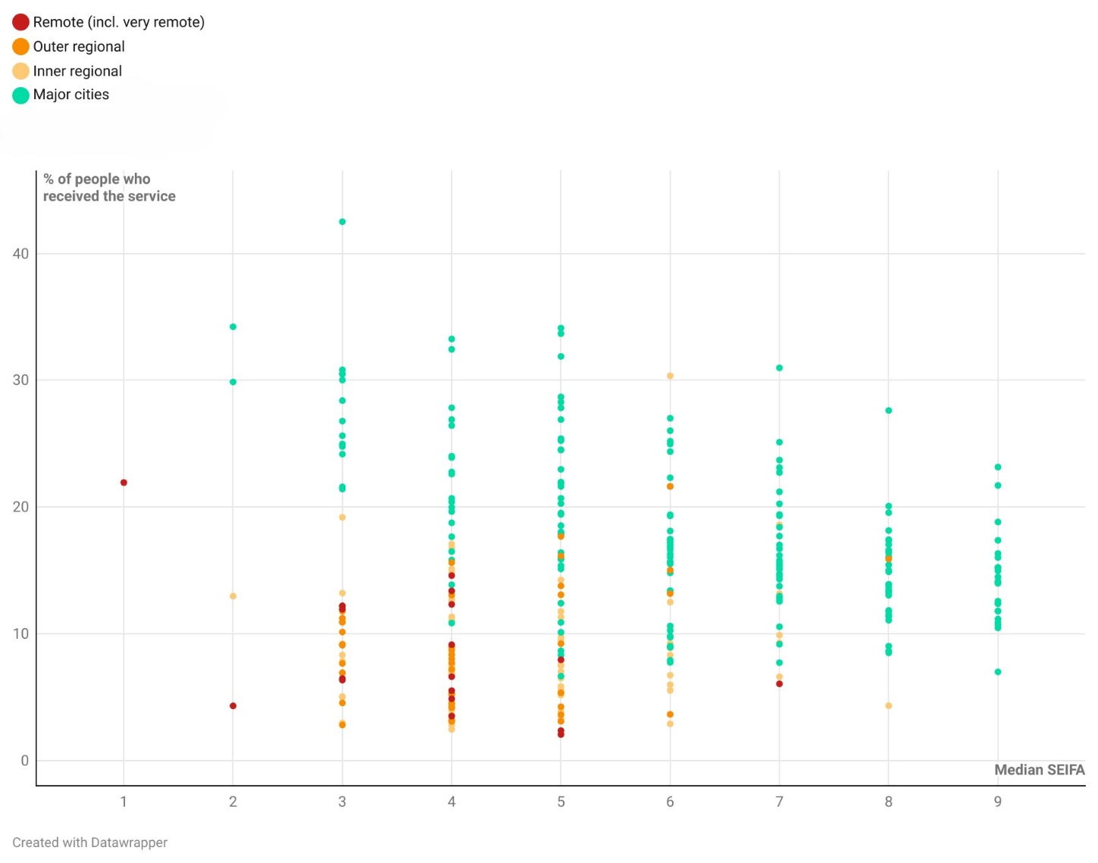Source: Derived from AIHW Medicare-subsidised services, by Statistical Area Level 3 (SA3): 2022–23 and ABS, Socio-Economic indexes for Australia (SEIFA) 2021

Practitioner and practice owner/manager survey respondents mostly disagreed that the current after hours system met the needs of people in precarious or less flexible employment (Figure 62).
Figure 62: Practitioner and practice owner/manager perception of the extent to which the current after hours system meets the needs of people in precarious or less flexible employment (n=170)
Survey text: To what extent do you agree the current after hours system meets the needs of people in precarious or less flexible employment
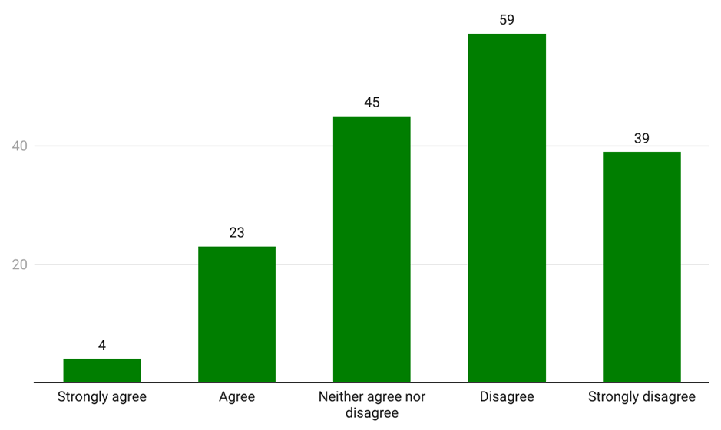Source: Consultation Hub Survey (2024)

KEQ 2: Findings
- 9 | - Consumer awareness of how to access the right after hours care from the right provider at the right time is low, particularly among some patient cohorts. Some consumers choose to attend hospital emergency departments because they are confused about, or lack confidence in, after hours primary care services.
- 10 | - Consumers often find it difficult to find reliable, comprehensive information on available primary care after hours services, and internet search engines do not always surface complete and reliable information.
- 11 | - Available and accessible allied health services (in particular pharmacy and imaging) are an important aspect of effective after hours care, and influence where consumers seek help in the after hours period.
- 12 | - Out-of-pocket costs incurred by consumers when accessing after hours care can act as a barrier to access.
- 13 | - Continuity of care is both critically important and challenging to sustain in the after hours context. Effective information sharing between after hours services, regular GPs and other care team members is essential to support high-quality, personalised care that meets consumer needs.


Part 4: Successful models of primary care after hours services

Successful models of primary care after hours services (KEQ 3)
This part addresses the question – ‘What are successful models of primary care after hours service provision?’ The part considers a number of current and emerging models of after hours primary care, and the conditions under which they are appropriate and effective. However, individual models of care cannot be considered in isolation, and systemic considerations are also critical. For this reason, this part also outlines principles and design considerations identified in the literature and by stakeholders as essential to an effective after hours primary care system.

Matching care to need
A consistent theme across consultations with a range of stakeholders and consumers was the importance of matching consumers to accessible, available services which meet their needs. Clinical presentation, cultural and emotional safety, service availability and accessibility all inform the overall picture of a consumer’s need (see section 3.2 for a detailed discussion of consumer need and help-seeking behaviour).
Different models of care, including primary care clinics, urgent care centres, telehealth, and home visits, all play important roles within the health care system by providing flexibility, accessibility, and personalised care options. People should be matched to the most appropriate services based on their needs, preferences, circumstances, and the services available. – Workforce organisation, written submission
A one-size-fits-all approach to after hours primary care is not sustainable. Rather, models should be designed to meet the specific needs of individual communities. – Workforce organisation, written submission
After hours primary care incentives were designed to reduce patient demand for emergency department presentations. However, a patient-centred approach that addresses the needs of the community must also be considered when designing after hours programs. – Service provider, written submission

Consumers and sector stakeholders identified three dimensions of service design and delivery which should align with patient need:
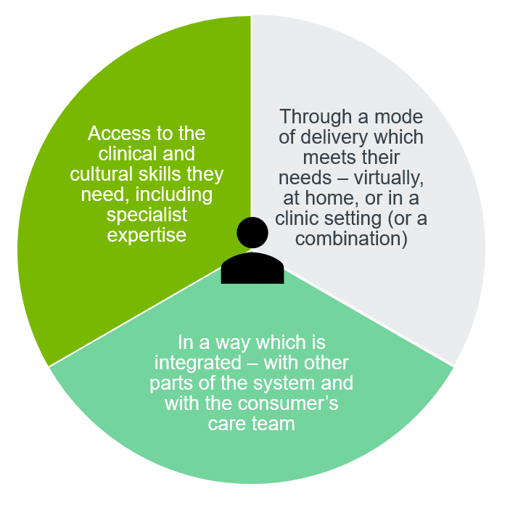
Figure 63: Stakeholder-identified dimensions of patient-centred service design

Consumers and stakeholders emphasised the importance of training and professional development, effective triage, and clear and accessible information on available services, what they can offer, and their limitations (including clinical capabilities, and cost). Consumers also emphasised the importance of being able to access specialist skills or insights relevant to their condition, medical or cultural background. For example, one stakeholder expressed the view that people living in RACHs need and expect access to an after hours workforce with skills and an interest in gerontology. While there was an expectation from some consumers and stakeholders of direct access to specialist expertise after hours, others envisaged a ‘hub and spoke’ model where health practitioners have access at the point of care to escalating specialist advice and assistance.
… With an increasing number of after hours referrals from RACH and palliative care providers, it’s crucial to ensure that clinicians with relevant expertise and/or training can provide tailored health advice and/or care. This includes enhancing skills in geriatrics and palliative care through cross-training opportunities, developing integrated care plans, sharing resources, establishing robust referral networks, and implementing quality improvement initiatives. – Service provider, written submission
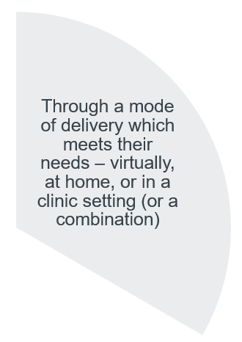
Stakeholders and consumers highlighted the influence of clinical presentation, service availability and accessibility, consumer characteristics (such as age) and preference in informing which mode of delivery is most appropriate for a consumer at any given time. Given this variability, several stakeholders observed the value of hybrid models, in which consumers are triaged and connected with the most appropriate mode of service delivery.
Consumers deserve access to care that is tailored to their needs, this includes availability of care via a range of mediums. – Workforce organisation, written submission
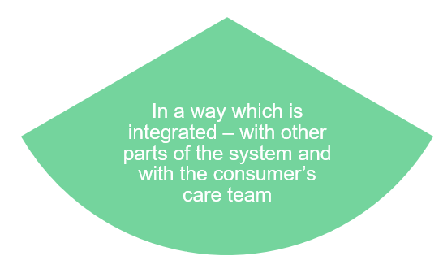
As described in section 3.1.7, consumers considered systems which support continuity of care and appropriate sharing of information to be critical to an effective after hours system. This was seen as essential to ensuring clinically appropriate and efficient care, cultural and emotional safety, and to relieving consumers and carers of the burden of having to re-tell their stories or act as the source of truth for complex medical histories. The need for patient privacy to be protected in the context of information sharing was emphasised by some consumers, most notably mental health consumers and carers (see section 1.1.1).
A substantial number of stakeholders and consumers considered that specific strategies (including tailored approaches to funding, workforce, and service design) were required for some priority population groups. Rural and regional areas, and residents of aged care homes, were frequently identified as requiring specific strategies. Other cohorts identified by stakeholders as potentially requiring tailored approaches included people receiving palliative care, people experiencing or at risk of homelessness, and Aboriginal and Torres Strait Islander people.
In designing targeted strategies and services, stakeholders highlighted the importance of rigorous research and needs assessments, undertaken in partnership with affected consumers.
Unless the needs of specific populations are examined in depth…with input from the impacted populations (“nothing about us, without us”), services cannot be designed to adequately meet these needs. – Service provider, written submission

In depth: Home visits
Access to home-visiting primary care in the after hours period is the most critical unmet need we see for our patients across Australia. - Service provider, written submission
A broad range of stakeholders offered strong feedback that, for some priority population groups, home visits are an important model of care. Residents of aged care homes, older people in their own homes, and people with chronic illness, disability or reduced mobility were all identified as cohorts likely to benefit in some circumstances from in home care rather than virtual or in clinic services. Indeed, services delivered where the consumer is located are the only primary care option for some consumers, who would otherwise require specialised transport (such as by ambulance). It was also said that for some of these consumer cohorts, unnecessary visits to the emergency department can result in poor clinical outcomes. Some stakeholders highlighted the value of home visits for other consumers for whom clinics are inaccessible, such as single parent families or those lacking transport.
Despite the consensus that home visits are important for some priority populations, there was a clear view across the consultation that home visits are increasingly inaccessible. Fewer than 20% of practitioner and practice owner/manager respondents to the Consultation Hub Survey agreed or strongly agreed that patients in their local communities who need home visits were able to receive one (see Figure 64).
Figure 64: Practitioner and practice owner/manager perception of the accessibility of home visits (n=190)  Survey text: Patients in my local community who need a home visit after hours get one |  | 7  30  42  70  41  Strongly agree  Agree  Neither agree  nor disagree  Disagree  Strongly disagree  Source: Consultation Hub Survey (2024)
Some stakeholders expressed concern that the shift towards virtual and urgent care models may leave some consumers without the care they need.
It's a question really of where telehealth [and urgent care clinics] sit […] in the after hours space…, a lot of money [is] throw[n] at urgent care clinics to try and absorb a lot of the after hours demand. And these are probably … not sorting out the issues for the extremely vulnerable patients like nursing home [residents]. What I worry about is that there's a lot of money spent on these initiatives, but I'm worried that the baby will be thrown out with the bathwater. – Workforce stakeholder, interview
Stakeholders generally considered that current funding arrangements are poorly suited to supporting and incentivising home visits, and that workforce challenges are exacerbated in this area. The decline of the AMDS program was also identified as a contributing factor. Some stakeholders expressed concern about the quality of care currently being provided by some MDSs and other providers conducting home visits. There was consistent feedback that volume-based funding through MBS – within the current workforce environment – is unable to support consistent, accessible, quality home visits for those who need them.
There is absolutely no incentive to do home visits in the After-Hours space due to the way it’s funded. – Service provider, written submission
Stakeholders posited several options for ensuring home visits are accessible to those who most need them. These included:
1 | Targeted strategies and funding for priority cohorts
Some stakeholders considered that a separate strategy is required, at a minimum to support visits to RACHs, and that any targeted strategy should be underpinned by a revised approach to funding. It was suggested that this could involve block or blended funding models, with funding tied to the provision of services to specific target consumer cohorts.
[You need a] policy which preferences one cohort over another so it pushes the industry into making sure that it does a great job for those in need… If we can identify… [and] focus on those and maybe a dedicated funding stream where you… get paid a separate stream of funding to prioritise these patients… then I think we would go forward with a better system.
- Workforce stakeholder, interview
2 | Expanded use of nurses and nurse practitioners in conducting home visits, particularly to RACH and similar
Some stakeholders considered that the non-medical workforce could be mobilised through enhanced incentives and team-based arrangements to play a more central role in the provision of home visits.
An efficient and multidisciplinary after hours visiting primary care/urgent care service could significantly reduce presentations to hospitals, and avoid unnecessary admissions, however few primary care services provide this service.
- Workforce organisation, written submission
3 | Enhanced use of hub and spoke and supported virtual health options
 | Building on the principle of supporting multidisciplinary team-based care, several stakeholders suggested that visits to RACHs and other locations could be made more accessible by harnessing the potential of supported telehealth to link allied health practitioners who visit consumers with GPs or other specialist medical practitioners to provide advice and treatment where required.

Health technologies and digital transformation
The appropriate role of telehealth and other digital health tools in the provision of after hours primary care was a prominent theme in the literature as well as consultations with stakeholders and consumers.

Telehealth services
Telehealth was identified as a significant advancement in after hours care access in both the literature and in stakeholder consultation. Changes to service provision in response to the COVID-19 pandemic have improved consumer and provider access, capability, and confidence in using technology. Almost half of respondents to the 2021 Australian Health Consumer Sentiment Survey (46.7%) reported using digital health technologies (including, telehealth, helplines, apps, and websites) in 2021, an increase from just 11.8% in 2018. The number of people reporting they had accessed telehealth services through phone or video consultations in the previous 12 months increased considerably from a modest 5.5% in 2018, to 37.1% in 2021 (Zurynski et al., 2022).
Despite this, studies show mixed evidence on the effectiveness of after hours telephone services. Over half of respondents to the 2021 Australian Health Consumer Sentiment Survey who had used telehealth rated the quality of the most recent appointment as about the same as in-person, and 17.1% rated the appointment as better than in-person. However, almost 30% felt that the appointment was not as good as in-person (Zurynski et al., 2022). Most of the participants reported that the technology (both telephone and videoconference) was easy to use. People who ranked the ease of use of the technology lower were more likely to rate the quality of the appointment as not as good as in-person. In addition, 823 respondents reported having a telehealth consultation before March 2020, and 535 (65%) of these said that their most recent telehealth consultation was much better than the previous appointment, while approximately 32% said the appointments were about the same. This suggests that the quality of telehealth consultations increased over the 2 years of the pandemic. However, technological literacy, internet and mobile connectivity in remote and rural areas was also identified as a barrier to these services being fully effective (Consumers Health Forum of Australia, 2020).
Telehealth has been found to increase access to after hours help for a range of consumer cohorts including people receiving palliative care in rural and remote areas (Namasivayam et al., 2022) and communities (Dykgraaf et al., 2021; Mathew et al., 2023), and people living in RACHs (Trankle & Reath, 2023). For people receiving palliative care, telehealth was said to enable them to continue seeking care from home in a timely manner however, more guidance protocols, procedures and education and training for staff were required to ensure care was delivered effectively (Namasivayam et al., 2022). Further limitations identified included poor internet coverage and connectivity in rural and remote areas, and a lack of communication and care coordination between healthcare providers and professionals.
For RACHs, there is some indication that virtual emergency care could play a useful role in ensuring high-quality after hours care. A study of the use of My Emergency Doctor (MED) was found to be successful with a reduction in ambulance call outs, after hours hospital transfers and the provision of support and good communication between GP and RACH staff (Trankle & Reath, 2023). At least 2 sector stakeholders and service providers spoke positively of state government-run virtual emergency options. Whilst some GPs expressed a preference for providing their own service due to the benefits of continuity of care, other stakeholders suggested the virtual emergency care model could be rolled out to palliative care to cover normal business hours when there was no GP available.
I think that the SAVES system (SA Virtual Emergency Service) is a success story because it supports rural nursing staff overnight to deal with minor problems so that rural GPs can sleep better, only being disturbed about the seriously ill. – Service provider, interview
A qualitative study looking at the preferences, experiences, and attitudes towards telehealth of 90 consumers from across Australia found they appreciated the convenience and reduced wait times telehealth provided, particularly for people who faced additional accessibility barriers including older people and people with disability (Toll et al., 2022). However, this study also found several barriers to telehealth effectiveness, including that some telehealth services have longer wait times and inefficient booking and other systems; as well as poor connectivity; and difficulty with forming trusted relationships with unfamiliar practitioners. The study also found perceptions that care delivered virtually may be impersonal undermining trust and confidence in advice. The study found that consumers prefer a flexible model that sits alongside face-to-face delivery providing care at certain points of the patient journey, rather than replacing it entirely (Toll et al., 2022).
A recent scoping review examining telehealth use by Indigenous populations from Australia, Canada, New Zealand and the United States found that for telehealth to be effective, services need to be adapted to their social and cultural contexts (Moecke et al., 2023). Barriers to effective use include concerns about privacy and confidentiality, limited broadband availability, low health and/or digital literacy, and difficulty establishing trusting relationships. Proposed solutions include training and employing local Aboriginal health staff as digital navigators to ensure a culturally safe clinical environment for telehealth consultations and to promote the effective use of telehealth services amongst community members (Mathew et al., 2023). This could also address identified issues with digital literacy and accessibility which act as impediments to the uptake of telehealth.
A small qualitative study of 14 GPs found a tension between the ability to provide high quality care through telehealth and the relative lack of remuneration (De Guzman et al., 2022). Several factors were seen to influence the use of telephone or video software for consultations including reimbursement amounts; the time-poor nature of GPs leading them to opt for shorter telehealth consultations; and logistical challenges including insufficient telehealth infrastructure.
Sector stakeholders and consumers were broadly supportive of the use of telehealth, noting that it has the potential to significantly increase access to health care services, particularly for people who face barriers because of their geographical location, lack of access to transport and/or work or carer responsibilities.
[Telehealth] was a part of my journey. It was a real revelation actually, that I was quite anti-telehealth, particularly for Aboriginal communities and really it became very apparent to me that if it's done intelligently and sensitively and with the patient’s needs in mind, then it's actually brilliant. – Sector stakeholder, interview
Sector stakeholders and consumers also discussed the potential benefit of having allied and other health services provided via telehealth:
You know, I remember explaining during COVID to a dietitian’s [receptionist] that telehealth would be fantastic because I had absolutely no intention of having the nonverbal child who uses an augmentative communication device sit in on the appointment anyway. So, if the dietitian could just ring me, that would be awesome. – Sector stakeholder, interview
Consumers highlighted that one of the main benefits of telehealth services was that it offers an accessible pathway to reassurance and triage when people are uncertain about what to do in the after hours period. However, some consumers said that information provided through services like the healthdirect helpline can be generic and resulted in them being referred to emergency departments anyway.
Stakeholders highlighted several key points to ensure that telehealth is effective, including:
- providing high-quality interpreter services
- providing culturally sensitive care for CALD people and Aboriginal and Torres Strait Islander people either through mainstream telehealth services or specialised telehealth services, including strengthening ACCHS sector capabilities through increased after hours funding
- accounting for equitable access needs and abilities due to varied digital literacy and technology access across different cohorts. These include people over 75 years of age, low-income households, people from CALD backgrounds, Aboriginal and Torres Strait Islander people, people with disability, and people in rural and remote areas.
- providing specialised care support and advice to people with disabilities, people with chronic illnesses, people receiving palliative care, and other complex health needs. F
Overall, the appropriateness of telehealth was seen as contextually dependent upon the individual consumer preference, their health need(s), their capacity to use and access to technology, and the capacities of service providers and health professionals, exemplifying the importance of matching service to need with appropriate funding and other support mechanisms (as discussed in section 4.1).
Workforce stakeholders highlighted the potential for telehealth to play a central role in the provision of repeat prescriptions and initial urgent care triage, and some workforce stakeholders highlighted that telehealth has a role to play in alleviating rural and remote workforce fatigue and burnout. However there was a general consensus from workforce stakeholders that telehealth services should be supplementary to in-person services rather than wholly replacing them. Workforce stakeholders and consumers from rural and remote settings were concerned that telehealth would be used to plug service gaps, undermining health and access equity. They emphasised the need to ensure that services such as healthdirect helplines were integrated with regional placed-based services delivered by skilled local practitioners to ensure appropriate and relevant care navigation alongside in-person care.
I’ve had some great experience at telehealth after hours, especially during COVID … they were absolutely amazing, they were fantastic. They would call you every morning on … telehealth, just an audio call and do your OBS [clinical observations] for you and then again in the afternoon and do your OBS. They send out medication that arrived within 2 hours and an oximeter. It was [an] excellent service that telehealth … would run 24/7 if I needed to call anyone. Such a better idea than seeing everybody sitting in a hospital.
[1300 Health] was a fantastic service because you had a nurse that could just walk you through a few things and recommend whether you should go to emergency [or] to the chemist, you know. – Consumer, focus group
Several mechanisms were identified for improving telehealth functionality including:
- the use of ‘local knowledge summaries’ on each referral service which outlines available onsite and nearby services, similar to what is provided by Healthdirect’s National Health Service Directory
- appropriate telehealth remuneration and sufficient funding to ensure telehealth is timely, appropriate, and of a high-quality
- ensuring clear communication between a consumer’s regular care team, and any after hours care team with digital health record update or summary of interactions provided as soon as possible to allow for follow-up
- increased use of virtual based platforms recognised as having potential for videoconferencing for remote monitoring of symptoms, and better sharing of information between consumers and providers
- appropriate telehealth infrastructure and education for both practitioners and consumers, particularly in rural and remote areas where internet connectivity and telephone reception are highly variable.
Workforce organisations identified the need to ensure health care providers were supported to deliver telehealth services through training, appropriate and up-to-date technology, and equivalent MBS items to in-person care provision. Several workforce organisations and practitioners expressed concern about the proliferation of telehealth-only service providers and the implications for quality and continuity of care. Some workforce organisations expressed concern about telehealth-only providers taking advantage of standalone telehealth items.
Some stakeholders observed that the active patient requirement (to attract a rebate for a telehealth consultation the consumer must have had a face-to-face consultation with the practice in the past 12 months) made it difficult to provide sufficient telehealth services in some circumstances, for example in rural and remote communities and where there were insufficient doctors to otherwise provide home visits. It also constrains the potential role of telehealth in after hours service provision by limiting the ability of practitioners to provide episodic after hours care.to consumers who are not their regular patients.
In depth: Mob Link
Mob Link is a 1800 telephone triage service run by the Institute of Urban Indigenous Health (IUIH) and funded by the Commonwealth and Queensland Governments. It runs from 7:00 am - 7:00 pm, 7 days a week. It provides a culturally safe, single point of contact for Aboriginal and Torres Strait Islander people in South East Queensland for:
- triage assessment, and provision of same-day virtual clinic care
- short-term, community virtual clinical monitoring and care
- specialist time-critical primary care services.
Mob Link sits alongside IUIH Network clinics that have implemented extended hours, including after hours services. IUIH has reported that between July-December 2023, Mob Link received 22,607 calls, of which:
75% | were received overnight between the hours of 6:00 pm and 8:00 am, compared to 4.5% in the corresponding period in 2022
2.6% | were received between 6:00 pm and 8:00 pm – the period classed as after hours but not eligible for enhanced MBS payments for non-urgent services
9.4% | were received on weekends, compared to 6.3% in the corresponding period for 2022.
IUIH has identified anecdotal evidence that extended clinic hours has led to:
- reduced overall GP wait times and high-up take of appointments and walk-in services
- strong representation of men relative to their underrepresentation in regular clinic client populations
- increased demand for appointments outside usual business hours, especially for preventative health assessments and chronic disease management.

Digital health records
There is limited research on the use of digital health technologies in after hours settings. However, stakeholders and consumers throughout the Project identified continuity of information through the effective use of digital health record systems as vital to continuity of care when access to a regular GP or health professional in the after hours period cannot be assured. Stakeholders identified that this was contingent largely on the availability of patient health records during an after hours appointment, and on the timely sharing of information about after hours care back to a consumer’s regular GP and/or care team. This can be impeded by some GP’s lack of digital literacy; requirements for patient permissions, partnered with privacy concerns; and providers outside of primary care teams often lacking access rights, thereby limiting the digital health records usability and relevance (Banfield et al., 2013). In addition, the poor quality of some digital health data can undermine the delivery of effective patient care and more streamlined organisational outcomes in turn creating inefficiencies and burdens for cleaning datasets (Downey et al., 2019; Kanika et al., 2023; Weiskopf et al., 2017).
My Health Record, overseen and operated by the Australian Digital Health Agency, and My Medicare, as well as initiatives like the Electronic National Residential Medication Chart (eNMRC), are the primary means for consumers, their regular GPs, after hours services and other healthcare professionals to share information. Evidence on the effectiveness of My Health Record is limited and mixed. A systematic review found limited uptake of My Health Record among private hospitals and specialists, meaning it has had limited impact on information fragmentation and care continuity (Mesquita & Edwards, 2020). Qualitative research conducted with pharmacists found that whilst My Health Record has the potential to bring several benefits, including improving privacy and the quality of care provided, there were several measures needed to improve data security and to ensure the accurate recording and transfer of data by users (Kosari et al., 2020).
Reflecting these findings, a recent report on leveraging digital technology in health care found that whilst My Health Record is crucial to continuity of care and information sharing, there are several outstanding issues undermining its ability to reach its full potential (Productivity Commission, 2024). This includes a lack of interoperability between GP and hospital IT systems and the varying quality of information uploaded, as well as ongoing information gaps. This was attributed to several factors including disjointed uptake and usage of My Health Record by clinicians and consumers, insufficient incentives and support systems to ensure standardised and consistent uploading and sharing of information, and clinicians time-poor and high-pressure work context which disincentivises uploading or accessing information where work is duplicative or time demanding. This results in incomplete, inaccurate, and inconsistent patient data records with limited functionality for building understanding of patient’s medical profile and history.
Digital interoperability was identified as a key area for improvement in the after hours space, including ensuring administration was streamlined across all areas of service delivery to reduce the burden on health care providers. Several workforce organisations identified the need to address segregated health record systems which limited how, where, when, and who could share and access information. This included the inability of midwives who are not also registered nurses, and allied health professionals, to author a shared health summary in My Health Record (at present these providers are able to register to participate in the My Health Record system, contribute health information through completing an Event Summary and view a patient’s My Health Record to support clinical decision-making at the point of care).
Several workforce and sector stakeholders identified that there were insufficient incentives for patients to enrol in either My Medicare or health record systems. In addition, whilst privacy concerns were raised by several stakeholders and appear as a barrier in several studies (Mathew et al., 2023; Moecke et al., 2023; Toll et al., 2022), research by the Office of the Australian Information Commissioner indicates that health is one of the few areas where the public view it is fair and reasonable for their information to be accessed by relevant providers (Office of the Australian Information Commissioner, 2023). This suggests that uptake of digital health record systems could be further explored through continued communication on its purpose and by addressing various utility and access barriers. It is recognised that these observations, whilst discussed in the context of after hours settings, apply to digital health and the health system as a whole.
The Australian Government’s Digital Health Blueprint 2023-2033 and its accompanying Action Plan outlines work underway to address areas for improvement in the after hours space, and progress real-time information sharing capabilities. This includes several updates to My Health Record to align it with contemporary data standards, such as:
- progressively expanding the types of information available in My Health Record by default including pathology and diagnostic imaging reports
- expanding allied health professional access to My Health Record and improving digital capabilities to support the delivery of multi-disciplinary care
- establishing National Health Information Exchange capabilities to support secure, safe and seamless, near real-time sharing of patient health information across all parts of the health system, between health care providers and across jurisdictional borders.
Whilst not directly concerned with digital health technology in after hours settings, the Australian Digital Health Agency’s National Digital Health Strategy 2023-2028 provides further impetus for the refinement of the digital health system in Australia. Its emphasis on system interoperability, digital health literacy, and equitable access, amongst other factors, reflects stakeholder feedback on the need for relevant, accessible, and appropriate digital health services.
Consistent with the Closing the Gap Priority Reforms, principles of Indigenous Data Sovereignty and Governance must be used to inform the ongoing collection – via digital health tools such as telehealth – and use of individual and population-level primary health data (Trudgett et al., 2022). This includes ensuring data is accessible and has utility to Aboriginal and Torres Strait Islander people and that data and its collection and use has a basis in self-determination, their differing social and cultural viewpoints, and subsequent data needs (Walter et al., 2021). This also includes consideration of the need to address the disproportionate administrative burden placed on Aboriginal and Torres Strait Islander organisations through government funding and other arrangements which make them dependent on accessing and informing governments owned data assets, whilst simultaneously suppressing community-owned data assets (Rose et al., 2023).

Other digital health technology options
The rise of telehealth has coincided with the increased use of home monitoring and other remote diagnostic software for a range of chronic health conditions including cardiac health (Banchs & Scher, 2015) and diabetes-related foot disease (Golledge et al., 2020). Digital health technologies have the potential to support specific consumer cohorts including older people living independently at home to access healthcare more easily as required (Bradford et al., 2018).
Reflecting this trend, stakeholders identified several health technologies which, in conjunction to telehealth services, have the potential to improve telehealth deliver. These include remote diagnostic and monitoring tools such as blood pressure monitoring cuffs. Their potential in underserviced rural and remote areas settings was emphasised. Stakeholders recognised that this would require specific training and support for consumers to use this technology effectively and appropriately, as well as the provision of technology and supporting health infrastructure in some settings.
One example provided by a workforce stakeholder of technology-based initiatives was nurses using Bluetooth stethoscopes, COPD-6 screeners, and 12-lead ECG tools via telehealth to allow complex conditions to then be diagnosed remotely by nurse practitioners and GPs.
In depth: Royal Flying Doctor Service
Royal Flying Doctor Service unstaffed clinic in William Creek, South Australia
RFDS is piloting from March an unstaffed clinic in William Creek, South Australia. The clinic will have no permanent staff but will be accessible and linked 24/7 to a telehealth unit. The clinic represents a new model of care which is potentially scalable.
Someone will pick up the phone, operations will let them into the telehealth kiosk that will automatically activate a telehealth appointment with a [saturation] monitoring blood pressure cuff, ECG and a first aid kit. And if that person requires additional help, they will activate the medical chest custodian and remotely access them into a treatment room that will have oxygen, and the medical chest custodian will access the medical chest. So without any healthcare practitioners being available at 3:00 am we can start diagnosing a heart attack, treating a heart attack, giving oxygen, giving drugs, and then that's where the retrieval team will respond to.
– Service provider, interview

Navigation
As discussed in section 3.1.6, a key challenge facing consumers is the complexity of navigating the after hours primary care system, which can result in consumers presenting to inappropriate service providers (such as presenting to the emergency department), receiving the wrong care, or forgoing timely care entirely. Workforce and sector stakeholders as well as consumers identified as priorities the simplification of entry points to the after hours system and streamlining consumers’ pathway through it, with a considerable number supporting further consideration of a ‘single front door’ model.
Stakeholders proposed awareness raising, and the use of peer and other navigators, as potential interventions to improve the navigability of the after hours system.
Consumers considered that proactive awareness raising would help consumers to understand where, when and how to seek help in the after hours period. Guidance on available services, as well as their respective benefits, limitations and costs was considered imperative. Some consumers called for a government-led advertising campaign, and dissemination of information about available services through local councils, local libraries, community health centres, shelters, other health providers, as well as leaflets and other information artefacts. Some stakeholders highlighted the potential impact of the strategic placement of information, such as including a poster with information on local urgent care options outside emergency departments. There was also recognition by several stakeholders that assertive outreach which is appropriate, and community supported (by, for example, peer or bicultural workers), is necessary to reach some multicultural and other hard-to-reach communities.
Other consumers and stakeholders emphasised the importance of comprehensive information being made available to support transparent and informed decision-making. Several suggested including estimates of wait times on the websites of Medicare UCCs and other walk-in services would be useful, along with clearer indications of the out-of-pocket costs involved in accessing all after hours services.
Lastly, when asked how they would find out information about after hours services in their areas, almost all consumers said they would turn first to Google. Search results are often overwhelming and surface private service options (such as online prescription services) before Medicare UCCs and healthdirect services. This suggests that search engine optimisation plays a significant role in which services are brought to consumers’ attention.
It seems to me [that] within the community at large there’s no understanding that [..]urgent care [clinics] exist at all, or that it's an option. One of the things that I think that we could do better is … that at the emergency departments … people could be notified or redirected towards some of those other options. ‘Have you tried your locum? Have you tried urgent care?’, you know, ‘do you know that these things exist?’ So even some signs or some information given by the triage nurses that says you know ‘the wait time here tonight is extremely long. Here are some other options for you’ because if those people don't know about those options or aren’t aware that some of those options can be bulk billed … They see the emergency department [because they think it] is the only way to get free healthcare. So, some extra education, not just generally in the community but at that point of care, I think would be beneficial. – Consumer, focus group
I think it's the education of people and knowing … when you should be accessing them. I think that … is really important that people know what they should be doing and when they should go and it's not … happening. … For a lot of people … like pensioners and people are doing it really hard with the mortgage rates ridiculous at the moment…it's just my opinion but they…might think, well, you know, let's just go somewhere where I don't have to pay perhaps. – Consumer, focus group

Peer and other navigators
Two stakeholders identified a potential role for peer navigators to support consumers, in particular Aboriginal and Torres Strait Islander consumers and consumers from a CALD background. The details of what this would entail in the after hours context was not explored, however the feasibility of peer navigators in a primary care setting has been demonstrated in other studies (Peart et al., 2018).
Enhancing patient literacy and providing peer navigators and educators helping guide patients to access the right care at the right time, particularly for [people from] CALD/Refugee backgrounds were seen as effective models. These roles and education provide crucial support and guidance, easing patient anxiety, clarifying options, and improving healthcare outcomes and health literacy. – Service provider, written submission
Feedback was also received that community pharmacists already play an important navigator role, assisting and directing members of their communities to appropriate after hours care options. The view was advanced by some sector and workforce stakeholders that this role could be enhanced with appropriate support, access to information, and funding.

The role of Healthdirect
Healthdirect services play an important role in the after hours primary care landscape. Analysis of Healthdirect data indicates peak demand during the after hours period across all helplines. 70% of all calls received between January 2019 and June 2023 occurred during the after hours period (see Figure 65).
Figure 65: Healthdirect calls by helpline and hour of call, 2020-2023
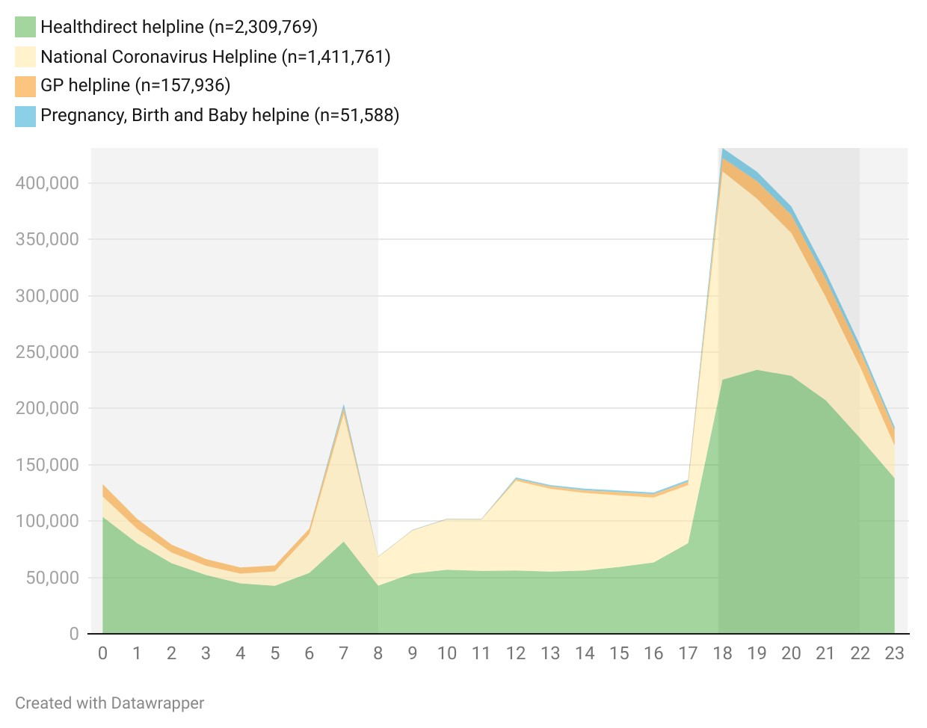
Source: Internal data provided by the Department of Health and Aged Care. Data reflects calls made across all days of the week (including weekends).
Consumers were generally familiar with the telephone nurse triage model, which they identified variously as Healthdirect, Nurse on Call, 13 HEALTH, or often in generic terms. A significant number of consumers reported they had contacted a helpline for assistance after hours. Their satisfaction with the service they receive varied. Similarly, several other stakeholders discussed the important and constructive role which Healthdirect Australia plays as a nationally consistent and efficient provider of information and triage services.
I cannot speak highly enough of [Healthdirect], I think it has been wonderful. I think the team who facilitated it did a really good job. I think they continue to do [a] good job. I think they listened to the consumers. I think it's used frequently and regularly, and I think it's been a great addition to the healthcare delivery service. – Workforce stakeholder, focus group

However, there was a persistent perception among consumers and other stakeholders that nurse helpline triage protocols are risk-averse and ‘generally send you to the emergency department anyway’. Some consumers described being dissuaded from calling healthdirect or another helpline because they felt they would simply be told to go to another service provider.
One of the issues with … Healthdirect and those kinds of organisations - and it's the same in the UK - is they are very protocol driven. So, most of the time they end up not giving you an answer. They end up referring you because [of] the nature of the protocols they have to follow. – Workforce stakeholder, focus group

Healthdirect Australia’s analysis of call outcomes during 2022 to the healthdirect nurse triage line indicates that 47% were advised to see a GP. A significant proportion of callers, approximately 38%, were advised to go to the emergency department. This indicates that a substantial number of callers had health concerns deemed urgent or severe enough to warrant immediate medical attention at a hospital, or required an immediate face-to-face consultation but appropriate primary care services were not available or accessible. The remaining 15% were advised to either self-care or to attend another service (see Figure 66 below).
Figure 66: Healthdirect helpline calls received in the after hours period by call outcome, 2019 - 2022
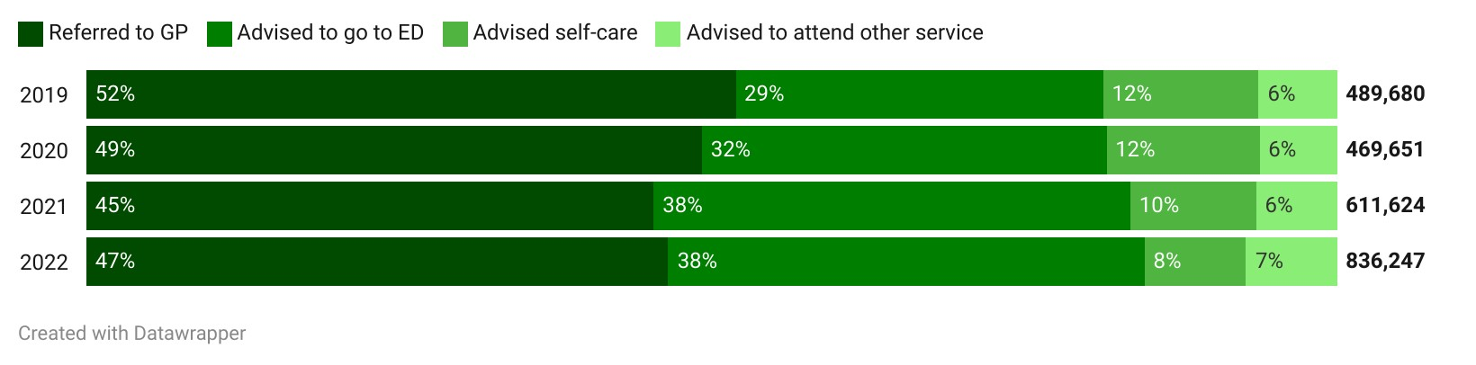Source: Internal data provided by the Department of Health and Aged Care
Of those referred to the healthdirect GP helpline, 80% received advice on self-care and 9% were advised to see a GP where, for example, the helpline GP determined a physical examination or intervention was required. Another 10% were advised to go to the emergency department Figure 67).
Figure 67: Healthdirect GP helpline calls received in the after hours period by call outcome, 2019 - 2022
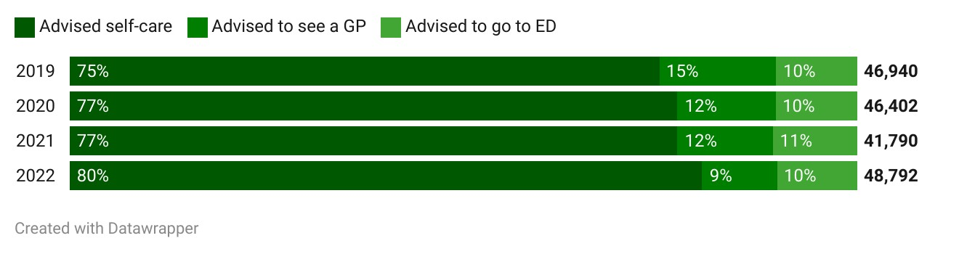
Source: Internal data provided by the Department of Health and Aged Care
There is mixed evidence on the extent to which consumers comply with advice provided by telephone triage services such as the healthdirect helpline and 13 HEALTH. A 2020 review of a telephone triage service showed that the service assists callers in accessing appropriate services. Callers who were initially inclined to access high urgency care were often diverted to low-urgency care such as GP services or home-based care (Siddiqui et al., 2020). However, there are limitations on the generalisability of the findings of these studies and further research exploring the reasoning driving these outcomes is suggested.
Other studies have concluded that compliance with telephone triage advice varies substantially according to both patient- and call-related factors (Tran, 2017), and that triage decisions to contact primary care may have lower compliance than decisions to contact emergency services or self-care.
In depth: A single front door
[The concept of an After Hours ‘single front door’ would represent a monumental change in the primary care landscape and would require significant structural reforms. What segments of the community would be targeted for the single front door approach if it’s not intended to be whole of population? Would a regional approach be more suited than a national approach? After Hours services represent a finite resource at any given time, so managing the demand on accessing this resource would be key to managing expectations of those seeking to receive care, or seeking advice to potentially receive care.
– Service provider, written submission
The PHN Review identified resolving the multiple and confusing entry points to the after hours system as a key to system effectiveness. Several overseas jurisdictions have sought to address this by implementing streamlined entry points. Denmark and the Netherlands use telephone-based GP gatekeeping of access to emergency departments, whereby access to emergency departments requires patients to first ring the GP-led call centre. In other countries a single telephone number has been created to deal with urgent needs and link with appropriate services (Health Policy Analysis, 2020).
NSW Health operates a single front door service, delivered by Healthdirect Australia. People with non-emergency medical queries are encouraged to contact healthdirect where they speak to a registered nurse. They can then be referred to a GP, virtual or urgent care, a pharmacist or allied health professional; or provided with guidance as to how to care for their condition at home. More than 315,000 people in NSW contacted healthdirect between 1 January and 31 December 2023. Of these, over 175,000 people were referred to a healthcare service other than the emergency department or triple zero. Approximately 50% were referred to a GP, approximately 20% were referred to virtual care or urgent care and approximately 10% were provided with information or guidance on self-care at home. Approximately 5% were referred to other pathways such as pharmacies or allied health and close to 2% were referred to virtualKIDS (NSW Health, 2024a).
Another prominent example of the single front door telephone number is the UK’s NHS 111. The telephone line, formally launched in 2014, functions as a telephone triage and advice service (Anderson & Roland, 2015) and offers patients evidence-informed practices (Nakubulwa et al., 2022) for improved access to a 24/7 urgent clinical assessment, advice, and treatment service – bringing together out of hours primary care, and clinical advice (J. Turner et al., 2013).
While other comparative telephone triage services are commonly delivered by clinically trained personnel, including nurses and physicians (Lake et al., 2017), NHS 111 call handlers are non-clinically trained staff (Lewis et al., 2021). Call handlers assess calls through a computer decision support system (NHS Pathways) to aid in assessing symptoms, prioritise care requirements, and provide advice to service users (Pope et al., 2017). Decisions and advice provided can include sending an ambulance to assist callers, providing advice to callers to attend emergency departments, or out-of-hours services, as well as advice on how to self-care at home (Egan et al., 2020). Non-clinical staff are also supported by clinicians (who may be nurses, GPs, or paramedics) working as clinical advisors, who will take calls escalated by non-clinical staff (Anderson & Roland, 2015).
The NHS 111 suite now also includes NHS 111 online, an alternative pathway to the telephone triage system (National Health Service England, 2015).
During consultations, many stakeholders were in favour of, at a minimum, further investigation and consideration of the possibility of a single front door service. One stakeholder described such a service as ‘akin to a command centre [which] would assist patients navigate the system to receive the right treatment, at the right place, right time and by the right provider.’ In this regard, most stakeholders envisioned an extension, and reimagining, of Healthdirect Australia services. Stakeholders considered the strengths as including simpler and more streamlined experiences for consumers, and better matching of consumers to the right care. Nevertheless, stakeholders identified a range of success factors which they perceived would need to be in place to ensure the effective operation of a single front door. These included:
- sufficient resourcing to ensure calls are answered and responses are timely
- triaging nurses with the right clinical skills, and triaging protocol
- triaging nurses and other service providers able to provide sensitive, culturally competent help to all members of the community, including Aboriginal and Torres Strait Islander consumers, CALD consumers, LGBTIQA+ consumers, people with disability, chronic illness and mental ill health, patients with a terminal illness, and others
- appropriate escalation pathways, including the capacity to connect people to specialist help (either directly or with specialists providing advice where needed)
- accurate local service mapping and understanding of local conditions and access considerations
managing expectations of those seeking to receive care, or seeking advice to potentially receive care, given the significant demands on after hours services at different times.
A standardised central intake/triage system which will allow efficient and appropriate access to afterhours services is needed. Person-centred care approaches are required (especially for CALD, aged, mental health, complex needs, carers, children and LGBTQIA+) so that the right approach, service and referrals can be made.
– Sector organisation, written submission
Not all stakeholders were convinced that a single front door has merit. Key concerns were that it may undermine local pathways to help, and that multiple entry points mean people have more choice about what works for them. This is particularly relevant in rural and remote areas where local services may change frequently.
The other concern regarded implementation, and the importance of getting it right to ensure consumers are not left without a timely, effective and trusted entry point into the system. Specific concerns were raised by sector stakeholders that being left on hold, or being connected to a triage operator without the cultural or other skills to work appropriately with consumers may undermine trust in the system or leave consumers without the care they need. This is supported by literature, where NHS 111 has been found to be ineffective at times, with people more likely to present to emergency or other out-of-hours services because they are unsure of the advice they received (Nakubulwa et al., 2022).
The problem is, resourcing is the enemy… [People] are not going to be reassured if they’re having to wait thirty minutes.
– Sector stakeholder, focus group

In one instance, the triage line for ambulance didn’t seem to understand the slurring of voice and confusion and inability to answer questions was due to severe infection rather than alcohol. Hence, those staffing a single front door would need to have significant training and understanding to meet the needs and cover information relevant across a very broad and diverse set of needs, circumstances and groups.
- Sector organisation, written submission
Some stakeholders considered that modified approaches to the single front door model might be more suited to the Australian context. Some suggested an enhanced role for Healthdirect Australia which falls short of a single front door (a ‘main door’), while others considered that ‘front doors’ operating at a regional or state/territory level would be more effective than a national approach. It was also suggested that specific segments of the population could be targeted for a single front door approach if it is not feasible or intended to serve the whole population.

System planning and evidence
Stakeholders provided clear feedback that future approaches to after hours primary care policies and programs should focus on coordination, planning and evidence-based interventions.

System planning and coordination
Stakeholders identified several measures to improve planning, including clear definitions of success, including those relating to value for money, sustainability and scalability. The importance of centring consumer outcomes and experience and requiring services to measure client experience and care outcomes, was emphasised. One stakeholder suggested that [definitions of success] need to be based on what the impacted populations requiring assistance define as success, rather than funding body mandated KPIs.
What gets measured, gets managed! – Service provider, written submission
Several stakeholders identified the availability of data as a key barrier to effective planning and coordination. Stakeholders emphasised the value in ensuring routine administrative data captures a broad range of relevant data and is consistently reviewed to allow for the identification of gaps in service provision. More than one stakeholder observed that routine service data for all primary care services should include indicators related to ethnicity, language spoken other than English, use of interpreter, and country of birth. One workforce stakeholder claimed that the monitoring and evaluation of after hours services and activities was complicated in part by the fragmented nature of the health system with funding and delivery of services split across federal and state and territory governments. They also emphasised the current lack of consolidated primary healthcare data which is necessary to support proactive and targeted after hours investment.
Currently, consolidated primary healthcare data in Australia is poor. However, individual providers of primary health care often hold significant information on the services provided to patients, the conditions for which they are being treated and the progression of a patient’s recovery or further deterioration of their condition. Consolidating this data could be facilitated ideally through the development of a primary healthcare national minimum dataset that provides common data standards and reporting frameworks. – Workforce stakeholder, written submission
Stakeholders also identified the potential for improved data linkage, including linkage for emergency department, Healthdirect Australia and primary care after hours service data to better understand consumer pathways and outcomes. Several noted that there were limited means of tracking patient outcomes once they have attended services, undermining evaluation and monitoring activities.
You know, there's a whole bunch of risks […] to do with data linkage and we're just starting on that journey. But for me, I think that's critical for us to understand the performance of our service and whether we're adding value and how effective it is because we could just be adding time and cost to the system, and we don't really know. I mean, we do, we do callbacks like 14 days after we've got a company that does callbacks to say what happened, how was it and we get fantastic ratings. But… that's a consumer, reported one, which has a place, but it's not the rigour that I would like to see to truly know are we effective. – Workforce stakeholder, written submission
Stakeholders also emphasised the need for investment in targeted research to better understand the needs of specific populations and places, as well as best practices and innovative approaches to care delivery. This could include funding research studies on the effectiveness of different after hours care models, supporting pilot programs to test new initiatives, and fostering collaboration between researchers, policymakers, and health care providers, with input from the impacted populations.
A study of various integrated primary centres and their informatic capability maturity found infrastructure connectivity for digital tools to be key to communicating and sharing information. Impediments to the collection, integration, and sharing of primary health data include differing technical, data and software interoperability standards; differences in clinical coding across services; and insecure messaging platforms (Liaw et al., 2017). Data collection competencies in primary health care settings needs to be addressed as well, for example, by building health manager competencies and understanding of health informetric systems, with associated resourcing, process, and policy supports at both an organisational and government level (Brommeyer et al., 2023)
AIHW is currently developing a National Primary Health Care Data Collection (NPHCDC) to improved understandings of population health and patient journeys. Designed for scalability this project aims to broaden primary health care data collection and to develop data capacity and capability projects. This includes building understandings of the current data utility and data gaps; building understandings of data ingestion, transformation, and linkages; building stakeholder relationships and community trust in and support for AIHW primary care data projects and identifying and addressing technical and governance barriers. To improve the quality and relevance of data collected, a workforce stakeholder recommended that this be expanded to include UCCs and various allied health and other primary healthcare practitioners.
Together with a more expansive understanding of individual’s experience of healthcare through the collection of patient reported outcomes and experience measures, deeper insights will be available to inform how the healthcare system needs to be adapted to meet patient’s needs and experiences. – Workforce stakeholder, written submission
AIHW have already been undertaking this in part by expanding NPHCDC to include allied health practitioners. Other NPHCDC projects underway includes a data demonstration project for GP gathered data on dementia; development of a Primary Health Care Data Governance Roadmap and Framework; development of minimum national data standards; and developing principles for Indigenous Data Governance and Indigenous Data Sovereignty to inform NPHCDC.

Evidence and research
The capacity and capability of health workers, particularly in rural and remote areas, to engage in data collection for research purposes is complicated by a variety of factors including workforce shortages and the need to balance competing priorities (Wong Shee et al., 2022). As one workforce stakeholder emphasised, specific funding is needed to build workforce and broader capacities to conduct the research necessary to support evidence-based decision-making in after hours primary care.
Investing in research and innovation to identify best practices and innovative approaches to after-hours care delivery is essential. This could include funding research studies on the effectiveness of different after-hours care models, supporting pilot programs to test new initiatives, and fostering collaboration between researchers, policymakers, and health care providers. – Workforce stakeholder, written submission
Research commissioned by the Australian Health Research Alliance (AHRA) looking to improve the secondary research-based use of primary healthcare data identified 106 primary healthcare datasets across Australia which was said to suggest ‘duplication of effort around data collection, cleaning, and use.’ (Canaway et al., 2022). Interviews conducted with data custodians identified a lack of use or clarity around data quality frameworks and the overall quality of datasets with a strong identified need for data linkages across datasets to improve research, and in turn, health outcomes. These datasets were found to have several other shortcomings undermining their ability to support secondary usage including:
- administrative data from MBS and PBS lacking clinical data (i.e., patient diagnoses, test results, observations, measures and prescribing instructions)
- electronic medical records not being fit-for-purpose with differing schema for medical terminology and clinical coding (i.e., use of non-standardised free-text entry over standard codes)
- lack of accreditation to ensure data is standard against common data models undermining data aggregation, as well as lack of overarching standards and guidelines or common data models resulting in standardised datasets
- lack of buy-in and agreement to support data linkages amongst those with commercial intellectual concerns or other reasons to not support standardised data collection
- lack of ongoing support and infrastructure to build workforce capabilities, capacity, and expertise
- GP data security, privacy, and reputational concerns, as well as GP aversion to perceived government attempts to exert excess control over caregiving activities
- accessibility to data limited to certain organisations and purpose, for example PHNs conducting quality improvement activities, thereby limiting access to outside institutions, along with various other access barriers including privacy concerns, cost, and time delays (Canaway et al., 2022; Cheah et al., 2024).
Through their research, AHRA have identified a need to build trust through transparent data governance arrangements, strong leadership and collaboration, and end-to-end data related processes, with robust data security and privacy protection, amongst several other reforms (Canaway et al., 2022; Cheah et al., 2024). There was also an identified need for resourcing and investment in data training and education, improving data quality and tools through provision of incentives, workforce upskilling, as well as making data access more cost accessible to end-users outside of PHNs and other immediate primary health contexts.
In depth: Medicare UCCs
In recent years, the Government has introduced and expanded a network of Medicare UCCs. Medicare UCCs are intended to be GP-led, with staffing mix based on availability, local need and context (Department of Health and Aged Care, 2022b), and are intended to provide short term, episodic care for urgent conditions that are not immediately life-threatening. As of July 2024, there were 58 Medicare UCCs across Australia, with the Government committing $227 million in the 2024-25 Budget for a further 29 clinics. Several states and territories have established similar models of care, including Priority Care Centres in Victoria, nurse-led Walk in Clinics in the ACT which form 5 of the 58 established Medicare UCCs, New South Wales Urgent Care Services, and Queensland’s satellite hospital co-located Minor Injury and Illness Clinics.
Stakeholder and consumer feedback on Medicare UCCs was mixed. Stakeholders identified several advantages, including that they fill service gaps, are quick and simple, and are bulk billed. Some consumers considered, however, that they were unsuitable for more complex matters, including concerns which might be related to chronic conditions, which demonstrates a mismatch in consumer understanding of the scope of Medicare UCC.
My experience with going to urgent care… has been when it's been for things like stitches or I've had some food stuck in my throat a few months back. If it's one of those things where my bigger history doesn't play a part in what's happening and it's just that one little thing … and you need some stitches or you need an x-ray or something, [then] it is brilliant because it's fast… I don't spend hours and hours sitting in an emergency department to wait for 4 or 5 stitches or whatever it is. So I love that the service exists and that it's an option.
– Consumer, focus group

The most effective method for us has been the… urgent care clinics… We’ve used them for a variety of things. So my son broke his wrist on the weekend and I heard from another parent that they had taken their child to the walk in clinic for stitches. So, I thought, well, I'll go there because the accident and emergency usually have like a 6 hour wait and so we went there and they were able to send him off to assess him, sent him off for an X-ray to the hospital. So, we bypassed everyone at emergency and then we were sent home. While we waited for the results to go to the clinic, we went back to the clinic and they were able to put the temporary cast on and everything that a doctor would normally do, and there's no cost to that at all. So, we go there a lot.
– Consumer, focus group
However, a number of workforce stakeholders expressed concerns that the introduction of Medicare UCCs has contributed to greater fragmentation of an already complex after hours primary care system. The potential for Medicare UCCs to undermine continuity of care was identified, particularly if there is patient confusion on their purpose. However, the Medicare UCC Operational Guidance clearly articulates the urgent care scope and requirements for referring and reporting to the patients’ regular GP. The Australian Government has funded a consumer education campaign to promote reasons where a visit to a Medicare UCC may be appropriate. Some workforce stakeholders expressed concerns about staff simply being shifted from one part of the after hours system to another (without increasing the number of after hours providers), and concerns that nurses and nurse practitioners are being underutilised.
There was also a view that the specific and favourable funding arrangements for Medicare UCCs which enable them to bulk bill put them at a competitive advantage vis a vis general practices, resulting in consumers turning away from after hours general practices. Some stakeholders felt that this made after hours work less viable for some after hours general practices.
Consumers and consumer stakeholders raised concern that waiting times at Medicare UCCs are often long, or that the service booked out quickly. Some expressed confusion about whether the services accepted walk-ins or required an appointment, which may be due to local provider arrangements to manage patient flow. It was also observed that the operating hours of some Medicare UCCs are often truncated, with some closing as early as 5:00 pm on a weeknight. All Medicare UCCs are required to accept walk-ins.
Workforce and consumer stakeholders expressed reservations about the placement of some Medicare UCCs. Some consumers expressed dissatisfaction that their community did not have a Medicare UCC. Several expressed concerns about the accessibility of their local Medicare UCC. An Aboriginal consumer observed that the only Medicare UCC near her was in a part of town in which Aboriginal people do not feel safe or welcome.
A common theme across stakeholders was that more thorough evaluation of Medicare UCCs is required, to properly understand: the profiles of consumers presenting to them; patient journeys, experiences, and outcomes; whether they divert demand from emergency departments; their impact on the after hours system and other service providers; whether they represent value for money; and the conditions under which they are most effective.
The Government has commissioned an independent evaluation of the Medicare UCC program, which has commenced. The evaluation is based on Key Measures of Success developed and agreed by the Commonwealth and state and territory governments. These measures recognise the importance of ensuring Medicare UCCs are delivering coordinated care within the broader health ecosystem. This report is due in 2026.

KEQ 3: Findings
- 14 | - Continuity of care and information sharing is undermined by lack of interoperability across health record systems and by the lack of access which many primary care and allied health services have to patient records.
- 15 | - Services should be patient centred and responsive to the needs of particular cohorts and geographic locations. The development of specific funding, workforce and service delivery strategies for priority populations should be explored, and tailored after hours models of care for some cohorts may be required. These strategies should be developed with a view to coordinating with and bolstering existing local service providers.
- 16 | - Virtual services including telehealth play an important role in improving access to primary care after hours. However, they can only be one component of the broader primary care after hours landscape and require complementary supports to ensure they are fit for purpose.
- 17 | - Stakeholders had mixed views on the use of a single entry point to the after hours system. Nevertheless, a single entry point warrants further consideration as streamlined access and navigation needs to be an important feature of after hours service design.
- 18 | - Improved system planning and coordination is needed. This should be supported by more strategic collection, governance and use of primary health data, and by ongoing research to better understand the effectiveness and efficiency of after hours primary care programs and policies.


Conclusion

Conclusion
This review has found that, reflective of the need that it is serving, the after hours system is complex. This complexity has resulted in the system being difficult to navigate with a broad and varied range of different service models, providers and funding sources as well as confusion as to where to turn, resulting in avoidable emergency department visits. In order to inform the development of options to improve the provision of after hours primary care, there must be clear articulation of the objectives of after hours care.
Workforce shortages are exacerbating the complexity of service provision in the after hours period and this is heightened in rural and remote areas. These workforce shortages are driven by a range of factors. The current system does not effectively incentivise multi-disciplinary models of care. There is evidence that supporting nurse practitioners, nurses and other health professionals to participate fully and to their full scope of practice would ease the pressure on GPs in the after hours system. Further, insufficient incentivisation for GPs to work in the after hours period is having a significant impact on workforce supply and the After Hours PIP is not optimally incentivising active after hours service provision in an equitable way across Australia.
After hours service provision should be person-centred and responsive to the needs of particular cohorts and should support Australians equitably across a range of geographic areas. Whilst there are some notable examples of innovative practice in this area, more can be done including consideration of tailored, innovative funding models for thin markets (including rural and remote areas) and for specific consumer cohorts. These should draw on and learn from existing services, including for example: Healthdirect Australia, 13 HEALTH, virtual only service providers, Priority Primary Care Centres, virtual emergency departments, the Royal Flying Doctor Service and Mob Link. Further, in order to be patient centred, the development of specific funding, workforce and service delivery strategies for priority populations should be explored. A greater emphasis should also be afforded to continuity of care and information sharing between after hours service providers and treating practitioners. Increased consumer demand during the early evening period should be considered carefully in future system design and funding approaches. The complexity of the after hours system is leading to confusion amongst consumers as to the appropriate pathway for provision of non-emergency after hours primary care. Lack of confidence and clarity around payment structures and the possibility of out-of-pocket costs are also driving consumer behaviour in this period. However, the primary factor driving this confusion is a lack of reliable, comprehensive information on available services. There are benefits and disadvantages arising from a single entry point to the after hours system and these warrant further consideration.
In recent years, there has been a proliferation of varying models of service delivery in the after hours period. The importance of technology needs to be further explored including as a means of triage and connection to ensure that consumers are connected to the right care. Virtual services including telehealth play a critical role, but require complementary supports from the broader health care system.
Finally, this review has found that improved system planning and coordination is needed and would be supported by enhanced collection and use of data and research.

Bibliography
Adeniyi, A. O. (2024). The impact of electronic health records on patient care and outcomes: A comprehensive review. 21(2), 1446–1455. https://doi.org/10.30574/wjarr.2024.21.2.0592
After Hours Primary Health Care Working Party. (2005). Towards Accessible, Effective and Resilient After Hours Primary Health Care Services: Report of the After Hours Primary Health Care Working Party. Ministry of Health.
Anderson, A., & Roland, M. (2015). Potential for advice from doctors to reduce the number of patients referred to emergency departments by NHS 111 call handlers: Observational study. BMJ Open, 5(11), e009444. https://doi.org/10.1136/bmjopen-2015-009444
Armstrong, K., Amoyal, G., Jacups, S., & Verhoeven, A. (2016a). Review of after-hours service models: Learnings for regional, rural and remote communities (Issues Brief 15; Issue 15). Deeble Institute. https://ahha.asn.au/publication/issue-briefs/deeble-institute-issues-brief-no-15-review-after-hours-service-models
Armstrong, K., Amoyal, G., Jacups, S., & Verhoeven, A. (2016b). Review of after-hours service models: Learnings for regional, rural and remote communities (Issues Brief 15). Deeble Institute. https://ahha.asn.au/publication/issue-briefs/deeble-institute-issues-brief-no-15-review-after-hours-service-models
Australian Bureau of Statistics. (2023). Patient Experiences, 2022-23.
Australian Bureau of Statistics. (2024). National state and territory population, September 2023.
Australian Government Department of Health. (2021). National Medical Workforce Strategy 2021-2031.
Australian Government Department of Health and Aged Care. (2023). Data tables: Primary Care GP Statistics by Calendar Year.
Australian Health Practitioner Regulations Agency. (2022, June). Pharmacy Workforce Analysis.
Australian Institute of Health and Welfare. (2022a). Changes in the health of Australians during the COVID-19 period.
Australian Institute of Health and Welfare. (2022b). Data tables: Emergency department care 2021–22.
Australian Institute of Health and Welfare. (2022c). Health across socioeconomic groups.
Australian Institute of Health and Welfare. (2023a). National summary of Primary Care GP workforce: 2015-2022.
Australian Institute of Health and Welfare. (2023b, February 28). Data tables: Australia’s Disability Strategy 2021–2031 Outcomes Framework: First annual report. Australian Institute of Health and Welfare. https://www.aihw.gov.au/reports/australias-disability-strategy/australias-disability-strategy-outcomes-framework/data
Australian Institute of Health and Welfare. (2024a). Data tables: Emergency department care 2022–23.
Australian Institute of Health and Welfare. (2024b). Data tables: Medicare-subsidised GP, allied health and specialist health care across local areas: 2022–23.
Australian Institute of Health and Welfare. (2024c, March). LGBTIQ+ communities: Overview. https://www.aihw.gov.au/reports-data/population-groups/lgbtiq/overview
Australian Institute of Health and Welfare. (2024d, May). 3.16 Access to after-hours primary health care. Australian Institute of Health and Welfare. https://www.indigenoushpf.gov.au/measures/3-16-access-to-after-hours-primary-health-care
Australian Institute of Health and Welfare. (2024e, May). Palliative Care Services in Australia.
Australian Institute of Health and Welfare. (2022a). Data tables: Medicare-subsidised GP, allied health and specialist health care across local areas: 2021–22.
Baker, J., Britt, H., & Harrison, C. (2020). GP services in Australia: Presentation profiles during usual practice hours and after-hours periods. Australian Journal of Primary Health, 26(2), 117. https://doi.org/10.1071/PY19169
Baker, K. B., Adams, J., & Steel, A. (2022). Experiences, perceptions and expectations of health services amongst marginalized populations in urban Australia: A meta‐ethnographic review of the literature. Health Expectations, 25, 2166–2187. https://doi.org/DOI: 10.1111/hex.13386
Banchs, J. E., & Scher, D. L. (2015). Emerging role of digital technology and remote monitoring in the care of cardiac patients. The Medical Clinics of North America, 99(4), 877–896. https://doi.org/10.1016/j.mcna.2015.02.013
Banfield, M., Gardner, K., McRae, I., Gillespie, J., Wells, R., & Yen, L. (2013). Unlocking information for coordination of care in Australia: A qualitative study of information continuity in four primary health care models. BMC Family Practice, 14(1), 34. https://doi.org/10.1186/1471-2296-14-34
Banfield, M., McGorm, K., & Sargent, G. (2015). Health promotion in schools: A multi-method evaluation of an Australian School Youth Health Nurse Program. BMC Nursing, 14(1), 21. https://doi.org/10.1186/s12912-015-0071-0
Barnes, K., Agostino, J., Ceramidas, D., & Douglas, K. (2022). After-hours presentations to community-based primary care in the Australian Capital Territory. Australian Journal of Primary Health, 28(3), Article 3. https://doi.org/10.1071/PY21261
Barnes, K., Arpel, C., & Douglas, K. (2023). Low agreement among patients and clinicians about urgency and safety to wait for assessment in primary care after hours medical care: Results of cross-sectional matched surveys. BMC Health Services Research, 23(1), 422. https://doi.org/10.1186/s12913-023-09399-3
Barnes, K., Ceramidas, D., & Douglas, K. (2022). Why patients attend after-hours medical services: A cross-sectional survey of patients across the Australian Capital Territory. Australian Journal of Primary Health, 28(6), Article 6. https://doi.org/10.1071/PY22087
Bastos, J., Harnois, C., & Paradies, Y. (2018). Health care barriers, racism, and intersectionality in Australia. Social Science & Medicine, 199, 209–218. https://doi.org/DOI: 10.1016/j.socscimed.2017.05.010
Berry, A., Brousseau, D., Brotanek, J. M., Tomany-Korman, S., & Flores, G. (2008). Why do parents bring children to the emergency department for nonurgent conditions? A qualitative study. Ambulatory Pediatrics: The Official Journal of the Ambulatory Pediatric Association, 8(6), Article 6. https://doi.org/10.1016/j.ambp.2008.07.001
Bingham, A. L., Allen, A. R., Turbitt, E., Nicolas, C., & Freed, G. L. (2015). Co-payments and parental decision-making: A cross-sectional survey of the impact on general practice and emergency department presentations. Australian Family Physician, 44(12), Article 12.
Black, N., Harris, A., Jayawardana, D., & Johnston, D. (2024). High inflation and implications for health: A framework to examine the potential pathways through which high inflation may impact on health. VicHealth. https://doi.org/10.37309/2024.PO1075
Bradford, D., van Kasteren, Y., Zhang, Q., & Karunanithi, M. (2018). Watching over me: Positive, negative and neutral perceptions of in-home monitoring held by independent-living older residents in an Australian pilot study. Ageing and Society, 38(7), 1377–1398. https://doi.org/10.1017/S0144686X1700006X
Broadway, B., Kalb, G., Li, J., & Scott, A. (2016). Do Financial Incentives Influence GPs’ Decisions to Do After-Hours Work? A Discrete Choice Labour Supply Model. Melbourne Institute Working Paper Series, Article wp2016n12. https://ideas.repec.org//p/iae/iaewps/wp2016n12.html
Brommeyer, M., Whittaker, M., Mackay, M., Ng, F., & Liang, Z. (2023). Building health service management workforce capacity in the era of health informatics and digital health – A scoping review. International Journal of Medical Informatics, 169, 104909. https://doi.org/10.1016/j.ijmedinf.2022.104909
Brumpton, K., Ward, R., Evans, R., Neill, H., Woodall, H., McArthur, L., & Sen Gupta, T. (2023). Assessing cultural safety in general practice consultations for Indigenous patients: Protocol for a mixed methods sequential embedded design study. BMC Medical Education, 23(1), 306. https://doi.org/10.1186/s12909-023-04249-6
Buckley, D. J., Curtis, P. W., & McGirr, J. G. (2010). The effect of a general practice after-hours clinic on emergency department presentations: A regression time series analysis. The Medical Journal of Australia, 192(8), Article 8. https://doi.org/10.5694/j.1326-5377.2010.tb03583.x
Butun, A., & Hemingway, P. (2018). A qualitative systematic review of the reasons for parental attendance at the emergency department with children presenting with minor illness. International Emergency Nursing, 36, 56–62. https://doi.org/10.1016/j.ienj.2017.07.002
Canaway, R., Boyle, D., Manski-Nankervis, J.-A., & Gray, K. (2022). Identifying primary care datasets and perspectives on their secondary use: A survey of Australian data users and custodians. BMC Medical Informatics and Decision Making, 22(1), 94. https://doi.org/10.1186/s12911-022-01830-9
Caughey, G. E., Rahja, M., Collier, L., Air, T., Thapaliya, K., Crotty, M., Williams, H., Harvey, G., Sluggett, J. K., Gill, T. K., Kadkha, J., Roder, D., Kellie, A. R., Wesselingh, S., & Inacio, M. C. (2024). Primary health care service utilisation before and after entry into long-term care in Australia. Archives of Gerontology and Geriatrics, 117, 105210. https://doi.org/10.1016/j.archger.2023.105210
Chan, K.-S., Wan, E. Y.-F., Chin, W.-Y., Cheng, W. H.-G., Ho, M. K., Yu, E. Y.-T., & Lam, C. L.-K. (2021). Effects of continuity of care on health outcomes among patients with diabetes mellitus and/or hypertension: A systematic review. BMC Family Practice, 22(1), Article 1. https://doi.org/10.1186/s12875-021-01493-x
Cheah, R., Canaway, R., Hallinan, C. M., De Mendonça, L., & Manski-Nankervis, J.-A. (2024). Using primary care data for research: What are the issues and potential solutions? Australian Journal of General Practice, 53(6), 408–411. https://doi.org/10.31128/AJGP-07-23-6887
Commonwealth Fund. (2021). Commonwealth Fund Survey, 2021.
Consumers Health Forum of Australia. (2020). Australia’s Health Panel Survey Results. https://chf.org.au/australias-health-panel-results
Crossland, L., & Veitch, C. (2005). After hours service models in Queensland Australia: A framework for sustainability. Australian Journal of Primary Health, 11, 9–15. https://doi.org/10.1071/PY05016
Cultural Respect Framework for Aboriginal and Torres Strait Islander Health 2016-2026 | Gayaa Dhuwi. (2023, January 19). https://www.gayaadhuwi.org.au/resource/cultural-respect-framework-for-aboriginal-and-torres-strait-islander-health-2016-2026/
Curtis, E., Jones, R., Tipene-Leach, D., Walker, C., Loring, B., Paine, S.-J., & Reid, P. (2019). Why cultural safety rather than cultural competency is required to achieve health equity: A literature review and recommended definition. International Journal for Equity in Health, 18(1), 174. https://doi.org/10.1186/s12939-019-1082-3
Dawn, K., & Briant, K. (2018). Consumer experience and expectations of after-hours primary care in the ac: tFinal report (updated). Health Care Consumers Association.
De Guzman, K. R., Snoswell, C. L., Giles, C. M., Smith, A. C., & Haydon, H. M. (2022). GP perceptions of telehealth services in Australia: A qualitative study. BJGP Open, 6(1), BJGPO.2021.0182. https://doi.org/10.3399/BJGPO.2021.0182
De Zilva, S., Walker, T., Palermo, C., & Brimblecombe, J. (2022). Culturally safe health care practice for Indigenous Peoples in Australia: A systematic meta-ethnographic review. Journal of Health Services Research & Policy, 27(1), 74–84. https://doi.org/10.1177/13558196211041835
Department of Health and Aged Care. (2022a). Strengthening Medicare Taskforce Report. Department of Health and Aged Care. https://www.health.gov.au/sites/default/files/2023-02/strengthening-medicare-taskforce-report_0.pdf
Department of Health and Aged Care. (2022b, November 14). Operational Guidance for urgent care clinics. Department of Health and Aged Care. https://www.health.gov.au/sites/default/files/2024-03/medicare-ucc-operational-guidance.pdf
Department of Health and Aged Care. (2023a). The Ngayubah Gadan Consensus Statement – Rural and Remote Multidisciplinary Health Teams. Department of Health and Aged Care. https://www.health.gov.au/resources/publications/the-ngayubah-gadan-consensus-statement-rural-and-remote-multidisciplinary-health-teams?language=en
Department of Health and Aged Care. (2023b, June). Primary Care Rural Innovative Multidisciplinary Models (PRIMM). https://www.health.gov.au/our-work/primm
Department of Health and Aged Care. (2023c, October). What is palliative care? https://www.health.gov.au/topics/palliative-care/about-palliative-care/what-is-palliative-care
Department of Health and Aged Care. (2024, April 16). Unleashing the potential of our health workforce: Scope of practice review – Issues paper 2. Department of Health and Aged Care. https://www.health.gov.au/sites/default/files/2024-04/unleashing-the-potential-of-our-health-workforce-scope-of-practice-review-issues-paper-2_0.pdf
Department of Health and Human Services, USA. (2021, March). Trends in the utilisation of emergency department services, 2009-2018. Department of Health and Human Services, USA. https://aspe.hhs.gov/sites/default/files/private/pdf/265086/ED-report-to-Congress.pdf
Downey, S., Indulska, M., & Sadiq, S. (2019). Perceptions and challenges of EHR clinical data quality. Australasian Conference on Information Systems, Perth.
Duggan, M., Harris, B., Chislett, W., & Calder, R. (2020). Nowhere else to go: Why Australia’s health system results in people with mental illness getting ‘stuck’ in emergency departments. Victoria University.
Dykgraaf, S., Desborough, J., De Toca, L., Davis, S., Roberts, L., Munindradasa, A., McMillan, A., Kelly, P., & Kidd, M. (2021). “A decade’s worth of work in a matter of days”: The journey to telehealth for the whole population in Australia. International Journal of Medical Informatics, 151, 104483. https://doi.org/10.1016/j.ijmedinf.2021.104483
Egan, M., Murar, F., Lawrence, J., & Burd, H. (2020). Identifying the predictors of avoidable emergency department attendance after contact with the NHS 111 phone service: Analysis of 16.6 million calls to 111 in England in 2015–2017. BMJ Open, 10(3), e032043. https://doi.org/10.1136/bmjopen-2019-032043
Elias, A., & Paradies, Y. (2021). The Costs of Institutional Racism and its Ethical Implications for Healthcare. Journal of Bioethical Inquiry, 18(1), 45–58. https://doi.org/10.1007/s11673-020-10073-0
Ernst & Young. (2016). After Hours Review: Final Report.
Fatima, Hays, Neilson, Knight, & Jatrana. (2022). Why patients attend emergency department for primary care type problems: Views of healthcare providers working in a remote community. Rural and Remote Health. https://doi.org/10.22605/RRH7054
Firth, A. M., Lin, C.-P., Yi, D. H., Goodrich, J., Gaczkowska, I., Waite, F., Harding, R., Murtagh, F. E., & Evans, C. J. (2023). How is community based ‘out-of-hours’ care provided to patients with advanced illness near the end of life: A systematic review of care provision. Palliative Medicine, 37(3), Article 3. https://doi.org/10.1177/02692163231154760
Freed, G., Gafforini, S., & Carson, N. (2015). Age-related variation in primary care type presentations to emergency departments.
Freeman, T., Edwards, T., Baum, F., Lawless, A., Jolley, G., Javanparast, S., & Francis, T. (2014). Cultural respect strategies in Australian Aboriginal primary health care services: Beyond education and training of practitioners. Australian and New Zealand Journal of Public Health, 38(4), 355–361. https://doi.org/10.1111/1753-6405.12231
Fry, M. (2008). Impact of providing after hours care on acute care utilisation: An evidence check rapid review brokered by the Sax Institute. NSW Department of Health.
Golledge, J., Fernando, M., Lazzarini, P., Najafi, B., & G. Armstrong, D. (2020). The potential role of sensors, wearables, and telehealth in the remote management of diabetes-related foot disease. Sensors, 20(16). https://doi.org/10.3390/s20164527
Gomersall, J. S., Gibson, O., Dwyer, J., O’Donnell, K., Stephenson, M., Carter, D., Canuto, K., Munn, Z., Aromataris, E., & Brown, A. (2017). What Indigenous Australian clients value about primary health care: A systematic review of qualitative evidence. Australian and New Zealand Journal of Public Health, 41(4), 417–423. https://doi.org/10.1111/1753-6405.12687
Gordon, B., Mason, B., & Smith, S. (2021). Leveraging Telehealth for Delivery of Palliative Care to Remote Communities: A Rapid Review. J Palliat Care, 37(2), Article 2.
Government of South Australia. (2023, June). $130 million boost to virtual health care helping keep kids and adults out of hospital _ Premier of South Australia.pdf. https://www.premier.sa.gov.au/media-releases/news-items/$130-million-boost-to-virtual-health-care-helping-keep-kids-and-adults-out-of-hospital
Harris, P., Whitty, J. A., Kendall, E., Ratcliffe, J., Wilson, A., Littlejohns, P., & Scuffham, P. A. (2015). The Australian public’s preferences for emergency care alternatives and the influence of the presenting context: A discrete choice experiment. BMJ Open, 5(4), Article 4. https://doi.org/10.1136/bmjopen-2014-006820
Health Policy Analysis. (2020). Primary Health Network (PHN) After Hours Evaluation Report [Text]. Australian Government Department of Health and Aged Care; Australian Government Department of Health and Aged Care. https://www.health.gov.au/resources/publications/phn-after-hours-evaluation-report?language=en
Hofer, A., & McDonald, M. (2019). Continuity of care: Why it matters and what we can do. 25(3), 214–218. https://doi.org/10.1071/PY19041
Hong, M., Thind, A., Zaric, G. S., & Sarma, S. (2020). The impact of improved access to after-hours primary care on emergency department and primary care utilization: A systematic review. Health Policy, 124(8), Article 8. https://doi.org/10.1016/j.healthpol.2020.05.015
Idil, H., Yenice, G. O., & Atilla, O. D. (2023). The Effect of Complaint-based Patient Education on Inappropriate Use of the Emergency Department: Experiences of an Academic Centre in Turkey and Literature Review. Journal of Health Management, 25(4), 927–931. https://doi.org/10.1177/09720634231215138
Ifediora, C. O., & Rogers, G. D. (2017). Patient-reported impact of after-hours house-call services on the utilization of emergency department services in Australia. Family Practice, 34(5), 593–598. https://doi.org/10.1093/fampra/cmx038
Inacio, M. C., Collier, L., Air, T., Thapaliya, K., Crotty, M., Williams, H., Wesselingh, S. L., Kellie, A., Roder, D., Lewis, A., Harvey, G., Sluggett, J. K., Cations, M., Gill, T. K., Khadka, J., & Caughey, G. E. (2023). Primary, allied health, geriatric, pain and palliative healthcare service utilisation by aged care residents, 2012–2017. Australasian Journal on Ageing, 42(3), 564–576. https://doi.org/10.1111/ajag.13199
Jackson, C. (2014a). Review of after hours primary health care. https://citeseerx.ist.psu.edu/document?repid=rep1&type=pdf&doi=b80daeed0b59aaca3761e724c0a7bbcb0886227c
Jackson, C. (2014b). Review of after hours primary health care. https://citeseerx.ist.psu.edu/document?repid=rep1&type=pdf&doi=b80daeed0b59aaca3761e724c0a7bbcb0886227c
Joe, A., Lowthian, J. A., Shearer, M., Turner, L. R., Brijnath, B., Pearce, C., Browning, C., & Mazza, D. (2016). After‐hours medical deputising services: Patterns of use by older people. Medical Journal of Australia, 205(9), 397–402. https://doi.org/10.5694/mja16.00218
Jones, A., Bronskill, S. E., Schumacher, C., Seow, H., Feeny, D., & Costa, A. P. (2020). Effect of Access to After-Hours Primary Care on the Association Between Home Nursing Visits and Same-Day Emergency Department Use. Annals of Family Medicine, 18(5), Article 5. https://doi.org/10.1370/afm.2571
Kang, M., Robards, F., Luscombe, G., Sanci, L., & Usherwood, T. (2020). The relationship between having a regular general practitioner (GP) and the experience of healthcare barriers: A cross-sectional study among young people in NSW, Australia, with oversampling from marginalised groups. BMC Family Practice, 21(1), 220. https://doi.org/10.1186/s12875-020-01294-8
Kanika, K., Sadeghianasl, S., & Andrews, R. (2023). Digital health data imperfection patterns and their manifestations in an Australian digital hospital. Proceedings of the 56th Hawaii International Conference on System Sciences.
Karam, M., Lambert, A.-S., & Macq, J. (2019). Patients’ perceptions of continuity of care across primary care level and emergency departments in Belgium: Cross-sectional survey. BMJ Open, 9(12), e033188. https://doi.org/10.1136/bmjopen-2019-033188
Keneally, B. (2016, March 19). The case for improved access to after hours services • The Medical Republic. The Medical Republic. https://www.medicalrepublic.com.au/case-improved-access-hours-services/2326
Kosari, S., Yee, K. C., Mulhall, S., Thomas, J., Jackson, S. L., Peterson, G. M., Rudgley, A., Walker, I., & Naunton, M. (2020). Pharmacists’ Perspectives on the Use of My Health Record. Pharmacy, 8(4), Article 4. https://doi.org/10.3390/pharmacy8040190
Lai, G. C., Taylor, E. V., Haigh, M. M., & Thompson, S. C. (2018). Factors Affecting the Retention of Indigenous Australians in the Health Workforce: A Systematic Review. International Journal of Environmental Research and Public Health, 15(5), 914. https://doi.org/10.3390/ijerph15050914
Lake, R., Georgiou, A., Li, J., Li, L., Byrne, M., Robinson, M., & Westbrook, J. I. (2017). The quality, safety and governance of telephone triage and advice services – an overview of evidence from systematic reviews. BMC Health Services Research, 17(1), 614. https://doi.org/10.1186/s12913-017-2564-x
Lewis, J., Stone, T., Simpson, R., Jacques, R., O’Keeffe, C., Croft, S., & Mason, S. (2021). Patient compliance with NHS 111 advice: Analysis of adult call and ED attendance data 2013–2017. PLOS ONE, 16(5), e0251362. https://doi.org/10.1371/journal.pone.0251362
Li, J.-L. (2017). Cultural barriers lead to inequitable healthcare access for aboriginal Australians and Torres Strait Islanders. Chinese Nursing Research, 4(4), 207–210. https://doi.org/10.1016/j.cnre.2017.10.009
Liaw, S.-T., Kearns, R., Taggart, J., Frank, O., Lane, R., Tam, M., Dennis, S., Walker, C., Russell, G., & Harris, M. (2017). The informatics capability maturity of integrated primary care centres in Australia. International Journal of Medical Informatics, 105, 89–97. https://doi.org/10.1016/j.ijmedinf.2017.06.002
Low, C., Namasivayam, P., & Barnett, T. (2023). Co-designing Community Out-of-hours Palliative Care Services: A systematic literature search and review. Palliative Medicine, 37(1), Article 1. https://doi.org/10.1177/02692163221132089
Lyle, D., Saurman, E., Kirby, S., Jones, D., Humphreys, J., & Wakerman, J. (2017). What do evaluations tell us about implementing new models in rural and remote primary health care? Findings from a narrative analysis of seven service evaluations conducted by an Australian Centre of Research Excellence. Rural and Remote Health, 17(3). https://doi.org/10.22605/RRH3926
Mahmoud, I., Eley, R., & Hou, X.-Y. (2015a). Subjective reasons why immigrant patients attend the emergency department. BMC Emergency Medicine, 15, 4. https://doi.org/10.1186/s12873-015-0031-8
Mahmoud, I., Eley, R., & Hou, X.-Y. (2015b). Subjective reasons why immigrant patients attend the emergency department. BMC Emergency Medicine, 15, 4. https://doi.org/10.1186/s12873-015-0031-8
Masso, M., Bezzina, A. J., Siminski, P., Middleton, R., & Eagar, K. (2007). Why patients attend emergency departments for conditions potentially appropriate for primary care: Reasons given by patients and clinicians differ. Emergency Medicine Australasia: EMA, 19(4), Article 4. https://doi.org/10.1111/j.1742-6723.2007.00968.x
Mathew, S., Fitts, M. S., Liddle, Z., Bourke, L., Campbell, N., Murakami-Gold, L., Russell, D. J., Humphreys, J. S., Mullholand, E., Zhao, Y., Jones, M. P., Boffa, J., Ramjan, M., Tangey, A., Schultz, R., & Wakerman, J. (2023). Telehealth in remote Australia: A supplementary tool or an alternative model of care replacing face-to-face consultations? BMC Health Services Research, 23.
McCracken, M. A., Cooper, I. R., Hamilton, M.-A., Klimas, J., Lindsay, C., Fletcher, S., Price, M., Hedden, L., & McCracken, R. K. (2023). Access to episodic primary care: A cross-sectional comparison of walk-in clinics and urgent primary care centers in British Columbia. Primary Health Care Research & Development, 24, e66. https://doi.org/10.1017/S1463423623000580
McKenzie, R., Dunt, D., Hsueh, A., Williamson, M., & Yates, A. (2013). Evaluation of the after hours GP helpline. Centre for Health Policy, Programs and Economics Melbourne School of Population and Global Health.
Medicare Benefits Schedule Review Taskforce. (2017). Urgent after-hours primary care services funded through the MBS: Final report.
Mesquita, R. C. de, & Edwards, I. (2020). Systematic Literature Review of My Health Record System. Asia Pacific Journal of Health Management, 15(1), Article 1. https://doi.org/10.24083/apjhm.v15i1.311
Moecke, D. P., Holyk, T., Beckett, M., Chopra, S., Petlitsyna, P., Girt, M., Kirkham, A., Kamurasi, I., Turner, J., Sneddon, D., Friesen, M., McDonald, I., Denson-Camp, N., Crosbie, S., & Camp, P. G. (2023). Scoping review of telehealth use by Indigenous populations from Australia, Canada, New Zealand, and the United States. Journal of Telemedicine and Telecare, 1357633X231158835. https://doi.org/10.1177/1357633X231158835
Morgan, S. R., Chang, A. M., Alqatari, M., & Pines, J. M. (2013). Non–Emergency Department (ED) Interventions to Reduce ED Utilization: A Systematic Review. Academic Emergency Medicine : Official Journal of the Society for Academic Emergency Medicine, 20(10), Article 10. https://doi.org/10.1111/acem.12219
Morgan, T., Tapley, A., Davey, A., Holliday, E., Fielding, A., van Driel, M., Ball, J., Spike, N., FitzGerald, K., Morgan, S., & Magin, P. (2022). Influence of rurality on general practitioner registrars’ participation in their practice’s after‐hours roster: A cross‐sectional study. The Australian Journal of Rural Health, 30(3), Article 3. https://doi.org/10.1111/ajr.12850
Nagree, Y., Camarda, V. J., Fatovich, D. M., Cameron, P. A., Dey, I., Gosbell, A. D., McCarthy, S. M., & Mountain, D. (2013). Quantifying the proportion of general practice and low‐acuity patients in the emergency department. Medical Journal of Australia, 198(11), 612–615. https://doi.org/10.5694/mja12.11754
Nakubulwa, M. A., Greenfield, G., Pizzo, E., Magusin, A., Maconochie, I., Blair, M., Bell, D., Majeed, A., Sathyamoorthy, G., & Woodcock, T. (2022). To what extent do callers follow the advice given by a non-emergency medical helpline (NHS 111): A retrospective cohort study. PLOS ONE, 17(4), e0267052. https://doi.org/10.1371/journal.pone.0267052
Namasivayam, P., Bui, D. T., Low, C., Barnett, T., Bridgman, H., Marsh, P., & Lee, S. (2022). The use of telehealth in the provision of after-hours palliative care services in rural and remote Australia: A scoping review. PLOS ONE, 17(9), Article 9. https://doi.org/10.1371/journal.pone.0274861
National Health Service England. (2015, October 15). NHS England: NHS 111 opens new front door to improved urgent care. https://www.england.nhs.uk/2015/10/nhs111-urgent-care/
National Rural Health Commissioner. (2018). Advice to the National Rural Health Commissioner on the Development of the National Rural Generalist Pathway.
Neil, A. L., Nelson, M., & Palmer, A. (2016). The new Australian after-hours general practice incentive payment mechanism: Equity for rural general practice? Health Policy.
Nolan-Isles, D., Macniven, R., Hunter, K., Gwynn, J., Lincoln, M., Moir, R., Dimitropoulos, Y., Taylor, D., Agius, T., Finlayson, H., Martin, R., Ward, K., Tobin, S., & Gwynne, K. (2021). Enablers and Barriers to Accessing Healthcare Services for Aboriginal People in New South Wales, Australia. International Journal of Environmental Research and Public Health, 18(6), Article 6. https://doi.org/10.3390/ijerph18063014
North Western Melbourne Primary Health Network. (2018). After Hours Primary Health Care: Gap Analysis and Recommendations: Final Report. https://nwmphn.org.au/wp-content/uploads/2019/03/181219-NWMPHN-After-Hours-Gap-Analysis-Final-Report-FINAL.pdf
NSW Health. (2024a, February). More than 175,000 people avoid emergency departments. https://www.health.nsw.gov.au/news/Pages/20240222_00.aspx
NSW Health. (2024b, May). virtualKIDS Urgent Care Service. virtualKIDS Urgent Care Service. https://www.health.nsw.gov.au/Hospitals/Pages/urgent-care-virtual-kids.aspx#about
O’Cathain, A., Connell, J., Long, J., & Coster, J. (2020). ‘Clinically unnecessary’ use of emergency and urgent care: A realist review of patients’ decision making. Health Expectations: An International Journal of Public Participation in Health Care and Health Policy, 23(1), Article 1. https://doi.org/10.1111/hex.12995
Office of the Australian Information Commissioner. (2023). Australian Community Attitudes to Privacy Survey. https://www.oaic.gov.au/__data/assets/pdf_file/0025/74482/OAIC-Australian-Community-Attitudes-to-Privacy-Survey-2023.pdf
Payne, K., Dutton, T., Weal, K., Earle, M., Wilson, R., & Bailey, J. (2017). An after hours gp clinic in regional Australia: Appropriateness of presentations and impact on local emergency department presentations. BMC Family Practice, 18(1), Article 1. https://doi.org/10.1186/s12875-017-0657-6
Peart, A., Lewis, V., Brown, T., & Russell, G. (2018). Patient navigators facilitating access to primary care: A scoping review. BMJ Open, 8(3), e019252. https://doi.org/10.1136/bmjopen-2017-019252
Plowman, M., & de Vries, L. (2021). Bridging the Health Gap: Improving access to culturally safe primary health care services during the after hours period for culturally and linguistically diverse communities. Ethnic Communities’ Council of Victoria Inc. https://eccv.org.au/wp-content/uploads/2021/11/Bridging-the-Health-Gap_ECCV-NWMPHN-Report-FINAL-2021.pdf
Pope, C., Turnbull, J., Jones, J., Prichard, J., Rowsell, A., & Halford, S. (2017). Has the NHS 111 urgent care telephone service been a success? Case study and secondary data analysis in England. BMJ Open, 7(5), e014815. https://doi.org/10.1136/bmjopen-2016-014815
Productivity Commission. (2024). Leveraging digital technology in healthcare. https://www.pc.gov.au/research/completed/digital-healthcare
Rose, J., Langton, M., Smith, K., & Clinch, D. (2023). Indigenous Data Governance in Australia: Towards a National Framework. The International Indigenous Policy Journal, 14(1), 1–30. https://doi.org/10.18584/iipj.2023.14.1.10987
Royal Australian College of General Practitioners. (2023). General practice Health of the Nation 2023 report: An annual insight into the state of Australian general practice. Royal Australian College of General Practitioners. https://www.racgp.org.au/getmedia/122d4119-a779-41c0-bc67-a8914be52561/Health-of-the-Nation-2023.pdf.aspx
Royal Flying Doctor Service. (2022). Seeking the Best for the Bush: Annual National Report 2021/2022.
SA Ambulance Service. (2022, April). Extended care paramedics. SA Ambulance Service. https://saambulance.sa.gov.au/app/uploads/2022/04/ECP-factsheet.pdf
SA Health. (2024, May). SA Virtual Care Service. Https://Www.Sahealth.Sa.Gov.Au/Wps/Wcm/Connect/Public+content/Sa+health+internet/Services/Primary+and+specialised+services/Sa+virtual+care+service/Statewide+virtual+care+service. https://www.sahealth.sa.gov.au/wps/wcm/connect/public+content/sa+health+internet/services/primary+and+specialised+services/sa+virtual+care+service/statewide+virtual+care+service
Saxby, K., & Stephens, M. (2024). Medicare and priority populations: Structural and place‐based considerations for Aboriginal and Torres Strait Islander Peoples and LGBTIQ+ Australians. The Australian Economic Review, 57(2), 149–159. https://doi.org/10.1111/1467-8462.12561
Select Committee on Health. (2016). Sixth interim report: Big health data: Australia’s big potential. Australian Parliament. https://www.aph.gov.au/Parliamentary_Business/Committees/Senate/Health/Health/~/media/Committees/health_ctte/Sixth_Interim_Report/report.pdf
Siddiqui, N., Greenfield, D., & Lawler, A. (2020). Calling for confirmation, reassurance, and direction: Investigating patient compliance after accessing a telephone triage advice service. The International Journal of Health Planning and Management, 35(3), Article 3. https://doi.org/10.1002/hpm.2934
Song, H. J., Dennis, S., Levesque, J., & Harris, M. F. (2020). What do consumers with chronic conditions expect from their interactions with general practitioners? A qualitative study of Australian consumer and provider perspectives. Health Expectations, 23(3), 707–716. https://doi.org/10.1111/hex.13050
Steindal, S. A., Nes, A. A. G., Godskesen, T. E., Dihle, A., Lind, S., Winger, A., & Klarare, A. (2020). Patients’ Experiences of Telehealth in Palliative Home Care: Scoping Review. Journal of Medical Internet Research, 22(5), Article 5. https://doi.org/10.2196/16218
Street, T. D., Somoray, K., Richards, G. C., & Lacey, S. J. (2019). Continuity of care for patients with chronic conditions from rural or remote Australia: A systematic review. Australian Journal of Rural Health, 27(3), 196–202. https://doi.org/10.1111/ajr.12511
Terry, D., Phan, H., Peck, B., Hills, D., Kirschbaum, M., Bishop, J., Obamiro, K., Hoang, H., Nguyen, H., Baker, E., & Schmitz, D. (2021). Factors contributing to the recruitment and retention of rural pharmacist workforce: A systematic review. BMC Health Services Research, 21, 1052. https://doi.org/10.1186/s12913-021-07072-1
The Pharmacy Guild of Australia. (2024, May). Vital Facts on Community Pharmacy.
The Royal Australian College of General Practitioners (RACGP). (2018). Standards for after-hours and medical deputising services 5th edition. https://www.racgp.org.au/running-a-practice/practice-standards/standards-5th-edition/after-hours-and-medical-deputising-services
Toll, K., Spark, L., Neo, B., Norman, R., Elliott, S., Wells, L., Nesbitt, J., Frean, I., & Robinson, S. (2022). Consumer preferences, experiences, and attitudes towards telehealth: Qualitative evidence from Australia. PLOS ONE, 17(8), e0273935. https://doi.org/10.1371/journal.pone.0273935
Toloo, G. S., Bahl, N., Lim, D., FitzGerald, G., Wraith, D., Chu, K., Kinnear, F. B., Aitken, P., & Morel, D. (2020). General practitioner-type patients in emergency departments in metro North Brisbane, Queensland: A multisite study. Emergency Medicine Australasia: EMA, 32(3), Article 3. https://doi.org/10.1111/1742-6723.13447
Tran, D. T. (2017). Compliance with telephone triage advice among adults aged 45 years and older: An Australian data linkage study. BMC Health Services Research, 17(512). https://doi.org/10.1186/s12913-017-2458-y
Trankle, S. A., & Reath, J. (2023). Afterhours telehealth in Australian residential aged care facilities: A mixed methods evaluation. BMC Health Services Research, 23(1), 1263. https://doi.org/10.1186/s12913-023-10257-5
Trudgett, S., Griffiths, K., Farnbach, S., & Shakeshaft, A. (2022). A framework for operationalising Aboriginal and Torres Strait Islander data sovereignty in Australia: Results of a systematic literature review of published studies. eClinicalMedicine, 45. https://doi.org/10.1016/j.eclinm.2022.101302
Turner, J., O’Cathain, A., Knowles, E., & Nicholl, J. (2013). Impact of the urgent care telephone service NHS 111 pilot sites: A controlled before and after study. BMJ Open, 3(11), e003451. https://doi.org/10.1136/bmjopen-2013-003451
Turner, L. R., Pearce, C., Borg, M., McLeod, A., Shearer, M., & Mazza, D. (2017). Characteristics of patients presenting to an after-hours clinic: Results of a MAGNET analysis. Australian Journal of Primary Health, 23(3), 294. https://doi.org/10.1071/PY16084
U.S. Department of Health and Human Services. (2021, March). Trends in the utilisation of emergency department services, 2009-2018. https://aspe.hhs.gov/sites/default/files/private/pdf/265086/ED-report-to-Congress.pdf
Victorian Public Sector Commission. (2024, May). Revolutionising healthcare: Victoria’s Virtual Emergency Department. https://vpsc.vic.gov.au/workforce-data-state-of-the-public-sector/case-studies-on-the-public-sector-in-2023/community-case-studies/revolutionising-healthcare-victorias-virtual-emergency-department/
Wakerman, J., Humphreys, J. S., Wells, R., Kuipers, P., Entwistle, P., & Jones, J. (2008). Primary health care delivery models in rural and remote Australia – a systematic review. BMC Health Services Research, 8(1), 276. https://doi.org/10.1186/1472-6963-8-276
Walter, M., Lovett, R., Maher, B., Williamson, B., Prehn, J., Bodkin-Andrews, G., & Lee, V. (2021). Indigenous Data Sovereignty in the Era of Big Data and Open Data. Australian Journal of Social Issues, 56(2), 143–156. https://doi.org/10.1002/ajs4.141
Warwick, S., LeLievre, M., Seear, K., Atkinson, D., & Marley, J. V. (2021). Above and Beyond: Fashioning an Accessible Health Service for Aboriginal Youth in Remote Western Australia. Progress in Community Health Partnerships: Research, Education, and Action, 15(4), 463–473.
Weiskopf, N. G., Bakken, S., Hripcsak, G., & Weng, C. (2017). A data quality assessment guideline for electronic health record data reuse. Journal for Electronic Health Data and Methods, 5(1).
Williams, A., O’Rourke, P., & Keogh, S. (2009). Making choices: Why parents present to the emergency department for non-urgent care. Archives of Disease in Childhood, 94(10), Article 10. https://doi.org/10.1136/adc.2008.149823
Willson, K. A., Lim, D., Toloo, G., FitzGerald, G., Kinnear, F. B., & Morel, D. G. (2022). Potential role of general practice in reducing emergency department demand: A qualitative study. Emergency Medicine Australasia, 34(5), 717–724. https://doi.org/10.1111/1742-6723.13964
Wilson, E., Hanson, L. C., Tori, K. E., & Perrin, B. M. (2021). Nurse practitioner led model of after-hours emergency care in an Australian rural urgent care Centre: Health service stakeholder perceptions. BMC Health Services Research, 21(1), Article 1. https://doi.org/10.1186/s12913-021-06864-9
Wong Shee, A., Quilliam, C., Corboy, D., Glenister, K., McKinstry, C., Beauchamp, A., Alston, L., Maybery, D., Aras, D., & Mc Namara, K. (2022). What shapes research and research capacity building in rural health services? Context matters. Australian Journal of Rural Health, 30(3), 410–421. https://doi.org/10.1111/ajr.12852
Wright, M., Hall, J., Van Gool, K., & Haas, M. (2018). How common is multiple general practice attendance in Australia? Australian Journal of General Practice, 47(5), Article 5. https://doi.org/10.31128/AJGP-11-17-4413
Wu, H. S., & Mallows, J. L. (2023). Lower urgency care in the emergency department, and the suitability of general practice care as an alternative: A cross-sectional study. Medical Journal of Australia, 219(4), 166–167. https://doi.org/10.5694/mja2.52034
Zeitz, K., Malone, G., Arbon, P., & Fleming, J. (2006). Australian issues in the provision of after-hours primary medical care services in rural communities. Australian Journal of Rural Health, 14(3), Article 3. https://doi.org/10.1111/j.1440-1584.2006.00781.x
Zhou, Y., Abel, G., Warren, F., Roland, M., Campbell, J., & Lyratzopoulos, G. (2015). Do difficulties in accessing in-hours primary care predict higher use of out-of-hours GP services? Evidence from an English National Patient Survey. Emergency Medicine Journal, 32(5), Article 5. https://doi.org/10.1136/emermed-2013-203451
Zurynski, Y., Ellis, L. A., Dammery, G., Smith, C. L., Halim, N., Ansell, J., Gillespie, J., Caffery, L., Vitangcol, K., Wells, L., & Braithwaite, J. (2022). The voice of Australian health consumers: The Australian Health Consumer Sentiment Survey: preliminary analysis and key findings. Australian Institute of Health Innovation, Macquarie University.

- List of organisations consulted
The following organisations contributed to the Project by participating in a focus group or interview, and / or by providing a written submission. The names of individuals who provided input in their personal capacity have not been listed for privacy reasons.

Interviews and focus groups:
 | Organisation
- 1 | - Aboriginal Health and Medical Research Council
- 2 | - Aged & Community Care Providers Association
- 3 | - Australian Association of Practice Management
- 4 | - Australian Coalition for Endometriosis
- 5 | - Australian College of Midwives
- 6 | - Australian College of Nurse Practitioners
- 7 | - Australian College of Nursing
- 8 | - Australian College of Rural and Remote Medicine
- 9 | - Australian Medical Association
- 10 | - Australian Multicultural Health Collaborative
- 11 | - Black Dog Lived Experience Centre
- 12 | - Carers Australia
- 13 | - Children and Young People with Disability Australia
- 14 | - Council on the Ageing (COTA Australia)
- 15 | - Diabetes Australia
- 16 | - General Practice Deputising Association
- 17 | - Healthdirect Australia
- 28 | - Heart Foundation
- 19 | - Institute for Urban Indigenous Health
- 20 | - Kidney Health Australia
- 21 | - Lived Experience Australia
- 22 | - Mental Health Australia
- 23 | - My Emergency Doctor
- 24 | - Older Persons Advocacy Network (OPAN)
- 25 | - National Association for Medical Deputising Services
- 26 | - Palliative Care Australia
- 27 | - Pharmacy Guild of Australia
- 28 | - Primary Care Business Council
- 29 | - Royal Australian College of General Practitioners
- 30 | - Royal Flying Doctor Service
- 31 | - Rural Doctors Association of Australia
- 32 | - The Heart Foundation
- 33 | - The Pharmaceutical Society of Australia
- 34 | - The Social Policy Group
Over 40 palliative care stakeholders also provided input to the Project by participating in a workshop convened with the support of Palliative Care Australia.

Written submissions:
 | Organisation
- 1 | - ACT Health Directorate
- 2 | - Australian College of Midwives
- 3 | - Australian College of Nurse Practitioners
- 4 | - Australian College of Nursing
- 5 | - Australian College of Rural and Remote Medicine
- 6 | - Australian Dental and Oral Health Therapists’ Association
- 7 | - Australian Medical Association
- 8 | - Australian Healthcare and Hospitals Association
- 9 | - Australian Multicultural Health Collaborative
- 10 | - Australian Nursing and Midwifery Federation
- 11 | - Brisbane North Primary Health Network
- 12 | - Capital Health Network
- 13 | - Coast and Country Primary Care
- 14 | - COORDINARE - South Eastern NSW Primary Health Network
- 15 | - ForHealth
- 16 | - Gayaa Dhuwi (Proud Spirit) Australia
- 17 | - Gold Coast PHN
- 28 | - Gippsland PHN
- 19 | - Grampians Region Palliative Care Consortium
- 20 | - Headspace
- 21 | - Hunter New England and Central Coast Primary Health Network
- 22 | - Hunter Primary Care
- 23 | - Institute for Urban Indigenous Health
- 24 | - Health Contact Centre Queensland
- 25 | - Lived Experience Australia
- 26 | - NSW Health
- 27 | - Palliative Care Australia
- 28 | - Pharmaceutical Society of Australia
- 29 | - Pharmacy Guild of Australia
- 30 | - Primary Health Tasmania
- 31 | - Queensland Office of the Chief Nurse Officer
- 32 | - Royal Australian College of General Practitioners
- 33 | - Ruah Community Services
- 34 | - Rural Doctors Association of Australia
- 35 | - Silverchain
- 36 | - Tasmanian Government Department of Health
- 37 | - Victorian Tasmanian PHN Alliance
- 38 | - WA Chief Nursing and Midwifery Office
- Consultation Hub Survey Questions
The following questions comprised the Consultation Hub Survey. Survey logic was used to direct different respondents to questions relevant to them. Consequently, not all of the questions below were presented to all respondents.

Review of primary care after hours programs and policy

Consultation Hub Survey
This survey provides an opportunity to contribute your views to the Australian Department of Health and Aged Care's review of after hours primary care policies and programs (the Review). The survey is open to the general public, however input is sought especially from primary care providers, including practice owners and managers, general practitioners, non-vocational doctors, nurses and nurse practitioners, primary health networks and others working in primary care. Findings from this survey will inform the Review.
For more information on the Review and how your information will be used, please refer to the Consultation Paper.
Please note that:
- Your participation is voluntary
- The questions you are asked to answer will be tailored, depending on the earlier responses you provide
- Depending on your responses, the survey may take from 5 to 25 minutes to complete
We appreciate the time you are taking to complete this survey, and understand you may not wish to complete all the questions. Questions marked 'required' need to be answered before you can continue to the next page of the survey. All other questions are optional and can be skipped.
The survey will close on 20 April 2024 at 1700 hrs. We kindly ask that you submit your response before the survey closes. Questions about this survey or the Review can be directed to afterhours@allenandclarke.com.au.

Privacy and Personal Information
The Department has contracted Allen + Clarke Consulting (Allen + Clarke) to undertake evaluation activities to support the Review. Your personal information is protected by law, including the Privacy Act 1988 (Cth) and the Australian Privacy Principles, and is being collected by Allen + Clarke and the Australian Government Department of Health and Aged Care for the primary purpose of conducting a consultation process in relation to the Review of After Hours Primary Care Policies and Programs.
Allen + Clarke will collect some basic personal information at the time that you provide a submission, unless you choose to make a submission anonymously, and you are not reasonably identifiable from the information provided in your submission. All the information you provide in your survey response or written submission will be shared with the Department. All submissions for which consent has been provided may be published on the Department's Consultation Hub. Some submission content may be shared across the Department for purposes relating to after hours primary care policy and programs.
Submissions which have been published on the Department’s Consultation Hub can be accessed by the general public, including people overseas. Ordinarily, where the Department discloses personal information to an overseas recipient, Australian Privacy Principle (APP) 8.1 requires the Department to take reasonable steps to ensure that the overseas recipient does not breach the APPs. However, if you consent to the publication of your submission, APP 8.1 will not apply to this disclosure and the Department will not be accountable under the Privacy Act for any subsequent use or disclosure of the submission by an overseas recipient, and you will not be able to seek redress under the Privacy Act.
By providing your basic personal information to us, you consent to Allen + Clarke and the the Department collecting information about you for the purposes indicated above. If you do not provide this information, your submission will be unidentifiable and you may not receive any further updates on the progress of this Review.
Please note that your email address will not be published and responses may be moderated to remove content that is inappropriate/offensive, or contains sensitive information.
You can get more information about the way in which Allen + Clarke will manage your personal information by reading our Privacy Statement.
You can get more information about the way in which the Department of Health will manage your personal information, including our privacy policy, at
Privacy Policy Australian Government Department of Health and Aged Care.
The Department’s privacy policy contains information about:
- how you may access the personal information the Department holds about you and how you can seek correction of it; and
- how you may complain about a breach of the APPs or a registered APP code that binds the Department; and
- how the Department will deal with such a complaint.
You can contact the Department by telephone on (02) 6289 1555 or freecall 1800 020 103 or by using the online enquiries form at www.health.gov.au.

Consent
By making a submission, I acknowledge that:
- I understand that the giving of my consent is entirely voluntary
- I acknowledge that I have read and understood the Privacy and Personal Information (above)
- I am over the age of 18 years
- I understand the purpose of the collection, use, publication or disclosure of my submission
- I give permission to analyse and include my response in the Review results
- I understand that copyright in the content of my submission will vest in the Commonwealth of Australia
- Where relevant, I have obtained the consent of any individuals whose personal information is included in my submission, for the collection of this information by the Department for the purposes outlined in this notice.
I understand that, where I have provided consent to my submission being published, the Department has complete discretion as to whether my submission, in full or part, will be published.
Yes, I consent and will proceed (1)
No, I will withdraw from here (2)
Q5 Please indicate your publishing preference (required):
Yes, please publish my response (name/organisation name included) (4)
Yes, please publish my response anonymously (name/organisation name not included) (5)
No, please do not publish my response (6)

Q6 PART 1: Demographic information
Full name: (1) __________________________________________________
Name of my organisation: (2) __________________________________________________
Role: (3) __________________________________________________
Q76 I am completing this survey
in my personal capacity (1)
on behalf of my organisation (2)
Q8 4. I am completing this survey (required):
As a primary health practice owner or manager, or as a primary health practitioner (e.g., GPs, non-vocational doctors, nurse practitioners, nurses, allied health practitioners, Aboriginal and Torres Strait Islander health workers, and administrators) (1)
On behalf of a peak body, college, or other organization (2)
On behalf of a Primary Health Network (PHN) (3)
Other (e.g., as a member of the public. Please specify.) (4) ____________________

Block 5: Other
Q62 What are the strengths of the current after hours system?
________________________________________________________________
________________________________________________________________
Q63 What are the weaknesses of the current after hours system?
________________________________________________________________
________________________________________________________________
Q64 What single change would most improve the after hours system for practices and practitioners?
________________________________________________________________
________________________________________________________________
Q65 What single change would most improve the after hours system for consumers?
________________________________________________________________
________________________________________________________________
Q79 Is there anything you would like the Review to consider which has not been covered in this survey?
________________________________________________________________
________________________________________________________________
Q81 If you wish to make a written submission to the Review, please upload it below. Alternatively, you may email your written submission to afterhours@allenandclarke.com.au
Q67 Conclusion
Allen + Clarke may conduct interviews and focus groups with primary care providers to explore in more depth the issues covered in this survey. Please indicate below whether you would be interested in participating in an interview or focus group:
Yes, I would be interested in participating in an interview or focus group. (1)
No, I am not interested. (2)
Q68 Please leave us your full name and email address below.
We will select interview participants according to our sampling strategy. If we select you, we will be in touch in the near future to schedule a date and time that suits you best.
Name (1) __________________________________________________
Email address (2) __________________________________________________
Organisation (3) __________________________________________________
Role (4) __________________________________________________

Block 1-2: Practitioner demographics
Q9 I describe my gender as:
Man or Male (1)
Woman or Female (2)
Non-binary (3)
I use a different term (please specify) (4) _________________________________
I prefer not to say (5)
Q10 I am aged:
Under 25 (1)
26 to 40 (2)
41 to 55 (3)
Over 56 (4)
Q11 I am located in:
ACT (1)
NSW (2)
NT (3)
SA (4)
TAS (5)
VIC (6)
QLD (7)
WA (8)
Q12 My primary practice is located in the following Primary Health Network (PHN):
Central and Eastern Sydney (1)
Northern Sydney (2)
Western Sydney (3)
Nepean Blue Mountains (4)
Southwestern Sydney (5)
Southeastern NSW (6)
Western NSW (7)
Hunter New England and Central Coast (8)
North Coast (9)
Murrumbidgee (10)
Northwestern Melbourne (11)
Eastern Melbourne (12)
Southeastern Melbourne (13)
Gippsland (14)
Murray (15)
Western Victoria (16)
Brisbane North (17)
Brisbane South (18)
Gold Coast (19)
Darling Downs NS West Moreton (20)
Western Queensland (21)
Central Queensland, Wide Bay, Sunshine (22)
Northern Queensland (23)
Adelaide (24)
Country SA (25)
Perth North (26)
Perth South (27)
Country WA (28)
Tasmania (29)
Northern Territory (30)
Australian Capital Territory (31)
I don't know (32)
Q13 My primary practice location is best described as (required):
Metropolitan (1)
Regional centre (2)
Large rural town (3)
Medium rural town (4)
Small rural town (5)
Remote community (6)
Very remote community (7)
Q14 I primarily practice in:
A GP clinic (1)
A specialist or multidisciplinary clinic (2)
A Medical Deputising Service (3)
A GP or other clinic during the day, and in a hospital emergency department after hours (4)
Other (please specify) (5) __________________________________________________
Q15 I am the owner or manager of a practice (required):
Yes (1)
No (2)

Block 2: Practitioners
Q17 PART 2: Questions for primary health practitioners
I work as a:
General Practitioner (1)
Non-vocationally registered doctor (2)
Nurse practitioner (3)
Nurse (4)
Other primary health practitioner (please specify) (5) _____________________________
Q18 I currently deliver services in some or all of the after hours period (required):
The after hours period covers: outside 8 am to 6 pm on weekdays outside 8 am to 12 pm on Saturdays all day on Sundays and public holidays.
Yes (1)
No (2)
Q19 I deliver after hours service through (please select all that apply):
☐ A GP cooperative (1)
☐ A Medical Deputising Service (2)
☐ An extended hours GP clinic (3)
☐ An Urgent Care Clinic (4)
☐ An Aboriginal Community Controlled Health Servic (6)
☐ Other (please specify) (5) ______________________________________
Q20 I deliver the following services after hours (please select all that apply):
☐ Home visits (1)
☐ Visits to registered nursing home facilities (2)
☐ In clinic appointments (3)
☐ Telehealth or other virtual delivery (4)
☐ Other (please specify) (5)______________________________
Q21 I deliver at least one after hours service:
Daily (1)
Multiple times per week (2)
Once per week (3)
Less than once per week (4)
Q22 I deliver services in the following after hours periods (Please select all that apply, including where you only provide services in part of the period listed):
☐ 7am - 8am weekdays (2)
☐ 6pm - 8pm weekdays (3)
☐ 8pm - 11pm weekdays (4)
☐ 11pm - 7am weekdays (5)
☐ Saturday afternoons (1)
☐ Sundays (6)
Q23 In the next five years, I intend to:
Increase the amount of after hours work that I do (1)
Decrease the amount of after hours work that I do (2)
Keep doing the same amount of after hour work I am currently doing (3)
I'm not sure (4)
Q94 Please explain your reasons for providing the response above
________________________________________________________________
________________________________________________________________
Q24 The following questions focus on the enablers and barriers to doing after hours work.
(Please select and rank those reasons which apply, with 1 being the most important reason. You do not need to rank all the reasons listed.
The most important reason(s) I choose to do after hours work are:
______ Care for the community (1)
______ If I don't do it, there is no alternative help for people in my community (2)
______ I have specific patients, or patient cohorts, who need around the clock care (3)
______ It suits my lifestyle (4)
______ It is an expectation of practitioners at my practice (5)
______ For professional development reasons (6)
______ As part of my Fellowship training requirements (7)
______ For the financial benefits (8)
______ Other (please specify) (9)
Q95 Please elaborate on your response above
________________________________________________________________
Q25 (Please select and rank those reasons which apply, with 1 being the most important factor. You do not need to rank all the reasons listed.
The most important factors preventing me from doing more after hours work are:
_____ The financial returns are not worth it (1)
_____ I want to achieve work life balance (for instance, after hours family responsibilities) (2)
_____ I have concerns about my safety (3)
_____ It would impact the work I do in normal hours (4)
_____ Other (please specify) (5)
Q96 Please elaborate on any non-financial factors you have selected above
________________________________________________________________
________________________________________________________________
Q26 The following questions focus on the enablers and barriers to doing after hours work.
My practice provides after hours services
Yes (1)
No (2)
Q27 (Please select and rank those reasons which apply, with 1 being the most important reason. You do not need to rank all the reasons listed.)
I choose not to do after hours work because:
______ The financial returns are not worth it (1)
______ I want to achieve work life balance (for instance, after hours family responsibilities) (2)
______ I have concerns about my safety (3)
______ It would impact the work I do in normal hours (4)
______ Other (please specify) (5)
Q102 Please elaborate on your response above
________________________________________________________________
Q28 Under what circumstances – if any – would you consider providing services after hours?
________________________________________________________________
________________________________________________________________

Block 4: both
Q40 The following questions focus on the need for after hours care in your community.
You will be asked to rate your level of agreement with the statement, in a continuum from ‘strongly disagree’ to ‘strongly agree’.
 | Strongly disagree (1) | Disagree (2) | Neither agree nor disagree (3) | Agree (4) | Strongly agree (5)
There is a clear need for after hours primary care services in my community (1)
The need for after hours primary care services in my local community is being met by the services currently available (2)
Q41 Please describe how the needs of your local community are, or are not, being met
________________________________________________________________

Q42 The following questions focus on models of after hours care.
In the following question, 'open all after hours' means outside 8 am to 6 pm on weekdays; outside 8 am to 12 pm on Saturdays, and all day on Sundays and public holidays.
Thinking of the local council in which your practice is located, which of these service models are available in the after hours period:
 | Open all after hours (1) | Open limited after hours (2) | This service isn't available after hours (4) | I don't know (3)
Medical Deputising Service (1)
GP clinics with extended hours (2)
GP cooperative (3)
Urgent Care Clinic (4)
Other (please specify) (5)
Q43 The questions below ask you to rate your level of agreement with the statement, from ‘strongly disagree’ to ‘strongly agree’.
 | Strongly disagree (1) | Disagree (2) | Neither agree nor disagree (3) | Agree (4) | Strongly agree (5)
The availability and accessibility of allied health services such as pharmacy, imaging and pathology alongside general practice is necessary to providing effective after hours services (1)
Patients in my local community who need a home visit after hours are able to get one (2)
After hours services in my local community are well-planned and coordinated (4)

Q44 The following questions focus on incentives and remuneration for providers of after hours primary care.
My practice receives the following After Hours PIP:
Level 1 (1)
Level 2 (2)
Level 3 (3)
Level 4 (4)
Level 5 (5)
My practice isn't eligible for the After Hour PIP (6)
I don't know (7)
Q45 Please rate your level of agreement with each statement, from ‘strongly disagree’ to ‘strongly agree’.
 | Strongly disagree (1) | Disagree (2) | Neither agree nor disagree (3) | Agree (4) | Strongly agree (5)
Overall, the current funding arrangements for after hours care are effective in supporting me to deliver after hours services which meet the needs of my community (1)
The current after hours MBS items are effective in supporting me to deliver after hours services which meet the needs of my community (2)
The After Hours PIP is effective in supporting me to deliver after hours services which meet the needs of my community (3)
Q77 I would provide more after hours services if there was greater financial reward (e.g., through higher MBS or incentive payments)
Yes (1)
No (2)
Q46 Thinking about services I do not currently deliver, I would consider delivering the following services after hours if there was greater financial reward (please select all that apply):
☐ Home visits (1)
☐ Residential aged care visits (2)
☐ Telehealth appointments (3)
☐ In clinic appointments (4)
☐ None (5)
Q47 Thinking about services I do not currently deliver, I would consider delivering services in the following time periods if there was greater financial reward (please select all that apply):
☐ Weekend days (1)
☐ Weekdays 7am - 8am (2)
☐ Weekdays 6pm - 8pm (3)
☐ Weekdays 8pm - 11pm (4)
☐ Weekdays 11pm - 7am (5)
☐ None (6)
Q48 What changes to the current financial arrangements would better support practitioners to provide after hours services?
________________________________________________________________
________________________________________________________________
Q49 The following questions focus on the after hours primary care workforce.
Please rate your level of agreement with each statement, from 'strongly disagree' to 'strongly agree'.)
 | Strongly disagree (1) | Disagree (2) | Neither agree nor disagree (3) | Agree (4) | Strongly agree (5)
The current after hours system supports practitioners other than medical practitioners (e.g., nurses and nurse practitioners) to provide after hours services (1)
The current after hours system supports practitioners other than medical practitioners (e.g., nurses and nurse practitioners) to work to their full scope of practice (2)
The current financial arrangements are effective in supporting the provision of multidisciplinary team based care to consumers in the after hours period (3)
The current financial arrangements support practitioners other than medical practitioners to provide after hours services (e.g., nurses and nurse practitioners) (4)
Q50 What changes to the current after hours system would better support practitioners other than medical practitioners (e.g., nurses and nurse practitioners) to provide after hours services?
________________________________________________________________
Q51 The following questions focus on patients’ experience seeking and receiving care in the after hours period.
Please rate your level of agreement with the statement, from ‘strongly disagree’ to ‘strongly agree’.
 | Strongly disagree (1) | Disagree (2) | Neither agree nor disagree (3) | Agree (4) | Strongly agree (5)
Overall, the current after hours system adequately supports continuity of care for patients (1)
Patients in my local community are aware of the after hours options available to them (2)
Patients in my community are able to navigate the after hours system to get the help they need, when they need it (3)
I have reliable mechanisms in place to refer patients for appropriate after hours help when I can’t provide it (4)
A ‘single front door’ or access point for after hours services (similar to the United Kingdom’s NHS111) would improve Australia’s after hours system (5)
Q53 The following questions focus on the factors which influence patient choice and behaviour in seeking help in the after hours period, and the needs of priority populations.
(Please select the main reasons that consumers seek help from your practice. You may select up to three reasons.)
In your experience, what are the main reasons that consumers seek help from your practice in the after hours period?
☐ A patient’s illness or injury has arisen or worsened in the after hours period and cannot wait until normal hours (1)
☐ A patient was unable to get an appointment to see a doctor during normal hours (ie, spillover from normal hours) (2)
☐ A patient has an urgent need for a prescription (3)
☐ A patient is unable to access medical help during normal hours because of work, caring responsibilities etc (4)
☐ A patient has a non-urgent need for a script, or needs a medical certificate (5)
☐ A patient requires a bulk billing service (6)
☐ A patient needs a home visit or a visit to a residential facility (7)
☐ Other (please specify) (8) ________________________________________
Q54 How much of the after hours care you provide results from patients being unable to get an appointment during business hours?
☐ None (1)
☐ A small amount (2)
☐ A moderate amount (3)
☐ A significant amount (4)
☐ Most or all (5)
Q56 To what degree do you agree that the current after hours system meets the needs of:
 | Strongly disagree (1) | Disagree (2) | Neither agree nor disagree (3) | Agree (4) | Strongly agree (5)
Residents of aged care facilities (1)
Families with young children (2)
Culturally and linguistically diverse communities (3)
Aboriginal and Torres Strait Islander people (4)
People with disability (5)
People with chronic illness (6)
People receiving palliative care (7)
People in precarious or less flexible employment (8)
Q57 How could the after hours system better meet the needs of any or all of these patient cohorts?
________________________________________________________________
________________________________________________________________
Q58 To what degree do you agree with the statement below?
 | Strongly disagree (1) | Disagree (2) | Neither agree nor disagree (3) | Agree (4) | Strongly agree (5)
The current after hours system meets the needs of rural and remote communities (1)
Q60 What specific challenges do you face in providing after hours services in your regional, rural or remote community?
________________________________________________________________
________________________________________________________________
Q61 What changes to service, funding or workforce models would be most effective in improving access to after hours primary care services in your community?
________________________________________________________________
________________________________________________________________

Block 3: owners/managers
Q29 PART 3: Questions for practice owners and managers
The questions in this section are directed at your experiences and perspectives as a practice owner or manager. There are additional questions at the end of the survey for you to raise any issues you may experience as a practitioner.
My practice is owned:
☐ by a single general practitioner (1)
☐ in shares by multiple general practitioners (2)
☐ by a single non-general practitioner (i.e., Practice Manager) (3)
☐ by a corporation (4)
☐ by government (5)
☐ by no one - it is a not for profit (6)
Other (please specify) (7) __________________________________________________
Q30 The number of full-time equivalent staff at my practice is:
Less than 5 (1)
6 to 10 (2)
11 to 20 (3)
more than 21 (4)
Q31 My practice provides services in a physical clinic:
Yes (1)
No (2)
Q32 My practice currently delivers services in the after hours period (required):
Yes (1)
No (2)
Q33 My practice delivers the following services after hours (please select all that apply):
Home visits (1)
Visits to registered nursing home facilities (2)
In clinic appointment (3)
Telehealth (4)
Other (please specify) (5) _________________________________________
Q34 My practice delivers services in the following after hours periods (please select all that apply):
☐ 7am - 8am weekdays (2)
6pm - 8pm weekdays (3)
8pm - 11pm weekdays (4)
11pm - 7am weekdays (5)
Saturday afternoons (1)
Sundays (6)
Q35 In the next five years, I intend to:
Increase the amount of after hours work that the practice does (1)
Decrease the amount of after hours work that the practice does (2)
Keep doing the same amount of after hours work that the practice is currently doing (3)
I'm not sure (4)
Q36 The following questions focus on the enablers and barriers to doing after hours work.
(Please select and rank those reasons which apply, with 1 being the most important reason. You do not need to rank all the reasons listed.)
My practice provides services in the after hours period because:
______ There is significant demand from the community for these services (1)
______ If we don’t do it, there is no alternative help for people in our community (2)
______ There are particular patient cohorts which need around the clock care (3)
______ The work is profitable (4)
______ Other (please specify)(5)
Q103 Please elaborate on your response above
________________________________________________________________
Q80 The most important factors preventing the practice from doing more after hours work are (Please select up to three):
The financial returns are not worth it (1)
The administrative costs and other overheads are excessive (2)
There is insufficient demand for after hours services from the community we serve, or demand is already being met by other services (3)
I cannot hire and retain enough staff (4)
My staff do not want to work in the after hours period (5)
I am concerned about the safety of my staff (6)
Other (please specify) (7)________________________________________
Q101 Please provide more detail about the factors you have selected above.
________________________________________________________________
________________________________________________________________
Q38 The following questions focus on the enablers and barriers to doing after hours work.
(Please select the most important reasons your practice opts not to do after hours work. You may select up to three reasons.)
My practice opts not to do after hours work because:
The financial returns are not worth it (1)
The administrative costs and other overheads are prohibitive (2)
There is insufficient demand for after hours services from the community we serve (3)
I cannot attract and retain enough staff (4)
My staff do not want to work in the after hours period (5)
I am concerned about the safety of my staff (6)
Other (please specify) (7) ________________________________________
Q39 Under what circumstances – if any – would you consider providing services after hours?
________________________________________________________________
________________________________________________________________
- After Hours PIP Levels
PIP Level | Arrangements | Incentive
- Level 1: Participation Payment | - Practices must have formal arrangements in place to ensure practice patients have access to care in the complete after hours period.  - The practice doesn’t have to provide the care itself if it has formal arrangements in place for patients to access care through a third party.  - Third party arrangements may involve:  - other practices  - after hours services  - MDS, and  - after hours cooperatives. | - $1 per SWPE
- Level 2: Sociable After Hours Cooperative Coverage Payment | Practices must:  - participate in a cooperative arrangement (which meets the definition in the After Hours Incentive Guidelines) that provides after hours care to practice patients in the sociable after hours period (6:00 pm to 11:00 pm weeknights),  - provide the minimum levels of care towards the cooperative as indicated in the After Hours Incentive Guidelines, and  - ensure formal arrangements are in place to cover the unsociable after hours period (11:00 pm to 8:00 am weekdays, hours outside of 8:00 am and noon Saturdays and all day Sundays and public holidays). | - $4 per SWPE
- Level 3: Sociable After Hours Practice Coverage Payment | - Practices must:  - provide after hours care to practice patients directly through the practice in the sociable after hours period (6:00 pm through to 11:00 pm weeknights), and  - ensure formal arrangements are in place to cover the unsociable after hours period  - Practices participating in a cooperative arrangement are not eligible for this payment.  - Patients must receive care directly from a practice GP. This may include:  - telephone based advice  - telehealth based services  - home visits  - in-practice consultations, or  - consultations at hospitals or other local health care centres. | - $5.50 per SWPE
- Level 4: Complete After Hours Cooperative Coverage Payment | - Practices must participate in a cooperative arrangement (which meets the definition in the After Hours Incentive Guidelines) that provides after hours care to practice patients for the complete after hours period.  - The practices must meet the minimum level of care set out in the After Hours Incentive Guidelines The cooperative arrangement must allow practice patients to receive care directly from a GP. This may include:  - telephone based advice  - telehealth based services  - home visits  - in-practice consultations, or  - consultations at hospitals or other health care centres. | - $5.50 per SWPE
- Level 5: Complete After Hours Practice Coverage Payment | - Practices must provide after hours care to practice patients in the complete after hours period.  - Patients must receive care directly from a practice GP. This may include:  - telephone based advice  - telehealth based services  - home visits  - in-practice consultations, or  - consultations at hospitals or other local health care centres. | - $11 per SWPE



+61 447 734 185
office@allenandclarke.com.au
www.allenandclarke.com.au

The Health Contact Centre operates 17 different services using the numbers 13 HEALTH and 13 QUIT.
Services include urgent and non-urgent services delivered in a clinic, another setting (such as home visits and visits to residential aged care facilities) or by telehealth.
The MMM measures remoteness and population size on a scale of MM 1 (a major city) and MM 7 (very remote). The MMM is used widely by the Department, including for workforce programs.
Guidance provided by the Department to practitioners states that “MBS urgent after hours items may be used when, on the information available to the medical practitioner, the patient’s condition requires urgent medical assessment during the after hours period to prevent deterioration or potential deterioration in their health. Specifically, the patient’s assessment: - cannot be delayed until the next in-hours period; and - the medical practitioner must attend the patient at the patient’s location or reopen the practice rooms.” (MBS, Note AN.0.19)
We have avoided describing this data as “by gender” given the data uses only categories of “male” and “female” and does not provide for other gender identities.
These are classes of psychiatric medication.
The literature generally defines inappropriate use of the emergency department as the treatment of conditions or injuries that could be treatable in a primary care setting. Other terms used in the literature to describe these presentations are “potentially avoidable”, “GP style” and “lower-urgency”. The term “lower-urgency” will be used throughout this report, except where another term is used in the literature.
It is important to note that this review predates changes made to the healthdirect GP helpline which narrowed its scope to non-metropolitan areas.
This survey question asked respondents to indicate whether they agreed or disagreed with the following statements: ‘There is a clear need for after hours primary care services in my community’ and ‘The need for after hours primary care services in my local community is being met by the services currently available.’
Interestingly, the importance of “anticipated regular hours and quality of life” drops significantly in mid-career GPs – the fourth most important factor. Nonetheless, “ability to balance family and career” ranks first among this cohort.
In June 2021, Services Australia started using the Australian Health Practitioner Regulation Agency’s register of practitioners to confirm GP specialist registration. This change saw a significant short-term increase in medical specialist applications from GPs, which do not represent an additional GP workforce.
Respondents to the survey were asked to describe their gender as man or male, woman or female, non-binary, I use a different term (please specify) or I prefer not to say. All respondents to the question on factors preventing practitioners from doing more after hours work selected either man or male, or woman or female.
Data presented in Figure 31 represents employed nurses and midwives and excluded those who are on extended leave, looking for work, or non-practising.
The MBS includes 30 items applicable to the provision of after hours services. These items are distinguished by the following criteria: - service provider (vocationally registered or non-vocationally registered practitioner) - service level - urgency (urgent or non-urgent) - time of service (all after hours, after hours excluding unsociable hours, and unsociable hours) - service setting (in consulting rooms, residential aged care facility, or other place) - MMM area of service provision, or whether the service is a second and subsequent service. The full list of MBS items can be accessed at MBS Online.
While the findings provide useful information on whole-of-system use of after hours services, some caution needs to be given to the generalisability of these data to other areas of Australia due to the ACT’s specific demographic, workforce, and service model features.
This number varied across PHNs, from a high of 21.4 in the North Western Melbourne PHN to a low of 10.6 visits per year in the Northern Territory PHN. This data is drawn from MBS items which cover GP attendances within RACHs. People who live in RACHs may access other GP services, including visiting a GP at their practice outside of an aged care home. These services are not counted here. (AIHW, GP attendances in residential aged care facilities per patient who received at least one GP attendance in a facility, by PHN area: 2021–22).
This placed Australia as 4th lowest (below the average of 52%) in terms of accessibility to after hours care across the 11 countries surveyed with only Canada (42%), France (41%) and Sweden (29%) reporting lower access to after hours care.
In line with ‘Closing the Gap Priority Reform 1: Formal Partnerships and Shared Decision Making’ consultation with Aboriginal and Torres Strait Islander consumers was undertaken by an Aboriginal supplier commissioned by the Department separately from this Review.
The PBB is Healthdirect Australia’s Pregnancy, Birth and Baby helpline which connects callers with a maternal child health nurse. The NCH is the National Coronavirus Helpline.
The opening hours of Head to Health centres vary. Most open until around 8:00 pm or 9:00pm, however some operate only in business hours. At least one centre is open 24 hours a day. Almost all centres operate for at least art of the weekend.

