A better after-hours system

2023-24 Review of After-hours Primary Care Programs and Policy

Current landscape, immediate improvements, and options for long-term reform

A report to the Minister for Health and Aged Care, the Hon. Mark Butler MP

August 2024

Contents

Acknowledgements 2

Executive summary 3

Proposed next steps and timing 11

Background 12

1. Achieving value for money with after-hours primary care 14

2. Integrating after-hours primary care within an urgent care Framework 20

3. Improving accessibility of after-hours primary care 25

4. Improving equity of after-hours primary care in rural and remote Australia 32

5. Improving the quality and safety of after-hours primary care 37

Glossary 39

Appendix A: Review Process 40

Appendix B: Expert Advisory Panel for the Review of General Practice Incentives and Review of Primary Care After Hours Programs 41

# Acknowledgements

The After Hours Section would like to extend its gratitude to the members of the Expert Advisory Panel for their invaluable insights and guidance throughout the preparation of this report on the After Hours Review. Their expertise and dedication have been instrumental in shaping the findings and opportunities presented in this Report.

We also wish to thank all stakeholders and consultation participants that engaged in the review, including healthcare providers, policy makers and community organisations for their contributions and active engagement. A special note of appreciation goes to the consumers who participated in the Review, particularly those from priority populations such as consumers receiving palliative care, and First Nations people. Consumer voices have been crucial for ensuring that the Review findings reflected the diverse needs of Australian communities.

# Executive summary

## Introduction

After-hours care comprises primary care services provided outside of usual general practice opening hours. Australia’s after-hours care system aims to provide consumers with timely and accessible services, and reduce demand on hospital emergency departments

In response to a recommendation in the Strengthening Medicare Taskforce Report the Department of Health and Aged Care has undertaken a comprehensive review of Commonwealth primary care after-hours policies and programs. The After Hours Review (the Review) was held from October 2023 to June 2024. It aimed to identify areas for immediate improvement and develop options for longer term reforms.

The Review investigated the need for primary care after-hours services, the current state of after-hours service provision, and successful models of primary care after-hours service provision.

The Review involved engagement with medical, nursing and other colleges and associations; peak bodies and other sector organisations representing or with insight into consumer needs and experiences; primary care operators and practitioners; practice owners/managers primary health networks; and peak healthcare bodies, colleges and members of the public. State and territory health departments provided feedback on points of overlap with community services and acute care services, particularly emergency department diversion services.

This report presents the Department’s overall findings, outlines strategic themes and opportunities for improvement and reform, and identifies proposed next steps for consideration by Government. Decisions on any changes to Australia’s after-hours system are subject to Government and should be considered in the context of concurrent reviews affecting the after-hours workforce and funding mechanisms. This includes the [Unleashing the Potential of our Health Workforce – Scope of Practice Review](https://www.health.gov.au/our-work/scope-of-practice-review), the [Working Better for Medicare Review](https://www.health.gov.au/our-work/working-better-for-medicare-review), and the [Effectiveness Review of General Practice Incentives](https://consultations.health.gov.au/primary-care-reform-branch-primary-care-division/review-of-general-practice-incentives/)

## Method

The Review was undertaken by the Department from October 2023 to June 2024. Research methods included a desktop evidence review, a stakeholder survey and written submission process, interviews with many stakeholders, workshops with consumers, and analysis of Medicare Benefits Schedule (MBS) and Practice Incentives Program (PIP) data. Consideration was also given to the findings of a recent evaluation of the Primary Health Network (PHN) After Hours Program.

The Department was supported by:

* An Expert Advisory Panel, for advice on the Review’s direction
* Allen + Clarke Consulting, for evidence review and stakeholder engagement
* Ember Advisors, for data analysis
* First Peoples Health Consulting, for consumer engagement with First Nations people
* Consumers Health Forum of Australia, for consumer engagement
* HotDoc, for de-identified data on primary care service bookings and appointments

This report has been prepared by the Department with advice on key issues and direction from an Expert Advisory Panel. The Expert Advisory Panel’s contributions have been limited to advice, rather than endorsement of the findings, key themes or opportunities for reform. Membership of the Expert Advisory Panel is provided in an appendix to this Report.

The Expert Advisory Panel convened to advise on the After Hours Review was also tasked with leading the General Practice Incentives Review. This arrangement has enabled the two Reviews to undertake complementary research activities, and ensured that the Panel could provide advice to the After Hours Review about the Practice Incentives Program After Hours Incentive in the context of other incentives and practice payment reforms.

The Review investigated the need for primary care after-hours services, the current state of after-hours service provision, and successful models of primary care after-hours service provision.

Commonwealth primary care after‑hours policy settings, delivery strategies, infrastructure and administrative arrangements that provide the setting for MBS expenditure were within the Review’s scope. Specific MBS items were out of scope of this Review.

An overview of the Review process is provided in an appendix to this Report.

## Key findings

While after-hours care generally provides consumers with care when and where they need it, the Review has identified areas that can be improved and reformed over the coming 3 – 5 years:

* The current system for after-hours care is complex, fragmented, and difficult to navigate, with issues affecting both consumers and primary care providers.
* Too many people are presenting at emergency departments seeking care for non‑emergency health needs.
* Consumers are often not aware of appropriate services for care in the after-hours period, or how to access them.
* Some of Australia’s most vulnerable consumers are overly burdened by the lack of a consistent, national approach to after-hours care.
* Incentives are insufficient, misaligned and act as a limiting factor for take up or entry by primary care services. These issues are exacerbated in rural and remote areas.
* Consumer pathways are fragmented, impacting continuity of care and with consequent safety and quality issues.

Examples of different after-hours initiatives are provided in the following table.

| **After-hours support** | **Target population** |
| --- | --- |
| After Hours Practice Incentive Payment | General practices |
| Medicare Benefits Schedule items | Consumers receiving after-hours care from medical practitioners |
| PHN After Hours Program and some individual PHN grants | Organisations in catchments providing after-hours solutions |
| Medicare Urgent Care Clinics | Consumers needing urgent care |
| Healthdirect’s GP After Hours helpline | Consumers triaged for GP telehealth |
| Public Hospital Emergency Departments | Consumers needing emergency care |
| Public Hospital out-patients support | Consumers needing post-acute care |
| Healthdirect | Consumers needing advice or navigation support |
| Virtual Emergency Department services | Consumers needing emergency care (where telehealth is appropriate) |
| Nurse-led clinics | Consumers needing in-person, less complex care |
| Mental health services, aged care facilities | Consumers needing particular types of primary care services |
| General practices and GPs | Regular patients of these providers |
| After Hours Services | Consumers needing episodic non-emergency care (clinic or telehealth) |
| Medical Deputising Services | Consumers needing episodic non-emergency care (clinic, home or telehealth) |
| Auxiliary care, e.g. pharmacy, physiotherapy, radiology, dental. | Consumers needing these services to complement other care received |
| Non-accredited virtual after-hours services e.g. on-demand online prescription or medical certificate services. | Consumers needing prescriptions or medical certificates quickly |

This Report describes opportunities for improvement around five key themes:

* **Value for money**,
* **Integrating services** for urgent care
* **Improving accessibility** for consumers
* **Equity of access** for people living in rural and remote areas
* **Quality and safety of services**

A summary of these themes and opportunities for reform is provided on pages 8 – 10.

Improvement and reform must recognise that:

* After-hours care is complex. Changes to any supports will affect other elements of the health system. Consultation, piloting and testing of possible improvements is needed. This will ensure the acceptability and appropriateness of reforms and reduce the risk of unintended adverse consequences.
* Reviewing the after-hours system has occurred in concert with other reviews. After‑hours system changes should be consistent with other reforms and, where possible, implemented as part of a package of reform.
* Leveraging existing investment in Healthdirect, the After Hours Practice Incentive Program (PIP), Medicare Urgent Care Clinics and the PHN After Hours Program will help address some of the needs identified by the Review.
* Health care providers, managers and funders will need to be engaged early and often to ensure the success of reforms.

The Australian Government spent approximately $689 million on after-hours primary care services in 2023‑24. Some potential reforms could be implemented by better targeting this funding.

### Strengthening Medicare Taskforce recommendations

The Strengthening Medicare Taskforce Report found that:

* Australia must improve access to after-hours primary care and reduce avoidable emergency department presentations.
* After-hours programs and incentive payments need to be improved to support increased service provision in the early evening and other times of high demand on emergency departments.
* Improvements should be based on evidence of people’s access needs and better facilitate person-centred navigation to after-hours primary care.

The Review is one of several reform actions to address the findings of the Strengthening Medicare Taskforce Final Report, and recommendations from Australia’s Primary Health Care 10 Year Plan 2022 – 2032. Findings of the Review should be read in concert with concurrent reviews affecting the after-hours workforce and funding mechanisms. This includes the [Unleashing the Potential of our Health Workforce – Scope of Practice Review](https://www.health.gov.au/our-work/scope-of-practice-review), the [Working Better for Medicare Review](https://www.health.gov.au/our-work/working-better-for-medicare-review), and the [Effectiveness Review of General Practice Incentives](https://consultations.health.gov.au/primary-care-reform-branch-primary-care-division/review-of-general-practice-incentives/).

## An Ideal after-hours system

The Review found that the current system for after-hours care is fragmented, with issues affecting both consumers and primary care providers. An ideal after-hours system:

* Provides consumers with the care they need at the right time and place,
* Provides quality after-hours care with assurance of continuity of care, irrespective of postcode,
* Is culturally safe and appropriate, and meets the complex and unique needs of First Nations people,
* Has funding settings that incentivise high-quality cost-effective services,
* Supports consumers to engage with their regular primary care provider, and
* Improves providers’ quality of life through better planning and managing after-hours care demand, reducing the time spent on-call.

## Key themes and opportunities for reform

Connecting each of the five themes below are considerations of **continuity of care for consumers, access to care by home-bound consumers, workforce sustainability**, and **the need for improved data and transparency of reporting.**

**Theme 1: Improve value-for-money of after-hours primary care**

Opportunity: Better target incentives for after-hours primary care, to ensure a sustainable after-hours system

### Comments on this opportunity

Better targeting of funding for after-hours primary care could address unmet demand for after-hours services, particularly in regions with very little current capacity. Modelling undertaken for the Review has enabled the Department to identify the locations and times in greatest need of additional services.

Broadening the scope of after-hours incentives could expand the range of services supported to include home visits, and associated services such as after-hours pharmacy.

Changes to incentives for after-hours primary care could be integrated with other primary care reforms such as an increased scope for practice nurses, and multidisciplinary care teams for patients with chronic conditions.

**Theme 2: Integrate after-hours primary care services**

Opportunity: Include after-hours care within a broader Urgent Care Framework. This will improve continuity of care for consumers and reduce emergency department presentations.

### Comments on this opportunity

As noted in the table on page four, consumers may receive urgent after-hours care from a range of service providers. Some services, such as Medicare UCCs and Healthdirect, seek to triage consumers to the most appropriate care for their needs, but may lack information on all available local services, while other services accept all presenting consumers regardless of the level of care needed. Better coordination of urgent after-hours services would improve continuity of care and assist consumers to find the most appropriate service for their needs. A national Urgent Care Framework would support consistency across jurisdictions and include principles for:

* Improving data flow across services to improve continuity of care.
* Managing consumers without a usual primary care provider who present at urgent care or after-hours services.
* Promoting equity of access to urgent care and after-hours care for priority populations.

This approach could draw on lessons from the Review as well as current evaluations of the Medicare Urgent Care Clinics program, Primary Care Pilots, [the Innovative Models of Care Program](https://www.health.gov.au/our-work/imoc-program) and state-run virtual ED services.

Outcomes could include enhancing Healthdirect’s role in supporting continuity of care for consumers, tasking PHNs with improving coordination of after-hours care for local communities within their catchment area, and supporting hospital emergency diversion planning with Local Health Networks (LHNs).

**Theme 3: Improve the accessibility of after-hours primary care**

Opportunity: Improve consumer awareness of, and connectedness to, after-hours primary care services.

### Comments on this opportunity

Healthdirect could provide a virtual front door for consumers seeking care, particularly for consumers seeking urgent and semi-urgent care in the after-hours period.

Other themes include:

* Exploring methods for hospital emergency department diversion, for after-hours consumers with non-emergency needs.
* Developing consistent protocols for consumers to find, or be referred to, after-hours primary care.
* Strengthening the Approved Medical Deputising Program guidelines, to ensure the program remains relevant and accessible.

**Theme 4: Achieve equity of after-hours primary care in rural and remote Australia**

Opportunity: Develop a roadmap to address issues affecting the delivery of after‑hours primary care in non-metropolitan areas.

### Comments on this opportunity

A roadmap for addressing after-hours services in rural and remote Australia could build on other primary care policy settings and reforms affecting these regions. As an interim outcome, developing such a roadmap would assist providers to engage with the complex range of current primary access initiatives. Over the longer term, the roadmap could propose an approach for developing local solutions to improving access to after-hours services.

Considerable further consultation, planning and design will be needed to address particular gaps in services, which vary by remoteness and other factors. This process would also ensure broader changes to incentive settings are compatible with the particular challenges facing rural and remote primary care services.

**Theme 5: Improve quality and safety of after-hours primary care**

Opportunity: Uplift and promote core quality and safety standards for consumers receiving after-hours care and the health workforce delivering that care.

### Comments on this opportunity

This approach would consider the range of current safety and quality requirements for Commonwealth-funded after-hours services. Gaps and inconsistencies identified by the Review would be addressed in consultation with consumers and service providers.

Consistent guidelines would help improve continuity of care for consumers accessing multiple services including Medicare Urgent Care Clinics, Healthdirect, medical deputising services and after-hours clinics. The guidelines could also inform future changes to primary care accreditation settings, where required.

## Next steps

After-hours care is complex. Changes to any policies or programs will affect other elements of the health system. Consultation, piloting and testing of possible improvements is needed. This will ensure the acceptability and appropriateness of reforms and reduce the risk of unintended adverse consequences.

National planning is needed to include states and territories and health professionals in after-hours reform to make a lasting difference.

After-hours change activity should be consistent with other reforms and, where possible, implemented as part of a package of reform. Leveraging existing investment in Healthdirect, the After Hours PIP, Medicare Urgent Care Clinics and the PHN After Hours Program could help address some of the needs identified by the Review. A visual representation of potential reform directions is at **Proposed next steps and timing**, overleaf.

# Proposed next steps and timing

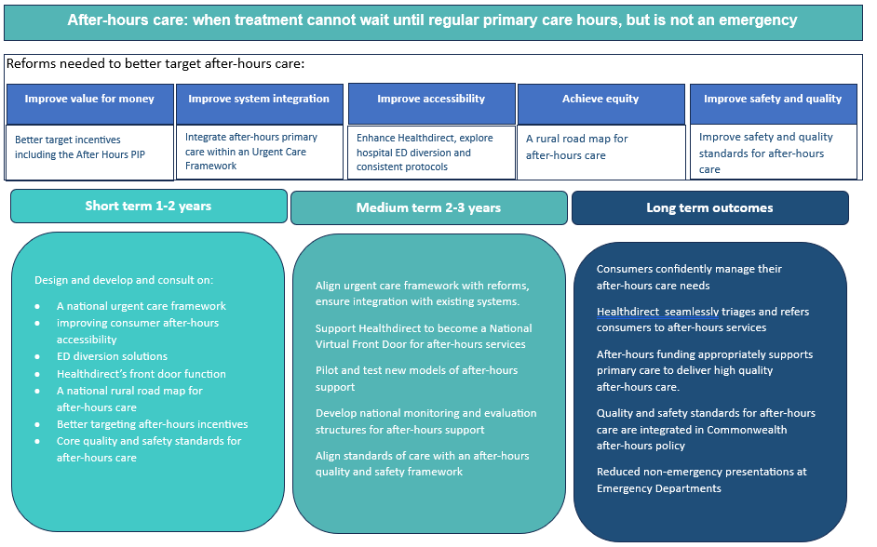

# Background

All Australian governments invest considerable resources to meet demand for after-hours primary care services. The Australian Government spent approximately $689 million in 2023‑24 on after-hours care. This investment included:

* approximately $521 million for around 8 million services funded through the MBS[1],
* $92 million for over 6,000 general practices claiming the After Hours PIP[2],
* $41 million for the PHN After Hours program, and
* $35 million on Healthdirect’s Nurse Triage and After Hours GP Helpline.

## After Hours Primary Care Services in Australia

After‑hours primary care is an evolving system, delivered in multiple physical and virtual settings, including by general practices, state and territory primary care clinics and hospital services, Medicare Urgent Care Clinics, Healthdirect, in aged care facilities, and in First Nations health services.

After Hours policies and programs operate in an environment shaped by workforce shortages, funding availability, policy and program settings and commercial decisions by practices and providers. Consumer demand for after‑hours care is also complex, reflecting the needs of different population groups, differences in consumer expectations, spillover from regular daytime care, convenience care, and episodic urgent care needs.

## Focus of the After Hours Review

The After Hours Review is a review of Commonwealth primary care after-hours policies and programs. The Review has arisen from several recent reforms and initiatives including the recommendations of the Strengthening Medicare Taskforce, the development of the 10 Year Primary Health Care Plan, and widespread changes to after‑hours services arising from the COVID pandemic.

After-hours primary care was last reviewed comprehensively in 2014. The review found considerable variation in availability and access to after-hours services across Australia, and the need to improve visibility for consumers of an overall structure for appropriate afterhours services.

Recommendations from the 2014 review resulted in significant changes to after-hours policy and programs including:

1. the creation of the current After Hours PIP,
2. the commencement of the PHN After Hours Program,
3. compliance activity to reduce expenditure on after-hours MBS items,
4. changes to workforce programs to decrease access to higher-priced after-hours MBS items by unethical business models,
5. controls on Approved Medical Deputising Service advertising, and
6. consideration of continued investment in Healthdirect’s After Hours GP Helpline,

In 2023, new program guidelines were introduced to focus the PHN After Hours Program on improving access to primary care services in the after-hours period.

## Review scope

The Review considered the efficiency and effectiveness of the Commonwealth’s support for after-hours care, while mindful of state and territory roles in providing acute and community care services. Commonwealth, state and territory governments all provide considerable resources to meet demand for after-hours primary care services, and reduce unnecessary presentations to hospital emergency departments. In particular, the Review considered:

* the impact of MBS funding on supply of services
* the After Hours PIP
* services provided by or through Healthdirect
* the Primary Health Networks (PHN) After Hours Program
* the Approved Medical Deputising Services (AMDS) program and
* the Medicare Urgent Care Clinics program

## Review process

The Review commenced in October 2023 concurrently with the Review of General Practice Incentives, both overseen by the same Expert Advisory Panel. The Department engaged expert consultants to assist with examining the evidence base and supporting stakeholder engagement. Findings from this work have been integrated into this Report.

Stakeholder engagement was extensive, including with Colleges, professional associations, peak organisations, state and territory health departments, and consumers. A survey was released in March 2024 to seek sector views on after-hours primary care, resulting in more than 460 responses and submissions.

1. Achieving value for money with after-hours primary care

## Current situation

The Australian Government supports the delivery of after-hours care through a blended funding model.

* Medicare provides higher benefits for fee-for-service consultations with doctors providing primary care during the after‑hours period that have higher out of pocket fees, helping Australians receive affordable care.
* Support is available to general practice to help off-set the costs of providing after-hours care, through the After Hours Practice Incentive Payments (PIP) Program.
* Medicare Urgent Care Clinics provide urgent episodic care that extends into the after‑hours period for minor illness or injuries.
* The Government funds PHNs to address after-hours needs at a local level.
* All governments except for Queensland contribute to Healthdirect’s nurse advice and triage service, which provides 24/7 services.
* The Government supports Healthdirect’s After Hours GP helpline and other Healthdirect services.

The Government spent approximately $689 million in 2023‑24 on after-hours care. Ensuring that public resources are used in an efficient, effective, economical and ethical manner consistent with the policies of the Commonwealth, underpins value for money considerations. Current policy settings recognise that after-hours primary care services are essential, with most funding provided through MBS subsidies or the After Hours PIP.

## Medicare

To help off-set the additional burden of providing after-hours care, the Medicare Benefits Schedule (MBS) provides higher subsidies through defined after-hours time periods for some health professionals.

Practice owners and peak bodies report that after-hours Medicare items do not adequately subsidise after-hours care, and advocate changes to the rebate structure. [3] While changes to MBS items are outside the scope of this Review, consideration has been given to the underlying issues influencing stakeholder feedback.

The MBS after-hours rebate structure is complex, with items providing different levels of benefit for similar services delivered by different types of doctors, whether the service is urgent or not urgent, whether the service is delivered in a clinic or at another location, length of consultation, and whether it is a telehealth service or delivered in-person. Rural weighting and workforce incentives also apply to the after-hours items.

One of the core principles for MBS after-hours items is that the rebate structure for after‑hours services should not provide perverse incentives to divert services from in-hours to out‑of‑hours or to drive utilisation that is not commensurate with clinical need.[4] This principle underpins the MBS rebate structure for after-hours items:

* For weekdays, after‑hours items for in‑clinic consultations commence two hours later than after-hours items for home visits including consultations at residential aged care homes.
* Similarly, on Saturdays after-hours items for in-clinic consultations commence one hour later than those for home visits.

The commencement times for comparable Medicare after-hours items are identical for all doctors eligible for a Medicare provider number:

Table 1: After Hours MBS attendance periods

| **Monday – Friday After-hours attendance periods** | | | | | | | |
| --- | --- | --- | --- | --- | --- | --- | --- |
|  | Before 7am | 7-8am | Regular hours | 6pm | 8pm | 11pm | After 11pm |
| Non-urgent in consulting rooms |  |  |  |  |  |  |  |
| Non-urgent elsewhere |  |  |  |  |  |  |  |
| Urgent attendance |  |  |  |  |  |  |  |
| Urgent attendance in unsociable hours |  |  |  |  |  |  |  |
| Urgent telehealth |  |  |  |  |  |  |  |

| **Saturdays After-hours attendance periods** | | | | | | | | |
| --- | --- | --- | --- | --- | --- | --- | --- | --- |
|  | Before 7am | 7-8am | 8 am | Regular hours | 12 noon | 1pm | 11pm | After 11pm |
| Non-urgent in consulting rooms |  |  |  |  |  |  |  |  |
| Non-urgent elsewhere |  |  |  |  |  |  |  |  |
| Urgent attendance |  |  |  |  |  |  |  |  |
| Urgent attendance in unsociable hours |  |  |  |  |  |  |  |  |
| Urgent telehealth |  |  |  |  |  |  |  |  |

| **Sundays and public holidays After-hours attendance periods** | | | | |
| --- | --- | --- | --- | --- |
|  | Before 7am | From 7am | Before 11pm | After 11pm |
| Non-urgent in consulting rooms |  |  |  |  |
| Non-urgent elsewhere |  |  |  |  |
| Urgent attendance |  |  |  |  |
| Urgent attendance in unsociable hours |  |  |  |  |
| Urgent telehealth |  |  |  |  |

Urgent consultation items are intended to be used on an ad-hoc basis and may not be used by doctors or practices who routinely provide after-hours services in a clinic.[5]

Urgent telehealth consultations are exempt from the established clinical relationship criteria (standard requirement for a GP to have had at least one face-to-face service to the patient in the 12 months preceding the telehealth attendance).

## Approved Medical Deputising Service program

Medicare benefits are available for services provided by doctors participating in the Government’s Approved Medical Deputising Services (AMDS) program. Doctors participating in this program are not qualified as Fellows of either the Royal Australian College of General Practitioners or the Australian College of Rural and Remote Medicine.

Guidelines for the AMDS program specify the conditions under which a participating business may operate, including maintaining a call centre, stand-alone premises, and limited advertising.[6]

From 2018, the Government implemented a suite of reforms to address a growth in use of urgent after-hours MBS items where there was no evidence of clinical need for those services.[7] The reforms included limiting access to urgent after-hours items, changes to the AMDS guidelines to require participation on a Fellowship program, specifying AMDS advertising criteria, and ceasing access for new participants to the After Hours Other Medical Practitioners program.

While these reforms have succeeded in reducing the use of urgent after-hours items, it is timely to examine the role of the AMDS program in supporting general practice.

## After Hours PIP

Since 1999, the Government has encouraged general practices to provide services through practice incentive programs (PIP). The current After Hours PIP has been in place since 2014. More than 6,000 general practices in Australia participate in the PIP After Hours Incentive program. Incentive payments are based on one of five payment levels, and practices choose a model of care that suits their business needs. Some payment levels under the After Hours PIP do not require practices to provide care themselves if formal arrangements exist for consumers to access care in the after‑hours period through a third party. Practices eligible for the Level 1 After Hours PIP receive $1 per Standardised Whole Patient Equivalent (SWPE), while practices eligible for Level 5 receive $11 per SWPE. Sole practitioners, who have a smaller SWPE, receive around $1,000 per annum, while larger practices may receive up to a maximum of $220,000 per annum.

The After Hours PIP Is available to eligible general practices. Participating practices may elect to receive one of five payment levels, each reflecting a different level of after-hours service delivery. Level 1 reflects the lowest level of participation, merely requiring practices to have formal arrangements in place with a third party to provide practice consumers with after-hours care. Level 5 requires the practice to provide after-hours care throughout the after-hours period. Payments are calculated on the SWPE model.

Preliminary analyses indicate that the After Hours Practice Incentive Payment may not function as intended to incentivise after-hours service provision. Factors such as practice size and region may be more important drivers of after-hours service provision (Table 1: PIP practices and Medicare after-hours claims).

*Table 2: PIP practices and MBS after hours claims for the PIP year 2024 (May 2023 – April 2024)*

|  | Other1 | Level 1 | Level 2 | Level 3 | Level 4 | Level 5 |
| --- | --- | --- | --- | --- | --- | --- |
| Average # annual after-hours claims | 147 | 573 | 857 | 1,903 | 550 | 1,456 |
| Average # annual primary care claims | 11,643 | 20,808 | 22,592 | 27,849 | 21,308 | 25,797 |
| # of PIP practices with no after-hours claims2 (% of practices in this tier) | 219  (46%) | 665  (21%) | 104  (16%) | 48  (10%) | 57  (17%) | 245  (16%) |
| # of PIP practices (% of total PIP practices) | 475  (7%) | 3,114  (47%) | 655  (10%) | 462  (7%) | 341  (5%) | 1,561  (24%) |

*MBS services classified as a primary care service as per the primary care service type under the Medicare quarterly statistics. Covers services rendered between 1 May 2023 and 30 April 2024 and processed prior to 17 September 2024.*

*1 PIP practices not in the After Hours incentive.  
2 This does not mean the practice provided no after-hours services. Rather it provided no services with item codes specific to the after-hours period.*

Small practices with low numbers of after-hours claims were less likely to participate in the After Hours PIP.[8]

The department analysed the number of after-hours MBS item claims associated with practices participating in each level of the After Hours PIP. Between 7% and 19% of practices at each level were not associated with any after-hours MBS item claims in the twelve months from 1 May 2022. Those practices with no after-hours claims may not have delivered an after-hours service, or may have delivered after-hours services where there is no after‑hours MBS rebate, for example providing routine (not urgent) telehealth services.

## What is the need?

Current blended funding models primarily support a traditional model of doctors working within general practice. Funding models aim to help compensate doctors for the inconvenience of working unconventional hours when treatment can’t wait, to assist them in attending their patients at home on an ad-hoc basis, or in attending a patient for an urgent need. There is a tension between this funding model and consumer expectations. For some consumers, after-hours appointments for non-urgent needs may improve primary care accessibility with less disruption to work, study and other commitments than an appointment in regular business hours.

Stakeholders expressed strong views that current funding arrangements do not reflect the true costs of providing after-hours care, are insufficient to support a sustainable workforce and accessible care, and lead to the imposition of large out of pocket costs on consumers.

During the Review, survey respondents from the primary care sector expressed views that financial considerations, alongside lifestyle factors, limited their provision of after-hours care. Changes to MBS items are outside the scope of this Review. The MBS Review Advisory Committee (MRAC) has been appointed to advise Government on potential changes to publicly funded services listed on the MBS. The MRAC supports the MBS Continuous Review to ensure the MBS is contemporary, sustainable, evidence based, and supports universal access to high value care for all Australians.

The After Hours PIP was seen by multiple stakeholders as disadvantageous to small practices (or those in thin workforce markets) and regional, rural, and remote practices with a higher proportion of non-GP staff, as SWPE is based on a calculation of MBS services per practice.[9] Most stakeholders advised that the After Hours PIP could be more effective in incentivising more active and better distributed after-hours service provision. A stronger connection between funding recipient and delivery of care is needed to achieve value for money.

Stakeholders also identified structural issues within the After Hours PIP, with incentives available to practices providing after-hours care either not at all, throughout a defined “sociable” after-hours period, or for the entirety of the after-hours period. Stakeholders expressed the wish to receive support to provide shorter periods of after-hours care based on consumer needs.

The Review’s Expert Advisory Panel advised changes to the After Hours PIP could better support GPs and nurse practitioners to provide care to their patients in the after-hours period, particularly in the early evening.

## Better targeting after-hours incentive payments

Better targeting after-hours incentive payments to primary care businesses delivering after‑hours care will benefit consumers and primary care providers.

The Department considers that after-hours incentive payments should ensure a broader range of providers are eligible to receive incentive payments. Following recent technological innovation, models of after-hours care have changed considerably. GPs are no longer the sole providers of after‑hours care, with nurse-led clinics, Nurse Practitioners, and other primary care practitioners delivering after-hours services. After-hours care is provided through telehealth, home visits and in-clinic services, and in combinations of these modalities.

Further work is needed to develop a model that supports:

* General practices and other primary care services that deliver after-hours primary care, commensurate with consumer need.
* Primary care services to improve continuity of care for patients receiving after-hours care from other providers, through patient record sharing and referral pathways.
* Access to in-hours appointments for urgent needs and home visits, to reduce the burden on the after-hours system.

A careful approach would be needed to develop such a model, to ensure it aligns with Medicare policy and does not create perverse incentives to divert services from in-hours to out of hours or drive utilisation that is not commensurate with clinical need.

Standardised clinical data will underpin a sustainable after-hours system and support more flexible funding models monitoring and evaluation of after-hours services.

Better targeted incentives that improve the quality and safety of care should be enabled by the consistent capture and reporting of nationally standardised data, required to be collected by all healthcare providers irrespective of profession or care setting (face to face at a general practice, or through a connected after-hours service).

When health information obtained during clinical practice is uniformly recorded, this offers valuable data insights that enhance patient outcomes and promote sustainable care. This interaction of clinical practice and knowledge gathering informs and supports a continuous cycle of improvement in safety, quality and health outcomes. The consistent recording, use and reuse of data will enable researchers, innovators, collaborators and industry to contribute to growing a learning health system.

The Department, in collaboration with CSIRO and the Australian Digital Health Agency is establishing core data and exchange standards for the consistent capture of patient health interaction information, using the international standard Fast Healthcare Interoperability Resources.

**Theme 1: Improve value-for-money of after-hours primary care**

Opportunity: Better target incentives for after-hours primary care, to ensure a sustainable after-hours system

### Comments on this opportunity

Better targeting of funding for after-hours primary care could address unmet demand for after-hours services, particularly in regions with very little current capacity.

Broadening the scope of after-hours incentives could expand the range of services supported to include home visits, and associated services such as after-hours pharmacy.

Changes to incentives for after-hours primary care could be integrated with other primary care reforms such as an increased scope for practice nurses, and multidisciplinary care teams for patients with chronic conditions.

1. Integrating after-hours primary care within an urgent care Framework

## Current state

Primary care providers are private businesses and can set their own opening hours, including provision of extended hours for comprehensive care to meet consumer needs, or provision of home visits at any time to provide comprehensive care for home-bound patients.

After-hours care services are intended for when an episode of care can’t wait until the normal opening hours of a consumer’s regular primary care provider. Regular, comprehensive care, such as cervical screening, vaccinations and chronic disease management, are not suitably delivered by after‑hours services due to a lack of access to patient history, gaps in continuity of care, and unfamiliarity with the patient. After-hours primary care policy and planning falls within broader considerations of urgent care and hospital emergency department diversion activities. Around one third of all emergency presentations are triaged as low urgency. Some low-urgency presentations at hospital emergency departments are suitable for the setting, while others could be more appropriately treated in primary care. Low-urgency emergency department presentations occur at an average rate of 527 per hour per day from 8am to 8pm, decreasing from about 9pm onwards. Higher rates of low-urgency emergency department presentations occur on Sundays when most general practices are closed.[10]

Ideally, after-hours services should be delivered by providers who have a relationship with the patient’s usual primary care provider, facilitating safety, quality and continuity of care. An ongoing relationship between provider and patient means better continuity of care and better outcomes for the patient. However, it is not feasible for all primary care providers to offer after‑hours care.

In Australia, multiple options exist for consumers seeking after-hours primary care. This includes after-hours care from their regular primary care provider, as well as after-hours care from third parties. A range of settings is listed below.

After-hours care is delivered in a wide range of settings

Telehealth, Medicare Urgent Care Clinics, regular general practices, After Hours Services providing clinics open only in the after-hours period, state/territory and community health care options including nurse-led clinics, Medical Deputising Services providing clinics and home visits, pharmacies, imaging and pathology services, allied health practices, mental health hubs, midwifery, and specialised services for particular population groups.

One of the short-term recommendations of Australia’s Primary Health Care 10 Year Plan 2022-2032is that PHNs and LHNs should be required to develop joint regional plans and collaborative commissioning approaches for after-hours care pathways.

PHNs are funded through an After Hours Program to support local solutions for improving access to after-hours primary care services in their region. Some PHNs directly fund after‑hours services to ensure they are open and accessible during times of high demand. PHNs may also fund deputising services, collaborative arrangements, access for priority groups such as residents of aged care facilities, and access to related services such as after‑hours pharmacy.

The PHN After Hours Program was reviewed in 2021, with its final report recommending better targeting of the program to address specific and unique needs of local areas. The report identified a need for effective after-hours care that integrates with usual primary care providers and recommended co-development of regional after-hours plans with local primary care and hospital service providers.[11] The review noted that as the Program is funded on a maximum two-year cycle, PHNs are constrained in developing longer-term solutions for their regions.

New Grant Opportunity Guidelines issued in July 2023 reshaped the Program, aiming to improve the efficiency and effectiveness of after-hours primary health care services and meet consumer needs for access to after-hours primary health care services in participating PHNs’ catchments. Funding for the Program finishes on 30 June 2025. An evaluation of these reforms, and the creation of a longer-term monitoring and evaluation framework for the Program is also underway, addressing another recommendation from the 2021 review.

As primary care reforms progress, including the roll-out of Medicare Urgent Care Clinics (Medicare UCCs), the role of PHNs in supporting planning and coordination of after‑hours care may become more central. Stakeholders noted that rural and remote PHNs have very large and diverse catchment areas, which do not lend themselves to a single after-hours solution.

## Medicare Urgent Care Clinics (Medicare UCCs)

The Government is improving access to urgent episodic care in a non-hospital setting through the Medicare UCC program. Medicare UCCs provide walk-in, bulk billed healthcare for urgent (but not life threatening) presentations. They’re intended to be integrated within local health networks with triaging and referral to and from other health services. The Medicare UCC program is in its early stages of operation, with the initial 58 clinics progressively established throughout June to December 2023. In the 2024-25 Budget, the Government provided funding for an additional 29 Medicare UCCs.

Medicare UCCs are required to operate extended hours that may include part of the after‑hours period. Medicare UCCs have variable opening hours and exact hours depend on local conditions and need. The opening hours of clinics are intended to meet the peak periods for presentations at partner emergency departments and local community need. The full extended hours for Medicare UCCs are defined as 8am to 10pm, seven days a week or 14 hour or more equivalent. Overlap with the after-hours period is displayed at Figure 1 Medicare UCC after-hours opening hours.

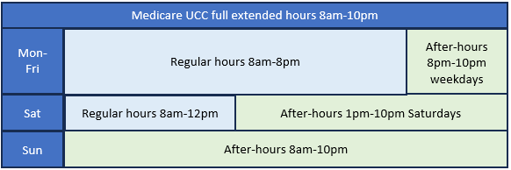

Figure 1 Medicare UCC after-hours opening hours

The full impact of Medicare UCCs on the after-hours landscape is not yet clear. Findings from evaluation of the Medicare UCC program could inform protocols for after-hours patient information flow. An independent evaluation of the Medicare UCC program has commenced, with the final report due in mid-2026.

## What is the need?

Integration of after-hours service planning in PHN/LHN local service delivery mapping is a priority of *Australia’s Primary Health Care 10 Year Plan 2022-2032.* This priority recognises the need for the primary and acute sector to work together for better health outcomes and to reduce unnecessary emergency department presentations.

Ensuring the information follows the patient no matter where they present, including after‑hours services, is a core capability to enable safe transitions of care.

The Strengthening Medicare Taskforce acknowledged that the ability to seamlessly exchange patient health information between healthcare providers and across healthcare settings is critical to supporting a modern, safe and efficient health system and to ensure all Australians receive integrated and person-centred care.

A patient centric data model where a patients’ health information can follow them means that healthcare providers are informed of the patient’s health history, at the point of care, resulting in provision of timely and effective care. During the consultations undertaken for the Review, consumers and providers articulated a need for better continuity of care for episodes of after‑hours primary care, primarily with regard to information sharing. Consumers advised on difficulties in providing comprehensive health histories to after-hours doctors providing urgent episodic care. After‑hours doctors advised consultations can be lengthy due to the need to take such histories, particularly for people with complex health conditions presenting for urgent care.

Consumers also identified a strong need for better information to be given at, or adjacent to, hospital emergency departments, on local after-hours services. This could improve hospital emergency department diversion, for after-hours consumers with non-emergency needs.

“One of the things that I think that we could do better is … that at the emergency departments … people could be notified or redirected towards some of those other options. ‘Have you tried your locum? Have you tried urgent care?’, you know, ‘do you know that these things exist?’

So even some signs or some information given by the triage nurses that says you know ‘the wait time here tonight is extremely long. Here are some other options for you’ because if those people don’t know about those options or aren’t aware that some of those options can be bulk billed … they see the emergency department [because they think it] is the only way to get free healthcare.

So, some extra education, not just generally in the community but at that point of care, I think would be beneficial.”[12]

Providers identified a range of potential solutions to these issues, such as supporting emergency department triage nurses to refer to an on-site, local or telehealth primary care after-hours service.

Peak and consumer stakeholders discussed the difficulties and frustrations some consumer groups experienced with ‘retelling their story’ and needing to explain their specific health needs that were not otherwise accessible through health records. Lack of access to medical records can mean that after-hours services misdiagnose conditions for people living with complex illnesses, people with language or communication difficulties, people with palliative care needs, and people with disabilities.[13]

In an ideal after-hours system, no-one uses after‑hours care as their only means of receiving primary care. Consumers seeking comprehensive care should ideally be able to access care from their usual primary care provider within regular or extended business hours. Data linkage is needed to better understand after-hours services consumer cohorts, and the circumstances in which they seek care.

## Key themes and opportunities for reform

**Theme 2: Integrate after-hours primary care services**

Opportunity: Include after-hours care within a broader Urgent Care Framework. This will improve continuity of care for consumers and reduce emergency department presentations.

### Comments on this opportunity

Better coordination of after-hours services would improve continuity of care and assist consumers to find the most appropriate service for their needs. A national Urgent Care Framework would support consistency across jurisdictions and include principles for:

* Improving data flow across services to improve continuity of care.
* Managing consumers without a usual primary care provider who present at urgent care or after-hours services.
* Promoting equity of access to urgent care and after-hours care for priority populations.

This approach could draw on lessons from the Review as well as current evaluations of the Medicare Urgent Care Clinics program, Primary Care Pilots and state-run virtual ED services.

Outcomes could include:

* Enhancing Healthdirect’s role in supporting continuity of care for consumers.
* Continuing funding for PHNs to improve and maintain coordination of after-hours care including for consumers seeking mental health services in primary care settings, and residents of Aged Care Homes needing urgent primary care services to avoid unnecessary hospital presentations.
* Supporting healthcare providers in primary care to uplift digital capabilities to support multidisciplinary, team-based care through seamless access to key health information.
* Further integrating Medicare Urgent Care Clinics with other local after-hours primary care and emergency diversion services.

1. Improving accessibility of after-hours primary care

## Current situation

In Australia, multiple options exist for consumers seeking after-hours primary care. These options vary by location and timing. Consumers are often not aware of which services are available, accessible or affordable for urgent non-emergency care, which may result in them presenting to a hospital emergency department. They may further struggle to distinguish different types of episodic care needs, including urgent and emergency care.

### Healthdirect Australia

Healthdirect provides national virtual public health information services on behalf of all Australian governments. It aims to provide information, advice, referral and virtual health services, where appropriate, and support consumers to navigate local and national health systems.

Since its establishment in 2006, Healthdirect has developed from an initial focus on providing a nurse-led telephone advisory service, to:

* Delivering health services in a virtual environment
* Enabling consumer-led health seeking behaviour
* Providing real-time patient navigation and connection back to usual care.

During the COVID-19 pandemic, Healthdirect was extensively leveraged by governments to provide a national focal point for consumer access to information and clinical advice through the National Coronavirus Helpline, COVID vaccine clinic finder and the Living with COVID community pathways, which supported COVID-positive consumers to access anti-viral treatments, connecting them back to their usual GP, or to the closest GP Respiratory Clinic.

Healthdirect’s National Health Service Directory lists health services information which can be searched by consumers and Healthdirect triage nurses, including contact details and hours of opening. There may be opportunities to improve the identification of general practices and other primary care providers offering home visiting services, after-hours consultations and palliative care services, alongside their mainstream and usual practice.

Healthdirect’s nurse triage and advice helpline is available 24 hours a day to provide health information and advice to consumers in all jurisdictions except Queensland. Healthdirect also provides an After Hours GP helpline and a Pregnancy, Birth and Baby helpline.

Around 70 per cent of all calls received by Healthdirect are received in the after-hours period.[14] The Review heard from sector and consumer stakeholders on the role of telehealth in connecting people with the right service at the right time. One respondent organisation suggested a role for Healthdirect as a “command centre” to assist consumers to navigate the system.[15]

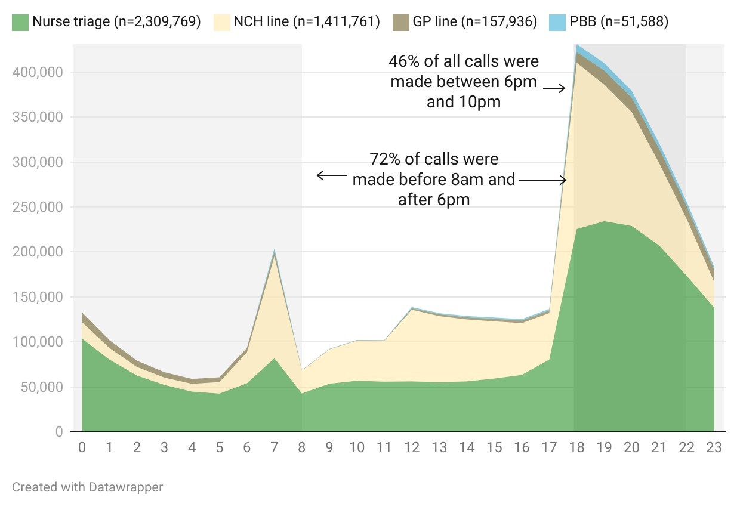

Figure 2: Healthdirect calls by helpline and time of day (24-hour clock) [16] National Coronavirus Helpline (NCH line), GP After‑hours Helpline (GP line), Pregnancy Birth and Baby Helpline (PBB line).

### The success of virtual front door trials across Australia

In 2022, NSW trialled an expansion of the After Hours GP Helpline to provide services to callers from all NSW regions at all times of day. Over 60% of consumers who accessed the expanded service indicated that they would have attended an emergency department (ED) if the virtual GP service was not available.

Similar trials are being implemented in Victoria and South Australia using Primary Care Pilot funding from the Commonwealth. The Primary Care Pilots aim to divert people with non‑life-threatening illnesses and injuries away from emergency departments to more appropriate care in the community.

These pilot sites offer a virtual front door through Healthdirect to provide consumers seeking urgent care with triage, advice and navigation to appropriate services, including access to Healthdirect’s own virtual urgent care services when appropriate.

### A virtual front door

The Review’s Expert Advisory Panel advised expansion and promotion of a virtual front door through Healthdirect Australia could help improve after-hours accessibility.

* Healthdirect’s flexible service model enable it to support consumers to access the most appropriate primary, urgent or emergency care services depending on their condition, the time of day and the availability of local services.
* Healthdirect has the potential to be a national virtual triaging service embedded within the urgent care ecosystem. It has the flexibility to provide tailored options to support priority populations, and to expand to non-urgent community-based health services. During the COVID pandemic Healthdirect developed and implemented a range of novel solutions including non-clinical advisory services; online symptom checkers; and targeted support for patients needing support to book into vaccination clinics.
* Healthdirect’s services continue to evolve and have the potential to link consumers with all relevant health services in their region, including virtual ED, home visits, telehealth appointments and after-hours clinics.
* Healthdirect could improve its offering to consumers in rural and remote areas by developing and maintaining information about locally available services.

### Advertising of after-hours doctor services

In 2017, several reforms were implemented to curb a commercially motivated rapid rise in Medicare Benefits Schedule urgent after-hours item claims. These items are not intended for use by services whose regular business is in the after-hours period.

One of the reforms was to the Government’s Approved Medical Deputising Service (AMDS) program guidelines, to heavily restrict advertising.[17] An AMDS is a service or organisation, approved by the Department of Health and Aged Care, to arrange and facilitate the provision of deputised medical services to patients at the request of their regular GP in the after‑hours period when they are not available. Deputising services can be provided at a clinic and/or in the home of a patient. AMDS doctors have not qualified for fellowship with either the RACGP or the Australian College of Rural and Remote Medicine. By participating in the AMDS program, services provided by AMDS doctors are eligible for a suite of Medicare benefits. AMDS advertising is restricted to providing contact details to practices with written deputising agreements in place, and providing contact details, opening hour and health advocacy information on passive websites or social media pages.

While the AMDS advertising restrictions apply only to AMDS participants, the Department notes that the medical deputising sector has broadly complied and passively advertises service availability. In undertaking any further reforms to improve consumer awareness of after-hours services, it will be important to ensure after-hours services are not accessed as convenient care in preference for regular primary care services.

## What is the need?

The Department received consistent advice from consumers that there are difficulties in both understanding the after‑hours system and accessing care. Consumers advised that these difficulties result in presentations at hospital emergency departments for care that could have been provided elsewhere.

Some consumer groups have greater barriers than others, including those facing stigma and cultural safety issues, with complex care needs, or with poorer health literacy. Some consumers from these groups suggested after-hours care coordinators could complement a consumer-friendly health service navigation interface.

The complexity of the after-hours system is leading to confusion as to where to go resulting in some consumers choosing to attend the Emergency Department because they know what to expect there.[18]

Clear and standard guidance for consumers will support them to identify and seek care for acute episodic conditions as well as better manage their after-hours care needs for complex and chronic conditions.

Most Australians will access after-hours primary care if services are available. The evidence review undertaken by Allen + Clarke Consulting drew upon Australian Institute of Health and Welfare data and the 2020 Australia’s Health Panel Survey to find patterns of after-hours consumer need.[19] The 2020 Australia’s Health Panel Survey showed that:

* 67 per cent of respondents had accessed after-hours primary care at least once in the previous 5 years.
* Most consumers received after-hours care from GPs (58 per cent), with 35 per cent accessing pharmacy services and 25 per cent accessing nursing services.
* Most after-hours care is accessed between 6pm and 11pm during weekdays.
* After-hours care is accessed during the weekend at a comparable rate, across the entire after-hours period, however there is a surge in non-emergency ED presentations during public holidays.

AIHW data shows that a significant proportion of consumers access emergency departments for non-emergency care:

Over 1 in 3 ED presentations (36 per cent or 3.1 million) were classified as lower urgency in 2021-22. Of those 3.1 million lower urgency presentations, 45 per cent were during the after‑hours period.

Seriousness of the condition and lack of access to a GP were the most common reasons for seeking ED care.

Most lower urgency after-hours presentations occur in the early evening, between 6pm and 9pm.[20]

Providing consumers with information that is accessible, readily understood and applicable to their situations will increase consumer knowledge, accessibility, appropriateness and efficiency of after-hours primary care.

Particular population groups may face different barriers to accessing appropriate after-hours primary care. Stakeholders from culturally and linguistically diverse groups advised that attending a primary care provider in the after-hours period can be confronting, expensive without access to Medicare, and frightening when trying to communicate health concerns and history with cultural and language barriers.[21]

Stakeholders advised that receiving care at home through a home visiting doctor, nurse or other primary care provider is important for some priority populations. This includes residents of aged care homes, older Australians, some people with disability or chronic illness, and people receiving palliative care. Some consumers may be accessing urgent home visits from after-hours doctors due to their regular GP choosing not to provide home visits in regular hours.

Further work is needed to identify:

* pathways to regular primary care services, for consumers receiving only urgent after-hours care,
* best-practice use of telehealth to deliver after-hours care, and
* support needed for general practice to provide home visits to patients at need of routine primary care within their own home, within usual hours.
* Local after-hours solutions for rural and remote communities.

The Review found that primary care sector and consumer stakeholders are broadly supportive of the use of telehealth during the after-hours period, noting that telehealth is not always clinically appropriate and should not replace face-to-face care.[22] Opportunities were identified during the Review for further work on linking telehealth with other after‑hours services, including potential enhancements to the data flow from Healthdirect to improve continuity for the consumer and improve efficiency of after‑hours services.

### Palliative Care

The palliative care sector and consumers advise that accessing after-hours palliative care is important for symptom management including pain management. Lack of appropriate care and medication can mean palliative care patients attending hospital settings.[23]

Telehealth may be of particular benefit in meeting the after-hours support needs of people living with life-limiting illness, their families, and caregivers, particularly for those living in aged care and disability support homes and rural and remote areas. Further work is needed to understand barriers and enablers of appropriate palliative care telehealth delivery in the after-hours period including prescribing Schedule 8 pain relief medication.

Stakeholders reported that GPs may be reluctant to provide palliative care services in the after-hours period given the significant time and costs associated with caring for someone who is dying.

Further work is needed to adequately incentivise GPs and explore opportunities for expanding the scope of practice for other health professionals including nurse practitioners, pharmacists and paramedics to assist in meeting urgent palliative care needs in the after‑hours period.

“Because you still get…those issues with people seeking access to care, who don’t necessarily need access to care in the after hours, but they do need reassurance. They do need someone to talk to them, to listen to them, to hear their worries and concerns and potentially, you know, make an appointment for them at their preferred healthcare provider for the next morning and so that people feel comforted and reassured. **– Sector stakeholder, interview*[24]***

### Feedback from First Nations Australians

The After Hours Review consulted with several organisations and experts to understand how the current after-hours system provides services for First Nations people. Following these group consultations, the Department funded First Nations Health Consulting to undertake four yarning circles to gather feedback from First Nations communities on after‑hours care experiences, drivers for help-seeking in the after-hours period, awareness of after-hours primary care service options, and needs for a future after-hours system.

Yarning circle participants reported many challenges to accessing appropriate after-hours care services, including long wait times, culturally unsafe care, a lack of care continuity and provider continuity, and a lack of First Nations Health Workers in after-hours care settings. Any reform of after-hours policies and programs will need to address the particular needs and experiences of First Nations people.

## Key themes and opportunities for reform

**Theme 3: Improve the accessibility of after-hours primary care**

Opportunity: Improve consumer awareness of, and connectedness to, after-hours primary care services.

### Comments on this opportunity

Healthdirect could provide a virtual front door for consumers seeking care, particularly for consumers seeking urgent and semi-urgent care in the after-hours period.

Other themes include:

* Exploring methods for hospital emergency department diversion, for after-hours consumers with non-emergency needs.
* Developing consistent protocols for consumers to find, or be referred to, after-hours primary care.
* Strengthening the Approved Medical Deputising Program guidelines, to ensure the program remains relevant and accessible.

1. Improving equity of after-hours primary care in rural and remote Australia

## Current situation

Australia’s geography poses unique issues to the delivery of equitable health care. Significant workforce pressures exist for the after-hours primary care workforce in parts of Australia outside major cities. Challenges for rural and remote communities include distance, workforce shortages[25] and lower population size.[26] These issues are magnified for after‑hours care where a fee‑for‑service model is unsustainable in low-density populations.

Non-metropolitan primary care may be delivered by doctors working in atypical practices, including nurse-led clinics, mixed telehealth and fly-in fly-out models, and in some regions providing primary care (including auxiliary primary care services) at hospital emergency departments.

The Government has established several workforce programs to attract doctors to non‑metro areas, including specifically in the after-hours period. These include workforce programs listed in the *Health Insurance Regulations 2018* which provide access to Medicare items for doctors otherwise ineligible, including after-hours Medicare items.

The Government also assists rural Australians to access after-hours care with specific urgent after‑hours Medicare items for regional and rural Australia, access to higher levels of the After Hours PIP payment with lower levels of GP engagement required, access to Healthdirect’s GP Helpline, and support for local after-hours solutions through the PHN After Hours Program. Targeted funding also supports delivery of primary and acute care through the Royal Flying Doctor Service, including innovative solutions such as the community chests initiative[27].

### Healthdirect’s After Hours GP Helpline

The Government funds Healthdirect to provide the After Hours GP Helpline. The After Hours GP Helpline is a telehealth service offering GP telephone advice and diagnostic services to the general public, and is accessed through the Healthdirect Helpline by a referral by a registered nurse. The service aims to reduce unnecessary presentations to hospital Emergency Departments and improve integration with other primary care services.

Callers to the Healthdirect Helpline during the after-hours period are assessed by a registered nurse who determines if they would benefit from speaking with a GP. The Healthdirect Helpline nurse can offer a call back (by phone or video call) from a GP within 15 minutes or within one hour, depending on the severity and urgency of the caller’s health issue.

The After Hours GP helpline also provides fast track support to health professionals, including registered nurses or enrolled nurses providing nursing services at residential aged care facilities or other like facilities. This allows health professionals attending to a person during the after-hours period, and in need of urgent GP advice, to receive a GP call back without undergoing triage from a Healthdirect Helpline nurse. The service is available to eligible callers in all states and territories except Tasmania, where an alternative service exists.

Access to the After Hours GP Helpline is available for the entire after-hours period across Australia, with priority given to callers from regional and rural Australia. Outside the major cities the After Hours GP helpline can be accessed during the following times: 6 pm-7:30am Monday to Friday, from 12 noon Saturday, and all day Sunday and Public Holidays.

Stakeholders advise that while useful, virtual services such as Healthdirect and telehealth providers do not currently meet rural Australia’s need for continuity of care, medication or treatments, cultural consideration, digital infrastructure, clinical procedures, symptom checking or summaries of consultations. These needs are not unique to rural Australia, but are significantly more prominent in thin markets. The expansion of telehealth needs to be designed carefully to promote continuity of care which is associated with the best health outcomes for patients, and not to undermine the importance of local regional and rural GPs to their communities (or undermine the local healthcare provider’s business model).

### Access to after-hours primary care in rural Australia

Providing primary care services in the after-hours period places an additional burden on the rural primary care workforce. Figure 3 shows that as remoteness increases, a lower proportion of people see a GP during the after-hours period.

Figure 3: Proportion of after-hours GP attendances by remoteness[28]

A chart showing that more after hours general practitioner services are delivered in major cities than in regional and remote areas. In major cities, more services are delivered in lower socioeconomic status areas thank in medium and higher socioeconomic status areas.

Conditions of work for rural primary care are very different to those in metropolitan regions. Stakeholders advised that rural and remote GPs typically have a heavier and more complex workload than GPs in metropolitan areas.

In rural, you’re everything… You’re the hospital emergency doctor, you’re the GP on call, you’re also the obstetrician after hours… So the after-hours work, whether it’s procedural or emergency or the GP type presentations, it also has a flow on impact… because, if you’re at a delivery from 2 o’clock till 7 o’clock in the morning, chances are you’re going to have to go to bed and therefore you can’t see patients and you lose money. – **Workforce organisation, interview[29]**

GPs in outer regional, remote and very remote regions work longer hours than GPs in metropolitan areas (Figure 4).

Figure 4: Average total hours worked per week by GPs[30]

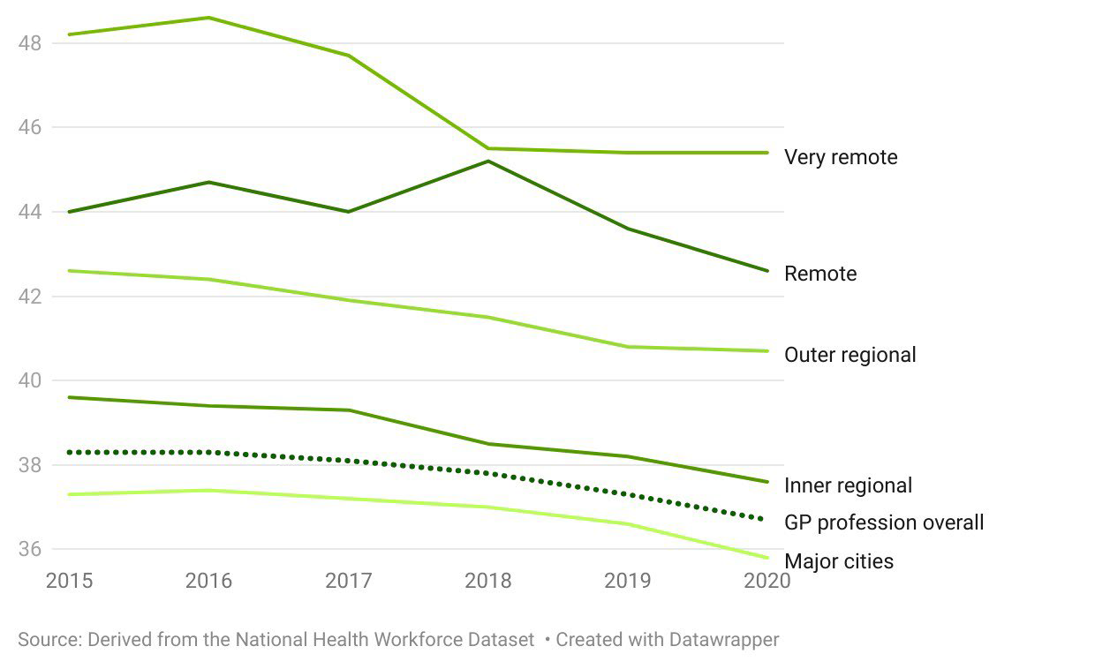

## What is the need?

The Strengthening Medicare Taskforce report highlighted the importance of providing rural and remote communities with the tools and resources necessary to flexibly design and fund solutions that better reflect the reality of what is needed and what can be sustainably delivered. The Taskforce’s recommendations included:

Develop new funding models that are locally relevant for sustainable rural and remote practice in collaboration with people, providers, and communities. Ensure new funding models do not disadvantage people who live in communities with little or no access to regular GP care, and whose care is led by other healthcare providers.

The availability of after-hours primary care in rural and remote areas is extremely limited and emergency departments are usually the only place to access any medical assistance. At 9 September 2024, 26 Medicare UCCs are in regional, rural and remote areas (Modified Monash Model 2 to 7). Systemic issues impacting the maldistribution of the health workforce across Australia has led to any form of after-hours primary care in rural and remote areas an exception to the rule. During the Review, consumers reflected on service sustainability needs in rural and remote areas, noting that services are frequently short-lived. In rural and remote areas where fly in – fly out models of care provide primary care services; consumers require solutions when primary care is not available. Consumers reported a growing need for after-hours non-crisis mental health services for younger people in rural areas.[31]

To be effective, rural and remote after-hours health policy must be co-designed with rural and remote communities to ensure outcomes align with the health needs of the target community. Stakeholders supported rigorous research and needs assessments, undertaken in partnership with affected consumers, to design targeted strategies to better support access to after-hours primary care services. [32]

Rural and remote stakeholders identified a need to ensure that telehealth models are integrated with regional, place-based services delivered by skilled local practitioners to ensure appropriate and relevant care navigation alongside in-person care.[33]

Technological literacy, internet and mobile connectivity in remote and rural areas was identified as a key need to support after-hours care in rural Australia for both consumers and providers. In addition, there is a need for health technology and infrastructure to support the use of remote diagnostic and monitoring tools via telehealth delivery in the after-hours period.[34]

## Key themes and opportunities for reform

**Theme 4: Achieve equity of after-hours primary care in rural and remote Australia**

Opportunity: Develop a roadmap to address issues affecting the delivery of after‑hours primary care in non-metropolitan areas, including sustainability of services, integration of technology and meeting community expectations and needs.

### Comments on this opportunity

A roadmap for addressing after-hours services in rural and remote Australia could build on other primary care policy settings and reforms affecting these regions. As an interim outcome, developing such a roadmap would assist providers to engage with the complex range of current primary access initiatives. Over the longer term, the roadmap could propose an approach for developing local solutions to improving access to after-hours services.

Considerable further consultation, planning and design will be needed to address particular gaps in services, which vary by remoteness and other factors. This process would also ensure broader changes to incentive settings are compatible with the particular challenges facing rural and remote primary care services.

1. Improving the quality and safety of after-hours primary care

## Current situation

Accreditation against standards of care ensures a minimum level of safety and quality is met for consumers and health professionals delivering services.

Current after-hours accreditation arrangements are limited to three modalities: general practice, After Hours Services, and Medical Deputising Services. Accreditation is voluntary and confers benefits in the current after-hours system for each of these types of providers:

* General practice accreditation against the Royal Australian College of General Practitioners (RACGP) Standards for General Practices[35] is a requirement for eligibility for the After Hours PIP.
* General practices participating in the After Hours PIP can receive a payment if they have a formal arrangement with an accredited After Hours Service or Medical Deputising Service for after-hours care to be provided on the practice’s behalf.
* After Hours Services and Medical Deputising Services can be accredited against the RACGP Standards for After Hours and Medical Deputising Services. Dependent on workforce program requirements, accreditation can mean access to general practice doctors with restricted registration who may be eligible for higher MBS rebates than those for non-vocationally registered doctors.

Accreditation to the RACGP Standards for general practices is undertaken within the National General Practice Scheme, administered by the Australian Commission on Safety and Quality in Health Care (ACSQHC). The RACGP *Standards for General Practices* are consistent with the ACSQHC’s overarching Primary and Community Healthcare Standards, both of which are standards designed for the delivery of comprehensive healthcare.

The RACGP *Standards for General Practices* include standards for providing information on how after-hours care can be obtained, and standards for inclusion of patient records of after‑hours care received by patients. The RACGP *Standards for General Practices* do not include standards for delivering after‑hours care, perhaps because after-hours care is characterised by its urgent and episodic nature rather than the delivery of comprehensive healthcare.

Other primary care practices, such as nurse-led clinics, mobile clinics providing out-reach services, aged care services and practices focusing on particular diseases or conditions are not eligible for accreditation under the RACGP *Standards for General Practices*.

## What is the need?

Sector and consumer feedback is supportive of a broader range of primary care providers receiving Government support for after-hours care.

In 2021, the Department commissioned an evaluation of general practice accreditation arrangements. The final report[36] noted that the RACGP *Standards for General Practices* are widely considered to include too many requirements that are not considered sufficiently relevant to quality and safety.

Consumers articulated the need for after-hours providers to be aware of clinical circumstances that affect after-hours delivery. For example, palliative care consumers advised that receiving safe and appropriate care was difficult, particularly when requiring palliative care medication or end-of-life care during the after-hours period. First Nations people consistently advised the need for cultural safety to be included in after-hours care clinical delivery standards.

The Review found more exploration is needed on safe and high‑quality delivery of virtual care in the after-hours period. Virtual services including telehealth play a critical role in the after-hours system, but require complementary supports from the broader health care system.

**Theme 5: Improve quality and safety of after-hours primary care**

Opportunity: Better articulate core quality and safety standards for consumers receiving after-hours care and the health workforce delivering that care

### Comments on this opportunity

This approach would consider the range of current safety and quality requirements for Commonwealth-funded after-hours services. Any gaps or inconsistencies would be addressed in consultation with consumers and service providers.

Consistent guidelines would help improve continuity of care for consumer accessing multiple services including Medicare Urgent Care Clinics, Healthdirect, medical deputising services and after-hours clinics. The guidelines could also inform future changes to primary care accreditation settings, where required.

# Glossary

| Glossary terms | Descriptions |
| --- | --- |
| After-hours primary care | Refers to care provided outside a patient’s regular primary care provider’s opening hours. This varies between providers, as opening hours are private business decisions. A regular primary care provider can provide after-hours care to their own patients, or this can be provided by another primary healthcare provider. |
| After-hours period | Refers to the time period in which a higher MBS subsidy is provided for in‑clinic, home visit and RACF attendances:  24 hours on Sundays and public holidays, Saturdays from noon and before 8am, weekdays after 6pm and before 8am. |
| After Hours Service | A clinic providing GP services only within the after-hours period. |
| Approved Medical Deputising Service (AMDS) | A Medical Deputising Service (see below definition) participating in the AMDS program [insert weblink] operating only in the after-hours period. AMDS employ doctors who are on a GP fellowship pathway. |
| Healthdirect | Healthdirect Australia is funded by all Australian governments to provide free health information and service to all Australians. Service offerings include a 24/7 nurse triage line and After Hours GP helpline, a website with general health advice, a symptom checker, and health services directory listing primary, secondary and tertiary care services. |
| Medical Deputising Service (MDS) | A Medical Deputising Service (MDS) provides general practice services for and on behalf of a patient’s regular practice. The service operates in the after-hours period and also can operate in normal hours. |
| Medicare Urgent Care Clinic (Medicare UCCs) | Medicare UCCs are required to open for extended hours so there is a cross over with the after-hours period. Opening hours vary depending on local context and need. |

# Appendix A: Review Process

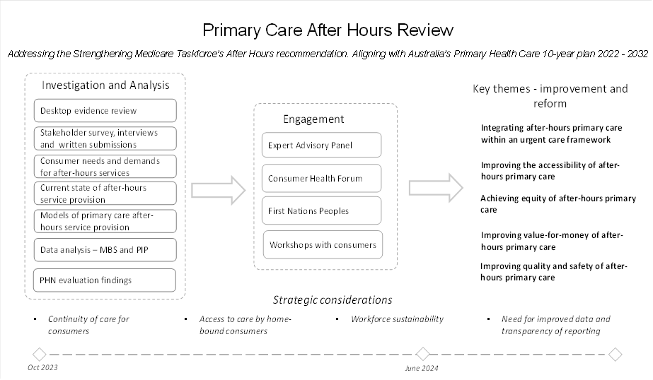

# Appendix B: Expert Advisory Panel for the Review of General Practice Incentives and Review of Primary Care After Hours Programs[37]

| Member | Representation | Background |
| --- | --- | --- |
| Emeritus Prof Stephen Duckett AM | Individual Health system financing, policy and management/ former Commonwealth public servant | * Honorary – General Practice and Primary Care, University of Melbourne * Honorary - Melbourne School of Population and Global Health, University of Melbourne * Board member, Healthdirect Australia * Board Chair, Eastern Melbourne Primary Health Network * Former Director, Health Program – Grattan Institute * Former Secretary of the Commonwealth Department of Health * Former member, Strengthening Medicare Taskforce |
| Prof Henry Cutler | Individual Health economist | * Director, Centre for Health Economy – Macquarie Business School * Chief investigator on several MRFF and NHMRC projects * Affiliated researcher, Centre for Emotional Health and the Centre for Hearing * Education Application Research – Macquarie University * Former lead of Health economics – KPMG * Former head, Sydney Health Economics and Social Policy - Access Economics * Former senior economic consultant, Centre for International Economics |
| Denise Lyons | Individual Nurse practitioner | * Nurse practitioner, Kotara Family Practice * Board member, APNA * Program Committee Member, Hunter Postgraduate Medical Institute * Clinical Editor, Health Pathways – Hunter New England and Central Coast PHN * Registered nurse |
| Dr Paul Mara | Individual Rural practitioner with experience in obstetrics, anaesthetics and emergency medicine | * 40 years experience in rural practice * Managing Director, Quality Practice Accreditation * Adjunct Associate Professor, Rural Clinical Schools - UNSW * Member of the Order of Australia * Founding executive member and former president, Rural Doctors Association of Australia * Co-founder, Rural Doctors Association of NSW * Member of the AMA and inaugural director from 1990-91. |
| Sinead O’Brien | Representative State and territory health department | * Deputy Chief Executive, Strategy and Governance, Department of Health and Wellbeing South Australia * Director and co-founder, Tinnitus Treatment * Former executive director, Northern Adelaide Local Health Network * Former director of consulting, Uncharted Leadership Institute * Former program director of ICT and Digital Transformation - Department of Premier and Cabinet, South Australia * Executive Director, Nursing and Integrated Performance, London Primary Care Trust. * Former nurse |
| Tracey Johnson, Churchill Fellow | Individual General practice administration | * CEO, Inala Primary Care * Co-Founder Cubiko * Deputy Chair, Primary Healthcare Advisory Committee – AIHW * Health Services Researcher inc Chair Meso System Working Group of “Getting Australia’s Health on Track” * Practice Management Consultant and Trainer * Ambassador, Australian Association of Practice Management * Former Member of Evaluation Committee Health Care Homes * Member, Women in Economics Network |
| Dr Clara Tuck Meng Soo | Individual General practitioner | * Practice Principal, Hobart Place General Practice, * Practice Principal, East Canberra General Practice * Immediate Past President, Australian Professional Association for Transgender Health * Member of the Order of Australia but returned it in 2021 in protest of Margaret Court’s honour. |
| Dr Dawn Casey  (Proxy Dr Jason Agostino) | Individual Aboriginal and Torres Strait Islander Peoples | * Tagalaka traditional owner, Northern Queensland * Deputy CEO, NACCHO * Co-Chair, Aboriginal and Torres Strait Islander Advisory Group on COVID-19 * Former Chairperson, Indigenous Land Corporation * Former Chair, Indigenous Business Australia * Previous Director, Western Australian Museum, Powerhouse Museum and National Museum of Australia * Founder, Aboriginal Reconciliation Unit - Department of Prime Minster and Cabinet * Founder and Assistant Divisional Head, Land and Natural Resources Branch – Department of Family Services and Aboriginal and Islander Affairs, QLD * Honorary Fellow, Australian Academy of the Humanities |
| Prof Anthony Scott  (from January 2024) | Individual Health Economist | * Current: Professor and Director, Centre for Health Economics, Monash Business School, Monash University * Former Health economics research lead at the Melbourne Institute: Applied Economic and Social Research, University of Melbourne * Elected Fellow of the Academy of the Social Sciences * Immediate Past President of the Australian Health Economics Society * Former Board Director of the International Health Economics Association * ARC Future Fellow and NHMRC Principal Research Fellow. * Consultant to World Bank, Commonwealth and State governments, Medibank Private, ANZ Health, Independent Hospital and Aged Care Pricing Authority, Productivity Commission, Australian Institute of Health and Welfare |

1. MBS services classified as GP NRA-After Hours as the primary care service type under the Medicare quarterly statistics, rendered between 1 July 2023 and 30 June 2024.
2. After hours PIP payments between 1 May 2023 – 30 April 2024 (i.e. PIP year 2024).
3. [AMA submission to review of primary care after hours programs and policy | Australian Medical Association](https://www.ama.com.au/articles/ama-submission-review-primary-care-after-hours-programs-and-policy)
4. 2017, Medicare Benefits Schedule Review Taskforce. *Urgent after-hours primary care services funded through the MBS, Final Report.* www.health.gov.au/sites/default/files/documents/2021/05/taskforce-final-report-urgent-after-hours-primary-care-services-funded-through-the-mbs.pdf
5. MBS note AN.0.19 After-Hours Attendances, www.mbsonline.gov.au/
6. www.health.gov.au/resources/publications/approved-medical-deputising-services-amds-program-guidelines?language=en
7. www.health.gov.au/sites/default/files/documents/2021/05/taskforce-final-report-urgent-after-hours-primary-care-services-funded-through-the-mbs.pdf
8. Size of practice defined by their SWPE in the PIP year 2023. 43% of PIP practices with less than 1000 SWPE and had less than 5% of their total primary care services as after-hours services in this period did not participate in the After Hours PIP.
9. After Hours Review Evidence Summary, Allen + Clarke Consulting, 2024, page 80
10. National non-admitted Patient Emergency Care Database.
11. [PHN After Hours Evaluation Report Vol 1 Summary Report. (health.gov.au)](https://www.health.gov.au/sites/default/files/2022-11/primary-health-network-phn-after-hours-evaluation-report.pdf)
12. After Hours Review Evidence Summary, Allen + Clarke Consulting, 2024, page 176
13. After Hours Review Evidence Summary, Allen + Clarke Consulting, 2024, page 139
14. After Hours Review Evidence Summary, Allen + Clarke Consulting, 2024, page 178.
15. After Hours Review Evidence Summary, Allen + Clarke Consulting, 2024, page 181
16. After Hours Review Evidence Summary, Allen + Clarke Consulting, 2024, page 178, from data provided by the Department of Health and Aged Care.
17. www.health.gov.au/our-work/amds
18. After Hours Review Evidence Summary, Allen + Clarke Consulting, 2024, page 191.
19. After Hours Review Evidence Summary, Allen + Clarke Consulting, 2024, page 42
20. 16 May 2024, [Use of emergency departments for lower urgency care, About - Australian Institute of Health and Welfare (aihw.gov.au)](https://www.aihw.gov.au/reports/primary-health-care/use-of-emergency-departments-lower-urgency-care/contents/about) accessed 3 June 2024
21. After Hours Review Evidence Summary, Allen + Clarke Consulting, 2024, page 131
22. After Hours Review Evidence Summary, Allen + Clarke Consulting, 2024 pages 168-172.
23. After Hours Review Evidence Summary, Allen + Clarke Consulting, 2024, pages 142-143.
24. After Hours Review Evidence Summary, Allen + Clarke Consulting, 2024, page 143.
25. National Medical Workforce Strategy 2021-2031
26. [Advice to the National Rural Health Commissioner on the development of the National Rural Generalist Pathway | Australian Government Department of Health and Aged Care](https://www.health.gov.au/resources/publications/advice-to-the-national-rural-health-commissioner-on-the-development-of-the-national-rural-generalist-pathway?language=en)
27. [www.flyingdoctor.org.au/qld/what-we-do/telehealth-medical-chests](http://www.flyingdoctor.org.au/qld/what-we-do/telehealth-medical-chests)
28. After Hours Review Evidence Summary, Allen + Clarke Consulting, 2024, page 116.
29. After Hours Review Evidence Summary, Allen + Clarke Consulting, 2024, page 75.
30. After Hours Review Evidence Summary, Allen + Clarke Consulting, 2024, figure 32, page 75.
31. After Hours Review Evidence Summary, Allen + Clarke Consulting, 2024, page 147.
32. After Hours Review Evidence Summary, Allen + Clarke Consulting, 2024, page 165.
33. After Hours Review Evidence Summary, Allen + Clarke Consulting, 2024, page 171.
34. After Hours Review Evidence Summary, Allen + Clarke Consulting, 2024, page 175.
35. https://www.racgp.org.au/running-a-practice/practice-standards/standards-5th-edition/standards-for-general-practices-5th-ed/table-of-contents
36. www.consultations.health.gov.au/primary-health-networks-strategy-branch/review-of-general-practice-accreditation-arrangement/
37. The Expert Advisory Panel provided advice to the Department on key issues and direction.