Communication toolkit – Residents’ Experience Survey
About this toolkit
This toolkit is designed to support both provider and consumer peak bodies in their communications with their members on the positive findings from the 2022 and 2023 rounds of the Residents’ Experience Survey.
What’s in this toolkit
- Key messages
- Frequently asked questions
- Editorial and website content
- Social media posts
Audience
- Aged care residents, their families and carers
- Older people aged 65+ living in the community (not in residential aged care)
- Aged care workers and providers
- Professional associations and unions
- Universities and other research bodies
Call to action
We recommend including the following call to action in communication materials:
- Read what older people in aged care are saying about their home in the ‘Residents’ Experience Survey Report: What we heard in 2022 and 2023’ or the summary factsheet for a high-level snapshot of the findings.
- Ask aged care providers and recipients in your networks about their experience participating in the survey.
Key messages
- The findings from the 2022 and 2023 Residents’ Experience Surveys show the residential aged care experience in Australia continues to improve.
- Residents were even more satisfied with their aged care homes in 2023 compared with 2022.
- In 2023, 85 per cent of residents said they would recommend their home to someone they know.
- Residents nominated safety, respect and kindness as the most positive aspects of their experience, with autonomy – the extent to which they are empowered to live independently – the most improved area of the survey.
- The results of the survey are used to calculate the Residents’ Experience rating of each aged care home, which then goes towards the home’s overall Star Rating.
- Around 37,000 residents across more than 2,600 homes participated in each year of the survey.
- The annual survey aims to engage around 20 per cent of Australia’s residential aged care population each year. The Department of Health and Aged Care (the department) commission the survey to understand what residents feel is working well and where providers might need to do better.
- The survey also highlighted areas where we still need to do more if we are going to permanently lift the standard of residential aged care in Australia.
- Seeking feedback from residents is just one of the ways the Government is reforming aged care to create a system built on choice, rights and transparency.
- For instance, finance and operations information is now published quarterly on the My Aged Care website via the Find a Provider tool, so older people can find information on how providers operate and what they are spending money on.
- These greater levels of choice and transparency have been a driving factor behind a lot of the improvements seen across the sector, with Australia now home to more 4- and 5- star homes and less 1- and 2- star aged care homes.
- The 2024 survey round is already underway at aged care homes across Australia.
Frequently asked questions
What is the Residents’ Experience Survey and what is done with the findings?
The survey is an annual opportunity for aged care residents to share their views on the care they receive.
It responds to a key finding of the Royal Commission into Aged Care Quality and Safety (the Royal Commission) for the need to adopt a comprehensive approach to quality of care and reporting.
Resident feedback collected through the survey informs the Residents’ Experience rating for each home, which accounts for 33 per cent of their overall Star Rating – the heaviest weighted subcategory.
Responses provided by residents are collated and a detailed report is then provided to each home directly. Aged care providers are encouraged to use the report to engage in discussions with their staff and residents and to inform their quality improvement activities.
Why is the survey conducted by an independent team?
Older people have told the department they feel more comfortable giving feedback to an independent survey team, rather than their home or the Government. The department has appointed an independent team to conduct the survey on its behalf, enabling residents to speak freely about their care without influence from aged care staff or the department. The survey team is trained in working with people, including people with cognitive impairment and those from culturally and linguistically diverse (CALD) backgrounds, to ensure residents can meaningfully engage in the survey process.
The survey providers are hired through an open and competitive tender process to ensure value for money and appropriate use of taxpayer money.
What kinds of questions are residents asked during the survey?
The Aged Care Quality and Safety Commission (the Commission), with the help of La Trobe University’s Lincoln Centre for Research on Ageing, developed the survey and its questions.
There are 12 simple Likert-scale questions that cover a range of different aspects related to a resident’s care experience. The questions cover three key themes of analysis – the care environment, the organisational aspects of care provision and resident autonomy.
There are also two open-response questions which encourage residents to further elaborate on their views.
What are the key findings from the 2023 survey compared to 2022?
Residents responded the same or more positively to all questions in 2023 compared to 2022.
Residents nominated safety, respect and kindness as the most positive aspects of their residential aged care experience.
Residents highly value having a say in their daily activities and routine so it’s pleasing to see that autonomy, the extent to which a resident can live independently, was the most improved area of the survey from 2022 to 2023.
What did residents say about the quality of food in aged care?
Nutritious and delicious meals and a positive dining experience are important parts of living a healthy and happy life.
Feedback is an important part of improving food quality and service. Although 70 per cent of residents were satisfied with the food offered in their aged care home, some residents still want to see further improvements to food quality, service, quantity and variety.
The Government is actively making changes to improve the quality of life for older people living in aged care homes through a range of food and nutrition initiatives, including:
- A Food, Nutrition and Dining Advisory Support Unit (Unit) within the Commission, conducting 720 targeted visits to homes across the country to provide expert advice on how to improve food and nutrition quality.
- This Unit includes the Food, Nutrition and Dining Hotline (ph: 1800 844 044) for people to ask questions or express concerns about food in their home.
- Offering up to 1,000 dietitian-led menu and mealtime reviews for aged care homes.
- Partnering with the Maggie Beer Foundation to deliver free education and training for aged care cooks and chefs on how to source, prepare and serve more delicious and nutritious food.
- Developed a dedicated Food and Nutrition Standard (Standard 6) as part of the strengthened Aged Care Quality Standards.
Almost one in ten residents said they don’t feel they’re getting the care they need. What is being done to improve this?
The Government is committed to increasing the amount of direct care residents receive. Mandatory direct care minutes were introduced in response to the Royal Commission to ensure older people in aged care homes receive the dedicated care time they need.
Currently, the sector-wide average is 200 minutes of care per resident per day, including 40 minutes of direct care by a Registered Nurse (RN). Later this year, this will increase to 215 care minutes per resident per day, including 44 minutes of direct care by an RN.
Are there any parts of the country performing better than others?
The ‘Residents’ Experience Survey Report: What we heard in 2022 and 2023’ provides a national snapshot of the residential aged care experience in Australia.
Survey results for individual residential aged care homes in a particular area can be accessed on the My Aged Care Find A Provider web page.
How many aged care residents participated in the survey?
Close to 75,000 face-to-face conversations were held with residents during the 2022 and 2023 survey rounds. This equates to around 20 per cent of all aged care residents which is considered statistically appropriate to ensure a representative sample of older people living in residential aged care across Australia.
Given some families and carers are very involved in a resident’s experience in aged care, why isn’t the next-of-kin surveyed as well?
The purpose of the survey is to give residents – the people actually living in the aged care home – an opportunity to provide feedback on their care. This reflects the recommendation of the Royal Commission that greater weight should be attached to the experience of people receiving aged care.
If a resident is unable to participate – for example, if they are at an advanced stage of illness – then the survey team will reach out to their nominated representative to complete the survey on their behalf.
How is the survey being improved to ensure it addresses the needs of diverse resident groups?
The survey has been designed to ensure it captures the views of residents with diverse backgrounds, including:
- Residents of Aboriginal or Torres Strait Islander descent
- Residents from CALD backgrounds
- Residents living with a physical and/or intellectual disability
- LGBTIQ+ residents
Forty per cent of the survey sample is randomly selected from residents from diverse backgrounds.
Within the 2024 survey round, a Diversity Research Study is being undertaken by the third party on behalf of the department. The study includes the co-design, implementation, and evaluation of modifications to the survey methods and approaches that may increase and better support diversity groups to participate in the residents’ experience survey.
In addition to this study, trials are being undertaken to explore expanding the survey into National Aboriginal and Torres Strait Islander Flexible Aged Care Program (NATSIFACP) and Multi-Purpose Services (MPS).

How is the survey run?
From February to October each year, an independent survey team visits participating aged care homes. At least 10 per cent of residents at each home are randomly selected to voluntarily participate.
The survey methodology, such as the wording of the questions and the face-to-face delivery of the survey, is designed to accommodate the needs of all residents. The survey team is also experienced in working with residents with diverse needs.
The survey takes place in private to respect residents’ comfort and right to anonymity. Aged care home workers are not present during the survey. The survey team always collects informed consent from residents before they participate.
What else is being done to better understand people’s experiences and interactions with the aged care system?
The survey is just one of many methods used to better understand the experience of people receiving aged care. The consumer experience is a point of focus for the National Aged Care Mandatory Quality Indicator Program. As part of this program, quality indicator data is collected from providers on a quarterly basis to provide an evidence base that can be used at an individual and collective level to improve the quality of services for aged care residents.
Feedback is central to the Government’s plans to reform aged care to create a system that places emphasis on the people receiving care and one built on choice, fairness and transparency. The reforms currently underway are focused on delivering high-quality person-centred care for older people, where and when they need it.
The Government is continually consulting and engaging with people who are living, working and delivering aged care, or have an interest in aged care. This ongoing feedback continues to shape policy and direct the changes being made across the sector.
When is the next survey being held?
The 2024 round is being delivered by HealthConsult and Access Care Network Australia. It is already underway, with independent survey teams visiting homes across the country from February to October.
Why aren’t home care recipients surveyed?
The department is currently exploring whether a similar style of survey for older people receiving in-home care might be appropriate.
Any future implementation will be aligned with the planned introduction of the new Support at Home program.

Editorial and website content
Guidance
This suggested content can be used in an email, local media release, printed newsletter or e-newsletter, or published on your website.
Link to: https://www.health.gov.au/our-work/residents-experience-survey/findings
Editorial
New report finds residents more satisfied with their aged care homes
The Australian Government’s aged care reforms are continuing to make a positive impact, with a new report highlighting the experience of older people living in residential aged care improved in 2023 compared with 2022.
The results of the 2022 and 2023 Residents’ Experience Surveys covers findings from close to 75,000 conversations between residents and independent survey teams over the last two years.
The survey is an annual opportunity for aged care residents to share their views on the care they receive. The feedback received as part of the survey is used to calculate the residents’ experience Star Rating for each home.
To ensure an inclusive experience for residents of all backgrounds, the survey has been designed to meet the needs of all residents. The survey team is also highly experienced in engaging with residents with diverse needs, such as cultural or language barriers and cognitive impairment.
Key findings
In the 2023 survey, 85 per cent of residents said they would recommend their home to someone they know.
Residents also nominated safety, respect and kindness as the most positive aspects of their experience, with autonomy – the extent to which they can live independently – the most improved area of the survey.
While 70 per cent of residents said they were satisfied with the food in their home, the Government is committed to further improving the quality, service and variety of food in aged care.
A new Food, Nutrition and Dining Advisory Support Unit has been established by the Aged Care Quality and Safety Commission, conducting 720 visits to homes across the country to provide expert advice on how to improve food quality.
Reforming aged care
The survey responds to a key finding of the Royal Commission into Aged Care Quality and Safety Commission for the need to adopt a comprehensive approach to quality of care and reporting.
The Government has also responded to the Royal Commission’s recommendation for older people to have better access to information on aged care provider operations.
Finance and operations information is now published quarterly on the My Aged Care website via the Find a Provider tool, so older people can find information on how providers operate and what they are spending money on.
Providing older people with more information about aged care homes is not only rebuilding trust in the sector but also making a big difference in the residential care experience.
These greater levels of choice and transparency have been a driving factor behind a lot of the improvements seen across the sector, with Australia now home to more 4- and 5- star homes and less 1- and 2- star homes.
This is in addition to other critical aged care reforms, such as having a registered nurse on site in every home 24 hours a day 7 days a week and increasing the amount of one-on-one time residents spend with carers each day.
Social media posts
Guidance
Below are suggested posts for your social media channels.
Channel | Copy | Social media tile
Facebook | Did you know 85 per cent of aged care residents said they would recommend their home to someone they know?  Overall, residents’ experiences in aged care homes improved in 2023 compared with 2022.  The Residents’ Experience Survey shows residents are happier with:  ✔️ safety, respect and kindness  ✔️daily activities and routine  ✔️staffing knowledge and follow-up  For more info, visit 💻 https://www.health.gov.au/resources/publications/RES-what-we-heard-2022-2023 | 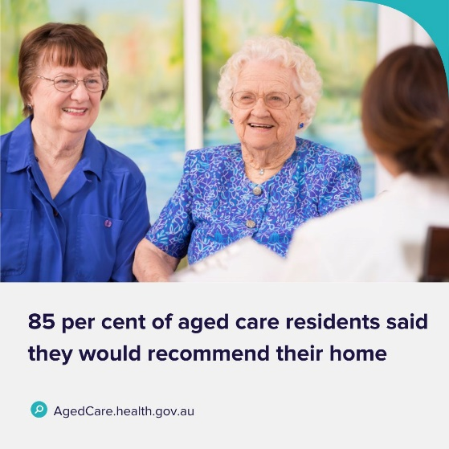
Instagram | Did you know 85 per cent of residents surveyed in the 2023 Residents’ Experience Survey said they would recommend their aged care home to someone they know?  Residents’ experiences in aged care homes improved in 2023 compared with 2022, with residents happier with:  ✔️ safety, respect and kindness  ✔️daily activities and routine  ✔️staffing knowledge and follow-up  Click the link 🖱️ in our bio, ‘2023 Residents’ Experience Survey’ for more information.
X | The 2023 Residents’ Experience Survey shows 85 per cent of residents would recommend their aged care home to someone they know.  For more info, visit 💻 https://www.health.gov.au/resources/publications/RES-what-we-heard-2022-2023 | 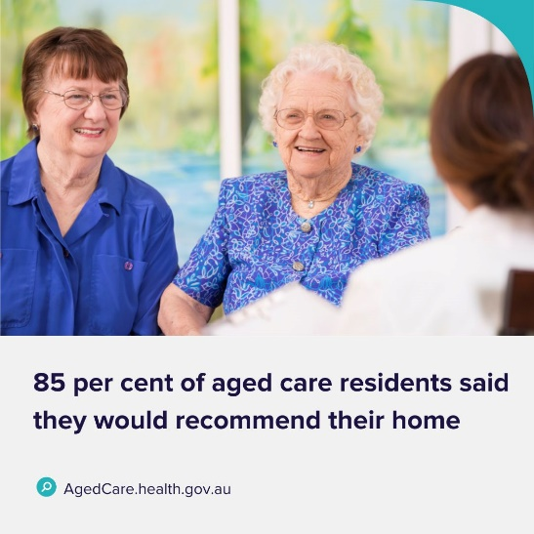
LinkedIn | The Australian Government is making big changes to aged care in Australia – more transparency, accountability and most importantly improving the experience for older people living in aged care.  Their Residents’ Experience Survey has delivered close to 75,000 face-to-face conversations with aged care residents across the country.  To read about what older people are saying about their experience in their home, visit 💻 https://www.health.gov.au/resources/publications/RES-what-we-heard-2022-2023 | 