# Better Practice Home Care Package Statement Guide

Version 3 – January 2023



## Introduction

The Australian Government (Government) is committed to improving the Home Care Packages (HCP) Program for care recipients. The Aged Care Quality Standards (standard 1 section 3(e)), require that: *information provided to each care recipient is current accurate and timely and communicated in a way that is clear, easy to understand and enables them to exercise choice.* A Better Practice HCP monthly statement template (template) has been developed for HCP Providers to:

* Improve the overall quality of HCP statements
* Make it easy for older Australians and their families to understand their Package statements - monthly statements should use language that is clear, and a care recipient must be able to understand what services they’ve received in the month.
* Support older Australians and their families to make informed choices around use of Package funds for their care in line with program rules

This template is **not mandatory** at this time; however, it is encouraged that HCP Providers align current statements to this template.

This template aligns with the Improved Payment Arrangements (IPA) reforms and pricing changes implemented on 1 January 2023.

|  |
| --- |
| The Aged Care Quality Standards (standard 1 section 3(e)), require that: *information provided to each care recipient is current accurate and timely and communicated in a way that is clear, easy to understand and enables them to exercise choice.*It is Mandatory that statements include:  1. **Itemised care and services**, including:  * Dollar figure amount of home care subsidy for that month * Dollar figure amount of any home care fees * Detailed listing of transactions * Details of any unpaid home care fees * An itemised list of each item of care and services delivered that month, including any travel, any subcontracting and package management. This must include total and line-item dollar amounts.  1. **Total unspent funds** held by the Provider at the end of the previous payment period, and this payment period. 2. **Breakdown of unspent funds held by:**  * Government (Services Australia) in the Home Care Account * Provider  1. **Breakdown of unspent funds held by Provider** into:  * Care recipient portion * Commonwealth portion     Once care and services start, providers must:   * supply monthly statements for any month they provide home care, even if the person does not receive services or has taken temporary leave * do this as soon as possible after they have all the information they need.   **Statements must be delivered in a timely manner. In most cases the department expects statements to be provided in the month after the service was provided. For example, a monthly statement for services provided in January should be provided before the end of February.** **The department strongly recommends providers issue monthly statements once they submit their monthly claim to Services Australia. Providers should not delay issuing a monthly statement without reason.** |

The template is accompanied by a **Care Recipient Guide** to assist older Australians and their families to understand their HCP statements. It is also accompanied by this **Provider Guide**, which gives a detailed explanation of the template and how to use it effectively.

The template, Care Recipient Guide and Provider Guide were developed in consultation with HCP Providers, software vendors, and provider and care recipient peak body groups. Their contributions and feedback were invaluable in the development of these resources.

**Page 2 of 15**

### Overview of the Better Practice HCP statement template

HCPs provide support to older people with complex needs to help them stay at home. Approved aged care service providers work with care recipients to plan, organise and deliver Home Care Packages.

The HCP Provider (Provider) is required to give care recipients a regular statement that shows how their Package funds are used. This statement needs to list the details and cost of each service and item so that the care recipient can review if their Package funds are being used in the best way possible and in accordance with program rules.

There are currently no standardised statement templates in use across the HCP industry, resulting in a wide range of statement formats, content and language. This makes it difficult for care recipients to review, compare and understand what services they are receiving.

A template has been developed with an accompanying Care Recipient Guide. An overview of the statement is shown below, with more detailed information in this document to help you understand each section.

Figure 1. Overview of the Better Practice Home Care Package Statement

|  |  |  |  |
| --- | --- | --- | --- |
| 1. Overview | 2. Summary income and expenses | 3. Detailed expenses and adjustments | 4. Other package information |



## 1. Overview

The template is intended to help care recipients understand:

* The funds coming into their Package every month from Government subsidy and their contributions.
* How funds are spent on services and items every month.
* The remaining balance which may be used for more services and items

to support them to live well at home.

The first page of the statement gives care recipients a summary of the above, so they can easily see the funds coming in and out of their Package.

Figure 2. Overview page for your HCP statement

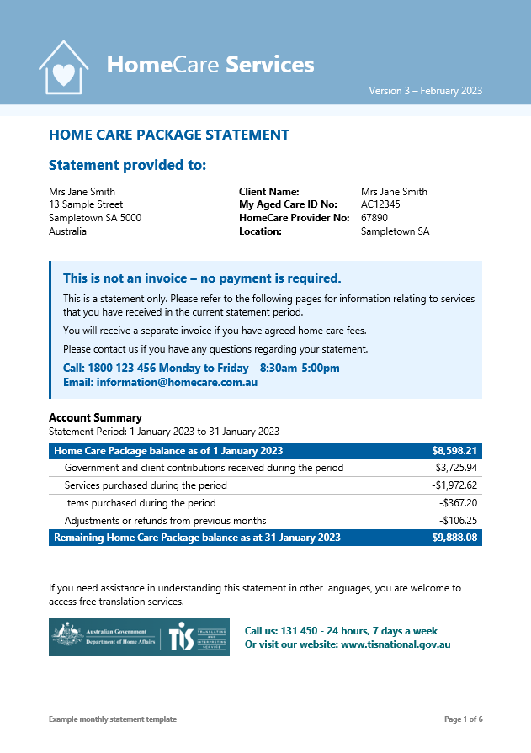

The remaining pages provide the details behind the income received, what was spent, and how much is remaining.

If care recipients need assistance understanding their Statement or accessing it in a different language, they should contact their Provider or access the free Translation & Interpretation Services on 131 450.



## 2. Summary income and expenses

This section provides a breakdown of the Package income and expenses.

At a glance, care recipients can see what makes up their Package income, and how it is being spent on services and items during the month.

Their Package income consists of Government subsidy (less any reductions that apply) and client contributions.

### (a) Income received during the period – Government subsidy

Government subsidy payable is based on the care recipient’s assessed needs and include:

(i) HCP basic subsidy: The basic subsidy rate depends on the package level – it increases for higher levels.

(ii) **Plus** Supplements: Primary and other supplements provide extra funding for specific care needs. For some supplements,

Services Australia automatically checks eligibility for the care recipient. For others, the Provider needs to apply on behalf of the care recipient.

(iii) **Less** Reductions that apply: The Government reduces the subsidy if reductions apply. There are two types that apply to Home Care – the care subsidy reduction and the compensation payment reduction.

a. Care subsidy reduction: This is the care recipient’s assessed   
income tested care fee, which is payable if they have entered Home Care from 1 July 2014 and have an income over a certain amount. This amount is automatically deducted from their Government subsidy.

b. Compensation payment reduction: A person can get an entitlement to compensation through a settlement, judgement, or reimbursement arrangement. This may be for things like an injury in the workplace or from a car accident. If the compensation covers some or all of the cost of their Home Care, a reduction applies. Services Australia will deduct the compensation amount from the subsidy they pay you on the care recipient’s behalf.

Figure 3. Government subsidy received during the period

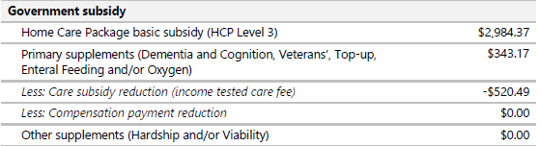

You can view the daily basic subsidy rates in the [Schedule of Subsidies and Supplements](https://www.health.gov.au/resources/publications/schedule-of-subsidies-and-supplements-for-aged-care). The rates are adjusted every year on 1 July.

**Page 5 of 15**

### (b) Income received during the period – Client contributions

Client contributions represent the other part of the Package income and may be referred to as fees. Any contribution that the care recipient makes is added to their Package balance to be spent on services and items for their care. The care recipient must pay the assessed income tested care fee. The Provider is responsible for discussing all other fees with the care recipient, noting that the Basic Daily Fee and Additional Service Fee may be zero by agreement.

Figure 4. Client contributions received during the period

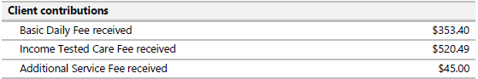

The fees that may apply to people who start HCPs from 1 July 2014 are:

(i) Basic daily fee: Everyone can be asked to pay this fee, but the care recipient must agree to pay this Basic Daily Fee before it can be charged. The amount the care recipient can pay varies depending on their package level and will increase the funds available to the care recipient. The Basic Daily Fee increases twice a year in line with the age pension. To see the maximum fee that you can charge for each package level, go to HCP costs and fees at [www.myagedcare.gov.au](http://www.myagedcare.gov.au).

(ii) Income tested care fee: If the care recipient’s income is above a certain amount, they will need to pay an income tested care fee to contribute to the cost of their care. This fee is different for everyone. Full pensioners do not pay an income tested care fee. Annual and lifetime caps apply to this fee. To see the caps, go to HCP costs and fees   
at [www.myagedcare.gov.au](http://www.myagedcare.gov.au).

(iii) Additional service fees: Care recipients may need or wish to receive care and services over the value of their package budget. Additional service fees may be charged to increase the budget value and meet the cost of care and services as outlined in a care recipient’s care plan. You and the care recipient must agree on the fees and document them in the home care agreement. For more information on what can or cannot be covered by the HCP, please refer to the [HCP Program Operational Manual](https://www.health.gov.au/sites/default/files/documents/2021/09/home-care-packages-program-operational-manual-a-guide-for-home-care-providers.pdf) (Chapter 9 – Inclusions and exclusions).

#### Exit amounts:

From 1 January 2023, you cannot charge an exit amount, even if the care recipient has agreed to one. Refer to the Department’s [Exiting people from your home care service](https://www.health.gov.au/our-work/home-care-packages-program/managing/exiting-people) and [Home Care Package pricing](https://www.health.gov.au/our-work/home-care-packages-program/pricing) webpages for further information.

**Page 7 of 15**

### (c) Expenses incurred during the period – Equipment, items and services purchased during the period

This section provides an overview of how Package funds have been spent on equipment, items and services during the period. This may be for the purchase or rental of items and equipment such as continence or mobility aids, or for services such as nursing and allied health, transport, personal care, respite, home cleaning, gardening and more. It also shows how much funds are spent on other Package services such as care management and package management.

To comply with the Aged Care Quality Standards, each service or item must be clearly described in plain English so that the care recipient would be able to identify and understand each item.

Care recipients’ care needs may change over time, so it’s important that they are given opportunities to continually review their care plan to ensure that they are making the best choices, in accordance with program rules, to live well at home.

Figure 5. Equipment, items and services purchased during the period

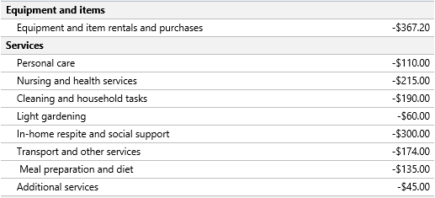

### (d) Refunds and adjustments

There may sometimes be adjustments or refunds for incorrect or missing charges relating to previous months. This is shown separately in the summary table as it does not relate to income received or services delivered in the statement period.

Figure 6. Adjustments or refunds from previous months

Image snapshot of the adjustments or refunds section of the Better Practice Home Care Package statement template.

**Page 8 of 15**



## 3. Detailed services and items

This section provides an itemised account of any items and services purchased during the month, so care recipients can check it for accuracy. This is presented in categories and shown in chronological order to make it easier for care recipients to review the information.

To comply with the Aged Care Quality Standards, each service or item must be clearly described in plain English so that the care recipient would be able to identify and understand each item.

### (a) Equipment and item rentals and purchases

This section lists out the equipment and items and related cost that month. This may be purchased or rented using Package funds

Figure 7. Equipment and item rentals and purchases

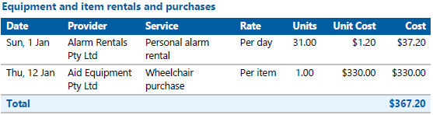

### (b) Services

This section lists out the services that the care recipient received during the period. The information is itemised to show when they received it, who delivered it, what service it was, and how the cost is calculated.

Providers will likely have different prices for services based on the time and day it was received (e.g. weekday, night or weekend), or if you are charging any related costs such as staff travel. You must publish all-inclusive prices for third-party services and cannot set or charge a separate amount to cover administrative costs arising from using the third-party service. For more information, please visit: [Third-party services](https://www.health.gov.au/initiatives-and-programs/home-care-packages-program/managing/third-party-services)

The key principle is to itemise these related charges as shown in Figure 7 so the care recipient can understand how the costs apply based on the choices they make about their care. These related costs should be included with the main service when adding them up in the Summary income and expenses section shown in Figure 5. For example, the summary cost of $310 for in-home respite and social support includes the $300 service **plus** $10 travel visit charge incurred on the 2 October 2021.

Please note that all prices shown in Figure 8 are example prices only, and not intended to be indicative of what Providers should charge. You are required to publish your Pricing Schedule online and include it as part of your Home Care Agreement. Care recipients should refer to that information if they have concerns on how the costs have been calculated.

**Page 9 of 15**

Figure 8. Purchased services

**Page 9 of 15**

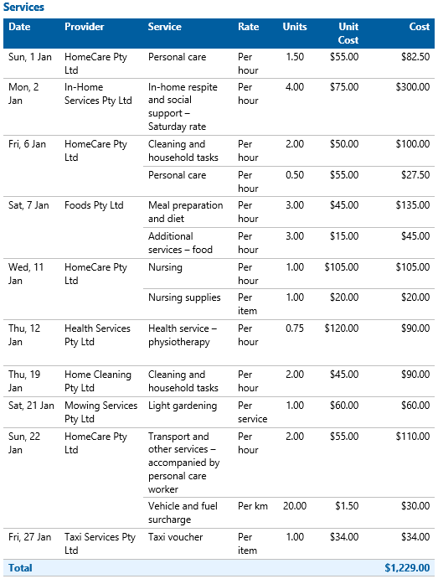

**Page 10 of 15**

### (c) Other package services

This section lists out other package services care recipients have received during the period, which generally include:

1. Care management, which may include reviewing the Home Care Agreement and care plan, coordinating and scheduling services, ensuring the care aligns with other supports, providing a point of contact for the care recipient or their support network, ensuring care is culturally appropriate, and identifying and addressing risks to the care recipient’s safety.

(ii) Package management, which may include preparing monthly statements, managing Package funds, and meeting compliance and quality assurance standards.

Note: On 1 January 2023, care management prices were capped at 20% of the package level and package management prices were capped at 15% of the package level. Providers were also required to publish all-inclusive prices for third party services so that care recipients no longer receive unexpected additional charges. Please refer to [HCP pricing updates](https://www.health.gov.au/resources/publications/home-care-packages-pricing-update?language=en)

Care recipients are asked to refer to the Provider’s Pricing Schedule for more information on pricing for care and package management services.

Figure 9. Other package services

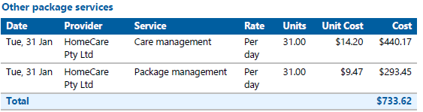

### (d) Adjustments or refunds from previous periods

From time to time, there may be errors in your HCP statement. Perhaps a care recipient was charged for two hours of a service, when it was only one hour; or perhaps a brokerage invoice provided incorrect details. Sometimes a Provider may have missed charging a service delivered.

These adjustments or refunds could either increase or decrease the care recipient’s Package balance. Because it relates to a previous period, it is shown separately in the statement, so it is easier for care recipients to understand what the charge or refund is for.

Figure 10. Adjustments or refunds from previous periods

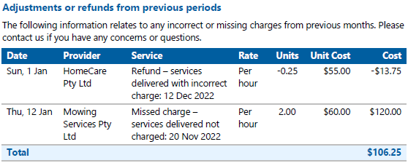

**Page 11 of 15**



## 4. Other information related to the Package

The information shown on this last page is for the care recipient’s reference only and is specifically included to comply with the IPA statement requirements.   
It shows additional information about who is holding the remaining Package funds and status of the care recipient’s agreed fees and contributions to their Package.

### (a) Remaining Package funds

The remaining Package funds that are available to the care recipients for their care. Changes made to funding arrangements in September 2021 means that the majority of these funds are held by Services Australia in care recipient’s Home Care Accounts, though the Provider may also hold some of the funds.

Most of the care recipient fees and contributions are spent on their care (noting that the Provider must deduct any received Basic Daily Fees and Additional Service Fees before making a claim to Services Australia), however there may be some amounts that have accumulated and may be refunded to the care recipient or their estate if they stop their services.

Since 1 September 2022, Providers have been **required** to break down the total unspent funds at the end of the current and previous payment periods. Providers **must** show:

* The care recipient portion of unspent funds held by the Provider
* The Commonwealth portion of unspent funds held by the Provider
* The Home Care account balance held by Services Australia.

In addition, it is also best practice to show:

* Whether the provider has opted-in to return the Commonwealth portion of unspent funds to the Government, by drawing down upon these funds first, before claiming Government subsidy.

Figure 11 shows an example of how this is reflected in template, except for the final point on showing if the provider has opted-in to return the Commonwealth portion of unspent funds to the Government.

Figure 11. Remaining package funds

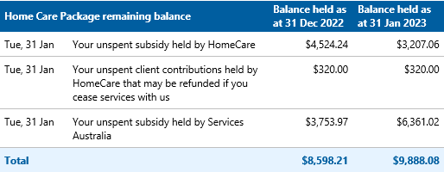

**Page 12 of 15**

### (b) Payment status of your fees and contributions

As noted above, the second page of the statement (Summary income and expenses) shows the client contributions that the Provider has received during the statement period.

In the section on page four of the statement, the Provider shows the total amount that may be outstanding from previous and current periods based on the assessed and agreed client contributions. Note that this is a **mandatory** item for the monthly statement.

Figure 12. Payment status of the care recipient fees and contributions

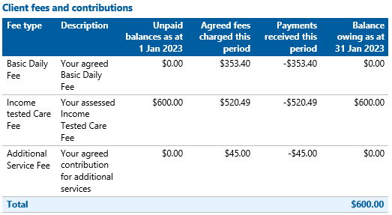

The balance owed amount is based on information held by the Provider at the end of the statement period. If the care recipient made any payments after this date, the payments will be reflected in the next statement.

It is understood that many Providers use separate software for HCP service management and financial management. As such, generation of the statement may require information from more than one system.

Potentially Providers may prefer to generate the payment status information directly from the financial systems (on its own page) and include that information when sending out the monthly HCP statements. This will fulfil the requirements.

If the care recipient’s financial situation has changed or if they are concerned about how they can pay the outstanding fees, they are asked to contact their Provider to discuss financial and hardship options.

Care recipients are also able to discuss their fees and services with an independent third party. Contact information is provided for the Older Persons Advocacy Network (OPAN) who can connect the care recipient to a representative to discuss their needs on a confidential basis. Please refer care recipients to their website ([www.opan.org.au](http://www.opan.org.au)) or to call them on 1800 700 600 for more information.

**Page 13 of 15**



## Frequently Asked Questions

### Do I have to create a statement template that looks like the Better Practice Monthly Statement Template?

The template is not mandatory. It does provide useful examples of how Providers can show new mandatory information, such as the breakdown of Package balances and unpaid fees and client contributions.

Providers may choose how much of the template they wish to align their current statements with. They may also adjust the format, colours, font, images and explanatory notes to suit their branding and service model.

**How often should I provide care recipients with a monthly statement?**Statements must be provided to care recipients in a timely manner. In most cases the department expects statements to be provided in the month after the service was provided. For example, a monthly statement for services provided in January should be provided before the end of February. (See page 2)

### I have not been charging my HCP care recipients any Basic Daily Fees. Do I need to start charging these fees?

Providers may ask a care recipient to pay the Basic Daily Fee at their discretion, which will increase the funds available to the care recipient. The care recipient must agree to pay the Basic Daily Fee before it can be charged.

Care and services delivered using the Basic Daily Fee funds should be separate from the Services Australia claiming process. Providers must minus the Basic Daily Fee amount from the price they claim from Services Australia. Providers will hold any unspent Basic Daily Fees and will be accountable for these to their care recipients.

**Page 14 of 15**

### I have not been charging my HCP care recipients their income tested care fee. Do I need to start charging this fee?

Any assessed income tested care fee will be automatically deducted by Services Australia from payments to the provider, regardless of whether the care recipient is paying it or not.

If a Provider has been waiving all or part of a care recipient’s income tested care fee prior to 1 September 2021 because they are not using all of their Package, the Provider can use any portion of the care recipient’s unspent funds they are holding to cover care and services that the income tested care fee would have contributed towards. This can continue as long as the Provider holds unspent funds on a care recipient’s behalf. Once the unspent funds that providers hold for care recipients have been used, providers will only be able to waive the income tested care fee by using retained earnings. If Providers are not able to do this, care recipients will need to start contributing their assessed income tested care fee.

Providers cannot charge care recipients the income tested care fees that they have waived in the past. However, Providers may request for any outstanding charged amounts from previous periods to be paid.

Please refer to the [Improved payment arrangements for home care – provider fact sheet](https://www.health.gov.au/sites/default/files/documents/2021/08/improved-payment-arrangements-for-home-care-provider-fact-sheet_2.pdf) for more information.

### Do I need to still show services listed in the Summary income and expenses section that have a zero balance (i.e. that the care recipient does not have any services for)?

The Summary income and expenses section shows the general categories of income, services and items that may be applicable under an HCP. A balance of zero reflects the care recipient did not make a contribution or receive services under this category in the period. Having all categories shown may be helpful to the care recipient when reviewing if their current care and services are still right for them, or if it’s timely to contact their Provider to make changes to their care plan.

### Do I still need to include information about fees and client contributions and any outstanding balances in a monthly statement if I already send this out separately?

As part of the changes effective 1 September 2021, Providers are required to share with care recipients any fees and contributions that they have agreed to that were still unpaid at the end of the statement period. If this information is provided on a regular basis to the care recipients, this may be considered as meeting this requirement.

**Page 15 of 15**