Communication toolkit

**Palliative care education and training for the aged care workforce**

This toolkit provides information and materials to help aged care providers and managers encourage people who work in aged care to undertake education and training that will help them deliver quality palliative care.

About this toolkit

Use the content and resources provided in this toolkit to encourage people who work in aged care or your staff to undertake palliative care education and training.

Aim

To increase the palliative care knowledge, skills and confidence of the aged care workforce.

Target audience

Anyone who works in aged care.

About palliative care education and training

Everyone who works in aged care has an important role to play in the delivery of high-quality palliative care.

To support the delivery of palliative care in Australia, the Australian Government funds organisations to produce resources and deliver education and training courses.

These resources and programs are available for free, and focus on a range of key palliative care skills and competencies that are common to everyone working in aged care.

Palliative care training can increase the knowledge, skills and confidence of people who work in aged care to care for and communicate with people who have a life-limiting illness.

For information about courses and resources visit <https://health.gov.au/palliative-care-education>.

What’s in this toolkit

* key messages
* editorial content for newsletters, emails and website/intranet news
* text message content for providers to send to their staff
* social media posts and tiles
* videos for inclusion in newsletters, websites/intranets or social media
* posters for staff rooms
* brochure with more information about education and training.

Call to action

We recommend including the following call to action in communication materials:

* Palliative care training can increase your knowledge, skills and confidence to care for and communicate with people who have a life-limiting illness.
* Access course information and resources to build your skills [health.gov.au/palliative-care-education](https://health.gov.au/palliative-care-education).

Key messages

Guidance

These key messages can be used to communicate the importance of palliative care education and training.

* Everyone who works in aged care has an important role to play in the delivery of high-quality palliative care.
* As the population ages and the number of people using aged care services rises, the necessity for palliative care in aged care settings is also increasing.
* It is important to provide older people with adequate choices and support to receive high-quality palliative care in their preferred setting. Palliative care can be delivered in an aged care facility, hospital or at home.
* People who work in aged care play a vital role in helping people and their families make informed decisions about accessing the care they need.
* Palliative care is rewarding work, but talking about death and dying can be difficult.
* [Market research](https://www.health.gov.au/resources/publications/palliative-care-market-research-insights-report) highlights that healthcare and aged care workers need continued support through education and training to feel more confident to talk about palliative care with patients and their families.
* Palliative care helps people live as fully and as comfortably as possible with a life-limiting illness.
* Best practice palliative care is multidisciplinary and includes addressing physical, psychological, emotional, cultural, medical and spiritual care needs.
* Quality palliative care is individualised, listening to the patient’s wishes, and is focused on their needs.
* Normalising the palliative care experience for health and aged care workers and the community will facilitate earlier, more productive and regular conversations between providers and patients, their families and carers.
* To support the delivery of palliative care in Australia, the Australian Government funds organisations to produce resources and deliver education and training courses.
* These resources and programs are available for free for all health and aged care workers and focus on a range of key palliative care skills and competencies that are common to everyone.
* Palliative care training can increase your knowledge, skills and confidence to care for and communicate with people who have a life-limiting illness.
* Access course information and resources to build your skills [health.gov.au/palliative-care-education](https://health.gov.au/palliative-care-education).

Editorial content

Guidance

Below is suggested content for your printed newsletter, e-newsletter, emails and/or website/intranet news section.

Free palliative care education and training

Everyone who works in aged care has an important role to play in the delivery of high-quality palliative care.

Palliative care education and training can increase your knowledge and skills to care for and communicate with people who have a life-limiting illness.

Free palliative care education and training is available for anyone who works in aged care.

Education and training can be delivered through:

* online or in-person courses and training programs
* in-service on the job training
* professional colleges’ continuing professional development (CPD) programs.

Topics include:

* the principles of palliative care
* end-of-life care
* ethical and legal issues
* communication skills
* psychosocial and spiritual issues
* identifying and controlling symptoms
* multidisciplinary care and teamwork.

Feel more confident to care for and communicate with people who have a life-limiting illness, their families and loved ones.

Access course information and resources to build your skills [health.gov.au/palliative-care-education](https://health.gov.au/palliative-care-education).

Text message content

Guidance

Below is suggested text message content for aged care providers to send to their staff.

Link to: <https://health.gov.au/palliative-care-education>

Content

Feel more confident to care for and communicate with people who have a life-limiting illness, their families and loved ones. Access course information and resources to build your skills <https://health.gov.au/palliative-care-education>.

OR

Palliative care training can increase your knowledge, skills and confidence to care for and communicate with people who have a life-limiting illness. Access course information and resources to build your skills <https://health.gov.au/palliative-care-education>.

OR

Access free palliative care education and training and resources to build your knowledge and skills <https://health.gov.au/palliative-care-education>.

OR

Learn or refresh your skills about the palliative approach to care through education and training <https://health.gov.au/palliative-care-education>

OR

Did you know that every day you are providing palliative care to people in our care? Free palliative care education and training is available. Access course information and resources to build your skills <https://health.gov.au/palliative-care-education>.

OR

Do you feel confident providing information on Advance Care Planning to our residents and their families? Access course information and resources to build your skills <https://health.gov.au/palliative-care-education>.

OR

Palliative care is individualised and person-centred. To learn more and refresh your skills in providing culturally appropriate palliative care visit <https://health.gov.au/palliative-care-education>.

Social media posts and tiles

Guidance

Below are suggested posts for your social media channels.

Copy

|  |  |
| --- | --- |
| Channel | Copy |
| Facebook / Instagram / LinkedIn | Free palliative care education and training is available for anyone who works in aged care.  Feel more confident to care for and communicate with people who have a life-limiting illness, their families and loved ones.  Topics include:   * the principles of palliative care * end-of-life care * ethical and legal issues * communication skills * psychosocial and spiritual issues * identifying and controlling symptoms * multidisciplinary care and teamwork.   Access course information and resources to build your skills <https://health.gov.au/palliative-care-education> |
| Twitter | Feel more confident to care for and communicate with people who have a life-limiting illness, their families and loved ones.  Access free palliative care education, training and resources to build your skills <https://health.gov.au/palliative-care-education> |
| Any channel – to use with video | Free palliative care education and training is available for aged care nurses.  “Death can be confronting, and it will give you the confidence to be able to deal with these situations.” Brigitte Karle, Aged Care Nurse Practitioner.  Access course information and resources to build your skills <https://health.gov.au/palliative-care-education> |
| Any channel – to use with video | Free palliative care education and training is available for aged care workers.  “It helped me to feel really confident and proud to take care of people as they approach the end of life. Being part of that is a privilege.” Christine Denton, Personal Care Worker.  Access course information and resources to build your skills <https://health.gov.au/palliative-care-education> |

Social media tiles

Download social media tiles at <https://www.health.gov.au/resources/collections/palliative-care-education-and-training-communication-toolkits>.

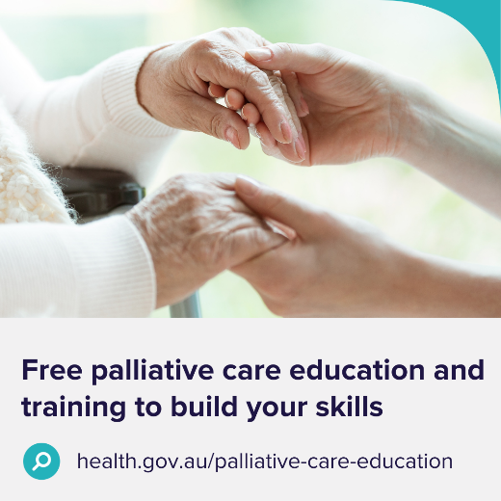 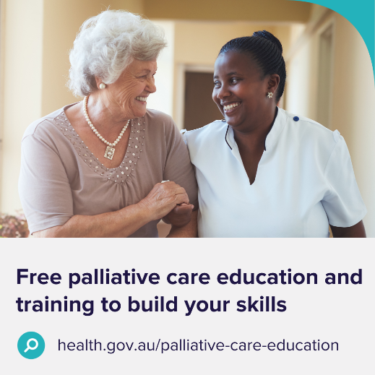 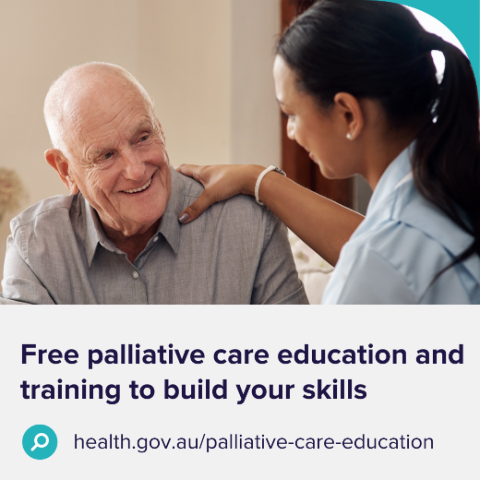 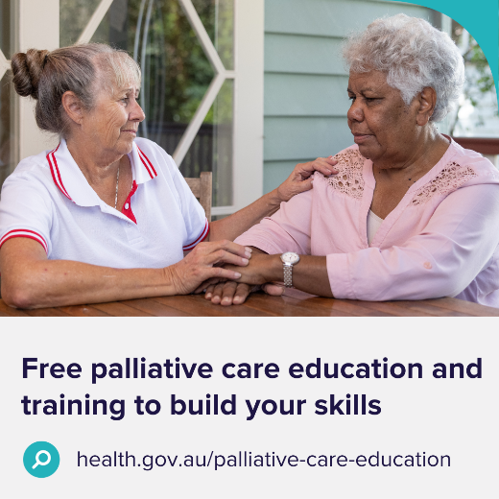 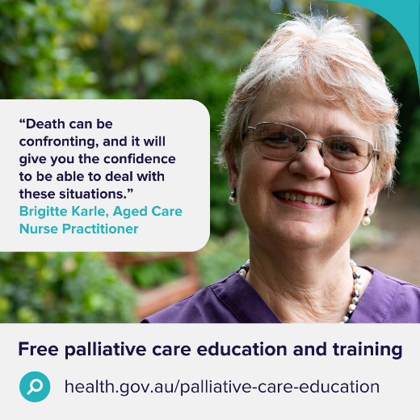 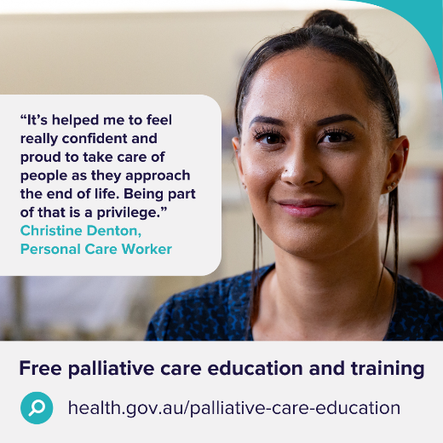

Videos

Guidance

These videos can be used in newsletter articles, intranets, websites and social media posts.

|  |  |
| --- | --- |
| [Aged care general – 2 minutes](https://www.youtube.com/watch?v=Uf4fkMkpYaY)  [Video thumbnail](https://www.youtube.com/watch?v=Uf4fkMkpYaY) | [Aged care personal care workers – 45 seconds](https://www.youtube.com/watch?v=JoV_WJB0A2k)  [Video thumbnail](https://www.youtube.com/watch?v=JoV_WJB0A2k) |
| [Aged care nurses – 45 seconds](https://www.youtube.com/watch?v=rKq3hhvVTR4)  [Video thumbnail](https://www.youtube.com/watch?v=rKq3hhvVTR4) | [General – 90 seconds](https://www.youtube.com/watch?v=mmsETzbHTa0)  [Video thumbnail](https://www.youtube.com/watch?v=mmsETzbHTa0) |

Webinars

**Delivering high quality, person-centred palliative care in aged care**

This webinar is for anyone who works in aged care. It discusses steps workers can take to build their skills, confidence and knowledge in caring for people at the end of life. Palliative care experts present case studies and talk about palliative care training opportunities designed for aged care. Answers to questions asked during the webinar are also available.

**Watch and share** the webinar [https://www.health.gov.au/resources/webinars/delivering-high-quality-person-centred-palliative-care-in-aged-care](https://www.health.gov.au/resources/webinars/delivering-high-quality-person-centred-palliative-care-in-aged-care?).

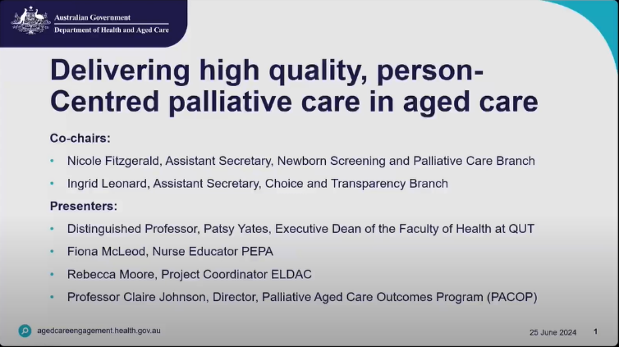

Posters

Download posters at <https://www.health.gov.au/resources/collections/palliative-care-education-and-training-communication-toolkits>.

Order A3 size hard copy posters by emailing [health@nationalmailing.com.au](mailto:health@nationalmailing.com.au) or call (02) 6269 1080. Specify the item code(s), quantity of each item and delivery address.

|  |  |  |
| --- | --- | --- |
| Poster thumbnail | Poster thumbnail | Poster thumbnail |
| Item code: A03002 | Item code: A03004 | Item code: A03005 |
| Poster thumbnail | Poster thumbnail | Poster thumbnail |
| Item code: A03003 | Item code: A03011 | Item code: A03010 |

Brochure

Download brochures at <https://www.health.gov.au/resources/collections/palliative-care-education-and-training-communication-toolkits>.

Order A4 (tri-fold) hard copy brochures by emailing [health@nationalmailing.com.au](mailto:health@nationalmailing.com.au) or call (02) 6269 1080. Specify the item code A03001, quantity and delivery address.

Outside pages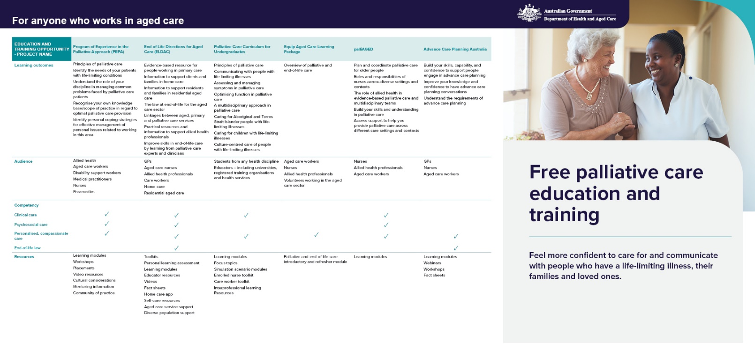

Inside pages