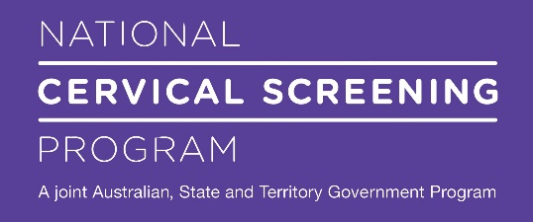

**Cervical Screening Tests**

**Easy Read**

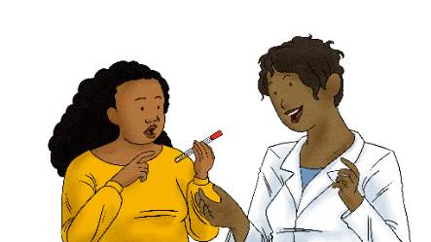

 

|  |  |
| --- | --- |
| Woman holding a test speaking to a female doctor | This fact sheet is about getting a **Cervical Screening Test.** |
| Centre for Disability Studies logo  The Daffodil Centre logo, a partnership between Cancer Council and the University of Sydney | This fact sheet is from  **The** **Centre for Disability Studies** and **The Daffodil Centre.** |
| Intellectual Disability Health Capability Framework and Easy Read resources  | Australian Government Department of Health and Aged Care | This fact sheet is in **Easy Read** format.  If you need help to understand, you can ask someone you trust. |
| Screen Me logo | You can find more information and watch a short film at  **www.health.gov.au/screen-me** |

Table of Contents

What is a Cervical Screening Test? 4

What does a Cervical Screening Test check for? 5

Who should do a Cervical Screening Test? 6

When should I do a Cervical Screening Test? 6

How can I book a Cervical Screening Test? 7

What happens in a Cervical Screening Test? 8

Doing the test yourself with a self-swab 9

Getting help to do the test with a self-swab 10

Getting your doctor or nurse to do the test 11

What kind of test should I choose? 12

How can I make getting a test easy for me? 13

Where can I read more information? 15

|  |  |
| --- | --- |
| What is a Cervical Screening Test? | |
| Illustration of vagina and cervix | A **Cervical Screening Test** is a check to make sure your **cervix** is healthy.  Your **cervix** is inside your body at the top of your vagina.  This picture shows an arrow pointing to the cervix. |
| Woman holding a test speaking to a female doctor | Getting a Cervical Screening Test every 5 years can help protect you against cervical cancer. |

|  |  |
| --- | --- |
| What does a Cervical Screening Test check for? | |
| Illustration of a vagina and cervix | A Cervical Screening Test checks foran infection called **human papillomavirus.**  We say **HPV** for short. |
| Group of women standing together | HPV is a very common virus.  You can get it from having sex or sexual touching.  HPV usually has no symptoms and goes away on its own. |
| Woman holding a test speaking to a female doctor | Sometimes HPV can cause changes that turn into **cervical cancer.**  **Cervical cancer** is a problem with your cervix that can make you very sick.  A Cervical Screening Test can help prevent cervical cancer so you stay healthy. |

|  |  |
| --- | --- |
| Who should do a Cervical Screening Test? | |
| A group of women standing together | You should do a Cervical Screening Test if:   * You are a woman or a person with a cervix * You are aged 25 to 74 * You have ever had sex or sexual touching with anyone |

|  |  |
| --- | --- |
| When should I do a Cervical Screening Test? | |
| Calendar with pages folding | Most people need to do a Cervical Screening Test every 5 years.  You will get a letter in the mail to remind you. |
| Woman holding a test speaking to a female doctor | If you are not sure when to do a cervical screening test, you can ask your doctor or nurse. |
| How can I book a Cervical Screening Test? | |
| Woman holding a test swab speaking to a female doctor | You can do a Cervical Screening Test with a doctor or a nurse. |
| Woman in a call centre taking a phone call using a headset looking at a computer | You can book an appointment at:   * Your doctor’s clinic * A Family Planning clinic * An Aboriginal Health service |
| 2 women standing together | If you need help to make an appointment, you can ask someone you trust. |

|  |  |
| --- | --- |
| What happens in a Cervical Screening Test? | |
| Woman with red hair thinking with a hand near her mouth | There are two ways to do a Cervical Screening Test:   * You can do the test yourself * A doctor or nurse can do the test for you   You can choose which way you want to do the test. |

|  |  |
| --- | --- |
| Doing the test yourself with a self-swab | |
| Someone looking at a test swab | You can do the test yourself with a **self-swab.**  Another word for doing the test yourself is **self-collection.** |
| Hands pulling a test swab from its tube | Your doctor or nurse will give you a **swab**.  A **swab** is a small bendy stick that feels soft at the end.  Your doctor or nurse will show you how to use it. |
| Inserting the swab into the vagina | You do the test by putting the swab inside your vagina.  You do not need to reach all the way to your cervix. |

|  |  |
| --- | --- |
| Getting help to do the test with a self-swab | |
| Woman speaking to a doctor | Some people need help to use a self-swab.  You might need help if:   * you find it hard to hold the swab * you find it hard to reach your vagina * you aren’t sure what to do |
| Woman holding a test swab speaking to a female doctor | When you get help to use a self-swab, we call this **assisted self-collection**. |
| Woman speaking to a doctor | A doctor or nurse can help you to do the test. |
| Hands pulling a test swab from its tube | They will use a swab to take a sample from your vagina. |

|  |  |
| --- | --- |
| Getting your doctor or nurse to do the test | |
| Woman speaking to a doctor | Your doctor or nurse can do the test for you.  Another word for when your doctor or nurse does the test is **clinician collection.** |
| Gloved hands of a doctor holding a speculum and soft brush | Your doctor or nurse will use a tool called a **speculum** to look inside your vagina.  They will use a soft brush on your cervix. |
| Woman lying on a bed in the doctor's office with doctor holding up a sheet | The test should not hurt, but some people find the speculum uncomfortable |

|  |  |
| --- | --- |
| What kind of test should I choose? | |
| Hands pulling a test swab from its tube | Both kinds of test are safe. |
| Gloved hands of a doctor holding a speculum and soft brush | Both kinds of test are very good at checking for HPV. |
| Woman with red hair thinking | You can choose which one you want. |
| Group of women standing in a line | If you are not sure which test to choose, you can ask your doctor or nurse.  Or you can ask someone you trust to help you decide. |

|  |  |
| --- | --- |
| How can I make getting a test easy for me? | |
| Woman with red hair thinking | You can ask your doctor or nurse for what you need.  Think about what would make getting a test easier for you. |
| Woman taking a phone call | You can ask for an appointment at a time when the clinic is less busy.  You can ask for a longer appointment. |
| A calendar with a page turned up | Or you can book 2 appointments:   * one appointment to talk and ask questions about getting a cervical screening test. * another appointment to do the cervical screening test |
| Woman in a call centre taking a phone call using a headset looking at a computer | Tell the clinic staff if you need:   * An Auslan interpreter * Information in Easy Read or large print * A space with less noise or smells * A female doctor or nurse * Wheelchair access * Equipment like a hoist |
| 2 women standing together | You can talk about the test with someone you trust.  You can bring a support person with you when you do the test.  The doctor or nurse should still talk to you, not your support person. |
| Woman making a decision and thinking | Most people find the test quick and easy.  If you feel very uncomfortable, you can ask the doctor or nurse to stop.  You can ask to take a short break. You can try again another day. |

|  |  |
| --- | --- |
| Where can I read more information? | |
| Screen Me logo | If you want more information about cervical screening and disability, you can go to this website:  **health.gov.au/screen-me** |
| Thumbnail from the Screen Me! short film of 2 women at a breakfast table looking at a Cervical Screening Test form | **Screen Me!** is a short film about cervical screening.  It shows people with disability choosing to get a Cervical Screening Test. |