Specialisation Verification

Aged Care Provider Manual

**Abbreviations**

| Term | Definition |
| --- | --- |
| Assessor | Assessor within the Specialisation Verification assessment team |
| CALD | culturally and linguistically diverse |
| the department | the Australian Government Department of Health and Aged Care |
| the framework | My Aged Care Provider Specialisation Verification Framework |
| LGBTI | lesbian, gay, bisexual, transgender and/or intersex |
| OPAN | Older Persons Advocacy Network |
| Provider | Aged care provider |

Contents

1. Introduction 6

Why and how was the framework created? 6

How the process works 7

What’s in this manual? 7

2. How to apply 8

1. Lodge a new application 8

2. Select specialisations and download the specialisation evidence form 10

3. Upload evidence to support your application 11

4. Select services to which the specialisation/s apply 12

5. Complete the declaration 13

6. We assess your application and notify you of the outcome 13

Editing an application 14

3. The aged care recipient feedback process 15

How to facilitate aged care recipient feedback 15

Sample aged care recipient feedback form 17

Sample form to collect verbal feedback 19

4. How to request a review of application outcome 22

Appeal process 22

5. Privacy policy 23

Personal information that we may collect 23

Collecting, storing and using personal information 23

Disclosing personal information 24

Giving access to personal information 24

6. Complaints policy 25

Written complaints 25

Verbal complaints 25

Response timeline 25

Escalating a complaint 26

7. Frequently asked questions 27

How long will it take for my application to be assessed? 27

When do we need to submit an application by? What happens if we don’t apply? 27

Can we apply for more than one specialisation on the same application? 27

What evidence is required to support our application? 27

How do we provide the evidence to support our application? 27

Who processes the applications, and do they have aged care experience and training in trauma-informed care? 28

During the application process, will you contact me to request additional information if this is required? 28

How can I find out the status of my application? 28

How will we be notified of a successful or unsuccessful application? 28

When will my profile on My Aged Care be updated to reflect the approved specialisation? 28

Can we apply for additional specialisations in the future? 29

How long does the approval last? 29

Are the specialisations reviewed on a regular basis to ensure that they continue to meet the requirements? 29

What is the process for removing a specialisation listed for our service if it is no longer applicable? 29

If my application is declined, can we submit another application immediately for the same specialisation? 29

Is Specialisation Verification linked to the Aged Care Quality and Standards? 30

Will my verified specialisation/s transfer if my organisation merges with another? 30

Are all specialisations listed on My Aged Care part of the verification process? 30

8. Need help? 31

# Introduction

Aged care providers (providers) can apply to specialise in the care of older Australians from one or more of these 9 special needs groups

* Aboriginal and Torres Strait Islander peoples and communities
* people from culturally and linguistically diverse (CALD) backgrounds
* people who are financially or socially disadvantaged
* veterans
* people who are homeless or at risk of becoming homeless
* care leavers
* parents separated from their children by forced adoption or removal.
* lesbian, gay, bisexual, transgender and/or intersex (LGBTI) people
* people who live in rural or remote areas.

The My Aged Care Provider Specialisation Verification Framework (the framework) and its assessment criteria helps the Department of Health and Aged Care (the department) to verify that providers are delivering these specialised services.

This manual will help you to submit a specialisation application and to learn how the assessment process works. You should read this manual in conjunction with [information on the department’s website](https://www.health.gov.au/topics/aged-care/providing-aged-care-services/reporting/specialisation-verification-framework).

## Why and how was the framework created?

Prior to June 2022, providers could self-nominate through the My Aged Care Service and Support Portal (formerly the Provider Portal) that they deliver specialised services for older people in Australia from any of the 9 groups identified as having special needs in the Aged Care Act 1997 (sometimes referred to as ‘diverse needs specialisation’). In turn, aged care recipients and their representatives can use the My Aged Care ‘Find a Provider’ tool to search for providers with relevant specialisations.

In 2021, the Royal Commission into Aged Care Quality and Safety recommended that provider claims to specialise in caring for people with diverse backgrounds and life experiences are verified to improve the reliability of the My Aged Care ‘Find a Provider’ tool.

In 2020-21, the department developed a specialisation verification framework, with input from special needs group representatives, provider representatives and verification experts. The framework includes criteria and corresponding evidence requirements for providers to show that they are delivering specialised services. The department refined the framework in May 2022 and began verifying provider specialisation claims on 27 June 2022.

A copy of the [final framework](https://www.health.gov.au/sites/default/files/documents/2022/06/specialisation-verification-final-framework-specialisation-verification-framework_1.pdf#:~:text=The%20Specialisation%20Verification%20Framework%20presents%20a%20two-tiered%20approach,criteria%20need%20to%20be%20met%20to%20attain%20verification.) is on the department’s website.

## How the process works

Providers must submit a specialisation application through the My Aged Care Service and Support Portal to have their specialisation claims verified before the service can be listed on the My Aged Care website. While all providers must demonstrate that they meet the Aged Care Quality Standards, providing specialised services for the special needs groups is an optional step.

Providers with multiple outlets must apply for each outlet’s specialisation by submitting a detailed application form through the My Aged Care Portal, ensuring they meet all specific criteria and include the necessary supporting documentation for each outlet.

The specialisation verification assessment team, within the department, will assess the applications. (For details of the assessment process, see section 2 of this guide and [information on the department’s website](https://www.health.gov.au/health-topics/aged-care/providing-aged-care-services/delivering-quality-aged-care-services/about-specialisation-verification).)

All un-verified specialisations listed on a provider’s My Aged Care profile were removed on 27 February 2023.

## What’s in this manual?

You can use this manual to learn about:

* the application and assessment process
* the aged care recipient feedback process
* how to request a review of decision on the outcome of your application
* information on the privacy policy
* information on the complaints policy
* frequently asked questions (FAQs)
* how to get help desk support.

# How to apply

The application process has 6 key steps, outlined below.

## 1. Lodge a new application

**Log into the** [My Aged Care Service and Support Portal](https://www.health.gov.au/resources/apps-and-tools/my-aged-care-service-provider-portal) **and click on Outlet administration.**

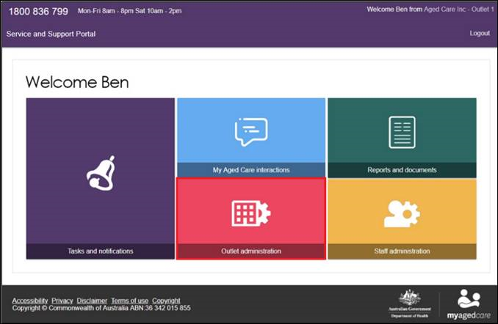

**Select the outlet you wish to submit a specialisation application for**

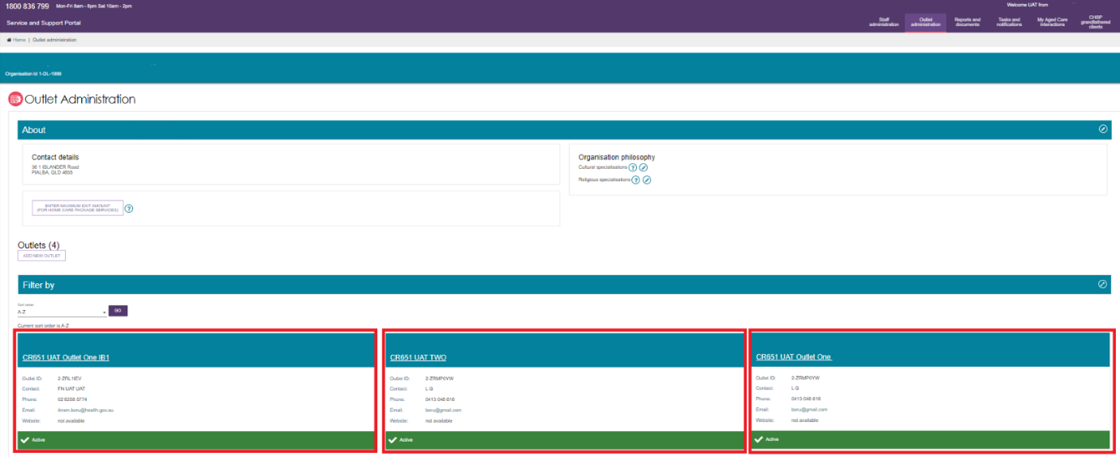

**Click Manage verifications**

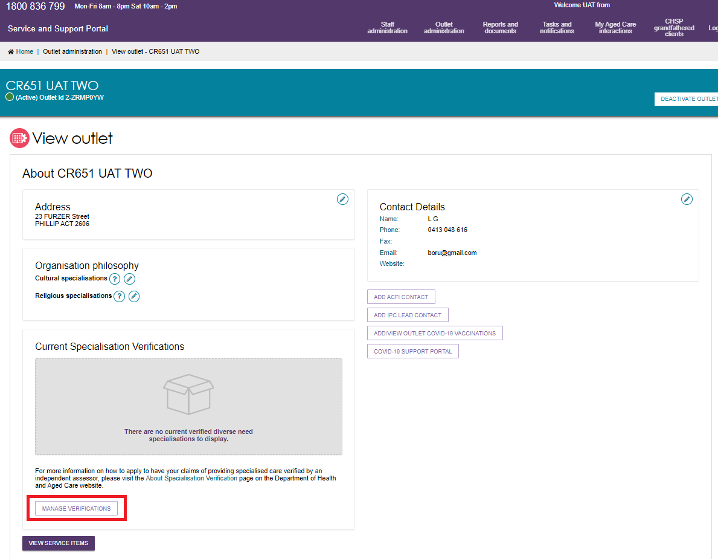

**Then click Lodge a new application**

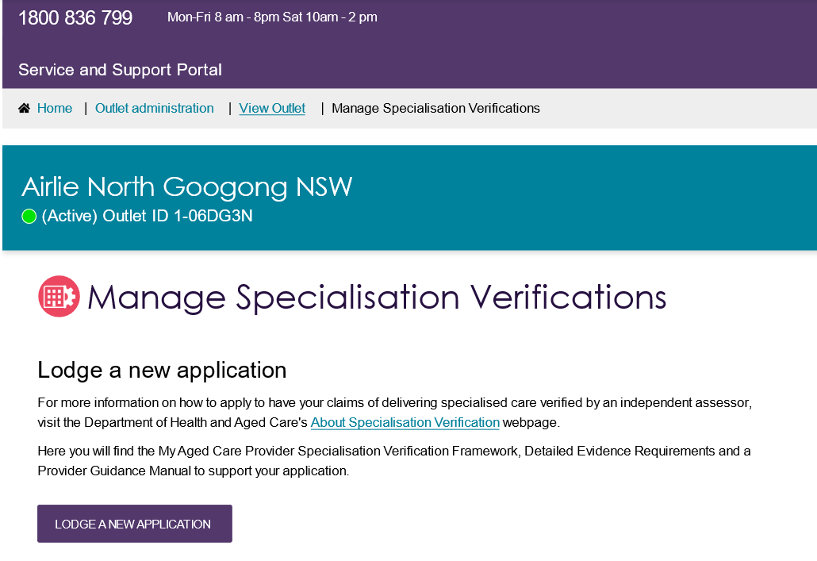

After reading information about where to find additional resources to help you complete your application, click Next.

## 2. Select specialisations and download the specialisation evidence form

Select the specialisations you wish to apply for and then click **Next**. You can also:

* click **Close** to close the application screen without saving
* click **Save** to save the status of the application and come back later;
* click **Previous** to go to the previous application screen.

The current status of each application for your outlet is displayed under the relevant specialisation name. They are:

* Not verified
* Current (with a green dot)
* Expired on [Date] (with a red dot)
* Expiring on [Date] (with a yellow dot).

In this instance, the applicant is seeking specialisation in caring for Aboriginal and Torres Strait Islander peoples and communities.

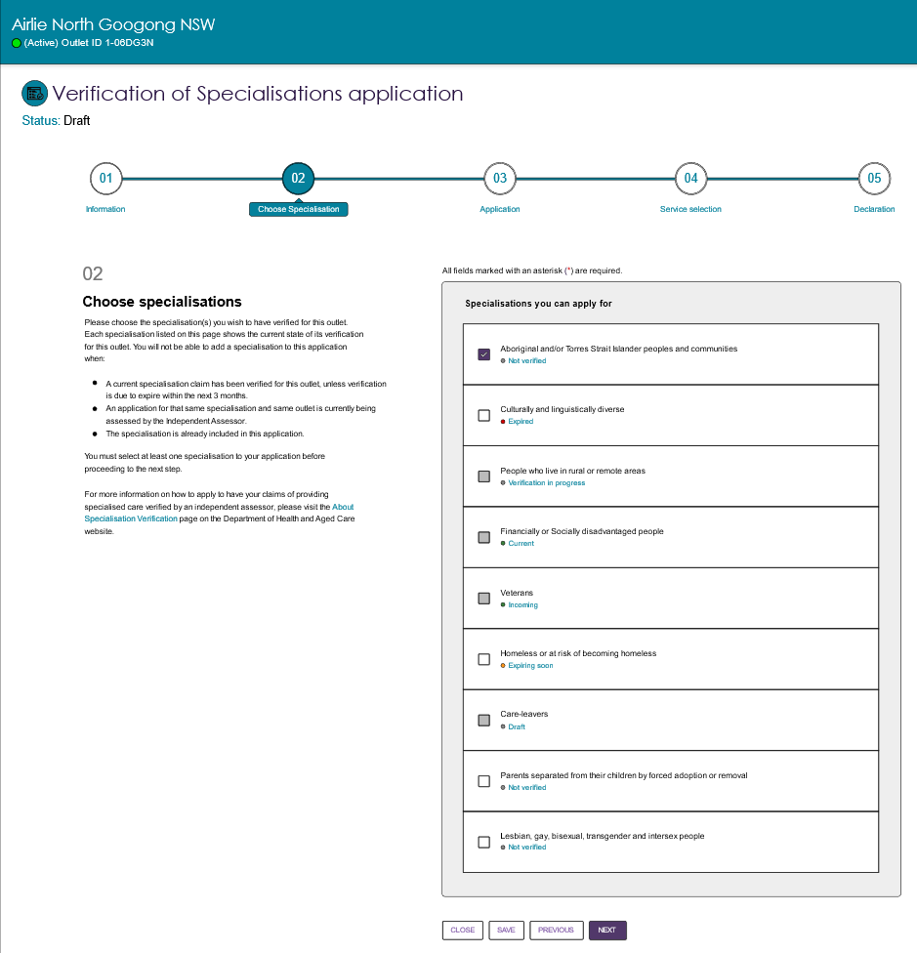

Click **download form** which will direct you to the relevant form for the specialisation claim you are applying to have verified on the department’s website.

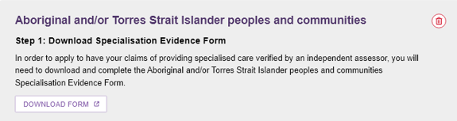

## 3. Upload evidence to support your application

To achieve specialisation, you must meet one Tier 1 criterion **OR** four Tier 2 criteria. For some special needs group, such as Veterans, less than four criteria are specified. In these cases, all Tier 2 criteria for that specialisation need to be met.

Complete the specialisation evidence form for each criterion you wish to apply for then upload the completed form and supporting evidence documents by clicking Provide Evidence.

If you are applying for more than one specialisation you will need to complete Steps 2 and 3 for each specialisation.

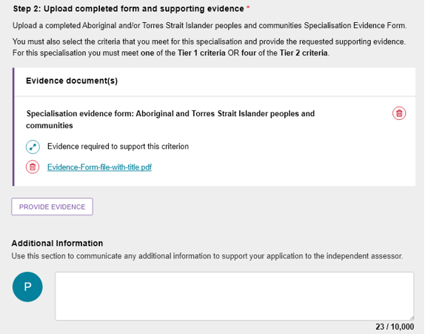

A pop-up box will appear. Select which Tier and Criterion you wish to upload evidence against in the drop-down menu then click **Choose Files** to upload the PDF file. Click **Submit,** then repeat for any additional evidence required for each specialisation application.

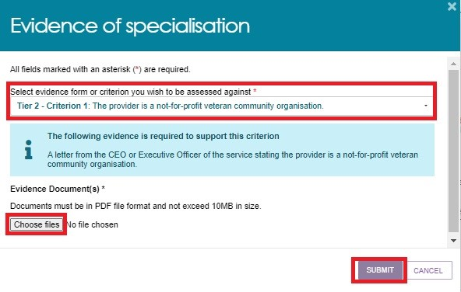

If required, record any further information to support your application, then click **Next.**

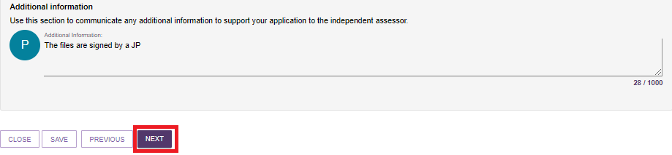

## 4. Select services to which the specialisation/s apply

Select the services associated with the outlet which cater for each diverse needs specialisation being verified then click **Next**.

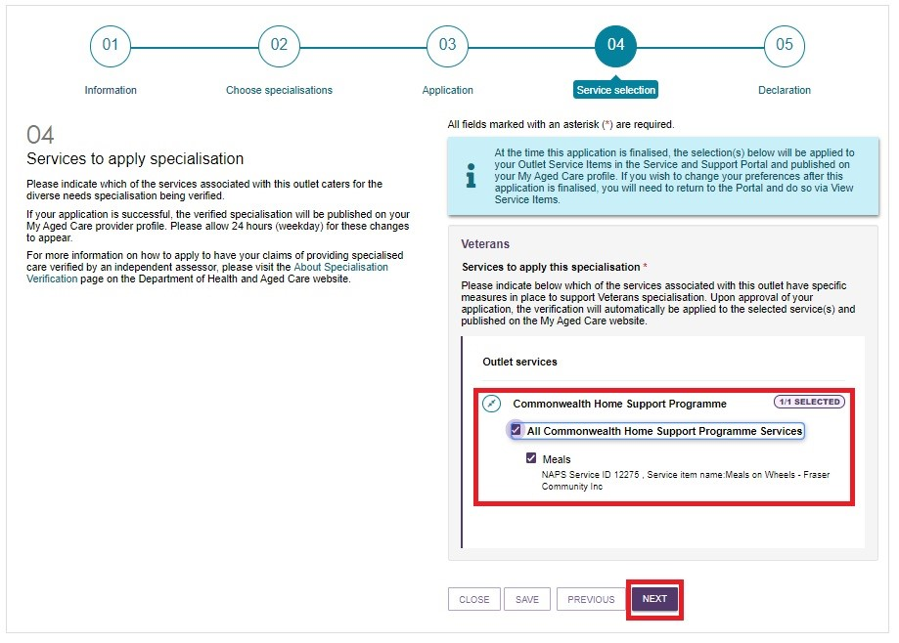

## 5. Complete the declaration

Complete the declaration and click **Submit**. Your application will then be provided to the assessment team for review.

## 6. We assess your application and notify you of the outcome

The assessment team will evaluate your application and supporting documentation. If we have any questions about your application or if we need more information, we will contact you through the My Aged Care Service and Support Portal, by phone, or by email. If no action is taken following the assessor contacting you twice, your application will be declined.

You will receive an email via the My Aged Care Service and Support Portal to let you know the verification process is complete within approximately 20 business days of your application and supporting evidence submission. You can view the outcome in the My Aged Care Service and Support Portal.

If your application has been successful, the verified specialisation and a tick icon will be displayed on your My Aged Care provider profile to show that you have met the criteria to provide these form(s) of specialised care.

## Editing an application

If an application requires additional information, you may be required to update and resubmit an application. The assessment team will reissue the application back to you with a note explaining the additional information needed. You will be notified of your requirement to resubmit by:

* an email that your application has been reissued.
* The email address associated with your My Aged Care account will be contacted.
* The applicant will be copied into this email.

Once you have received these emails, click on the application tile to find a message from the assessment team and edit your application.

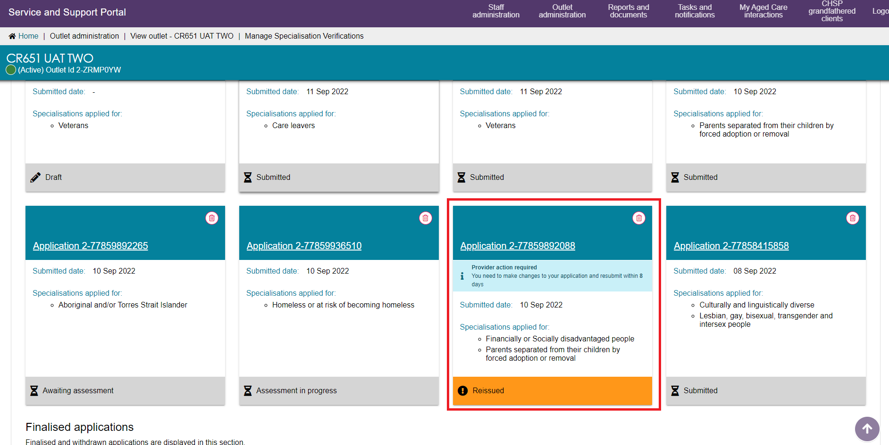

# The aged care recipient feedback process

Most of the specialisations covered by the framework have an aged care recipient feedback criterion. To meet the evidence requirements for this criterion, you must arrange for aged care recipients to give feedback on the specialised care they receive from your organisation. This feedback must substantiate your specialisation claim, as it relates to that criterion.

You may select an aged care recipient feedback criterion as one of your four Tier 2 criteria.

## How to facilitate aged care recipient feedback

The aged care recipient feedback process has five steps:

### Select the aged care recipient feedback criterion

Lodge a new specialisation application in the My Aged Care Service and Support Portal as described in section 2, nominate your specialisation and then select the aged care recipient feedback criterion (and 3 other Tier 2 criteria).

Upload the required evidence for the 3 other Tier 2 criteria.

Complete the declaration and submit your application.

### Receive the aged care recipient feedback form

The assessor will send you the aged care recipient feedback form, tailored to the special needs group(s) that you have nominated in your application.

### Promote the feedback opportunity to aged care recipients and their representatives

It is your responsibility to promote the feedback opportunity to aged care recipients, as well as their representatives. To promote the feedback opportunity, you could try any of the following, using inclusive and accessible forms of promotion as required (e.g. culturally specific language, large-print versions):

* Run an article or advertisement in your organisation’s newsletter for aged care recipients.
* Send letters or handouts to aged care recipients and/or their representatives.
* Email aged care recipients and/or their representatives.
* Discuss the feedback opportunity during meetings with aged care recipients and/or their representatives.
* Display posters in prominent places at your facility (e.g. front door, lifts, dining rooms, activity areas).
* Inform your care and activity staff about your specialisation application and discuss how they can encourage aged care recipients and/or their representatives to give feedback.
* Post to your social media channels.
* Publish information about the feedback opportunity on your website.
* For residential aged care providers: leave copies of the aged care recipient feedback form in the main reception area of your facility and educate reception staff about the process for giving feedback.

You should also provide aged care recipients and/or their representatives with information about how the department will handle their personal information. [A privacy policy](https://www.ahaconsulting.com.au/resources/mac/) is available at [[Privacy Policy | My Aged Care](https://www.health.gov.au/resources/publications/privacy-policy)](https://www.health.gov.au/resources/publications/privacy-policy).

### Aged care recipients give their feedback to the department

Aged care recipients and/or their representatives can give either written or verbal feedback. They must give their feedback directly to the assessor by telephone, email, or post. Providers should not upload completed feedback forms to their application.

The feedback form contains further guidance for aged care recipients, including all contact details for giving feedback (for a sample form, see page 20).

#### Supporting aged care recipients to give feedback

For aged care recipients who wish to give verbal feedback, it may be appropriate for you to support them in setting up a time to give this feedback to the assessor. This may be particularly important where:

* an **interpreter** is required. Letting the assessor know the aged care recipient’s name, contact details, preferred contact time and language required will allow the assessor to arrange for a [Translating and Interpreting Service](https://www.tisnational.gov.au/) interpreter to be on the line.
* **two or more aged care recipients from the relevant special needs group would prefer to have a phone call with the assessor in a group setting**. This may involve you arranging a suitable private venue for these recipients to gather and speak with the assessor and/or arranging a suitable date and time for the assessor to initiate a group call with these recipients.

Note that your involvement in the process should end with you providing the recipients’ contact details to the assessor. Provider representatives should not be present when aged care recipients give verbal (or written) feedback to the assessor.

You may also wish to consider involving other organisation – such as your local Older Person Advocacy Network (OPAN), care finder or relevant community organisation – to help facilitate the aged care recipient feedback process.

If recipient feedback is not received within 20 business days, an assessor will contact the provider to discuss ways to further promote the feedback opportunity, or the outlet applying under a different criterion.

### We use the feedback to assess your application

The assessor will use the feedback, along with your evidence for the three other Tier 2 criteria, to assess your application.

## Sample aged care recipient feedback form

Specialised aged care

Older people in Australia are a diverse group of people with a wide range of care needs. While all aged care providers must be respectful and responsive to the background and life experiences of the people they support, some aged care providers go beyond that basic requirement to specialise in caring for one or more groups that have special aged care needs according to the Aged Care Act 1997.

People can search for providers with these specialisations by using the ‘[Find a provider’](https://www.myagedcare.gov.au/find-a-provider/) tool on the My Aged Care website.

Can you share some feedback with us?

Your aged care provider, **[assessor to insert provider name**], has submitted an application to nominate itself as a specialised aged care provider for people from the following group:

People who are lesbian, gay, bisexual, transgender and/or intersex (LGBTI)

To support their application for specialisation, [**assessor to insert provider name**] wants to use feedback (opinions and reported experiences) from aged care recipients who identify as being part of this group.

If you belong to this group, the department invites you to share your experiences of receiving this specialised care from your provider with us. The assessor will collect this information to verify applications for specialisations made by aged care service providers.

**[If more than one group is listed, add this additional instruction]:** You may give feedback from the perspective of any or all the groups that you belong to, by answering the questions that apply to you.

**Your feedback will be private, and you can choose to remain anonymous or use a pseudonym**

Your personal information is protected by law, including the Privacy Act 1988 and the Australian Privacy Principles. Your personal information, including name and phone number, is being collected by the department. The assessor collects personal information for the primary purpose of verifying the eligibility of aged care providers against the criteria set out in the Specialisation Verification Framework to ensure that aged care provider profiles on My Aged Care reflect information, which is accurate and relevant, for the purposes of providing aged care recipients and their representatives with specialised healthcare services. Your personal information may also be used and disclosed for secondary purposes such as delivering and evaluating the initiative and for statistical, performance, policy development and research purposes.

More information about the collection of your personal information for My Aged Care Provider Specialisation Verification can be found at [Privacy Policy | My Aged Care](https://www.health.gov.au/resources/publications/privacy-policy)

**Please note:** If you would like to give feedback to your provider, please contact them directly. You can also contact the Older Person’s Advocacy Network on 1800 700 600 to be connected with a local aged care advocate. If you want to make a complaint about your provider, contact the Aged Care Quality and Safety Commission, by visiting [agedcarequality.gov.au](http://www.agedcarequality.gov.au/) or phoning 1800 951 822.

How to give your feedback

Choose the way to give your feedback that best suits you.

If you have received this form as an email attachment, you can do any of the following:

* Fill in the relevant fields on a computer and email your completed form to us at [macspecialisation@health.gov.au](mailto:macspecialisation@health.gov.au).
* Fill in the relevant fields on a computer, print your completed form and mail it to us at the address below.
* Print the document, fill in the relevant fields by hand and mail it to us.

If you have received this form in hard copy, please fill in the relevant fields by hand and mail it to us at:

**My Aged Care Provider Specialisation Verification, Mail Drop Point 765**

**Market and Workforce Division, Dementia, Diversity and Design Branch,**

**Diversity and Inclusion Section**

**PO BOX 9848**

**Canberra ACT 2601**

If you prefer to give your feedback by phone, please let us know by emailing [macspecialisation@health.gov.au](mailto:macspecialisation@health.gov.au) and one of our friendly team will be in touch.

**Do you need an interpreter?**

If you need an interpreter, please email us at [macspecialisation@health.gov.au](mailto:macspecialisation@health.gov.au) to let us know your preferred language and a suitable time for us to call you. We will then arrange an interpreter at no cost to you and phone you back.

## Sample form to collect verbal feedback

| Question | Response |
| --- | --- |
| 1. Date | [Free text] |
| 2. Provider name | [Free text] |
| 3. Outlet number | [Free text] |
| 4. Type of aged care | * residential aged care * home-based aged care   If you selected home-based care, what services do you receive from [insert provider name]?  [Free text] |
| 5. Name of respondent (optional) | [Free text] |
| 6. Respondent’s phone number (optional)  We ask for this in case we need to clarify anything with you. | [Free text] |
| 7. Are you: | * an aged care recipient * a family member of an aged care recipient * a friend or other personal representative of an aged care recipient * an aged care advocate, navigator or member of a community organisation who is responding with or on behalf of an aged care recipient |
| 8a. If you are an aged care recipient, do you identify as (please select all that apply): | * lesbian * gay * bisexual * transgender * intersex * none of these * prefer not to say   If ‘none of these’, or ‘prefer not to say’, please do not provide feedback using this form/answer questions 9a to 12. |
| 8b. If you are responding on behalf of an aged care recipient, does the recipient identify as (please select all that apply): | * lesbian * gay * bisexual * transgender * intersex * none of these * prefer not to say   If ‘none of these’, or ‘prefer not to say’, please do not provide feedback using this form/answer questions 9a to 12. |
| Please answer the following questions.  (If you are a family member, friend or other representative of the aged care recipient, please answer these questions from their perspective or on their behalf.) | **9a.** Do you feel comfortable talking to [insert provider name] staff about your specific aged care needs as a member of the group(s) selected in question 8a or 8b?   * No * Unsure * Yes   9b. If you identify with more than one group listed in question 8a or 8b, please comment on any differences you experience as a member of one group compared with another.  [Free text]  10a. If you answered yes to question 9a, do you feel that [insert provider name] staff meet, or try to meet, those needs?   * No * Unsure * Yes   10b. If you identify with more than one group listed in question 8a or 8b, please comment on any differences you experience as a member of one group compared with another.  [Free text]  11a. Some aged care services specialise in caring for LGBTI (lesbian, gay, bisexual, transgender and/or intersex) people. What do you think these aged care services should provide or consider when caring for LGBTI people?  Please describe what is important to you as a member of the group(s) indicated above. This could include, for example, being cared for by LGBTI staff, recognising family of choice, public displays of support for the LGBTI community (e.g. displaying the rainbow flag or the Darlington statement), specific policies and procedures to support care for people living with HIV/AIDS.  [Free text]  11b. Do you feel that [insert provider name] provides the specialised care that you have described in question 11a?   * No * Unsure * Yes   11c. In what ways does [insert provider name] do this or not do this?  [Free text]  12. Do you have any other comments about [insert provider name]’s ability to meet the aged care needs of LGBTI people?  [Free text] |

# How to request a review of application outcome

If your specialisation application is declined, you can request a review of the decision within 20 business days of receiving this outcome. Only one request can be submitted per application, however the request can include more than one declined specialisation if the declined specialisations were part of the same application.

A request to review the decision can only be submitted for an application for a specialisation that has been declined (for example, if a provider applies for 3 specialisations in one application, and 2 are declined, they can appeal for the 2 declined specialisations, but the approved specialisation will not be appealed).

To lodge a request to review the decision, you must be able to substantiate your concerns by:

* giving additional evidence that was not part of your original application, and/or
* outlining the reasons why you believe that the process of assessing your application was deficient.

## Appeal process

The appeal process has 2 steps, with a third step where required.

Email us with details

Gather electronic copies of any additional supporting evidence, if required.

Write a letter that clearly states that you are lodging a request to review the outcome decision and outline the reasons for the appeal, including any reasons why you believe the process of assessment was inadequate. You do not need to submit a new application.

Email your letter and any additional supporting evidence to [macspecialisation@health.gov.au](mailto:macspecialisation@health.gov.au).

We assess your request and notify you of the outcome

Our assessor team leader or an assessor who did not perform the original assessment will review your request.

We will email you the outcome of your request as soon as possible. We anticipate that we will assess most requests within 20 business days.

Escalate your concerns to the department, if required

If you are unsatisfied with the result of your request, you may contact the department by emailing the delegate of the Secretary, c/o [ageing.and.diversity@health.gov.au](mailto:ageing.and.diversity@health.gov.au).

# Privacy policy

This policy describes how the department will protect people’s privacy and handle personal information in accordance with the Privacy Act 1988 and Australian Privacy Principles.

## ****Personal information that we may collect****

The assessor may collect personal information, including sensitive information, by receiving evidence from:

* providers – through the process of applying to be a specialised provider
* aged care recipients – through the aged care recipient feedback process.

This information includes:

* providers’ names
* providers’ telephone numbers
* names of staff members
* names and telephone numbers of aged care recipients who identify as being from one or more special needs groups, and/or their representatives.
* meeting minutes that may identify individual staff or aged care recipients.

We may directly collect personal information when people complete online or hard copy forms, email us and/or speak with us on the telephone. Aged care recipients who contact us by any of these means will be able to be anonymous or use a pseudonym, if they wish.

If a person believes that the information that the department holds is incorrect or out-of-date, or if they have concerns about how we are handling personal information, they can contact us by email at macspecialisation@health.gov.au.

If some or all personal information is not collected, the assessor may be unable to verify an application made by a provider representative to be listed on the My Aged Care website as delivering specialised services.

## Collecting, storing and using personal information

The department collects, stores, uses and discloses personal information for varying purposes that may include one or more of the following:

* to provide our assessment services under the framework
* to respond to a person’s request
* for general management purposes
* for reporting to the department.

Your information may also be used and disclosed for other purposes such as delivering and evaluating the initiative and for statistical, performance, policy development and research purposes.

The department stores all data related to an individual application, including personal information, on My Aged Care and in the department’s file management system.

## Disclosing personal information

The department does not disclose personal information to individuals or organisations that are located outside of Australia.

Within Australia, we do not disclose personal information to other individuals or organisations unless:

* the department requests that we transfer information to them
* some or all of the assets or operations of the specialisation verification assessment services are or may be transferred to another party as part of a contract transition process
* a person gives consent for their personal information to be disclosed.

## Giving access to personal information

The assessor will give a person access to personal information upon request, except in the limited circumstances in which it is permitted for us to withhold this information (for instance, where granting access would infringe another person’s privacy). When a person contacts the specialisation verification assessment team to request access to personal information (e.g., evidence that the assessor has received as part of an application), we may require them to provide some form of identification (such as an outlet ID number) so that we can verify their identity.

If at any time a person wants to know what personal information we hold about them, they should make a request in writing to:

**My Aged Care Provider Specialisation Verification, Mail Drop Point 765**

**Market and Workforce Division, Dementia, Diversity and Design Branch,**

**Diversity and Inclusion Section**

**PO BOX 9848**

**Canberra ACT 2601**

In circumstances where we have refused a person access to or correction of their person information, we will give them a written notice that explains:

* the reason for the refusal (where it is reasonable for us to do so)
* how they may make a complaint about the refusal to the department.

# Complaints policy

This policy describes how:

* stakeholders can lodge written and verbal complaints.
* The department will handle complaints.

More broadly, the Specialisations Verification team within the Diversity and Inclusion Section encourages a broad range of feedback – for example, compliments and suggestions for improvement – from all stakeholders, including providers and aged care recipients. We have systems and processes in place to ensure that we:

* handle all feedback fairly and respond in a timely manner
* take appropriate action taken where required.

Feedback will inform our quarterly progress reporting to the department, continuous improvement activities and staff training.

## Written complaints

Stakeholders can submit written complaints to [macspecialisation@health.gov.au](mailto:macspecialisation@health.gov.au) or to:

**My Aged Care Provider Specialisation Verification, Mail Drop Point 765**

**Dementia, Diversity and Design Branch**

**Diversity and Inclusion Section**

**PO BOX 9848**

**Canberra ACT 2601**

We log all complaints in a complaints register managed by our project management team.

## Verbal complaints

Stakeholders can give verbal feedback by requesting a phone appointment. To do so, please email macspecialisation@health.gov.au. The help desk officer or an assessor will transcribe the complaint directly into the complaints register.

## Response timeline

We will acknowledge all complaints within 2 business days of receipt and resolve them within 7 business days, where possible.

## Escalating a complaint

If a complainant is still not satisfied with our handling of their complaint, they can escalate their complaint to the department by emailing [ageing.and.diversity@health.gov.au](mailto:ageing.and.diversity@health.gov.au).

# Frequently asked questions

## How long will it take for my application to be assessed?

Each assessment will take approximately 20 business days once we receive your supporting evidence.

## When do we need to submit an application by? What happens if we don’t apply?

You can apply to have your specialisation claim/s verified at any time. Unverified provider-nominated specialisations were removed from providers’ My Aged Care profiles as of 27 February 2023. If you offer specialised care but don’t apply for Specialisation Verification, you cannot list your specialisation(s) on your My Aged Care provider profile.

## Can we apply for more than one specialisation on the same application?

Yes, you can use the same application to apply for as many specialisations per outlet as you need through the My Aged Care Service and Support Portal.

## What evidence is required to support our application?

The evidence requirements for each specialisation are in the [detailed evidence requirements](https://www.health.gov.au/resources/publications/specialisation-verification-framework-detailed-evidence-requirements-for-providers) document.

## How do we provide the evidence to support our application?

After you have selected your specialisations within the My Aged Care Service and Support Portal, you are required to upload a completed **Specialisation Evidence Form** and supporting evidence documents against each criterion you wish to apply under.

If you have selected any criteria that require feedback from aged care recipients to support your application, an assessor will send you a feedback form and you will need to promote this feedback opportunity to the relevant aged care recipients. Any aged care recipients who take up this feedback opportunity must give their feedback directly to the assessor.

If feedback is not received within 20 business days an assessor will contact you to discuss ways to further promote the feedback opportunity, or your outlet applying under a different criterion.

## Who processes the applications, and do they have aged care experience and training in trauma-informed care?

The applications are processed by an internal assessment team within the Diversity and Inclusion section within the department. This team comprises experienced professionals who specialise in diversity in aged care and have a deep understanding of the unique needs and challenges faced by diverse populations. These team members have received training in trauma-informed care.

## During the application process, will you contact me to request additional information if this is required?

Yes. If any documentation is missing or unclear, an assessor will contact you through the My Aged Care Service and Support Portal, by phone or by email.

If you do not respond to the request for additional information the assessor will phone you. If no action is taken after your assessor contacting you twice, your application will be declined.

## How can I find out the status of my application?

You will be notified when:

* your application has been assigned to an assessor for processing
* the assessor requests additional information from you
* the assessor resumes assessment of your application after additional information was provided.
* your application has been finalised.
* verified specialisations are due to expire in three months.
* the outcome of your application has been changed following a review of decision.

## How will we be notified of a successful or unsuccessful application?

Once the verification process is complete you will receive an email advising your application has been finalised. You can view this outcome in the My Aged Care Service and Support Portal.

## When will my profile on My Aged Care be updated to reflect the approved specialisation?

Verified specialisations will display a ‘tick’ icon next to the specialisations on your My Aged Care profile, and the criteria that the specialisation was verified against. When a person views the specialisations listed on your profile, it will be clear to them if your claims have been verified. It takes approximately one business day for these changes to appear.

## Can we apply for additional specialisations in the future?

Yes, you can apply to have your specialisations verified at any given time.

## How long does the approval last?

Approved specialisations will be listed on your My Aged Care provider profile for 3 years. Three months before the expiry date, you will be reminded to submit a new specialisation application.

## Are the specialisations reviewed on a regular basis to ensure that they continue to meet the requirements?

Aged care providers are expected to maintain the accuracy of their claims for the 3 years for which their specialisation is valid.

The department reserves the right to review a listed specialisation before renewal is due, if we receive information that the specialisation may no longer be valid.

## What is the process for removing a specialisation listed for our service if it is no longer applicable?

If you no longer meet the criteria for specialisation, you need to remove this specialisation from your outlet via the Service and Support Portal. Alternatively, you can tell us by emailing [macspecialisation@health.gov.au](mailto:macspecialisation@health.gov.au). If you wish to advise us in writing, send your letter to:

**My Aged Care Provider Specialisation Verification, Mail Drop Point 765**

**Market and Workforce Division, Dementia, Diversity and Design Branch,**

**Diversity and Inclusion Section**

**PO BOX 9848**

**Canberra ACT 2601**

## If my application is declined, can we submit another application immediately for the same specialisation?

You will be able to submit a new application no sooner than 3 months after your previous application was declined.

## Is Specialisation Verification linked to the Aged Care Quality and Standards?

All providers are bound by the [Aged Care Quality Standards](https://www.agedcarequality.gov.au/providers/standards). These standards set out the minimum requirements all providers must meet, including that care recipients are treated with dignity and respect, and can maintain their identity.

To deliver specialised aged care services is an optional additional step. If you claim to deliver specialised care to people with one or more of the special need’s groups, your service needs to go above and beyond the Aged Care Quality Standards to provide care that is sensitive to these people’s needs.

## Will my verified specialisation/s transfer if my organisation merges with another?

Any specialisation claims recorded against the service will be removed upon transferring a service to a new outlet.

## Are all specialisations listed on My Aged Care part of the verification process?

The focus of My Aged Care Provider Specialisation Verification is to assess a provider’s application that they specialise in providing services for older Australians identified with the special need’s groups defined by the Aged Care Act 1997. This includes:

* Aboriginal and Torres Strait Islander peoples and communities
* People from culturally and linguistically diverse backgrounds
* People who live in rural or remote areas
* People who are financially or socially disadvantaged
* Veterans
* People who are homeless or at risk of becoming homeless
* Care leavers
* Parents separated from their children by forced adoption or removal.
* Lesbian, gay, bisexual, transgender and intersex people.

Other specialisations listed on the My Aged Care Find a Provider tool such as health conditions, language, or culture, are not currently included under the initiative. However, providers that indicate they specialise in these areas should ensure they have the necessary skills, qualifications and/or facilities to cater to the specialisation as this information is used by older Australians to find a provider that can meet their needs.

# Need help?

For queries about the framework or the application process, please contact the Specialisation Verification assessment team.

**Email:** [**macspecialisation@health.gov.au**](mailto:macspecialisation@health.gov.au)