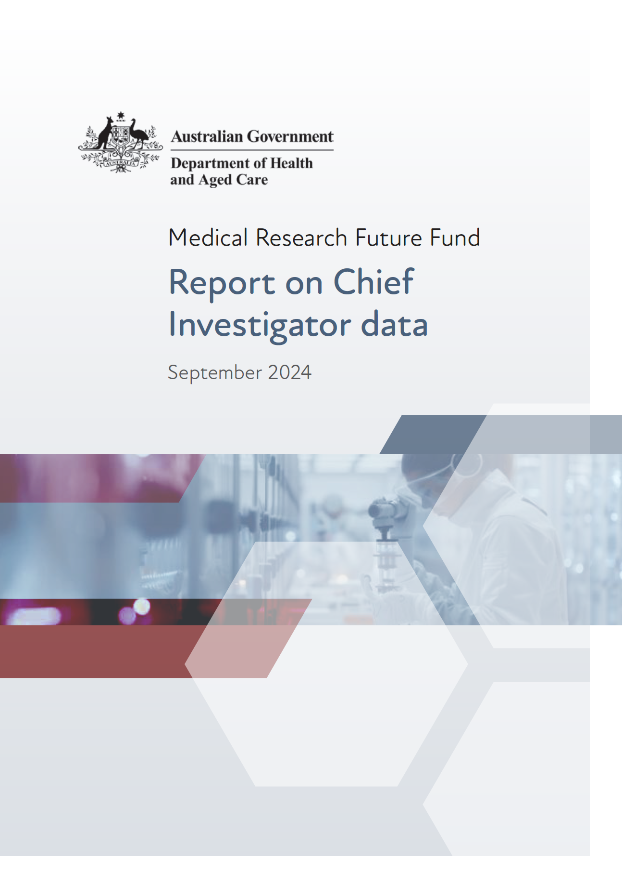

Contents

[Introduction 3](#_Toc176335732)

[Reporting on Chief Investigator data for MRFF grant opportunities 3](#_Toc176335733)

[Report overview 4](#_Toc176335734)

[Approach 5](#_Toc176335735)

[Limitations 6](#_Toc176335736)

[MRFF funding insights 8](#_Toc176335737)

[Summary 8](#_Toc176335738)

[Overall trends 10](#_Toc176335739)

[Age 11](#_Toc176335740)

[Career stage 13](#_Toc176335741)

[First Nations status 15](#_Toc176335742)

[Gender 17](#_Toc176335743)

[Primary institution location 19](#_Toc176335744)

[Remoteness status 21](#_Toc176335745)

[Research area 23](#_Toc176335746)

[Sector/industry 24](#_Toc176335747)

[How the MRFF and NHMRC complement each other 27](#_Toc176335748)

[Overall funding 27](#_Toc176335749)

[Characteristics of researchers funded through the MRFF and NHMRC 29](#_Toc176335750)

[Conclusions 37](#_Toc176335751)

[Appendix A Modified Monash Model 38](#_Toc176335752)

# Introduction

The Australian Government invests in Australian research and its translation into practice to ensure that Australia’s health system remains prepared for current and future health challenges.

The Australian Government provides direct support for health and medical research through the complementary Medical Research Future Fund (MRFF) and the National Health and Medical Research Council (NHMRC) Medical Research Endowment Account (MREA). The MRFF funds priority‑driven research with a focus on research translation, whereas the NHMRC focuses on investigator-led research. Both work together to support a diversity of Australian health and medical research and researchers.

The MRFF is a $22 billion (as at the end of 2023) long-term investment supporting Australian health and medical research. It was established in 2015 and, at present, is forecast to provide up to $650 million in annual health and medical research funding. The MRFF aims to support Australian research and innovation to improve health outcomes, build the economy and contribute to health system sustainability.

The NHMRC is a statutory authority within the Australian Government Department of Health and Aged Care portfolio. It has been supporting health and medical research and translation in Australia since 1937. The NHMRC invests in people with outstanding research achievement and promise, and supports high-quality, innovative research to solve complex problems. The NHMRC is also one of 2 grant hubs that administers the MRFF program, the other being the Business Grants Hub (BGH) at the Department of Industry, Science and Resources.

## Reporting on Chief Investigator data for MRFF grant opportunities

The purposes of this report on Chief Investigator data are to:

describe the diversity of researchers that apply to and are supported by the MRFF within the broader health and medical research ecosystem

demonstrate how the MRFF and NHMRC complement each other in terms of the research and researchers they fund.

Annual reporting of this type is in line with the [MRFF Monitoring, Evaluation and Learning Strategy](https://www.health.gov.au/resources/publications/mrff-monitoring-evaluation-and-learning-strategy-2020-21-to-2023-24).

Data analysis, reporting and data-informed decision making are critical for the MRFF to achieve its strategic objectives, namely:

equitable health outcomes through research-informed preventive health and health care, from primary to tertiary care

health and economic benefits from the translation of innovative research into policy and practice, and the commercialisation of new diagnostics, therapeutics and preventive health interventions

a skilled and sustainable health and medical research workforce with expertise in research translation, innovation and commercialisation

a health and medical research sector and a health system that are positioned to respond to emerging and future challenges.

## Report overview

This report provides an overview and insight into the characteristics of Chief Investigators who applied for open competitive and targeted or restricted competitive MRFF grant opportunities that opened before 31 December 2023 and had applications and outcomes data available as of 24 January 2024. Where possible, the report also analyses comparable data of MRFF Chief Investigators who applied for funding through the NHMRC MREA, to investigate complementary funding across the health and medical research funding landscape.

This report aims to:

identify the consistent or common traits of successful MRFF applicants

clarify who the MRFF funds and with what frequency

examine the complementarity between MRFF and NHMRC funding.

# Approach

Grant opportunity, application, grant and researcher data were sourced from 2 grant hubs involved in administering MRFF grants, specifically:

NHMRC – Chief Investigator data were captured through the NHMRC grants management platform, Sapphire, and through NHMRC awardee data from published [outcomes of funding rounds](https://www.nhmrc.gov.au/funding/data-research/outcomes)

BGH – Chief Investigator data from grant opportunities that closed after November 2021 were captured through Excel spreadsheets submitted by applicants; Chief Investigator data were captured inconsistently before November 2021.

Chief Investigators are researchers on a grant application who are responsible for significant contributions towards the outcomes of the research proposal. The lead Chief Investigator (also known as Chief Investigator A), who is the Chief Investigator listed first on a grant application, takes the lead role in submitting the application, conducting the research, and reporting as required under the grant agreement.

Because this report focuses on researchers, Chief Investigator location and remoteness status were based on the Chief Investigator’s primary institution, defined as their place of employment provided at the time of application; this is distinct from the administering institution or lead organisation listed on the application. Remoteness status was defined using the Modified Monash (MM) Model, based on the postcode of the primary institution. More information on this model is in [Appendix A](#_Appendix_A Modified_Monash).

Where data are available, Chief Investigator characteristics were explored around the following 8 demographics:

age

career stage

First Nations status

gender

primary institution location

remoteness status

research area

sector.

Data for this report consisted of:

**137 competitive grant opportunities** (107 administered through the NHMRC, 30 administered through the BGH)

**5,969 applications** received through competitive grant opportunities

**41,816 Chief Investigator applicants** (17,730 distinct; see [Limitations](#_Limitations) regarding distinct applicants)

**1,278 awarded grants** (for grant opportunities that closed before 31 December 2023).

The following steps have been taken to preserve anonymity of data:

All data are de-identified and no names of people or institutions are published in this report.

Generally, any subcategory values with fewer than 10 applicants identified are not reported.

## Limitations

While the analysis presented in this report is comprehensive, the following limitations to the analysis should be noted:

Reportable data for the MRFF are only available from 2017 onwards, corresponding to the earliest MRFF investments.

Only those applications for which detailed Chief Investigator data are available are included.

All non-competitive, demand-driven and one-off/ad hoc grant opportunity types, and competitive grant opportunity types with fewer than 10 applications, are excluded from this analysis.

An individual may be named on more than one application; these instances were treated as distinct applicants for the purpose of this analysis.

Career stage is defined as number of years post-PhD at the time of application; this does not factor in career disruption, as these data were not available. For the NHMRC, PhD data were captured specifically. For the BGH, PhD data were captured using the highest qualification reported, and included mapping to either qualifications that mention a doctorate (such as PhD, DPhil, DHlthSc, DMedSc, DSc) or an applicant selecting ‘PhD/doctorate (Australian Qualifications Framework Level 10 or equivalent)’. When no PhD or equivalent qualification is reported, the Chief Investigator is excluded from any career stage analyses involving years post-PhD in this report.

On 28 October 2022, gender categorisation changed within the NHMRC’s grant system. Accordingly, this report uses the updated categories of ‘men’, ‘women’, ‘non-binary’ and ‘not stated’.

When a postcode comprised more than one category on the MM Model and there was uncertainty around which was more relevant for the primary institution, a conservative approach was taken such that the lower MM category (less remote) was selected to determine remoteness status. This may result in under-representation of rural, regional and remote Chief Investigators. However, the use of the Chief Investigator’s primary institution rather than the application’s administering institution helps reduce the impact of central, more urban-centric campuses frequently being listed as the administering institution despite the research being conducted in rural or regional campuses.

All demographic information for Chief Investigators is based on self-reported data and is only available for BGH-administered grant opportunities from November 2021 onwards (when this data was systematically captured).

At the time of analysis, data for 2022–23 are incomplete as not all grant opportunities that opened during this period had outcomes available.

Analyses of Chief Investigators funded by both the MRFF and NHMRC are limited to publicly available grants data from the NHMRC. Therefore, these analyses

* are limited to the lead Chief Investigator only and, in most cases, to the NHMRC Investigator Grants and Ideas Grants schemes (as there are no or incomplete data for other NHMRC schemes); where overall trend data are presented, these are based on outcomes across all NHMRC schemes for which public data are available, including those pre-dating the current grants program
* are presented in terms of lead Chief Investigators with both MRFF and NHMRC funding (when it is possible to match to MRFF data), rather than those with MRFF funding only
* do not consider researchers supported by the NHMRC only (that is, those who have not received MRFF funding), as their detailed demographic data are not available for this report.

# MRFF funding insights

## Summary

During the analysis period, there were 41,816 (17,730 distinct) Chief Investigators who had applied for MRFF funding through 5,969 applications to 137 competitive grant opportunities. Of these, 10,551 (6,555 distinct) Chief Investigators were funded, representing a funded rate of 25.4% (37.0% for distinct applicants). More than half (52.1%) of distinct Chief Investigators have been funded more than once (average number of grants held: 1.61).

For lead Chief Investigators, there were 4,716 (2,959 distinct) applicants who applied for MRFF funding and 1,024 (842 distinct) were funded, representing a funded rate of 21.7% (28.5% for distinct applicants).

### Age

More Chief Investigators in the middle-to-older age brackets received MRFF funding than those in the younger age bracket, with the age brackets spanning 40–49 years having the highest proportions of funded grants (19.9% for the 40–44-year age bracket, 19.6% for the 45–49-year age bracket).

When considering all Chief Investigators, funded rates increased with age. However, applications led by Chief Investigators who were in the middle age groups (40–49 years) had the highest funded rates (average of 31.4%).

### Career stage

Most applications were submitted by early- to mid-career researchers. The career stage with the highest proportion of funded Chief Investigators was 0–5 years post-PhD (17.4%). For lead Chief Investigators, the mid-career stage (11–15 years post-PhD) had the highest proportion of funded applicants (21.3%). These figures are likely driven by 2 MRFF grant opportunities that became available in recent years that are specific to early- to mid-career researchers. Chief Investigators and lead Chief Investigators who were 11–20 years post-PhD had the highest funded rates (average of 43.2% for Chief Investigators, 32.8% for lead Chief Investigators). Once funded, the chances of further funded applications increased with career stage.

### First Nations status

Funded rates for First Nations Chief Investigators were generally higher than those for non-First Nations Chief Investigators. Within Indigenous Health Research Fund grant opportunities, 98.1% of funded grants had at least one First Nations Chief Investigator on the team (the only exception being one grant awarded before a refresh of grant assessment criteria to encourage First Nations leadership of projects); this was 15.5% for the MRFF more broadly. First Nations Chief Investigators were at least as likely to hold multiple grants (average number of grants: 1.78) as non-First Nations Chief Investigators (average number of grants: 1.63).

### Gender

There were more women Chief Investigator and lead Chief Investigator applicants than men, which is consistent with findings from other MRFF analyses. Funded rates were very similar between genders, both for all Chief Investigators (38.4% for women and 38.2% for men) and lead Chief Investigators (28.5% for women and 28.9% for men).

### Primary institution location

Victorian institutions had the highest number of Chief Investigator applicants overall. Correspondingly, they had the highest number of funded applicants and received the highest amount of funding. However, Chief Investigators and lead Chief Investigators in the Northern Territory had the highest overall funded rates (44.4% and 41.4%, respectively), followed by those in South Australia (42.6% and 33.2%, respectively).

### Remoteness status

The number of applications submitted by researchers in rural, regional and remote locations has generally increased over time, most notably by those in MM 2 locations.

### Research area

More applicants were from the broad research area ‘Clinical medicine and science’ than were from any other area. Consequently, more funded applicants came from this area than from any other area. They also had the highest funded rates (43.1% for Chief Investigators, 32.3% for lead Chief Investigators).

### Sector

Most (84.3%) MRFF grants administered by the NHMRC were awarded to Chief Investigators from the university sector, followed by those from medical research institutes (11.7%). These sectors had similar funded rates (39.2% for universities, 38.8% for medical research institutes). Similar findings were seen for lead Chief Investigators, although the funded rate was higher for lead Chief Investigators from medical research institutes (34.4%) than universities (28.6%). Funded rates were highest for applicants from charities and philanthropic organisations. However, this is based on a very small number of applications, so meaningful conclusions cannot be drawn.[[1]](#footnote-2)

For BGH-administered MRFF grant opportunities, most applications were from primary institutions in the education and training sector (universities), followed by the professional, scientific and technical services sector (including medical research institutes). Overall funded rates were also higher for the education and training sector (14.1%) than for the professional, scientific and technical services sector (10.0%). Additionally, several BGH-administered MRFF grant opportunities supported researchers in Australian small-to-medium enterprises (SMEs). This included funding of around $146 million awarded to 134 SMEs or researcher groups in the medical technologies, biotechnologies and pharmaceutical sectors (with a further $199 million to be awarded) under the Medical Research Commercialisation initiative alone.

## Overall trends

The numbers of distinct Chief Investigators and lead Chief Investigators applying for and securing funding have generally increased over time. Similar trends were seen with funded rates (Figure 1). This observed growth is likely a result of increased available funding, leading to a higher number of grant opportunities annually. Consequently, this has led to a rise in the number of applications and to larger team sizes in recent years.

Figure 1 Number of applicants and funded rates for distinct Chief Investigators and lead Chief Investigators, 2017–18 to 2021–22

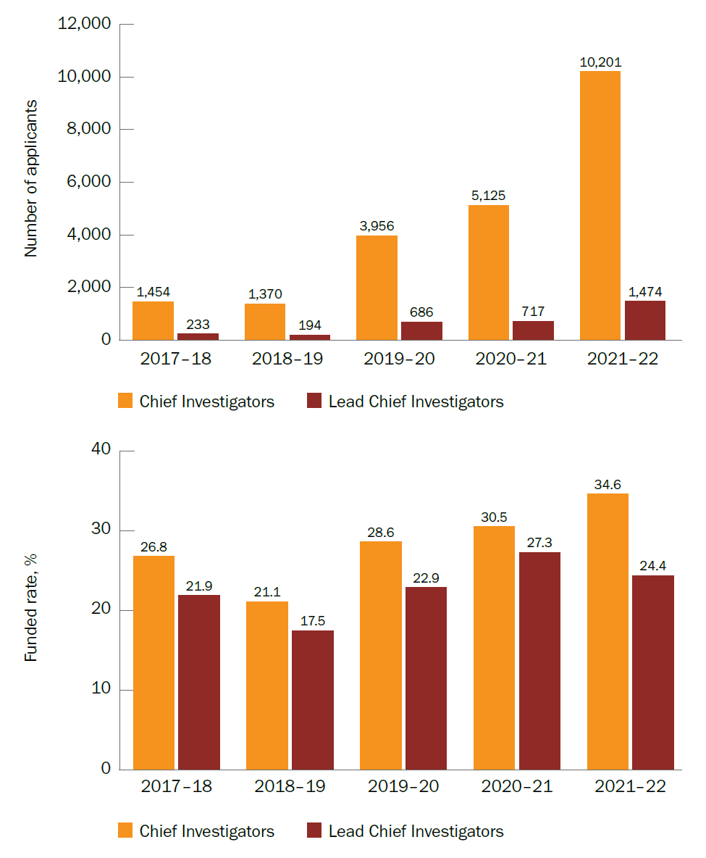

## Age

The 40–44-year age bracket provided the most Chief Investigator applicants, while the youngest age bracket (25–29 years) provided the fewest. Funded rates tended to increase with age, with the oldest Chief Investigators having the highest funded rates (Figure 2). A high number of applications came from the middle age brackets (between 40 and 49 years). This bracket also had the highest proportion of funded Chief Investigator applicants (Figure 3).

For lead Chief Investigators, the middle age brackets (between 40 and 54 years) had the highest number of applicants (Figure 2) and the highest number of funded applicants. These age brackets also had the highest proportions of funded applicants (Figure 3). However, the trend for funded rates was similar to that for all Chief Investigators, with younger lead Chief Investigators having lower funded rates than their older counterparts. The youngest age bracket (25–29 years) had the fewest lead Chief Investigator applicants (Figure 2), and the fewest applicants funded.

Figure 2 Number of applicants and funded rates for Chief Investigators and lead Chief Investigators by age, 2017–18 to 2021–22

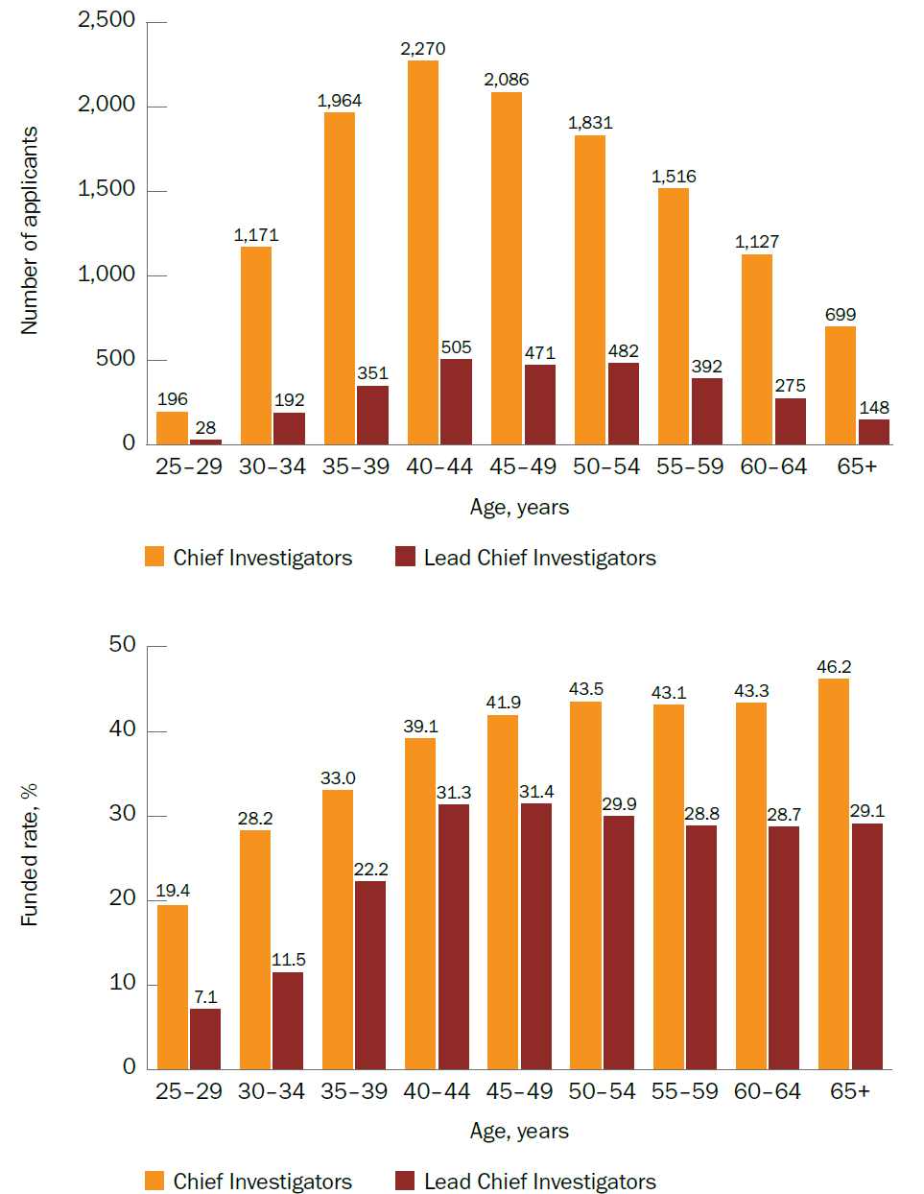

Figure 3 Proportion of funded Chief Investigators and lead Chief Investigators by age, 2017–18 to 2021–22

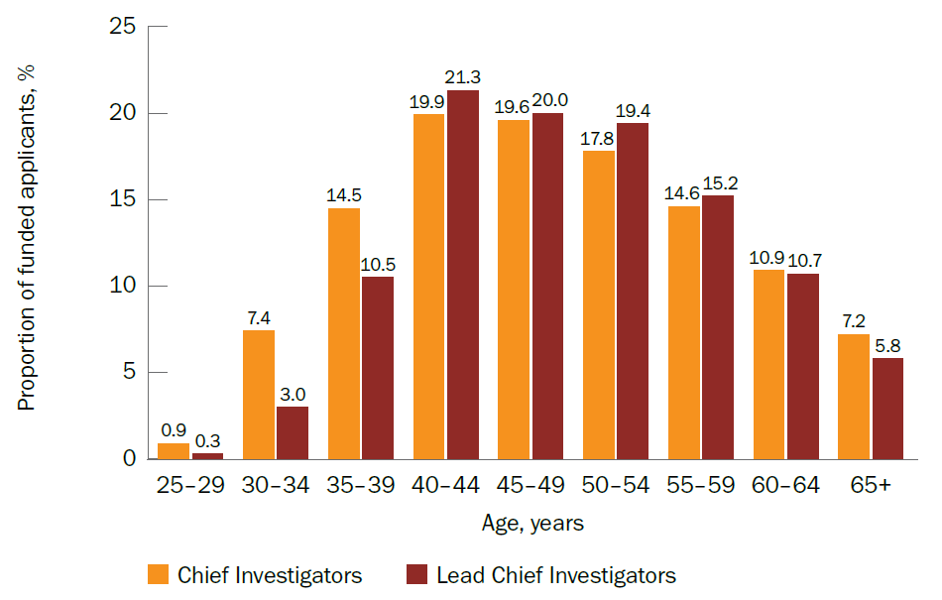

## Career stage

For both Chief Investigators and lead Chief Investigators, the earliest career stage (0–5 years post-PhD) had the highest number of applicants, with this number decreasing as the years post-PhD increased. However, funded rates were lowest for early-career researchers. The funded rates were highest for those who were 11–20 years post-PhD, and the rate remained high for later-career researchers (Figure 4).

For Chief Investigators, the proportion of funded applicants for each career stage tended to correspond to the number of applications submitted (that is, it tended to decrease as the years post-PhD increased). However, this was not the case for lead Chief Investigators – the 11–15 years post-PhD stage had the highest proportion of funded applicants (21.3%). Later-career stages had the lowest proportion of funded applicants (Figure 5).

Figure 4 Number of applicants and funded rates for Chief Investigators and lead Chief Investigators by years post-PhD, 2017–18 to 2021–22

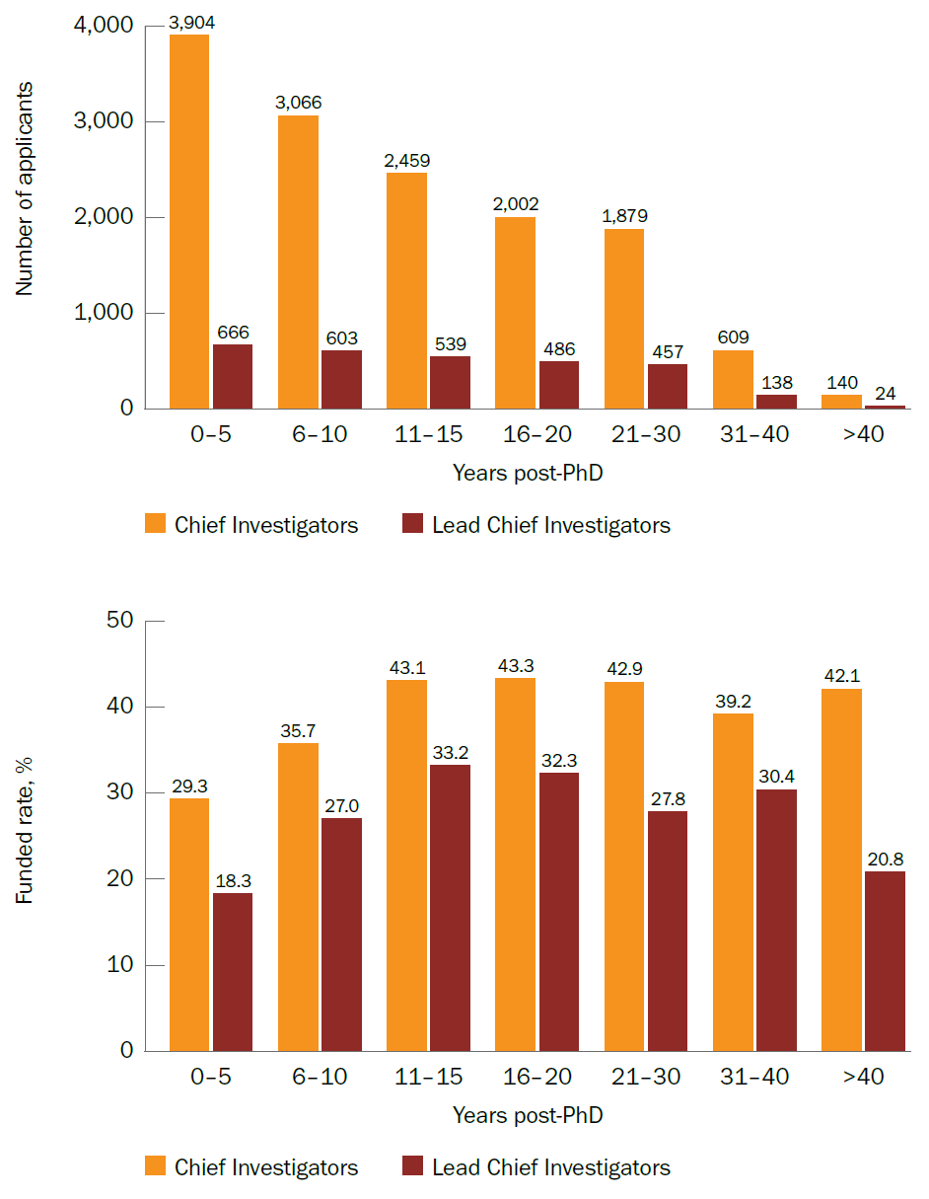

Figure 5 Proportion of funded Chief Investigators and lead Chief Investigators by years post-PhD, 2017–18 to 2021–22

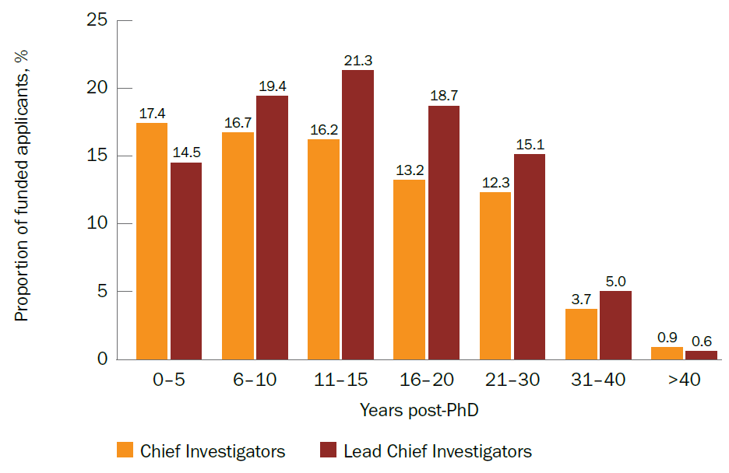

## First Nations status

The numbers of First Nations Chief Investigator and lead Chief Investigator applicants (based on self-declared First Nations status) have generally increased over time, especially in recent years. Notably, despite the data for the 2022–23 financial year being incomplete, the number of First Nations applicants in that financial year is almost equal to, or has already exceeded, the previous financial year (2021–22) (Figure 6). Furthermore, the funded rates for First Nations applicants have generally been higher than those for non-First Nations applicants over time, with the most recent funded rates (from 2021–22 to 2022–23) for First Nations lead Chief Investigators being more than double that for non-First Nations lead Chief Investigators (Figure 7).

Figure 6 Number of First Nations Chief Investigator and lead Chief Investigator applicants, 2017–18 to 2022–23

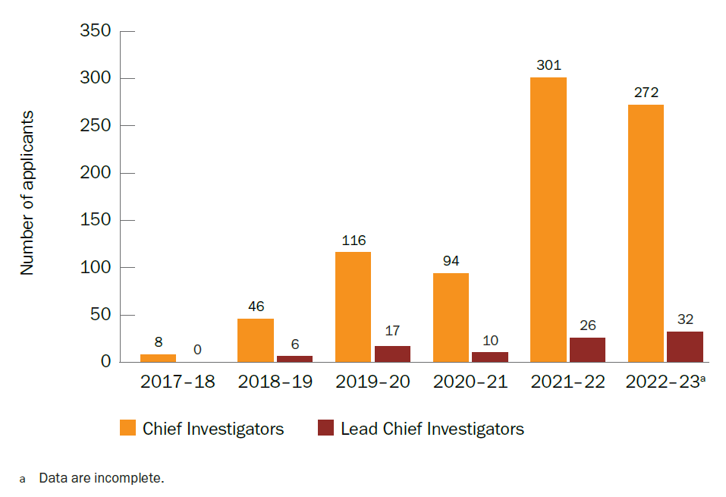

Figure 7 Funded rates for First Nations and non-First Nations Chief Investigators and lead Chief Investigators, 2017–18 to 2022–23

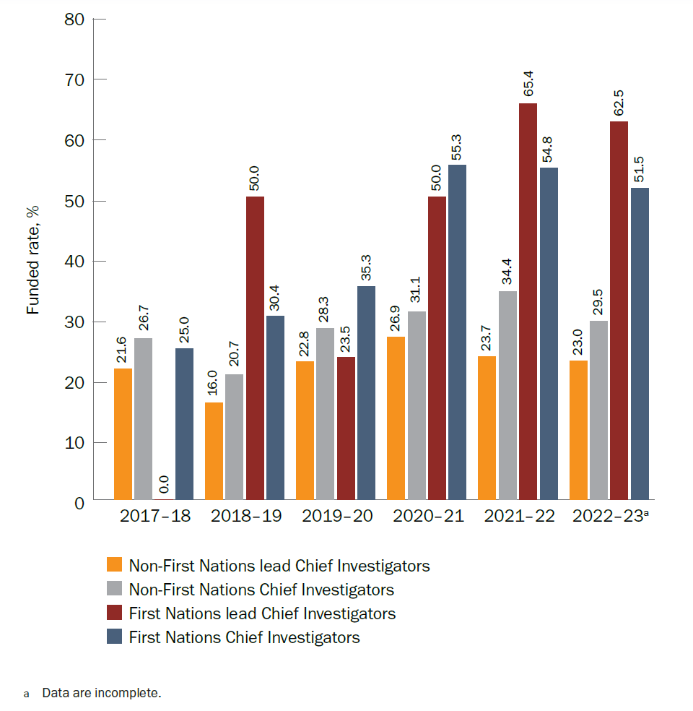

## Gender

For both Chief Investigators and lead Chief Investigators, there were slightly more women applicants than men. Funded rates were similar between the 2 genders (Figure 8). Figures for non-binary and other identified genders could not be included in this report due to very low numbers.

A higher proportion of both Chief Investigators and lead Chief Investigators who identified as women received funding early in their careers (between 0 and 15 years post-PhD) than those who identified as men. A higher proportion of men than women tended to receive funding from 16 years post-PhD onwards (Figure 9).

More information on MRFF gender data can be found in the MRFF [Report on gender data for grant opportunities](https://www.health.gov.au/resources/publications/mrff-report-on-gender-data-for-grant-opportunities-august-2023?language=en) (published August 2023).

Figure 8 Number of, and funded rates for, women and men Chief Investigators and lead Chief Investigators, 2017–18 to 2021–22

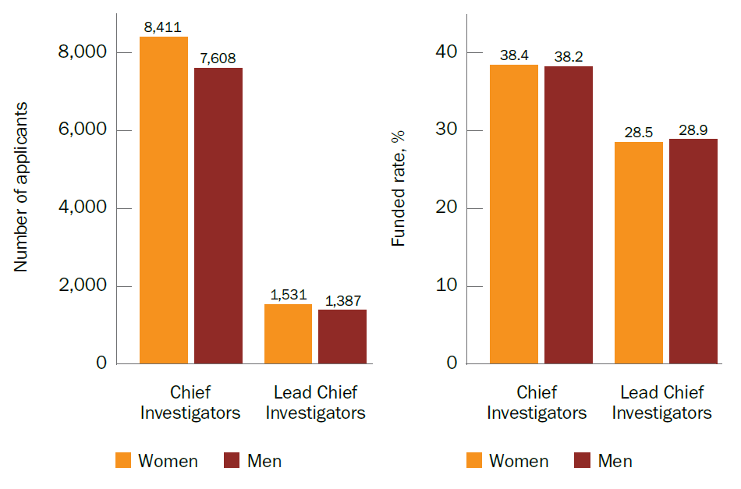

Figure 9 Proportion of funded women and men Chief Investigators and lead Chief Investigators by years post-PhD, 2017–18 to 2021–22

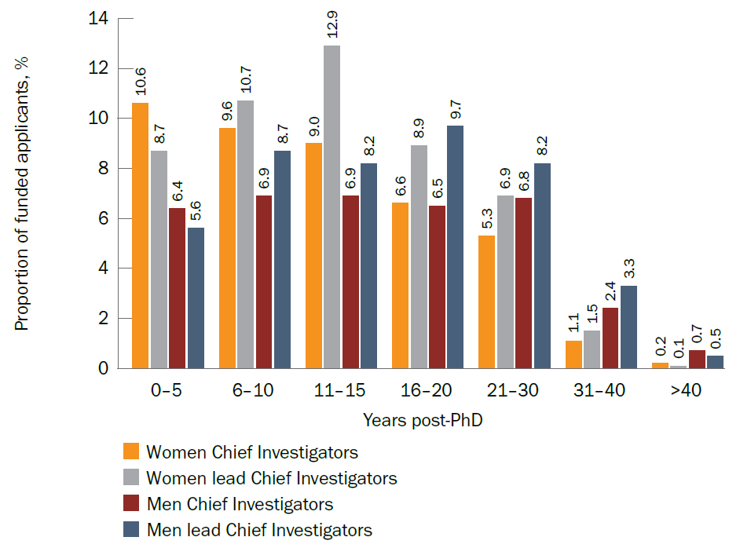

## Primary institution location

The state or territory with the most MRFF applicants was Victoria, closely followed by New South Wales (Figure 10). These locations also had the highest proportions of funded applicants (Figure 11). However, they did not have the highest funded rates; these were achieved by applicants in the Northern Territory and South Australia, for both Chief Investigators and lead Chief Investigators (Figure 10). However, these rates are based on a small number of applicants, so no definite conclusions can be drawn.

Figure 10 Number of applicants and funded rates for Chief Investigators and lead Chief Investigators by location of primary institution, 2017–18 to 2021–22

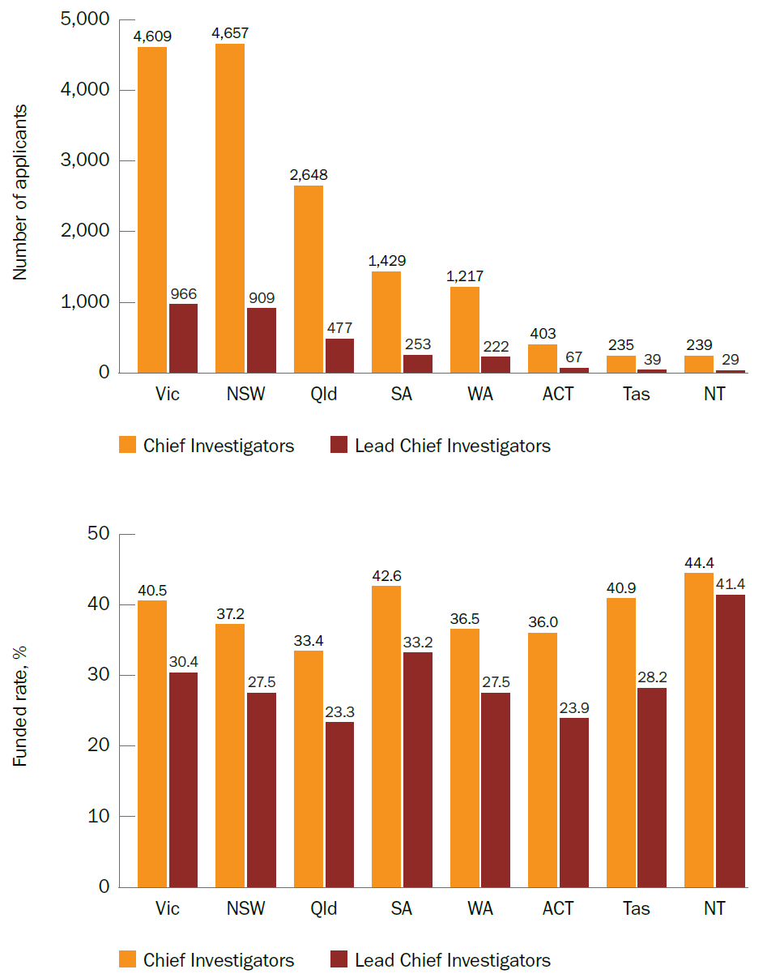

Figure 11 Proportion of funded Chief Investigators and lead Chief Investigators by location of primary institution, 2017–18 to 2021–22

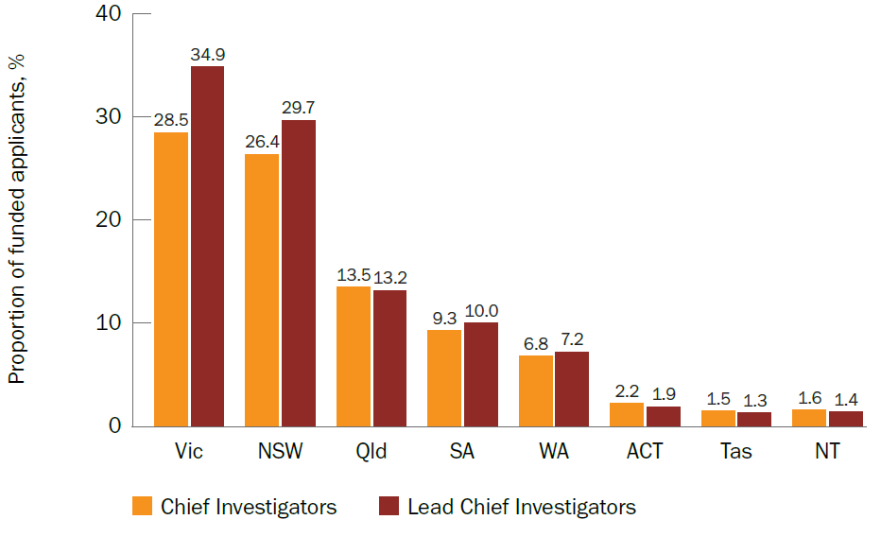

## Remoteness status

The number of lead Chief Investigator applicants from rural, regional and remote locations (MM 2–7) has generally increased over time, including in the most remote locations (Figure 12). The number of applicants decreased in 2020–21. There may be several reasons for this, including the impact of the COVID-19 pandemic on research activity, or the introduction of a specific grant opportunity in 2019–20 (2019 Rural, Regional and Remote Enabling Clinical Trial Infrastructure) mandating a focus on rural, regional and remote research, which resulted in an increase in the number of applications that year.

Notably, funded rates for distinct lead Chief Investigators from MM 2–7 locations have generally been similar to, or higher than, the funded rates for MM 1 applicants over time (Figure 13). Furthermore, funded rates for rural, regional and remote lead Chief Investigators have been similar or higher than the overall funded rates for lead Chief Investigators over the same period. However, this is based on small numbers, and it is too early for trends to be seen.

More information on MRFF funding for rural, regional and remote applicants and research can be found in the MRFF [Report on funding for rural, regional and remote health research](https://www.health.gov.au/resources/publications/mrff-report-on-funding-for-rural-regional-and-remote-health-research?language=en) (published July 2023).

Figure 12 Number of distinct lead Chief Investigator applicants from rural, regional and remote locations (MM 2–7), 2017–18 to 2021–22

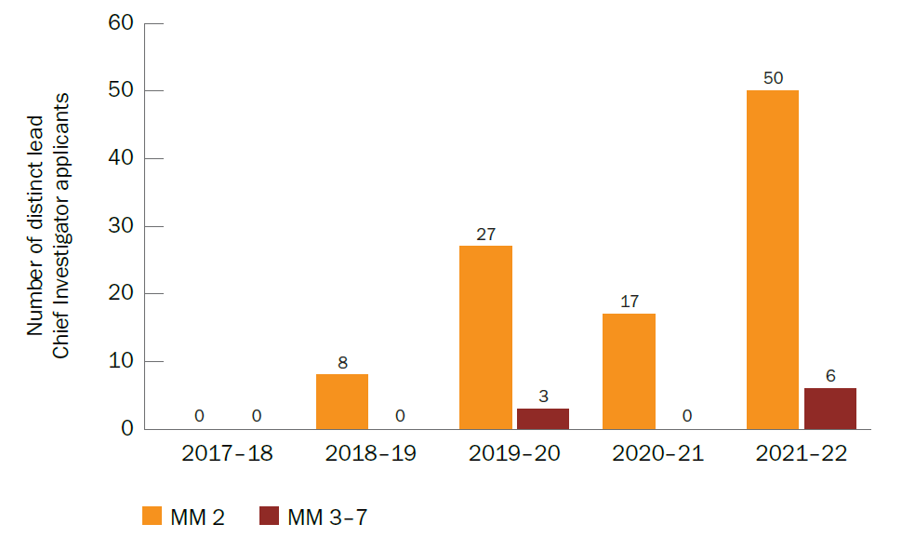

Figure 13 Funded rates for distinct lead Chief Investigators by Modified Monash category, 2017–18 to 2021–22

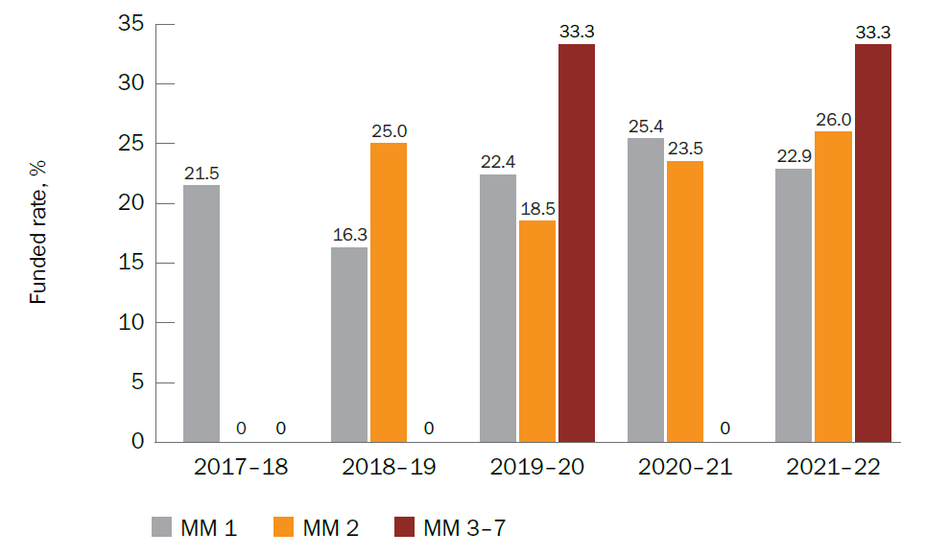

## Research area

The broad research area with the most applicants (for both Chief Investigators and lead Chief Investigators) was ‘Clinical medicine and science’. This broad research area also had the highest funded rates for both Chief Investigators and lead Chief Investigators (Figure 14). Although the broad research area of ‘Public health’ had less than half the applicants of ‘Clinical medicine and science’, the funded rates were similar.

Figure 14 Number of applicants and funded rates for Chief Investigators and lead Chief Investigators by broad research area, 2017–18 to 2021–22

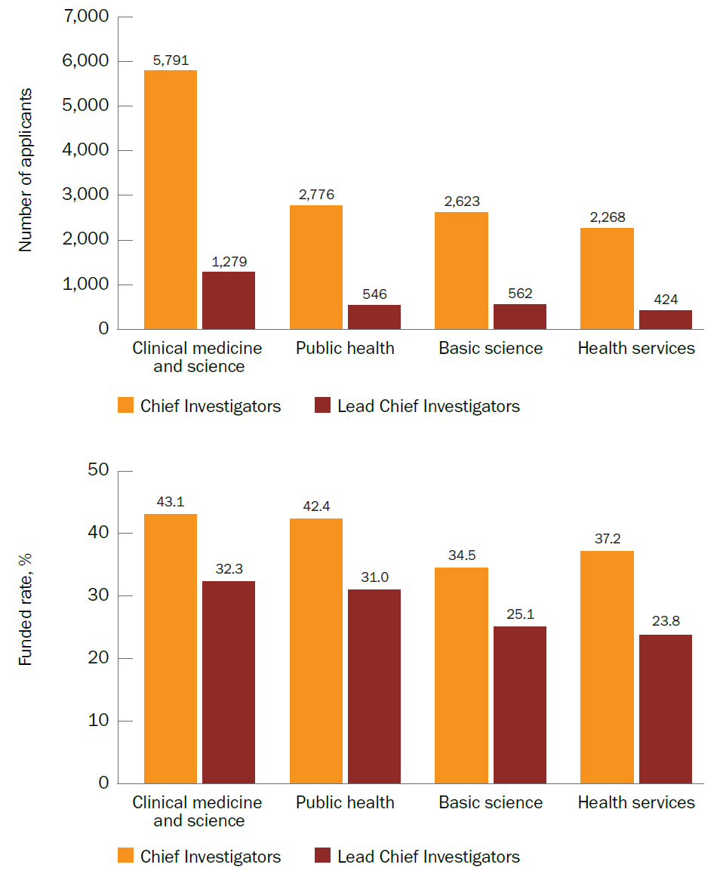

## Sector/industry

Sector and industry data were analysed separately for NHMRC- and BGH-administered grant opportunities, as the 2 grant hubs collect and report these data differently. Specifically, NHMRC data are based on the characteristics of Chief Investigator applicants from each sector (data available from 2017–18), while BGH data are based on the characteristics of lead organisation applicants in each industry category (data available from 2018–19).

For NHMRC-administered MRFF grant opportunities, most applicants (both Chief Investigators and lead Chief Investigators) were from the university sector, followed by medical research institutes. These sectors also had the highest proportions of funded applicants. For Chief Investigators, these 2 sectors had similar funded rates, but for lead Chief Investigators, the university sector had a lower funded rate. The government and charity/philanthropy sectors had the fewest applicants, but these sectors had some of the highest funded rates, especially the charity and philanthropy sector (Table 1).[[2]](#footnote-3)

Table 1 Number of applications and funded rates for Chief Investigators and lead Chief Investigators for NHMRC-administered MRFF grant opportunities by sector, 2017–18 to 2021–22

| Sector | Number of Chief Investigators | Number of lead Chief Investigators | Funded rates for Chief Investigators, % | Funded rates for lead Chief Investigators, % |
| --- | --- | --- | --- | --- |
| University | 14,095 | 2,500 | 39.2 | 28.6 |
| Medical research institute | 1,972 | 256 | 38.8 | 34.4 |
| Health | 113 | 18 | 0.0 | 0.0 |
| Government | 53 | 7 | 41.5 | 28.6 |
| Charity and philanthropy | 16 | 2 | 62.5 | 50.0 |
| Professional bodies, networks, associations, etc. | 6 | 1 | 0.0 | 0.0 |

For BGH-administered MRFF grant opportunities, most applications were from lead organisations in education and training (that is, universities), followed by professional, scientific and technical services (which includes medical research institutes and medical technology and pharmaceutical companies). However, the industries with the highest funded rates were financial and insurance services and information media and telecommunications, although these were based on a low number of applications. Note that industry-sector data are based on self-reported data, which may reflect the organisation’s broader activities (for example, charities, philanthropy, investments) and may include organisations applying to deliver grant programs. Furthermore, a high number of applications did not list an industry sector (Table 2).

Table 2 Number of applications and funded rates for BGH-administered MRFF grant opportunities by industry category, 2018–19 to 2021–22

| Industry category | Number of applications | Funded rate, % |
| --- | --- | --- |
| Education and training | 874 | 14.1 |
| Professional, scientific and technical services | 261 | 10.0 |
| None listed | 209 | 5.3 |
| Other services | 30 | 6.7 |
| Manufacturing | 24 | 4.2 |
| Financial and insurance services | 16 | 25.0 |
| Wholesale trade | 10 | 0.0 |
| Information media and telecommunications | 6 | 16.7 |
| Arts and recreation services | 2 | 0.0 |
| Accommodation and food services | 1 | 0.0 |
| Agriculture, forestry and fishing | 1 | 0.0 |
| Construction | 1 | 0.0 |
| Mining | 1 | 0.0 |

Several BGH-administered MRFF grant opportunities supported researchers in industry and other organisations. These include grant opportunities from initiatives such as the Medical Research Commercialisation initiative, Frontier Health and Medical Research initiative, Global Health initiative and National Critical Research Infrastructure initiative. The establishment of the MRFF has allowed health researchers in the medical technologies, biotechnologies and pharmaceuticals sectors to access funding that has not previously been directly available to them.

In addition, there are data on researcher groups and Australian SMEs not captured elsewhere in this report, as the grants are delivered through subcontracts by a program management organisation that supports other researchers or research organisations to progress their own research:

Under the Medical Research Commercialisation initiative, the

* $45.0 million BioMedTech Horizons Program has awarded 49 projects to 47 SMEs and researchers through MTPConnect
* $22.3 million Biomedical Translation Bridge has awarded 21 projects to 20 SMEs and researchers through MTPConnect
* $79.0 million Early Stage Translation and Commercialisation Support Program has awarded funding to 75 SMEs and researchers through MTPConnect, ANDHealth and Brandon BioCatalyst (CUREator)
* $199 million BioMedTech Incubator Program will be awarded through a partnership between Brandon BioCatalyst and ANDHealth (CUREator+), as well as through a new grant opportunity currently open for applications.

The Researchers Exchange and Development within Industry (REDI) initiative was a workforce and training initiative delivered through MTPConnect. The flagship element was the REDI Fellowship Program, which supported 49 researchers to undertake industry fellowships in Australia, Asia, North America and Europe.

The 2020 Targeted Translation Research Accelerator Program, funded through the MRFF Preventive and Public Health Research initiative, has to date supported the establishment of 2 new national research centres for diabetes and cardiovascular disease – the Australian Centre for Accelerating Diabetes Innovations and the Australian Stroke and Heart Research Accelerator – as well as 22 research projects from universities, research institutes, SMEs and Indigenous-led health organisations.

# How the MRFF and NHMRC complement each other

## Overall funding

Since MRFF data have been available (from 2017), around half (54.7%) of the lead Chief Investigators funded through the MRFF have only received MRFF funding (that is, they have not received NHMRC funding as lead Chief Investigator through any of the NHMRC schemes dating from 2017 onwards). This percentage is lower when considering from the time NHMRC data have been publicly available (from 2013, before the establishment of the MRFF): more than one-third (38.3%) of those funded have received MRFF funding only as lead Chief Investigator. However, the high percentages demonstrate that the MRFF and NHMRC are not always funding the same researchers and are complementary funding mechanisms.

Compared with 2 key schemes within the current NHMRC grants program (which commenced in 2019) – the Ideas Grants scheme and the Investigator Grants scheme – the MRFF has received fewer applications overall (5,969 versus 13,829). Factors influencing the differences in the number of overall applications include the narrow applicability of MRFF grant opportunities to specific research priorities and topics (whereas the Ideas Grants and Investigator Grants schemes are open to all researchers based in Australia regardless of topic), as well as the funding quantum available and maximum budget caps per application. For NHMRC grantees who have also received MRFF funding, there is a higher proportion from the Investigator Grants scheme (47.7%) than the Ideas Grants scheme (31.5%).

Note that analysis and cross-matching against NHMRC data are based on publicly available data for the lead Chief Investigator only. Additionally, most of the analyses in the remainder of this report (except for overall trend data) focus on the NHMRC Ideas Grants and Investigator Grants schemes, as there are no or incomplete published outcomes for other NHMRC schemes. Where overall trend data are presented, these are based on outcomes across all NHMRC schemes for which public data are available, including those pre-dating the current grants program.

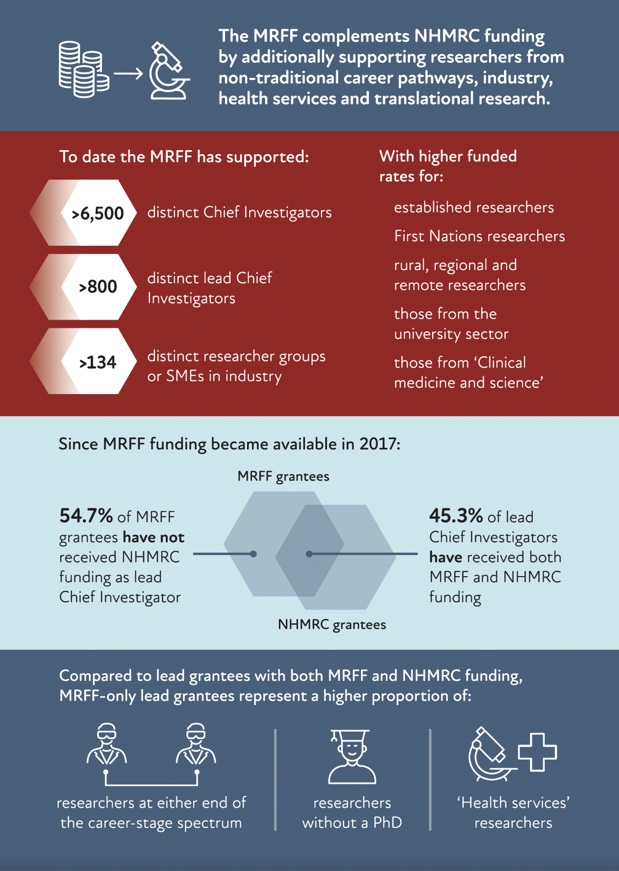

## Characteristics of researchers funded through the MRFF and NHMRC

### Summary

From the overall trends data, compared to those who had received both MRFF and NHMRC funding, there were more lead Chief Investigators who had only received MRFF funding:

in the earliest (0–5 years post-PhD) and latest (>40 years post-PhD) career stages

in the broad research area of ‘Health services’; 11.6% of those who received only MRFF funding were in the broad research area of ‘Health services’, compared to 9.7% of those who received both MRFF and NHMRC funding

who did not have a PhD; 13.4% of those who received only MRFF funding did not have a PhD, compared to 7.9% of those who received both MRFF and NHMRC funding.

First Nations lead Chief Investigators were just as likely to have received only MRFF funding as they were to have also received NHMRC funding; 4.3% of lead Chief Investigators who received only MRFF funding were First Nations, compared to 4.7% of those who received both MRFF and NHMRC funding.

When compared to the NHMRC Ideas Grants scheme, a higher proportion of NHMRC Investigator Grants grantees were also funded by the MRFF, especially for established researchers (≥10 years post-PhD). Of the NHMRC Investigator Grants grantees, the proportion who had also received MRFF funding was generally higher among women lead Chief Investigators than among men; the opposite was true for the Ideas Grants scheme.

### Career stage and PhD status

Lead Chief Investigators in either the earliest (0–5 years post-PhD) or latest (>40 years post-PhD) career stages were more likely to have only received MRFF funding than those in the middle of their careers.

Funded rates for established researchers (≥10 years post-PhD) tended to be higher than those for early- to mid-career researchers across both the MRFF and NHMRC Ideas Grants and Investigator Grants schemes (Figures 15 and 16). However, early- to mid-career researchers (considered to be those <10 years post-PhD) tended to have higher funded rates for the MRFF than for the Ideas Grants and Investigator Grants schemes (Figure 15). NHMRC Investigator Grants are track-record driven, whereas the MRFF and NHMRC Ideas Grants are for innovative projects addressing a specific question and are not assessed against track record. The MRFF also tends to support larger multi-applicant grants, which may contribute to the greater participation and mentoring of early-career researchers within project teams.

For MRFF grants, researchers without a PhD or with unknown PhD status had funded rates similar to or higher than they had for NHMRC schemes (Figure 17). This likely reflects the research areas of focus for the MRFF as a priority-led fund with a focus on translation and, consequently, stronger support for researchers in health or clinical services or industry. Again, this complements the research areas that are largely funded by the NHMRC schemes (Figure 18, based on overall trend data). While the Investigator Grants scheme had a high funded rate in 2022 for those without PhDs, this has fluctuated since 2019 and there is no obvious trend.

Figure 15 Funded rates for lead Chief Investigators less than 10 years post-PhD for the MRFF and NHMRC, 2019–2022

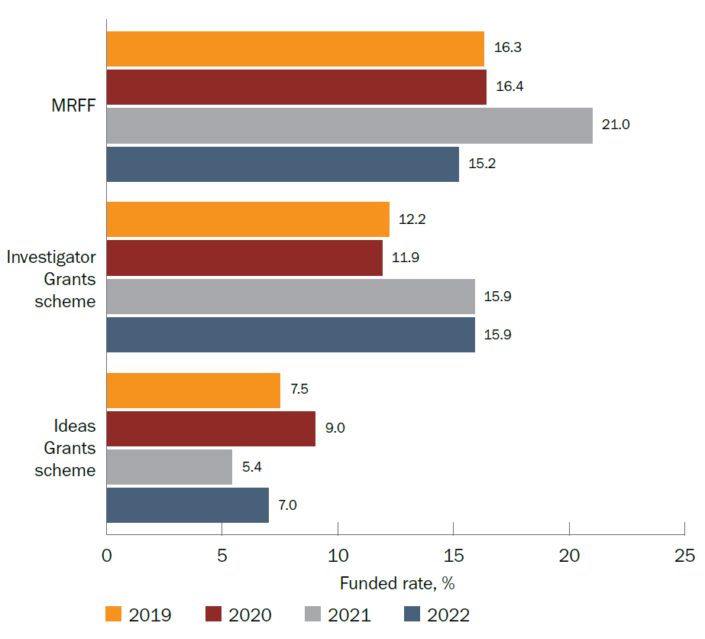

Notes:

1. Reporting is by calendar year to align with NHMRC reporting.
2. Data for other NHMRC schemes are not included as they are incomplete or unavailable.

Figure 16 Funded rates for lead Chief Investigators at least 10 years post-PhD for the MRFF and NHMRC, 2019–2022

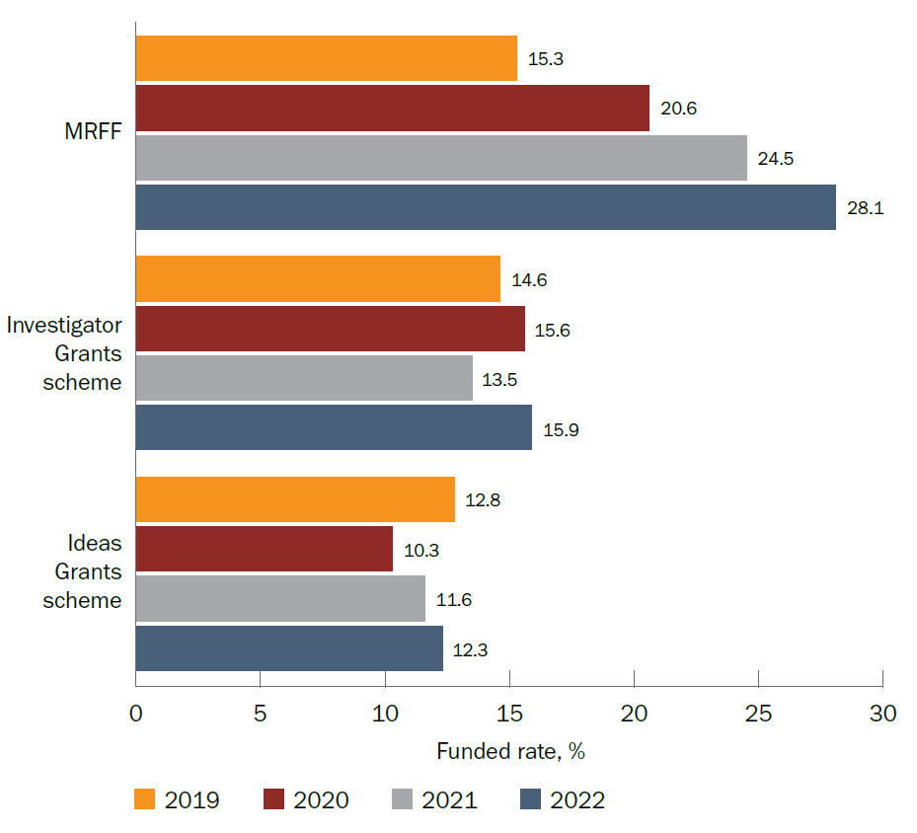

Notes:

1. Reporting is by calendar year to align with NHMRC reporting.
2. Data for other NHMRC schemes are not included as they are incomplete or unavailable.

Figure 17 Funded rates for lead Chief Investigators with no PhD or unknown PhD status for the MRFF and NHMRC, 2019–2022

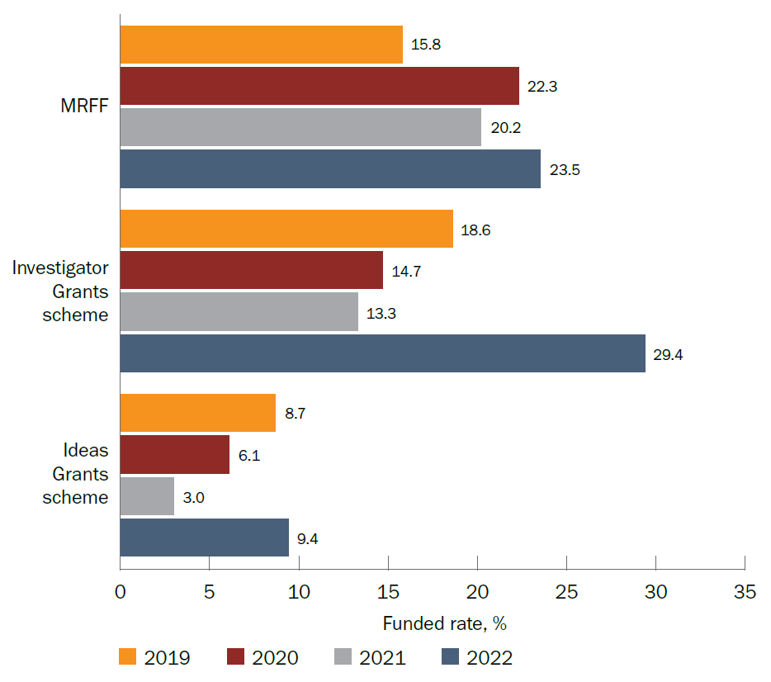

Notes:

1. Reporting is by calendar year to align with NHMRC reporting.
2. Data for other NHMRC schemes are not included as they are incomplete or unavailable.

Figure 18 Proportion of lead Chief Investigators who only received MRFF funding versus those who received both MRFF and NHMRC funding by broad research area, 2019–2022

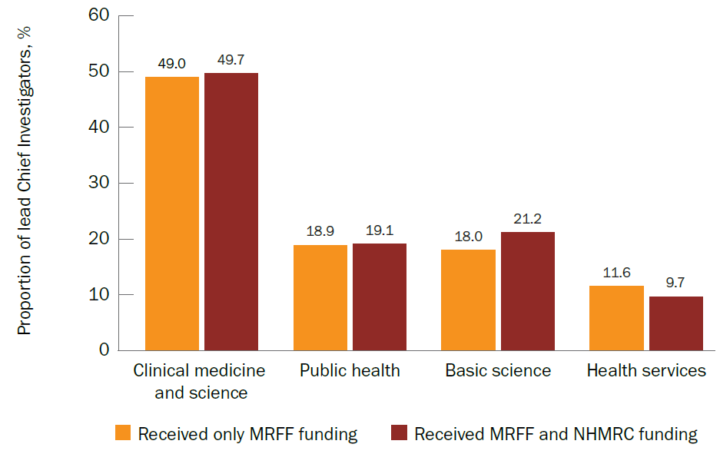

Note: Presents overall trend data, which are based on outcomes across all NHMRC schemes for which public data are available, including those pre-dating the current grants program.

### First Nations status

The number of applications from First Nations researchers over the years has generally increased for the MRFF and decreased for the NHMRC. However, funded rates have generally remained stable or increased for both funding sources, and have always been high for NHMRC Investigator Grants (Figure 19). This shows the commitment of both the MRFF and NHMRC in providing an equal opportunity for all researchers and research.

Figure 19 Number of applications and funded rates for First Nations lead Chief Investigators for the MRFF and NHMRC, 2019–2022

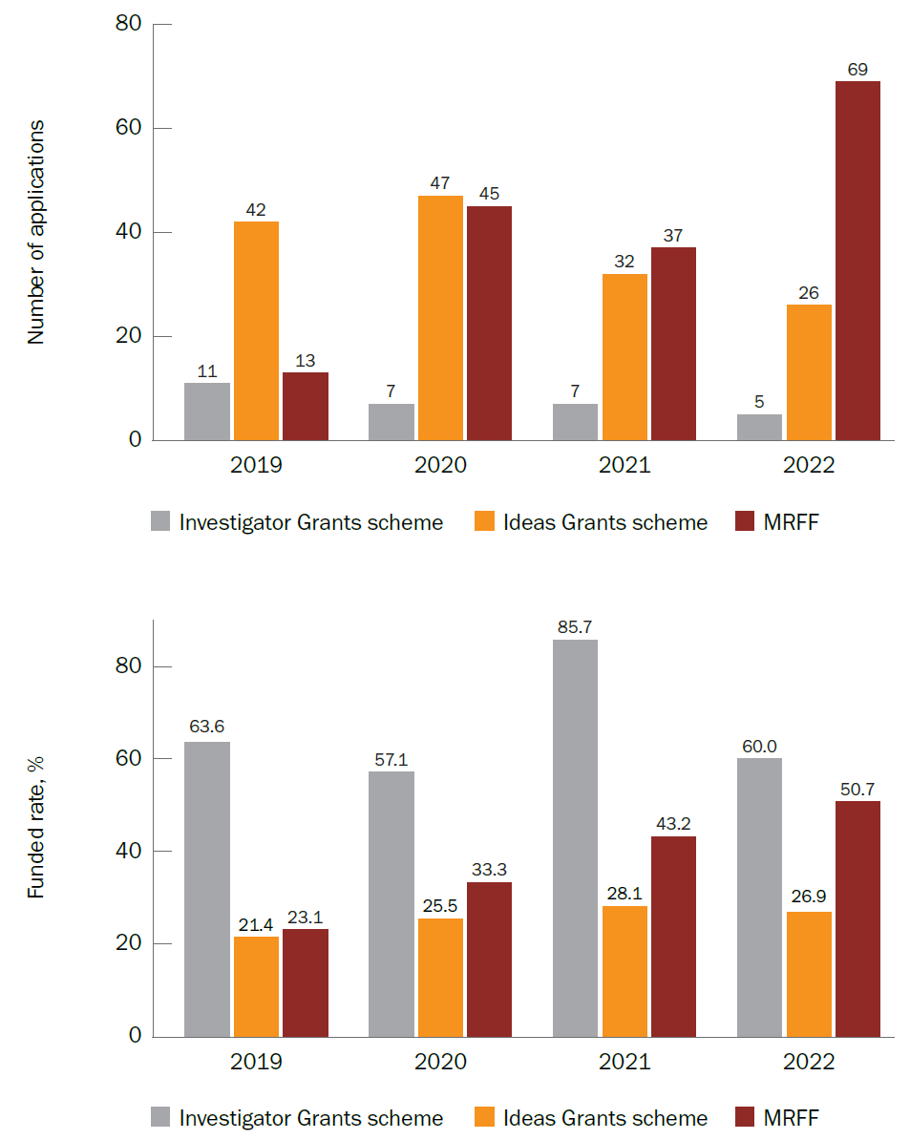

Notes:

1. Reporting is by calendar year to align with NHMRC reporting
2. Data for other NHMRC schemes are not included as they are incomplete or unavailable.

### Gender

Traditionally, there have been fewer women lead Chief Investigator applicants than men. However, in 2022, the MRFF had more women lead Chief Investigator applicants than men. This has yet to happen with NHMRC schemes, but recent trends appear promising for the Investigator Grants scheme (noting that 2023 data are incomplete and not included in this report).

Despite the general gender disparity in the number of applicants, funded rates for the MRFF and the NHMRC Ideas Grants scheme – both of which are not focused on supporting an individual Chief Investigator – have been generally similar between genders (Figure 20). This is improving with the NHMRC Investigator Grants scheme, noting that this can be attributed to the NHMRC introducing structural priority funding in 2017 and new initiatives in 2021 to address gender imbalance.

Figure 20 Funded rates for women and men lead Chief Investigators for the MRFF and NHMRC, 2019–2022

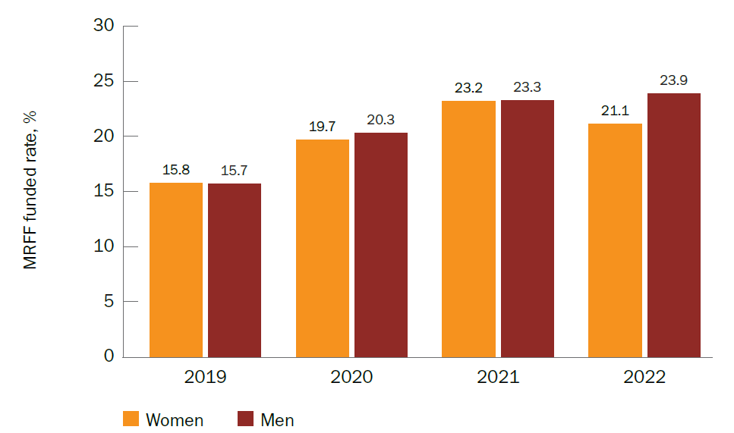

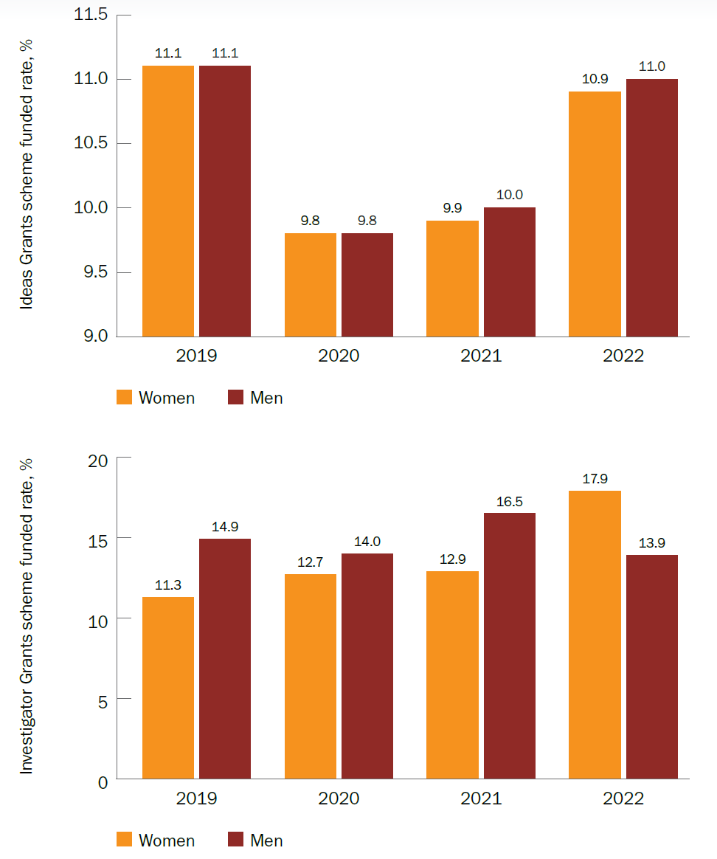

Notes:

1. Reporting is by calendar year to align with NHMRC reporting.
2. Data for other NHMRC schemes are not included as they are incomplete or unavailable.

# Conclusions

This report reveals characteristics of researchers who have received MRFF funding. MRFF applicants are of all ages and career stages; from all states and territories across Australia; from urban and rural, regional and remote areas; and from different research sectors. First Nations researchers are applying for more MRFF grants each year, with strong success rates.

About half of all MRFF applicants have more than one MRFF grant. The funded rate for distinct Chief Investigators is 37.0%, and 28.5% for distinct lead Chief Investigators. Generally, more distinct Chief Investigators and lead Chief Investigators apply to, and are funded by, the MRFF each year.

Funded rates tend to be the highest for:

established researchers

First Nations researchers

rural, regional and remote researchers

university-based researchers

‘Clinical medicine and science’ researchers.

However, funded rates are still high for researchers from other areas of research, such as ‘Public health’ and ‘Health services’. There is also a strong representation from researchers based in industry, especially SMEs.

The MRFF has also provided support to a significant proportion of researchers who have not received NHMRC funding in recent years or within the past decade as lead Chief Investigators. Furthermore, there is some evidence to suggest that these researchers are at opposite sides of the career-stage spectrum (that is, very early or very late), are more likely to not have a PhD, and are more strongly represented in the ‘Health services’ broad research area. Therefore, in addition to increasing the funding pool for traditional researchers, the MRFF is opening opportunities not previously available to researchers, particularly those in health services and those who do not follow a traditional research career pathway, as well as researchers in industry and SMEs. Also, as a priority-led funder with a focus on research translation and commercialisation, MRFF funding complements NHMRC funding, which supports investigator-led research spanning basic, applied and clinical research.

The department will continue to monitor Chief Investigator characteristics and funding rates, which are important in the broader understanding of the relative contributions of the MRFF and NHMRC to the health and medical research landscape. They also inform ongoing efforts for reform, and better alignment and coordination between the funding mechanisms.

# Appendix A Modified Monash Model

The [Modified Monash Model](https://www.health.gov.au/topics/rural-health-workforce/classifications/mmm) defines whether a location is a city, rural, remote or very remote. The model categorises geographical remoteness and population size on a 7-point scale (Table 3) that is based on the [Australian Statistical Geography Standard – Remoteness Area](https://www.health.gov.au/topics/rural-health-workforce/classifications/asgs-ra) framework.

People living in rural and remote areas find it harder to access medical services. To help address this, the Modified Monash Model was developed to better distribute the health workforce and attract health professionals to rural and remote areas. Some government programs also use the Modified Monash Model to define their eligibility requirements.

Table 3 Descriptions of Modified Monash Model categories (last updated in 2019)

| Modified Monash category | Description |
| --- | --- |
| 1 | Metropolitan areas — includes major cities |
| 2 | Regional centres — inner and outer regional areas that are within a 20 km drive to a town with a population greater than 50,000 |
| 3 | Large rural towns — inner and outer regional areas that are not MM 2 and are within a 15 km drive to a town with a population of 15,000–50,000 |
| 4 | Medium rural towns — inner and outer regional areas that are not MM 2 or MM 3 and are within a 10 km drive to a town with a population of 5,000–15,000 |
| 5 | Small rural towns — all remaining inner and outer regional areas |
| 6 | Remote communities — remote mainland areas and islands less than 5 km offshore with a population less than 1,000 |
| 7 | Very remote communities — very remote areas and all other islands that are more than 5 km offshore |

1. MRFF grant opportunities administered through the NHMRC are restricted to MRFF Eligible Organisations, whereas the BGH has no such restrictions. Furthermore, the Medical Research Future Fund Act 2015 restricts the types of entities that can receive MRFF funding to (a) a medical research institute; (b) a university; (c) a corporate Commonwealth entity; and (d) a corporation. [↑](#footnote-ref-2)
2. MRFF grant opportunities administered through the NHMRC are restricted to MRFF Eligible Organisations, whereas the BGH has no such restrictions. Furthermore, the Medical Research Future Fund Act 2015 restricts the types of entities that can receive MRFF funding to (a) a medical research institute; (b) a university; (c) a corporate Commonwealth entity; and (d) a corporation. [↑](#footnote-ref-3)