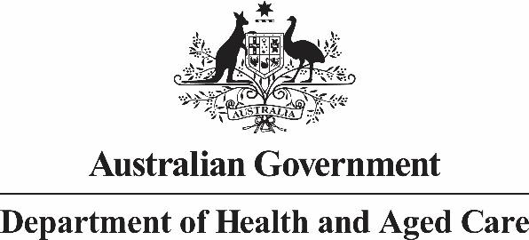

## LGBTIQA+ Health and Wellbeing 10 Year Action Plan Expert Advisory Group

## 19 September 2024 Meeting Communique

The Australian Government is continuing to progress work in improving access to care, support, and better physical health, mental health, and wellbeing outcomes for LGBTIQA+ people.

The fourth meeting for the LGBTIQA+ Health and Wellbeing 10 Year National Action Plan Expert Advisory Group (EAG) was held today, in Melbourne, on the land of the Wurundjeri People of the Kulin Nation. Assistant Minister Kearney, Chair of the EAG, opened the meeting and reflected on the progress made since the previous meeting of the EAG on 1 February 2024.

Inclusive Rainbow Voices presented on the experiences and health needs of LGBTIQA+ people with intellectual disability. The presentation outlined the barriers and challenges they face in accessing safe and appropriate health care and a lack of understanding from healthcare providers. Members noted under the National Roadmap for the Health of People with Intellectual Disability, the Government has established a National Centre of Excellence in Intellectual Disability Health.

The Department of Health and Aged Care (the Department) presented on work exploring the nature and drivers of LGBTIQA+ stigma and safety in the health care system to improve access to inclusive and safe primary care. This work informs development of the Action Plan.

The Department also presented reflections on the national consultation process with LGBTIQA+ people which has included over 25 roundtables, held across Australia. The generosity of participants in sharing their experiences and insights throughout consultation was appreciated and informs the Action Plan.

Members discussed the draft Action Plan which is intended to set the forward direction of change needed to improve the health and wellbeing of LGBTIQA+ people over the next 10 years. Members will continue to collaborate to finalise the Action Plan, expected to be released by Government by the end of 2024.

**Chair**

**The Assistant Minister for Health and Aged Care and Assistant Minister for Indigenous Health,**

**the Hon Ged Kearney MP**

**19 September 2024**

**Melbourne**