This report presents the views of the authors and does not represent the view of the Department of Health and Aged Care

|  |  |
| --- | --- |
| *Better thinking. Better advice.* | healthconsult.com.au |

Department of Health and Aged Care

Review of the Stoma Appliance Scheme

Final Report

20 March 2024

Contents

Abbreviations vi

Executive Summary 1

Recommendations 6

1. Introduction 8

2. Scheme Overview 10

3. Clinical Eligibility 15

4. Accessibility of the Scheme 22

5. The Scheme Schedule 25

6. Pricing Methodology and Alternatives 31

7. Budgetary Implications 43

8. Conclusions and Recommendations 51

Appendix A List of Stakeholders Consulted 59

Appendix B Review Topics and Questions 60

Appendix C Schedule Groups and Subgroups 62

Appendix D Overview of SPAP 64

Appendix E Comparator Schemes 65

Appendix F Budgetary Implications of Access Modifications 95

Appendix G Budgetary Implications of Pricing Changes 106

Appendix H Budgetary Implications of Time Components 114

Tables

Table 1: Key recommendations from the Review of the Scheme 6

Table 2: Restrictions definitions for the Scheme Schedule 12

Table 3: Characteristics of stoma users in Australia 13

Table 4: Gaps in current eligibility criteria of the Scheme 17

Table 5: Stoma types not currently in scope for the Scheme 19

Table 6: Barriers and enablers impacting access to the Scheme for marginalised groups 23

Table 7: Non-essential products on the Scheme and justification for potential removal 27

Table 8: Advantages and disadvantages of current pricing methodology 33

Table 9: Advantages and disadvantages of price-setting options 36

Table 10: Potential price update options and their advantages and disadvantages 39

Table 11: Costs associated with expanding clinical eligibility 45

Table 12: Access modifications: summary of expenditure changes and number of ostomates impacted, 2022-23 46

Table 13: Pricing changes: summary of expenditure changes 48

Table 14: Time components: summary of expenditure changes 50

Table 15: Budgetary implications of 19 agreed scenarios 56

Table 16: Key stakeholders consulted throughout the Review 59

Table 17: Review Topics and accompanying Research Questions 60

Table 18: Scheme Schedule Groups and Subgroups 62

Table 19: Summary of jurisdictional schemes compared with the Scheme 65

Table 20: Description of jurisdictional comparator Schemes 66

Table 21: Comparator national Australian schemes 87

Figures

Figure 1: The two components of the Scheme Review 8

Figure 2: Methodology of the Review 9

Figure 3: Overview of the Stoma Appliance Scheme 10

Figure 4: Quantity by month and year 15

Figure 5: Expenditure by month and year 16

Figure 6: Ostomate access by MMM 24

Figure 7: Proportion of products in Groups 1 to 7 with premium vs benchmark price, 2022-23 32

Figure 8: Average price of products in Groups 1 to 7, 2022-23 32

Figure 9: Average price of products in Groups 8 to 11, 2022-23 33

Figure 10: Annual expenditure and products dispensed on the Scheme 43

Figure 11: Quantity of dispensed products by main group 44

Figure 12: Expenditure on Scheme products by main group 44

Figure 13: Access modifications: expenditure changes vs number of ostomates impacted, 2022-23 47

Figure 14: International comparison of the unit price of five core products under indexation and one-off price increases 49

Figure 15: Comparator international stoma schemes summary 77

Figure 16: Comparator international stoma schemes 78

Figure 17: Features national schemes in comparison with the Scheme 86

Figure 18: Expenditure related to creams and ointments if removed or restricted on the Scheme 95

Figure 19: Expenditure related to catheters if removed from the Scheme 96

Figure 20: Catheter users by stoma type, 2022-23 97

Figure 21: Expenditure related to deodorants if removed from the Scheme 98

Figure 22: Expenditure related to cleanser wipes if removed from the Scheme 99

Figure 23: Expenditure related to low-utilisation products if removed from the Scheme 100

Figure 24: Expenditure related to closed bag systems if maximum quantity was decreased 50% on the Scheme 101

Figure 25: Expenditure related to plug systems if maximum quantity was increased 100% on the Scheme 102

Figure 26: Expenditure related to increasing maximum quantity of caps on the Scheme 103

Figure 27: Expenditure related to increasing the maximum quantity of seals on the Scheme 104

Figure 28: Expenditure related to increasing the maximum quantity of seals on the Scheme 105

Figure 29: Expenditure related to backdating indexation on unit prices on the Scheme 107

Figure 30: Expenditure related to ongoing indexation on unit prices on the Scheme 108

Figure 31: Expenditure related to backdated and ongoing indexation on unit prices on the Scheme 109

Figure 32: Expenditure related to a one-off increase in benchmark prices for core products on the Scheme 110

Figure 33: Expenditure related to a one-off increase in premium prices for select products on the Scheme 111

Figure 34: Expenditure related to a one-off increase in benchmark and premium prices 112

Figure 35: Expenditure related to a one-off increase in benchmark and premium prices followed by annual indexation 113

Figure 36: Expenditure related to increases in ostomate numbers on the Scheme 114

Abbreviations

ABF Activity Based Funding

ABN Australian Business Number

ABS Australian Bureau of Statistics

ACC Adults with Chronic Conditions

ACE Antegrade Continence Enema

ACSA Australian Council of Stoma Associations

ACT Australian Capital Territory

ACTES ACT Equipment Scheme

AHPRA Australian Health Practitioner Regulation Agency

ALTER Assistive Living Technologies Equipment Resources

ARM Anorectal malformation

ARTG Australian Register of Therapeutic Goods

AT Assistive technology

CA Continence Aids

CAC Clinical Advisory Committee

CAEP Community Aids and Equipment Program

CAHO Chief Allied Health Officer

CALD Culturally and linguistically diverse

CAPS Continence Aids Payment Scheme

CPI Consumer Price Index

DHS Department of Human Services

DMEPOS Durable Medical Equipment, Prosthetics, Orthotics, and Supplied

DoHAC Department of Health and Aged Care

DVA Department of Veterans' Affairs

EB Epidermolysis bullosa

HCP Home Care Package

HME Heat and Moisture Exchange

HPOS Health Professional Online Services

HTA Health Technology Assessment

IA Imperforate anus

IHACPA Independent Health and Aged Care Pricing Authority

LAC Local Area Coordinator

LARS Low anterior resection syndrome

MACE Malone Antegrade Continence Enema

MAIB Motor Accidents Insurance Board

MASS Medical Aids Subsidy Scheme

MBS Medicare Benefits Schedule

MMM Modified Monash Model

MS Multiple sclerosis

NDIA National Disability Insurance Agency

NDIS National Disability Insurance Scheme

NDSS National Diabetes Services Scheme

NEBDS National Epidermolysis Bullosa Dressing Scheme

NHS National Health Service

NSW New South Wales

NT Northern Territory

PBS Pharmaceutical Benefits Scheme

PSD Public Summary Documents

QHSSL Queensland Heat Moisture Exchange Subsidy Scheme for Laryngectomy

SIA Stoma Industry Association

SPA Speech Pathology Australia

SPAP Stoma Product Assessment Panel

SPR Statutory price reductions

STN Stomal Therapy Nurses

TEP Territory Equipment Program

UK United Kingdom

VAEP Victorian Aids and Equipment Program

WA Western Australia

1. Executive Summary
   1. Overview

The Stoma Appliance Scheme (the Scheme) commenced in 1975 as a federally funded program that now provides fully subsidised stoma appliances and products to approximately 49,000 Australian ostomates each year.

The Scheme’s Schedule (the Schedule) lists all the stoma products and appliances that are subsidised. The Schedule lists around 3,600 stoma appliances which assist people with stomas to better manage their condition and allow greater participation in society and the workforce.

To access subsidised products under the Scheme, ostomates must be a member of one of the 19 approved stoma associations and complete Services Australia’s PB049 form which collects information to determine eligibility. Stoma associations are not-for-profit organisations that order and distribute stoma-related products on behalf of ostomates. Stoma associations then claim the cost of stoma products through Services Australia. An administration fee is paid to stoma associations to cover distribution costs, in addition to the cost of products.

The Schedule sets monthly or annual quantity limits, with provisions for extra supplies with authorisation (i.e. approved clinician that completes a PB050 form). Stoma product suppliers seek listing on the Schedule through the Application and Assessment Guidelines, that are evaluated by the independent Stoma Product Assessment Panel (SPAP) that are appointed by the Department of Health and Aged Care.

* 1. Context for the Review

The 2023-24 Budget included a commitment to undertake a comprehensive Review (the Review) of the Scheme. The Review aimed to ensure the Scheme’s clinical eligibility aligns with the Scheme's principles, considers new types of stomas, avoids duplication with other schemes, maintains appropriate products on the Schedule, and review the pricing methodology.

Whilst clinical eligibility for the Scheme has been reviewed periodically due to advances in surgery and for specific conditions, there has been no comprehensive review of the Scheme that considers clinical eligibility, accessibility by marginalised groups, the appropriateness and necessity of products on the Schedule, or the method by which product prices in the Schedule are set, reviewed or updated.

Additionally, in 2022-23, expenditure for the Scheme has peaked at $114m, with product usage also continuing to rise year-on-year despite the relatively stable number of ostomates accessing the Scheme.

This Review has considered all these factors to ensure the Scheme continues to meet its intended objectives whilst uncovering opportunities to improve efficiencies and accessibility, and potentially curb rising expenditure in a way that continues to meet the needs of ostomates and other stakeholders.

* 1. Key findings of the Review
     1. Clinical eligibility

The Scheme has undergone periodic reviews of clinical eligibility, adapting to advances in surgical techniques and specific medical conditions. The eligibility definition has been expanded to include various stoma types, such as neo-anus openings, fistulas, and biliary stomas. Notably, recent changes in 2021 and January 2022 incorporated patients with neo-anus openings due to anorectal malformation (ARM), imperforate anus (IA), Malone Antegrade Continence Enema (MACE), and Mitrofanoff stoma subtypes. These additions and formal recognition of eligibility closed previous gaps which existed for ostomates accessing subsidised products on the Scheme.

Whilst there were overall increases in expenditure and usage of the Scheme over the past three years, an analysis of the data suggests that the introduction of new stoma types did not drive the increases. While limitations in the data made it challenging to assess participant numbers, stakeholder feedback and available data indicate a stable ostomate count. The temporary nature of some stomas contributes to individuals transitioning off the Scheme while new ostomates join.

Stakeholders generally affirm that the Scheme addresses clinical eligibility effectively. However, certain conditions, technically meeting eligibility criteria of stomas which facilitate the removal of waste products from the gastrointestinal (GI) tract, face challenges in formal recognition during application. Notably, this includes Antegrade Continence Enema (ACE) stomas, esophagostomies, nephrostomies, and vesicostomies, which often require additional support letters.

Varied interpretations of eligibility criteria exist among stakeholders, leading to potential inconsistencies in application. Publishing a set list of eligible stoma types to reduce interpretation discrepancies would improve clarity. Some stakeholders proposed modifications to the criteria, incorporating GI tract dysfunction, to include individuals with conditions like Hirschsprung's disease, multiple sclerosis (MS), or Low anterior resection syndrome (LARS).

Stoma types which exist outside of the GI tract including thoracostomy, pharyngostomy, and wound management requiring drainage, or within the GI tract but not for the removal of waste including tracheostomy and gastrostomy were generally supported by stakeholders to remain out of scope, with exceptions for vesicostomy and esophagostomy, which some consider fitting into the eligibility criteria.

Advances in stoma care primarily involve enhancements in product design, including water-repellent materials, improved fastening mechanisms, and skin protective technologies. Notable advancements like hydrocolloid adhesives and precision surgery techniques positively impact ostomates' physical wellbeing. However, the most up-to-date products in international markets are reportedly not available in Australia due to limitations in the current pricing methodology.

* + 1. Duplication with other government schemes

The Scheme is the sole stoma scheme offered in Australia, with no duplication or overlap identified with other national schemes or state and territory-funded medical appliance or equipment schemes. Stakeholder consultation and documentation review highlight the absence of redundancy, reinforcing the uniqueness and targeted focus of the Scheme.

* + 1. Accessibility

Stoma care is crucial for individuals across diverse demographics, including those in rural and remote locations, First Nations people, financially disadvantaged individuals, and those from culturally and linguistically diverse (CALD) backgrounds.

While the Scheme is available to all ostomates, challenges exist for marginalised groups, including barriers to accessing stoma equipment and advice. Particularly of concern was adequate access to stoma care and advice from Stomal Therapy Nurses (STNs) in rural and remote areas.

There were mixed responses from ostomates regarding out-of-pocket costs which indicate varied experiences with the healthcare system, with some opting for private health cover for their specialist and surgical care needs due to public system barriers, while others find the Scheme sufficient.

Barriers to access for marginalised groups include longer delivery times in rural areas, language-related challenges, health literacy issues, and inadequate access to STNs and other healthcare professionals when needing authorisation to access to restricted products on the Schedule.

* + 1. Products on the Schedule

The Scheme, aimed at providing subsidised appliances and products to eligible ostomates, has not undergone a comprehensive review of all products, pricing, and groups since 2010.

The Schedule offers approximately 3,600 products and appliances to support ostomates. The wide availability and range are viewed positively by stakeholders, supporting patient choice, individual needs, and preferences in stoma care. Clinician feedback justifies the extensive product range, considering various factors such as weight, body shape, physicality, job, and climate. Stakeholders argue that maintaining this range is crucial for patient-centred care.

Products such as deodorants, creams and ointments, cleanser wipes and catheters were questioned for their appropriateness on the Scheme with considerations of clinical evidence and alignment with stoma care guidelines. Specifically, some STNs expressed varying views on the need for certain products in the Accessories category, particularly cleanser wipes and deodorants, suggesting potential removals based on clinical necessity.

Concerns were raised about the Scheme supporting older technology and products that may no longer align with STN recommendations. Analysis of product utilisation rates aimed to identify opportunities to remove low-utilisation products and support better clinical outcomes was undertaken. Stakeholders suggested adjustments to maximum quantities of products, such as increases in plug systems and bags and seals, and decreases in closed bag systems, based on patient needs and potential wastage concerns.

Concerns were raised about potential wastage due to ostomates and suppliers over-ordering products deemed unnecessary or influenced by marketing efforts. Reasons for over-ordering included ostomates' lack of understanding, marketing influence, self-prescription, and fear of running out of products.

* + 1. Pricing methodology

The current Scheme employs benchmark and premium pricing, ensuring transparency and uniformity among manufacturers. Absence of indexation since 2013 is a significant concern for product suppliers, potentially eroding profit margins for suppliers, as the costs of labour, and raw materials have increased. Additionally, there has been no review or update of benchmark pricing since 2013, leading to outdated pricing and an inability to adapt to market changes. Alternative price-setting methods were discussed with stakeholders:

* **Tendering:** Stakeholders were sceptical about its feasibility due to the extensive product range, fearing inefficiency and potential limitation of essential products.
* **Negotiation:** Partial support, especially from product suppliers, with concerns about administrative complexities for individual pricing.
* **Cost-Based Pricing:** Unanimous disagreement among stakeholders, indicating a preference for maintaining the current benchmark and premium pricing model.

Stakeholders supported a continuation of the current approach for price-setting of reference (benchmark) and premium pricing as it is well-established, links similar products for cost minimisation, and provides transparency across product suppliers. However, there was strong support from stakeholders for the inclusion of indexation and/or regular price reviews within this current structure, citing inflation and the need for mechanisms to address rising costs. Stakeholders did not support introducing a discounting mechanism or cost-based pricing method to the Scheme.

Overall, the Scheme's current pricing methodology lacks regular reviews and/or indexation, and mechanisms to adapt to changing market dynamics. Yet, stakeholders prefer maintaining the current benchmark and premium pricing approach with the inclusion of indexation and/or price reviews for sustainability.

* + 1. Budgetary implications

Nineteen agreed scenarios were modelled, and the budgetary implications assessed. The analysis identified some cost-saving measures, such as the removal of certain products and/or reduction of product quantities, to contribute to enhancing the Scheme’s cost-effectiveness. Conversely, some scenarios resulted in modifications to the Scheme which require additional expenditure, such as the modifying quantities for clinically necessary products and adjustments to benchmark prices through one-off pricing reviews or indexation.

Budgetary implications for the access modification scenarios tested resulted in two scenarios with cost savings greater than 1%: Scenario Five (cleanser wipes removed), and Scenario Seven (decreasing the maximum annual quantity of closed bag systems). However, these scenarios impacted many ostomates (19,229 and 7,202 ostomates respectively).

The largest additional cost for FY23-24 and beyond occurs under Scenario 18 (one-off price increase for all products in 2023-24 plus ongoing indexation from 2024-25) which results in an additional $11,331,439 in expenditure in 2023-24, and an additional $22,290,678 in 2025-26. Scenario 14 (backdated and ongoing annual indexation) similarly results in an additional $11,255,981 in FY23-24 AND reaches an additional $22,100,577 by FY25-26. Applying ongoing annual indexation, based on the 5-year average of Consumer Price Index (CPI) (as in Scenario 13), results in an additional $3,971,406 in expenditure if it were applied for FY23-24, whilst a one-off price increase in benchmark prices (Scenario 15) results in $7,213,057 extra expenditure compared to the forecast following current trend. By 2025-26, this extra expenditure under Scenario 13 reaches $13,540,275, or $7,764,193 under Scenario 15.

* + 1. Conclusion

Overall, the Review found:

* **Clinical eligibility assessment:** The Scheme has adapted well to advancements in surgical techniques and medical conditions. Recommendations include maintaining the focus on GI tract stomas and clarifying the eligibility criteria.
* **Support from other government schemes:** The Scheme is unique and does not duplicate other schemes. Concerns about Continence Aids Payment Scheme (CAPS) falling short in covering consumers costs were raised, and addressing this gap should be the responsibility of CAPS, rather than the Scheme.
* **Accessibility for marginalised groups:** There are challenges being experienced in Scheme accessibility by marginalised groups. Recommendations include improving access to STNs, implementing health literacy initiatives, streamlining ordering processes, and expanding support networks.
* **Products on the Schedule:** The Schedule offers a wide range of products, and stakeholders generally support its diversity. There are concerns about outdated technology and wastage of products because of insufficient access to STNs. Recommendations include rationalising products on the Schedule, reviewing maximum quantities, and addressing over-ordering issues.
* **Methodology for product pricing:** The current benchmark and premium pricing model is favoured by stakeholders. Concerns about lack of indexation and pricing updates were raised. Recommendations include maintaining the current pricing model, introduction of an immediate and then regular ongoing price reviews, and improve the premium pricing application process.
* **Budgetary implications:** Various scenarios were tested, indicating either potential cost savings or additional expenditure requirements.

1. Recommendations

The 10 recommendations formulated based on the Review findings, summarised in to Table 1, aim to enhance the Scheme’s efficiency, accessibility, and sustainability while addressing the needs of ostomates and aligning with the financial constraints of the program.

Table 1: Key recommendations from the Review of the Scheme

|  |  |
| --- | --- |
| Recommendation No. | Recommendation statement |
| Clinical Eligibility | |
| Recommendation #1 | The Scheme should maintain its focus on stomas originating from the GI tract for the removal of waste and neo-anus openings, refraining from expanding eligibility to cover non-GI stomas. |
| Recommendation #2 | Clarify and standardise the eligibility criteria to mitigate potential inconsistencies in application, by publishing a set list of eligible stoma types alongside the clinical eligibility criteria in the SAS Operational Guidelines. |
| Recommendation #3 | Address gaps in Schedule’s product offerings for paediatric stomas by exploring the possibility of engaging with suppliers who can provide the necessary products to enhance the Scheme. |
| Recommendation #4 | Maintain the intended objectives of the Scheme and do not modify the criteria to include GI tract dysfunction conditions where patients do not have a stoma or where a stoma is not for the removal of waste. |
| Overlap with other schemes | |
| No duplication or overlap was identified with other national schemes or state and territory-funded medical appliance or equipment schemes; therefore, no recommendations have emerged from the Review in this domain. | |
| Access for marginalised groups | |
| Recommendation #5 | Review and implement strategies to enhance accessibility to the Scheme, including: (1) improving access to STNs; (2) implement health literacy initiatives; (3) streamline ordering processes to reduce administrative burdens on ostomates; and (4) expand support networks to ensure that marginalised groups have adequate assistance in navigating the Scheme and addressing their needs. |
| Product range | |
| Recommendation #6 | Implement a strategic approach to rationalise products on the Schedule (e.g. introduction of STN approval to dispense certain products) to enhance appropriateness, minimise wastage, and optimise expenditure to rationalise products on the Schedule, leveraging opportunities to remove products that may not be clinically necessary and/or adjusting product quantities that lead to cost savings. For consideration is the removal of non-clinically necessary products such as cleanser wipes, deodorants, and creams and ointments, and reducing maximum quantities subsidised for closed bag systems. |
| Pricing methodology | |
| Recommendation #7 | Maintain the current benchmark and premium pricing model. |
| Recommendation #8 | Undertake an immediate price review of benchmark products, with a view to implement regular price reviews (every three years) into the Scheme pricing model. |
| Recommendation #9 | Review the process for assessing premium pricing applications and enhance transparency in the process. This could involve clearer guidelines for application requirements and improved communication of decisions, along with providing an opportunity for suppliers to respond to evaluation questions before SPAP decision-making. Reviewing this process also provides an opportunity to develop a framework or supporting mechanism to assist suppliers in generating the relevant evidence to demonstrate value for premium-priced products and will continue to ensure innovative technologies are assessed in a robust way. |
| Recommendation #10 | Implement a cost recovery mechanism from suppliers to offset the increased administration costs of Government associated with the introduction of a regular price review process. |

# Introduction

The Department engaged **HealthConsult** to undertake a comprehensive review of the Scheme, specifically to review the Scheme’s clinical eligibility and pricing of products.

## Background of the Stoma Appliance Scheme

The Scheme is a federally funded program that provides stoma appliances and products to approximately 49,000 Australian ostomates.

The Scheme commenced in 1975 under Section 9A of the National Health Act 1953, which permits the Minister to make arrangements for the provision of aids and appliances. The Scheme provides fully subsided access to around 3,600 stoma appliances. Products supplied under the Scheme assist people with stomas to better manage their condition, and thereby allow greater participation in society and the workforce.

Products are provided free of charge. This saves each ostomate an average of over $2,300 per year. In 2022-23, the Scheme provided ostomates with $114 million worth of stoma appliances and products.[1]

## Purpose and scope of the Review

There were two components to the Review including:

1. Review the Scheme’s clinical eligibility, and
2. Review the Scheme’s pricing of products.

Figure 1 describes the components of the Review and the included scope.

Figure 1: The two components of the Scheme Review

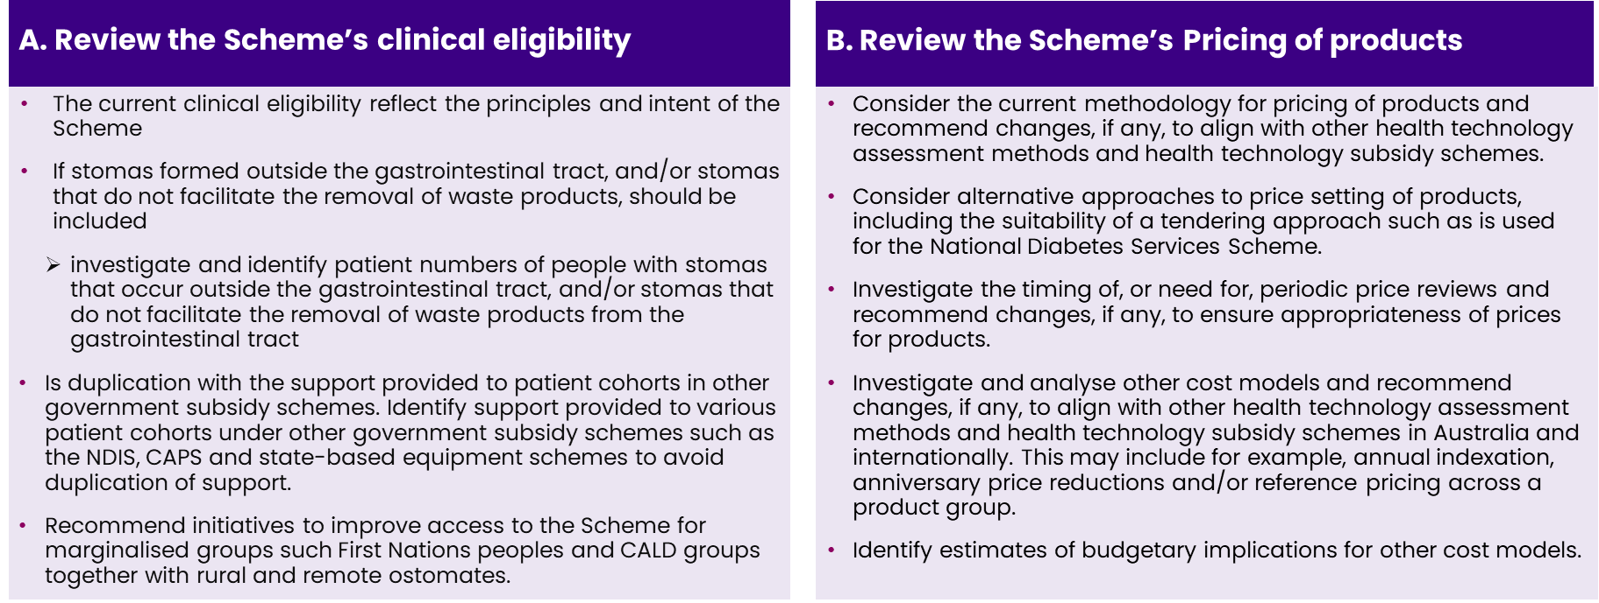

## Review Methodology

Figure 2 presents the methodology and the deliverables for each stage of the Review. The Review methodology used mixed-methods research, along with participatory consultation with key stakeholder groups to gather expectations and to validate and refine our findings. The list of stakeholders consulted throughout the Review is available in Appendix A.

Figure 2: Methodology of the Review

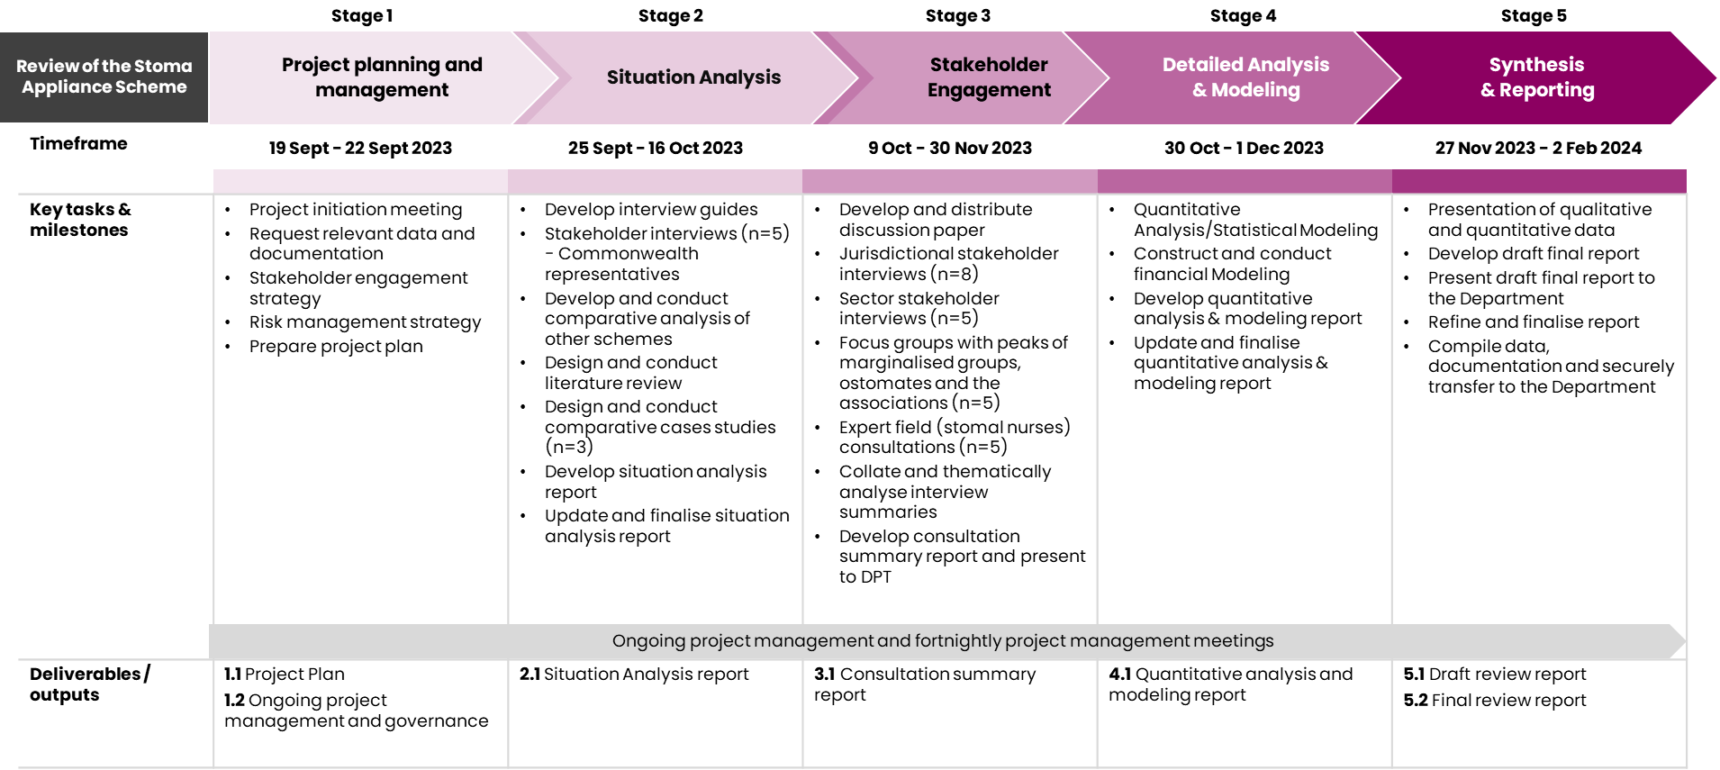

## Review questions

The Review was guided by a Review Framework that included nine Topic Areas and 30 Review Questions (Appendix B). The Framework guided data collection, assisted in identifying relevant literature and informed the targeting of stakeholder consultations.

## Purpose of the document

This draft final report provides an overview of the key learnings and findings identified through the Review process. The structure of this report is as follows:

* **Chapter 2** an overview of the Scheme and characteristics of ostomates accessing it.
* **Chapter 3:** a summary of the key clinical eligibility themes and feedback.
* **Chapter 4:** findings related to the accessibility of the Scheme for marginalised groups.
* **Chapter 5:** an overview of the products available on the Schedule, and details issues and feedback which arose throughout the Review.
* **Chapter 6:** an overview of the current pricing methodology, and key considerations for alternative approaches and their feasibility.
* **Chapter 7:** an assessment of the budgetary implications associated with the proposed changes to the Scheme.
* **Chapter 8:** provides the key recommendations to emerge from the Review.

# Scheme Overview

This Chapter provides a high-level overview of the Scheme and how it supports individuals with stomas in Australia. It details the structure and components of the Scheme, outlining its key processes as well as the key characteristics and the types of stomas which people have accessing the Scheme.

## Overview

Figure 3 provides a visual representation of the Scheme and its various components.

**Stoma Appliances**

**Eligible Stoma Appliances**

**Stoma Appliance Manufacturers and Suppliers**

PRODUCTS

Figure 3: Overview of the Stoma Appliance Scheme

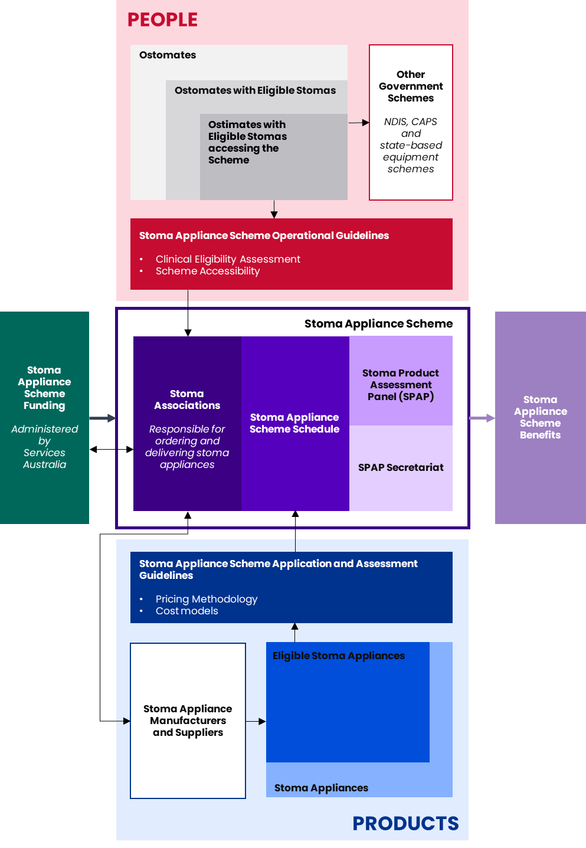

Source: HealthConsult informed by documentation review

### Clinical eligibility

To be eligible for free stoma appliances and products under the Scheme, a person must have a stoma (definition below), be an eligible person within the meaning of the Health Insurance Act 1973, reside in Australia and have one of the following: a current Medicare or Department of Veterans’ Affairs number, Australian Reciprocal Medicare number, or Australian passport number.

The current Ministerially approved clinical eligibility in the Scheme’s Operational Guidelines provides access to people who:

have a temporary or permanent artificial body opening (created surgically or otherwise, including a fistula that originates from the urinary or gastrointestinal tract) which facilitates the removal of urine and/or products of the gastrointestinal tract from the body where the person does not have normal gastrointestinal or bladder functions, and provide evidence, consisting of a certificate from a registered medical practitioner or STN (Stoma Therapy Nurse) in an approved form (Services Australia form PB049).[2]

Clinical eligibility for the Scheme has been reviewed periodically due to advances in surgery and for specific conditions. For example, in 2021, the then Minister for Health agreed that patients with a neo-anus opening created due to ARM or IA, MACE and Mitrofanoff (also known as appendicovesicostomy) stoma subtypes meet the eligibility requirements for the Scheme. Additionally, in January 2022 it was agreed that patients with biliary stomas meet the eligibility for the Scheme.

### Access to products

To access subsidised products under the Scheme, ostomates must be a member of one of the 19 approved stoma associations. Stoma associations are not-for-profit organisations that order and distribute stoma-related products on behalf of ostomates. Stoma associations must be members of the Australian Council of Stoma Associations (ACSA).

These stoma associations purchase stoma-related products from suppliers and distribute them to their members when products are ordered, generally monthly. Stoma associations then claim the cost of stoma products through Services Australia. An administration fee is paid to stoma associations, in addition to the cost of products, to account for distribution costs. Services Australia reimburses stoma associations for products at the listed price on the Scheme Schedule, plus a 2.75% distribution fee.

### The Scheme Schedule

Appendix C summarises the main groups and subgroups by number of products on the Scheme. Each product on the Schedule has a description and contains the Scheme and company product codes, pack size, maximum issue and price that suppliers can charge.

Certain products on the Schedule are subject to restrictions. Where a product is subject to a restriction, the restriction group is identified as part of the product description on the Schedule. Table 2 describes the Restriction definitions.

Table 2: Restrictions definitions for the Scheme Schedule

|  |  |
| --- | --- |
| Restriction Group | Definition |
| R1 | Requires STN, Nurse Practitioner, Registered Nurse or Registered Medical Professional authorisation |
| R2 | No authority for an increase in the yearly allocation can be granted |
| R3 | Strict Usage Restriction – Requires STN, Nurse Practitioner, Registered Nurse or Registered Medical Professional authorisation including clinical justification |
| R4 | Strict Usage Restriction – Requires Colorectal or General Surgeon authorisation |

### Governance

Sponsors apply to have their products listed on the Scheme Schedule in line with the processes outlined in the Application and Assessment Guidelines. The SPAP is an independent technical advice panel appointed by the Department, whose primary role is to consider applications from sponsors for the listing of new products on the Schedule and to make recommendations to Government regarding those applications. More information on SPAP and their processes for listing products is available in Appendix C.

The Department oversees and supports the SPAP and monitors Scheme access and compliance of stoma associations. The Department works closely with Services Australia, which administers payments made under the Scheme and liaises with the ACSA on Scheme-related issues.

## Stomas and characteristics of ostomates supported under the Scheme

Stomas come in three primary forms:

1. **Colostomy:** openings made in the abdomen originating from locations throughout the large intestine (or colon).
2. **Ileostomy:** an opening originating from the ileum of the small intestine / bowel.
3. **Urostomy:** an opening diverting urine from the bladder via the small intestine.

In addition to the most common types described above, Table 3 describes each of the stoma types in scope of the Scheme, the causes for the stoma, an indication of the types of appliances required and the average expenditure per ostomate for each stoma type. **At this point in time, no data is captured on the specific stoma type outside of the three primary forms outlined above**. In the data, where the stoma type is indicated as ‘Other’, the below figures have combined them.

Table 3: Characteristics of stoma users in Australia

|  |  |  |  |
| --- | --- | --- | --- |
| Stoma type | Causes/reasons for a stoma | Proportion of ostomates with this stoma on SchemeA | Expenditure per ostomateA |
| Colostomy | * Bowel cancer * Inflammatory bowel diseases (Crohn’s Disease, Ulcerative Colitis) * Diverticulitis * Bowel obstruction * Trauma * Birth abnormalities * Genetic disorders * Neurological disorders | **47.3%**  (5.2% of these have two stomas, and 0.1% of these have three stomas) | |  |  |  |  | | --- | --- | --- | --- | | **Expenditure ($)** | **One stoma** | **Two stomas** | **Three stomas** | | Min | $20 | $366 | $921 | | Average | $2,655 | $4,900 | $7,602 | | Median | $2,434 | $4,431 | $5,168 | | Max | $16,890 | $21,329 | $39,681 | |
| Ileostomy | * Bowel cancer * Inflammatory bowel diseases (Crohn’s Disease, Ulcerative Colitis) * Diverticulitis * Bowel obstruction * Trauma * Birth abnormalities * Genetic disorders * Neurological disorders | **31.8%**  (3.0% of these have two stomas, and 0.1% of these have three stomas) | |  |  |  |  | | --- | --- | --- | --- | | **Expenditure ($)** | **One stoma** | **Two stomas** | **Three stomas** | | Min | $38 | $366 | $526 | | Average | $2,555 | $4,505 | $3,731 | | Median | $2,224 | $3,918 | $3,207 | | Max | $21,797 | $14,431 | $7,795 | |
| Urostomy | * Bladder cancer * Bladder obstruction * Trauma * Birth abnormalities * Genetic disorders * Neurological disorders | **17.7%**  (13.6% of these have two stomas, and 0.2% of these have three stomas) | |  |  |  |  | | --- | --- | --- | --- | | **Expenditure ($)** | **One stoma** | **Two stomas** | **Three stomas** | | Min | $34 | $490 | $526 | | Average | $2,164 | $5,042 | $8,082 | | Median | $1,971 | $4,563 | $5,484 | | Max | $9,352 | $21,329 | $39,681 | |
| Biliary stomas (cholecystostomy) | * Biliary duct obstruction | **6.5%**  (Combined in ‘Other’)  (8.8% of these have two stomas, and 0.6% of these have three stomas) | |  |  |  |  | | --- | --- | --- | --- | | **Expenditure ($)** | **One stoma** | **Two stomas** | **Three stomas** | | Min | $27 | $447 | $526 | | Average | $2,475 | $4,531 | $7,649 | | Median | $2,087 | $3,844 | $5,188 | | Max | $22,531 | $14,207 | $39,681 | |
| Neo-anus openings | * ARM * IA * Bowel obstruction * Trauma * Birth abnormalities * Genetic disorders * Neurological disorders |
| Malone Antegrade Continence Enema | * Faecal incontinence * Spina bifida * Birth abnormalities * Genetic disorders * Neurological disorders |
| Mitrofanoff stoma (appendicovesicostomy) | * Spina bifida * Bladder exstrophy * Bladder obstruction |
| Fistulae (enterocutaneous, enteroatmospheric, urocutaneous) | * Inflammatory bowel diseases (Crohn’s Disease, Ulcerative Colitis) * Trauma |

Source: A: based on FY22-23 PBS data. There were 1,011,578 data entries and 48,770 unique ostomate IDS. 169,900 orders (16.8%) had information regarding stoma type, as this data was only available from March 2023 onwards. As such, it was assumed that the stoma type seen from March 2023 was the same for all blank entries before this date. For example, an ostomate with 5 orders after March 2023 listed as stoma type Colostomy but 13 orders before March 2023 with blank stoma type data would be assumed to have 18 orders with Colostomy type across FY22-23, and the annual expenditure for this ostomate would include all 18 orders. This assumption meant that stoma type was imputed for 33,446 or 68.6% of ostomate IDs. The average cost of the remaining 15,324 ostomates without stoma type information was $1,364.

# Clinical Eligibility

This Chapters provides a summary of the key clinical eligibility themes that emerged during the situational analysis and stakeholder consultations throughout the Review.

## Current clinical eligibility

To be eligible for free stoma appliances and products under the Scheme, a person must have a stoma as defined by the current Ministerially approved clinical eligibility in the Scheme’s Operational Guidelines (see Section 2.1.1).

Clinical eligibility for the Scheme has been reviewed periodically due to advances in surgery and for specific conditions. Recent changes include:

* 2021: addition of patients with a neo-anus opening created due to ARM or IA[3],MACE[4] and Mitrofanoff stoma[5] subtypes.
* January 2022: addition of patients with biliary stomas.

To understand whether previous changes to eligibility have impacted the number of products and the volume of products used, the Review looked to see if the introduction of new stoma types has had a significant impact on the utilisation and expenditure (Figure 4 and Figure 5).

Figure 4: Quantity by month and year

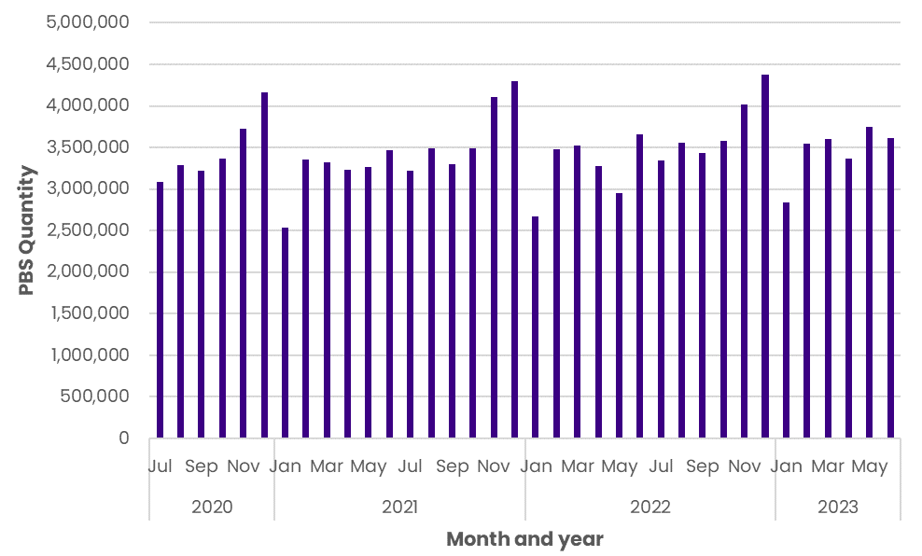

Source: Pharmaceutical Benefits Scheme (PBS) data

Figure 5: Expenditure by month and year

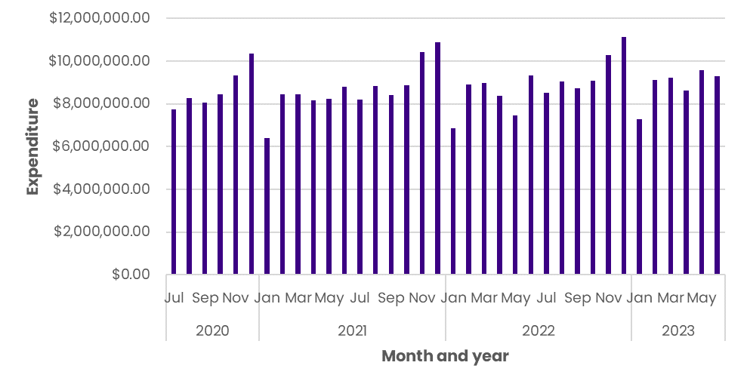

Source: PBS data

In the analysis, there does not appear to be significant increase in expenditure or usage at the time of introducing new stoma types to the Scheme. **Due to limitations in the data, it was more difficult to ascertain whether the introduction of these new stoma types affected the number of participants in the Scheme;** however, based on feedback from stakeholders and the available data there has not been a significant increase in number of ostomates reported year-on-year. This is because of the temporary nature of some stomas, with those being reversed transitioning off the Scheme whilst new ostomates join.[6]

## Comparison of current clinical eligibility with international schemes

The Scheme is reliant on a set clinical definition of a stoma which determines eligibility and the outcome of an individual’s application to access the Scheme.

Comparative analysis of the Scheme and similar international stoma programs in the United Kingdom (UK), USA and Switzerland show that eligibility criteria for accessing stoma appliances is largely similar. Within these schemes, a combination of clinical judgement and a set criterion is used to determine the products an ostomate require and every much decided on an individual basis:

* In the UK, practitioners prescribe individuals with access to appliances approved by National Health Service (NHS) Prescription Services on behalf of the Secretary of State for Health and Social Care. Individuals with a permanent fistula (including, a laryngostomy, colostomy, ileostomy or some renal dialysis fistulas) requiring continuous surgical dressing or an appliance are eligible to apply for a medical exemption certificate which permits access to prescriptions for required equipment free of charge.[7]
* In Switzerland, all individuals are required to have private health insurance which make them eligible to access products when required.
* In the US, stoma nurses determine the appliances necessary, then a physician confirms the order. To access stoma supplies, the individual must meet Medicare criteria, and have a surgically created opening (stoma) to divert urine, or faecal contents outside the body. Subsidised ostomy supplies are used for colostomies, ileostomies or urinary ostomies.[8]

This comparative analysis underscores the commonality in eligibility criteria across Australia’s Scheme and similar schemes. The importance of medical professionals, such as STNs and other medical professionals, in guiding this process remains consistent across these healthcare systems.

## Feedback and gaps in the current clinical eligibility

Stakeholders confirmed that the Scheme does not have any major gaps regarding clinical eligibility. The inclusion of neo-anus opening created due to ARM or IA, MACE, Mitrofanoff stoma and biliary stomas has meant that the Scheme caters to a more appropriate range people than previously. There was agreement amongst stakeholders that neo-anus openings should remain within the clinical eligibility of the Scheme.

Whilst the Scheme is largely available to its intended participants, there are conditions which technically meet the clinical eligibility (being stomas in the GI tract), align with the aims of the Scheme but are not always formally recognised by the Scheme when applying to participate. STNs conveyed that these eligibility gaps often require additional letters of support which leads to added administrative burden for ostomates and STN’s. Stoma types that currently require additional letters of support or PB50 forms for special consideration often include fistulas, vesicostomies, and esophagostomies.

Table 4 describes the key gaps identified through the Review in the Scheme’s current clinical eligibility.

Table 4: Gaps in current eligibility criteria of the Scheme

|  |  |  |  |
| --- | --- | --- | --- |
| Type | Description | Equipment needed | Scheme eligibility |
| Antegrade Continence Enema (ACE) | A surgically created opening between the intestine and abdomen which create a continent pathway that require frequent bowel washouts. This allows management of GI tract dysfunction at home and often prevents children from needing a typical stoma. | Specialised catheters, bags, enema fluids and stoppers | Currently eligible for the Scheme. Equipment in line with best practice is currently not available on the Scheme, examples include hydrophilic catheters, lubricants, ACE stoppers, and stopper dressings. |
| Esophagostomy (spit fistula) | A surgically created opening between the oesophagus and the neck which allows food to be delivered to the stomach, by-passing the mouth and pharynx. | Fistula bags, adhesives | STNs often write extra support letters for those with esophagostomies to access the Scheme; however, under the current clinical eligibility with the focus on stomas required for the removal of waste this is not approved and recommended it remains out-of-scope for the Scheme. |
| Vesicostomy | A surgically created connection between the urinary bladder and the skin used to drain urine from the bladder in individuals with obstruction of normal urinary flow. | Catheters, skin protective creams and powders | Required to get a support letter from a STN to access the Scheme. Products for children such as specialised nappies and skin protectants are not accessible through any other programs, including the Scheme. |
| Nephrostomy | A surgically created opening between the kidney and the skin which allows for the urinary diversion directly from the upper part of the urinary system. | Catheters, bags | Stakeholder feedback from STNs was that this is currently not eligible for the Scheme (although should be based on current clinical eligibility). Appliances required for management are available on the Scheme. |

### Potential inconsistencies in the application of current criteria

The understanding and interpretation of the Scheme eligibility criteria was varied amongst stakeholders. In some focus groups, STN’s discussed differences in interpretation and therefore application of the eligibility criteria. There were several instances of STN’s noting that the reference to ‘GI tract’ in the eligibility criteria meant that they guided patients with many different stomas or conditions to access the Scheme. Consultation with associations highlighted variation in application of the criteria, for example a clinical team listing a fistula as a colostomy so a PB049 is not required to be completed every six months. Another example of variation in access to the Scheme was discussed with associations whereby some allow ostomates who have undergone stoma reversal surgeries continue to access irrigation equipment through the Scheme. The prevalence of this is hard to determine through the data alone.

Additionally, not all STN’s were aware of updates to the eligibility criteria, notably the inclusion of biliary stomas. Whilst this likely only affects a small number of individuals, it highlights that all eligible ostomates may not be accessing the Scheme due to differences in the way STN’s apply and understand the eligibility criteria.

The eligibility criteria wording which refers to “artificial body opening” restricts all people with GI tract dysfunction from accessing the scheme. Those with malformation (ARM) or IA, MACE/ ACE, and fistulas do not have stomas, but rather GI tract dysfunction which permits their access to the Scheme. However, other conditions involving a dysfunction of the GI tract however do not involve the creation of a stoma for waste removal – such as Hirschsprung’s disease, MS, or LARS – are not currently eligible for the Scheme. It was suggested by a product supplier stakeholder that modifying the criteria to include GI tract dysfunction would be of benefit to these groups and allow application of eligibility to cover all individuals with GI tract dysfunction; however, this view was not held by a wide range of stakeholders.

To overcome varied application of eligibility criteria and nuances in the wording of the criteria, some stakeholders suggested that a set list of stoma types and conditions that make an individual eligible for the Scheme be published. If a list like this were to be published alongside the current eligibility criteria, inconsistencies in its application would be reduced and the accessibility and understanding of the Scheme criteria would be improved. This view was also shared by associations, who often receive paperwork from individuals wanting to access the Scheme’s products but do not always feel confident in questioning the eligibility of the applicant because they do not have the clinical background to make decisions.

### Stomas not included in the Scheme

Stoma types that are not in scope of the Scheme have been identified by the evidence review and consultations with HealthConsult’s Expert Advisory Group (Professor Richard Rood (Inflammatory Bowel Disease Gastroenterologist in Missouri), Professor Omar Faiz (Colorectal Surgeon, UK) and Laurent Chabal (Specialised Stoma Nurse, Switzerland)).

Table 5 describes stoma types and/or situations not currently in scope of the Scheme where patients may need equipment/appliances to support them living in the community (e.g. catheters, dressings, or pouching systems). There was agreement across stakeholders that the stoma types identified in Table 5 were not appropriate for eligibility. Other stoma types identified – such as Dacryocystorhinostomy, Middle Ear Ventilation and Sclerostomy – were considered out of scope for consideration of inclusion on the Scheme given their temporary or post-surgery only requirements (equipment/appliances only required up to 48 hours post-surgery).

Table 5: Stoma types not currently in scope for the Scheme

|  |  |  |  |
| --- | --- | --- | --- |
| Type | Description | Current numbers | Current supports available |
| Tracheostomy | A hole that surgeons make through the front of the neck and into the windpipe (trachea). | Approximately 7000 conducted annually in Australia and NZ[9] | State-based schemes. |
| Gastrostomy | An opening into the stomach from the abdominal wall, made surgically for the introduction of food and/or medication, or the release of gastric pressure. | Information not available. | Patients have equipment needs that are usually met by the National Disability Insurance Scheme (NDIS)[10], and in some cases statewide schemes[11]. Equipment not funded under any scheme includes Mic-key buttons and FARREL valves, resulting in out-of-pocket costs for the patient. |
| Thoracostomy | A small incision of the chest wall, with maintenance of the opening for drainage. It is commonly used for the treatment of a pneumothorax. | Information not available. | Thoracostomies are usually created for a short term and are managed in hospital settings. |
| Pharyngostomy | A surgical process of creating a hole or opening in the throat or neck to insert a pharyngostomy tube. Also known as cervical pharyngostomy, the procedure is done to facilitate feeding when patients cannot eat by mouth for a short period. | Information not available. | Pharyngostomies are usually created for a short term and are managed in hospital settings. |
| Wound management requiring drainage | A procedure involving the removal of excess fluid or pus from a wound to promote healing and prevent infection. This is commonly necessary in cases of abscesses, deep wounds, surgical incisions, or wounds that are at risk of infection or excessive fluid buildup. | Approximately 450,000 Australians currently live with a chronic wound (AMA)[12] | There is currently no national wound management subsidy scheme. |

## Advances in stoma care and their impact on eligibility criteria

The basic function of stoma products has remained constant since the establishment of the Scheme in 1975, and any advances in stoma care have mostly involved enhancing product design and functionality. Notable areas of product development include:

* Stoma pouch fabrication to include water-repellent material formulation and increased strength to allow resistance to creasing and sagging.
* Hook-to-hook fastening, dual carbon filters for gas release, variation in flange shape, and variation in pouch transparency.
* Skin protective technologies, such as novel silicone compound adhesives to manage peristomal skin complications – which affect 88% of ostomates and cause the costs of ostomy supplies to increase six-fold over a 7-week period.

A review of the evidence suggests that changing design features or practices surrounding stoma care positively impacts the overall physical health and wellbeing of ostomates. Appliances with these features and skin protective technologies are currently provided by the Scheme.

The most notable advance in stoma care products are hydrocolloid adhesives and skin-protectant technologies used in the products. STNs reported that ostomates who previously lived overseas and accessed other international stoma schemes noted that whilst the Scheme does have similar appliances with these features and skin protective, the most up-to-date products on the market are not available in Australia.

From a surgical perspective, recent advances in surgery techniques such as robotics and precision surgery produce better outcomes for patients and reduce the likelihood of requiring a stoma permanently. There were suggestions that more temporary stomas were being created as a result however, because of limitations in the current data provided by the Department the Review was not able to determine the accuracy of this assertion. Analysis undertaken by Queensland Stoma Association indicated 34% of stomas were temporary[13] whereas a survey conducted 2020 by the Department[14], 50% of ostomates who responded indicated they had a temporary stoma. STN’s consulted also provided feedback that surgeries which enable bowel washouts and also reduce the chance of a stoma like ACE are becoming more frequent.

Improved treatments for conditions often requiring a stoma such as bowel or colorectal cancer have meant that individuals can live longer with their stomas. These two factors have resulted in a consistent number of individuals accessing the Scheme over time.

# Accessibility of the Scheme

This Chapter describes the findings of this Review related to the accessibility of the Scheme.

## Comparison of the Scheme to national and statewide schemes

In Australia, the Scheme is the only stoma-related scheme available to provide ostomates with the products and appliances they need to manage their stomas. All States and Territories health department websites refer to the Scheme and/or local stoma associations supporting the delivering of Scheme.

The Scheme was compared to four federally funded national comparator schemes and nine state or territory-funded medical appliance/equipment schemes. No duplication with any of these programs or schemes was identified. Insights gathered through consultation with STN’s and administrators of these programs confirmed that there is no duplication or overlap of the products and appliances accessible through the Scheme with other jurisdictional or federal schemes. Detailed comparative analysis of the Scheme with national, international and jurisdictional schemes is provided in Appendix B.

Whilst there is no overlap between the Scheme and other national or jurisdictional programs, some STNs provided feedback that some products should be available under the Scheme as opposed to CAPS. CAPS allocates a set amount to eligible individuals yearly to offset the cost of supplies. Often, the total funding allocation does not cover the entire cost of the supplies required by a consumer. There were suggestions that providing access to the Scheme for some of these consumers would be beneficial to their care.

Feedback provided by STNs and associations suggested that ostomates who are also eligible for the NDIS for other conditions could use their funding to purchase stoma appliances and products. Often this was done in circumstances where the consumer wanted to ensure they were fully utilising their NDIS funding package or pay for the postage of their products using a NDIS or similarly, through an Aged Care Package. However, the extent to which this occurs is difficult to ascertain through Scheme data alone.

## Access for marginalised groups

Stoma care is required for individuals living in metropolitan as well as rural and remote locations, First Nations people, financially disadvantaged individuals and/or those from CALD backgrounds across Australia. Whilst most stakeholders held the view that the Scheme did a great job of being available to all ostomates, those from marginalised groups are more likely to experience challenges when accessing stoma equipment and advice.

Even though access to stoma care products through the Scheme is fully subsidised, some ostomates do pay out-of-pocket for costs associated with their stoma care. When asking ostomates about this, there were mixed responses – some ostomates said they pay for private health because of the barriers to access stoma care and surgery in the public health system, whilst others said the Scheme provides all necessary products and access care through the public health system.

Stakeholder consultation highlighted barriers to accessing the Scheme and maintain their stomas appropriately for these marginalised groups, and effective strategies in place to enhance access to the Scheme. The ability to access STNs when needed, especially face-to-face, was one of the biggest barriers and consistent feedback from all stakeholders when it came to accessibility to stoma care. Other barriers included poor health literacy, geographical remoteness, and the requirement to obtain bi-annual updates to additional order forms. Common enablers which facilitated accessibility to the Scheme included personalised STN support, stoma association support and specialised link/healthcare workers. A summary of barriers and enablers that impact marginalised groups when accessing the Scheme are listed in Table 6.

Table 6: Barriers and enablers impacting access to the Scheme for marginalised groups

|  |  |  |  |
| --- | --- | --- | --- |
| Rural and remote | CALD | First Nations | Financially disadvantaged and homeless |
| Barriers | | | |
| * Longer handling and delivery times compared to metro areas. * Large distances to Associations to drop in and collect supplies or seek advice. * Fewer STNs in regional/remote areas and long wait times/ high cost to access the clinical workforce. * Stoic attitude delaying access to clinical support when complications arise. | * Difficulty navigating ordering processes if English is not first language. * Health literacy if translated information isn’t accessible. * Culturally appropriate and accessible community education and health support. | * Difficulty navigating ordering processes if English is not first language. * Health literacy if information designed for First Nations people isn’t accessible. * Lack of a permanent address to post supplies to if living in community. * Access to technology to complete ordering and/or access additional supply forms | * Lack of funds to pay association membership fees. * Lack of a permanent address to post supplies to if homeless or moving around. * Storage of supplies in a safe location that can be accessed continuously. * Lack of funds to pay out-of-pocket costs for handling fees, clinical care or additional equipment. |
| Enablers | | | |
| * Telehealth with STN’s in metro areas through local GP * Advice from associations about delivery timeframes | * Translator services in hospitals * Translated information and support material * Opportunity to drop into associations | * Aboriginal Health workers who provide support and advice in a culturally appropriate way * Indigenous health services acting as the delivery point for stoma supplies for those with a non-permanent address | * Social workers who pay association membership fees to ensure supplies can be accessed * STNs who keep emergency supplies * Temporary housing facilities or clinics acting as the delivery point for those with non-permanent addresses |

## Proportion of eligible ostomates from marginalised groups accessing the Scheme

PBS data from 2022-23 was analysed to understand the proportion of eligible ostomates from marginalised groups accessing the Scheme.

The available data allowed an analysis of ostomate orders by Modified Monash Model (MMM), to understand the proportion of ostomates living in rural and remote areas.[15] Figure 6 illustrates the MMM classifications of ostomates accessing the Scheme, with 72% (35,096) living in MM 1 or 2, and 28% (13,829) living in rural or remote areas (MM 3 to 7).

Figure 6: Ostomate access by MMM

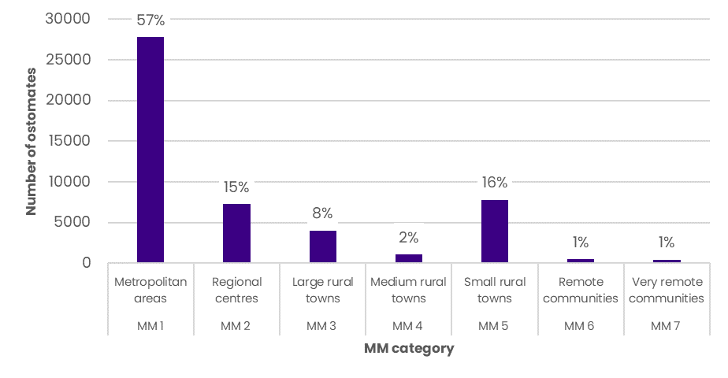

Note: 1076 ostomates had no location information (excluded here). 1205 ostomates had multiple location entries, so will be double counted in the above figures. Further, the Department has flagged potential double counting of some ostomates due to patient ID data. Source: PBS data

# The Scheme Schedule

This Chapter provides an overview of the products available on the Schedule, and details issues and feedback related to the products and applications on the Schedule. It also evaluates the appropriateness of certain products available on the Scheme for ostomates, with a focus on their clinical efficacy and alignment with established guidelines for stoma care.

## Product range

The objective of the Scheme is providing subsidised appliances and products to eligible ostomates. The Schedule lists all stoma products and appliances that are subsidised.[16] While there have been reviews of specific subgroups or products on the Scheme Schedule, there has been no comprehensive review of all products, pricing and groups since 2010.

The Scheme’s Schedule provides approximately 3,600 products and appliances to support ostomates manage and care for their stoma.

With the range of products available on the Scheme’s Schedule, many stakeholders agreed that the wide availability and range of appliances available to ostomates were required. The product range was seen as a major benefit of the Schedule, especially it supports patient choice, individual needs, and preference when it came to caring and managing their stoma.

Many considerations are made when deciding and trialling which products work best for ostomates, such as their weight, body shape, physicality, job, skin reactivity, mobility, stoma location, and climate. Therefore, clinician feedback was that the wide product range is justified, particularly the product range in core products such as pouching systems which feature a range of different sized and shaped products. When comparing the product range to other similar schemes internationally, whereas Switzerland and Australia both have approximately 3000-4000 products on their schemes, the UK has over double that (i.e. 8,856).

This is a key consideration when reviewing the pricing methodology, with feedback from stakeholders noting that a tendering approach would not work for the Scheme given the need to maintain the product range of the Schedule.

## Recent Schedule updates

On 1 October, 2023[17] there were several changes made to the Scheme Schedule including:

* Support Garments[18] were removed (n= 322 products)
* The maximum quantity for Support Belts was changed to a 4 per annum (rather than 3)
* Cleanser Wipes allocation was standardised to a maximum monthly quantity of 60 units/month. The restriction on cleanser wipe products changed from R2 to an R1 restriction.

Throughout stakeholder consultations, there were views that these changes were appropriate and did not result in significant cause for concern by ostomates and product suppliers, other than those specifically focused on this space (for example, Omnigon which supplies many support garments and other associated products to the Scheme).

However, there was still concerns raised about specific product removals from the Scheme such as removal of the 3M Cavilon No Sting Barrier Film Wipes from 1 July 2018, which was removed at the request of the supplier. It was raised several times by ostomates, associations and STNs that the removal of this specific product was of concern, as a high-quality product and not replaced on the Scheme by a similar or better alternative in the cleanser wipes category. It was noted by STNs that regular wet wipes – whilst not available on the Schedule – would work as well, and that cleanser wipes were not clinically necessity for stoma care; however, this would result in an out-of-pocket expense for ostomates.

## Access to high-quality products

Concerns were raised about the Schedule’s product offerings for certain stoma types and ostomates. Some STNs noted that these products may not meet the ostomate’s specific needs and are of inferior quality compared to international options. Anecdotal feedback from ostomates who have used these international schemes indicated a lack of up-to-date products on the Scheme.

For ACE/MACE individuals, the Scheme products do not align with best practice guidelines. Essential items such as specialised hydrophilic catheters, lubricants, ACE stoppers, and stopper dressings are considered necessary for optimal ACE/MACE management. Access to high-quality appliances in sufficient quantities would enhance compliance, quality of life, and reduce complications. For instance, a broader range of hydrophilic catheters could decrease the incidence of infections and instances of tract damage requiring surgical intervention.

Furthermore, individuals with a vesicostomy, particularly children, require specialty nappies and skin protectants which are not available through the Scheme or any other program. These products are crucial for effectively managing vesicostomies and reducing the likelihood of skin complications associated with inadequate management.

These limitations are also noted as an impact of the current pricing methodology and further explored in Chapter 6.

## Clinical necessity

Some products were queried for their appropriateness to be available on the Scheme, as they lacked the clinical evidence to demonstrate a significant benefit for ostomates or went against clinical guidelines when it came to caring for a stoma.

There were opposing views from STNs on their need for certain products in the Accessories category, although many noted some were necessary (i.e. seals) and others (i.e. cleanser wipes) not. Table 7 presents these products and justification for their potential removal from the Scheme.

Table 7: Non-essential products on the Scheme and justification for potential removal

|  |  |  |
| --- | --- | --- |
| Product type | Group number/s | Justification |
| **Catheters** | 8I | Some STNs noted catheters may not be necessary for all ostomates to access as self-catheterisation is related to continence and not required for the three main stoma types (colostomy, ileostomy and urostomy). Feedback received noted that in cases where catheterisation is required, an authorisation form should be required to restrict access and avoid inappropriate usage. |
| **Cleanser wipes** | 9(d) | STNs do not recommend these be used, especially as some have alcohol, and clinical guidelines recommend using water and a soft cloth to remove. Regular wet wipes available in supermarkets can also do the same and are considered just as effective. |
| Creams | 9(f) | Not necessary, if the pouching technology is good enough there shouldn’t be a requirement for the creams to help with skin adhesiveness. |
| Deodorisers | 9(g) | It is a personal choice and not clinically necessary. |

There was the suggestion that in the event these products were required by an ostomate, approval by an STN to dispense could support more appropriate utilisation, reduce wastage, and lower expenditure in the Accessories category of the Scheme. Some of these products already have authorisations required, such as cleanser wipes[19] and deodorants.[20]

As an example, instances of the clinical appropriateness for cleanser wipes provided include:

* + inability to access clean water to clean stoma
  + limited access to a pharmacy/supermarket (i.e. in rural and remote areas), or
  + limited financial means to purchase water-based wipes.

It was also advised that the cleanser wipes provide security and discreteness when managing waste removal in a public bathroom, and therefore are required for the social wellbeing and confidence of ostomates in public settings. Ostomates wanted to ensure they were still able to access products that contributed to their quality of life and did not want to be penalised by paying out-of-pocket for them.

## Low-utilisation and older products

There were concerns raised that the Scheme may be supporting older technology and products which is no longer recommended by STNs. This has an impact on the clinical care and outcomes of ostomates, but also on stoma associations which need to support the ordering and distribution of low-utilisation products.

An analysis was undertaken on the utilisation rates of specific products to understand if there were opportunities to remove low-utilisation rates of products (see Section 7.2.2).

Removing older technology meant STNs could also have a follow-up with patients to reassess and recommend better products for ostomates and support rationalisation of redundant products on the Scheme, supporting better efficiencies for stoma associations.

Additionally, it was also suggested by product suppliers that these older products had effectively set the benchmark price for their categories, making it harder for new technologies to be added to the Schedule if they could not justify the cost and clinical effectiveness to gain approval for premium pricing. Considerations for rationalising and re-benchmarking the price of core product categories is assessed further in Chapter 6 when reviewing the current pricing methodology.

## Maximum quantities

Throughout stakeholder consultations, there were examples raised by STNs where the maximum quantities supplied under the Scheme were inadequate or could be reduced. However, there were diverging viewpoints regarding the maximum quantities supplied under the Scheme. There are maximum quantity anomalies in the Scheme, with suggestions this has been sustained based on historical decisions, and related to ensuring that the patient does not get too many.

These include options to:

* Increase maximum quantities of products such as:
* Convex bags from 60 to 90 bags per month: it was raised this would better help with managing supply and lower the administrative burden for STNs by not having to do additional request forms for many ostomates each month. There were suggestions that the quantities should match the number of bags provided in other flat pouching and mechanical systems, although this feedback is in opposition to other feedback that closed bag systems should be reduced as highlighted below.
* Caps and seals from 60 to 90 seals per month: this is to reflect the number of caps or seals matching with quantity of bags administered per month. At the moment, caps and seals are provided with a 30 or 60 maximum quantity but to use with 90 bag systems.
* ACE stoppers and dressings from 1 to 2 per month: feedback from paediatric STNs noted several examples of products where monthly allocation did not meet the required need for their patients and that they are having to write additional supply forms for every patient for these products.
* Reduce maximum monthly quantities of products such as:
* Closed bag systems from 20 to 10 bags per month: it was suggested that 20 per month is excessive and potentially leading to wastage in the system.

These contrasting perspectives underscore the complexity of determining optimal maximum quantities within the Scheme and appropriate allocation according to ostomate’s needs.

## Over-ordering and wastage

Concerns were raised regarding potential wastage in the Scheme, with some believing that the perception of it being "free" led ostomates and suppliers to over-order products for various reasons:

1. Ostomates may lack a clear understanding of the necessity for specific products, leading them to order items “just in case” they help with their stoma care.
2. Product suppliers actively promote the benefits of their product to ostomates, enticing them to try them out since they can access them through the Scheme.
3. The current responsibility of ordering products largely falls on the ostomate, sometimes resulting in “self-prescription” of products that may have no clinical benefit or worse lead to skin complications.
4. The use of newly marketed accessories, while unnecessary, can lead to additional product requirements, e.g. use of skin creams necessitating extra adhesives to secure products in place.
5. Feedback from a few of the associations highlighted a common practice of automatically sending products monthly without confirming their ongoing necessity or usage by ostomates. The assumption is that if there's no change in the order, the products are still needed. However, associations vary in their ability to check monthly order requirements. Some lack the necessary knowledge or resources, such as access to an STN, or the capacity to follow up with ostomates to ensure continued necessity for the products.
6. Ostomates often fear running out of products within their usual maximum allocation, prompting them to stockpile to ensure adequate supply. This fear intensified during the COVID-19 pandemic, when delays in product delivery were a concern, especially for rural and remote ostomates.
7. In some cases, the quantities of certain products available through the Scheme don't align with ostomates' actual needs, leading to the necessity of ordering more than their maximum allocation, particularly in cases where caps or seals for the bags are insufficient.

## Other emerging issues

Throughout consultations, several other issues emerged related to the Schedule and how the Scheme is administered for consideration in the Review:

1. **Diverse views on available products**: Stakeholders, primarily STNs, from different healthcare settings (hospital and community) and with experience in both adult and paediatric stoma care discussed the product range on the Schedule. While clinical necessity was emphasised, it's essential to also consider products that support ostomates' confidence and discretion in stoma care. The social impact of product accessibility should not be overlooked.
2. **Concerns about product suppliers' marketing** : Clinical stakeholders expressed worries about product suppliers directly marketing to ostomates through various channels. This could lead to over-ordering, misuse, and potential system wastage.
3. **Administrative challenges of imposing restrictions**: if additional restrictions are placed on products, it's important to assess the impact on STNs and healthcare providers responsible for approving products. This could increase administrative burdens for healthcare professionals, ostomates, and the Government, potentially offsetting any cost-saving objectives.
4. **Communications and change management:** It was the views of some stakeholders, such as ostomates, product suppliers and STNs, that decisions regarding changes to the Schedule often seem disconnected from ostomates and clinicians working within the system. The perception of some stakeholders is that decisions made solely by SPAP members do not adequately represent the wider stoma care community. Feedback suggests that any recommendations from this Review should be subject to broader consultation before pursuing changes.

# Pricing Methodology and Alternatives

This Chapter provides an overview of the current pricing methodology, analyses the main features including advantages and disadvantages and key considerations for alternative approaches and their feasibility for the Scheme.

## Current pricing methodology

The Scheme has a well-established pricing methodology that has been developed and refined over the past 40 years since its inception.

Product prices in the Schedule are set by the Department following advice from SPAP and negotiation with Scheme sponsors.

There are two pricing categories:

* Benchmark prices – the product prices set by the Department and defined in the Scheme Schedule.
* Premium prices – Products may be listed at a price higher than the benchmark if they are assessed by SPAP as providing superior efficacy and/or safety and their cost-effectiveness is relative to their clinical effectiveness at the higher price.

Current pricing and maximum quantities of products in each of the Schedule groups are:

* Groups 1 to 7 have a defined benchmark price.
* Products in Groups 1-7 may be eligible to be listed at a price premium relative to the benchmark if they are assessed by the SPAP as providing improved health outcomes and are cost-effective at the higher price.
* Products listed in Groups 8 to 11 are reviewed by the SPAP to determine the most appropriate benchmark price and restriction quantities for these products.

Figure 7 highlights the proportion of products with benchmark vs premium prices for 2022-23, and Figure 8 and Figure 9 provide the average costs of benchmark and premium prices in each subgroup.

Figure 7: Proportion of products in Groups 1 to 7 with premium vs benchmark price, 2022-23

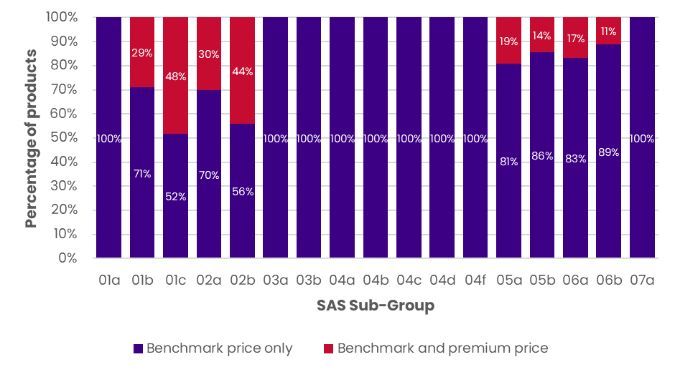

Note: products listed with a negative premium price on the Scheme are assumed to have zero premium (i.e., are counted as benchmark price only)

Source: Scheme October 2023, HealthConsult analysis

Figure 8: Average price of products in Groups 1 to 7, 2022-23

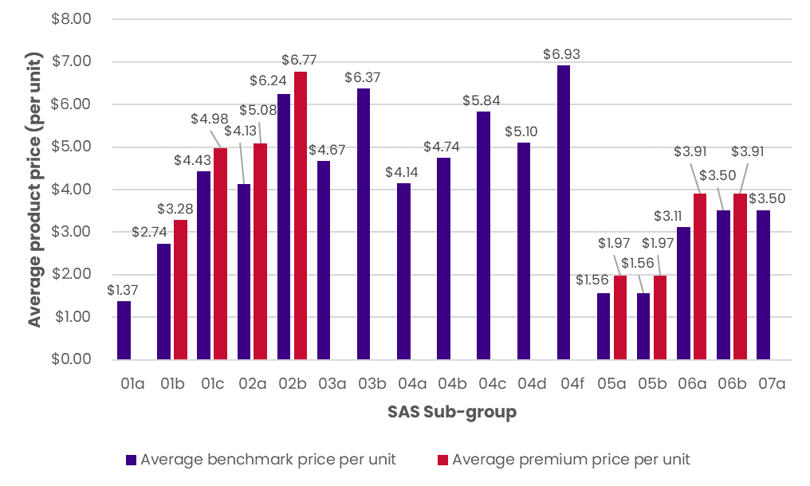

Note: products listed with a negative premium price on the Scheme are assumed to have zero premium (i.e., are counted as benchmark price only)

Source: Scheme October 2023, HealthConsult analysis

Figure 9: Average price of products in Groups 8 to 11, 2022-23

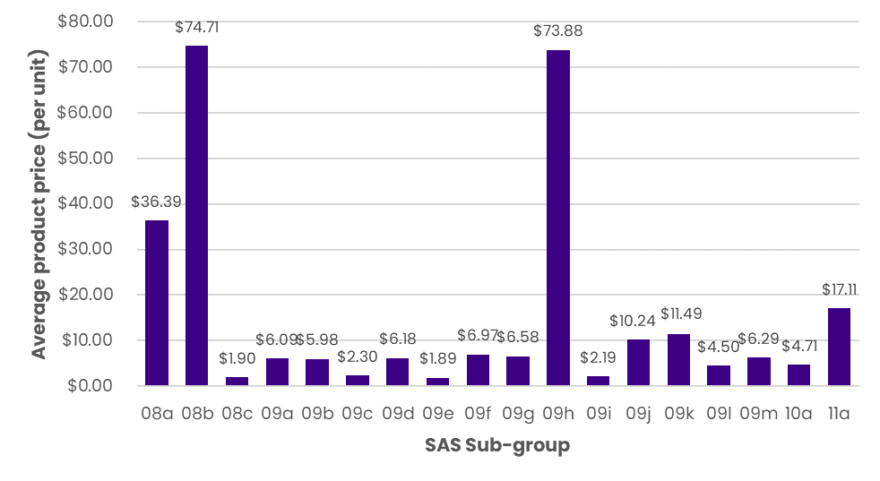

Source: Scheme October 2023, HealthConsult analysis

Up until 2013 there was annual indexation of the Scheme product prices. In the 2013-14 Budget, there was a commitment to remove the annual indexation process and undertake annual pricing reviews. To date no review has been undertaken and prices have been maintained at 2013 levels.

Table 8 provides a summary of the key advantages and disadvantages of the current pricing methodology.

Table 8: Advantages and disadvantages of current pricing methodology

|  |  |
| --- | --- |
| Advantages | Disadvantages |
| Transparency and uniformity  The current pricing methodology maintains benchmark and premium pricing, ensuring transparency and uniformity among manufacturers but also promotes higher pricing when required for higher cost, clinically effective products. | **Lack of indexation**  The absence of indexation since 2013 is a significant concern. Cost increases faced by product suppliers like inflation, increased labour costs, increased travel and freight and rising raw material expenses have not been reflected in the Scheme prices. This is potentially eroding in the profit margin of product suppliers. |
| Reduced competition on price  The current methodology discourages competition based solely on price, potentially promoting product availability over price. | **No mechanism for price reviews**  Similar to indexation, there has been no review or update of the benchmark pricing since 2013. This may lead to outdated pricing and a failure to account for changes in market dynamics. This is reportedly affecting the competitiveness of products and availability in Australian markets. |
| Wider range of product choice  Having benchmark pricing across the core product categories ensures a wide range of products are made available to ostomates and to suit their needs. | **Premium pricing requirements**  There are mixed views on the clinical evidence and economic justification requirements for premium pricing. Some find the requirements too stringent, while others believe more evidence should be provided for new technologies, especially if proven effective overseas. |
| Effective mechanism for subsidising associations  A streamlined and efficient method for subsidising stoma associations to purchase and distribute stoma-related products to their members. This process ensures that ostomates have access to necessary products while maintaining a sustainable and cost-effective subsidy mechanism. | **Handling fee tied to product pricing**  Whilst not in scope for this Review, feedback from associations suggested that the subsidies received should not be explicitly tied to the product pricing, given the prices are the domain of SPAP and the product suppliers. This does not allow for associations to have any buy-in or negotiation related to increasing their distribution and handling fee. |

## Alternative price-setting methods

The establishment of an effective pricing strategy is crucial for the successful implementation of the Scheme. Various pricing options have been identified, each with its own set of advantages and considerations.

The Scheme currently uses two methods for price-setting:

1. **Reference (benchmark) pricing:** Reference pricing applies where products considered to be of similar safety and efficacy for pricing purposes are linked and are recommended on a cost minimisation basis. This means the lowest priced brand or product sets a benchmark price for either the other brands of that product or the other products within the same subgroup.[21] Benchmark pricing is currently the pricing approach used in the Scheme. As previously highlighted, the Department has defined a benchmark price for each subgroup in Groups 1 to 7 of the Schedule. The benchmark price is derived by calculating the sum of the base product price plus the specified cost of each key feature of the benchmark product additional to the base product’s set of key features. For a product to receive the benchmark price that applies for a subgroup, the product must include all the specified key features. [22] This allows new products listed on the Schedule in these subgroups to be priced consistently and transparently in relation to existing products.
2. **Premium pricing**: Premium pricing is a component of benchmark pricing and is currently used in the Scheme. It describes the incremental price that has been justified for a key feature that provides improved health outcomes, additional to those provided by the benchmark product.[23] Assessment of benefits that justify a price premium are based on evaluation by SPAP, which considers whether the product provides improved cost-effectiveness, quality of life and/or survival. Premium pricing is also a feature of the PBS. The premium is an additional payment to the supplier of the specified brand of a PBS medicine. The additional charge does not mean there is any difference in quality between brands, although a prescriber may direct patients to a specific brand where a price premium would be incurred for reasons specific to each patient. Consumers pay the difference between any price premium and the amount subsidised by the Government for that medicine under the PBS.[24] This is a key difference to the premium pricing arrangements under the Scheme, where the premium is paid by the Government.

Several options were identified for setting prices that could be adopted for the Scheme, including:

1. **Negotiation**: a common approach to price-setting for schemes where products are supplied from providers operating in the private sector, including for the Scheme. Negotiation is also part of the price-setting approach for programs such as the PBS and for blood products supplied under the National Blood Agreement. In each case, the Department of Health and Aged Care or the National Blood Authority negotiates with pharmaceutical companies to set prices. Parameters for negotiating prices are commonly informed by expert assessment of clinical safety, efficacy, and cost-effectiveness by committees such as the MSAC, PBAC or SPAP.
2. **Tendering**: Tendering involves specifying a range of products (and conditions/requirements that suppliers must meet) and inviting responses from the market. Tenders may be evaluated on price only, or a combination of factors that lead to an overall ranking of suppliers that determines which will be offered supply contracts. Tenders for products such as those listed on the Schedule may occur for all products, at the group level or individual product level. Tendering can also be used to set a benchmark price for a group of products with similar characteristics. Tendering may result in an exclusive or non-exclusive contracting arrangement, such as a preferred panel of suppliers. Under an exclusive contracting arrangement, a single supplier is awarded the contract(s) to supply all products listed on the Schedule (or alternatively, all products within a certain group/category). Exclusive contract may result in lower scheme administration costs/time but could also restrict consumer choice and create competition concerns. If a single supplier is awarded a contract, then consumers may still be able to access alternative (or premium) products available on the market via a co-payment above the government subsidised price. Tendering may be typically well suited to small groups of homogenous products but may be more complex for large groups of different products such as those under the Schedule.
3. **Cost-based pricing:** Cost-based pricing relies on identifying and measuring the costs associated with the delivery of services, or the development of products. Prices may be set with reference to various measures of cost, such as the average, median or within an identified range, such as a confidence interval. Activity-based funding of public hospital services uses cost-based pricing, whereby the Independent Health and Aged Care Pricing Authority (IHACPA) calculates an annual National Efficient Price (and cost) using cost data submitted by public hospitals. Cost-based pricing via Activity Based Funding (ABF) has been proven to be an effective way of transparently containing cost escalation but relies on the submission of cost data by suppliers, which may be challenging in competitive markets such as those involving the suppliers of products listed in the Schedule.

In some cases, these different approaches are used together to price different components of health-related programs or fee schedules. This currently occurs in the Scheme, where negotiation is used to set prices and reference pricing is used to group benchmark prices. A similar combination of price-setting approaches is used in the PBS, where drug prices are negotiated between Government and suppliers. The price paid by consumers includes a co-payment amount that is indexed annually, along with a price premium for some products related to certain brands or therapeutic groups.

Table 9 summarises the advantages and disadvantages identified through this Review of these price-setting options, based both on publicly available information on these methods but also stakeholder feedback elicited through the consultation process.

Table 9: Advantages and disadvantages of price-setting options

|  |  |  |  |
| --- | --- | --- | --- |
| Approach and description | Examples | ✓ Advantages | 🗶 Disadvantages |
| **Reference (benchmark) pricing** Products considered to be of similar safety and efficacy for pricing purposes are linked and priced (typically) on a cost minimisation basis | * Scheme * PBS * Prostheses List | * Well-established method of minimising costs * Transparent * A wide range of approaches can be used to establish benchmarks, including an independent pricing review or tendering | * Can be administratively complex and time-consuming. * Relies on multiple (often expert) inputs, complex analysis and high-quality data. * Can be time-consuming to administer due to requirements for analysis, information-gathering and expert input. |
| **Premium pricing** An incremental price that has been justified for a key feature that provides improved health outcomes, additional to those provided by the benchmark product | * Scheme * PBS | * Provides flexibility for higher prices to be paid for products that can demonstrate superior safety, efficacy or cost-effectiveness * Improves access for consumers. | * Can be administratively complex and time-consuming. Relies on multiple (often expert) inputs, complex analysis and high-quality data. * Can be time-consuming to administer due to requirements for analysis, information-gathering and expert input. * May result in out-of-pocket costs for consumers (although not the case for the Scheme), and/or additional costs for Government. |
| **Negotiation** Pricing arrangements for health-related products are negotiated between suppliers and government departments or agencies. | * Scheme – negotiations with suppliers undertaken by Department of Health and Aged Care (DoHAC) * PBS – negotiations with suppliers undertaken by DoHAC * Products funded under the National Blood Agreement – negotiations with suppliers undertaken by the National Blood Authority. | * Familiar approach that is commonly used by similar government-funded schemes * Provides flexibility in prices paid in response to factors such as cost and clinical benefits. | * Administratively complex, time-consuming and often dependent on complex data analysis and expert input via committees. * Limited transparency – requires decisions and rationale to be documented and made publicly available. |
| **Tendering** Suppliers invited to propose prices for items through a competitive process. Tendering may occur at the group level or individual product level. | * National Diabetes Services Scheme (NDSS) launched tender in September 2023 | * May be useful to contain costs if expanded clinical eligibility criteria for the Scheme would result in a significant increase in demand. * NDSS tendering approach is being used for a small number of product groups (four). * Tendering may create a high level of competitive tension in mature markets such as those for stoma supplies and consumables. * Could produce agreed product prices or establish benchmark prices that are fixed for a period of time, thus reducing requirements for ongoing analysis and approval processes. | * Too early to determine whether NDSS tendering approach will deliver on its cost reduction objectives. * May be too administratively complex for products such as those on the Scheme with many groups and high levels of heterogeneity between products. * May lead to limiting the product range available on the Schedule, thus limiting choice and preference for ostomates. * May be difficult to implement premium pricing - additional consideration required to balance objectives related to cost minimisation and maximising consumer health benefits. |
| **Cost-based pricing** Prices are set with reference to a measure of cost, such as the average, median, or within an identified range. | * Activity-based funding for hospitals – IHACPA calculates a National Efficient Price and National Efficient Cost based on analysis of cost data submitted by hospitals. | * Has been proven as an effective way to drive efficiencies in operating costs in application as part of ABF * Can provide flexibility to adjust prices according to key drivers of cost * Transparent – but transparency relies on publication of analysis methodology and results. | * Cost analysis / studies would be required to implement cost-based pricing. This is likely to be highly challenging for markets where suppliers are based in the private sector due to competition and confidentiality issues. * Requires regular (often complex) updates and analysis to ensure prices are set with reference to changes in costs over time. |

Alternative methods for setting prices on the Scheme were explored with stakeholders, and feedback provided valuable insights to be considered in the Review of the current pricing methodology and the viability of alternative methodologies.

Firstly, stakeholders unanimously expressed scepticism regarding the feasibility of tendering as a pricing mechanism for the Scheme, given the extensive array of products available and listed on the Schedule. The consensus was that the large product range would render tendering inefficient and could potentially limit access to essential products for ostomates. Additionally, concerns were raised about the potential for tendering or other methods to limit the range, leading to increased utilisation of inappropriate products. It was consistently raised that the pricing approach needs to support and maintain similar product diversity as is current available on the Schedule.

Regarding negotiation, there was partial support, particularly from product suppliers. However, stakeholders highlighted the administrative complexities associated with individual pricing for each appliance on the Schedule. The concern was that such complexity might outweigh the intended benefits for suppliers, emphasising the importance of a pricing approach that balances administrative efficiency with the interests of both suppliers and users.

Notably, there was unanimous disagreement among stakeholders regarding the implementation of cost-based pricing as an alternative to the existing benchmark and premium pricing model. The lack of support for cost-based pricing suggests a clear preference for maintaining the current pricing structure, indicating potential reservations about the practicality and effectiveness of a cost-based approach within the context of the Scheme.

These stakeholder sentiments underscore the importance of carefully weighing the implications of alternative pricing methods for the Scheme. As stakeholders were largely not supportive of implementing any of the presented alternatives with a strong preference to maintain the current benchmark and premium pricing, the Review has considered what modifications or enhancements could be made to the existing pricing model to address the identified challenges and disadvantages summarised previously.

## Other mechanisms for pricing reviews and updates

As previously noted, there has been no mechanism in place for price reviews or updates since 2013 with the removal of annual indexation from the Schedule’s product prices. In this time, the Consumer Price Index (CPI) has increased approximately 32%, which means product suppliers have had to absorb the rising costs of goods and services without any significant change to the prices they are paid under the Scheme.

Various strategies for periodically updating prices that could be considered for adoption in the Scheme were identified, including:

1. **Indexation**: Indexation increases the base price of a product or service with reference to a key variable(s). In Australia, indexation of health-related fees and charges typically occurs annually, although the timing of when indexation applies can vary. For publicly funded health services, indexation is currently applied differently. For instance, fees paid under the Medicare Benefits Schedule (MBS) are indexed on 1 July each year with reference to the Australian Government Department of Finance’s Wage Cost Index, a combination of indices relating to wage levels and the CPI.
2. **Price reviews**: Regular price reviews of products or services may be conducted to examine the suitability of prices on a periodic basis. The mechanisms for conducting regular price reviews vary, and typically include data-driven price reviews, such as IHACPA’s annual calculation of a National Efficient Price and National Efficient Cost, or qualitative price reviews, such as the NDIS’s Annual Pricing Review process, which is conducted by engaging with participants, providers, the community and government stakeholders. In both cases, price reviews are conducted annually, however the frequency of price reviews can vary. Ideally, price reviews should be conducted at a frequency that will allow material variations in factors such as input costs, supply chain factors or consumer demand, to be identified and reflected in pricing arrangements.
3. **Discounting**: Discounting arrangements are a key feature of the PBS. Drugs listed on F1 Formulary Allocation of the PBS are subject to statutory price reductions (SPR) under the National Health Act 1953 (‘the Act’) on the 5th, 10th and 15th anniversary of the date that the drug was listed on the PBS.[25] A range of other statutory price reduction mechanisms are provided for under the Act, but these occur in response to changes in other listings on the PBS. Other statutory price reduction mechanisms include first new brand price reductions, catch up SPR and flow-on price reductions for combination items.

Advantages and disadvantages of the price update options explored in this section are summarised in Table 10.

Table 10: Potential price update options and their advantages and disadvantages

|  |  |  |  |
| --- | --- | --- | --- |
| Approach and description | Examples | Advantages | Disadvantages |
| **Indexation** An increase the base price of a product or service with reference to a key variable(s). | * Annual indexation on the MBS * Annual indexation on dispensing co-payments under the PBS | * Administratively simple * Can provide for changes in fees/prices to respond to measures that are considered relevant to underlying changes in input costs * Can be applied flexibly to meet a wide range of objectives * Highly transparent | * Requires detailed consideration to select an appropriate measure(s) to use as the basis for applying indexation amounts * Requires periodic review to ensure indexation variables are relevant and appropriate over time * Production costs do not always move with price indexes, e.g. there are circumstances where production costs fall due to technology advances. |
| **Price reviews** Regular examination of prices for products or services | * IHACPA’s annual calculation of a National Efficient Price and National Efficient Cost * the NDIS’s Annual Pricing Review process | * Provide for regular consideration of price suitability – can be designed flexibly to focus on variables such as cost, demand or supply chain factors | * Data-driven price reviews rely on submission of consistent, accurate and reliable data, which may be challenging for private sector providers such as those that supply products under the Scheme * Often takes substantial time, effort and coordination to collect, analyse and report on the data / information that is gathered during the review period. |
| **Discounting** Prices are periodically decreased in accordance with a set schedule and price reduction methodology. | * PBS anniversary price reductions | * Can support strong cost savings for government over time * Well-suited to products with reducing production costs, good revenue margins and / or high volume demand. | * May not be attractive to some suppliers, which may restrict competition * May be less suitable for products where margins are low, or volumes are restricted. |

Among the various options presented to stakeholders, feedback received highlighted strong support for the inclusion of indexation and/or regular price reviews in the pricing methodology of the Scheme. Stakeholders emphasised the pressing need for these mechanisms, citing factors such as inflation, which has contributed to a general rise in the costs of goods and services (e.g., manufacturing, raw materials, energy, labour, transport, and shipping).

Notably, the absence of indexation since 2013 was identified as a significant concern. The Stoma Industry Association (SIA) has previously argued that the lack of indexation is posing challenges to the sustainability of suppliers and potentially affecting patient outcomes. In response to these concerns, the SIA proposed a one-off price increase of 32% for products listed on the Scheme, coupled with the reintroduction of annual 'health inflation' from 1 July 2024.[26]

Conversely, stakeholders did not support the idea of introducing a discounting mechanism to the Scheme. Feedback from product suppliers underscored that the cost of manufacturing older products remains comparable to that of newer ones, with no apparent decrease in costs or efficiency gains over time.

## Comparison to other cost/price models in international contexts

Australia’s closest counterpart is the scheme administered by the NHS in UK.

As a point of comparison, the UK's reimbursement process involves a Health Technology Assessment (HTA) based assessment to determine the reimbursement rates for stoma appliances, a mechanism not explicitly adopted by the Australian Scheme which relies on benchmarking of prices within defined product categories.

Moreover, the UK NHS Stoma Scheme implements annual automatic indexation of the prices of stoma appliances. This measure ensures that the reimbursement rates keep pace with inflation and evolving economic factors. The UK scheme also provides an opportunity for stakeholders to seek a price increase for stoma appliances under exceptional circumstances. However, there are recent suggestions that this approach is leading to over-expenditure in the UK and a review is being undertaken to ensure it can continue to be financially viable.[27]

In contrast, the Australian Scheme grapples with challenges arising from the absence of both indexation and a formalised mechanism for price reviews. Stakeholders continue to advocate for the reintroduction of these measures to address sustainability concerns for suppliers and potential impacts on patient outcomes. The balance between satisfying stakeholders' needs and controlling government spending remains an ongoing challenge for the Scheme and similar healthcare programs.

## Financial benefits and risks of transitioning to alternative models

The Review has highlighted multiple opportunities to transition to an alternative pricing model, and the benefits need to be weighed against the potential risks of adjusting the current pricing methodology.

As is explored further in Chapter 7, the costs associated with modifying access or pricing of the Scheme highlights both opportunities for cost savings but also changes that will result in additional expenditure.

As an example, implementing price reviews and/or indexation comes with potential risks, such as:

* **Budgetary impact**: Regular price reviews and the introduction of an indexation mechanism will have budgetary implications for the Government. While these measures aim to ensure the sustainability and fairness of the pricing structure, they could result in increased costs for government, especially if there are significant upward adjustments in response to market changes.
* **Administrative burden:** Conducting regular price reviews and/or incorporating an indexation mechanism requires additional administrative resources and expertise. The Department and SPAP may face challenges in managing the administration associated with these processes, including data collection, analysis, and stakeholder consultations. Additionally, changes to the overall prices on the Scheme (for example, if benchmark prices are raised) could attract additional applications from stoma product suppliers who perceive being listed on the Schedule as attractive. There would need to be consideration of the impact of increased product applications.
* **Complex negotiations**: The consideration of regular price reviews and/or an indexation mechanism may lead to more complex negotiations between the Department and suppliers. Determining the appropriate criteria for adjustments, managing the expectations of product suppliers and ensuring fairness in negotiations could be challenging.

To mitigate these risks, the Department will need to carefully plan and communicate the rationale behind any changes, actively engage with stakeholders, and conduct thorough assessments of the potential impacts before implementing changes to the pricing methodology.

The Department may also wish to consider whether a cost recovery mechanism is implemented to fund the price review process. In the context of cost recovery for government programs such as the PBS, the recovery typically involves product suppliers or pharmaceutical companies contributing funds to offset the program administration costs borne by the government. These suppliers would contribute to the costs of the government considering their applications to list products on the Scheme, which would also allow for broader access by patients.

This approach could maintain the financial sustainability of the Scheme while ensuring the availability of necessary products for those in need. A similar strategy could be employed, where suppliers of stoma appliances contribute to the cost recovery mechanism, supporting the Scheme’s ongoing operation and its commitment to assisting individuals with stomas.

# Budgetary Implications

This Chapter provides an assessment of the budgetary implications associated with the proposed changes to the Scheme uncovered throughout this Review. The focus was to detail estimates of the financial impact arising from suggested changes, offering an analysis of potential cost implications and where alternative cost models may be a viable option for the Scheme’s pricing methodology.

The Chapter also aims to ascertain whether the proposed changes will lead to additional expenditure or, conversely, yield cost savings. This critical evaluation of budgetary considerations is instrumental in making informed decisions that strike a balance between enhancing the effectiveness of the Scheme in providing the needed products and appliances to ostomates whilst maintaining fiscal prudence.

## Current utilisation and expenditure

Figure 10 shows **the total quantity of products provided to ostomates rose by 13.7% from 2020-2021** (39,958,196 products) **to 2022-2023** (45,438,902 products). Across the same period, the total **expenditure rose by 16.1%**, from $98,414,570 in 2020-2021 to $114,161,309 in 2022-2023.[28]

Figure 10: Annual expenditure and products dispensed on the Scheme

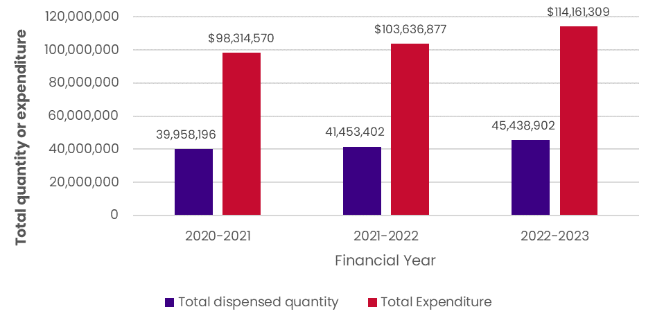

Source: DoHAC Stoma Appliance Scheme utilisation and expenditure data collection

Figure 11 illustrates the overall dispensed quantity of products by group. **Group 9 has the largest volume of products**, rising from 22,017,588 in 2020-2021 to 25,827,154 in 2022-2023. Further, Group 9’s volume as a proportion of the overall volume is rising, up from 55.1% of total 2020-2021 volume to 56.8% of total 2022-2023 volume. The **fastest growing group was Group 10**, from 62,340 in 2020-2021 to 78,860 in 2022-2023, or a 26.5% increase; however, this was the smallest group as a proportion of overall volume, accounting for 0.2% of 2022-2023 total quantity.

Figure 11: Quantity of dispensed products by main group

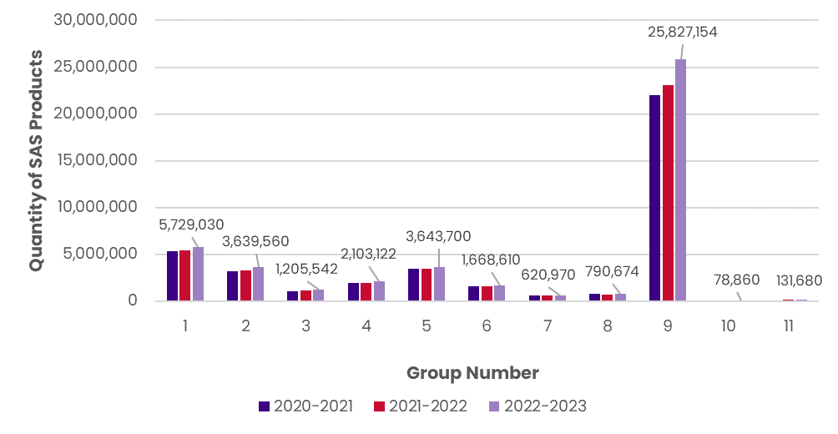

Note: Data labels display 2022-23 quantities.

Source: DoHAC Stoma Appliance Scheme utilisation and expenditure data collection

The expenditure by group is demonstrated in Figure 12. **Group 9 (Accessories) accounts for the largest total cost in all years.** In 2020-2021, the total **Group 9 expenditure was $30,425,227, and this increased by 22.4% to $37,254,535 (32.6% of total expenditure) in 2022-2023**. Group 1 and Group 2 expenditure relative to the total (16.7% and 19.0%, respectively) is higher than the volume relative to total (12.6% and 8.0%, respectively). The **fastest growing group by cost was group 11 (fistulae)**, increasing 27.9% from 2020-2021 ($1,646,877) to 2022-2023 ($2,106,389).

**Figure 12: Expenditure on Scheme products by main group**

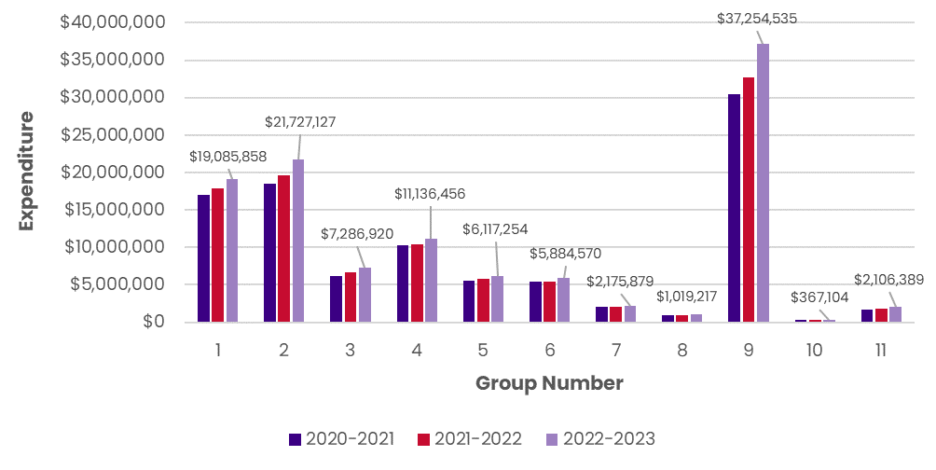

Note: Data labels display 2022-23 expenditure.

Source: DoHAC Stoma Appliance Scheme utilisation and expenditure data collection

## Access modifications

Following stakeholder feedback, it was suggested that there are a number of products available on the Scheme that are not clinically necessary and may be contributing to the rising costs seen in the expenditure calculations. The practicality and impact of reviewing clinical eligibility and of modifying the products available on the Scheme was tested in the following section.

### Clinical eligibility

The appropriateness and necessity of expanding clinical eligibility was tabled with multiple stakeholders. There was some support for inclusion of those with GI tract dysfunction as a result of MS, Hirschsprung’s disease and LARS Although this is not a recommended course of action for the Government, analysis was undertaken on the impact this would have on the Scheme if clinical eligibility was to be expanded.

Table 11 summarises the expected cost of including these disorders. Considering the average cost of ostomate care in FY22-23 was $2,220, should the Scheme open its clinical eligibility up to these disorders, the additional cost could equate to $10,446,650 (minimum) and $14,188,819 (maximum) per annum.

Table 11: Costs associated with expanding clinical eligibility

|  |  |  |  |
| --- | --- | --- | --- |
| Disorder | Estimated number of people added to the Scheme | Minimum cost (p.a.) | Maximum cost (p.a.) |
| MS | 1,6–7 - 2,200[29] | $3,699,456 | $4,883,282 |
| Hirschsprung’s disease | 1,9–8 - 2,397[30] | $4,257,066 | $5,321,333 |
| LARS | 1,1–2 - 1,795[31] | $2,490,128 | $3,984,204 |
| Total | 4,7–7 - 6,723 | $10,446,650 | $14,188,819 |

Note: calculations estimate the number of people with each disorder who may have GI dysfunction. Cost is based on the average cost of those currently accessing the Scheme with one stoma ($523.36).

### Product modifications

Stakeholder feedback did, however, point to several products available on the Scheme that are not clinically necessary and may be contributing to the rising costs seen in the expenditure calculations. To understand the budgetary implications if certain products were removed, restricted or altered (i.e. changes in quantity allowances), eleven access modifications were tested and are summarised in Table 12. Additional information and figures on the costing implications for each scenario are available in Appendix F.

Table 12: Access modifications: summary of expenditure changes and number of ostomates impacted, 2022-23

|  |  |  |  |  |
| --- | --- | --- | --- | --- |
| Scenario | Change in expenditure | Number of ostomates impacted | Percentage change in expenditure | Proportion of ostomates impacted |
| 1. Creams and ointments (09f) removed[32] | ($75,876) | 2,340 | -0.07% | 4.80% |
| 2. Creams and ointments (09f) quantity limited[33] | ($12,917) | 382 | -0.01% | 0.78% |
| 3. Catheters (08c) removed[34] | ($647,740) | 621 | -0.59% | 1.27% |
| 4. Deodorants (09g) removed[35] | ($480,380) | 9,051 | -0.44% | 18.56% |
| 5. Cleanser wipes removed (03568T, 09981H, 03520G, 80125D) | ($3,786,367) | 19,229 | -3.44% | 39.43% |
| 6. Removal of low-utilisation products (<20 total per annum)[36] | ($6,076) | 45 | -0.01% | 0.09% |
| 7. 50% decrease in maximum quantity of closed bag systems (group 1 and 5)[37] | ($6,744,893) | 7,202 | -6.14% | 14.77% |
| 8. 100% increase in maximum quantity of plug systems (08a)[38] | +$7,255 | 47 | +0.01% | 0.10% |
| 9. Increase maximum quantity of caps to 90 per month (01a) | +$6,426 | 25 | +0.01% | 0.05% |
| 10. Increase maximum quantity of seals to 90 per month (09l) | +$639,515 | 1,408 | +0.58% | 2.89% |
| 11. Increase maximum quantity of convex bag systems to 90 per month (01c and 03b) | +$902,978 | 1,074 | +0.82% | 2.20% |

Note: green text is cost savings, and red text is additional cost

There were two scenarios with cost savings greater than 1%:

* Scenario Five (cleanser wipes removed), and
* Scenario Seven (decreasing the maximum quantity of closed bag systems).

However, these scenarios impacted a large number of ostomates (19,229 and 7,202 ostomates respectively). Figure 13 provides a visual comparison of changes in expenditure compared to impact on ostomates. Red columns represent cost savings, pink columns represent additional costs, and the blue line shows the number of ostomates that would be impacted under each scenario. **Scenarios One, Two, Three, Six, Eight and Nine have small cost changes and small number of ostomates impacted**, although notably Scenario Three (removing catheters) has proportionately high savings for the number of ostomates impacted**. Scenario Five (removing cleanser wipes) has high cost-saving but the highest impact on ostomates**.

It should be noted that for Scenario Six, removing low-utilisation products would likely be cost-neutral as ostomates would transition to equally priced products if no longer available on the Scheme.

Importantly, the underlying objective of the Scheme is to provide subsidised products to allow ostomates to live a high-quality life and be able to participate in social and work activities with confidence. Any removal or restriction of products must consider this objective.

Figure 13: Access modifications: expenditure changes vs number of ostomates impacted, 2022-23

## Pricing changes

The Review aimed to understand the changes in expenditure associated with changes to the way products on the Scheme were priced. Indexation and price review costing methods were tested, with several scenarios modelled.

Table 13 summarises the budgetary implications for the pricing change scenarios that have been tested as part of the Review. The **largest additional cost for FY23-24 and beyond occurs under Scenario 18 (one-off price increase for all products in 2023-24 plus ongoing indexation from 2024-25**), which results in an additional $11,331,439 in expenditure in 2023-24, and an additional $22,290,678 in 2025-26. Similar in costs, **Scenario 14 (backdated and ongoing annual indexation)** will incur an additional $22,100,577 by FY25-26.

**Ongoing annual indexation, based on the 5-year average of CPI, (Scenario 13) results in an additional $3,971,406 in expenditure** if it were applied for FY23-24, whilst a one-off price increase in benchmark prices for groups 1-7 (Scenario 15) results in $7,213,057 extra expenditure compared to the forecast following current trend. By 2025-26, this extra expenditure under Scenario 13 reaches $13,540,275, and $7,764,193 under Scenario 15.

Table 13: Pricing changes: summary of expenditure changes

|  |  |  |  |
| --- | --- | --- | --- |
| Scenarios | Change in expenditure from current FY forecast | | |
| **2023-24** | **2024-25** | **2025-26** |
| 12. CPI indexation: one-off increase[39] | +$3,971,406 | +$4,161,878 | +$4,361,663 |
| 13. CPI indexation: ongoing annual adjustment (cumulative) [40] | +$3,971,406 | +$8,466,924 | +$13,540,275 |
| 14. CPI indexation: ongoing annual adjustment with backdated prices[41] | +$11,255,981 | +$16,363,480 | +$22,100,577 |
| 15. One-off 10% increase in benchmark prices for groups 1-7 | +$7,213,057 | +$7,479,361 | +$7,764,193 |
| 16. One-off 10% increase in premium prices | +$179,570 | +$189,749 | +$199,934 |
| 17. One-off 10% increase in both benchmark and premium prices (all products) | +$11,331,439 | +$11,922,395 | +$12,539,737 |
| 18. One-off price increase in benchmark and premium prices AND ongoing CPI adjustment[42] | +$11,331,439 | +$16,494,403 | +$22,290,678 |

Note: red text signals additional cost compared to current forecast

Stakeholders suggested the Review consider testing the pricing scenarios with the intent of bringing the Scheme closer to international prices. This is expected to make the Australian stoma market more attractive for suppliers to release and test newer and more efficient appliances, leading to better outcomes for ostomates in Australia.

Figure 14 illustrates the unit price of five core products (as suggested by stakeholders) compared to the UK, Switzerland and the USA. Current (2022-23) unit prices are below all three comparator countries – on average, these five products are priced 56% higher in the UK, 412% higher in Switzerland and 243% higher in the USA. Changes to price in 2023-24 via indexation (using five-year average CPI) or a one-off price increase in both benchmark price (10%) and premium price (10%) close this gap slightly, although international comparators are still higher for all five products. The last row demonstrates the 2024-25 prices if a one-off increase was applied in 2023-24 and then indexation was applied in 2024-25. Prices for the five core products are still higher in the UK (37% higher on average), Switzerland (350% higher on average) and the USA (201% higher on average).

Figure 14: International comparison of the unit price of five core products under indexation and one-off price increases

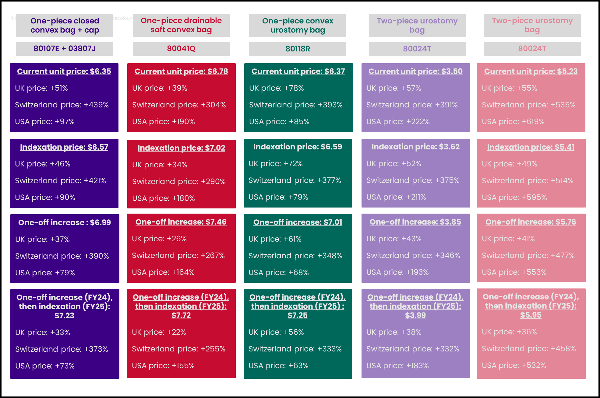

Note: Indexation price is the potential 2023-24 price if the five year average June CPI was applied to 2022-23 prices. One-off increase is the potential 2023-24 price if both benchmark and premium prices were increased by 10%, and the one-off increase then indexation applies the one-off increase in FY24, followed by indexation in FY25 (i.e. compounded increases).

Conversions from international currency to Australian Dollar (AUD) were based on the following exchange rates: 1 GBP = 1.92 AUD, 1 CHF = 1.73 AUD, 1 USD = 1.54 AUD.

USA prices are scheduled within a range - the price ceilings are used here.

Sources: UK Drug Tariff Part IX October 2023, Mediq Suisse Catalogue des produits stomie, USA Durable Medical Equipment, Prosthetics, Orthotics, and Supplied (DMEPOS) October 2023 Fee Schedule

## Time components

There was mixed feedback from stakeholders on the expected future increase or decrease in number of ostomates accessing the Scheme. Potentially, more temporary stomas are being performed, as well as more stomas on older people, however technological advancements in surgery and medical care may help offset these increases. Additionally, there may be an increase in ostomates in line with projected population growth in Australia.

Based on what was possible with the available data, the following scenario was modelled:

* Increase in ostomates in line with population growth.

This scenario tests the predicted increases in expenditure if the number of ostomates increased in line with population growth, as per Table 14.

Table 14: Time components: summary of expenditure changes

|  |  |  |  |  |
| --- | --- | --- | --- | --- |
| Scenario |  | 2023-24 | 2024-25 | 2025-26 |
| 19. Increase in ostomates in line with population growth | Expenditure | +$1,345,479 | +$2,452,582 | +$3,378,739 |
| Total number of ostomates | 49,689 | 50,468 | 51,225 |

# Conclusions and Recommendations

This Chapter summarises the keys findings of the Review and provides recommendations to enhance and optimise the Scheme.

## Clinical eligibility assessment

The Scheme has adapted through periodic reviews of clinical eligibility closing gaps for ostomates accessing subsidised products without significantly increasing expenditure.

Compared to international stoma schemes (UK, USA, and Switzerland), the Scheme aligns closely with eligibility criteria. However, challenges persist in formally recognising certain conditions, leading to the need for additional support letters or forms in cases like esophagostomies, nephrostomies, and vesicostomies.

Differing interpretations of eligibility criteria lead to inconsistencies in applications, prompting suggestions for publishing a set list of eligible stoma types to mitigate discrepancies. While some proposed modifying the criteria to include conditions like Hirschsprung’s disease, MS, or LARS to enhance inclusivity for those requiring products available on the Scheme but lacking a technically defined stoma, it is recommended that support for these patients remain outside the Scheme so that it maintains its intended objectives to “provides free stoma appliances and products to people who have a stoma (ostomates)”.

The Review considered whether the Scheme should expand its clinical eligibility and be available to either stoma types outside of the GI tract or those within the GI tract but not for the removal of waste, but the review of the published literature and expert consultations deemed these stoma types, including tracheostomy, gastrostomy, thoracostomy, pharyngostomy, and wound management requiring drainage, as out of scope for Scheme inclusion.

Despite advances in stoma care, including product design and surgical techniques, Australian ostomates lack access to more current international products. Gaps exist for less common stoma types, particularly paediatric stomas, lacking essential items like hydrophilic catheters, lubricants, ACE stoppers, stopper dressings, and specific products for children with ACE and vesicostomy stomas, which do not align with best practices for stoma care.

| Recommendation #1 |
| --- |
| The Scheme should maintain its focus on stomas originating from the GI tract for the removal of waste and neo-anus openings, refraining from expanding eligibility to cover non-GI stomas. |
| Recommendation #2 |
| Clarify and standardise the eligibility criteria to mitigate potential inconsistencies in application, by publishing a set list of eligible stoma types alongside the clinical eligibility criteria in the SAS Operational Guidelines. |
| Recommendation #3 |
| Address gaps in Schedule’s product offerings for paediatric stomas by exploring the possibility of engaging with suppliers who can provide the necessary products to enhance the Scheme. |
| Recommendation #4 |
| Maintain the intended objectives of the Scheme and do not modify the criteria to include GI tract dysfunction conditions where patients do not have a stoma. |

## Support from other government schemes

The Scheme is the sole stoma scheme in Australia, with no duplications or overlaps detected with other federally funded national schemes or state and territory-funded medical appliance or equipment schemes. Stakeholder input and analysis have emphasised this absence of redundancy, highlighting the Scheme's unique and targeted focus.

Some STNs suggested that certain products should be available under the Scheme rather than under the CAPS as CAPS funding often falls short in covering the complete cost of required supplies such as nappies and catheters. It is not the Scheme's responsibility to address these gaps. However, given the received feedback it is important to understand the drivers and impacts for the Scheme when other government schemes do not fully meet patients’ needs. It is recommended that these concerns be brought to the attention of the administrators responsible for CAPS.

Ostomates who qualify for the NDIS due to reasons unrelated to their stoma condition can utilise their NDIS funding to purchase stoma appliances and products if their association is an NDIS provider. Additionally, NDIS or HCP funds may be used to cover postage costs for stoma products. Determining the extent to which ostomates utilise NDIS funding for stoma-related expenses or leverage NDIS and HCP funds for postage costs has not been possible within this Review given limitations with the Scheme data.

Given that no duplication or overlap has been identified with other national schemes or state and territory-funded medical appliance or equipment schemes, the Reviewers have not made any recommendations related to this domain.

## Accessibility for marginalised groups

Stoma care plays a crucial role in the lives of individuals across diverse demographics in Australia, including those in metropolitan, regional, rural, and remote areas.

Despite the Scheme providing full subsidies for stoma care products, some ostomates still incur out-of-pocket costs. Some ostomates choose private health options due to barriers in accessing stoma care and surgery within the public health system, while others find the Scheme sufficient for their needs through the public system.

There are barriers for marginalised groups in accessing the Scheme and maintaining proper stoma care which results mainly from difficulty in accessing STNs. However poor health literacy, geographical remoteness, and the need for bi-annual updates to additional order forms (require access to an STN or other healthcare provider for approval) were also identified barriers to access.

|  |
| --- |
| Recommendation #5 |
| Review and implement strategies to enhance accessibility to the Scheme, including:   1. Improving access to STNs: Enhance strategies for improved access to STNs, especially in remote or marginalised areas. Consider telehealth options, utilising STNs in associations, and increasing the availability of face-to-face consultations. 2. Health literacy initiatives: Implement targeted health literacy programs to empower ostomates, particularly those from marginalised groups, with the knowledge and understanding needed to navigate the healthcare system effectively. 3. Streamline ordering processes: Simplify and streamline the process of obtaining additional order forms, possibly by exploring digital or automated solutions, to reduce administrative burdens on ostomates. 4. Expand support networks: Strengthen support networks, such as stoma associations, support groups and specialised healthcare workers such as Aboriginal Health Workers, to ensure marginalised groups have adequate assistance in navigating the Scheme and addressing their needs. |

## Products on the Schedule

The Schedule offers an extensive range of approximately 3,600 products and appliances, aimed at providing diverse support to ostomates. Stakeholders viewed this broad selection as positive, as it allows for patient choice and caters to individual needs and preferences in stoma care. Clinician feedback emphasised the importance of considering factors such as weight, body shape, physicality, job requirements, and climate, supporting the argument for maintaining this wide-ranging product selection to ensure patient-centred care.

In 2023, the Schedule underwent significant changes, including the removal of support garments, adjustments to the maximum quantity for Support Belts, and standardisation of cleanser wipes allocation. Stakeholders generally endorsed these changes to the Schedule, expressing minimal concerns, except for specific instances such as the removal of the 3M Cavilon No Sting Barrier Film Wipes in 2018 which was removed at the request of the product supplier.

The Review focused on questions regarding the appropriateness of certain products available on the Schedule, prompting considerations regarding clinical evidence and alignment with stoma care guidelines. STNs presented varying opinions on the necessity of specific products in the Accessories category, suggesting potential removals based on clinical necessity. Additionally, there were queries from some STNs about whether catheters should be subsidised on the Scheme given its primary focus on stomas and the need for self-catheterisation may be relatively low. In the analysis provided in Appendix F, the majority of ostomates using catheters have a stoma type listed as “Other” (55%), with urostomy the second most common (27%) and Ileostomy the third most common (9%). This may be clinically appropriate given the number of ostomates that have two or more stomas accessing the Scheme.

Concerns were raised regarding the Scheme offering potentially outdated technology and products that may no longer align with STN recommendations. An analysis of product utilisation rates aimed to identify opportunities to eliminate low-utilisation products and enhance overall clinical outcomes. Stakeholders recommended adjustments to the maximum quantities of various products, proposing both increases and decreases based on patient needs and concerns related to potential wastage.

There were also concerns about potential wastage arising from ostomates and suppliers over-ordering products deemed unnecessary, influenced by factors such as supplier’s marketing efforts. Reasons for over-ordering included ostomates' lack of understanding, susceptibility to marketing influence, self-prescription, and the fear of running out of essential products. These concerns highlighted the need for a nuanced and proactive approach to ensure optimal efficiency, patient satisfaction, and resource utilisation within the Scheme.

|  |
| --- |
| Recommendation #6 |
| Implement a strategic approach to rationalise products on the Schedule, leveraging opportunities to remove products that may not be clinically necessary and/or adjusting product quantities that lead to cost savings. Specific consideration should be given to:   1. Removal or restriction on specific product categories: Evaluate and, if deemed necessary, implement the removal or restriction of certain product categories from the Schedule including cleanser wipes, deodorants, and creams and ointments. While this action would result in cost savings, it must be carefully considered in light of the number of ostomates who would be affected by such changes. 2. Assessment of product utilisation: The Review identified several products with low utilisation and has assessed the associated costs related to their potential removal from the Scheme. This analysis offers insights into the financial implications and benefits of eliminating products with limited demand. However, this action would only result in a rationalisation of products rather than cost savings, given ostomates would transition to similarly priced alternative products if they were to no longer be available on the Scheme. 3. Adjustment to maximum product allocation: Review and, if needed, adjust the maximum allocation of products. This adjustment may involve increasing or decreasing allocations based on usage patterns and requirements. Products for consideration in this category include closed bag systems, plug systems and an overall increase in bags and seals provided by the Scheme. The financial modelling includes cost estimates associated with such adjustments. |

If pursuing recommendation #6, it is essential to strike a balance between addressing the diverse needs of ostomates and maintaining responsible government spending. It is crucial to recognise the significance of offering essential products and services to ostomates. Any removal or restriction of product categories must consider the potential effects on the quality of life and health outcomes for individuals with stomas. Therefore, prior to making any decisions about removing products from the Schedule, it is suggested to engage further with the ostomate community to assess the potential impacts on their health and well-being. Additionally, consultations with the clinical community, particularly STNs, should be undertaken to ensure a comprehensive understanding of the consequences of such actions.

## Methodology for product pricing

The current Scheme utilises a benchmark and premium pricing approach, which enhances transparency and consistency among manufacturers. Although alternative price-setting methods were considered, they were largely deemed unfeasible for the Scheme and lacked support from stakeholders. The current benchmark and premium methodology for price-setting aligns with the Scheme’s objectives, which further supports retaining this approach.

The absence of any price increase since 2013 has raised significant concerns. Furthermore, the lack of review or update of benchmark pricing has resulted in outdated pricing and an inability to adapt to market changes. Comparisons of international pricing for core products has also revealed substantial disparities between the Australian market and how the product suppliers are subsidised internationally.

To address concerns highlighted by the Review, the introduction of regular price reviews is important to ensure that the Scheme's pricing structure remains equitable, transparent, and responsive to changing market conditions. While implementing retrospective indexation will be cost-prohibitive for the Government and is therefore not recommended, conducting an immediate price review of the Schedule (involving a combination of market research and supplier submissions), with adjustments. This approach will align product prices with current industry standards and effectively address the concerns raised by the stoma appliance industry.

Mixed feedback on the processes and requirements needed to justify premium pricing also emerged throughout the Review. Some stakeholders expressed concerns about the stringency of the existing criteria, asserting that it may impede innovation and accessibility. Conversely, there is an argument for more comprehensive evidence requirements, especially for new technologies, if proven effective internationally. It is the view of the Reviewers that the Scheme should explore opportunities to streamline the assessments for premium pricing and where possible, enhance transparency in decisions made by SPAP where premium pricing application has not been successful. This may include providing clearer guidelines on the requirements for applying and improved communication of decisions from SPAP. Feedback received from product suppliers suggested that applying for premium pricing requires cost-effectiveness and clinical evidence to justify a higher cost product, which is not always present for many of these products where new technologies are focused on the overall wellbeing and maintaining skin integrity of ostomates. Other feedback also highlighted the process does not provide an opportunity to respond to evaluation questions prior to SPAP decision making.

|  |
| --- |
| Recommendation #7 |
| Maintain the current benchmark and premium model for price-setting products. |
| Recommendation #8 |
| Undertake an immediate price review of benchmark products, with a view to implement regular price reviews (every three years) into the Scheme pricing model.  A systematic and periodic review of benchmark and premium pricing within the Scheme would involve regular assessments to ensure that the pricing structure remains aligned with market changes, addressing concerns about outdated pricing. |
| Recommendation #9 |
| Review the process for assessing premium pricing applications and enhance transparency in the process. This could involve clearer guidelines for application requirements and improved communication of decisions, , along with providing an opportunity for suppliers to respond to evaluation questions before SPAP decision-making. Reviewing this process also provides an opportunity to develop a framework or supporting mechanism to assist suppliers in generating the relevant evidence to demonstrate value for premium-priced products and will continue to ensure innovative technologies are assessed in a robust way. |

## Budgetary implications

Table 15 summaries the budgetary implications of various scenarios tested through financial modelling, including access modifications and pricing changes.

Table 15: Budgetary implications of 19 agreed scenarios

|  |  |  |  |  |  |  |
| --- | --- | --- | --- | --- | --- | --- |
| Scenarios | Change in expenditure | | | | | |
| **2020-21** | **2021-22** | **2022-23** | **2023-24** | **2024-25** | **2025-26** |
| 1. Creams and ointments (09f) removed | ($87,606) | ($80,961) | ($75,876) | ($80,070) | ($81,453) | ($83,307) |
| 2. Creams and ointments (09f) quantity limited | ($6,998) | ($11,950) | ($12,917) | ($19,865) | ($23,141) | ($26,852) |
| 3. Catheters (08c) removed | ($640,753) | ($653,364) | ($647,740) | ($654,521) | ($674,221) | ($729,182) |
| 4. Deodorants (09g) removed | ($448,417) | ($457,067) | ($480,380) | ($495,894) | ($512,630) | ($536,265) |
| 5. Cleanser wipes removed (03568T, 09981H, 03520G, 80125D) | ($3,107,124) | ($3,411,070) | ($3,786,367) | ($4,116,770) | ($4,453,562) | ($4,790,354) |
| 6. Removal of low-utilisation products (<10 orders per annum) | ($3,191) | ($1,290) | ($6,076) | ($5,983) | ($8,258) | ($8,234) |
| 7. 50% decrease in annual quantity of closed bag systems | ($3,117,106) | ($6,249,906) | ($6,744,893) | ($9,060,627) | ($11,109,633) | ($13,057,223) |
| 8. 100% increase in annual quantity of plug systems (08a) | +$3,860 | +$5,918 | +$7,255 | +$17,931 | +$21,333 | +$24,736 |
| 9. Increase maximum quantity of caps to 90 per month (01a) | +$1,977 | +$8,403 | +$6,426 | +$9,736 | +$12,293 | +$14,850 |
| 10. Increase maximum quantity of seals to 90 per month (09l) | +$194,955 | +$474,741 | +$639,515 | +$3,514,826 | +$4,429,227 | +$5,343,629 |
| 11. Increase maximum quantity of convex bag systems to 90 per month (01c and 03b) | +$220,996 | +$687,083 | +$902,978 | +$2,953,684 | +$3,802,376 | +$4,651,906 |
| 12. CPI indexation: one-off increase | - | - | - | +$3,971,406 | +$4,161,878 | +$4,361,663 |
| 13. CPI indexation: ongoing annual adjustment | - | - | - | +$3,971,406 | +$8,466,924 | +$13,540,275 |
| 14. CPI indexation: backdated and ongoing annual adjustment | - | - | - | +$11,255,981 | +$16,363,480 | +$22,100,577 |
| 15. One-off 10% increase in benchmark prices for core products | - | - | - | +$7,213,057 | +$7,479,361 | +$7,764,193 |
| 16. One-off 10% increase in premium prices for select products | - | - | - | +$179,570 | +$189,749 | +$199,934 |
| 17. One-off increase in benchmark prices (percentage as above) AND premium prices (percentage as above) |  |  |  | +$11,331,439 | +$11,922,395 | +$12,539,737 |
| 18. One-off increase in benchmark prices AND CPI ongoing adjustment |  |  |  | +$11,331,439 | +$16,494,403 | +$22,290,678 |
| 19. Increase in ostomates in line with population growth | - | - | - | +$1,345,479 | +$2,452,582 | +$3,378,739 |

The costs associated with modifying access or pricing of the Scheme highlights both opportunities for cost savings but also changes that will result in additional expenditure.

Implementing changes to the Scheme comes with potential risks, such as budgetary impacts, additional administrative burden and complex negotiations between the Department and suppliers. Determining the appropriate criteria for adjustments, managing the expectations of product suppliers and ensuring fairness in negotiations could be challenging. To mitigate these risks, the Department will need to carefully plan and communicate the rationale behind any changes, actively engage with stakeholders, and conduct thorough assessments of the potential impacts before implementing changes to the pricing methodology.

A cost recovery mechanism could be implemented to offset the additional administrative costs associated with regular price review processes. Regular pricing reviews will ensure the availability of necessary products for those in need, supporting the Scheme's ongoing operation and its commitment to assisting individuals with stomas with quality appliances and products.

|  |
| --- |
| Recommendation #10 |
| Implement a cost recovery mechanism from suppliers to offset the increased administration costs of Government associated with the introduction of a regular price review process. |

1. List of Stakeholders Consulted

Table 16: Key stakeholders consulted throughout the Review

|  |  |  |  |
| --- | --- | --- | --- |
| Stakeholder Type | Stakeholder | Date consulted | Number of consultation attendees |
| Jurisdictional representatives | The Victorian Aids and Equipment Program - Statewide Equipment Program (SWEP) | 1/11/2023 | 1 |
| Department of Human Services (DHS) Equipment Program South Australia | 15/11/2023 | 2 |
| Enable New South Wales (NSW) | 17/11/2023 | 1 |
| Western Australian Community Aids and Equipment Program (CAEP) | 9/11/2023 | 2 |
| Territory Equipment Program (TEP) Northern Territory | 10/11/2023 | 2 |
| SPAP Advisory Committee for the Department of Health and Aged Care | SPAP Committee Meeting (All Members) | 24/10/23 | 9 |
| ACSA representative | 19/10/2023 | 1 |
| Colorectal Surgeon | 1/11/2023 | 1 |
| Industry Representative | 4/12/2023 | 1 |
| Health Economist | 8/11/2023 | 1 |
| Stomal Therapy Nurse | 10/11/2023 | 1 |
| Stomal Therapy Nurse | 14/11/2023 | 1 |
| Consumer Representative | 10/11/2023 | 1 |
| Health Economist | 20/11/2023 | 1 |
| Australian Association of Stomal Therapy Nurses (AASTN) | President and Secretary | 14/11/2023 | 2 |
| Stoma Industry Association | Chair | 21/11/2023 | 1 |
| Industry | Stoma product supplier | 13/11/2023 | 2 |
| Stoma product supplier | 24/11/2023 | 2 |
| Stoma product supplier | 28/11/2023 | 2 |
| Special Needs Group | National Rural Health Alliance | 4/12/2023 | 2 |
| Consumers | Ostomates | 20/11/2023-24/11/2023 | 4 |
| Focus groups | Stoma Associations | 22/11/2023 | 6 |
| Stoma Associations | 24/11/2023 | 5 |
| Stomal Therapy Nurses | 27/11/2023 | 4 |
| Paediatric Stomal Therapy Nurses | 27/11/2023 | 4 |

1. Review Topics and Questions

Table 17: Review Topics and accompanying Research Questions

|  |  |
| --- | --- |
| Review Area | Review Questions |
| **Clinical Eligibility Assessment** | 1. How does the current clinical eligibility criteria compare with other national/international schemes? 2. How do various stakeholder groups view the alignment of the criteria with the fundamental principles and objectives of the Scheme? 3. Have there been recent advances in stoma care and relevant clinical findings that impact the current eligibility criteria? 4. Are there potential inconsistencies in how the current eligibility are applied in practice? 5. How have previous changes to eligibility impacted the number of listed products, the volume of products used and the number of participants in the Scheme? |
| **Stomas Outside Gastrointestinal (GI) Tract** | 1. What types of stomas exist outside the GI tract and are not primarily used for waste removal? 2. How many patients currently have the defined stoma types? 3. How do patients currently manage their stomas, and what support is available to them? 4. Based on current trends, population growth, and medical advancements, what is the predicted number of patients with these stoma types in the foreseeable future? 5. Given the current cost data and future projections, what is the estimated potential cost if these patients were included in the Scheme? |
| **Support from Other Government Schemes** | 1. How does the Scheme (eligibility criteria, patient numbers, and costs) compare with other government subsidy schemes such as the NDIS, CAPS and state-based equipment schemes? 2. What duplication exists (i.e. patient eligibility and numbers, financial support etc), if any, with support provided to the patient cohort from other government subsidy schemes? |
| **Access for Marginalised Groups** | 1. What proportion of eligible ostomates from marginalised groups access the Scheme? 2. What are the current barriers to access for First Nations peoples, CALD groups, and rural and remote ostomates? 3. How do these barriers compare to the general population? 4. What initiatives or strategies have been effective in other schemes or settings (nationally and internationally) to enhance access for these groups? |
| **Methodology for Product Pricing** | 1. How does the current pricing methodology compare with other HTA methods and health technology subsidy schemes (nationally and globally)? 2. What are the pros and cons of the current pricing methodology? |
| **Alternative Approaches to Price-Setting** | 1. What are the alternative methods used for price-setting of products in similar schemes (e.g., market based pricing, standardised benchmark price at group or subgroup level, or competitive tendering as per the NDSS)? 2. How effective is a tendering approach in determining prices, and would it be applicable to the current Scheme? 3. What are the pros and cons of adopting a tendering approach compared to the current methodology? |
| **Periodic Price Reviews** | 1. What is the historical frequency of price reviews within the Scheme? 2. What is the impact of price changes on product use? 3. What factors or indicators trigger the need for price reviews, and how often do these factors change or arise? 4. How do other schemes and methods (nationally and internationally) approach the timing of price reviews? 5. What is the administrative burden and costs associated with increasing or decreasing the frequency of price reviews? |
| **Other Cost Models** | 1. What is the predominant cost/price models used in HTA methods and subsidy schemes, both in Australia and internationally? 2. Which of these cost/price models might be suitable for integration into the current Scheme? 3. What are the potential financial risks and benefits associated with transitioning to each of the alternative cost/price models? |
| **Budgetary Implications** | 1. How will the proposed modifications identified through the review (i.e., modifications associated with clinical eligibility, access modifications, pricing and cost models) impact the Scheme’s Budget? |

1. Schedule Groups and Subgroups

Table 18: Scheme Schedule Groups and Subgroups

|  |  |  |  |
| --- | --- | --- | --- |
| Group number | Group | Subgroup letter and description | # products |
| 1 | **One-Piece Closed** | (a) Stoma Caps | 10 |
| (b) Flat Baseplate | 381 |
| (c) Convex Baseplate | 355 |
| 2 | **One-Piece Drainable** | (a) Flat Baseplate | 325 |
| (b) Convex Baseplate | 483 |
| 3 | **One-Piece Urostomy** | (a) Flat Baseplate | 115 |
| (b) Convex Baseplate | 322 |
| 4 | **Two-Piece Baseplate** | (a) Mechanical Coupling – Flat | 153 |
| (b) Mechanical Coupling – Extended Wear | 38 |
| (c) Mechanical Coupling – Convex | 210 |
| (d) Adhesive Coupling – Flat | 60 |
| (e) Adhesive Coupling – Extended Wear | 0 |
| (f) Adhesive Coupling – Convex | 42 |
| 5 | **Two-Piece Closed** | (a) Mechanical Coupling | 119 |
| (b) Adhesive Coupling | 45 |
| 6 | **Two-Piece Drainable** | (a) Mechanical Coupling | 130 |
| (b) Adhesive Coupling | 50 |
| 7 | **Two-Piece Urostomy** | (a) Mechanical Coupling | 67 |
| (b) Adhesive Coupling | 0 |
| 8 | **Alternative Systems** | (a) Plug Systems | 21 |
| (b) Irrigation | 28 |
| (c) Catheters | 94 |
| (d) Rubber Appliances | 3 |
| 9 | **Accessories** | (a) Adhesive Barrier | 22 |
| (b) Belts | 16 |
| (c) Clamps and Clips | 4 |
| (d) Cleansers and Solvents | 26 |
| (e) Convexity Inserts | 3 |
| (f) Creams and Ointments | 8 |
| (g) Deodorants | 13 |
| (h) Hernia Support Belts and Garments | 188 |
| (i) Night Drainage | 14 |
| (j) Powders and Pastes | 15 |
| (k) Protective Films | 15 |
| (l) Seals | 79 |
| (m) Miscellaneous | 6 |
| 10 | **Paediatric** | (a) All | 36 |
| 11 | **Fistulae** | (a) All | 81 |
| **Total** |  |  | **3,577** |

Source: Stoma Appliance Schedule. 1 October 2023.[43]

1. Overview of SPAP

The Department established the SPAP in 2002 and restructured it following a 2009-2010 review to improve its independence and ability to assess economic evidence. The SPAP comprises nine members: an independent chair; clinical and economic experts; a consumer representative; and non-voting representatives from the ACSA and industry.

At the conclusion of each SPAP meeting, the SPAP’s recommendations are provided to sponsors for their respective applications and the SPAP recommendation is then provided to Government for approval.

A recommendation will include:

* whether the product should be listed on the Schedule
* an explanation of SPAP recommendations.

If SPAP recommends that the product should be considered for listing on the Schedule, it will also provide the following information:

* Monthly (or annual) maximum quantity for the product
* The price at which the product should be listed
* Any usage restrictions, if relevant.

The SPAP determines if products on the Schedule will be subject to restrictions. Where a product is subject to a restriction, the restriction group will be identified as part of the product description on the Schedule.

Sponsors can request a meeting with the SPAP Secretariat to discuss the outcomes of the SPAP meeting.

The Secretariat prepares Public Summary Documents (PSDs) which are ratified by the SPAP and sent to sponsors for comment. The ratified PSDs with sponsor comments are published on the Department's website, usually within two months after the SPAP meeting.

1. Comparator Schemes

Table 19: Summary of jurisdictional schemes compared with the Scheme

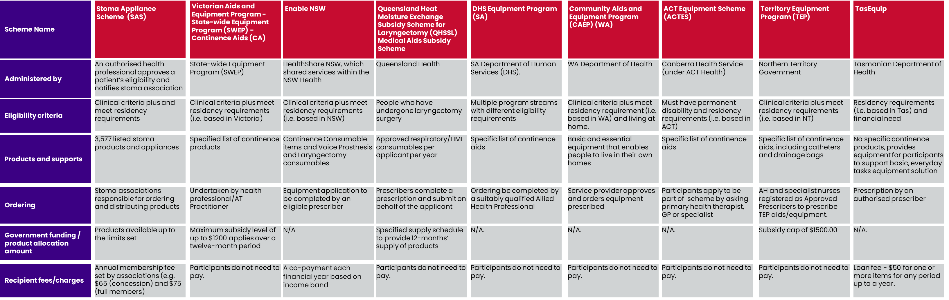

Table 20: Description of jurisdictional comparator Schemes

|  |  |  |  |  |  |  |  |  |  |
| --- | --- | --- | --- | --- | --- | --- | --- | --- | --- |
| Element | Definition | Vic | NSW | Queensland (QLD) | SA | Western Australia (WA) | Australian Capital Territory (ACT) | Northern Territory (NT) | Tas |
| Scheme or program name | **The formal title under which the initiative operates** | **The Victorian Aids and Equipment Program - Statewide Equipment Program (SWEP) - Continence Aids (CA)** | **EnableNSW** | **Queensland Heat Moisture Exchange Subsidy Scheme for Laryngectomy (QHSSL) Medical Aids Subsidy Scheme** | **DHS Equipment Program (SA)** | **Community Aids and Equipment Program (CAEP)** | **ACT Equipment Scheme (ACTES)** | **Territory Equipment Program (TEP)** | **TasEquip** |
| Overview | A brief outline that provides a snapshot of the scheme. | The Victorian Aids and Equipment Program provides subsidised aids and equipment, home and vehicle modifications to help people live safely and independently in their own home. Re-issued items of equipment are also available at no cost to the eligible person. | EnableNSW provides assistive technology and related services to people in NSW with specific, short term or ongoing health needs to assist them to live safely at home. | QHSSL provides people who have undergone laryngectomy surgery with subsidised access to Heat and Moisture Exchange (HME) consumable devices to enhance pulmonary and respiratory function, voicing and quality of life. All eligible applicants to the scheme will be assessed through an equitable process based on clinical need. | The DHS Equipment Program funds South Australians who are otherwise ineligible for mobility and support equipment and home modifications, through Commonwealth options (like the NDIS). These are sourced from preferred suppliers. | The CAEP provides an equitable and accessible scheme for the provision of equipment and home modifications to benefit people with long-term health, disability or age related functional impairment living at home. | The ACTES provide equipment, aids and appliances to eligible people in the ACT who have a life-long or long-term disability. | The TEP, provides community equipment and aids to children and adults who live in the community and have a functional impairment that requires prescribed equipment, aids and appliances that assist in maintaining and improving their capacity to live and participate in everyday activities. | TasEquip provide a range of assistive technology to eligible Tasmanians to improve their ability to safely engage in basic, everyday tasks, to transition home from acute care or to access mandated education settings. |
| Approx funding |  | A maximum subsidy level of up to $1200 applies over a twelve-month period to eligible consumers. | EnableNSW has funding criteria for each equipment category, which have been developed in consultation with expert clinicians and are designed to specify when equipment will be funded by EnableNSW for each category of assistive technology (AT). | Approved applicants are eligible for approved respiratory/HME consumables per applicant per year (12 months), commencing from when the first application for that year is lodged with Medical Aids Subsidy Scheme (MASS). | Funding or subsidy amount not specified. | Funding or subsidy amount not specified. | Funding or subsidy amount not specified. | Funding or subsidy amount not specified. | Funding or subsidy amount not specified. |
| Eligibility | The conditions that an individual must meet to qualify for the scheme. | People with a disability who do not meet NDIS eligibility due to age, residency status or functional impairment level can apply.  CA eligible for funding if:   * Are a permanent Victorian Resident or hold a temporary or permanent protection Visa or are an asylum seeker * Have a long-term disability and/or are frail aged * Are not an in-patient of a public or private hospital or permanent residential care facility * Cannot claim continence items through private health insurance policy * Have not been released from hospital or an extended care centre within 30 days, where continence items required is related to the hospital admission | A person is eligible for EnableNSW AT programs if:   * they are a resident of NSW or Lord Howe Island, or are an asylum seeker, refugee or * humanitarian visa holder residing in NSW or Lord Howe Island; * they are enrolled with Medicare * the AT is prescribed to support a health need; and, * they are not receiving or eligible for AT through a third party insurance or * other Commonwealth, state or territory government schemes for the identified health need.   Possible alternative funding sources are:   * NDIS * Department of Veterans’ Affairs * Australian Government aged care services * Compensation or damages for the condition requiring AT (e.g. worker’s compensation). | In addition to meeting administrative eligibility and to be clinically eligible for assistance from QHSSL, the applicant must also have:   * Undergone a surgical procedure for laryngectomy; and * Completed an appropriate trial of laryngectomy respiratory consumables for a minimum of 4-weeks; or * Provided evidence (e.g. receipts, clinician statement) that the applicant is currently using laryngectomy respiratory consumables; or * Successfully trialled in the last 12 months but not used laryngectomy respiratory consumables due to lack of affordability.   Note: The laryngectomy respiratory consumables used during these trials are not funded through QHSSL. | There are multiple program streams with different eligibility requirements.  The Adults with Chronic Conditions funding stream (most relevant to ostomates) is available for:   * Adults aged between 18 and 65 years (50 ATSI) * Living in Metropolitan Adelaide * Identified as having a chronic medical condition that has been, or is likely to be, present for at least 6 months or is terminal. * Is not eligible to receive equipment through an alternate funding source * Meets Program Key Criteria. | To be eligible for CAEP participant must have:   * a long-term health, disability, or age related functional impairment, * live at home in the community most of the time, * have a Pensioner Concession Card, Health Care Card or Commonwealth Seniors Health Card, or be a carer of a child with a permanent disability in receipt of a Carer Payment or be able to demonstrate financial hardship. | ACTES provide equipment to people who:   * are a permanent resident of Australia * have lived in the ACT for at least six months * have had a permanent disability for more than two years * hold a current Centrelink Pension or Low-Income Health Care Card in their name. Please note, this does not include the Senior Health Care Card or a Mobility Allowance (MO). * ACTES cannot provide equipment to people who: * receive the equipment through a Department of Health HCP * receive the equipment from other government-funded schemes including the NDIS * claim the cost of the aid or equipment back through a private health fund insurance policy. | The TEP is eligible for persons who:   * Have a functional impairment of a permanent or long-term duration; and * Are a permanent resident of the NT; and * Are living in or returning to the community, and are not a resident of a Residential Aged Care facility; and * Require access to prescribed items of AT on a permanent or long-term basis; and * Are not eligible to receive the item of AT under any other government-funded program; and * Are not eligible to receive compensation in respect of the functional impairment for which the item of AT has been prescribed; * Are beneficiaries of a Centrelink Disability Support or Age Pension; * Children up to the age of 16-years with a long-term functional impairment are eligible for TEP regardless of parental income; * Special consideration may apply for those experiencing financial hardship or require assistance with high cost items. | TasEquip provides equipment to:   * permanent Tasmanian residents * who have proven financial need for assistance to access the range of equipment we offer.   To be eligible, clients need to be:   * A Centrelink benefit recipient – Health Care, Pensioner Concession, and * Living in the community, and * Ineligible if living in Residential Aged Care Facility, on Homecare Package level 3 or 4, NDIS participant, Department of Veterans' Affairs (DVA) (gold card holder), receiving funding from Motor Accidents Insurance Board or from Workers Compensation * Those who do not meet the above eligibility criteria may, in certain restricted circumstances still be able to access equipment through TasEquip. |
| Range of products and supports | Types and diversity of stoma-related products offered through the scheme. | CA is able to help fund the following items:   * Anal plugs * Anal irrigation systems * Catheters (long-term and intermittent) * Catheter drainage tubing, connectors, straps and valves * Condom drainage systems * Drainage bags * Drainage bottles and connectors * Intra vaginal bladder supports * Washable bedding and chair pads * Washable briefs and pads | Continence - Consumable items including   * catheters; drainage bags and * associated accessories; and * pads.   Excludes: Underwear, gloves, cleaning   * solutions, gels, creams * dressings, enemas, dressing * packs, stoma products   Voice Prosthesis and Laryngectomy consumables includes:   1. Voice prosthesis and accessories 2. Laryngectomy tubes and other associated consumables 3. Tracheostoma/hands-free speech valve kits   Excludes: lug inserts for voice prostheses; cloth stoma covers; shower covers; silicone adhesive; adhesive barrier and remover products; lubricant | * HME cassette - 450/year HME cassettes * Foam stoma cover - 370/year foam stoma covers * Cloth stoma cover - 12 boxes/year OR 12 individual/year * Tracheostoma button and Laryngectomy tube or button - 3 buttons or tubes/year * Standard adhesive and Non-standard adhesive - 365 standard adhesives/year OR 180 non-standard adhesives/year * Hands-free device - 1 every 3 years * Securing device for tracheostoma button or laryngectomy tube e.g. neck strap or LaryClip - 12 boxes/year OR 12 individual/year * Skin care (i.e. skin preparation and adhesive removal products) - 14 boxes/year * Silicone glue – 4/year * Shower Aid – 1/year | CA:   * Bed Pan * Bedding Protector * Urinal (Male and Female) * Urinal Bottle Holder | Access to CAEP funded equipment is guided by the CAEP Manual and Imprest Lis (not available online).  The CAEP essential criteria to be addressed are:   * equipment is essential for independent functioning and functional care at home * equipment must be the most basic model/type that meets the clinical need * equipment must be for personal use only, that is not communal use * equipment is required for use in the person’s primary residence * the item costs more than $50 * equipment is required for safety and behavioural purposes where applicable. | ACTES will fully fund the following types of equipment:   * Bariatric equipment * Bathroom aids * Compression garments * CA * Hoist/Slings * Hospital beds * Manual wheelchairs * Medical grade/custom footwear * Mobility aids * Foot orthoses * Powered wheelchairs * Pressure care cushions * Pressure care mattresses * Standers * Utility/Hilite chairs * Wigs | Level 2 General Equipment   * Catheters (Intermittent Catheters and Indwelling Catheters) * Uridomes * Drainage Bags * Reusable Pads * Disposable Pads * Miscellaneous:   O Gloves  O KY Gel /Lubricating Gel  O Urosol  O Prantal Powder  O Urocare Night Drainage Bottles  O Urocare Adhesive Remover Pads  O Skin Bond Cement  O Ansell Non-Lubricating Condoms  O Shepherd Sporan Bag  O Xylocaine / Lignocaine Syringe  O Triple Care Cleanser  O Urocare Catheter Valve  O Urocare Tubing Connector | * Adjustable height chair * Bath transfer bench * Bathboard * Bedside commode * Over toilet frame * Shower chair/stool * Swivel bather * Swivel chair |
| Financial support | Level and type of financial assistance provided, including subsidies, grants, etc. | There is a maximum annual subsidy level for continence items. Supply is based on consumer need, recommended by a Continence AT Practitioner. A maximum subsidy level of up to $1200 applies over a twelve-month period to eligible consumers. If the subsidy does not cover the full cost of the continence item, you or a third party will need to pay the remainder. | People accessing EnableNSW are required to pay a co-payment each financial year they receive AT, consumable re-orders or repairs and maintenance.  The co-payment is based on income bands and allowances, with adjustments for increases in the Australian CPI since December 1998. No changes have been made to the level of consumer co-payments. | Prescribers complete a prescription for the applicant’s laryngectomy respiratory consumables and apply on behalf of the applicant to QHSSL for processing pending availability of sufficient funds within the applicant’s annual allocation. | Information not available. | N/A. | N/A. | N/A. | N/A. |
| Requirements for Providers | Criteria and responsibilities that providers of the scheme must fulfill, including eligibility and dispute resolution. | All applicants must be referred by a registered Continence AT Practitioner.  The Continence Practitioner Standard provides an objective means of structuring, measuring and authorising AT Practitioners to deliver AT solutions. | To be eligible for AT, EnableNSW requires an equipment application to be completed by an eligible prescriber. The funding criteria outlines the required qualification and level of experience for health professionals to be considered as eligible prescribers. Where required, prescribers must be registered through the Australian Health Practitioner Regulation Agency (AHPRA). | Eligible prescribers for QHSSL include:   * Otolaryngologists registered with AHPRA. * Speech pathologists with a minimum three years of experience in working with laryngectomy care and eligible for certified practising membership with Speech Pathology Australia (SPA). * Speech pathologists with less than three years’ clinical experience eligible for certified practising membership with SPA in consultation with an eligible speech pathology prescriber or otolaryngologist. | Equipment and home modification requests must be completed by a suitably qualified Allied Health Professional who will submit all paperwork direct to the Equipment Program.  The Equipment and Home Modification In scope lists identify which discipline can prescribe for each item type. | A referral is required from a recognised Referrer for initial specification of aids and equipment.  The referrer advises the person on the CAEP process and refers them to the relevant CAEP service provider/budget holder and organises an appropriate specifier for the person.  The specifier assesses the person and recommends the appropriate item of equipment to meet their functional need.  The specifier contacts the service provider /budget holder and applies for funding.  The service provider/budget holder approves funding and orders equipment prescribed. | Participants can apply to be part of this scheme by asking their primary health therapist, GP or specialist to complete the ACTES application form. | All allied health professionals and specialist nurses must be registered as Approved Prescribers with the TEP in order to prescribe TEP aids and equipment.  Prescribers must have the stipulated professional qualification and experience to prescribe from different TEP Equipment Types, as detailed in the TEP Clinical Guidelines.  Equipment groups and professional criteria determine the equipment level at which a prescriber may prescribe. | Authorised Prescribers are health professionals who have undertaken the required TasEquip training, who prescribe within their professional scope.  Clinical decision making when prescribing equipment is the responsibility of the prescriber. |
| Requirements for Participants | Conditions and procedures that individual participants must adhere to for successful enrolment and ongoing participation. | Applicants are responsible for accepting the terms and conditions of the supply of the recommended AT and must advise the service provider of any change to their eligibility status. This includes: becoming an NDIS participant or recipient of other government schemes that fund AT; becoming a recipient of a Commonwealth Government HCP or entering residential aged care; receiving compensation for AT from any other source; and moving interstate or overseas. | Information not available. | An applicant must continue to meet eligibility requirements to receive ongoing funding and assistance and is responsible for advising their eligible prescriber and QHSSL of any change to their eligibility status, contact details (including if they move interstate or overseas), change in nominated contact person’s details and physical condition such as change or decrease in functional or cognitive ability.  In order to meet clinical eligibility requirements for ongoing support through QHSSL, applicants are required to undergo a minimum 12-month clinical review with an eligible prescriber. | Information not available. | CAEP equipment is provided to people as a long-term loan until no longer needed.  When people no longer need the equipment, they should advise the prescribing therapist. | Participants must return equipment to ACTES if they no longer need the equipment provided; move to a high-level residential care facility; and/or plan to move out of the ACT. | The regular review of allocated items of AT is required to ensure items are still required, meet the client’s needs and are not in need of replacement or repair.  Generally, an initial review will be conducted by the approved prescriber at the time of delivery or within four weeks of issue. Subsequent reviews are then carried out between four to 12 weeks and at 12 months or as identified in the relevant clinical guidelines. | When the participant no longer requires the equipment, it must be cleaned and returned to one of the warehouses in Tasmania.  If the participant is admitted to an Aged Care Facility, the equipment must be returned. |
| Fees and Charges | Details on any access or membership fees associated with participating in the scheme. | N/A. | $100 each year for Band 1 and 2 taxable income and $800 per year for Band 3 taxable income  N.B. People in Band 3 are not eligible for AT under $800. | N/A. | If eligible for the DHS Equipment Program, participants do not need to pay for the equipment received. | N/A. | N/A. | TEP only require client contributions for major home modifications and/or when the cost of the item of AT is beyond the specifications prescribed and is selected by client preference. Clients required to contribute in excess of $2 000 can apply for Special Consideration for High Cost Items. | There is a loan fee of $50 for one or more items for any period up to a year. |
| Application process | Steps required for an individual to apply for and receive assistance from the scheme. | The participant needs to be assessed by an appropriate health professional/AT Practitioner (continence nurse, etc.) who will help determine the most suitable continence item needed. This includes an assessment of whether them or their carer can safely use the continence item. The health professional/AT Practitioner will complete the online form for the item that is needed. | A person or their representative must complete a consumer application form and provide any requested documentation to EnableNSW. | A prescriber completes a prescription for the applicant’s laryngectomy respiratory consumables and apply on behalf of the applicant to QHSSL for processing, pending availability of sufficient funds within the applicant’s annual allocation. | Registration to the Adults with Chronic Conditions (ACC) funding stream can be completed using the ACC Client Registration Form by an assessor. | An applicant needs to be referred to CAEP from either:   * a medical practitioner or allied health professional * a disability sector organisation with the expertise to refer from within their organisation * in rural and remote areas, a community nurse, remote area nurse, clinical therapist or local coordinator may refer applicants.   A referral is required from a recognised Referrer for initial specification of aids and equipment. | Applicants can make an application to ACTES using the ACTES application form. The form must be completed by all the following people:   * The applicant’s primary health therapist * The applicant * The applicant’s GP or Specialist   Application forms are available from the ACTES office and their primary health therapist. | An approved prescriber makes the application on behalf of an individual to the TEP. | Access to TasEquip resources is only through prescription by an authorised prescriber. Clinical priorities apply, and there is a funding cap for new equipment purchases. |
| Payments of claims | Processes for transferring funds to cover the cost of stoma-related products and services. | If the subsidy does not cover the full cost of the AT item, a gap funding form may be sent to complete. This form will advise SWEP as to how the remainder of the cost is to be paid. When funding is available, SWEP will call the participant to check if the AT item or customisation is still needed and then place an order. | The co-payment is made online. | Where insufficient funds are available, the applicant will be required to self-fund their laryngectomy respiratory consumables by purchasing directly from the supplier. | N/A. | N/A. | N/A. | N/A. | N/A. |
| Pricing | How pricing is structured for products and services. | The AT item categories and their maximum subsidy levels under the Victorian Aids and Equipment Program: <https://swep.bhs.org.au/available-items-and-subsidy.php> | A co-payment is only required when receive the equipment or when access the service (including a repair or a consumable reorder), however it is capped at one $100 payment per financial year. | N/A. | N/A. | N/A. | N/A. | N/A. | N/A. |
| Ordering | The procedure by which participants request specific stoma-related products or services. This involves selecting items based on eligibility, adhering to set limits, and submitting the request through designated channels. | Once eligibility is confirmed, SWEP will order the required continence items from the supplier which will be delivered to a nominated address.  Supply is based on consumer need, recommended by a Continence AT Practitioner. If the $1200 subsidy does not cover the full cost of the continence item, the participant or a third party will need to pay the remainder. | To place an order for continence, Home Enteral Nutrition or Respiratory items, a reorder request can be sent via email or can contact support team via phone.  EnableNSW Online is an online platform that allows NSW Health clinicians to submit equipment requests and check the status at any time. | There is a specified supply scheduled to provide 12-months’ supply of products. | Equipment items for clients is sourced through not-for-profit AT provider, Assistive Living Technologies Equipment Resources (ALTER). Participants select equipment items via the ALTER online catalogue. | The service provider/budget holder approves funding and orders equipment prescribed for the person when funding is available. | Once a referral is received, ACTES contacts the participant to arrange ordering. | TEP manages centrally located pools of new and re-issue items of AT.  TEP maintains responsibility for all TEP items including review; pick up/delivery; and repair and maintenance. | Approved prescribers apply on behalf of participants and ordering is arrange with local warehouses located in all regions in Tasmania. |
| Customer Support | Types of support services offered (e.g., hotlines, consultations) and their availability at some associations. | There is a Customer Service line on: 1300 PH SWEP (1300 747 937) or (03) 5333 8100. | There is a support hotline, 1800 ENABLE. | There is not a specific customer support line but issues and complaints can be directed to MASS which are reviewed by QHSSL working group/MASS administrative, clinical and management personnel, and if necessary, with advice from expert clinicians who have a holistic knowledge of QHSSL client population, procedures, and services delivered. | DHS Equipment Program has a dedicated Phone: 1300 130 302 and Email: DHSEquipmentProgram@sa.gov.au | There is not a specific customer support line. | There is an information line available for referrers only. | Participants are encouraged to contact their therapist. If they do not have a therapist, contact one of NT Health intake offices. | There is a support line on 1300 827 378 between 8:00am and 4:00pm, Monday to Friday (closed on weekends and public holidays). |
| Governance arrangements | The bodies or panels responsible for overall governance, policy direction, quality assurance, and compliance. | The Chief Allied Health Officer (CAHO) provides a leadership and liaison role for SWEP.  A Clinical Advisor panel reports to the CAHO and consist of Clinical Advisors and Subject Matter Experts which ensure AT item applications across the State is safe, consistent, and of highest possible quality. | EnableNSW is a business unit of HealthShare NSW, the statewide organisation established to provide shared services within the NSW Health system. | The scheme is currently administered by Independence Australia on behalf of the Australian Government. | The Equipment Program is part of the DHS. | The CAEP is funded by the WA State Government and administered by the Department of Health. | ACTES is administered by Canberra Health Services. | The TEP use a clinical framework for prescription of items of AT that includes Clinical expertise of the TEP/ SEAT Team Leader and TEP Advisory Committee; and Clinical governance by TEP Advisory Committee. | TasEquip is managed by the Tasmanian Department of Health and has warehouses in all regions. |
| Policy documents and operational guidelines | Official written instruments that outline the framework, objectives, and operational procedures governing the scheme | Victorian Aids and Equipment Program Guidelines (September 2020) | EnableNSW AT Program: Operational Guidelines (2020) | MASS – Guidelines for Queensland HME Subsidy Scheme for Laryngectomy (May 2023) | There are a number of program documents to support the Equipment Program: <https://equipmentprogram.sa.gov.au/lists/dhs-equipment-program-documents> | Referrer information – CAEP: <https://www.wa.gov.au/government/publications/referrer-information-community-aids-and-equipment-program> | ACTES: <https://www.canberrahealthservices.act.gov.au/__data/assets/pdf_file/0007/1935772/ACTES-loan-equipment-scheme_accessible-FA.pdf> | Territory Equipment Program Policy (TEP PO-1) (2021) | Medical aids and equipment (TasEquip): <https://www.health.tas.gov.au/patients/support-services-your-visit-hospital/medical-aids-and-equipment-tasequip> |
| Forms and Documentation | Types of forms used for various purposes like applications, special authorisations, and audit evidence. | <https://swep.bhs.org.au/other-relevant-documents.php> | <https://www.enable.health.nsw.gov.au/prescribers/forms> | Speech Pathologists and Otolaryngologists need to register and apply through MASS-eApply to prescribe HME products for clients. | <https://equipmentprogram.sa.gov.au/__data/assets/word_doc/0017/19700/DHS-EP-Equipment-Request-Form.docx>  Alternatively, therapists can raise requests directly on the ALTER portal. | <https://www.wa.gov.au/government/publications/referral-form-community-aids-and-equipment-program> | Not available online. | <https://health.nt.gov.au/professionals/disability-equipment-program> | <https://ilct.com.au/uploads/general/Welcome-Pack/TasEquip-Standard-Equip-Request.pdf> |

Figure 15: Comparator international stoma schemes summary

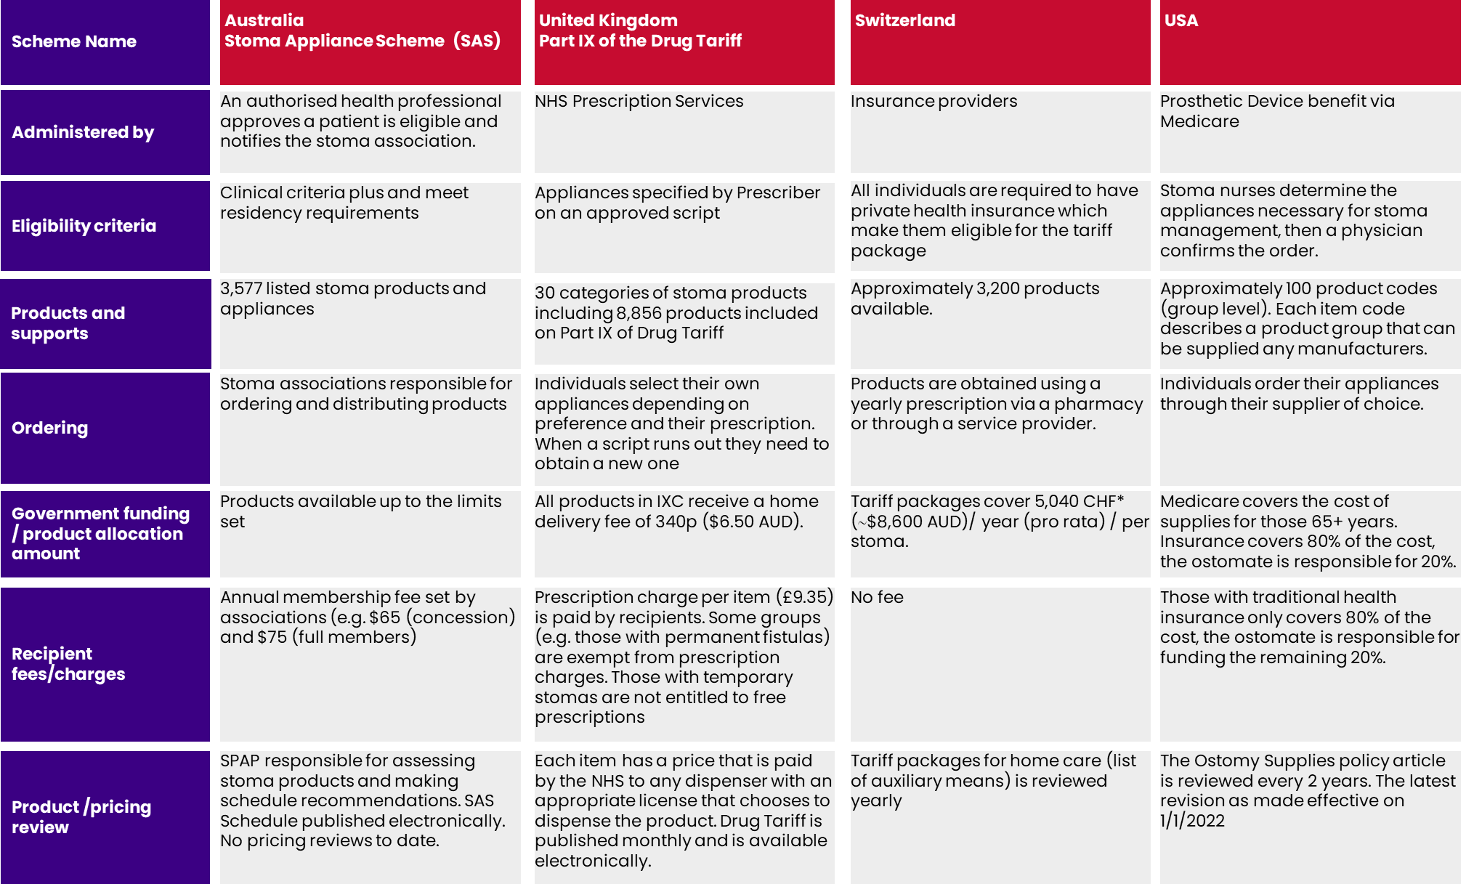

Figure 16: Comparator international stoma schemes

|  |  |  |  |  |  |
| --- | --- | --- | --- | --- | --- |
| Element | Definition | Australia | Comparative Country #1 | Comparative Country #2 | Comparative Country #3 |
| Scheme/program name | The formal title under which the initiative operates. | [Stoma Appliance Scheme](https://www.health.gov.au/our-work/stoma-appliance-scheme) | UK: Part IX Drug Tariff | Switzerland | USA |
| Overview | A brief outline that provides a snapshot of the scheme. | The Stoma Appliance Scheme provides free stoma appliances and products to people who have a stoma (ostomates). Products supplied under the Scheme assist people with stomas to better manage their condition, and thereby allow greater participation in society and the workforce. Products are provided free of charge. This saves each ostomate an average of over $2,300 per year. | Stoma products sit on Part IX of the Drug Tariff which is a list of appliances approved on behalf of the Secretary of State and which may be prescribed at NHS expense by an appropriate prescriber.  Individuals with a prescription elect where to get their supplies from and the type of supplies they want to use. | Individuals are provided with tariff packages on a pro-rata basis which allows them to access stoma-related supplies from a pharmacy or a service provider as needed. | Ostomy supplies are covered under the Prosthetic Device benefit. Access to appliances is varied and depends on an individual’s insurance cover. Typically, an ostomate accesses a supplier and makes an order that is communicated to Medicare to claim. |
| Approx funding |  | The Scheme provided ostomates with $114 million worth of stoma appliances and products in 2022-23 (reference). | £364 million ($690 million AUD) was spent on stoma products in 2022. |  |  |
| Eligibility | The conditions that an individual must meet to qualify for the scheme. | A person must have a temporary or permanent artificial body opening (created surgically or otherwise,  including a fistula that originates from the urinary or GI tract) which facilitates the removal of urine and/or products of the GI tract from the body where the person does not have normal GI tract or bladder functions, and provide evidence, consisting of a certificate from a registered medical practitioner or STN in an approved form (PB049). | Appropriate practitioners prescribe individuals living in England access to appliances approved by NHS Prescription Services on behalf of the Secretary of State for Health and Social Care for prescribing at NHS. | All individuals are required to have private health insurance which make them eligible for the tariff package | Stoma nurses determine the appliances necessary for stoma management, then a physician confirms the order. To access appliance subsidised by Medicare an ostomate must meet all coverage guidance criteria which includes a ‘reasonable and necessary’ need for the supplies. |
| Range of products and supports | Types and diversity of stoma-related products offered through the scheme. | * 3,792 stoma products and appliances listed on the [Stoma Appliance Scheme](https://www.health.gov.au/resources/apps-and-tools/stoma-appliance-scheme/schedule) | Adhesive Discs/Rings/Pads/Plasters  Adhesives (Pastes, sprays, solutions)  Adhesive Removers (Sprays, Liquids, Wipes)  Bag Closures  Bag Covers  Belts  Colostomy Bags - see also Two-Piece Ostomy Systems  Colostomy Sets  Deodorants  Discharge Solidifying Agents  Filters/Bridges  Flanges  Ileostomy (Drainable) Bags - see also Two-Piece Ostomy Systems  Ileostomy Sets  Irrigation/Wash-Out Appliances  Pressure Plates/Shield  Skin Fillers and Protectives (Barrier creams, pastes, aerosols, lotions, gels, wipes)  Skin Protectors (Wafers, blankets, foam pads, washer)  Stoma Caps/Dressings  Tubing and Accessories  Two-Piece Ostomy Systems  Urostomy Bags - see also Two-Piece Ostomy Systems  [NHS Electronic Drug Tariff (nhsbsa.nhs.uk)](http://www.drugtariff.nhsbsa.nhs.uk/#/00465833-DB_1/DB00465714/Part%20IXC%20-%20Stoma%20Appliances) | Approximately 3200 products available.   * 1 and 2 piece stoma bags: Approximately 2700 product types * Accessories: Approximately 500 product types | Approximately 100 item codes. Each item code describes a product that can be supplied any manufacturers.  On average, patients are entitled to 20 drainable pouches per month or 60 closed end pouches per month.  When a liquid barrier is necessary, either liquid or spray (A4369) or individual wipes or swabs (A5120) are appropriate. The use of both is not reasonable and necessary.  Beneficiaries with continent stomas may use the following means to prevent/manage drainage: stoma cap (A5055), stoma plug (A5081), stoma absorptive cover (A5083) or gauze pads (A6216). No more than one of these types of supply would be reasonable and necessary on a given day.  Beneficiaries with urinary ostomies may use either a bag (A4357) or bottle (A5102) for drainage at night. It is not reasonable and necessary to have both. |
| Financial support | Level and type of financial assistance provided, including subsidies, grants, etc. | * Funding is provided (via associations) to cover the costs of stoma appliances and products. * The Scheme Schedule specifies the maximum number of units available to participants under the Scheme monthly or annually. | The patient will pay a charge per item to the NHS (currently £9.35) although there are options to pay for all prescriptions on a monthly basis at a reduced fee.  Some groups (e.g. those with permanent fistulas) of people are exempt from prescription charges and can apply for a prescription exemption certificate.  Those with temporary stomas are not entitled to free prescriptions, however prescription prepayment certificates are available.  [Colostomy UK website](https://www.colostomyuk.org/information/prescriptions/#:~:text=When%20you%20leave%20hospital%20you,specialist%20supplier%20or%20local%20chemist)  [Free prescription eligibility](https://www.nhs.uk/nhs-services/prescriptions-and-pharmacies/who-can-get-free-prescriptions/) | The service providers generate their invoices based on tariffs and rates, and that is how they are reimbursed for their services. Tariffs, rates and maximum levels of reimbursement are determined by authorities in the provisions on the service obligation and the scope of coverage in the case of aids and devices. | The cost of supplies is covered by Medicare insurance that is available to individuals over 65 years.  Those with traditional health insurance are covered for 80% of the cost of items deemed to be medically necessary. The ostomate is responsible for funding the remining 20% of the cost. Several people get a second insurance plan. |
| Quality Assurance | Procedures in place to ensure the quality and safety of stoma appliances and other resources offered. | * Prior to their listing on the Scheme Schedule, products must be assessed by the SPAP on the basis of their comparative clinical function and effectiveness, comparative cost-effectiveness and comparative safety. * Products approved for listing will be published on the Scheme Schedule. * Stoma associations must comply with the Stoma Appliance Scheme Operational Guidelines and reporting requirements. |  |  |  |
| Requirements for Providers | Criteria and responsibilities that providers of the scheme must fulfill, including eligibility and dispute resolution. | * A sponsor of a stoma-related product must have an Australian Business Number (ABN) and be able to guarantee supply of the product. * Products must be registered on the Australian Register of Therapeutic Goods (ARTG). | Manufacturers and distributers wishing to supply an appliance or chemical reagent for NHS prescribing must first seek approval from NHS Prescription Services for inclusion of that product in Part IX of the Drug Tariff. Regulations provide that the Drug Tariff must state the prices at which the dispenser’s reimbursement for appliances is to be calculated. |  | To justify payment, suppliers must provide:   * Standard written order * Medical Record Information (including continued need/use if applicable) * Correct Coding * Proof of Delivery   Suppliers also must not dispense a greater quantity than the maximum number of supplies permitted for each category per person per month/ six months. |
| Requirements for Participants | Conditions and procedures that individual participants must adhere to for successful enrolment and ongoing participation. | * A participant must be a current financial member of an approved stoma association. * A participant must only use products supplied through the Scheme for their own personal use. |  | It is mandatory to have a private insurance   * Basic level is nationally the same and cover stoma products * The amount/ month is around 500 CHF (Approx. $850 AUD) If the individual agrees to have a higher deductible rate (will be more expensive for a lower deductible rate) |  |
| Fees and Charges | Details on any access or membership fees associated with participating in the scheme. | * Annual stoma association membership fee – set by associations (e.g. NSW Stoma membership is $65 for concession holders and $75 for full members) * Participants are responsible for any costs (e.g. postage and handling costs) associated with obtaining stoma-related products. |  | Tariff packages cover 5040 CHF* (Approx. $8600 AUD)/ year (pro-rata)/ per stoma.   * Insurance can cover up to 100% more but with Stoma and GM explanation * Patients exceeding limit: ≈ 18% (5% 2x over limit) |  |
| Application process | Steps required for an individual to apply for and receive assistance from the scheme. | A member of a stoma association needs to:   * complete part 1 of the Stoma Appliance Scheme application form (PB049) * get their medical practitioner or stomal therapy nurse to complete Part 2 * send the completed form. | Consultation with practitioners who can supply a prescription. | Stoma Nurses often do the prescription and its annual renewal. |  |
| Claims process | Processes for preparing, submitting, and receiving payment for claims. | To claim a reimbursement, a stoma association needs to upload an electronic claim file through Health Professional Online Services (HPOS).  **Note:** Stoma associations no longer need to send Services Australia copies of the claim paperwork or patient forms PB049 and PB050. |  |  |  |
| Payments of claims | Processes for transferring funds to cover the cost of stoma-related products and services. | Payments for all claims processed by Services Australia are paid via electronic funds transfer to the financial institution nominated by the stoma association. |  |  |  |
| Pricing | How pricing is structured for products and services. | Product prices in the Scheme Schedule are set by the Department following advice from SPAP and negotiation with Scheme sponsors.  There are two pricing categories:   * **Benchmark prices** – the product prices set by the Department and defined in the Scheme Schedule. * **Premium prices** - Products may be listed at a price higher than the benchmark if they are assessed by SPAP as providing improved health outcomes and are cost-effective at the higher price. | Each item has a price that is paid by the NHS to any dispenser with an appropriate license that chooses to dispense the product. |  |  |
| Frequency and process for reviewing pricing of products/appliances | Up until 2013 there was annual indexation of the prices.  Post 2013 budget review, there was a commitment to remove the annual indexation process and undertake annual pricing reviews. To date no review has been undertaken and prices have been maintained at 2013 prices. | Frequency and process for reviewing pricing of products/appliances. | The Drug Tariff is published monthly and is available electronically from NHS Prescription Services’ website <http://www.nhsbsa.nhs.uk/PrescriptionServices/4940.aspx> | Tariff packages for home care (list of auxiliary means) is reviewed yearly. | The Ostomy Supplies policy article is reviewed every 2 years. The latest revision as made effective on 1/1/2022. |
| Reporting | What types of reporting are required and to whom they should be directed. | Stoma associations are required to provide ACSA with:   * monthly new membership numbers and statistics * annual membership numbers and statistics * details of members accessing the Scheme * yearly financial statements * any other information related to Scheme activities as requested.   ACSA is required to provide the above information to the Department on an annual basis, or as requested. |  |  |  |
| Ordering | The procedure by which participants request specific stoma-related products or services. This involves selecting items based on eligibility, adhering to set limits, and submitting the request through designated channels. | * Orders must be in writing by post, fax, email or online form (e.g. [NSW Online Order Form](https://www.nswstoma.org.au/online-order-form/)) via a stoma association. * Members are entitled to one supply per month only. * Maximum quantities are determined by Scheme Schedule. | Individuals select their own appliances depending on preference and their prescription. When prescriptions run out, individuals must acquire a new prescription from a practitioner. | Products are obtained via a pharmacy or through a service provider.  Through a pharmacy:   * In ten open days * Some deliver at home * Some charges taxes on the public recommended price   Through a service provider   * Mailed in 24 to 72 hours in anonymous packages * Plate cuts free of charge | Individuals order their appliances through their supplier of choice. |
| Customer Support | Types of support services offered (e.g., hotlines, consultations) and their availability at some associations. | * Support during business hours available via associations may include – website, email, telephone and in-person (via office premises). * Some associations offer After Hours emergency support e.g. the QLD Ostomate Support After Hours emergency support service. |  |  |  |
| Public Awareness | Measures to educate the public about the scheme. | Via ACSA whose mission is to provide support and assistance to all stoma associations in carrying out their work in promoting the general wellbeing of persons who have undergone ostomy surgery in Australia. | [Colostomy UK](https://www.colostomyuk.org/about-us/): Charity that supports and empowers people living with a stoma, and acts as advocates for raising awareness about the experience/challenges of ostomates.  [Ileostomy & Internal Pouch Association](https://iasupport.org/): Support group for people living with an ileostomy or internal pouch, their families, friends and carers in the UK and Ireland.  [Association of Stoma Care nurses UK:](https://ascnuk.com/default.aspx) Aims to develop and advance the specialist knowledge required to deliver expert healthcare to individuals with a stoma.  [Urostomy Association](https://urostomyassociation.org.uk/): Provides support to those with urostomy and aims to increase awareness of urinary diversions across healthcare and the general public. |  | [United Ostomy Associations of America](https://www.ostomy.org/): The peak body that supports, empowers, and advocates for people who have had or who will have ostomy or continent diversion surgery. |
| Governance arrangements | The bodies or panels responsible for overall governance, policy direction, quality assurance, and compliance. | * **Scheme participants** – an eligible person registered with an association * **Stoma associations** – responsible for ordering and distributing stoma-related products * **Health professionals (e.g. medical and STNs)** assess and sign-off if patient is eligibility and should access restricted products * **Scheme sponsor** is a manufacturer or distributor of stoma-related products * **Services Australia** – claims processing and payments * **ACSA** – represents individual stoma associations * **SPAP** - an independent technical advice panel responsible for assessing stoma products and makes recommendations to Government regarding any changes, including new listings, to the Stoma Appliance Scheme Schedule * **Australian Government DoHAC** – overall scheme responsibility |  | It is mandatory to have a private insurance. Basic level is nationally the same and cover stoma products |  |
| Policy documents and operational guidelines | Official written instruments that outline the framework, objectives, and operational procedures governing the scheme. These documents set the formal rules, delineate responsibilities, and offer step-by-step instructions for both administration and participation. | [Stoma Appliance Scheme Operational Guidelines](https://www.health.gov.au/sites/default/files/documents/2022/10/stoma-appliance-scheme-operational-guidelines.pdf)  [Stoma Appliance Scheme Schedule](https://www.health.gov.au/sites/default/files/2023-04/stoma-appliance-scheme-schedule_0.pdf)  [Stoma Appliance Scheme Application and Assessment Guidelines](https://www.health.gov.au/sites/default/files/2023-07/stoma-appliance-scheme-application-and-assessment-guidelines.pdf)  [Stoma Appliance Scheme application forms for suppliers](https://www.health.gov.au/resources/publications/stoma-appliance-scheme-application-to-list-products-on-the-schedule-benchmark-groups-1-to-7?language=en) | [Drug Tariff Part IX October 2023](https://www.nhsbsa.nhs.uk/sites/default/files/2023-09/Drug%20Tariff%20Part%20IX%20October%202023.pdf)  [Drug Tariff Part IX Guidance](https://www.nhsbsa.nhs.uk/sites/default/files/2023-07/Drug%20Tariff%20Guidance%20v1.7.pdf) |  |  |
| Forms and Documentation | Types of forms used for various purposes like applications, special authorisations, and audit evidence. | [Application for stoma association membership](https://qldstoma.asn.au/wp-content/uploads/QSA-member-application-CLG-From-1-July-2023.pdf) (QLD)  [Stoma Appliance Scheme application form (PB049)](https://www.servicesaustralia.gov.au/pb049)  [Stoma Appliance Scheme application for additional supplies form (PB050)](https://www.servicesaustralia.gov.au/pb050)  [NSW Online Order Form](https://www.nswstoma.org.au/online-order-form/)  [Stoma Appliance Scheme forms for ostomates](https://www.health.gov.au/our-work/stoma-appliance-scheme/stoma-appliance-scheme-for-ostomates%23forms) (for products with restrictions). |  |  | [Local Coverage Article: Ostomy Supplies Policy Article](https://www.cms.gov/medicare-coverage-database/view/article.aspx?articleId=52487)  [Local Coverage Determination: Ostomy Supplies](https://www.cms.gov/medicare-coverage-database/view/lcd.aspx?lcdId=33828&ver=25) |

Figure 17: Features national schemes in comparison with the Scheme

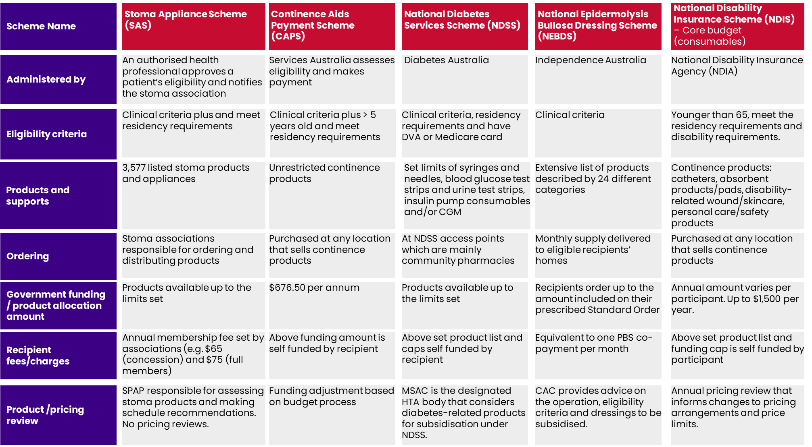

Source: HealthConsult (2023) based on stakeholder consultation and documentation review.

Abbreviations: SPAP: Stoma Product Assessment Panel; CAC = Clinical Advisory Committee

Table 21: Comparator national Australian schemes

|  |  |  |  |  |  |  |
| --- | --- | --- | --- | --- | --- | --- |
| Element | Definition | Stoma Appliance Scheme | Continence Aids Payment Scheme | NDSS | National Epidermolysis Bullosa Dressing Scheme (NEBDS) | NDIS |
| Scheme/program name | The formal title under which the initiative operates. | [Stoma Appliance Scheme](https://www.health.gov.au/our-work/stoma-appliance-scheme) | CAPS 2020 | NDSS | NEBDS | NDIS |
| Overview | A brief outline that provides a snapshot of the scheme. | The Stoma Appliance Scheme provides free stoma appliances and products to people who have a stoma (ostomates). Products supplied under the Scheme assist people with stomas to better manage their condition, and thereby allow greater participation in society and the workforce. Products are provided free of charge. This saves each ostomate an average of over $2,300 per year. | The CAPS is an Australian Government scheme that assists eligible people who have permanent and severe incontinence to meet some of the costs of continence products and continence related products. | The NDSS is an initiative of the Australian Government that commenced in 1987 and is administered by Diabetes Australia.  The NDSS helps people with diabetes to understand and manage their life with diabetes. It also provides timely, reliable and affordable access to diabetes support services and products. | The NEBDS helps eligible people with epidermolysis bullosa access dressings, bandages and ancillary products at a reduced cost. It also ensures a consistent level of care across Australia.  Epidermolysis bullosa (EB) is a rare condition that causes fragile, blistering skin. The blisters may appear in response to minor injury, even from heat, rubbing or scratching. | The NDIS is Australia’s national scheme for people with disability.  Note: If an NDIS participant has continence supports funded in their NDIS plan, they won’t generally be eligible for funding under the CAPS. |
| Approx funding |  | The Scheme provided ostomates with $114 million worth of stoma appliances and products in 2022-23 (reference). | CAPS is an ongoing program funded by the Australian Government. | The NDSS supports ~1.4 million Australians with diabetes. It delivered more than 5.7 million diabetes products in 2019–20, at a cost of more than $188 million.  In July 2021 a new three-year $140 million agreement with Diabetes Australia to continue delivering the NDSS.  State and Territory governments have agreed to cover the co-payments for pen needles or syringes purchased through the NDSS. This effectively means the needles and syringes are “free” to eligible people registered with the NDSS. | In the 2009 – 2010 Budget, the Australian Government committed $16.4m over four years to establish the National EB Dressing Scheme. The scheme supports people with EB who are most in need by improving access to appropriate dressings and bandages which can be costly. Dressings help reduce infection, complications and unnecessary hospitalisation. | Under an NDIS plan “Core budget” which is the most flexible there are four categories of support. One of the categories is “Consumables (e.g. purchasing everyday use items such as CA). The consumables budget can be used to purchase reasonable and necessary everyday items valued at up to $1500. This may include single-use disposable items such as absorbent pads and some personal care items. Once an amount is allocated in an NDIS plan, a recipient can choose how to spend it, providing it relates to their disability support needs and meets the reasonable and necessary test. |
| Eligibility | The conditions that an individual must meet to qualify for the scheme. | A person must have a temporary or permanent artificial body opening (created surgically or otherwise, including a fistula that originates from the urinary or GI tract) which facilitates the removal of urine and/or products of the GI tract from the body where the person does not have normal GI tract or bladder functions, and provide evidence, consisting of a certificate from a registered medical practitioner or STN in an approved form (PB049) | The applicant has permanent and severe incontinence of bladder and/or bowel function due directly to an eligible neurological condition;  OR  The applicant has permanent and severe incontinence of bladder and/or bowel function caused by an eligible other condition, provided the applicant has a Centrelink or DVA Pensioner Concession Card entitlement.  To get paid under CAPS all of the following criteria must be met:   * be 5 years or older * have permanent and severe incontinence confirmed by a registered health professional * be an Australian permanent resident or citizen for as long as you get the payment * have eligible neurological conditions or other conditions as mentioned on the DoHAC website.   If they have a non-neurological condition, they must also be a Pensioner Concession Card (Department or DVA) | You can register for NDSS if:   * live in Australia or * are a resident of a country with which Australia has a Reciprocal Health Care Agreement (and not visiting on a student visa if a resident of Finland, Malta, Norway or the Republic of Ireland). * have been diagnosed with any type of diabetes by a doctor or * have other eligible conditions requiring regular monitoring of blood glucose levels and * hold (or are eligible to hold) a Medicare card or DVA card.   People with type 1 diabetes, type 2 diabetes, gestational diabetes, or ‘other’ diabetes may apply to be registered with the NDSS. ‘ | Clinically diagnosed with EB and be an Australian citizen or resident who is eligible to receive Medicare benefits.  People with all types of EB are eligible under the scheme.   * Proof of diagnosis is required: * skin biopsy testing results; or * genetic testing results; or * genetic testing results of a family member.   The evidence must clearly state the diagnosis and subtype of EB for the family member. Sufficient evidence of family relationship (including birth certificates) and the probability of inheritance must also be supplied.  Provisional access to the NEBDS can provided on clinical diagnosis by an Approved Specialist Health Care Professional or a multidisciplinary EB clinic.  ➤ Note that clinical diagnosis must be followed by a skin biopsy, genetic testing or genetic tests of a family member:  • within six (6) months of provisional approval; or  • within three (3) months for a newborn  Where a new applicant’s eligibility to access the scheme is unclear (in accordance with the eligibility guidelines), the application can be referred to the Clinical Advisory Committee (CAC) who will assess the application and make a recommendation regarding eligibility to access the NEBDS. Please note, in these circumstances the approved specialist health care professional is required to provide a detailed letter clearly outlining the applicant’s case, their expert opinion of the EB sub type category, and any additional supporting evidence, including clinical photographs. | Participant must be younger than 65, meet the residency requirements and disability requirements. Disability requirements include:   * Disability is caused by an impairment. * The impairment is likely to be permanent. * The permanent impairment substantially reduces one’s functional capacity to undertake one or more of the following activities: moving around, communicating, socialising, learning, or undertaking self-care or self-management tasks. * The permanent impairment affects their ability to work, study or take part in social life. * They will likely need support under the NDIS for their whole life. |
| Range of products and supports | Types and diversity of stoma-related products offered through the scheme. | * 3,792 stoma products and appliances listed on the [Stoma Appliance Scheme](https://www.health.gov.au/resources/apps-and-tools/stoma-appliance-scheme/schedule) | Any continence products can be purchased with the provided CAPS funding.  A list of products is available on from Continence Foundation of Australia. | NDSS subsidised products are available through NDSS Access Points (usually community pharmacies).  The NDSS provides subsidised access to the following products for the management of diabetes:   * syringes and needles (limit 1,200 syringes or pin needles or) * blood glucose test strips and urine test strips (limit is 900 strips) and/or * insulin pump consumables (limits: 90 insulin pump cannulae and/or 90 insulin pump reservoirs/cartridges). * continuous glucose monitoring products (limits based on use of device as advised by manufacturer).   The NDSS also provides support services for people with diabetes.  Supplies can be ordered at a NDSS Access Point. | An extensive list of dressings has been approved for subsidised supply to eligible applicants under the NEB DS. Currently 24 categories of products  Recipients can order dressings up to the amount of their Standard Order prescribed by their Treating Healthcare Professional. | Examples of the things that can be purchased under the NDIS Consumables budget include (related to stoma care):   * Continence products (subject to meeting the age requirements) * Catheters * Absorbent products and pads * Disability-related wound and skincare * Personal care and safety products |
| Financial support | Level and type of financial assistance provided, including subsidies, grants, etc. | * Funding is provided (via associations) to cover the costs of stoma appliances and products. * The Scheme Schedule specifies the maximum number of units available to participants under the Scheme monthly or annually. | The CAPS payment rate for 2023–24 is $676.50. The payment may increase or decrease a little every year following the Government’s budget process. | Products available up to the limits. | A monthly supply of approved dressings is delivered to eligible recipients’ homes.  Recipients are required to contribute to the cost of their monthly supply of dressings. This contribution is equivalent to one PBS co-payment and the Australian Government meets the remaining costs. | Annual plan. The consumables budget can be used to purchase reasonable and necessary everyday items valued at up to $1500 |
| Quality Assurance | Procedures in place to ensure the quality and safety of stoma appliances and other resources offered. | * Prior to their listing on the Scheme Schedule, products must be assessed by the SPAP on the basis of their comparative clinical function and effectiveness, comparative cost-effectiveness and comparative safety. * Products approved for listing will be published on the Scheme Schedule. * Stoma associations must comply with the Stoma Appliance Scheme Operational Guidelines and reporting requirements. | Information not available. | Information not available. | Information not available. | NDIS Plans are developed in consultation with the NDIS participant with early childhood partner, a Local Area Coordinator (LAC) or an National Disability Insurance Agency (NDIA) planner. |
| Requirements for Providers | Criteria and responsibilities that providers of the scheme must fulfill, including eligibility and dispute resolution. | * A sponsor of a stoma-related product must have an ABN and be able to guarantee supply of the product. * Products must be registered on the ARTG. | CAPS applicants are required to obtain a continence assessment from an appropriate Health Professional who cannot be a family member. A Health Professional should only complete the Health Report (Section 3) of the CAPS Application Form if they are able to make an accurate assessment of the applicant in relation to their incontinence and the cause of their incontinence. The Health Professional’s assessment must be based on evidence that the applicant has been diagnosed with an eligible neurological condition or an eligible other condition. | The NDSS Registration Form can be completed and certified online by a health professional through the new NDSS Health Professional Portal or by using the form available to print from the NDSS website.  Once completed by a health professional, the form is processed, and if all required information is supplied, confirmed within minutes. If a printed form is submitted, it can take up to seven days on receipt, to be processed and confirmation sent.  An authorised health professional such as doctor, endocrinologist, obstetrician, credentialled nurse educator, nurse practitioner or practice nurse. | Information not available. | Have input to NDIS application process (Section 2) describing the disability and needs of the potential participant. |
| Requirements for Participants | Conditions and procedures that individual participants must adhere to for successful enrolment and ongoing participation. | * A participant must be a current financial member of an approved stoma association. * A participant must only use products supplied through the Scheme for their own personal use. | CAPS clients do not need to reapply each financial year, however it is advisable for children aged 5 years to 15 years to have their continence reassessed at least every 2 years by a Health Professional. | Registration with the NDSS is free all eligible individuals and only needs to be done once. | Information not available. | Complete the form and attend meeting with the allocated planner. |
| Fees and Charges | Details on any access or membership fees associated with participating in the scheme. | * Annual stoma association membership fee – set by associations (e.g. NSW Stoma membership is $65 for concession holders and $75 for full members) * Participants are responsible for any costs (e.g. postage and handling costs) associated with obtaining stoma-related products. | N/A. | N/A. | N/A. | None |
| Application process | Steps required for an individual to apply for and receive assistance from the scheme. | A member of a stoma association needs to:   * complete part 1 of the Stoma Appliance Scheme application form (PB049) * get their medical practitioner or stomal therapy nurse to complete Part 2 * send the completed form. | There are four steps in applying for CAPS:   * Obtain Application Guidelines and Application Form. * Get a doctor or health professional to complete their part of the form. * Submit the application. * Wait for the result. | NDSS registration can be completed and certified online by a health professional through the NDSS Health Professional Portal or by using the form available to print from the NDSS website. | Information not available. | If applicant is aged 9 and older, they can apply by:   1. LAC or local NDIS office can help complete the application process  * Complete application over the phone * Complete an NDIS application form online or print and paper based. |
| Claims process | Processes for preparing, submitting, and receiving payment for claims. | To claim a reimbursement, a stoma association needs to upload an electronic claim file through HPOS.  **Note:** Stoma associations no longer need to send Services Australia copies of the claim paperwork or patient forms PB049 and PB050. | Services Australia administers CAPS. They process the application and make the payments. | Information not available. | The monthly Standard Order is initially prescribed by the recipient’s Treating Healthcare Professional and may be varied from time to time by Treating Healthcare Professionals to meet changing wound care needs. | Once plan is approved, participants can spend their plan according to the approved categories. |
| Payments of claims | Processes for transferring funds to cover the cost of stoma-related products and services. | Payments for all claims processed by Services Australia are paid via electronic funds transfer to the financial institution nominated by the stoma association. | CAPS payment is paid into your choice of an Australian bank account.  CAPS is not a retrospective payment scheme. The applicant’s initial CAPS payment is based on a pro-rata rate calculated from the date Services Australia receives a complete application form. Applicants can receive the CAPS payment in one annual payment or in two bi-annual payments. Annual payments are paid in July and bi-annual payments are paid in July and January of each financial year. | Information not available. | N/A. | N/A. |
| Pricing | How pricing is structured for products and services. | Product prices in the Scheme Schedule are set by the Department following advice from SPAP and negotiation with Scheme sponsors.  There are two pricing categories:   * **Benchmark prices** – the product prices set by the Department and defined in the Scheme Schedule. * **Premium prices** - Products may be listed at a price higher than the benchmark if they are assessed by SPAP as providing improved health outcomes and are cost-effective at the higher price. | Information not available. | Information not available. | Information not available. | Information not available. |
| Frequency and process for reviewing pricing of products/appliances | Up until 2013 there was annual indexation of the prices.  Post 2013 budget review, there was a commitment to remove the annual indexation process and undertake annual pricing reviews. To date no review has been undertaken and prices have been maintained at 2013 prices. | Frequency and process for reviewing pricing of products/appliances. | Information not available. | From 1 November 2020, MSAC became the designated HTA body to consider diabetes-related products for subsidisation under the NDSS. | Information not available. | Annual pricing review that involves a combination of market data, research, public consultation and regular industry engagement informs changes to pricing arrangements and price limits. |
| Reporting | What types of reporting are required and to whom they should be directed. | Stoma associations are required to provide ACSA with:   * monthly new membership numbers and statistics * annual membership numbers and statistics * details of members accessing the Scheme * yearly financial statements * any other information related to Scheme activities as requested.   ACSA is required to provide the above information to the Department on an annual basis, or as requested. | Information not available. | Information not available. | Information not available. | Annual report published on NDIS website and annual pricing by component area. |
| Ordering | The procedure by which participants request specific stoma-related products or services. This involves selecting items based on eligibility, adhering to set limits, and submitting the request through designated channels. | * Orders must be in writing by post, fax, email or online form (e.g. [NSW Online Order Form](https://www.nswstoma.org.au/online-order-form/)) via a stoma association. * Members are entitled to one supply per month only. * Maximum quantities are determined by Scheme Schedule. | N/A. | N/A. | Information not available. | N/A. |
| Customer Support | Types of support services offered (e.g., hotlines, consultations) and their availability at some associations. | * Support during business hours available via associations may include – website, email, telephone and in-person (via office premises). * Some associations offer After Hours emergency support e.g. the QLD Ostomate Support After Hours emergency support service. | CAPS team. Contact to report a change in circumstances or if any questions about CAPS payments. The CAPS team is part of Services Australia and operates from 8.30am to 5pm (AEST) Monday to Friday.  National Continence Helpline: is staffed by a team of continence nurse advisors and is available to anyone in Australia. It operates from 8am to 8pm (AEST) Monday to Friday. | Contact the NDSS for information about access to subsidised diabetes products and support. | Information not available. | Offices and contacts by area   * LAC * Early childhood partner for children younger than 9 * Local NDIS offices   Phone NDIS on 1800 800 110 or chat now  Via the NDIS website   * Contact and feedback form * Make an enquiry * Request a call back * Feedback or complaints |
| Public Awareness | Measures to educate the public about the scheme. | Via ACSA whose mission is to provide support and assistance to all stoma associations in carrying out their work in promoting the general wellbeing of persons who have undergone ostomy surgery in Australia. | Information not available. | Information not available. | Independence Australia and DEBRA Australia | Information not available. |
| Governance arrangements | The bodies or panels responsible for overall governance, policy direction, quality assurance, and compliance. | * **Scheme participants** – an eligible person registered with an association * **Stoma associations** – responsible for ordering and distributing stoma-related products * **Health professionals (e.g. medical and STNs** assess and sign-off if patient is eligibility and should access restricted products * **Scheme sponsor** is a manufacturer or distributor of stoma-related products * **Services Australia** – claims processing and payments * **ACSA** – represents individual stoma associations * **SPAP** - an independent technical advice panel responsible for assessing stoma products and makes recommendations to Government regarding any changes, including new listings, to the Stoma Appliance Scheme Schedule * **Australian Government DoHAC** – overall scheme responsibility | DoHAC is responsible for CAPS policy. They also manage communications about CAPS. They work with Services Australia on eligibility and payment issues and respond to policy enquiries. | Information not available. | The scheme is currently administered by Independence Australia on behalf of the Australian Government.  A CAC provides advice on the operation of the scheme, eligibility criteria and dressings to be subsidised under the scheme.  The committee consists of a variety of clinical experts and an EB consumer representative, who may seek input from DEBRA Australia (a not-for-profit volunteer based organisation) and EB nurses from time to time. | The NDIA administers the scheme. It is governed by a Board. The NDIA Board is advised by the Independent Advisory Council. |
| Policy documents and operational guidelines | Official written instruments that outline the framework, objectives, and operational procedures governing the scheme. These documents set the formal rules, delineate responsibilities, and offer step-by-step instructions for both administration and participation. | [Stoma Appliance Scheme Operational Guidelines](https://www.health.gov.au/sites/default/files/documents/2022/10/stoma-appliance-scheme-operational-guidelines.pdf)  [Stoma Appliance Scheme Schedule](https://www.health.gov.au/sites/default/files/2023-04/stoma-appliance-scheme-schedule_0.pdf)  [Stoma Appliance Scheme Application and Assessment Guidelines](https://www.health.gov.au/sites/default/files/2023-07/stoma-appliance-scheme-application-and-assessment-guidelines.pdf)  [Stoma Appliance Scheme application forms for suppliers](https://www.health.gov.au/resources/publications/stoma-appliance-scheme-application-to-list-products-on-the-schedule-benchmark-groups-1-to-7?language=en) | CAPS guidelines and form <https://www.health.gov.au/resources/publications/continence-aids-payment-scheme-application-guidelines-and-application-form?language=und>  CAPS webpage on the Department’s website <https://www.health.gov.au/our-work/continence-aids-payment-scheme-caps>  CAPS 2020 legislative instrument – as the payment amounts and eligibility etc. are set out in legislation. <https://www.legislation.gov.au/Details/F2023C00676> | Information not available. | [PowerPoint Presentation (ebdressings.com.au)](https://www.ebdressings.com.au/wp-content/uploads/2018/09/NEBDS_ScheduleOfDressings_February2022-.pdf) | https://www.ndis.gov.au/about-us/operational-guidelines |
| Forms and Documentation | Types of forms used for various purposes like applications, special authorisations, and audit evidence. | [Application for stoma association membership](https://qldstoma.asn.au/wp-content/uploads/QSA-member-application-CLG-From-1-July-2023.pdf) (QLD)  [Stoma Appliance Scheme application form (PB049)](https://www.servicesaustralia.gov.au/pb049)  [Stoma Appliance Scheme application for additional supplies form (PB050)](https://www.servicesaustralia.gov.au/pb050)  [NSW Online Order Form](https://www.nswstoma.org.au/online-order-form/)  [Stoma Appliance Scheme forms for ostomates](https://www.health.gov.au/our-work/stoma-appliance-scheme/stoma-appliance-scheme-for-ostomates%23forms) (for products with restrictions). | [Continence Aids Payment Scheme application guidelines and form (health.gov.au)](https://www.health.gov.au/sites/default/files/2023-08/continence-aids-payment-scheme-application-guidelines-and-application-form_0.pdf) | [form-ndss-registration-form.pdf](https://www.ndss.com.au/wp-content/uploads/forms/form-ndss-registration-form.pdf) | [NEBDS | Independence Australia](https://www.independenceaustralia.com.au/nebds/#:~:text=The%20National%20Epidermolysis%20Bullosa%20Dressing%20Scheme%20%28NEBDS%29%20supports,the%20Australian%20Government%20and%20administered%20by%20Independence%20Australia.) | Information not available. |

1. Budgetary Implications of Access Modifications

Scenario One and Two: Removal or restrictions of Creams and Ointments

In stakeholder feedback, it was heard that creams and ointments (product category 09(f)) were not clinically necessary and there is an opportunity to reduce expenditure of the Scheme by removing or restricting the following codes as subsidised products: 03526N, 03528Q, 03557F, 03787H, 03829M, 03979K, 09858W, 09907K, 09933T, 09934W.

In considering the costs associated with creams and ointments, it was found that from the total expenditure of the Scheme in FY25-26, creams and ointments accounted for **$83,307**and would result in **less than 1% in cost savings for the Scheme if removed or restricted**. Figure 18provides three years of predicted expenditure related to this scenario and highlights the change would affect approximately 2,340 ostomates if removed from the Scheme, or 382 ostomates if maximum annual quantity was restricted by half.

Figure 18: Expenditure related to creams and ointments if removed or restricted on the Scheme

|  |  |  |  |
| --- | --- | --- | --- |
| Scenario: | | Creams and ointments (09f) removed | 09f quantity restricted by 50% |
| 2023-24 | **Change in expenditure from predicted** | **($80,070)** | **($19,865)** |
| Percentage change | -0.07% | -0.02% |
| 2024-25 | **Change in expenditure from predicted** | **($81,453)** | **($23,141)** |
| Percentage change | -0.07% | -0.02% |
| 2025-26 | **Change in expenditure from predicted** | **($83,307)** | **($26,852)** |
| Percentage change | -0.07% | -0.02% |
| *Number of ostomates impacted (based on current ostomate #)* | *2,340* | *382* |

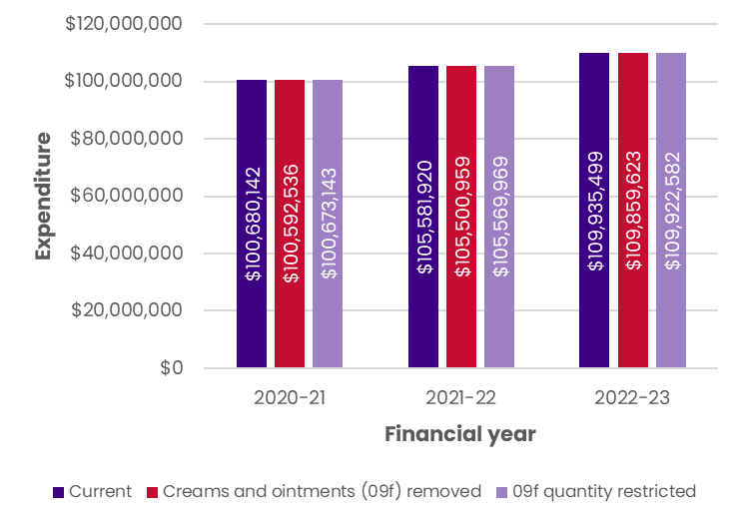

Scenario Three: Removal of Catheters

The removal of catheters (product category 08(c)) was also tested for expenditure changes following stakeholder feedback suggesting they were not clinically necessary, particularly for certain stoma types. Group 08c contains the following product codes: 03671F, 09755K, 09822Y, 09867H, 09869K, 09870L, 09962H, 80151L, 80157T, 80158W, 80184F, 80198Y.

It was found that from the total expenditure of the Scheme in FY25-26 ($126,792,538), catheters accounted for **$654,521**and would result in **less than 1% in cost savings for the Scheme if removed**. Figure 19 provides three years of predicted expenditure related to this scenario and highlights the change would affect approximately 621 ostomates if removed from the Scheme.

Figure 19: Expenditure related to catheters if removed from the Scheme

|  |  |  |
| --- | --- | --- |
| Scenario: | | Catheters (08c) removed |
| 2023-24 | **Change in expenditure from predicted** | **($654,521)** |
| Percentage change | -0.57% |
| 2024-25 | **Change in expenditure from predicted** | **($674,221)** |
| Percentage change | -0.56% |
| 2025-26 | **Change in expenditure from predicted** | **($729,182)** |
| Percentage change | -0.58% |
| *Number of ostomates impacted (based on current ostomate #)* | *621* |

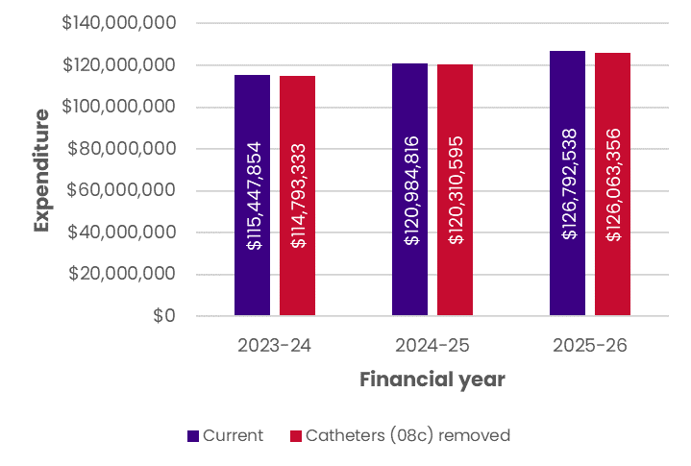

A deeper dive on stoma types amongst catheter users was conducted. Figure 20 illustrates that the majority of ostomates using catheters have a stoma type listed as “Other” (55%), with urostomy the second most common (27%) and Ileostomy the third most common (9%). This may be clinically appropriate given the number of ostomates that have two or more stomas accessing the Scheme.

Figure 20: Catheter users by stoma type, 2022-23

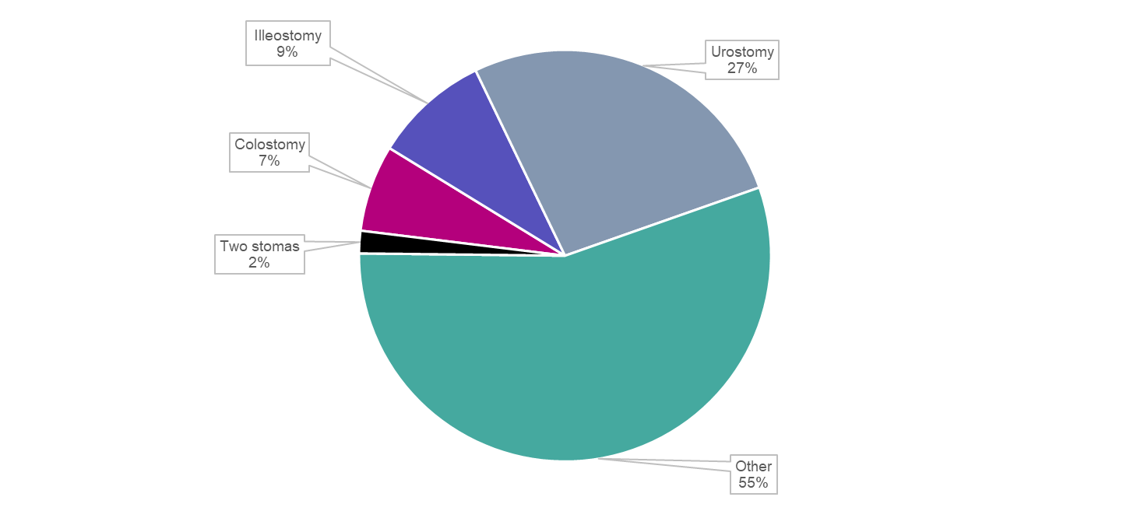

Source: PBS data, n=396 (of the 621 ostomates accessing catheters, stoma type was known for 396)

Scenario Four: Removal of Deodorants

Similarly, stakeholder feedback suggested deodorants (product category 09(g)) were a personal choice and not clinically necessary. The reduction of expenditure was tested after removing the following codes as a subsidised product: 03514Y, 03516C, 03517D, 03518E, 03798X, 03811N, 03872T, 09823B, 09855Q, 09954X, 09988Q, 80016J, 80029C.

It was found that from the total expenditure of the Scheme in FY25-26 ($126,792,538), deodorants accounted for **$536,265**and would result in **less than 1% in cost savings for the Scheme if removed**. Figure 21 provides three years of expenditure related to this scenario and highlights the change would affect approximately 9,051 ostomates if removed from the Scheme.

Figure 21: Expenditure related to deodorants if removed from the Scheme

|  |  |  |
| --- | --- | --- |
| Scenario: | | Deodorants (09g) removed |
| 2023-24 | **Change in expenditure from predicted** | **($495,894)** |
| Percentage change | -0.43% |
| 2024-25 | **Change in expenditure from predicted** | **($512,630)** |
| Percentage change | -0.42% |
| 2025-26 | **Change in expenditure from predicted** | **($536,265)** |
| Percentage change | -0.42% |
| *Number of ostomates impacted (based on current ostomate #)* | *9,051* |

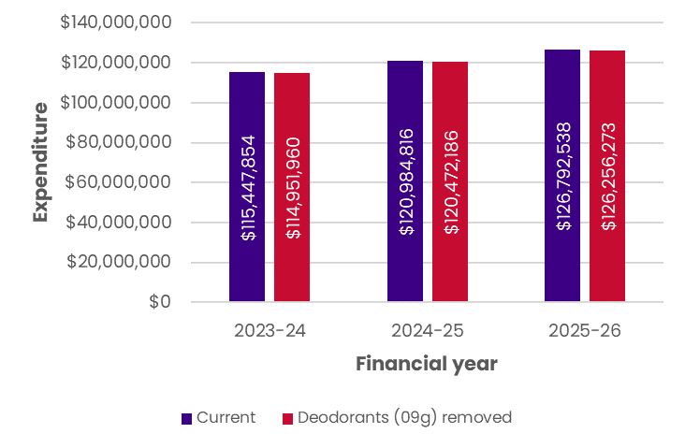

Scenario Five: Removal of cleanser wipes

Stakeholders also suggested that cleanser wipes were not clinically necessary. Thus, the removal of cleanser wipe product subsidies from the Scheme (product codes 03568T, 09981H, 03520G, 80125D) and subsequent expenditure changes were tested.

It was found that from the total expenditure of the Scheme in FY25-26 ($126,792,538), cleanser wipes accounted for **$4,790,354**and would result in **3.8% in cost savings for the Scheme if removed**. Figure 22 provides three years of expenditure related to this scenario and highlights the change would affect 19,229 ostomates (39% of ostomates accessing the Scheme in 2022-23) if removed.

Figure 22: Expenditure related to cleanser wipes if removed from the Scheme

|  |  |  |
| --- | --- | --- |
| Scenario: | | Cleanser wipes removed (03568T, 09981H, 03520G, 80125D) |
| 2023-24 | **Change in expenditure from predicted** | **($4,116,770)** |
| Percentage change | -3.57% |
| 2024-25 | **Change in expenditure from predicted** | **($4,453,562)** |
| Percentage change | -3.68% |
| 2025-26 | **Change in expenditure from predicted** | **($4,790,354)** |
| Percentage change | -3.78% |
| *Number of ostomates impacted (based on current ostomate #)* | *19,229* |

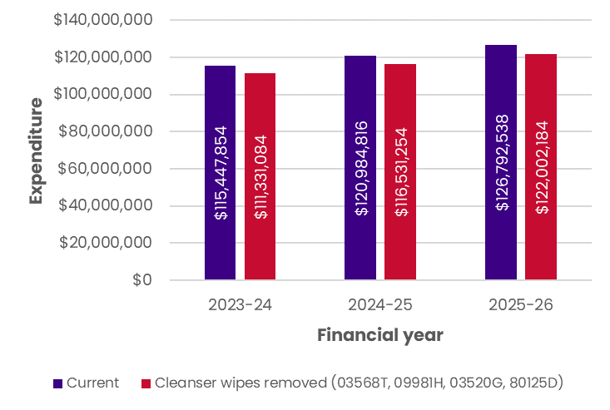

Scenario Six: Removal of low-utilisation products

There was some stakeholder support for review and removal of low-utilisation products (<20 products ordered per year) from the Scheme. Changes to overall expenditure for the next three years was tested after these low-utilisation products were removed from the Scheme.[44]

It was found that from the total expenditure of the Scheme in FY25-26 ($126,792,538these low-utilisation products accounted for **$8,234**and would result in **less than 1% in cost savings for the Scheme if removed**. Figure 23 provides three years of expenditure related to this scenario and highlights the change would affect approximately 45 ostomates if removed from the Scheme. Notably it is likely these ostomates would switch to similarly products and these cost savings may not be realised.

Figure 23: Expenditure related to low-utilisation products if removed from the Scheme

|  |  |  |
| --- | --- | --- |
| Scenario: | | Removal of low utilisation products (<20 total quantity per annum) |
| 2023-24 | **Change in expenditure from predicted** | **($5,983)** |
| Percentage change | -0.01% |
| 2024-25 | **Change in expenditure from predicted** | **($8,258)** |
| Percentage change | -0.01% |
| 2025-26 | **Change in expenditure from predicted** | **($8,234)** |
| Percentage change | -0.01% |
| *Number of ostomates impacted (based on current ostomate #)* | *45* |

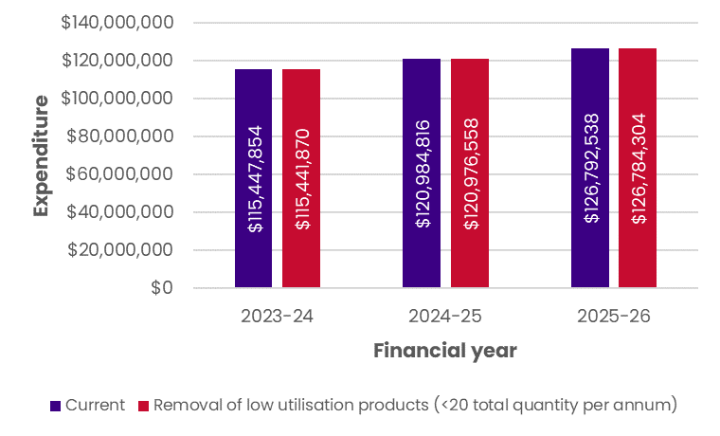

Scenario Seven: Decrease in maximum quantity of closed bag systems

According to stakeholders, closed bag system allocation could be reduced on the Scheme. A 50% decrease in maximum annual quantity of closed bag systems (all product codes in groups 1 and 5) was tested.

It was found that a 50% decrease in maximum quantity of closed bag systems in FY25-26 (total expenditure $126,792,538), would result in a cost-saving of **$13,057,223** (a **10.3% decrease in expenditure for the Scheme)**. Figure 24 provides three years of predicted expenditure related to this scenario and highlights the change would affect approximately 7,202 ostomates if restricted on the Scheme.

Figure 24: Expenditure related to closed bag systems if maximum quantity was decreased 50% on the Scheme

|  |  |  |  |  |
| --- | --- | --- | --- | --- |
| Scenario: | | 50% decrease in annual quantity of closed bag systems | | |
| 2023-24 | **Change in expenditure from predicted** | | **($9,060,627)** |
| Percentage change | | -7.85% |
| 2024-25 | **Change in expenditure from predicted** | | **($11,109,633)** |
| Percentage change | | -9.18% |
| 2025-26 | **Change in expenditure from predicted** | | **($13,057,223)** |
| Percentage change | | -10.30% |
| *Number of ostomates impacted (based on current ostomate #)* | | *7,202* |

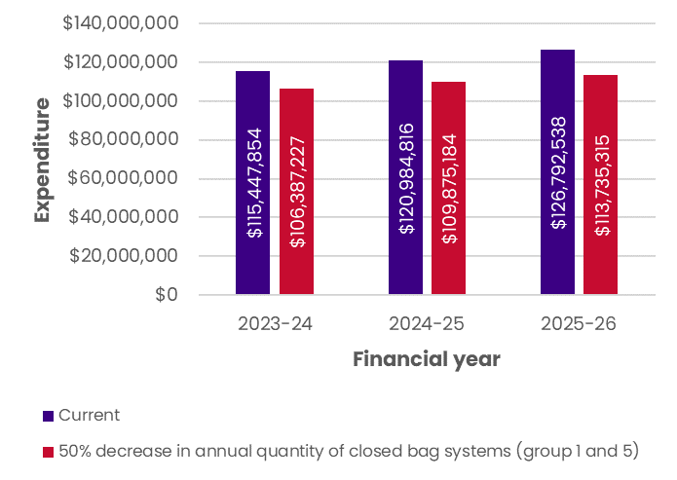

**Scenario Eight: Increase in maximum quantity of plug systems**

There was some stakeholder support for an increase in maximum annual quantity for plus systems (product group 08(a)). A 100% increase in annual quantity of plug systems (product codes 03641P, 09845E, 80101W, 80163D, and 80179Y). The Scenario assumes that any ostomate currently ordering the maximum would instead order the new doubled maximum quantity.

It was found that a 100% increase in maximum quantity in FY25-26 (total expenditure $126,792,538), could result in an additional **$24,736, or less than 1% increase in expenditure for the Scheme**. Figure 25 provides three years of predicted expenditure related to this scenario and highlights the change would impact approximately 30 ostomates currently accessing maximum quantity from the Scheme.

Figure 25: Expenditure related to plug **systems if maximum quantity was increased 100% on the Scheme**

|  |  |  |  |
| --- | --- | --- | --- |
| Scenario: | | 100% increase in annual quantity of plug systems | |
| 2023-24 | **Change in expenditure from predicted** | **$17,931** |
| Percentage change | +0.02% |
| 2024-25 | **Change in expenditure from predicted** | **$21,333** |
| Percentage change | +0.02% |
| 2025-26 | **Change in expenditure from predicted** | **$24,736** |
| Percentage change | +0.02% |
| *Number of ostomates impacted (based on current ostomate #)* | *30* |

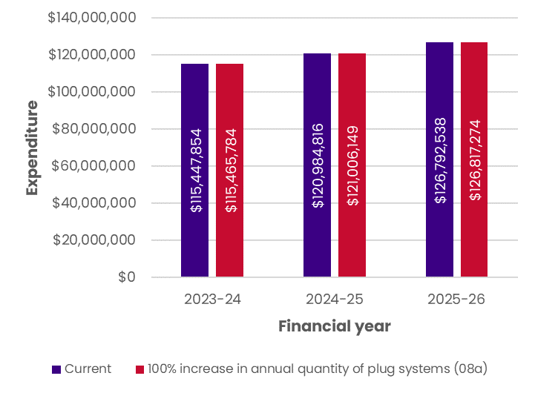

Scenario Nine: Increase in maximum quantity of caps

Stakeholder feedback showed wide support for rationalisation of quantities for certain products, particularly maximum quantities of bags, caps and seals to align with usage. This Scenario tests the impact of increasing the maximum quantity of stoma caps (group 01a) from 60 per month to 90.

It was found that the increase in maximum quantity of caps in FY25-26 (total expenditure $126,792,538), could result in an additional **$$14,850** (a **0.01% increase in expenditure for the Scheme)**. Figure 26 provides three years of predicted expenditure related to this scenario and highlights the change would affect 25 ostomates who are currently ordering the maximum monthly amount.

Figure 26: Expenditure related to increasing maximum quantity of caps on the Scheme

|  |  |  |
| --- | --- | --- |
| Scenario: | | Increase in maximum quantity of caps (01a) |
| 2023-24 | **Change in expenditure from predicted** | **$9,736** |
| Percentage change | +0.01% |
| 2024-25 | **Change in expenditure from predicted** | **$12,293** |
| Percentage change | +0.01% |
| 2025-26 | **Change in expenditure from predicted** | **$14,850** |
| Percentage change | +0.01% |
| *Number of ostomates impacted (based on current ostomate #)* | *25* |

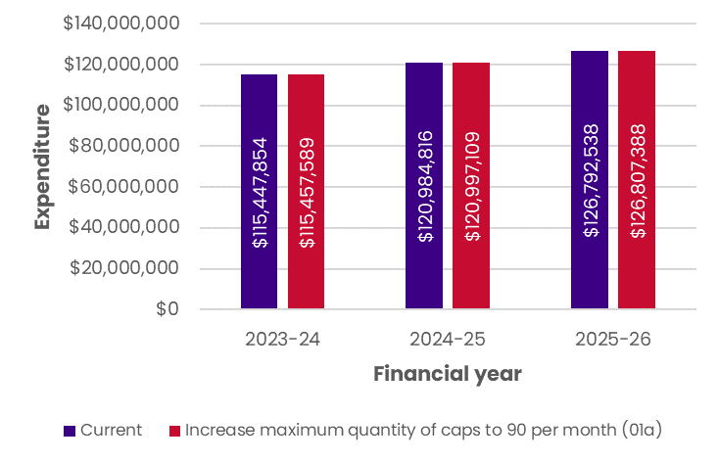

Scenario Ten: Increase in maximum quantity of seals

After stakeholder feedback regarding aligning usage of bags, caps and seals, this Scenario tests the impact of increasing the maximum quantity of seals (group 09l) from 30 per month to 90.

It was found that the increase in maximum quantity of caps in FY25-26 (total expenditure $126,792,538), could result in an additional **$5,343,629** (a **4.21% increase in expenditure for the Scheme)**. Figure 27 provides three years of predicted expenditure related to this scenario and highlights the change would affect approximately 1,408 ostomates who are currently ordering the maximum monthly amount.

Figure 27: Expenditure related to increasing the maximum quantity of seals on the Scheme

|  |  |  |
| --- | --- | --- |
| Scenario: | | Increase in maximum quantity of seals (09l) |
| 2023-24 | **Change in expenditure from predicted** | **$3,514,826** |
| Percentage change | +3.04% |
| 2024-25 | **Change in expenditure from predicted** | **$4,429,227** |
| Percentage change | +3.66% |
| 2025-26 | **Change in expenditure from predicted** | **$5,343,629** |
| Percentage change | +4.21% |
| *Number of ostomates impacted (based on current ostomate #)* | *1,408* |

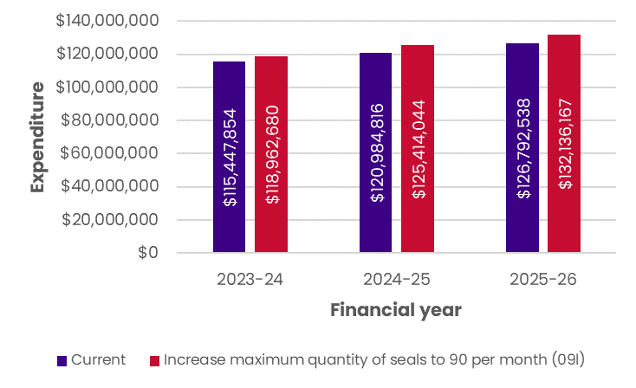

**Scenario 11: Increase in maximum quantity of convex bag systems**

In line with Scenario nine and ten, this Scenario tests the impact of aligning the maximum quantity of bags, caps and seals. Specifically, the maximum quantity of convex bag systems (group 01c and 03b) was increased from 60 or 30 per month to 90. .

It was found that the increase in maximum quantity of convex bags in FY25-26 (total expenditure $126,792,538), could result in an additional **$4,651,906** (a **3.67% increase in expenditure for the Scheme)**. Figure 28 provides three years of predicted expenditure related to this scenario and highlights the change would affect approximately 220,996 ostomates who are currently ordering the maximum monthly amount.

Figure 28: Expenditure related to increasing the maximum quantity of seals on the Scheme

|  |  |  |
| --- | --- | --- |
| Scenario: | | Increase in annual quantity of convex bags systems (01c and 03b) |
| 2023-24 | **Change in expenditure from predicted** | **$2,953,684** |
| Percentage change | +2.56% |
| 2024-25 | **Change in expenditure from predicted** | **$3,802,376** |
| Percentage change | +3.14% |
| 2025-26 | **Change in expenditure from predicted** | **$4,651,906** |
| Percentage change | +3.67% |
| *Number of ostomates impacted (based on current ostomate #)* | *220,996* |

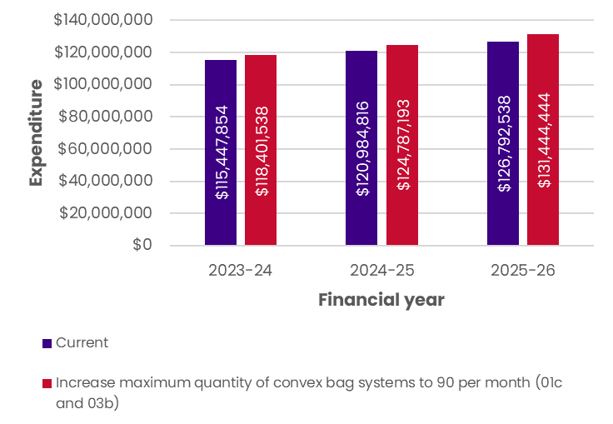

1. Budgetary Implications of Pricing Changes

Scenario 12: One-off increase through CPI indexation

Stakeholders from the stoma product industry expressed support for indexation given the extraordinary levels of inflation seen in Australia post-COVID-19.[45] A number of indices were considered, such as the Australian Institute of Health and Welfare Total Health Price Index or a Weighted Price Index, however due to the nature of stoma appliances and accessories, and the availability of more recent data, the Consumer Price Index (CPI) was used. CPI is a widely used indicator of inflation which encapsulates the changes in price of goods and services commonly purchased by households. CPI values from the Australian Bureau of Statistics (ABS) was applied to each product’s unit price to estimate expenditure if indexation occurs**.**[46]

The This Scenario looks at the expected expenditure should indexation been applied at any point in the next three financial years as a one-off. The Scenario does not compound the indexed prices and uses the five-year average of CPI taken at June.

It was found that one-off indexation would result in an additional cost of $4,361,663in FY25-26 (a 3.4% increase in expenditure for the Scheme). Notably, when tying prices to an index such as CPI there may be fluctuations above or below the average used here. For example, the 6.1% CPI seen in June 2023 was much higher than the 5-year index average (3.4%).

Figure 29 provides the next three years of predicted expenditure related to this scenario.

Figure 29: Expenditure related to backdating indexation on unit prices on the Scheme

|  |  |  |
| --- | --- | --- |
| Scenario: | | CPI indexation: backdated |
| 2023-24 | **Change in expenditure from predicted** | **$3,971,406** |
| Percentage change | +3.44% |
| 2024-25 | **Change in expenditure from predicted** | **$4,161,878** |
| Percentage change | +3.44% |
| 2025-26 | **Change in expenditure from predicted** | **$4,361,663** |
| Percentage change | +3.44% |

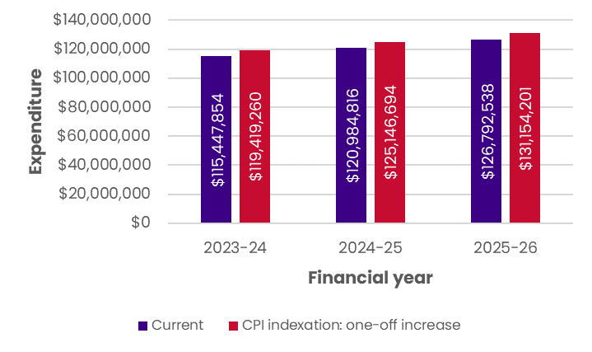

**Scenario 13: Introduction of ongoing annual indexation**

There was stakeholder support for ongoing annual indexation of prices on the Scheme, similar to international comparators. The average of the ABS CPI index from June over the past 5-years was applied to each product’s unit price and then multiplied by a forecast quantity for each product to estimate expenditure with indexation in future.[47] Please note that prices are compounding in this Scenario.

It was found that ongoing indexation is predicted to result in an additional cost of **$13,540,275 by FY25-26 (a 10.68% increase in predicted expenditure without ongoing indexation**). Figure 30 provides three years of predicted expenditure related to this scenario.

Figure 30: Expenditure related to ongoing indexation on unit prices on the Scheme

|  |  |  |  |
| --- | --- | --- | --- |
| Scenario: | | CPI indexation: ongoing annual adjustment | |
| 2023-24 | **Change in expenditure from predicted** | **$3,971,406** |
| Percentage change | +3.44% |
| 2024-25 | **Change in expenditure from predicted** | **$8,466,924** |
| Percentage change | +7.00% |
| 2025-26 | **Change in expenditure from predicted** | **$13,540,275** |
| Percentage change | +10.68% |

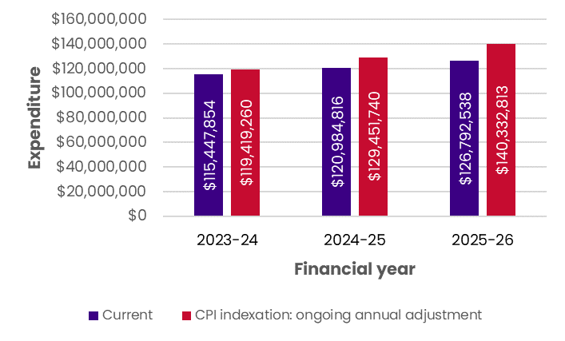

**Scenario 14: Backdated prices and ongoing annual indexation**

Another scenario was tested in which prices were backdated according to CPI in June of the previous FY, and then ongoing annual indexation occur for unit prices on the Scheme from 2023-24. Under this Scenario, prices begin compounding in 2023-24 using the five-year June CPI average.

It was found that this scenario is predicted to result in an additional cost of **$27,294,862 by FY25-26 (a 21.53% increase in predicted expenditure without indexation**). Figure 31 provides the next three years of predicted expenditure should prices be backdated according to CPI and then indexation be applied from 2023-24 at the five-year June CPI average.

Figure 31: Expenditure related to backdated and ongoing indexation on unit prices on the Scheme

|  |  |  |
| --- | --- | --- |
| Scenario: | | CPI indexation: backdated and ongoing annual adjustment |
| 2023-24 | **Change in expenditure from predicted** | **$11,255,981** |
| Percentage change | +9.75% |
| 2024-25 | **Change in expenditure from predicted** | **$16,363,480** |
| Percentage change | +13.53% |
| 2025-26 | **Change in expenditure from predicted** | **$22,100,577** |
| Percentage change | +17.43% |

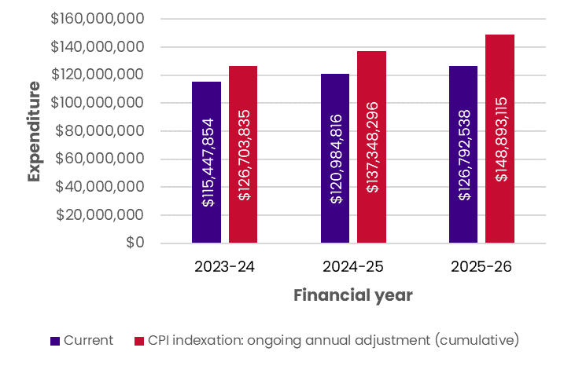

Scenario 15: Changes in benchmark pricing for core products

Stakeholder feedback suggested that prices on the Australian Scheme be increased to align with international product pricing more closely. A one-off price increase was tested, currently at 10% although further increases can be tested via the Financial Model provided to the Department separately. The following shows expenditure given a one-off 10% price increase for the benchmark price of core products (product groups 1 to 7 on the Scheme) in any given year.[48]

It was found that this scenario could result in additional cost of **$7,764,193** **in FY25-26 (a 6.12% increase in predicted expenditure for the Scheme without the one-off increase).** Figure 32 provides three years of forecast expenditure related to this Scenario.

Figure 32: Expenditure related to a one-off increase in benchmark prices for core products on the Scheme

|  |  |  |
| --- | --- | --- |
| Scenario: | | One-off (10%) increase in benchmark prices for core products |
| 2023-24 | **Change in expenditure from current** | **$7,213,057** |
| Percentage change | +6.25% |
| 2024-25 | **Change in expenditure from current** | **$7,479,361** |
| Percentage change | +6.18% |
| 2025-26 | **Change in expenditure from current** | **$7,764,193** |
| Percentage change | +6.12% |

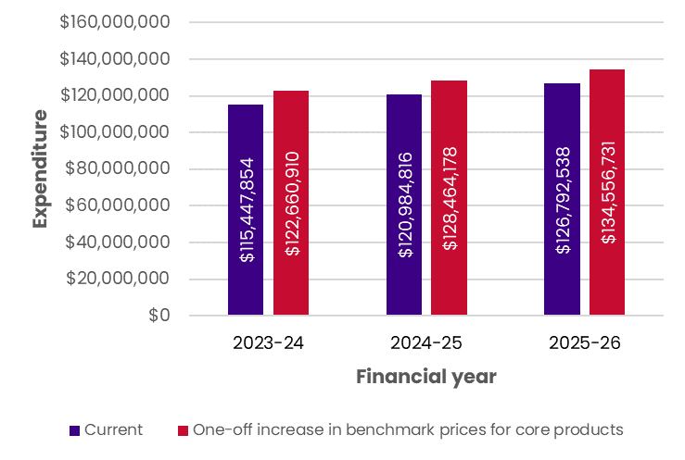

**Scenario 16: Changes in premium pricing for select products**

A one-off price increase was tested as an alternative price-setting mechanism to bring prices closer to international comparators. The following shows expenditure given a one-off price increase for the premium price of products (product groups 1 to 7 on the Scheme) in any given year. [49]

It was found that this scenario could result in additional cost of **$199,934** **in FY25-26 (a 0.16% increase in predicted expenditure for the Scheme without the one-off increase).** Figure 33 provides three years of forecast expenditure related to this scenario.

Figure 33: Expenditure related to a one-off increase in premium prices for select products on the Scheme

|  |  |  |
| --- | --- | --- |
| Scenario: | | One-off (10%) increase in premium prices for select products |
| 2023-24 | **Change in expenditure from current** | **$179,570** |
| Percentage change | +0.16% |
| 2024-25 | **Change in expenditure from current** | **$189,749** |
| Percentage change | +0.16% |
| 2025-26 | **Change in expenditure from current** | **$199,934** |
| Percentage change | +0.16% |

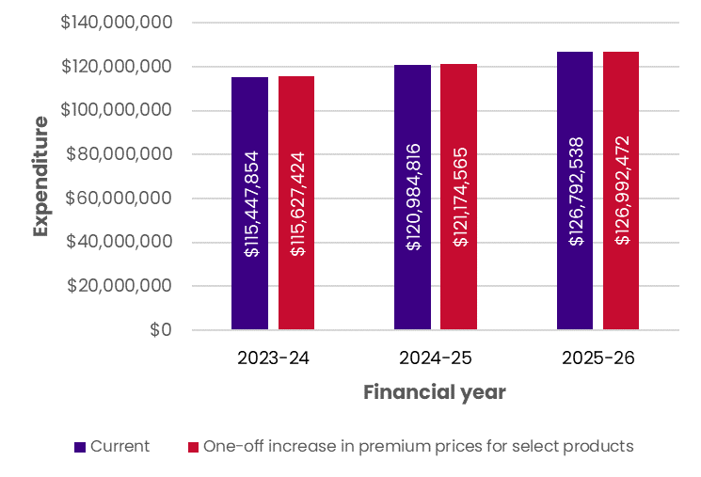

**Scenario 17: Changes in benchmark pricing and premium pricing combined**

This Scenario illustrates expenditure with an increase in both benchmark and premium prices (for those with premium price listed on the Scheme) for all products.

It was found that this scenario would result in additional cost of **$12,539,737 in FY25-26 (a 9.89% increase in predicted expenditure for the Scheme without the one-off increases).** Figure 34 provides three years of forecast expenditure related to this scenario.

Figure 34: Expenditure related to a one-off increase in benchmark and premium prices

|  |  |  |
| --- | --- | --- |
| Scenario: | | One-off (10%) increase in benchmark and premium prices |
| 2023-24 | **Change in expenditure from current** | **$11,331,439** |
| Percentage change | +9.82% |
| 2024-25 | **Change in expenditure from current** | **$11,922,395** |
| Percentage change | +9.85% |
| 2025-26 | **Change in expenditure from current** | **$12,539,737** |
| Percentage change | +9.89% |

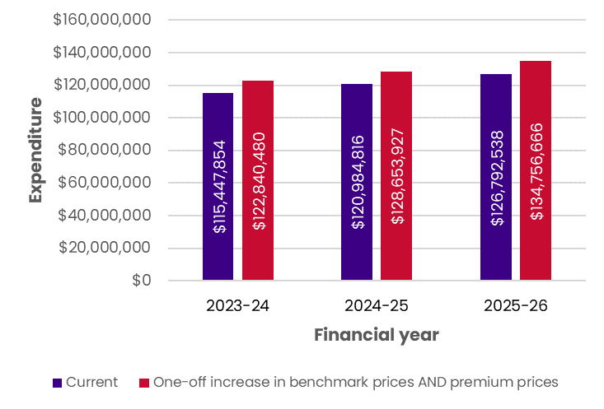

**Scenario 18: Changes in benchmark pricing and ongoing annual indexation**

This Scenario was modelled by taking a one-off benchmark and premium increased price in 2023-24, and then applying the five-year average June CPI with annual compounding from 2024-25 onwards.

It was found that this scenario would result in additional cost of **$22,290,678 in FY25-26 (a 17.58% increase in predicted expenditure for the Scheme without the one-off increase and indexation).** Figure 35 provides three years of forecast expenditure related to this scenario.

Figure 35: Expenditure related to a one-off increase in benchmark and premium prices followed by annual indexation

|  |  |  |  |
| --- | --- | --- | --- |
| Scenario: | | | One-off (10%) increase in benchmark and premium prices and indexation |
| 2023-24 | **Change in expenditure from current** | **$11,331,439** | |
| Percentage change | +9.82% | |
| 2024-25 | **Change in expenditure from current** | **$16,494,403** | |
| Percentage change | +13.63% | |
| 2025-26 | **Change in expenditure from current** | **$22,290,678** | |
| Percentage change | +17.58% | |

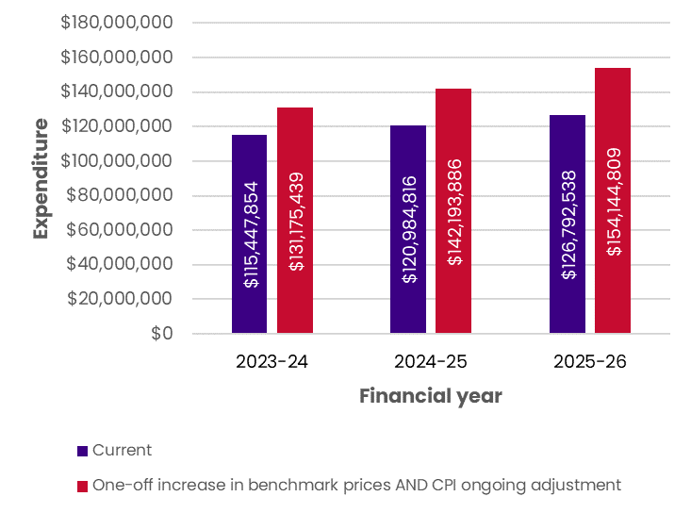

1. Budgetary Implications of Time Components

Scenario 19: Increase in ostomates in line with population growth

This scenario tests the predicted increases in expenditure if the number of ostomates increased in line with population growth. Notably, the PBS data on the overall number of ostomates was not cleansed until 2023 and the Department advised of some potential double counting. In consultation with stakeholders the number of ostomates in 2022-2023 (48,770) was deemed a good approximation and was used as a proxy for the number of ostomates in 2020-21 and 2021-22. The average expenditure per ostomate based on this figure was found and forecast three years into the future. This forecast was then multiplied by the number of ostomates expected in the next three FYs if the number grew in line with projected population.

It was found that this scenario would result in additional projected cost of **$3,378,739 in FY25-26 compared to the predicted expenditure (a 2.66% increase in expenditure for the Scheme).** Figure 36 provides the projected three years of expenditure related to this scenario.

Figure 36: Expenditure related to increases in ostomate numbers on the Scheme

|  |  |  |  |
| --- | --- | --- | --- |
| Scenario: | | Increase in ostomates in line with population growth | |
| 2023-24 | **Change in expenditure from predicted** | **$1,345,479** |
| Percentage change | +1.17% |
| 2024-25 | **Change in expenditure from predicted** | **$2,452,582** |
| Percentage change | +2.03% |
| 2025-26 | **Change in expenditure from predicted** | **$3,378,739** |
| Percentage change | +2.66% |

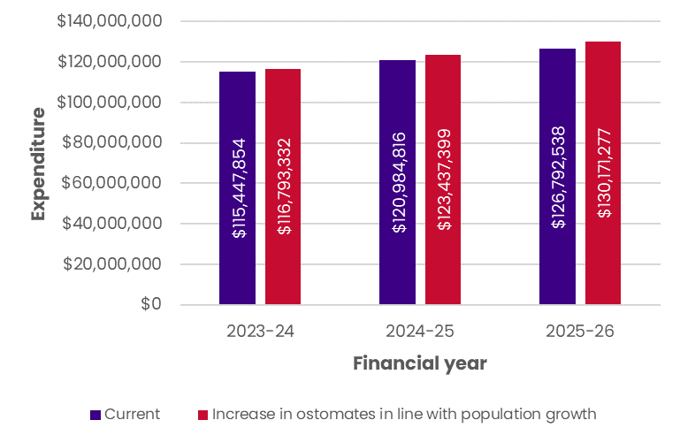

1. [Stoma Appliance Scheme utilisation and expenditure data quarterly report – April to June 2023 and End of Financial Year 2022-23 | Australian Government Department of Health and Aged Care](https://www.health.gov.au/resources/publications/stoma-appliance-scheme-utilisation-and-expenditure-data-quarterly-report-april-to-june-2023-and-end-of-financial-year-2022-23?language=en)
2. Stoma Appliance Scheme: Operational Guidelines – September 2022: <https://www.health.gov.au/sites/default/files/documents/2022/10/stoma-appliance-scheme-operational-guidelines.pdf>
3. Imperforate anus, also called an anorectal malformation, is a rare birth defect that includes the absence of a normal anal opening (anus).
4. A Malone antegrade continence enema is a surgical procedure used to create a continent pathway proximal to the anus that facilitates faecal evacuation using enemas.
5. The Mitrofanoff procedure is a surgical procedure in which the appendix is used to create a conduit, or channel, between the skin surface and the urinary bladder.
6. Data provided by Coloplast
7. https://www.nhs.uk/nhs-services/prescriptions-and-pharmacies/who-can-get-free-prescriptions/
8. https://www.cms.gov/medicare-coverage-database/view/article.aspx?articleId=52487
9. Nakarada-Kordic, I., Patterson, N., Wrapson, J. et al. A Systematic Review of Patient and Caregiver Experiences with a Tracheostomy. Patient 11, 175–191 (2018). https://doi.org/10.1007/s40271-017-0277-1
10. https://ourguidelines.ndis.gov.au/would-we-fund-it/consumables/home-enteral-nutrition
11. https://www.enable.health.nsw.gov.au/__data/assets/pdf_file/0019/262432/Home-Enteral-Nutrition-Funding-Criteria.pdf
12. https://www.ama.com.au/ama-rounds/18-february-2022/articles/ama-submission-new-standards-wound-prevention-and-management#:~:text=The%20AMA's%20submission%20acknowledges%20enhancing,live%20with%20a%20chronic%20wound.
13. Data provided by the Qld Stoma Association.
14. Department of Health, Stoma Appliance Scheme: Consultation Outcomes – February 2020. <https://www.health.gov.au/resources/publications/stoma-appliance-scheme-consultation-outcomes?language=en>
15. The MMM is a measure of whether a location is metropolitan, rural, remote, or very remote, where Modified Monash (MM) 1 is a major city, and MM 7 is a very remote community.
16. The current 1 October 2023 Scheme Schedule is available on the Department’s website at: <https://www.health.gov.au/resources/publications/stoma-appliance-scheme-schedule>.
17. [NSW Stoma | NSW Stoma](https://www.nswstoma.org.au/)
18. [2023 Discontinued Pants.xlsx (nswstoma.org.au)](https://www.nswstoma.org.au/wp-content/uploads/2023/07/Garments-Discontinued-1st-October-2023.pdf)
19. <https://www.health.gov.au/resources/publications/stoma-appliance-scheme-cleanser-wipe-authorisation-form?language=en>
20. <https://www.health.gov.au/resources/publications/stoma-appliance-scheme-deodorant-and-absorption-gelling-sachets-authorisation-form?language=en>
21. Australian Government Department of Health and Aged Care (2017). ‘Fact sheet – Setting an approved ex-manufacturer price for new or extended listings’, accessed from https://www.pbs.gov.au/info/industry/pricing/pbs-items/fact-sheet-setting-an-approved-ex-manufacturer-price
22. Australian Government Department of Health and Aged Care (2023). ‘Stoma Appliance Scheme: Application and Assessment Guidelines, July 2023.
23. Australian Government Department of Health and Aged Care (2023). ‘Stoma Appliance Scheme: Application and Assessment Guidelines, July 2023.
24. Australian Government Department of Health and Ageing (2023). ‘About the PBS’, accessed from https://www.pbs.gov.au/info/about-the-pbs
25. The percentage reductions applied are: 5% on the 5th and 10th year anniversary; 26.1% on the 15th year anniversary for drugs listed under Section 99ACKA of the Act; and 1.48% on the 15th year anniversary for drugs listed under Section 99ACP of the Act.
26. Implementing this proposal is estimated to result in an additional expenditure of approximately $30 million from 2023-24.
27. <https://www.nursingtimes.net/clinical-archive/stoma-care/stoma-savings-helping-to-reduce-waste-and-spend-in-the-nhs-28-09-2022/>
28. From 4 June 2022, Stoma Appliance Scheme claims were sent to the Department via the PBS online claims data feed. Reporting is now based on the date that individual claims are processed, rather than the Claim Period in which they were processed. This means that data from 2021-22 and 2022-23 are not directly comparable.
29. Latest data shows that 33,345 Australians were living with MS in 202. Minimum assumes 50% of those with MS develop bowel issues, and maximum assumes 66% of those with MS develop bladder issues. Stomas are seen as a last resort treatment, so both assume 10% of those with bladder issues resort to stoma formation.

    Sources: Menzies Institute for Medical Research (2023). Multiple Sclerosis Rising and Accelerating in Australia New Data Shows. *University of Tasmania.* Retrieved from: <https://www.msaustralia.org.au/wp-content/uploads/2023/02/media-release-ms-rising-and-accelerating-in-australia.pdf>,

    Magnuson, F., et al. (2023). Neurogenic Bowel Dysfunction in Patients with Spinal Cord Injury and Multiple Sclerosis—An Updated and Simplified Treatment Algorithm. *Journal of Clinical Medicine, 12*(22), 6971
30. In 2018, 1 in 5000 babies were born with Hirschsprung’s disease. Minimum assume 36% require a stoma, and maximum assumes 45% require a stoma.

    Sources: AIHW (2023). Congenital anomalies in Australia. <https://www.aihw.gov.au/reports/mothers-babies/congenital-anomalies-in-australia/data>,

    Bradnock, T., Knight, M., Kenny, S., Nair, M. & Walker G. (2017). The use of stomas in the early management of Hirschsprung disease: Findings of a national, prospective cohort study. *J Pediatr Surg, 52*(9), 1451-1457
31. At the end of 2018, 56,095 people in Australia were living with colorectal cancer. Minimum assumes 50% of bowel cancer patients require surgery and maximum assumes 80% of bowel cancer patients require surgery. Both assume 40% develop LARS, and 10% then require a stoma (stomas are typically used as a final treatment option).

    Sources: Cancer Australia (2023). Bowel cancer (Colorectal cancer) in Australia statistics. Retrieved from: <https://www.canceraustralia.gov.au/cancer-types/bowel-cancer/statistics>,

    Croese, A., Lonie, J., Trollope, A., Vangaveti, V., & Ho, Y. (2018). A meta-analysis of the prevalence of Low Anterior Resection Syndrome and systematic review of risk factors. *International Journal of Surgery, 56*(1), 234-241,

    Bryant, C., Lunniss, P., Knowles, C., Thaha, M., & Chan, C. (2012). Anterior resection syndrome. *The Lancet Oncology, 13*(9), e403-e408.
32. This Scenario models the removal of all creams and ointments (Group 09f removed) which includes the following products codes: 03526N, 03528Q, 03557F, 03787H, 03829M, 03979K, 09858W, 09907K, 09933T, 09934W.
33. This Scenario models the expenditure when the maximum quantity of all creams and ointments (Group 09f, see specific codes in the footnote above) is halved. Specifically, this expenditure analysis sums the PBS quantity of each product ordered per financial year for each ostomate and caps the maximum quantity at 50% of the current maximum. Any expenditure related to orders above this cap was subtracted from the total current expenditure.
34. Group 08c contains the following product codes: 03671F, 09755K, 09822Y, 09867H, 09869K, 09870L, 09962H, 80151L, 80157T, 80158W, 80184F, 80198Y. Expenditure relating to these codes were removed, however as noted earlier in the report, catheters are required for certain stoma types.
35. This Scenario models the removal of all products in Group 09g, i.e. the following codes: 03514Y, 03516C, 03517D, 03518E, 03798X, 03811N, 03872T, 09823B, 09855Q, 09954X, 09988Q, 80016J, 80029C.
36. This Scenario looks at the number of orders in a financial year, and removes the expenditure related to products with less than 20 PBS quantity in total. Please note that ostomates are likely to switch to an alternative product and thus the cost savings identified here may not be realised.

    In 2022-23 the following products had less than 20 total yearly quantity: 09983K, 80052G, 80102X, 80163D, 80179Y, 80220D, 80267N, 80273X, 80275B
37. . This Scenario models the expenditure when the maximum quantity of all products in Group 01 – One-Piece Closed and Group 05 – Two Piece Closed is halved. Specifically, this expenditure analysis sums the PBS quantity of each product ordered per financial year for each ostomate and caps the maximum quantity at 50% of the current maximum. Any expenditure related to orders above this cap was subtracted from the total current expenditure.
38. This Scenario models the impact of doubling the maximum quantity of all codes in Group 08a, i.e.: 03641P, 09845E, 80101W, 80163D, 80179Y. The Scenario assumes that any ostomate currently ordering the maximum would instead order the new doubled maximum quantity.
39. One-off CPI indexation examines the expenditure if indexation was applied using the average CPI taken from June of the previous five financial years. For example, the 2023-2024 expenditure applies the ABS June five-year average CPI (3.4%) to calculate a new unit price for each product, which is then multiplied by the yearly quantity to find the new product expenditure. The price indexation is NOT compound in this Scenario – i.e. the unit price indexation is a one-off increase taken at each financial year individually. The forecast product quantity uses Excel’s exponential triple smoothing (ETS) algorithm to estimate future figures based on past trends.
40. Ongoing CPI adjustment takes the five-year average CPI change taken at June each year (3.4%) and applies this to the previous year’s unit price to estimate future indexation. The price indexation in this Scenario is compound. For example, the 2024-25 ongoing CPI expenditure is calculated by taking the 2023-24 indexed unit price for each product and multiplying this by the five-year average to estimate future unit price. Then, the future unit price is multiplied by the forecast product quantity in 2023-24 to estimate future expenditure.
41. This Scenario uses ‘backdated’ indexation to calculate the 2022-23 price if compounded CPI indexation had been applied in 2020-21, 2021-22 and 2022-23. From 2023-24 onwards, compounding indexation is applied at the five-year average. Please note the -0.3% annual indexation change between June 2019 and June 2020 caused a decrease in unit prices, however this was an outlier due to the COVID-19 pandemic.
42. This Scenario was modelled by taking the one-off benchmark increased price of 2023-24, and then applying the 5-year average June CPI with annual compounding from 2024-25.
43. Notes: A one-piece system is made up of a pouch or bag (that collects stool or urine) and a skin barrier (with an adhesive backing; that can be flat or convex). A two piece system is made up of pouch/bag; skin barrier and flange (i.e. plastic ring on both the pouch and skin barrier that provides a secure attachment). Both systems are available with closed ends, drainable ends, or tap/plug ends. Generally speaking, a person with a colostomy will use a closed end pouch, a person with an ileostomy will use an open ended pouch to allow for regular content draining, and a person with a urostomy (or ileal conduit) will use a pouch with a tap or plug closure. In some cases, though consistency and regularity of output may be such that a person with a colostomy will find a drainable pouch to be more appropriate or a person with an ileostomy may find that a closed end pouch better suits their situation.
44. In 2020-21 the following products had less than 20 total yearly quantity so were removed from the total: 03516C, 09980G, 80052G, 80102X, 80215W, 80220D

    In 2021-22 the following products had less than 20 total yearly quantity so were removed from the total: 03864J, 03914B, 09980G, 09983K, 80052G

    In 2022-23 the following products had less than 20 total yearly quantity so were removed from the total: 09983K, 80052G, 80102X, 80179Y, 80220D, 80267N, 80273X, 80275B

    In 2023-24 the following products are forecast to have less than 20 total yearly quantity so were removed from the total: 03914B, 80052G, 80179Y, 80220D, 80273X, 80267N, 80275B

    In 2024-25 the following products are forecast to have less than 20 total yearly quantity so were removed from the total: 03914B, 03982N, 09822Y, 80033G, 80052G, 80173P, 80179Y, 80220D, 80267N, 80273X, 80275B

    In 2025-26 the following products are forecast to have less than 20 total yearly quantity so were removed from the total: 03914B, 09958D, 80052G, 80179Y, 80220D, 80267N, 80273X, 80275B
45. Since September 2021, Australia has been above the 2-3% inflationary target set by the Reserve Bank of Australia (RBA). See https://www.rba.gov.au/inflation-overview.html
46. It is assumed the annual percentage change in CPI in June of the previous financial year would be used – e.g. June 2021 CPI of 3.8% was applied to each unit price on the 2021-2022 Scheme. Quantity was then multiplied by the inflated price to calculate expenditure.
47. The forecasting algorithm used was an Excel exponential triple smoothing (ETS) formula, which predicts future values based on existing time series data.
48. Note: prices are not compounding in this Scenario.
49. Note: prices are not compounding in this Scenario.