# **Government Provider Management System**

# **Quick Reference Guide: How to edit a user**

Organisation Administrators can edit user accounts. Currently, the editing of user accounts is limited to user roles and removing access to GPMS provider portal.

## **Editing user roles**

To edit a user’s roles, complete the following actions:

1. In the **Manage users** screen, locate the user you want to edit, and select the **Manage** link.

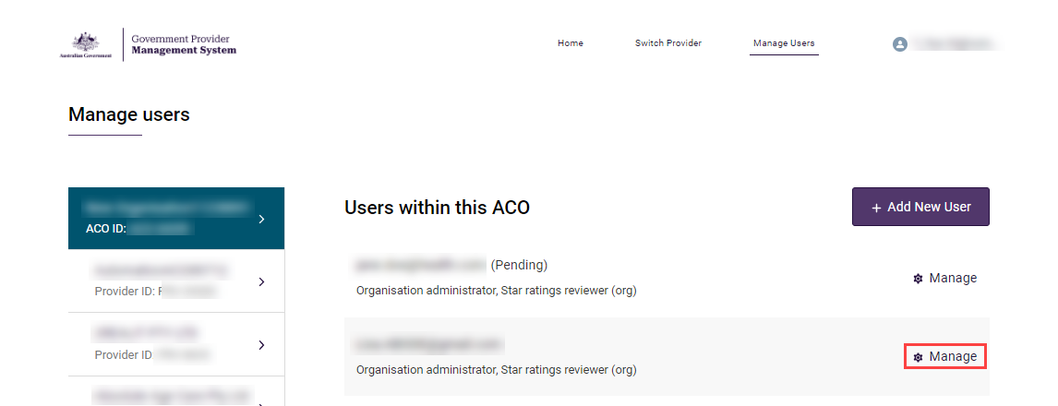

1. The editable options will differ depending on if the user was created at the organisation or provider level.

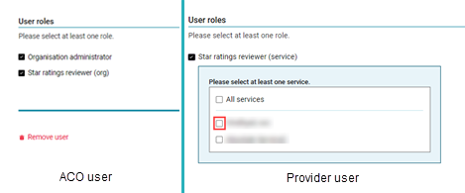

**To edit the user’s roles:**

* For organisation level users select and/or deselect the **Organisation administrator** and/or **Star ratings reviewer (org)** check boxes.
* For provider level users select and/or deselect the **All services** and/or individual services check boxes.

1. Select the **Save** button.

The Manage Users screen will display again. The user will receive an email notification advising their access roles have been changed.

## **Removing a user from GPMS**

To remove a user from GPMS, complete the following actions:

1. In the **Manage users** screen, locate the user you want to edit, and select the **Manage** link.



1. Scroll to the bottom of the screen and select the **Remove** link.

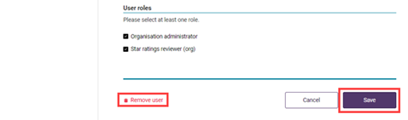

1. A pop-up will display advising you are removing this user at this level of your organisation and that the action cannot be undone. Select the **Remove** button.

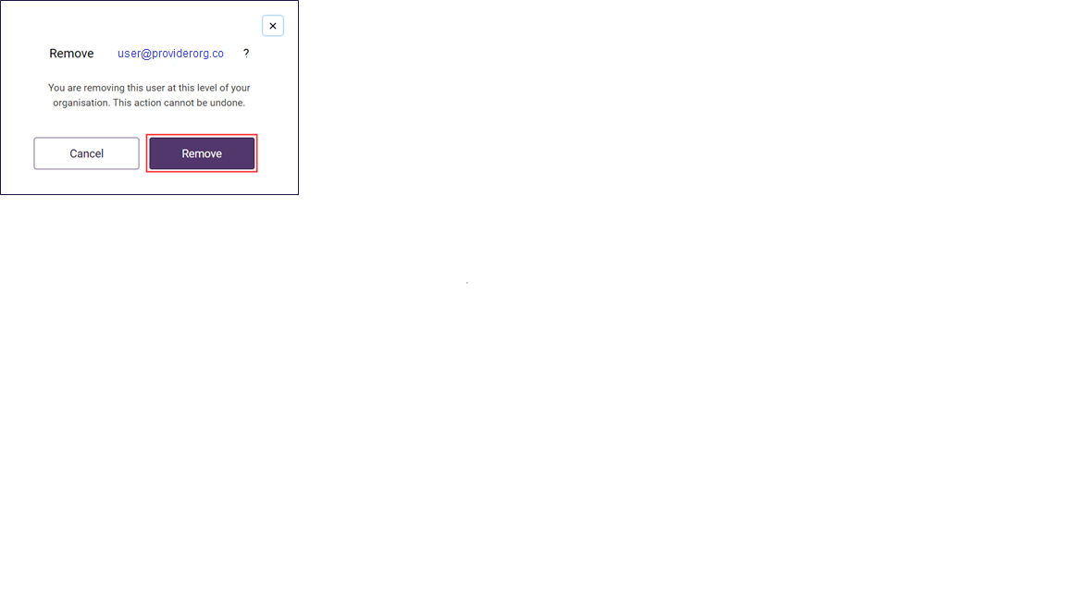

The Manage users screen will display again. The user will no longer be listed.