# **Government Provider Management System**

# **Quick Reference Guide: How to add a user**

Organisation Administrators can add new users to the GPMS provider portal. These new users can be added either at the organisation level or at the provider level. The level the new user is added to will determine what kind of access roles can be attributed to them.

## **Adding a user at the organisation level**

To add a new user at the organisation level, complete the following actions:

1. In the **Manage users screen**, ensure the **ACO account** is highlighted, and select the + **Add New User** button.

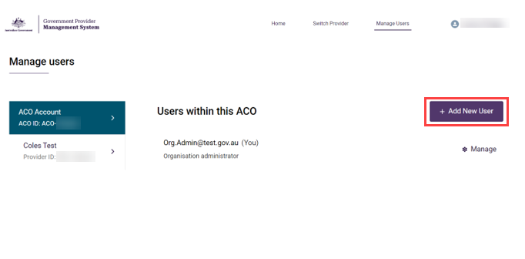

1. In the **Add new ACO user** screen, enter the new user’s company email address and select the **Next** button.

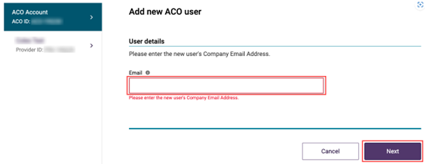

If the user does not exist in the GPMS provider portal go to step 3. If user does exist in GPMS provider portal, you will receive a notification of this. Go to step 4.

1. Add the new user’s Salutation, First name, Surname, and Date of birth. If the date of birth is not provided you can enter a default of 19/01/1900.
2. Under **User roles,** tick the check box for **Organisation administrator** and/or   
   **Star ratings reviewer (org)**
3. Select the **Add User** button.

## **Adding a user at the provider level**

To add a new user at the provider level, complete the following actions:

1. In the **Manage users** screen, ensure the **provider account** is highlighted, and select the **+ Add New User button**.

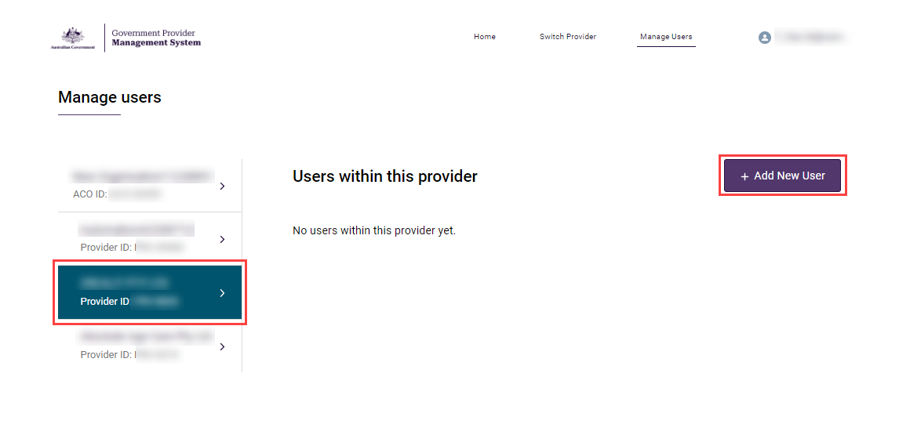

1. In the **Add new provider user** screen, enter the new user’s company email address and select the **Next** button.

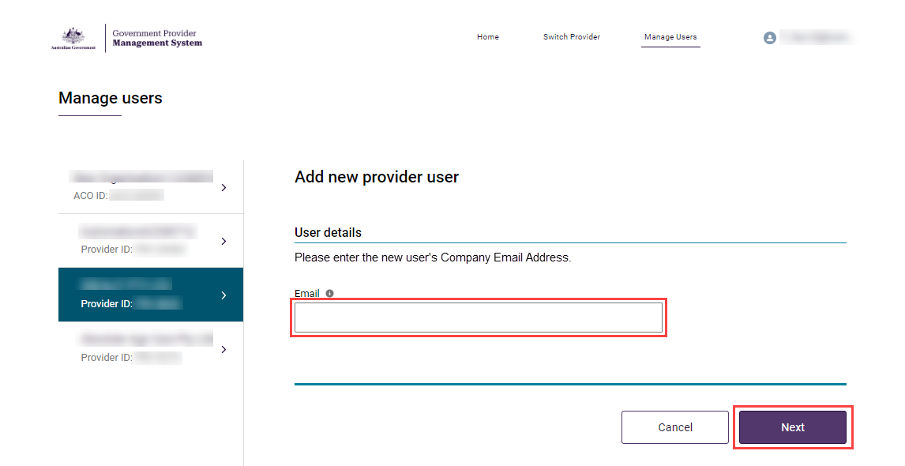

1. Add the new user’s Salutation, First name, Surname, and Date of birth.
2. Under **User roles**, tick the check box for **Star ratings reviewer** (service).
3. Tick the check box for **All services** to let the new user view the Star Ratings for all the listed services or tick the check box for services individually.
4. Select the **Add User button**.

The Manage Users screen will display again. A green banner will display at the top of the screen advising an invitation has been sent to the new user. The new user will need to select the link in the email and log into GPMS to complete their registration.