Department of Health and Aged Care

External Breast Prostheses Reimbursement Program Evaluation

Final report

7 June 2024

Table of contents

Executive Summary 2

Background 2

Objectives and approach of this Evaluation 3

Key findings 3

Recommendations 6

Conclusion 9

1. Introduction 10

1.1 Background 10

1.2 Programs to support the purchase of breast prostheses 11

1.3 Objectives of the Evaluation 13

2. Evaluation approach 14

2.1 Data collection methods 14

2.2 Analysis 15

3. Key findings 17

3.1 EQ1 – Is the reimbursement amount of $400 still appropriate? 18

3.2 EQ2 – Is the EBPRP easy to access and make a claim? 21

3.3 EQ3 – Is Services Australia the most appropriate organisation to be delivering the EBPRP? 34

3.4 EQ4 - Are there special requirements for First Nations and CALD people that need to be incorporated into the design of the EBPRP? 35

3.5 EQ5 – Is the EBPRP achieving its intended outcomes? 39

4. Recommendations and conclusion 41

4.1 Overview 41

4.2 Conclusion 46

5. References 47

Appendix A International literature scan case studies 50

Appendix B Evaluation Question findings mapped to recommendations 56

Executive Summary

In February 2024, the Department of Health and Aged Care (the Department) engaged Ernst & Young (EY) to undertake an Evaluation of the External Breast Prostheses Reimbursement Program (“the Program”). This Evaluation aimed to assess the extent to which the Program meets its objectives, make recommendations to inform the Australian Government of future funding and Program design, and determine if the Program is easily accessible to priority populations. This Evaluation is the first since 2016 and builds upon previous Evaluation learnings.

Background

Breast cancer is the most diagnosed cancer among women in Australia, and it is estimated that one in seven Australian women will be diagnosed with breast cancer in their lifetime (1) (2). Approximately 40% of women diagnosed with breast cancer will undergo a mastectomy, which involves the removal of part or all of the breast (3).

Following a mastectomy, an individual has several options regarding their post-operative breast care, including (1):

* Surgical breast reconstruction.
* Choosing to remain “flat” without additional intervention.
* Using a breast prosthesis to recreate the natural form of the breast.

Breast prostheses can be a crucial support for women who may feel “strange, incomplete, and embarrassed in front of other people, due to the asymmetrical shape of the chest after mastectomy” (4). External breast prostheses, which are available in a range of shapes and sizes, can be attached to the skin or inserted into clothing such as a mastectomy bra or swimsuit (5).

The Program was launched by the Department in 2008 to provide reimbursement for the cost of breast prostheses for women who have undergone breast surgery due to breast cancer. The Program is delivered by Services Australia on behalf of the Department.

The Program objectives are presented below:

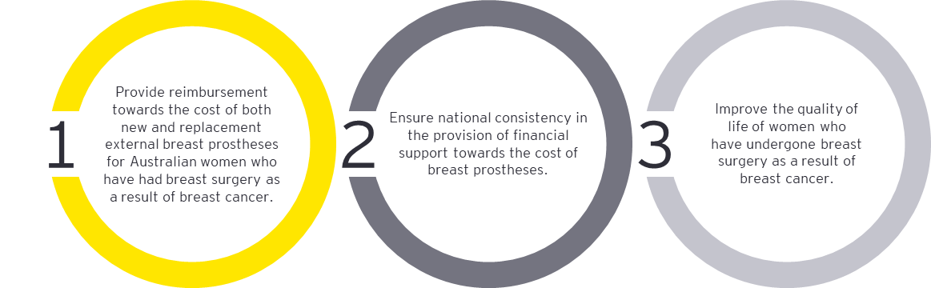

The Program plays a role in the Australian Government’s Cancer Plan (“the Plan”), which has a primary objective of improving cancer outcomes for all Australians. In particular, the Plan targets the importvement of outcomes for groups that current experience the most significant disparities in health outcomes (6).

Objectives and approach of this Evaluation

The objectives of this Evaluation are to:

* Assess to what extent the Program meets its objectives.
* Make recommendations to inform the Australian Government of future funding and Program design.
* Determine if the Program is easily accessible to priority populations (including First Nations people, culturally and linguistically diverse (CALD) groups, people with disability and aged care).

Five Evaluation Questions (“EQs”) were designed by the Department to address the above Evaluation Objectives. These EQs are mapped to the Evaluation Objectives in Table 1 below, which also shows how each data source (i.e. desktop review, international literature scan and stakeholder consultation) was used to inform the relevant EQ.

Table 1. Data collection activities mapped against EQs

|  |  |  |  |  |  |  |  |  |
| --- | --- | --- | --- | --- | --- | --- | --- | --- |
| **Evaluation Objective** | **Evaluation Question** | **Desktop review** | | **International literature scan** | **Stakeholder consultation** | | | |
| **Past Evaluations of the Program** | **Secondary Program data** | **Consumer group** | **Retailer group** | **Services Australia** | **The Department** |
| 1, 2 | * Is the reimbursement amount of $400 still appropriate? | **P** | **P** | **P** | **P** | **P** | **P** | **P** |
| 1, 2 | * Is the EBPRP easy to access and make a claim? | **P** | **P** | **P** | **P** | **P** | **P** | **P** |
| 1, 2 | * Is Services Australia the most appropriate organisation to be delivering this EBPRP? | **P** |  |  | **P** |  | **P** | **P** |
| 1, 2, 3 | * Are there special requirements for First Nations and CALD people that need to be incorporated into the design of the EBPRP? | **P** |  |  | **P** | **P** | **P** | **P** |
| 1, 2 | * Is the EBPRP achieving its intended outcomes*? | **P** |  |  | **P** |  |  | **P** |

*Note that the intended outcomes of the Program were determined to be the Program objectives outlined on the previous page

Key findings

The findings from this Evaluation revealed mixed results across the five EQs.

EQ1: Is the reimbursement amount of $400 still appropriate?

Appropriateness was determined by exploring trends in prostheses prices, participant out-of-pocket expenses over time, and its acceptability to consumers. Considerations for any changes in the reimbursement amount and types of items included for reimbursement were also explored. The key findings include:

* **The reimbursement amount has remained the same, but out-of-pocket expenses have increased**. Since Program commencement in 2008, the average price of prostheses claimed through the Program has increased by 10% from $374 in FY2008-09 to $411 in FY2023-24. Participants now pay on average $11 out-of-pocket per prosthesis, compared to having no out-of-pocket expenses in 2008 (Figure 1). Three of the international programs reviewed covered the entire average price of a prosthesis (7) (8) (9).
* **The appropriateness of any out-of-pocket expense was unclear.** Stakeholders held varying views on the reasonable level of out-of-pocket expenses for Program participants. While some deemed it appropriate as it covers lower-priced prostheses without extra costs, others suggested indexation should be applied.
* **Any changes in the reimbursement amount / additional item inclusions need to be carefully considered.** Retailer groups highlighted that the pricing of prostheses is directly influenced by the reimbursement amount. Consequently, they cautioned that any increase in the reimbursement amount could trigger a subsequent rise in prostheses prices. This scenario could then lead to increased profits for the retailer, while participants would receive no additional benefit and have higher out-of-pocket costs. Stakeholders also expressed a desire for extending reimbursement eligibility to supplementary items such as mastectomy bras. This was suggested to meet the needs of a women post mastectomy more holistically. Three out of the five international programs reviewed incorporate supplementary items into their program coverage (10) (8) (9).

Figure 1: Average price of a breast prosthesis claimed from FY2008-09 to FY2023-24*

Reimbursement amount

Years without average prosthesis price data

Source: 2008-09 and 2014-15 figures taken from past Evaluations, 2020-21 onwards calculated from the Department’s secondary data: Breakdown EOFY2020-21 (36), Breakdown EOFY2021-22 (37), Breakdown EOFY2022-23 (38).

*The average price of a prosthesis claimed is calculated as: Total purchase costs claimed / number of prostheses claimed

EQ2: Is the EBPRP easy to access and make a claim?

This Question was answered by exploring Program claims and reimbursement trends, including the extent to which people of all ages and geographical locations accessed the Program. Stakeholder opinion on accessibility, ease of claiming, eligibility criteria and reimbursement timing were also explored. The key findings include:

* **Lack of Program awareness is a barrier to access.** Limited Program awareness was identified as a significant barrier to access, with current promotional activities being less prominent than when the Program was first launched in 2008. Currently, breast care nurses and the Breast Care Network Association (BCNA) are the key promoters of the Program. Stakeholders agreed that the timing of Program introduction to eligible participants is crucial for enhancing awareness, however there was a lack of agreement on the optimal moment for this introduction. For instance, some stakeholders suggested that eligible individuals be informed about the Program prior to surgery. This would enable the individual to evaluate all treatment alternatives, including opting for a prosthesis over reconstructive surgery. Conversely, other stakeholders believed that introducing the Program should occur later in the individual’s care, either during their hospitalisation or at follow-up appointments.
* **There were mixed findings regarding the extent to which demographic characteristics impacted Program access.** The trends in age and geographic remoteness of people claiming in the Program, compared to trends in breast cancer incidence by age and geographic remoteness respectively, were relatively similar. This suggests that the Program is accessible to people regardless of age and geographic location. However, stakeholders noted that retailer locations are limited, especially in remote areas, potentially impacting Program access for individuals living in these areas.
* **The eligibility criteria may be too restrictive.** Some stakeholders suggested that eligibility criteria for the Program ought to be extended to include all individuals with breast cancer, those with relevant congenital birth defects, and to more than those who identify as “female”.
* **The upfront payment (which can be more than $800 in the case of those with bilateral mastectomy) was reported to adversely affect Program access.** The current cost of living crisis, rising out-of-pocket costs for cancer care and low awareness of the advance payment option for those on eligible Centrelink payments compounded this issue (13). Stakeholders suggested that a HICAPs-like system, where participants only pay the balance which exceeds the reimbursement amount could overcome this barrier. International programs such as those in the United Kingdom, New Zealand and Manitoba in Canada have adopted this approach, whereby the cost burden is shifted from the participant to the retailer (10) (14) (9).
* **Length of time to process claims is a potential barrier to access.** Participants are advised that most claims are processed within 10 business days. This reflects the key performance indicator (KPI) set in the Department’s Program agreement with Services Australia that 90% of claims are processed with 10 business days. However, this KPI was extended to 14 business days in FY2021 as staff resources were redirected to deal with COVID-19 payments. Regardless of this, there has been a decline in the proportion of claims processed within the defined KPI period. In FY2022-23, 69.32% of claims were processed within the revised 14 business days, compared to 99.78% processed within 10 business days in FY2008-09.
* **The current claim form and process can make it difficult to claim for some.** The current claiming process received mixed feedback, with some finding it straightforward and simple. Others considered it cumbersome and time-consuming, with retailers, family members, and caregivers needing to provide crucial support to complete the necessary paperwork. Despite paper forms being commonly used globally, there is a strong push from stakeholders to integrate the Program online. Services Australia suggested integrating the Program with the MyGov platform, in line with existing programs. They noted that this could offer a seamless digital experience for Program users, reduce workload for Services Australia staff, and decrease the fraud risk associated with nominated bank accounts (as is the case with the Program’s paper form).

EQ3: Is Services Australia the most appropriate organisation to be delivering the EBPRP?

In determining whether Services Australia is the most appropriate organisation to deliver the Program, stakeholder feedback and consumer experience was considered. The key findings include:

* **The transition from State and Territory governments to a nationalised Program in 2008 has been well received** **by all key stakeholders**. It has standardised Program delivery across the country, improving consumer satisfaction and promoting more equitable access.
* **Services Australia was found to be best placed to deliver the Program** given its remit, capability, and capacity in administering similar Programs. An alternative administering body was not identified.

EQ4: Are there special requirements for First Nations and CALD people that need to be incorporated into the design of the EBPRP?

Whether there are special requirements for First Nations and CALD people that need to be incorporated into the Program was determined by understanding the Program experience from a First Nations and CALD perspective. The key findings include:

* **There are underlying systemic challenges within cancer care for First Nations people, extending to participation in both preventative and treatment-related aspects of cancer care.** Stakeholders expressed a need to examine cancer care more comprehensively for First Nations communities, addressing the current low engagement with preventive measures such as screening and treatments for cancer.
* **Special requirements exist for First Nations and CALD people to access the Program.** Engaging with relevant stakeholders from First Nations and CALD communities, such as representative bodies and community members, will be critical in informing culturally appropriate promotional material for the Program. This engagement should aim to understand the needs of these populations and identify opportunities for collaboration. Examples of these key stakeholders include groups such as the National Aboriginal Community Controlled Health Organisation (NACCHO) and State/Territory-based ethnic community councils**.**
* **CALD communities prefer in-person and community engagement over written material;** therefore, Program promotional resources aimed at CALD communities should incorporate in-person elements. This includes culturally appropriate discussions with clinicians, engagement at community events facilitated by community leaders, and the use of online videos featuring individuals speaking their language.
* **First Nations and CALD individuals face similar access challenges to the general population (e.g. financial constraints), but it is reported that they are more exacerbated.** It will therefore be necessary to create more tailored interventions to meet their needs.

EQ5: Is the EBPRP achieving its intended outcomes?

The extent to which the Program is achieving its Objectives (or intended outcomes) relied on the relevant findings from the desktop review and stakeholder consultations. The key findings include:

* **The Program effectively fulfills its first objective of providing financial support towards the cost of a breast prosthesis for women who have undergone a mastectomy because of breast cancer**. However, the exact level of financial support provided is not clearly defined in this Objective (i.e. the whole amount of the cost of the prosthesis, or only a proportion).
* **Nationalising the Program under Services Australia ensures national consistency in its delivery, thereby achieving the second objective.** The administration of the Program by Services Australia was well received, and there were no indications to transfer the Program to another organisation.
* **There is some evidence to indicate that the Program enhances the quality of life for women who have obtained a breast prosthesis** through it, however quality of life measures would help to quantify this impact.

Recommendations

Six recommendations have been developed to address the key findings and align with the objectives of the Plan. Figure 2 illustrates how the recommendations map to each EQ.

Figure 2: Recommendations relevant to each EQ

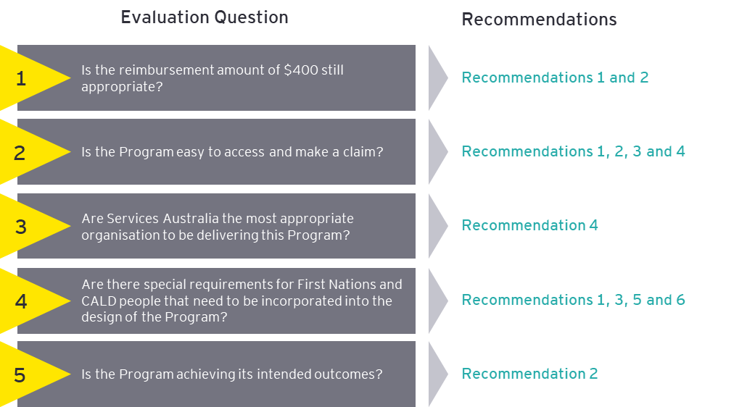

**Recommendation 1: Annually review the reimbursement amount to ensure it meets Program objectives and explore alternative payment models to reduce the initial financial burden for Program participants.** To reduce out-of-pocket costs, the Department could consider conducting an annual review of the previous financial year’s average price of a breast prosthesis claimed; and then adjust the coming year’s reimbursement amount accordingly. This will need careful monitoring for any resulting exponential rises in average price of prostheses claimed, which may indicate a market pricing response to the increased reimbursement amount. Additionally, the Department could consider the feasibility of different payment options that can alleviate the upfront costs for Program participants (such as a HICAPs-like system at the point of sale, so that Program participants would only be required to pay the gap payment).

*This recommendation aligns with the Plan’s focus on creating a national framework aimed at minimising the financial burden for cancer patients, ensuring equitable access to cancer care services and support, regardless of an individual’s financial situation or geographic location* (15)*.*

**Recommendation 2: Review and update the Program Objectives to reflect the maturity of the Program, meet consumer needs in a holistic way, and focus more on equity of access.** This update should consider**:**

* The potential for reimbursement of supplementary items such as mastectomy bras to ensure holistic support post mastectomy.
* Extending the eligibility criteria to cover a wider array of relevant medical conditions such as Poland Syndrome and congenital conditions.
* Extending the eligibility criteria to all individuals with breast cancer, regardless of gender identity.
* Developing a corresponding Evaluation Plan.

*This recommendation aligns with the Plan’s commitment to inclusivity and equitable health outcomes, advocating for a Program that is responsive to the diverse and current needs of all individuals requiring external breast prostheses* (12)*.*

**Recommendation 3: Consider relaunching the Program to boost awareness, leveraging existing consumer data sources and organisations to update relevant consumers.** This could include:

* A promotional campaign to target groups with low Program awareness, inform clinicians / carers and update existing Program materials.
* Targeting eligible participants using Medicare data (as seen with the National Bowel Cancer Screening Program) and consumer groups like BCNA.
* The development of a centralised resources on retailers and types of external breast prostheses and/or updating existing communication products such as websites.

*This recommendation aligns with the Plan’s goal of reducing disparities in cancer outcomes through tailored promotional efforts and data-driven strategies to increase Program awareness among underrepresented groups. By collaborating with organisations such as BCNA and using Services Australia’s data, the initiative supports the Plan’s commitment to tailored, equitable cancer care for all Australians, particularly those facing barriers due to social determinants of health. The emphasis on co-designed information also ensures that the materials are relevant and accessible, thereby enhancing health literacy and empowering consumers in their cancer journey* (19)(6)*.*

**Recommendation 4: Continue Program delivery through Services Australia while exploring opportunities to modernise the Program by integrating the claims process with the existing online MyGov claims platform.** Continuing the Program’s delivery through Services Australia will continue its uniform national approach to Program delivery. The Department should consider restoring the 10-business day reimbursement KPI (which had increased to 14 days during the COVID-19 Pandemic) and exploring the integration of the claims processed within the MyGov online platform (whilst also retaining a paper-based option). These improvements may enhance the participant experience, facilitate easier Program access, improve Services Australia’s operational efficiency, and standardise the claims process in line with similar programs like the Continence Aids Payment Scheme.

*This recommendation aligns with the Plan’s strategic emphasis on leveraging digital technologies to improve access to cancer care services across Australia. By modernising the Program through integration with the MyGov online platform, the initiative supports the Plan’s objective to expand access to digitally enabled cancer care, particularly for those in regional, rural, and remote areas* (16)*.*

**Recommendation 5: Given the stated preference and trust for in-person and community-led sources of information, it will be critical to collaborate with relevant First Nation stakeholders to identify and leverage existing initiatives to implement culturally appropriate promotion and education about the Program.** This should include engaging with NACCHO to identify opportunities within the NACCHO Aboriginal and Torres Strait Islander Cancer Plan and members of the First Nations community to co-design Program updates.

*This recommendation aligns with the Plan’s commitment to support Aboriginal and Torres Strait Islander knowledge and strength, ensuring equitable cancer care outcomes. The Plan advocates for shared decision-making, collaborative partnerships, and cross-sector approaches at all levels. By adopting co-design methods, this recommendation ensures that Aboriginal and Torres Strait Islander people have a significant role in shaping the policies, programs, and services that impact them, leading to improved life outcomes* (20)(17)*.*

**Recommendation 6: Engage with relevant CALD stakeholders, including representative bodies such as the Federation of Ethnic Communities’ Councils of Australia (FECCA) and individuals from these communities, to understand their unique needs and inform Program engagement strategies.** This collaboration should:

* Focus on developing a tailored approach for the CALD population group, which includes developing culturally appropriate promotional materials that cater to the CALD communities’ preference for in-person and community-based interactions.
* Produce materials in multiple languages and employing a variety of communication channels, such as multimedia and community events, to effectively promote the Program.

*This recommendation aligns with the Plan’s commitment to improving health equity among CALD communities by ensuring that communication and engagement strategies are culturally sensitive and linguistically appropriate. The Plan’s focus on training healthcare providers in cultural competency, enhancing the use of interpreter services, and improving health literacy through targeted information aligns with the recommendation’s emphasis on tailored promotional materials and the use of diverse communication channels. By collaborating with stakeholders like FECCA and employing a variety of outreach methods, the recommendation supports the Plan’s overarching goal to provide equitable, accessible, and high-quality cancer care to all segments of the population, regardless of cultural or linguistic background* (18)*.*

Conclusion

The national format of the Program, which standardises the reimbursement amount and claims process across Australia, has received positive feedback from key stakeholders. Stakeholders reported favourably on the level of reimbursement and the straightforward nature of the paper claim form. As a result, Services Australia appears to be the appropriate administering organisation of the Program.

Despite the Program’s success in meeting its Objectives, there are notable barriers that limit equitable Program access. These include a lack Program awareness and the prohibitive impact of the need for an up-front payment by the participant. Such barriers have a pronounced effect on priority populations, including First Nations and CALD communities, as evidenced by the limited awareness of the Program within NACCHO.

To enhance the Program’s effectiveness, it is necessary to address these barriers and consider revising the Program’s objectives to meet the current needs of participants. Implementing these changes will support the Program’s ongoing evolution in line with the Australian Cancer Plan’s focus on health equity and the provision of accessible cancer care across the country.

1. Introduction

In February 2024, the Department engaged EY to undertake an Evaluation of the Program. This Evaluation will be the first since 2016 and will build from previous Evaluation learnings. It will assess the EQs to determine the Program’s accessibility and whether it meets its original policy intent.

* 1. Background

1. Breast cancer and mastectomy in Australia

Breast cancer is the most diagnosed cancer among women in Australia and it is estimated that one in seven Australian women will be diagnosed with breast cancer in their lifetime (1) (2). Approximately 40% of these women will undergo a mastectomy as part of their breast cancer care, both in early and advanced disease stages (3). A mastectomy involves the removal of part or all of the breast to eliminate or prevent the spread of breast cancer (21).

1. Management options post mastectomy

Following a mastectomy, an individual has several available options regarding their post-operative breast care, including (1):

* Surgical breast reconstruction.
* Choosing to remain “flat” without additional intervention.
* Using a breast prosthesis to recreate the natural form of the breast.

Surgical breast reconstruction is a surgical process aimed at reinstating the original shape, size, and appearance of the breast post-mastectomy (22). The procedure involves creating a breast shape using either an implant or tissues (skin, fat, and muscle) from another part of the body. The reconstruction can be performed simultaneously with the mastectomy, referred to as immediate reconstruction, or can be scheduled for a later time, referred to as delayed reconstruction (5).

The length of time before undergoing a delayed breast reconstruction can fluctuate considerably among hospitals across the country, with some individuals experiencing wait periods of up to two years (23). During this time, it is not uncommon for individuals to use a breast prosthesis.

An alternative to surgical breast reconstruction is to “stay flat”. Several reasons why some individuals choose to remain flat include (24):

* Feeling complete or whole without the presence of breasts.
* Avoidance of a potentially lengthy, multi-step reconstruction process in addition to other cancer treatments such as radiation and chemotherapy.
* Understanding that breast reconstruction can be pursued at a later time if desired.
* Availability of external breast prostheses that can be used as needed.

Individuals who choose to remain flat have the option of using external breast prostheses at their discretion. These breast prostheses can be a crucial support for individuals who may feel “strange, incomplete, and embarrassed in front of other people, due to the asymmetrical shape of the chest after mastectomy” (4). External breast prostheses can be attached to the skin or inserted into clothing such as a mastectomy bra or swimsuit and can provide a sense of balance and symmetry post-mastectomy (22).

1. The First Nations and CALD experience

First Nations and CALD populations encounter distinct barriers throughout the breast cancer care continuum, including lower participation in preventive measures such as breast cancer screening. Data from FY2020-21 demonstrates this disparity, with 37% of non-English speakers and 35% of First Nations women participating in screening Programs, compared to 49% of English-speaking and 47% of non-Indigenous women (1). This indicates the presence of obstacles from the outset of the cancer care journey.

As these women advance from screening and diagnosis to treatment options and recovery, the challenges persist. There is a notable gap in evidence regarding the use of breast prostheses among First Nations and CALD populations, yet it is acknowledged that these groups face specific hurdles in accessing breast reconstruction services (25). These include a lack of timely access to information and services that are culturally resonant, all of which may impact on access to external breast prostheses (26).

1. The Australian Cancer Plan

The Plan is designed to improve cancer outcomes for all Australians, with an emphasis on addressing the needs of groups with poorer health outcomes. It aims to achieve equity in cancer care, a crucial benchmark of its success. The Plan’s execution requires collaborative efforts across the entire cancer sector, recognising that success depends on the shared responsibility of various stakeholders (27).

The Plan prioritises groups at risk of poorer health outcomes, including Aboriginal and Torres Strait Islander people, CALD communities, people with disabilities, LGBTIQA+ individuals, those in lower socioeconomic groups and residents of rural and remote communities. The Program plays a role in the Plan’s aim of achieving equity in cancer care.

* 1. Programs to support the purchase of breast prostheses

This Section provides an overview of the Program and similar international programs.

1. The Program

The Program was launched in 2008. It aims to provide reimbursement for the cost of external breast prostheses for women who have undergone breast surgery due to breast cancer (Figure 3). The Program is delivered by Services Australia on behalf of the Department.

Figure 3: The process of obtaining reimbursement through the Program

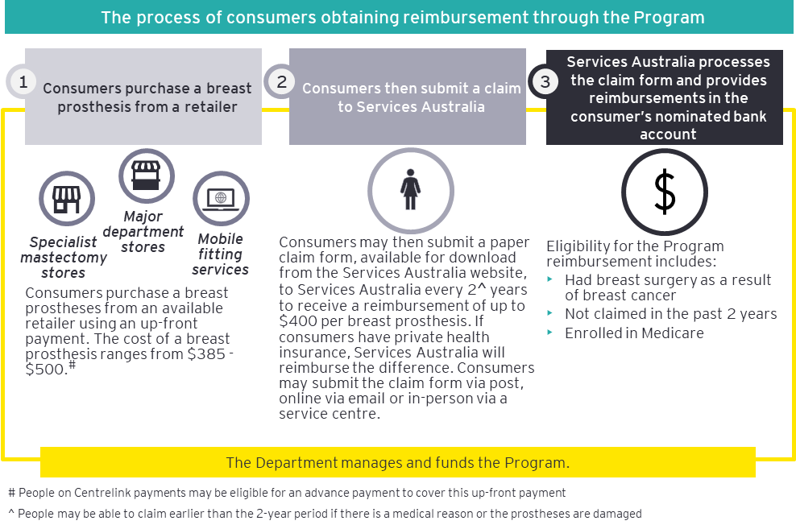

Sources: Cancer Council NSW, 2021 (28), Services Australia, 2023 (29)

The objectives of the Program are to:

* Provide reimbursement towards the cost of both new and replacement external breast prostheses for Australian women who have had breast surgery as a result of breast cancer.
* Ensure national consistency in the provision of financial support towards the cost of breast prostheses.
* Improve the quality of life of women who have undergone breast surgery because of breast cancer.

The Program has evolved since its inception in 2008. In 2010 and 2016, the Department commissioned Evaluations of the Program to assess its ongoing appropriateness, effectiveness, and efficiency. The recommendations from these Evaluations and subsequent modifications made to the Program are presented in Figure 4.

Figure 4: Recommendations arising from the past Evaluations and subsequent Program changes

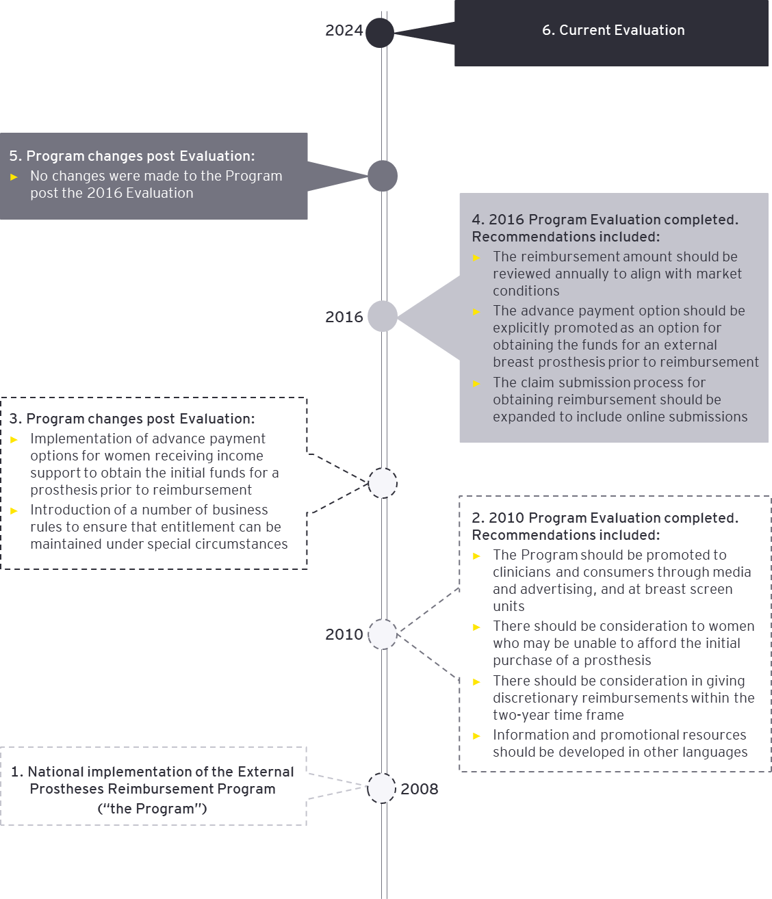

Sources: 2010 EBPRP Evaluation (30), 2016 EBPRP Evaluation (31), discussion with Department representatives

1. International programs to support the purchase of breast prostheses

Recognising the cost to consumers, various international jurisdictions have established programs to support people in purchasing breast prostheses. Examples include:

* The *Breast prosthesis subsidy* in New Zealand, administered by Health New Zealand Te Whatu Ora, which reimburses people after they have purchased a prosthesis from a retailer (10).
* The *External Breast Prostheses and Associated Consumables* Framework, which provides eligible women with free breast prostheses as part of the National Health Service (NHS) (14).
* The *Assistive Devices Program* in Ontario, the *Breast Prosthesis Program* in Nova Scotia, and the *Breast Prosthesis Program* in Manitoba (all in Canada), which reimburse women after they have purchased a prosthesis from a retailer (32) (8) (9).

Applicable learnings from the international programs are discussed throughout this report, and presented in detail in Appendix A.

* 1. Objectives of the Evaluation

The objectives of this Evaluation are to:

* Assess to what extent the Program meets its objectives.
* Make recommendations to inform the Australian Government of future funding and Program design.
* Determine if the Program is easily accessible to priority populations (including First Nations people, CALD groups, people with disability and aged care).

This Evaluation was guided by five EQs outlined in Table 2.

Table 2: Evaluation Questions

| Evaluation Questions | |
| --- | --- |
| 1 | Is the reimbursement amount of $400 still appropriate? |
| 2 | Is the Program easy to access and make a claim? |
| 3 | Is Services Australia the most appropriate organisation to be delivering this Program? |
| 4 | Are there special requirements for First Nations and CALD people that need to be incorporated into the design of the Program? |
| 5 | Is the Program achieving its intended outcomes? |

1. Evaluation approach

This Chapter outlines the overarching approach used to conduct the Evaluation.

* 1. Data collection methods

Three data collection methods, described in Table 3, were used to conduct this Evaluation and answer the EQs listed in Table 2.

Table 3: Data collection methods for each EQ

|  |  |  |  |  |  |  |  |  |
| --- | --- | --- | --- | --- | --- | --- | --- | --- |
| **Evaluation Objective** | **EQ** | **Desktop Review** | | **International literature scan** | **Stakeholder consultation** | | | |
| **Past Evaluations of the Program** | **Secondary Program data** | **Consumer group** | **Retailer group** | **Services Australia** | **The Department** |
| 1, 2 | 1. Is the reimbursement amount of $400 still appropriate? | **P** | **P** | **P** | **P** | **P** | **P** | **P** |
| 1, 2 | 2. Is the EBPRP easy to access and make a claim? | **P** | **P** | **P** | **P** | **P** | **P** | **P** |
| 1, 2 | 3. Is Services Australia the most appropriate organisation to be delivering this EBPRP? | **P** |  |  | **P** |  | **P** | **P** |
| 1, 2, 3 | 4. Are there special requirements for First Nations and CALD people that need to be incorporated into the design of the EBPRP? | **P** |  |  | **P** | **P** | **P** | **P** |
| 1, 2 | 5. Is the EBPRP achieving its intended outcomes*? | **P** |  |  | **P** |  |  | **P** |

*Note that the intended outcomes of the Program were determined to be the Program objectives

The remainder of this section provides additional detail for each data collection method.

1. Desktop review

The Desktop review consisted of two components:

1. **A review of past Evaluations of the Program** (provided by the Department), including:

* Evaluation of the National External Breast Prostheses Reimbursement Program, Final Report, 16 September 2010 (“the 2010 Evaluation”) (30).
* Evaluation of the National External Breast Prostheses Reimbursement Programme (“the 2016 Formative Evaluation”) (33).
* Evaluation of the National External Breast Prostheses Reimbursement Programme, Impact Evaluation Report, June 2016 (“the 2016 Impact Evaluation”) (31).

1. **Analysis of available secondary Program data** (provided by the Department), including:

* EBPRP Program Agreement 2021– outlining Program intent, business arrangements, and performance management and assurance processes effective until 2024 (34).
* Program claims and reimbursement data 2022 – in the form of a summary report (35).
* Services Australia claims data 2021-2023 – granular data containing claims data and additional breakdown of claims by postcode and age (36) (37) (38).
* Services Australia KPI data 2021-2023 – reporting percentage of reimbursements processed at different time intervals (39) (40) (41).
* Services Australian rejected claims data 2021-2023 – reporting the number of rejected claims within the financial year (42) (43) (44).

Where possible, data was analysis using descriptive statistics to inform the findings.

1. International literature scan

Publicly available international literature was scanned to identify three countries with programs like the Australian Program. Programs were considered similar if they provided external breast prostheses to people post-mastectomy and were delivered within a public health system. The search included a scan for previous program evaluations, government policy/reports and consumer-facing program websites. These programs were then reviewed in terms of implementation and funding model, to provide learnings to inform the recommendations of this Evaluation. See Appendix A for full case studies on the selected international programs.

1. Stakeholder consultations

Four groups of stakeholders were consulted, with Table 4 outlining each stakeholder group and the focus of the consultations (which links back to Table 3). Each consultation consisted of 30-to-60-minute interviews with one or more stakeholders from each group. Notes were taken during each consultation, which were later thematically analysed (see next section for further information).

Table 4: Stakeholder groups consulted and aims of consultation

|  |  |
| --- | --- |
| **Stakeholder group\*** | **Aims of the consultation** |
| Consumers  *(8 consultations, 9 individuals)* | * To identify overarching insights of the user experience of the Program, including priority populations user experience. * To assess the appropriateness of the reimbursement amount to each stakeholder group. * To evaluate the accessibility of the Program, including Program awareness, and time to receive reimbursement. |
| Retailers  *(3 consultations, 3 individuals)* | * To assess the appropriateness of the reimbursement amount with respect to trends in breast prostheses’ retail prices (i.e. are there any out-of-pocket costs for consumers, market drivers for pricing). * To obtain retailer perspectives on access challenges they may have observed. |
| Services Australia  *(1 consultation,*  *5 individuals)* | * To gain insight into the Program’s claiming process and identify areas of improvement (e.g. system enhancements required). * To evaluate the accessibility of the Program, including Program awareness, and time to receive reimbursement. |
| The Department  *(1 consultation,*  *4 individuals)* | * To understand the historical context of the Program and the Department’s perspective on Program experience and future Program ambitions. |

*Some consultations involved more than one stakeholder from the representative organisation

* 1. Analysis

Thematic analysis was conducted on qualitative data sources, while quantitative data analysis, using descriptive statistics, was performed on secondary Program data where possible. Findings from these data sources were mapped against the EQs and contextualised with insights from the international literature scan. These findings were then used to develop recommendations for the Department. Figure 5 provides a high-level overview of this process and labels the location of the relevant findings in this Evaluation report.

Figure 5: Data analysis and synthesis of findings, mapped to Evaluation Report sections

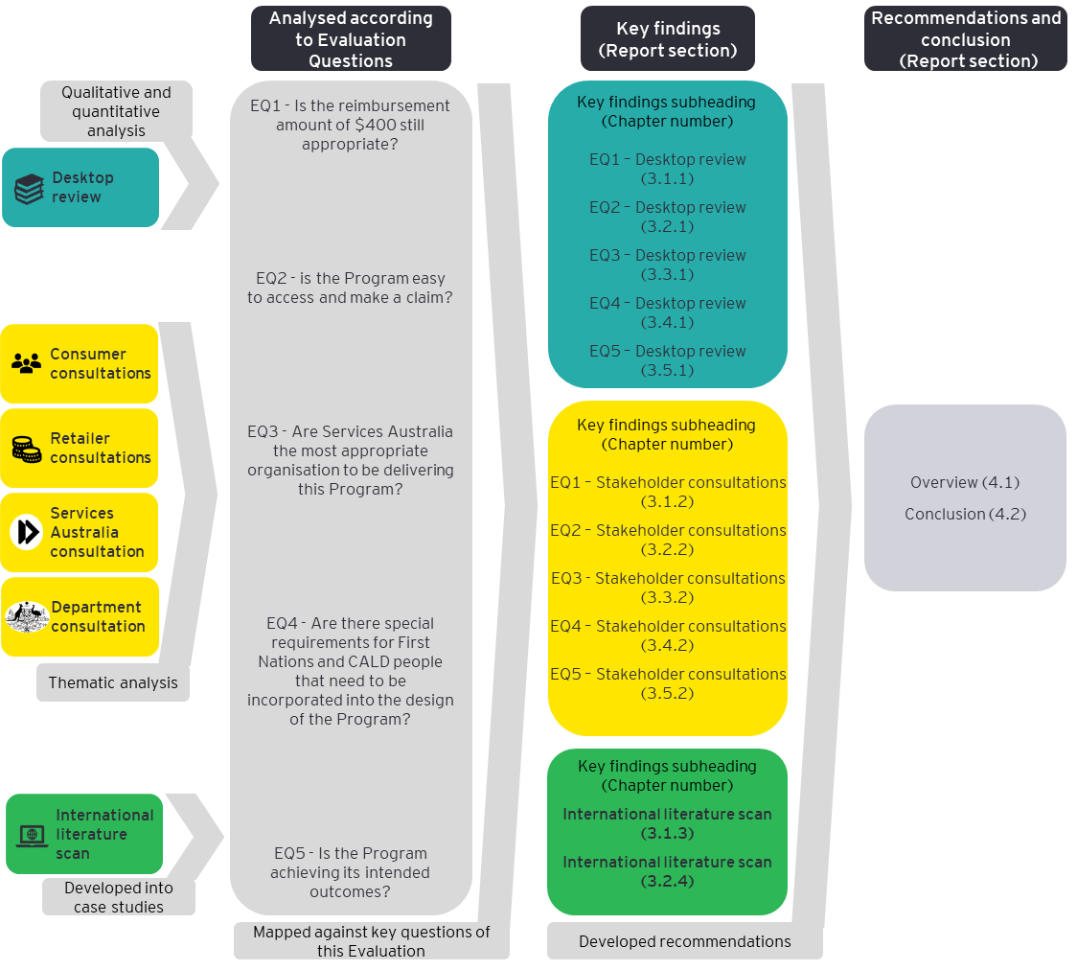

1. Key findings

This Chapter provides an overview of the key findings for each EQ. For each Question, the tailored approach and findings according to data source is provided.

This Chapter is organised by EQ. For each EQ, the tailored approach and findings according to data source is provided (see Figure 6 for an example).

Figure 6: Components of the Key Findings section for each EQ

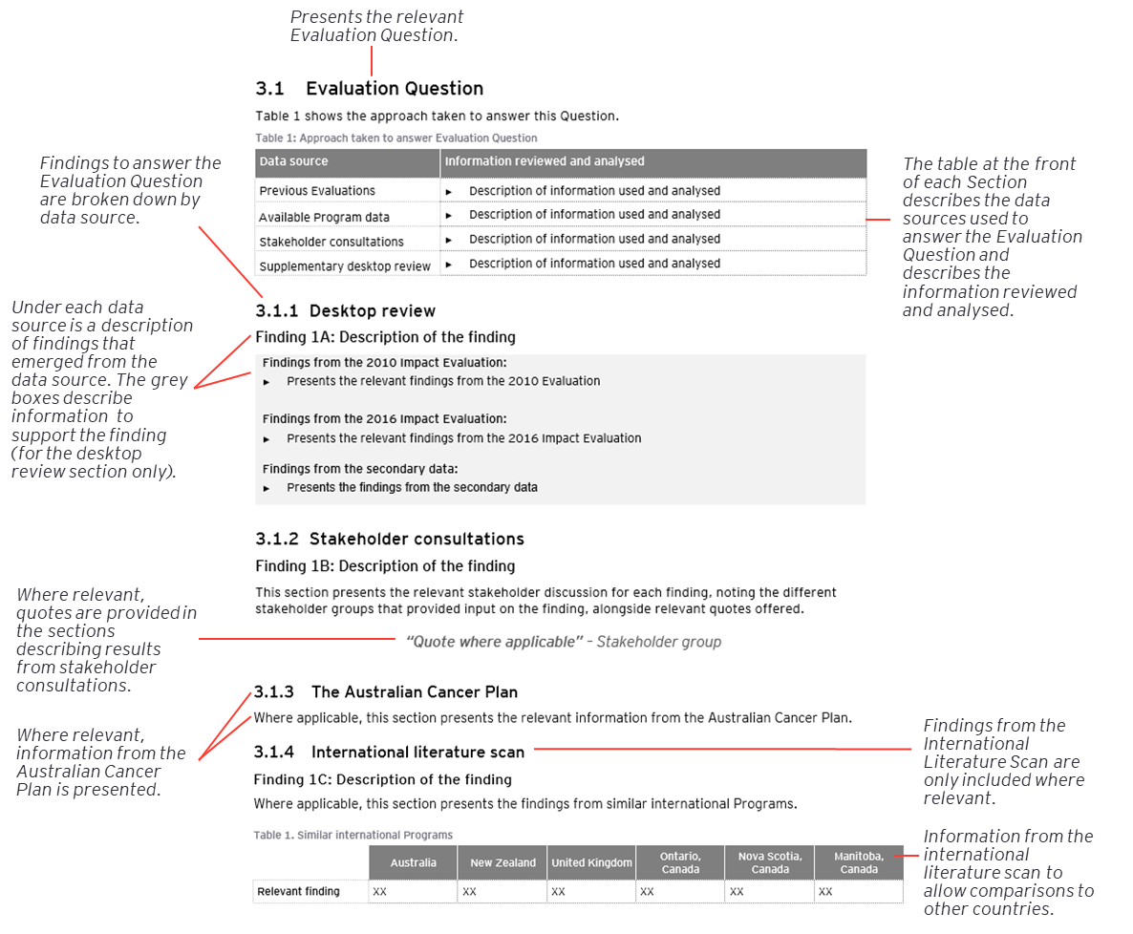

* 1. EQ1 – Is the reimbursement amount of $400 still appropriate?

Table 5 shows the approach taken to answer this Question.

Table 5: Approach taken to answer EQ1 – Is the reimbursement amount of $400 still appropriate?

| Data source | Information reviewed and analysed |
| --- | --- |
| Previous Evaluations | * Program reimbursement figures, including changes over time, and indications of future change e.g. any recommendations for new reimbursement amount. |
| Available Program data | Longitudinal claims data and reimbursement levels were analysed to explore:   * Claims and reimbursement values in dollars ($) over time. * Prices of prostheses, including trends over time. * Out-of-pocket expenses (the difference between what the Program participant paid for the prosthesis and what was reimbursed). |
| Stakeholder consultations | * The ongoing feasibility and appropriateness of the $400 reimbursement amount from a consumer perspective, including specific experience and needs from a priority population perspective. * Retail pricing of prostheses, including recommended retail price and market trends. |
| Supplementary desktop review | * Similar Programs in the United Kingdom, New Zealand and Canada were reviewed for any applicable learnings regarding the coverage of the reimbursement (please refer to Appendix A for a detailed analysis). |

1. Desktop review

##### Finding 1A: Since Program commencement in 2008, the average price of prostheses claimed has increased by 10%, resulting in Program participants paying on average $11 out-of-pocket. While the reimbursement fully covered the average prosthesis price claimed in 2008, it covered 97% of the average price in FY2022-23.

Since Program commencement in 2008, the average price of prostheses claimed has increased by 10% (Figure 7). Participants now pay on average $11 out-of-pocket per prostheses, compared to having no out-of-pocket expenses in 2008.

|  |
| --- |
| **Findings from the 2016 Impact Evaluation** (31)**:**   * Out of the 295 respondents who participated in the online survey, 75% considered the reimbursement amount sufficient, rating the amount four (25%) or five (50%) out of five. * Several participants, (exact numbers not specified), reported small out-of-pocket expenses, typically between $10 and $50, however this was mostly considered manageable. * Recommended the reimbursement amount be reviewed on an annual basis to ensure the amount remains in line with market rates.   **Findings from the secondary data (Figure 7):**   * Since the Program’s inception in 2008, the average price of prostheses claimed has risen by 10%. * From FY2020-21, the average price of a prosthesis claimed surpassed the reimbursement amount. * In FY2022-23, the average price of a prosthesis claimed was $411, with the reimbursement covering approximately 97% of this price. * In FY2022-23, participants pay on average $11 out-of-pocket for a prosthesis. |

Figure 7: Average price of a breast prosthesis claimed from FY2008-09 to FY2023-24*

Reimbursement amount

Years without average prosthesis price data

Source: 2008-09 and 2014-15 figures taken from past Evaluations, 2020-21 onwards calculated from the Department’s secondary data: Breakdown EOFY2020-21 (36), Breakdown EOFY2021-22 (37), Breakdown EOFY2022-23 (38).

*The average price of a prosthesis claimed was calculated by: (total purchase costs claimed / number of prostheses claimed)

1. Stakeholder consultations

##### Finding 1B: Stakeholders had mixed views on whether the $400 reimbursement is appropriate. While some deem it suitable as it covers lower-priced prostheses without extra costs, others suggested indexation should be applied.

All three retailer groups along with two of the four consumer groups who commented on the reimbursement amount indicated their satisfaction with the current amount. These groups found it adequate for covering lower-priced prostheses without incurring additional costs. The reported retail price range for all prostheses stocked, as per the retailers, is $385 to $499. The lower costing choices reportedly lack the more sophisticated features—such as lighter silicone or air pumps—found in the more expensive models.

On the other hand, one consumer group, Services Australia and the Department considered the $400 reimbursement insufficient due to the lack of adjustment since Program commencement. These stakeholders suggested introducing indexation to ensure the reimbursement amount remains appropriate over time. As reported by Services Australia, this approach would mirror similar Programs such as the *Continence Aids Payment Scheme (CAPS)* which uses indexation to adjust reimbursement levels on an annual basis.

However, while recognising the need for an increase, one consumer group acknowledged that any changes to the reimbursement must be pragmatic and considerate of government healthcare spending.

##### Finding 1C: All three retailer groups stated that prostheses pricing is impacted by the reimbursement amount and highlighted that any increases in this amount could affect the price of prostheses. In this case, participants would face higher prices for the same products.

All three retailer groups reported that the prostheses pricing structure is influenced by the reimbursement amount, with many products strategically priced near the $400 mark. It was reported that this deliberate approach is aimed at providing options that align with the reimbursement amount, thus preventing additional costs for people who cannot afford to pay any out-of-pocket expenses.

Considering the link between reimbursement and pricing, retailer groups suggested that an increase in the reimbursement amount could result in a corresponding increase in prostheses retail prices. In this case, an increase of the reimbursement amount is likely to increase the profit margins of retailers, without offering any additional benefit to participants, ultimately leading to individuals paying more for the same product. Therefore, careful consideration is required to avoid any unintended consequences when contemplating adjustments to the reimbursement amount.

**“[Retailers] would put the price up to meet the scheme”** – A retailer group

##### Finding 1D: Most stakeholders expressed a preference for supplementary items to be included in the reimbursement eligibility. However, Services Australia recognised that expanding the range of covered items would lead to an increased workload and potentially impact service delivery.

Of the seven stakeholder groups who commented on the reimbursement item inclusion, two retailer groups, two consumer groups and Services Australia expressed a want for supplementary items such as mastectomy bras, swim prostheses and prosthetic nipples, to be eligible for reimbursement.

**“They give us the boobs but nothing to put them in"** – Program participant via a consumer group

One retailer group suggested that if the Program allowed the inclusion of supplementary items, the policy should require the mandatory inclusion of a prosthesis in every purchase. The intent behind this, as per the retailer group, is to prevent potential misuse of the reimbursement system where the reimbursement is used on products other than breast prostheses.

On the other hand, another retailer group expressed the opinion that supplementary items should not be covered by the reimbursement at all.

**“A woman would be buying bras anyway, even if she didn’t have breast cancer"** – A retailer group

Services Australia indicated that an expansion of items covered under the Program would lead to an increase in their workload and could significantly affect service delivery. By adding supplementary items to the list of reimbursable products, Services Australia anticipates a higher volume of claims, which would in turn require more resources to manually process and manage, impacting the overall workflow within the organisation.

1. International literature scan

##### Finding 1E: Reimbursement levels vary across similar programs internationally, with three out of five programs reviewed covering the entire average price of a prosthesis.

The Breast Prosthesis Program in the United Kingdom covers the entire price of a breast prosthesis through their public health model of care, and the reimbursement amount in Nova Scotia and Manitoba Canada covers the entire average price of a breast prosthesis (Table 6) (7) (8) (9). See Appendix A for further detail.

Table 6. Reimbursement levels in similar programs internationally

|  | Australia | New Zealand | United Kingdom | Ontario, Canada | Nova Scotia, Canada | Manitoba, Canada |
| --- | --- | --- | --- | --- | --- | --- |
| **Percentage of average prosthesis price reimbursed\*** | 97% | 82% | 100% | 49% | 75 – 100% | 100% |

* Calculated by dividing the average price of breast prostheses for each Program (identified via a Google search) by each Program’s reimbursement schedule. The exception was the calculation of the Australian figure, which relied upon calculation methods described in Section 3.1.1.

##### Finding 1F: Three out of the five international programs reviewed included coverage for supplementary items.

The program in New Zealand and programs in Nova Scotia and Manitoba Canada include reimbursement for supplementary items (Table 7). See Appendix A for further information.

Table 7. Supplementary items covered in similar programs internationally

|  | Australia | New Zealand | United Kingdom | Ontario, Canada | Nova Scotia, Canada | Manitoba, Canada |
| --- | --- | --- | --- | --- | --- | --- |
| **Supplementary items covered** | No | Yes – swim prostheses, special bras, surgical bras, normal bras, prosthetic nipples, modified swimwear | No | No | Yes – mastectomy bras | Yes – mastectomy bras |

* 1. EQ2 – Is the EBPRP easy to access and make a claim?

Table 8 shows the approach taken to answer this Question.

Table 8: Approach taken to answer EQ2 – Is the EBPRP easy to access and make a claim?

| Data source | Information reviewed and analysed |
| --- | --- |
| Previous Evaluations | * Total dollar ($) figures indicating overarching use and Program access. * Findings relating to access, including reported consumer experience, barriers to access and strategies to overcome these. |
| Available Program data | Longitudinal claims data and reimbursement levels were mapped to:   * Postcodes to explore the differences in claiming behaviours across remoteness areas. * Age to explore the differences in claiming behaviours across different ages. * Secondary data categorising claims against background (e.g. First Nations, or CALD) were unavailable. |
| Stakeholder consultations | * Accessibility from a consumer perspective, including ease of claiming process, time to reimbursement, including specific experience and needs from a priority population perspective and views to areas for improvement. * The claims process from a Services Australia perspective, including current challenges and views to areas for improvement. * Accessibility from a Services Australia perspective, to explore any available participant feedback data available. |
| Supplementary desktop review | * To contextualise the above findings where appropriate, including a review of breast cancer incidence in metropolitan, regional and remote areas. * Relevant sections of the Australian Cancer Plan are provided. |

1. Desktop review

##### Finding 2A: Increased Program awareness between the two Evaluations was attributed to improved dissemination of Program information among eligible women and supporting organisations.

While the 2010 Evaluation reported low awareness of the Program, the 2016 Impact Evaluation reported a significant rise in awareness (30) (31). This increased Program awareness was attributed to enhanced information dissemination among eligible women and support organisations. However, this finding should be interpreted with caution, as Program awareness was not measured quantitatively. See below for documentation to support this finding.

|  |
| --- |
| **Findings from the 2010 Evaluation:**   * Feedback from key stakeholders including State and Territory Cancer Councils, breast cancer advocacy groups and breast prostheses suppliers emphasised a lack of Program awareness among eligible women and clinicians (excluding breast care nurses) (30). * This Evaluation recommended targeted promotion of the Program to heighten its awareness among consumers and clinicians (30).   **Findings from the 2016 Impact Evaluation:**   * An online survey disseminated through major breast cancer organisations and breast prosthesis retailers gathered responses from 295 eligible women and Program participants. 90% of these respondents reported awareness of the Program (31). * Consultations with multiple stakeholders, including government agencies, medical professionals, State and Territory Cancer Councils, support groups, charities, and professional organisations showed a high level of Program awareness among eligible women and support organisations (31). |

##### Finding 2B: Since the Program’s commencement, there has been a steady increase in the volume of claims, with the highest number of claims recorded in the first year of its operation.

The number of prostheses claimed has remained relatively stable since the commencement of the Program, with the first year of the Program recording the highest number of claims (Figure 8). See below for documentation to support this finding.

|  |
| --- |
| **Findings from the 2010 Evaluation:**   * Despite perceived lack of Program awareness, the first year of the Program experienced the highest number of prostheses claims in the Program’s history, with 17,997 claims submitted and 19,962 reimbursements paid in FY2008-09 (30). This is lower than anticipated, with the Business Rules estimating 50,000 reimbursements would be paid during this period (30).   **Findings from the 2016 Impact Evaluation:**   * Approximately 16,500 prostheses were claimed in FY2014-15 (31).   **Findings from the secondary data:**   * The number of prostheses claimed between the first year (FY2008-09) and second year (FY2009-10) of the Program reduced from 17,997 prostheses to 14,600 prostheses respectively (see Figure 8). This decrease might be explained by the Program policy that allows for claims only once every two years. Since then, the number of prostheses claimed has remained relatively stable, at between approximately 14,500 and 16,000 per year. |

Figure 8: Total number of prostheses claimed from Project commencement to FY2023-24

16,497

FY2023-24 projection

Non-consecutive years

Source: Approximate figures taken from the 2009-10 and 2014-15 previous Evaluations as actual values are not stated. Figures from 2020-21 onwards from the Department’s secondary data: Breakdown EOFY2020-21 (36), Breakdown EOFY2021-22 (37), Breakdown EOFY2022-23 (38).

*June 2023 to January 2024 figures taken from the Department’s Program data. The projection figure for FY2023-24 is calculated as: (Total number of prostheses from June 23 to Jan 24 / 8 months) * 12 months. This assumes the number of prostheses claimed remained consistent throughout the year.

##### Finding 2C: Since the commencement of the Program, the rate of claim rejections has consistently decreased. This suggests better access for individuals who wish to use the Program.

Following the first financial year of the Program, the claim rejection rate decreased markedly and has been incrementally decreasing since (see Table 9). In FY2022-23 approximately 98% of claimants successfully accessed the Program, indicating effective access for those intending to use it. The primary reason for the rejection of a claim is the submission of an additional claim during the two-year period of eligibility. See below for documentation to support this finding.

|  |
| --- |
| **Findings from the 2010 Evaluation:**   * While the total number of rejected claims was not provided, it was reported that claim rejections increased by 45% from August to December 2009, rising to 153 rejections. * By approximating the average number of rejections, this equates to a total of 1,242 rejections, indicating that about 8.51% of total submitted claims were rejected.   **Findings from 2016 Impact Evaluation:**   * The total number of rejected claims in FY2014-15 was approximately 393. Using the same methods as described above, this equates to approximately 2.38% of the total claims submitted that financial year being rejected.   **Findings from the secondary data (Table 9):**   * Since the first year of the Program, the rate of claim rejections has consistently remained around 2% (see Table 9), indicating that nearly 98% of women who submit a claim are successfully accessing the Program. * The data showed two reasons why claims were rejected:   + The claimant was deemed ineligible for the Program due to the two-year eligibility rule for receiving reimbursement. This cause accounted for 99% of rejected claims from FY2020-21 to FY2022-23.   + The claimant was deemed ineligible for the Program due to the private health fund reimbursing the individual. This cause accounted for 1% of rejected claims from FY2020-21 to FY2022-23. |

Table 9: Percentage of claims rejected from Program inception to FY2022-23

| Financial Year | Percentage of claims rejected |
| --- | --- |
| 2008-09 | 8.51% |
| 2014-15 | 2.38% |
| 2020-21 | 2.16% |
| 2021-22 | 2.01 |
| 2022-23 | 1.69% |

Source: Approximate figures taken from the 2009-10 and 2014-15 Evaluations as actual values are not stated. Figures from 2020-21 onwards from the Department’s secondary data: Rejected Claims FY2020-21 (42), Rejected Claims FY2021-22 (43), Rejected Claims FY2022-23 (44).

Percentage of claims rejected is calculated as: (number of claims rejected / number of claims submitted).

##### Finding 2D: The requirement of an up-front payment was reported as a potential barrier to Program access, particularly for priority populations. Although participants on eligible Centrelink payments could access an advance payment, awareness of this option was low.

The requirement to purchase the prosthesis prior to reimbursement was reported as a significant barrier to access, particularly for priority populations in both Evaluations. While advance payments were available for people on eligible Centrelink payments, the 2016 Impact Evaluation showed that awareness of this option was low. See below for documentation to support this finding.

|  |
| --- |
| **The 2010 Evaluation:**   * This Evaluation identified the requirement to make an upfront payment for a prosthesis prior to reimbursement could pose a barrier to accessing the Program (30). This concern was particularly noted for individuals such as pension or healthcare card holders, the elderly, single parents, and First Nations communities, as well as those experiencing financial difficulties, who may face challenges in meeting the initial costs required by the Program. * Despite this, instances of financial hardship reported by survey participants were minimal, with specific figures not provided. The concerns raised were largely based on hypothetical situations regarding obstacles that others might encounter, as opposed to being informed by the direct personal experiences of the respondents. * In response to this potential barrier, the Department introduced an advance payment option aimed at women on income support payments. This payment option can allow the eligible participant to access the necessary funds for a breast prosthesis, prior to reimbursement.   **The 2016 Impact Evaluation:**   * The 2016 Impact Evaluation noted that interview participants were largely unaware of the advance payment option (31). * It was therefore recommended that explicit promotion of the advance payment option be carried out to improve its visibility among potential Program participants.   **Findings from the secondary data:**   * The advance payment option is publicised on the Services Australia website (45). |

##### Finding 2E: People of all ages are accessing the Program.

Age does not appear to be a barrier to accessing reimbursement, with the Program appearing to be accessible to all ages, including older people. See below for documentation to support this finding.

|  |
| --- |
| **The 2010 Evaluation:**   * Stakeholders suggested a possible underutilisation of the Program among older women. This was primarily attributed to an intermittent association with healthcare providers, often due to a considerable lapse of time since their mastectomy. Consequently, this could lead to limited knowledge of the Program among these women as breast care nurses were identified as the primary informants about the Program (30).   **The 2016 Impact Evaluation:**   * Age was not mentioned as a potential barrier to Program access.   **Secondary data (Figure 9):**   * A comparison of the Department’s Program data for FY2022-23 and the incidence of breast cancer across age groups for 2023, reveals that older women are actively accessing the Program (Figure 9). The parallels are evident in the simultaneous escalation of breast cancer incidence and total prostheses claims with age, despite their respective peaks in different age brackets. * Program data illustrates that the claims for breast prostheses are most prevalent among the 70 to 80-year-old age bracket while the highest occurrence of breast cancer is evidenced a decade earlier, in the 60 to 70-year-old age bracket (46). This trend could be attributed to there being a delay between breast cancer incidence and the time to prosthesis. Individuals may also choose to acquire a breast prosthesis well after their mastectomy. * Despite a post-peak decline in both trends, claims for breast prostheses remains proportional to the reducing breast cancer incidence in those age groups. The data reveals a considerable level of claims in the 80-90 and 90+ age categories, reinforcing that the Program is effectively reaching older women. |

Figure 9: Breast Cancer Incidence in 2023 and Total Prostheses Claimed in FY2022-23 by age group

Sources: Figures taken from the Department’s secondary data: Breakdown EOFY2020-21 (36), Breakdown EOFY2021-22 (37), Breakdown EOFY2022-23 (38) , Australian Institute of Health and Welfare (2), Cancer Data in Australia, 2023 (46)

##### Finding 2F: Breast prostheses claims broadly reflect the geographic distribution of the Australian population.

Location and remoteness do not appear to be a significant barrier to access with claims being in proportion to population figures across the Remoteness areas. See below for documentation to support this finding.

|  |
| --- |
| **The 2010 Evaluation:**   * Geographical location was identified as a potential barrier to Program access. Stakeholders reported that residents living in rural or small towns may face difficulties accessing the Program due to a limited availability of health services and networks compared to urban dwellers (30).   **The 2016 Impact Evaluation:**   * Some stakeholders believed the Program held greater relevance for non-metropolitan women due to the limited post-surgery treatment options, making external prostheses a more appealing choice (31). * Stakeholders raised concerns about the difficulties women living in regional and remote areas may have in accessing health and retail services. Despite these concerns, the Program data indicated women living outside metropolitan areas were successfully accessing the Program. In fact, survey results reflected a lesser likelihood of claim submissions by metropolitan residents compared to those in regional and remote areas.   **Secondary data (Figure 10):**   * FY2022-23 Program data and the remoteness categorisations as classified by the Australian Bureau of Statistics (ABS), based on respective geographical access to services were used to investigate whether geographical location is a barrier to Program access (47). * While current data on breast cancer or mastectomy incidence by remoteness area is unavailable (the latest data is from 2016), existing population data acts as a valuable proxy in analysing the distribution of breast prostheses claims. This substitute provides an overall perspective of claim trends across Australia. * See Figure 10 for a summary of the FY2022-23 claims data, sorted into the five remoteness categories - Major Cities, Inner Regional, Outer Regional, Remote, and Very Remote areas. This shows the largest proportion of claims are from people who live in Major Cities. Overall, breast prostheses claims broadly reflects the distribution of the Australian population, with data suggesting that remote communities are accessing the Program proportionally to their population. This indicates that geographical remoteness does not significantly hinder Program participation. |

Figure 10: Percentage of claimants in FY2022-23 who live in the defined area and Percentage of the total population who live in the defined area*

Sources: Percentage of population by remoteness category was taken from the Australian Institute of Health and Welfare, Rural and Remote Health, 2023 (48). Claimants from the Program were categorised by remoteness using their postcodes according to the postcode classifications provided by AIHW. Percentage of total claims was taken from the Departments secondary data: Breakdown EOFY2022-23 (38).

* Note that using general population data to analyse breast prosthesis claims has limitations, as it does not reflect mastectomy incidence, demographics of breast cancer patients, or choices for post-mastectomy treatments. Targeted mastectomy data would offer better insights but must also consider alternative options like reconstruction surgery to accurately gauge prosthesis demand.

##### Finding 2G: High satisfaction with the manual claiming process was reported in the past Evaluations, and an online submission process was recommended to further enhance the claims process.

Program participants in the previous Evaluations reported high satisfaction levels with the current manual claiming process, noting that an online submission process was recommended to further enhance the claims process. See below for documentation to support this finding.

|  |
| --- |
| **The 2010 Evaluation:**   * Participants expressed satisfaction with the Program’s paper-based claims submission process. 76% of survey respondents reported the process of being reimbursed to be straightforward (30). * A great majority of women (exact number not disclosed) reported it was easy to obtain an application form, lodge the form, and obtain the reimbursement following lodgement of application (30).   **The 2016 Impact Evaluation:**   * Participants were highly satisfied with the process of claims submission and processing (31). Two claim submissions processes were identified:   + The first scenario involved the breast prosthesis supplier providing the application form and either filling in the form on the behalf of the participant or assisting the participant in doing so. After the form was completed, the supplier usually handled mailing the application. This method was particularly common among women residing in regional areas (31).   + The second scenario was that the participant purchased the prosthesis, downloaded the application form themselves, and either mailed the form or submitted it at a Medicare office (31). * Despite the general satisfaction around the claims process, there was a consensus this process could be further streamlined through the introduction of an online submission portal. It was therefore recommended the claim submission process for the Program be expanded to include an online portal (31).   **Secondary data:**   * Currently, there is no option to submit a claim online, however the claim form can be sent to a dedicated Services Australia email mailbox. |

##### Finding 2H: Participants are advised that most claims are processed within 10 business days, in line with Services Australia’s original KPI for 90% of claims to be processed within this timeframe. However, since FY2021, this KPI was extended to 14 business days due to the increased volume of claims processing during the COVID-19 pandemic. In FY2022-23, 69.32% of claims were processed within this revised timeframe, compared to 99.78% processed within 10 days in FY2008-09.

Consumers are advised that most claims are processed within 10 business days, which reflects the KPI set in the Department’s Program Agreement with Services Australia. This KPI states that 90% of claims be processed within 10 business days (49). However, this KPI was extended to 14 business days in FY2021 due to the impact of COVID-19 payments during the pandemic in which staff resources were redirected to provide COVID-related support.[1]

In FY2022-23, the percentage of claims processed within the revised 14 days was 69.32%, a decrease compared to the 99.78% processed with 10 business days in FY2008-09 (Table 10).

Table 10: Percentage of claims processed within 10 business days (pre-FY2021) and 14 business days (post-FY2021)

| Financial Year | Percentage of claims processed within 10 business days |
| --- | --- |
| 2008-09 | 99.78% |
| 2014-15 | Approximately 98%* |
| 2020-21 | 91.81% |
| 2021-22^ | 88.74% |
| 2022-23^ | 69.32% |

Sources: 2010 Evaluation (30), 2016 Evaluation (31), the Department’s secondary data: Percentage of claims processed within X days FY2020-21 (39), Percentage of claims processed within X days FY2021-22 (40), Percentage of claims processed within X days FY2022-23 (41).

*The 2016 Evaluation does not state the exact percentage, only that less than 2% of claims fell outside this 10-day window

^As per the Department, since FY2021, Services Australia’s KPI extended to 14 business days due to COVID-19 payments requiring additional staff resources.

1. Stakeholder consultations

##### Finding 2I: The majority of stakeholder groups report the general lack of Program awareness to be a major barrier to Program access. Current promotional activities are less prominent than when the Program was first launched.

Program awareness was found to be a key barrier to accessing the Program. Of the nine stakeholder groups who commented on Program awareness, four consumer groups, two retailer groups, Services Australia and the Department reported a general lack of Program awareness. Observations from two consumer groups indicate that the Program is not consistently integrated into the established breast cancer treatment pathway, with no uniform step at which the Program is introduced to individuals.

Two additional consumer groups and a retailer group raised concerns that individuals who underwent a mastectomy before the Program’s introduction in 2008 might not be aware of the current resources and support available.

Services Australia and the Department stated that while the Program previously received substantial advertising in general practitioner (GP) offices and Services Australia locations, such promotional activities is not as prevalent at present. The Department reported a widespread campaign is required to promote the Program to eligible individuals.

For individuals who are aware of the Program, there can still be some confusion about its scope. For example, two retailer groups and a consumer group identified some confusion surrounding the Program’s coverage, claim frequency, and eligibility criteria. An example cited involved a woman using a worn prosthesis for an extended period due to unawareness of her biennial claim entitlement.

##### Finding 2J: The timing of Program promotion was recognised as a critical element in raising awareness, however there was no consensus on the ideal time to introduce the Program to individuals.

Of the thirteen consultations, four consumer groups and a retailer group highlighted the timing of promoting the Program as a key element in raising awareness among eligible individuals. These stakeholders recognised that the effectiveness of promotion hinges on the timing of information delivery, yet there was no consensus on the ideal time to introduce the Program to individuals.

The retailer group suggested that dissemination of information at the point of diagnosis could potentially lead to information overload, as patients are dealing with their initial diagnosis. One consumer group, however, proposed that offering information about the Program prior to surgery could allow for a thorough consideration of available options, including the use of a prosthesis instead of surgical reconstruction.

According to another consumer group, while individuals can feel well supported within the healthcare system during their treatment, the information provided about the Program during this time may not be fully absorbed due to the high volume of medical information received. This is complemented by a retailer group’s observation that individuals inundated with information during hospital stays might overlook details about the Program. Another consumer group pointed out that brochures and verbal information provided by healthcare professionals, such as breast care nurses, might not be effective during this phase, as the individual’s capacity to engage with new information may be limited.

It was suggested by a consumer group that the desire to use a prosthesis might arise at a later stage, indicating that reintroducing the Program during subsequent medical consultations could be beneficial. The suggestion was that GPs, as well as surgeons in follow-up appointments, might be well-positioned to provide information when women may be more prepared to engage with the Program.

##### Finding 2K: Breast care nurses and the Breast Cancer Network Association (BCNA) have been identified as key promoters of the Program. Breast care nurses are considered crucial in disseminating information about the Program and are integral to reaching diverse groups, including those in remote areas.

Of the five stakeholder groups who commented on the promotion of the Program, two retailer groups and two consumer groups identified breast care nurses as the primary advocates of the Program. These healthcare professionals are considered crucial in disseminating information about the Program and are integral to reaching diverse groups, including those in remote areas. These stakeholder groups all agreed on the pivotal role of breast care nurses in enhancing awareness and facilitating access to the Program.

**“They [breast care nurses] are the number one trusted source”** – A consumer group

Additionally, the two consumer groups noted the BCNA as another important promoter of the Program. Women who are preparing for a mastectomy receive a *‘My Care Kit’* from the BCNA, which contains a post-operative bra and a soft form prosthesis designed for initial use during the first six weeks post-surgery (50). These kits also include information about the Program. As per a consumer group these kits reach approximately 13,500 women a year. Despite having received the kit, one Program participant mentioned she did not read the included brochure due to receiving lots of information at this time.

In some cases, participants learnt about the Program during a visit to a prosthesis store, receiving information directly from the retailer. This point of contact is sometimes the first instance where individuals are made aware of the Program.

##### Finding 2L: To improve Program awareness, stakeholders suggested utilising organisations with established communication networks with the target audience and implementing a communication campaign using MBS data to identify and inform eligible women of the Program. Leveraging existing communication channels such as consumer groups (BCNA, McGrath Foundation) and applying learnings from other Programs such as the National Bowel Cancer Screening Program to send reminders may help facilitate increased Program awareness.

Of the three stakeholder groups who made suggestions to improve Program awareness, one consumer group highlighted the important role that existing organisations can play in increasing the visibility and promotion of the Program. This consumer group suggested that organisations such as BCNA and the McGrath Foundation often have established communication channels and access to women with breast cancer, and therefore could utilise their networks and platforms to disseminate information more effectively.

One retailer group and Services Australia proposed that a communication campaign, like that used by the National Bowel Cancer Screening Program, which uses MBS data to identify and inform women who are eligible for the Program. They suggested that a letter or a Medicare notification could be sent to women who have had a mastectomy due to breast cancer, advising them of the Program and reminding them that they can access the Program every two years.

However, Services Australia also recognised the need for careful consideration regarding the timing and manner of this communication, to ensure it is sensitive to the recipients’ circumstances and emotional readiness to receive such information.

##### Finding 2M: The majority of stakeholder groups identified the initial requirement to pay upfront for a prosthesis before obtaining reimbursement as a significant barrier to accessing the Program. They suggested adopting a HICAPS-like system or providing upfront payments as potential solutions to this issue. Additionally, there was a notable lack of awareness regarding the available option for an advanced payment.

Of the nine stakeholder groups who commented on barriers to Program access, two retailer groups and two consumer groups reported the initial upfront payment required for the prosthesis to be a significant barrier. They reported that the initial payment, which can exceed $800 for individuals with a double mastectomy, can represent a significant financial burden for some participants and may be prohibitively expensive for others.

**“Love the Program but wish people could access it without having to fork out the $400"** –Program Participant via a consumer group

One retailer group highlighted that the optimal timing for a prosthesis fitting is usually around six weeks following a mastectomy. According to this retailer group, it is during this time a woman may face restricted financial availability due to the substantial medical costs often associated with cancer treatment, such as payments for the anaesthetist and chemotherapy. This view was supported by two consumer groups who have indicated that medical costs relating to breast cancer treatment can be substantial.

Another retailer group reported observing a shift in the demographic facing challenges with affording the initial payment for the prosthesis. According to this retailer group, young women often manage the payment through instalment plans such as Afterpay, or by using a credit card. In contrast, the retailer group pinpointed ‘older, asset-rich women’ as the group encountering the most difficulties, as they may not readily have access to liquid funds and might not possess a credit card. A consumer group also highlighted that older woman, particularly those on a pension, can be financially vulnerable, and for them, the expense can be quite significant.

Both retailer groups noted that many women are unaware of the existence of the advance payment option, typically learning about it only when visiting the stores where retailers provide the information as needed. Nonetheless, the retailer groups identified that the women who could benefit from this option, such as the aforementioned older asset rich women with limited cash flow, frequently do not meet the eligibility criteria for such financial assistance.

Additionally, Services Australia reported being unaware of the advanced payment option, explaining that it is managed as a Centrelink payment, which falls outside of their jurisdiction.

In response to these challenges, of the seven stakeholder groups who suggested a solution to this barrier, three retailer groups, three consumer groups and the Department suggested a HICAPS-like system[2]. Retailer groups describing this situation reported retailers would need to be registered and the participant only required to pay any gap above the reimbursement amount. A consumer group also reported that a HICAPS-type system would also reduce the admin burden associated with the claim.

One consumer group proposed providing a direct payment to individuals to assist with covering the initial cost. However, two retailer groups expressed concerns about such upfront payments, reporting that there is a risk women may not use the funds to purchase a prosthesis, and that recouping money can be challenging. Services Australia agreed with this sentiment, noting that transitioning to an upfront payment system instead of a reimbursement model may lead to difficulties in monitoring the legitimacy of claims and ensuring the funds are spent on the intended items.

Services Australia also highlighted that except for the Continence Aids Payment Scheme (CAPS), which offers an upfront contribution to mitigate some costs of incontinence products, none of their other Programs operate on this basis. They cited significant challenges with the CAPS model, including issues that have necessitated considerable debt recovery efforts and the deployment of multiple resources.

##### Finding 2N: The Program’s eligibility criteria may be too limited, with suggestions to expand the Program to people who do not identify as “female” but who meet the other eligibility criteria and encompass conditions other than breast cancer.

Of the seven stakeholder groups who commented on the Program’s eligibility criteria, one retailer group and a consumer group reported that women who underwent prophylactic mastectomies and lumpectomies were not aware they could access the Program. This is despite the claims form including this eligibility information from September 2023. The same retailer group suggested expanding the Program to include conditions such as Poland syndrome[3] or evaluating uncommon conditions on an individual basis.

Also of note is that the Program is transitioning to gender-neutral language so that any person who has experienced a mastectomy because of breast cancer can access the Program, regardless of their gender identity. However, Services Australia’s existing system is configured to only process claims exclusively for people who identify as “female”; thus, presenting a systemic barrier to the expansion of the gender-specific eligibility criteria.

##### Finding 2O: There are limited prostheses retailers in Australia, particularly in remote regions, which may impact on access. Creating a centralised list of retailers has been suggested as a potential solution to improve accessibility to retailers.

Three stakeholder groups identified two main prostheses retailers in Australia, with The Mastectomy Store situated in Brisbane and Colleen’s Lingerie and Swimwear based in Canberra. In other States and Territories, prosthesis fitting services are more commonly provided by mobile fitters who travel to clients rather than operating from a fixed retail location. One retailer group mentioned that access to fitters is especially challenging in more remote regions, such as parts of the Northern Territory, where there are very few fitters.

To enhance awareness among participants about where they can acquire a prosthesis and to potentially improve access, one retailer group proposed the development of a centralised repository that lists prosthesis retailers throughout Australia. This directory would serve as a resource for individuals seeking prosthesis fitting services.

##### Finding 2P: The current claim form received mixed feedback, from straightforward and simple, to being cumbersome and time consuming. An online claiming system was suggested as a streamlined alternative that could simplify the claims process for Program participants.

Of the seven stakeholder groups who commented on the Program’s claiming process, two retailer groups and three consumer groups reported the claim form to be straightforward. The retailer groups found the form to be user-friendly and quick to complete. One of the consumer groups appreciated the form’s conciseness, noting it does not demand an excessive amount of personal information, contrasting it with the National Disability Insurance Scheme’s (NDIS) process that requires participants to fill out numerous forms and provide ‘proof’ of disability.

**"This form is luckily very straightforward. Don’t need to go through more pain"** – Consumer group

Additionally, another consumer group highlighted the benefits of the paper form, emphasising its suitability for older women who may not be comfortable using technology.

On the other hand, of the seven stakeholder groups who commented on the Program’s claiming process, one consumer group and one retailer group identified the Program’s paper-based claim system as a potential barrier to accessing the Program. The consumer group noted that some individuals might not have access to a printer or scanner, complicating the claims process for them. The retailer group added that the reliance on paper forms can be particularly cumbersome for those in regional communities, who may face the additional burden of needing to print the forms and then travel to a post office or Services Australia centre to submit them.

In response to this potential barrier, of the eight stakeholder groups who provided a suggestion to improve the Program’s claiming process, three consumer groups, one retailer group, Services Australia and the Department proposed moving to an online claiming system. Two of the consumer groups pointed out that an online system would especially benefit those living in remote areas distant from post offices or Services Australia centres, as well as individuals with disabilities who might find it difficult to leave their homes.

One consumer group also suggested that an online claiming platform could streamline the process for subsequent claims with the advantage of having information pre-populated from a database, thereby reducing the need for repetitive data entry.

**"In this day and age, online processing is a must"** – A retailer group

Despite the support for digital transformation, another retailer group reported the necessity to retain the paper claim option. This is to accommodate individuals, including many in the older population, who are more comfortable with this traditional method due to years of familiarity and possibly limited technological proficiency. The retailer group suggested retaining the paper form as a parallel option to ensure that the transition to online systems is inclusive and does not alienate any group of users.

Services Australia has also expressed a preference for an online claiming system which could potentially streamline the current process, reduce manual entry, and improve efficiency. The existing paper-based process involves the scanning of completed forms, which are then uploaded to the system and assigned to a Services Australia staff member. The staff member must then manually input the data from the scanned forms into the system.

**“In principle, the claims process is easy as it’s a simple form and an individual can fill it out and send in. However, the biggest thing we need to highlight is that we need to go digital"** – Services Australia

Services Australia has highlighted several challenges with the current paper-based claims process, including:

* Scanning paper forms can result in poor digital image quality, making it difficult to process the information.
* If the form is not filled out correctly, Services Australia must send a letter to the participant to request the missing details, which is problematic especially for those without a fixed address.
* The existing paper-based claims process entails a risk of fraud as it involves individuals providing their bank details on the form. These details are not cross verified with any additional identification or account information, which means there is no secondary confirmation to ensure the bank details belong to the Medicare number provided.

##### Finding 2Q: Retailers, family members and caregivers have been identified as key support for individuals in completing the necessary claims paperwork.

Two of the three retailer groups stated they facilitate participants in completing the necessary claim forms in-store. These retailer groups take the initiative to print out the form, fill it in collaboratively with the participant, and then directly email the filled form to Services Australia. One retailer group indicated that should any additional information or clarification be needed, Services Australia would reach out to the retailer. Conversely, another retailer group noted that in such instances, Services Australia would communicate directly with the participant to address any further clarification requirements.

**“The lingerie store did my fitting and filled in the paperwork; it is an excellent Program"** – Program participant via a consumer group

Two consumer groups also mentioned that family members, caregivers, and NDIS support workers often play a role in assisting with the claim submission process.

##### Finding 2R: Program participants may wait longer than the expected 10 days for reimbursement. This may be due to the impact of the emergency payments and the COVID-19 pandemic, during which staff resources were redirected to provide COVID-related support.

Of the two stakeholder groups that commented on the reimbursement timeframe, one consumer group reported that while the reimbursement process typically takes around 10 days, there have been instances where it has extended beyond this period. Services Australia acknowledged the 10-day processing time as a standard KPI for the Programs they manage and reported this timeframe to be suitable.

Services Australia has also noted a decrease in meeting the 10-day KPI in recent years. They attribute this to the impact of the emergency payments and the COVID-19 pandemic, during which staff resources were redirected to provide COVID-related support. As per the Department, from FY2021, the 10-day KPI was increased to 14-days to support Services Australia staff in processing Program payments.

1. The Australian Cancer Plan

In assessing the ease of Program access and the claims process, the Plan highlights:

* The importance of timely and appropriate information delivery to empower individuals in their healthcare decisions, including developing resources and communication strategies to enhance health literacy (6).
* The need for improved service delivery in rural and remote areas to ensure consistent access to cancer care to ensure that all Australians, irrespective of geographic location have access to cancer care and support programs (11).
* Inclusivity for the LGBTIQA+ community in cancer care access to create inclusive services to ensure that all individuals with cancer can access care (12).
* The need to minimise financial barriers in cancer care to ensure that all Australians have equitable access to care and services, regardless of their income (15).
* A strategic emphasis on leveraging digital technologies to improve access to cancer care services across Australia (16).

1. International literature scan

##### Finding 2S: Three out of five international programs reviewed shifted the up-front cost of the prostheses to either the government or retailers, away from participants.

Programs in New Zealand and Manitoba in Canada have shifted the cost burden of prostheses to the retailer. In the United Kingdom, the government covers the cost of the prosthesis (Table 11). See Appendix A for further information.

Table 11. Cost burden of breast prostheses and retailer types in similar programs internationally

|  | Australia | New Zealand | United Kingdom | Ontario, Canada | Nova Scotia, Canada | Manitoba, Canada |
| --- | --- | --- | --- | --- | --- | --- |
| **Cost burden** | Participant | Retailer or participant | Government | Participant | Participant | Retailer |
| **Retailer type** | Independent | Independent | N/A | Approved retailer linked to Program | Approved retailer linked to Program | Approved retailer linked to Program |

##### Finding 2T: Three out of five international programs reviewed included indications other than breast cancer into program eligibility criteria. Two out of the five programs reviewed also specified an exclusion criteria.

The program in New Zealand and programs in Ontario and Manitoba in Canada include medical indications other than breast cancer into the program eligibility criteria. Programs in the United Kingdom and Ontario Canada also include an exclusion criterion (Table 12). See Appendix A for further information.

Table 12. Eligibility criteria for similar programs internationally

|  | Australia | New Zealand | United Kingdom | Ontario, Canada | Nova Scotia, Canada | Manitoba, Canada |
| --- | --- | --- | --- | --- | --- | --- |
| **Eligibility criteria** | Woman,  Mastectomy or  Lumpectomy  Due to breast cancer | Mastectomy or  Lumpectomy or  Congenital needs or  Reconstructive surgery | Women,  Mastectomy  Due to breast cancer | Woman,  Mastectomy or  Lumpectomy or  Breast deformity | Mastectomy or  Lumpectomy  Due to cancer | Woman,  Mastectomy or  Lumpectomy or  Surgery resulting in a significant loss of breast tissue |
| **Exclusion criteria** | Nil | Nil | Treatment completed through private health | Transition in gender identity,  Augmentation,  Skeletal deformities,  Temporary use | Nil | Nil |

* 1. EQ3 – Is Services Australia the most appropriate organisation to be delivering the EBPRP?

Table 13 shows the approach taken to answer this Question.

Table 13: Approach taken to answer EQ3 – Is Services Australia the most appropriate organisation to be delivering the EBPRP?

| Data source | Information reviewed and analysed |
| --- | --- |
| Previous Evaluations | * Findings pertaining to EBPRP governance and any corresponding recommendations. |
| Stakeholder consultations | * Consumer experience at the interface with Services Australia. * Services Australia’s views on governance. |

1. Desktop review

##### Finding 3A: The nationalised format of the Program, administered by Services Australia has enabled a consistent uniform approach to the reimbursement amount and claims process across the country.

Prior to the establishment of the Program in 2008, reimbursement for external breast prostheses was provided at State and Territory level, leading to variability in both reimbursement amounts and claims processes. When it was first introduced, the Program was administered by Medicare, and now sits with Services Australia. This transition from a State / Territory administered Program to a national one has provided a standardised process for claims and reimbursement. See below for documentation to support this finding.

|  |
| --- |
| **Findings from the 2010 Evaluation:**   * Prior to the introduction of the national Program in 2008, each State and Territory had its own distinct system for providing financial support for breast prostheses, for example:   + Each Area Health Services (AHS) in New South Wales allotted a flat $180 for prostheses   + Tasmania’s scheme provided $230 towards the purchase of a prosthesis, and   + The Australian Capital Territory, the local government issued a single $200 reimbursement per prosthesis (30).   **Findings from the 2016 Formative Evaluation:****[4]**   * Medicare was integrated into the Department of Human Services (DHS) in 2011 which resulted in a shift of administrative responsibility for the Program within various departmental area. |

##### Finding 3B: Key stakeholders such as consumers, the Department and Services Australia are satisfied with the nationalised Program delivered by Services Australia.

Consumers reported high levels of satisfaction with Service Australia’s approach to service delivery, and the Department and Services Australia are confident that the Program is meeting its objective of standardising financial support. See below for documentation to support this finding.

|  |
| --- |
| **Findings from the 2010 Evaluation:4**   * Survey participants positively received the national approach, which was administered by Medicare Australia. * Participants regarded the Program as a considerable advancement due to breast prostheses becoming more affordable, the claims process becoming more straightforward, and not requiring a medical certificate to access reimbursement (30). * Program participants also appreciated Medicare’s sensitive approach, which allowed participants to maintain anonymity - a contrast to the prior system that sometimes required women to visit hospitals or Cancer Council offices to obtain their prostheses (30). * Based on the findings in the Evaluation, both the Department and Medicare Australia expressed their confidence in the Program having met its objective of standardising financial support for the cost of breast prostheses across the nation (30).   **Findings from the 2016 Formative Evaluation:[5]**   * Medicare was integrated into the Department of Human Services (DHS) in 2011 which resulted in a shift of administrative responsibility for the Program across various departmental areas. Despite the internal changes within the organisation structure, stakeholders reported no significant disruption or impact on the Program’s operations (33). |

1. Stakeholder consultations

##### Finding 3C: Services Australia is best placed to deliver the Program given its remit and ability to standardise delivery to promote equitable access.

Of the three stakeholder groups who commented on Program delivery, one consumer group and Services Australia reported Services Australia as the most appropriate organisation to be delivering the Program. Services Australia reported that its purpose to “support Australians by efficiently delivering high-quality, accessible services and payment on behalf of the government“(26), and its experience in administering similar programs validated its position in administering the Program.

The consumer group agreed that Services Australia is the most appropriate organisation to be administering this Program, noting that nationalising the Program under Services Australia has led to a more equitable access to prostheses. This group also noted that past State-managed programs created variation in reimbursement amounts, with the level of coverage varying by hospital and State. This led to confusion regarding entitlements and variability in reimbursement timeframes.

The Department reported leveraging existing Services Australia infrastructure and data was more efficient than establishing the Program within the Department itself.

* 1. EQ4 - Are there special requirements for First Nations and CALD people that need to be incorporated into the design of the EBPRP?

Table 14 shows the approach taken to answer this Question.

Table 14: Approach taken to answer EQ4 – Are there special requirements for First Nations and CALD people that need to be incorporated into the design of the EBPRP?

| Data source | Information reviewed and analysed |
| --- | --- |
| Previous Evaluations | * Findings outlining the experience of the Program and reported needs of First Nations and CALD people, including any specific recommendations. |
| Available Program data | * Categorisation of claims data according to these groups was requested, however unavailable for this Evaluation. |
| Stakeholder consultations | * The consumer experience of the Program from a First Nations and CALD perspective, including barriers, enablers and views to areas for improvement. * The retailer experience in supporting consumers from First Nations and CALD populations, including barriers, enablers and views to areas for improvement. * The experience in administering the Program, Services Australia perspective, to explore any available participant feedback data available for First Nations and CALD populations. |
| Supplementary desktop review | * Relevant sections of the Australian Cancer Plan are provided. |

1. Desktop review

##### Finding 4A: The language of Program resources, the requirement for up-front purchase of prostheses and geographic isolation are key Program barriers for First Nations and CALD communities.

Key barriers to the Program identified included not having the preferred language on Program materials, the requirement for an up-front purchase (due to financial hardship or inability to access credit cards) and geographic isolation (including access to retailers/fitters). See below for documentation to support this finding.

|  |
| --- |
| **Findings from the 2010 Evaluation:**   * There were significant challenges in assessing the Program’s accessibility for women from First Nations communities and CALD communities, and there were only a few participants from these groups who provided direct experiences. Due to the underrepresentation of First Nations and CALD women, most findings were often inferred from second-hand reports from stakeholders linked to these communities (30). * Stakeholders suggested that the current English-dominant resources should be translated into other languages to enhance their utility for CALD and First Nations women (30).   **Findings from the 2016 Formative Evaluation:**   * There were significant challenges in assessing the Program’s accessibility for women from First Nations communities and those from CALD backgrounds. This was due to no First Nations women and few CALD individuals participating in the research. The limited engagement was attributed to the potential discomfort in discussing personal health matters with unfamiliar people, or a possible lack of Program awareness. Consequently, most findings were inferred from second-hand reports from stakeholders linked to these communities (31). * Several stakeholders identified the lack of translated resources as a potential barrier for CALD women in accessing the Program (31). * Stakeholders also identified financial hardship and geographic isolation as potential barriers to Program access in these communities. One stakeholder highlighted an example of a remote community where several women faced obstacles such as being able to afford the initial cost of the prostheses and accessing a retailer due to their remote location (31). |

1. Stakeholder consultations

##### Finding 4B: The requirement for an up-front payment, lack of Program awareness, cultural perceptions of cancer and geographical remoteness are key barriers to First Nations people accessing the Program.

Of the four stakeholder groups who commented on priority population Program needs, one retailer group noted that First Nations women, single mothers, those undergoing cancer treatment, and individuals receiving payments from Centrelink are among those facing the greatest challenges in accessing the Program. Additionally, one consumer group highlighted that the initial up-front payment could be a barrier to participation of First Nations peoples.

**“Generally, anywhere there is an out-of-pocket expense, if community members are struggling financially, they are less likely to participate"** – A consumer group

This stakeholder group, which works closely with First Nation communities, reported that these populations may have different perceptions of cancer, with prevailing fears and stigma possibly deterring them from seeking treatment or leaving their communities. Additionally, this group also expressed strong preference among these communities for discussing sensitive health matters, such as breast cancer, with female healthcare professionals.

Living in remote areas was identified by this consumer group as another obstacle for First Nations people in accessing cancer treatment. One retailer group also pointed out that geographical location could act as a barrier to accessing the Program, as there tends to be a scarcity of retailers in remote regions. The Northern Territory was specifically mentioned as an area with a limited number of retailers.

##### Finding 4C: For First Nations people, the challenges in Program access reflect deeper systemic issues in cancer care. This includes the current challenges and priorities in addressing low engagement with preventive measures such as screening and treatments for cancer.

Of the three stakeholder groups who commented on Program access for First Nation individuals, one consumer group expressed a need to examine cancer care more comprehensively for these communities. This includes addressing the current low engagement with preventive measures such as screening and treatments for cancer.

##### Finding 4D: For CALD communities, the requirement for an up-front payment, lack of Program awareness, the manual claiming process and cultural perceptions are barriers to accessing the Program.

The one consumer group who commented on CALD Program access identified the upfront payment for prostheses as an obstacle preventing CALD women from accessing the Program. This group pointed out that the initial cost can discourage many from visiting retailers or purchasing a prosthesis. The group emphasised the importance of eliminating the financial burden that comes with the Program’s current structure to improve access.

**“Asking them to pay upfront, some women won’t even attend because they won’t have the money upfront”** – A consumer group

Additionally, the consumer group mentioned that the manual claiming process could act as a deterrent, leading people to opt out of obtaining a prosthesis or even submitting a claim. They provided an example of CALD women who may be isolated, with little to no family support to navigate the claiming process.

In addition to financial and process-related barriers, this group also recognised the social and cultural perceptions surrounding cancer care for these communities which can act as a barrier to Program access. This group highlighted that some individuals may be reluctant to discuss sensitive health issues such as breast cancer. Secrecy and fear were highlighted as substantial factors that could hinder these women from seeking available services and support from the Program.

**“Women can be not comfortable to talk about uncomfortable things”** – A consumer group

##### Finding 4E: Currently, Program promotional materials are not developed in languages other than English. There are mixed views on the ideal type of material to promote the Program to CALD and First Nation communities, however, there appears to be a strong preference for in-person and community-led channels.

Of the three stakeholder groups who commented on Program promotion for priority populations, Services Australia noted that the Program stands out as one with scarce promotional content in languages other than English.

One consumer group, engaged with CALD communities, indicated that print promotional materials are not the most effective method for disseminating information within these groups. This consumer group expressed that producing brochures in different languages may appear productive, but it could be seen as a superficial gesture rather than meaningful engagement by the Department. This group reported that CALD communities tend to prefer in-person engagement over print materials and effectively disseminate similar health information through trusted community leaders and community groups and events.

Despite recognising the good intent behind creating multilingual brochures, this consumer group noted that women dealing with breast cancer have other priorities and are unlikely to focus on reading additional materials. As reported by this stakeholder, given the multitude of concerns they face, absorbing information from brochures is not considered a priority for these women.

**“Making a brochure is going to add to the pile they take home**” – A Program participant via a consumer group

A different consumer group working with CALD communities recommended using short, culturally relevant videos in various languages as a method of communicating Program information. This group also proposed that these videos be presented at different stages of the individual’s cancer journey and include a contact number for women to call should they have additional questions.

A consumer group working with First Nations communities expressed a preference for receiving information about breast cancer and the Program through face-to-face interactions. They advocate for the involvement of female health professionals to convey this information, respecting the cultural importance of sensitivity in conversations about intimate issues.

Additionally, the group emphasised the importance of delivering this information in the community’s native language to ensure comprehension. In situations where in-person communication is not feasible, they recommend the use of video or audio materials in the community’s native language as an alternative.

##### Finding 4F: There is an opportunity to leverage existing initiatives to facilitate targeted Program promotion.

Of the three stakeholder groups who commented on Program promotion for priority populations, two consumer groups suggested collaborating with existing initiatives to facilitate awareness. To effectively reach First Nations populations, one consumer group suggested collaborating with the NACCHO as they implement the Aboriginal and Torres Strait Islander Cancer Plan (51). This collaboration would aim to find opportunities to streamline education and promotional activities. This Cancer Plan includes deploying 100 ‘Cancer Navigators’ within First Nations communities to provide support to First Nations people with cancer across the entire patient journey, who could further support decision making post-mastectomy.

Additionally, another consumer group pointed out that State-based ethnic community councils and the Federation of Ethnic Communities’ Councils of Australia (FECCA) could help promote the Program to relevant individuals through community events and partnerships with State and Territory health departments.

Breast care nurses were identified as crucial health professionals who can significantly impact First Nations and CALD communities. These consumer groups mentioned that enhancing the skills of these nurses could aid in promoting the Program among vulnerable populations. It was further noted by a consumer group that it is important for breast care nurses to ensure they are educated to deliver culturally appropriate care to their patients.

These two consumer groups working with both First Nations and CALD communities both stated preference and trust for in-person and community-led sources of information. These groups reported it to be critical to engage with relevant stakeholders to identify and leverage existing initiatives to implement culturally appropriate promotion and education about the Program.

**“If women aren’t feeling culturally safe to receive the treatment they need, they’re not going to need to access the prostheses”** – A consumer group

##### Finding 4G: Direct engagement with priority populations is critical to ensure the voice of the consumer informs Program design and instils trust in the Program.

It was reported by all three stakeholder groups representing priority populations that direct interaction with members within these community is essential in building trust in the Program. It was reported that this engagement will allow community members to share their experiences, which can influence the design and delivery of the Program.

1. The Australian Cancer Plan

In assessing the special requirements which need to be incorporated into the design of the Program for First Nations and CALD people, the Plan highlights:

* Shared decision making, collaborative partnerships and cross-sector approaches with First Nations people is recommended to ensure this priority population has a genuine say in the design and delivery of policies, programs and services that affect them (17).
* Accountability for the delivery of culturally safe services by health professionals, and for the establishment of further training opportunities and support programs for First Nations health professionals in the cancer sector (17).
* Training healthcare providers in cultural competency, enhancing the use of interpreter services, and improving health literacy through targeted information and resources is recommended to improve health equity for people from diverse backgrounds (18).
  1. EQ5 – Is the EBPRP achieving its intended outcomes?

To determine the extent to which the Program is achieving its intended outcomes, relevant findings from Q1 – Q4 and any additional insights from the desktop review and stakeholder consultations were used. Below outlines key findings for this EQ, presented by Program Objective.[6]

1. Objective 1: Providing financial support towards the costs of external breast prostheses for women who have undergone a mastectomy as a result of breast cancer

##### Finding 5A: The Program is providing financial support towards the cost of external breast prostheses for women who have undergone a mastectomy as a result of breast cancer to some extent (Program Objective 1).

As presented in Finding 1A, the Program provides substantial financial support, contributing to 97% of the average price of prostheses claimed. Currently there is an average out-pocket-cost of $11, and 98% of claims are accepted and reimbursed. However, if the intention is for the reimbursement amount to result in no out-of-pocket expenses, the amount will need to be reviewed.

Of the four stakeholder groups who commented on whether the Program meets the first objective, two retailer groups and one consumer group reported it does. Both retailer groups highly rated the Program, indicating that it enables women seeking a breast prosthesis post-mastectomy to obtain one without incurring personal expenses.

**“The Program does allow them [women] to access a form, which will change how they emotionally and physically see themselves”** – A retailer group

This positive sentiment was echoed by a consumer group, reporting that participants, including those desiring and those already using a breast prosthesis through the Program, consider it to be excellent.

An alternative view was expressed by a different consumer group who indicated that the Program falls short of its objective as the reimbursement provided is insufficient and participants are still bearing out-of-pocket costs.

1. Objective 2: Ensuring national consistency in the provision of support towards the cost of breast prostheses

##### Finding 5B: There is national consistency in the Program provision of support towards the cost of breast prostheses (Program Objective 2).

Findings 3A and 3B confirm that the national delivery of the Program provides consistent support towards the cost of breast prostheses. Of the three stakeholder groups who commented on whether the Program meets the second objective, one consumer group and one retailer group both reported success in meeting this objective. They praised the Program for its national approach, which has streamlined access to breast prostheses for eligible women.

**“Nationalising the program was the greatest success of the Program” –** A retailer group

The retailer group specifically noted the contrast between the current Program and previous State and Territory-led programs, where there were varying levels of reimbursement. This inconsistency often led to disparities in the level of financial support individuals received based on their location. Furthermore, the consumer group commended the Program for its equitable and consistent approach, which does not incorporate means testing as an obstacle.

Of note is feedback from one retailer group that reported the Program does not meet this objective due to inadequate promotion and potential barriers to technology access, which affect the uniformity of Program access. The retailer group suggested enhancing the Program’s website to provide comprehensive information, including listing retailers involved in the Program and possibly requiring them to complete specialised training to ensure a uniform standard of service.

1. Objective 3: Improving the quality of life of women who have undergone breast surgery as a result of breast cancer

##### Finding 5C: There is evidence of the Program improving quality of life for women who have undergone breast surgery as a result of breast cancer (Program Objective 3), however further data collection / research is required.

It is noted that this Evaluation was not able to assess this Objective using quality of life measures, however both the desktop review and stakeholder consultations showed a strong positive sentiment that the Program did indeed improve participant quality of life.

The 2010 Evaluation found that 77% of the 362 survey participants agreed or strongly agreed that the Program improved their quality of life (30). Similarly, the 2016 Impact Evaluation showed that 93% of participants who had accessed the Program in the prior two years either agreed or strongly agreed that the Program has made breast prostheses more affordable (31); and 86% agreed or strongly agreed that the Program had positively impacted their quality of life (31).

All five of the stakeholder groups (three retailer groups and two consumer groups) who commented on whether the Program meets the third objective, reported the Program’s success in achieving this objective. A retailer group emphasised that a correctly fitted prosthesis can significantly uplift a woman’s wellbeing. Additionally, another retailer group noted that the Program helps to restore a sense of ‘normalcy’ in body image, which is reported to have a notable impact on overall self-perception.

**“It’s [the Program] absolutely life changing. It’s the first time you look at yourself and think, I look absolutely normal, I can do this”** – A retailer group

A consumer group has commended the Program for offering individuals the autonomy to choose how to manage their post-operative care, highlighting the value of having options available.

Despite these reported successes, a retailer group highlighted the psychological distress that can arise if a woman, having been informed of the benefits of a prosthesis and how it could enhance her self-perception, discovers that she is unable to afford it. This relates to Program access (see Section 3.2).

1. Recommendations and conclusion

This Chapter outlines the key recommendations of this Evaluation.

* 1. Overview

Six recommendations were developed to comprehensively address the findings of the EQs, as detailed in Chapter 3. These recommendations are presented in Table 15 below. Each recommendation is mapped to the EQ it addresses and presents the associated findings and rationale. See Appendix B for detailed mapping of each finding from Sections 3.1 to 3.5 to the corresponding Recommendation. Note that all recommendations will require consideration of cost, additional funding requirements and alignment with other cancer funding principles.

Table 15. Evaluation recommendations

| **No.** | **Recommendation** | **EQ/s** | **Finding/s addressed** | **Additional detail and rationale** |
| --- | --- | --- | --- | --- |
| 1 | **Annually review the reimbursement amount to ensure it meets Program objectives and explore alternative payment models to reduce the initial financial burden for Program participants.** To reduce out-of-pocket costs, the Department could consider conducting an annual review of the previous financial year’s average price of a breast prosthesis claimed; and then adjusting the coming year’s reimbursement amount accordingly. This will need careful monitoring for any resulting exponential rises in average price of prostheses claimed, which may indicate a market pricing response to the increased reimbursement amount. Additionally, the Department could consider the feasibility of different payment options that can alleviate the upfront costs for Program participants | 1, 2, 4, 5 | 1A, 1B, 1C, 1E, 2D, 2M, 2S, 4B, 4D | **Reimbursement amount:**  When the Program was first introduced, the reimbursement amount was $26 less than the average price of a breast prosthesis claimed (2008-2009). The average price of a breast prosthesis claimed has steadily increased, so that in 2023-2024, participants paid $11 *more* than the reimbursement amount. To reduce out of pocket costs, the Department should therefore consider conducting an annual review of the previous financial year’s average price of a breast prosthesis claimed and adjusting the reimbursement amount accordingly. This will need careful monitoring for any exponential rises in average price of prostheses claimed, which may indicate a market pricing response to the reimbursement amount.  **Requirement for upfront payment:**  The requirement for upfront, out-of-pocket payment prior to reimbursement (which can be more than $800 in the case of those with bilateral mastectomy) was reported to be a significant barrier to many participants. The current cost of living crisis, rising out-of-pocket costs for cancer care and low awareness of the advance payment option for those on eligible Centrelink payments compound this. Therefore, the Department should consider alternatives for upfront, out-of-pocket payment, including:   * Shifting the up-front cost burden to either retailers or the government, which aligns with some international programs reviewed (see Appendix A). * Using a HICAPS machine at the point of sale, so that Program participants would only be required to pay the gap payment.   **The Australian Cancer Plan:**  This recommendation aligns with the Plan’s focus on creating a national framework aimed at minimising the financial burden for cancer patients. By reviewing the reimbursement amount annually and considering alternative payment models, the initiative seeks to ensure that the financial aspects of the Program align with its objectives and respond to the economic realities faced by participants. This approach is consistent with the Plan’s goal to ensure equitable access to cancer care services and support, regardless of an individual’s financial situation or geographic location, and directly addresses the need to alleviate upfront costs for those affected by breast cancer, in the face of increasing treatment expenses and cost-of-living challenges (15). |
| 2 | **Review and update the Program Objectives to reflect the maturity of the Program, meet participant needs in a holistic way, and focus more on equity of access.** This update should consider:   * The potential for reimbursement of supplementary items such as mastectomy bras to ensure holistic support post mastectomy. * Extending the eligibility criteria to cover a wider array of relevant medical conditions such as Poland Syndrome and congenital conditions. * Extending the eligibility criteria to all individuals with breast cancer, regardless of gender identity. * Developing a corresponding Evaluation Plan. | 1, 2, 5 | 1D, 1F, 2N, 2T, 5A, 5B, 5C | While the Program meets the current Objectives, the Department should consider reviewing and updating them to reflect the maturity of the Program, meet participant needs in a holistic way, and focus more on equity of access. This should include:   * Specifying the level of financial support that the Program aims to provide participants (e.g. to cover 100% of out-of-pocket expenses). * Reviewing the Program cohort eligibility criteria to expand to people requiring a breast prosthesis due to other medical conditions (such as Poland Syndrome)[7] and for all individuals with breast cancer, regardless of gender identity. * Considering the potential for reimbursement of supplementary items such as mastectomy bras and swimwear. To do this, the Department could still set the reimbursement amount as suggested in Recommendation 1 (i.e. based on the average price of a breast prosthesis claimed in the previous financial year) but expand what it can be spent on. * Reframing the Objectives to have a focus on equity of Program access i.e. all individuals can access the Program, rather than consistency in Program delivery, now that the national Program is well established.   Once Program objectives have been reviewed, a corresponding Evaluation plan, including relevant EQs and associated key indicators and measures, data sources and review periods can be used to inform ongoing Program Evaluation and improvements.  **The Australian Cancer Plan:**  This recommendation aligns with the Plan’s commitment to inclusivity and equitable health outcomes, advocating for a Program that is responsive to the diverse and current needs of all individuals requiring external breast prostheses. By considering the inclusion of supplementary items and expanding eligibility criteria, the Program will offer holistic support and acknowledge the varying medical conditions necessitating prostheses (12). |
| 3 | **Consider relaunching the Program to boost awareness, leveraging existing participant data sources and organisations to update relevant participants.** This could include:   * A promotional campaign to target groups with low Program awareness, inform clinicians / carers and update existing Program materials. * Targeting eligible participants using Medicare data (as seen with the National Bowel Cancer Screening Program) and consumer groups like BCNA. * The development of a centralised resources on retailers and types of external breast prostheses and/or updating existing communication products such as websites. | 2, 4 | 2I, 2J, 2K, 2L, 2O, 2Q, 4B, 4D | Relaunching the Program will provide an opportunity for a carefully considered and tailored promotional campaign. Based on this Evaluation, key considerations for this campaign include:   * Target groups additional to the general population of people post mastectomy, including:   + Those who had a mastectomy prior to 2008, who may not know about the Program.   + First Nations and CALD communities (see recommendations 5 and 6),   + Clinicians along the care pathway (recognising there is no universally agreed upon time to promote the Program).   + Carers, recognising their role in supporting claims for older Australians and those with disability. * Channels beyond traditional media including:   + Promotion targeted for First Nations and CALD populations (see Recommendations 5 and 6).   + The potential use of Medicare data to identify eligible participants, as seen in the National Bowel Cancer Screening Program.   + Leveraging existing organisations such as the BCNA. * The development of a centralised resource to supplement existing content on the Services Australia website such as information on retailers and types of external breast prostheses.   **The Australian Cancer Plan:**  This recommendation aligns with the Plan’s goal of reducing disparities in cancer outcomes through tailored promotional efforts and data-driven strategies to increase Program awareness among underrepresented groups. By collaborating with organisations such as BCNA and using Services Australia’s data, the initiative supports the Plan’s commitment to tailored, equitable cancer care for all Australians, particularly those facing barriers due to social determinants of health. The emphasis on co-designed information also ensures that the materials are relevant and accessible, thereby enhancing health literacy and empowering consumers in their cancer journey (19) (6). |
| 4 | **Continue Program delivery through Services Australia while exploring opportunities to modernise the Program by integrating the claims process with the existing online MyGov claims platform.** Continuing the Program’s delivery through Services Australia will continue its uniform national approach to Program delivery. The Department should consider restoring the 10-business day reimbursement KPI (which had increased to 14 days during the COVID-19 Pandemic) and exploring the integration of the claims processed within the MyGov online platform (whilst also retaining a paper-based option). These improvements may enhance the participant experience, facilitate easier Program access, improve Services Australia’s operational efficiency, and standardise the claims process in line with similar programs like the Continence Aids Payment Scheme. | 2, 3 | 2G, 2H, 2P, 2R, 3A, 3B, 3C | **Continue Program delivery through Services Australia:**  The nationalised Program has been well received by all key stakeholder groups and has standardised Program delivery across the country. An alternative administering body was neither indicated nor identified based on the Evaluation findings. The Department should consider restoring the 10-business day reimbursement KPI which was extended to 14 days due to Services Australia staff prioritising the processing of payments related to the COVID-19 Pandemic.  **Online claims platform:**  Building on the use of HICAPS technology to improve the participant experience (see Recommendation 1), there is also an opportunity to modernise the claims administration process by transitioning away from the paper forms towards a digital option. While paper forms are common in other countries globally, Services Australia has an online function for similar Programs which integrates with the MyGov platform. This may provide a seamless digital experience for those interfacing with Services Australia, reduce the manual workload for Services Australia staff and reduce the fraud risk associated with nominated bank accounts (as is the case with the current paper form). However, it is noted that a paper form is preferable for specific populations e.g. older Australians, so the option to also retain a paper form appears appropriate.  **The Australian Cancer Plan:**  This Recommendation aligns with the Plan’s strategic emphasis on leveraging digital technologies to improve access to cancer care services across Australia. By modernising the Program through integration with the MyGov online platform, the initiative supports the Plan’s objective to expand access to digitally enabled cancer care, particularly for those in regional, rural, and remote areas (16). |
| 5 | **Given the stated preference and trust for in-person and community-led sources of information, it will be critical to collaborate with relevant First Nation stakeholders to identify and leverage existing initiatives to implement culturally appropriate promotion and education about the Program.** This should include:   * Engaging with NACCHO to identify opportunities within the NACCHO Aboriginal and Torres Strait Islander Cancer Plan. * Members of the First Nations community to co-design Program updates. * Focus on developing a tailored approach for the First Nations population group, which includes developing culturally appropriate promotional materials that cater to the First Nations communities’ preference for in-person and community-based interactions. | 4 | 4A, 4B, 4C, 4F, 4G | **Engagement with relevant First Nations stakeholders:**  Given the stated preference and trust for in-person and community-led sources of information, it will be critical to engage with relevant First Nation stakeholders to identify and leverage existing initiatives to implement culturally appropriate promotion and education about the Program. It is important that the delivery of such information comes from groups or individuals who have already established relationships and connections within these communities, as this trust is foundational for effective communication and engagement. In the first instance, this Evaluation recommends engaging the following:   * NACCHO – to identify opportunities within the NACCHO Aboriginal and Torres Strait Islander Cancer Plan. From this Evaluation, it appears that the planned implementation of 100 Cancer Navigators into the community (health promotion officers aiming to support those with cancer across the continuum with resources and information) may be an appropriate initiative for exploration. * Members of First Nations community – to ensure the voice of the participant is incorporated into Program design and implementation decisions, gain buy-in and support future uptake of the Program. This interaction will be crucial for appreciating cultural subtleties, such as the preference for sensitive health-related discussions to be conducted by female health professionals.   **Development of targeted Program promotional resources:**  This Evaluation identified that First Nations communities prefer in-person delivery of information about breast cancer and the Program, and the importance of communication in their native language for clear understanding. When direct interaction is not possible, it is recommended to provide video or audio content in the community’s first language as a substitute.  **The Australian Cancer Plan:**  This recommendation aligns with the Plan’s commitment to support Aboriginal and Torres Strait Islander knowledge and strength, ensuring equitable cancer care outcomes. The Plan advocates for shared decision-making, collaborative partnerships, and cross-sector approaches at all levels. By adopting co-design methods, this recommendation ensures that Aboriginal and Torres Strait Islander people have a significant role in shaping the policies, programs, and services that impact them, leading to improved life outcomes (20) (17). |
| 6 | Engage with relevant CALD stakeholders, including representative bodies such as the Federation of Ethnic Communities’ Councils of Australia (FECCA) and individuals from these communities, to understand their unique needs and inform Program engagement strategies. This collaboration should:   * Focus on developing a tailored approach for the CALD population group, which includes developing culturally appropriate promotional materials that cater to the CALD communities’ preference for in-person and community-based interactions. * Produce materials in multiple languages and employing a variety of communication channels, such as multimedia and community events, to effectively promote the Program. | 4 | 4A, 4B, 4D, 4E, 4F, 4G | **Engagement with relevant CALD stakeholders:**  Given the stated preference and trust for in-person and community-led sources of information, it will be critical to engage with relevant CALD stakeholders to identify and leverage existing initiatives to implement culturally appropriate promotion and education about the Program. In the first instance, this Evaluation recommends engaging the following:   * State-based ethnic community councils and the FECCA – stakeholder consultations showed that these organisations can support Program uptake through two mechanisms. Firstly, through existing engagement with community groups including community events, and secondly via collaboration with State and Territory Departments of Health. * Members of the CALD community – to ensure the voice of the participant is incorporated into Program design and implementation decisions, gain buy-in and support future uptake of the Program.   **Development of targeted Program promotional resources:**  The recommendation in the 2016 Evaluation to develop promotional resources in other languages remains relevant; however these need to be contextualised against the strong preference of CALD communities to engage in-person or through community. Therefore, Program promotional resources targeted for CALD communities should also include in-person elements such as:   * Culturally appropriate discussions with clinicians * Engagement at community events or through community leaders * The use of online videos with people speaking their language   This Evaluation identified an opportunity for collaboration with stakeholders such as BNCA, who were eager to partner with the Department to support Program uptake, recognising their established role with the My Care Kit as a key resource for those undergoing mastectomy. BCNA have developed several multilingual education videos, available on the BCNA website, which appear to have been well received and were identified by CALD stakeholders as being an appropriate vehicle for CALD communities.  **The Australian Cancer Plan:**  This recommendation aligns with the Plan’s commitment to improving health equity among CALD communities by ensuring that communication and engagement strategies are culturally sensitive and linguistically appropriate. The Plan’s focus on training healthcare providers in cultural competency, enhancing the use of interpreter services, and improving health literacy through targeted information aligns with the recommendation’s emphasis on tailored promotional materials and the use of diverse communication channels. By collaborating with stakeholders like FECCA and employing a variety of outreach methods, the recommendation supports the Plan’s overarching goal to provide equitable, accessible, and high-quality cancer care to all segments of the population, regardless of cultural or linguistic background (18). |

* 1. Conclusion

The national format of the Program, which standardises the reimbursement amount and claims process across Australia, has received positive feedback from key stakeholders. Stakeholders particularly reported favourably on the level of reimbursement and the straightforward nature of the paper claim form. As a result, Services Australia appears to be the appropriate administering organisation of the Program.

Despite the Program’s success in meeting its Objectives, there are notable barriers that limit equitable Program access. These include a lack Program awareness and the prohibitive impact of the need for an up-front payment by the participant. Such barriers have a pronounced effect on priority populations, including First Nations and CALD communities, as evidenced by the limited awareness of the Program within NACCHO.

To enhance the Program’s effectiveness, it is necessary to address these barriers and consider revising the Program’s objectives to meet the current needs of participants. Implementing these changes will support the Program’s ongoing evolution in line with the Australian Cancer Plan’s focus on health equity and the provision of accessible cancer care across the country.

1. References

1. **Australian Government Cancer Australia.** Breast cancer. Australian Government Cancer Australia. [Online] 25 January 2024. [Cited: 20 March 2024.] https://www.canceraustralia.gov.au/cancer-types/breastcancer/statistics#:~:text=Breast%20cancer%20in%20Australia%20statistics%201%20New%20cases,Australia.%20...%203%20Survival%20...%204%20Prevalence%20.

2. **AIHW**. BreastScreen Australia monitoring report 2023. Australian Institute of Health and Welfare. [Online] 2023. [Cited: 20 March 2024.] https://www.aihw.gov.au/getmedia/54a38a6a-9e3c-4f58-b2f6-cdef977a7d60/aihw-can-155_15sept.pdf?v=20230915162104&inline=true.

3. **Royal Australasian College of Surgeons**. BQA annual reports. [Online] September 2021. [Cited: 20 March 2024.] https://www.surgeons.org/-/media/Project/RACS/surgeons-org/files/morbidity-audits/BQA_Annual_Report_2019.pdf?rev=645ce9dd0c6844f3bb144c9750843ec2&hash=7F96B063C29CCC83FEB97DA5F0B50155.

4. Women Experiences of Using External Breast Prosthesis after Mastectomy. **Jetha, Zohra Asif, Gul, Raisa B and Lalni, Sharifa**. 3 Asia-Pacific Journal of Oncology Nursing, 2017, Vol. 4.

5. **Breast Cancer Network Australia**. Breast prostheses. Breast Cancer Network Australia. [Online] 11 July 2023. [Cited: 20 March 2024.] https://www.bcna.org.au/resource-hub/articles/breast-prostheses/.

6. **Australian Government Cancer Australia**. Achieving Equity. Australian Cancer Plan. [Online] 2024. [Cited: 29 05 2024.] https://www.australiancancerplan.gov.au/populations.

7. **NHS**. Prosthesis, bras and swimwear. NHS Harrogate and District Cancer Services. [Online] 2024. [Cited: 17 April 2024.] https://harrogatecancerservices.nhs.uk/health-and-wellbeing/prosthesis-bras-and-swimwear/.

8. **NovaScotia.ca**. Breast Prostheses Program. NovaScotia.ca. [Online] 2023. [Cited: 22 March 2024.] https://novascotia.ca/dhw/breast-prostheses-program/.

9. **Cancer Care Manitoba**. Manitoba Breast Prosthesis Program. Cancer Care Manitoba. [Online] 2024. [Cited: 19 April 2024.] https://www.cancercare.mb.ca/Patient-Family/breast-gyne-cancer-center-of-hope/manitoba-breast-prosthesis-program.

10. **Ora, Health New Zealand Te Whatu**. Breast prosthesis subsidy. [Online] 17 February 2023. [Cited: 2 April 2024.] https://www.tewhatuora.govt.nz/our-health-system/claims-provider-payments-and-entitlements/breast-prosthesis-subsidy/#:~:text=from%20this%20date.,Entitlements,the%204%2Dyear%20entitlement%20period..

11. **Australian Government Cancer Australia**. People living in rural and remote areas. Australian Cancer Plan. [Online] 2024. [Cited: 31 05 2024.] https://www.australiancancerplan.gov.au/populations/people-living-in-rural-and-remote-areas.

12. **Australian Government** **Cancer Australia**. Lesbian, Gay, Bisexual, Transgender, Intersex, Queer & Asexual People. Australian Cancer Plan. [Online] 2024. [Cited: 29 05 2024.] https://www.australiancancerplan.gov.au/populations/lgbtiqa-people.

13. **Breast Cancer Network Australia**. The financial impact of breast cancer. 2023.

14. **NHS Supply Chain**. External Breast Prostheses, Bras and Associated Consumables. NHS Supply Chain. [Online] 30 October 2020. [Cited: 22 March 2024.] https://www.supplychain.nhs.uk/product-information/contract-launch-brief/external-breast-prostheses-and-associated-products/.

15. **Australian Government Cancer Australia**. Enhanced Consumer Experience. Australian Cancer Plan. [Online] 2024. [Cited: 31 05 2024.] https://www.australiancancerplan.gov.au/actions/2.2.1.

16. **Australian Government Cancer Australia**. Strong and Dynamic Foundations. Australian Cancer Plan. [Online] 2024. [Cited: 31 05 2024.] https://www.australiancancerplan.gov.au/actions/4.5.2.

17. **Australian Government Cancer Australia**. Aboriginal and Torres Strait Islander People. Australian Cancer Plan. [Online] 2024. [Cited: 29 05 2024.] https://www.australiancancerplan.gov.au/populations/aboriginal-and-torres-strait-islander-people.

18. **Australian Government Cancer Australia**. People from Culturally & Linguistically Diverse Backgrounds. Australian Cancer Plan. [Online] 2024. [Cited: 31 05 2024.] https://www.australiancancerplan.gov.au/populations/people-from-cald-backgrounds.

19. **Australian Government Cancer Australia**. People In Lower Socioeconomic Groups. Australian Cancer Plan. [Online] 2024. [Cited: 29 May 2024.] https://www.australiancancerplan.gov.au/populations/people-in-lower-socioeconomic-groups.

20. **National Aboriginal Community Controlled Health Organisation**. Aboriginal and Torres Strait Islander Cancer Plan. 2023.

21. **Council, Cancer**. Treatment Methods - Mastectomy. [Online] [Cited: 2 April 2024.] https://www.cancer.org.au/mastectomy.

22. **Breast cancer now**. Breast prosthesis. Breast cancer now. [Online] 2024. [Cited: 22 March 2024.] https://breastcancernow.org/about-breast-cancer/life-after-treatment/your-body-after-breast-cancer-treatment/breast-prosthesis/.

23. **Breast Cancer Network Australia**. Breast Reconstruction. Breast Cancer Network Australia. [Online] 11 July 2023. [Cited: 29 April 2024.] https://www.bcna.org.au/resource-hub/articles/breast-reconstruction/.

24. **Conner, Kristine.** Deciding To Go Flat. Breastcancer.org. [Online] 14 September 2023. [Cited: 5 April 2024.] https://www.breastcancer.org/treatment/surgery/going-flat-no-reconstruction/deciding-to-go-flat.

25. Does breast cancer policy meet the needs of Aboriginal and Torres Strait Islander women in Australia? a review. **Vira, Christe, et al.** 129, s.l. : International Journal for Equity in Health, 2023, Vol. 22.

26. Barriers and facilitators to breast reconstruction in ethnic minority women—A systematic review. **Lee, Rachel, et al.** 3, s.l. : Journal of Plastic, Reconstructive & Aesthetic Surgery, 2021, Vol. 74.

27. **Australian Government Cancer Australia**. Australian Cancer Plan Summary. 2023.

28. **Cancer Council**. Paying for a breast prosthesis. Cancer Council. [Online] 2021. [Cited: 28 March 2024.] https://www.cancercouncil.com.au/cancer-information/managing-cancer-side-effects/breast-prostheses-and-reconstruction/breast-prostheses/costs-and-financial-assistance/.

29. **Services Australia**. How to claim. Services Australia. [Online] 7 December 2023. [Cited: 28 March 2024.] https://www.servicesaustralia.gov.au/how-to-claim-external-breast-prosthesis-reimbursement-program?context=21976.

30. **Urbis**. Evaluation of the National External Breast Prostheses Final Report. 2010.

31. **Urbis**. Evaluation of the National External Breast Prostheses Reimbursement Programme Impact Evaluation Report. 2016.

32. **Health, Ontario Ministry of**. Breast prostheses and artificial limbs. [Online] [Cited: 29 April 2024.] https://www.ontario.ca/page/breast-prostheses-and-artificial-limbs.

33. **Urbis**. Evaluation of the National External Prostheses Reimbursement Programme Formative Evaluation Report. 2016.

34. **The Australian Government** **Department of Health**. Program Agreement for the External Breast Prostheses Reimbursement Program. 2021.

35. **Services Australia**. National External Breast Prostheses Reimbursement Program Data Report 2021-

36. **Services Australia**. Breakdown EOFY2020-21. 2021.

37. **Services Australia**. Breakdown EFOY 2021-22. 2022.

38. **Services Australia**. Breakdown EOFY 2022-23. 2023.

39. **Services Australia**. Percentage of claims processed within X days FY2020-21. 2020.

40. **Services Australia**. Percentage of claims processed within X days FY2021-22.

41. **Services Australia**. Percentage of claims processed within X days FY2022-23. 2023.

42. **Services Australia**. Rejected Claims FY2020-21. 2021.

43. **Services Australia**. Rejected Claims FY2021-22. 2022.

44. **Services Australia**. Rejected Claims FY2022-23. 2023.

45. **Services Australia**. How much can you get. Services Australia. [Online] 15 January 2024. [Cited: 27 March 2024.] https://www.servicesaustralia.gov.au/how-much-you-can-get-for-external-breast-prostheses-reimbursement-program?context=21976.

46. **Australian Institute of Health and Welfare**. Cancer data in Australia. Australian Institute of Health and Welfare. [Online] 31 August 2023. [Cited: 22 March 2024.] https://www.aihw.gov.au/reports/cancer/cancer-data-in-australia/contents/cancer-incidence-by-age-visualisation.

47. **Australian Bureau of Statistics**. Remoteness Areas. Australian Bureau of Statistics. [Online] 21 March 2023. [Cited: 26 March 2024.] https://www.abs.gov.au/statistics/standards/australian-statistical-geography-standard-asgs-edition-3/jul2021-jun2026/remoteness-structure/remoteness-areas.

48. **Australian Institute of Health and Welfare**. Rural and Remote Health. Australian Institute of Health and Welfare. [Online] 11 September 2023. [Cited: 26 March 2024.] https://www.aihw.gov.au/reports/rural-remote-australians/rural-and-remote-health.

49. **The Department of Health and Aged Care**. Program Agreement for the External Breast Prostheses Reimbursement Program. 2021.

50. **Breast Cancer Network Australia**. My Care Kit. Breast Cancer Network Australia. [Online] 2023. [Cited: 20 April 2024.] https://www.bcna.org.au/my-care-kit/?gad_source=1&gclid=EAIaIQobChMIueerxo74hQMVKBqDAx2-qAVKEAAYASAAEgIRZ_D_BwE.

51**. NACCHO**. Aboriginal and Torres Strait Islander Cancer Plan. NACCHO. [Online] October 2023. [Cited: 24 April 2024.] https://www.naccho.org.au/app/uploads/2024/02/NACCHO_CancerPlan_Oct2023_FA_online.pdf.

52. **Ministry of Health**. What you need to know about Breast Prosthesis service payments. Ministry of Health. [Online] October 2018. [Cited: 22 March 2024.] https://www.tewhatuora.govt.nz/assets/Our-health-system/Claims-provider-payments-and-entitlements/Provider-payments-and-entitlements/breast-prosthesis-service-payments-nov-2018-002.pdf.

53. **Government of Ontario**. Breast prostheses and artificial limbs. Ontario. [Online] 1 December 2023. [Cited: 22 Marcg 2024.] https://www.ontario.ca/page/breast-prostheses-and-artificial-limbs#:~:text=in%20gender%20identity-,Amount%20covered%20for%20breast%20prostheses,for%20a%20partial%2Dbreast%20prosthesis.

54. **Canadian Breast Cancer Network**. Prosthetics & Reconstruction. Canadian Breast Cancer Network. [Online] N.d. [Cited: 18 April 2024.] https://www.cbcn.ca/en/breast_prosthetics.

55. **Reserve Bank of Australia**. Historical Data. Exchange Rates - Monthly. [Online] [Cited: 24 April 2024.] https://www.rba.gov.au/statistics/historical-data.html.

1. International literature scan case studies

Appendix A outlines the findings of the international literature scan which includes case studies of breast prostheses programs in New Zealand, the United Kingdom and Canada.

The international literature scan searched for breast prosthesis programs in New Zealand, the United Kingdom, and Canada. The principal objective was to identify key learnings concerning program implementation and funding arrangements that could be applied in an Australian context. Table 16 presents a comparative analysis of Australia’s breast prosthesis program with its international counterparts, benchmarking against specified criteria.

Table 16: Comparison of international breast prostheses schemes

|  | Australia | New Zealand | United Kingdom | Ontario, Canada | Nova Scotia, Canada | Manitoba, Canada |
| --- | --- | --- | --- | --- | --- | --- |
| **Program Type** | Reimbursement | Reimbursement | Public Health funded | Reimbursement | Reimbursement | Reimbursement |
| **Cost burden** | Participant | Retailer or participant | Government | Participant | Participant | Retailer |
| **Retailer type** | Independent | Independent | N/A | Approved retailer linked to Program | Approved retailer linked to Program | Approved retailer linked to Program |
| **Percentage of average prosthesis price reimbursed\*** | 97% | 82% | 100% | 49% | 75 – 100% | 100% |
| **Additional items covered** | No | Yes – swim prostheses, special bras, surgical bras, normal bras, prosthetic nipples, modified swimwear | No | No | Yes – mastectomy bras | Yes – mastectomy bras |
| **Claim process** | Paper-based | Paper-based | N/A | Paper-based | Paper-based | N/A |
| **Eligibility criteria** | Woman,  Mastectomy or  Lumpectomy  Due to breast cancer | Mastectomy or  Lumpectomy or  Congenital needs or  Reconstructive surgery | Women,  Mastectomy  Due to breast cancer | Woman,  Mastectomy or  Lumpectomy or  Breast deformity | Mastectomy or  Lumpectomy  Due to cancer | Woman,  Mastectomy or  Lumpectomy or  Surgery resulting in a significant loss of breast tissue |
| **Exclusion criteria** | Nil | Nil | Treatment completed through private health | Transition in gender identity,  Augmentation,  Skeletal deformities,  Temporary use | Nil | Nil |

Sources: Ministry of Health (52), New Zealand Health (10), NHS Harrogate and District Cancer Services (7), NHS Supply Chain (14), Government of Ontario (53), NovaScotia.ca (8), Cancer Care Manitoba (9), Canadian Breast Cancer Network (54)

* Calculated by dividing the average price of breast prostheses for each Program (identified via a Google search) by each Program’s reimbursement schedule. The exception was the calculation of the Australian figure, which relied upon calculation methods described in Section 3.1.1.

The following section presents the case studies of the selected breast prostheses Programs. Each case study provides detailed information about the Program and key insights that may be applicable to the Australian Program.

New Zealand

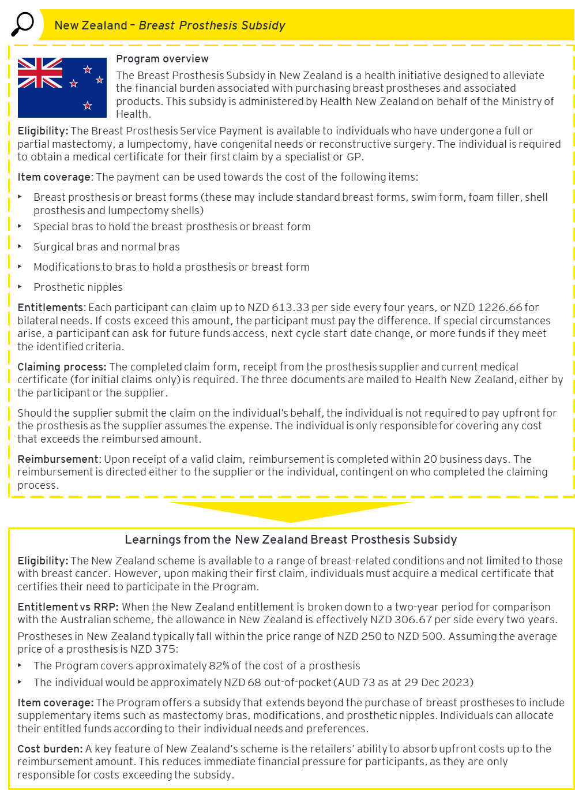

Sources: Ministry of Health (52), New Zealand Health (10), Reserve Bank of Australia (55)

United Kingdom

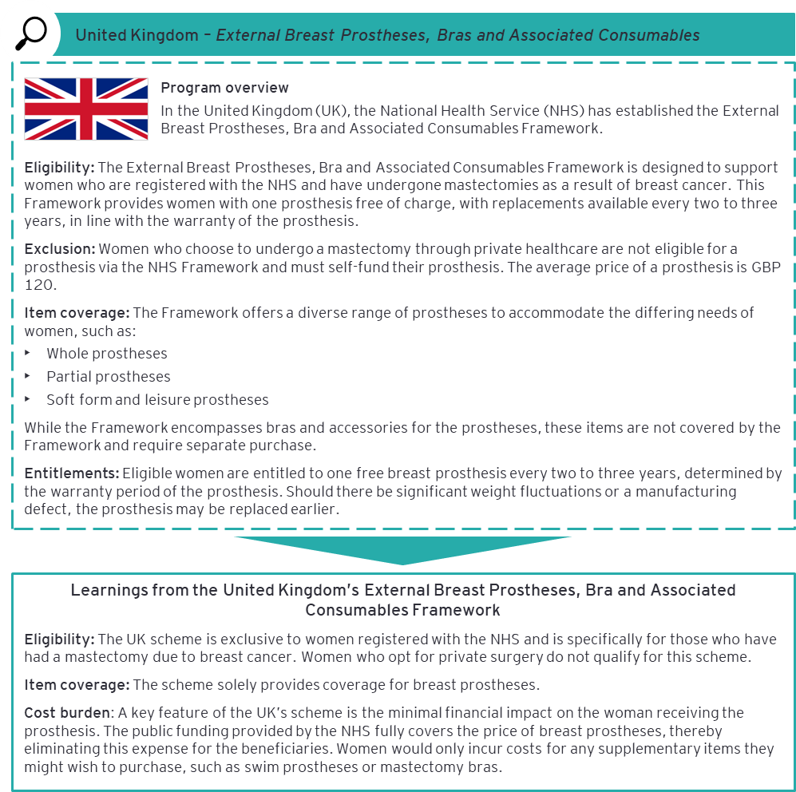Sources: NHS Harrogate and District Cancer Services (7), NHS Supply Chain (14)

Canada – Ontario

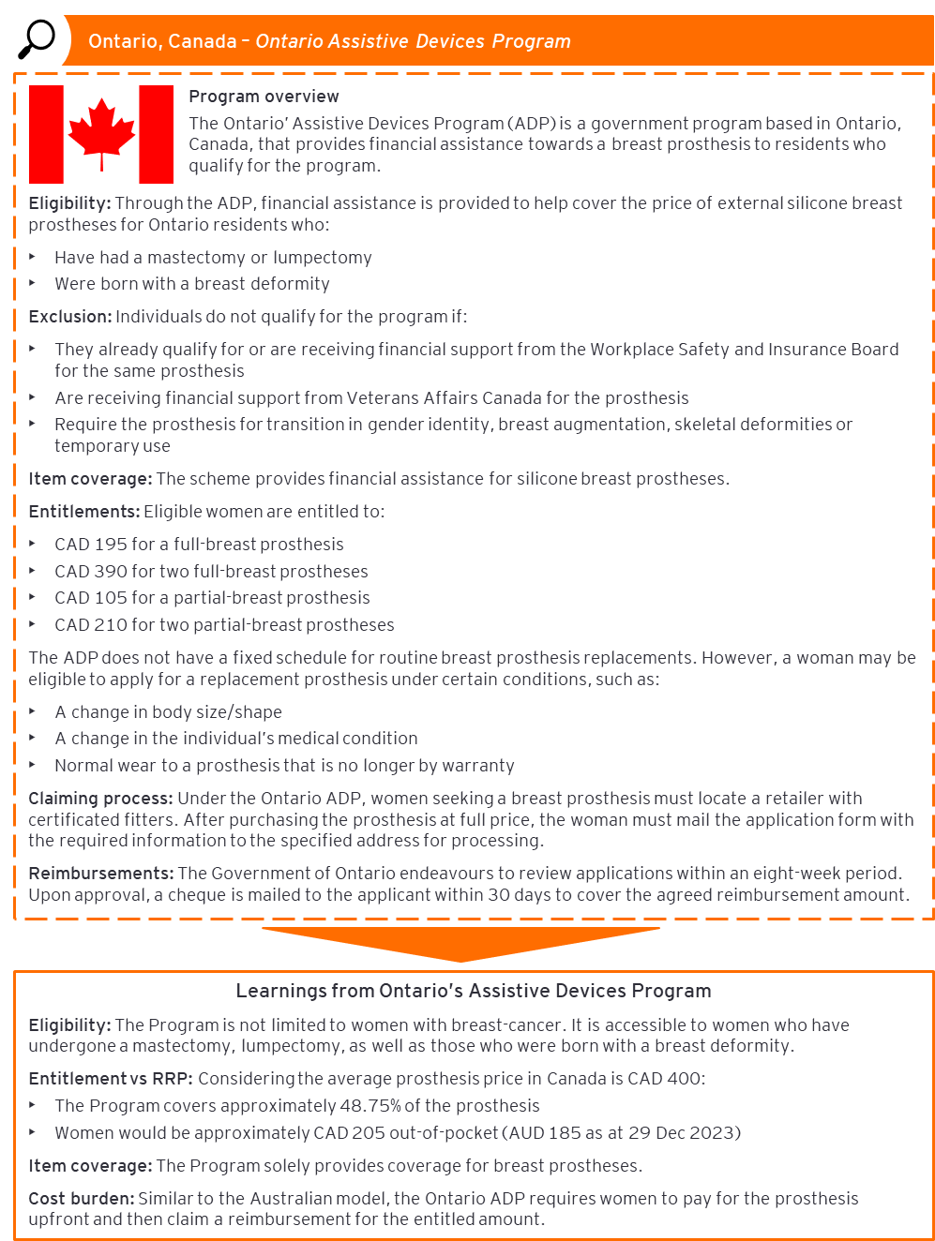Sources: Government of Ontario (53), Reserve Bank of Australia (55)

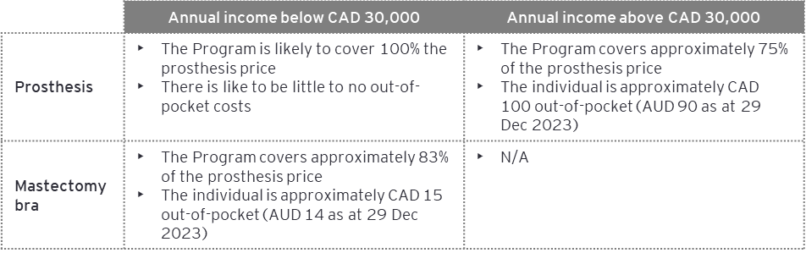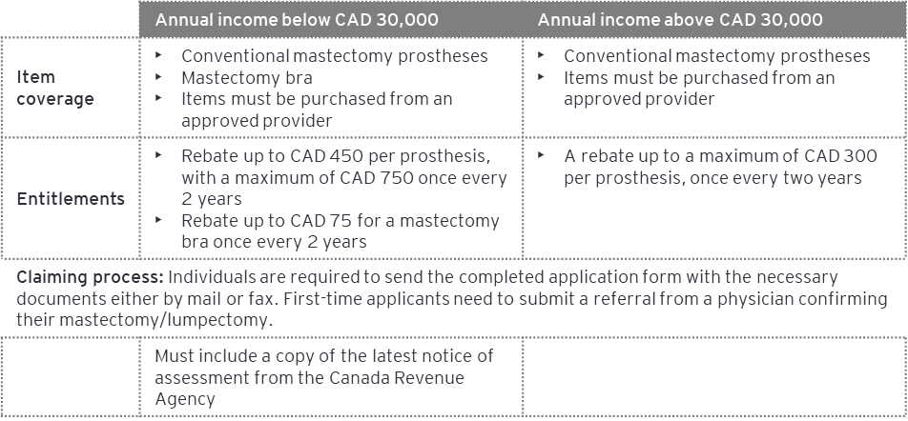Canada – Nova Scotia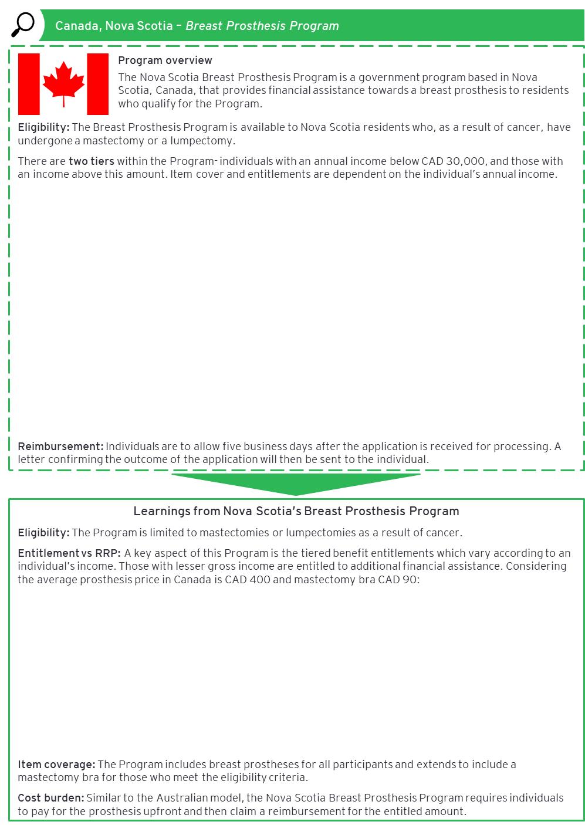Sources: NovaScotia.ca (8), Reserve Bank of Australia (55)

Canada – Manitoba

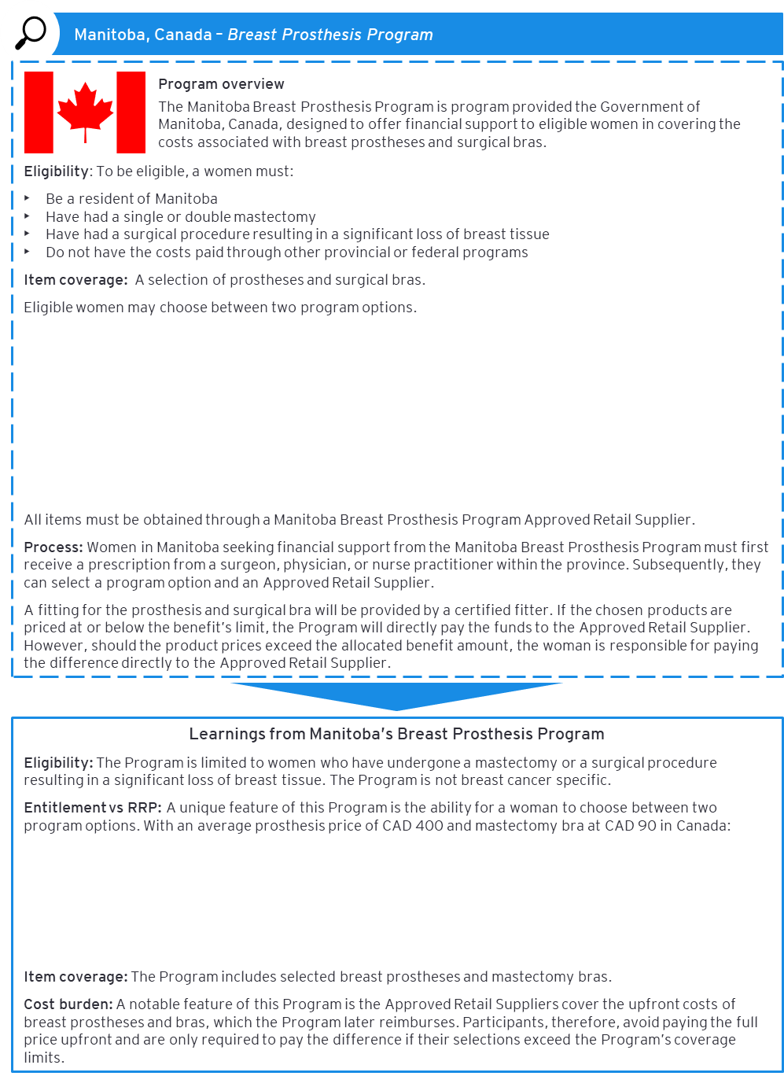

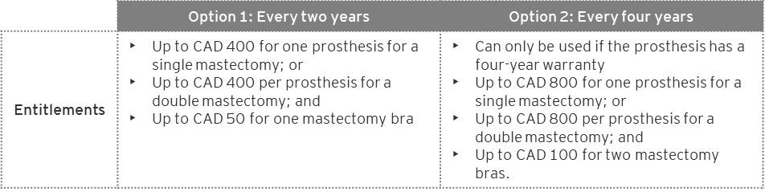

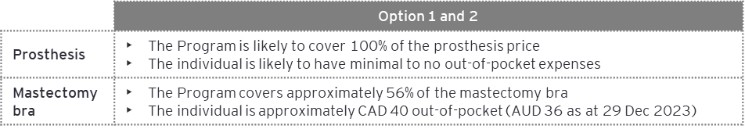

*Sources: Cancer Care Manitoba* (9)*, Canadian Breast Cancer Network* (54)*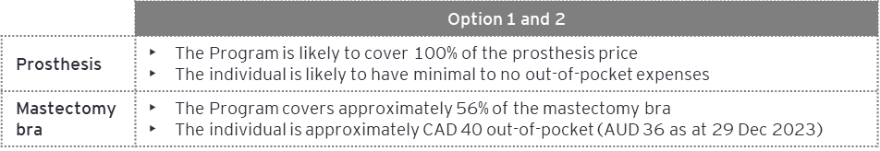, Reserve Bank of Australia* (55)

1. Evaluation Question findings mapped to recommendations

Appendix B presents a mapping of each finding to the relevant recommendation.

The table below presents a detailed mapping of each EQ finding presented in Sections 3.1 to 3.5 to its corresponding recommendation/s. The data source for each finding is also presented.

Table 17: EQ findings mapped to the associated recommendation

| **Data source** | **Finding** | **Corresponding recommendation** |
| --- | --- | --- |
| **EQ 1: Is the reimbursement amount of $400 still appropriate?** | | |
| Desktop scan | **Finding 1A:** Since Program commencement in 2008, the average price of prostheses claimed has increased by 10%, resulting in Program participants paying on average $11 out-of-pocket. While the reimbursement fully covered the average prosthesis price claimed in 2008, it covered 97% of the average price in FY2022-23. | 1 |
| Stakeholder consultation | **Finding 1B:** Stakeholders had mixed views on whether the $400 reimbursement is appropriate. While some deem it suitable as it covers lower-priced prostheses without extra costs, others suggested indexation should be applied. | 1 |
| **Finding 1C:** All three retailer groups stated that prostheses pricing is impacted by the reimbursement amount and highlighted that any increases in this amount could affect the price of prostheses. In this case, participants would face higher prices for the same products. | 1 |
| **Finding 1D**: Most stakeholders expressed a preference for supplementary items to be included in the reimbursement eligibility. However, Services Australia recognised that expanding the range of covered items would lead to an increased workload and potentially impact service delivery. | 2 |
| International literature scan | **Finding 1E:** Reimbursement levels vary across similar programs internationally, with three out of five programs reviewed covering the entire average price of a prosthesis. | 1 |
| **Finding 1F:** Three out of the five international programs reviewed included coverage for supplementary items. | 2 |
| **EQ 2: Is the EBPRP easy to access and make a claim?** | | |
| Desktop scan | **Finding 2A**: Increased Program awareness between the two Evaluations was attributed to improved dissemination of Program information among eligible women and supporting organisations. | No recommendation |
| **Finding 2B:** Since the Program’s commencement, there has been a steady increase in the volume of claims, with the highest number of claims recorded in the first year of its operation. | No recommendation |
| **Finding 2C:** Since the commencement of the Program, the rate of claim rejections has consistently decreased. This suggests better access for individuals who wish to use the Program. | No recommendation |
| **Finding 2D:** The requirement of an up-front payment was reported as a potential barrier to Program access, particularly for priority populations. Although participants on eligible Centrelink payments could access an advance payment, awareness of this option was low. | 1 |
| **Finding 2E:** People of all ages are accessing the Program. | No recommendation |
| **Finding 2F:** Breast prostheses claims broadly reflect the geographic distribution of the Australian population. | No recommendation |
| **Finding 2G:** High satisfaction with the manual claiming process was reported in the past Evaluations, and an online submission process was recommended to further enhance the claims process. | 4 |
| **Finding 2H:** Participants are advised that most claims are processed within 10 business days, in line with Services Australia’s original KPI for 90% of claims to be processed within this timeframe. However, since FY2021, this KPI was extended to 14 business days due to the increased volume of claims processing during the COVID-19 pandemic. In FY2022-23, 69.32% of claims were processed within this revised timeframe, compared to 99.78% processed within 10 days in FY2008-09. | 4 |
| Stakeholder consultation | **Finding 2I:** The majority of stakeholder groups report the general lack of Program awareness to be a major barrier to Program access. Current promotional activities are less prominent than when the Program was first launched. | 3 |
| **Finding 2J:** The timing of Program promotion was recognised as a critical element in raising awareness, however there was no consensus on the ideal time to introduce the Program to individuals. | 3 |
| Finding 2K: Breast care nurses and the Breast Cancer Network Association (BCNA) have been identified as key promoters of the Program. Breast care nurses are considered crucial in disseminating information about the Program and are integral to reaching diverse groups, including those in remote areas. | 3 |
| **Finding 2L:** To improve Program awareness, stakeholders suggested utilising organisations with established communication networks with the target audience and implementing a communication campaign using MBS data to identify and inform eligible women of the Program. Leveraging existing communication channels such as consumer groups (BCNA, McGrath Foundation) and applying learnings from other Programs such as the National Bowel Cancer Screening Program to send reminders may help facilitate increased Program awareness. | 3 |
| **Finding 2M:** The majority of stakeholder groups identified the initial requirement to pay upfront for a prosthesis before obtaining reimbursement as a significant barrier to accessing the Program. They suggested adopting a HICAPS-like system or providing upfront payments as potential solutions to this issue. Additionally, there was a notable lack of awareness regarding the available option for an advanced payment. | 1 |
| **Finding 2N:** The Program’s eligibility criteria may be too limited, with suggestions to expand the Program to people who do not identify as “female” but who meet the other eligibility criteria and encompass conditions other than breast cancer. | 2 |
| **Finding 2O:** There are limited prostheses retailers in Australia, particularly in remote regions, which may impact on access. Creating a centralised list of retailers has been suggested as a potential solution to improve accessibility to retailers. | 3 |
| **Finding 2P:** The current claim form received mixed feedback, from straightforward and simple, to being cumbersome and time consuming. An online claiming system was suggested as a streamlined alternative that could simplify the claims process for Program participants. | 4 |
| **Finding 2Q:** Retailers, family members and caregivers have been identified as key support for individuals in completing the necessary claims paperwork. | 3 |
| **Finding 2R**: Program participants may wait longer than the expected 10 days for reimbursement. This may be due to the impact of the emergency payments and the COVID-19 pandemic, during which staff resources were redirected to provide COVID-related support. | 4 |
| International literature scan | **Finding 2S:** Three out of five international programs reviewed shifted the up-front cost of the prostheses to either the government or retailers, away from participants. | 1 |
| **Finding 2T:** Three out of five international programs reviewed included indications other than breast cancer into program eligibility criteria. Two out of the five programs reviewed also specified an exclusion criteria. | 2 |
| **EQ 3: Is Services Australia the most appropriate organisation to be delivering the EBPRP?** | | |
| Desktop scan | **Finding 3A:** The nationalised format of the Program, administered by Services Australia has enabled a consistent uniform approach to the reimbursement amount and claims process across the country. | 4 |
| Stakeholder consultation | **Finding 3B:** Key stakeholders such as consumers, the Department and Services Australia are satisfied with the nationalised Program delivered by Services Australia. | 4 |
| **Finding 3C:** Services Australia is best placed to deliver the Program given its remit and ability to standardise delivery to promote equitable access. | 4 |
| **EQ4: Are there special requirements for First Nations and CALD people that need to be incorporated into the design of the EBPRP?** | | |
| Desktop scan | **Finding 4A:** The language of Program resources, the requirement for up-front purchase of prostheses and geographic isolation are key Program barriers for First Nations and CALD communities. | 5, 6 |
| Stakeholder consultations | **Finding 4B:** The requirement for an up-front payment, lack of Program awareness, cultural perceptions of cancer and geographical remoteness are key barriers to First Nations people accessing the Program. | 1, 3, 5, 6 |
| **Finding 4C:** For First Nations people, the challenges in Program access reflect deeper systemic issues in cancer care. This includes the current challenges and priorities in addressing low engagement with preventive measures such as screening and treatments for cancer. | 5 |
| **Finding 4D:** For CALD communities, the requirement for an up-front payment, lack of Program awareness, the manual claiming process and cultural perceptions are barriers to accessing the Program. | 1, 3, 6 |
| **Finding 4E:** Currently, Program promotional materials are not developed in languages other than English. There are mixed views on the ideal type of material to promote the Program to CALD and First Nation communities, however, there appears to be a strong preference for in-person and community-led channels. | 6 |
| **Finding 4F:** There is an opportunity to leverage existing initiatives to facilitate targeted Program promotion. | 5, 6 |
| **Finding 4G:** Direct engagement with priority populations is critical to ensure the voice of the consumer informs Program design and instils trust in the Program. | 5, 6 |
| **EQ 5: Is the EBPRP achieving its intended outcomes?** | | |
| Findings from all Questions | **Finding 5A:** The Program is providing financial support towards the cost of external breast prostheses for women who have undergone a mastectomy as a result of breast cancer to some extent | 2 |
| **Finding 5B:** There is national consistency in the Program provision of support towards the cost of breast prostheses (Program Objective 2). | 2 |
| **Finding 5C:** There is evidence of the Program improving quality of life for women who have undergone breast surgery as a result of breast cancer (Program Objective 3), however further data collection / research is required. | 2 |

1. Direct advice from the Department
2. HICAPS is an electronic health claims system that allows individuals to claim automatically on the sport at their health service provider.
3. Poland syndrome is a condition where a child is born with missing or underdeveloped chest muscles.
4. Medicare was integrated into the Department of Human Services (DHS) in 2011, which ultimately transitioned into Services Australia in 2020
5. Medicare was integrated into the Department of Human Services (DHS) in 2011, which ultimately transitioned into Services Australia in 2020.
6. The intended outcomes of the Program have been defined as the Program objectives as stated in the *Program* *agreement for the External Breast Prostheses Reimbursement Program 2021-2024*
7. This is in line with some international programs – see Appendix A.