Enhance HTA: An Enhanced Consumer Engagement Process in Australian Health Technology Assessment

# A Report of Recommendations

June 2024

# Acknowledgment of Traditional Owners

We acknowledge the Traditional Owners and Custodians of Country throughout Australia, and their continuing connection to land, sea and community. We pay our respects to them and their cultures, and to Elders both past and present.

This report was prepared by researchers from the Co-design and Community Involvement node in the Methods and Implementation Support in Clinical and Health (MISCH) Research Hub at The University of Melbourne, Victoria.

The researchers facilitated development of recommendations to inform the co-design of an Enhanced Consumer Engagement Process and prepared this report.

This work was commissioned by the Australian Government Department of Health and Aged Care, 2024.

# Table of Contents

Foreword 4

Executive Summary 5

Background 9

Enhance HTA Recommendations in Detail 11

Recommendation 1: Transparent communications and timely notifications 12

Transparent communications 12

Timely notifications 12

Recommendation 2: Centralised and expanded consumer support 13

Recommendation 3: Consumer identification 14

Recommendation 4: Resources and training 14

Recommendation 5: Elevate consumer evidence and input 15

Defining consumer evidence 15

Capturing consumer input 15

Recommendation 6: Early and continuous collaboration between stakeholders 16

Recommendation 7: Consumer-identified items for HTA Committees’ considerations 17

Recommendation 8: Consumer feedback loop following HTA Committee recommendations 18

Recommendation 9: Consumer digital portal 18

Recommendation 10: Consumer-focused horizon scanning 19

Implementation principles and foundations 21

Implementation principles 21

Implementation foundations 21

Invest in systemic change 21

Establish a consumer engagement framework 22

Strengthened by HTA Policy and Methods 22

Co-design Working Group 24

Thank you to our survey and submission respondents 25

Key terms 26

Acronyms 27

References 28

# Foreword

The Co-design Working Group (CWG) for the Enhanced Consumer Engagement Process is pleased to provide the *Enhance HTA* Report of Recommendations to the Minister for Health and Aged Care, for his consideration.

On behalf of the CWG, I would like to acknowledge the significance of the work being undertaken in the healthcare system to establish Australia as a leader in consumer engagement. This work has been a culmination over many years of collective advocacy by consumers seeking appropriate recognition and involvement in health technology assessment (HTA) processes.

The evolution of the Australian healthcare system and the HTA process that is the mechanism for Australians to access the right medicines at the right time is now at a critical point in its development.

The pace of new medicines and health technologies becoming available to improve and save lives is occurring at an unprecedented level. The CWG has provided recommendations and actions in this report to ensure consumer evidence and input will be integral in the delivery of a HTA system that aligns with our National Medicines Policy.

The CWG also acknowledges the recently completed HTA Policy and Methods Review as a once-in-a-generation, collective and collaborative opportunity to design and implement changes that will reap benefits not only for consumers, but for the healthcare system as a whole.

The recommendations included in this document are the result of broad consultation during which the CWG has embraced the principles of co-design to ensure all voices are heard. If adopted in full, the recommendations and actions will deliver systemic changes and updated processes to enable millions of Australians to live longer and have more fulfilling lives.

We are seeking a system that is built on transparency and inclusion that can be realised via a roadmap of collaborative action that will lead to the changes that give all Australians access to the right healthcare regardless of where they live.

The consumer sector looks forward to working with all key stakeholders to ensure there is a prompt and dedicated implementation process to deliver equitable and bold reform to improve outcomes for all Australians.

Sharon Winton

Chair

Co-design Working Group

# Executive Summary

Health technology is a term applied to medicines, vaccines, medical services, products, devices, and human tissue products.[1] Health technology assessment (HTA) is a framework that evaluates the safety, effectiveness, and cost-effectiveness ("value for money") of health technologies compared to the existing standard of care. It informs the Australian Government’s decisions on subsidising health technology items under government-funded programs, such as the Pharmaceutical Benefits Scheme (PBS).[2]

Consumers’[3] diverse health care experiences, needs, preferences and perspectives bring a unique expertise which must be integral to HTA decision-makers’ considerations. Consumer evidence and input brings not only insight of ‘end-user’ needs, but also the ‘real world’ practical, financial, cultural and wellbeing experiences of living with a health condition and their impact on accessing healthcare services and technologies.

This report emerged from a component of the 2022-2027 Strategic Agreement between the Commonwealth of Australia and Medicines Australia (the Strategic Agreement).[4] A multi-stakeholder Co-design Working Group (CWG) was formed to progress this work and develop recommendations which reflect consumer engagement as a tool to broaden and elevate the consumer voice.[5] This “Enhance HTA” report acknowledges the need to evolve HTA processes so that consumer engagement becomes embedded, and the inclusion of consumer evidence and input informs HTA deliberations. This is captured in the report’s vision:

“*Australians' diverse health care experiences and needs are understood, and consumer engagement is integral in HTA decision-making.”*

Three interrelated themes underpin the recommendations of this report:

* **Partnerships** across stakeholder groups to facilitate collaboration on elevating the consumer voice in HTA processes.
* **Transparency** and clarity on HTA processes, supported by easily accessed, plain language information and pro-active notifications of HTA activities.
* **Evidence and input** collected from consumers early in the health technology pathway for inclusion in HTA decision-making considerations.

The recommendations are complementary and interrelated, and each are considered necessary to fully realise an enhanced consumer engagement process. Their implementation requires progress across all recommendations to realise their full potential and achieve the vision of this report. Partnerships and transparency will support the integration of consumer evidence and input into HTA processes.

The recommendations proposed for consideration by the Minister for Health and Aged Care   
(the Minister) are:

1. Provide **transparent communications and timely notifications** to enhance the clarity of HTA processes and enable timely consumer engagement.

2. Coordinate **centralised and expanded consumer support** to facilitate engagement across the health technology pathway.

3. Develop a process for **consumer identification** to expand the diversity of consumers engaged in HTA processes.

4. Provide accessible **resources and training** to support equitable consumer engagement in HTA.

5. **Elevate consumer evidence and input** for consideration in HTA deliberations and decision-making.

6. Establish guidance to enable **early and continuous collaboration** between stakeholders.

7. Further develop processes to enable **consumer-identified items for HTA Committees’ considerations**.

8. Establish a **consumer feedback loop following HTA Committee recommendations** to provide insight into how consumer input has been used to inform the assessment of health technologies.

9. Develop a **consumer digital portal** to connect consumers with information and resources required for consumer engagement.

10. Ensure consumer engagement is informed by **consumer-focused horizon scanning** processes and opportunities.

Achieving successful implementation of the recommendations will require sustained focus from all stakeholders. The CWG established guiding principles for implementation: formal and ongoing multi-stakeholder collaboration; and measures and monitoring of outcomes arising from the new enhancements, to ensure accountability and assess their impact.

Additionally, the CWG recognised that key foundational elements are required to enable progressive change to be implemented from the recommendations:

* **Invest in systemic change** to ensure the Department of Health and Aged Care (the Department) and other stakeholders are resourced to support implementation strategies.
* Establish a **consumer engagement framework** to formally incorporate and monitor consumer evidence and input early and across the health technology pathway.
* Utilise current and future **HTA policy and methods** to strengthen and embed consumer evidence within this setting.

The proposed recommendations presented in this report seek to increase transparency, foster stakeholder collaborations and partnerships, and embed consumer evidence and input into HTA processes. Implementation principles and foundational elements will support collaborative development of these enhancements. A roadmap of implementation actions provides initial guidance of how the recommendations may be incrementally introduced to progressively elevate consumer engagement in the HTA setting. The overall potential impact of these recommendations will enable the diverse health care needs of Australians to be truly understood and considered in HTA decision-making.

## **Enhance HTA**

**An Enhanced Consumer Engagement Process in Health Technology Assessment**

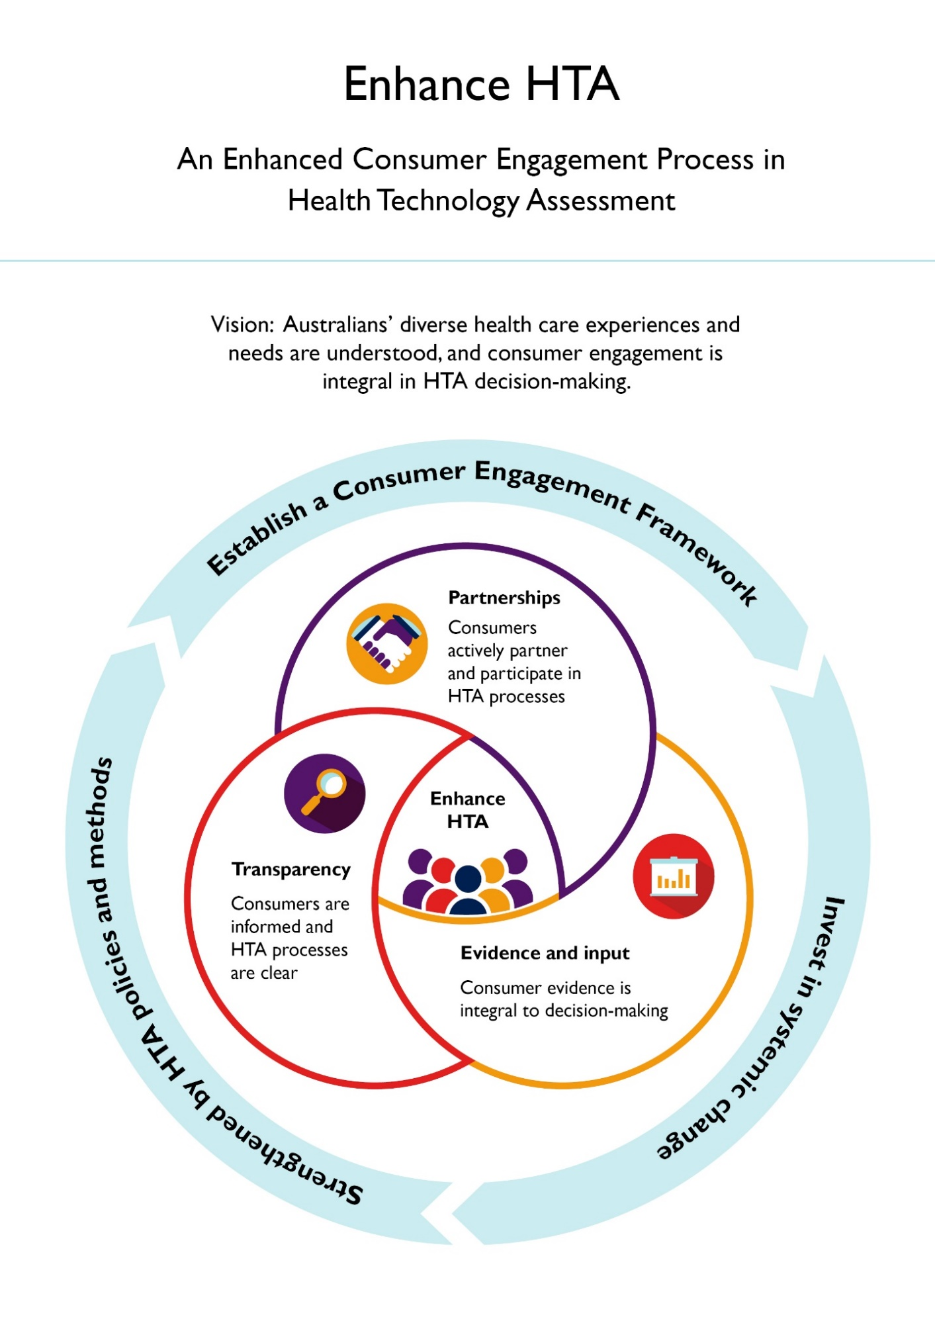Vision: Australians’ diverse health care experiences and needs are understood, and consumer engagement is integral in HTA decision-making.

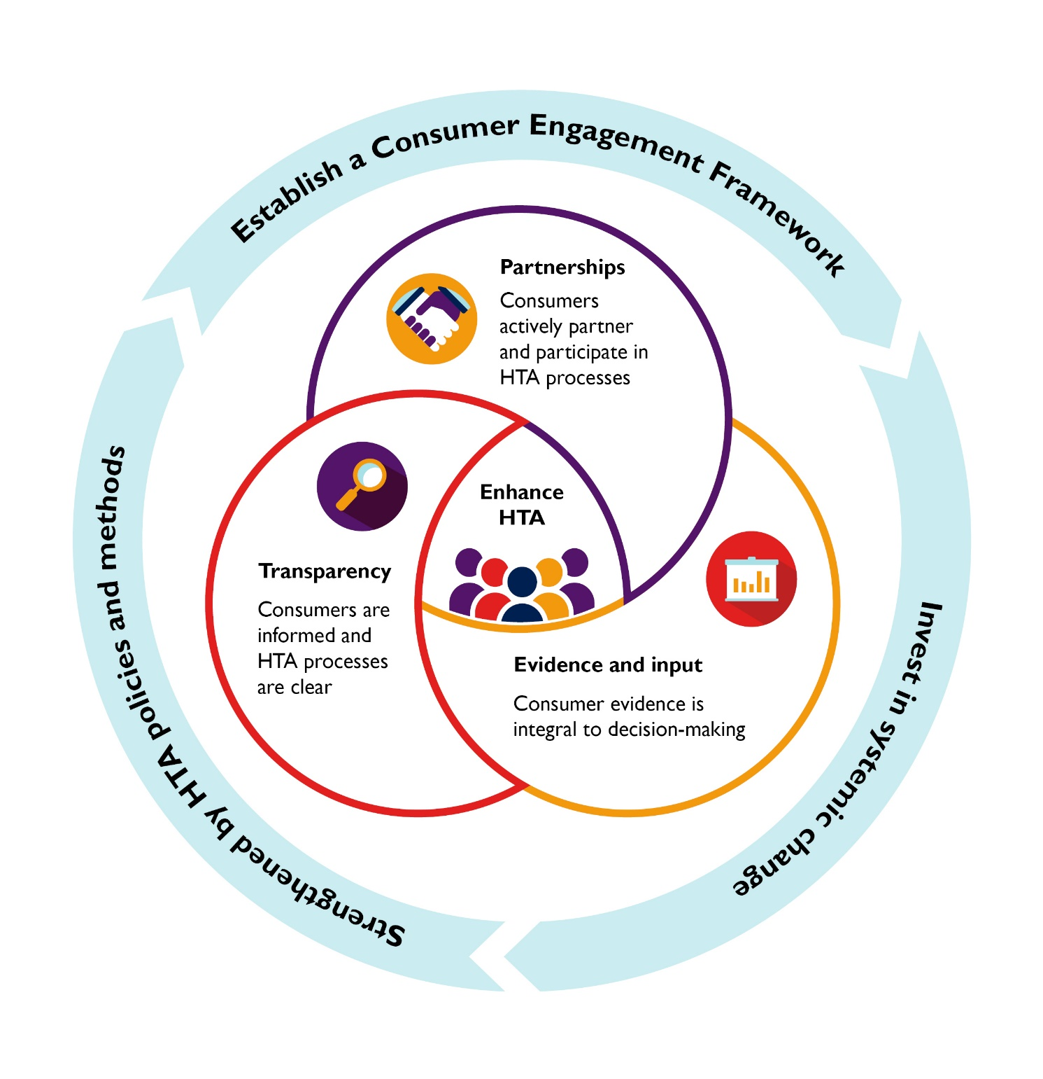

## **Enhance HTA – Summary of recommendations**

1. **Transparent communications and timely notifications**

Provide transparent communications and timely notifications to enhance the clarity of HTA processes and enable timely consumer engagement.

1. **Centralised and expanded consumer support**

Coordinate centralised and expanded consumer support to facilitate engagement across the health technology pathway.

1. **Consumer identification**

Develop a process for consumer identification to expand the diversity of consumers engaged in HTA processes.

1. **Resources & training**

Provide accessible resources and training to support equitable consumer engagement in HTA.

1. **Elevate consumer evidence and input**

Elevate consumer evidence and input for consideration in HTA deliberations and decision-making.

1. **Early and continuous collaboration**

Establish guidance to enable early and continuous collaboration between stakeholders.

1. **Consumer-identified items for HTA Committees' considerations**

Further develop processes to enable consumer-identified items for HTA Committees' considerations.

1. **Consumer feedback loop following HTA Committee recommendations**

Establish a consumer feedback loop following HTA Committee recommendations to provide insight into how consumer input has been used to inform the assessment of health technologies.

1. **Consumer digital portal**

Develop a consumer digital portal to connect consumers with information and resources required for engagement in HTA processes.

1. **Consumer-focused horizon scanning**

Ensure consumer engagement is informed by consumer-focused horizon scanning processes and opportunities.

# Background

This report outlines recommendations resulting from a co-design project to design an Enhanced Consumer Engagement Process as defined in the Strategic Agreement.4 It coincides with a period of rapid advancements in medical science, underscoring the necessity to adapt the healthcare system to maximise the potential health benefits derived from these developments. Integrating consumer perspectives into HTA processes, particularly those evaluating health technologies for government programs such as the PBS, is essential for supporting a person-centred health care system. In this report, the term consumer refers to a patient, carer, consumer organisation and members of the general public.3

The CWG membership consisted of representatives of the consumer and medicines industry sectors and the Department of Health and Aged Care (the Department), led by a consumer Chair.[6] The project was facilitated by researchers commissioned by the Department from the Co-design and Community Involvement node in the Methods and Implementation Support in Clinical and Health (MISCH) Research Hub at The University of Melbourne, Victoria. The facilitators ensured the project adhered to the principles of co-design: an iterative and participatory process that brings people together to share ideas, experiences, and evidence to design and implement solutions that aim to address a specific issue or topic.[7],[8] The Department’s Consumer Evidence and Engagement Unit (CEEU), within the Office of Health Technology Assessment (OHTA), provided project management and secretariat support.

At the outset of this project, the CWG drew on the evolving application of patient-centred principles in healthcare policy and delivery. The project was informed by foundational documents such as *The New Frontier – Delivering better health for all Australians* (2021)[9], the *National Medicines Policy* (2022)[10], the *Bringing Patient Centricity to Life* report (2022)[11], and the *Conversations for Change* report (2023)[12]. These were developed through extensive consultations with consumers and other stakeholders in the HTA environment, collectively highlighting the increasing importance of the consumer voice in this setting.

In approaching enhancements to consumer engagement, the CWG considered the broader health technology pathway for perspective and context. Beginning with scientific discovery and clinical research, a health technology requires registration on the Australian Register of Therapeutic Goods (ARTG). This is attained through the Therapeutic Goods Administration (TGA), who assess a technology on its safety, quality and effectiveness.[13] HTA Committees may then assess a health technology for comparative effectiveness and cost effectiveness to determine if it should be recommended to the Minister for consideration of its inclusion on a government subsidised program.[14] These programs include the PBS and the Medicare Benefits Schedule (MBS).

While consumer engagement in Australian HTA processes has evolved over time, recent reports confirm that further enhancements to the engagement process are required.9,11,12 The Strategic Agreement recognised the importance of consumer involvement in HTA processes. A commitment in the agreement (clause 6.3) includes a project “to co-design and agree upon an Enhanced Consumer Engagement Process, for consideration by the Minister (for Health and Aged Care), to capture consumer voices in respect to applications to list new medicines on the PBS.”4

The CWG commenced work in developing its recommendations in November 2023 by firstly considering the project scope, informed by the Strategic Agreement:

* Submissions to list new health technologies (single or class) on the PBS (i.e. medicines, vaccines, nutritional products, codependent technologies[15]).
* Changes to early stages of the HTA pathway.
* Clarifying the relationship with horizon scanning information.
* Understanding where conflicts of interest may need to be managed.

Of note, while the purpose and scope focus on enhancing consumer engagement in relation to the PBAC processes, the CWG considered opportunities to strengthen consumer engagement across the entire health technology pathway. This recognises that consumer engagement earlier in this pathway, from the clinical trial stage, may support the inclusion of consumer evidence early to better inform later subsidisation decision-making. Additionally, the CWG developed its recommendations with consideration of relevance for not only PBAC processes but also potential adaptation to other HTA Committees such as the Medical Services Advisory Committee (MSAC).

At its first meeting in November 2023, the CWG agreed on design principles to inform its co-design work of enhancing consumer engagement processes:

* Consumer evidence and experience is prioritised and integral in health technology assessment processes.
* Recommendations to enhance consumer engagement must not delay access to medicines.
* Enhancements for consumer engagement may be prioritised to achieve maximum impact through implementation.

The CWG developed proposed recommendations for open consultation with consumers and other stakeholders during March 2024. These consultation responses, representing a wide range of stakeholder groups (page 25), informed the finalisation of the recommendations described in this report.

The CWG acknowledged that the recently completed HTA Policy and Methods Review (the HTA Review)[16] may provide additional guidance on how this report’s consumer enhancement recommendations might be further informed.

This report proposes a vision where “*Australians' diverse health care experiences and needs are understood, and consumer engagement is integral in HTA decision-making*”. The recommendations and implementation considerations described in this report are designed to support the realisation of this vision.

# Enhance HTA Recommendations in Detail

## Recommendation 1: Transparent communications and timely notifications

### Transparent communications

**Purpose:** To ensure consumers have clear information about HTA processes and decisions including timely updates on the progression of a health technology along the HTA pathway.

Stakeholders have reported that the HTA environment can seem complex and unfamiliar when first encountered. Consumers have different levels of experience and knowledge of HTA processes, shaped by their prior engagement. Consumer feedback highlights the need for clearer and more transparent communication about HTA processes, tailored to diverse audiences with varying levels of familiarity, ensuring greater equity of access to information.

The CWG recommends the development of communications intended to inform consumers of HTA processes, ‘translating’ technical and complex guidelines, procedures, and public summary documents into more accessible plain language. These should be consistently adopted across the health technology pathway - from clinical trial protocols to information on medicine registration and through to public funding processes and decisions.

It is recommended the Department collaborate with the medicines industry to provide additional information on the status of a medicine on the Medicines Status Website, in consultation with consumers. The additional information may include dates for existing milestones for assessment processes, greater detail on the steps involved following a positive recommendation by PBAC, PBS listing information, and where possible, providing information on the reason for a delay outside the expected time to listing on the PBS following a positive PBAC recommendation.

The following existing communications are recommended as an initial focus area:

* Transparent criteria for the circumstances where consumer hearings and stakeholder meetings may be convened by HTA Committees.
* Greater awareness of consumer nominated topics for PBS post-market review.

### Timely notifications

**Purpose:** to enable consumers and clinicians to prepare informed input for consideration in HTA decision-making.

Currently, consumer input to PBAC submissions is primarily captured during an 8-week consultation period following the publication of a PBAC meeting agenda. This process is facilitated by the Department’s OHTA Consultation Hub which, since its inception (2021), has elevated consumer perspectives within the PBAC’s considerations. Consumers and clinicians may receive digital notification on HTA Committee meeting activities and agendas via several pathways including PBS News e-bulletins and/or the CEEU e-newsletter (*HTA Engage*).

Timely notifications to consumers and health care professionals regarding the status of health technology assessments could increase opportunities for consumers to prepare and provide input.

This recommendation can be supported by developing a consumer identification process (Recommendation 3) to enable targeted notifications and updates. Timely notifications of the following existing information will support enhanced consumer engagement:

* New medicines or new uses of existing prescription medicines under evaluation by the TGA.
* Health technologies being considered by HTA Committees (including plain language information of a submission).

Consumer notifications are recommended to be complemented by plain language information and shared via a digital platform (such as email, social media, or e-newsletter). The design of the plain language information about a submission should be informed by the previously piloted Summary of Information for Patients (SIP) project, with a focus on the Population, Intervention, Comparator, Outcome (PICO). A template for this plain language information should be designed in partnership with the medicines industry, the Department, and consumers, and include commercial-in-confidence considerations.

## Recommendation 2: Centralised and expanded consumer support

**Purpose:** to facilitate consumer engagement across the health technology pathway via a single-entry point, to guide consumers towards resources and support systems.

The CWG recognises that across the Department’s health technology pathway work areas, support exists for consumer engagement. The establishment of the CEEU within the OHTA in 2019 demonstrates the growing evolution of consumer-focused initiatives aimed at supporting consumer engagement within HTA processes.

As consumer engagement continues to evolve across the health technology lifecycle, consumers have identified a need for coordinated, centralised and expanded consumer support within the Department. The CWG proposes that the CEEU and existing consumer engagement supports in other areas of the health technology pathway are better connected, to facilitate ongoing support for consumers to engage with these processes.

The consumer engagement framework (page 22), identified as an implementation foundation of this report, will support the development of this coordinated Departmental support.

## Recommendation 3: Consumer identification

**Purpose:** to facilitate identification of consumers and their specific interest in health technology matters, and broaden the diversity of consumer input into HTA decision making.

While consumers may vary in their experience of engaging in HTA processes, any consumer has the potential to contribute the ‘expertise’ of their lived experience to better inform the assessment of health technologies. The CWG recommends the identification of consumers and consumer organisations across a broad range of health conditions, linked to their area(s) of interest.

This recommendation aims to identify a broader diversity of consumers who wish to engage in HTA processes. It will enable communication and notifications of HTA activities, targeted to the consumers identified interest area(s), in a more intentional and efficient way. Such a process will also support timely notifications (Recommendation 1).

Over time, this enhancement will deepen the understanding of the diversity of consumer experiences and their access, resource and engagement needs.

The development of an identification process will consider how best to capture diversity and ensure equitable access to information and engagement activities, and how the consumer information will be collected and utilised.

## Recommendation 4: Resources and training

**Purpose:** to provide accessible resources and training modules on HTA processes which are tailored to the level and type of engagement consumers and other stakeholders may wish to have with the HTA environment.

Currently, information on HTA processes, including how consumers can engage in these and how their input is considered by HTA committees, is accessed from various sources provided by the Department, consumer organisations and the medicines industry. This recommendation aims to build the capacity of identified consumers (Recommendation 3) and other stakeholders by developing resources and training to enhance engagement capability. This is proposed across two phases.

Initially, the focus will be on identifying and consolidating existing, accurate, and suitable resources. These materials can be transformed into plain language formats, incorporating infographics and videos, and categorised to help consumers find the information they need for engaging with HTA processes. Resources and training will, in time, be housed on the consumer digital portal (Recommendation 9).

The second phase involves developing a skills and experience matrix through consultations with identified consumers (Recommendation 3). This matrix will assess the current skills and proficiency levels of individual consumers and consumer organisations. It will guide the creation of tailored resources and training programs to meet the diverse needs of consumers.

Encouraging shared learning among stakeholder groups is crucial to fostering a deeper understanding of the varied perspectives within the HTA environment. This approach will provide all HTA stakeholders with opportunities to develop their understanding of the value and utilisation of consumer input in HTA decision making.

## Recommendation 5: Elevate consumer evidence and input

**Purpose:** to facilitate consumer input into PICO and implementation considerations early in the submission process and enhance the use of consumer evidence and input in HTA submissions and deliberations. This may assist understanding of the consumer perspective and early identification of implementation implications for consumers.

### Defining consumer evidence

Consumer evidence is recognised as that which is produced through research and generally published in peer-reviewed journals. It is noted that much of the early health technology research and clinical trials occur outside Australia. Nevertheless, the evolving global medical research and clinical trial environment, including in Australia, is working to incorporate consumer voices in the early phases of a medicine lifecycle. This includes consideration of the capture of consumer evidence such as Patient Reported Experience Measures (PREMS), Patient Reported Outcomes Measures (PROMS) and Real World Evidence (RWE).

In Australia, RWE is increasingly utilised in HTA submissions.[17] Collaboration with consumer organisations (Recommendation 6) to increase the visibility and utility of consumer evidence within a submission will assist HTA Committees’ consideration of consumer-specific matters.

### Capturing consumer input

The existing consumer comments pathway process is a means of providing consumers’ lived experience into HTA decision-making considerations. The CWG considers that this could be further improved by developing tailored consumer comments templates, such as for consumers, consumer organisations and clinicians. This will assist with capturing the specific perspectives and needs of these stakeholders to better inform HTA Committees.

Consumer frustration has been expressed that the inclusion of consumer comments generally occurs after the lodgement of a submission. Specifically, there is a view that consumer and clinician input is missing on matters relating to the PICO and practical considerations of how a health technology may be accessed following subsidisation. Consumers and clinicians can provide valuable insight into these matters which may inform HTA Committee recommendations. This is especially important where the recommendation involves a first-in-class medicine and the outcome could lead to unintended barriers to access (such as availability of specialists, health system readiness, and clinical monitoring).

The CWG recommends inclusion of early (pre-submission) consumer input to inform equitable access to new medicines or new uses of existing medicines. This will better inform the submission content, and may reduce the need for multiple reimbursement submissions, supporting timely access to the health technology. This recommendation would greatly benefit from early and continuous stakeholder collaboration (Recommendation 6).

## Recommendation 6: Early and continuous collaboration between stakeholders

**Purpose:** to enable early and continuous collaboration between consumers, industry and the Department along the HTA pathway and ensure the shared goal of embedding consumer evidence and input in HTA considerations is realised.

Capturing consumer evidence and input in HTA decision-making relies on effective communication between the Department, the medicines industry and the broad and diverse range of consumers and other stakeholders involved in HTA. As noted in Recommendation 5, the CWG has identified that consumer input after a HTA submission has been lodged is too late for consumers to effectively contribute to key elements such as the PICO and implementation considerations.

Incorporating these aspects of consumer input earlier in the health technology pathway would ensure that considerations from ‘end-users’ are included in HTA decision-making. However, stakeholders report that earlier collaboration and input on these specific matters is restricted due to current legislative and regulatory requirements. These restrictions include direct-to-consumer advertising and commercial-in-confidence issues prescribed under the *Therapeutic Goods Act 1989* and the *Competition and Consumer Act 2010.*

The CWG proposes prudent examination of how earlier consumer input may be facilitated within existing regulations and legislation. This would allow for subsequent development of guidance for how stakeholders may work together, while supporting adherence to the regulatory and legislative requirements. This would, in part, be supported by the identification of key consumer organisations (Recommendation 3) involved in the related health condition having facilitated a commercial-in-confidence communication with the medicine sponsor. The identified consumer organisation would then work with its consumer network to capture any issues and ensure consumer perspectives are provided to the medicine sponsor for inclusion in the HTA submission.

Guidance on this matter will lay the foundation for all stakeholders to develop a template for early engagement: for the medicines industry it will establish avenues and relationships needed to capture consumer perspectives of issues arising from new technologies for input into HTA submissions; and for consumers it will enable pathways for providing input early and across the HTA pathway. It is further recommended resources and training (Recommendation 4) be developed specifically to support collaborations between consumers, consumer organisations and consumer networks.

## Recommendation 7: Consumer-identified items for HTA Committees’ considerations

**Purpose:** to enable consumers, through appropriate collaboration with the Department and the medicines industry, to identify health technology items that address unmet clinical needs for consideration by HTA Committees.

Submissions of health technology items for HTA consideration are initiated by a sponsor or manufacturer. The TGA Medicines Repurposing Program provides a process for consumers to identify medicines that could potentially be considered for new therapeutic uses (repurposing).[18] This identification process means sponsors may apply for regulatory approval for the medicine's new use, and subsequently seek subsidy for the new use of the medicine. Consumers are also able to identify medicines for consideration of ongoing access and subsidy arrangements through the post-market review framework.[19]

The ability for consumers and clinicians to identify opportunities for expanded public access of a subsidised medicine to address an unmet clinical need is a critical element of a person-centred healthcare system. However, securing such an outcome is complex with multiple factors such as legal responsibility and supply guarantee to be considered. In acknowledging this need, the CWG recommends an approach in which consumers and clinicians can inform regulatory and/or HTA processes of health technology items identified as having potential utility in a specific or expanded patient population.

Such an approach would need to be undertaken in collaboration with the medicines industry and the Department and require the development of guidance and specific criteria for how consumer identified items can be considered by a HTA Committee. The guidance must incorporate how to understand the consumer-identified unmet needs and outline the exchange of information and measures required to adhere to confidentiality, commercial-in-confidence, and data protections. This will require a clear process for determining the opportunity to progress to a submission and implications under the[Australian Government Cost Recovery Policy](https://www.finance.gov.au/government/managing-commonwealth-resources/implementing-charging-framework-rmg-302/australian-government-cost-recovery-policy).[20]

The CWG recognises existing processes to support consumer- and clinician-identified items. These include the TGA [Medicines Repurposing Program](https://www.tga.gov.au/resources/publication/publications/establishment-medicines-repurposing-program)16 and the MSAC[Department Contracted Assessment Report (DCAR)](http://www.msac.gov.au/internet/msac/publishing.nsf/Content/Documents-for-Applicants-and-Assessment-Groups) [21]process. As part of the development of guidance, it is recommended consideration be given to the extensive work undertaken in the development of these processes.

## Recommendation 8: Consumer feedback loop following HTA Committee recommendations

**Purpose:** to provide feedback to consumers and clinicians to assist their understanding of how their input has impacted specific health technology decisions and to inform future consumer input.

The CWG notes that consumers and clinicians have expressed uncertainty regarding how their comments relating to an item for HTA Committee consideration is recognised and valued within decision-making. The lack of visibility concerning how consumer input might inform and impact HTA determinations has been identified as an opportunity to improve information sharing.

A feedback loop could act as a mechanism to enable consumer organisations and other stakeholders to receive direct feedback from the HTA Committee on how their input, submitted as part of the HTA consumer comments process, has been considered in decision-making deliberations.

The feedback loop should align with agreed principles of transparency and adherence to confidentiality and timing of information connected to HTA Committee processes. It will therefore require development in consultation with the Department and other stakeholders. The feedback loop could provide information such as insight on how consumer evidence and input was utilised in decision making or where further consumer engagement may have been useful. This would inform improvements to future consumer comments and input (Recommendation 5).

It is important that such a process also identifies where additional resources or capacity building is required to support ongoing consumer input, strengthening both consumer evidence and consumer engagement in HTA processes.

## Recommendation 9: Consumer digital portal

**Purpose:** to provide consumers with a digital resource where they can easily access and navigate information, resources, tools, training, and notifications in one place to support their engagement across the health technology pathway.

It is challenging for consumers to find information relating to a specific health technology of interest across the health technology pathway. Challenges in locating relevant and easy to understand information along these time points pose a barrier to earlier and more meaningful consumer engagement, participation in HTA processes, and engagement in post-market considerations.

The CWG recommends a consumer digital portal be developed to provide a ‘one-stop-shop’ that enables consumers to access a wide variety of resources in an equitable and easy way. These resources include information on registration and reimbursement processes and activities. The design of the portal is recommended to consider the need for engagement to occur irrespective of diversity, background, age, disability, location, health literacy, digital literacy, or personal circumstances.

An initial activity is to collate existing resources onto one Departmental webpage as an interim central hub for consumers and health professionals. This can include links to existing websites such as:

* HTA Committee webpages.
* Medicines Status Website.
* OHTA webpage.
* OHTA consultation hub.
* TGA prescription medicines: applications under evaluation webpage.

This initial activity will enable consumers to more easily navigate and find important information such as that relating to:

* A medicine’s regulatory status.
* HTA Committee agendas, outcomes, and public summary documents.
* Criteria for the circumstances where consumer hearings and stakeholder meetings may be convened by HTA Committees.
* Status updates for medicines pending PBS listing.
* The post-market review framework.

The CWG agrees that the portal will serve to expand diversity of consumer engagement in health technology processes. This includes improving access to information for consumers in regional, rural, and remote locations, facilitating their ability to provide input.

## Recommendation 10: Consumer-focused horizon scanning

**Purpose:** to ensure that as horizon scanning continues to evolve in Australia, consumers and clinicians participate as essential stakeholders to identify gaps in areas of high unmet clinical need.

Horizon scanning refers to “the systematic identification of health technologies that are new, emerging or becoming obsolete and that have the potential to effect health, health services and/or society.”[22]

The HTA Policy and Methods Review Options Paper20 included consideration of stakeholder feedback to identify various purposes for horizon scanning. These were grouped into the following:

* Identifying future products and technologies in therapeutic areas.
* Gathering patient insights in respect of health technologies of interest.
* Identifying gaps in knowledge and data relevant to a given health technology.
* Informing assessment pathways relevant to future health technologies.
* Informing health system resourcing and preparedness decisions necessary to support the introduction/adoption of new health technologies.

Establishing a horizon scanning process that embeds consumer input may assist the Australian healthcare systems preparedness and implementation timeliness.

The 2022-2027 Strategic Agreement4 set a foundation for an annual horizon scanning forum, which to date has been held in December 2022 and April 2024. These forums brought together stakeholders from across the Commonwealth Government, State and Territory Governments, the medicines industry, life science companies, researchers, clinicians, and consumers.

The CWG recommends that, as horizon scanning continues to evolve in Australia, consumers and clinicians are encouraged to participate in this process to identify gaps in areas of high unmet clinical need. This would enable consideration of horizon scanning with clinical purpose which will best serve the needs of Australians.

# Implementation principles and foundations

The proposed recommendations bring with them a need for sustained focus within the health technology environment and ongoing collaboration amongst its stakeholders. To support the recommendations of the report, the CWG recommends the following principles and foundations to guide and strengthen the planning, development, and implementation of enhanced consumer engagement processes.

## Implementation principles

* **Multi-Stakeholder collaboration** has been a prominent approach of the CWG during the co-design development of the recommendations contained in this report. The CWG views sustained formal collaboration with consumers, the Department, the medicines industry and other HTA stakeholders as essential for effectively planning and implementing the enhancements for consumer engagement. Multi-stakeholder collaboration will also assist in proactively identifying and determining solutions to manage potential conflicts of interest. A collaborative approach will facilitate a deeper understanding of stakeholders’ perspectives and needs, fostering novel approaches to developing processes and resources to support the integration of consumer evidence and input throughout the health technology pathway.
* **Monitoring outcomes** will be critical to ensuring accountability while assessing the impact of recommendations in this report. Multi-stakeholder agreed metrics to measure desired effects and safeguard against unintended consequences will be required to ensure the intended outcomes of the recommendations are delivered.

## Implementation foundations

Three fundamental foundations underpin the implementation of this report’s recommendations. They are essential for catalysing the practical, procedural and cultural shifts needed to implement these enhancements effectively.

## Invest in systemic change

Investment plays a crucial role in integrating consumer evidence into HTA processes. It enables the allocation of resources to build on initial activities and the development and implementation of more substantial goals outlined in this report. Many of the opportunities to enhance consumer engagement across the HTA pathway represent discrete projects and new processes that will require funding from sources within, and outside of, the Department.

A significant asset of the current HTA system lies in its existing and growing partnerships among stakeholders. Investing in processes will uphold and further develop collaboration between consumers, the medicines industry, the Department and other stakeholders. Such collaborations will strengthen appreciation for the value of consumer evidence and consolidate consumers as integral partners in the health technology pathway. The CWG strongly supports funding and/or resources from key stakeholders to support positive change across   
these partnerships.

## Establish a consumer engagement framework

The development of a consumer engagement framework is intended to provide a robust overarching structure that will be embedded into implementation planning and delivery, and evaluation activities. The CWG envisions the framework to align with HTA policy and methods and complement existing strategic and engagement documents, such as the National Medicines Policy (2022).10 The development of this framework would be a stand-alone project, ideally involving underrepresented consumers whose diverse perspectives are vital for fostering equitable consumer participation in the HTA environment.

The framework will define key principles of consumer engagement within the HTA system and pinpoint critical interaction points for consumers including the need to facilitate engagement for areas of high unmet need, rare diseases, and priority populations. It will set metrics and milestones to enable accountability through formalised monitoring of the implementation of this report’s recommendations. Additionally, it will delineate key partnerships to be formed, including collaborations with organisations representing priority populations.

## Strengthened by HTA Policy and Methods

A process designed to increase the breadth and depth of consumer evidence and input must be supported by policy and methods. These formal components are part of the required evidence that inform HTA Committees’ deliberations and decision-making.

The CWG acknowledges that the HTA Review has been completed in parallel to the Co-design of an Enhanced Consumer Engagement Process. Consideration of and alignment with the outcomes of the HTA Review may provide additional direction on elevating consumer evidence and input in HTA deliberations, alongside clinical, technical and health economic evidence.

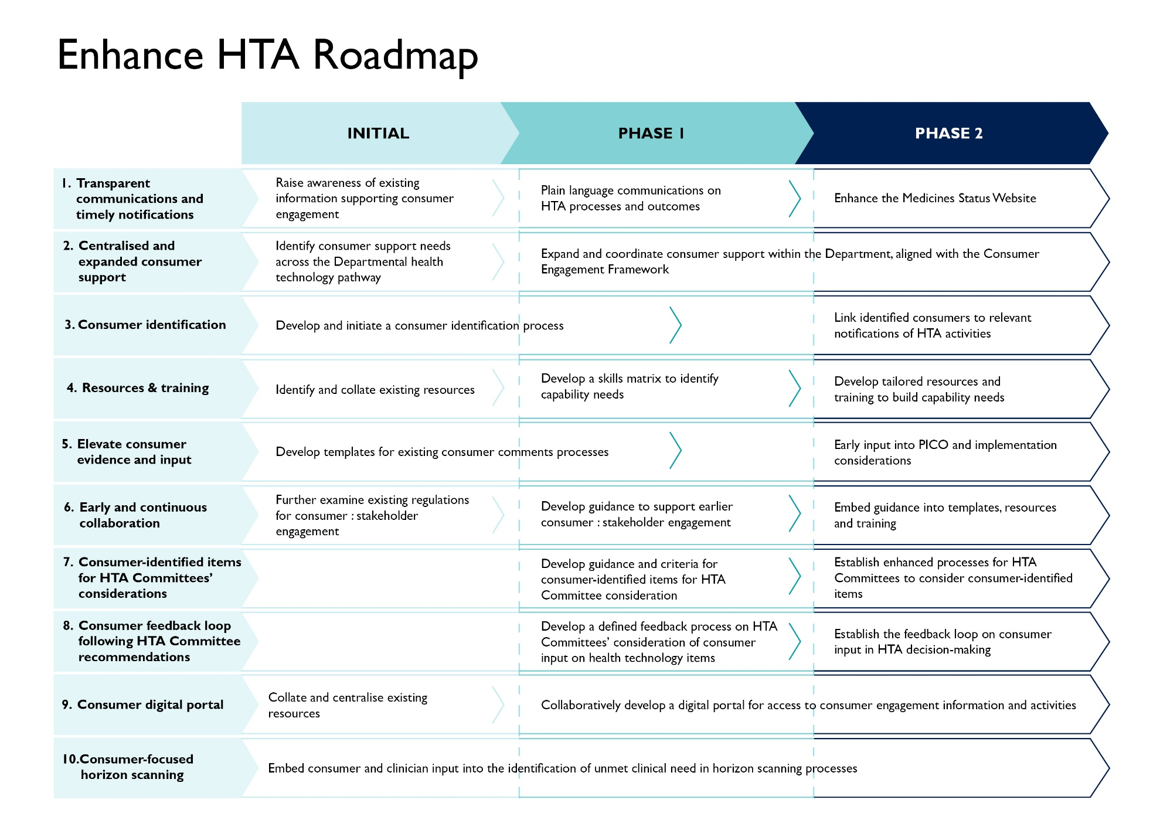

# Co-design Working Group

| **Team Member** | **Co-design role** |
| --- | --- |
| Sharon Winton (Chair) | Consumer representative |
| Karen van Gorp | Consumer representative |
| Nicole Millis | Consumer representative |
| Cara Philpott | Consumer representative |
| Genevieve Handley | Consumer representative |
| Petrina Keogh | Industry representative |
| Hayley Andersen | Industry representative |
| Liz Marshall | Department representative |
| Rebecca Pitman | Department representative |

# Thank you to our survey and submission respondents

The following individuals and organisations accepted an invitation to be acknowledged in this report. We would like to thank all who participated in the consultations, including the HTA Consumer Consultative Committee as well as those who chose not to have their names published, for their valuable contributions to this report.

| **Consumer Organisations** | **Individual Consumers  and Advocates** | **Medicines and**  **Research Industry** |
| --- | --- | --- |
| AccessCR  Asthma Australia  ausEE Inc  Australian Diabetes Alliance  Australian Patient Advocacy Alliance  Breast Cancer Network Australia  Consumer Health Forum  Crohn’s & Colitis Australia  Cystic Fibrosis Australia  DEBRA Australia  Dementia Australia  Dragon Claw Charity  Emerge Australia  Friedreich Ataxia Research Association  Genetic Alliance Australia  Genetic Support Network of Victoria  Leukaemia Foundation  Lived Experience Australia  Lung Foundation Australia  Lymphoma Australia  Medical Oncology Group of Australia  MND Australia  Mito Foundation  Myasthenia Alliance Australia  Myeloma Australia  Narcolepsy & Overwhelming Daytime Sleep Society of Australia  NeuroEndocrine Cancer Australia  Neuromuscular WA  Ovarian Cancer Australia  Pancare Foundation  Patient Voice Initiative  Pink Hope  Private Cancer Physicians of Australia  Psychosis Australia  Rare Cancers Australia  Rare Voices Australia  SCN2A Australia | Michael Aoun  Melissa Avery  Natasha Bell  Jen Bourke  Annette Margaret Fraser-Dunn  Professor Sharon Lawn  Sarah Lukeman  Jennifer Marty  Dr Aaron Schokman  Dianne Spillane  Associate Professor Christopher Steer  David Thomson | AbbVie  Alexion  Amgen Australia  AstraZeneca  Bensins Healthcare  Biogen Australia  Boehringer Ingelheim  Bristol Myers Squibb  CSL  Janssen (Australia)  Medicines Australia  MTAA - Medical Technology Association Australia  Pfizer Australia  Sanofi Australia |

# Key terms

| **Term** | **Meaning** |
| --- | --- |
| Consumer | Patients, their families, carers, consumer organisations and members of the general public. |
| Consumer evidence | Produced through research, generally published in peer-reviewed journals, which may be co-designed with consumers or their organisations, such as Patient Reported Experience Measures (PREMS), Patient Reported Outcomes Measures (PROMS), qualitative studies, health equity studies, and Real-World Evidence (RWE). |
| Consumer input | Input contributed by consumers and their representative organisations through engagement activities across HTA. |
| Health technology | A broad term encompassing medical tests, medical devices, medicines, vaccines, blood and human tissue products, procedures, programs, or systems involved in health care. |
| Health technology assessment | A process used to inform decisions about which health technologies can be sold in Australia and which ones qualify for Australian Government subsidy. |
| Health technology pathway | End-to-end system whereby a health technology generally goes through a lifecycle from the clinical research stage through to TGA applications and registration, then HTA decision-making to recommend subsidisation (via PBAC, MSAC or other committees), before Ministerial approvals for positive recommendations to be listed via a funding scheme, and finally post-market reviews after a health technology is made available to the public. |
| Horizon scanning | A process that systematically identifies, assesses, and plans for the potential impact of new and emerging health technologies. Including: high cost​, highly effective (large efficiency or health gains)​, disruptive (requiring changes to parts of the healthcare system)​, high unmet need​, rare disease or special populations​ or other health technologies. |
| Medicines (from the National Medicines Policy) | Covers a broad range of therapeutic options, products and interventions used to prevent, treat, monitor, manage or cure a disease or health condition. This encompasses prescription medicines, including biologic and non-biologic medicines, gene therapies, cell and tissue engineered medicines and vaccines, non-prescription medicines, complementary medicines, and traditional medicines, including Aboriginal and Torres Strait Islander traditional medicines. Devices used to administer and monitor the response to medicines, or in combination with medicines, are also included. |
| Priority populations | Refers to vulnerable groups in the community, including Aboriginal and Torres Strait Islander people, people from culturally and linguistically diverse backgrounds, children and older people, people with disability, people living in rural and remote areas, people on low incomes, people living with rare and under-recognised diseases, people with mental illness, LGBTIQ+ people, pregnant and breastfeeding women. Noting that people may be in more than one of these groups. |
| Sponsor | Pharmaceutical company (usually in the context of making a submission to PBAC). |
| Stakeholders | The stakeholders involved in the HTA process include consumers (as defined above), clinicians and health professionals, HTA Committee members including academics and assessors, Departmental staff and industry representatives. |

# Acronyms

| **Acronym** |  |
| --- | --- |
| CEEU | Consumer Evidence and Engagement Unit |
| CWG | Co-design Working Group |
| DCAR | Department Contracted Assessment Report |
| DHAC | Department of Health and Aged Care or ‘the Department’ |
| HTA | Health Technology Assessment |
| MBS | Medicare Benefits Schedule |
| MSAC | Medical Services Advisory Committee |
| OHTA | Office of Health Technology Assessment |
| PBAC | Pharmaceutical Benefits Advisory Committee |
| PBS | Pharmaceutical Benefits Scheme |
| PICO | Population, Intervention, Comparator, Outcome |
| PREMS | Patient Reported Experience Measures |
| PROMS | Patient Reported Outcome Measures |
| RWE | Real World Evidence |
| TGA | Therapeutic Goods Administration |

# References

1. Department of Health and Aged Care. *Health technologies and digital health. About health technologies and digital health.* Commonwealth of Australia. <https://www.health.gov.au/topics/health-technologies-and-digital-health/about>. *(Date last updated: 13 April 2022)*
2. Department of Health and Aged Care. *Health technologies and digital health. Health technology assessments. HTA for Australian Government subsidy.* Commonwealth of Australia. <https://www.health.gov.au/topics/health-technologies-and-digital-health/health-technology-assessments/for-subsidy>. *(Date last updated: 13 April 2022)*
3. National Health & Medical Research Council (NHMRC) (2018). *Guidelines for Guidelines: Consumer Involvement.* Commonwealth of Australia. <https://nhmrc.gov.au/guidelinesforguidelines/plan/consumer-involvement>
4. Department of Health and Aged Care (2021). *Strategic Agreement in relation to reimbursement, health technology assessment and other matters.* *Commonwealth of Australia and Medicines Australia. (clause 6.3)* Commonwealth of Australia. <https://www.pbs.gov.au/general/medicines-industry-strategic-agreement-files/MA-Strategic-Agreement-Signed.pdf>.
5. Department of Health and Aged Care. *Our Work. Co-design of an Enhanced Consumer Engagement Process for health technology assessment.* Commonwealth of Australia. <https://www.health.gov.au/our-work/co-design-of-an-enhanced-consumer-engagement-process>. *(Date last updated: 1 March 2024)*
6. Department of Health and Aged Care. *Committees and groups. Co-design Working Group for the HTA Enhanced Consumer Engagement Process.* Commonwealth of Australia. <https://www.health.gov.au/committees-and-groups/co-design-working-group>. *(Date last updated: 1 March 2024)*
7. Paul Bate & Glenn Robert (2007). *Bringing User Experience to Healthcare Improvement: The Concepts, Methods, and Practices of Experience-Based Design* (1st ed.). CRC Press.
8. Elizabeth B.-N Sanders & Pieter Jan Stappers (2008). *Co-creation and the new landscapes of design.* Co-Design 4(1), 5-18. DOI: 10.1080/15710880701875068.
9. Parliament of the Commonwealth of Australia (2021) *The New Frontier – Delivering better health for all Australians*. Commonwealth of Australia. <https://parlinfo.aph.gov.au/parlInfo/download/committees/reportrep/024755/toc_pdf/TheNewFrontier-DeliveringbetterhealthforallAustralians.pdf;fileType=application%2Fpdf>.
10. Department of Health and Aged Care (2022) *National Medicines Policy*. Commonwealth of Australia. <https://www.health.gov.au/sites/default/files/2022-12/national-medicines-policy.pdf>.
11. Bristol Myers Squibb (2023) *Bringing Patient Centricity to Life: Harnessing the patient voice for a better healthcare system*. <https://www.bms.com/assets/bms/australia/documents/Bringing%20Patient%20Centricity%20to%20Life%20in%20Australian%20Healthcare.pdf>.
12. Department of Health and Aged Care (2023). *Conversations for Change report: improving consumer engagement in Health Technology Assessment.* Commonwealth of Australia. <https://www.health.gov.au/resources/publications/conversations-for-change-report-2023?language=en>.
13. Department of Health and Aged Care. Therapeutic Goods Administration. *How the TGA regulates.* Commonwealth of Australia. <https://tga.gov.au/how-we-regulate/advertising/legal-framework/act-regulations-and-code-offences-how-tga-regulates>
14. *Medicine and vaccine submissions may also be made under the TGA and PBAC parallel process arrangements. This enables the respective registration and reimbursement evaluation and assessment processes for submissions meeting the required criteria to be undertaken in parallel.* [*https://www.pbs.gov.au/info/publication/factsheets/shared/tga-pbac-parallel-process*](https://www.pbs.gov.au/info/publication/factsheets/shared/tga-pbac-parallel-process)
15. *A codependent technology relies on another technology to work properly e.g. a test that guides the use of a medicine. The principal HTA committees work together as needed to assess codependent technologies.* [*https://www.health.gov.au/topics/health-technologies-and-digital-health/health-technology-assessments/for-subsidy*](https://www.health.gov.au/topics/health-technologies-and-digital-health/health-technology-assessments/for-subsidy)
16. Department of Health and Aged Care (2023). *Our work. Health Technology Assessment Policy and Methods Review.* Commonwealth of Australia. *(Date last updated: 24 April 2024)*
17. Department of Health and Aged Care (2023). *HTA Policy and Methods Review – Research and analysis papers. Draft paper: Optimised real world evidence to support health technology assessment in Australia.* Commonwealth of Australia. <https://www.health.gov.au/resources/publications/hta-policy-and-methods-review-draft-paper-optimised-real-world-evidence-to-support-health-technology-assessment-in-australia?language=en>.
18. Department of Health and Aged Care (2024). Therapeutic Goods Administration. *Establishment of the Medicines Repurposing Program.* Commonwealth of Australia. <https://www.tga.gov.au/resources/publication/publications/establishment-medicines-repurposing-program>. *(Published: 1 March 2024)*
19. Department of Health and Aged Care (2024). *The Pharmaceutical Benefits Scheme.* *2024 PBS Post-market Review Framework; Information for Stakeholders.* Commonwealth of Australia. <https://www.pbs.gov.au/reviews/subsidised-medicines-reviews-files/2024-post-market-review-framework.PDF>.
20. Department of Finance. *Australian Government Cost Recovery Policy*. Commonwealth of Australia. <https://www.finance.gov.au/government/managing-commonwealth-resources/implementing-charging-framework-rmg-302/australian-government-cost-recovery-policy>. *(Last updated: 21 June 2023)*
21. Department of Health and Aged Care. *Documents for Applicants and Assessment Groups.* Commonwealth of Australia. [www.msac.gov.au/internet/msac/publishing.nsf/Content/Documents-for-Applicants-and-Assessment-Groups](http://www.msac.gov.au/internet/msac/publishing.nsf/Content/Documents-for-Applicants-and-Assessment-Groups). *(Last updated: 31 May 2024)*
22. Department of Health and Aged Care (2024). *Health Technology Assessment Policy and Methods Review. Consultation options paper. Report of the Health Technology Assessment Policy and Methods Review Reference Committee (January 2024).* Commonwealth of Australia. <https://ohta-consultations.health.gov.au/ohta/hta-review-consultation-2/>.