General Practice in Aged Care Incentive care planning template

Effective – August 2024

# Disclaimer

This care planning template is for information purposes and is based on consensus from published material. The Australian Government does not accept any legal liability or responsibility for any injury, loss or damage incurred by the use of, reliance on, or interpretation of the information provided in this template.

# Care planning

Care planning anticipates a patient’s health care needs and provides a more preventive approach.

A typical care plan for an older person includes several parts, summarised in the figure below.

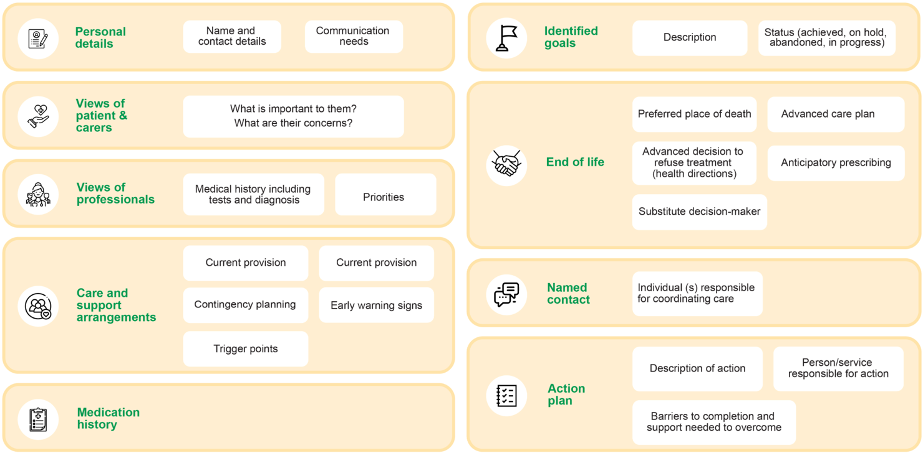  
Figure 1: Care plan elements

When reviewing or contributing to a care plan, consider the elements above.

For example, planning may include:

* providing ranges of biomedical parameters (such as blood pressure ranges)
* sick day action plans
* monitoring requirements for medications or cycle-of-care elements for long-term conditions.

Care plans also provide guidance to other members of the care team in both the delivery of care and parameters for escalation or intervention if there is a change (including residential aged care home clinical staff, and other visiting primary care providers).

# Care plan review/contribution

A care plan review/contribution template for residential aged care home residents is provided on the next page.

# Review of care plan/care plan contribution for residential aged care home residents

## Patient information:

|  |  |
| --- | --- |
| Patient name: | Click to enter patients name. |
| Date of birth: | Enter date of birth. |
| Medicare/Department of Veteran’s Affairs (DVA) number: | Enter DVA number. |
| Substitute decision maker (where applicable): | Enter substitute decision maker (where applicable). |
| Residential aged care home/provider (RACH): | Enter residential aged care home/provider (RACH). |
| Responsible GP: | Enter GP responsible for patient. |
| Date of care plan contribution: | Enter date of plan contribution. |

## General information:

|  |  |
| --- | --- |
| Health status and list of conditions/problems  Summary of health conditions and recent changes. Medical history relevant to care plan. | List of medications  List all medications, including dosages and frequency. Note any recent changes to medication regimen. |
| Allergies  Document any known allergies and reactions. |
| Advanced care plan  Date of advanced care plan and summary of wishes. | |

## Sources of information:

|  |
| --- |
| Comprehensive Medical Assessment (CMA) summary  Date of last CMA and key findings and recommendations.  Click or tap here to enter CMA summary. |
| Multidisciplinary care plan from residential aged care provider  Team members involved: List of all healthcare professionals involved in the patient’s care (for example, GP, nurse, physiotherapist, pharmacist).  Click or tap here to enter details of the multidisciplinary care plan. |
| Contributions  Summarise the contributions and input from each team member.  Click or tap here to enter the contributions and input from each team member. |
| Action plan  Detailed actions to be taken, including responsible team member and timeline for each action. Include specific interventions, treatments, and follow-up activities.  Click or tap here to enter the detailed actions to be taken, including responsible team member and timeline for each action. Include specific interventions, treatments, and follow-up activities. |
| Coordination of care  Describe how care activities will be coordinated among team members. Outline communication plan for updates and reviews.  Click or tap here to Describe how care activities will be coordinated among team members. |
| Medication review (RMMR)  Medication management: Summary of recent RMMR. Changes made to medications and reasons for changes. Plan for monitoring and follow-up.  Click or tap here to enter Medication management: Summary of recent RMMR. |
| Case Conferences  Date of last case conference  Click or tap to enter a date.  Participants: List of participants involved in the case conference.  Click or tap here to enter List of participants involved in the case conference.  Summary of discussion: Key points discussed. Decisions made and action items assigned.  Click or tap here to enter Key points discussed. Decisions made and action items assigned. |
| Risk management and preventive care  Risk factors: Identify and document risk factors (for example, falls, infections, chronic conditions).  Preventive measures: Outline preventive measures and screenings (for example, vaccinations, regular check-ups).  Click or tap here to enter Identify and document risk factors. |
| Monitoring and review  Monitoring plan: Frequency of monitoring and specific health parameters to be tracked.  Click or tap here to enter Monitoring plan.  Review schedule: Dates for future reviews and updates to the care plan.  Click or tap here to enter Review schedule.  Follow-up appointments: Schedule for follow-up visits and reassessments.  Click or tap here to enter Follow-up appointments. |
| Weight  Click or tap here to enter weight.  Blood Pressure  Click or tap here to enter blood pressure. |
| Patient and family involvement  Engagement: Describe how the patient and their family are involved in care planning.  Click or tap here to enter detail on engagement.  Feedback: Document any feedback from the patient and family regarding the care plan.  Click or tap here to enter feedback from the patient and family regarding the care plan. |
| Additional notes  Other relevant information: Any other information relevant to the patient’s care that has not been covered.  Click or tap here to enter other relevant information. |

## Individualised goals of care:

**Patient’s goals**: Outline the patient’s short-term and long-term health goals. Include patient’s preferences and priorities for care based on what matters to them.

**Health professional’s goals**: Describe the clinical goals set by the healthcare team.

|  |  |  |  |  |
| --- | --- | --- | --- | --- |
| Goal | How will it be achieved? | Who else will be involved? | How will it be monitored? | When will it be reviewed? |
| Click or tap here to enter goal 1. | Describe how goal 1 will be achieved. | Describe who will be involved with goal 1. | Describe how goal 1 will be monitored. | List when goal 1 will reviewed. |
| Click or tap here to enter goal 2. | Describe how goal 2 will be achieved. | Describe who will be involved with goal 2. | Describe how goal 2 will be monitored. | List when goal 2 will reviewed. |
| Click or tap here to enter goal 3. | Describe how goal 3 will be achieved. | Describe who will be involved with goal 3. | Describe how goal 3 will be monitored. | List when goal 3 will reviewed. |
| Click or tap here to enter goal 4. | Describe how goal 4 will be achieved. | Describe who will be involved with goal 4. | Describe how goal 4 will be monitored. | List when goal 4 will reviewed. |

## Signatures:

I have reviewed the care plan created by the [INSERT NAME] aged care provider/home and recommend the above.

|  |  |  |
| --- | --- | --- |
| GP signature: |  | Date:  Enter date GP signed this document. |
| Patient/Family signature (if applicable) |  | Date:  Enter date patient or family member signed this document. |